See if you can follow the steps below to add instructors. Go to the Course → select Instructors from the upper tabs → select Assign Instructors from the Action Menu.

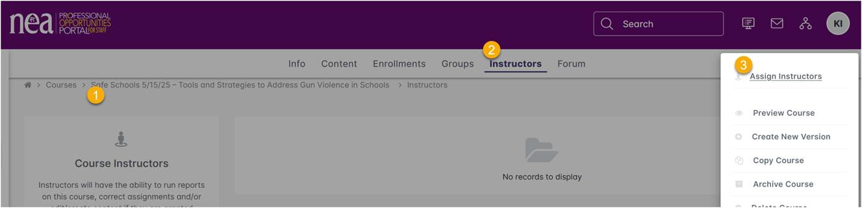

Let me know if you can’t assign Chad and/or if you need to add someone who doesn’t already have that role.

