Campaign Academy, September 25-27, 2026, Salt Lake City
Course Description
This course is both the pre-academy experience and resource container for the in-person Campaign Academy. Campaign Academy is intended for Campaign Lab coaches or those who want to learn coaching skills, this training covers the fundamentals of coaching a campaign lead through their campaign. Learn how to diagnose problems and how to center the lead in your response. Participants will also get an overview of the mechanics of a campaign cycle and learn how they can help develop plans, analyze data, and encourage strategic thinking in those they are coaching. Participants will also receive certification as an NEA Campaign Coach. This training is appropriate for Affiliate Staff, Members, and Leaders who are already Team Leads, Coaches, or Mentor Coaches in the Campaign Lab System. Participants should leave with a level of confidence, knowledge, methods, and resources allowing them to coach and lead an issue campaign cycle.
The course is made of eleven modules. You will need to complete all of modules 1-8 before you arrive. Module 1 Pre-Academy outlines what must be completed before our meeting. Several of the items will be used first thing on the first day. The Pre-Academy module provides good guidance on how long it should take to complete the Pre-Academy work.
Each day, the PPTs used in the room will be loaded to this course in the module "Daily PPTs." This will allow you to easily see what we are showing. Please download the file to your device each day to facilitate ease of use.
In the module "Participant Handouts," there is a file of the same name that we will use during our time together. That file can be downloaded to a device large enough to ensure that you can use it in small groups. A cell phone is typically not big enough. Tablets or laptops are the most successful for participants. You may also opt to download and print these files before you arrive and bring them with you. There will be no paper copies provided.
The module "Additional Resources" will have other items that we may not have included in other modules or that participants share for everyone to use.
Course Objectives
Participants will learn how to help themselves and others:
- Develop core coaching skills that transform individual and team agency into action within an issue campaign
- Build strong leadership teams with defined boundaries and roles
- Develop skills around strategic planning, leadership tests, data collection, and narrative development.
- Move away from episodic mobilization of the already engaged – to the deeper work of moving people to “our” side.
Focus on long-term campaign planning around organizing issues.

Pre-Attendance Assignment Descriptions
Welcome to NEA's Campaign Lab Coaching Academy. This is an in-person event. It is required that you complete all modules in this pre-attendance session. Please download and complete the following Pre-Attendance Activities Before Arriving.
Why Pre-Academy Assignments? The resources compiled here are short, relevant, and intended to help you shift from the day-to-day cognitive load of work to the thinking you will use as a learner at the academy. It should take no longer than 6 hours to complete the entire pre-attendance package. There are 8 modules, two articles to read, one brief writing activity, and scenarios that need to be completed and reviewed before your arrival. They are listed below.
Module 1: Pre-Academy Assignments (Approximate time to Complete - 6 Hours Total)
There is a fillable form PDF of the entire Pre-Academy Assignment Package that you must n download to your device before working on it, or your work will not be saved. If you prefer paper to device, you will need to print this document and complete the assignments on the document. Be sure to bring your copies with you as there will be no printed versions on site.
Module 2. Building Inclusive Union Communities: Community Agreements in Action (required) – Please complete this module and pages of the pre-attendance package that are our Community Agreements before attending. We will be doing an activity on day one in the first 30 minutes that requires your prior reading of these. There is a copy of these along with reflection questions for you to complete in the pre-attendance package.
Module 3. Coaching Foundations for Campaign Lab Coaches (required) – This module will equip you with the historical roots, essential frameworks, and practical tools of campaign coaching to help you grow strong, strategic organizers and leaders in your union. Discover how coaching can transform organizing efforts, deepen your capacity to support new organizers, and foster a culture of learning and empowerment. Through a blend of movement history, proven coaching models, and actionable techniques, you’ll gain the confidence and skills to lead, inspire, and develop others through transformational conversations that drive real change in public schools. The article included in your handouts named “ Ella Baker’s Legacy: A Different Model of Leadership” should be read alongside this module.
Module 4. Centering Equity in Campaigns (required) - This module is designed for Campaign Lab Team Leads and Coaches. It helps participants integrate race, class, and gender equity into every stage of their campaign planning. Participants will apply a specific Equity Tool to help them identify systemic barriers, set measurable equity-focused goals, and use practical tools to ensure their campaigns build power with those most impacted by oppression. By the end, learners will have the skills to proactively advance equity and foster meaningful change within their organizations and communities. This module is designed to be used with the handout titled, "Centering Equity in your Campaigns."
Module 5. Building and Coaching High Participation Locals in Education Unions (required)– This course module aligns with the High Participation Local Assessment Tool. This module empowers union staff, member-leaders, and coaches in education unions to build and sustain high participation locals. Through hands-on tools, real-world case studies, and equity-driven strategies, you'll gain the skills to assess your organization's strengths, develop distributed leadership, and design targeted interventions for lasting impact. Discover how to move beyond traditional service models and unleash the full power of your membership to win on the issues that matter most. The article included in your Pre-Attendance handouts, Problem Solving: From Good Service to Centering Worker Agency, should be read alongside this module.
Module 6, Coaching Organizers through the Campaign Cycle (required)- This module will guide you through the essential practices for coaching campaign organizers, from foundational coaching mindsets to advanced strategies for equity, power-building, and adaptive leadership. You'll learn how to ask the right questions, facilitate structured campaign planning, and support organizers in moving from big ideas to concrete, winnable actions. Through reflective and pragmatic lessons, you'll gain the tools to foster leadership, accountability, and sustained impact in every stage of the campaign cycle.
Module 7. Campaign Coach Self-Assessment Introduction (required)– This module introduces you to the essential skills and reflective practices needed to become an impactful campaign coach in the NEA Campaign Lab. You'll explore foundational coaching competencies, learn to assess and develop your coaching abilities, and discover how to center equity in every conversation. Whether you're a union staff member, leader, or new coach, this course will help you build confidence and clarity as you begin your coaching journey. This self-assessment is found in your pre-attendance package. Make sure to complete this and that you have access to either a completed paper version or a completed electronic version on your device.
Module 8. Using the Wheel of Privilege for Equity-Centered Union Organizing (required) – This module is designed for new Campaign Lab Coaches supporting public school employees. This course invites you to explore the powerful role of intersectionality in building trust, credibility, and effective relationships. Through practical reflection and guided activities, you’ll discover how the Wheel of Privilege can deepen your self-awareness, enhance your equity lens, and strengthen your impact as an organizer and leader. You will complete the Wheel of Privilege handout that is included in the Pre-Attendance Package. Make sure you have access to either a printed-out version or an electronic version on your device. This includes the Guided Reflection Questions page.
Writing Activity: Your Campaign Story - Please prepare a story of a campaign you were part of for one of our coaching sessions. In your pre-attendance handouts, there is a handout named “Writing Your Campaign Story” that will provide guidance. Use the following checklist as a guide to frame your campaign story. It does not need to include all the components, nor be a winning campaign. It simply needs to be an honest story from your perspective about the campaign with enough detail to allow you to be coached during one of our practice sessions.
Review of Scenarios: There are a number of scenarios that we will be using during our time together. Sometimes individuals struggle with reading while in a group. It is strongly suggested that you read the scenarios in advance so that the first time you are experiencing them is not in our training room.
Module 10. Participant Handouts (Required Action: Download to your device or print before arriving) - the file Participant Handouts is a fillable PDF file, and YOU MUST DOWNLOAD it to your device before you begin working on it, or your work will not be saved. If you prefer paper copies and handwriting your work, you will need to print these before arriving. There will be no paper copies provided on-site.
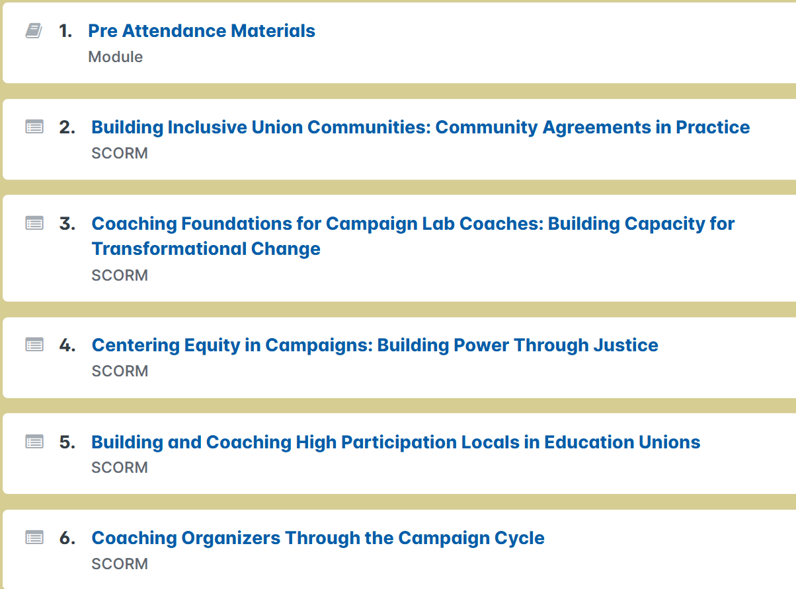
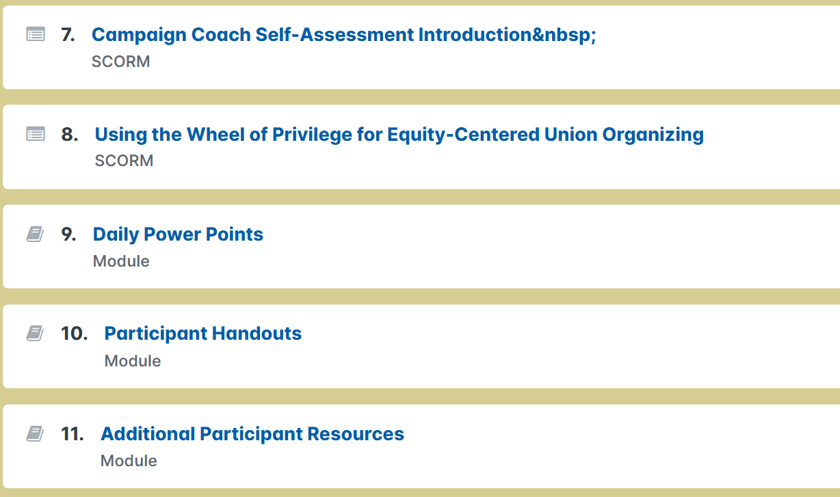
9. Dail PPT Module
This module will contain the PPTs, in PDF format, used during Foundations of UniServ Academy. It is recommended that you download these to your devices. Wifi connections can fluctuate and using the files while logged in may be problematic. The PPTs will be available each day before 8:30 AM for your access.
10. Participant Handout Module
READ FIRST - DOWNLOAD AND PRINT - If you are a person who prefers using paper and pencil, you will want to download the file Participant Handouts and print it prior to arriving. There will be no paper copies provided on-site. This is a fillable PDF file and YOU MUST DOWNLOAD them to your devices before you begin working on them or your work will not be saved. If you prefer paper copies, you will need to print these as well.

11. Additional Resources Module
This module contains files that you may find useful but are not necessarily part of the actual event.

