Foundations LMS
Course Description
This course is both the pre-academy experience and resource container for the in-person foundations of UniServ and Organizing Academy. Foundations Academy is required of any Organizer or UniServ Director with up to three years of experience. This requirement intends to ensure a consistent foundation of knowledge across the NEA UniServ workforce. The Foundations of UniServ and Organizing Academy is a five-day, in-person, intensive classroom and worksite organizing experience led by practicing Affiliate and NEA staff. The first three days are devoted to classroom content, the fourth day is spent in a worksite applying skills, and the final day is a scenario-based team experience.
The course is made of elevent modules. You will need to complete all of modules 1-6 before you arrive. Module 1 Pre-Academy outlines what must be completed before our meeting. Several of the items will be used first thing on the first day. The Pre-Academy module provides good guidance on how long it should take to complete the Pre-Academy work.
Each day, the PPTs used in the room will be loaded to this course in the module "Daily PPTs." This will allow you to easily see what we are showing. Please download the file to your device each day to facilitate ease of use.
In the module "Participant Handouts," there is a file of the same name that we will use during our time together. That file can be downloaded to a device large enough to ensure that you can use in small groups. In this same module is another document, Campaign Plan Guide, that you will need to download to your device that we will use during our time together. A cell phone is typically not big enough. Tablets or laptops are the most successful for participants. You may also opt to download and print these files before you arrive and bring them with you. There will be no paper copies provided.
Materials for our worksite visit will be in the module "Worksite Visit." These will not be ready for your review until you arrive.
The module "Additional Resources" will have other items that we may not have included in other modules or that participants share for everyone to use.
The final module, "Campaign Cycle Planning," is intended for your use after you complete your time with us. It is a way for you to continue building your learning once you return to your "home base."

Course Objectives
Overall Outcome:
Participants will learn core, foundational practices that can support a successful UniServ or Organizer career.
Key Objectives:
Participants will understand the role of power and oppression in their work and apply that learning to scenarios
Participants will learn best practices for member recruitment, engagement, and leadership development and apply those in worksite settings and scenarios.
Participants will work as teams to apply organizing methods and skills to team-based scenarios

Pre Attendance Module
Welcome to NEA's UniServ and Organizer Foundations Academy. This is an in-person event. It is required that you complete all modules in this pre-attendance session. Please download and complete the following Pre-Attendance Activities Before Arriving.
Why Pre-Academy Assignments? The resources compiled here are short, relevant, and intended to help you shift from the day-to-day cognitive load of work to the thinking you will use as a learner at the academy. It should take no longer than 6 hours to complete the entire pre-attendance package. There are 6 modules, one online activity, and two readings that are required. They are listed below.
Module 1: Pre-Academy Assignments (Approximate time to Complete - 6 Hours Total)
There is a PDF of the entire Pre-Academy Assignment Package that you can download to your device. If you prefer paper to device, you will need to print this document and complete the assignments on the document. Be sure to bring your copies with you as there will be no printed versions on site. Any of the fillable form PDFs must be downloaded to your device BEFORE you work on them. Your work may not be saved if you don't do this.
Module 2. Building Inclusive Union Communities: Community Agreements in Action (required) – Please complete this module and pages 6-8 of the pre-attendance package that are our Community Agreements prior to attending. We will be doing an activity on day one in the first 30 minutes that requires your prior reading of these. There is a copy of these along with reflection questions for you to complete in the pre-attendance package.
Module 3. Leadership Styles for Union Staff: Discover, Reflect, Lead (required) – There is a module of the same name that you will complete along with the Leadership Style Survey included as a fillable form PDF in the Pre- Attendance package within the pages 9-14. Make sure to have completed this Leadership Style survey and either bring a completed copy or have the completed fillable form available to you on day 1. We will be using this in the first half of the first day. As a UniServ Director or Organizer focused on recruiting, engaging, and supporting members in your affiliate, building your communication and listening skills are critical. This activity and module of the same name is one way to begin reflecting on how your style can support your work. When you take this survey, you should approach each line of “descriptors” with the following in mind: “When I am stressed about getting others to accomplish a goal, I am most likely to …” - then, assign a total of 5 points by dividing points between both actions on each line – 1 and 4, 2 and 3, 0 and 5, etc. Use any combination that adds up to 5 points, but don’t use fractions. Follow the scoring directions to determine what the survey has to say about your communication style.
Module 4. Using the Wheel of Privilege for Equity Centered Union Organizing (required) - There is a module of this same name that you will complete along with the Wheel of Privilege handout that is included in the Pre-Attendance Package within pages 15-18. Make sure to have this completed and available for late morning of Day 1, either printed out and completed or as a file on your device. This includes the Guided Reflection Questions page.
Module 5. Organizing for Power: Addressing NEA Member Challenges Through Collective Action (required) - This course module is to be completed in the online course prior to attending. This will help you apply an organizing framework in several of the scenarios and group discussions about member challenges. This content will be touched upon across all days of the academy.
Module 6. Envisioning the Future: NEA Union Organizing in the Next Decade (Not Required, but highly recommended)– This course module aligns with the section, “ Reading for the Plane,” starting on page 45 and is designed to kickstart your thinking about a future where public education and labor movements are rapidly evolving. This also accompanies our overarching question for the academy, ”What will our union look like and need 10 years from now?” It invites UniServ Directors and Organizers to critically examine the challenges, opportunities, and transformative strategies shaping the future of NEA-affiliated unions. Through real-world scenarios, analysis of current trends, and thought-provoking questions, you'll explore how economic, political, and technological forces intersect with organizing. Prepare to envision actionable pathways that build union power, equity, and resilience for the years ahead.
ACTIVITY Implicit Association Bias Activity (required) –
This is an online-only activity and is outside of the LearnUpon Course System. You will use the URLs below. We will be exploring what implicit bias is and how this intersects with attitudes and actions. The first step in becoming astute at racial discourse is to explore and reflect on your own possible implicit biases. This activity is designed to help you with that. It is highly recommended that prior to taking the Implicit Association Test, you visit: https://www.tolerance.org/professional-development/test-yourself-for-hidden-bias for a brief but thorough description of why we ask you to do this. It is strongly suggested that you read this section.
Directions for Accessing the Implicit Association Tests
https://implicit.harvard.edu/implicit/
Click on the button "Test Yourself for Hidden Bias”
Read the Preliminary Information, and select "I Agree"
Select “United States” to take this as a Guest
Take at least the “Race” test (try out others if you would like). Select “Continue”
Reflect on findings and be prepared to share your thoughts, questions, and/or concerns during the training. You will not be asked to disclose your findings – but will be expected to participate in the reflection on what it means to learn about your biases.

READ Team Scenarios (required) -You will be working on a scenario with a team during your time with us. You will find 10 scenarios about Enchanted School District that are found on pages 19-34 of the Pre-Academy Package. Please become familiar with these prior to attending. Complete a very cursory summary of your thinking about each scenario using the fillable form PDF called Team Scenarios Summary Sheet found on this course site. Make sure that you have completed a very cursory – you do not need to do this in detail - Summary Sheet available to you by day 2. Think about which of the scenarios has some similarity to something that you are going through in your current work situation or will be most applicable to you.
READ Frames of Unionism (review and be familiar)- Pages 35-44 of the Pre-Academy Package describes a number of ways that the work of a UniServ Director or an Organizer is FRAMED. As you review these, please think about EITHER your own organization that employs you or a local that you work with. Circle items that describe your situation. We will be using these documents and your responses to these as part of a group activity, and you will not have time at the Academy to read and respond.
Reading for the Plane (not required but helpful) - This is a collection of relevant and current items that begins on page 45 of the Pre-Academy Package and is great for anyone in the early part of their career with an NEA affiliate. They continue to support and push your thinking about the type of Union members will need 10 years from now.

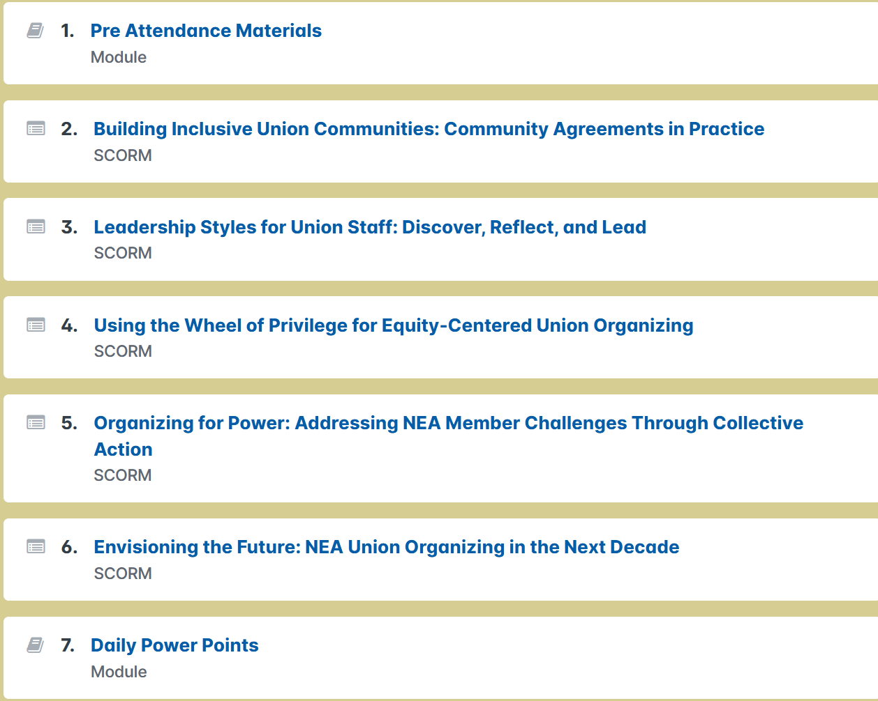
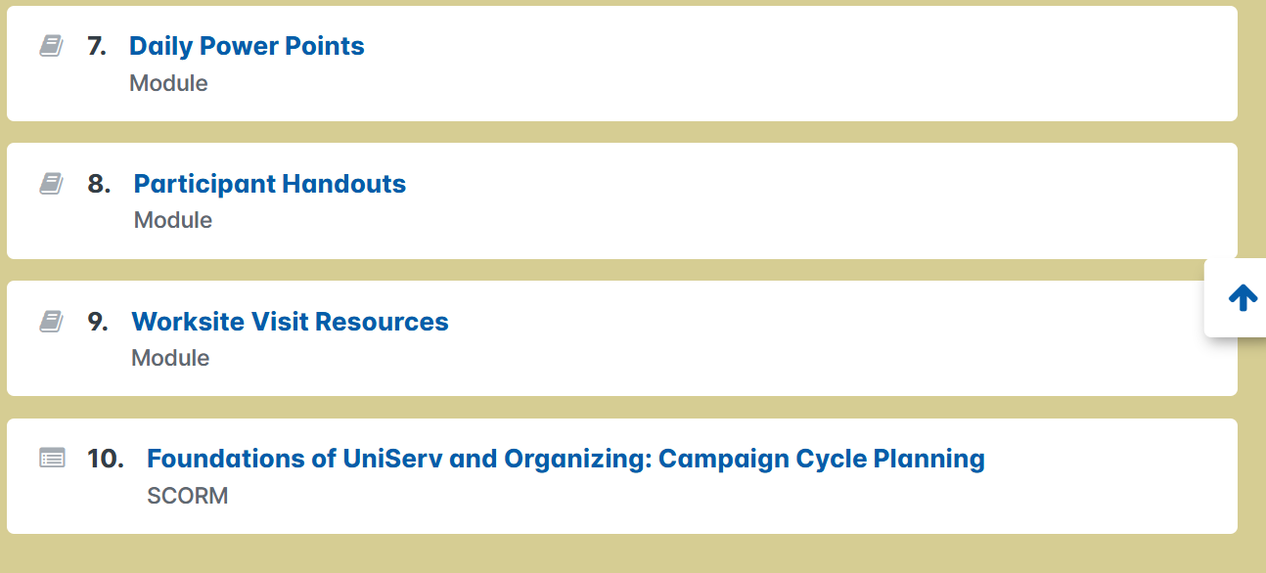
PPT Module
This module will contain the PPTs, in PDF format, used during Foundations of UniServ Academy. It is recommended that you download these to your devices. Wifi connections can fluctuate and using the files while logged in may be problematic. The PPTs will be available each day before 8:30 AM for your access.

Participant Handout Module
READ FIRST - DOWNLOAD AND PRINT - If you are a person who prefers using paper and pencil, you will want to download the file Participant Handouts and print it prior to arriving. There will be no paper copies provided on-site. Included in this module is another file, the Campaign Plan Guide. These are fillable PDF files and YOU MUST DOWNLOAD them to your devices before you begin working on them or your work will not be saved. If you prefer paper copies, you will need to print these as well.
Files – compiled handouts and Campaign Plan Guide

Worksite Visit Resources
This module will be updated throughout the week of Foundations. It will include worksite team assignments, links to any data collection tools we will use, host/leader contact information, and other items needed to support the worksite visits.

Campaign Cycle SCORM Description
This course equips UniServ and Organizers with the skills and knowledge to effectively plan and execute a campaign cycle. Participants will explore critical components, including defining problems, conducting power analyses, and designing escalating tactics. They will learn to apply an equity lens to campaigns, ensuring inclusivity and addressing systemic inequities. The course also focuses on building effective campaign teams, mapping allies, and setting measurable goals to track progress and success. Designed for affiliate staff, this program provides practical tools and strategies to drive strategic change.

Additional Resources Module
This module contains files that you may find useful but are not necessarily part of this week's curriculum.
