

STORY OF SELF, US and NOW

“Why am I called to lead?”
“Who are we together?”
“Why do we need to act now?”

public narrative: story of self

EACH OF US HAS A COMPELLING STORY TO TELL

Each of us has a story that can move others to action. As you learn this skill, you will be learning to tell a story about yourself, the community you organize with, and your strategy that motivates others to join you in creating change. In addition, you will gain practice in listening, and coaching others to tell a good story.

PUBLIC NARRATIVE IS A PRACTICE OF LEADERSHIP

Leadership is about accepting responsibility for enabling others to achieve shared purpose in the face of uncertainty. Narrative is how we learn to make choices and construct our identities and purpose—as individuals, as communities and organizations, and as nations.
What does public narrative have to do with this definition of leadership? You can’t ask others to follow you if they don’t understand what your intentions are, and why you are called to lead.

THE HEAD & THE HEART
There are two ways we understand the world: through our head (strategy & analysis) and through our heart (story & motivation). To enable others to achieve shared purpose, public leaders must employ BOTH the head and the heart of their constituency in order to mobilize others to act on behalf of shared values. In other words, they engage people in interpreting why they should change their world (their motivation) and how they can act to change it (their strategy). Public narrative is the “why”: the art of translating values into action through stories.

VALUES INSPIRE ACTION THROUGH EMOTION

We don’t think our values; we feel our values. Often we don’t realize what we value in the world until we hear a story or witness an injustice that stirs emotions within us. Emotions inform us of what we value in ourselves, in others, and in the world, and they enable us to express the motivational content of our values to others. Because stories allow us to express our values not as abstract principles, but as lived experience, they have the power to move others to action.

SOME EMOTIONS INHIBIT ACTION, OTHERS MOTIVATE ACTION
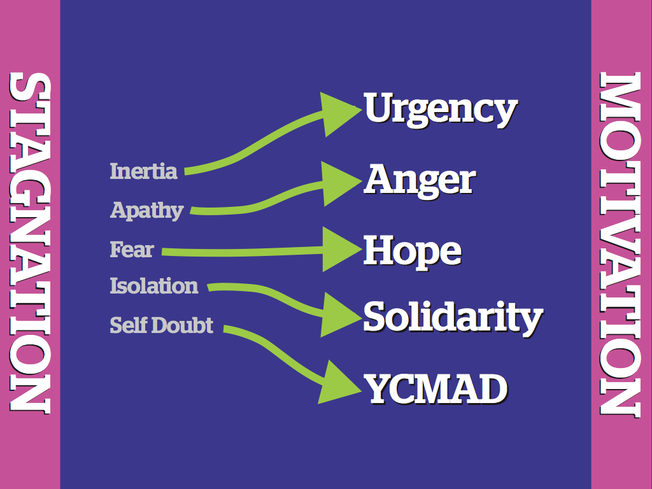
Public leaders often encounter individuals or groups where mindful action is inhibited by inertia, fear, self-doubt, isolation, and apathy. The job of a leader is not to tell people to stop feeling this way but rather use storytelling to move people from feelings of stagnation to feelings of motivation: urgency, hope, YCMAD (you can make a difference), solidarity, and anger. The language of emotion is the language of movement: they actually share the same root word. Stories mobilize emotions of action to overcome emotions that inhibit us from mindful action.

PUBLIC NARRATIVE COMBINES A STORY OF SELF, US AND NOW

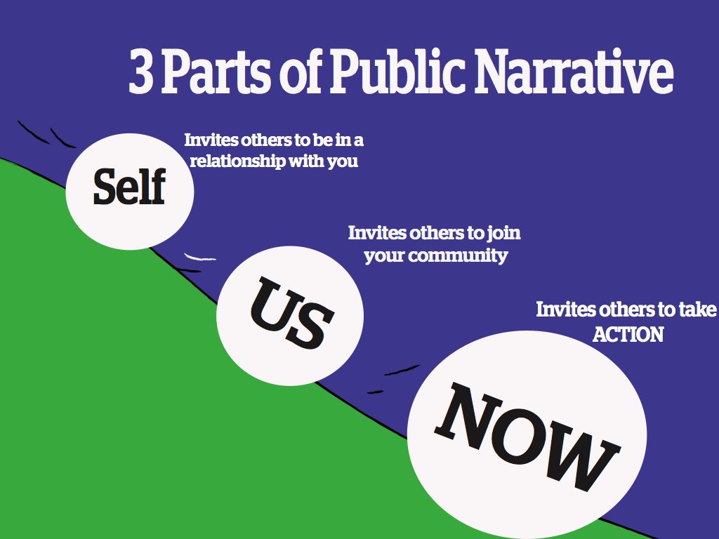
STORY OF SELF By telling a “story of self” you can communicate the values that move you to lead. Public leaders face the challenge of enabling others to “get” the values that move them to lead. Effective communication of motivating values can establish grounds for trust, empathy, and understanding. In its absence, people will infer our motivations, often in ways that can be very counterproductive. Telling our story of self can help establish firm ground for leadership, collaboration and discovering common purpose.
Every one of us has a compelling story of self to tell. We all have people in our lives (parents, grandparents, teachers, friends, colleagues) or characters we love, whose stories influence our own values. And we all have made choices in response to our own challenges that shape our life’s path: confrontations with pain, moments of hope, calls to action.

The key focus is on our choices, those moments in our lives when our values moved us to act in the face of challenge. When did you first care about being heard? When did you feel you had to act? Why did you feel you could act? What were the circumstances, the place, the colors, the sounds? What did it look like? The power in your story of self is to reveal something of those moments that were deeply meaningful to you in shaping your life; not your deepest private secrets, but the events that shaped your public life. Learning to tell a good story of self demands the courage of introspection, and of sharing some of what you find.

STORY OF US
By telling a “story of us” you can communicate values that can inspire others to act together by identifying with each other, not only with you.
Just as with a story of self, key choice points in the life of a community: its founding, crises it has faced, or other events that everyone remembers are moments that express the values shared. Consider stories that members of your group have shared, especially those that held similar meaning for all of you. The key is to focus on telling a specific story about specific people at a specific time that can remind everyone, or call to everyone’s attention, values that you share. Telling a good story of us requires the courage of empathy to consider the experience of others deeply enough to take a chance at articulating that experience.

STORY OF NOW
By telling a “story of now” you can communicate an urgent challenge we are called upon to face, the hope that we can face it, the hopeful outcome we can create together, and the choice we must make to act now.
A story of now requires telling stories that bring the urgency of the challenge alive: urgency because of a need for change that cannot be denied, urgency because of a moment of opportunity that may not return. A story of now also offers hope, not make-believe hope, but real, plausible hope, often grounded in what others are already achieving, grounded in the courage of others’ actions, and in the strategic vision of what we can achieve together. At the intersection of the urgency and the promise of hope is a choice that must be made to act, or not to act, to act in this way, or in that. Telling a good story of now requires the courage of imagination, or as Walter Brueggemann named it, a prophetic imagination, in which you call attention both to the pain of the world and also to the possibility for a better future.

STORY STRUCTURE: CHALLENGE, CHOICE, OUTCOME
Every human story has a plot. A plot begins with a challenge that confronts a character with an urgent need to pay attention, to make a choice for which they are unprepared. The choice yields an outcome, and the outcome teaches a moral.
A good story allows the listener to empathetically identify with the character and “feel” the moral. We hear “about” someone’s courage; we are also inspired by it.
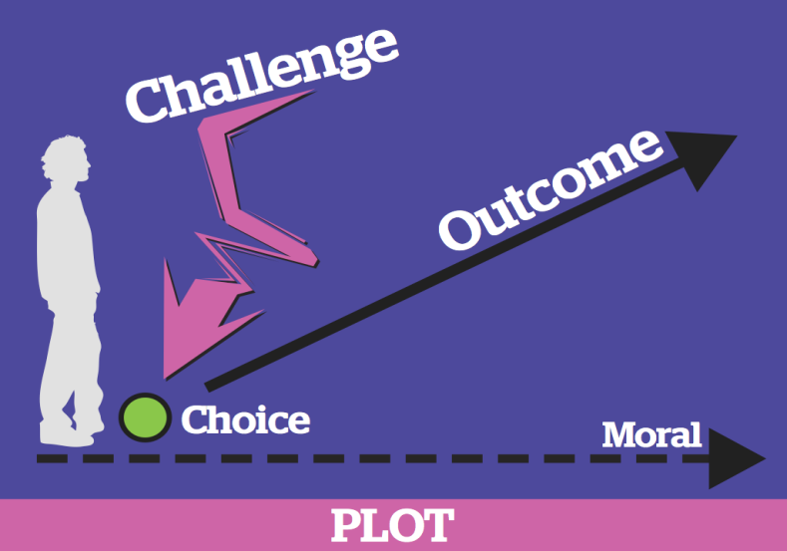
The story of the character and their choices encourages listeners to think about their own values and challenges and inspires them with new ways of thinking about how to make choices in their own lives.

Incorporating Challenge, Choice, and Outcome in Your Own Story

There are some key questions you need to answer as you consider the choices you have made in your life and the path you have taken that brought you to this point in time as a leader. Once you identify the specific relevant choice, dig deeper by answering the following questions.

Challenge: Why did you feel it was a challenge? What was so challenging about it? Why was it your challenge?

Choice: Why did you make the choice you did? Where did you get the courage (or not)? Where did you get the hope (or not)? Did your parents or grandparents’ life stories teach you in any way how to act in that moment? How did it feel?

Outcome: How did the outcome feel? Why did it feel that way? What did it teach you? What do you want to teach us? How do you want us to feel?

A word about challenge. Sometimes people see the word challenge and think it means describing the worst misfortunes of our lives.Sometimes those are the moments that most shaped us. But keep in mind that a struggle might also be one of your own choosing: a high mountain you decided to climb as much as climbing out of a valley. Many things may have been a challenge to you and can be the source of a good story to inspire others.

VIDEO REVIEW
SAMPLE STORY OF SELF, US, AND NOW

We'll be watching a sample story of Self, Us and Now. While you watch it, think about the elements of SELF – US – NOW that you hear in this story.

SELF | US | NOW
- What experiences and values call this person to leadership?  - What choice points does the speaker include to show, rather than tell us about their values? | - Who is the “us” that the speaker identifies?  - What are the common values the speaker appeals to? How?  - What challenges and hopes does this “us” or community share? | - What urgent challenge does this speaker identify?  - How does the speaker make that challenge real?  - What gives us real hope that we can do something?  - What is the first step that each person can take to be part of the solution?

- What was the speaker’s purpose in telling these stories? What were they moving people to do?

- What values did this story convey? How? By telling or showing?

- What details or images in particular reflected those values?

- What were the challenges, choices and outcomes in each part of the story? What morals do the outcomes teach?

WORKSHEET

Instructions:
Write your story of self and include 2-3 sentences of your story of us and your story of now in a separate word document. It should be no longer than 2 minutes when reading it aloud. Use the Public Narrative Guide to craft your narrative. You will be using your public narrative in your plan presentation.

For this exercise you will focus primarily on your story of self; however, public narrative is not just a form of self-expression. It is a way to exercise leadership by motivating others to join you in action on behalf of a shared purpose. Although we will focus on your story of self, this worksheet will start to get you thinking about your story of us and story of now as well. The goal is to identify your own motivations, or values, for why you have been called to leadership, because soon you will be calling on others (story of us) to join you in action (story of now). Public narrative is about learning a process, not writing a script. It can be learned only by telling, listening, reflecting, and telling it over and over again. This worksheet is to help you begin.
1. A story of now: What urgent challenge are you calling on others to join you in facing. What is the source of hope that action could be fruitful? What action can they take together to achieve a clear outcome? And how can they begin now, at this moment? Spend about 5 minutes thinking about and writing down your story of now in only 2-3 sentences.

2. A story of us: Who is the “us” that you will call upon? What shared values, experiences, or hopes will you draw upon when you ask them to join you in action? What stories can you share that express these values? Spend about 5 minutes thinking about and writing down your story of us in only 2-3 sentences.

3. A story of self: You should spend most of your time focusing on this part of your story for this assignment. Why were you called to take leadership on this urgent challenge? Why do you care? Why do you care enough to act? Why do you care enough to lead? Where did you get the hope? What were the key choice points that set you on your path? What stories can you share that will enable us to experience sources of your caring and your hope, moments that moved you, that will enable us to “get you”? Invest most of your time in this section. Use the following worksheets to help guide you.

DEVELOPING YOUR STORY OF SELF

WHAT ARE THE SOURCES OF YOUR OWN CALLING?
WHAT CRITICAL CHOICES POINTS CAN YOU RECALL?
WHAT STORIES CAN YOU TELL ABOUT THESE CHOICE POINTS?

Before you decide what part of your story to tell, think about these questions:
    - What will I be calling on others to do?
    - What values move me to act and might also inspire others to take action?
    - What stories can I tell from my own life about specific people or events that would show (rather than tell) how I learned or acted on those values?

What are the experiences in your life that have shaped the values that call you to participate?

What are the experiences in your life that have shaped the values that call you to leadership in this campaign?

FAMILY & CHILDHOOD | LIFE CHOICES | ORGANIZING EXPERIENCES
Parents/Family  Growing up  Your community  Role models  School | School  Career  Partner/Family  Hobbies/Interests/Talents  Finding passion  Overcoming challenge | First experience of organizing  Connection to key books or people  Role models

Think about the challenge, choice and outcome in your story. The outcome might be what you learned, in addition to what happened. Try drawing pictures here instead of words. Powerful stories leave your listeners with images in their minds that shape their understanding of you and your calling.

CHALLENGE | CHOICE | OUTCOME

For Further Reflection:
STORY OF SELF

We all live very rich, complex lives with many challenges, many choices, and many outcomes of both failure and success. That means we can never tell our whole life story in two minutes. The challenge is to learn to interpret our life stories as a practice, so that we can teach others based on reflection and interpretation of our own experiences. We should choose stories to tell from our own lives based on what’s appropriate in each unique situation.

Take time to reflect on your own public story, beginning with your story of self. You may go back as far as your parents or grandparents, or you may start with your most recent organizing and keep asking yourself why you got involved when you did. Focus on challenges you had to face, the choices you made about how to deal with them, and the satisfactions or frustrations you experienced. Why did you make those choices? Why did you do this and not that? Keep asking yourself why.
What did you learn from reflecting on these moments of challenge, choice, and outcome? How do they feel? Do they teach you anything about yourself, about your family, about your peers, your community, your nation, your world around you, and about what really matters to you? What about these stories was so intriguing? Which elements offered real perspective into your own life?
Many of us active in public service have stories of both loss and hope. If we did not have stories of loss, we would not understand that loss is a part of the world, and we would have no reason to try to fix it. But we also have stories of hope, otherwise we wouldn’t be trying to fix it.

A good public story is drawn from the series of choice points that have structured the “plot” of your life – the challenges you faced, choices you made, and outcomes you experienced.

Challenge: Why did you feel it was a challenge? What was so challenging about it? Why was it your challenge?
Choice: Why did you make the choice you did? Where did you get the courage or not? Where did you get the hope or not? How did it feel?
Outcome: How did the outcome feel? Why did it feel that way? What did it teach you? What do you want it to teach us? How do you want us to feel?

In the end, you will be asked to link your story of self, story of us, and story of now into a single public narrative.

As you will see, however, this is an iterative, non-linear process. Each time you tell your story, you will adapt it to make yourself clearer, to adjust to a different audience, or to locate yourself in a different context. As you develop a story of us, you may find you want to alter your story of self, especially as you begin to see the relationship between the two more clearly. Similarly, as you develop a story of now, you may find it affects what came before. And, as you go back to reconsider what went before, you may find it alters your story of now. You will not leave with a final “script” of your public narrative, but you will learn a process by which you can generate that narrative over and over and over again when, where, and how you need to.

© Marshall Ganz, Kennedy School of Government, 2012

COACHING TIPS:
STORY OF SELF

Remember to balance both positive and constructive critical feedback. The purpose of coaching is to listen to the way stories are told and think of ways that the storytelling could be improved.

DON’T simply offer vague “feel good” comments. (“That was a really great story!”)
DO coach each other on the following points:

- THE CHALLENGE: What were the specific challenges the storyteller faced? Did the storyteller paint a vivid picture of those challenges?
“When you described ________, I got a clear picture of the challenge.”
“I understood the challenge to be ________. Is that what you intended?”

- THE CHOICE: Was there a clear choice that was made in response to each challenge? How did the choice make you feel? (Hopeful? Angry?)
“To me, the choice you made was _______, and it made me feel _______.”
“It would be helpful if you focused on the moment you made a choice.”

- THE OUTCOME: What was the specific outcome that resulted from each choice? What does that outcome teach us?
“I understood the outcome was _______, and it teaches me _______. But how does it relate to your work now?”

- THE VALUES: Could you identify what this person’s values are and where they came from? How? How did the story make you feel?
“Your story made me feel ________ because _________.”
“It’s clear from your story that you value _______; but it could be even clearer if you told a story about where that value comes from.”

- DETAILS: Were there sections of the story that had especially good details or images (e.g. sights, sounds, smells, or emotions of the moment)?
“The image of ________ really helped me identify with what you were feeling.”
“Try telling more details about _______ so we can imagine what you were experiencing.”

As You Listen to Your Colleagues:
STORY OF SELF

As you hear each other's stories, keep track of the details of each person’s story to help you reflect and provide feedback and remember details about people on your team later. Use the grid below to track your team's stories in words or images.

NAME | VALUES | CHALLENGE | CHOICE | OUTCOME

ACKNOWLEDGEMENTS

We welcome your suggestions for improving this guide further for future trainings. We also welcome you to use it and adapt it for your own trainings, subject to the restrictions below. This workshop guide has been developed over the course of many trainings by Liz Pallatto, Joy Cushman, Jake Waxman, Devon Anderson, Rachel Anderson, Adam Yalowitz, Kate Hilton, Lenore Palladino, New Organizing Institute staff, MoveOn Organizers, Center for Community Change staff, Jose Luis Morantes, Carlos Saavedra, Sean Thomas-Breitfeld, ShuyaOhno, Petra Falcon, Michele Rudy, Hope Wood, Kristen Dore and many others.

RESTRICTIONS OF USE

The following work [this workshop guide] is provided to you pursuant to the following terms and conditions. Your acceptance of the work constitutes your acceptance of these terms:

- You may reproduce and distribute the work to others for free, but you may not sell the work to others.
- You may not remove the legends from the work that provide attribution as to source (i.e., “originally adapted from the works of Marshall Ganz of Harvard University”).
- You may modify the work, provided that the attribution legends remain on the work, and provided further that you send any significant modifications or updates to marshall_ganz@harvard.edu or Marshall Ganz, Hauser Center, Harvard Kennedy School, 79 JFK Street, Cambridge, MA 02138
- You hereby grant an irrevocable, royalty-free license to Marshall Ganz and New Organizing Institute, and their successors, heirs, licensees and assigns, to reproduce, distribute and modify the work as modified by you.
- You shall include a copy of these restrictions with all copies of the work that you distribute and you shall inform everyone to whom you distribute the work that they are subject to the restrictions and obligations set forth herein.

If you have any questions about these terms, please contact marshall_ganz@harvard.edu or Marshall Ganz, Hauser Center, Harvard Kennedy School, 79 JFK Street, Cambridge, MA 02138.

