Labor History Game Placards

The following pictures and descriptions in this packet can be used in a number of “community building” or introductory activities. Below are some ideas – but feel free to apply your own creative lens to the set of placards. These are designed so that when printed off, they could be folded in half so that only the picture shows on the front with the description on the back.

Timeline Game
Each person selects a “placard” that as a picture and description from labor history. Using the dates found in their descriptions, participants align themselves in a timeline. At this point, what you do depends on the size of the group and the amount of time that you have. Ask pairs of people who are side by side to introduce themselves and the person/event on their placard. You could have the timeline fold in half – so that the person with the earliest date is paired off with the person with the latest date and so on until you reach the middle.

Labor Leaders Mixer
Make sure to pull out any Placards that are events. Each person takes a placard that has a person and their information. When the signal to begin is given, each person moves around the room introducing who their leader on the placard is by using the information on the back of the card to as many people as possible. The goal is to see how many “labor leaders” you can meet in the time provided. You could create a bingo game out of this type of activity as well.

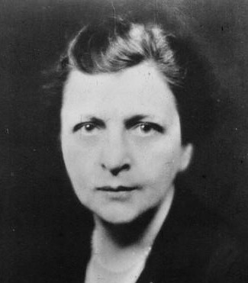

Frances Perkins
Frances Perkins was the secretary of labor during the Franklin Delano Roosevelt administration. Perkins, who had studied economics and sociology at the University of Pennsylvania’s Wharton School, championed both labor and workplace safety. As a cabinet member, she helped develop and implement key pieces of the New Deal, including enacting minimum wage laws. She oversaw key pieces of the National Industrial Recovery Act, the Public Works Administration and the Civilian Conservation Corps. While chairing the President’s Committee on Economic Security, she pushed through the Social Security Act of 1935. In 1980, the headquarters of the U.S. Department of Labor was named in her honor.
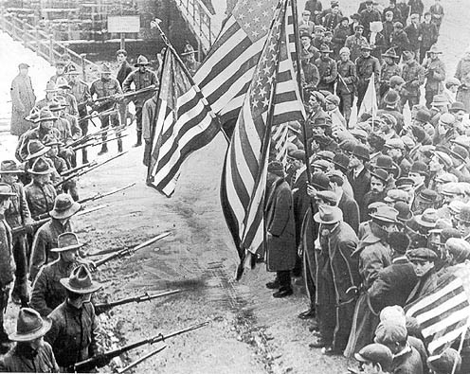

Bread and Roses Strike
The Lawrence textile strike, commonly referred to as the “Bread and Roses” strike, took place in Lawrence, Mass., from January to March 1912. The strike defied expectations, uniting workers (who were mostly immigrant women) from 51 different nationalities. The workers lived in terrible conditions, with high mortality rates for the children who worked in the factories. The phrase “bread and roses” came from a line in a speech by organizer Rose Schneiderman: “The worker must have bread, but she must have roses, too.” It became a cry not just for fair wages, but also for decent working and living conditions. The strike inspired the famous song “Bread and Roses.”
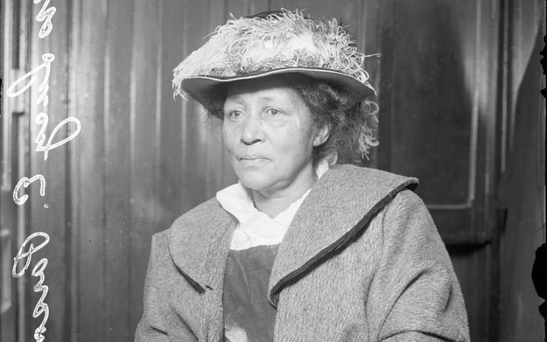

Lucy Parsons
Lucy Parsons was a radical labor organizer. In the early 1870s, she and her husband had to flee Texas, where she was from, because of intolerant reactions to their interracial marriage. Throughout her subsequent career in Chicago, she wrote for various leftist and labor publications, and in 1905, she participated in the founding of the Industrial Workers of the World. In 2004, the city of Chicago named a park after her.

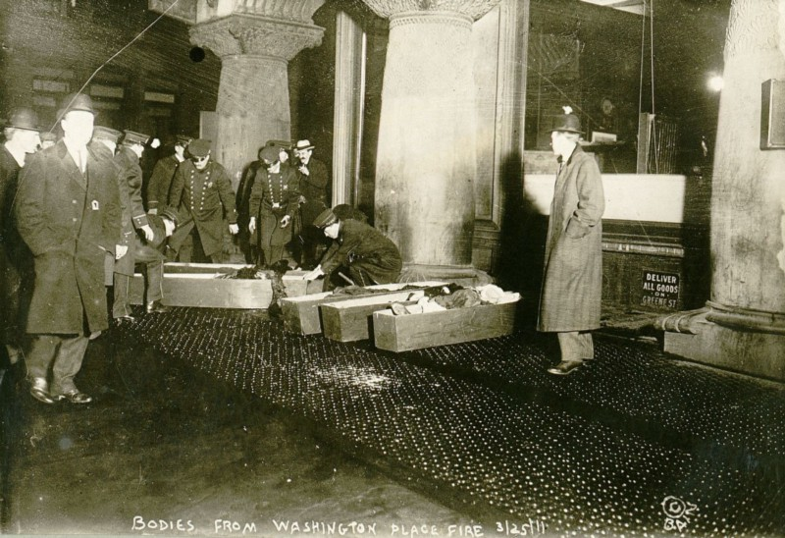

Triangle Shirtwaist Factory Fire
The 1911 Triangle shirtwaist factory fire was one of the deadliest industrial disasters in U.S. history, killing 146 garment workers who couldn’t escape the burning building because the owners of the factory had locked the doors to the stairs and exits, a common practice to prevent workers from taking unauthorized breaks. In the aftermath of the fire, the New York State Legislature created a commission to investigate working conditions in factories and passed new laws protecting workers’ safety.

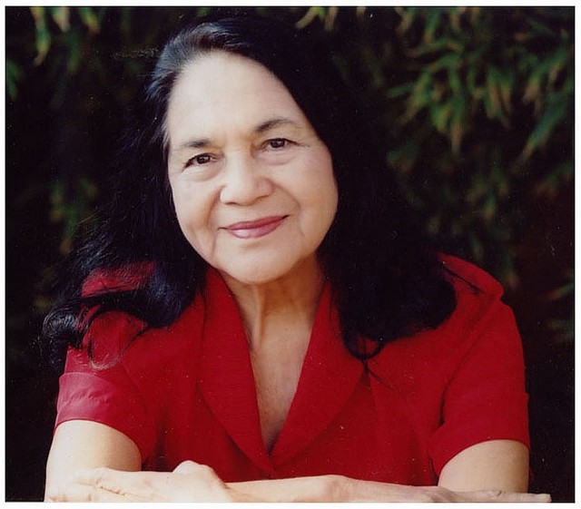

Dolores Huerta
Dolores Huerta is a labor leaderand civil rights activist who has received numerous awards, including the Presidential Medal of Freedom. In 1962, she co-founded the National Farm Workers Association with Cesar Chavez, and in 1965, she directed its national boycott during the Delano grape strike.
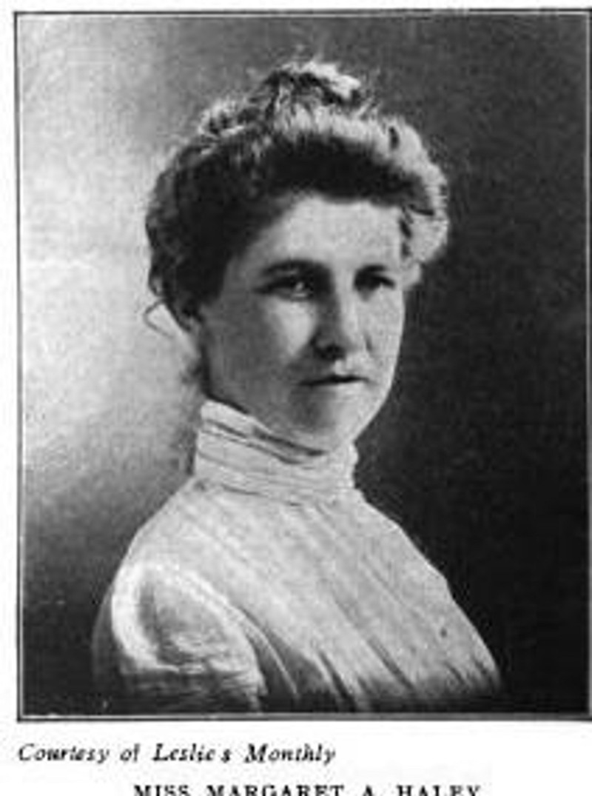

Margaret Haley
Margaret Haley was a teacher and labor leader in the late 1800s and early 1900s. She was an early member of the Chicago Teachers Federation and became its first district vice president in 1898. In 1916, Haley helped found the American Federation of Teachers, of which the current-day Chicago Teachers Union is Local 1.
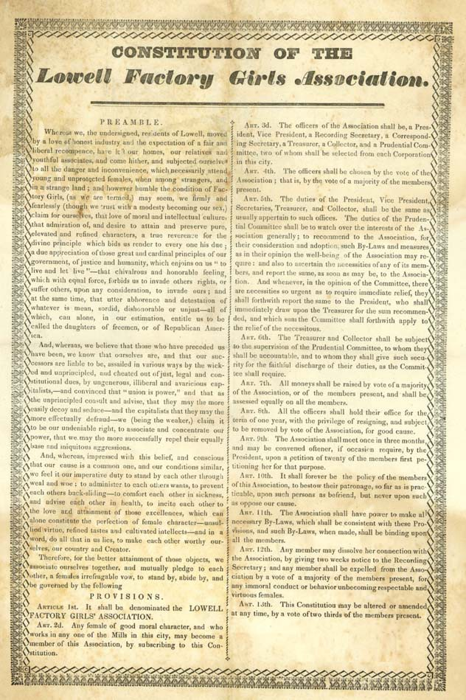

Lowell Female Labor Reform Association
The Lowell Female Labor Reform Association, founded in 1845, was one of the first American labor organizations organized by and for women. The union petitioned for a 10-hour workday, which prompted the state of Massachusetts to investigate working conditions in Lowell factories — the first investigations into working conditions by a governmental body in the United States.


Ai-Jen Poo
Ai-Jen Poo is the director of the National Domestic Workers Alliance. She has organized domestic workers for nearly 20 years and was instrumental in the 2010 passage of New York’s Domestic Workers Bill of Rights.
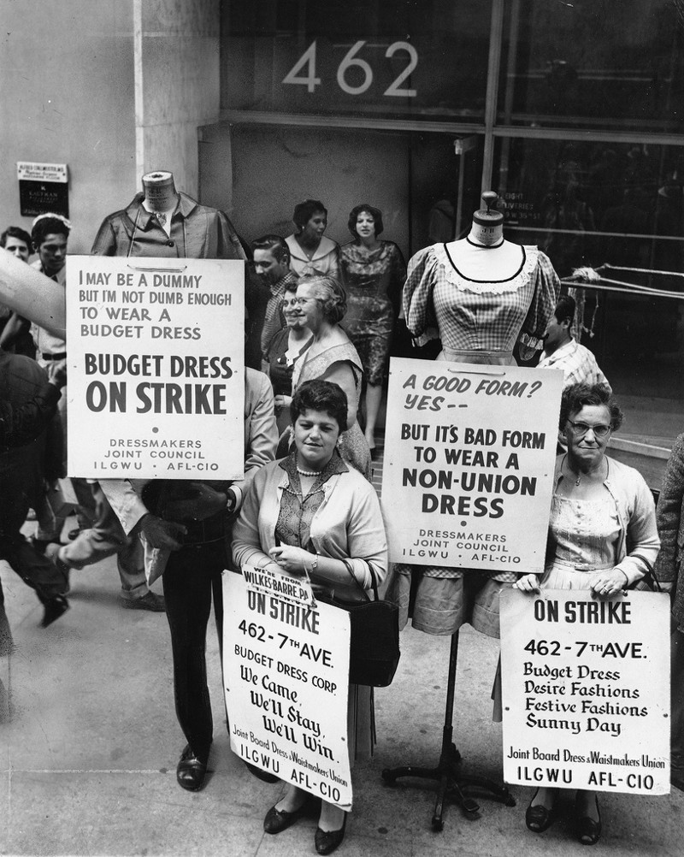

International Ladies’ Garment Workers’ Union
The International Ladies’ Garment Workers’ Union was one of the largest labor unions in the United States. The union was founded in 1900 in New York City and grew to 450,000 members by the late 1960s. Its first strike, in 1909, was known as the “Uprising of 20,000.”In 1910, ILGWU led an even larger strike of 60,000 cloakmakers, commonly called “The Great Revolt.” In the 1970s, the union was responsible for the popular song “Look for the Union Label.” In 1995, the union merged with the Amalgamated Clothing and Textile Workers Union to form UNITE, and in 2004, UNITE merged with the Hotel Employees and Restaurant Employees Union to form UNITE HERE.
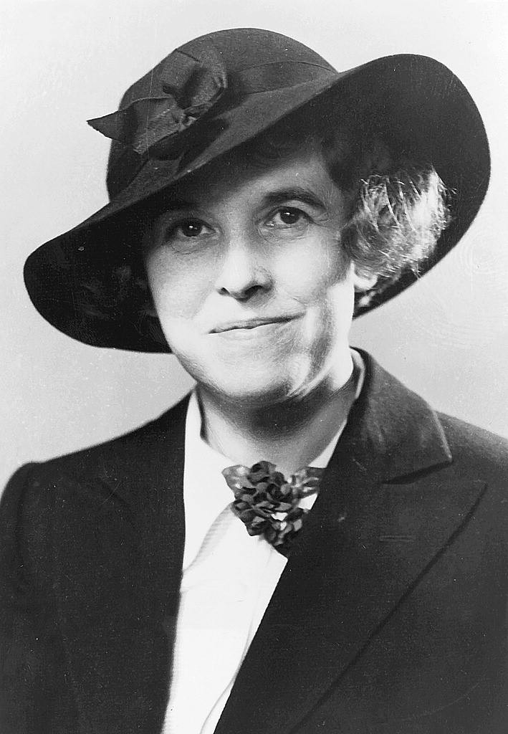

Hallie Flanagan
Hallie Flanagan was a writer and theatrical director and producer. She spent much of her early career studying theater at Grinnell College, Harvard University and Vassar College. As part of the Works Progress Administration, Flanagan led the Federal Theatre Project, which funded and produced live theater across the United States during the Great Depression. By producing theater, the Federal Theatre Project created jobs across the country for actors, dancers, writers, directors, stage crew and set construction workers. Under Flanagan’s leadership, the program employed tens of thousands of workers, including 15,000 in the first year alone. During the four years of the program, the project produced around 1,200 shows to more than 30 million people.
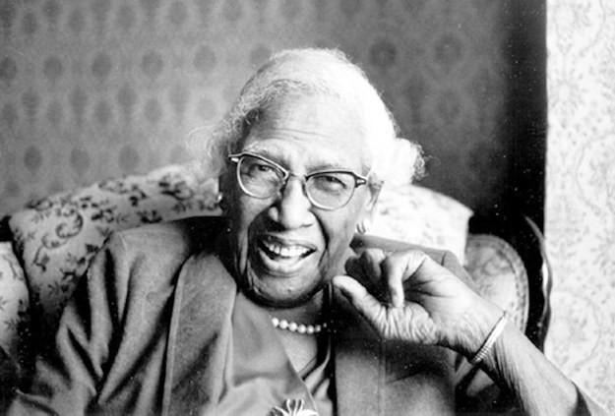

Rosina Tucker
Rosina Tucker was an important figure in the foundation of the Brotherhood of Sleeping Car Porters. Tucker was married to a railroad porter and became involved in the union. She visited the homes of more than 300 workers to secretly collect their union dues, and in 1938, she was elected secretary-treasurer of the union’s auxiliary. She continued her union involvement, helping organize teachers, laundry workers and railway clerks in Washington, D.C.
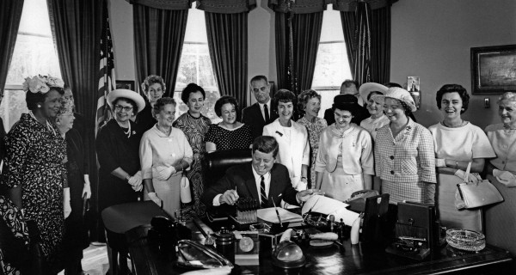

The Equal Pay Act of 1963

The Equal Pay Act of 1963, which was signed into law by President John F. Kennedy, was aimed at eliminating wage disparities between men and women. According to the U.S. Equal Employment Opportunity Commission, “The EPA provides that employers may not pay unequal wages to men and women who perform jobs that require substantially equal skill, effort and responsibility, and that are performed under similar working conditions within the same establishment.”
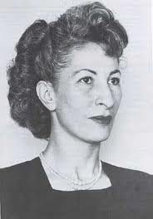

Luisa Moreno
Luisa Moreno was a Guatemalan-born American labor organizer. She started organizing while working in a cafeteria in New York in the 1930s, protesting against long hours and consistent sexual harassment. She later organized African-American and Latina cigar makers in Florida. She became a representative of the United Cannery, Agricultural, Packing, and Allied Workers of America, where she organized workers in Texas and California during the 1930s. Moreno was a staunch advocate for the rights of immigrants, especially from Latin American countries. She organized the Sleepy Lagoon Defense Committee to help clear those indicted in what the media dubbed the “Sleepy Lagoon murder.” In the 1950s, she was targeted by immigration officials because of her activism. She was offered citizenship in exchange for testifying against a labor leader, but she refused, stating that she would not be “a free woman with a mortgaged soul.”
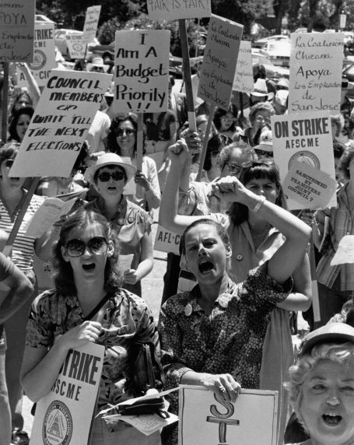

1981 San Jose Strike
In 1981, AFSCME Local 101 members in San Jose went on strike for equal pay. This was the first strike for equal pay in the United States. AFSCME had pressured the city government on pay equity, and the strike was successful in getting the government to agree to close the pay gap.
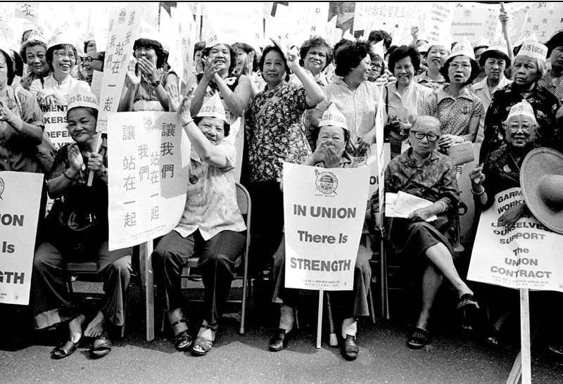

May Chen
May Chen was working with the International Ladies’ Garment Workers’ Union in 1982 when she led the New York Chinatown workers strike. The strike was one of the largest Asian-American strikes in history, with around 20,000 workers walking out and marching through New York City. Chen was a founding member of the AFL-CIO’s Asian Pacific American Labor Alliance and, until her retirement in 2009, was an international vice president of UNITE HERE.
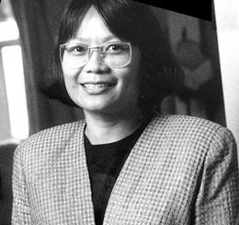

Velma Veloria
Velma Veloria immigrated to the United States from the Philippines in the 1950s and became a labor activist. She was an organizer for the Office and Professional Employees International Union, ILWU Local 37 and the Service Employees International Union. In 1992, she became the first Asian-American woman elected to the Washington State Legislature, serving until 2004.


Christa McAuliffe
Christa McAuliffe was a high school social studies teacher in Concord, N.H., when she was selected to be the first civilian and educator to fly into space. Before her flight on the ill-fated space shuttle Challenger,McAuliffe was a member of the National Education Association and an official in her local union. She had also been a member of the American Federation of Teachers while teaching in Maryland.
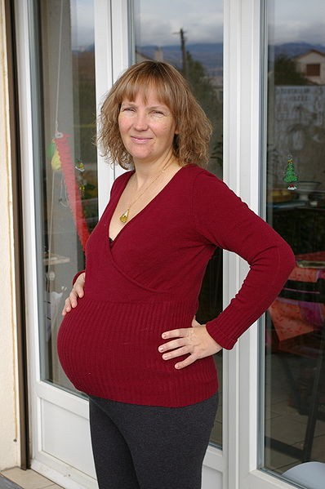

Pregnancy Discrimination Act
In 1978, Congress amended the Civil Rights Act of 1964 to prohibit discrimination on the basis of pregnancy. Prior to the passage of the act, there was no federal law protecting women from workplace discrimination while pregnant.
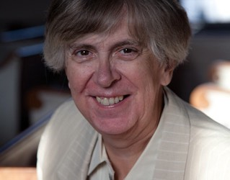

Donna Cartwright
Donna Cartwright is a LGBT and labor activist. She was a co-president of Pride at Work, worked for 30 years as a New York Timescopy editor and was an active member of the Newspaper Guild before retiring in 2006. She also was an executive board member of the Maryland State and District of Columbia AFL-CIO and the National Center for Transgender Equality.
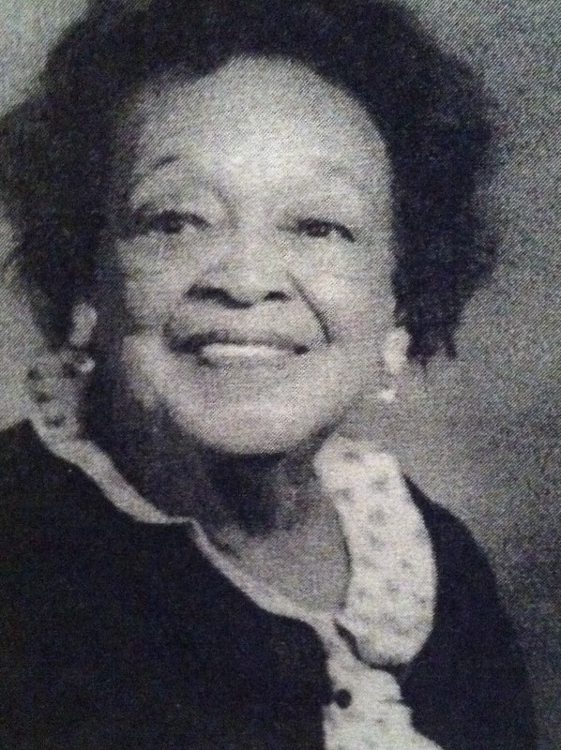

Sue Cowan Williams
Sue Cowan Williams, a former high school teacher, represented African-American educators in the Little Rock School District in Arkansas as the plaintiff in the case Morris v. Williams, which challenged salary discrepancies based on race. She lost the case in 1942 but won on appeal in 1943.
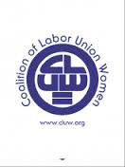

Coalition of Labor Union Women
The Coalition of Labor Union Women was founded in 1974 to build a bridge between the feminist movement and the labor movement. Since its founding, it has held conferences on pay equity, pushed for equality and supported organizing projects around the country.
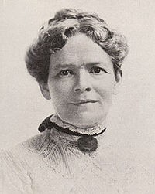

Ella Reeve “Mother” Bloor
Mother Bloor was an active socialist and labor organizer at the turn of the 20th century. She worked with Upton Sinclair on his best-selling book The Jungle, documenting the poor working conditions in Chicago stockyards. She took jobs in Chicago factories under an assumed name to help gather firsthand information, and she worked with miners in Calumet, Mich., and Ludlow, Colo. She unsuccessfully ran for office several times in the early 1900s, and her autobiography, We Are Many, was published in 1940.
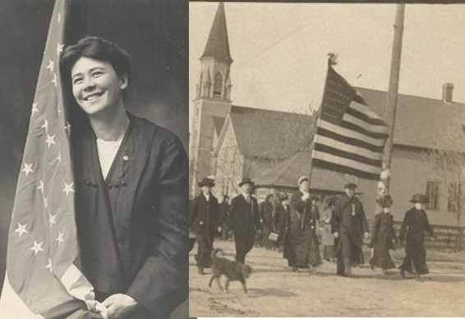

Anna “Big Annie” Klobuchar Clemenc
Big Annie was the president of the Women’s Auxiliary No. 15 of the Western Federation of Miners. She was known for leading marches in support of striking miners while wearing a plain gingham dress and carrying a 10-foot flagpole with a large American flag waiving. She was one of the organizers of the Christmas party for striking miners and their families at the Italian Hall in Calumet, Mich., in 1913, where more than 70 people were killed in a stampede caused by anti-union thugs. She has been described as an “American Joan of Arc,” and her portrait hangs in the Michigan Women’s Hall of Fame.
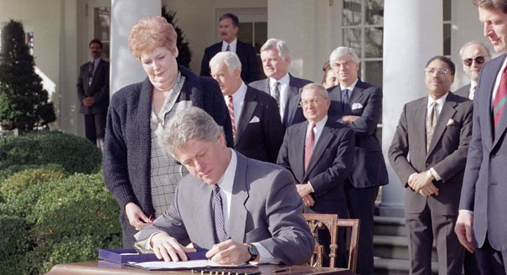

Family and Medical Leave Act
In 1993, Congress passed the Family and Medical Leave Act, requiring employers to provide job-protected leave for medical and family reasons.

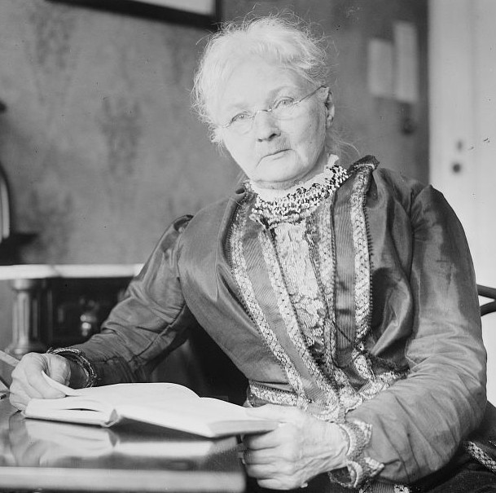

Mary Harris “Mother” Jones
Mother Jones was an Irish-American schoolteacher and labor organizer. She organized and supported mining country strikes in the eastern United States. In 1903, she organized the Children’s Crusade, in which children who worked in mines and factories marched from Philadelphia to President Theodore Roosevelt’s home in Oyster Bay, N.Y., with banners stating, “We want to go to school and not to the mines!”

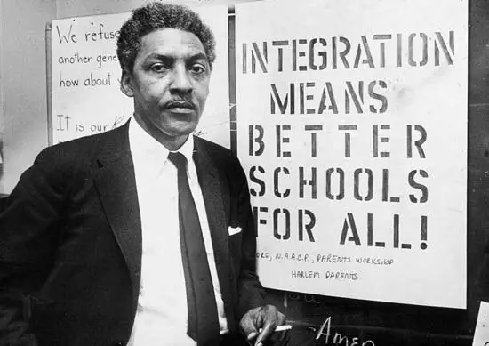

Bayard Rustin
Bayard Rustin has been described as the man homophobia almost erased from history. Rustin was an active member of the civil rights and labor movements and the primary organizer of the 1963 March on Washington for Jobs and Freedom. Rustin believed that economic justice and workers’ rights were a key part of the fight for civil rights for black Americans. Rustin became the first executive director of the AFL-CIO’s A. Philip Randolph Institute.

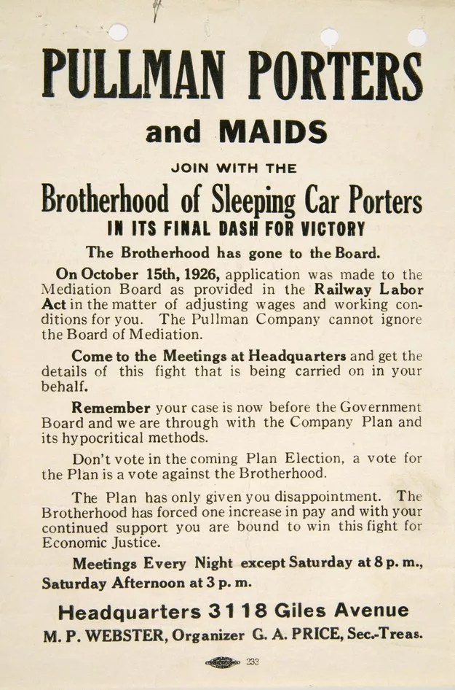

Pullman Porters
In the late 1860s, George Pullman hired former slaves to work on his railroad sleeping cars. He exploited their labor, with each porter making the equivalent of about $22,000 a year (in today’s dollars) while working under unfair conditions, including 100-hour workweeks. These workers formed a union, the Brotherhood of Sleeping Car Porters; in 1925, it became the first African-American labor union to receive a charter in the American Federation of Labor.

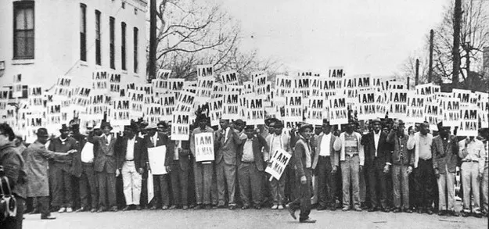

Memphis Sanitation Workers Strike
In 1968, sanitation workers in Memphis, Tenn., members of AFSCME Local 1733, went on strike after years of discrimination and dangerous working conditions. The union strikers carried the now famous “I Am a Man” signs. The Rev. Martin Luther King Jr. visited the striking workers in April 1968, and delivered his “I’ve Been to the Mountain Top” speech the day before he was assassinated at a motel in Memphis.

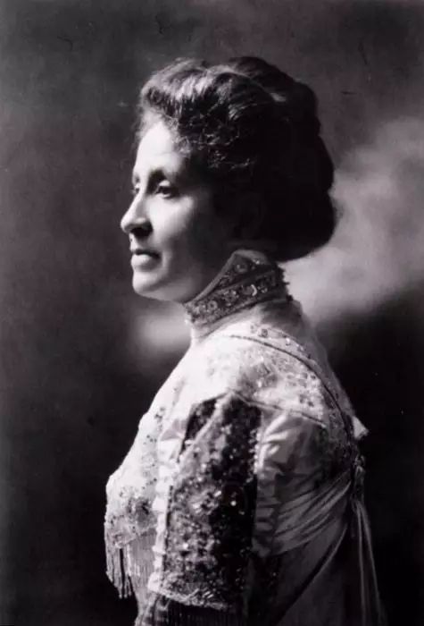

Mary Church Terrell
Mary Church Terrell was one of the first African-American women to earn a college degree. She worked for suffrage and civil rights, helping found the National Association of Colored Women in 1896. She was also a charter member of AFT’s first higher education local at Howard University.

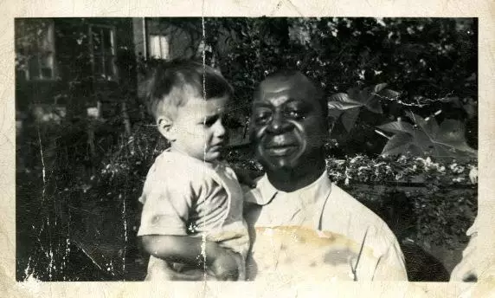

Ben Fletcher
Ben Fletcher was an African-American labor activist in the early 20th century. He was a leader in IWW Local 8, a radical union of longshoremen in Philadelphia. Companies would often try to divide workers based on race, but Local 8 and Fletcher’s leadership showed that when workers rejected racism and stuck together, they would lift each other up.

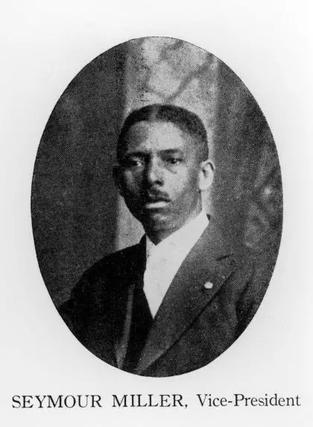

Chicago Flat Janitors
In the 1920s, the Chicago Flat Janitors were an integrated local union, which was considered radical at the time. The union worked to include black members in leadership roles, including its vice president, Seymour Miller. The union eventually grew and today is known as the Service Employees International Union, or SEIU.

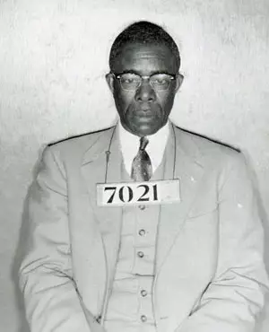

Edgar Nixon
Edgar Nixon was a civil rights leader and union organizer in Alabama. He played a key role in the Montgomery Bus Boycott, even bailing Rosa Parks out of jail after her arrest in December 1955 for refusing to give up her seat on a bus to a white man, just a few days before the boycott began. Prior to organizing the bus boycott, Nixon organized and led the Montgomery branch of the Brotherhood of Sleeping Car Porters. The Rev. Martin Luther King Jr. called him "one of the chief voices of the Negro community in the area of civil rights.” Nixon continued to support civil rights causes until his death in 1987.

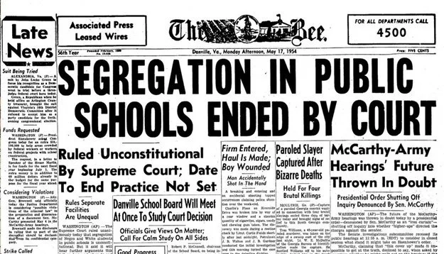

Brown v. Board of Education
The Supreme Court’s landmark 1954 ruling in Brown v. Board of Education, requiring school desegregation, had the support of unionized teachers. In fact an AFT local, the Teachers Guild —a precursor of New York City’s United Federation of Teachers—filed an amicus brief on behalf of the plaintiffs.
Here are free classroom resources on Brown v. Board of Education.

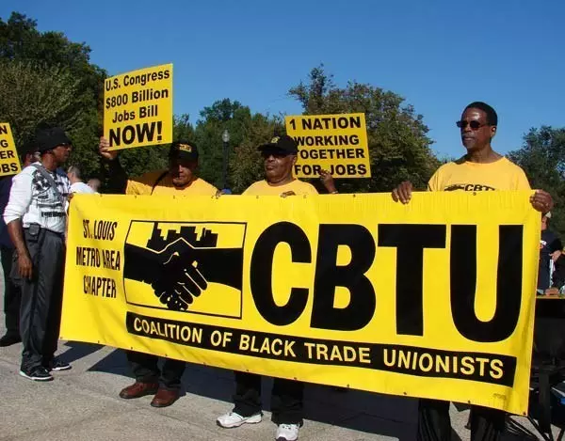

Coalition of Black Trade Unionists
In 1972, more than 1,200 black union leaders and members met in Chicago and founded the Coalition of Black Trade Unionists. Since its formation, the organization has worked to raise black voices in the labor movement.

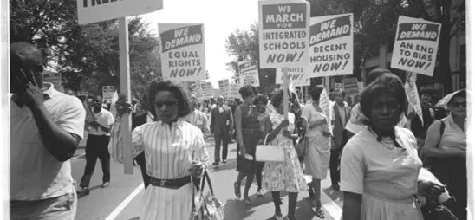

The 1963 March on Washington for Jobs and Freedom
The 1963 March on Washington for Jobs and Freedom was organized by Bayard Rustin and A. Philip Randolph and had support from other labor unions and labor activists, including the United Auto Workers and the Amalgamated Clothing Workers. Two of the official speakers at the event were labor leaders; Randolph and UAW President Walter Reuther. Union members from around the country, including busloads of teachers from New York, came to the event. After the march, the Rev. Martin Luther King Jr. sent a letter, which included a handwritten note, to then-United Federation of Teachers President Albert Shanker thanking him for his help.

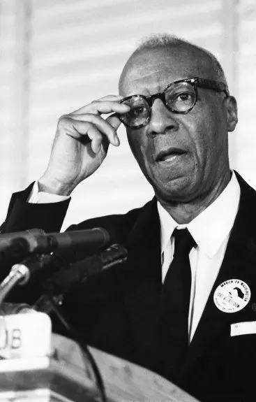

A. Philip Randolph
Randolph is one of the most important figures in both black history and labor history. In addition to his work with the Pullman porters (see No. 2, above) and the 1963 March on Washington for Jobs and Freedom, he prominently pushed for civil rights during World War II. He planned a 100,000 person march on Washington during the war, which led President Franklin D. Roosevelt to sign an executive order ending discrimination in defense industries. After the order was signed, the march was canceled.

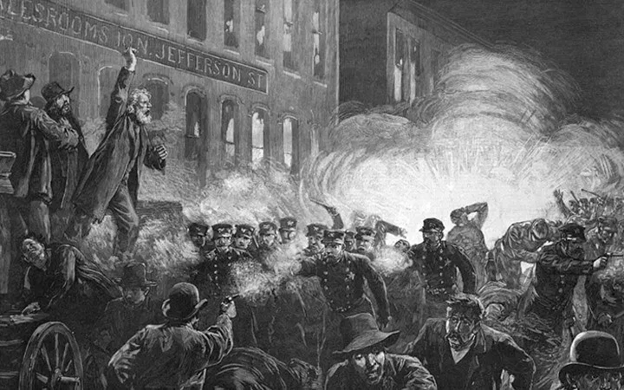

The Haymarket Martyrs, eight Chicago anarchists, May 4, 1886
What began as a rally for workers who went on strike for the 8-hour workday ended when someone threw a bomb, triggering open gunfire between the police and civilians. Seven people died and many more were injured.
Eight Anarchists were convicted of conspiracy. Some were later freed amid questions about the lack of physical evidence, while others lived out their days in prison. At the time numerous rank-and-file workers believed that the Pinkertons — a notorious anti-union security agency who were used by factory owners to break labor unions by bringing in scabs, spying on organizers, and utilizing violence — were to blame for the bomb-throwing incident.
The aftermath of the Haymarket incident would be the first red-scare in U.S. history, with the government clamping down on organized labor.

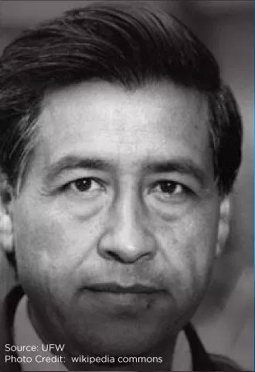

Cesar Chavez, Farm Workers of America
Cesar Chavez helped build a campaign that won better working conditions for Californian grape pickers by leading an international boycott of grapes that were picked in some of the harshest conditions in the U.S. The California grape pickers’ strike led to a successful campaign to win recognition by the two largest growers of grapes in the Delano Area.
Chavez founded the National Farm Workers Association and built solidarity that prevented grapes from being shipped to Europe, and ultimately showed the power of organized labor for even the most vulnerable people in the United States.
Chavez helped popularize Dolores Huerta’s slogan, “Sí, se puede,” which translates to “Yes, we can.”

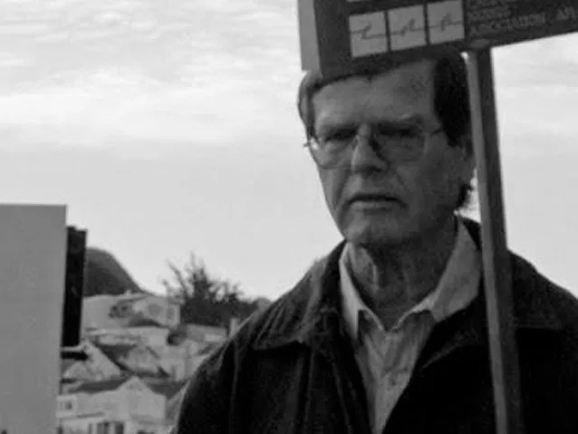

Howard Wallace, LGBTQIA and union activist
According to the San Francisco Bay Guardian, “[Howard Wallace] was forced to drop out of college when his father saw some United World Federalist literature he’d brought home and told him to drop out of ‘commie’ politics.” “He put a couple of checks on the dining-room table — the checks for next year’s tuition — and said, ‘Get out [of activism] and you can have those checks.’ I tore them up in his face, and that was the end of my college education,” the article noted.
A few blue collar jobs later, Wallace came to organized labor.Coors in the 1960s notoriously refused to hire black, Latino, LGBT people, and women workers; after breaking up their unionized staff. At that time, inspired by the success of the international boycott lead by the Farm Workers of America, Wallace labor unions and the LGBT community to boycott the beer. Howard Wallace, along with LGBT activist and San Francisco Supervisor Harvey Milk, enlisted the Teamsters to promote hiring openly gay truck drivers, allowing the boycott of Coors to go national.
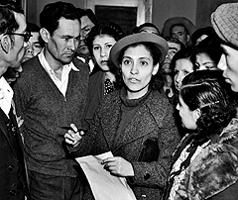

Emma B. Tenayuca
In Depression-era south Texas, a young Mexican-American woman broke tradition when she stood up for oppressed workers in her community and made an important contribution to the fight for social justice.Vilified by the conservative establishment that controlled San Antonio, she became a beloved leader to oppressed workers in the Mexican-American community. They called her “La Pasionaria.”
Tenayuca was born in 1916 to a large family in San Antonio. Her grandfather, Francisco Zepeda, helped her read newspapers as a young girl and often took her to San Antonio’s Plaza del Zacate, a gathering spot where community leaders shared news and talked about politics. The discussions instilled in her a lifelong passion for learning and social justice. By 15, she was a gifted, well-read high school student, who could debate the issues of day in English and Spanish.
Most families in her community struggled to survive on low-wage jobs, and they faced racial and gender discrimination. Many were farm workers who were exempt from coverage by the National Labor Relations Act of 1935, which granted union organizing rights to industrial workers. Those who chose to stand up for better wages faced unjust firings, jail, or the threat of having loved ones deported.

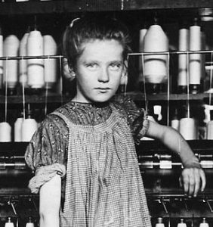

THE DOVER MILL GIRL STRIKE
In 1822, the textile mill ran a Help Wanted ad for smart, capable girls ‘between 12 and 25 years old,’ promising ‘constant employment and good encouragement.’The Dover mill girls, mostly from farms in New Hampshire and southern Maine, were paid 47 cents a day plus room and board. Two cents were taken from their paychecks for medical insurance. They needed it. The girls worked with only one break from 6:30 a.m. to 6:30 p.m. They breathed noxious fumes and worked with noisy, dangerous machinery that mangled fingers and limbs.
Managers forbade the girls from talking to each other during the 11-hour day. They were paid in scrip and required to shop in the company store, which raised prices higher than other shops. Most lived in boardinghouses supervised by a widow, who enforced strict rules of behavior. On the day after Christmas in 1828, about 600 of the Dover mill girls marched out of the factory yard, declaring war on the mill owners. They formed a half-mile procession and marched around the mill waving signs and banners, playing martial music and setting off artillery. They then marched through town.The Dover mill girls underestimated management. The next day, the company ran a Help Wanted ad for several hundred scabs to break the strike. By Tuesday, most of the Dover mill girls were back at work, except for the strike leaders who were blacklisted by the company.
Though the strike failed, women like Harriet Hanson Robinsonand Elizabeth Gurley Flynn would lead many more: in Lowelland Lawrence, in Bridgeport, New Haven and throughout New England.

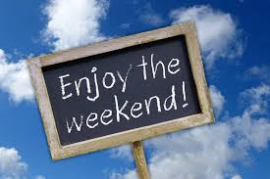

The Weekend

In 1908 a textile mill in New England set a precedent in the United States by giving all employees a five-day week. This was done to settle issues resulting from Jewish workers not being available on the Sabbath and the Christian staff demanding the same treatment. Other factories slowly began to move towards the model as the labor movement rallied behind the idea.
In 1938, the Fair Labor Standards Act gave Americans the modern 40-hour five-day work week as a response to both increasing labor power and stubbornly high unemployment rates. Americans have not seen their hours decrease since then, despite predictions they would from Congress. The five-day week was adapted across Europe by the 1970s.



Family Medical Leave Act:

Unions Spearheaded The Fight For The Family And Medical Leave Act: Labor unions like the AFL-CIO federation led the fight for this 1993 law, which “requires state agencies and private employers with more than 50 employees to provide up to 12 weeks of job-protected unpaid leave annually for workers to care for a newborn, newly adopted child, seriously ill family member or for the worker’s own illness.”

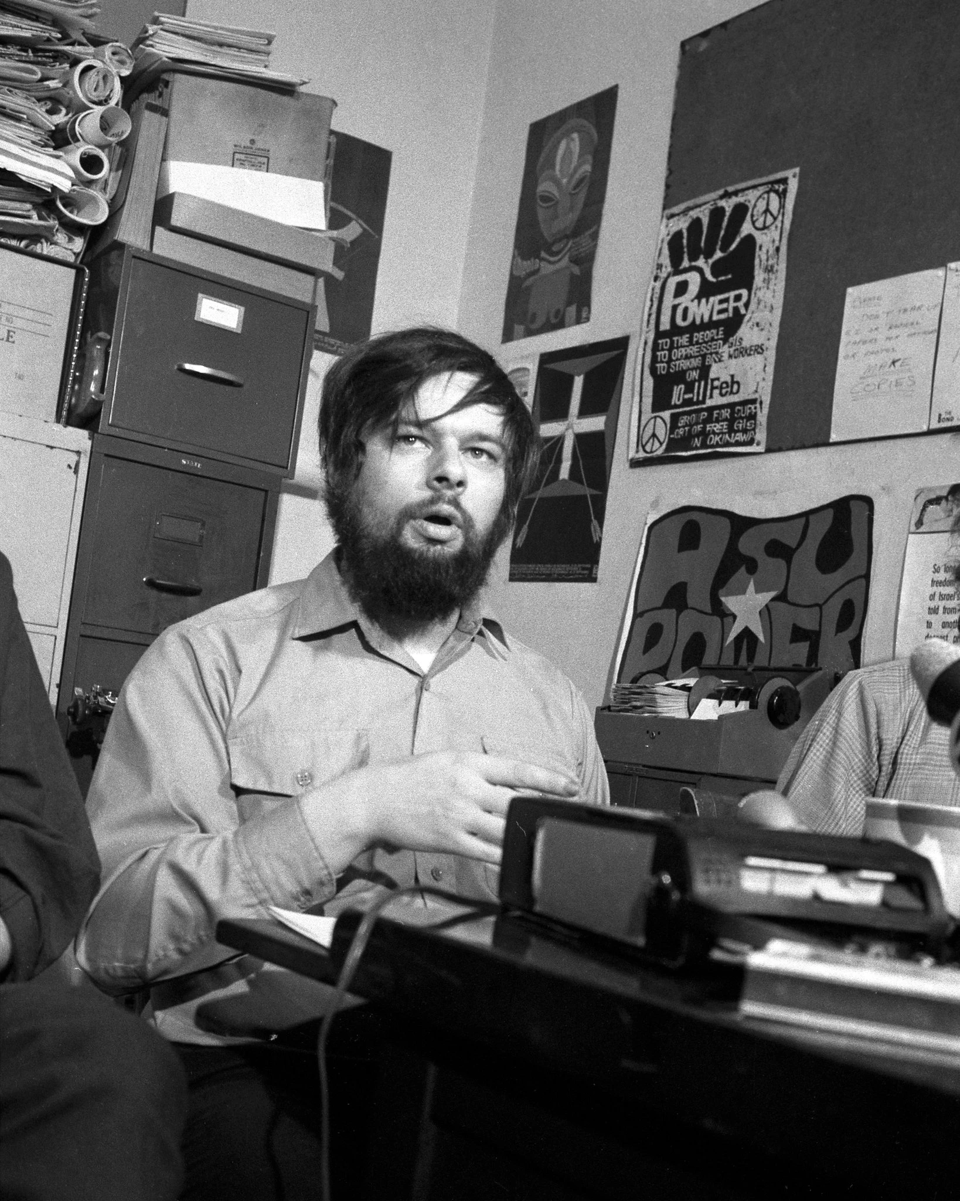

Andy Stapp

Andy Stapp expressed his opposition to the Vietnam War by joining the Army and proceeding to do a very unmilitary thing — form a union among soldiers that demanded, among other things, the right to elect officers and reject what they viewed as illegal orders. At its peak in the early 1970s, the union that Mr. Stapp formed, the American Servicemen’s Union, claimed to have tens of thousands of members. It issued membership cards, published a newspaper and helped form chapters at military bases, on ships and in Vietnam. Although the Army never came close to recognizing the union formally, it certainly recognized it as a problem. Mr. Stapp brought colorful idealism to his counterintuitive cause, and the Army did what it could to silence him. In 1967, while stationed at Fort Sill in Lawton, Okla., Mr. Stapp twice faced court-martial. The first time was for refusing an order to open his footlocker, which served as his unit’s library of leftist literature. (Officers broke it open with an ax.) He was convicted and served 45 days of hard labor. The second was based on charges that he had left his barracks when he was forbidden to do so. He was acquitted in late 1967.
36 Reasons Why You Should Thank a Union
Weekends
All Breaks at Work, including your Lunch Breaks
Paid Vacation
FMLA
Sick Leave
Social Security
Minimum Wage
Civil Rights Act/Title VII (Prohibits Employer Discrimination)
8-Hour Work Day
Overtime Pay
Child Labor Laws
Occupational Safety & Health Act (OSHA)
40 Hour Work Week
Worker's Compensation (Worker's Comp)
Unemployment Insurance
Pensions
Workplace Safety Standards and Regulations
Employer Health Care Insurance
Collective Bargaining Rights for Employees
Wrongful Termination Laws
Age Discrimination in Employment Act of 1967
Whistleblower Protection Laws
Employee Polygraph Protect Act (Prohibits Employer from using a lie detector test on an employee)
Veteran's Employment and Training Services (VETS)
Compensation increases and Evaluations (Raises)
Sexual Harassment Laws
Americans With Disabilities Act (ADA)
Holiday Pay
Employer Dental, Life, and Vision Insurance
Privacy Rights
Pregnancy and Parental Leave
Military Leave
The Right to Strike
Public Education for Children
Equal Pay Acts of 1963 & 2011 (Requires employers pay men and women equally for the same amount of work)
Laws Ending Sweatshops in the United States

