ONLINE Facilitator Agenda- Advancing LGBTQ+ Justice
General Materials Needed: |  |  |  |  |  | Room Set-up:
1 Set of Handouts per Person  Chart Markers – non-permanent |  |  | Chart Paper  Post its |  |  | Round Tables  Projector, Screen and Speakers  Carousel stations and reporting stations around the perimeter  50 people

Key Outcomes for the Day
  - Starting the conversation outside the umbrella
  - Issues
  - Framework for Determining Actions
  - A Little Law Talk
  - Lessons Learned and Actions to Apply
Time |  | Essential Questions |  | Resources | Instructions, Activity and Debrief (Facilitators) |  | Outcomes
90- Minutes Total | What question(s) should this learning section answer? |  |  | Charts, handouts, articles, materials, slide | What are you saying, what are they doing, what questions will you use to guide learning and make clear the important points  Include an estimate for how long each section of the learning will take |  | As a result of this section of learning, what will participants know or be able to do?
10 Mins. Michelle  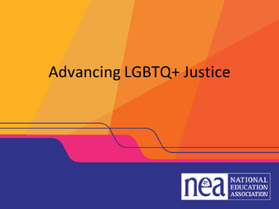  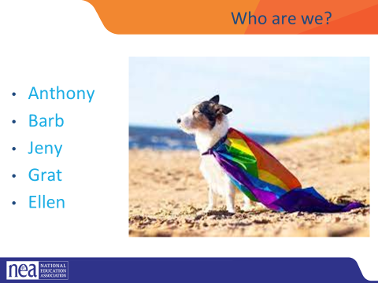  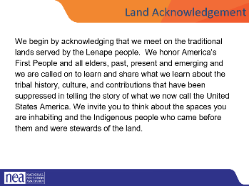  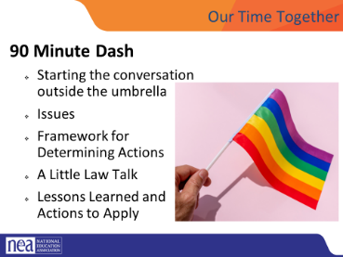  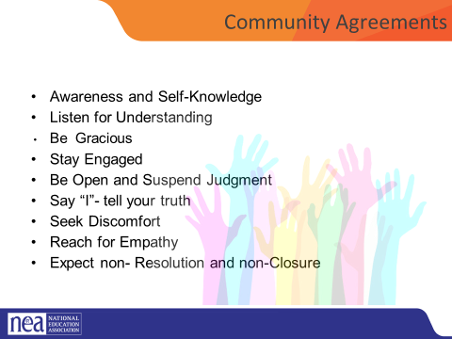  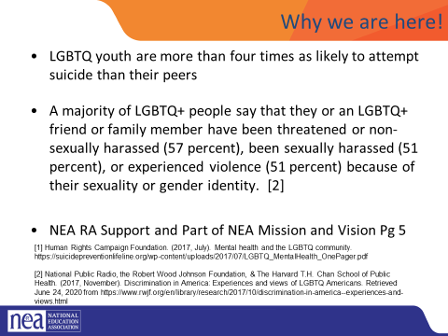  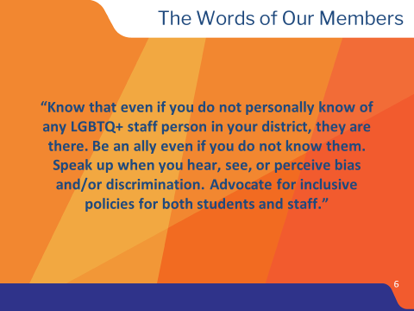 | Who am I? Who are we together? |  |  | Community Agreements | 10 Minutes: Getting Started  General Welcome  Intro of Facilitators  Quick Intro – 15 Seconds Each  Name, Pronouns, Title  Land Acknowledgment -  NEW:  Every community owes its existence and vitality to generations from around the world who contributed their hopes, dreams, and energy to making the history that led to this moment. Some were brought here against their will, some were drawn to leave their distant homes in hope of a better life, and some have lived on this land for more generations than can be counted. Truth and acknowledgment are critical to building mutual respect and connection across all barriers of heritage and difference. We begin this effort to acknowledge what has been buried by honoring the truth. We are standing on the ancestral lands of Indigenous People. We pay respects to their elders past and present. Please take a moment to consider the many legacies of violence, displacement, migration, and settlement that bring us together here today.  OLDER VERSION (to revert, if needed)  We begin by acknowledging that we meet on the traditional lands served by the XXXXXXX people. We honor these People, all elders, past, present and emerging and we are called on to learn and share what we learn about the tribal history, culture, and contributions that have been suppressed in telling the story of what we now call the United States America. We invite you to think about the spaces you are inhabiting and the Indigenous people who came before them and were stewards of the land.  Overview of Agenda – 90 Minute Dash  - Starting the conversation outside the umbrella  - Issues  - Framework for Determining Actions  - A Little Law Talk  - Lessons Learned and Actions to Apply  Community Agreement Review  - Using Self-Awareness and Self-Knowledge  - Listening for Understanding  - Being Gracious  - Staying Engaged  - Being Open and Suspend Judgment  - Saying “I”- tell your truth  - Seeking Discomfort  - Reaching Empathy  - Expecting Non-Resolution and Non-Closure  Why We are Here  Why are we here – the system of oppression’s outcomes on the the LGBTQ+ community are something that justice seeking people can not tolerate.  LGBTQ+ youth are more than four times as likely to attempt suicide than their peers  A majority of LGBTQ+ people say that they or an LGBTQ+ friend or family member have been threatened or non-sexually harassed (57 percent), been sexually harassed (51 percent), or experienced violence (51 percent) because of their sexuality or gender identity. [2]  NEA RA Support and Part of NEA Mission and Vision Pg 5  [1] Human Rights Campaign Foundation. (2017, July). Mental health and the LGBTQ community. https://suicidepreventionlifeline.org/wp-content/uploads/2017/07/LGBTQ_MentalHealth_OnePager.pdf  [2] National Public Radio, the Robert Wood Johnson Foundation, & The Harvard T.H. Chan School of Public Health. (2017, November). Discrimination in America: Experiences and views of LGBTQ Americans. Retrieved June 24, 2020 from https://www.rwjf.org/en/library/research/2017/10/discrimination-in-america--experiences-and-views.html  In the words of our members – show slide  “Know that even if you do not personally know of any LGBTQ+ staff person in your district, they are there. Be an ally even if you do not know them. Speak up when you hear, see, or perceive bias and/or discrimination. Advocate for inclusive policies for both students and staff.” |  | Participants will understand how the entire program flows.
5 Mins. Beth  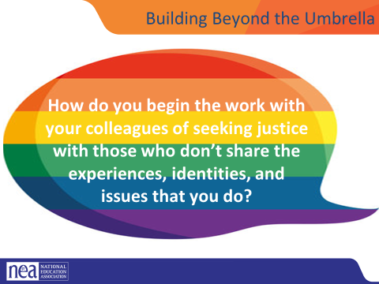  20 Mins. Bekah and Anthony  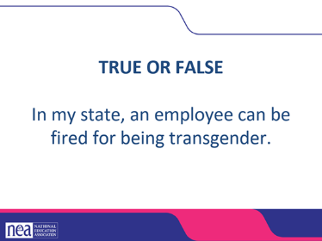  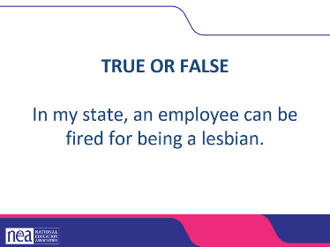  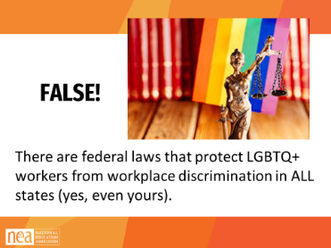  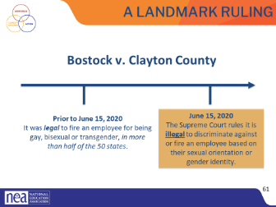  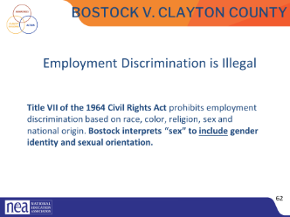  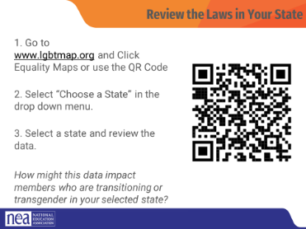  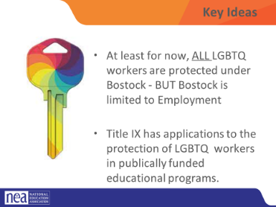 | How do I start organizing for change with someone that is not yet a supporter of my issues?  What are the protections for LGBTQ people? |  |  |  | 5 Minutes: Building Beyond the Umbrella  Show this question :  How do you begin the work with your colleagues of seeking justice with those who don’t share the experiences, identities, and issues that you do?  Union members, leaders, and staff know the word solidarity – but let’s review what it means  Unity or agreement of feeling or action especially among individuals with a common interest, mutual support; mutual support within a group.  If we are going to achieve justice for all the various constituencies within our unions, schools, and communities we have to build across these – looking for ways to empathize and understand the experiences and issues of others. Intentionally looking for issues that we have common interests in. That often begins by reaching out to those not under the LGBTQ umbrella and cultivating their support and allyship.  20 Minutes: Bostock and Title IX  The Civil Rights Act of 1964 prohibits discrimination based on race, color, religion, sex, or national origin. The courts and the federal government have long refused to recognize LGBTQ+ discrimination as a form of sex discrimination. Over the past 20 years, however, federal courts and the government have at times recognized LGBTQ+ discrimination as sex discrimination.  It was not until June 15, 2020 that the Supreme Court finally recognized that LGBTQ+ employment discrimination is prohibited sex discrimination under Title VII of the Civil Rights Act of 1964.  This ruling recognized that it is illegal to discriminate against or fire an employee based on their sexual orientation or gender identity. Now lower federal courts and the Biden Administration are applying that ruling to education, health care, housing, credit discrimination, and more.  The Bostock ruling specifically states that employment discrimination on the basis of gender identity and sexual orientation is illegal.  Title VII of the Civil Rights Act covers the full spectrum of employment decisions, including recruitment, selections, terminations, and other actions concerning terms and conditions of employment. This is significant for the LGBTQ+ community because, as we saw, in many states it was legal to be denied an interview or a promotion, and even to be fired because of one’s gender identity or sexual orientation.  On March 26, 2021, the Department of Justice concluded that, as a result of the Bostock ruling, Title IX of the Education Amendments Act of 1972 also prohibits sexual-orientation and gender-identity discrimination in educational institutions that receive federal funding. This means all public schools. This means that students cannot be discriminated against in schools based on their LGBTQ+ identity.  There have been some significant wins recently for LGBTQ+ rights in the US But while progress is being made, attacks on LGBTQ+ rights in certain states have accelerated.  Reference: Department of Justice, “Application of Bostock v. Clayton County to Title IX of the Education Amendments of 1972,” March 26, 2021, https://www.justice.gov/crt/page/file/1383026/download  While some schools and districts are implementing gender-affirming policies and practices, like recognizing proper names and pronouns for children, in the background, states are trying to license LGBTQ+ discrimination under the guise of religious freedom. The proposed legislation in these areas, if passed, would serve to limit, further marginalize, and in some cases criminalize efforts to support LGBTQ+ youth and adults.  These attacks on LGBTQ+ people, especially young people, are being challenged in court and should be struck down under the reasoning of Bostock. But those lawsuits are just getting started.  Key Notes  Bostock only applies to employers with more than 15 employees. Employers with fewer than 15 total employees are not covered by Title VII.  Bostock applies nationwide and protects employees from sexual orientation or gender identity discrimination regardless of state or local laws.  An employer covered by Title VII is not allowed to fire, refuse to hire, or take assignments away from someone (or discriminate in any other way) because customers or clients would prefer to work with people who have a different sexual orientation or gender identity. (For example, keeping LGBTQ+ employees out of public-facing positions.)  Although accidental misuse of a transgender employee’s preferred name and pronouns does not violate Title VII, intentionally and repeatedly using the wrong name and pronouns to refer to a transgender employee could contribute to an unlawful hostile work environment.  As it pertains to Trump’s Title IX: Title IX's status is currently the 2020 Trump-era regulations, which prohibit sex discrimination in education programs, following a January 2025 district court ruling that vacated the Biden administration's 2024 Title IX rule. This decision ended different enforcement regimes across the country, restoring the 2020 rules nationwide and limiting protections based on gender identity and sexual orientation. Educational institutions must now adhere to the 2020 framework regarding prohibited conduct and procedural requirements for addressing sex discrimination.  As UniServs, we need to be able to understand the fundamentals of Title VII protections and Title IX protections as two separate but valuable tools in our advocacy and service arsenal. We also need to understand our state, any lawsuits that might be pending, our contracts and school policies and how they interact. For example, if a cheerleading coach is fired because she marched in a parade wearing a shirt that said “I am a proud lesbian,” which caused parents to complain... if that extra curricular contract isn’t covered by the contract, then the Union may not have standing to fight the termination. We do, however, have the ability to organize and advocate around the issue, provide the person with outlets for resources outside of what we can provide, and make clear to the board that this type of discrimination is not something the union believes is acceptable. Etc etc. One good way to start to understand what your sate looks like is to check out your state’s equity profile (transition)  Look at Your State’s Equality Profile.  How might this impact members who are transitioning or transgender?  Instructions:  Go to www.lgbtqmap.org  Click Equality Maps  Select “Choose a State” in the drop down menu.  Select a state and review the data. How might this data impact members who are transitioning or transgender in your selected state?  Key Ideas  - At least for now, ALL LGBTQ+ workers are protected under Bostock - BUT Bostock is limited to Employment  - Title IX has applications to the protection of LGBTQ+ workers in publicly funded educational programs. |  | Participants will familiarize how to use a tool designed to open up conversations and develop understanding of intersections.
10 Mins. Taraja  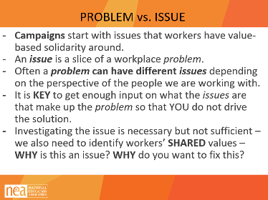  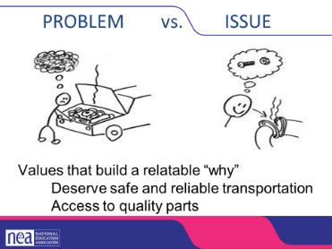  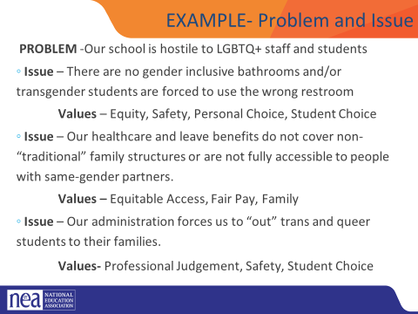  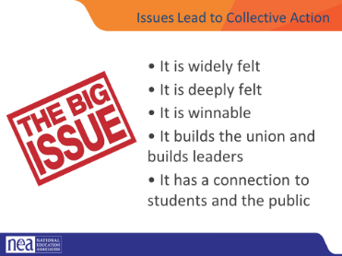  10 Mins. Beth  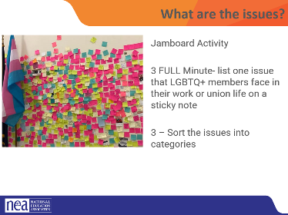  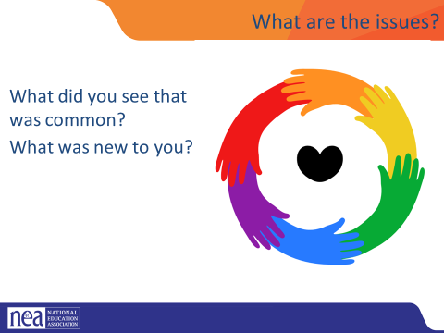  10 Mins. Michelle  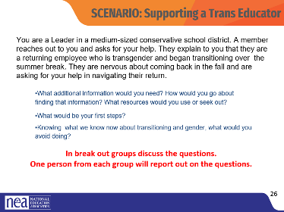  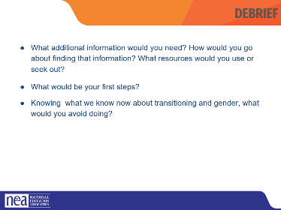  15 Mins. Bekah and Anthony | How do we begin to build a campaign to make the kind of changes that matter in the lives of LGBTQ workers? |  |  | Post It Notes | 15 Minutes What are the Issues?  PROBLEM vs. ISSUE  - Campaigns start with issues members care about.  - An issue is a slice of a workplace problem.  - Often, a problem can have different issues depending on the perspective of the people we are working with.  - It is key to get enough input on what the issues are that make up the problem so that YOU don’t drive the solution.  - A staff-driven solution may not meet the needs and commitment of the people you are working with.  Problems are debilitating and overwhelming, issues build solidarity through shared values.  Examples  How to select an issue  Since there may be many issues confronting workers on the job, we have to also think about what makes a good issue to organize around.  CRITERIA:  - It is widely felt.  - It is deeply felt.  - It is winnable.  - It builds the union and builds leaders.  - It has a connection to students and the public  NOTE HERE: Often, issues of equity are deeply felt by a marginalized few, and NOT by the privileged majority. If an issue is very deeply felt, it does not have to be widely felt.  Key Points  Problems are disabling.  Issues build solidarity.  We don’t choose the issues, the people who want the change choose the issue AND work to build a bigger base.  What are all the issues that LGBTQ people face in their work and union lives?  PADLET ACTIVITY  Go to the Padlet Link (Link needs to be put into the chat)  3 FULL Minutes, list one issue that LGBTQ members face in their work or union life. Put one issue per post. Feel free to post more than one.  5 Minutes – in breakout groups, sort the issues into categories – name the categories, and write those names in the chat (will need at least 3 break out groups here)  2 Minutes- WHAT ARE THE ISSUES:  What did you see that was common?  What was new to you?  SCENARIO:  DIRECTIONS: In break out groups discuss the questions.  One person from each group will report out on the questions.  You are a Leader in a medium-sized conservative school district. A member reaches out to you and asks for your help. They explain to you that they are a returning employee who is transgender and began transitioning over the summer break. They are nervous about coming back in the fall and are asking for your help in navigating their return.  DEBRIEF QUESTIONS:  - What additional information would you need? How would you go about finding that information? What resources would you use or seek out?  - What would be your first steps?  - Knowing what we know now about transitioning and gender, what would you avoid doing?  ACTIVITY: Turning Your Issue into Action  We are going to put you back into your breakout groups and have you pick one issue from the padlet page. Once you have decided on the issue, use the action plan from your course materials to start working through it. Think about sections 1, 2, 4, 9 and 10. How can addressing this issue help support your Association/District goals? What types of challenges might you face, and how can you engage your membership/community in it?  Paste link for Padlet back into chat so participants can access it. Break participants back up into their groups  Post questions in chat:  1. What is the issue  2. How does this support the Association/District goals?  4. What do you want to achieve?  9. Reasons that might be raised as objections to your plan  10. Reasons people will support your plan |  | Participants will understand the difference between problem identification and issue statements.
5 Mins. Michelle  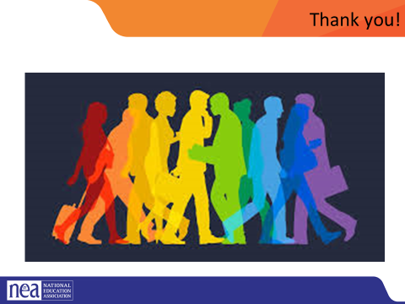 |  |  |  |  | 5 Mins Ending Right  What did you learn about today that:  - You’re going to immediately tell your union bestie?  - You’re going to use in the near future as part of your union work?  - You’re going to work to learn more about?
ADJOURN

