.
Facilitator Agenda Day 1 - Effective Worksite Leadership Systems
General Materials Needed: |  |  |  |  | Room Set-up:
1 Set of Handouts per Person  Name Tents with the Norms  Sign-in Sheet  Agendas on the table (1 per)  Room signs, sign in signs  One ream of white photocopy paper  Chart Paper (4 to 5 full w Sticky Strip) |  |  | Materials Box for each table with:  Markers (Mr. Sketch variety)  Post its – 3x3” and 4X5” sizes  Index Cards  Highlighters – 4 colors  Pens and Pencils  Participant “toys” |  | Round Tables  Projector, Screen and Speakers  Carousel stations and reporting stations around the perimeter  50 people
Key Outcomes for the Event:
Participants will learn a number of strategies for identifying and tracking leaders
Participants will learn about task design and its importance in testing and developing leaders
Participants will learn key concepts of effective coaching and its importance in developing teams
Participants will explore and be able to design the types of structures required to effectively build and use power

Time | Essential Questions | Resources |  | Instructions, Activity and Debrief (Facilitators) |  | Outcomes
 | What question(s) should this learning section answer? | Charts, handouts, articles, materials, slide  RED is for Facilitator  BLUE is for Participant |  | What are you saying, what are they doing, what questions will you use to guide learning and make clear the important points  Include an estimate for how long each section of the learning will take |  | As a result of this section of learning, what will participants know or be able to do?
7:00 -8:30 | Breakfast, Facilitator Prep
Entry Activity  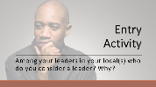 | What is your definition of a leader? – As you enter – consider a leader in your organization back home – on a piece of copier paper write the person’s first name AND how you know they are a leader.  Ellen Send LINK TO scenarios and reading assignments in first onsite email
8:30 -9:15  Ellen (Heidi)    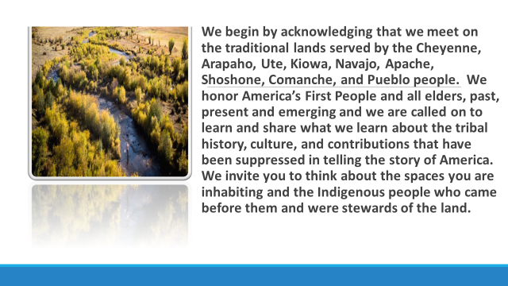      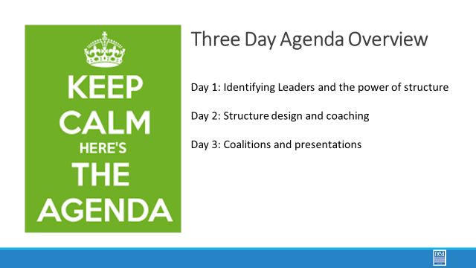  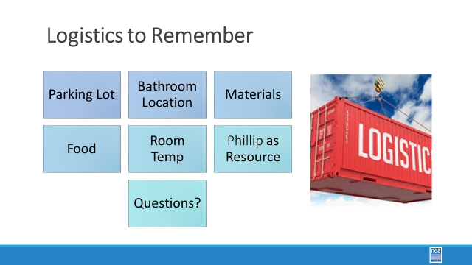  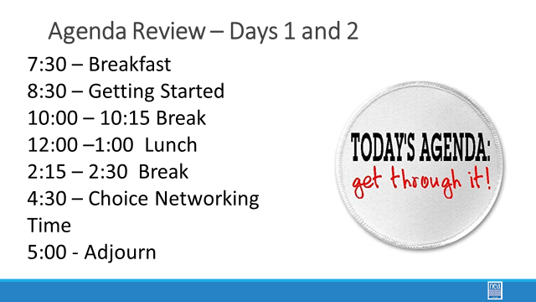  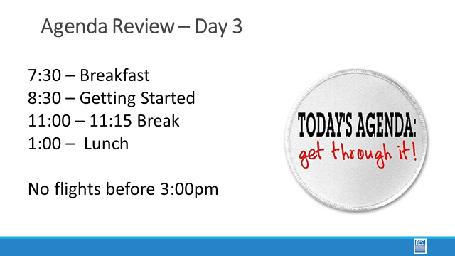  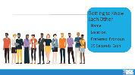  Albert  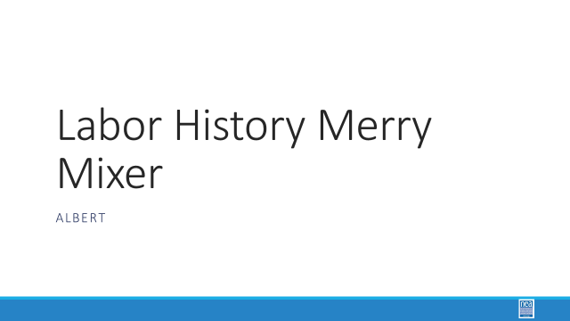  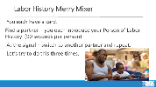 | How will we work together to support learning? | Norms  Parking Lot  Agendas on the Table  Name Tents  Handouts,  Wall Charts  Place for the Entry Activity |  | 45 Mins TOTAL Getting Started  10 Mins NEA Welcome, Logistics and Agenda Review  Why are we here?  - We are here to build stronger affiliates.  - Create structures and find and grow leaders.  - NEA is committed to building effective sites where members can lead and growth their associations.  5 Mins Facilitator Introductions  - Team intros include: Name, Work Location, years in the work, and a leader we coached and saw grow into a leader.  5 Mins Group Introduction Whip  - Have a quick model from one of the trainers.  Three Day Agenda Review  - See chartse on walls for review.  - Note the two breaks, lunch, and adult network 4:30-5pm each day and then 1pm on Thursday.  10 Mins – Group Agreements  15 Mins – People in Labor History Mix Up  3 rounds – 3 minutes per pair  Facilitator only gives signals at the three minutes |  | Participants will know how we are going to work, the basic schedule, and the logistics relevant to the training.
9:15- 10:00  Zac J.  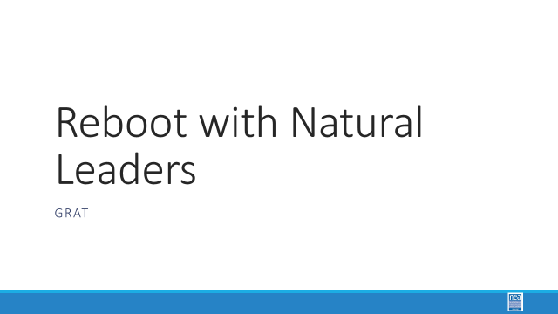  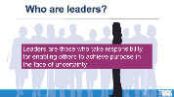  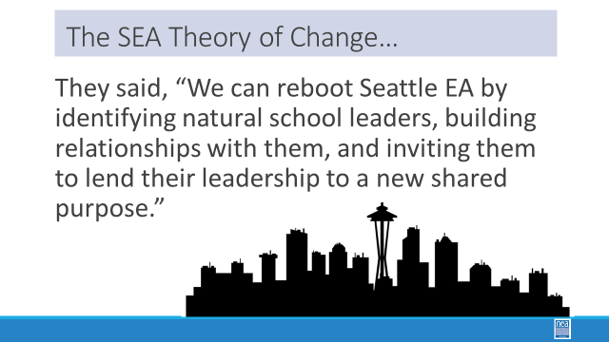  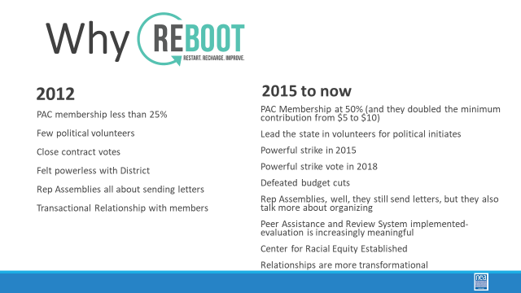  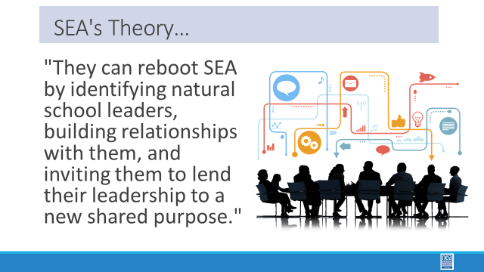  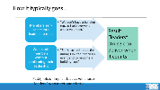  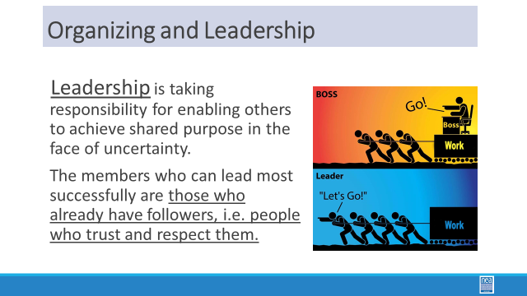  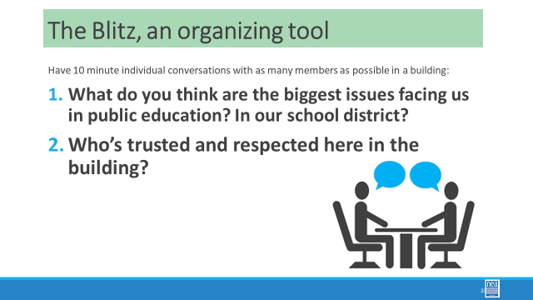  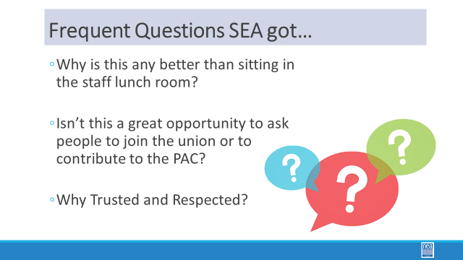  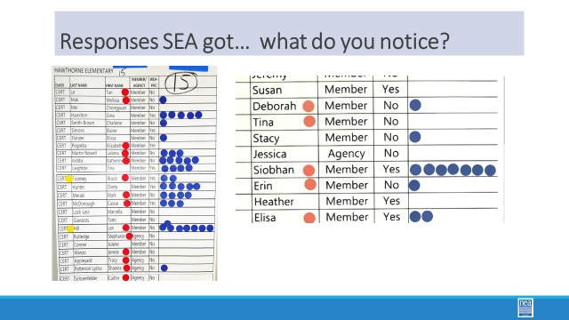  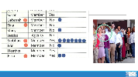    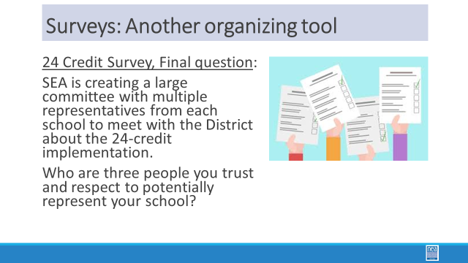  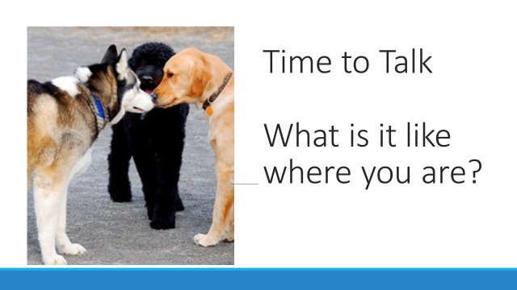  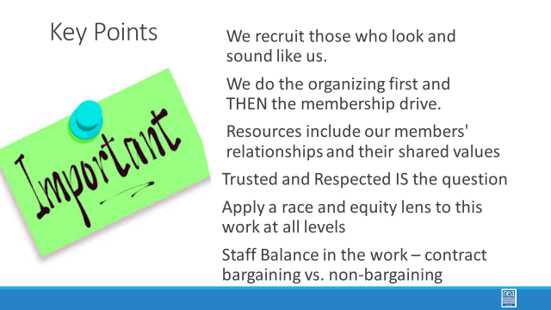 | How do we identify enough leaders? | Basic Information about Seattle  https://neahq-my.sharepoint.com/:w:/g/personal/eholmes_nea_org/EYuDR99kXH1PpYZzIATbST0Bz0HnbwkyU1gi_6RN52BTKA?e=h8oevv  Figure out when we can stop and ask questions. |  | 45 Mins TOTAL – The Case of Seattle (Total of 20 Minutes Content and 25 minutes of discussion)  Content-  Overview of Seattle as it was … and the Seattle as it now is.  Make sure you say up front why Seattle was weak –  Make connections to structures and be honest about what you think about structures – we need them, but they also need to be reorganized so that they don’t become bureaucracies. We knew that we needed to find the 500 leaders and create a big bargaining team.  The change begins with intentional identification of leaders. You can go high tech or low tech, but the process is the same.  Simple: go to your people, record what they say, identify who they have relationship with, build relationship with leaders, and help them realize their agenda.  Seattle Leadership Identification model and the changes needed for equity within leadership -- only go over – natural leaders' part and the shifts you have made to apply a racial equity lens to the process. Make sure to include the key idea from the Seattle Model that staff do the one on ones with the identified leaders. Building level leaders- members – do the one on ones with everyone else.  Stop FAQ slide and turn at table and ask- why not just go to the staff lounge? Why not make membership asks? Why Trusted and Respected?  The purpose for member to member one on ones is forming relationships, gathering data about issues, gathering data about agendas and asking, “Who here is a trusted and respected colleague?” We will build on this later in the day.  The data that was gathered was put on “wall charts” for every worksite. You can see from this one HS, the yellow dots are the Building reps. Notice that Len has far more blue dots – more trusted and respected. Let’s look at Siobhan (chevoynne) -- trusted and respected but not a building leader.  Point out that our own biases – and those of workers can skew who is reported as trusted and respected – we are biased towards those who look and sound like us. Same for workers. SO, it is likely that in your data, if any person of color has anyone identify them, they are likely a bigger leader than you would think.  TIME TO TALK Where could you start? (10 minutes at tables)  Encourage folks to discuss at their tables the strengths and challenges of this strategy. Then have strong debrief (15 minutes with members of the team helping with different perspectives. )  Key Point – We launched an organizing campaign and then we did a membership drive  Key Point -- We tend to recruit those that look like us  Key Point – Resources include our members and their relationships and shared value  Key Points – Use Trusted and Respected  Key Points – Racial Equity Lens to the work  Key Points – Staff Balance- expectations for staff  Key Points – Membership Recruitment is the job of the members  Key Points– When you do it – you have taken away the opportunity for a leader to grow through.  Key Points – Who is doing the conversations – mix of staff and leaders  Key Points- Without leaders, you will never move towards power building – the basic formula or goal to moving towards 1 identified leader in relationship with the union per 10 to 20 workers. |  | Participants will understand how a system for leader identification develops and shifts.
10:00- 10:15   | BREAK  - Reminder look at the article age of leadership in age of complexity (p.5 of pre attendance package emailed to you or p.21 of participant handout).
10:15- 10:45  Lakilia  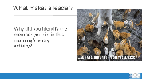    Terri     | How do we know they are a leader?  What are the cues we look for when identifying a leader? | Leader Identification Scenario Handout  https://neahq-my.sharepoint.com/:b:/g/personal/eholmes_nea_org/EdGphVG28HlOtSaaJyNngMYBlrxoB5TUOW6dVeY8cRz96Q?e=6jsDka  Core Content for Facilitators  https://neahq-my.sharepoint.com/:b:/g/personal/eholmes_nea_org/EZX8blXMHf5IrD2yzPtPThgB4EEtlm_cBEbDPy0fAfhGKQ?e=T60eCT |  | 30 Mins – TOTAL – Who is the Best Leader Activity  Open with referring to the questions from this AM.  Be clear when directing the group – based on what you can see in the “discussion bubbles” which of these is the strongest leader and which of these is the weakest leader. Your team will have 15 minutes to rank order these four people. Make sure you understand the “why” Discussion based on scenarios of leaders who have been identified by colleagues as someone they trust and respect.  Key Points to pull out in the debrief –  Understanding their agenda and their willingness to link it with your agenda matters  How you invite someone into YOUR agenda matters  Determining how your agendas build together matters  Who is the “best leader” - the answer will be – “it depends” as there is little to indicate what their agenda is and there is too little information about what the “union” agenda is.  Just because they have a dot does not mean they will be a leader aligned with our interests and agendas.  Let’s take a look at one on ones |  | Participants will understand that there is a difference between leadership ID and Leadership Engagement.
10:45-11:30  Albert and Jessica  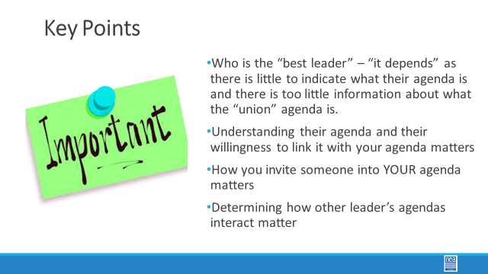  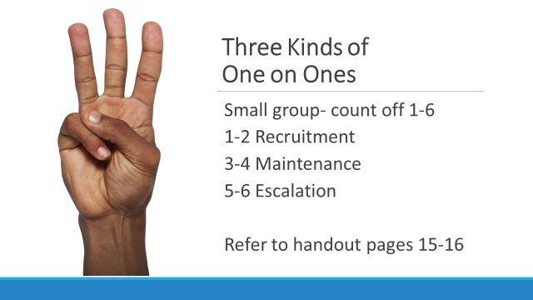  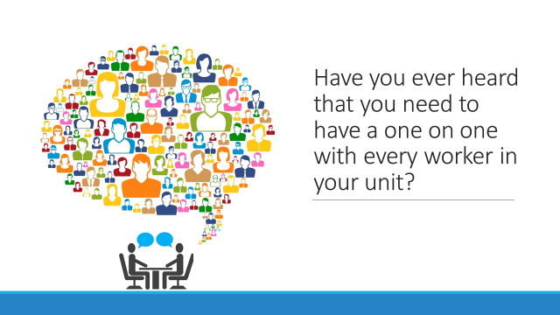  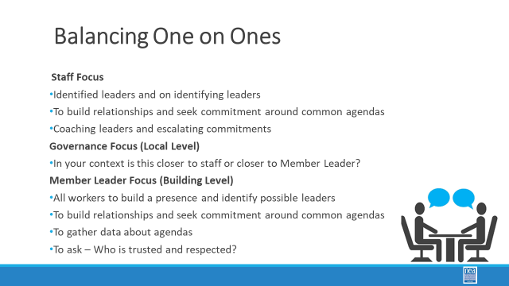  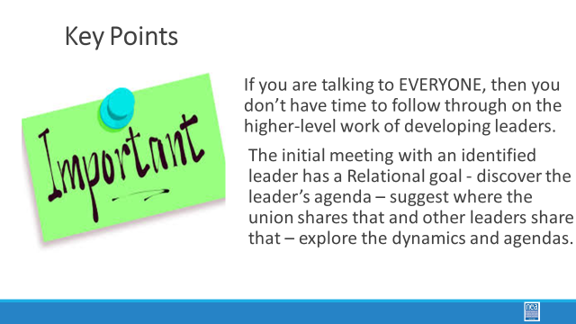  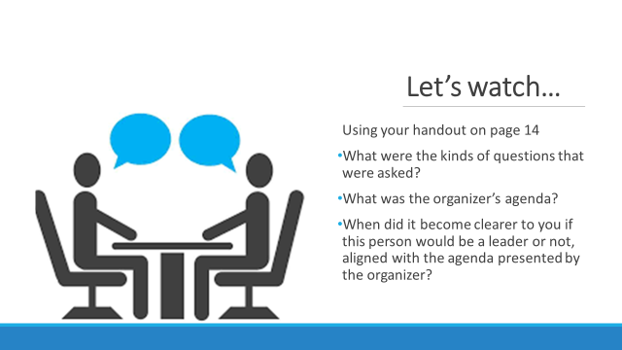  Facilitators will need to practice a very tight one on one as an example – so that the participant a good model to see.    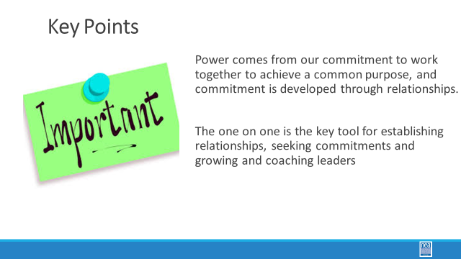 | How do we recruit members into engagement and leadership roles? | Chart paper at each table.  One on One Content pg 14-20 and  Ladder of Engagement Content Pg 26 From  https://neahq-my.sharepoint.com/:b:/g/personal/eholmes_nea_org/EZX8blXMHf5IrD2yzPtPThgB4EEtlm_cBEbDPy0fAfhGKQ?e=GPy0RR  One on One Content for Participants  https://neahq-my.sharepoint.com/:f:/g/personal/eholmes_nea_org/Elp54EtK8IZEphYDQrtZXiwBa13-a-ytF25yS7Odd7Uzpg?e=5bqyrq  One on One Observation sheet  FOUND ON PG 20 of Participant Handout BOOK  https://neahq-my.sharepoint.com/:b:/g/personal/eholmes_nea_org/EYVgfWkS0p9Dhdzen3JJxgQBkm7UagHQ7SoOxeU8iluvvg?e=yisk98 |  | 45 Mins TOTAL – How do we recruit leaders?  5 Mins - Why do we do one on ones? Turn in at your tables and identify “WHY” we do one on ones. – Ask each table to create chart of their key reasons for why.  After you hear of all the Why’s is to build relationships – relationships are long term, built around common agendas and are strengthened through commitments. Relationships require maintenance. Your work is in the development and maintenance of the “leaders” who are each building relationships with their “followers.” You are a resource to this leader.  10 minutes - Report out and chart – make check marks by those responses that are common – ask a co – trainer to do the charting as you manage the report out.  Once the report out is done say – We are typically doing one of three categories when we do a one on one – sometimes there is overlap across categories. The categories are ---recruitment, maintenance, and escalation. The handout found on page 14-15 provides a good overview of these.  Small group work – count off by 6’s, groups 1and2 will do recruitment, groups 3 and 4 will do maintenance, and groups 5and6 will do escalation – report out what you have learned.  5 Minutes - Begin the following brief content by posing the following question – How many of you have ever felt that you the staff person needs to have had a one on one with every one of your members?  Consider the Seattle model -- staff do the one on ones with the identified leaders. Building level leaders- members – do the one on ones. The purpose for member to member one on ones is forming relationships, gathering data about issues, gathering data about agendas and asking, “Who here is a trusted and respected colleague?”  Your goal in setting up one on ones with the identified leaders is relational – in which you are sharing a bit of your agenda, discovering the member’s agenda, and then suggest where other leaders’ agendas and the union agenda might share this member’s agenda. You might even probe a little as to the level of commitment in working together to forward these agendas the identified leader has.  10 Minutes - Model a leadership (pick one of the types in the content) one on one. – Two facilitators who have had a conversation prior will conduct about a 10-minute conversation.  Give the following directions – This is going to be a shortened – much shortened version of a one on one – they are typically 30 to 60 minutes. As you watch use the handout to capture the following-  What were the kinds of questions that were asked?  What was the organizer’s agenda?  When did it become clearer to you if this person would be a leader or not, aligned with the agenda presented by the organizer?  10 Mins- Debrief – What kind of one on one was this? Recruitment, engagement, or maintenance?  What did you see and record?  Key Points – If you the staff are talking to everyone then you don’t have time for the higher-level work of developing leaders.  The initial meeting with an identified leader has a Relational goal - discover the leader’s agenda – suggest where the union shares that and other leaders share that – explore the dynamics and agendas.  Keep in mind that a union is a group of people with a set of agendas |  | Participants would understand different types of 1:1s
11:30 -12:00  Lakilia  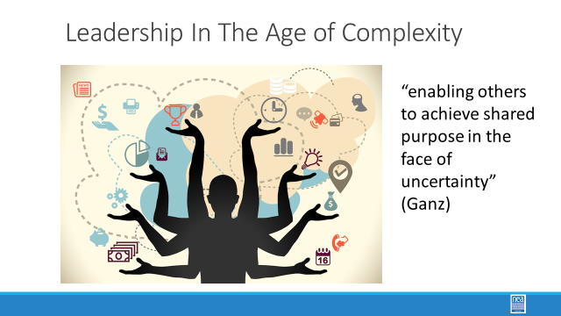  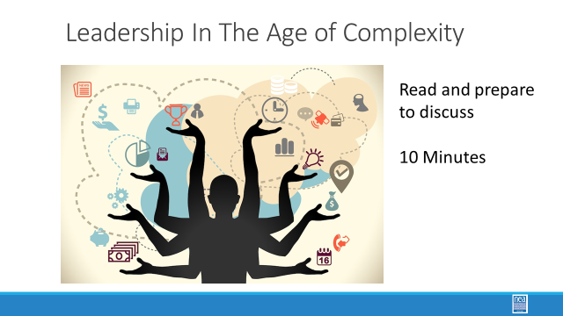    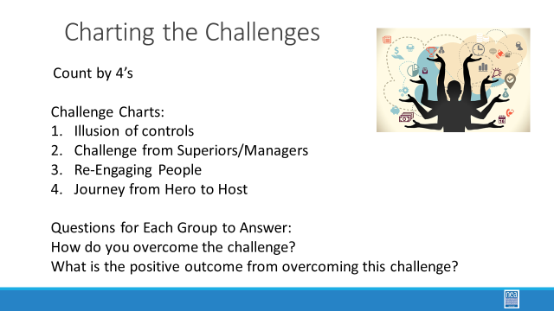  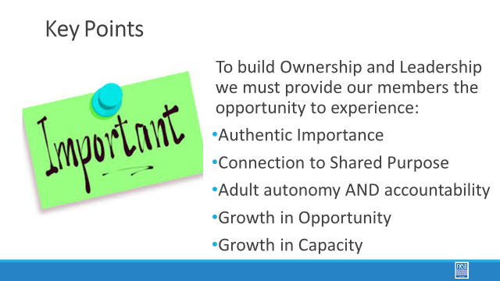 | How do we think about engagement with our members and leaders that allows them to grow? | Hero to Host NEED TO PRINT FOR PARTICIPANTS – add to pre-attendance readings p.21  https://neahq-my.sharepoint.com/:b:/g/personal/eholmes_nea_org/EaeZd5IrgUNCqcl6B1HF3uABH80vuSgH9ttMM_YzgNHKSw?e=y0V9fu  Engagement Grid Handout  https://neahq-my.sharepoint.com/:w:/g/personal/eholmes_nea_org/EWjdiKInc6NPp-tB9p_08rMB8Fmg-Sl5Boym1568hEg2Fg?e=YJv45e  Task Design Readings Ganz Pg. 10-12  https://neahq-my.sharepoint.com/:b:/g/personal/eholmes_nea_org/EVpxb9PHbGlJjVpBObxnlYwBA3-yw699g01SAEaviGncEg?e=gwmTxK  Sierra Club https://neahq-my.sharepoint.com/:b:/g/personal/eholmes_nea_org/ET5SZLAMU9ZNiE5-3KMhiZgB3srPqM1PKli6HxtG6qjBbA?e=kieSlA |  | 60 Mins TOTAL– 30 Minutes before Lunch and 30 Minutes after lunch  Levels of Engagement  10 Mins Hero to Host  Breaking the illusion of control. (Reference Leadership in an Age of Complexity). Introduce the grid and give context with the article.  How do we set the stage for members to engage? What environment do staff create to facilitate leader engagement?  - If this is your challenge, how do you overcome and what is the result of this challenge?  - EX: If I give up control, how do I do this? And if I give up the control, what does this look like?  - How do we move people in the quadrants? From servicing to organizing.  Structured conversation before lunch.  Conversation: how do we move hero from host?  FACILITATORS MAKE 4 CHARTS -Create charts with the following topics:  Challenges:  - Illusion of controls  - Challenge from Superiors/Managers  - Re-Engaging People  - Journey from Hero to Host  Questions to answer:  - How do you overcome the challenge?  - What is the positive outcome from overcoming this challenge?  Activity- 10 minutes  Count off by 4 head to your poster and stay in the room.  Debrief with whole room- 10 minutes.  Key Points:  - You do not have control, it's an illusion  - Too rigid of a hierarchy can be an impediment to innovation.  - Staff provide the conditions for people working together and we work to provide the resources people need, while not doing for them what they can do for themselves.  - We work towards building Leadership and Ownership  - We build power when we actual move people to the organizing quadrant |  | Participants will understand how the careful structuring of tasks and asks develops leaders and capacity.  I
12:00 - 1:00     | LUNCH – Read your assignment - if you have not.
1:00 – 1:30  Zac  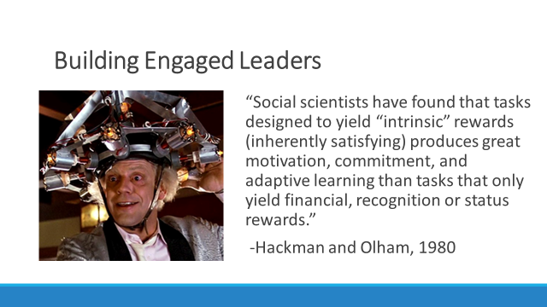  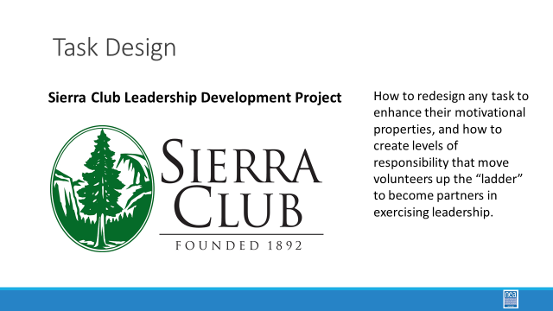  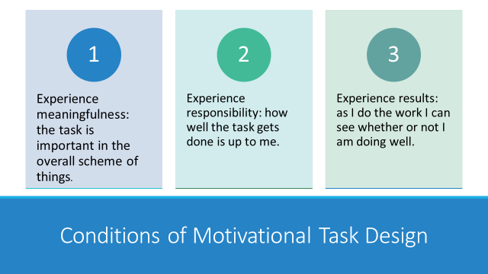  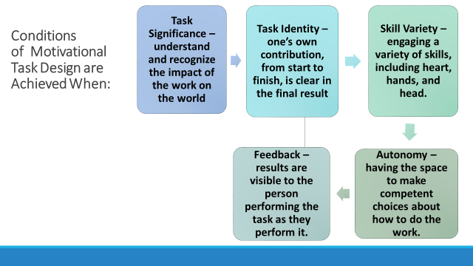  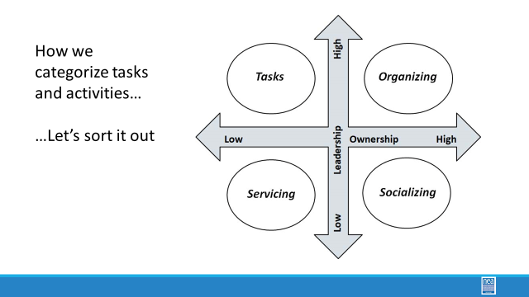  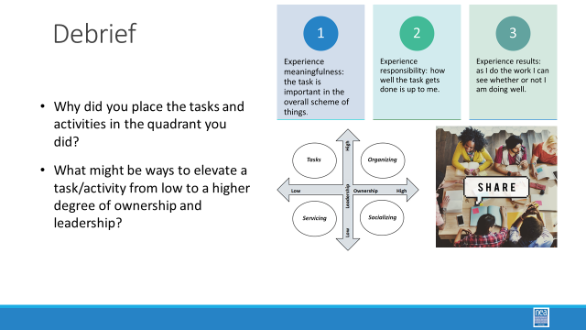  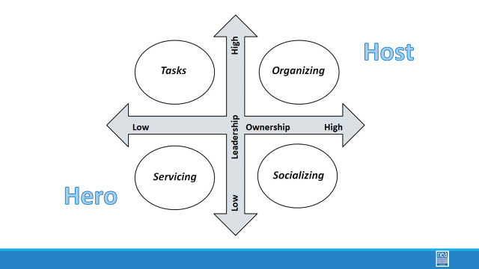  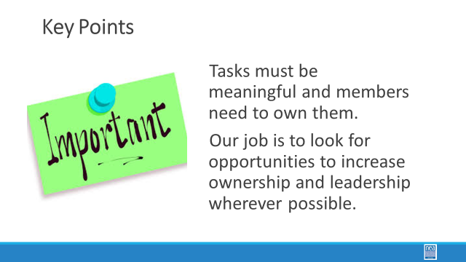 | How do we think about engagement with our members and leaders that allows them to grow? | Engagement Grid Handout  https://neahq-my.sharepoint.com/:w:/g/personal/eholmes_nea_org/EWjdiKInc6NPp-tB9p_08rMB8Fmg-Sl5Boym1568hEg2Fg?e=YJv45e  Activity Envelopes  https://neahq-my.sharepoint.com/:f:/g/personal/eholmes_nea_org/EnXc1RlLN91Fk32_9zu876oB4kHXrBzpk6s_wV_G8pGJyw?e=rIa6LL  Task Design Readings:  Ganz Pg 10-12 of  Task Design Readings:  https://neahq-my.sharepoint.com/:b:/g/personal/eholmes_nea_org/EVpxb9PHbGlJjVpBObxnlYwBA3-yw699g01SAEaviGncEg?e=gwmTxK  Sierra Club https://neahq-my.sharepoint.com/:b:/g/personal/eholmes_nea_org/ET5SZLAMU9ZNiE5-3KMhiZgB3srPqM1PKli6HxtG6qjBbA?e=DwDxds |  | 60 Mins TOTAL– 30 Minutes before Lunch and 30 Minutes after lunch  Levels of Engagement  Stay in your groups of 4 from before lunch.  5 Mins of Content - Show the slide Building Engaged leaders. Intrinsic and Authentic. Share the slides that have the 3 conditions of Motivational Task Design and the 5 ways to assess if they have been achieved.  Looking at the quadrants, where do these tasks fall? (page 11-13)  Key Point  - Servicing is not bad and there will always be a role for service. But how do we move members and our work into a higher role.  15 Mins Activity -  As the facilitator determine if it is time to regroup the participants – if so – do a count off into groups of 4 to 5 – Make sure each group has a set of activity cards and knows where to find the sorting grid.  Directions - Turn to page ------- This is the grid that was shared during description of how the SEA staff think about developing leaders. We are going to use this grid to support your thinking about structuring engagement that grows capacity to lead. As a team, using the frame that was presented in the Seattle story and the pre-reading – sort the activities in your envelope into the most appropriate quadrants. Come to some level of agreement as a team about WHY you are placing these where you are.  First part of the activity – simple sort – sort these into the quadrants  10 Mins Debrief:  Why were activities placed where they were? Were there any of the engagement activities that your table struggled with placement?  The next section will help us understand how we escalate and grow leaders.  Key Points  - Tasks must be meaningful and members need to own them.  - Our job is to look for opportunities to increase ownership and leadership wherever possible. |  | Participants will analyze asks and redesign them according to the Sierra Club Materials.
1:30 – 2:15  Terri  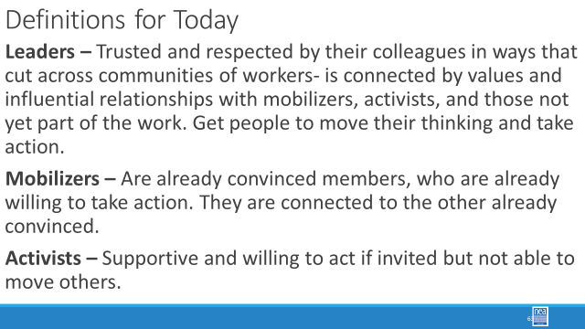  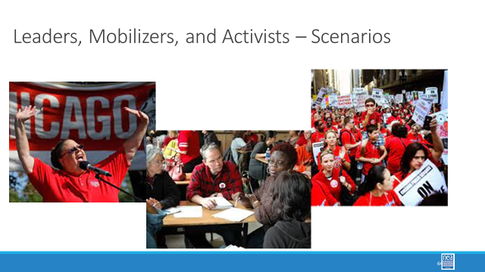  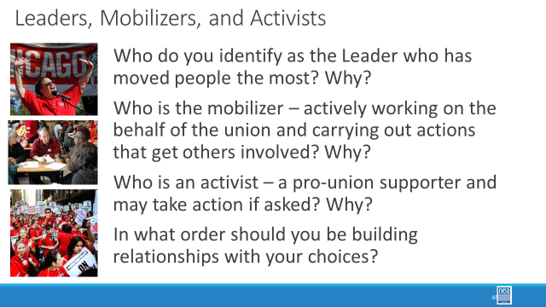  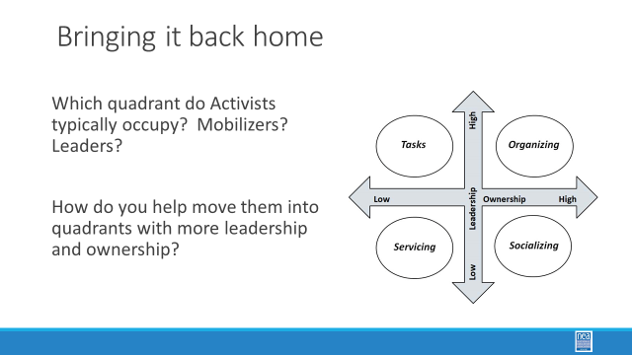  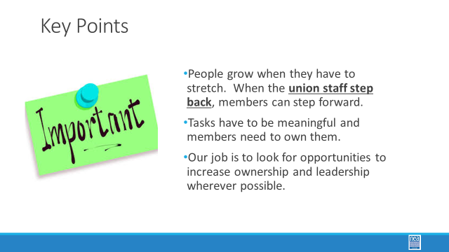 | Why do the kinds of leaders we identify matter? | Scenarios for the Leadership ID  https://neahq-my.sharepoint.com/:w:/g/personal/eholmes_nea_org/EZwJBwHG8Z5Kp7Fy9oWo_qoBuGPibyuJEGGTKILHiHAGYw?e=x0w8Xs |  | Leaders Mobilizers and Activists  Share these leadership definitions  - Leaders – Trusted and respected by their colleagues in ways that cut across communities of workers- is connected by values and influential relationships with mobilizers, activists, and those not yet part of the work. Get people to move their thinking and take action.  - Mobilizers – Are already convinced members, who are already willing to take action. They are connected to the other already convinced.  - Activists – Supportive and willing to act if invited but not able to move others.  Scenarios – Teams will need about 30 minutes to read this.  Based on what's in the scenario only:  Who do you identify as the Leader who has moved people the most? Why?  Who is the mobilizer – actively working on the behalf of the union and carrying out actions that get others involved? Why?  Who is an activist – a pro-union supporter and may take action if asked? Why?  In what order should you be building relationships with your choices?  (Facilitator note – the leader moves the most people and is the last person to get engaged with BECAUSE that is the big ask. No where to go if the answer is n)  Bringing it all back home -- Which quadrant do Activists typically occupy? Mobilizers? Leaders?  How do you help move them into quadrants with more leadership and ownership?  Key points of final debrief -  People grow when they have to stretch. When the union staff step back, members can step forward.  Tasks have to be meaningful and members need to own them  Our job is to look for opportunities to increase ownership and leadership wherever possible.
2:15-2:30 | BREAK!
2:30-3:15  Albert  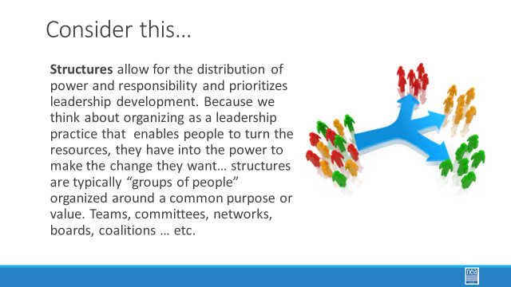  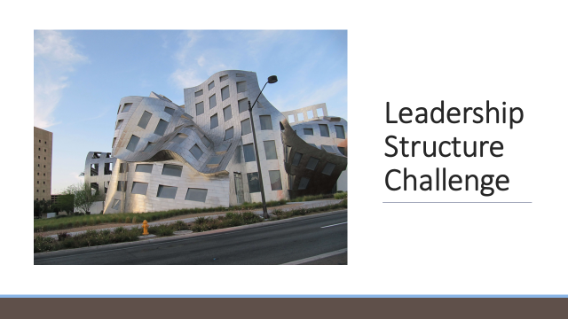  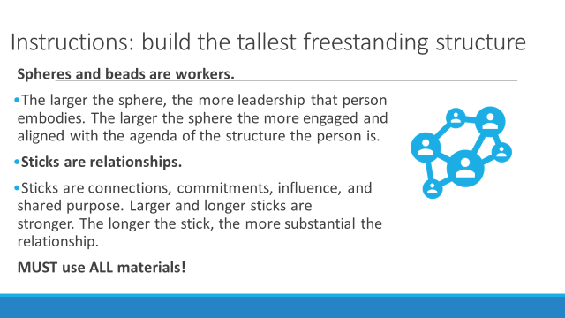  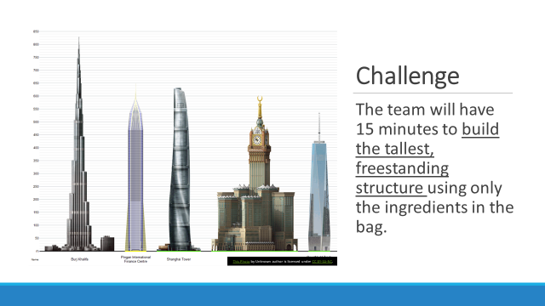  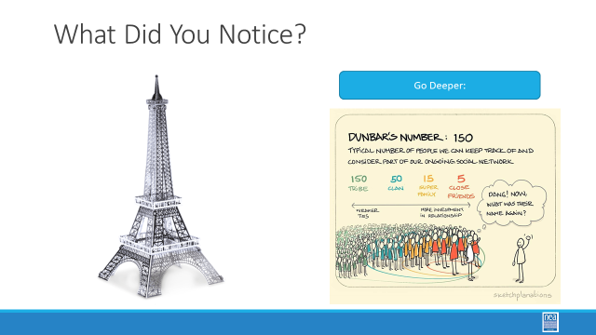  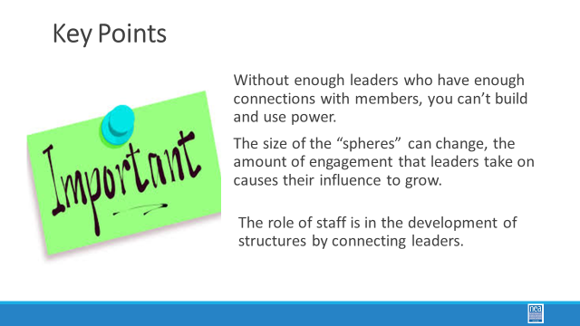 | What is the right recipe for using power? | Ziploc bags and materials for building towers.  The Tyranny of Structurelessness  https://neahq-my.sharepoint.com/:f:/g/personal/eholmes_nea_org/EnXc1RlLN91Fk32_9zu876oB4kHXrBzpk6s_wV_G8pGJyw?e=bf7KVK  Participant Examples  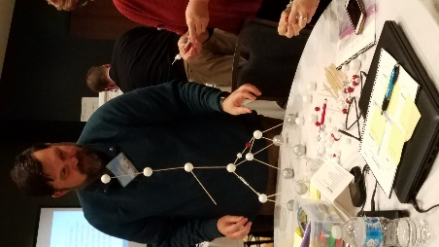  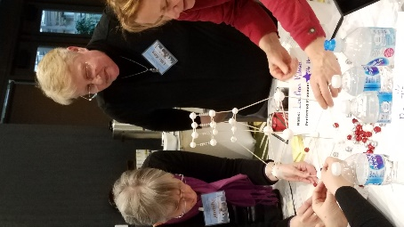 |  | 45 Minutes Total - Structural Challenge Activity  5 Mins Intro - We are going to shift from thinking about leaders and their level of engagement to structures. Structures allow for the distribution of power and responsibility and prioritizes leadership development. Because we think about organizing as a leadership practice that enables people to turn the resources they have into the power to make the change they want… structures are typically “groups of people” organized around a common purpose or value. Teams, committees, networks, boards, coalitions … etc.  There are a number of bags that have a different combination of the following materials: small Styrofoam balls and medium sized along with toothpicks and hard beads. The larger the ball, the “bigger” the leader. The toothpicks represent commitment, relationship, shared accountability and purpose.  15 Mins Activity -  Teams are given a bag. The object is to make the tallest free-standing structure you can in 15 minutes using only what is in the bag.  Key:  Each bag is a local of 200 workers.  Large Styrofoam balls are leaders  Small Styrofoam balls are members  Hard Beads are non-members or disengaged members  Toothpicks are relationships, commitments, common purpose  The perfect bag has 20 Leaders and 180 Workers with no disengaged members and about 200 toothpicks  Other versions could be  20 leaders and 180 beads with 40 toothpicks  1 leader, 150 members, 50 beads and 100 toothpicks  10 Mins Debrief-  Ask people to look around at the other models – what has made a structure more or less successful? (quick walk around).  Are leaders static – in other words does the size of the sphere shift depending on…  IS anything in this model static?  What do we also notice? Leaders can only connect to so many people.  Dunbar’s number also notes that leaders can only get to about 15-20 people. It is on that next 15-20 to build and grow as leaders.  10 Mins Key points:  Without enough leaders who have enough connections with members, you can’t build for power.  The size of the “spheres” can change, the amount of engagement that a leader takes on causes their influence grows, the circle of influence grows.  If the leader understands the need to develop more leaders – then the smaller spheres change shape and the number of connections grows.  As the leadership engagement in a building expands then there can be multiple agendas….  Build a union in a building  Build a union across the district  Build the union across organizations |  | Participants will understand the importance of intentional structure for building power.
3:15- 3:30  Yvie  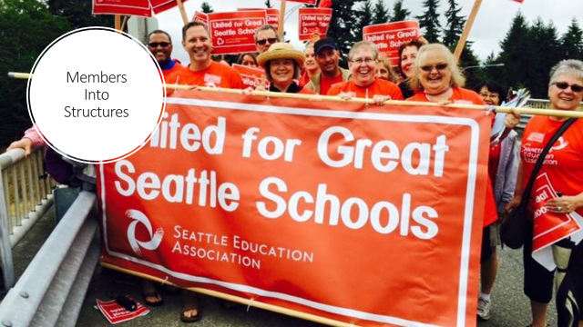  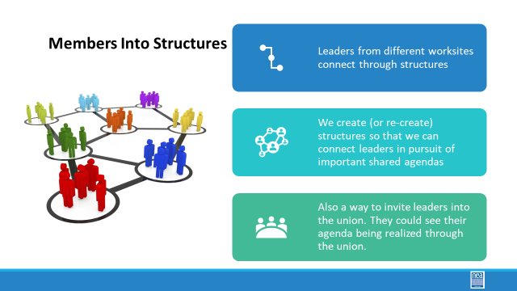  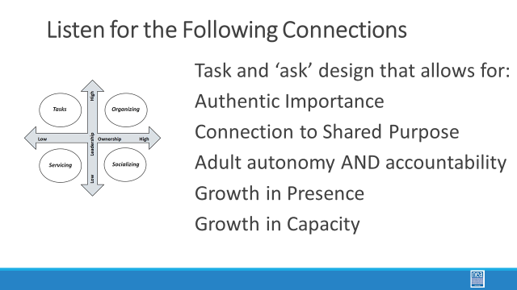  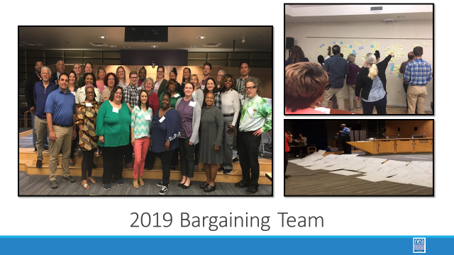  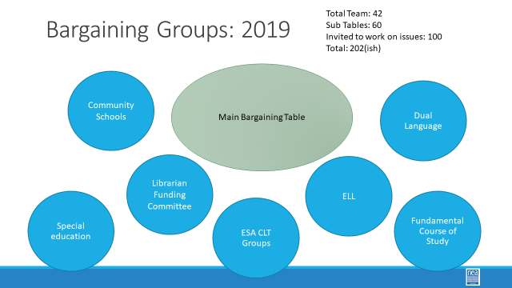  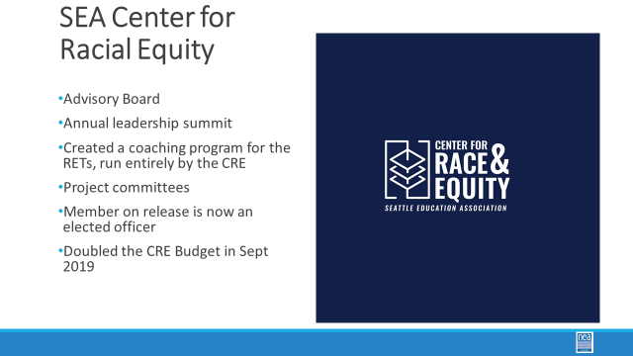  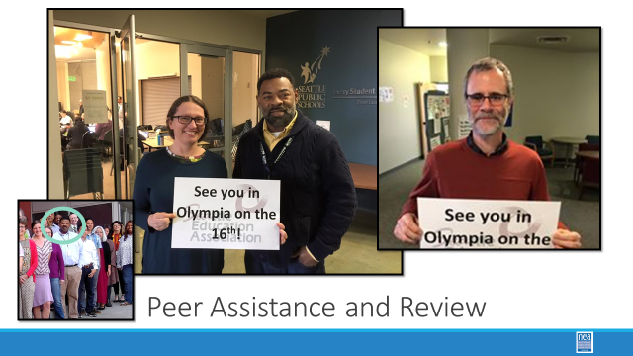  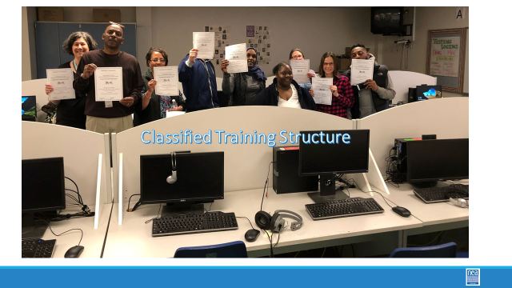  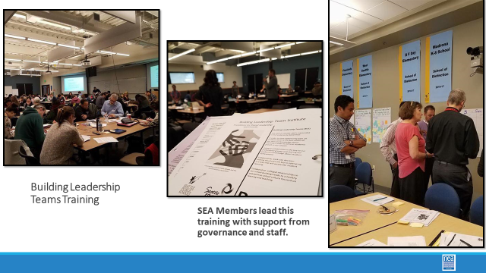  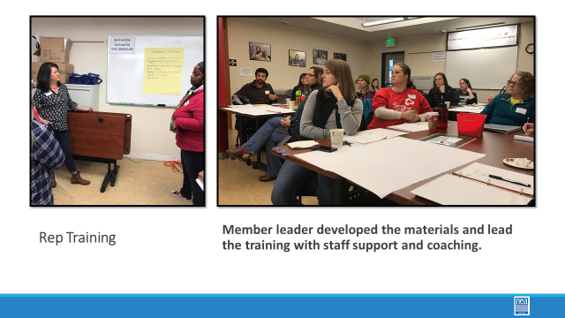  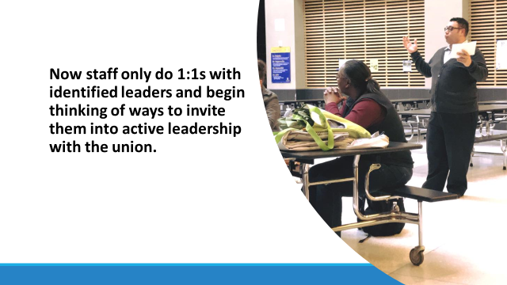  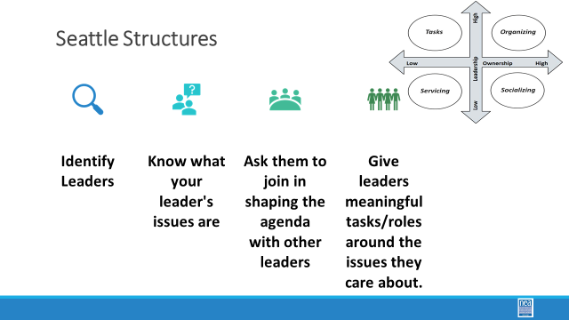  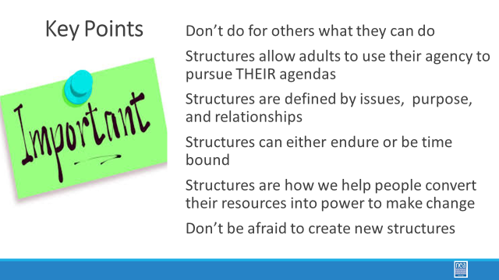 | What are examples of structures that allow members to use their collective power? | Need some Seattle Specific documents  Link to the Pre-Reading from MCEA regarding all the ways that members lead and make decisions  https://neahq-my.sharepoint.com/:b:/g/personal/eholmes_nea_org/Eaxzk7OT3YFOhxzfBxbsSbIBBlMY2Fh9M2qvBt2YXkfTig?e=NPfAjR |  | 15 Mins Total: How Seattle Put Leaders and Workers into Structures  Part of the Seattle story will hit the following points:  Task and ‘ask’ design that allows for:  - Authentic Importance  - Connection to Shared Purpose  - Adult autonomy AND accountability  - Growth in Presence  - Growth in Capacity  Ground this in the Center for Race and Equity in Seattle  IBB Contract Language  High member interest in this  A body was created and exists  Overview of all the structures in which members are engaged and led by other members  Worksite teams  ESP PD Teams  Bargaining groups  Special Ed  PGES, PAR Panel, Coursework, BLT, CLT and PD  Caucuses  Etc. Etc.  What did staff do? Coach and support?  Who puts the agenda together who?  Cardinal Rule: don’t do for the members what they can do for themselves  What was the shift in how members and staff were expected to think about engagement with each other?  What is your theory of action for staff? -- use the grid to explain the moves in staff work that were made  Key Points –  Structures allow leaders to pursue agendas –  Leaders have agendas and our work is to get them to see the union as place to pursue that agenda  Structures are defined by issues, purpose and relationships  Structures can be organic and time bound – or they can be defined and enduring  Structures can fall in love with themselves but not have a shared purpose  Don’t be afraid to create a new structure  Structures are how we turn the resources of our people into power to make change |  | Participants will consider how structures in a particular local have contributed to its power and credibility.
3:30 – 4:15  Added more debrief time.  Yvie  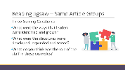  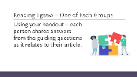  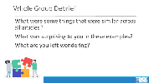  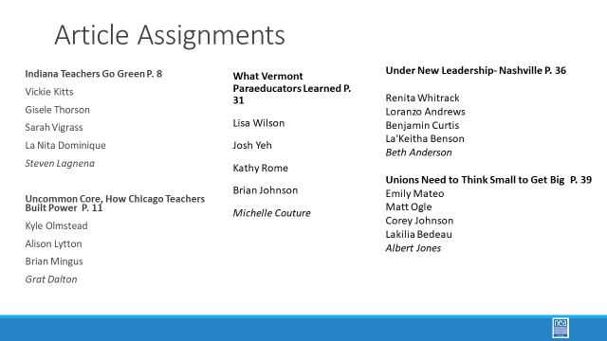  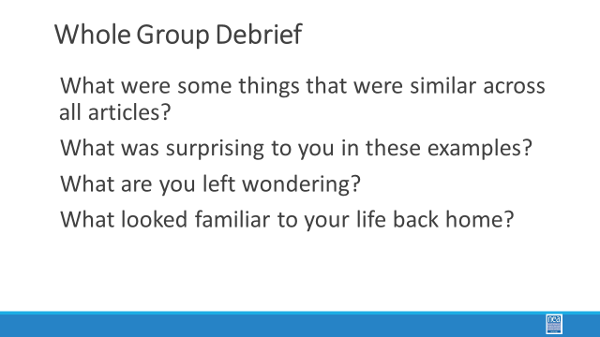 | How do you plan for structures you will need to achieve outcomes? | Ellen will Pre-Assigned the Articles before they arrive – there will be 4 groups.  Pre-Attendance Handouts  https://tinyurl.com/y6ezp8oa  Article Discussion Handout  https://neahq-my.sharepoint.com/:w:/g/personal/eholmes_nea_org/EQWiMmNfdIVFrdSMdaKnChkBopOUOS8Km-NXOU9TKVYK8w?e=9V9gd5  Chart Paper and places around the room |  | 45 Mins TOTAL: Leaders and Structures that Have Achieved Change  Pre-reading Jigsaw – The group has been divided into 5 teams and each has been pre-assigned one of the following articles – Indiana Teachers Go Green, Uncommon Core, How Chicago Teachers Built Power, Under New Leadership- Nashville, Unions Need to Think Small to get big, and VT Paras.  Round 1 – 15 Mins -Teams from the same article discuss what they found –  Ask the teams to gather according to the article they read.  Using the Handout to Capture their Discussion – have the groups report their thinking on the following three questions – it is important that everyone have their own notes on these questions as they will need them for the next round.  Three Guiding Questions:  - What were the ways that leaders were identified and grown?  - What were the structures were developed, expanded and tested?  - What do you think was the role of the staff in these examples?  Round 2 – 20 Mins – Ask the teams to rearrange into 6’s with at least one person from each article present – there may be a team of 3 or a team of five depending on the math. Once in the reformed groups, share with each other what each article has to teach us in regard to the 3 guiding questions.  Debrief - 10 Mins  What were some things that were similar across all articles?  What was surprising to you in these examples?  What are you left wondering?  What looked familiar to your life back home? |  | Participants will apply their learning about types of structures.
4:15-4:20  Ellen Holmes (Heidi)  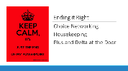   | How are we doing so far? |  |  | 5 Minutes - Ending it Right  Questions, Connections, Reflections  Housekeeping announcements  Plus/Delta at the Door  FOR TOMORROW – WHAT IS A PROBLEM THAT YOU ARE EXPERIENCING AROUND DEVELOPING LEADERS AND STRUCTURES. (Reminder this is about staff. ) |  | Participants will be able to bring a little closure to their learning and provide feedback on the day.
4:30 – 5:00  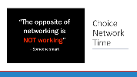 | What is the expertise among my colleagues? |  |  | Choice Networking Activities |  | Participants will make useful connections with staff from other affiliates.
5:00 | ADJOURN

