Facilitator Agenda 90 Minute Online Focused Discussion
General Materials Needed: |  |  | Session Links and Notes
PDF of flyers  Handout of Roles in Campaign Lab  PDF of Slides  All are in the course and in the materials folder |  |  | Prep for breakout rooms – arrive 15 minutes early  Zoom Link https://nea-org.zoom.us/meeting/register/LtWQgEvWR5C_ekaap0ptLA  Materials folder OL Campaign Lab  Course Link https://neapartnerb.learnupon.com/courses/4420159
Key Outcomes for the Event:
Participants will understand what Campaign Lab is and how it is connected to a wider movement
Participants will understand how to apply to be part of the Campaign Lab
Participants will understand why coaching is the backbone of the Lab and how to engage in that.

Overview of Content, Time, and Facilitator Assignment
5 Minutes – Welcome and Intros  20 Minutes – What would a loving community or school look like?  10 Minutes – Campaign Lab Concept  20 Minutes – 10 minutes in BREAKOUTS How COULD you use the concept as presented with your own locals? 10 Minutes report out and conversation. | Ellen  Alan  Ellen  Taraja |  |  | 15 Minutes – Nuts and Bolts of Campaign Lab  Roles  Process  QR CODES  5 Minutes - Closing | Halimah or Ellen  Alan and or Ellen
Time Slides Facilitator | Resources | Instructions, Activity and Debrief (Facilitators) | Essential Questions and Outcomes
Facilitators Join 15 Minutes Early if Possible – Team prep, practice, room set up, sound check, etc.
90 Minutes- Total In Session
5 Minutes ELLEN |  | Welcome and Intros
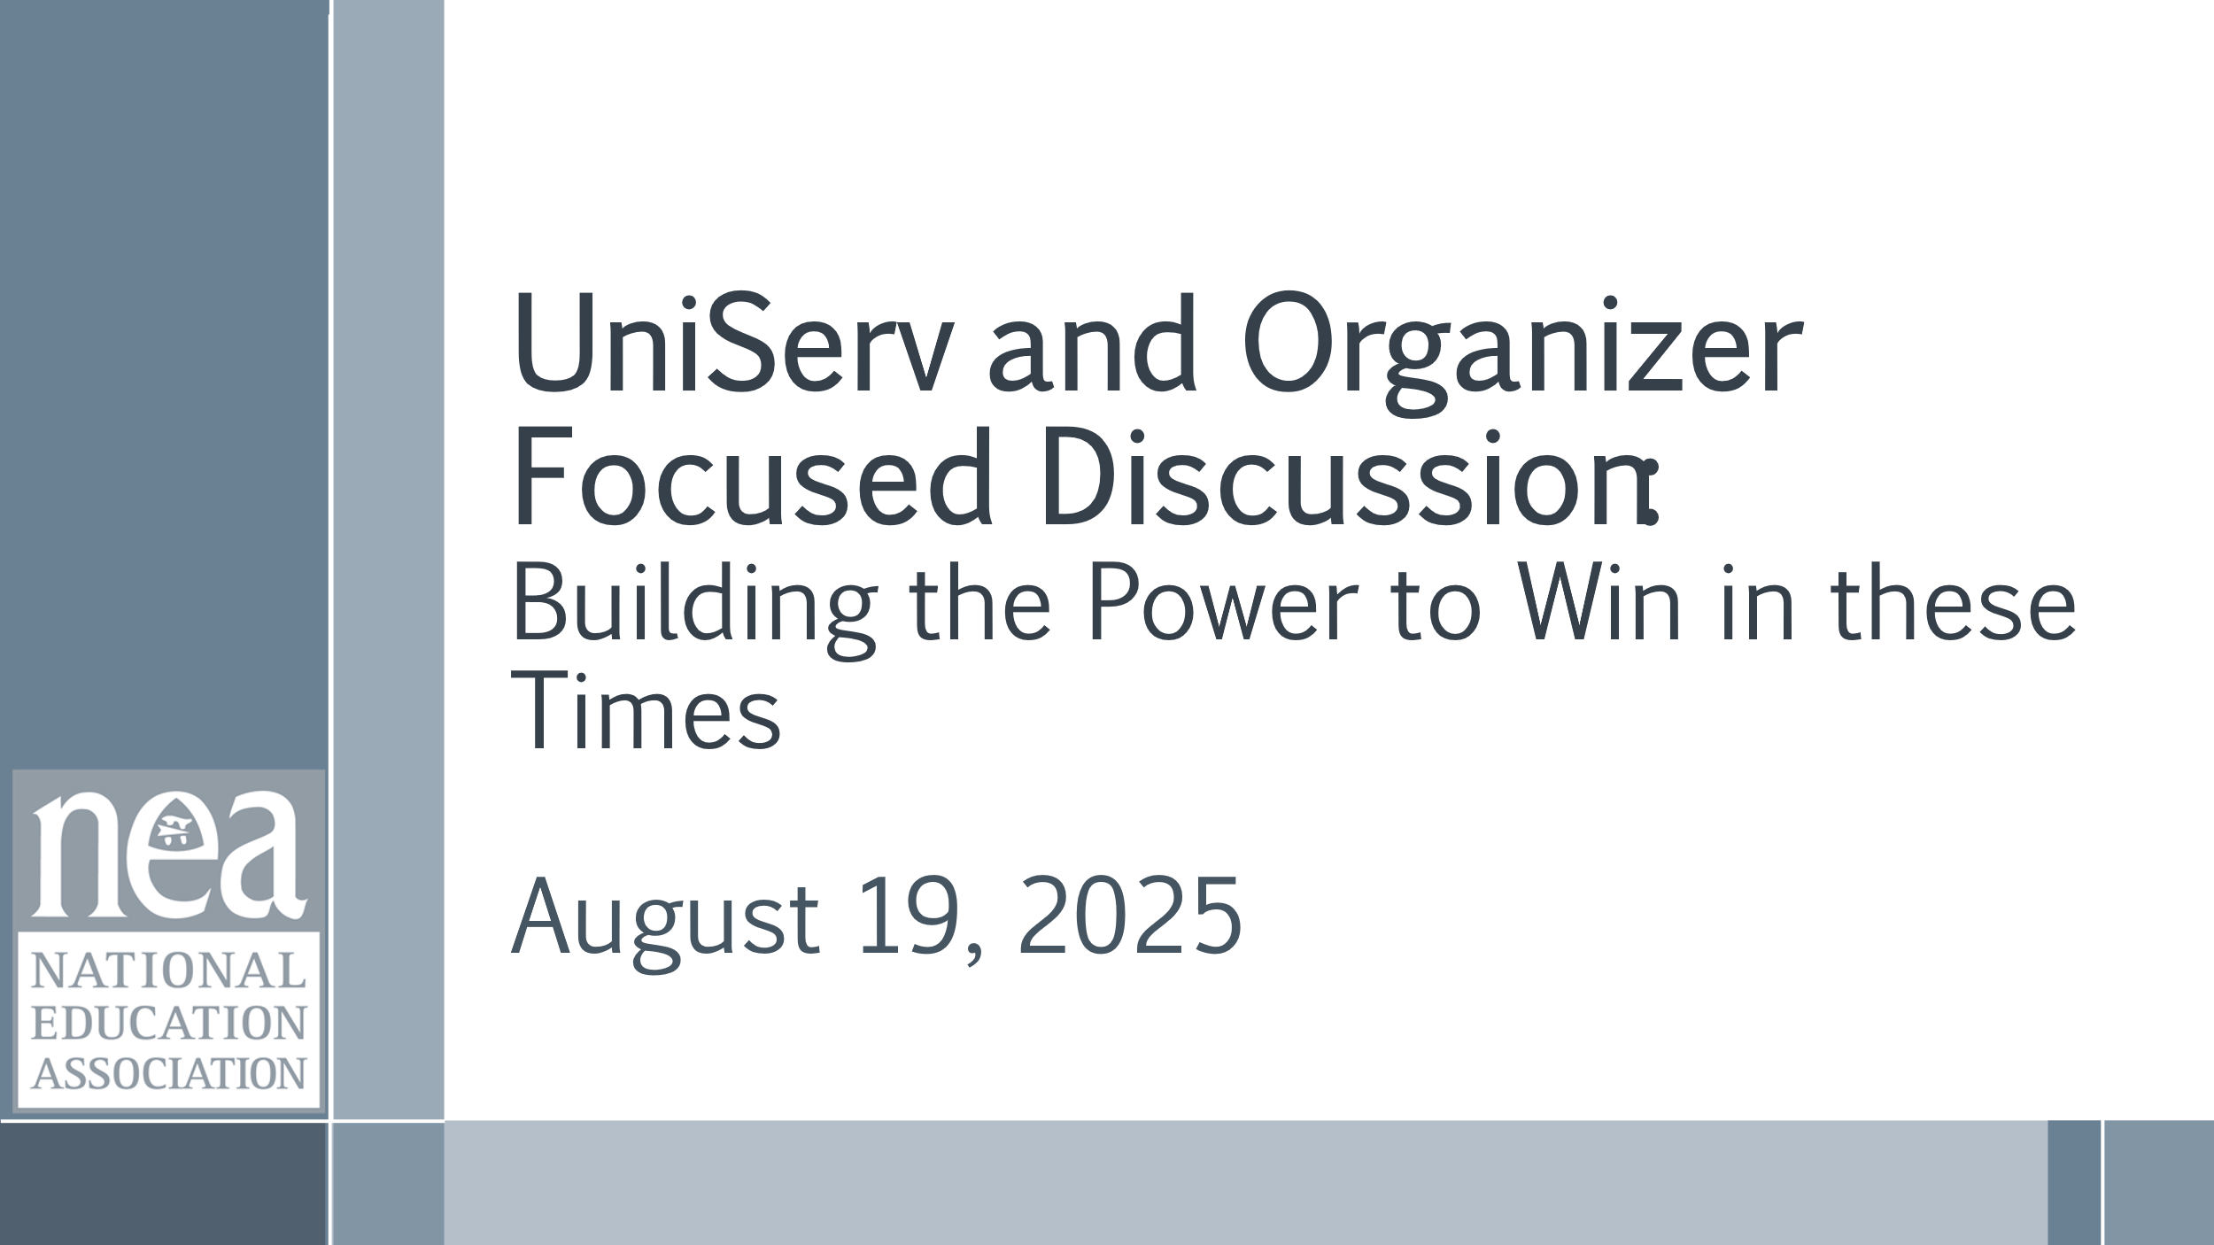  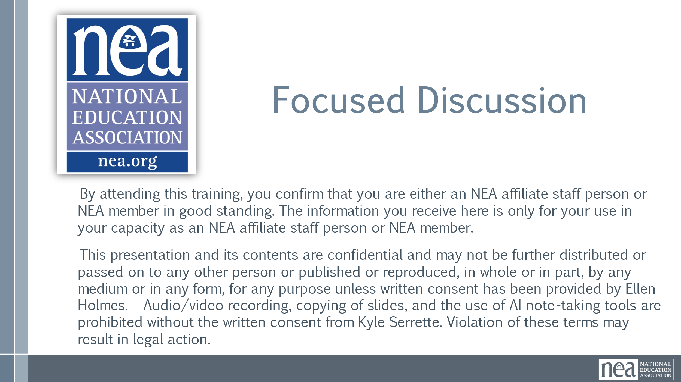  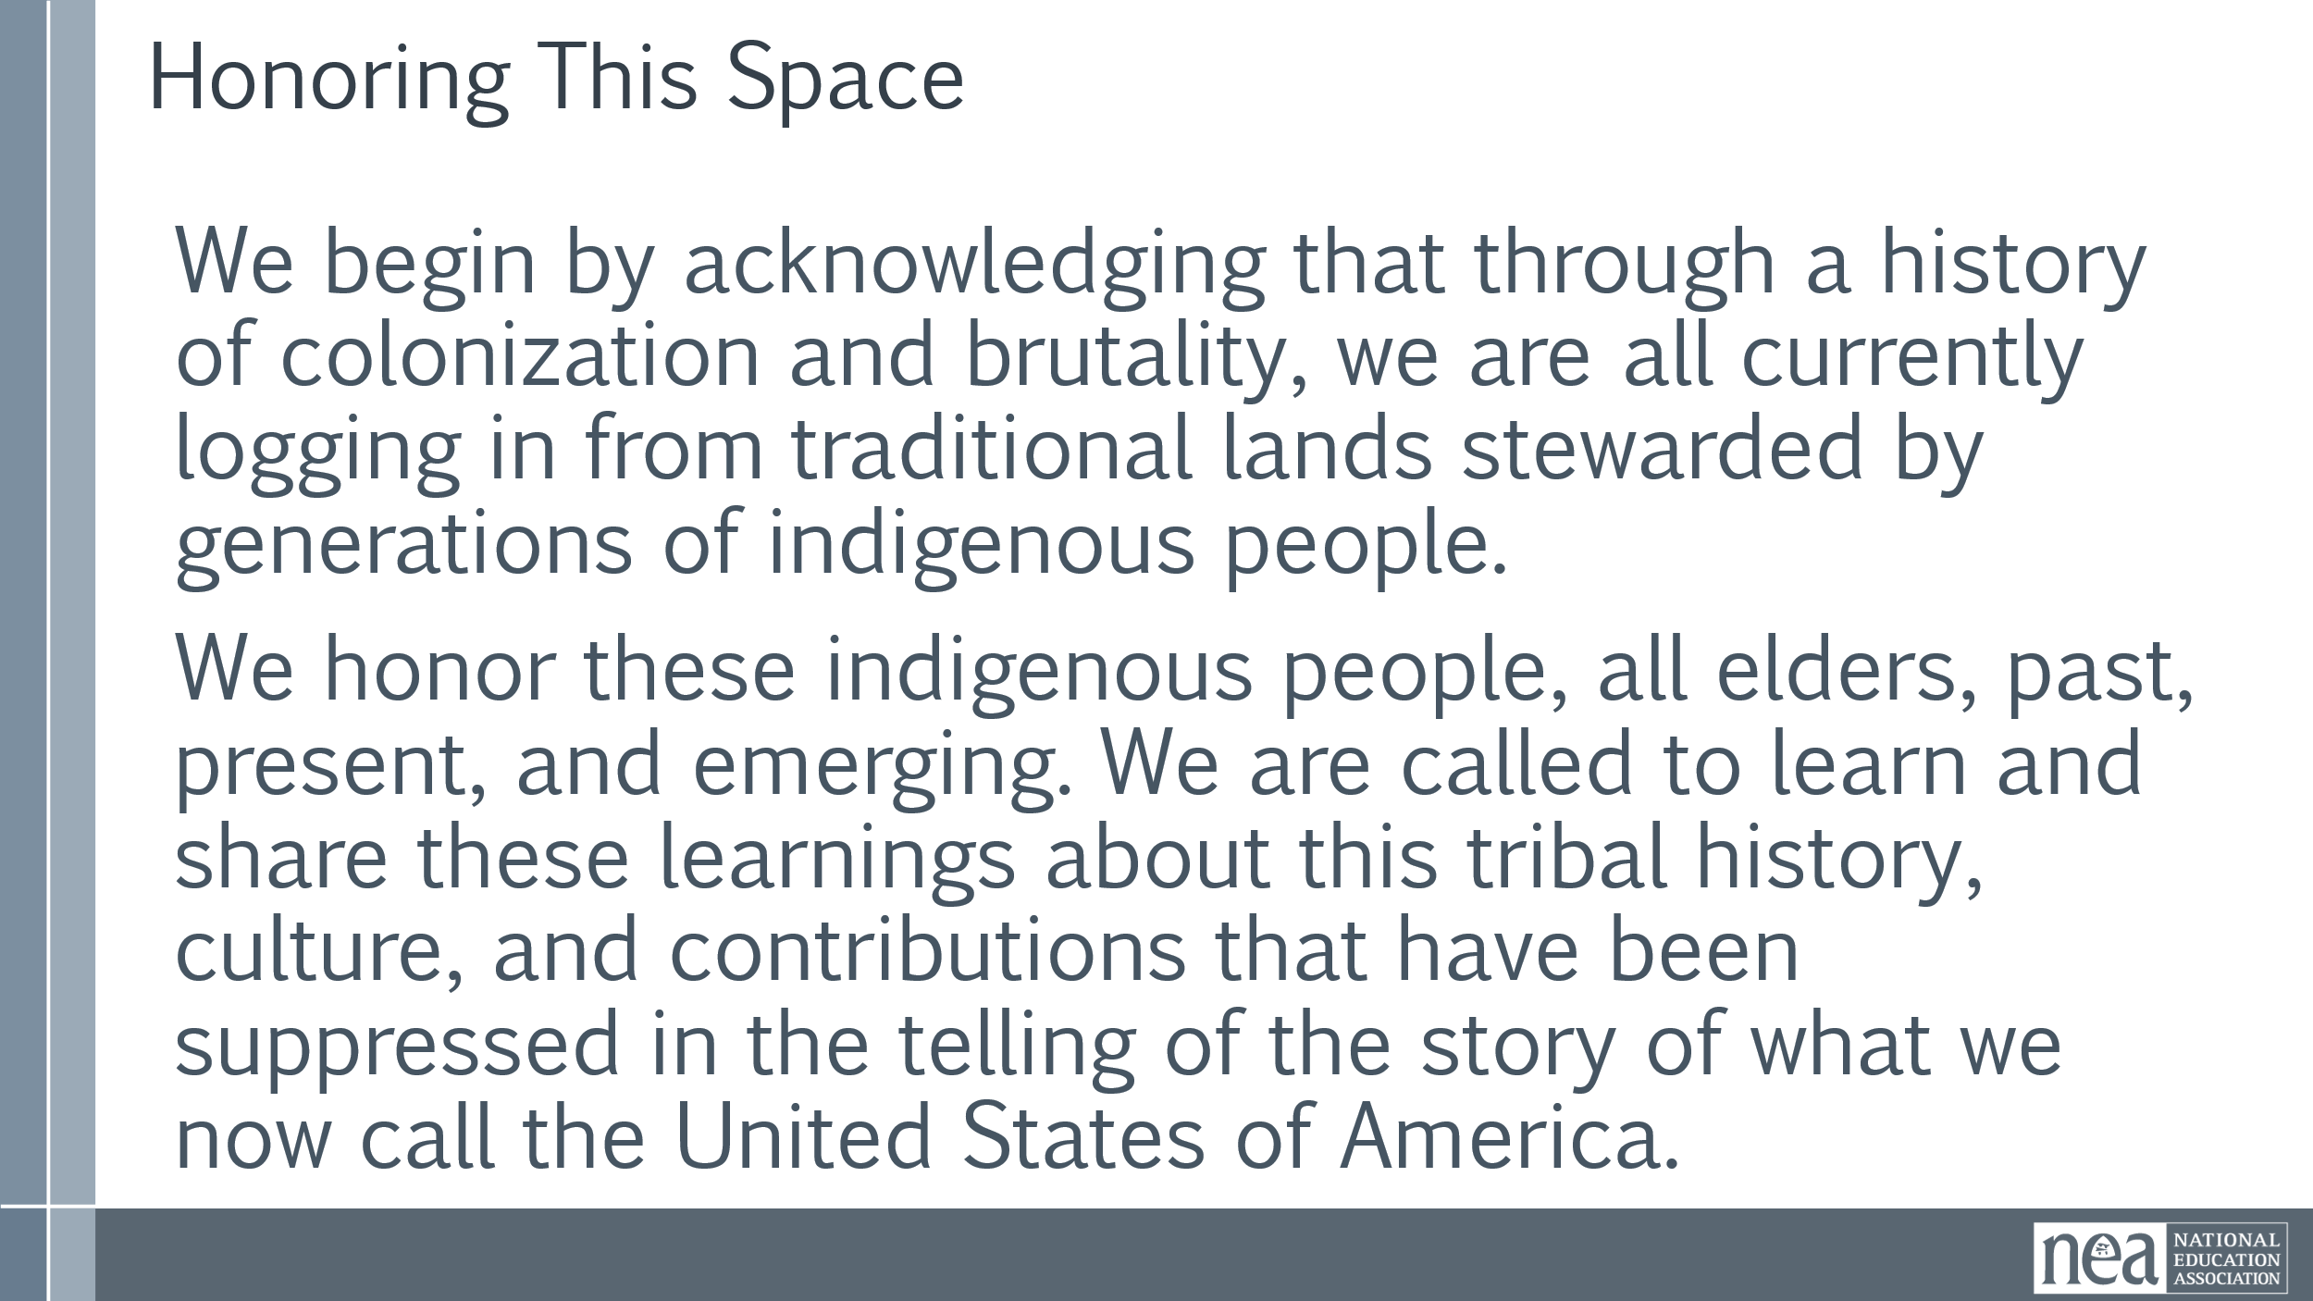  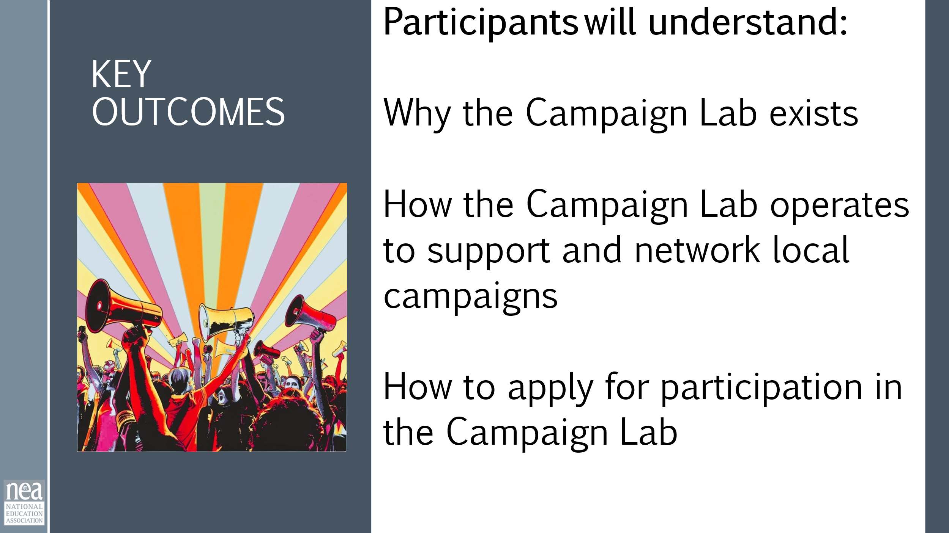  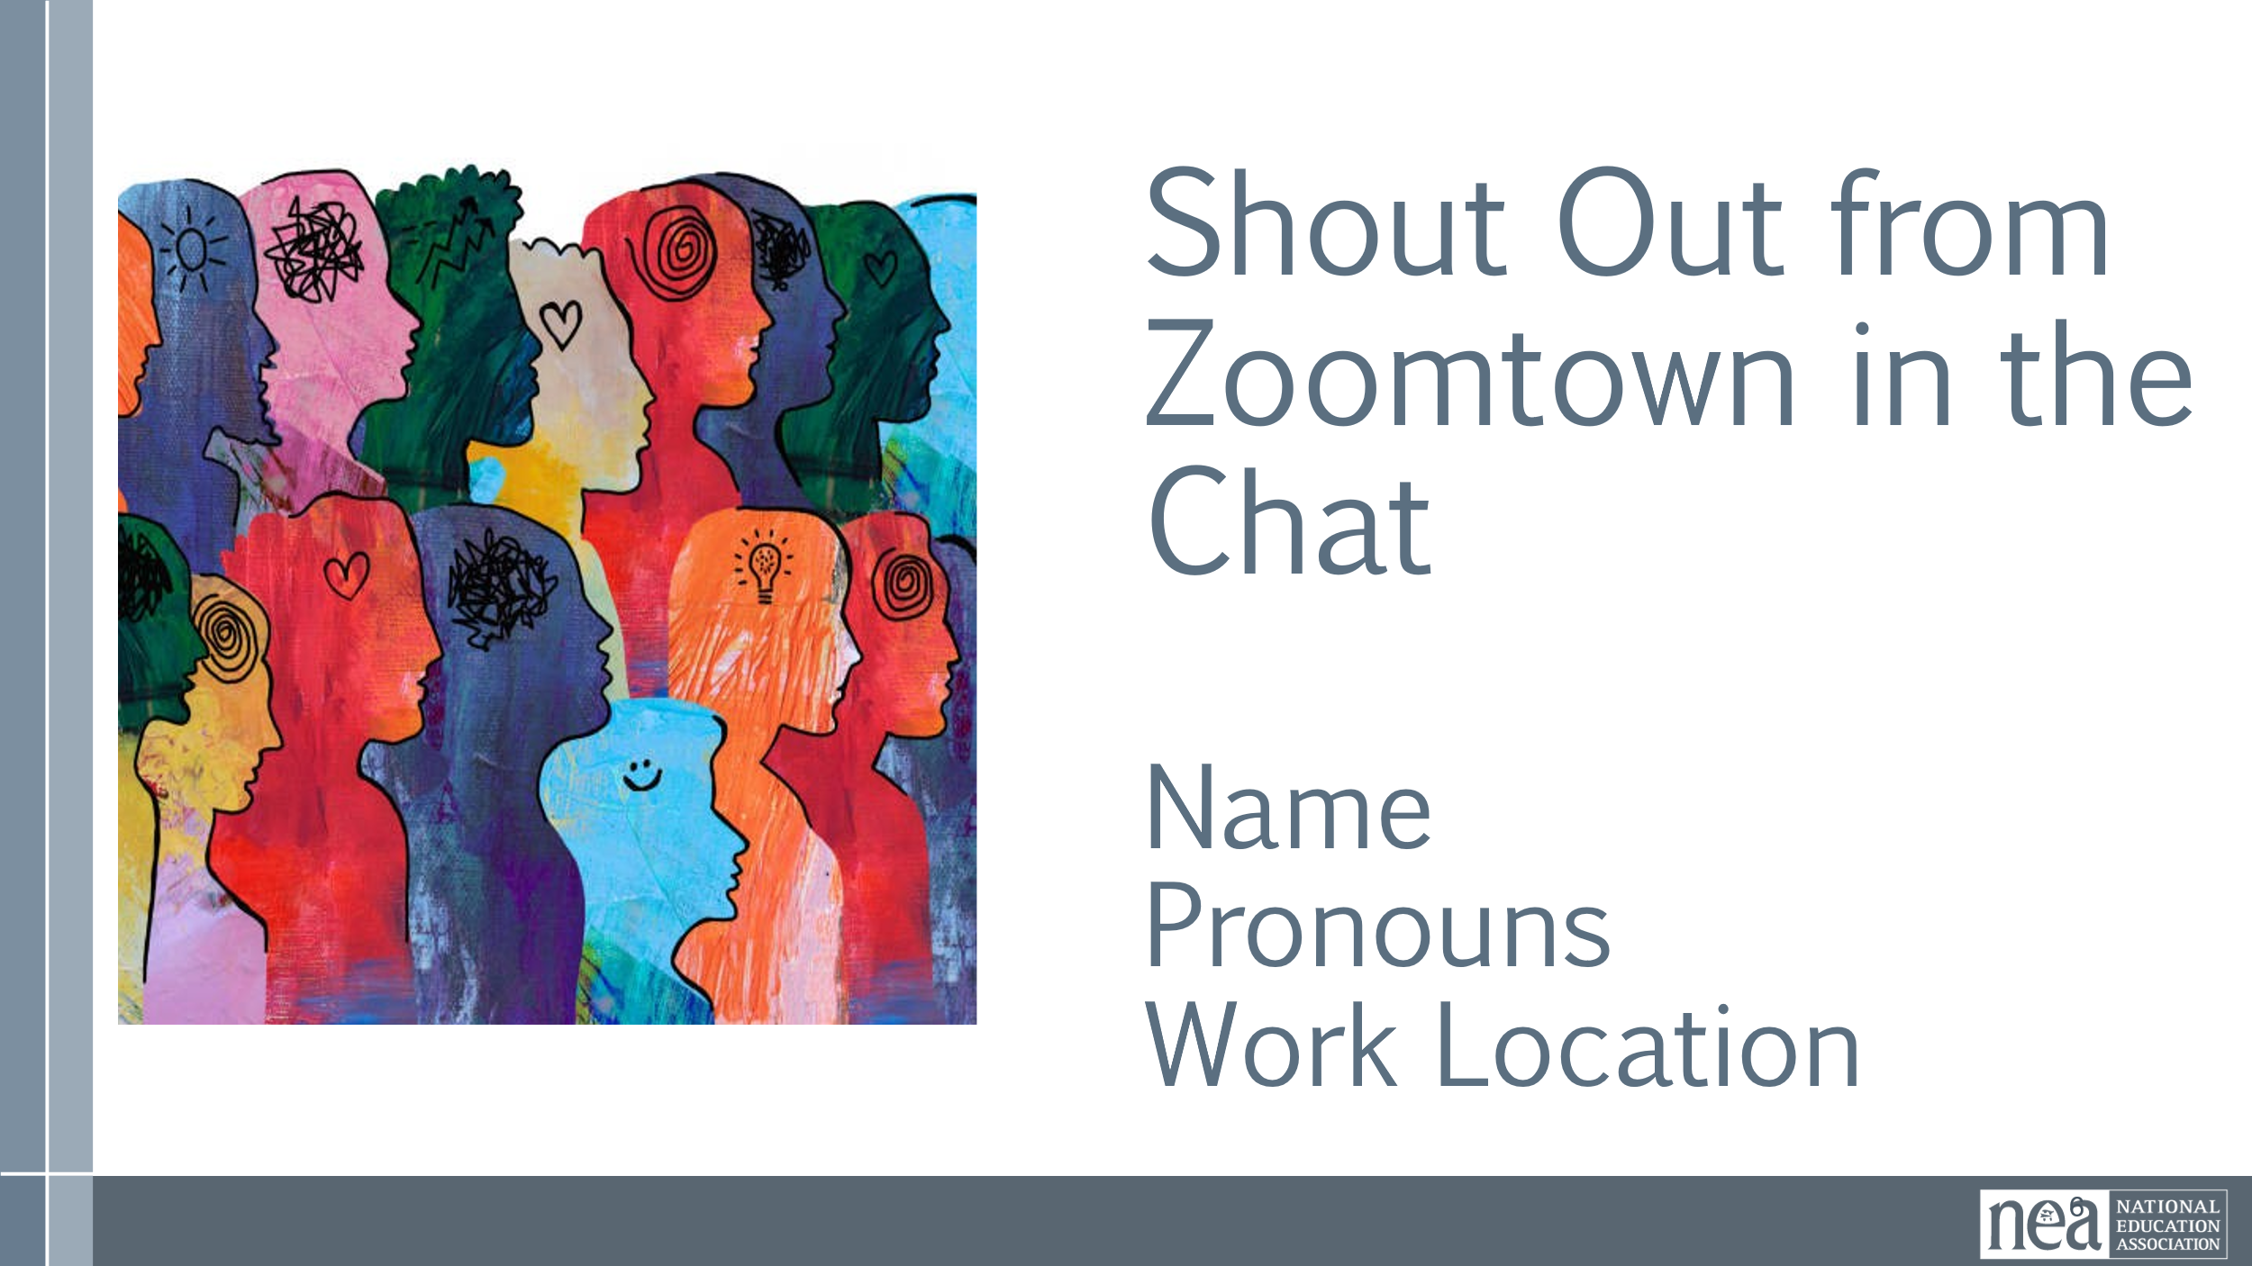 | .  Online Agreements | Welcome  Legal Slide – show it don’t read it  Honoring the Space  Key Outcomes  Facilitators model name/pronouns/state/role, while prompting Participants to add intros in the Chat Window. | Participants will know how we are going to work, the basic schedule, and the logistics relevant to the training.
20 Minutes – Alan |  | Dreams and Challenges
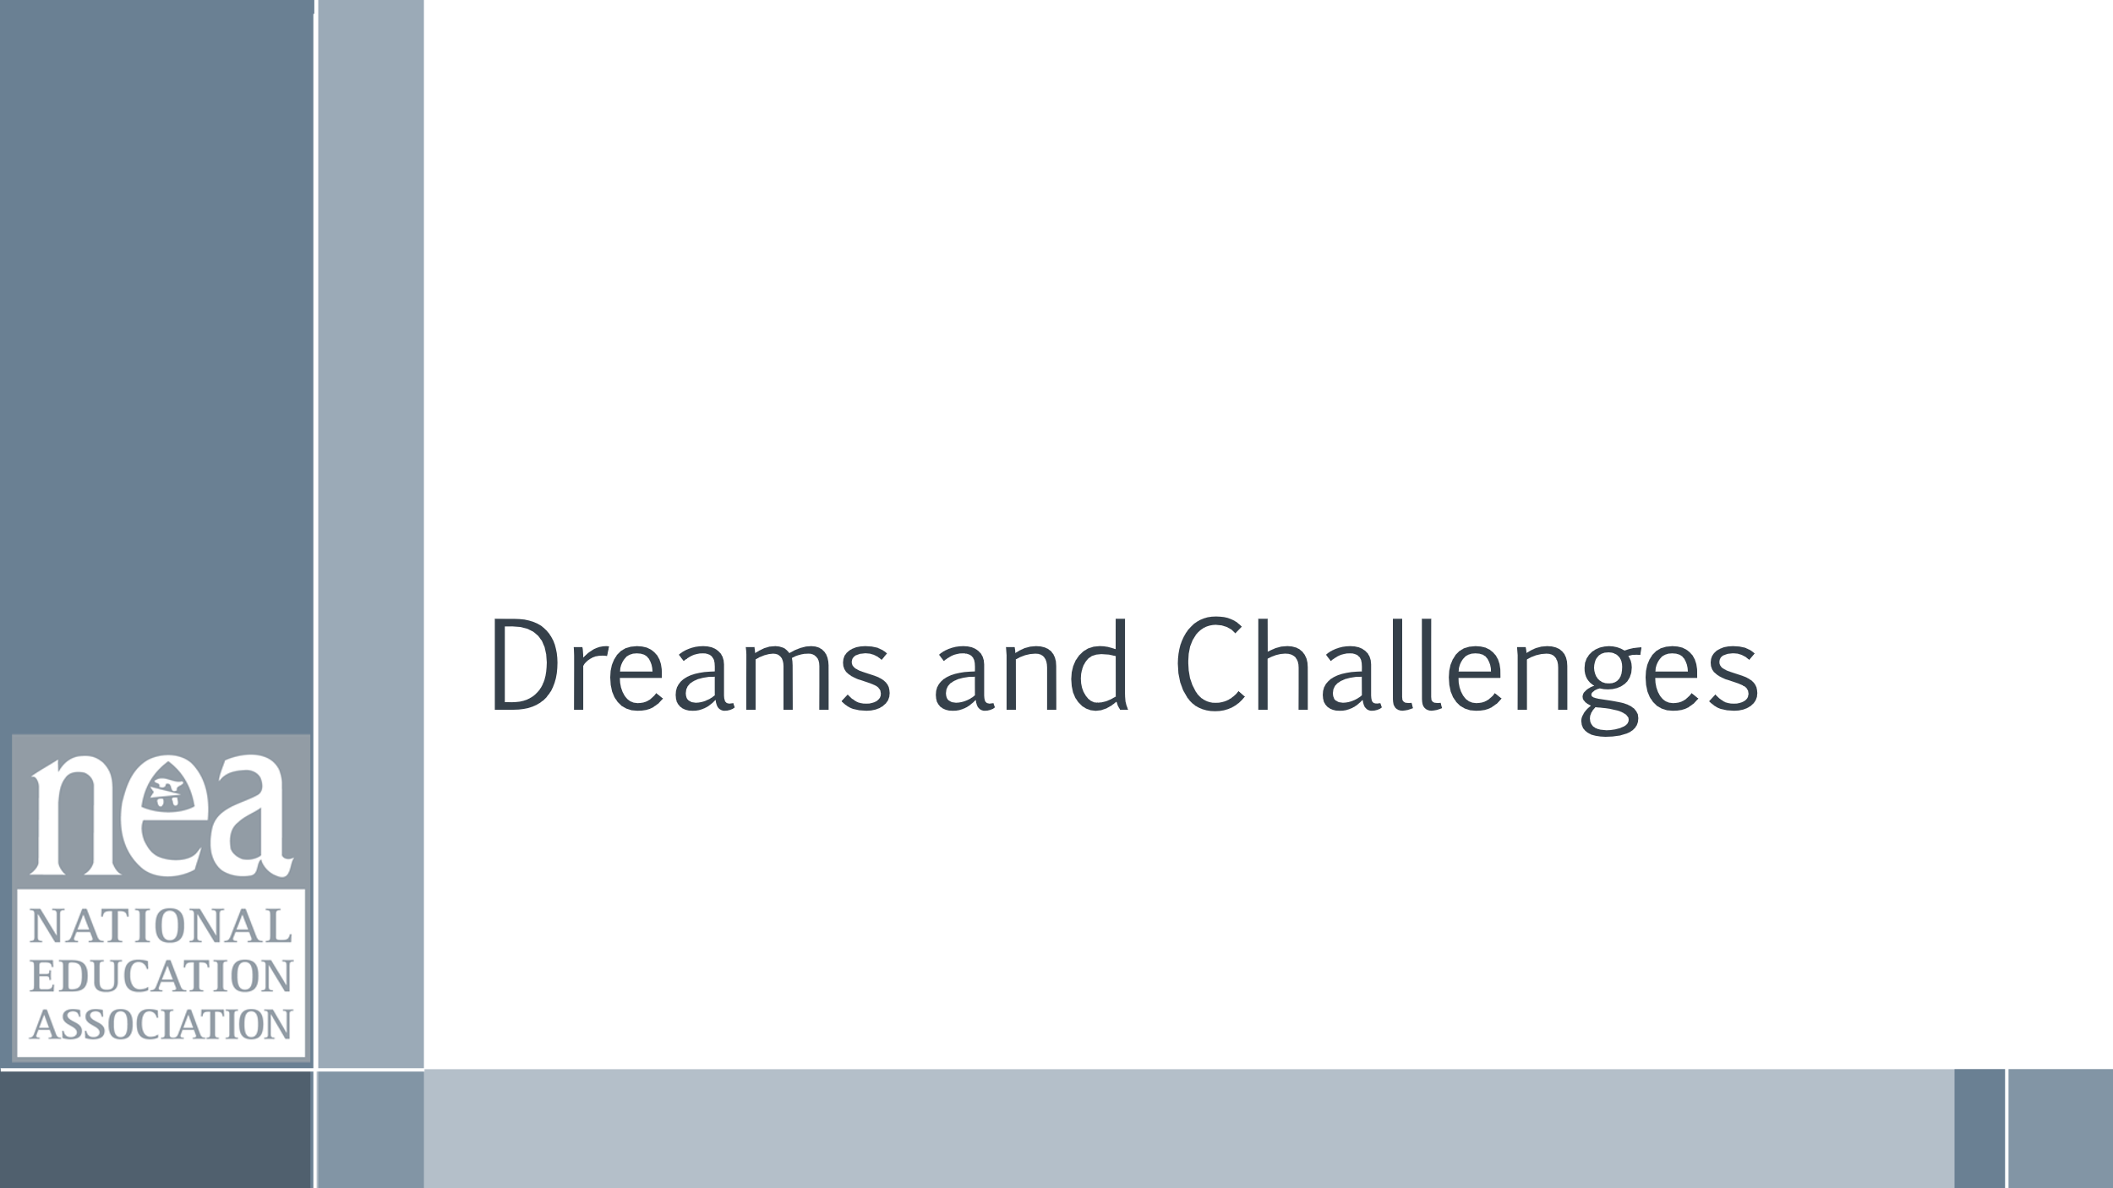      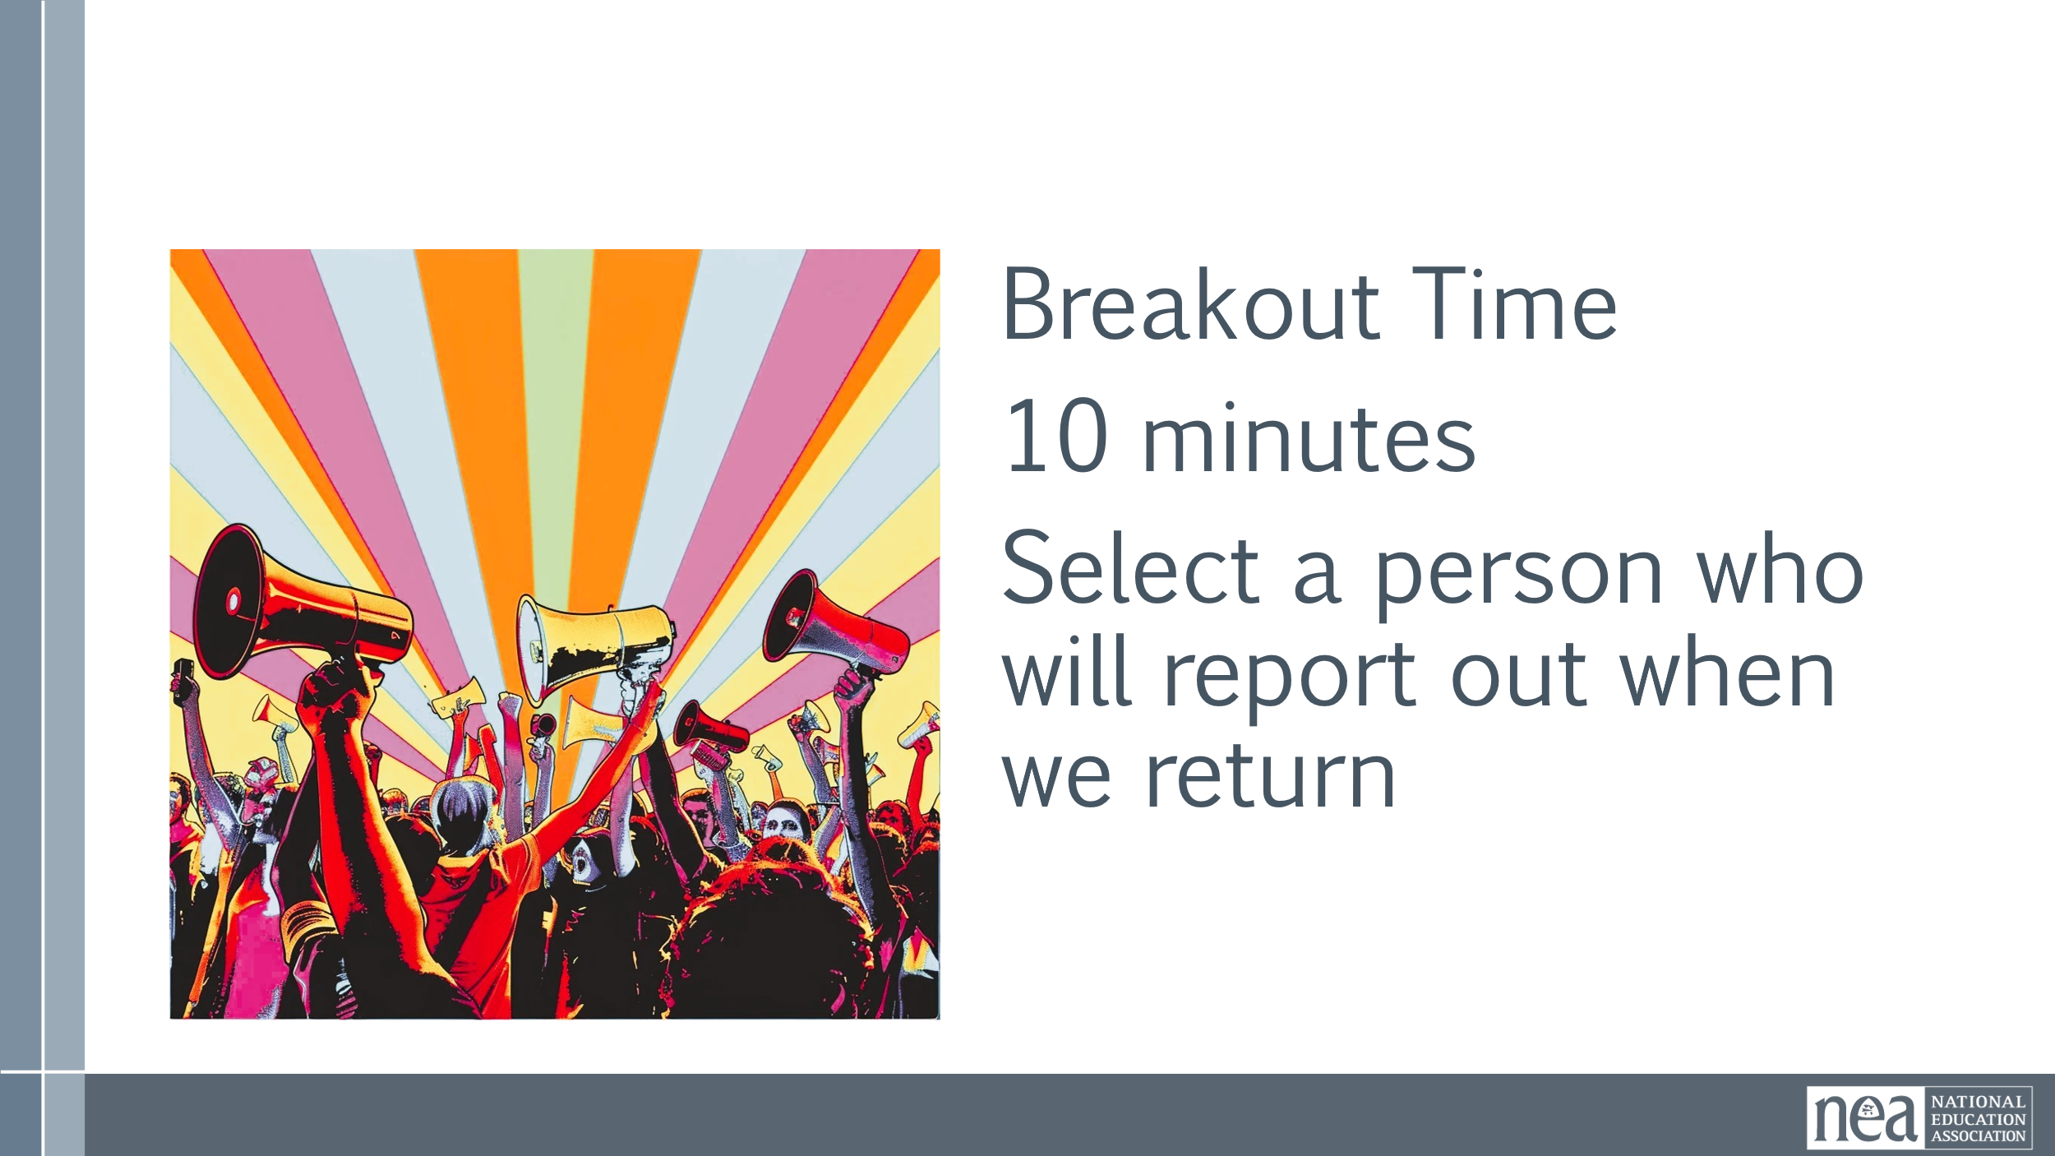  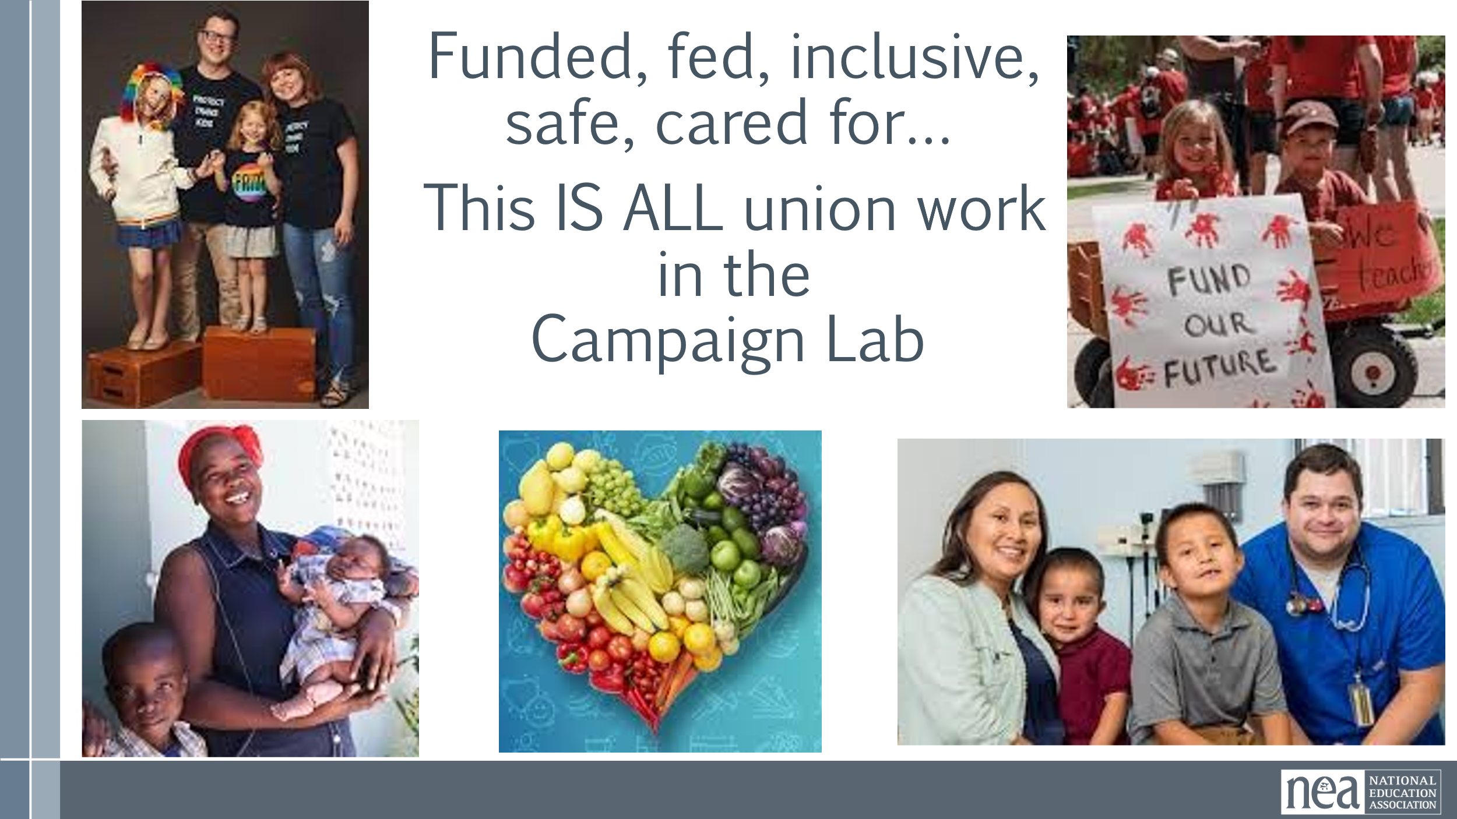 | Copy Questions into window | 3 Minutes  You are going to be placed into random breakout rooms.  You will have 10 minutes to discuss the following three ideas:  What does a Loving Community or School look like?  What of these descriptors your Union Work now?  Who or what is preventing you from achieving this dream?  Select a reporter from your group to speak when we return  (copy and past these questions into the chat window)  KEEP BREAK OUT ROOMS TO 4-5 people  10 Minutes Breakout  8 Minutes Whole Room Report out | Participants establish “world as it is” and “World as it should be”. I.
10 Minutes Ellen |  | Campaign Lab
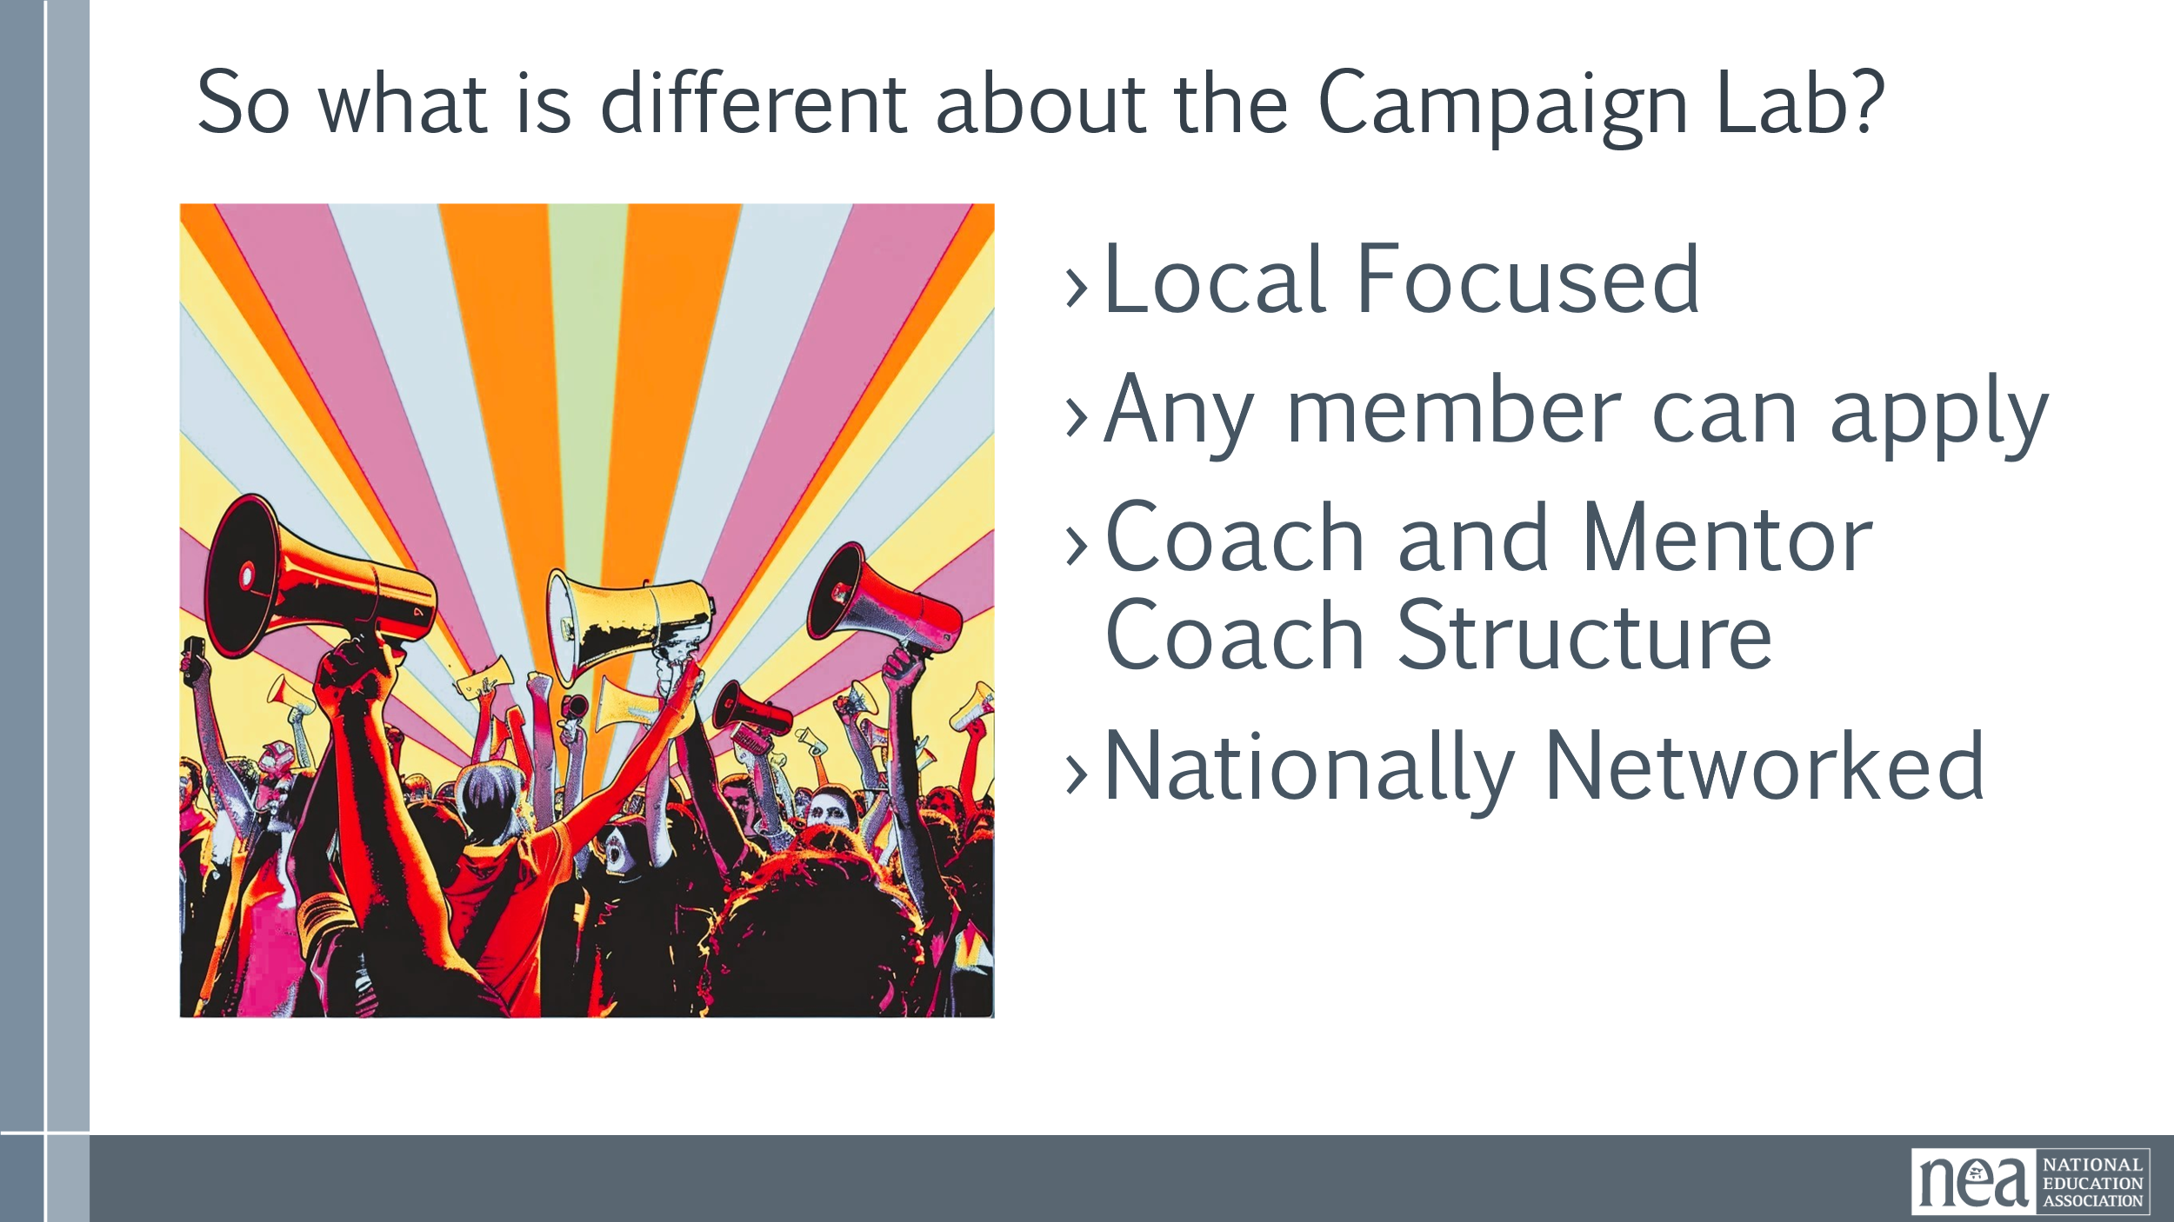  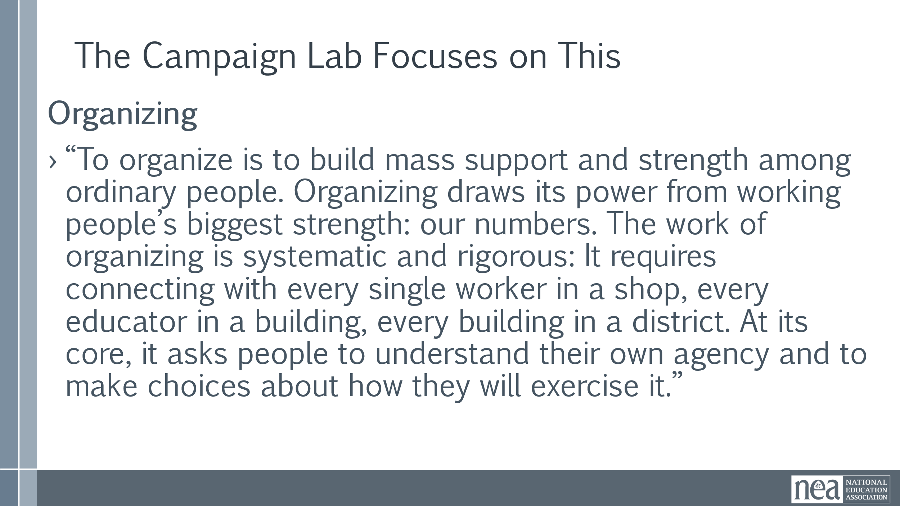  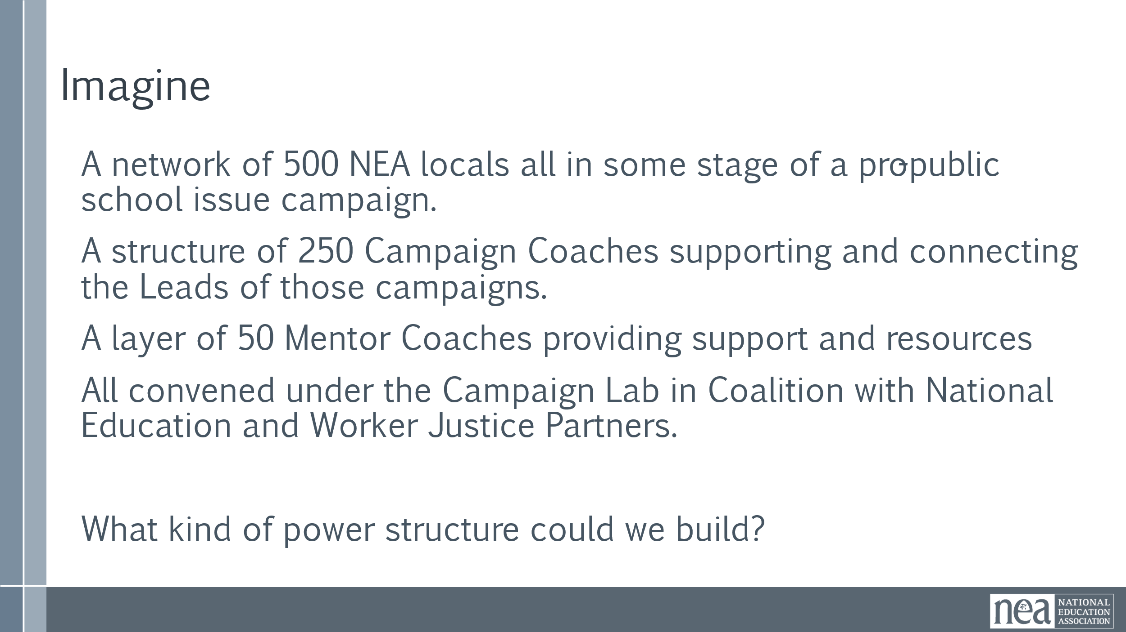  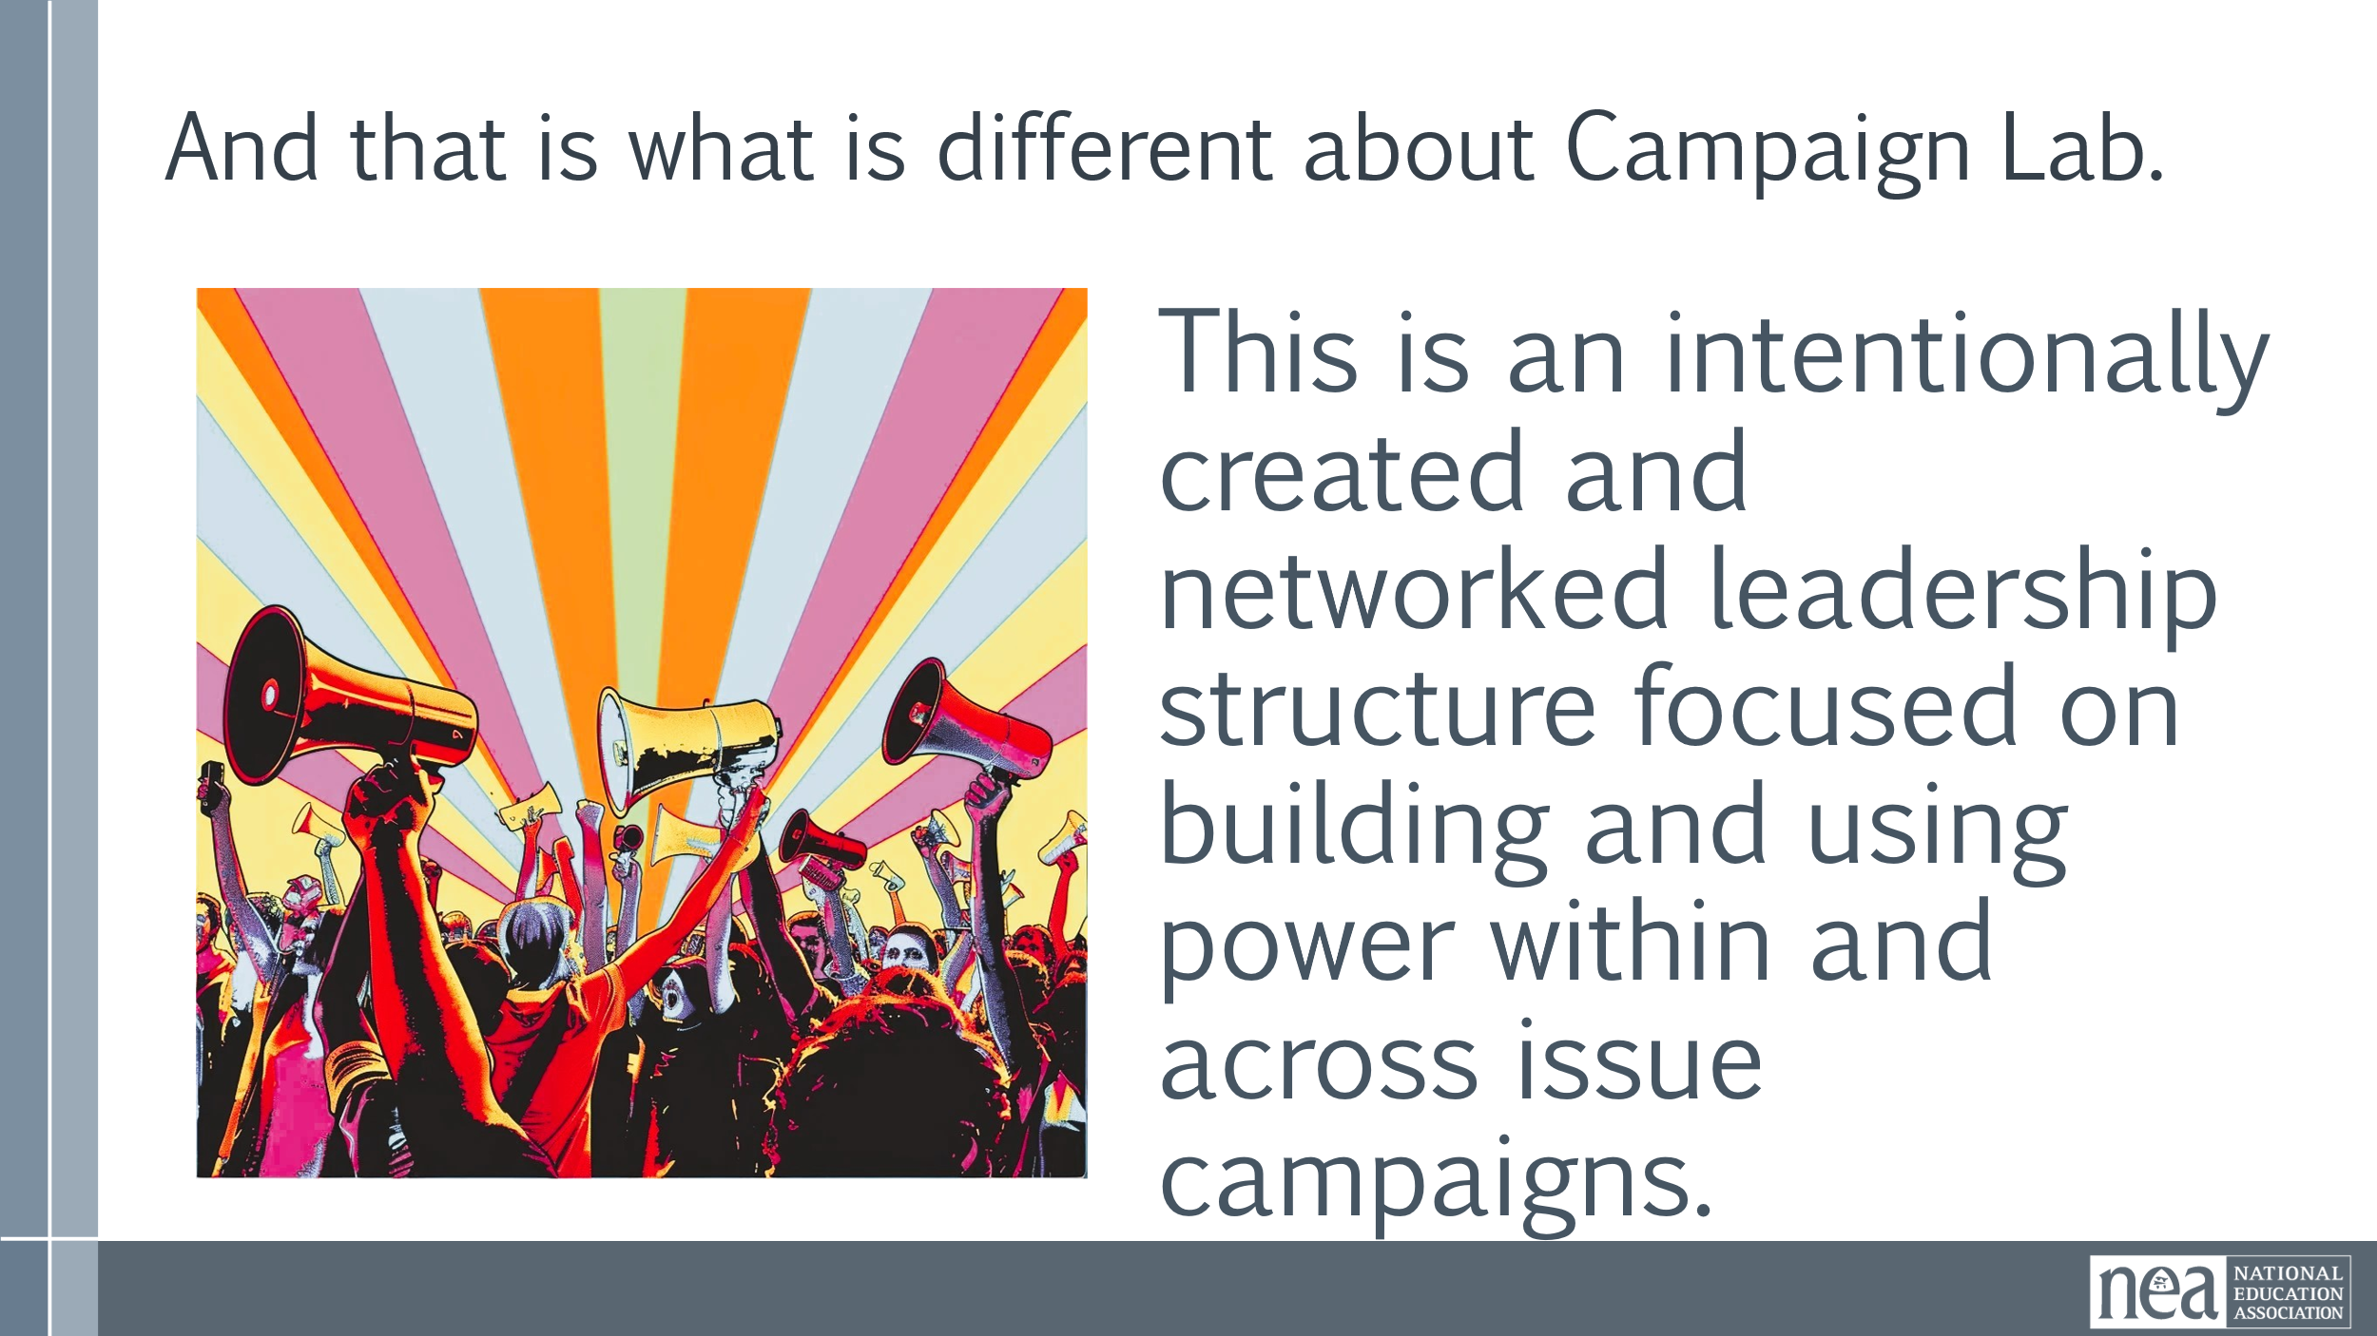 |  | All Content in the Whole Room Setting  Basically review the slides, and work in the following key points  Members (site level, across sites), Local and State have identified an issue that you want to run a campaign on. Issues are not determined by the NEA. They submit an application.  The state is notified when an application is accepted. This is so the state knows that someone in their state is about to execute a campaign. States will not review the application or be involved in interviews. BUT – if there is a major issue – we will defer to the will of the state.  Mentor coaches, NEA staff or state staff review and conducts interviews with the team for the purpose of aligning resources to support the success of the campaign. The first task of the applicant is to identify a team.  Team starts planning with their identified coach. The coach is a fellow NEA member coach, a skilled peer campaign coach, this is peer to peer coaching. The coach and the team build community, and together via coaching conversations, will determine what types of training and supports are needed to support the campaign to achieve identified goals.  Execute the campaign (includes access to ongoing coaching). Coaching involves meeting bi-weekly.  Grant (up to $2500) to be utilized to support events and activities related to your campaign. This could include funds for release time for internal organizing. This is not funding to pay stipends (we have some locals where leaders think if we pay people they will participate).  Monthly meetings- with teams from across the country who are running campaigns. Your team is a part of a larger community of campaigners. Sharing experiences, building community. | Participants will understand the basic premise of the Campaign Lab
20 Minutes Taraja |  | Possibilities
  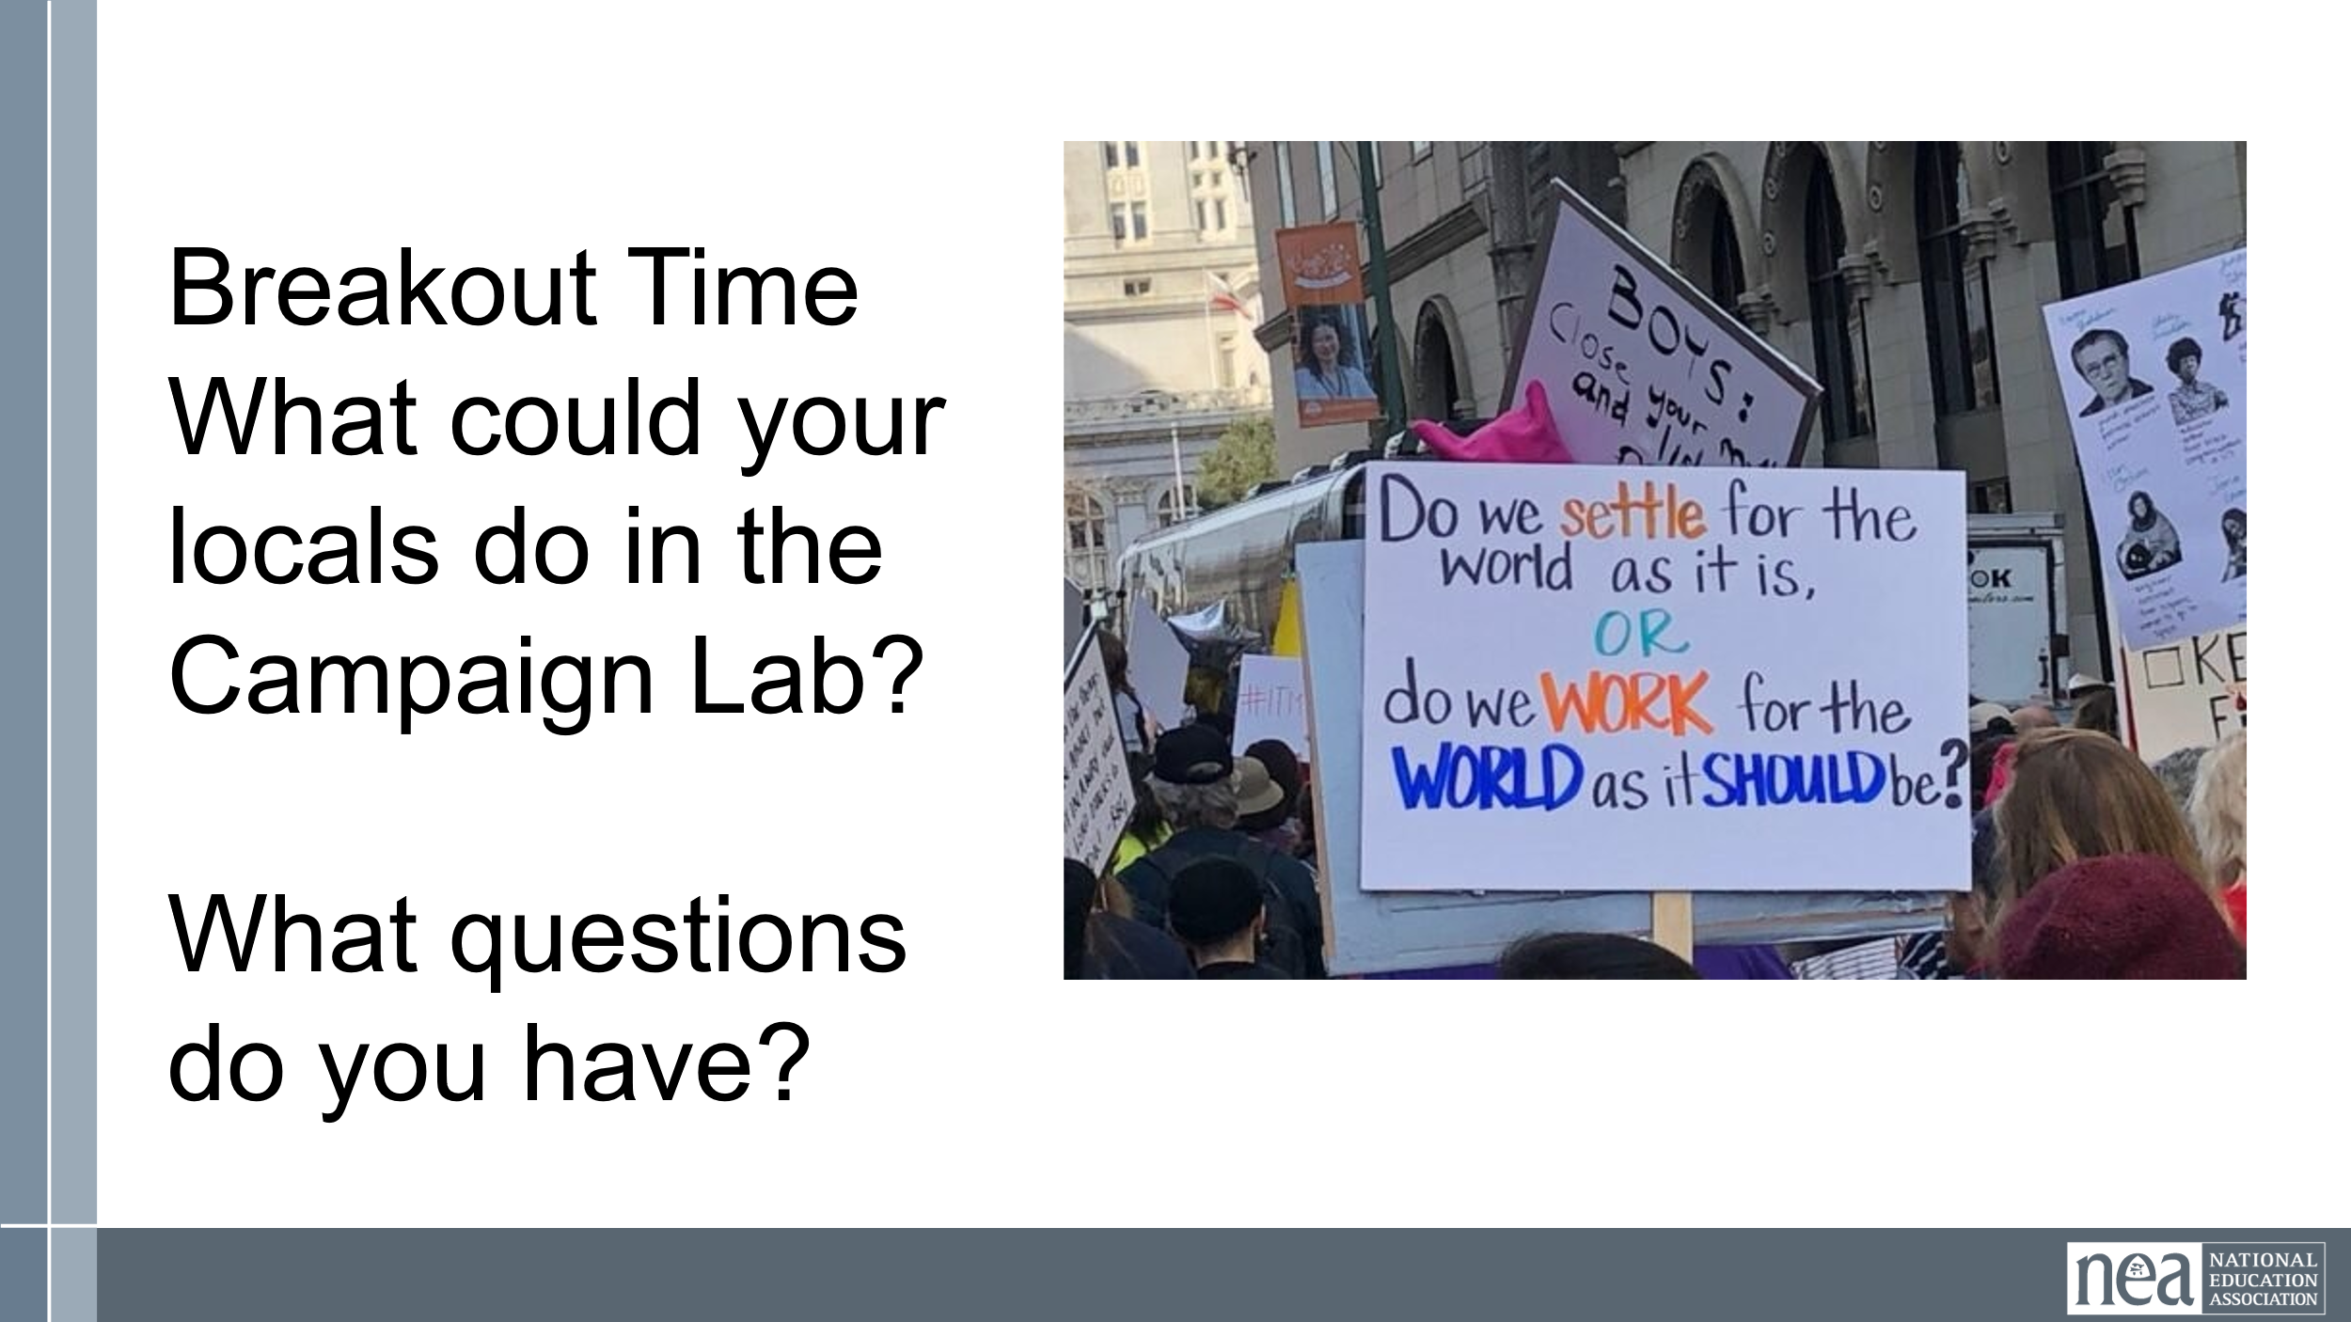 |  | 3 Minutes  You are going to be placed into random breakout rooms.  You will have 10 minutes to discuss the following :  What could your locals do in the Campaign Lab?  What questions do you have?  Select a reporter  (copy and paste these questions into the chat window)  KEEP BREAK OUT ROOMS TO 4-5 people  10 Minutes Breakout  10 Minutes Whole Room Dialogue about the possibilities and answering questions. Encourage them to also post in the chat so in case we don’t get to all the questions, we can follow up. | Participants will have an opportunity to discuss how they might use Campaign Lab with their locals.
15 Minutes Halimah /Ellen |  | Nuts and Bolts
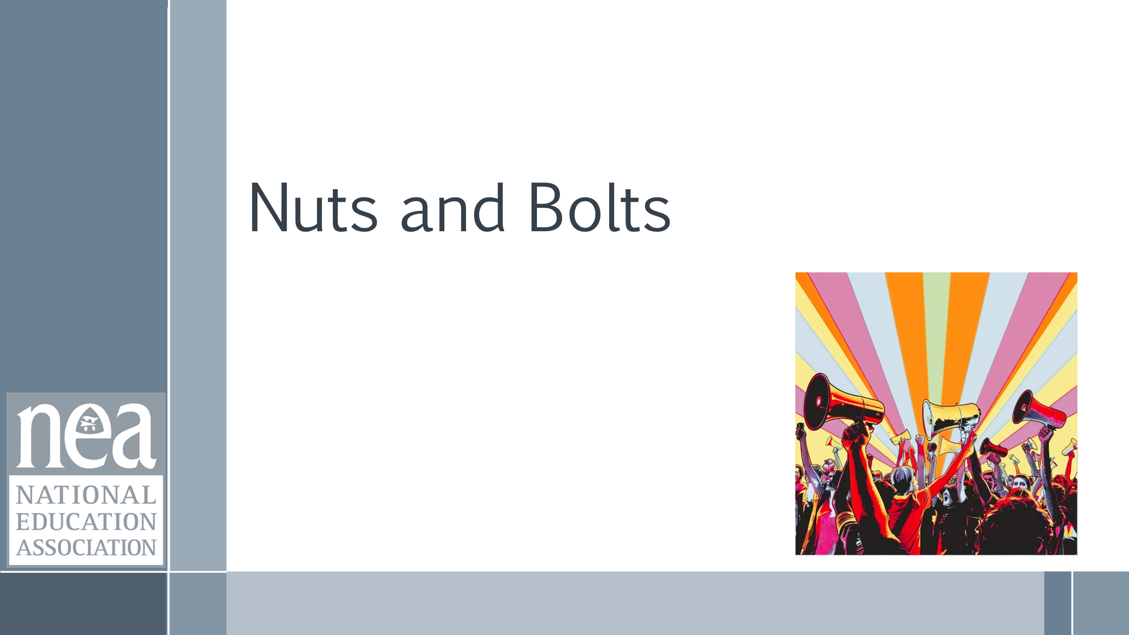  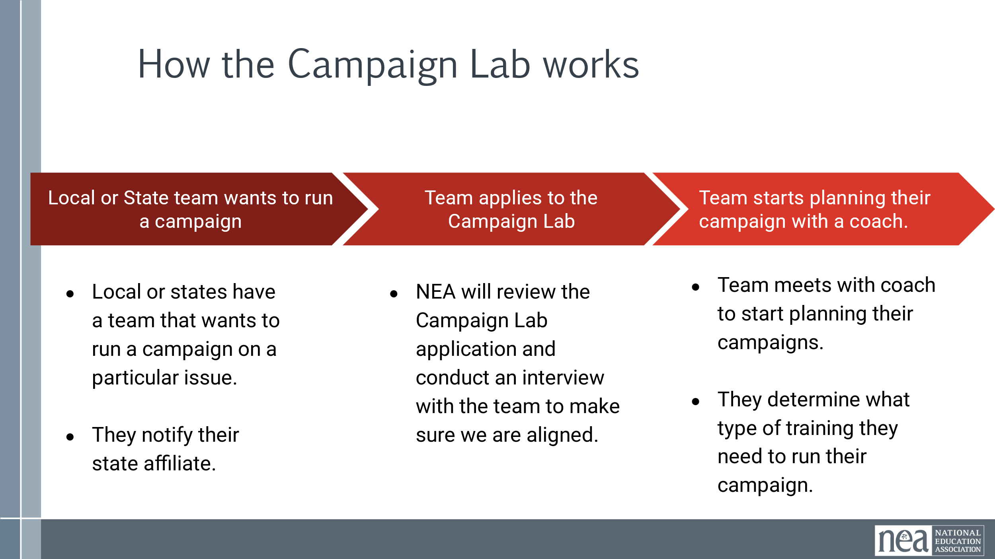  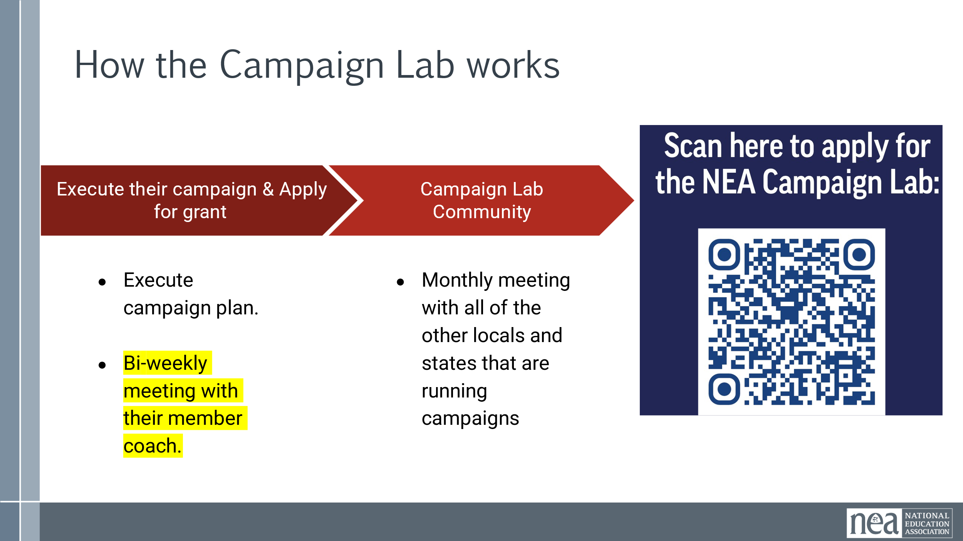  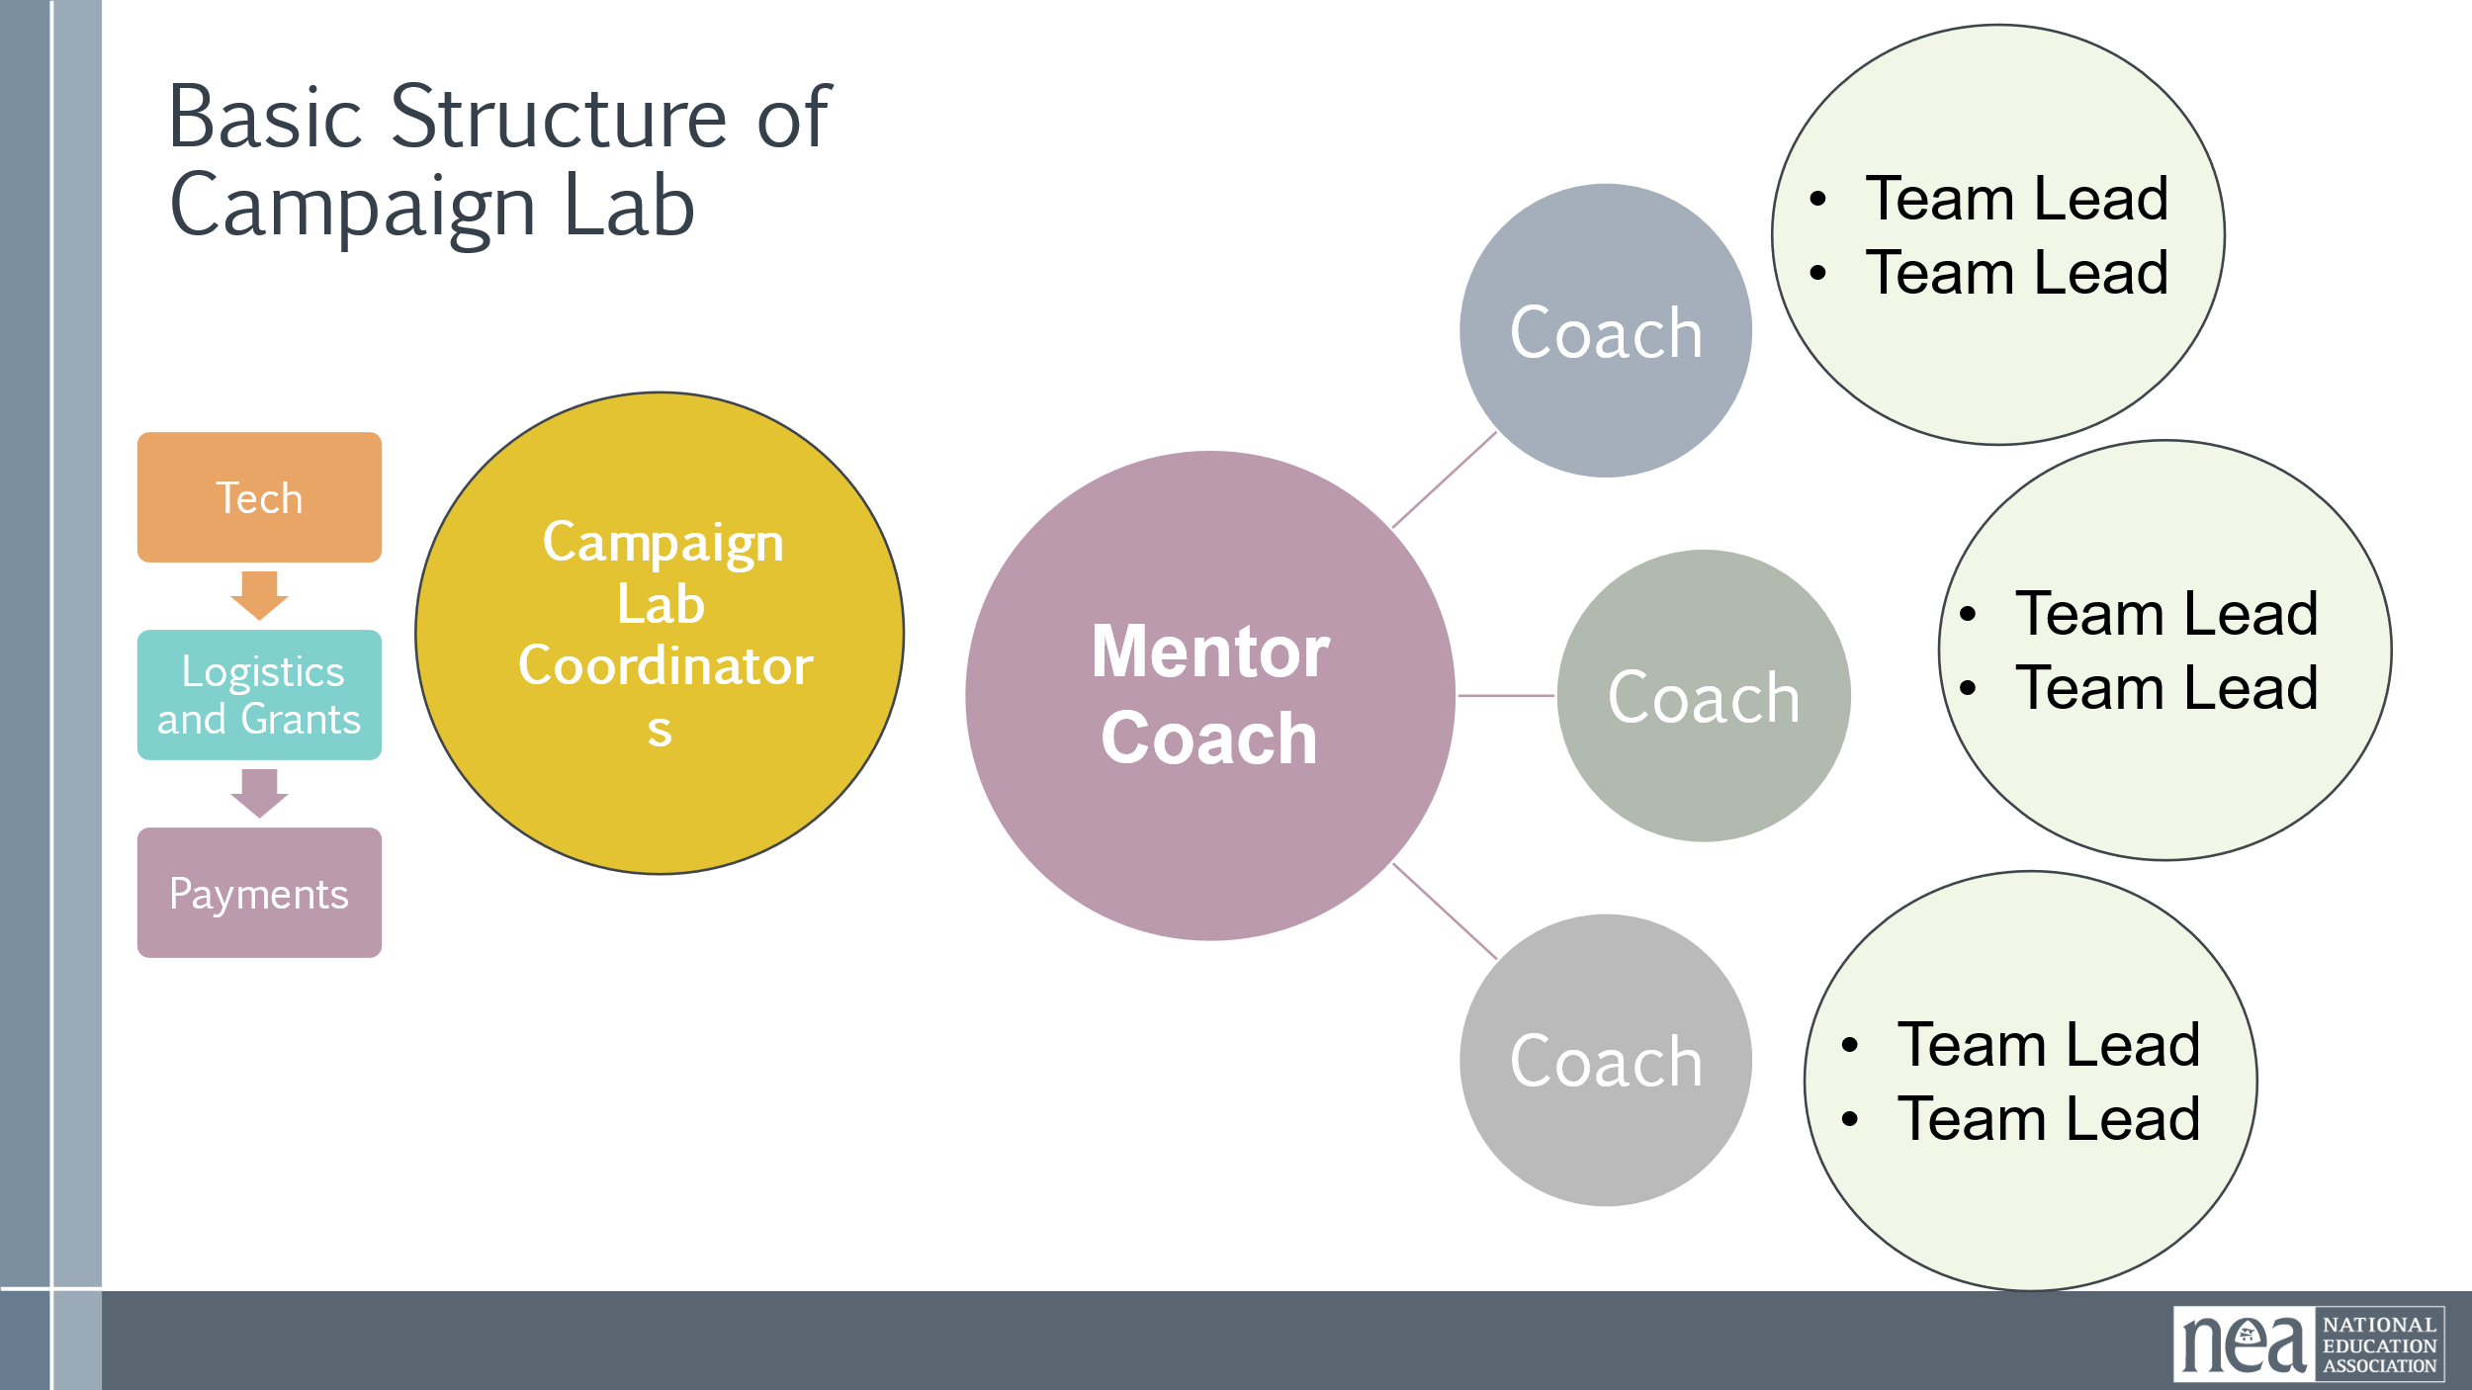  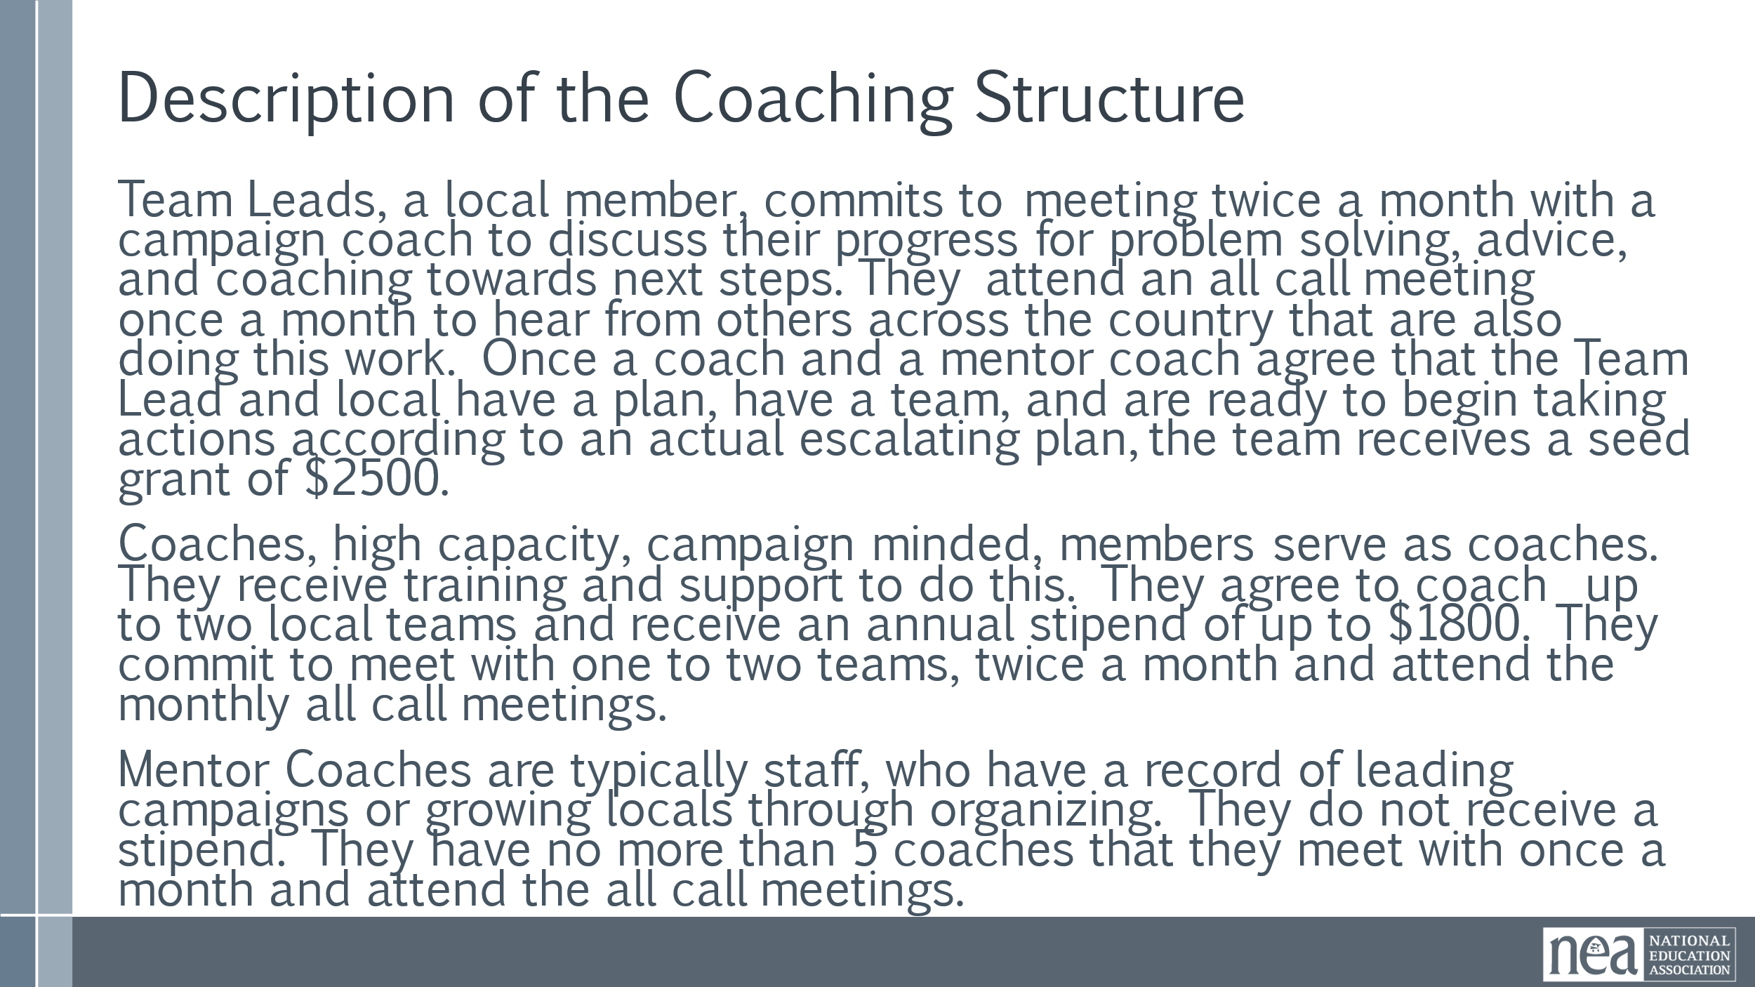  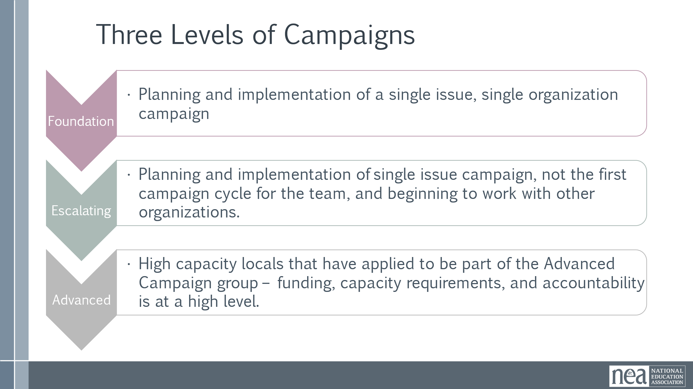  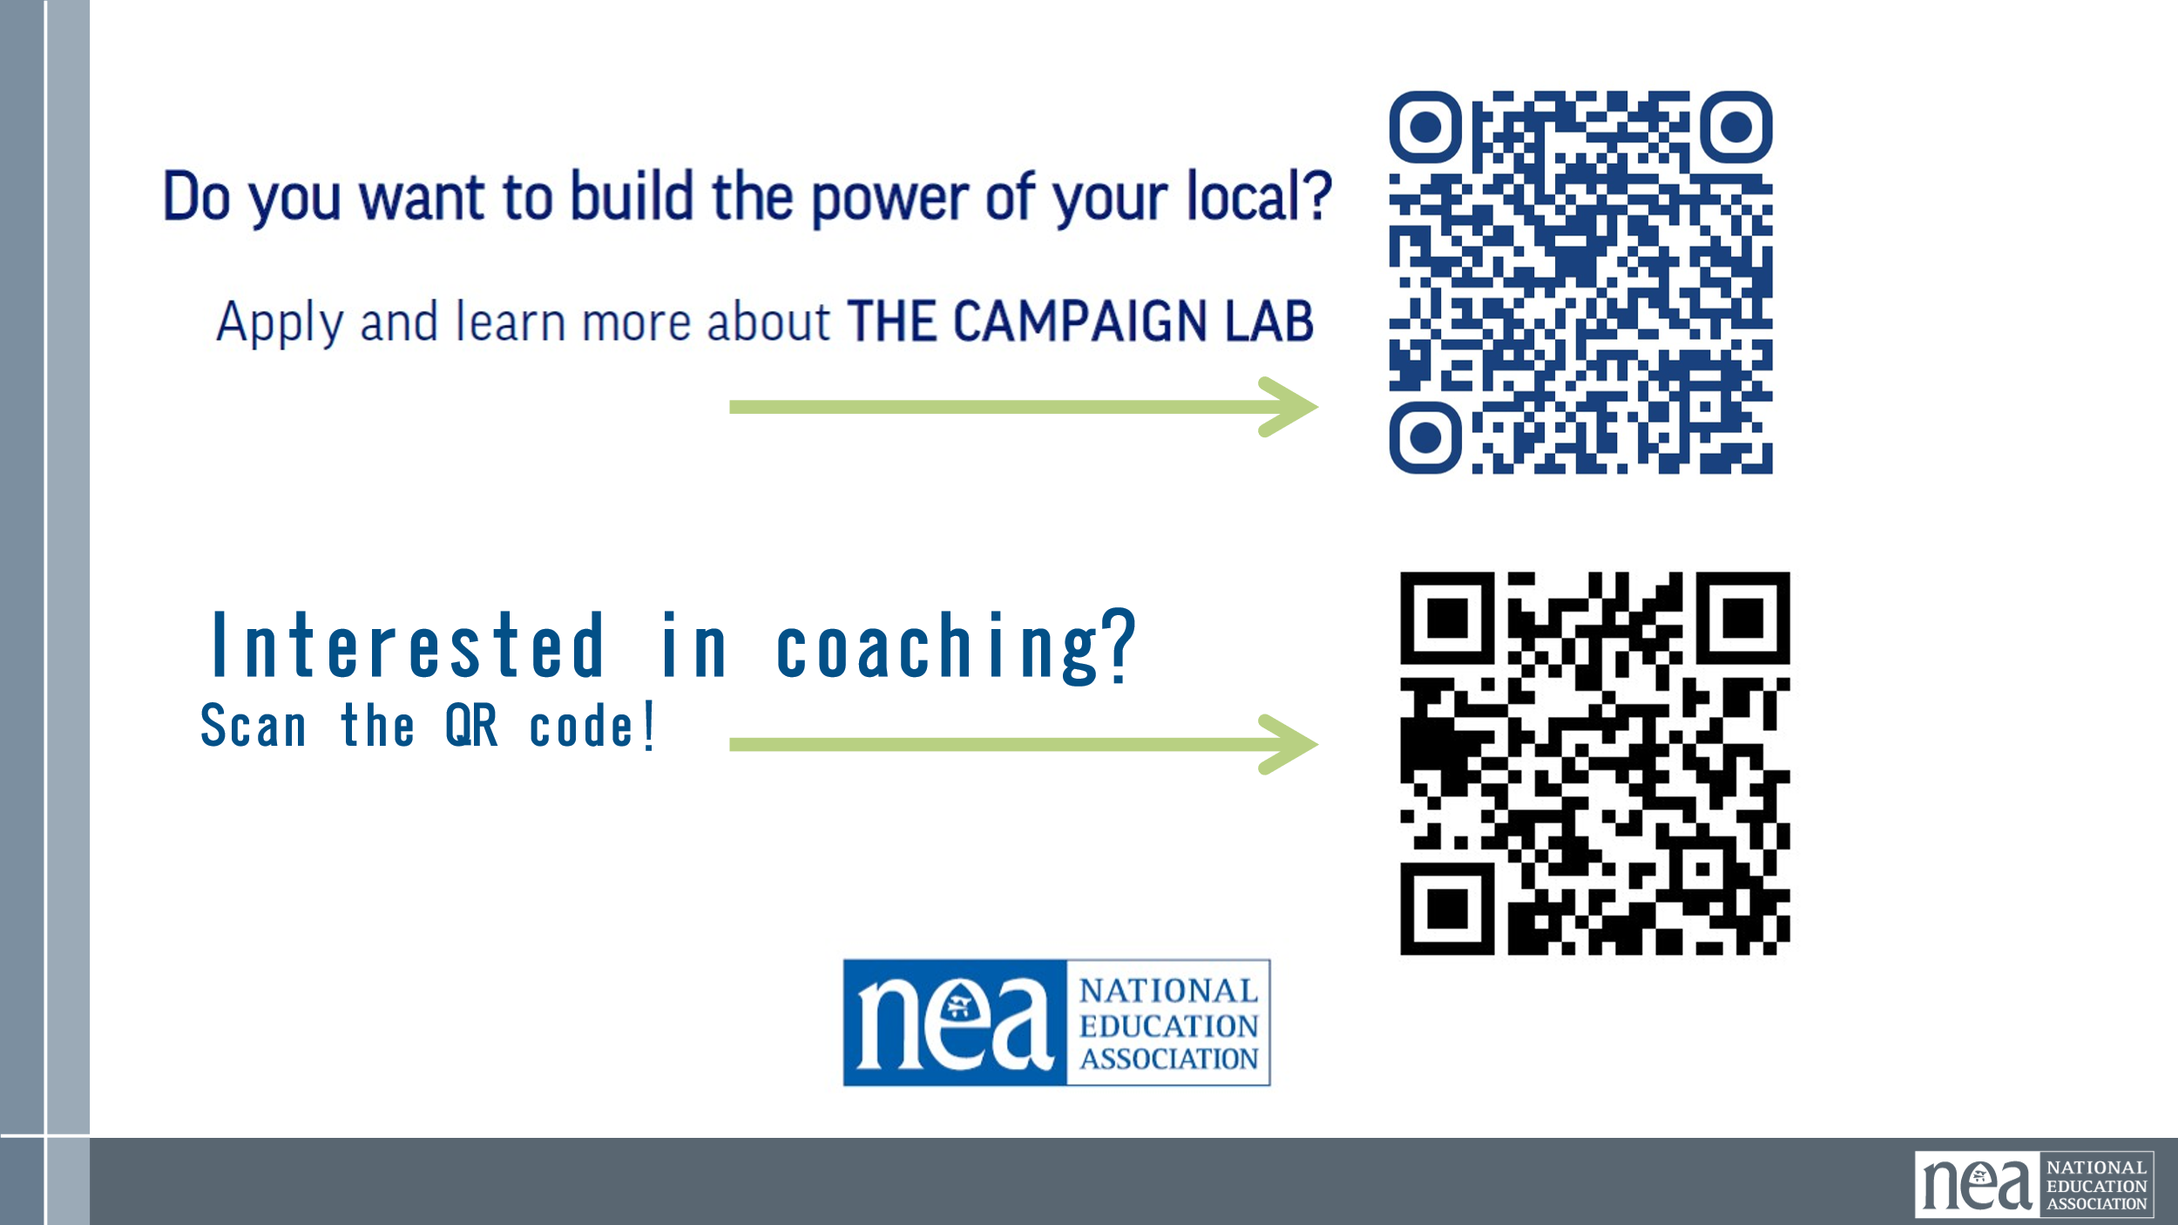 | PDF Flyer  PDF of Roles | (This is a suggested Script to go with the slides)  7 Minutes Content and 8 Minutes of Questions  It all begins with someone who wants to make a change. They start an application and notify their state that they want to make that change. They become the Team lead.  The application is reviewed by the Campaign Lab coordinators and the Mentor Coaches. If accepted, the state is notified and a coach is assigned.  That coach works with the lead to develop a campaign plan and identify a campaign team. At that point, the funds are sent to the local if they have a W-9 on file with NEA and if they have the ability to accept and distribute funds. If not, it is sent to the state.  The commitment for the local team lead is that they meet twice a month with a campaign coach to discuss their progress and receive just in time problem solving, advice, and coaching towards next steps. They also agree to attend an all call meeting once per month to hear from others across the country that are also doing this work. What this is NOT is the NEA managing your campaign or telling you what to do. YOU know what your local needs and the structure is intentionally lateral/collective, not top-down. Coaches are members who apply, are interviewed, and trained on the specific practices for coaching a campaign. Coaches support the team Team lead with questions, ideas, and connections available in the NEA universe. Coaches are supported by mentor coaches who are typically affiliate staff who have been trained in specific coaching practices. They help connect the coaches with other campaigns and resources within NEA for the implementation of the local campaigns they are coaching.  Team Leads, a local member, commit to meeting twice a month with a campaign coach to discuss their progress for problem solving, advice, and coaching their local campaign team towards next steps. They attend an all call meeting once a month to hear from others across the country that are also doing this work. Once a coach and a mentor coach agree that the Team Lead and local have a plan, have a team, and are ready to begin taking actions according to an actual escalating plan, the team receives a seed grant of $2500.  Coaches, high capacity, campaign minded, members serve as coaches. They receive training and support to do this. They agree to coach up to two local teams and receive an annual stipend of up to $1800. They commit to meet with one to two teams, twice a month and attend the monthly all call meetings.  Mentor Coaches are typically staff, who have a record of leading campaigns or growing locals through organizing. They do not receive a stipend. They have no more than 5 coaches that they meet with once a month and attend the all call meetings.  There are three levels of campaigns in the campaign lab system  Foundations ($2500 first timers – single issue single organization campaigns)  Escalating ($2500, possibly renewed, working on either multi issue or multi organization campaigns. Not their first campaign cycle.  Advanced (high Capacity, High Resource locals, with a history of being in multi issue multi organization campaigns – there is a separate application for this – funding is significant as is the expectations, coordination, and accountability. | Participants will learn how the Campaign Lab works and the structure of it.
5 Minutes Alan |  | Closing
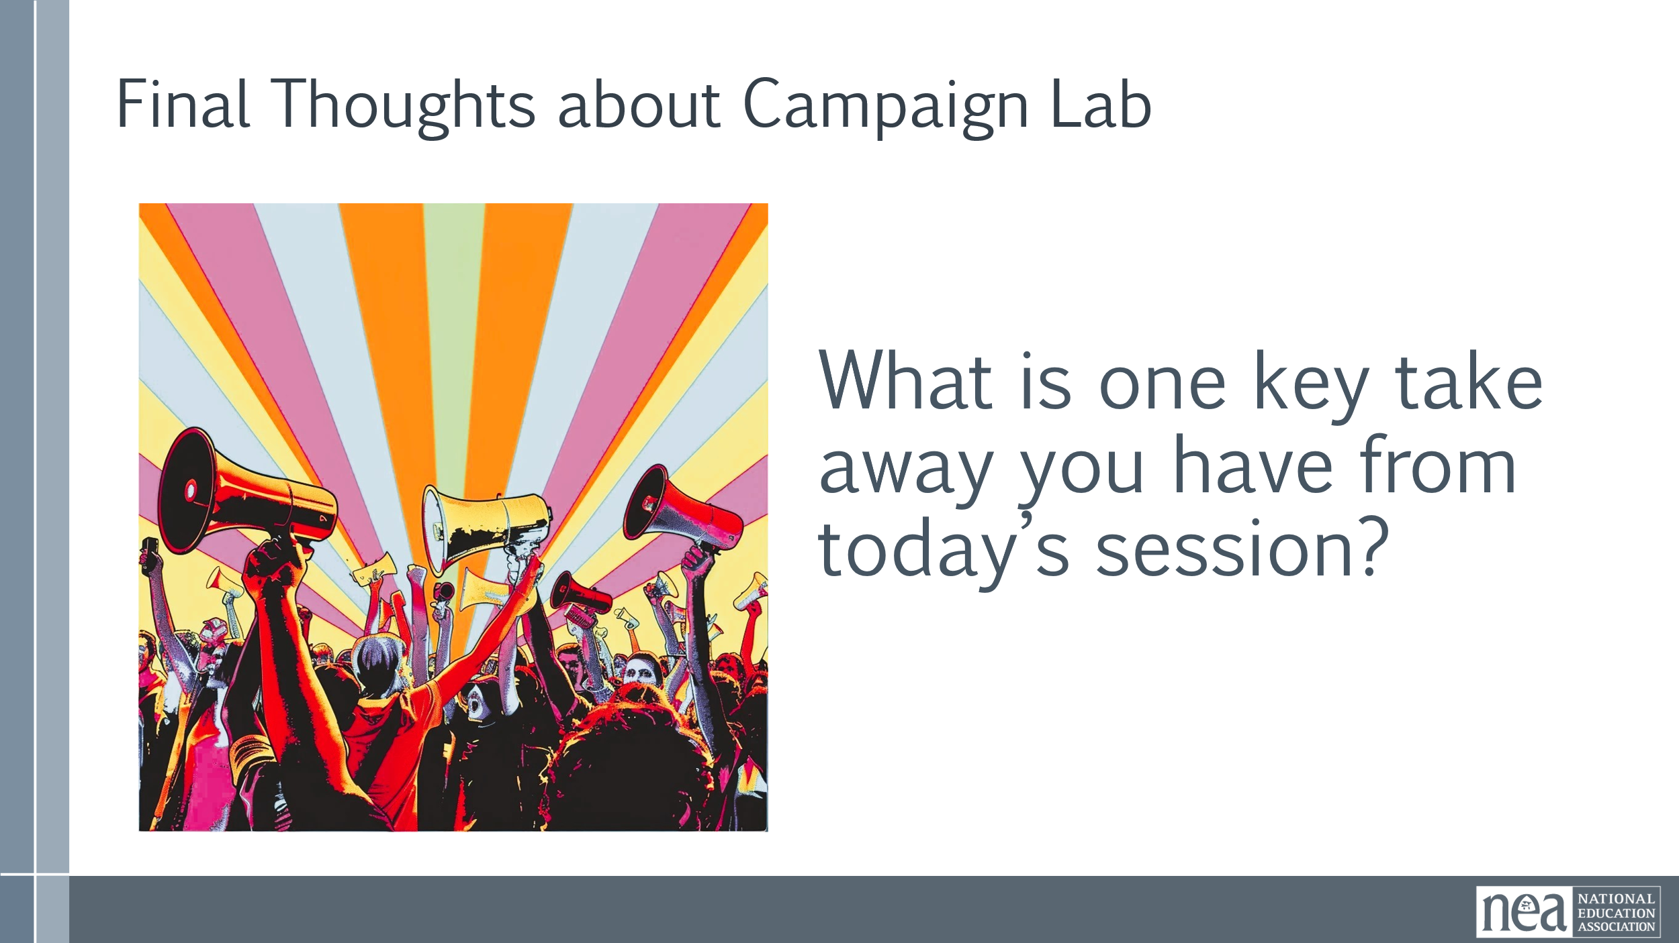  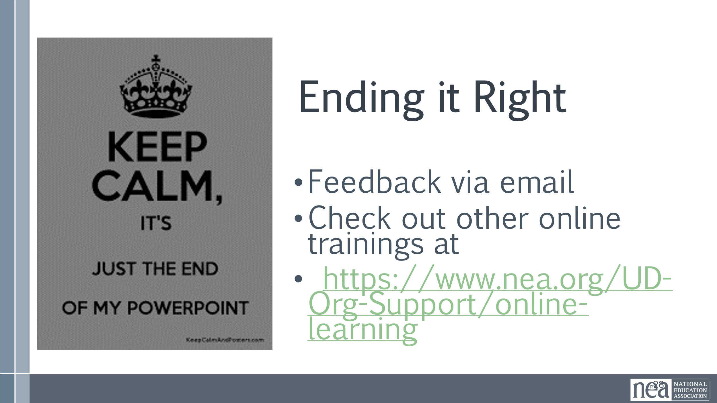 | Feedback link for chat | This is whole group  What is one key take away you have from today’s session?  Take comments and also encourage adding to chat  - Feedback via email and link in chat – 7 short Questions  - Check out other online trainings at  - https://www.nea.org/UD-Org-Support/online-learning  COPY AND PASTE INTO CHAT  Feed back form  https://forms.office.com/r/XnV9pzpvgk | Participants will share their final thoughts.
Adjourn

