May Day – NEA Engagement, Impact, and Outcomes

Introduction – Why Did NEA Engage?

The May Day coalition of over 200 organizations, including major national labor unions and hundreds of community organizations, planned and executed 1,273 mass mobilizations, from strikes to sit-downs to rallies, across 1,031 cities and towns nationwide between May 1 and May 3. This was the most widespread May Day action is history! NEA was a proud partner in this effort, mobilizing members across the country, including a major event in Washington, DC.

The National Day of Action was conceived when our partner, Bargaining for the Common Good, invited key labor and community allies to come together and conceived of a major set of actions to demonstrate the strength of labor-community coalitions and kick-off an effort to build toward a major national mobilization in 2028. The demands of networked actions were laid out as follows:

STOP THE BILLIONAIRE TAKEOVER. WE ARE THE MANY. THEY ARE THE FEW. THIS IS MAY DAY. OUR DEMANDS TO BUILD THE SOCIETY WE ALL DESERVE:
- Stop the billionaire takeover and rampant corruption of the Trump administration.
- Protect and Defend Medicaid, Social Security, and other programs working people rely on.
- Fully funded schools, healthcare, and housing for all.
- Stop the attacks on immigrants, Black, indigenous, trans people, and other communities.
- Invest in communities not wars.

May Day was not just a series of rallies—it kicked off a long-term strategy. The partners and activists who came together will continue organizing for a world where every family has housing, healthcare, fair wages, union protection, and safety—regardless of race, zip code, or immigration status.

The Chicago Grassroots Meeting

In late March following our 3.19 Walk Ins, a meeting of over 250 grassroots leaders from all parts of the social justice movement came together to begin discussing and planning for May Day 2025, and how our respective unions and organizations could engage. NEA had over twenty leaders in attendance, including state affiliate leaders from Colorado, Maryland, Massachusetts, and North Carolina.

Planning and Logistics

Shortly after the Chicago convening, NEA convened a cross-center team of nearly 40 staff that jumped into action to move May Day events across the country. From setting up a Mobilize registration for nationwide events to crafting a toolkit for participants to host events (in record time) to building out a communications plan and building out logistics for our DC event led by CASA, this team worked tirelessly to move all logistics for the event forward. NEA staff liaised with the broader May Day coalition, as well as with CASA to drive the event in which our leaders engaged in DC. We engaged our Executive Committee to liaise with state affiliate leaders to mobilize locals in an effort to meet our goal of a minimum of 185-190 local events, and further engaged them to lead small groups during the DC march on May 1. Great credit and kudos to the staff team that harnessed the resources of NEA to move this effort forward.

What Happened?

We were part of the team that produced the most widespread May Day in history. This was possible because national and local partners came together in huge numbers, more than 200 partner organizations, including dozens of additional partners who helped support events across the country. Partners who signed on to the May Day Strong coalition included Bargaining for the Common Good, the National Education Association, Indivisible, Working Families Party, the Chicago Teachers Union, MoveOn, Public Citizen, and many more. Check out the full list here. These national, state and local coalitions will become the foundation of building for the future.

The May Day Strong mobilization aimed to center the narrative on class interests that cast billionaires as villains and builds a ‘broader we’ for working class Americans. They also worked to promote a broad swath of demands that can express a positive vision for the country and unite disparate forces under one banner, “our families over their fortunes.”

In Washington, DC, NEA members were able to engage in a march and rally led by CASA that engaged nearly 10,000 people from across the DMV, including almost 300 NEA members and staff. NEA President Becky Pringle spoke, joined onstage by Vice President Princess Moss, Secretary-Treasurer Noel Candelaria, and Executive Committee member Christine Sampson-Clark. Our members were not just part of a one-day event – they were a part of the movement, and part of the continued cadence of growing that movement.

The Impact

May Day Communications Recap

Reporting Period: April 21 – May 5, 2025

Over the two weeks before and following May Day, we launched a coordinated digital push to amplify worker voices, highlight organizing efforts, and drive engagement across our platforms.

Digital and Creative Coverage

Social Media
Our social media coverage sought to reinforce the connection between NEA members and the rest of the labor movement, tying together traditional union messaging with the national call for investment in public schools and our communities.

Our day-of coverage focused on educating followers about May Day and bringing them into the action through content from D.C. and 15+ other local events.

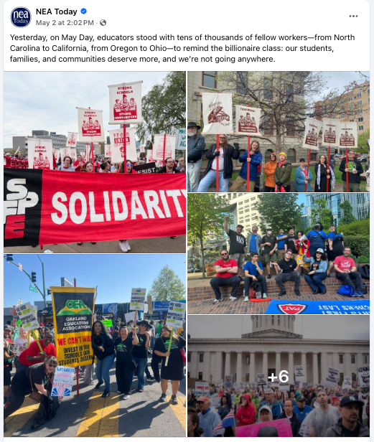
- Examples:
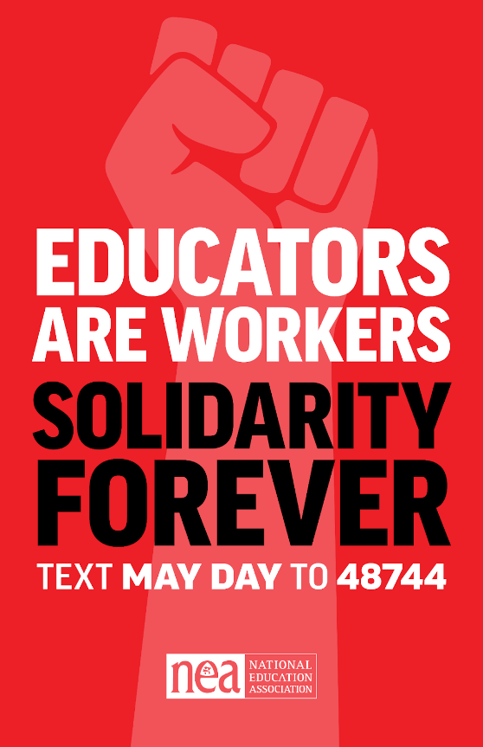

- Performance:
- 107 posts, reels, and stories across platforms
- 244,454 impressions
- 16,025 total engagements
- 7% engagement rate (well above industry average)

Video
We created a series of videos to capture the energy from May Day and local events. These include:
- May Day Promo GIF | Total Views: 12,399 (Instagram: 7,717, Facebook: 4,682 views)
- May Day Mash Up | Total Views: 2,451 (Instagram Only)
- Becky Pringle’s May Day Address | Total Views: 3,858 (Instagram Only)
- May Day Recap Sizzle Reel | Total Views: 22,591 (Instagram: 13,738 views, Facebook: 8,853 views)
- NEA May Day Rally Recap | Total Views: 156 (Not yet promoted)

Text
We used a new text check-in system to allow people across the country to let us know they were joining a May Day event by simply texting MAYDAY to 48744.
- MayDay Check-In:
- We had 583 people check in to May Day using our text system.
- Shout out to Fort Collins, CO - with almost 50 check-ins.
- May Day Promo:
- Sent to 85,785 subscribers
- Responses: 1,508

Toolkit and Commitment Form
Our May Day toolkit supported event hosts and our commitment form asked participants to continue to take action in the future.
- 15,517 visits to the May Day toolkit
- 1,732 people committed to take further action with NEA, including:
- 1,367 to contact Congress
- 843 to host a local/school action
- 685 to be a social media ambassador
- 74 to run for office

Email
We sent a series of emails to segmented audiences, targeting specific people to drive turnout to webinars and events. We also sent a recap email to the full EdAction list, including our commitment form as the main CTA.
- Segmented sends: Event hosts, DC staff, state and local leaders
- Recap email:
- Sent to a list of 329,705
- Drove 5,870 clicks

Summary:
This year’s May Day digital campaign demonstrated strong reach and above-average engagement, thanks to consistent content, member storytelling, and real-time event amplification. We’re building momentum—and people are paying attention.

Editorial Coverage

We released an NEA Today article on the May Day Strong movement, including a recording of Becky Pringle’s speech at the D.C. rally and photos from local events across the country.

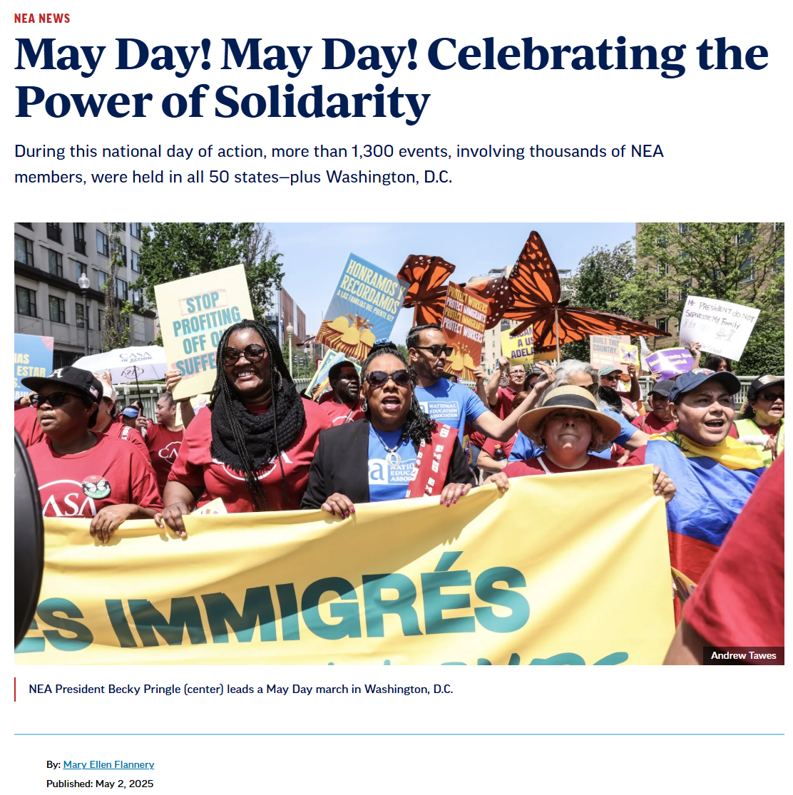

Media Coverage
- Black Press USA: May Day and the intersection of civil rights and workers rights
- The Bulwark: Labor Goes All In for Kilmar
- USA TODAY: Thousands rally against Trump, Musk in nationwide May Day protests
- In These Times: Workers Defy the Billionaire Takeover on May Day
- Salon: I Ain’t Got Nothing to Say to Donald Trump, May Day Organizers Say their Message is for the People
- NYTimes: May Day protests mobilize a growing outcry against Trump.
- MSNBC: ‘We won’t back down’: Resistance against Trump continues with hundreds of May Day protests
- Washington Post: Immigrants rally to show their worth during annual May Day celebrations
- Associated Press: May Day demonstrations in US and around the globe protest Trump agenda
- Common Dreams: Nationwide May Day Protests Target Trump's 'Billionaire Agenda'
- The Contrarian: Mobilizations Planned in Over 1,000 events in all 50 States as Workers Demand Justice
- WITN: Educators and advocates rally on ‘May Day’, urge Congressman Greg Murphy to defend public education
- KCCI: Des Moines educators, union members, and community members rally for public education
- KGE8: Multiple May Day rallies planned in Portland, Vancouver, Salem
- Planet Princeton: Photos: May Day protesters rally in Princeton against the ‘war on working people’
- KXL: May Day Brings Prospect of Thousands of Protesters in Oregon
- Spectrum: 50501 movement plans anti-Trump May Day rallies
- Greenwich Free Press: Over 200 People Assembled in front of the Havemeyer Building on Greenwich Ave for “May Day Strong” Vigil
- WUSA9: Kilmar Abrego Garcia spotlighted at DC May Day rally
- The American Prospect: A May Day for the Age of Trump and Oligarchy
- The Nation: The Call Is Out for Mass, Simultaneous Strikes in 4 Years
- Mother Jones: Thousands Call on the Trump Administration to Return Kilmar Abrego Garcia
- Herald-Mail Media: Who is protesting in Hagerstown? What to know about rallies in Washington County and area
- TMJ4 News: 'We’re here to fight for our students': Racine educators rally against cuts to public schools
- Manchester Journal: 'Mayday, Mayday' Protest in Bennington focuses on workers' rights
- Daily Independent: May Day protestors reach from Sun City to Phoenix and countrywide
- Santa Fe New Mexican: May Day protest at state Capitol draws hundreds protesting Trump policies
- Messenger inquirer: Indivisble Owensboro to hold 'May Day Strong' rally
- PNS: PA 'Day of Action' planned for higher minimum wage, immigrants' rights

Overall Social Media Mentions:

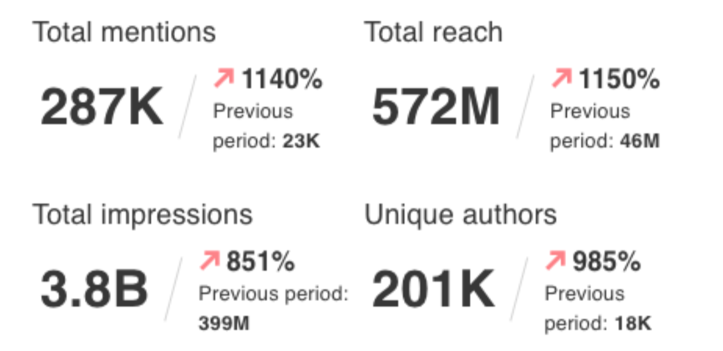

Next Steps

The May Day Movement Organizing Committee is planning a series of strategic planning meetings and convenings to build a movement powerful enough to win the demands (above) born through it. This will include determining
- which local unions and community organizations are going to anchor this campaign on a local level,
- the federal agenda,
- Sharpening the demands,
- the support these local and state level campaigns need to succeed,
- and more.

The immediate next step was a webinar on Thursday, May 8. NEA pushed this out to participants across the country for engagement, as did the May Day organizers.

Source: https://inthesetimes.com/article/may-day-2025-labor-actions-against-billionaires

