Facilitator Agenda: Day #1 Bargaining for All
General Materials Needed: |  |  |  |  | Room Set-up:
1 Set of Handouts per Person  Name Tags AND Name Tents  Sign-in Sheet  Room signs  Chart Markers – non-permanent |  |  | Chart Paper (Adhesive strip on Top)  Post its  Index Cards  Highlighters – 3 colors  Pens and Pencils |  | Round Tables  Projector, Screen, Microphones and Speakers  Carousel stations and reporting stations around the perimeter  30 to 50 people
Key Outcomes for the Day
Understand Collective Bargaining as a Moral Imperative – It is the way to secure dignity for workers in all aspects of their economy
What is your Policy Landscape
Explore Current Examples of New Bargaining Agreements
Internal Organizing and Required Foundation Building (Education and Messaging)
Assessment of Who is Ready
Time | Essential Questions | Resources |  | Instructions, Activity and Debrief (Facilitators) |  | Outcomes
 | What question(s) should this learning section answer? | Charts, handouts, articles, materials, slide |  | What are you saying, what are they doing, what questions will you use to guide learning and make clear the important points  Include an estimate for how long each section of the learning will take |  | As a result of this section of learning, what will participants know or be able to do?
8:30-9:00  Ellen  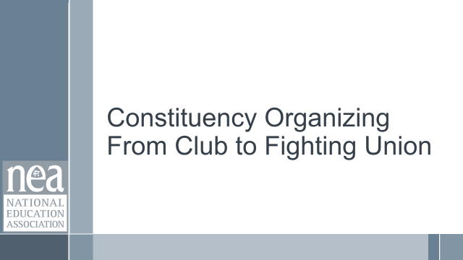  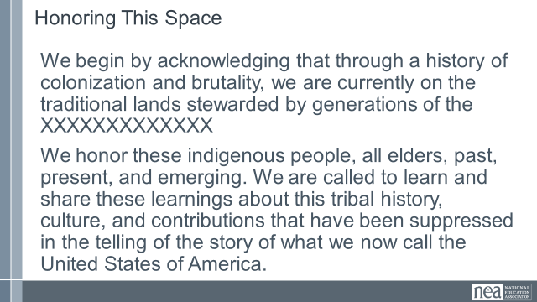  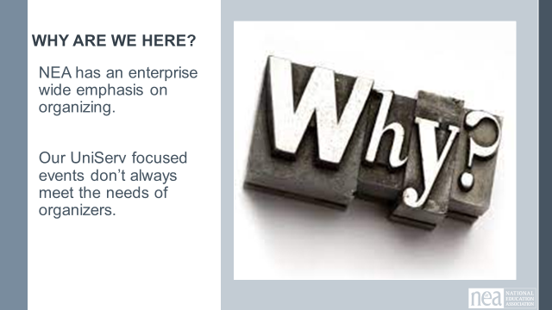  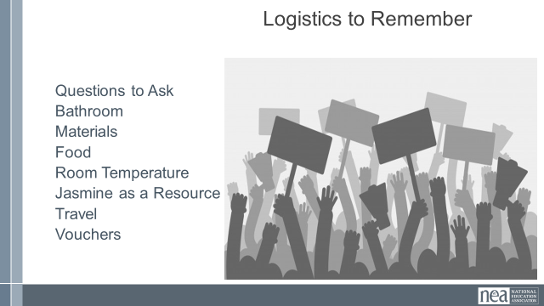  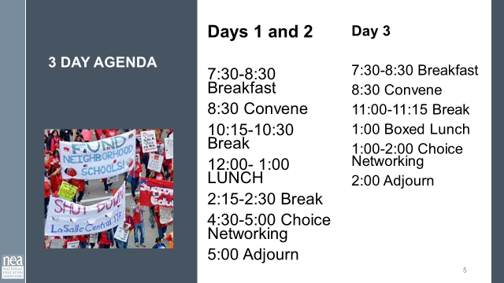  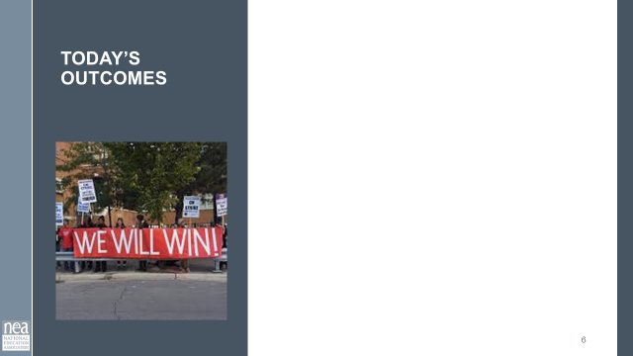  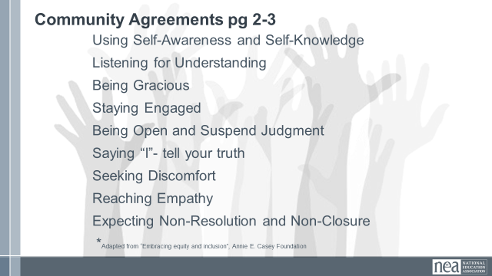  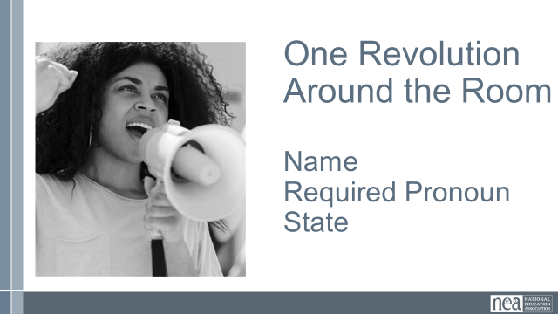 | How will we work together during our time? |  |  | 30 Minutes Getting Started:  Welcome  Land Acknowledgement – include the native peoples names on slides (the Arapaho, Ute and Cheyanne peoples)  Agenda for our Time  Outcomes for Today  Why Collective Bargaining?  They Can Bargain, Why Don't They?  Workplace Democracy  What Do We Say about Collective Bargaining  Power  Community Agreements – Take 5-10 minutes to review pages 3-4 of handouts, these were sent in advance. At your tables first then as a whole group, answer any questions, discuss anything that you want to include, seek understanding of what is needed to learn. As a whole room we are going to do a visible community adoption of these agreements. We seek consensus. In this case consensus will mean the following: each person only has to be comfortable enough to move forward, showing a sideways thumb, we don’t have to strive for perfect agreement, a completely upright thumb. IF however you cannot move forward you indicate that with a down thumb. The responsibility for the down thumb is to explain what it would take to move at least to side-ways. These agreements will be revisited as needed by anyone in this community and each morning. Show me up, side, or down thumb and please keep them in this position until I can visually check.  Quick Intro Whip Around the Room - Name, Required Pronouns, Location |  | Participants will understand the structure of their time and how we will work together.
9:00-9:30  Halimah  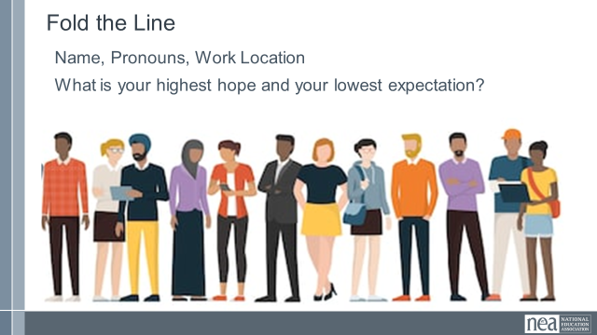  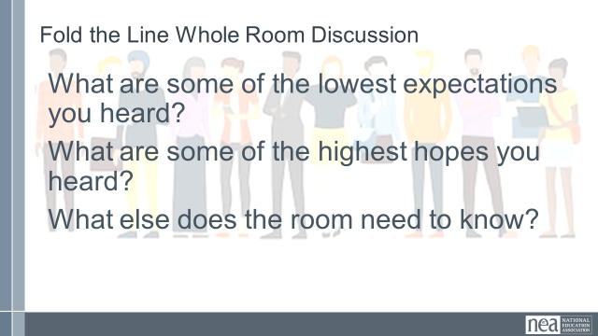  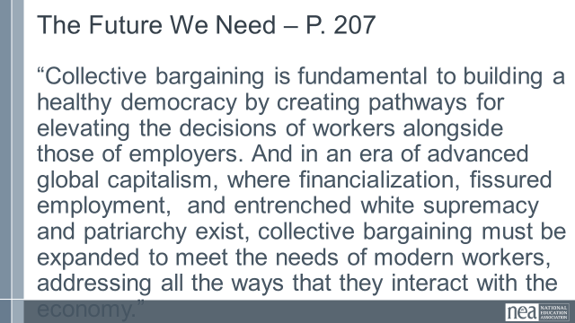 | What do I think about the prospects of collective bargaining? | TWO OPTIONS  Fold the Line |  | 30 Minutes Fold the Line activity –  7 Minutes Intro, Movement and Pairing – We have just done a quick whip around the room to hear everyone’s name, and now we are going to get to know one other person more deeply. Think about the number of miles that you traveled to get here. The people that traveled the shortest distance, begin the line here – and those that traveled the longest distance will be over there – so a line from least to most amount of travel. Now move (Help folks get into a line – it does not have to be perfect –should take about 3 minutes)  Now that we are lined up, we are going to pair off – the very ends of the line are partners, the next one in are partners, so on and so forth until we meet in the middle. (Help and give them about 3 minutes to do this) Now that you have a partner or a triad – Here is what I would like you to spend the next 10 minutes talking about:  Name Pronouns Work Location  What is your highest hope (for this training)?  What is your lowest expectation (for this training)?  You can bargain, why aren’t you?  10 Minutes Group Talk  3 Minutes Directions and Return to Seats – Ok, let’s head back to your seats (give them time to get resettled.  8 Minutes Whole Group Discussion –  What are some of the lowest expectations you heard?  What are some of the highest hopes you heard?  Why aren’t you bargaining?  What else does the room need to know?  2 Minutes for Final Words - Debrief with the quote from page 207 - “Collective bargaining is fundamental to building a healthy democracy by creating pathways for elevating the decisions of workers alongside those of employers. And in an era of advanced global capitalism, where financialization, fissured employment, and entrenched white supremacy and patriarchy exist, collective bargaining must be expanded to meet the needs of modern workers, addressing all the ways that they interact with the economy. “ |  | Participants will build a sense of community around the topic of learning.
9:30-9:45  Ellen  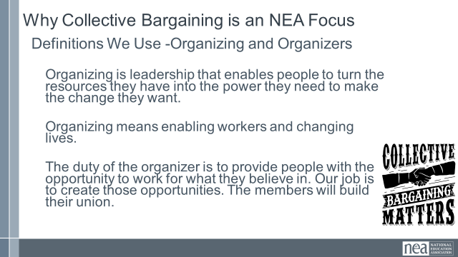  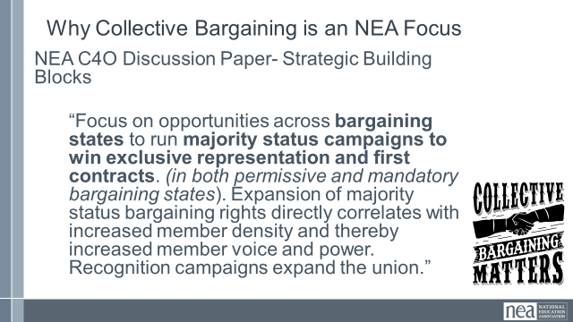  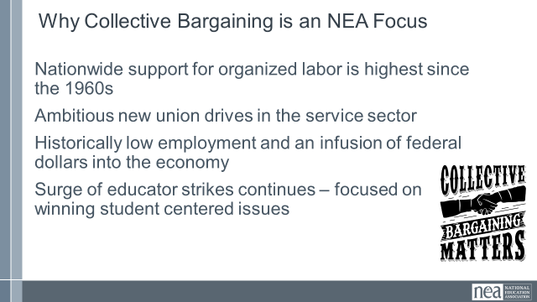  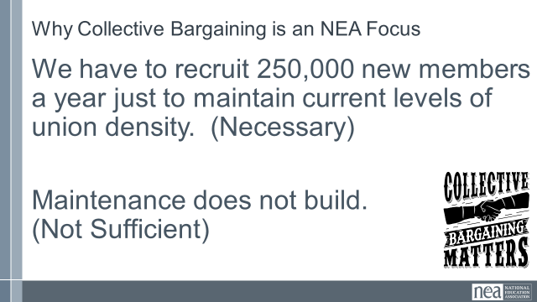  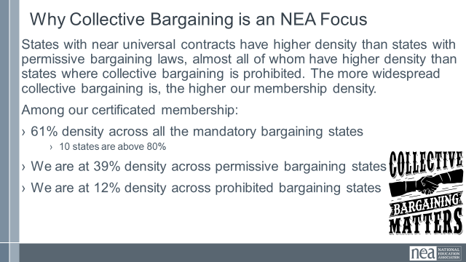  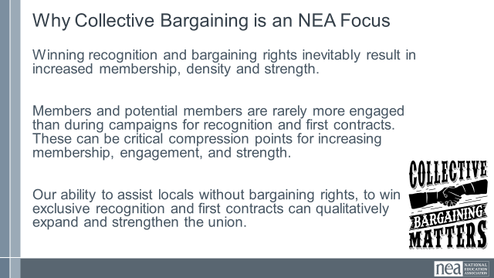  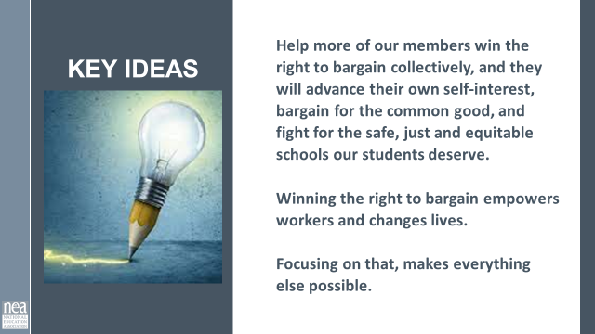 | Why is it imperative for NEA to focus on bargaining? | C4O Discussion Paper Highlights  Page 56 |  | 15 Minutes -Why Collective Bargaining is an NEA Focus  (This is a mini-lecture on the C4O Discussion Paper) We are going to need a reminder of three definitions that matter to us in this work. There are number of ways to define Organizing and the work of Organizers, but for the next two days we are going to use these:  - Organizing is leadership that enables people to turn the resources they have into the power they need to make the change they want.  - Organizing means enabling workers and changing lives.  - The duty of the organizer is to provide people with the opportunity to work for what they believe in. Our job is to create those opportunities. The members will build their union.  As we reorganize and right-size the Center for Organizing and Affiliate Support we have a number of key building blocks. The one that is important for us in this training is:  “Focus on opportunities across bargaining states to run majority status campaigns to win exclusive representation and first contracts. (in both permissive and mandatory bargaining states). Expansion of majority status bargaining rights directly correlates with increased member density and thereby increased member voice and power. Recognition campaigns expand the union.”  Why is 2023 the right time to focus on this?  Nationwide support for organized labor is highest since the 1960s  Ambitious new union drives in the service sector  Historically low unemployment and an infusion of federal dollars into the economy  Surge of educator strikes continues – focused on winning student-centered issues  We have been incredibly successful at building one of the largest member organizing programs in the labor movement. It is necessary for our survival – but alone it is not sufficient.  We have to recruit 250,000 new members a year just to maintain current levels of union density. (Necessary)  Maintenance does not build.  (Not Sufficient)  We know that routine engagement in collective bargaining creates a different relationship between members and their union. States with near universal contracts have higher density than states with permissive bargaining laws, almost all of whom have higher density than states where collective bargaining is prohibited. The more widespread collective bargaining is, the higher our membership density.  Among our certificated membership:  - 61% density across all the mandatory bargaining states  - 10 states are above 80%  - We are at 39% density across permissive bargaining states  - We are at 12% density across prohibited bargaining states  To maximize the efforts of our current member recruitment programs and continue to build our membership we need to run recognition campaigns for collective bargaining in places where they already have the right to do it.  Winning recognition and bargaining rights inevitably result in increased membership, density and strength.  Members and potential members are rarely more engaged than during campaigns for recognition and first contracts. These can be critical compression points for increasing membership, engagement, and strength.  Our ability to assist locals without bargaining rights, to win exclusive recognition and first contracts can qualitatively expand and strengthen the union.  Increased membership and density isn't just about numbers, its about the power to make systemic change through working together.  "We claim the power to make the big decisions that will shape the changes that impact our lives in the years to come." (pg. 206)  Leaders are developed through action.  Campaigns for recognition and first contracts are powerful crucibles for the identification, testing and validation of trusted and respected worksite leaders.  Successful recognition campaigns are led by effective member organizing committees. And they build effective worksite leadership networks.  Key Points  Help more of our members win the right to bargain collectively, and they will advance their own self-interest, bargain for the common good, and fight for the safe, just and equitable schools our students deserve.  Winning the right to bargain empowers workers and changes lives.  Focusing on that, makes everything else possible.
9:45-10:15  Charles  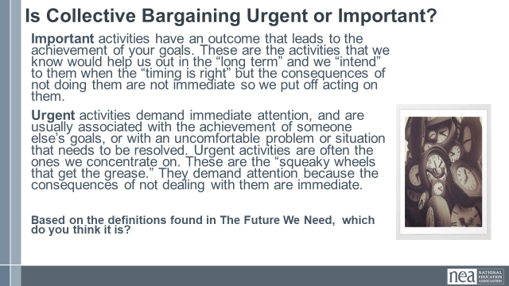  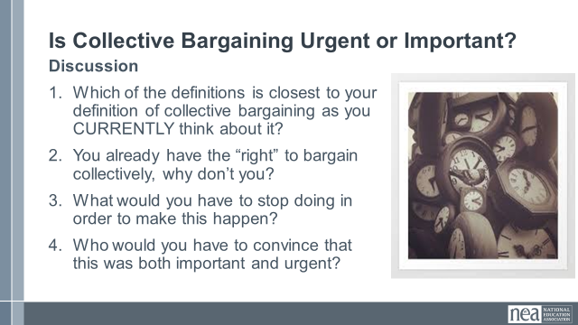  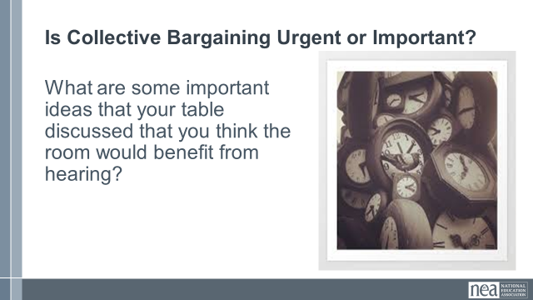   | What does collective bargaining mean to me? | Chapter 1 Collective Bargaining  Definitions  p. 13-15, and p.19 |  | 30 Minutes Total – Is Collective Bargaining Urgent or Important?  5 Minutes Introduction - The word “urgent” gets used a lot in organizing and union work. If everything is urgent, then nothing is really strategic. We are going to look at two definitions that can help you think strategically about the work you do, AND how to make collective bargaining a part of that.  Turn to page and look at the two definitions for Important and Urgent.  - Important activities have an outcome that leads to the achievement of your goals. These are the activities that we know would help us out in the “long term” and we “intend” to them when the “timing is right” but the consequences of not doing them are not immediate so we put off acting on them.  - Urgent activities demand immediate attention, and are usually associated with the achievement of someone else’s goals, or with an uncomfortable problem or situation that needs to be resolved. Urgent activities are often the ones we concentrate on. These are the “squeaky wheels that get the grease.” They demand attention because the consequences of not dealing with them are immediate.  Turn to the handout titled is Bargaining Important and/or Urgent? We have pulled 4 quotes from your book, The Future We Need. Take 20 minutes to read those to yourselves, and then 10 minutes to discuss the four questions. At the end of that time, we will stop you and do a little whole room discussion.  20 minutes Group time – 5 minutes to read the 4 quotes, and then 15 minutes to discuss the 3 questions.  - Which of the definitions are CLOSEST to your definition as you currently think about it?  - You already have the “right” to bargain collectively, why don’t you?  - What would you have to stop doing in order to make this happen?  - Who would you have to convince that this was both important and urgent?  5 Minutes Whole Room Conversation – OK wow some great conversations happening.  What are some important ideas that your table discussed that you think the room would benefit from hearing?  We are going to return to this after break. |  | Participants will begin to explore their own understandings of what collective bargaining is.
10:15-10:30   | BREAK
10:30-11:20  Zac  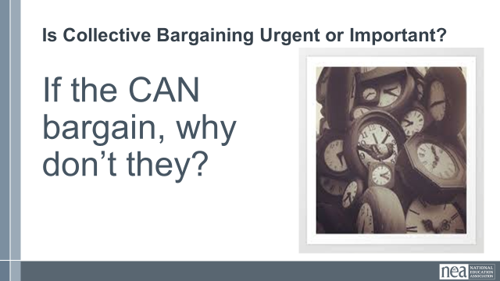  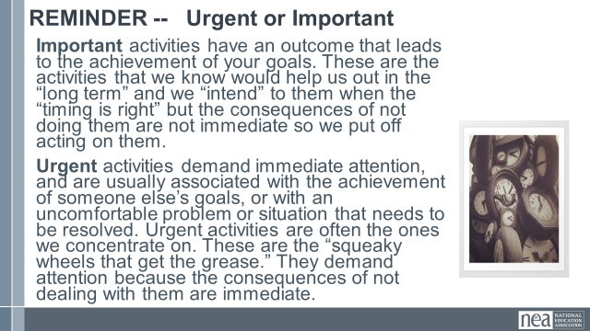  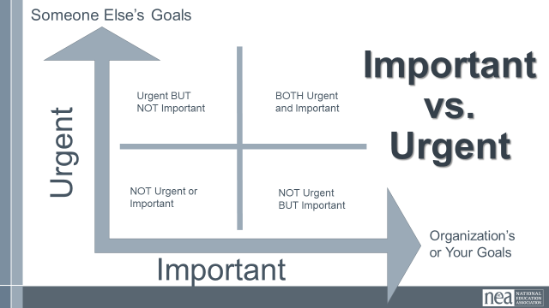  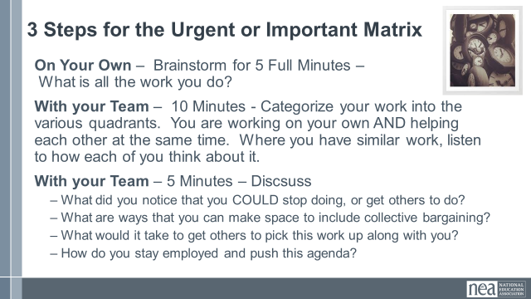  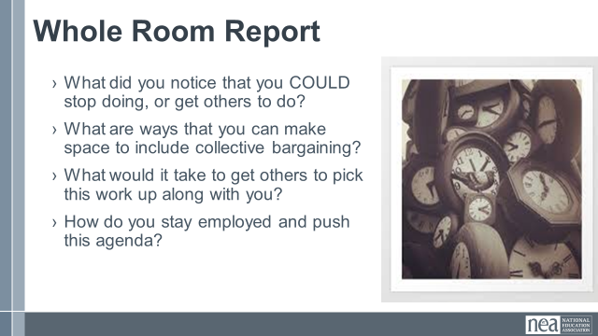  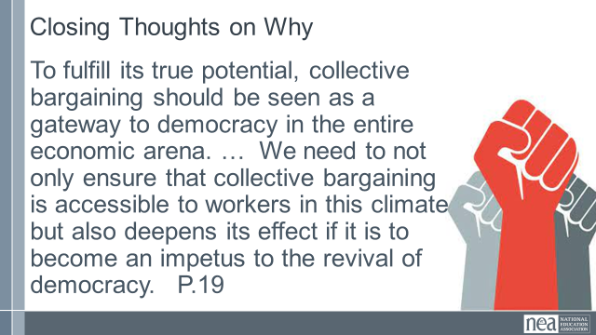  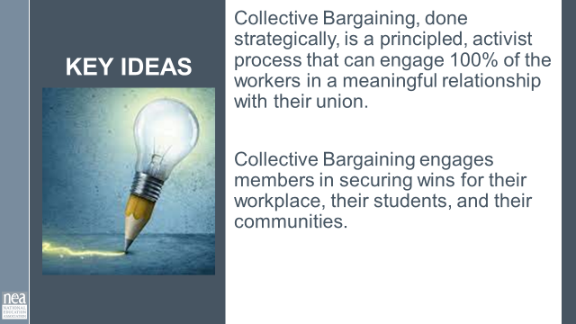 | Why do we need to bargain collectively?  Why is it urgent to move our locals that can into their first collective bargaining agreement? | Worksheet  Important and Urgent Worksheet  Chapter 1 Collective Bargaining  Definitions  p. 13-15, and p.19 |  | 40 Minutes – They Can Bargain, Why Don’t They? Urgent and Important Matrix  5 Minutes Introduction and directions - Our locals and ourselves have more to do than we have time for. But, if everything is important – then nothing can be important. Just with a quick show of hands as a reminder of the work we did before break, raise yours if you think collective bargaining is important? Ok – look around. Raise your hands if you think that it is urgent? OK look around. So almost everyone believes it is one or the other or both. So if this is the case why has it not yet been done? We are going to do some work with our table mates on thinking strategically about how we use our time. Because if we are already fully scheduled, and we can’t strategically make time to bargain – it is simply not going to happen. Turn to the handout titled is Bargaining Important and/or Urgent?  A way to strategically prioritize our work including collective bargaining. When I turn you back to your table groups you are going to need the page Urgent and Important Matrix. Two key ideas from before break are:  - Important activities have an outcome that leads to the achievement of your goals. These are the activities that we know would help us out in the “long term” and we “intend” to them when the “timing is right” but the consequences of not doing them are not immediate so we put off acting on them.  - Urgent activities demand immediate attention, and are usually associated with the achievement of someone else’s goals, or with an uncomfortable problem or situation that needs to be resolved. Urgent activities are often the ones we concentrate on. These are the “squeaky wheels that get the grease.” They demand attention because the consequences of not dealing with them are immediate.  When you look at the table on the other side you can see that it is like a Johari Window that allows you to analyze the intersections of important and urgent. Each window gives you some ideas about the kind of work that should go in each window and what actions you should take.  There are three steps you are going to do. FIRST ON YOUR OWN– Brainstorm for 5 full minutes all the work you do. All of it. When those five minutes are up, then you are going to take 10 minutes WORK AS A TABLE TEAM to categorizing your work using the urgent and important matrix. And then for step 3 you will take another 5 minutes as group to answer where you think collective bargaining sits in this matrix and why.  20 Minutes Table Work – first 5 minutes on their own, then 15 minutes of table discussion.  10 Minutes – Whole Group Report out  What did you notice that you COULD stop doing, or get others to do?  What are ways that you can make space to include collective bargaining?  What would it take to get others to pick this work up along with you?  How do you stay employed and push this agenda?  5 Minutes Closing Thoughts and Key Ideas  Out closing thoughts connecting this section from our book on P. 19  To fulfill its true potential, collective bargaining should be seen as a gateway to democracy in the entire economic arena. … We need to not only ensure that collective bargaining is accessible to workers in this climate but also deepens its effect if it is to become an impetus to the revival of democracy. P.19  Key Ideas - Collective Bargaining, done strategically, is a principled, activist process that can engage 100% of the workers in a meaningful relationship with their union. Collective Bargaining engages members in securing wins for their workplace, their students, and their communities. |  | Participants will think strategically about their time and the work they need to give up in order to include collective bargaining.
11:20-12:00  Jeny  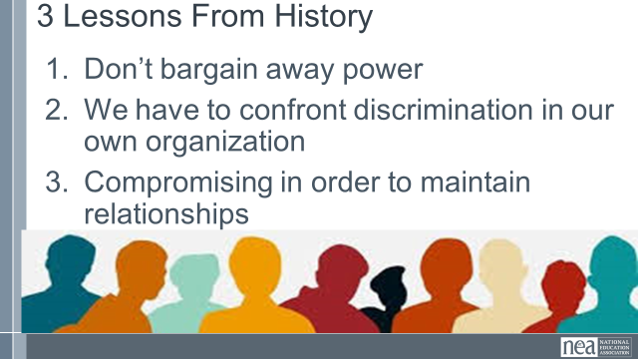  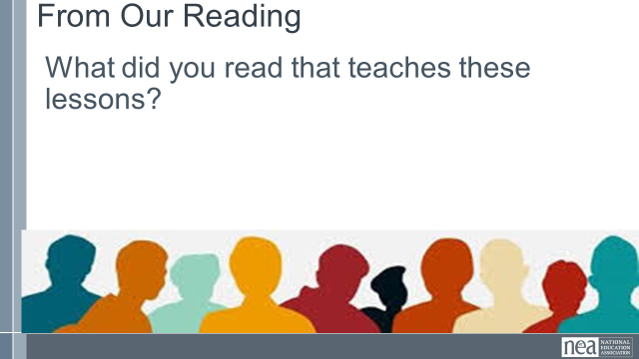  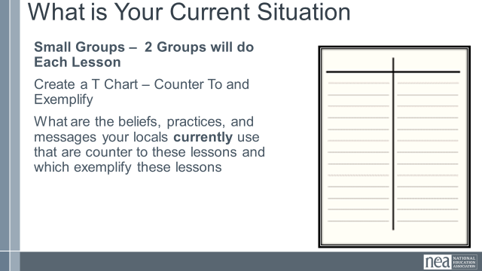  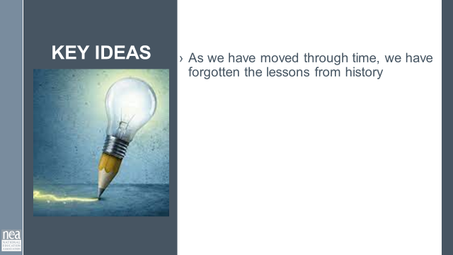 | What does history have to teach us about | Chapter 2  History of Collective Bargaining  Need some sort of graphic organizer |  | 40 Minutes Three Lessons History Has to Teach Us about Workplace Democracy  Chapter 2 teaches us three lessons from history we need to remember when we begin collective bargaining.  5 Minutes  The first lesson – Don't bargain away power, even if it gets a short-term win  The second lesson – We have to confront the individual and systemic discrimination present in our organization  The third lesson – Don't compromise core-values to maintain perceived relationships  What did you read that supports each of these lessons  (Possible Examples:  P. 20 Black Washerwomen of Atlanta  P. 22 Knights of Labor, IWW, Craft Unions  P. 24 Laws and Acts  P. 25 Main point  P. 27 Wagner Act  P 28 Black Rail Workers)  20 Minutes  Make Six small groups (First Day let them be comfortable)  6 Small Groups – (Each group will only address one of the lessons from above) Make a T Chart with Counters and Exemplify at the top.  In each column list the  - beliefs  - practices  - messages  your locals currently use that are either counters to these lessons or which exemplifies these lessons  5 Minutes  What is your role in moving your affiliates to understand that this what collective bargaining is about?? (Give 5 minutes to discuss this in groups and then)  10 Minutes  Debrief -- What is your role in moving your affiliates to understand that this what collective bargaining is about??  Key points  - As we have moved through time, we have forgotten the lessons from history  - History doesn't repeat, it rhymes.  - Collective Bargaining is what democracy looks like in the workplace. To have a healthy democracy we must all get involved.  After lunch we get the pleasure of meeting Erica Smiley (who goes by Smiley) and we will be able to dive in deeper into these conversations. |  | Participants will understand some of the important points in history of Collective Bargaining
12:00 to 1:00  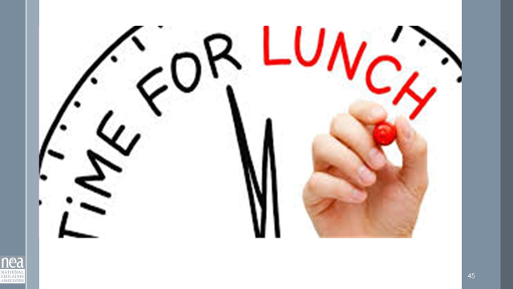 | LUNCH
1:00-2:30   |  |  |  | Guest Authors Panel
2:30-2:45   | BREAK
2:45-3:45  Sara and Monet  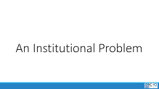  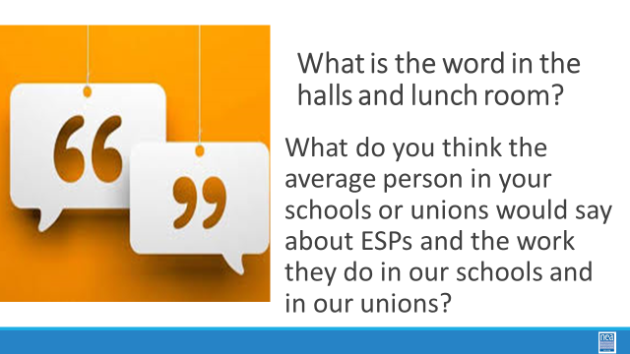    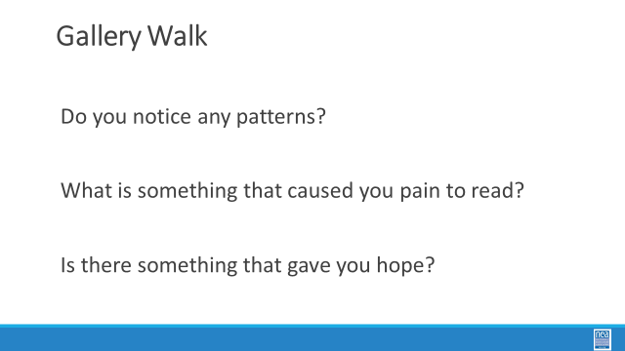  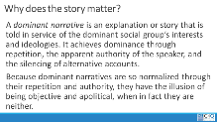  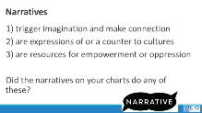    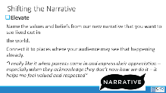  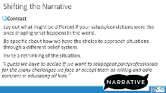  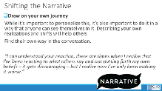  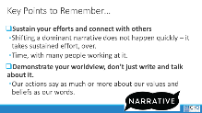  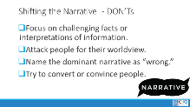  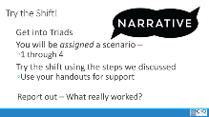  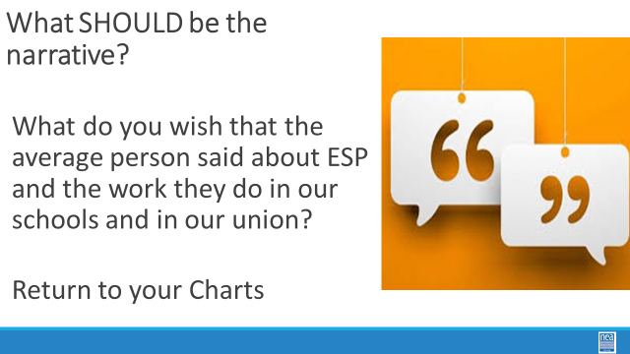  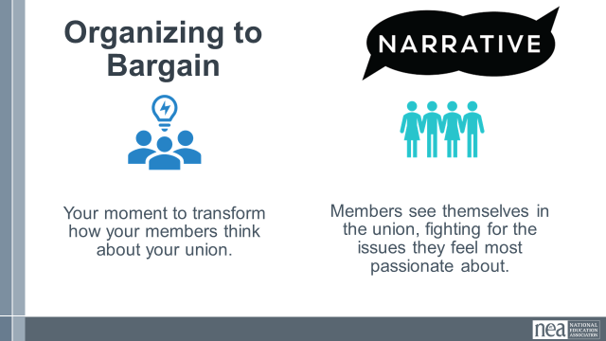  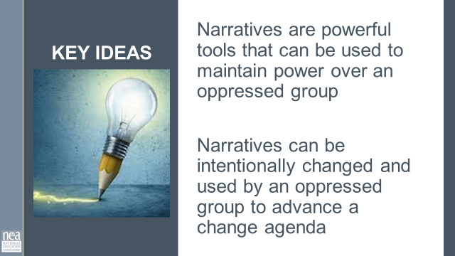  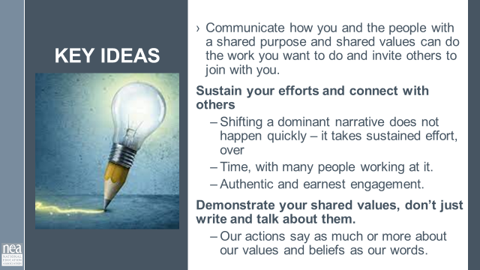 | What are some of the reasons for the injustices that our ESP members face each day? | Chart Paper  REWORK Dominant Narrative Handouts with ESP Scenarios  Monet Start Here |  | 60 Minutes – What do We Say About Collective Bargaining  2 Minutes Introduction:  Behind the issues we have described above, there may be a number of institutionalized narratives that are supporting these challenges – both for ourselves and for our members - we are going to examine one – classism. There are others – racism, genderism, ageism, and other oppressive systems and these are addressed in ARJ 1 and 2 extensively. For our work together thinking about ESP we are going to explore classism with the clear understanding that in all ways this is coded language in our society for institutionalized racism.  Count off – or some other way to new group – Carousel through the charts – you have 8 minutes at your first start then 4, 4, 4, and then report out on the chart you land at  20 Minutes Charting What We have Heard:  Participants will work to create a chart. The chart is divided into three equal rows. In each space record all your answers to:  What do their employers say about collective bargaining?  What does the public say about collective bargaining?  What does your governance say about collective bargaining?  What do your rank and file members say about collective bargaining?  5 Minutes What are some themes?  Share out the posters - Either do a gallery walk looking for similarities and outliers, OR do a share out from each chart. Ask them to return to their seats and ask folks to do a little report out –  Do you notice any patterns?  What is something that caused you pain to read it?  Was there something that caused you to have hope?  5 Minutes –  Why does this matter?  - A dominant narrative is an explanation or story that is told in service of the dominant social group’s interests and ideologies. It achieves dominance through repetition, the apparent authority of the speaker, and the silencing of alternative accounts.  - Because dominant narratives are so normalized through their repetition and authority, they have the illusion of being objective and apolitical, when in fact they are neither.  - Why does language matter?  - Should vs How  - If asked “Should this person drive a car.” You will get X number opinions on if they should or shouldn’t  - If asked “How can we help this person drive this car” you get more of an organizing creative plan of possible changing the shape of the steering wheel or making the numbers larger to read. We must be careful how we frame our questions based on our goals for the conversation.  - Narratives are used to  - 1) trigger imagination and make connection  - 2) are expressions of or a counter to cultures  - 3) are resources for empowerment or oppression  - Did the narratives on your charts do any of these?  Add Pages In  10 Minutes So let’s explore how do we change and use narratives There is good research that says the more you “argue with” someone, the less they are willing to hear a new idea – or new frame. You are going to learn a simple process and practice it around a small set of scenarios.  Share the slides that outline a four step process for shifting narratives  Unmask  Elevate  Contrast  Draw On Your Own Journey  Key points  Don’ts  (Make sure that they know these are in their handouts)  10 Mins Narrative Scenario Groups - assign triads to the scenarios. First 2 minutes, get familiar with the assigned scenario. Second 5 minutes - One person takes the stance of the “not our framing of the issue” the other two people take the stance of trying to reframe using the process outlined in the handouts. Final 53minutes – what worked and what did not  5 Mins Debrief – What did you notice? What was tough? What worked well?  10 Minutes Return to our Narrative Charts - What is the narrative you want to be promoted about your union?  Teams now return to their Dominant Narrative charts AND COVER those with a blank chart paper – they will come up a with a list of bulleted statements that they want the PUBLIC to know about their union.  Debrief – Share out the new narrative – what is common, what are outliers?  Show the Key points slide:  - Narratives are powerful tools that can be used to maintain power over an oppressed group  - Narratives can be intentionally changed and used by an oppressed group to advance a change agenda  MORE KEY POINTS  - Communicate how you and the people with a shared purpose and shared values can do the work you want to do and invite others to join with you.  Sustain your efforts and connect with others  - Shifting a dominant narrative does not happen quickly – it takes sustained effort, over  - Time, with many people working at it.  - Authentic and earnest engagement.  Demonstrate your shared values, don’t just write and talk about them.  Our actions say as much or more about our values and beliefs as our words. |  | Participants will develop a narrative about why collective bargaining is necessary and learn how to challenge the dominant narrative.
3:45-4:15  Heidi    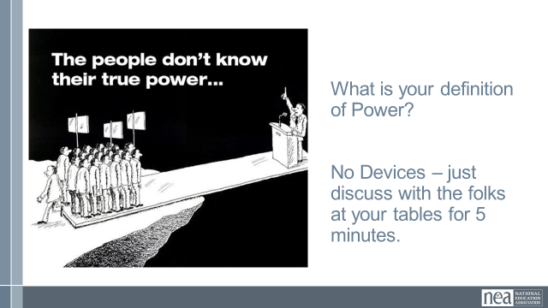  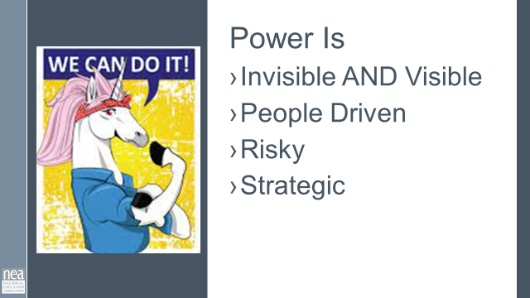  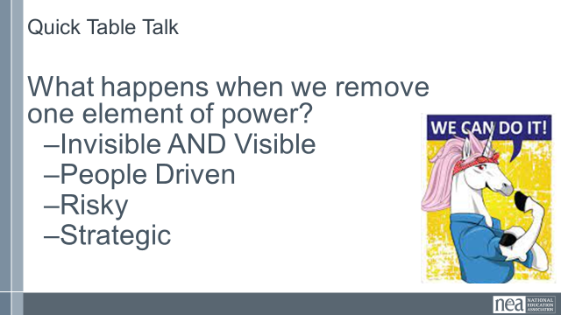  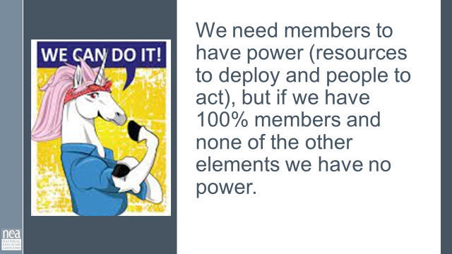  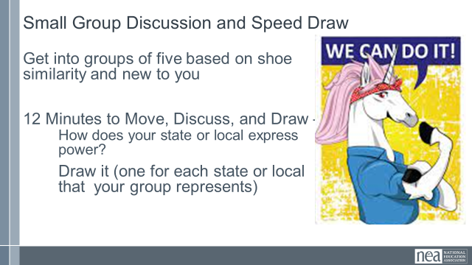  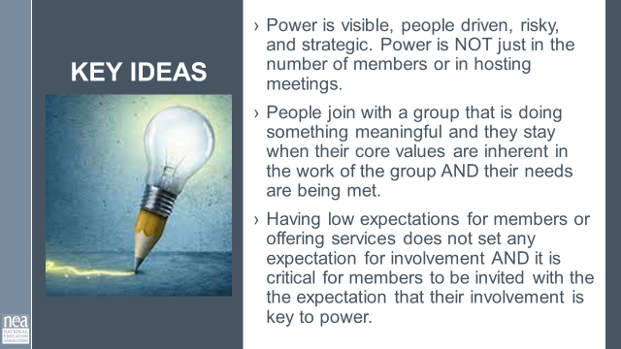 | What is power and what is it now? | JUST AN IDEA  Use this as a general discussion of power and that this work is about building power – not about staff making a thing happen. |  | 30 Minutes - What is power?  7 Minutes – Intro and Table discussion –no report out: What is your definition of power? How does your local express their power? No cheating or googling! Just a five minute discussion at your tables.  5 Minutes of Whole Room Content:  Power is:  Visible  - Invisible & visible  - Perception is part of power and is invisible, which cannot always be seen.  - Visible power is members expressing their unity through different tactics and through strategy. Remember that PEOPLE JOIN SOMETHING THAT THEY CAN SEE THAT IS ACTING TO ACHIEVE THEIR NEEDS AND EXPRESSING THEIR VALUES  People driven  - Power over versus power with.  - We do not have power over, we have power with. A strong reminder for members who may feel uncomfortable with the idea of power. It is that we have power WITH and not OVER.  Risky  - To win the things we cannot alone, it takes putting faith and trust in the group to work together to solve. This is risky.  - If it was easy to win, we would have done it.  - Pushing against those with power over us (perceived or real) is risky and takes courage to undertake.  - Demanding resources for the things our people need requires courage and does take risk. We are asking those with perceived or real power to give up something to make us whole, that is not without risk.  Strategic  - Strategizing, like story telling, is a way we exercise agency, making purposeful choices in the face of uncertainty.  - We focus on re Strategizing in a way of imagining, theorizing or hypothesizing. It is the conceptual link we make among the places, the times and the activities with which we mobilize and deploy resources and goals we hope to achieve. It is how we can frame specific choices within a broader framework of purpose  2 Minutes – Quick Table Talk What happens when we remove one element of power? (quick discussion from the group).  1 Minute – Whole Group Content -A note: We do need members to have power (resources to deploy and people to act), but if we have 100% members and none of the other elements above... do we have power? No. We must have both members and be actively building power in order to achieve the things our members cannot alone.  12 Minutes Intro and Small Group Activity:  How do we currently express power in our locals back home? How do we do this?  - Let’s create some new groupings – get into groups of five by looking for ways that your shoes are alike – example, we all have black shoes – BUT – you need to be in a group of people that are new to you. Once you are assembled, introduce yourself and where you are from.  - Draw your state or locals and how you express power?  3 Minutes Key Ideas  - Power is visible, people driven, risky, and strategic. Power is NOT just in the number of members or in hosting meetings.  - People join with a group that is doing something meaningful and they stay when their core values are inherent in the work of the group AND their needs are being met.  - Having low expectations for members or offering services does not set any expectation for involvement AND it is critical for members to be invited with the expectation that their involvement is key to power.
4:20-4:30  Ellen  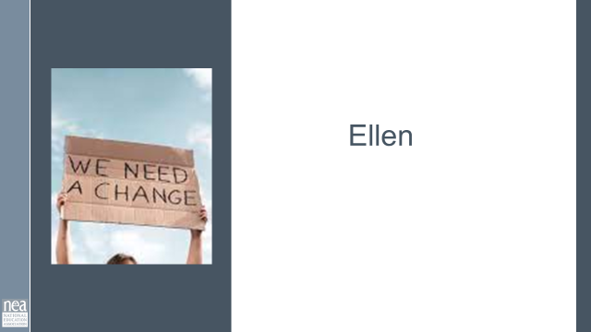  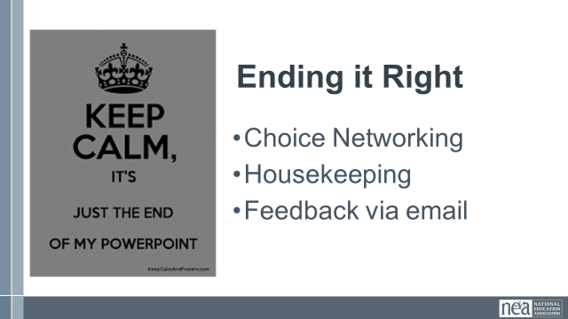  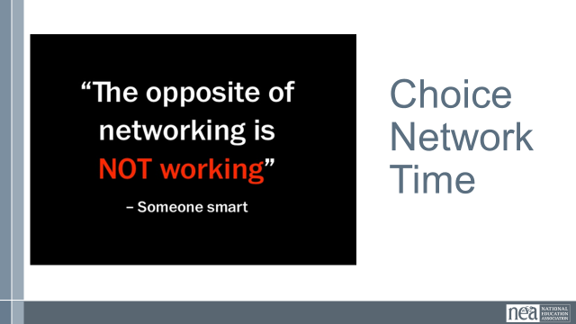 |  |  |  | Closing  Remind them about breakfast being an actual restaurant.
4:30-5:00 |  |  |  | Choice Networking
5:00 | ADJOURN

