Facilitator Agenda: Day # 2 Bargaining for All
General Materials Needed: |  |  |  |  | Room Set-up:
1 Set of Handouts per Person  Name Tags AND Name Tents  Sign-in Sheet  Room signs  Chart Markers – non-permanent  Pens and Pencils |  |  | Chart Paper (Adhesive strip on Top)  Post its  Index Cards  Highlighters – 3 colors |  | Round Tables  Projector, Screen, Microphones and Speakers  Carousel stations and reporting stations around the perimeter  30 to 50 people
Key Outcomes for the Day
Leader Identification Methods
Structures for Moving towards the First CBA
Compression Points to Consider
Essentials for a First Contract
Collectivizing the Process
Big Bargaining, IBB, Common Good
Time | Essential Questions | Resources |  | Instructions, Activity and Debrief (Facilitators) |  | Outcomes
 | What question(s) should this learning section answer? | Charts, handouts, articles, materials, slide |  | What are you saying, what are they doing, what questions will you use to guide learning and make clear the important points  Include an estimate for how long each section of the learning will take |  | As a result of this section of learning, what will participants know or be able to do?
8:30-8:45  Ellen  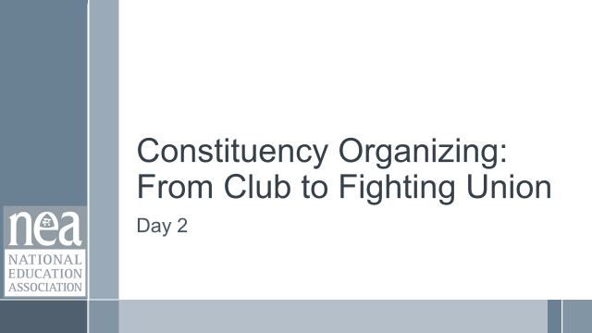  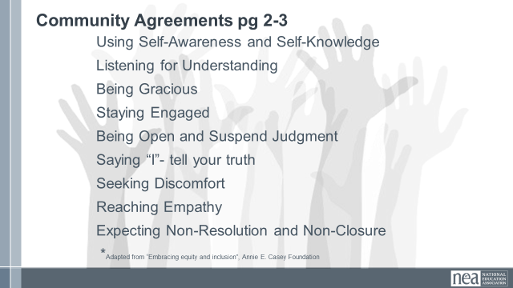  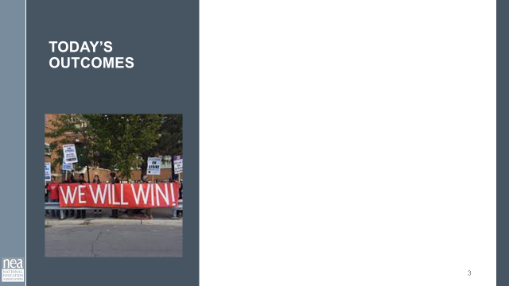  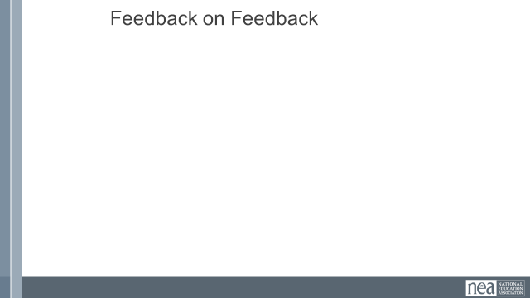 | How will we work together on Day 2? |  |  | Re-entry  Review of Community Agreements  Housekeeping Details  Feedback on Feedback |  | Participants continue to build as a learning community.
10:15-10:30 | BREAK
12:00 to 1:00 | LUNCH
2:15-2:15 | BREAK
4:20-4:30  Ellen |  |  |  | Closing  Prepping for Getting Home
4:30-5:00 |  |  |  | Choice Networking
5:00 | ADJOURN

