Facilitator Agenda: Day # 2 Bargaining for All
General Materials Needed: |  |  |  |  | Room Set-up:
1 Set of Handouts per Person  Name Tags AND Name Tents  Sign-in Sheet  Room signs  Chart Markers – non-permanent  Pens and Pencils |  |  | Chart Paper (Adhesive strip on Top)  Post its  Index Cards  Highlighters – 3 colors |  | Round Tables  Projector, Screen, Microphones and Speakers  Carousel stations and reporting stations around the perimeter  30 to 50 people
Key Outcomes for the Day
Leader Identification Methods
Structures for Moving towards the First CBA
Compression Points to Consider
Essentials for a First Contract
Collectivizing the Process
Big Bargaining, IBB, Common Good
Time | Essential Questions | Resources |  | Instructions, Activity and Debrief (Facilitators) |  | Outcomes
 | What question(s) should this learning section answer? | Charts, handouts, articles, materials, slide |  | What are you saying, what are they doing, what questions will you use to guide learning and make clear the important points  Include an estimate for how long each section of the learning will take |  | As a result of this section of learning, what will participants know or be able to do?
8:30-8:45  Ellen  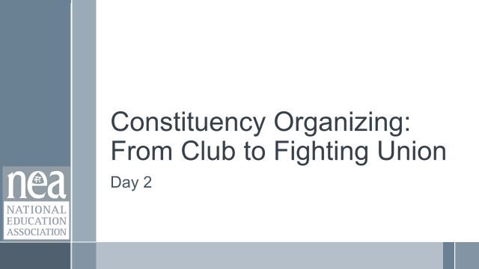  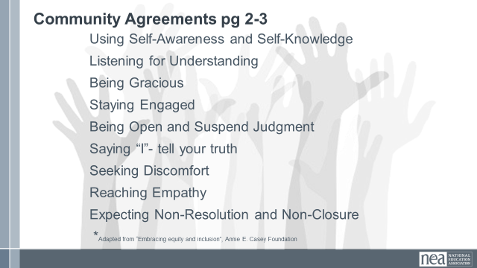    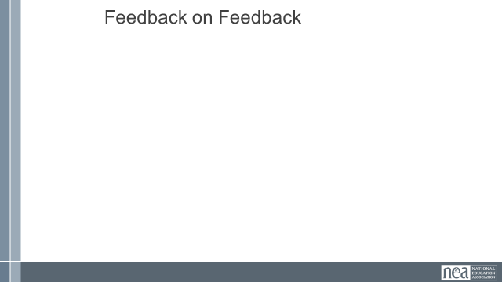 | How will we work together on Day 2? |  |  | Re-entry  Review of Community Agreements  Housekeeping Details  Feedback on Feedback |  | Participants continue to build as a learning community.
8:45-9:10  Halimah      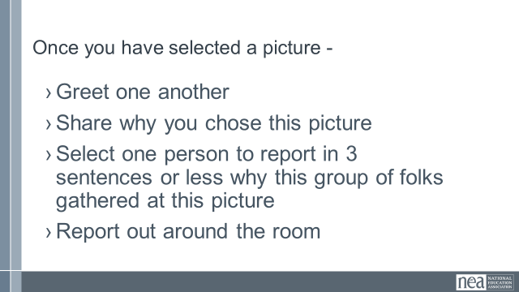 |  | How am I feeling about convincing others to begin a campaign to achieve a first contract? |  | 25 Minutes – Convincing Your Locals to Move to Collective Bargaining  5 Minutes introduction and group movement -There are a number of pictures on the wall. Select the one that best represents how you feel about convincing your local to move to their first collective bargaining agreement.  Go there, meet the folks that show up. Share why you choose to be there.  Pick one person to share a single sentence report out about why you all arrived at this picture. (Facilitator note: Adjust the number of pictures according the number of people and the amount of time you have)  10 Minutes – Group discussion  Gather, greet.  Share why.  One person reports out in three sentence about why this group gathered.  10 Minutes - 3 Sentences from each group – then facilitator will provided some sort of summary of the key points raised – then send folks back to their tables. |  | Participants will discuss how they are feeling about convincing their locals to move into their first contracts.
9:10-10:00  Charles  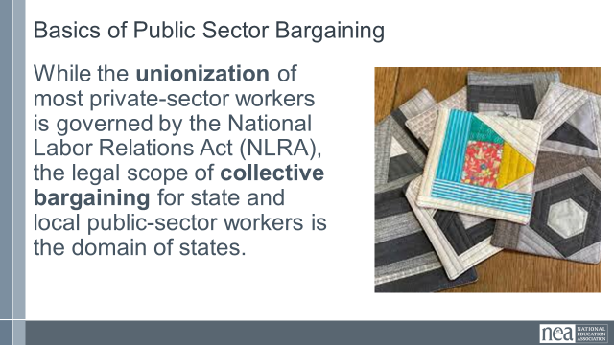  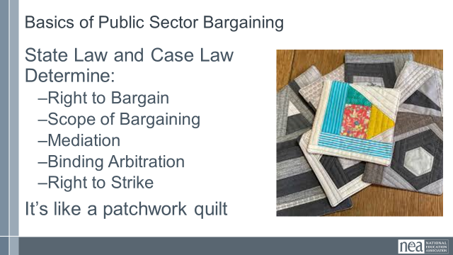  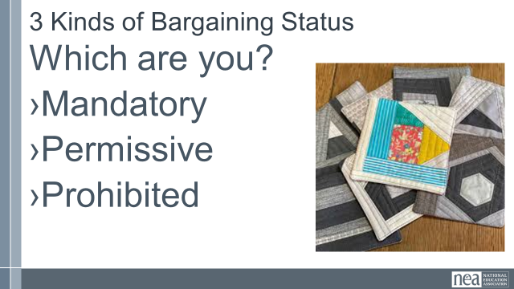      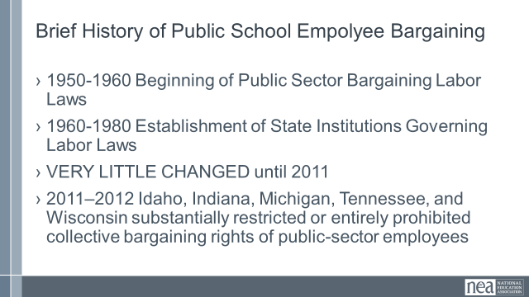  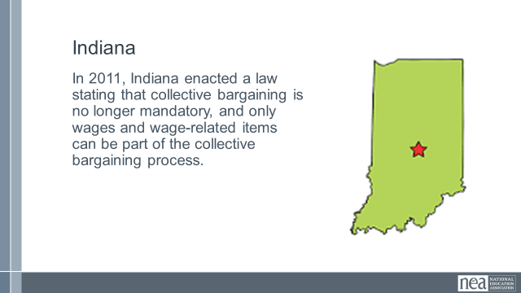  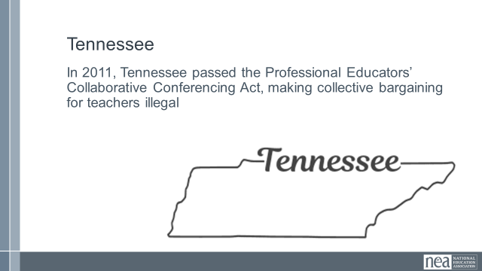  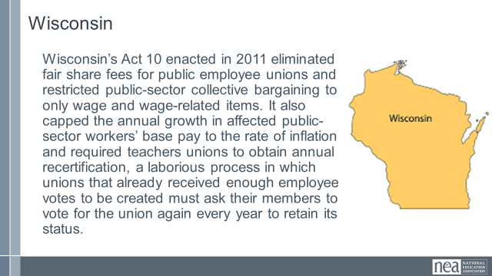  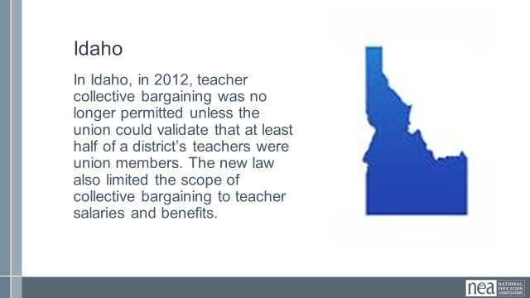  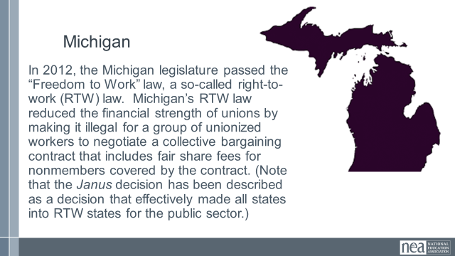  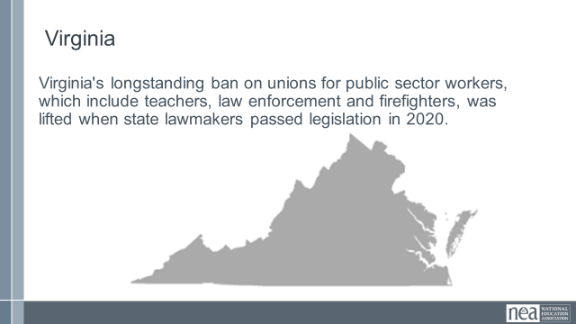  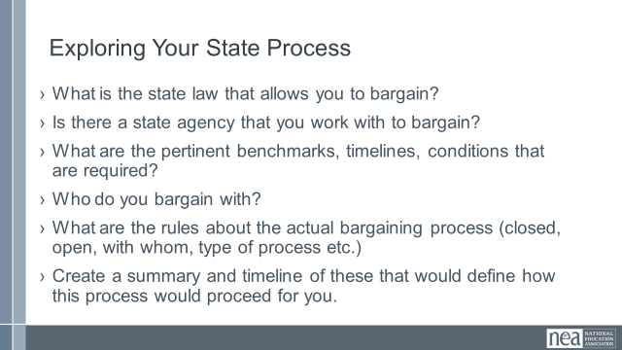  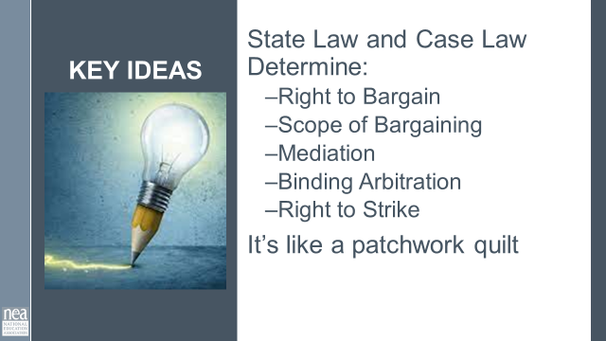 |  | Participants need their regulations for how, when, and with whom they bargain. |  | 50 Minutes Big Picture – Status of Bargaining  10 Minutes Intro and Whole Group Content– Public sector unionizing for educators is governed at the state level. State law and case law determine the right bargain or not, the extent or scope of what can be bargained, any procedures that need to be followed, if there is mediation, fact-finding, Interest binding arbitration, and the right to strike.  Do you know what kind of state is your state regarding bargaining ? There are three statuses of bargaining for public sector employees.  Bargaining Law – there are state level laws that require bargaining – “a duty to bargain”  Permissive – No state statutory law requiring bargaining, but bargaining is allowable if the parties agree to bargain  Prohibited – it is not legal to enter into a collective bargaining agreement if you are a public sector education employee.  Let’s take a look at some state maps to help you see the status of bargaining in your state.  10 Minutes – Brief History of Attacks and Changes in Bargaining  State and local governments began enacting labor laws to govern public-sector unions in the 1950s and 1960s. Some laws prohibited collective bargaining for their public-sector workers, some created a framework for a full set of collective bargaining rights (e.g., including a right to strike, a right to bargain over wages, etc.), and some created no framework but did not prohibit collective bargaining  Most states established their own legal institutions for teachers unions in the 1960s, 1970s, and 1980s, and these laws changed little through the first decade of the new century.  2011–2012, state legislators in Indiana, Michigan, Tennessee, and Wisconsin launched unprecedented initiatives substantially restricting or entirely prohibiting the collective bargaining rights of public-sector employees, including public school teachers.  In 2011, Indiana enacted a law stating that collective bargaining is no longer mandatory, and only wages and wage-related items can be part of the collective bargaining process.  In 2011, Tennessee passed the Professional Educators’ Collaborative Conferencing Act, making collective bargaining for teachers illegal.  Wisconsin’s Act 10 enacted in 2011 eliminated fair share fees for public employee unions and restricted public-sector collective bargaining to only wage and wage-related items. It also capped the annual growth in affected public-sector workers’ base pay to the rate of inflation and required teachers unions to obtain annual recertification, a laborious process in which unions that already received enough employee votes to be created must ask their members to vote for the union again every year to retain its status.  In 2012, the Michigan legislature passed the “Freedom to Work” law, a so-called right-to-work (RTW) law.4 Michigan’s RTW law reduced the financial strength of unions by making it illegal for a group of unionized workers to negotiate a collective bargaining contract that includes fair share fees for nonmembers covered by the contract. (Note that the Janus decision has been described as a decision that effectively made all states into RTW states for the public sector.)  Virginia's longstanding ban on collective bargaining for public sector workers, which include teachers, law enforcement and firefighters, was lifted when state lawmakers passed legislation in 2020.  25 Minutes – What are the Policies and Processes for You?  You are going to support each other in the development a summary flow chart of how achieving a first contract would look like. This is not full blown plan, it is just a quick summary of the who, what, and when of the policies and procedures you would have to find and follow. IF there are others from your state you will likely benefit from working together. You are each creating your own document.  - What is the state law that allows you to bargain?  - Is there a state compliance agency that governs the  - ^{above law ?}  - What are the pertinent benchmarks, timelines, conditions that are required?  - Who do you bargain with at the table (District; City/County Agency; State Agency)?  - What are the statutory rules about the actual bargaining process (closed, open, date deadlines, subjects of bargaining; etc.)  - Create a summary and timeline of these that would define how this process would proceed for you.  5 Minutes Key Take Aways -  - State Law and Case Law Determine, including but not limited to:  - ^{Right to Bargain}  - ^{Scope of Bargaining}  - ^{Impasse resolution options:}  ^{*Mediation}  ^{*Fact-Finding}  ^{*Interest Binding Arbitration}  - ^{Right to Strike}  > Understanding the framework in your state |  | Participants will understand the big picture of collective bargaining policy. They will explore their own policies and develop a flow chart for what it would look like for them to move towards their first bargaining agreement.
10:00-10:15   | BREAK
10:15-10:45  Monet  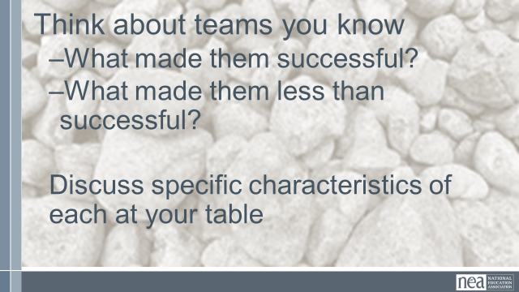  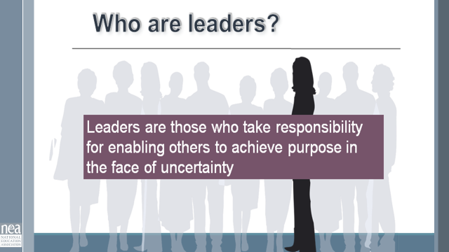  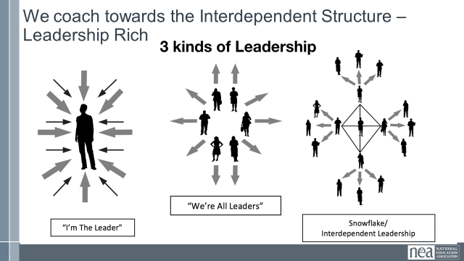  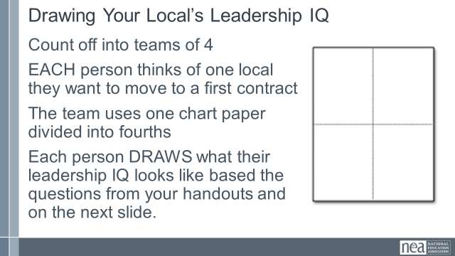  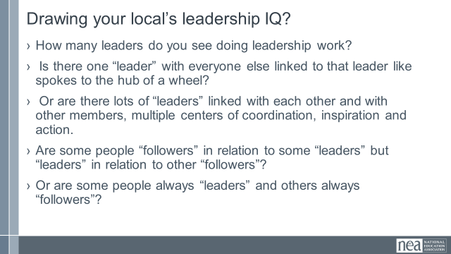  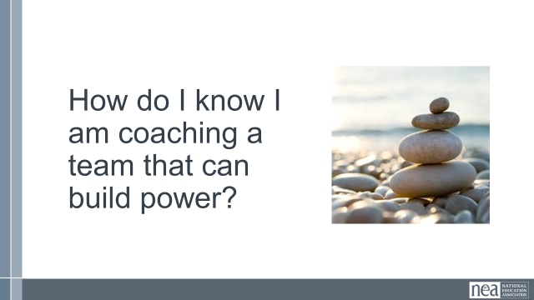  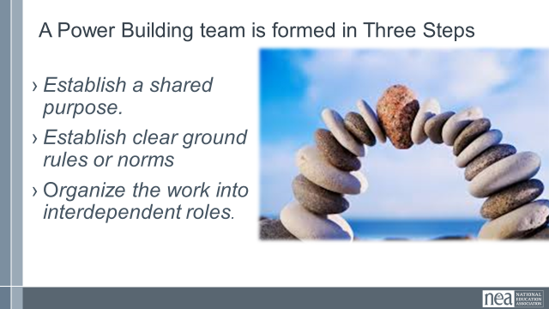  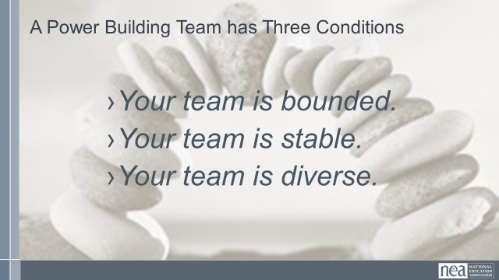  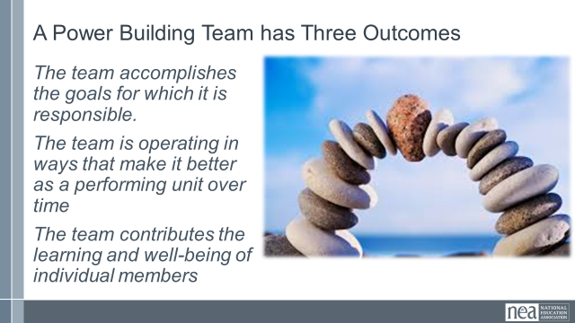  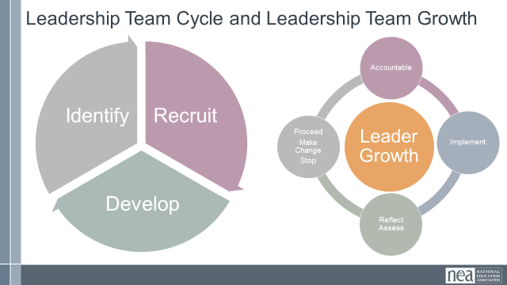  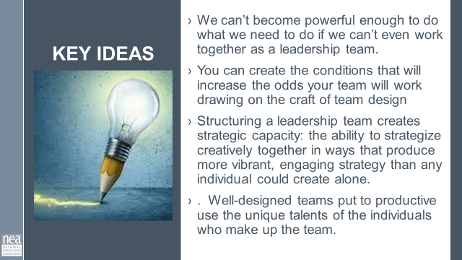 | What is an effective team? | Marshall Ganz “Structuring Leadership” |  | 30 minutes- Teams for Building Power  5 Minutes Introduction and quick table talk Visualize teams you have been a part of  - What made them successful?  - What made them less than successful?  Hold on to those core memories for a few minutes  Who are leaders?  15 Minutes Intro and Group Work – A reminder Leaders are those who enable others to achieve purpose in the face of uncertainty. WE are always coaching away from single leaders/authorities towards interconnected leadership/ teams. We are going to spend time at your tables drawing your local’s Leadership IQ. EACH person think of a local that you want to move to a first contract. Let’s count into groups of Four people to a team Each team gets on piece of chart paper divided into 4 quadrans. Each person draws what their local’s leadership IQ looks like using the following questions on the screen.  - How many leaders do you see doing leadership work?  - Is there one “leader” with everyone else linked to that leader like spokes to the hub of a wheel?  - Or are there lots of “leaders” linked with each other and with other members, multiple centers of coordination, inspiration and action.  - Are some people “followers” in relation to some “leaders” but “leaders” in relation to other “followers”?  - Or are some people always “leaders” and others always “followers”?  12 minutes of time work as a team.  These teams don’t just magically happen. No difference than letters don’t just fall together for people to know how to read. The mechanics are there, but someone needs to teach the rules, and guide you to how to do it.  6 Minutes of Content given to whole group:  What makes an effective team – it is the rule of 3’s  Three Steps  Establish a shared purpose. What are you fighting for and can you clearly articulate your common purpose as a team. It is clear, challenging, and matters. You have defined your goal, whom you work with, and the kinds of things you will do?  • Establish clear ground rules or norms. Your team sets explicit expectations of how you will work together: how you will make decisions, manage your time, and honor your commitments. What are things you will always do and what are the things you will never do. And how will you correct yourselves if you do them. Perhaps you most important norm is how you will make decisions. Steps that can guide effective decision making are: defining the problem, establishing criteria, brainstorming possibilities, synthesizing ideas, formulating options, evaluation options against the criteria, deciding. Some prefer deciding by vote; others, by consensus; others by delegating the decision to an individual.  • Organize the work into interdependent roles. Everyone should have responsibility for their own share of the leadership work needed to achieve the goal. Role requirements need to be clearly described. Team members need to assess their strengths and limitations, to the greatest extent possible, matching individual capabilities with role requirements. Because roles are designed to be interdependent, everyone has a stake in everyone else’s success. Team members speak up when they need help and get it. No one works in a silo that’s secretive to others. The team with diverse identities, experiences and resources brings more to the table than a team that is very homogeneous  Three Conditions  Your team is bounded. It is clear who is on the team and who is not on the team. It is clear how new people can join the team and what is expected of those who must leave the team.  • Your team is stable. People commit to clear terms of service: regular meetings, length of time, etc. Your team is not a revolving door, never knowing who will show up.  • Your team is diverse. Your team has the appropriate diversity of skills, talents, viewpoints, and constituencies that will be needed to do a good job.  Three outcomes  - The team accomplishes the goals for which it is responsible.  - The team is operating in ways that make it better as a performing unit over time  - The team contributes the learning and well-being of individual members  Leadership Team and Leadership Growth Cycle  As an organizer your job is to recognize and then help the team recognize that in order to build power, there is a continual identify, recruit, and develop cycle of new folks into the team. A team that does not continual recognize that one of their jobs is to continue to make space for new leaders, perspectives, diversity, and talents is a team that is not intent on base building and power development. Further a team grows in capacity to strategically achieve outcomes using everyone’s unique talents by attending to a continual cycle of implementation, reflection/assessment, proceed-change-stop, and accountability for the outcomes. We do a disservice to teams, the constituencies they are from, and the local as a whole when we don’t identify non-growing, non-power building teams. An even great disservice is done when we jump in to do it ourselves.  2 Minutes of Key Ideas –  - We can’t become powerful enough to do what we need to do if we can’t even work together as a leadership team.  - You can create the conditions that will increase the odds your team will work drawing on the craft of team design  - Structuring a leadership team creates strategic capacity: the ability to strategize creatively together in ways that produce more vibrant, engaging strategy than any individual could create alone.  - Well-designed teams put to productive use the unique talents of the individuals who make up the team. |  | WHAT IS THE OUTCOME IF THEY DO THIS?
10:45-11:15  Jeny  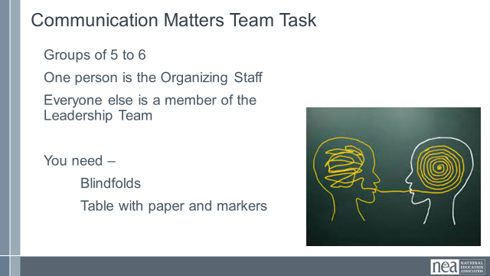  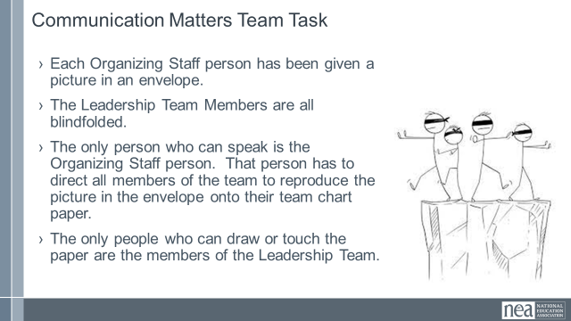  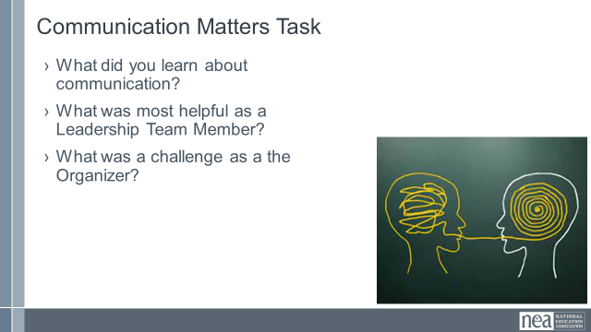  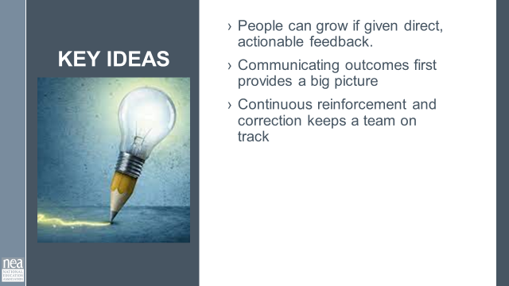 | How do we communicate with teams? |  |  | 30 Minutes Total -Communication in Teams Matters  3 minutes to give intro and divide into teams – We are going to be working in teams of 5 to 6. Go ahead and get settled in with your team. Now that you are settled, pick one person to be the Organizing Staff Person. The rest of you will be members of a leadership team. We are going to co-create a product in teams. On your tables are blindfolds paper and markers. If you are a Leadership team member you need to put your blindfold on so that you can’t see – no peeking out the side, and if you can see through it—close your eyes.  Organizing Staff person- you have an envelope in your hand that contains a drawing. When we begin you are the only person allowed to talk to your team. They can not ask you questions, they can not talk to each other or to you or out loud at all. When we begin you will be able to open your envelope and your task is to direct every member of your team to draw as closely as possible the picture in your envelope. You can not touch them in any way, only use your voice to direct. The only people allowed to touch markers or paper or to draw on the paper are the leadership team. You will have 10 minutes to make your masterpieces.  10 Minutes of Group activity  5 Minutes – Sharing of Pictures and Reflection on Learning as teams  Take of your blindfolds. Take 5 minutes to discuss as a team the following questions:  - What did you learn about communication?  - What was most helpful as a Leadership Team Member?  - What was a challenge as the Organizer?  5 Minutes whole group report out on the questions above  2 Minutes Key Ideas  - People can grow if given direct, actionable feedback.  - Communicating outcomes first provides a big picture  - Continuous reinforcement and correction keeps a team on track |  | Participants will experience the kind of complex communication required to get a task done in a specific timeline.
11:15- 12:00  Zac  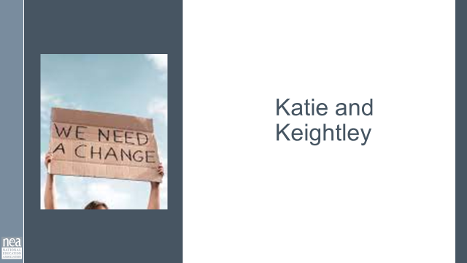  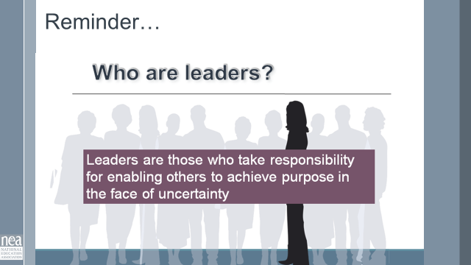  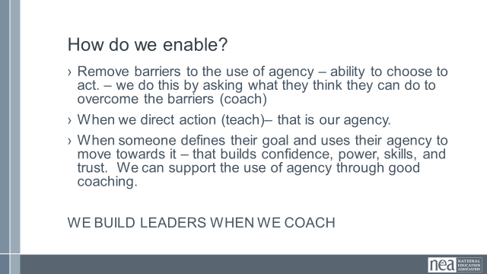  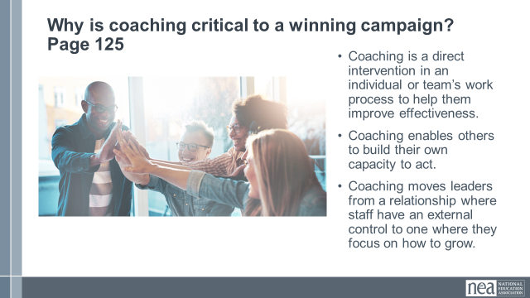  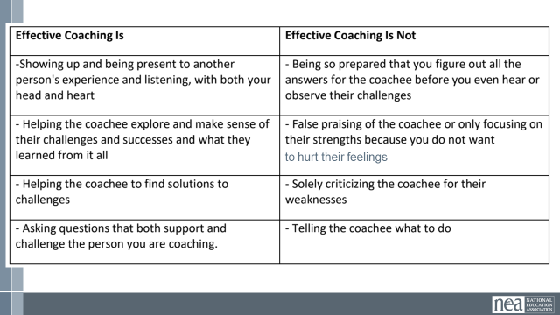  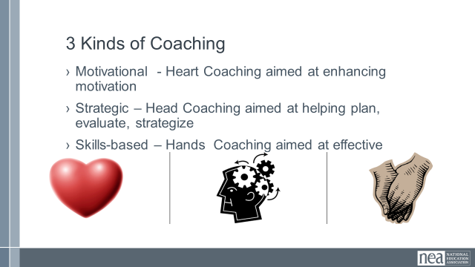  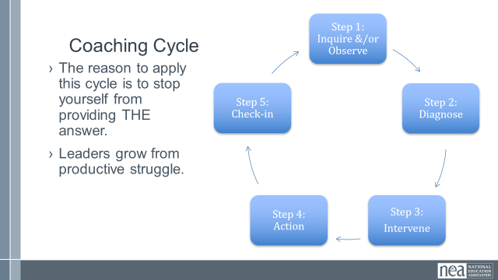  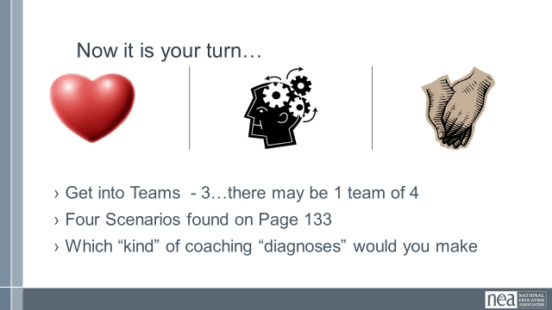  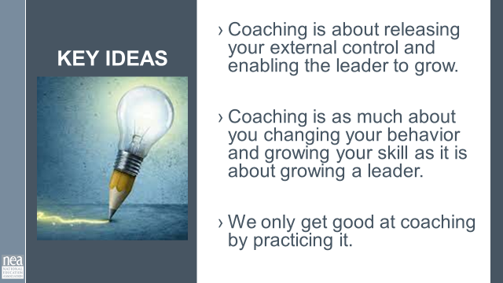  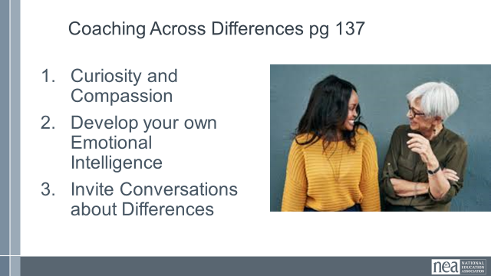  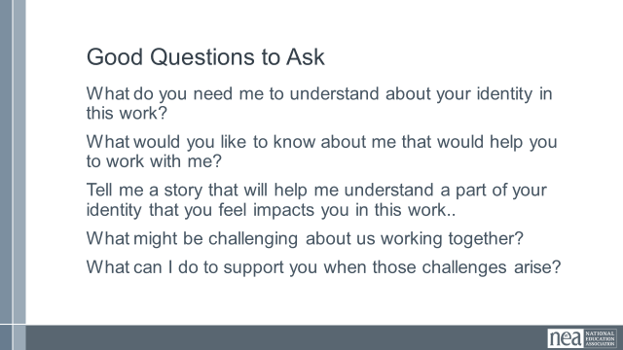  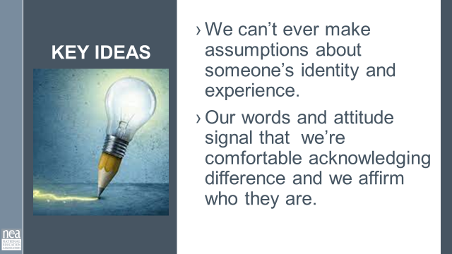 | How do I coach a team? | Resources –  Coaching 101  Video- Ganz coaching class.  Ask Drew for Cross Race Coaching Article or Podcast  Ganz Coaching Cycle |  | 45 minutes- Coaching towards Collective Bargaining  3 Minutes Introduction: Building off our activity- we want to go deeper into coaching. Every strong team needs coaching and a leader.  Reminder Leaders are those who take responsibility for enabling others to achieve purpose in the face of uncertainty.  How do we enable?  Remove barriers to the use of agency – ability to choose to act. – we do this by asking what they think they can do to overcome the barriers (coach)  - When we direct action (teach)– that is our agency.  - When someone defines their goal and uses their agency to move towards it – that builds confidence, power, skills, and trust. We can support the use of agency through good coaching.  WE BUILD LEADERS WHEN WE COACH  10 Minutes - Why is coaching critical to a winning campaign?  10 mins – Content for coaching (All comes from the content handout, pp) - Provide the definition of coaching we are going to use in this training. Share why we think this model of coaching is useful, and what is the difference between good coaching and bad coaching.  Good coaching and ineffective coaching  Chart to read is on page 128 as well as in slides  3 Types of Coaching - knowing which you need  - Motivational - Heart Coaching aimed at enhancing motivation  - Strategic – Head Coaching aimed at helping plan, evaluate, strategize  - Skills-based – Hands Coaching aimed at effective  Coaching Cycle  - The reason to apply this cycle is to stop yourself from providing THE answer.  - Leaders grow from productive struggle  PG 133 Teams will work through the four scenarios and identify which of the three types of coaching might be required.  Get into small groups.  Debrief by going over the responses from the teams. Facilitate dialogue and questions between teams as opposed to you “leading and lecturing. “  Key points to draw out – when we coach we are releasing the external control we have and allowing for the individuals to grow. It is really step 4 and 5 that several struggle – for a variety of reasons. We only get good at coaching by doing it. We use a coaching framework to break the habit of “diagnose and direct” which takes away the person’s ability to rise as a leader.  Coaching Across Differences Pg 137  - Curiosity and Compassion  - Develop your own Emotional Intelligence  - Invite Conversations about Differences  Good Questions to Ask  What do you need me to understand about your identity in this work?  What would you like to know about me that would help you to work with me?  Tell me a story that will help me understand a part of your identity that you feel impacts you in this work..  What might be challenging about us working together?  What can I do to support you when those challenges arise?  Key Points  - We can’t ever make assumptions about someone’s identity and experience.  Our words and attitude signal that we’re comfortable acknowledging difference and we affirm who they are.  Inherent, in a coaching relationship is trust. There has to be trust to give and receive feedback. |  | Participants will apply a coaching model to a number of scenarios.
12:00 to 1:00  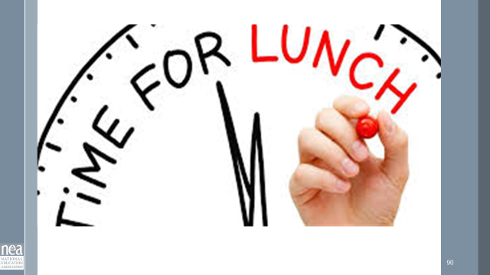 | LUNCH
1:00 – 2:00  Sara  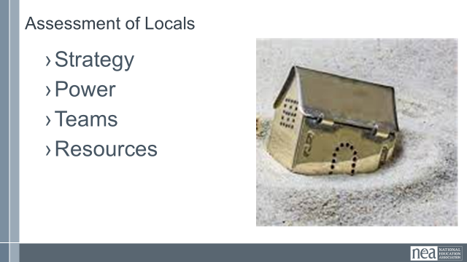  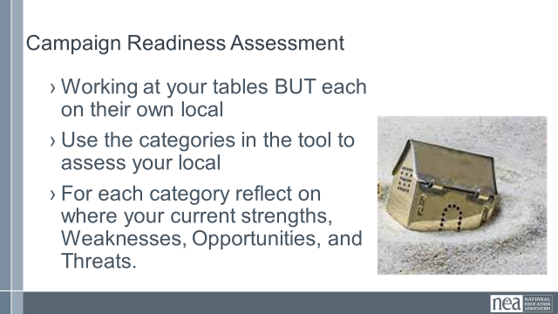  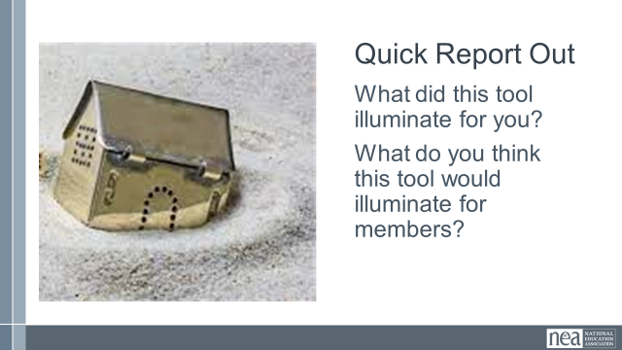  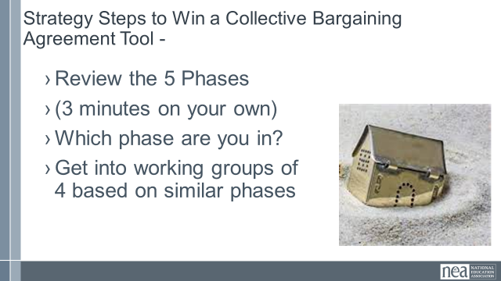  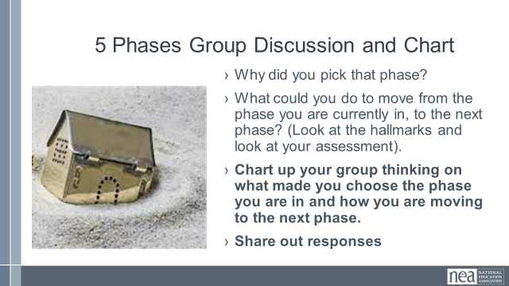  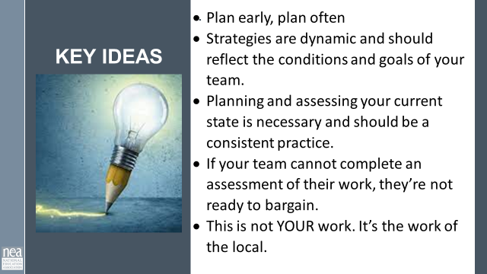 |  | Ask People to Bring a listing of their locals that don’t yet bargain, if possible member lists that include identified leaders  Need a rubric for readiness to bargain |  | 60 Minutes Assessing Your Readiness  3 Minutes Intro and Directions -We spent the morning going over what makes a strong team and a core skill, coaching, that we utilize as staff.  Why all the assessment? We cannot build a house on quicksand. A campaign with a strong foundation allows us to go father and do more. Given that winning collective bargaining requires strategy, power, and a high functioning team to win. Knowing where we are becomes critical to where we spend our energy as staff.  Looking at the Organizing to Bargain Campaign Readiness Assessment- take some time to reflect on your back home work. Assess your local and reflect on where your current strengths, Weaknesses, Opportunities, and Threats.  20 Minutes Group work Time – note – they are each doing their own assessment but should feel free to talk at their tables about their thinking.  10 Minutes Short Report Out and Next step Directions  Given where you have assessed yourself, now turn to Strategy and the Strategy Steps to Win a Collective bargaining Agreement.  Take 3 minutes to Review the phases and decide Which phase you are currently in?  Group up into phases. (5 phases, no group should be larger than 4) Once you are in a group you are going to discuss and chart.  - What made you pick that group?  - What could you do to move from the phase you are currently in, to the next phase? (Look at the hallmarks and look at your assessment).  Chart up your group thinking on what made you choose the phase you are in and how you are moving to the next phase.  15 Minutes Group Discuss and Chart  10 Minutes Sharing out responses  2 Minutes -Key ideas:  - Plan early, plan often  - Strategies are dynamic and should reflect the conditions and goals of your team.  - Planning and assessing your current state is necessary and should be a consistent practice.  - If your team cannot complete an assessment of their work, they’re not ready to bargain.  - This is not YOUR work. It’s the work of the local. |  | 30 Minutes  Day 2
2:00-2:15   | BREAK
2:15-2:45pm  Heidi    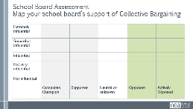  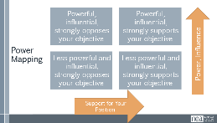      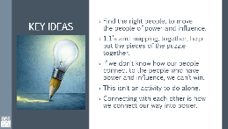 | Who has the power? How do we fully understand the power structure? | Take mapping from the  Power Mapping |  | Power Mapping  5 mins to introduce  Mapping your community and decision makers  Think back to yesterday's review of power. Power is the ability to use your resources to make change or to win the resources necessary to make the changes our members seek. Is the ability to achieve purpose, it is not fixed, it is part perception, part relationship, part capacity – organizing encompasses all of these.  School boards are often a major hill to climb. Do they support our push for bargaining? Do they know about it? Do they follow the supt blindly? Are they a board in name only or do they have their own agendas?  It’s important to strategically analyze how much power and how much influential each of our board members has. We also need to analyze who has power and influence over them. Think about this chart. Where would you place your board members?  When we begin mapping this out, we see a trend that will get us to success and it requires those with the most power and influence to be motivated, inspired, swayed, etc...to support our objective.  We’re going to take time analyze our situation from the realities of power. It’s crucial to know who is supporting our cause, who is opposing, and of those, who actually has the influence for their opinion to have weight with others.  [pass out power analysis handout]  20 mins on step 1  ****group up by state or small group of 4-5 using one person’s situation. This is to help you with your learning so you can coach your teams through this. Using one of your campaigns, start with Step 1  Power Analysis: It’s crucial to know who is supporting our cause, who is opposing, and of those, who actually has the influence for their opinion to have weight with others.  - Internal (to our Union) Power Actors: President, VP, building reps, ID-ed leaders.  - External (to our Union) power actors: Supt., Principals, School Board.  - Community Power (within our community): Parents, PTSA, retirees, Other Unions in our vicinity, employers, small businesses.  - At-Large Power Actors: Governor, legislator, state supreme court, Moms for Liberty, Acorn, Labor Notes.  Step 1: identify and rank your internal (members), external (others within the district, but not part of your membership), community (parents and other community members within your district), and at large power actors (elected officials, people of influence who may not live in the community but can drive change in one direction or another)  Step 2: Start mapping your identified actors on your chart to visually measure where the people of influence set compared to those with the influence to move the masses.  4 mins  Debrief: What trends did you see? What information are you missing?  1 min  Key Points:  Find the right people, to move the people of power and influence.  1:1’s and mapping, together, help put the pieces of the puzzle together.  If we don’t know how our people connect to the people who have power and influence, we can’t win.  This isn’t an activity to do alone.  Connecting with each other is how we connect our way into power.
2:45-3:45pm  Monet-moderator  Amanda Kail 1st, Evette Wilson 2nd  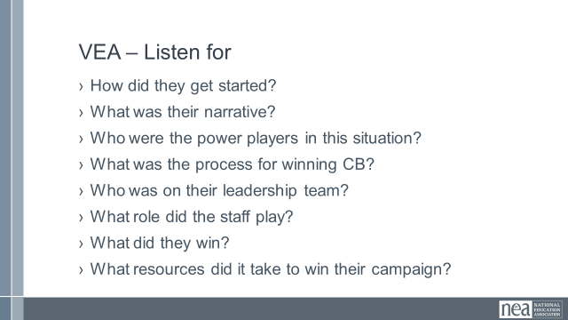 | What does a successful CB campaign look like? |  |  | VEA Panel from A Successful Bargaining Campaign in a Permissive Bargaining State  We wanted to share a story of a successful campaign. This is from a permissive bargaining state.  Things we want you to listen for:  - How did they get started?  - What was their narrative?  - Who were the power players in this situation?  - What was the process for winning CB?  - Who was on their leadership team?  - What role did the staff play?  - What did they win?  - What resources did it take to win their campaign?  Story of a successful campaign. x2  15 minutes of story and sharing from the campaign.  10 mins Questions from the participants  (If time, get in groups and share their reflections and how it informs their back home work.) |  | Understand the core elements of a CB campaign and what it took to win the right to bargain and what did they win.
3:45-4:20pm  Sara  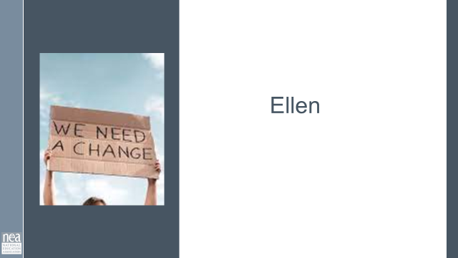  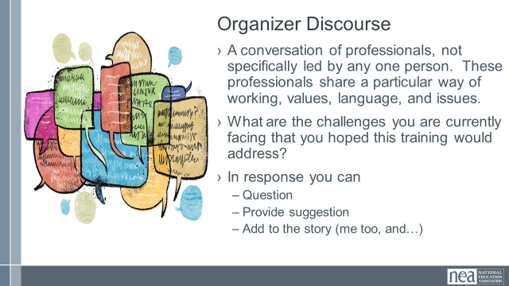 |  | Possible idea – have those folks more alike work together  Move into a circle or move into “world café" sorts of groups. |  | Organizer Discourse  25 minutes of talk time and then 10 minutes of report out  A conversation of professionals, not specifically led by any one person. These professionals share a particular way of working, values, language, and issues.  What are the challenges you are currently facing that you hoped this training would address?  - In response you can  - Question  - Provide suggestion  Add to the story (me too, and…) |  | Participants will share their current realities and begin to from networks to support each other after this training.
4:20-4:30  Ellen  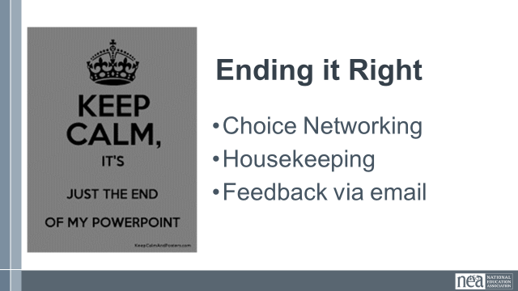 |  |  |  | Closing  Prepping for Getting Home
4:30-5:00  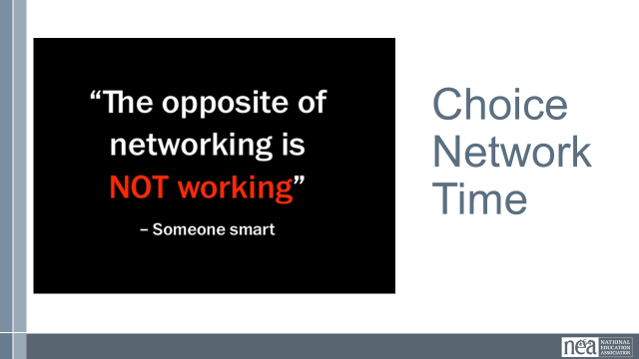 |  |  |  | Choice Networking
5:00 | ADJOURN

