Facilitator Agenda: Day #3 Bargaining for All
General Materials Needed: |  |  |  |  | Room Set-up:
1 Set of Handouts per Person  Name Tags or Name Tents  Sign-in Sheet  UBL Form Folder  Agendas on the table (1 per)  Room signs, sign in signs |  |  | Chart Paper  Markers  Post its  Index Cards  Highlighters – 3 colors  Chart Markers – non-permanent  Pens and Pencils |  | Round Tables  Projector, Screen and Speakers  Carousel stations and reporting stations around the perimeter  50 people
Key Outcomes for the Day
Apply concepts to develop a plan to achieve the first contract
Escalation of actions, structures, and messages

Time | Essential Questions | Resources |  | Instructions, Activity and Debrief (Facilitators) |  | Outcomes
 | What question(s) should this learning section answer? | Charts, handouts, articles, materials, slide |  | What are you saying, what are they doing, what questions will you use to guide learning and make clear the important points  Include an estimate for how long each section of the learning will take |  | As a result of this section of learning, what will participants know or be able to do?
8:30-8:40  Ellen  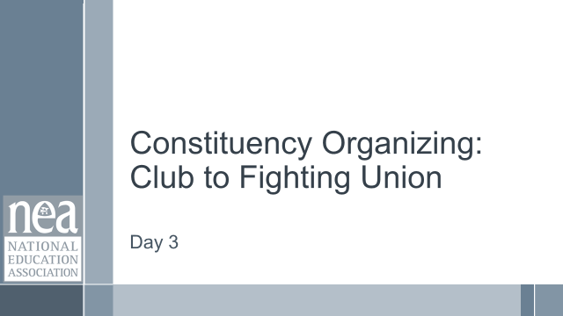  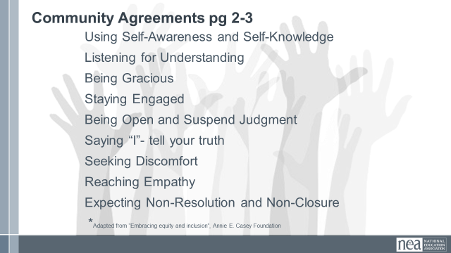  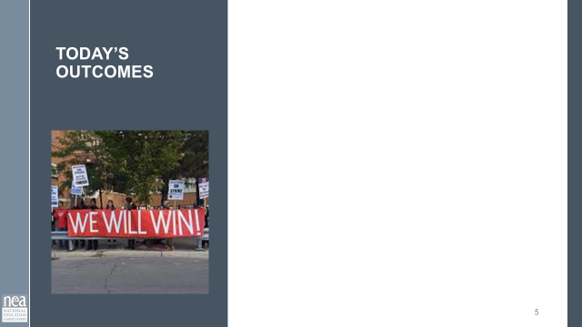  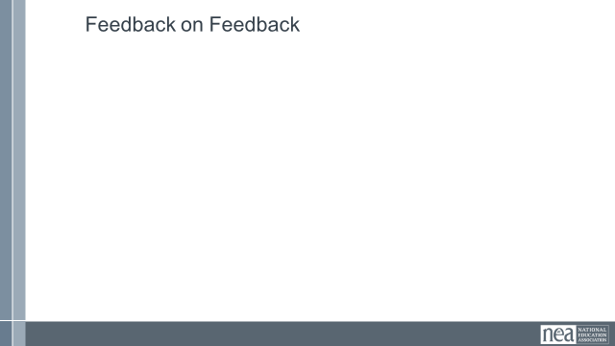 | How and what will I be learning today? |  |  | Re-entry  Review the Norms  Today’s Outcomes  Housekeeping Details  Feedback on Feedback |  | Participants will understand how the final day of learning will proceed and have the ability to see how their feedback is incorporated.
8:40-9:10am  Charles | Bargaining Team and First Contract |  |  | 30 min: Importance of Constitution/Bylaws re Bargaining concepts and creation of the Bargaining team; Bargaining Team Roles; Topics for the First Contract  10 min Constitution/bylaws re Bargaining and the creation of the bargaining team:  For internal transparency and protocol, concepts re the bargaining process and the creation of the bargaining team must be in the local’s constitution/bylaws  Speak to the sample bargaining bylaw concepts listed on the slides:  - Bargaining Team to be “elected” ..(or appointed)  - ^{Racial Diversity}  - Representative of bargaining unit job  assignments/classifications/specialists etc.  - Responsibilities of the bargaining team  - Communication with members including the proposals from both sides  - Share ENTIRE Tentative Agreement (NOT just a summary)  - ^{Ratification Process}  - Quorum (members present …or…total membership)  Bargaining Team roles:  - Spokesperson: Advocates the Association’s positions and responds to those of the employer  - Communications Person: Sends updates to membership & passes notes to Spokesperson  - Official Note taker: Takes the official notes/including intent of the parties for record keeping  - Numbers Person: Does quick math at the table/caucusing and might do the costing  - Board Reaction Observer: Interpreting Board/District behaviors/reactions/reading upside down  10 min Topics in the First contract  There are important topics that should be in the first contract because of the immediate and direct impact on the lives of members on a daily basis during the school year  Briefly speak to and go over the listed topics on the slides  - ^{Recognition}  - ^{Workday/ workweek / work year}  - ^{Just Cause}  - Grievance Procedure with Binding Arbitration  - ^{Union Rights}  - ^{Representation}  - ^{Nondiscrimination}  - Duty-Free Lunch (might be statutory)  - Transfers (voluntary & involuntary)  - ^{Seniority Rights}  - Reduction in Force/Layoffs/Recall Rights  - ^{Personnel Files}  - ^{Leave}  - ^{Holidays}  - ^{Health and Safety provisions}  - ^{Salary}  - ^{Health Insurance}  - ^{Dues Deduction}  - ^{Successor Contract}  - ^{Duration Clause}  5 min….Take 5 min and write down 3 additional topics that have been areas of concern/need final written clarification regarding your local/district relations that must be in the 1st contract  ^{5 min...Key Take Aways:}  -Internal concepts and protocols re Bargaining and the Bargaining Team must be in the Local Constitution and Bylaws  -Each person on the bargaining table team should have an active role  -There are important topics that must be in the 1st contract because the topics immediately and directly impact the lives of members on a daily basis during the school year
9:10-10:30  Zac    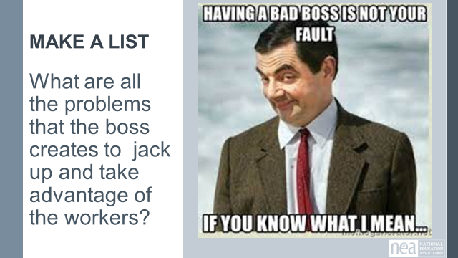  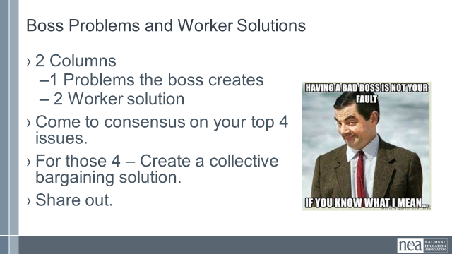  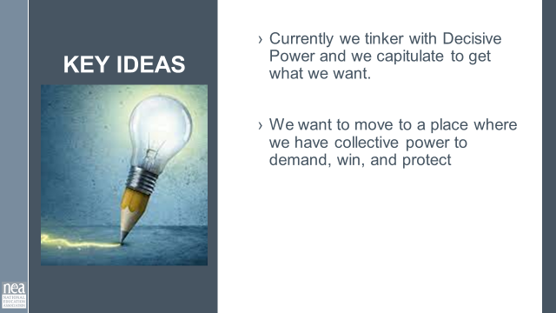  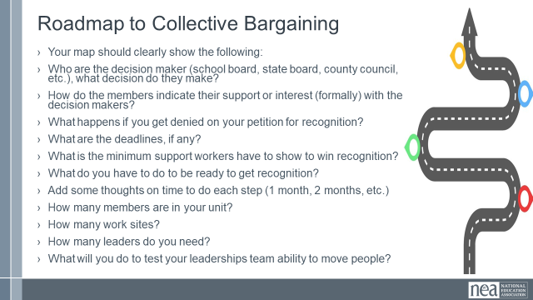  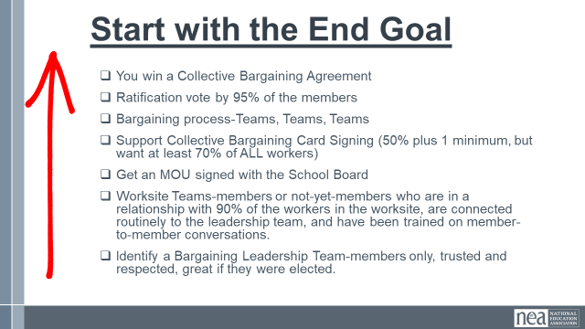  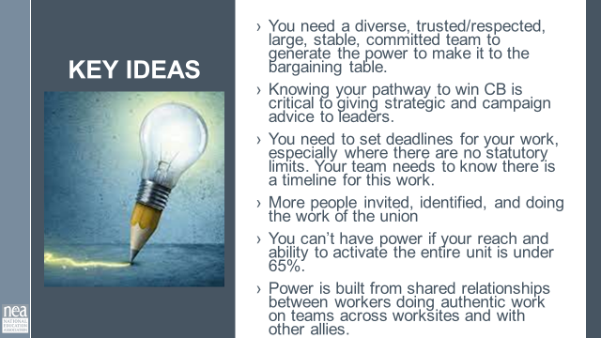  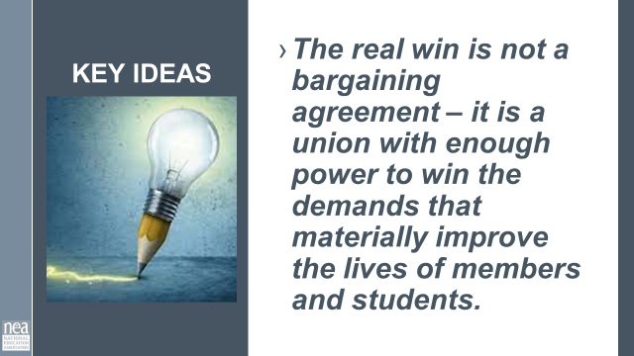 | What is the roadmap to a first contract? | Strategies Step to Win a Collective Bargaining Agreement  Roadmap to Collective Bargaining  Participants bring –  List of all locals with membership density  Building Lists and Leader Lists  Rules and Regulations that Exist in Order for you to Bargain |  | 60 Minutes Your Roadmap to Collective Bargaining break in the space-time continuum has gifted us a bonus 20 minutes here  First Section Boss Problems and Worker Solutions 20 Minutes  3 Minutes Introduction and Directions for Whole Group - Knowing what we need in a 1st contract, how will the boss react or try to disrupt that?  “What are all the ways the boss jacks up/take advantage the workers?” Divide into groups of (SIZE) and put up the issues on a piece of poster paper. Create a column for the problems the boss creates and a column for how collective bargaining could solve the issues.  Chart up your answers and look for what is the same. Come to consensus on your top 4 issues. What could be the solutions you could bargain to what the boss is doing? Are we asking for bargaining solutions to boss antics, or solutions to get through boss antics to bargaining?  15 Minutes Group Work Time Chart and Discuss  2 Minute Whole group Key Take Away: Currently we tinker with Decisive Power and we capitulate to get what we want. We want to move to a place where we have collective power to demand, win, and protect  Second Section What is the Roadmap (40 minutes)  3 Minutes Introduction and Content to whole group  Knowing the rules of engagement and being able to convey this is a core to setting our membership teams on a pathway to success. We want you to develop a plan for what your state or local needs to do to get to the Collective Bargaining table. What is your local process. Looking at the O2B roadmap and using the information from the prior presentation, what is your roadmap to the bargaining table?  Combine the rules you know apply and how many members (potential and active) in the local you are focusing on.  Your map should clearly show the following:  - Who are the decision maker (school board, state board, county council, etc.), what decision do they make?  - How do the members indicate their support or interest (formally) with the decision makers?  - What happens if you get denied on your petition for recognition?  - What are the deadlines, if any?  - What is the minimum support workers have to show to win recognition?  - What do you have to do to be ready to get recognition?  - Add some thoughts on time to do each step (1 month, 2 months, etc.)  - How many members are in your unit?  - How many work sites?  - How many leaders do you need?  - What will you do to test your leaderships team ability to move people?  15 Minutes Individual draft on Chart Paper - As an individual first – make a rough draft of your roadmap (15 minutes)  12 Minutes to move and Share with others - Find states that have similar laws as yours (groups no bigger than 3) and share your road maps.  20 Minutes – NOW THAT YOU HAVE some input from others, develop a Timeline for CB (18-24 months) that includes as much detail as possible. A way to get you started might be to work backwards.  - Write out timeline with deadlines for your campaign  - Ensure to build your team  Key Take Away:  - You need a diverse, trusted/respected, large, stable, committed team to generate the power to make it to the bargaining table.  - Knowing your pathway to win CB is critical to giving strategic and campaign advice to leaders.  - You need to set deadlines for your work, especially where there are no statutory limits. Your team needs to know there is a timeline for this work.  - More people invited, identified, and doing the work of the union  - You can’t have power if your reach and ability to activate the entire unit is under 65%.  - Power is built from shared relationships between workers doing authentic work on teams across worksites and with other allies.  - The real win is not a bargaining agreement – it is a union with enough power to win the demands that materially improve the lives of members and students.
10:30-11:00  Sara  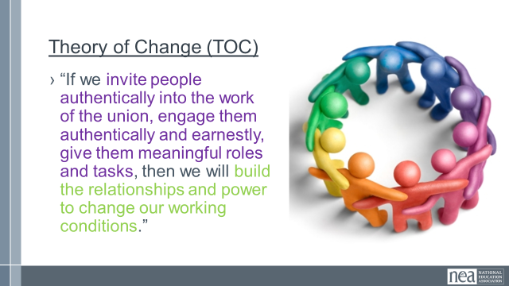  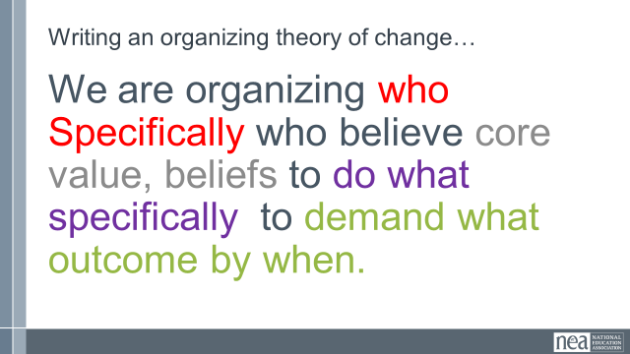  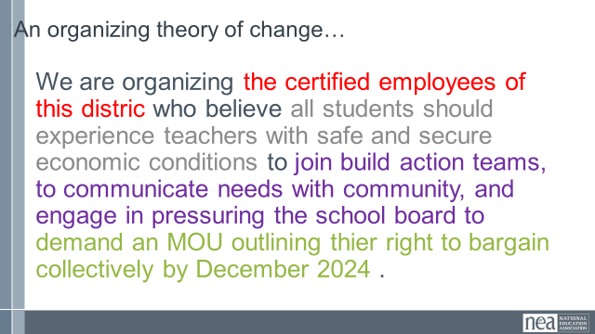  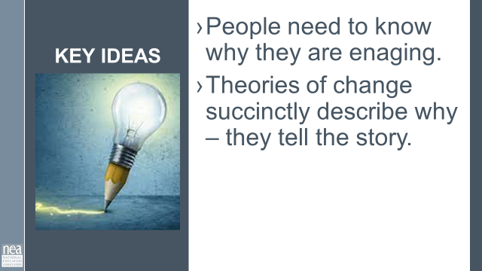 | Theory of Change |  |  | 30 Minutes Theory of Change  Work Backwards - that is a lot of work – how do you get more and more people engaged ?  You invite and agitate around a WHY that meets the needs and values of the people you are inviting. You need a story about that why that is authentic and succinctly communicates what you are doing. This is a theory of change.  An organizing theory of change is even more specific.  Write a theory of change for your campaign.  Coach that into an organizing theory of change.  Key Points –  - People need to know why they are engaging.  - Theories of change succinctly describe why – they tell the story.
11:00-11:15   | BREAK
11:15-12:00  Heidi  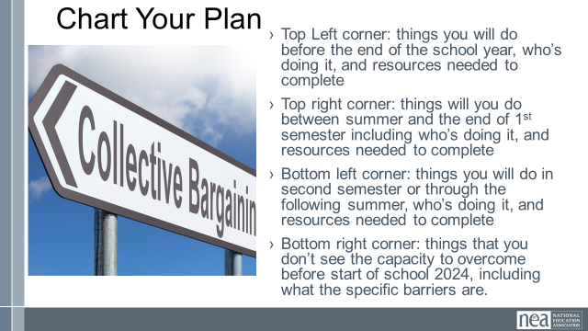 |  |  |  | 45 Minutes Work on your back home plan  - Triage Chart  - Top Left corner: things you will do before the end of the school year, who’s doing it, and resources needed to complete  - Top right corner: things will you do between summer and the end of 1st semester including who’s doing it, and resources needed to complete  - Bottom left corner: things you will do in second semester or through the following summer, who’s doing it, and resources needed to complete  - Bottom right corner: things that you don’t see the capacity to overcome before start of school 2024, including what the specific barriers are.
12:00-12:45  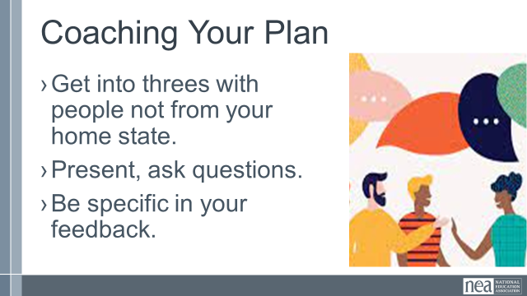 |  |  |  | 45 Minutes Coaching Triads on their plans  - Get into threes with people not from your home state.  - Present, ask questions.  - Be specific in your feedback.
12:45-1:00  Ellen  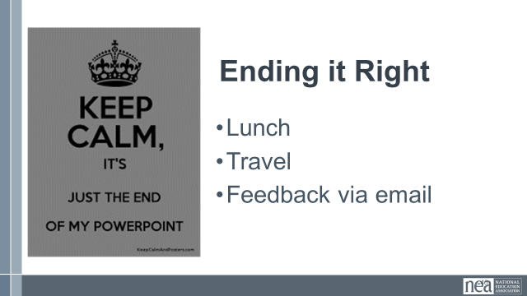 |  |  |  | Closing  Some kind of recognition and time to do evaluations?
1:00 -2:00 | LUNCH and Networking
2:00 | ADJOURN

