Facilitator Agenda: Day # 2 Bargaining for All
General Materials Needed: |  |  |  |  | Room Set-up:
1 Set of Handouts per Person  Name Tags AND Name Tents  Sign-in Sheet  Room signs  Chart Markers – non-permanent  Pens and Pencils |  |  | Chart Paper (Adhesive strip on Top)  Post its  Index Cards  Highlighters – 3 colors |  | Round Tables  Projector, Screen, Microphones and Speakers  Carousel stations and reporting stations around the perimeter  30 to 50 people
Key Outcomes for the Day
Leader Identification Methods
Structures for Moving towards the First CBA
Compression Points to Consider
Essentials for a First Contract
Collectivizing the Process
Big Bargaining, IBB, Common Good
Time | Essential Questions | Resources |  | Instructions, Activity and Debrief (Facilitators) |  | Outcomes
 | What question(s) should this learning section answer? | Charts, handouts, articles, materials, slide |  | What are you saying, what are they doing, what questions will you use to guide learning and make clear the important points  Include an estimate for how long each section of the learning will take |  | As a result of this section of learning, what will participants know or be able to do?
8:30-8:45  Ellen  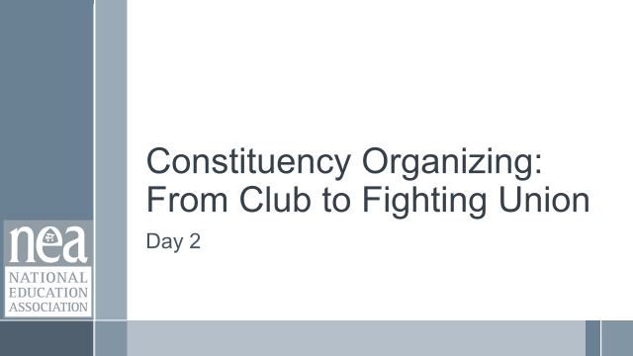  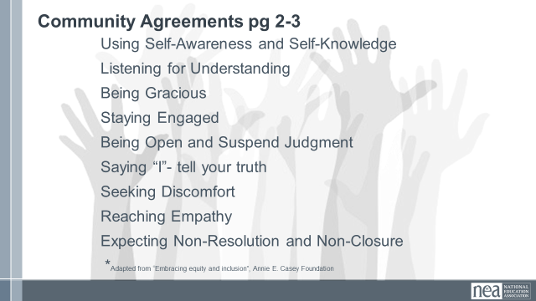  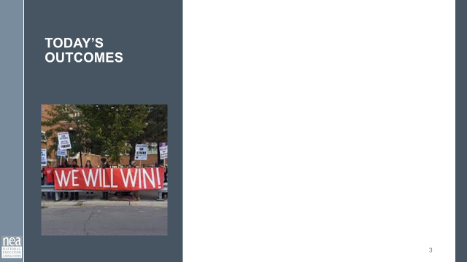  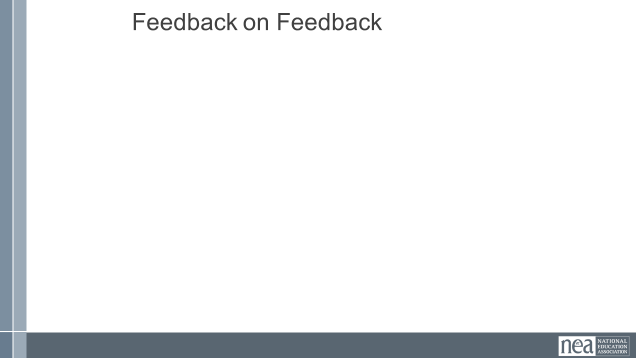 | How will we work together on Day 2? |  |  | Re-entry  Review of Community Agreements  Housekeeping Details  Feedback on Feedback |  | Participants continue to build as a learning community.
30 Minutes  Charles  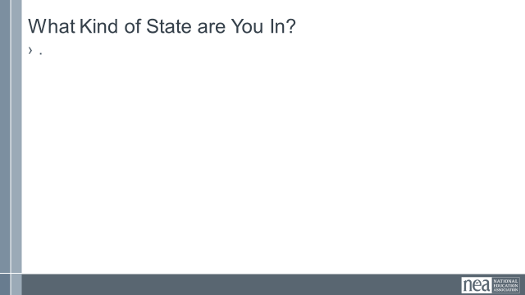  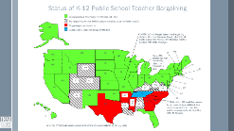  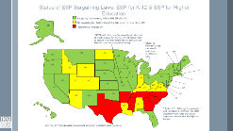 | Charles Holmes | Participants need their regulations for how, when, and with whom they bargain. |  | 30 Minutes Big Picture – Status of Bargaining  Maps and the three descriptions  Mandatory  Permissive  Prohibited  What are the attacks and changes over time of bargaining rights? (timeline)  Indiana  Wisconsin  Fight back of Michigan  Maybe some parallel discussion of how some states lost and some states won  What are the regulations about bargaining where you are?  If you are not currently bargaining, where do you spend most of your work time?
9:15-10:15 Day 2  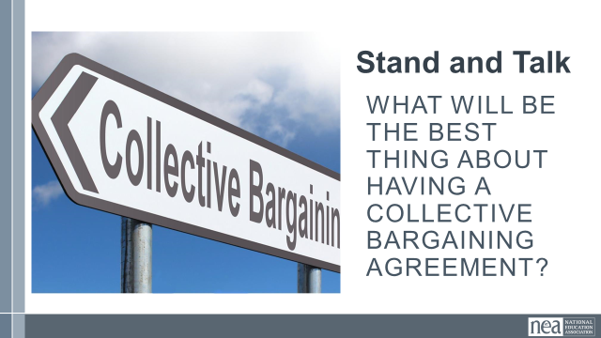    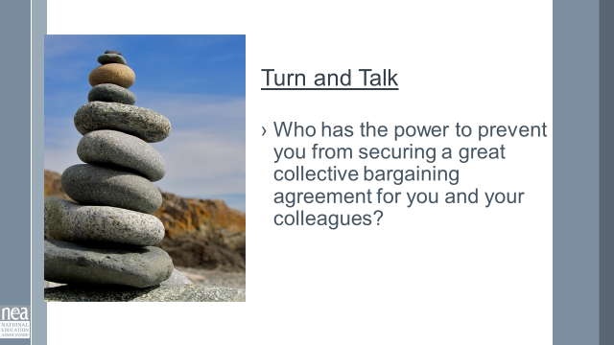  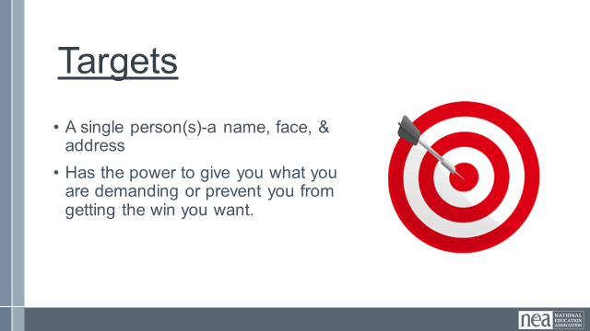  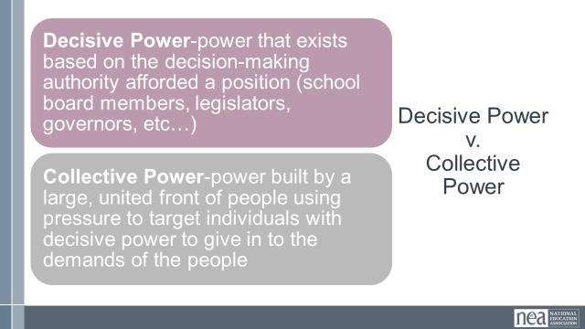  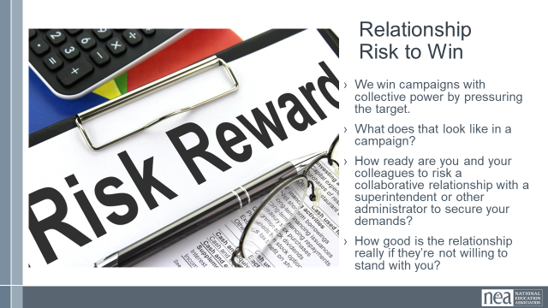  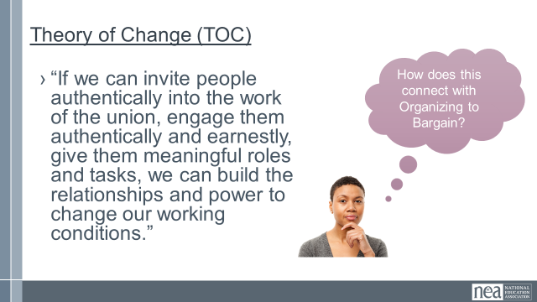  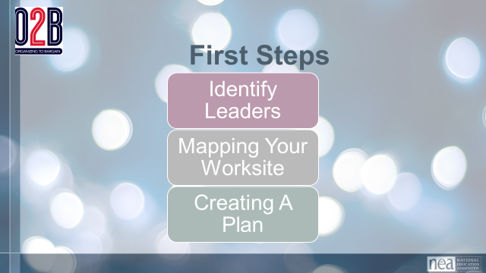  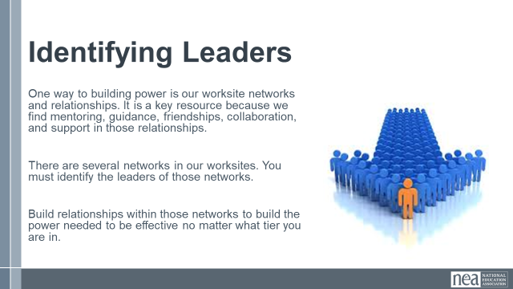  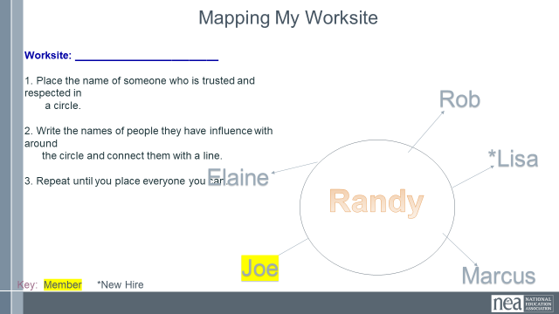  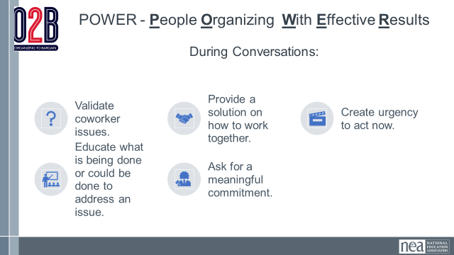  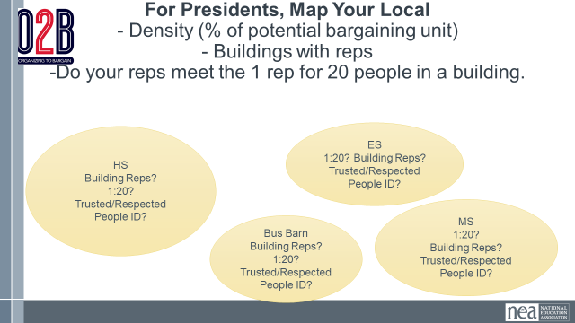  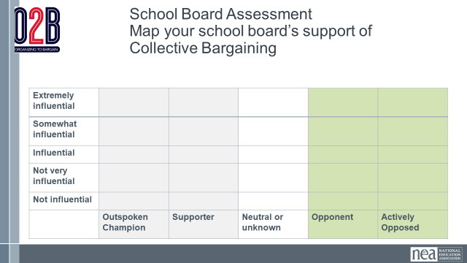  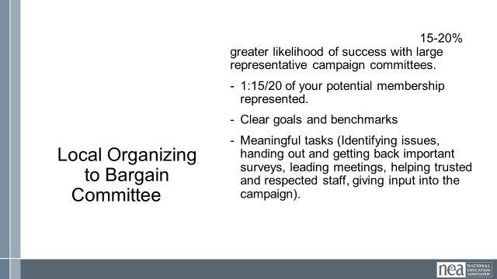  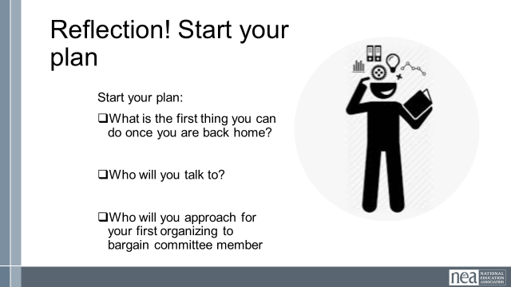  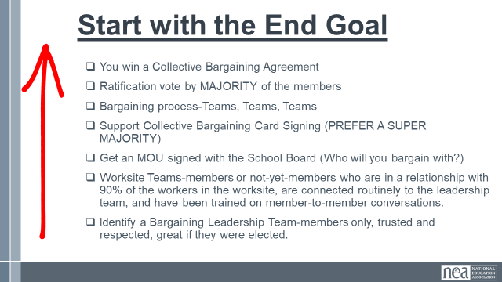  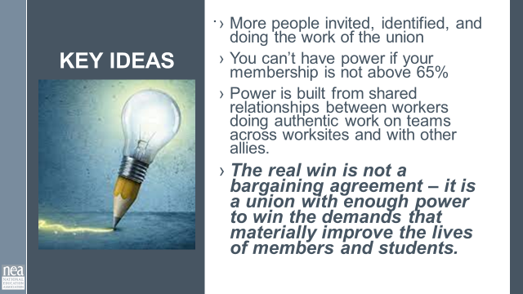 | What is the roadmap to a first contract? | Need a Planning Template  -  Strategies Step to Win a Collective Bargaining Agreement  Roadmap to Collective Bargaining  Participants bring –  List of all locals with membership density  Building Lists and Leader Lists  Rules and Regulations that Exist in Order for you to Bargain |  | 60 Minutes Your Roadmap to Collective Bargaining  20 minutes  “What are all the ways the boss jacks up/take advantage the workers?” Divide into groups of (SIZE) and put up the issues on a piece of poster paper. Create a column for the problems the boss creates and a column for how collective bargaining could solve the issues.  Chart up your answers and look for what is the same. Come to consensus on your top 4 issues. What could be the solutions you could bargain to what the boss is doing? Share out.  Key Take Away: Currently we tinker with Decisive Power and we capitulate to get what we want. We want to move to a place where we have collective power to demand, win, and protect  What is the Roadmap (40 minutes)  Knowing the rules of engagement and being able to convey this is a core to setting our membership teams on a pathway to success. We want you to draw up what your state needs to do to get to the CB table. What is your local process. Looking at the O2B roadmap and using the information from the prior presentation, what is your road to the bargaining table?  Combine the rules you know apply and how many members (potential and active) in the local you are focusing on.  Your map should clearly show the following:  - Who are the decision maker (school board, state board, county council, etc.), what decision do they make?  - How do the members indicate their support or interest (formally) with the decision makers?  - What happens if you get denied on your petition for recognition?  - What are the deadlines, if any?  - What is the minimum support workers have to show to win recognition?  - What do you have to do to be ready to get recognition?  - Add some thoughts on time to do each step (1 month, 2 months, etc.)  - How many members are in your unit?  - How many work sites?  - How many leaders do you need?  - What will you do to test your leaderships team ability to move people?  Take a moment to draw your CB roadmap up as an individual (15 minutes)  Draw up your CB roadmap (10 minutes).  Find states that have similar laws as yours (groups no bigger than 3) and share your road maps. (10 minutes)  Key Take Away:  - You need a diverse, trusted/respected, large, stable, committed team to generate the power to make it to the bargaining table.  - Knowing your pathway to win CB is critical to giving strategic and campaign advice to leaders.  - You need to set deadlines for your work, especially where there are no statutory limits. Your team needs to know there is a timeline for this work.  - More people invited, identified, and doing the work of the union  - You can’t have power if your reach and ability to activate the entire unit is under 65%.  - Power is built from shared relationships between workers doing authentic work on teams across worksites and with other allies.  - The real win is not a bargaining agreement – it is a union with enough power to win the demands that materially improve the lives of members and students.
10:15-10:30 | BREAK
10:30-11:00  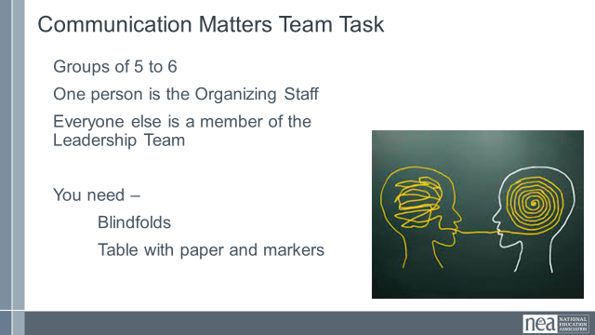  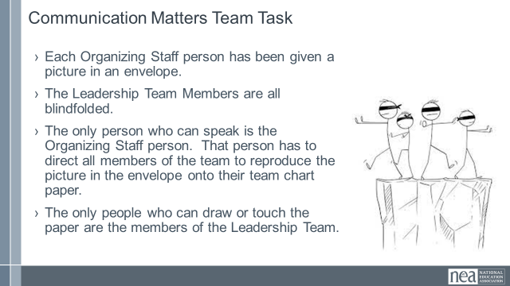  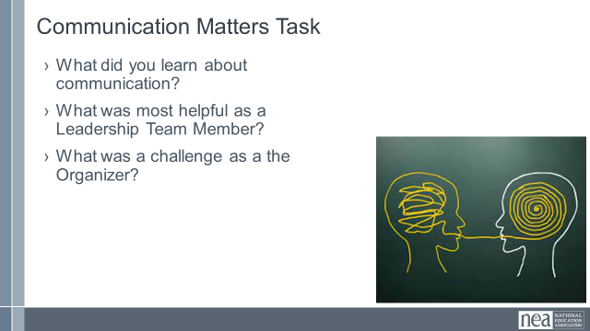  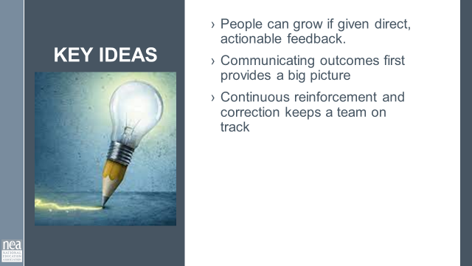 | How do we communicate with teams? |  |  | 30 Minutes Total -Communication in Teams Matters  3 minutes to give intro and divide into teams – We are going to be working in teams of 5 to 6. Go ahead and get settled in with your team. Now that you are settled, pick one person to be the Organizing Staff Person. The rest of you will be members of a leadership team. We are going to co-create a product in teams. On your tables are blindfolds paper and markers. If you are a Leadership team member you need to put your blindfold on so that you can’t see – no peeking out the side, and if you can see through it—close your eyes.  Organizing Staff person- you have an envelope in your hand that contains a drawing. When we begin you are the only person allowed to talk to your team. They can not ask you questions, they can not talk to each other or to you or out loud at all. When we begin you will be able to open your envelope and your task is to direct every member of your team to draw as closely as possible the picture in your envelope. You can not touch them in any way, only use your voice to direct. The only people allowed to touch markers or paper or to draw on the paper are the leadership team. You will have 10 minutes to make your masterpieces.  10 Minutes of Group activity  5 Minutes – Sharing of Pictures and Reflection on Learning as teams  Take of your blindfolds. Take 5 minutes to discuss as a team the following questions:  - What did you learn about communication?  - What was most helpful as a Leadership Team Member?  - What was a challenge as the Organizer?  5 Minutes whole group report out on the questions above  2 Minutes Key Ideas  - People can grow if given direct, actionable feedback.  - Communicating outcomes first provides a big picture  - Continuous reinforcement and correction keeps a team on track |  | Participants will experience the kind of complex communication required to get a task done in a specific timeline.
11:00- 12:00  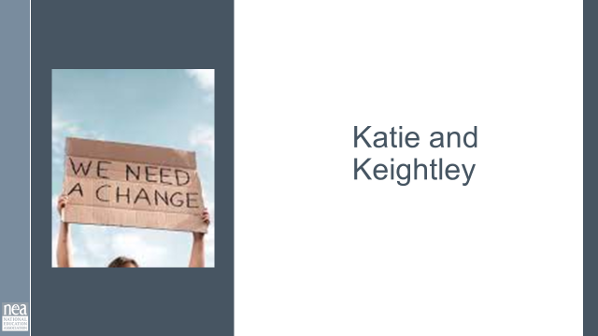  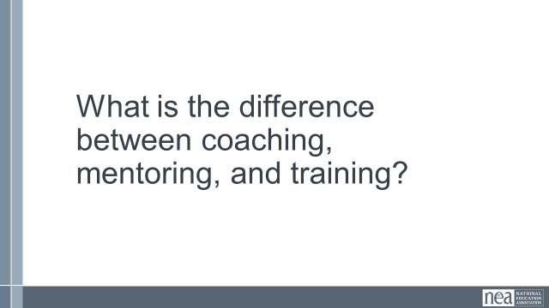  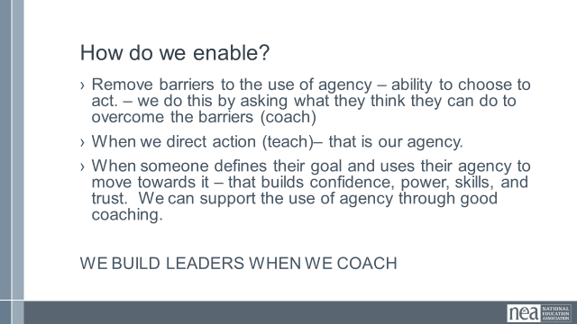  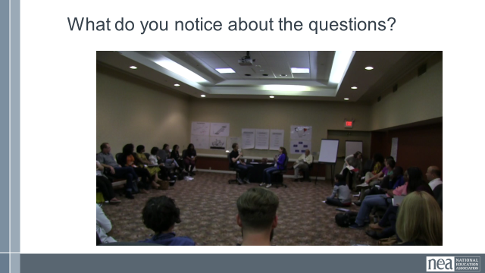  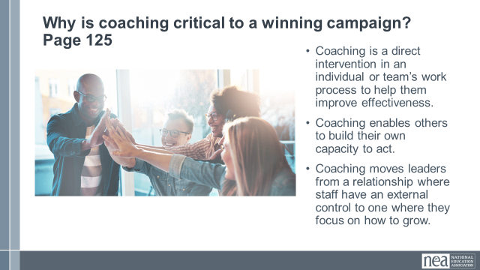  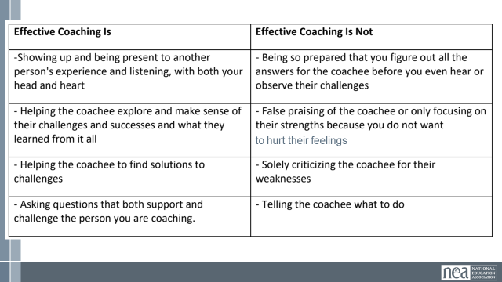  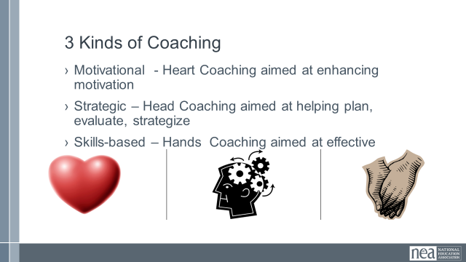  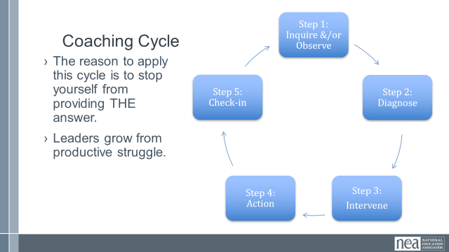  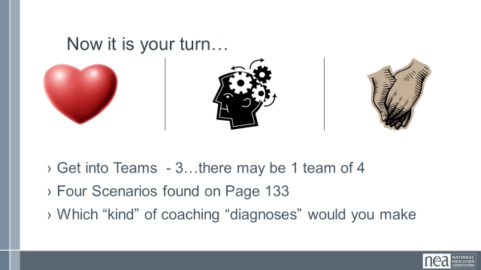  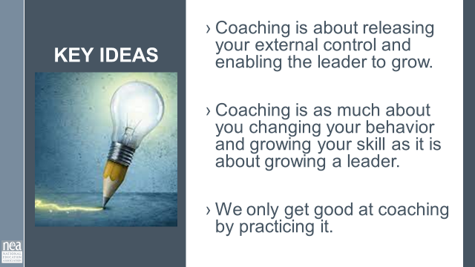  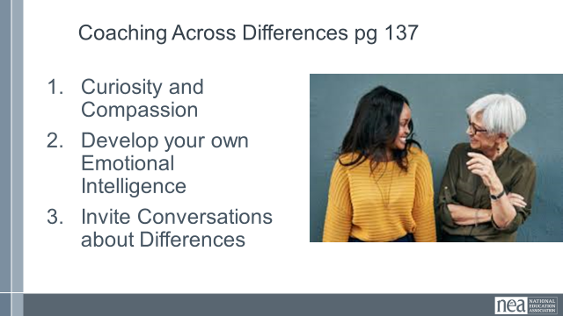  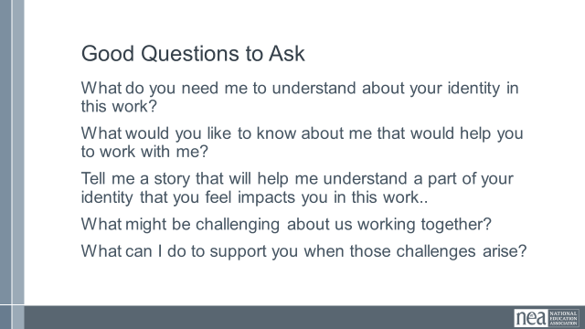  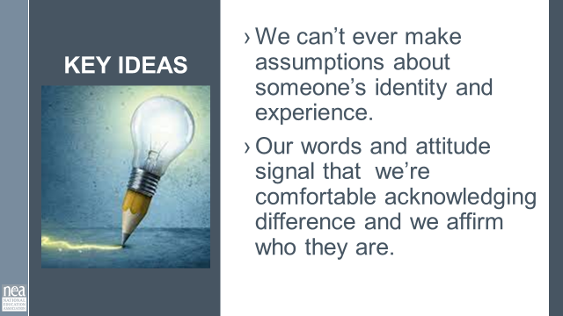 | How do I coach a team? | Resources –  Coaching 101  Video- Ganz coaching class.  Ask Drew for Cross Race Coaching Article or Podcast  Ganz Coaching Cycle |  | 60 Minutes – How do we develop leaders? We have used this in Foundation's of Organizing Winning Campaigns so I think we need to change it up somehow- I feel like we could shorten up the front of this and the video did not get us a great return for the time it takes last time.  Turn at your table be ready to rapid fire out.  Reminder Leaders are those who take responsibility for enabling others to achieve purpose in the face of uncertainty.  How do we enable?  Remove barriers to the use of agency – ability to choose to act. – we do this by asking what they think they can do to overcome the barriers (coach)  - When we direct action (teach)– that is our agency.  - When someone defines their goal and uses their agency to move towards it – that builds confidence, power, skills, and trust. We can support the use of agency through good coaching.  WE BUILD LEADERS WHEN WE COACH  10 mins SHOW VIDEO (Needs to have closed captions added) – What do you notice about the questions that are asked? Look at resistance school video on YouTube!!  Why is coaching critical to a winning campaign?  10 mins – Content for coaching (All comes from the content handout, pp) - Provide the definition of coaching we are going to use in this training. Share why we think this model of coaching is useful, and what is the difference between good coaching and bad coaching.  Good coaching and ineffective coaching  Chart to read is on page 128 as well as in slides  3 Types of Coaching - knowing which you need  - Motivational - Heart Coaching aimed at enhancing motivation  - Strategic – Head Coaching aimed at helping plan, evaluate, strategize  - Skills-based – Hands Coaching aimed at effective  Coaching Cycle  - The reason to apply this cycle is to stop yourself from providing THE answer.  - Leaders grow from productive struggle  PG 133 Teams will work through the four scenarios and identify which of the three types of coaching might be required.  Get into small groups.  Debrief by going over the responses from the teams. Facilitate dialogue and questions between teams as opposed to you “leading and lecturing. “  Key points to draw out – when we coach we are releasing the external control we have and allowing for the individuals to grow. It is really step 4 and 5 that several struggle – for a variety of reasons. We only get good at coaching by doing it. We use a coaching framework to break the habit of “diagnose and direct” which takes away the person’s ability to rise as a leader.  Coaching Across Differences Pg 137  - Curiosity and Compassion  - Develop your own Emotional Intelligence  - Invite Conversations about Differences  Good Questions to Ask  What do you need me to understand about your identity in this work?  What would you like to know about me that would help you to work with me?  Tell me a story that will help me understand a part of your identity that you feel impacts you in this work..  What might be challenging about us working together?  What can I do to support you when those challenges arise?  Key Points  - We can’t ever make assumptions about someone’s identity and experience.  Our words and attitude signal that we’re comfortable acknowledging difference and we affirm who they are.  Inherent, in a coaching relationship is trust. There has to be trust to give and receive feedback. |  | Participants will apply a coaching model to a number of scenarios.
12:00 to 1:00 | LUNCH
1:00-2:00 |  | Take mapping from the  Power Mapping |  | Power Mapping  Mapping your community and decision makers  Power Analysis: It’s crucial to know who is supporting our cause, who is opposing, and of those, who actually has the influence for their opinion to have weight with others.  Step 1: identify and rank your internal (members), external (others within the district, but not part of your membership), community (parents and other community members within your district), and at large power actors (elected officials, people of influence who may not live in the community but can drive change in one direction or another)  Step 2: Start mapping your identified actors on your chart to visually measure where the people of influence set compared to those with the influence to move the masses.  Discuss.
2:00-2:15  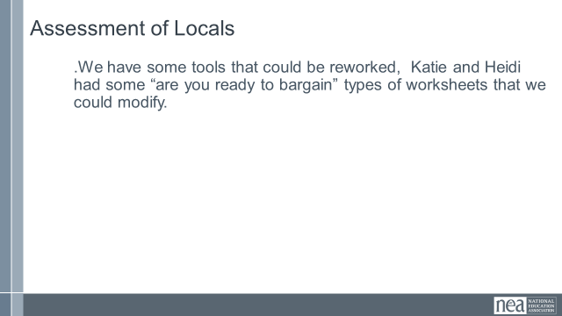  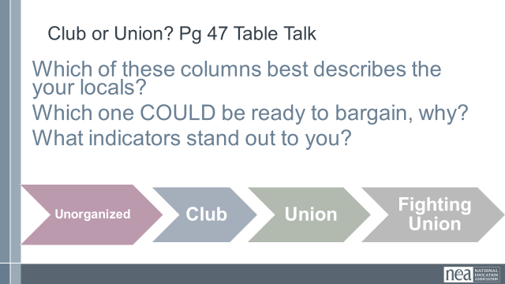  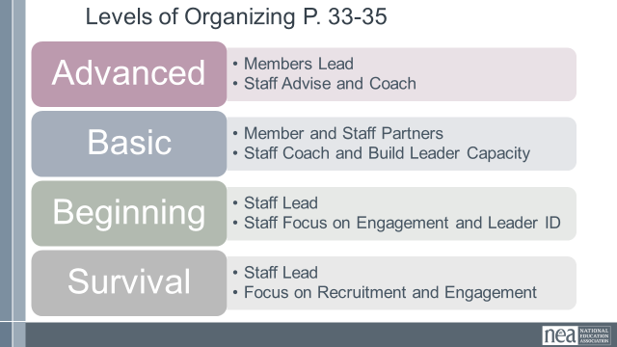  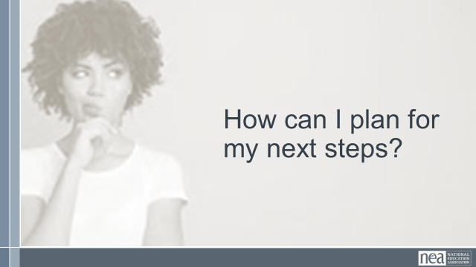   | INCLUDE BREAK IN THIS FROM 2:15-2:30 | Ask People to Bring a listing of their locals that don’t yet bargain, if possible member lists that include identified leaders  Need a rubric for readiness to bargain |  | 60 Minutes  60 Minutes Readiness Assessment  GIVE THE DIRECTIONS and content then continue after break  Assessment of Locals (MAYBE THIS IS SEPARATE OR COMBINED WITH ABOVE  We need tool – can we reuse the Levels of Organizing or Club to Fighting Union here?  Or the tool from TUSJ?  How does a campaign for the first collective bargain move you through the levels?  I think we also need them to asses |  | 30 Minutes  Day 2
2:15-2:30 | BREAK
2:30-3:15 |  |  |  | CONTINUED FROM BEFORE BREAK
60 MInutes  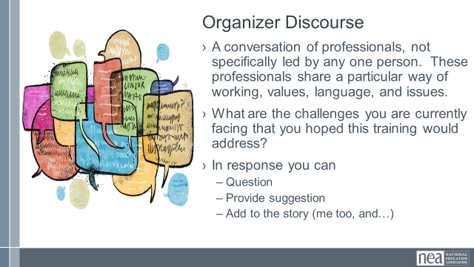 |  | Possible idea – have those folks more alike work together  Move into a circle or move into “world café" sorts of groups. |  | Organizer Discourse  60 minutes of talk time and then 10 minutes of report out  A conversation of professionals, not specifically led by any one person. These professionals share a particular way of working, values, language, and issues.  What are the challenges you are currently facing that you hoped this training would address?  - In response you can  - Question  - Provide suggestion  Add to the story (me too, and…) |  | Participants will share their current realities and begin to from networks to support each other after this training.
4:20-4:30  Ellen |  |  |  | Closing  Prepping for Getting Home
4:30-5:00 |  |  |  | Choice Networking
5:00 | ADJOURN
 |  |  |  | BELOW THIS IS ALL EXTRA STUFF
45 Minutes | How do we convince our locals to get started? | I say this is not needed at this point |  | Building Blocks for Democracy  This may be an opportunity to divide into 6 groups each with one of the people stories from section 2 – they become an expert on that section – then they reform (jigsaw) so that there is one person from each of the groups and they teach the others about their section  The outcome for this – how did these people/groups get started?  How will you get started?
30 Minutes |  |  |  | How do you form and build teams  Something about selecting leaders and creating team commitments
60 Minutes |  |  |  | Building a Timeline for Achieving Bargaining  18 to 24 months
30 Minutes |  |  |  | What to consider in a bargaining team
60 Minutes |  |  |  | What should a first contract include
30Minutes |  |  |  | Theory of Change for your campaign
30 minutes |  |  |  | Missteps that do not build power  - Skipping steps  - How we remedy missteps or a lack of team

