Facilitator Agenda: Day #3 Bargaining for All
General Materials Needed: |  |  |  |  | Room Set-up:
1 Set of Handouts per Person  Name Tags or Name Tents  Sign-in Sheet  UBL Form Folder  Agendas on the table (1 per)  Room signs, sign in signs |  |  | Chart Paper  Markers  Post its  Index Cards  Highlighters – 3 colors  Chart Markers – non-permanent  Pens and Pencils |  | Round Tables  Projector, Screen and Speakers  Carousel stations and reporting stations around the perimeter  50 people
Key Outcomes for the Day
Apply concepts to develop a plan to achieve the first contract
Escalation of actions, structures, and messages

Time | Essential Questions | Resources |  | Instructions, Activity and Debrief (Facilitators) |  | Outcomes
 | What question(s) should this learning section answer? | Charts, handouts, articles, materials, slide |  | What are you saying, what are they doing, what questions will you use to guide learning and make clear the important points  Include an estimate for how long each section of the learning will take |  | As a result of this section of learning, what will participants know or be able to do?
8:30-8:40  Ellen  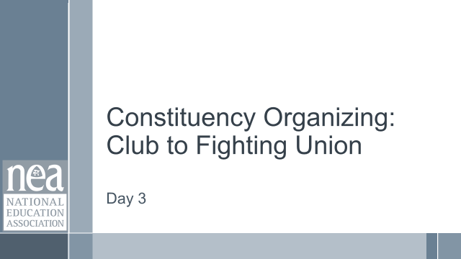  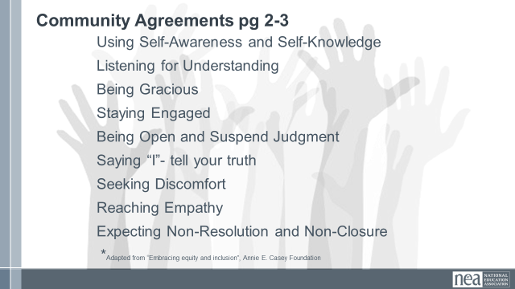    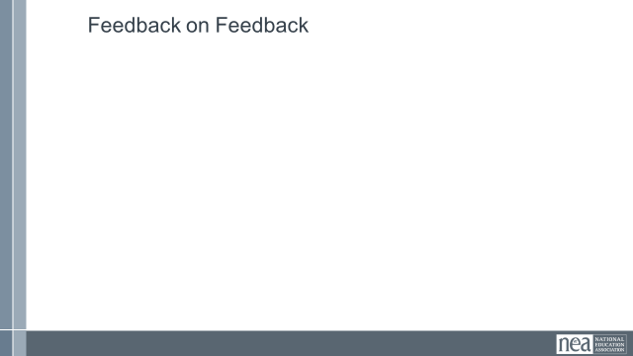 | How and what will I be learning today? |  |  | Re-entry  Review the Norms  Today’s Outcomes  Housekeeping Details  Feedback on Feedback |  | Participants will understand how the final day of learning will proceed and have the ability to see how their feedback is incorporated.
60 Minutes
30 Minutes
60 Minutes
30Minutes
12:45-1:00  Ellen    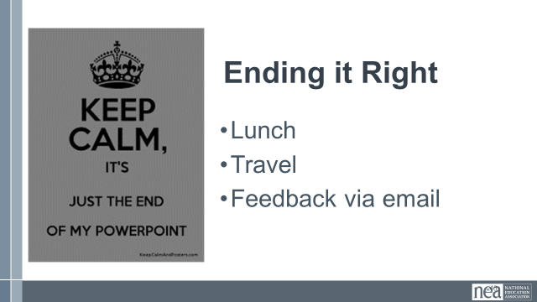 |  |  |  | Closing  Some kind of recognition and time to do evaluations?
1:00 -2:00 | LUNCH and Networking
2:00 | ADJOURN

