Facilitator Agenda: VEA Organizing 2 Bargain
General Materials Needed: |  |  |  | Virtual Set-up:
Resource Package that supports the learning, Planning Template, 1-4 of Locals  Link to package https://neahq-my.sharepoint.com/:b:/g/personal/eholmes_nea_org/EaYxY8OnqFlOsF3XUqeK0CEBfDpX2myNzq82TL97-3ZitA?e=IBH2Ht |  |  |  | Zoom, computers with audio and video connectivity  FULL PPT - https://neahq-my.sharepoint.com/:p:/g/personal/eholmes_nea_org/EY3zn2OgoQpMldsjYdn4LScBnl95BFtWuRcEOlNW8rcXBA?e=QRDAzM
Key Outcomes for the Full Training
Participants will form a common vocabulary for organizing and this campaign
Participants will rate their locals-worksites using the 1 to 4 framework
Participants will develop a strength and growth plan that leads to a set of “ready to bargain” indicators
Module 1 | Slides | Resources Found in Handout Document | Instructions, Activity and Debrief (Facilitators) |  | Outcomes
Module #, Facilitators, Date, Time and Link | Slides | Charts, handouts, articles, materials, slides | What are you saying, what are they doing, what questions will you use to guide learning and make clear the important points  Include an estimate for how long each section of the learning will take |  | As a result of this section of learning, what will participants know or be able to do?
Module 1: Our Campaign and Locals – Katie, Todd, Jennifer, Toney – December 2, 9:00- 10:30 Module PPT https://neahq-my.sharepoint.com/:p:/g/personal/eholmes_nea_org/EUuljB6aXthIhYsye-PbrMQB54fShk_luFiwMTHPsWFjLQ?e=c1XSGi

https://nea-org.zoom.us/j/96578727085?pwd=WmNhOThWZ0tCd1pROTAxalpyR1drUT09  Meeting ID: 965 7872 7085  Passcode: ZN673d | 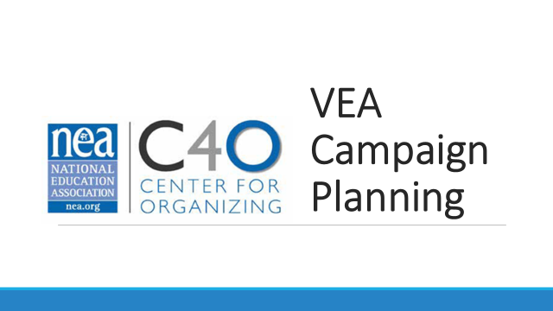  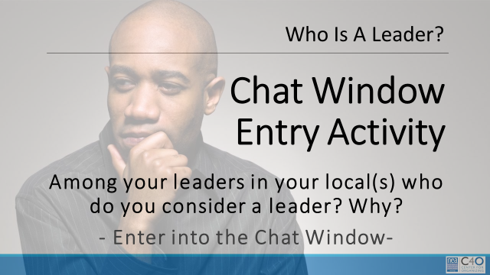  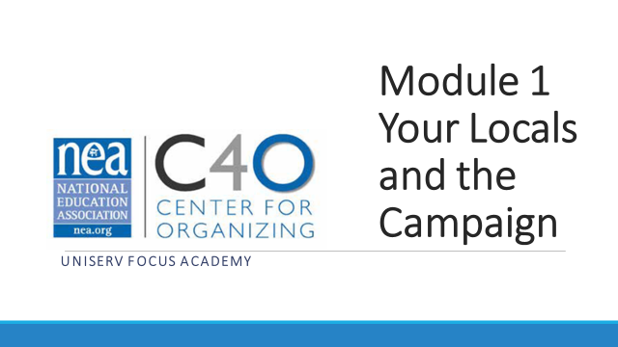  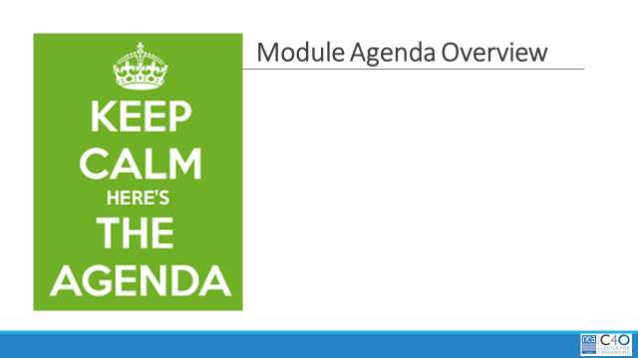  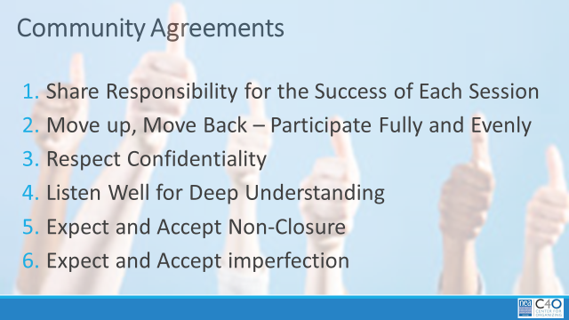    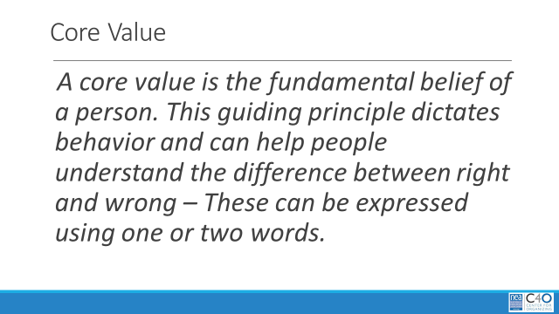  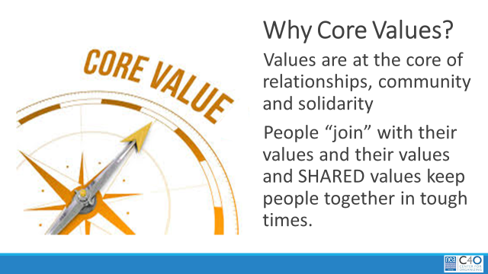  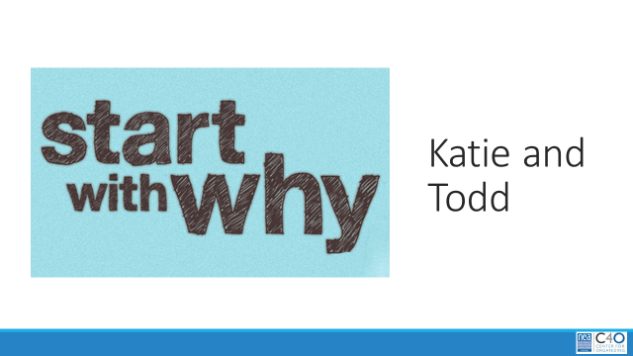  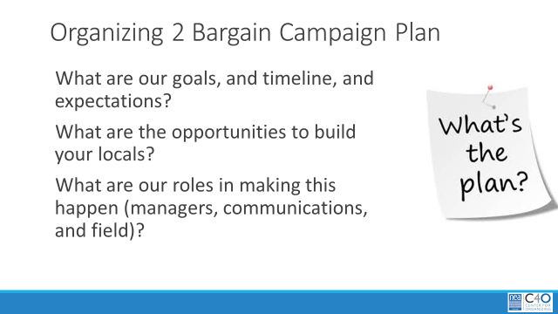  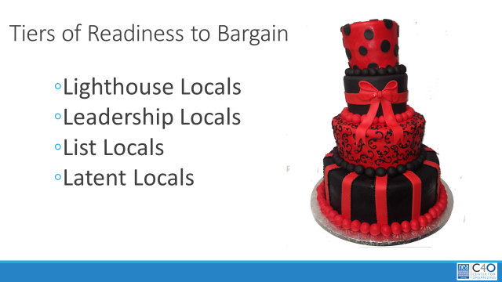  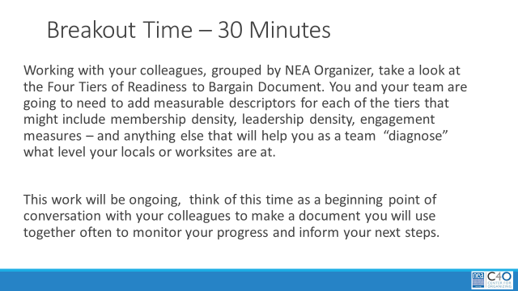  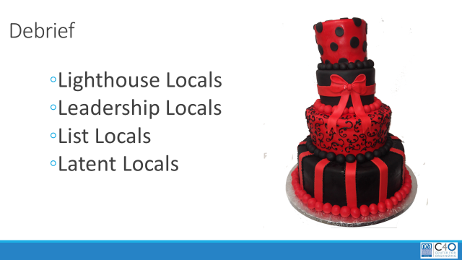  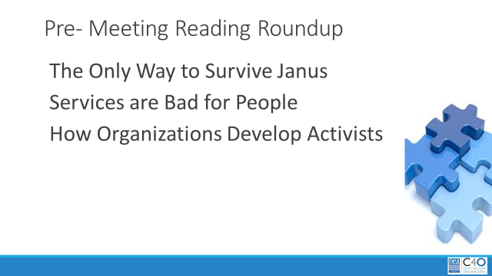  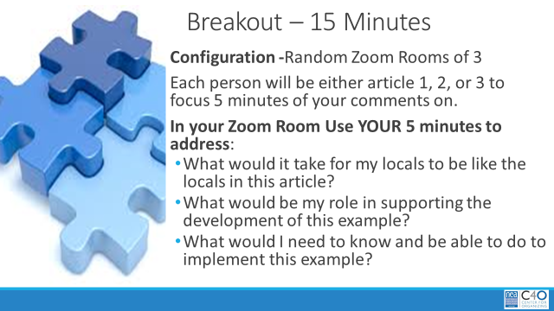  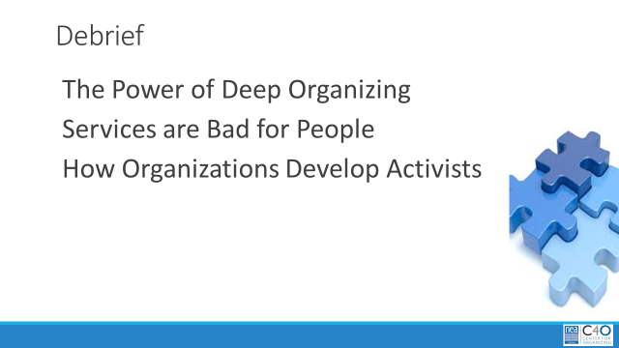  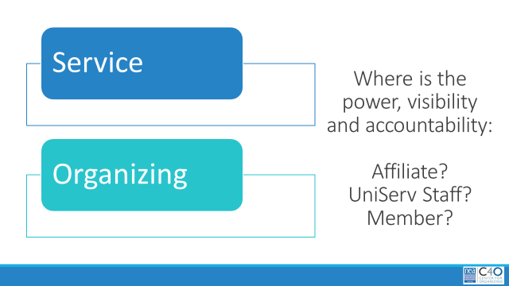  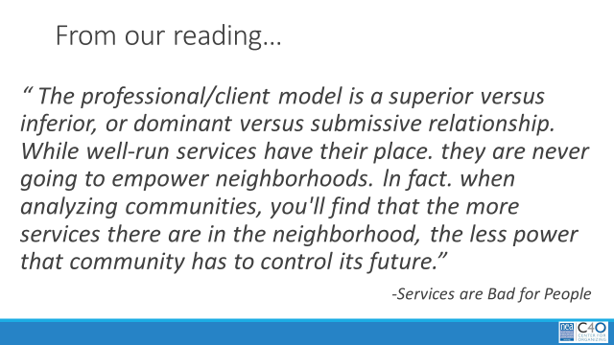  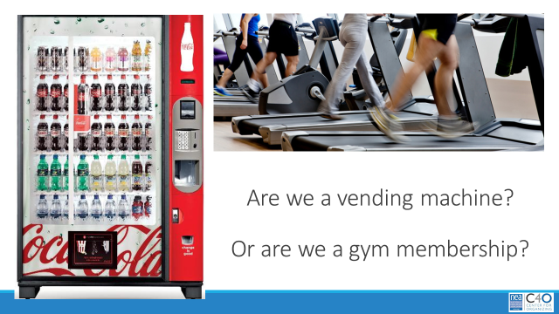  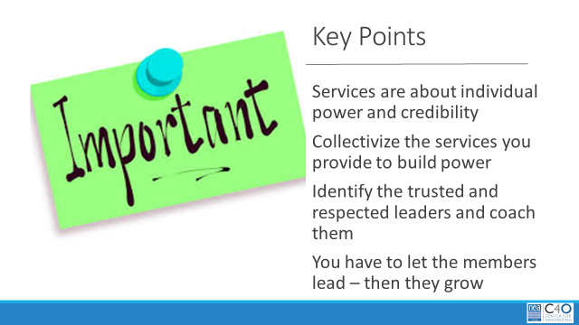  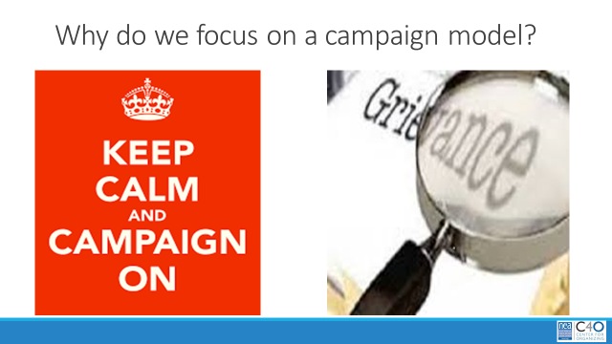  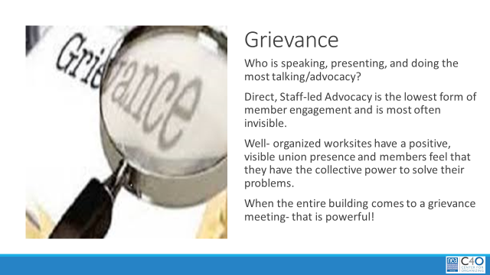  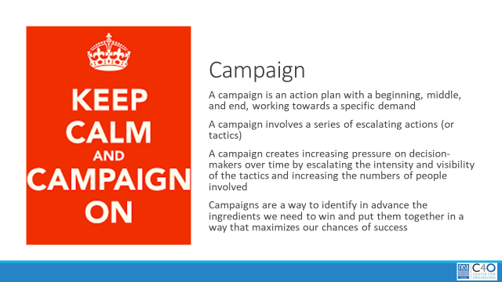  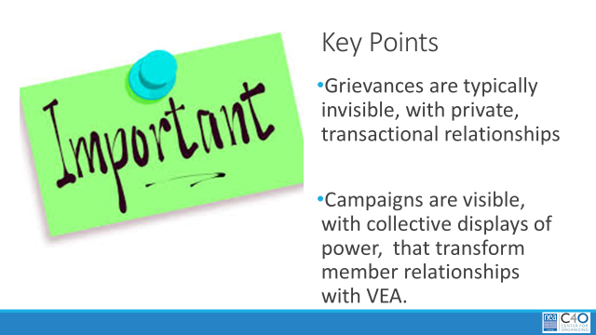 | Community agreements  Core Values  VEA Plan  4 Tiers of PG 26-27 Readiness (will be used through Several Modules)  3 Articles from Pre-Reading:  Deep Organizing  How Organizations Build Activists  Services are Bad for People | 9:00 – 9:15 Jennifer  Welcome  Agenda Review,  Community Agreements – you were asked to preview them and note any questions or additions you would like to make  Introductions of all the VEA colleagues leading this training  Core Values – You were asked to brainstorm a list of Core Values prior to this session- we are going share these in the chat window now. As you type we will begin to call out themes that we notice across the values.  9:20- 9:45 Katie and Todd  Present the Campaign – its goals, and timeline, and expectations  What are the opportunities to build your locals?  What are our roles in making this happen  (managers, communications, and field)?  9:45 – 10:25  Introduce participants to the 4 Tiers of Readiness Document  Stress that it is a work in progress and it is designed to help you target and differentiate your work .  You will be sending them into breakout rooms based on their NEA organizer. Once in their rooms, they will need to complete the tiers. They should discuss  What other metrics and descriptors will help them in their team to “level” their locals or worksites. They should then begin to identify what are the “types” of steps and work that they would be doing at each tier. IF they have extra time, they might begin to name locals or worksites in each of the tiers.  They will work for 30 minutes in their groups then 10 Minutes of Debrief  This would be about 30 Minutes to do well –  - You were asked to read 3 articles prior to coming. The Power of Deep Organizing, How Organizations Build Activists, Services are Bad for People. You are going to be sent to zoom rooms in random triads. Each person will be either article 1, 2, or 3 to focus 5 minutes of your comments on.  - In your Zoom Room Use YOUR 5 minutes to address:  - What would it take for my locals to be like the locals in this article?  - What would be my role in supporting the development of this example?  - What would I need to know and be able to do to implement this example?  Debrief for 5 minutes  Where is the power of the affiliate, the staff, the members? When we are providing services or when we are organizing? Type your answers in the chat window or unmute yourself and shout out an answer  This quote from one our readings brings the point home – are we a vending machine in which members put some dollar amount in and expect that value in return and will hold YOU accountable for that --- or are we a gym membership that accepts member dollars allowing them to make a plan for making change in which there is shared accountability?  And these are our key points to remember  So why should we focus on campaign thinking for making our tiers stronger over providing services (this does not mean we don’t provide any services – but instead we guide our leaders into owning the services a union provides)  Grievances are …  Campaigns are…  Final Points  IN THE CAMPAIGN: Which locals are at which tier, what is the focus of your work with the different tiers. |  | Participants will be able to describe key aspects of the VEA Plan  Participants will understand their unique roles in making the campaign a success  Participants will identify the opportunities that this campaign has for their unique locals  Participants will begin a plan for targeting their work based on tiers of readiness that their locals and worksites are in
Module

Module 2 | Slides | Resources | Instructions, Activity and Debrief (Facilitators) | Outcomes
Module #, Facilitators, Date, Time and Link | Slides | Charts, handouts, articles, materials, slides | What are you saying, what are they doing, what questions will you use to guide learning and make clear the important points  Include an estimate for how long each section of the learning will take | As a result of this section of learning, what will participants know or be able to do?
Module 2 – What is organizing? Strength and Growth -Fabricio, Jennifer, (Katie) - December 2, 11:30-1:00 Module PPT https://neahq-my.sharepoint.com/:p:/g/personal/eholmes_nea_org/EYXTZ3Lm9ylFnwMsHEHD6s8B6Wu85kYn4Xaqw0d-n7rk9A?e=DX2bEB

https://nea-org.zoom.us/j/98314972478?pwd=TE8rN3J6ZTVUNWZLMnZnUzN0MTRTQT09  Meeting ID: 983 1497 2478  Passcode: 6kc3rK | 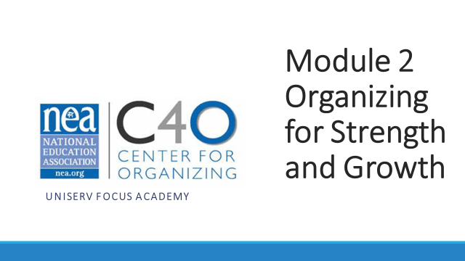  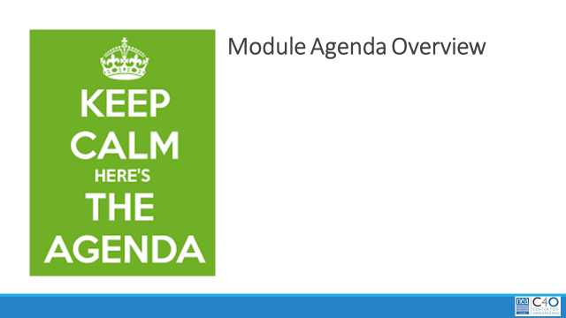  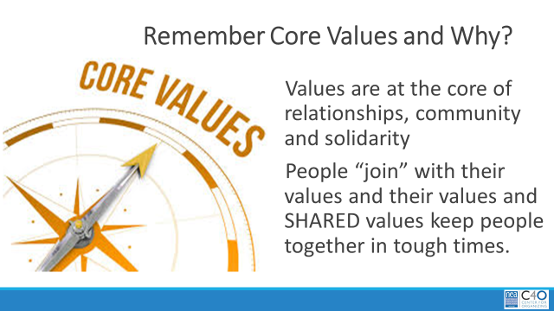  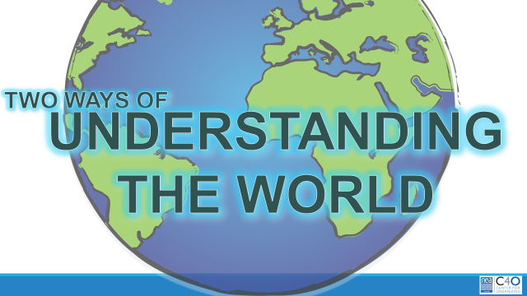  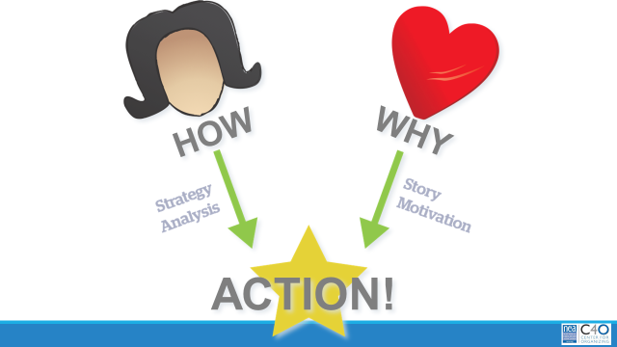  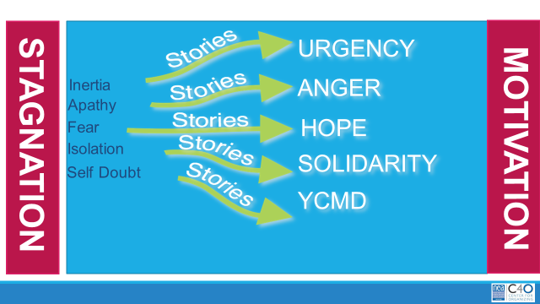  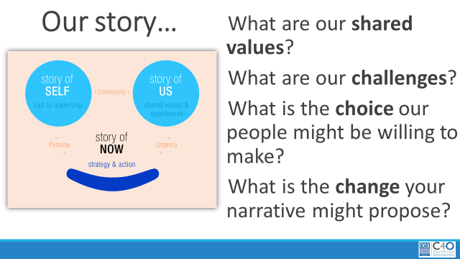  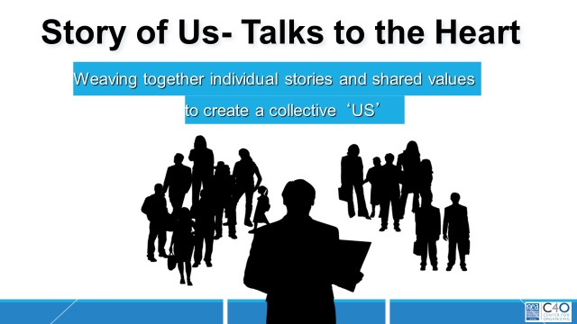  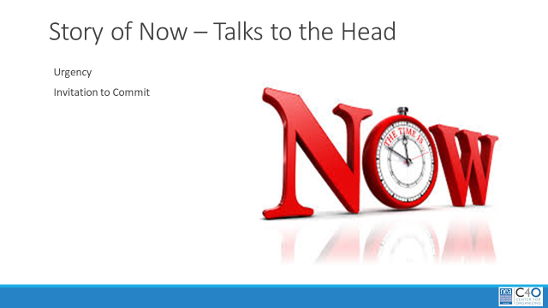    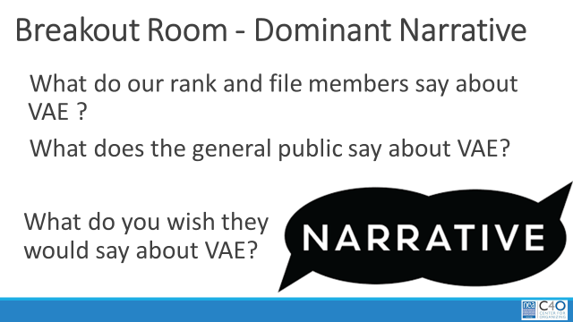  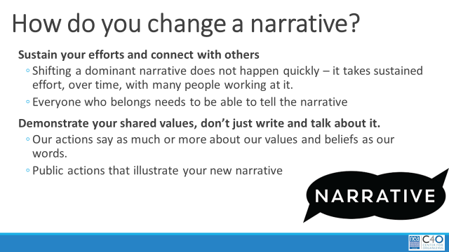  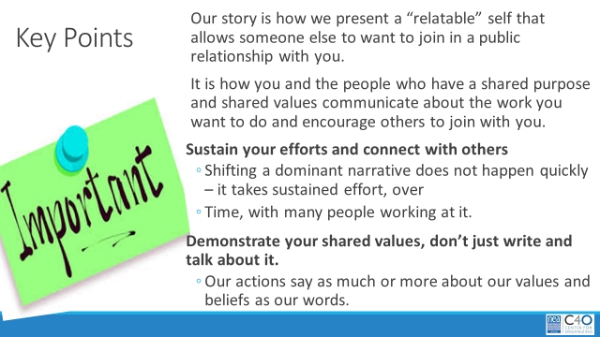  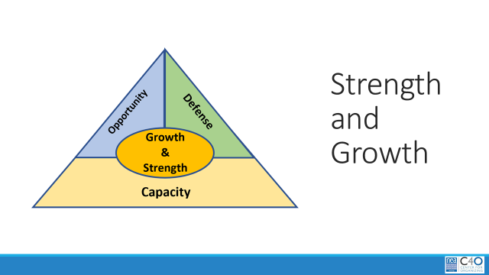  JENNIFER WAS GOING TO MAKE A DENSITY SLIDE  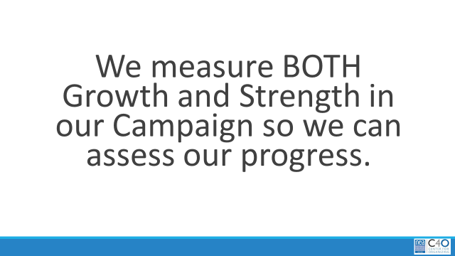    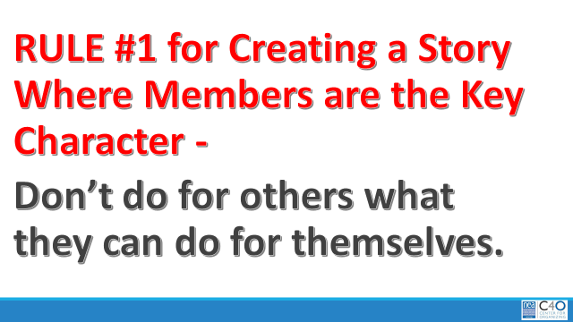  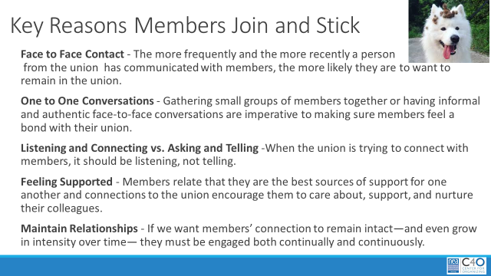  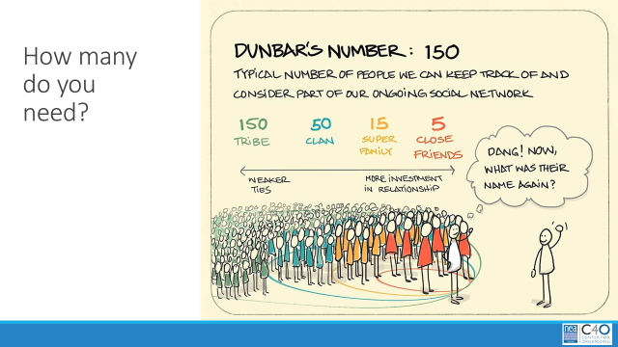  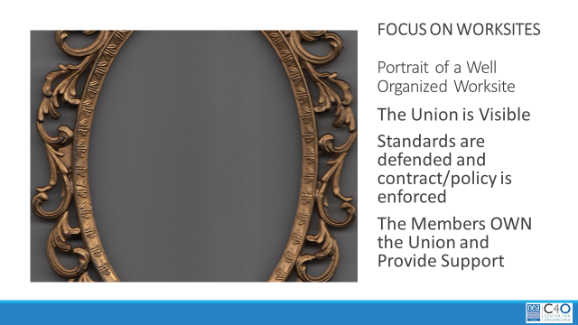  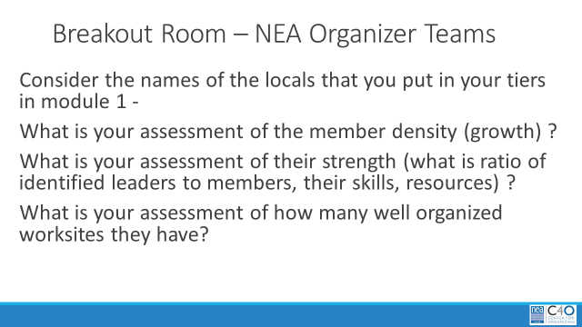  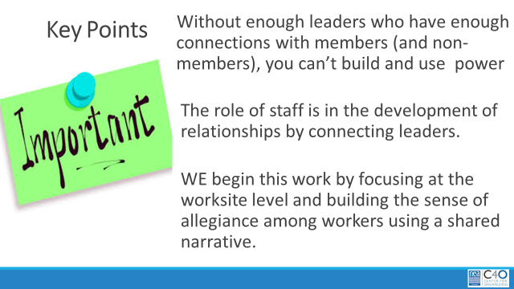  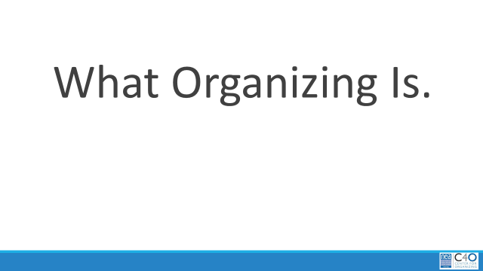  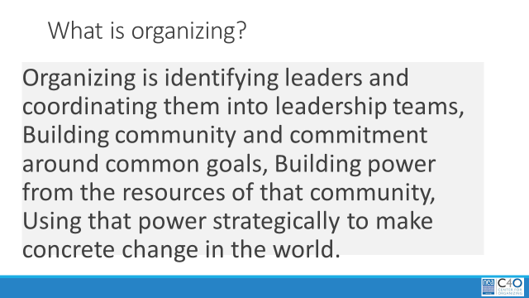  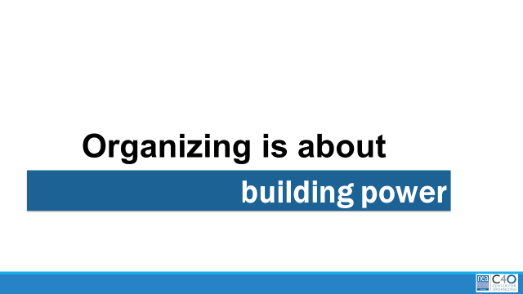  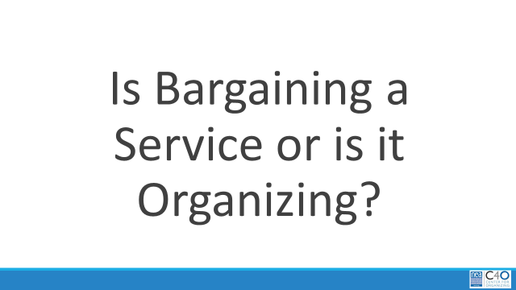  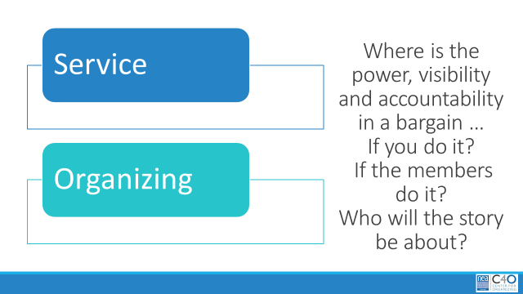  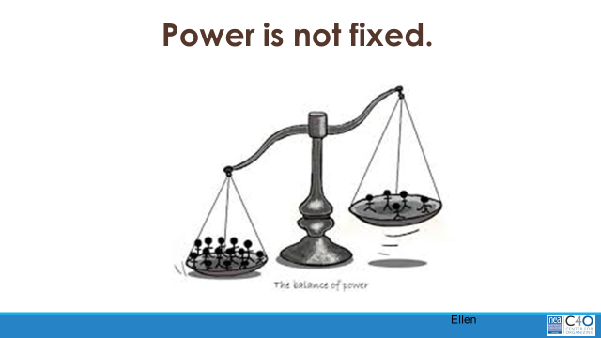  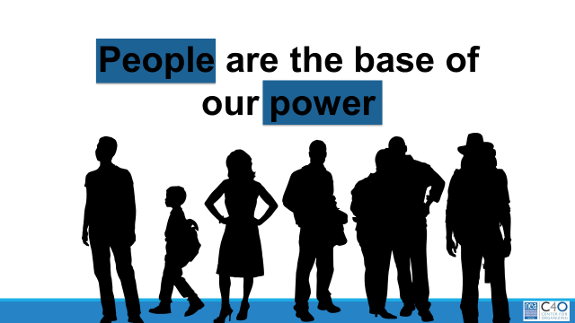  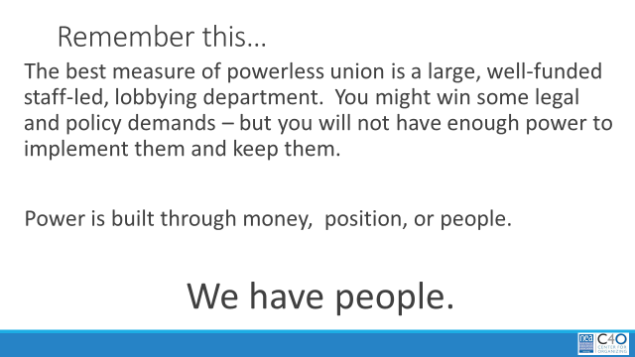  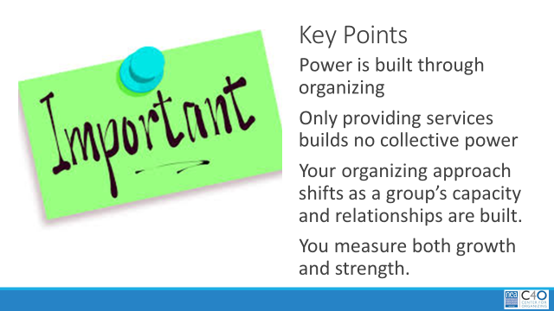 | What’s the Real Problem  Apathy Isn’t Real  Shifting the Narrative Dos and Don’ts  NEA Member Retention report  TIER DOCUMENT  What is Organizing What is Leadership  Also helpful in Module 3 | 11:30-12:00 – What is the Story We Want to be Telling  Quick review of agenda for this module and a quick flash of the community agreements  Remember Core Values from the first module? We are going to connect them to why they are important to us in the work of this campaign.  There are two ways that we make sense of our world. There is the head – which is all the strategic planning and the analysis of how things are going. There is the heart where stories that activate and represent who we are move us to act. It is through value-based stories that we “convince” people to move from the stagnant emotions (often grouped together as apathy) to the motivating emotions. Nearly everyone on staff has participated at one time or another in a story of self training – we are not going to do that – but we do want to underscore how story is critical in the work of this campaign.  Each of us has a story of WHY we do this work – as do our members. The key in sharing our stories is to LISTEN deeply to others enough that we know the COLLECTIVE story of who are locals are – what is that SHARED story of values, challenges and choices. AND most importantly what is the story of what we MUST do in this moment to achieve the wins we all want.  Our members, and ourselves get very caught up on telling the stories of the past – why we didn’t, why we can’t, why it didn’t work, why this will fail, why status quo is the best they can get. Our job in this campaign is to take those dominant narratives and help them tell a different story.  In this video, notice when the story “flips” – same people, same context, just a new way to tell the story.  Breakout Rooms – Grouped by NEA Organizer – 15 minutes to work  In your zoom rooms, consider the following:  What do the rank and file members have to say about VEA?  What does the general public (including non-members) have to say about VEA?  What do you wish they would say? – If helpful try framing your answer in this way - “I belong to VEA because together we will_____________ and we will build that into a contract”  Debrief what the breakout rooms did and then point out how to change a narrative -  So how do we change a narrative? Everyone needs to know the new story – everyone needs to share it with everyone – in a sustained way. We need to provide PUBLIC actions that “prove” the narrative and retell and retell and retell.  Key Points  12:00-12:30 What is Strength and Growth  Let’s discuss the difference between Strength and Growth. They work together. Growth is simply the number of members. It is possible to have a very high membership density, and very weak union. So, what is strength? It is the ability (skills, leadership, resources) to achieve change, to act and win both in opportunities and in fighting against challenges. It is impossible to demonstrate strength without growth. People want to belong to something that allows them to be a character in a meaningful story. A local with high density numbers, that receives a lot of services, that views their membership as a product or transaction – will not automatically be able to act collectively. They may not have the capacity (skills, leadership, resources) to take advantage of opportunities or defend against challenges. Why? They have learned that they don’t have to – THE UNION WILL DO IT FOR THEM.  We measure both strength and growth so we can assess our progress.  Watch video – 2 minutes then show the slide – Rule 1….  Go over the key reasons why members join and stick with their union – this was from a huge survey of members and non-members done for the NEA. This report is in your resource package.  Members don’t want to feel helpless, they want to act out on behalf of their values.  So how do we know we have enough members who can also act to achieve wins?  Let’s look at Dunbar’s Number for a Little Guidance.  One Leader can be in close, invested, strong relationship, with shared accountability with about 5 to 10 others. These would be people that would be able to share the strongest story of us that is in tight alignment – these are your “ride or die” crew willing to take a high risk with you. This same leader can be in a strong relationship with about 15 to 30 others – know the shared values, have some investment in each other, have some sense of shared accountability and they will be aligned - but they may or may not be willing to take as big a risk as you – they will cheer you on – but they won’t be joining you in the car. The same leader will likely have a relationship with 50 to 70 that allows strong recognition, decent communication, and a knowledge of values – but they may not really be willing to risk participation or support – they will want to hear about the trip though. Our leader can be in name and narrative relationship with 150 plus people. There is very limited relationship beyond this – and they may or may not care, support, or want to know that you have been on a trip.  Given this – to have strong and growing local – you need to keep this simple ratio in mind -- do you have 1 leader for every 5 to 15 people? If not, you likely don’t have a local that will be able to display to kind of strength that lead to a transformation of your local and the story that your members and the public tell about this local.  Another way to think about building strength is to focus on worksites – in each worksite the union is visible, it openly defends standards and enforces rights, and the members are the MAIN CHARACTERS IN THEIR STORY – not you  Breakout Room – Working with your NEA Organizer Team – 15 Minutes  Consider the names of the locals that you put in your tiers in module 1 - what is your assessment of their member density (growth) and what is your assessment of their strength (how many identified leaders) do they have and how many well organized worksites do they have  Report out and Key points  12:30- 1:00 What Organizing is Overview  Show the definition that we will use for this training.  Organizing is about building power – enough growth with enough leaders to achieve change  Power is the ability to act – and cause others to act.  Is bargaining a service that is provided, or is it organizing in the way we just defined it? It depends on how you approach it. If you do it, the story will be about you – if you do a great job – members will join, but they will drop as soon as YOU don’t deliver what they think they wanted. If the members do it – they are accountable, they are using their agency to make demands and their relationships to bring more people into the process – they are building strength to act and to win. The story is about the members. They can win – They are not helpless –They find meaning in their union.  Organizing helps members know that power is not fixed they CAN shift the scales with enough resources, action, and commitment  People are the base of OUR power – we can not outspend the other side, we can not demand anything but the status quo without more people, who are engaged in our story, willing to put their time in to the work, and willing to take necessary risks to win.  - The best measure of powerless union is a large, well-funded staff-led, lobbying department. You might win some legal and policy demands – but you will not have enough power to implement them and keep them.  - Power is built through money, position, or people. We have people.  We measure BOTH Growth and Strength in our Campaign so we can assess our progress.  Key Points  IN THE CAMPAIGN  Metrics to Measure in plan: density increase of membership in a local, leaders identified, members engaged as part of the collective bargaining support structure, and number of authorization cards signed | Participants will be able to identify dominant narratives and connect “change” narratives to the campaign.  Participants will begin to assess growth and strength of their locals in various tiers.  Participants will understand the connection of strength and growth with organizing and servicing.

Module 3 | Slides | Resources | Instructions, Activity and Debrief (Facilitators) | Outcomes
Module #, Facilitators, Date, Time and Link | Slides | Charts, handouts, articles, materials, slides | What are you saying, what are they doing, what questions will you use to guide learning and make clear the important points  Include an estimate for how long each section of the learning will take | As a result of this section of learning, what will participants know or be able to do?
Module 3 – Kevin, Fabricio, Toney – December 2, 2:00 – 3:30 Who are our people? Who are Leaders? What are their Structures? Module PPT https://neahq-my.sharepoint.com/:p:/g/personal/eholmes_nea_org/ERc4gChHqwhBvRRJVqVkwtIBkW2db7qorBKA4SrtIPmu4g?e=iF3xJ0

https://nea-org.zoom.us/j/98207109586?pwd=OFlGNi9QNmpGYjhDZ3NGUVRYeUM1dz09  Meeting ID: 982 0710 9586  Passcode: W11#qN | 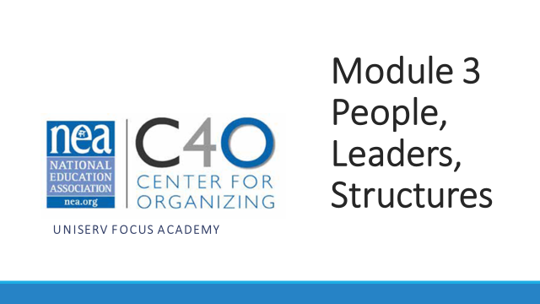  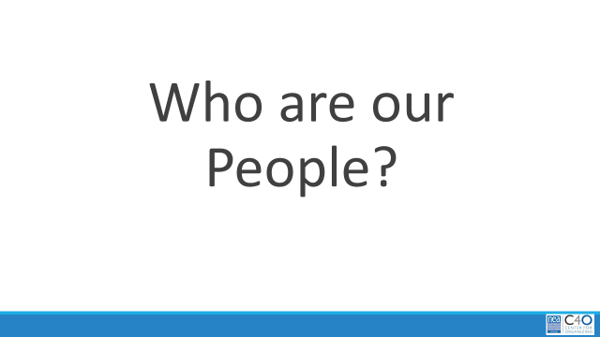  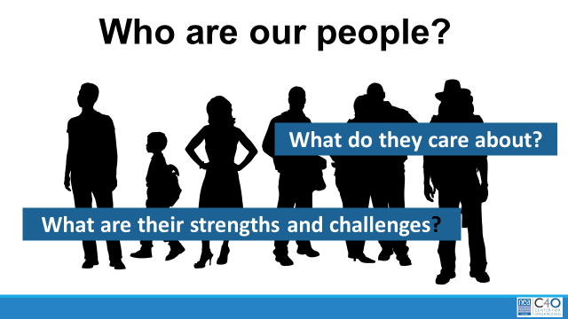  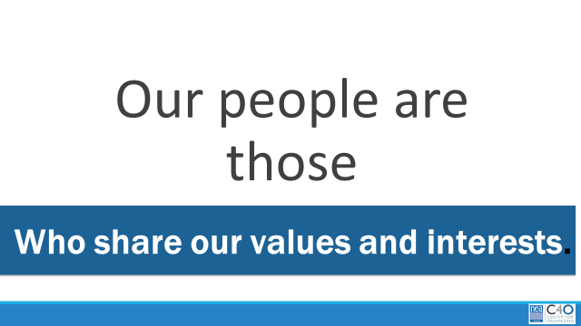  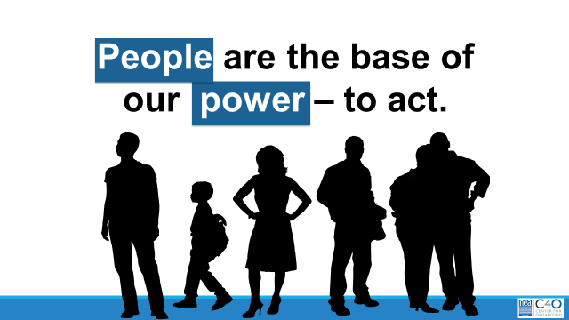  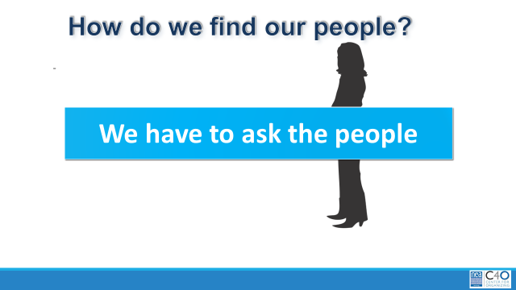  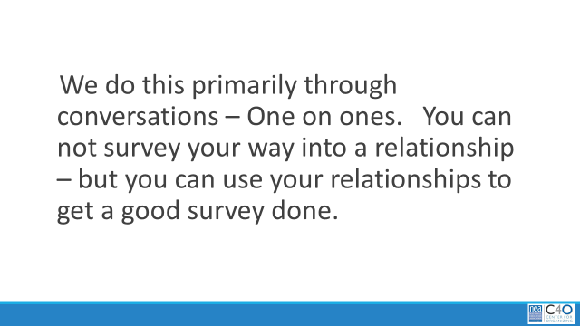  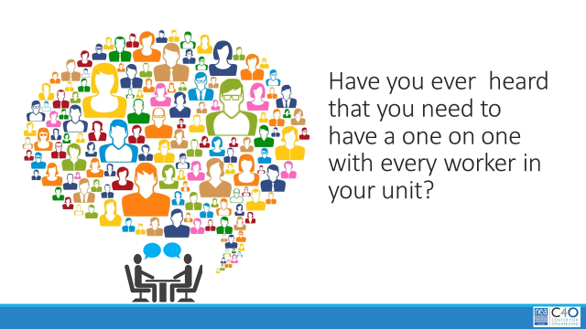  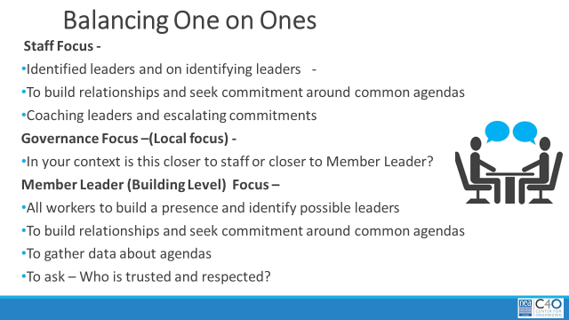  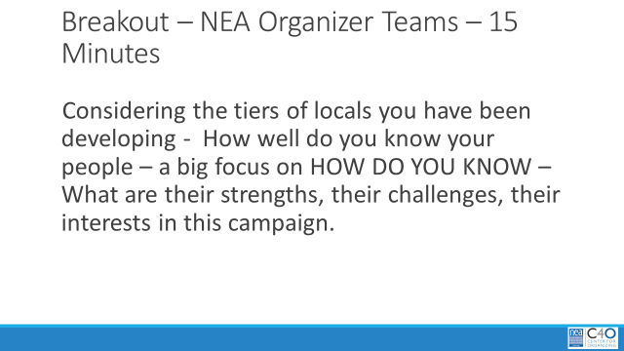  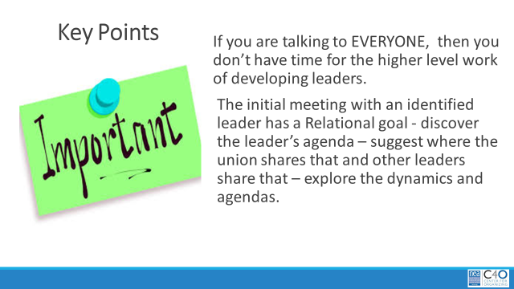  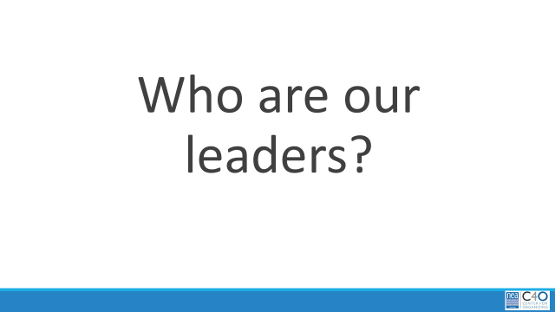    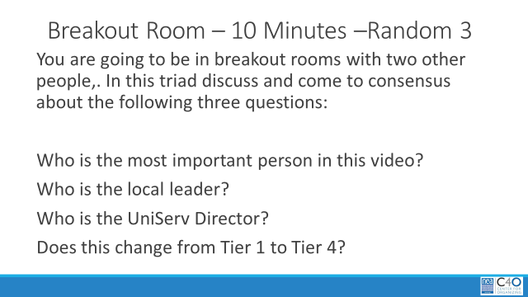  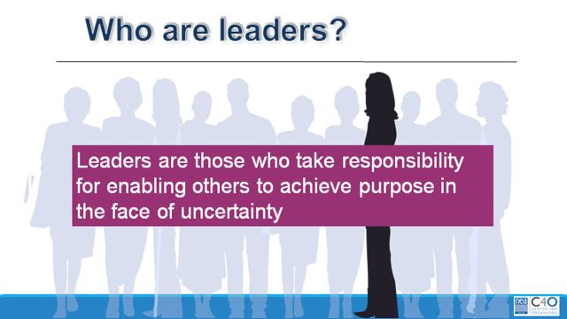  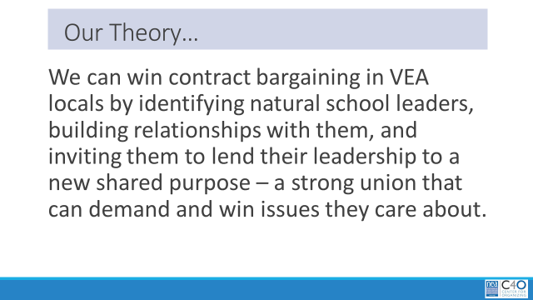  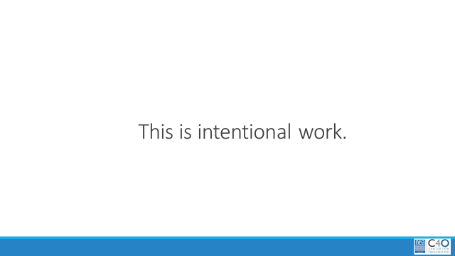  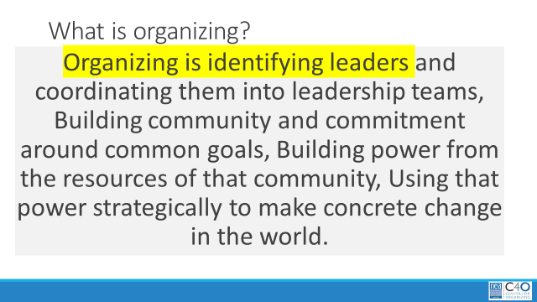  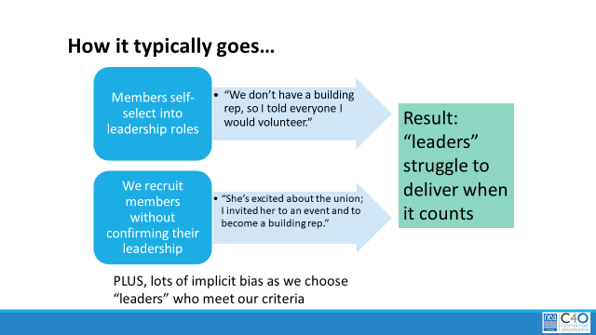  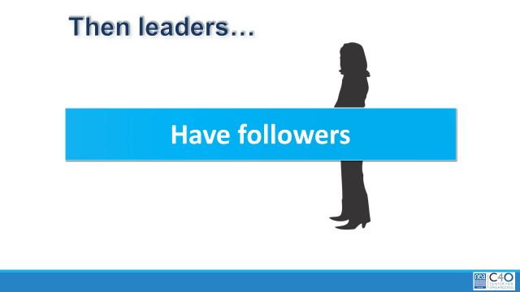  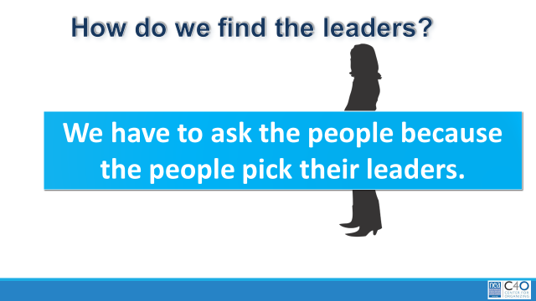  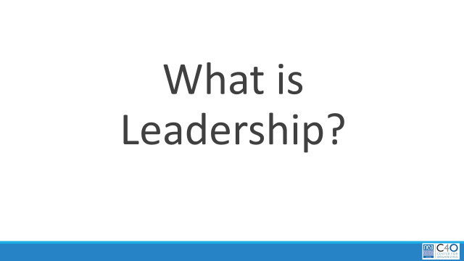  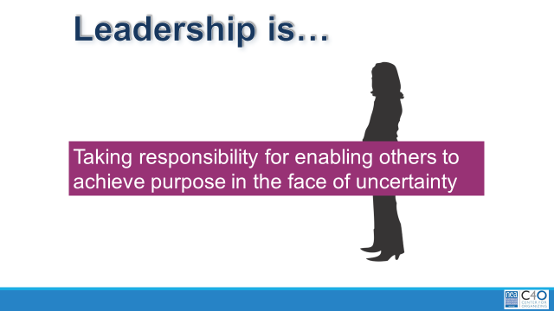  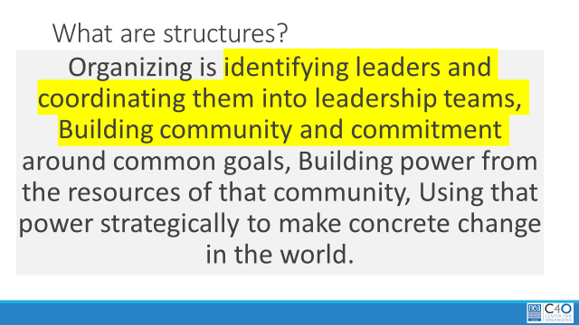  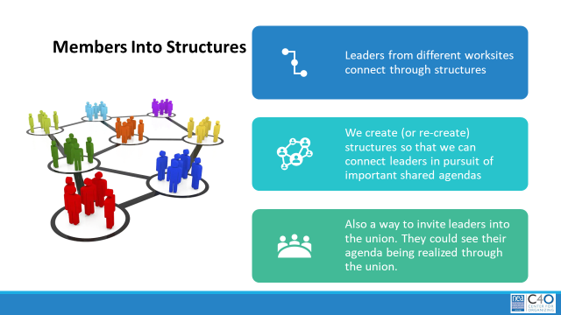  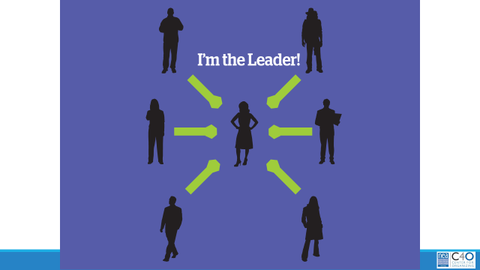    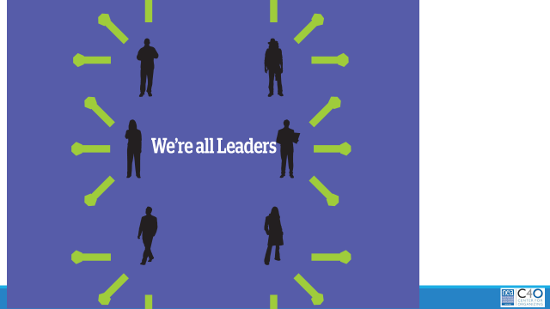    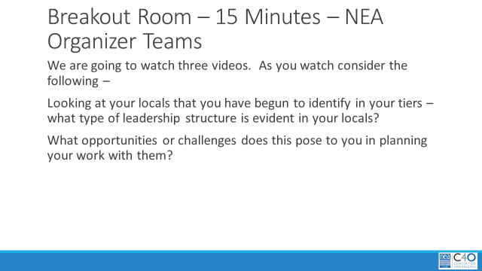  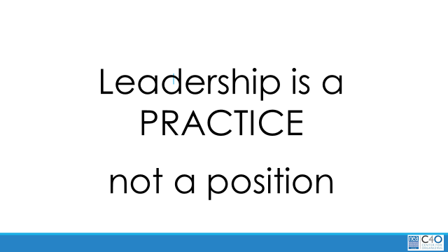  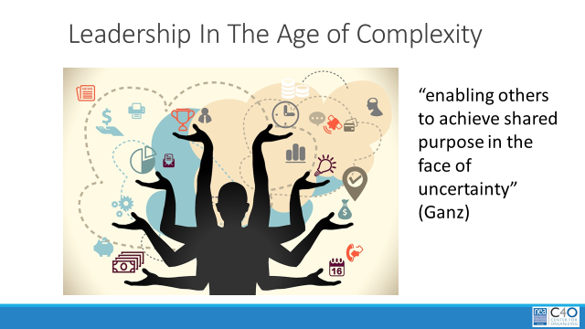  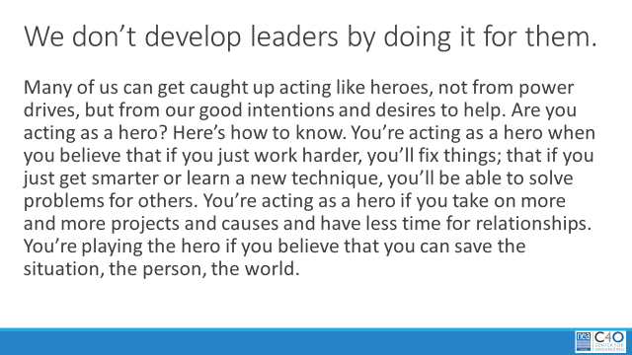  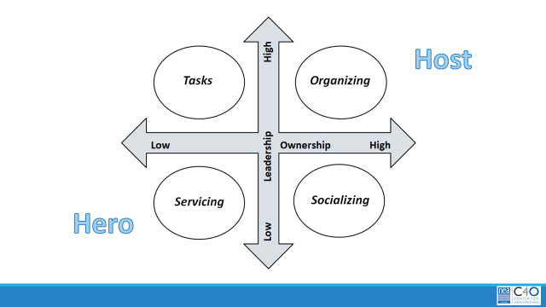  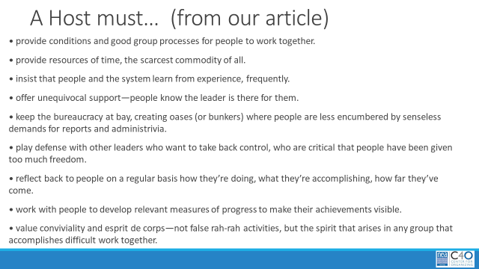  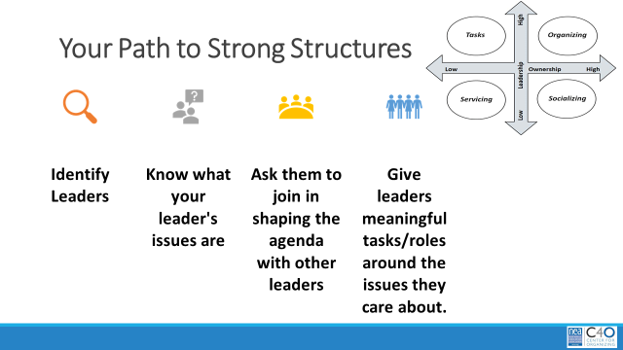  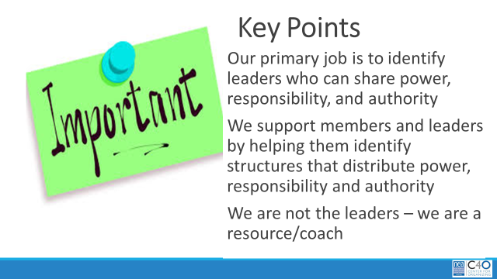 | A Resource – Organizers Handbook  Leadership Readiness Checklist  (Fabricio was going to make this)  TIER DOCUMENT  TIER DOCUMENT  A Resource – Developing Strong Leadership Structures  Leadership in the Age of Complexity  Engagement Grid | 2:00-2:30 Who are our people?  Brief overview of this 90 minutes and reminder of the community agreements  Who are our people ? This is the first question that we ask when we are using an organizing mindset. Who are our people, while it may begin with pulling list of members – this means much more than that – and we will have to focus on this bigger meaning to achieve the goals of our campaign.  We have to be in relationship with the people in our worksites in a way that allows us to know what they care about, what are their strengths, and what are their challenges.  Our people are those who share our values and interests – they may or may not be our members.  Remember from module 2 that PEOPLE are the base of our power – not money, not staff who lobby or in other states staff who bargain. So how do we find our people?  We start by asking them questions. – What is it like to work here? What would you like to change about working here? We do this primarily through conversations – One on ones.  You can not survey your way into a relationship – but you can use your relationships to get a good survey done.  Have you ever felt like YOU need to have a one on one with every worker in your unit? Let’s look at how we balance the need to know our people – and attend to all of our work assignments.  How do we balance the work of finding out who are people are?  Staff Focus -  - Identified leaders and on identifying leaders -  - To build relationships and seek commitment around common agendas  - Coaching leaders and escalating commitments  Governance Focus –(Local focus) -  - In your context is this closer to staff or closer to Member Leader?  Member Leader (Building Level) Focus –  - All workers to build a presence and identify possible leaders  - To build relationships and seek commitment around common agendas  - To gather data about agendas  - To ask – Who is trusted and respected?  Breakout 15 Minutes – In your NEA Organizer Teams  Considering the tiers of locals you have been developing - How well do you know your people – a big focus on HOW DO YOU KNOW – What are their strengths, their challenges, their interests in this campaign.  Debrief  Key Points  2:30 – 3:00 This leads to the second question that we ask when we are thinking with an organizing mindset – Who are our leaders.  We are going to watch a video in preparation for our next Breakout– I think a number of you will have seen this – as you watch, consider the following ideas –  Who is the most important person in this video?  Who is the local leader?  Who is the UniServ Director?  Does this change from your Tier 1 to your Tier 4?  Breakout Room – Random 3 people – 10 minutes  Debrief  Who are our leaders? Leaders are those who take responsibility for enabling others (not doing for them and teaching them that they are NOT ABLE) to achieve purpose in the face of uncertainty.  Our theory about leadership that is critical to this campaign and the future of VEA as a strong union is this:  We can win contract bargaining in our VEA locals by identifying natural school leaders, building relationships with them, and inviting them to lend their leadership to a new shared purpose – a strong union that can demand and win on issues they care about.  This is intentional work  It is the first step of our Organizing definition.  What typically happens …without intentionality in identifying leaders – we get whoever comes to the dance. When that happens we can be assured that all the structural bias in our schools and locals gets in the way of new leaders rising. We can also be assured that if we don’t intentionally seek natural leaders – those who “volunteer” will likely struggle and will not have the relationships with their co-workers to deliver when it counts.  So then, Leaders must have volunteers. Not just the willingness to volunteer.  How do we find leaders – when we are asking who are people are – we also have to ask them to tell us “who here is trusted and respected in this worksite?” Because – Our People PICK THEIR LEADERS – no us.  What then is the leadership that we want?  Leadership is taking responsibility for enabling others (getting out of their way and allowing THEM TO ACT) to achieve purpose in the face of uncertainty.  3:00-3:30 What are our Structures?  Let’s look at our organizing definition – structures are teams of people that are formed around a common purpose – a health and safety team, a new member recruitment team, a community connection team – each with a shared interest and purpose --- that ultimately connect to the values of a local, and state affiliate.  So if we remember the first part of our Organizing definition: Organizers identify, recruit and develop leadership – I want to give you three structures to consider. As we move through these structures keep track of where the power is and what your job would look like in each of these structures.  Let’s take a look at the first model – the “I am the leader” model. Some things to notice in each slide – these lines represent relationships, and the ends of the lines represent “weight” like dumbells – the weight of accountability, responsibility, direction of resources. So in this slide – where is the weight? Where is the power? Is this a powerful or sustainable model? Who benefits from the resources?  Let’s look at a short video to help you remember this model – First Rule of Leadership..  Let’s take a look at another model – this is the “we are all leaders” model. So in this slide – where is the weight? Where is the power? Is this a powerful or sustainable model – Who benefits from the resources?  Let’s look at a short video to help you remember this model – Cat Herders  Let’s take a look at our last model – this is the “Interdependent Leadership” model. So in this slide – where is the weight? Where is the power? Is this a powerful or sustainable model – Who benefits from the resources? In this video, the people all have a common purpose – get to the ground alive. There is a leadership team that is outside of the action – they are assessing, communicating and coaching so that there is a story of success to tell.  Breakout time – NEA Organizer Teams – 15 minutes  We are going to watch three videos. As you watch consider the following –  Looking at your locals that you have begun to identify in your tiers – what type of leadership structure is evident. What opportunities or challenges does this pose to you in planning your work with them?  Debrief  I DON’T THINK YOU WILL HAVE ENOUGH TIME FOR THIS PART  In the article Leadership in the Age of Complexity you see that there is a strong connection to our definition of the leadership we are looking for - Enabling others to achieve shared purpose in the face of uncertainty.  Are you a hero or a host? This paragraph from the article highlights how you will know. When you are the hero, the story is about you and that does nothing to strengthen the union – nothing to develop leaders. Leaders grow as THEY take ownership and decide to act – as they see themselves as lead characters in the story.  A useful tool is the Engagement grid. What are we asking people to do? When WE ask people to sign a card, collect them, and enter the data – that puts us solidly in the servicing zone. When we ask our building reps to get others to sign cards, collect them and enter the data - they have moved to the “tasks” zone. When a group of leaders in a local decide they should host an online discussion to talk about the benefits of belonging to the union, or discuss local business – that moves us to the socializing zone. We want to be in the organizing zone – Leaders in relationship with their followers determine that they want to bargain – they decide what teams they need to be in relationship with so that cards can be signed, gathered, and data entered. These teams all have a common narrative about the collective benefit of this work and they are building relationships beyond their structures in the name of the union. The Ownership of the plan, the achievement of goal, and story is about the members. You are a host not a hero.  A host Must ….  Your path to strong structures that can act and get others to act (build and use power) is…  Key Points  IN THE CAMPAIGN enough of a density of membership in a local, leaders identified and assessed and tested, members engaged, | Participants would be able to identify leaders, and differentiate leadership structures at the different tiers.  Data to track this – and what you’re actually tracking. Assessment tool.

Module 4 | Slides | Resources | Instructions, Activity and Debrief (Facilitators) | Outcomes
Module #, Facilitators, Date, Time and Link | Slides | Charts, handouts, articles, materials, slides | What are you saying, what are they doing, what questions will you use to guide learning and make clear the important points  Include an estimate for how long each section of the learning will take | As a result of this section of learning, what will participants know or be able to do?
Module 4 – Pat, Vickie – December 4, 9:00-10:30 What are Our People Willing to Do? Module PPT https://neahq-my.sharepoint.com/:p:/g/personal/eholmes_nea_org/Eb4QvWXuQWpChsMXFbbipwMBEB0bA6zCcvLGNWZUstb5bg?e=PU3TqS

https://nea-org.zoom.us/j/94274969056?pwd=RnFDYmRNQUV3TG9WbFIrTUJ1a0xvZz09  Meeting ID: 942 7496 9056  Passcode: 9U+Cai | 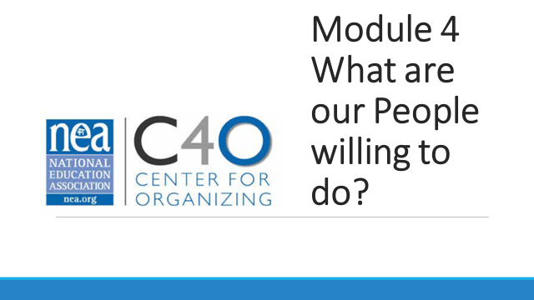  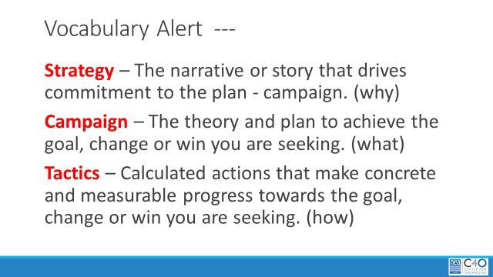  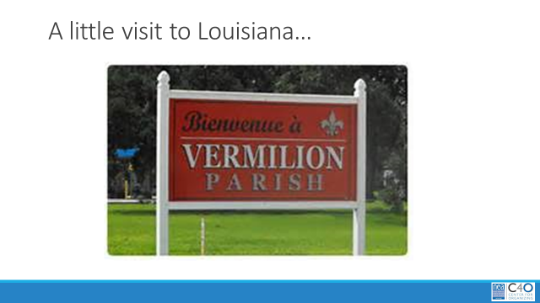  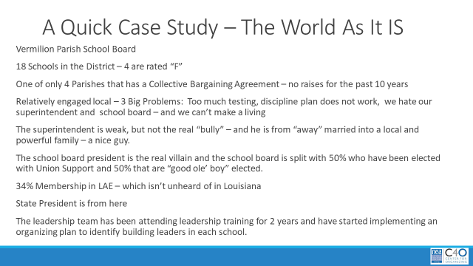  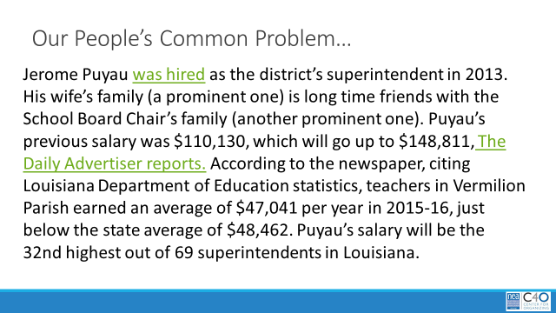  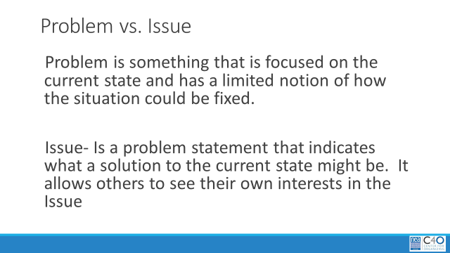  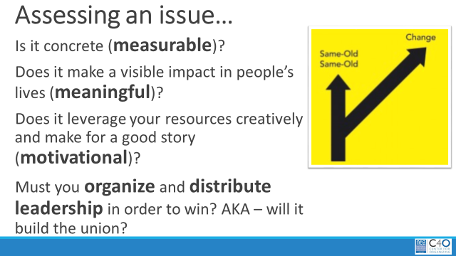  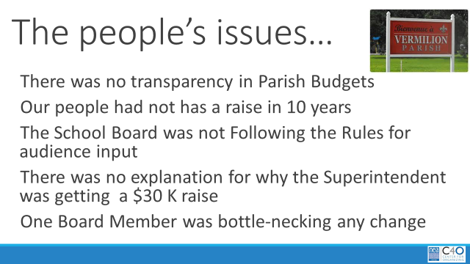  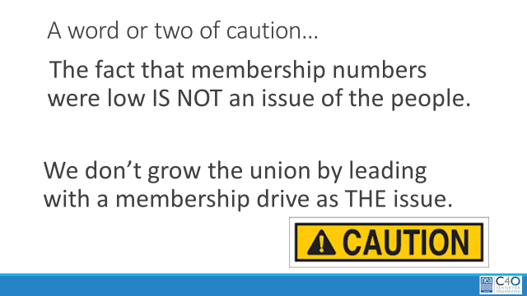  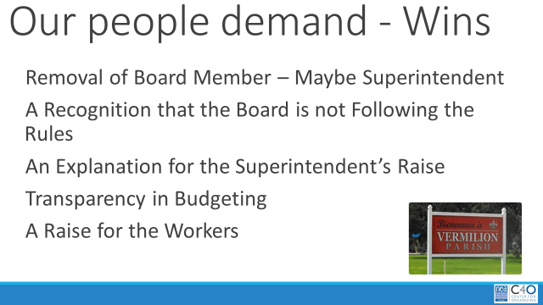  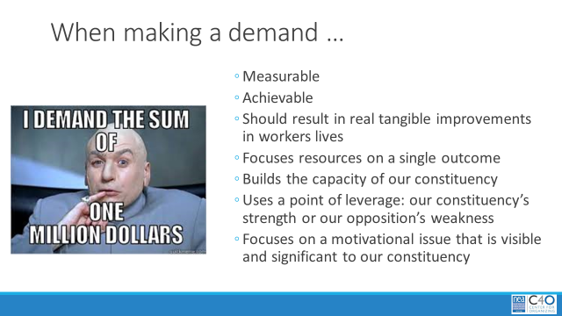  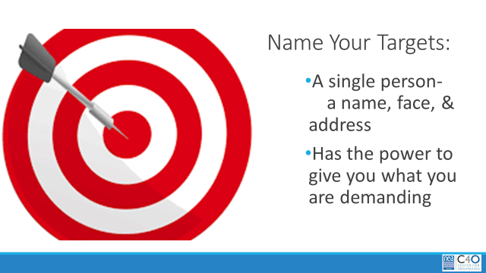  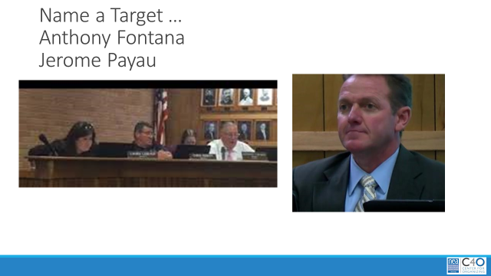  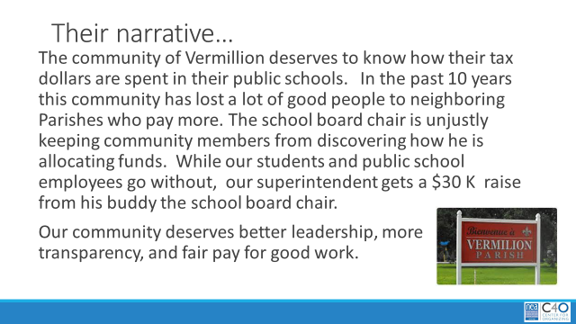  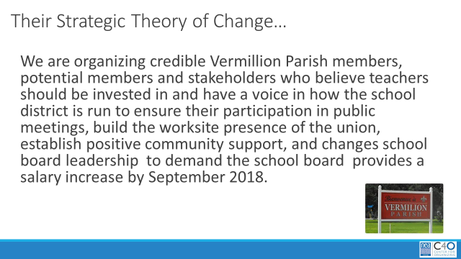  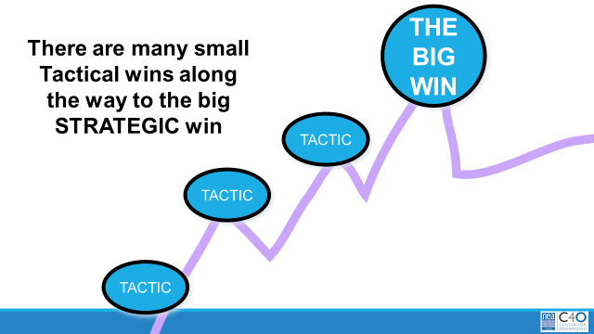  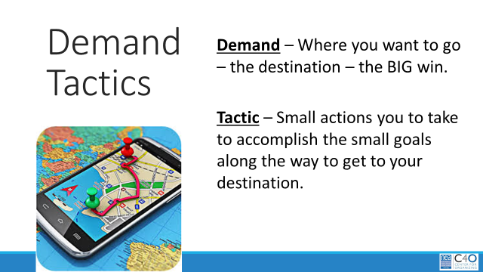  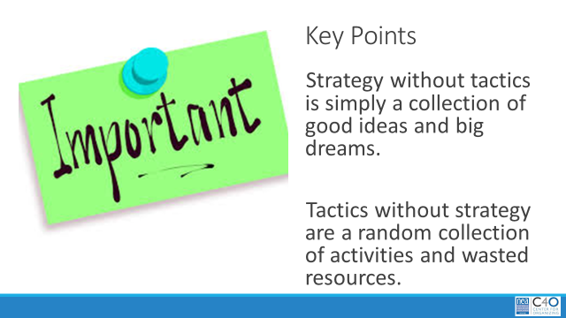  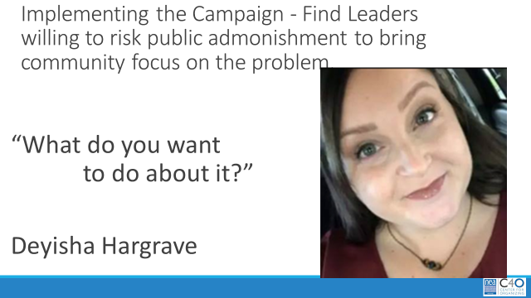  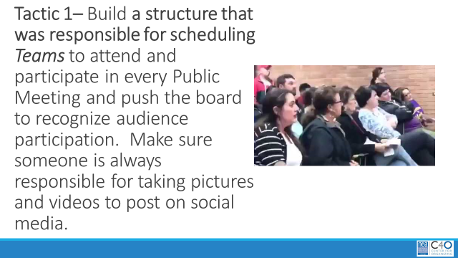  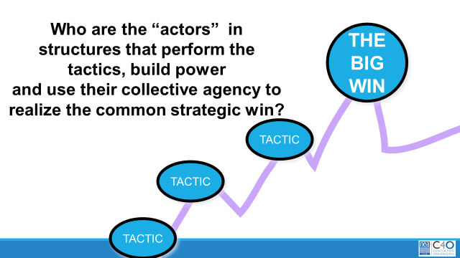  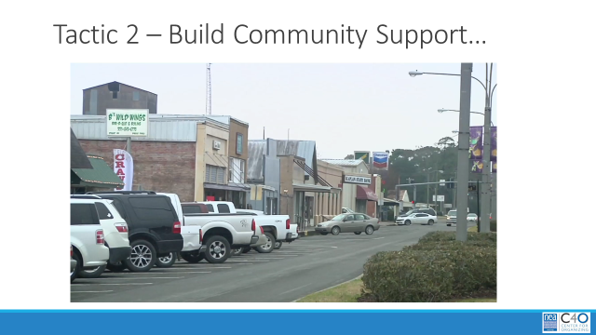  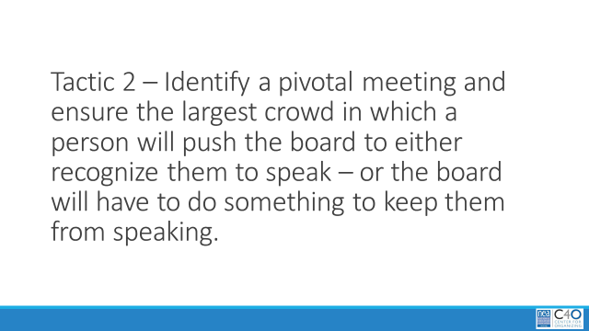  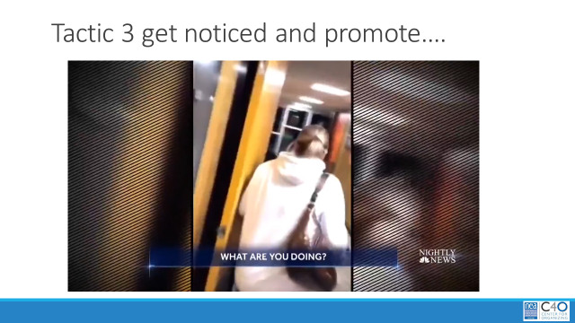  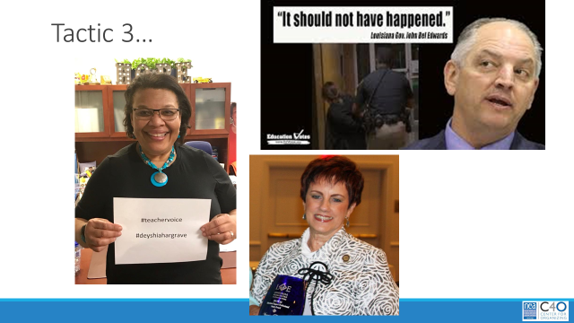  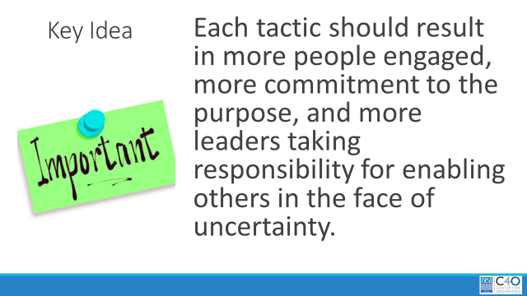  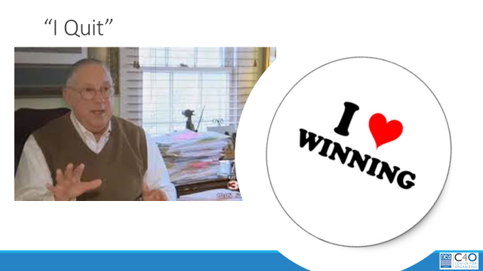  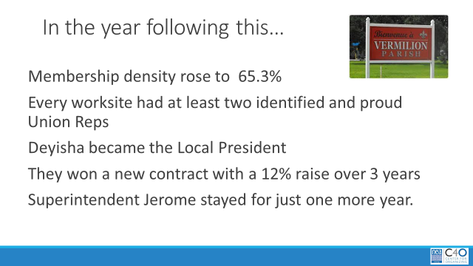  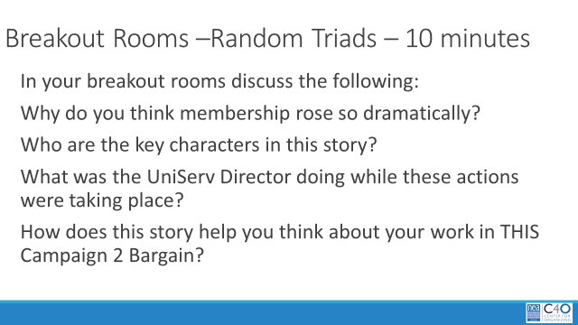  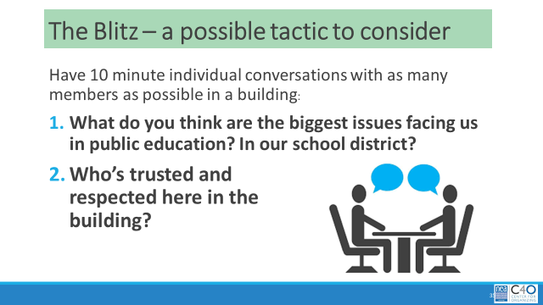  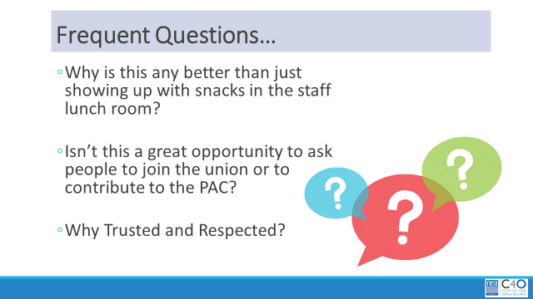  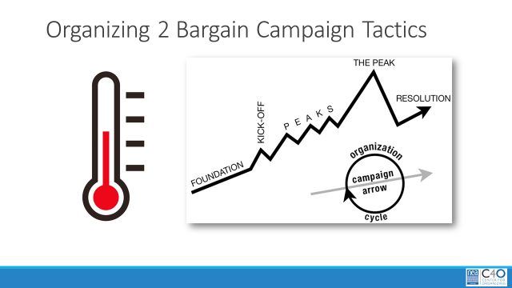  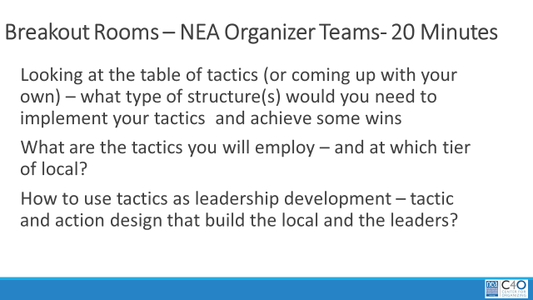 | Campaign Plan Document  Resource Section:  Blitzes  Toolkits  Leadership Trainings | 9:00-9:45 - What are our people willing to do?  Quick Agenda overview and review of community agreements  A little vocabulary alert to kick off our morning -  Strategy – The narrative or story that drives commitment to the plan - campaign. (why)  Campaign – The theory and plan to achieve the goal, change or win you are seeking. (what)  Tactics – Calculated actions that make concrete and measurable progress towards the goal, change or win you are seeking. (how)  In this module, we are going to take a virtual field trip to a small local in Louisiana. It is a local that is a lot like many here in Virginia. The purpose is to share how a local that would be in the same Tier as our List Locals, transformed how members viewed and participated in their union.  Welcome to Vermillion Parish .  Here are some quick details about Vermillion Parish  They had a common problem as old as time – the inept Superintendent got his job because he married into an old, wealthy, powerful family – and his “Daddy in law” and the school board chair – another member of an old powerful family were friends. He was the only school employee in 10 years to get a raise – and it was a $30K per year one. In one of the smallest Parishes in Louisiana – it put him in the top third of Superintendent earnings.  This was their problem. A problem is a story that gets complained about, and focused on the current state – such as “my car is a piece of junk.” The troubling thing about telling “problem stories” is that they tend to reinforce the status quo that the system is rigged and there is nothing we can do about it.  When you begin to frame stories around ISSUES – you begin to indicate how the problem is going to get solved – such as My car is going to be much safer and reliable when I put on new tires, get a paint job, get the brakes fixed, and put in a new transmission. By stating the issues that are “creating” the whole problem – I can begin to prioritize the change I am going to make and align resources to those issues.  When we pull apart problems – some issues are better to organize around than others – they have more potential to build the union and serve to solve the big problem. In my car issues – Maybe getting it painted really won’t make it safer and more reliable. IN our work, we are helping members identify issues that when we solve them we can measure them, they have meaningful and visible impact on people’s lives, it is a motivating issue that brings more people to the work, AND MOST IMPORTANTLY - it can not simply be achieved by one person making it happen  In Vermillion Parish their issues were –  - There was no transparency in Parish Budgets  - Our people had not has a raise in 10 years  - The School Board was not Following the Rules for audience input  - There was no explanation for why the Superintendent was getting a $30 K raise  - One Board Member was bottle-necking any change  A word of caution – the UniServ staff traditionally felt that the number one problem for the local was that people don’t care about being in the Union and that the biggest issue for Vermillion Parish was low membership density. However, repeated, yearly membership drives simply weren’t making a dent in improving that low number. The reason that was reported – the AFT has better food and give aways on their tables.  What did the workers in Vermillion Parish want?  - Removal of Board Member – Maybe Superintendent  - A Recognition that the Board is not Following the Rules  - An Explanation for the Superintendent’s Raise  - Transparency in Budgeting  - A Raise for the Workers  When you make demands – they need to tick most of the boxes on this list –  - Measurable  - Achievable  - Should result in real tangible improvements in workers lives  - Focuses resources on a single outcome  - Builds the capacity of our constituency  - Uses a point of leverage: our people’s strength or our opposition’s weakness  - Focuses on a motivational issue that is visible and significant to our constituency  The challenge was to help the leaders determine the difference between telling a “complaining” story and telling a “ hopeful” story. They had been focused on telling a story about their targets – Their Superintendent and the School Board Chair. The real motivating story was “We need to be fairly compensated” as they had not had a raise in 10 years. So their overall message was, “ be belonging to the union you can help us all achieve a raise – but we are going to need the school board and the superintending to see that we are united in this.” They then began to sort out the small issues that IF solved would make the path towards solving their big problem.  One of the hardest shifts, because public school employees want to be “nice” – is to have them focus their energy on identifying a target. This is critical in a campaign that publically builds the union. A target is a person with a name, a face and an address – AND this target has the power to give or prevent what you are demanding.  Vermillion’s targets are Anthony Fontana and Jerome Payau  The next bit of planning was to craft a short narrative (think strategy story that pulls more people into the cause) that defines the campaign using the HEART – not the HEAD.  Then define that narrative in a “theory of change” that outlines what your people will actually do to achieve the change they want.  The key in this theory of change – it is a relatable story that participants can repeat and it outlines the tactical wins along the way to the big win.  The Demand becomes the location your enter into your navigation app and tactics are the points along the way towards that.  Key Points  Let’s walk through some of their campaign. First find leaders who are willing to speak up and risk some sort of public admonishment – and that leader should fit the part of, “Fresh, young, southern sweetheart, teacher.” Meet Deyisha Hargrave. Born and raised in Vermillion Parish and married to a local man with two lovely babies – church members, and members of two, long time farm families.  Deyisha and her team of “ride or die” members got to work on identifying leaders in each of the buildings that would recruit teams of people to attend every public school board meeting. The goal was at least 2 from each building. Everyone attending would have a target set of questions to go to the microphone, get recognized, and ask. The School Board chair was notorious for not allowing audience questions despite a state law that requires it. These teams also identified a number of people who would take pictures of Vemillion Parish members at meetings and post them on social media. They were to be ready to record any reactions that the school board chair took towards their attempts to speak.  Remember structures from Module 3? They created a “turnout structure” that was responsible for meetings. In addition the created another structure – the community contact team.  The community contact team agreed to go to local businesses and community members to begin sharing the narrative of what was happening to the employees in the school district. This team was also sharing how unjust it was that they were not allowed to speak up at the school board. They discovered that in this small town – their was a SHARED VALUE around transparency and right to speak up . PLAY VIDEO  Another part of this was for them to identify a pivotal meeting and get as many community members AND school employees to attend as possible and really push for recognition to speak. At a packed meeting, their risks and planning paid off…  PLAY VIDEO  Immediately following this, they made media contacts, contacts with “big” partners (NEA, LAE, and the Governor) and built up their social media profile AND made sure to tell their story in all worksites.  Key points During each of these actions, more and more people felt more and more confidence in joining in and showing up publically – more and more people were willing to be responsible for more and more activities (making posters, sharing social media posts, providing child care, bringing food, taking pictures, etc. etc. )  Just days after the rally – the School Board Chair resigned in shame.  In the year following - Membership density rose to 65.3%  Every worksite had at least two identified and proud Union Reps  Deyisha became the Local President  They won a new contract with a 12% raise over 3 years  Superintendent Jerome stayed for just one more year.  Breakout Rooms – Random Triads – 10 Minutes  In your breakout rooms discuss the following:  Why do you think membership rose so dramatically?  Who are the key characters in this story?  What was the UniServ Director doing while these actions were taking place?  How does this story help you think about your work in THIS Campaign 2 Bargain?  Debrief  9:45-10:15 – Looking at Actions Your People Might Be Willing to Do  In VAE we have not yet participated much in a fairly tried and true tactic - the “Blitz” there is a blitz planning guide in your resources, and we are not saying that you have to do a blitz, but it may be something to consider.  A blitz is typically employed when you want to build a sense of Union Presence AND gather a lot of early assessment data in a campaign. It is great for finding out who people trust and respect and what are key issues that people are concerned about. IN COVID times, a blitz switches to a virtual setting, but the idea is the same. A number of “organizers” head into a concentrated set of worksites all seeking the same data. On this slide as you can see, the organizers are having genuine conversations with workers about what their experience is in their worksites AND they are asking who is trusted and respected. This second ask is key.  Remember the leadership module? People in our worksites, in our locals ARE ALREADY ORGANIZED AND HAVE LEADERS THAT THEY TRUST AND RESPECT. Our role is to identify who those are and develop a relationship with those leaders. WE CAN NOT MAKE LEADERS.  The benefits of blitz are that months of work can be accomplished in a few days. It helps establish a presence – AKA the union is more than my one UniServ Director.  While tempting – don’t pile on the asks – stick to the collection of the data you need at the start of campaign – Who are my people? Who are their Leaders? What are their issues?  We use trusted and respected very intentionally – trust means someone you feel is genuine and does what they say they will do. Respected means that you believe they are the kind of worker we should try to be. YOU can trust someone – and completely not respect how they approach their work. The other side of the coin is that you can completely respect how someone does their work – but would not trust them as far as you can throw them. We are looking for people whose co-workers identify as trusted and respected. If co-workers in a worksite name a person over and over, then that is who we will want to follow up with ESPECIALLY IF WE DON’T ALREADY KNOW THEM. We need to be in relationship – a public union relationship – with those natural leaders BECAUSE THEY ALREADY HAVE FOLLOWERS  In the Organizing 2 Bargain Campaign plan there is a table of tactics – these are not an exhaustive list, but they represent some of the expected tactics that we will use across our locals.  Breakout Rooms - NEA Organizer Teams – 15 Minutes  In this work session – review carefully the tactics grid that has been provided as part of the VEA Organizing 2 Bargain Campaign plan.  Looking at the table of tactics (or coming up with your own) – what type of structure(s) would you need to implement your tactics and achieve some wins  What are the tactics you will employ – and at which tier of local?  How to use tactics as leadership development – tactic and action design that build the local and the leaders?  Debrief and Wrap Up

Module 5 | Slides | Resources | Instructions, Activity and Debrief (Facilitators) | Outcomes
Module #, Facilitators, Date, Time and Link | Slides | Charts, handouts, articles, materials, slides | What are you saying, what are they doing, what questions will you use to guide learning and make clear the important points  Include an estimate for how long each section of the learning will take | As a result of this section of learning, what will participants know or be able to do?
Module 5 – Bekah – December 4, 11:30-1:00 Make Your Plan – Wins and Targets – What do your people want and Who is keeping them from getting it. How many people do they need to get the win they want? Module PPT https://neahq-my.sharepoint.com/:p:/g/personal/eholmes_nea_org/EVux8GYzuPlPpC_giTWhp1IBXKJ8-o_gVUZxtxuWzZ9vsg?e=TIpjxJ

https://nea-org.zoom.us/j/96163333533?pwd=T1BDOVk5eEppQUhVYWVjQ1c3ZnBHZz09  Meeting ID: 961 6333 3533  Passcode: #3tTP* | 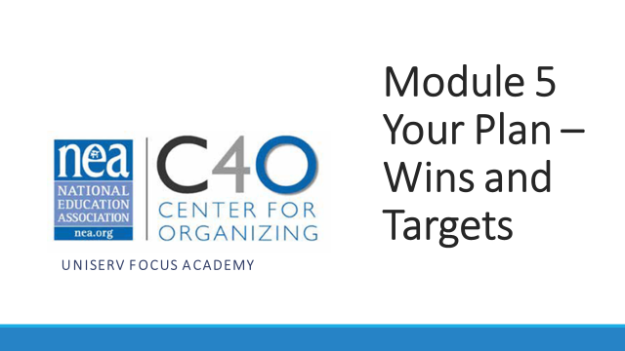  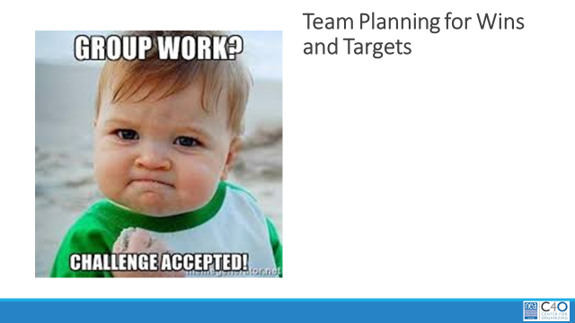  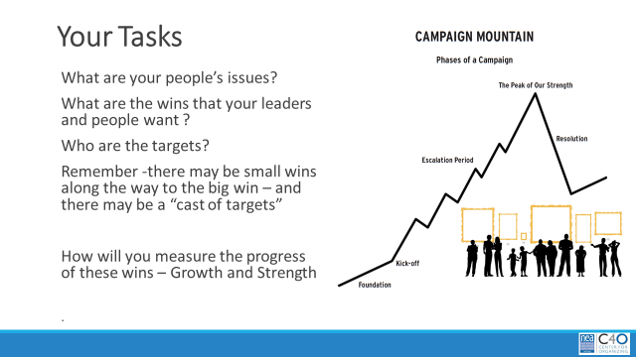 |  | What is the plan for your work to implement the VEA Campaign  Brief agenda overview and community agreements  Breakout rooms will be NEA Organizer Teams – Teams will have 75 minutes to work on their plans – with special focus on ISSUES WINS AND TARGETS  We will use the final 15 minutes of this module to share our thinking and ask question about our work.

Module 6 | Slides | Resources | Instructions, Activity and Debrief (Facilitators) | Outcomes
Module #, Facilitators, Date, Time and Link | Slides | Charts, handouts, articles, materials, slides | What are you saying, what are they doing, what questions will you use to guide learning and make clear the important points  Include an estimate for how long each section of the learning will take | As a result of this section of learning, what will participants know or be able to do?
Module 6 – Pat- December 4, 2:00 -3:30 Tactics and Strategy – What do your people say about their struggle and hope, and what are the actions that they are going to put in place to overcome their struggles Module PPT https://neahq-my.sharepoint.com/:p:/g/personal/eholmes_nea_org/ESQTqssupOZDpcRnEw5enycBcDRQqSf6wjx0Ev9tAWNs8A?e=tyv2Vd

https://nea-org.zoom.us/j/96370968702?pwd=TFNlcW1EZGRhSm9ZeFdrUHJnc0I5QT09  Meeting ID: 963 7096 8702  Passcode: pS+cA8 | 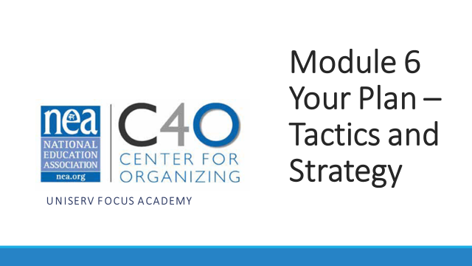  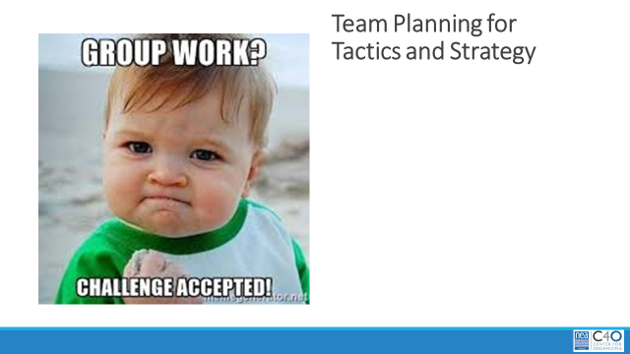  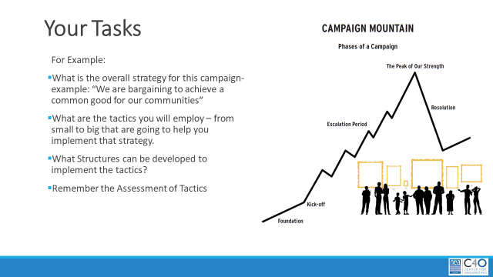 |  | What is the plan for your work to implement the VEA Campaign  Brief agenda overview and community agreements  Breakout rooms will be NEA Organizer Teams – Teams will have 75 minutes to work on their plans – with special focus on Narrative, Strategy, Escalation of Tactics --- and determining what makes for good tactics.  We will use the final 15 minutes of this module to share our thinking and ask question about our work.

Module 7 | Slides | Resources | Instructions, Activity and Debrief (Facilitators) | Outcomes
Module #, Facilitators, Date, Time and Link | Slides | Charts, handouts, articles, materials, slides | What are you saying, what are they doing, what questions will you use to guide learning and make clear the important points  Include an estimate for how long each section of the learning will take | As a result of this section of learning, what will participants know or be able to do?
Module 7 – Jennifer – December 7, 9:00-`10:30 - Focus on Data – How do your people know that they are winning or not? How do the measure GROWTH and STRENGTH https://neahq-my.sharepoint.com/:p:/g/personal/eholmes_nea_org/Edamhpb6b51Mhe1ZgIW_yVABKjNaKYebv-loK8FQ8fGE6A?e=12JFqx

https://nea-org.zoom.us/j/98168932645?pwd=S1RTQmpVTGdVUTlPaUtUWHVaYlNwQT09  Meeting ID: 981 6893 2645  Passcode: %c8JH5 | 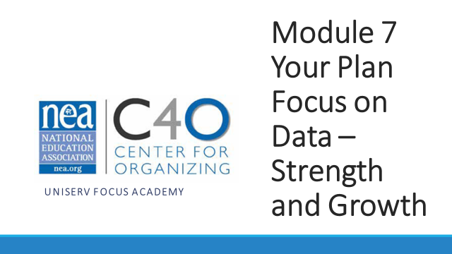  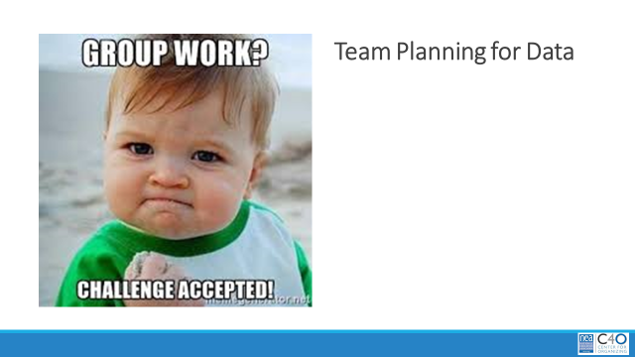  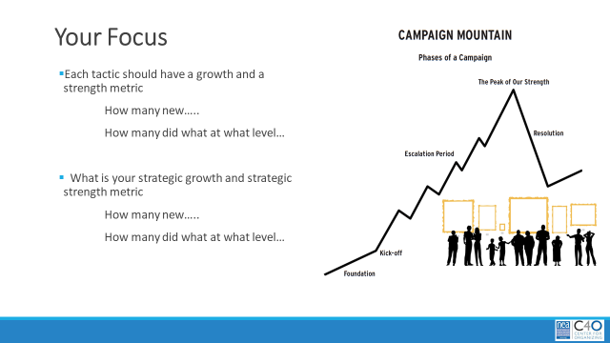 |  | What is the plan for your work to implement the VEA Campaign  Brief agenda overview and community agreements  Breakout rooms will be NEA Organizer Teams – Teams will have 75 minutes to work on their plans – with special focus on the types of data you will gather, the goals and targets that you might measure, and differentiation of growth and strength data  We will use the final 15 minutes of this module to share our thinking and ask question about our work.

Module 8 | Slides | Resources | Instructions, Activity and Debrief (Facilitators) | Outcomes
Module #, Facilitators, Date, Time and Link | Slides | Charts, handouts, articles, materials, slides | What are you saying, what are they doing, what questions will you use to guide learning and make clear the important points  Include an estimate for how long each section of the learning will take | As a result of this section of learning, what will participants know or be able to do?
Module 8 – December 7, 1:00-2:30 Peer Presentation and Feedback Module PPT https://neahq-my.sharepoint.com/:p:/g/personal/eholmes_nea_org/EblJgUTPeJJOhuJXUitjTnQBtjiu7IhYY-MRqQDKz7T5kg?e=EHadZf

https://nea-org.zoom.us/j/96440517456?pwd=eGNHdmRSZlpvcUxETHN2b042Y2ZEdz09  Meeting ID: 964 4051 7456  Passcode: NS5%!@ | 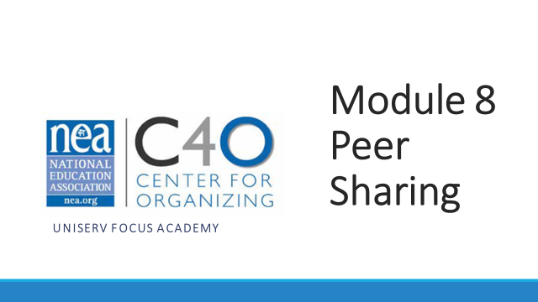  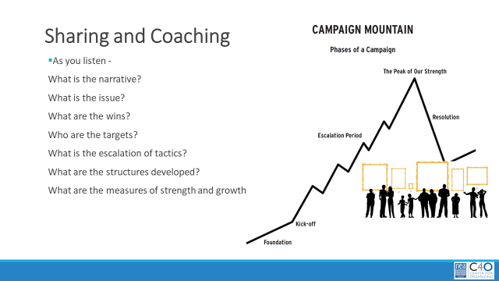 |  | Brief agenda overview and community agreements  We are going to be sharing our plans with our peers. WE want to be able to give good coaching as plans are shared. As you present and as you listen – identify the following  What is the narrative?  What is the issue?  What are the wins?  Who are the targets?  What is the escalation of tactics?  What are the structures developed?  What are the measures of strength and growth?  What types of questions do you want to ask the presenters?  What does the plan as presented make you wonder?  What suggestions might you have for the presenters?

