  - VEA Staff Resources

    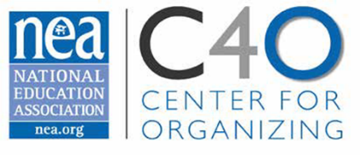 | Organizing 2 Bargain  UniServ Directors are the first line of contact between the workers in our public schools and the state and national affiliates. The challenges of workload, shifting priorities and having an organizing mindset in the face of overwhelming requests for service make the job a challenging and complex one. Organizing 2 Bargain will help you build and calibrate your current skills, knowledge and dispositions with the goal of our campaign.  Participant Resources  The resources compiled here are to support your learning while in our trainings and to provide you enough content and framing for continued application of the skills and concepts presented.

