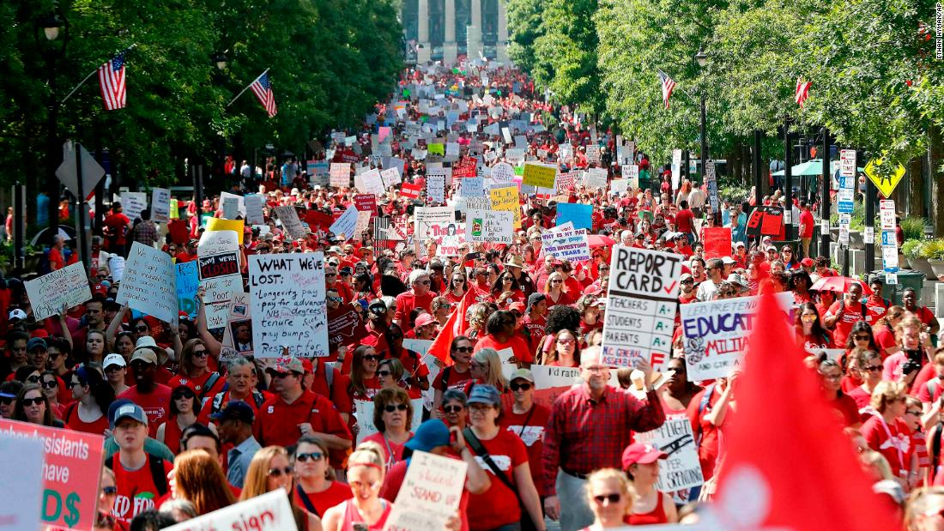

Bargaining  for All   | Participant Handouts  Collective Bargaining allows working people to directly confront their employers to shape their own social and economic futures. Like voting, collective bargaining is a way to exercise power in a healthy democracy. In the NEA system of affiliates, there are many locals that are already organized in states where they could have a collective bargaining agreement, but they have not yet done so. Moving a local from a non-bargaining entity to one that ratifies a strong contract requires a solid campaign plan. This Academy will focus on the skills and mindset required to agitate and build support for collective bargaining internally while also cultivating community support. Tools, resources, and timelines associated with strong initial contract campaigns is provided.  Lead Contact:  Ellen Holmes  NEA Center for Organizing and Affiliate Support  eholmes@nea.org  Director:  Tom Israel  NEA Center for Organizing and Affiliate Support  tisrael@nea.org

