Organizing Notes

Structuring Leadership

Week 5

What Is Leadership?

“Leadership is accepting responsibility for enabling others to achieve shared purpose in the face of uncertainty”
Many of us call to mind historic figures like Dr. Martin Luther King, Nelson Mandela, Jane Addams, Robert Kennedy or President Reagan. In reality, we find leadership everywhere - linking together networks through which we work to achieve common purposes. In every community, church, classroom, and organization hundreds of people are doing the work of leadership without which these efforts would not survive.
So what do leaders do that makes them leaders? They accept the responsibility for working with others to define desired outcomes and achieve them in an uncertain world. When we know what to do, when there are no surprises, no new challenges to face, and we’re following a routine, what need do we have of leadership? It’s when we enter the domain where the rules don’t quite work, where we don’t know which rules apply, where we’re trying to do something that hasn’t been done before – or that we haven’t done before - that’s when leadership enters the picture.
Leadership as Relationship

Relationships are the foundation of organizing, including the exercise of leadership. James McGregor Burns argues leadership relationships emerge through repeated “exchanges” or “transactions” among leaders and followers or constituents. Leaders offer resources constituents need to address their interests and constituents offer resources leaders need to address theirs in turn. These relationships may form between individuals, a team, a group, a community, or even a constituency enabled to work together effectively.
What do we exchange in this kind of relationship? Constituents may get a sense of empowerment, access to resources, help solving a problem, etc. Leaders may get the same things - and they get something that is worth accepting the responsibilities that come with leadership. Dr. King describes this as the “drum major instinct” - a desire to be first, to be recognized, and even to be praised. As much as we may not want to admit it, this might sound familiar. Rather than condemn it - it is, after all, part of us - Dr. King argues it can be a good thing, depending on what we do to earn the recognition we seek. He quotes Jesus as saying to James and John, “if you want to be my disciples you not only “can” be first, you must be first - first in love and first in service.”
With this view of leadership, who makes leaders? Can they be self-anointed? Can I decide one day that I am a leader? Or must I earn leadership by entering into relationships with those who enable my exercise of it? This makes it easy to recognize. There is a simple test. Is there a constituency? Fine speeches, a wonderful appearance, lovely awards and excellent work aside - no constituency, no leadership.

Leadership and Structure


Many of us may not want to think of ourselves as followers or as leaders for that matter. Often we are told, especially in elite institutions, that we are all leaders...or we should be. Leadership is highly praised, but no one says anything about good constituents, collaborators…or citizens. But organizations that depend on collective action can be effective only if people learn to practice good leadership and followership. Leading and following are not expressions of who we “are” but of what we “do” – in this meeting, committee, project, organization, or institution. We may play a leadership role with respect to one project and followership role with respect to another.
What are the differences in those roles? Most importantly, leaders accept responsibility for a “whole” – a whole team, a whole project, a whole job – while others accept responsibility for a “part” of the whole. Leaders accept responsibility for seeing to the work that a group must do to work together successfully.
“I’m The Leader”
But what type of leader should you be, and what are you looking for in others? Sometimes we think the leader is the person everyone goes to, like this “I’m the leader!” approach. But what does it feel like to be the “leader” in the middle? What does it feel like to be the arrow that can’t get through? What happens if the “leader” in the middle drops out?

On the other hand, some of us question the whole concept of leadership. Shouldn’t everyone be considered a leader? Is leadership really necessary? Isn’t it repressively hierarchical? Why do we need this kind of structure at all? Can’t we just “come together”? Sometimes this works. But who’s responsible for coordinating everyone? And who’s responsible for pushing the whole group forward when you can’t reach a decision?
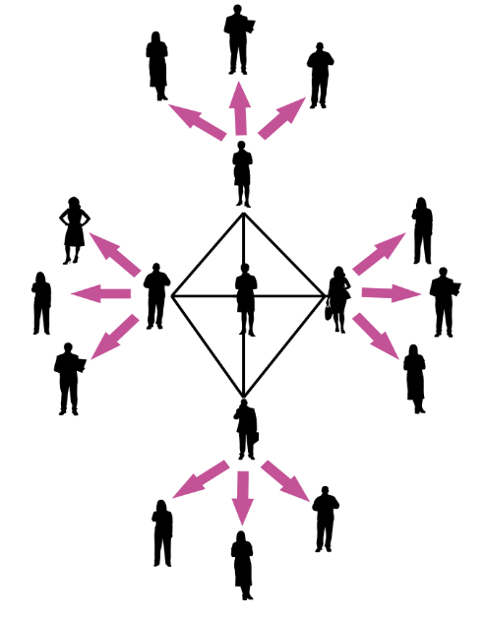
In her Tyranny of Structurelessness, feminist sociologist Jo Freeman argues that organization (or collaboration of any kind) simply doesn't work if we don’t have ways to assign clear responsibilities and hold ourselves accountable for fulfilling them. The idea of a structureless group, she writes, “becomes a smokescreen for the strong or the lucky to establish unquestioned hegemony over others.” And, “for everyone to have the opportunity to be involved in a given group and to participate in its activities the structure must be explicit, not implicit.”
“We’re All Leaders”
A third option is an interdependent leadership team in which individuals can bring complementary strengths to bear on solving a common problem. On the one hand, leadership doesn’t rest on one person. On the other hand, it is clear where responsibility for leadership does rest. Effective leadership doesn’t imply domination but rests on interdependence and collaboration to create more “power to,” based on the interests of all parties. Domination is the exercise of “power over,” a relationship that meets interests of the “power wielder” at the expense of everyone else.
Snowflake/
Interdependent Leadership
An organizer’s job is to reach out and find leadership from within his or her constituency who can who can recruit and coordinate others. They may not be people others usually see as leaders, but they are people committed to change, willing to invite others to join them in the hard work of moving a campaign forward.

These leaders will be the backbone of you organizing campaign. You must be able to trust them to delegate responsibility to other dedicated, reliable people, and to follow through on commitments. You may be the leader in the middle, or part of a leadership team in the middle, guiding others’ efforts and being held accountable for outcomes, but you will be deeply reliant on your relationships with others for success.

Leadership and Authority

We are wise to distinguish “authority” from “leadership.” Authority is a “legitimacy” of command usually attached to social positions, offices, or roles - legitimacy supported by cultural beliefs as well as coercive resources. An organization is a way to formalize authority relations among the participants – people’s rights and their obligations. Bureaucracies structure authority as a set of rules according to which manager’s direct subordinates. Markets structure authority as a set of rules according to which people make enforceable contracts based on their individual resources. Civic associations usually structure authority democratically in that leaders are accountable to the constituents whom they serve. Exercising leadership in a civic context can require more skill than other settings because it depends more on persuasion than on command.
Most of us have been in situations in which those with authority have not earned their leadership, but try to compel cooperation based solely on their legitimacy or "power over". In these circumstances, to what extent do we think our interests are acknowledged and addressed? How does this affect our motivation and performance?
Cultures have institutionalized beliefs about who is “authorized” to lead and who isn’t that can bar certain “kinds” of people from the opportunity to earn leadership. Leaders who develop under these conditions constitute a challenge to conventional ideas of authority. Authority can also be a resource a person can draw upon to earn their leadership. And sometimes leaders find authority has been conferred upon them as a result of their having earned their leadership. But leadership and authority is not the same thing.
Finally, we can distinguish leaders from “activists.” Hard working activists show up every day to staff the phone bank, pass out leaflets, and put up posters, and make critical contributions to the work of any volunteer organization. This is not the same, however, as engaging others in doing the work of the organization.
Leadership Development
Letting Others Lead

So if leadership is so important to organizations, how can organizations make sure they have the leaders needed to accomplish its mission? Organized people empower themselves to make lots of things happen less by the efficiency of their systems than by the depth of their leadership capacity. This is particularly true of civic associations that bring people together, facilitate understanding one another, and enable them to act together on common interests.
Take a look at the “leadership quotient” of your organization. How many leaders do you see doing leadership work? Is there one “leader” with everyone else linked to that leader like spokes to the hub of a wheel? Or are there lots of “leaders” linked with each other and with other members, multiple centers of coordination, inspiration and action. Are some people “followers” in relation to some “leaders” but “leaders” in relation to other “followers”? Or are some people always “leaders” and others always “followers”? Is it "leadership rich" or is it "leadership poor"?
Chart #1

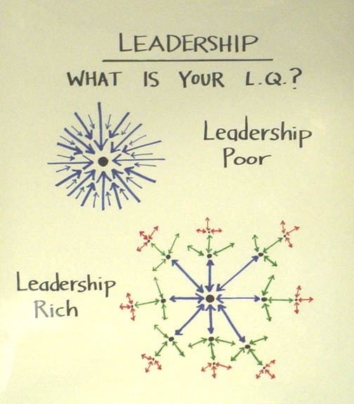

Giving Up Control to Build Power

Leadership Team or “Lone Ranger”

So why aren’t “leadership rich” organizations an everyday thing? Why is it that so often we wind up the dot in the middle of all the arrows? How can we build a “leadership rich” organization?
It’s not a new problem. As recounted in Exodus, Moses required the intervention of his father-in-law Jethro, who had his own interest in the matter to begin getting the picture. He was trying to do it all himself, but why? Because he was hungry for the power? Because he needed to keep himself busy? A more likely explanation is that, like many of us, he wanted it done right, and he thought that meant that he had to do it himself. But as long as he was trying to do it all himself, it couldn’t be done well, much would not get done at all. The belief that holding onto all the control would ensure all was done well was an illusion. So Jethro offered him a way out. Find the courage to let go of some of the control and risk letting others share in the responsibility for leading. But not just anyone – he urged him to find people with leadership potential, people who were “capable, God-fearing, and honest”.
As important as how we structure our organization is, nothing is more important than coming to terms with this fundamental question: are we willing, and able, to let go of enough control to let others lead? Can we let go of enough control to allow our organization to build the power that can only be achieved by letting it grow leadership rich?
Successful organizers form leadership teams with whom they can work early on in their campaign. Although it can be a mistake to recruit people to act as an "organizing committee" too early - especially if you are not careful to recruit people drawn from the constituency who are not seen as leaders or, at least, potential leaders - organizers more often err in delaying too long. The sooner you have a team of people with whom to work, the sooner the "I" of the organizer becomes the "we" of a new organization. Once you have formed a leadership team you can more easily establish a rhythm of regular meetings, clear decisions and visible accountability that will help make things actually happen. You don't build an organization of 500 people by recruiting them all yourself. You build it by finding people willing and able to commit to help building it with you. If you don't have a leadership team working with you by midterm, it’s time to look very closely at why.
Despite the “alpha” mythology, most effective leaders have always led through teams. Moses, Aaron and Miriam, for example, in the Exodus story or Jesus and His twelve disciples in the New Testament, or Martin Luther King, Ralph Abernathy, Rosa Parks, Jo Ann Robinson and E D Nixon during the Montgomery Bus Boycott.
Structuring a leadership team is a way to organize interdependent leadership – individuals working together to achieve a common outcome, like an athletic team, each person responsible for coaching the team on a different activity. Well-designed teams put to productive use the unique talents of the individuals who make up the team.
Structuring a leadership team creates strategic capacity: the ability to strategize creatively together in ways that produce more vibrant, engaging strategy than any individual could create alone. In the Obama campaign, the field structure created multiple layers of leadership teams to engage people creatively and strategically at all levels of the campaign. Each state had a state leadership team that coordinated regional leadership teams (of Regional Directors and Organizers), which coordinated local neighborhood leadership teams of volunteer leaders. At every level the people on leadership teams had a clear mission and could strategize creatively together about how to carry out their mission. This structure created multiple points of entry for volunteers, and multiple opportunities to learn and exercise leadership.
So why don’t people always work in teams?
We have all been part of groups that did not work well. They factionalize, alienate each other, or all the work falls on one person. Some aim to keep the pond small so they can feel like big fish. So many of us conclude: I’ll just do it on my own; I hate meetings, just tell me what to do; I don’t want any responsibility; just give me stamps to lick. For example:

• You are in a team meeting. You find that it’s never clear exactly whom you can count on to step up, take responsibility, and get the work done. So two or three people often wind up doing all the work, which means that no matter how hard we work, it still can’t get done.

• Whenever we need to make a decision we always seem to be missing some crucial piece of information, skill, or set of relationships.

• We talk and talk and talk, but, when it’s all over, we realized that we each had a different idea of the outcome we were talking about.

• When we get stuck, we have nowhere else to turn for help. We help each other as much as we can, we may contact another volunteer leader, but it’s not clear where we can go for expert advice.

There’s just one problem: we can’t become powerful enough to do what we need to do if we can’t even work together as a leadership team. But you can create the conditions that will increase the odds your team will work drawing on the craft of team design.

Three Outcomes of an Effective Team

- The team accomplishes the goals for which it is responsible.

- The team is operating in ways that make it better as a performing unit over time

- The team contributes the learning and well-being of individual members

Three Conditions for and Effective Team

These are conditions that you as an organizer are able to create in the way you design your leadership team: who is selected, what is required, what expectations you establish, etc.

• Your team is bounded. It is clear who is on the team and who is not on the team. It is clear how new people can join the team and what is expected of those who must leave the team.

• Your team is stable. People commit to clear terms of service: regular meetings, length of time, etc. Your team is not a revolving door, never knowing who will show up.

• Your team is diverse. Your team has the appropriate diversity of skills, talents, viewpoints, and constituencies that will be needed to do a good job.

Three Steps in Launching an Effective Team

These are three decisions that a leadership team must make at the very beginning to put itself on a constructive path. There are no “right” answers as to what these decisions must be, only that they must be made to give the team the structure it will need to do whatever it wants to do well.

• Establish a shared purpose. You do the work, based on your shared values and the relationships you have formed, to clearly articulate your common purpose as a team. It is clear, challenging, and matters. You have defined your goal, whom you work with, and the kinds of things you will do?

• Establish clear ground rules or norms. Your team sets explicit expectations of how you will work together: how you will make decisions, manage your time, and honor your commitments. What are things you will always do and what are the things you will never do. And how will you correct yourselves if you do them. Perhaps you most important norm is how you will make decisions. Steps that can guide effective decision making are: defining the problem, establishing criteria, brainstorming possibilities, synthesizing ideas, formulating options, evaluation options against the criteria, deciding. Some prefer deciding by vote; others, by consensus; others by delegating the decision to an individual.

• Organize the work into interdependent roles. Everyone should have responsibility for their own share of the leadership work needed to achieve the goal. Role requirements need to be clearly described. Team members need to assess their strengths and limitations, to the greatest extent possible, matching individual capabilities with role requirements. Because roles are designed to be interdependent, everyone has a stake in everyone else’s success. Team members speak up when they need help and get it. No one works in a silo that’s secretive to others. The team with diverse identities, experiences and resources brings more to the table than a team that is very homogeneous.
Leadership Development Cycle:
Identify, Recruit, Develop

Leadership development work occurs as a cycle, as shown in Chart #6: identifying potential leaders (opportunities for them to emerge), recruiting them into leadership positions (opportunities for leadership to be earned), and creating opportunities for them to develop their capacity (opportunities for leaders to grow) on an ongoing basis. It requires learning how to delegate - and mean it; creating a supportive organizational structure; and providing coaching.

Identifying leadership requires looking for it. Who are people with followers? Who brings others to the meetings? Who encourages others to participate? Who attracts others to work with them? Who do other people tell you to “look for??” Alinsky writes about community networks knit together by “native” leaders - people who take the responsibility for helping a community do its work out of their homes, small businesses, neighborhood hangouts, etc. They can be found coaching athletic teams, organizing little leagues, serving in their churches, and surfacing in other informal “schools” of leadership. Where would you look for these kinds of leaders around here?
Although leading is a matter of “doing” and not “being” – and people do leadership work in different ways - there are some clues you may want to attend to, especially when looking for people that will make good organizers. It is hard for a person who has not learned to be a good listener to become a good organizer. You have to understand the interests of your constituency if you are to help them act on those interests. Listening means learning to attend to feelings - empathy - as well as to ideas because the way we feel about things affects our actions more than what we think about them. Curiosity helps us see the novel as interesting rather than threatening, enabling us to learn how to face new challenges that are always a part of organizational life. A good imagination helps because strategizing is a matter of imagining different futures and possible ways to get to them. A sense of humor helps you from taking yourself and your troubles too seriously and helps keep things in perspective. A healthy ego is very important. Arrogance and a wish to dominate others are usually signs of a weak ego constantly in need of reassurance. Leadership also requires courage - the willingness to take risks, make choices, and accept the consequences.

Recruiting leadership requires giving people an opportunity to earn leadership. Since followers create leaders, they can’t appoint themselves and you can’t appoint them. What you can do is create opportunities for people to accept the responsibilities of leadership and support them in learning how to fulfill these responsibilities. If you have to get the word out for a meeting, you can get three of your friends to help you pass out leaflets in the Yard one day or you can find one or two people in each House who will take responsibility for recruiting 5 people from their House to attend. They earn their leadership by bringing the people to the meeting. What other ways can you think of that you can give people the opportunity to earn leadership?
No matter how careful you are, leadership development requires coming to terms with the fact that it entails risk. Risk small failures early in the life of a project in order to avoid big failures later on. If you take the risks required to learn to delegate, you will learn how to do it and you will learn who "comes through" and who doesn't. It is important to learn this with a small meeting at stake and not the monster rally of 5000 at which only 50 people show up. One reason to set up quantifiable goals, regular reports, and ongoing evaluation is to detect early failure and success so they become "learning opportunities" for everyone. "So, Mary, why did that work so well?" "So, Sam, what happened there? What could you have done differently?" Don't assume everyone is going to do everything right from the very beginning because it never happens. Also, it is often not completely clear what the "right" way is at the beginning of a project. Think about how to turn this fact to your advantage. Where can you get the courage to take the risk of letting other people share in the responsibility for outcomes you care about?
We only develop good judgment about whom to select by taking risks, making choices, experiencing success and failures, and learning from this experience - and we will still be surprised. On the other hand, the more experienced we are the better judgment we can begin to develop. There is no "rule book" to go to on this, but if you are afraid to risk making choices, you never learn to make good choices. Here are some questions you might ask yourself. How do you select to whom to delegate? How do you know who the right person is? How can you find out ahead of time? How do you know when a person is ready for a big job? Are you selecting them because they are easily available or because they are the right people for the job? Are you selecting them because they already know what to do because you have worked together before or because they "look as if they can learn what to do" with some good coaching? Or did you select them because you "heard" they were good? Where did you hear that? Who told you? Should you believe them? How do you know?

Developing leadership requires structuring the work of the organization so it affords as many people as possible the opportunity to learn to lead - delegation. Distributing the leaflets through House Committees, for example, shares the responsibility for engaging others with many people. It is true organizing the work in this way can be risky. You may delegate to the wrong people; they may let you down; etc. But as Moses learned from Jethro, if you fear delegating, the strength of the community is stifled and can never grow. But you can do things to increase the chances of success. Leadership training sessions help clarify what is expected of leaders in your organization, give people the confidence to accept leadership responsibilities, and express the value your organization places on leadership development.
Developing leaders is not about assigning tasks, but offering responsibility. It is different to ask: “would you make these 50 phone calls telling people about the meeting?” versus “would you take responsibility for getting 10 people to come to the meeting? You will? Great! Here’s some things that may help you contact them and get them there -- a list of names and phone numbers of people who said they were interested, 100 leaflets, some posters, and some sign-up sheets you could use to get commits." Do you see the difference? With the “task," the person can become a kind of yo-yo: go do this, come back for what’s next, go do that, come back for what’s next. They are “helping” you with your responsibility. With a “responsibility,” the person takes it and runs with it, and you can help them meet “their” responsibility. But when looking for someone to take responsibility, don't make the responsibility easier, and easier, and easier…until there’s nothing left. The challenge is in learning to motivate people to accept the level of responsibility needed to get the job done. And when a person has accepted responsibility, the motivation work continues. Keeping others motivated, keeping yourself motivated, and getting the work done go together. All are based on real accountability, lots of coaching, and lots of recognition of success.
Responsibility is only real, however, if the person is clearly accountable for the responsibility he or she accepted. Accountability should be regular, specific, and timely. The point of accountability is not to catch someone to punish them, but to learn what kind of results they are getting so everyone can learn from them. If someone is having trouble, we need to learn why so we can figure out what to do about it. If someone is being successful, we need to learn why so we can try the same thing in other places. Without accountability the most important learning we can do in the course of a campaign - systematic reflection on our own experience - is impossible. You cannot expect a person to take responsibility without authority. If you want someone to take the responsibility to get 10 people to a meeting, hold them accountable, provide training, offer support - but give them the authority to do what they’ve been asked to do. If you see or hear of them making a mistake - or think you can do it better - this means going directly to them, not around them or taking care of it for them. It is really a matter of basic respect.

Chart #2

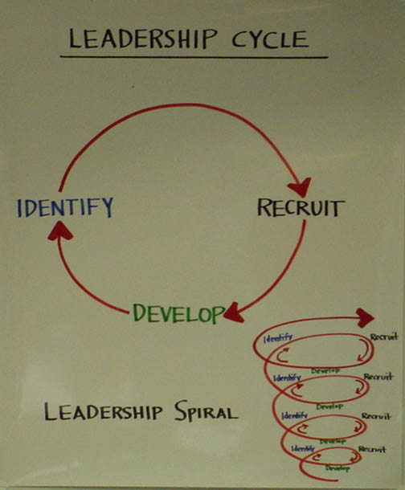
Leadership as Coaching and Coaching Leadership

Once a person accepts responsibility, it is in your interest to offer her as much support as she wants to ensure her success. The challenge is learning how to offer support without taking back the responsibility. “Oh, you’ll get the ten people to come? Great! Let’s sit down for a few minutes and “role play” just what you’re going to say to them." Or “give me a call to tell me how it's going - or if you run into problems.” A regular coaching session means you want to meet not because you think they are in trouble, but because you are interested in their work. These sessions can be very useful for learning what's really going on out there as well. And coaching is, of course, one of the best ways to make mentoring real.
The Hackman and Wageman article on team coaching is particularly useful in focusing on how to coach a leadership team, not only individuals, with sensitivity to the timing issues involved in a campaign type of project. Ongoing support for leadership development comes more and more to be in the form of leadership team coaching and teams themselves become more typical of how organizational life is being structured. And as more activity is outcome focused, rather that process focused, the more time issues will become critical. So learning how to coach multiple people within a changing time dynamic is will be critical for your success as an organizer.
Conclusion
Although identifying, recruiting and developing leaders is critical to the capacity - or power - of most organizations, it is the particular focus of organizers whose work is to be leaders of leaders. The primary responsibility of an organizer is to develop the leadership capacities of others and, in this way, of the organizations through which their constituents act on their common interests.

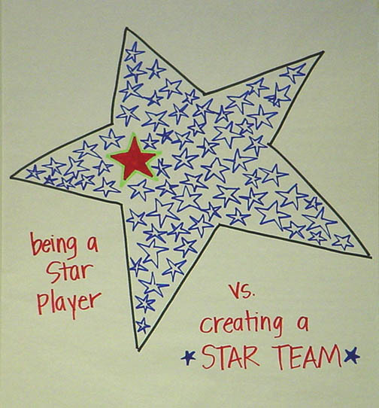
© Marshall Ganz, Kennedy School, 2014

QUESTIONS

    - Have you developed a leadership team? If yes, did your define a common purpose? If so, how? If not why not? Have you established norm? If not, why not? How often do you meet? Who does the agenda?

    - What are the various roles you have assigned for leaders in your team? Do they create opportunity for leadership development? How do you hold each other accountable?

    - Have you practiced coaching within your leadership team? If so how did it work? Who coached whom?

    - Do you, or others in your project/organization, have a conscious strategy for identifying, recruiting and developing leadership? What is it?

J. M. Burns (1978). Leadership. (New York, Harper and Row).
Martin Luther King, J., (1986 (1991)), The Drum-Major Instinct (4 February 1968). A Testament of Hope: The essential writings and speeches of Martin Luther King, Jr., (New York, HarperCollins) 259-267.
J. Freeman, (1970), "The Tyranny of Structurelessness." Women's liberation movement, USA.
The Bible, Exodus 18.

