Strategies Steps to Win a Collective Bargaining Agreement

Keep it simple!
Step 1
- Get your initial organizing team together and identified.
- Someone from each building, if possible. (More if the building is big).
Step 2
- Map Your Sites
- Have a rep or someone you know map the building or worksite.
  - Assess their support of collective bargaining, who does or does not support CB? (Add a notation if they are a member or not).
  - Who is trusted and respected? Just ask people.
Step 3
- Build Your Team
- Continue to build your team, pull more people into the team,
- Once your organizing team is established have them establish:
  - Benchmarks to win recognition.
  - Goals.
  - Tactics to build density of support for collective bargaining.
  - Identify community stakeholders.
Step 4
- Test
- Run a test to see if your team can get people to move.
  - Sticker up (how many schools will wear a sticker and report back on the number that wear a sticker).
  - Petition that your leads circulate.
  - Whole group pictures.
Step 5
- Cards
  - If you have a majority that have/can act, then run them move to get cards filled out.
Step 6
- School Board
- How to get your school board to vote on collective bargaining.
  - Have your organizing team lobby your board members.
    - SB can vote to approve an ordinance outlining the local CB process.
    - If the school board has not moved to approve an ordinance, you can file authorization cards. This gives the district 120 days to consider the employee request.

What does power actually
look like?

Effort ( # of members involved) +
Intensity (how difficult is the task)
= Amount of Power

Every member files the same grievance
Members turn in petition to the Supt.
Effort
Buildings Take Group Pictures all on the same day.
Each site hosts a 10 min meeting about bargaining.

Reps Wearing Red
Surveys
Host a pizza party.

Intensity

Phases of Bargain Readiness

Phase 1 is the lowest metrics of readiness.
The steps above will help you make the jump from Phase 3 to Phase 4.
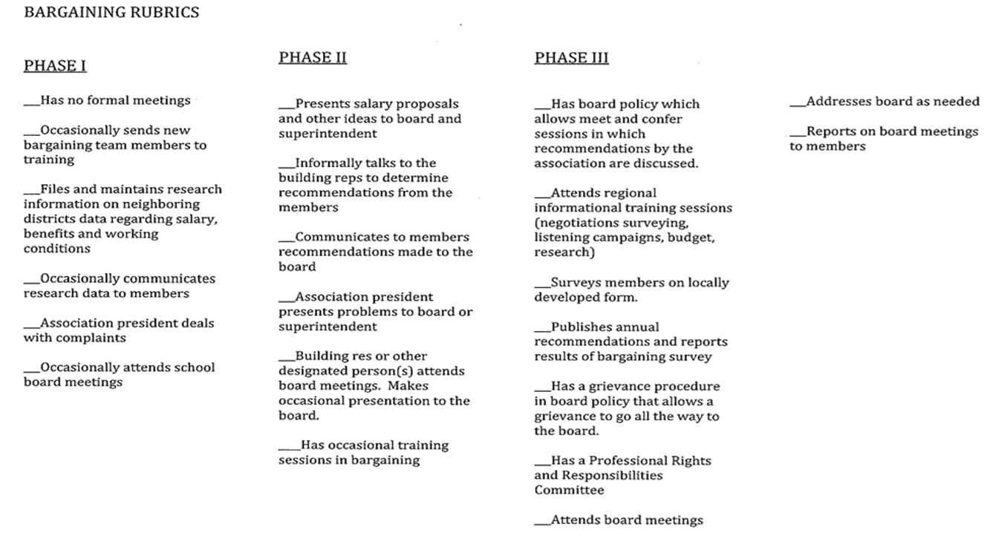

Phases of Bargain Readiness

