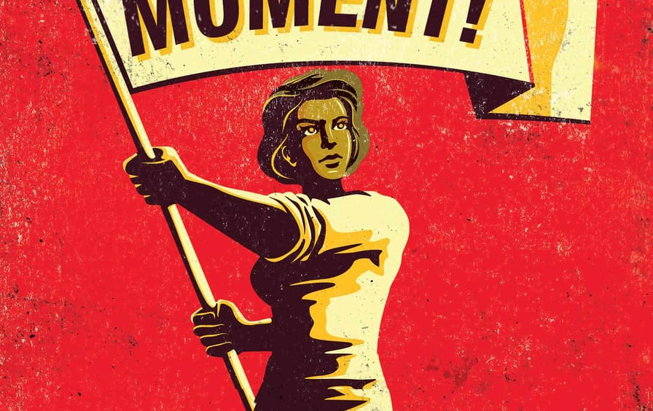
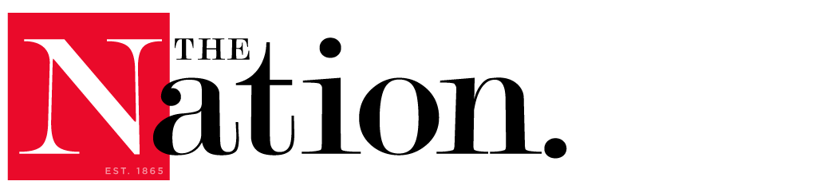
https://www.thenation.com/article/society/labor-strikes-workers-unions

How Workers Can Win in 2022

They need to create a crisis in order to turn this country around.

By Jane McAlevey
In the first full year of the Covid pandemic, Elon Musk’s wealth skyrocketed from $25 billion to $150 billion. Jeff Bezos became the first person on the planet to possess a fortune of more than $200 billion. The Financial Times has been fretting all of this past year about a crisis in superyacht production, and lately it’s been reporting on another crisis afflicting the rich. Flexjet and NetJets, two of the most well-known private-jet charter companies operating in the United States, recently stopped accepting new clients because they simply can’t acquire enough jets to accommodate the explosive growth of the billionaire class. Not only is this eye-popping wealth not being hidden; it’s being flaunted. After being propelled by his Blue Origin rocket for fewer minutes than the lifetime of a female mayfly, Bezos enthusiastically thanked Amazon’s employees and customers for allowing him to act as if he’d joined the ranks of astronauts like John Glenn and Neil Armstrong.

Our new Gilded Age of obscene wealth and arrogance stands in stark contrast to the everyday struggles faced by tens of millions of exhausted workers fighting just to stay healthy and alive, avoid eviction, make the next month’s rent payment, or find the kind of job that will leave enough free time to help their children with homework. In April, 3.8 million Americans quit their jobs, which prompted headlines about “the Great Resignation” and “the Big Quit.” By July, that number would climb to over 4 million in a single month, bested again in August (4.27 million) and then again in September (4.43 million). By October, pundits in the mainstream media began invoking a new trope, “Striketober,” as 10,000 workers walked off the job in the first strike against John Deere since 1986, with another 60,000 film production workers and 50,000 health care workers at Kaiser Health threatening to strike, along with dozens of small and medium strikes and work stoppages scattered across the country (including at Kellogg, Nabisco, and Catholic Health, in Buffalo). Although there’s no doubt that the abysmal treatment at the hands of absentee corporate bosses during the pandemic has led individual workers to resign in droves—and has caused a small uptick in strikes—anger at the elite and collective action by workers predate Covid.

In 2018, more than 485,000 workers waged 20 large strikes, with another 65,000 engaging in 123 smaller work stoppages that involved fewer than 1,000 workers. In 2021, through November, only 76,000 workers participated in large work stoppages during 39 disputes. While the number of smaller stoppages (involving fewer than 1,000 workers) that took place in 2021 is not yet known, it’s clear that worker anger at outrageous inequality didn’t suddenly bubble up in October. Although the increase in strikes involving more than 1,000 workers is notable, the number of workers acting collectively has yet to catch up to 2018’s total. Instead, labor’s discontents have been channeled into individual actions, like quitting. It’s also worth noting the key shift from public sector strikes in 2018 to increased walkouts in the so-called private sector today. But the seemingly random nature of the 2021 strikes—with workers pissed off at crappy and insulting offers by their employers—doesn’t come close to what is required to create the scale of crisis that will force the corporate elite to negotiate with the working class in significant ways that the nation hasn’t seen in decades.
Unfortunately, most national unions squandered 2021 by prioritizing behind-the-scenes jockeying for access to the Biden administration and crumbs from the bosses’ table—the kinds of actions easily overturned in a next administration—while the working class watched the president abandon one campaign pledge after another: free community college, cheaper prescription drugs, real relief for students and homeowners in debt, paid medical and family leave, and robust action on climate change that would shift subsidies toward unionized, high-paying jobs for a livable planet. Biden’s refusal to do away with the filibuster in 2021 vanquished many desperately needed structural changes—starting with the restoration of the Voting Rights Act and the passage of its workplace companion, the Protecting the Right to Organize, or PRO, Act. (Both aim to restore fundamental freedoms briefly enjoyed last century and essential to a functioning democracy.)
What should national unions have been doing? Mobilizing members to take the only action—strikes—that could have given them real power in the legislative fights that have ended badly for workers and have most certainly damaged the Democrats’ electoral prospects heading into 2022. Biden clearly doesn’t have the power to move Congress. Senators Joe Manchin and Kyrsten Sinema aren’t going to change their votes because of personal pleas from the president or the leaders of the Progressive Caucus. What their ilk do respond to is when the corporate elites whose bidding they do phone them and tell them to switch their votes because profits are being dented by the chaos of too many workers on strike. National legislation that’s good for most Americans passes only when workers create untenable crises that make that legislation seem like a far better option than expensive strikes, pitchforks, or falling bottom lines.

In another period of our country’s history—the two years after the election of Franklin Delano Roosevelt—tens of thousands of workers exercised just such transformative power. At the time, the Supreme Court was even more unabashedly pro-business than it is today with its supermajority of pro-shareholder judges. Joblessness, evictions, violent racist terror, extreme gerrymandering, serious health and safety violations, and threats to the basic rights of free speech and peaceful assembly were all at a boiling point when FDR won in November 1932, as they are today. In 1933, workers in key cities and industries launched a series of authorized and unauthorized strikes that forced FDR to live up to his promises. If we are ever going to take our country back from the billionaire class, 2021—a year in which relatively small-scale strikes broke out—will have to foreshadow a 2022 that feels like 1934, when mini general strikes erupted in key labor markets such as San Francisco and Minneapolis. In the 1930s, it took workers standing up to their national unions and their employers by the tens of thousands to create the conditions for the passage of many elements of the New Deal. Far too much attention and money is now focused on something called “narrative change,” when what’s required is the power that comes from strategic disruptions of production, ones that inflict real pain on CEOs and shareholders. Although it’s hard to see 2022 becoming 1934, it’s not impossible—and seizing the possible is the best hope we have.
There’s always time for a course correction. And while the prospects for shifting national unions away from their comfort zone of cooperating with corporate leaders and politicians might seem bleak, the only people who are in a position to force that change—workers on the front lines—showed how to get it rolling when they twice rejected proposed contracts that their national union recommended. The rank-and-file revolt over the contract at John Deere, and the massive media coverage it received, demonstrated to all workers that they can assert more control over the outcome of their collective agreements and thus their lives.
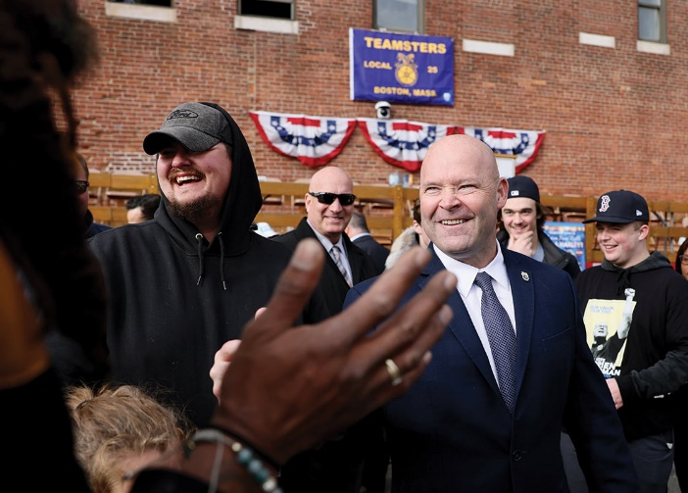
All’s not lost: Newly elected Teamsters president Sean O’Brien is pushing a bold agenda. (Jessica Rinaldi / The Boston Globe via Getty Images)
In the coming year, more than 1,577 contracts, covering over 1 million unionized workers, are set to expire in the United States. But that figure includes only contracts that cover more than 1,000 workers; there are plenty of other workers in smaller unionized workplaces who also have contracts expiring in 2022, including nursing homes and small hotels. Two of the three states with the largest number of contracts expiring are the swing states of Pennsylvania and Ohio. If more than 1 million US workers—or even fewer in key labor markets—take collective action toward common demands to radically improve their quality of life on and off the job, the results will be far more powerful than those of the Great Resignation. If even a tiny fraction of the number of people who quit in August and September choose to unionize—forcing their employers to improve their working conditions by threatening a collective, rather than an individual, exit, or by withholding their labor in supermajority strikes—the working class could radically lift the floor on what is considered acceptable corporate and shareholder behavior. As the John Deere strikers did.

As we move into 2022, bright spots include the Teamsters electing a bold reform slate to lead the national union for the first time this century and a successful member-led referendum vote in November that changed how national leaders are chosen in the United Auto Workers. There’s a slew of upcoming contract expirations in swing states, where national leaders (the president, the vice president, congressional leaders, and governors, for starters) should flock to the picket lines and actually use the power of the state to settle strikes on terms favorable to workers. When you consider how comfortable these politicians were as candidates campaigning for labor votes—practically tripping over one another other in photo ops during the 2019 General Motors strike, for example—it’s hard to accept their absence from the picket lines at John Deere and elsewhere. When Biden’s spokesperson stated at a press conference during the Deere strike that the president was going to remain neutral, it was the kind of missed opportunity that we can’t afford, given what’s at stake.

(Alex Milan Tracy / Sipa USA via AP Images)
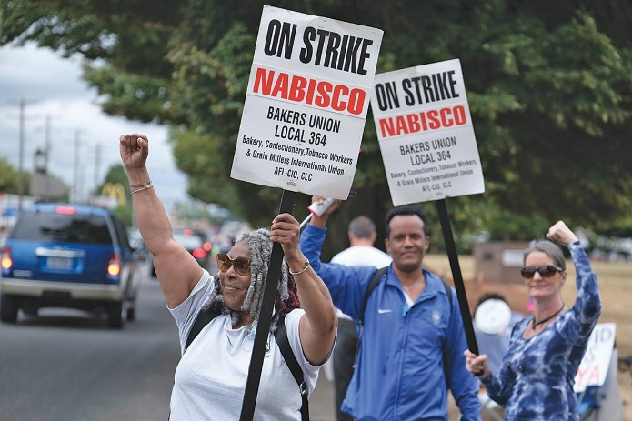
Everyone understands there are two intransigent senators who are the public faces blocking real progress. Precisely because of this, Biden needed to show up on these swing-state picket lines and drive home his message of fairness for workers. Sending the former governor of Iowa for a brief home state appearance sandwiched between his main events at the World Food Prize ceremony wasn’t enough.
With January 6 and the elections of 2022 and ’24 in mind, the president needed to embrace the workers on the John Deere picket lines in person and conduct broad political education about who is really causing the pain in workers’ lives. Instead, the administration made a point of stating it would let those workers fend for themselves against a giant corporation engorged with billions in profits. We need to understand that Biden’s public actions toward workers on strike are every bit as important as—if not more important than—his appointments to government agencies, which are inside baseball.
Out West, more than 100,000 grocery store employees in Colorado, California, and Washington state are already working cooperatively as they approach the spring 2022 contract expirations with the industry behemoths Kroger and Safeway. The leaders of the largest locals of the United Food and Commercial Workers Union have been building cross-local union solidarity for the past several years. If you begin to imagine strikes up and down the West Coast—along with strikes in critical swing states, either for better contracts or to demand union recognition in the logistics and supply chain sectors—you can actually begin to see a path away from Trumpism winning in 2022 and then Donald Trump or a Trumper winning in 2024. The best union organizing has long focused on coordinating contracts so that they are set to expire at the same time across industries, employers, and geographical locations—what’s known as “contract lineup”—during big political election seasons. Why? Because the majority of workers sit up and pay attention to collective action when their contracts are going to expire. And given the cynicism most people rightly have toward electoral politics, it takes contract and strike mobilizations to engage in meaningful political education about which set of politicians is connected to which set of corporate leaders.
Rather than surrender to gloom, we should keep in mind that workers who have contracts expiring stand the best chance of creating the conditions to fix our broken democracy (and to improve their lackluster unions). Unionized workers whose contracts are not set to expire in 2022 should immediately explore all opportunities to strike mid-contract, whether it’s over safety and health violations or demands to bargain over the impact of pandemic-era workplace changes. Workers who are not yet unionized should look to emulate the decisive actions taken by two different groups of workers in early December. A tiny but mighty group of Starbucks workers in Buffalo achieved what none before them had done when they defeated a ruthless union-busting campaign led by CEO and former presidential contender Howard Schultz and won their National Labor Relations Board election. Two thousand miles away and just one day earlier, the largest organizing win of the year was achieved using a different strategy to form a union under US labor law: 17,000 academic researchers across the University of California system asked for voluntary recognition of their demand for a union. When their bosses balked, they organized for a supermajority strike, and after they announced the results of their strike authorization vote, the employer had a sudden change of heart and agreed to recognize the union. This second strategy was far more common in the 20th century than it is today, and its revival is urgent in a period when the increasingly obvious vulnerability of the just-in-time supply chain has opened up a major window of opportunity for workers to gain leverage over capital.
Now more than ever, as go unions, so goes democracy.
Jane McAleveyJane McAlevey is The Nation’s strikes correspondent and the author of A Collective Bargain: Unions, Organizing, and the Fight for Democracy. She is a senior policy fellow at the University of California’s Institute for Research on Labor and Employment.

