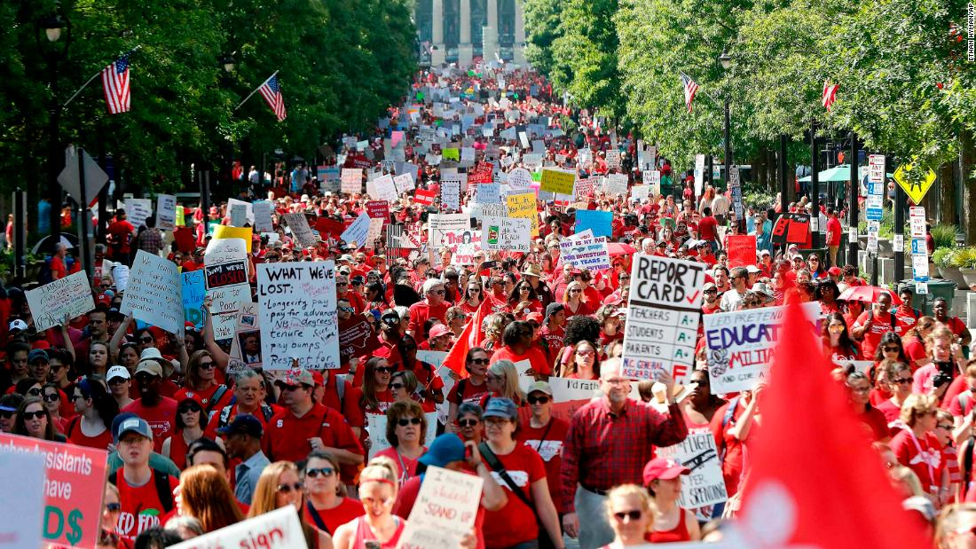

Bargaining  for  All   | Participant Handouts  Collective Bargaining allows working people to directly confront their employers to shape their own social and economic futures. Like voting, collective bargaining is a way to exercise power in a healthy democracy. There are many locals that are already organized in states where they could have a collective bargaining agreement, but they have not yet done so. Moving a local from a non-bargaining entity to one that ratifies a strong contract requires a solid campaign plan. This Academy will focus on the skills and mindset required to agitate and build support for collective bargaining internally; while also learning methods for pressuring school boards and districts to agree to bargain. Tools, resources, and timelines associated with strong initial contract campaigns are provided.  Lead Contact:  Ellen Holmes  NEA Center for Organizing and Affiliate Support  eholmes@nea.org  Director:  Tom Israel  NEA Center for Organizing and Affiliate Support  tisrael@nea.org

