Playbook for NEA ESP

- Goal and Plan to Win page 1

- Why Unionize?
  - Why Bargain? (attached) page 2
  - Testimonials page 3
  - MNEA ESP handout page 4

- Our Playbook
  - Benchmarks page 6
  - Tough Questions pages 7-9
  - Checklists (attached) pages 10-11
  - One on One conversation outline page 12
  - Timelines

- Inoculation Section

  - Union activists can’t be slackers page 13
  - Delta airlines anti-union play station info page 14
  - district letter during the teacher election page 15

Goal: We want to unionize the school district non-supervisory support staff, which includes bus drivers, bus aides, mechanics, maintenance workers, secretaries, cafeteria workers, Parents as Teachers staff, teacher assistants, paraprofessionals, custodians, nurses’ aides, and tech workers.
- Our plan to win is:
    - Build an Greatest Organizing Action Team (GOAT) of at least 10% of the potential bargaining unit. 10% of 541= 55 trusted and respected leaders. The OAT must be representative in all ways, including school, gender, job category, language, age, etc.
    - Talk with every worker to understand their issues at work
    - Encourage every worker to become a union member
    - File for an election when we have 60% of the potential unit as union members
    - Win an election to be recognized as a union by the district
Campaign to Unionize Support Staff**Progress to Campaign Benchmarks**9/23/19
Job | Number of workers | 10% of leaders NEEDED on Organizing Action Team | 60% membership | Current Membership | Agreed to be leader
Bus driver |  | 10 | 55 | 11 | 4
Aide |  | 8 | 52 | 17 | 2
custodian |  | 6 | 37 | 0
Food Service |  | 8 | 50 | 0
IT | 4 | 1 | 2 | 0
Maintenance | 11 | 1 | 7 | 0
Office Professionals | 10 | 1 | 6 | 0
Parents as Teachers | 11 | 1 | 7 | 0
Rickman Worker—full time? | 18 | 2 | 11 | 0
secretaries 1 &2 | 57 | 6 | 34 | 1 | 1
security officer | 5 | 1 | 3 | 0
TAs | 85 | 9 | 51 | 13 | 2
estimated size | 541 | 54 | 314 | 39 | 7

*10% workers on OAT is a unionizing standard to form a successful committee to organize coworkers. Build an Organizing Action Team (OAT) of at least 10% of the potential bargaining unit. 10% of 541= 55 trusted and respected leaders. The OAT must be representative in all ways, including school, gender, job category, language, age, etc.
** 60% union membership is an unionizing standard to before filing for a union election with the MO Department of Labor. Elections are expensive and likely to lose if we don’t have a majority of union members . We will keep talking to people until we hit this goal.

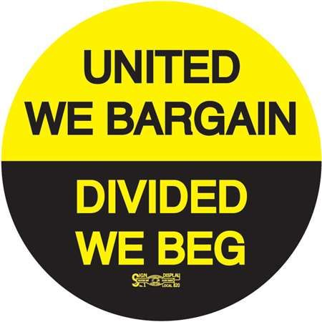
Why Bargain?
When employees meet and confer with administrators, we have a small voice. Maybe they’ll even “hear us out” on issues that matter to our jobs. They don’t do our jobs, though. We know what we really need.
Collective bargaining is a serious seat at the table. Decisions are made only if our union agrees to it. Together we have power.
Through collective bargaining, we can win:
- 30 minutes of duty free lunch
- Progressive discipline (due process)
- A substantial voice in the evaluation process
- Safer working conditions
- Improved holiday and inclement weather pay
- Higher salaries and better pay for extra work
- Better health, vision and dental insurance
- Clear policy for sick leave, jury duty leave, bereavement leave, personal leave days
- Clear process for transfer from one school to another
- Tuition reimbursement
- Union right to use facilities
- Union right to use equipment
- Union right to use mail systems
- Union right to use bulletin board
- Union access to information
If you believe having real power to control your working conditions, the only long term way to ensure that is COLLECTIVE BARGAINING.
Anything else is BEGGING.

UNION POWER: SUPPORT STAFF TESTIMONIALS
“I am a proud MNEA member for many reasons by my favorite reason is the knowledge and information that I receive from meetings. I bring back what I have learned to my colleagues so they have an understanding of what our association does and how our association fight for. I recommend to all my support staff colleagues that they join MNEA, not only from the benefits but for the support from people who are there to help you stand for what’s right, especially when you may find yourself in a not so food situation on the job.”

“I am proud to be a member of MNEA because for so many years I made a salary that I considered below my education. Through collective bargaining, MNEA has elevated nurses to the level of professionals in pay, and for that I will forever be grateful!”

“With the NEA, I have a voice to express my opinions on how to improve our workplace as well as the district as a whole. It is important for me, as an employee, a resident and a parent to have the opportunity to improve our school district from within.”

“We worked together and discovered that together we complemented each others strengths. Together we were stronger than any one of us would have been on our own….We are excited that we now have a Joint Labor Management Committee and can work with the administrative team to resolve issues as they arise. We look forward to working together with administration for the health of our students; because it takes a well-coordinated team to meet students’ health needs effectively.”

“The reason I’m a union member is simple. My union has been there for me. I won a grievance with my employer with the help and encouragement of MNEA. Together, we have improved our working experience with the school board. We have learned how to protect ourselves from anything that arises at work.”

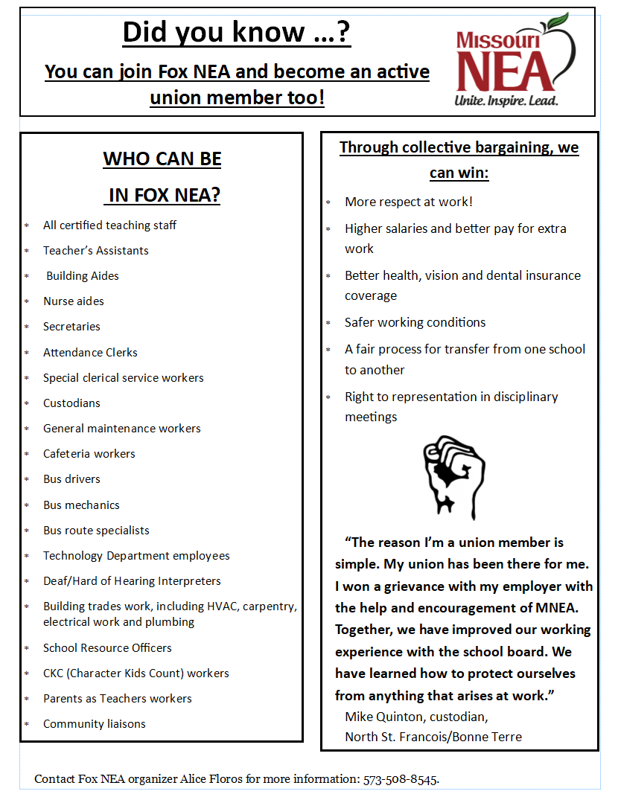

Benchmarks  If we don’t hit the benchmark on the timeline, we assess if we need to change tactics to be more effective. Right now, we have 7% membership density | Approximate Timeline
At least 30% of workers in potential bargaining unit become union members (162)
At least 50% of workers become union members (271)
30 workers on Organizing Action Team (representing at least 5 departments)

Custodial
Bus drivers
Maintenance
Cafeteria workers
Aides (classroom, bus, nurse)
TAs
Secretaries
Security
Parents as Teachers
At least 60% of workers become union members
Election petition—aim for at least 75% of workers signing the petition (406)
Final Get Out the Vote and Union Election (might not be email ballot)
Surveying +worker meetings+ election of bargaining team (2 from each job category or about 20 total)
Work on bargaining proposals + send Intent to Bargain letter to district
Collective bargaining with district
Ratify first union contract | J
Assessment System-
0-No assessment made on union question.
Why assess?
We need to track our leaders, followers, opposition and fence sitters.
The most dangerous people are real leaders who are anti-union.
They can tank the campaign if there is not a good plan to neutralize them.
1-union member, wants to unionize, trusted and respected by other workers
2-union member, interested in union campaign
3-not sure if they are interested in union campaign
4-not a union member
5-anti-union, but a credible, respected leader to some people

Name | Assessment | Next Step Notes | Ready for OAT?

TOUGH QUESTIONS: MEMBERSHIP QUESTIONS
Q1. How do I become a member?
A. We are glad you are joining our union! We are much more powerful with your voice! You can join NEA by completing a membership form and texting Alice Floros to pick it up (573-508-8545). You get to choose how you pay dues: credit card, bank draft, or check.
Q2. Do I have to be a member to get help from NEA?
- Yes. support staff employees must be members to receive legal services, employment support, and discounts from NEA.
Q3. I have been in unions before. I think we’d be better off with no union.
Working here can be frustrating. Did you know that teachers and nurses have won a stronger voice at work, better pay, and so much more by forming unions? Nurses won protections around their lunch time, improved the system to have equipment delivered to them, and got a professional development fund just for nurses. There are still improvements that need to be made, and our union can only do this with your presence and support. Do you think you or me could do that alone sitting at a table with the district?
Q4. We are at will employees and can be fired for anything. Why would we join the union?
Legally, you cannot be fired for becoming a union member or talking to your coworkers about issues. When you join NEA, we have your back against unfair firing. We’ll fight for you with administration and the school board if needed. Unionized support staff workers in Special School District, Desoto, Bonne Terre and many other places have a fair process to protect against being fired for nothing.
Q5. What’s the difference between MNEA and MSTA?
Power is the difference. NEA is a labor union, MSTA says they are a professional association. MNEA locals have bargained more then 60 union collective bargaining agreements. MSTA chapters have none and do not believe that employees have the right to negotiate with their employers.

Q6. How do I quit MSTA and join NEA?
A. You can cancel your CTA/ MSTA membership at any time. Call MSTA’s office at 1-800-392-0532 or membercare@msta.org. Tell them you want to cancel your membership. If you join NEA and fill out a membership form, our dues are pro-rated depending on when you join our union. You won’t be paying for a time when you were not a member.
Q7. What is the liability insurance coverage for NEA members?
A.In your work as an educator you are frequently exposed to situations that may give rise to legal actions which can involve your personal liability. If a student or a student’s parents file suit against you, the policy will provide you with insurance protection for the vast majority of cases. The program also reimburses you for damage to your personal property in assault-related incidents. The $4 million Educators Employment Liability (EEL) program covers union members at work in case of lawsuit, or accident at work. Outside of that, our members have access to 2 free legal consultations per year from our partner law firms, access to our in-house attorney if needed, and of course, lots of help from me as MNEA staff.

Tough Questions—HOW OUR UNION WORKS
Q8. How does the union work?
- A labor union is group of workers committed to improving conditions on the job. Our union has three levels: national (the National Education Association), the state (Missouri NEA), and the local ( NEA). Our NEA President is ____. If workers vote to form a union, the district legally must negotiate with us. Every union member gets a voice in the collective bargaining agreement (CBA).

Q9. What happens if I join NEA and want to quit?
A. We’re much more powerful with you as an active member of our union. Your voice matters to us. If there is a concern, please contact to share your concern. If you decide that you want to quit your union membership, contact
Q10. I’m retired from another union (Teamsters, UAW, etc). I’ve heard that I can’t join another union or I will lose my pension and benefits from my union. Is that true?
A. Don’t worry, your pension and benefits are not in danger. Here’s why: school district is a governmental employer, which is NOT a contributor to your union’s pension plan. Your membership in NEA doesn’t impact your retiree benefits at all.
Q11. Where do my union dues go?
A. Your $25/year NEA local dues go to a NEA shirt, monthly NEA rep meetings, twice yearly member happy hours, member appreciation gifts. Your MNEA and NEA dues fund our full time UniServ Director who answers questions, represents members in meetings and supports us, plus legal support, national conferences and more.
Q12. If we form a union, will I have to go on strike?
A. No. A strike occurs when a majority of workers take a vote and decide to do it together. That’s union democracy. Your local president and MNEA staff person won’t force you to strike.
Q13. How can I be sure that the administrators and my supervisor won’t find out?
A. We can’t be sure they won’t find out. However, you have a legal right to be a union member and be active in our union. Call ____immediately if you feel you are being targeted or have questions.
Q14. Why does NEA get involved in politics? I don’t care about that.
- Like it or not, your job at a public school is impacted by the people we elect to be school board members, state representatives and national representatives. Our top priority is our students. Because we have gotten involved, we have elected good school board members, have advocated for more school funding across the country, and have had a powerful voice in national education policy. It’s your choice about contributing to our funds to elect pro-public education candidates. You can opt out.
QUESTIONS ABOUT UNIONIZING SUPPORT EMPLOYEES
Q15. What’s NEA’s plan to win?
A. We need leaders and members like you to have enough support to win and enough power to bargain a strong contract that will improve life at work. Our plan has 3 parts: leaders come together at Greatest Organizing Action Team (GOAT) meetings then meet with every worker. When we have 60% membership in our union, we will file for a union election with the MO Dept of Labor.
Q16. Can I vote for NEA to be our union and not be a member?
A. Yes, its possible to do that. However, some of the key privileges of being a member—representation, support on the job, MNEA professional development network, MNEA’s much higher liability coverage, are only for members. I encourage you to review all those benefits.

Q17. What happens if NEA loses the election vote?
A. This is a worst case scenario. There will be no organization negotiating in the interest of teachers, and our contract will expire. We could lose everything we worked so hard for, and legally cannot have another election for 1 year. We need to win this election. Otherwise, administrators can change the rules any time they want. Will you stand with NEA?

Q18. What if I sign up to be in the union and it takes a year until we have enough people to win a union election?
A. That’s very possible. Our plan to win focuses on strength in numbers. We need power so our negotiations get you results—more $, better benefits, and better working conditions. We need to spend some time building our strength to get there. In the meantime, some of the key privileges of being a member—representation, support on the job, MNEA professional development network, MNEA’s $3 million liability coverage, are only for members. We need your help to keep growing. Can you talk to your coworkers about becoming union members?

Q19. What’s the reason why we can’t just negotiate all at one table—MNEA, MSTA and the district?
A. We want to negotiate a signed legal document, called a collective bargaining agreement or a contract, with the district that covers salary, benefits and working conditions. This is only binding among two parties—the district and our union. It is not enforceable with another group added. It’s true that MNEA costs more---that’s because we DO more.

Benchmarks 1: Are you ready to call for a union election?

Directions: Check off the benchmarks that your committee has currently achieved.

- A very accurate list with personal contact information of workers from each department and school

- At least 10% of all workers are on our Organizing Action Team (OAT) and are committed to talking to their coworkers and attending organizing meetings

- At least 60% of workers are union members within the group before we start gathering signatures to call for a union election.

- 70% of workers have signed the petition calling for a union election.

- As many workers in opposition identified by name as possible and rationale for opposition

- OAT conducts an analysis of District’s likely reaction and actions to our organizing

- OAT committed to collective bargaining training

Benchmarks 2: Are you ready to win a union election and negotiate a contract?

- Did we meet the requirements of Benchmarks 1?

- Did we schedule an election?
We need to turn in our signature pages and schedule the election with the MO State Board of Mediation in the Dept of Labor. The election can be either in person or using mail-in ballots.

- Do we have what it takes to win? Do we have a plan to talk to everyone eligible in every school to get out the vote for our election? Does everyone know the guidelines around election communication?

- Did we win the election? If yes, we have just become a union within the NEA local! We have the power to bargain a legally binding contract on behalf of all staff.

- Have we chosen a bargaining team to fight for us?
Members of the bargaining team will self-appoint or will be elected by the union membership. This is likely to be 7-10 people and we want a good representative mix across schools, job title, age, and gender.

- What do we want to win?
The bargaining team will survey, and come up with concrete proposals based on what everyone wants. We will make a plan and set up bargaining meetings with admin to try to reach resolution on these issues. Once an agreement has been reached, union members within the bargaining unit can vote to ratify it, then it is approved by the school board and officially signed and legally binding! Now you have your first collective bargaining agreement!

The Plan to Win: One on One Conversations
Why?
- COMMITMENT
  - Everyone needs to feel special when sticking out their neck a little bit.
- SOLIDARITY
  - Our union is only as strong as our relationships with each other.
- POWER
  - We need a majority of members to win an election and bargain a strong union contract.
What is a one on one? | What is not a one on one?
A personal meeting  Very rarely—a phone call if you already know someone a little bit | A text  A meeting with many people  A five minute conversation  Putting a membership form in a mailbox
BEWARE:
A one on one is a meeting to learn about someone’s concerns and share a little of yourself. It is not an interview. DO NOT take notes in front of the person EVER. It freaks them out. Write down your notes after the meeting in this form.

Please use these exact questions. If someone doesn’t understand, repeat the question to give them time to think.

What’s it like to do your job?
If you had a magic wand, what would you change at work?
Will you join together with us and become a NEA union member?
Who should else should I talk to? Who is trusted and respected here?

UNION ACTIVISTS CAN’T BE SLACKERS
Legally, you can’t be fired for being a union activist, but you can be watched more closely. Union activists can’t be slackers.
Call NEA Rep Alice Floros immediately if you feel you are being retaliated against because you are active in our union.

Dos | Don’ts
Keep your nose clean at work. Show up on time, do your work, and be respectful | Don’t give them a reason to discipline you.
Use social media to let people know you are a union member. | Our campaign is secret until our Organizing Action Team has decided its time to go public. We will decide as a team when to let the public know. Please do not post about our union campaign until that point.
Do your work on work time. | Don’t make personal phone calls or emails while you are clocked in. Don’t give them a reason to discipline you.
Do use personal email for union communication when at all possible. | When possible, avoid using school email to reach out to coworkers about the union. Also, don’t store union docs on the district’s Google Drive/Docs. The district owns all communication, and can be strict on usage of their tech.
Do use your breaks and lunch to talk to your coworkers (also clocked out) on school property. | Don’t have one on ones on the clock. Don’t give them a reason to discipline you.
If a supervisor approaches you, ask the purpose of the meeting. If the meeting is about your performance/discipline, ask to reschedule the meeting until you can have a rep. | If at all possible, don’t sit in a disciplinary meeting alone.  Don’t be insubordinate if the admin insists. Take very careful exact notes then call MNEA rep Alice Floros.



