Facilitator Agenda: From Club to Fighting Union Day #1
General Materials Needed: |  |  |  |  | Room Set-up:
1 Set of Handouts per Person  Name Tags or Name Tents  Sign-in Sheet  Pens and Pencils |  |  | Chart Paper  Post its  Highlighters – 3 colors  Chart Markers – non-permanent |  | Round Tables  Projector, Screen and Speakers  Carousel stations and reporting stations around the perimeter  50 people
Key Outcomes for the Day
Describing the kind of organizing that can actually build the power we need to get what our people want that can’t be won on their own.
Lots of things we do are programs and clubs – they may build numbers within the constituency for a time (but will not sustain majority power) but they are not building power, power is built through collectively confronting uncertainty/the boss
Being able to identify and define organizing -- includes winning stuff from the boss or the power holder
What does it look like when you are part of a culture of a fighting union – expectations of engagement and common practices of staff.
Clubs are formed around identities and not issues - organizing is about collectively demanding a solution to a widely felt problem
Limitations of Low-Risk Solidarity Groups (does not add to base) (need a scenario? Or real stories? Chart carousel with monikers at top- and ask what they have won) )
- Why would I want to change a club- it is successful Day 1
- Recognizing that clubs have limits – reframing what is success Day 1
- How to add to the base of club to achieve power – success is winning bigger and bolder things Day 2
- How to build out a campaign that moves a club to a fighting union Day 2 and Day3

Methods and Concepts to achieve these Outcomes
One on Ones (reasons to have them – targeting the kind that is needed for the point of the campaign you are in, next level)
Raise Expectations – Levels of Engagement - what we can win - (low risk social events – afraid to “be for something” -- afraid that we will reject the real vision of the union) and we miss the most powerful reason that someone might join and put their whole heart into it
Challenges of Leadership in a time of transformation – why might your employer not want a club to transform
Structure tests – do you have the right leaders to make the transformation – people get a lot of benefit from being leaders of clubs and there can become gate keeping to keep others out - (exercise that tries out recruitment based on fun and recruitment based on power -- you get the commitment that you recruit – recruit for fun you get frivolous – recruit for vision and hard work and you get folks who KNOW this is tough)

Data Use
Totally lost the audio about the “different scales of organizing” that Michelle began talking about
Time | Essential Questions | Resources |  | Instructions, Activity and Debrief (Facilitators) |  | Outcomes
 | What question(s) should this learning section answer? | Charts, handouts, articles, materials, slide |  | What are you saying, what are they doing, what questions will you use to guide learning and make clear the important points  Include an estimate for how long each section of the learning will take |  | As a result of this section of learning, what will participants know or be able to do?
1:00-1:30  Ellen  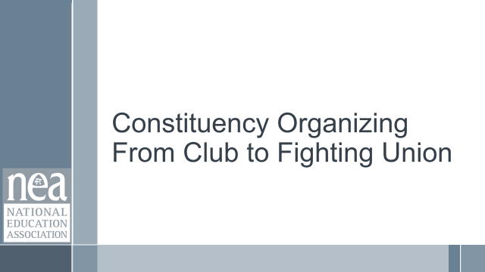  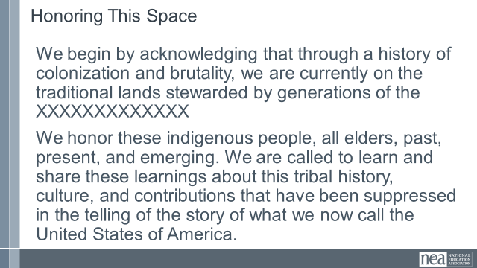  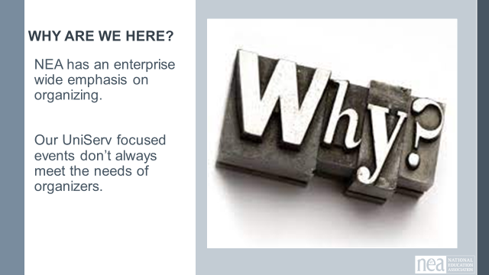  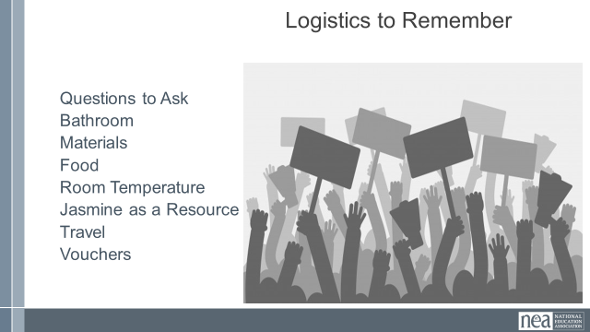  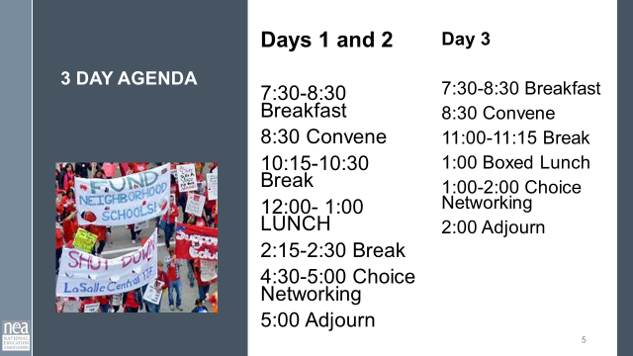  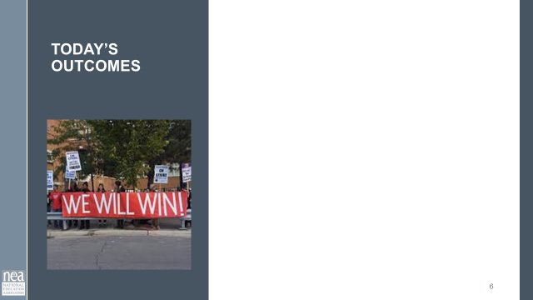  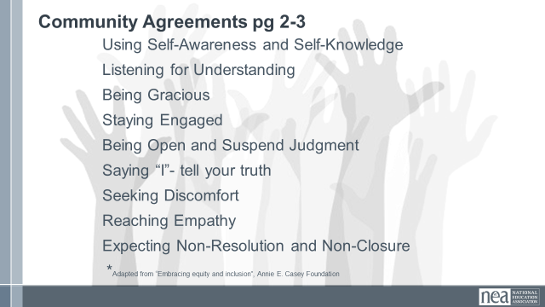  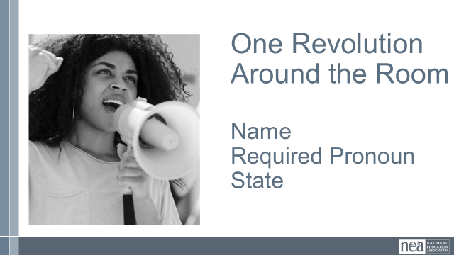  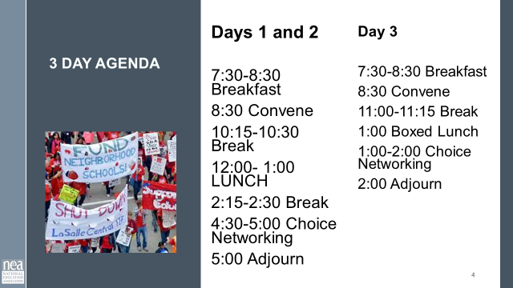  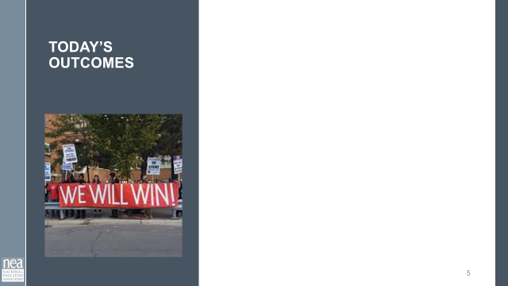 | How will we work together during our time? |  |  | 30 Minutes Getting Started:  Welcome  Community Agreements – Take 5-10 minutes to review pages 2-3 of handouts, these were sent in advance. At your tables first then as a whole group, answer any questions, discuss anything that you want to include, seek understanding of what is needed to learn. As a whole room we are going to do a visible community adoption of these agreements. We seek consensus. In this case consensus will mean the following: each person only has to be comfortable enough to move forward, showing a sideways thumb, we don’t have to strive for perfect agreement, a completely upright thumb. IF, however, you cannot move forward you indicate that with a down thumb. The responsibility for the down thumb is to explain what it would take to move at least to side-ways. These agreements will be revisited as needed by anyone in this community and each morning. Show me up, side, or down thumb and please keep them in this position until I can visually check.  Quick Intro Whip Around the Room - Name, Pronouns, Location  Agenda for our Time  Outcomes for Today  Introductions  - Name  - Required Pronoun  - State  - Job Title |  | Participants will understand the structure of their time and how we will work together.
1:30-1:55  Katie B    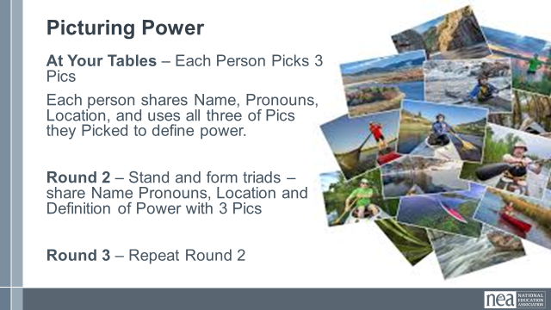  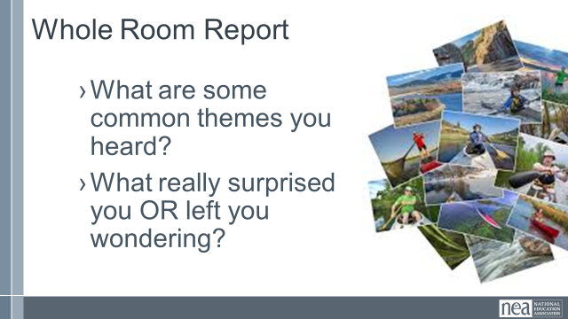 | Community Building | Need the Picture cards File |  | 25 Minutes Total – Picturing Power  2 minutes -Facilitator asks participants to choose 3 pictures from the piles on the tables.  Extra pics are picked up.  8 Minutes - Each person provides name, pronouns, location and uses the three pictures to describe what power means to them AND shares with the others at the tables.  5 minutes - Ask folks to move into new groups of not more than 3 – and share name, pronouns, location and their story of power  5 minutes - Ask folks to move into new groups of not more than 3 – and share name, pronouns, location and their story of power  5 Minutes Debrief  What are some common themes you heard as you travelled around the room |  | Participants will begin to develop a sense of community and begin to think about what power means.
1:55-2:40  Melissa  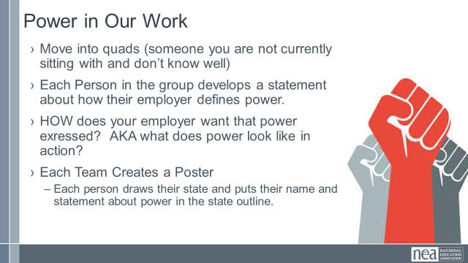  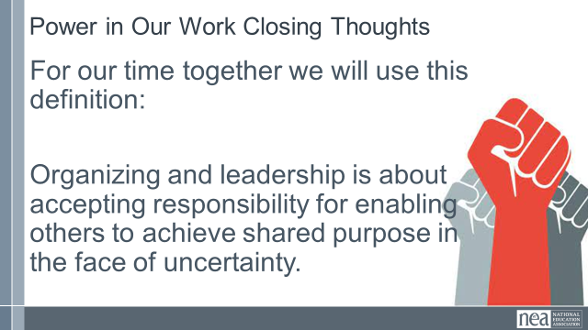\  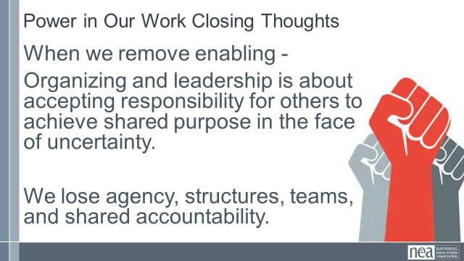  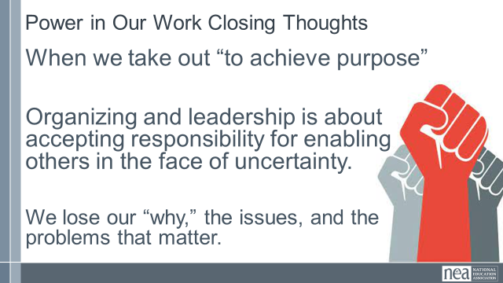  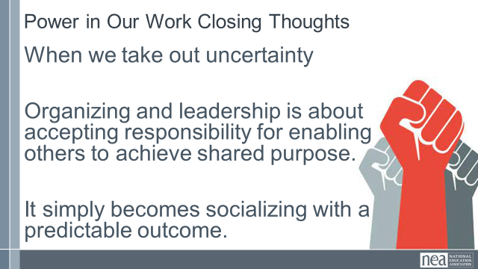  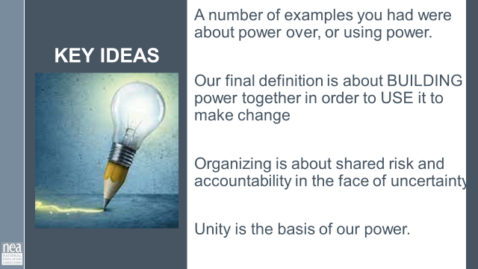 | What is your current thinking about power? | Ganz definition and reading about power pages 8-12 |  | 45 Minutes Total - Power In Our Work  3 Minutes - Intro - This training is about focusing on building the power necessary to achieve the things we cannot alone. If we could have won them already, we would have. But there are issues our members cannot change alone. You were given an article from Marshall Ganz that outlines in a deeper way concepts of power that we might think about in our work. This is included on pages 8-12 in your handouts.  Get into quads (find someone you do not actively work with).  20 Minutes - Group Discussion  - Each Person in the group develops a statement about how your employer defines power.  - Discuss within your group HOW your employer expresses their power? AKA what does power look like in action?  - Each person draws their state and puts their name and statement about power on your poster.  10 Minutes – Whole Room Share  Introduce your team to the room. Share what is common between your definitions of power  AS YOU LISTEN TO THE TEAMS Pay attention to  - Common threads  - Ideas that cause you to wonder  - Surprises  10 Mins - Closure  Share this Definition with the group:  Organizing and leadership is about accepting responsibility for enabling others to achieve shared purpose in the face of uncertainty.  Now break it down for them -  Take out the word enabling, we lose structure and building a team.  Take out the words achieve purpose; we lose the issues/problems that matter.  Take out the word uncertainty, then it is just socializing. If we were certain, it is likely already a pre-determined outcome.  2 Minutes Key Point  As we listened around the room, a good number of the examples and commonalities were about power over, or using power. Think about this final closing definition – it is about BUILDING POWER together in order to USE IT to achieve a common purpose. ** love this concept and pointing this out. KB  Organizing is about shared risk and accountability in the face of uncertainty. (Marshall Ganz definition)  Unity is the basis of our power. |  | Describing power and having a common definition.
2:40-2:55  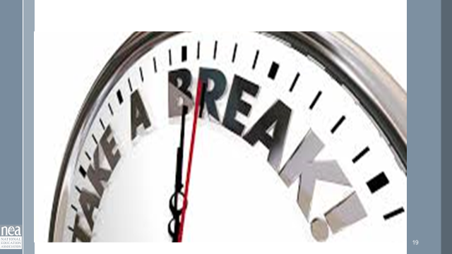 | BREAK
2:55-3:30  Zac  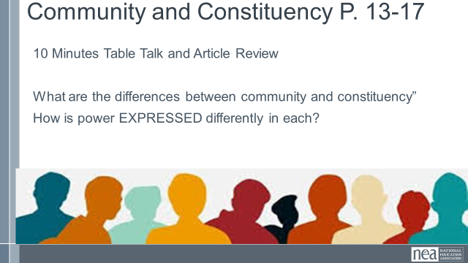  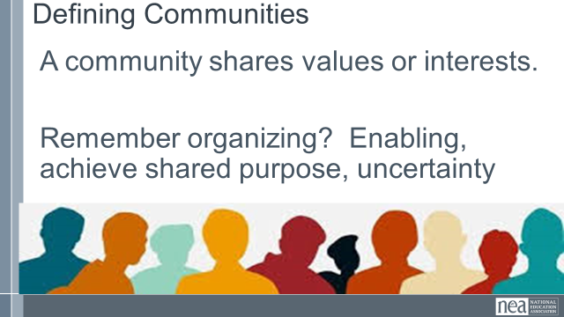  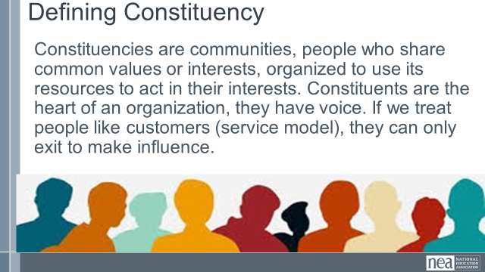  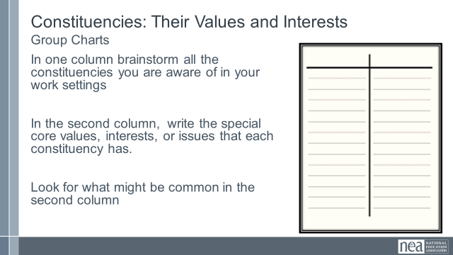  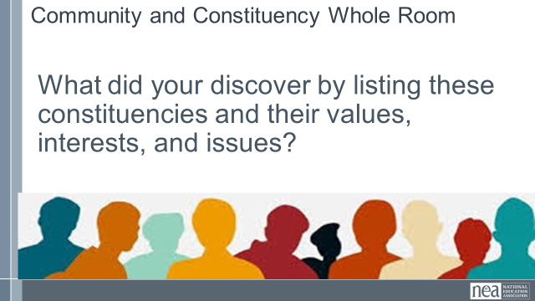  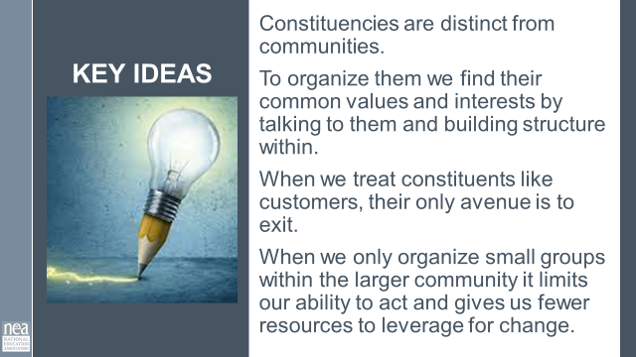 | What is the difference between a community and a constituency? | Community and Constituency Definition from Marshall Ganz pages 13-17 |  | 35 Minutes - Communities and Constituencies  2 Minutes - Introduction -As organizers, we work to turn communities into constituencies let’s work to define both of those. An article included in your pre attendance readings defines these in the ways that we will use in this training. They are also in your handouts on pages 13-17.  6 Minutes - Using the article from Marshall Ganz – identify the major differences between communities and constituencies. How is power expressed differently in a community or in a constituency?  2 Minutes Share our definitions  Communities share common values and interests but they are not organized.  Constituencies are communities, people who share common values or interests, organized to use its resources to act in their interests. Not clients or customers. Constituents are the heart of an organization, they have voice. If we treat people like customers, they can only exit to make influence.  Share the pause to think slide – no discussion yet – Does power look differently in each of these?  10 Minutes - Group Wall Chart Activity intro: In your table groups, now that we have some definitions, let’s apply those to our work. Step 1 – about 10 minutes -Thinking about your affiliates, brainstorm a list of the constituencies within them that you are aware of.  Step 2- about 10 minutes – what are the core values or interests in these constituencies? Are there any common values or interests across these?  10 Minutes – Whole Group Report  What did you discover by listing out these separate constituencies and their core values?  5 Minutes Key Points  Constituencies are distinct from communities.  Organizing identifies their common values and interests builds structure to act. Building power.  When we treat constituents like customers, their only avenue is to exit. They relied on us to have power.  Only organizing small groups within the larger community limits power and gives us fewer resources to leverage for change. |  | Understanding what a constituency is versus a community.
3:30  Ellen  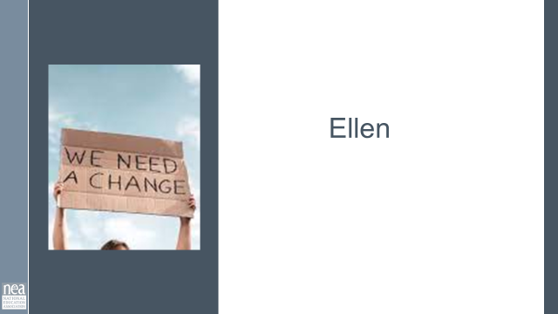  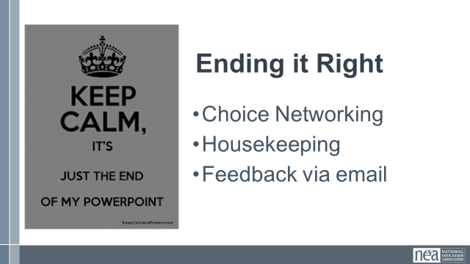  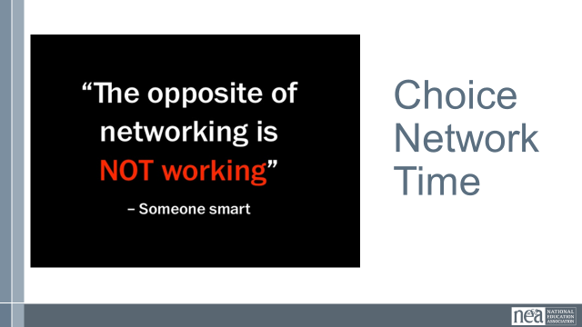 |  |  |  | Closing
3:30 -5:00 | Off-Site Museum Visit
5:00 | ADJOURN

