Facilitator Agenda: From Club to Fighting Union Day #2
General Materials Needed: |  |  |  |  | Room Set-up:
1 Set of Handouts per Person  Name Tags or Name Tents  Sign-in Sheet  Pens and Pencils |  |  | Chart Paper  Post its  Highlighters – 3 colors  Chart Markers – non-permanent |  | Round Tables  Projector, Screen and Speakers  Carousel stations and reporting stations around the perimeter  50 people
Recognize that they take a risk
Opportunities to build structures that scaffold the movement into risk
Identifying Leaders because they have followers not their personal attributes
Beyond Leader identification – how to you listen to their “objections and differences” and move them to the shared values (enhanced one on one)
Expansion beyond the safe 1/3 - communication outside of the safety of your community (how do we move away from the niche – transforming culture, small changes through organizing.) Is there a benefit in designing an exercise that has several “clubs” with similar “visions” and having teams work to get them to work together?
How do you invite into the base by inviting them to tackle an issue they cannot win alone and help them FACE uncertainty by joining with others.

Methods and Concepts
Recognizing Competing Clubs moving multiple clubs together – strategies that encourage the joining together (ex. Invite the best of the others,
Data Mapping – natural leaders, map connections to larger constituency (Michelle, draw our your leadership team. Draw out the leadership of your club, how are they connected to others, how were they invited and what qualities did we use to extend an invitation?) What kinds of data do we need – there are leaders and followers – who is trusted and respected
Identifying leadership – do we want to do a leadership ID activity?
Identifying issues – need the right leaders to move the issues
Assessing a worksite if they are ready to take action --

Time | Essential Questions | Resources |  | Instructions, Activity and Debrief (Facilitators) |  | Outcomes
 | What question(s) should this learning section answer? | Charts, handouts, articles, materials, slide |  | What are you saying, what are they doing, what questions will you use to guide learning and make clear the important points  Include an estimate for how long each section of the learning will take |  | As a result of this section of learning, what will participants know or be able to do?
8:30-8:45  Ellen  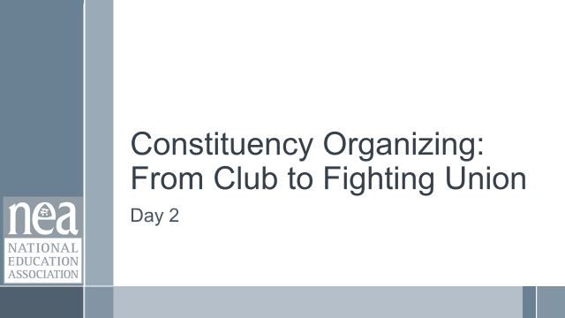  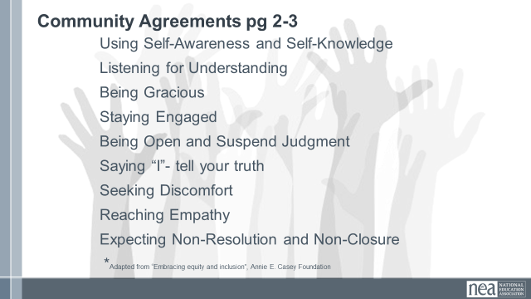    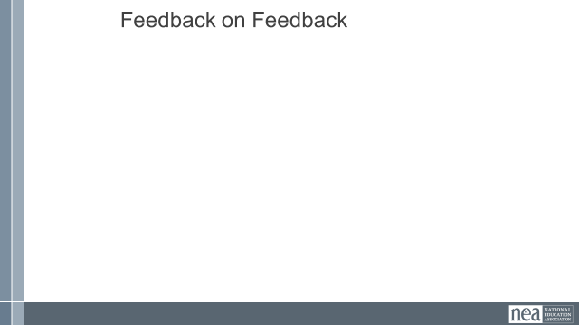 | How will we work together on Day 2? |  |  | Re-entry  Review of Community Agreements  Housekeeping Details  Feedback on Feedback |  | Participants continue to build as a learning community.
8:45-9:20  Zac | What is the difference between a community and a constituency? | Community and Constituency Definition from Marshall Ganz pages 13-17 |  | 35 Minutes - Communities and Constituencies  2 Minutes - Introduction -As organizers, we work to turn communities into constituencies let’s work to define both of those. An article included in your pre attendance readings defines these in the ways that we will use in this training. They are also in your handouts on pages 13-17.  6 Minutes - Using the article from Marshall Ganz – identify the major differences between communities and constituencies. How is power expressed differently in a community or in a constituency?  2 Minutes Share our definitions  Communities share common values and interests but they are not organized.  Constituencies are communities, people who share common values or interests, organized to use its resources to act in their interests. Not clients or customers. Constituents are the heart of an organization, they have voice. If we treat people like customers, they can only exit to make influence.  Share the pause to think slide – no discussion yet – Does power look differently in each of these?  10 Minutes - Group Wall Chart Activity intro: In your table groups, now that we have some definitions, let’s apply those to our work. Step 1 – about 10 minutes -Thinking about your affiliates, brainstorm a list of the constituencies within them that you are aware of.  Step 2- about 10 minutes – what are the core values or interests in these constituencies? Are there any common values or interests across these?  10 Minutes – Whole Group Report  What did you discover by listing out these separate constituencies and their core values?  5 Minutes Key Points  Constituencies are distinct from communities.  Organizing identifies their common values and interests builds structure to act. Building power.  When we treat constituents like customers, their only avenue is to exit. They relied on us to have power.  Only organizing small groups within the larger community limits power and gives us fewer resources to leverage for change. |  | Understanding what a constituency is versus a community.
9:20-10:10  Jeny | How has educator organizing changed across time? | TUSJ 3 Frames  18-22  Visions of Justice Article page 23-31  Two Tensions Worksheet page 32 |  | Framing Constituency Organizing Over Time  1 Minutes Intro - Let’s take a look at a framework for thinking about the various interests, values, and approaches that constituencies use. This Frame was first developed by the Mooney Institute for Teacher Union Leadership as a way to help leaders assess what they were doing and where they wanted to go.  13 minutes – Using the 3 Frames of Unionism found on pages 18-22, and your brainstormed list of constituencies (created on chart paper at the end of Day 1) – assess which frames these constituencies are operating in. Get into the groups you created your constituencies lists with. You will be assigned a few of the key components in from the 3 models listed on pages 18-22. Write in the name of the constituency wherever you feel they are represented. A single constituency may be in any of the columns, depending on the topic.  10 Minutes Whole Room Discussion –  What are you noticing in working to identify where your constituencies lie within the three frames?  If we had asked you to assess which frame your employers say they are working in – or your locals – do you think they would be different?  If the whole organization is the community – how then do these constituencies contribute to the overall picture of power?  2 Minutes Key Ideas  Without consistent and intentional organizing, constituencies become separate entities from the larger union community.  Without intentional and consistent organizing, unions become separate entities from larger social movements (labor, class, race, gender)  30 Total -THIS NEXT SECTION WILL BEGIN BEFORE LUNCH AND THEN CONTINUE  Visions of Justice- The shift of Unity and Power Shift Over Time You were asked to read the article Visions of Justice prior to arriving. It is the story of the rise of teacher unionism in New York. Whole group Discussion  23 minutes Visions of Justice- The shift of Unity and Power Shift Over Time You were asked to read the article Visions of Justice prior to arriving. It is the story of the rise of teacher unionism in New York. Get into a new group of 3.  In your group discuss the following keeping in mind what we learned/discussed:  - How do the tensions of self-interest (industrial, and professionalism) and broader social justice concerns (social justice) make it difficult to move a community to constituency?  - Across the history, as outlined in this article, when were the teachers most powerful? Least powerful? How did unity or the lack of it contribute to this?  - How do you see these tensions in your own work with members?  2 Minutes Key Point:  Without consistent and intentional organizing, constituencies become separate entities from the larger union community.  Without intentional and consistent organizing, unions become separate entities from larger social movements (labor, class, race, gender)  Long lasting Unity within teacher unions requires BOTH a focus on self-interests and public interest. |  | Be able to identify three frames of unionism they relate to constituencies.  Reflect on the complicated reality of organizing public sector employees.
10:10-10:25 | BREAK
10:25-11:25  Melissa | How do I determine what my next steps are? | Club to Fighting Union P 47  Levels of Organizing and Planning to Move  P. 33-38  MIGHT WANT THEM TO ASSESS THE FOUR CASE STUDIES WITH THE CLUB TO FIGHTING UNION Framework  Worried about the timing here – doesn't seem like enough to really digest all the definitions in the levels of organizing framework and they won’t have seen it before. I also imagine most will want more than 15 minutes for planning (Zac) |  | 60 Minutes Assessing Our Work.  1 Minutes Into - If organizing is about turning our community into a constituency that can pool its resources, we need to have a good handle on how they are currently operating so that we can adjust our work with them to grow their capacity. We are going to look at two frameworks – Club or Fighting Union P. 47 and Levels of Organizing p. 33-38. Make sure you are working with your same table that created your charts of constituencies, you will need these. Each person needs to have in their mind one of the constituencies they added to the chart that they work with. You are going to use this constituency to focus your work in this section.  15 Minutes Group Work -. Use your targeted constituency and assess which level it is operating at on the Club to fighting union scale. As your table finishes, discuss what you have assessed and why.  1 Minutes – Intro – now you are going to switch your focus a little bit and used the framework found on pages 33-35.  10 Minutes Group Work –Review the Levels of Organizing found on page 33-38. Think on your current work with your targeted constituency. What level of organizing are you working at with them? As your table finishes, discuss what you have assessed and why.  8 Minutes- Now we are going to rearrange and do some coaching and planning. If you are a person that has identified Survival or Beginning come to the left side of the room. If you are a person that has identified Basic or Advanced Bargaining come to the right side of the room. NOW, from groups of no more than 4 that includes at least one person who is advanced or basic, and at least one person that is survival or beginner. Get into your groups and then I will give you your directions.  Now that you are in your small groups, you are going to use pages 36-38 to do some planning. As peers, work to write explicit plans in worksheet that would move your work with your constituency from the level that it is apt to a higher level.  10 minutes Planning Work.  10 Minutes Whole Room Talk – What are some ways that you are thinking about changing your work?  5 Minute - Key Point:  Clubs are fixed, are not growing, and do not have enough resources to achieve the wins they want or to move the community to act.  The best way to transform a community into a constituency is to listen for the shared issues and values in order to invite members or other leaders to take action for a shared purpose.  When WE do the work, lead the work, make the change happen – we take the opportunity for growth away from a leader and a constituency.  Participants will be able to assess and plan their work through two frameworks. They will understand that Organizing across affiliates looks differently, but advanced organizing has similar characteristics, regardless of where you are. |  | Participants will be able to assess and plan their work through two frameworks. They will understand that Organizing across affiliates looks differently, but advanced organizing has similar characteristics, regardless of where you are.
11:25-12:00  Ellen    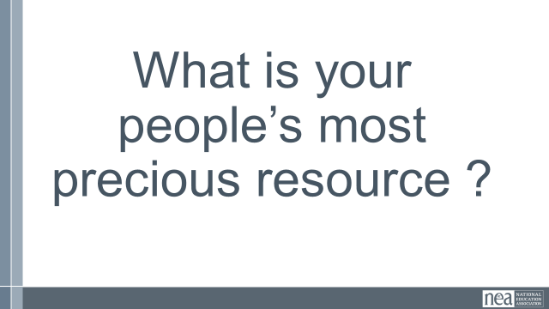    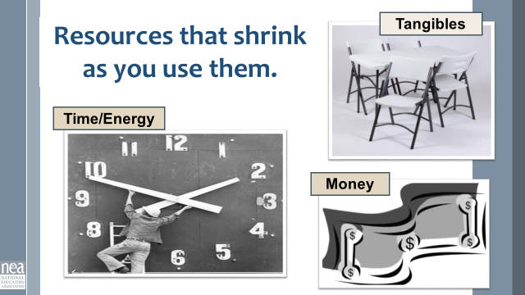  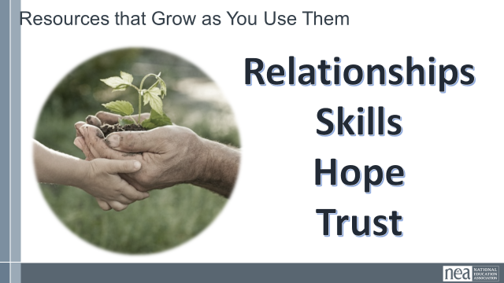  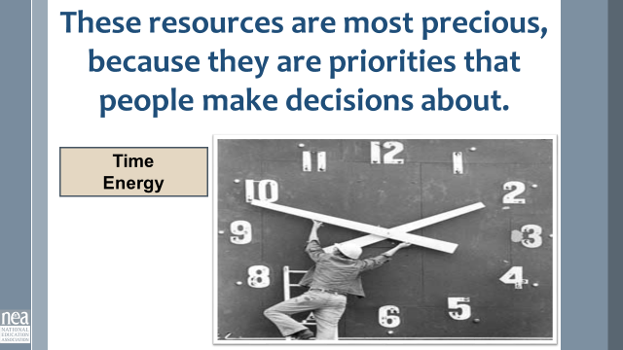  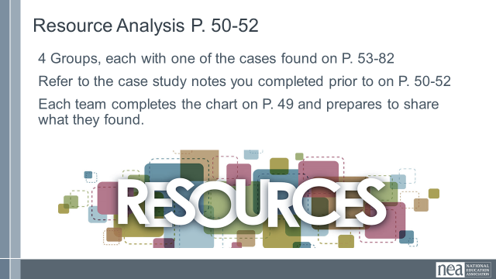  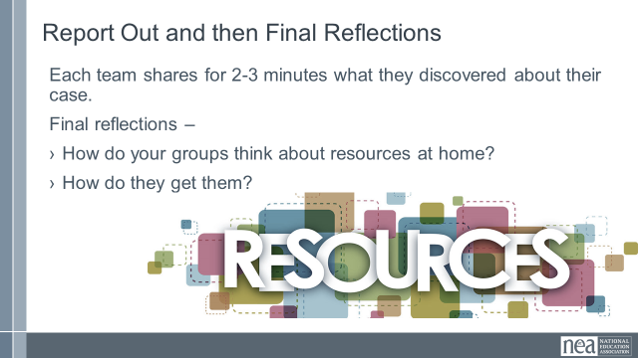  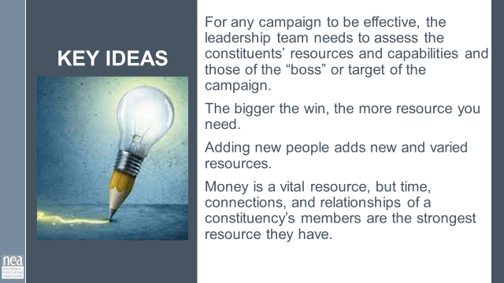 | What are the resources of my community?  How can my leadership team ID them? | Resource Assessment  P. 49  Case Analysis Worksheet  P. 50 -52.  Cases P. 53-82  PAR  New Teachers  Organizing a Caucus  It’s Not Magic |  | 35 Minutes Resources for Change  5 Minutes Introduction: Turn your heads in at your table and take one minute to decide what your members’ most valuable resource is that they have to give. Ok shout out that answer – most folks are going to say time. Resources are what organized people in a constituency have and are willing to risk to achieve the shared purpose that they want.  Some resources shrink as you use them like tangible goods, money, time and energy.  Some resources grow as you use them – hope, trust, relationships, skills  Some resources are especially precious because they are the result of a person’s decisions and priorities. Time and energy are like that. I might have time to binge watch my latest Netflix until 2:00 AM, but I can’t find the time or energy to help the bargaining team call my colleagues about coming to an information meeting.  20 Minutes: Group Activity We are going to move into four groups. Each group will be assigned to be the “expert” on one case found in p 53-82.  PAR  New Teachers  Organizing a Caucus  It’s Not Magic  Using the chart on page 49-and the analysis sheet of the four cases found on pages 50-52 that you completed prior to coming, let’s figure out what each of our cases had in terms of resources.  What resources are currently available to the group? What is the group lacking? What resources does the boss have? What is the boss lacking? In this assessment, be certain to consider all types of resources – those that deplete as you use them and those that grow.  15 Minutes – Sharing what you found – each group will report out what their case had for resources.  Final reflections – what do your groups consider as resources at home? How do they get them?  5 Minutes Key Point:  For any campaign to be effective, the leadership team needs to assess the constituents’ resources and capabilities and those of the “boss” or target of the campaign. The bigger the win you want, the more resource you need.  Adding new people adds new and varied resources.  Money is a vital resource, but time, connections, and relationships of a constituency’s members are the strongest resource they have.
12:00-1:00 | LUNCH
1:00-1:20  Ellen |  |  |  | Organizer Discourse
1:20-2:35  Katie  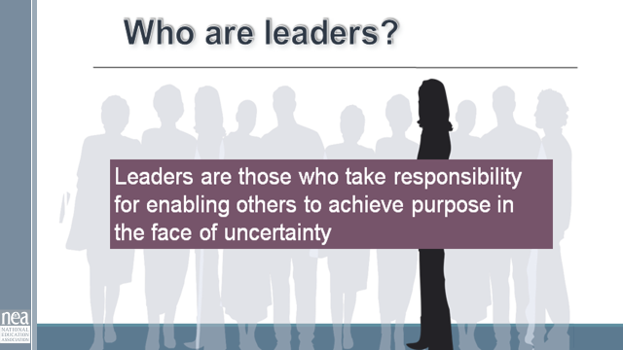  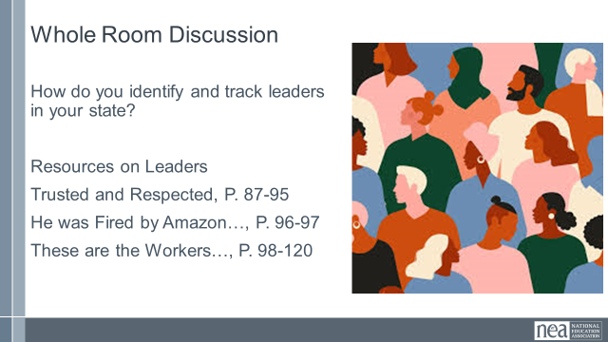    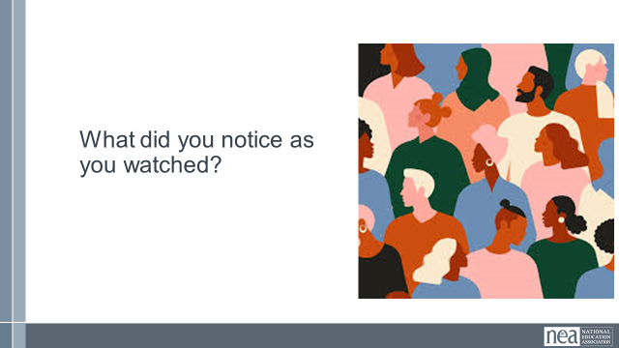  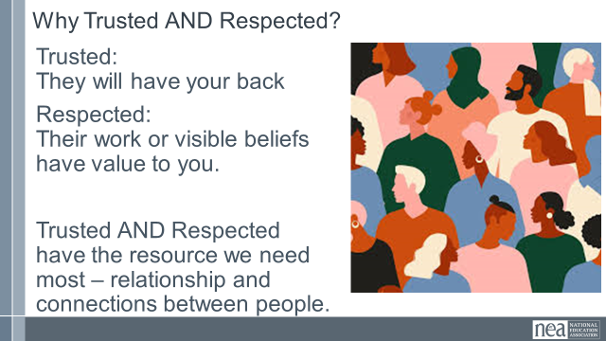  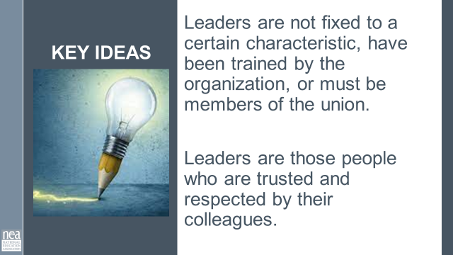  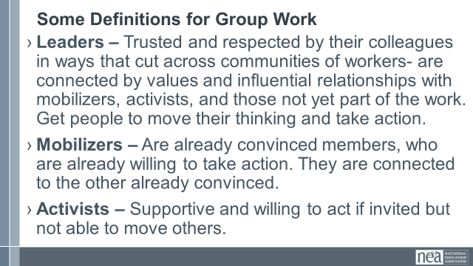  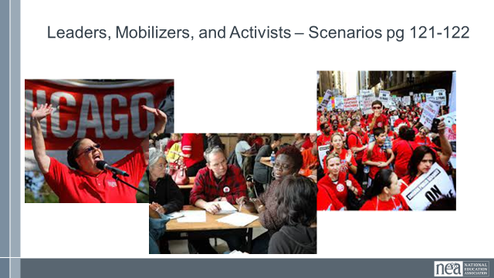  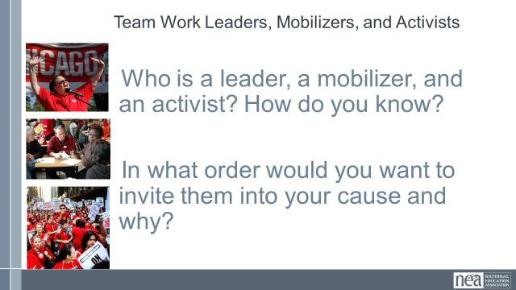  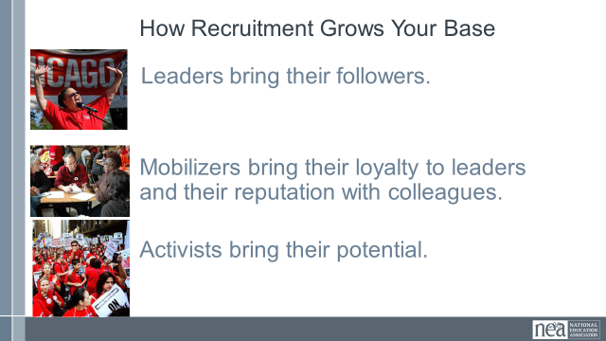  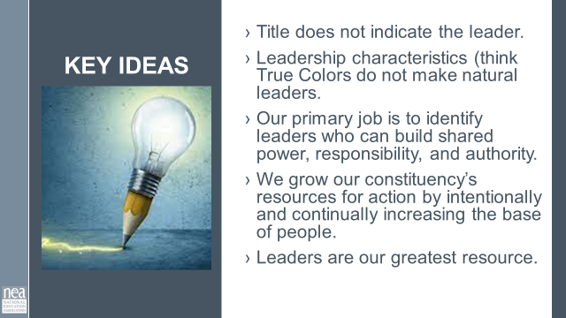    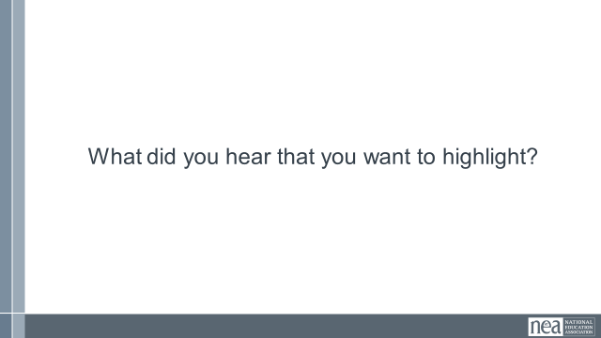  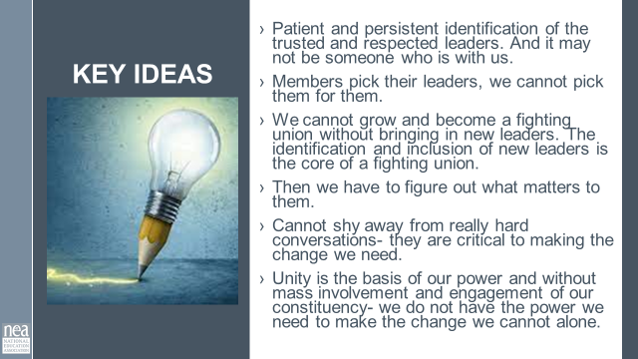 | Finding Leaders,  Why do we need to ID leaders?  How do we identify leaders? | Leadership Development Cycle P. 84-86  Trusted and Respected  P. 87-95  Chris Smalls  p. 96-97  These are the Workers  p 98-120  Activist Mobilizer Leader  P 121.122 |  | 75 Minutes Leaders  5 Minutes Introduction: If you have been with us before you know that we use the following definition of leaders: Show the slide and read Leader are those who enable others in the face of uncertainty. Very similar to the organizing definition we broke down on Day 1.  Quick share out: How do you ID leaders in your state? (Take about 3 or 4 – encourage them not to repeat) WE have included some additional resources on Leaders for your thinking and skill development.  5 Minutes Leadership Development Cycle – Pg 84-86  Every affiliate runs some sort of leadership conference. It is focused on building the skills of governing the organization. BUT the type of leadership development that turns a club into a fighting union is disciplined, intentional iterative. WE have to be disciplined about how we identify leaders – using methods grounded in good practice and data collection. We have to intentionally recruit leaders into our constituency by listening to what matters most to them and linking their core issues and values to our work. And then we repeatedly develop their ability to lead others by asking them to be responsible for meaningful work. We don’t ask them to do OUR responsibilities – we ask them to take responsibility for achieving an outcome, give any resources that might help, trust them to implement, reflect and assess with them, coach and give formative feedbackv0- then repeat and repeat and repeat this spiral. We sometimes refer to these as ‘tests’ – if they can’t do it, then they are not yet ready to move to the next level. They did not fail; they just did not grow.  20 minutes: 11 minutes on video We are going to take a look at a bit of a longish video. It is from Spokane Washington (a very conservative part of the state) about the power of 1:1’s and finding trusted and respected leaders. You should know that in this video: the people invited to the dinners were specifically asked because they were leaders.  Solid Gaines Through Solidarity 1920x1080 - YouTube  4 Minutes- What did you notice? (Take a few responses)  4 Minutes: Why trusted and respected?  Trusted: they are those people who will have your back when you need it. (The teacher you can count on to speak up when something needs to be said or done).  Respected: You see their work and know it is quality and/or something that is similar in its value to you.  Without respect, they maybe your friend, but not someone you would trust to have your back.  Without trust, you know they do good work, but when the boss asks what's going on, you are not sure they won’t throw you under the bus.  It is that intersection that we find people with a resource of gold- the resource of relationship and connection between people.  1 Minute key ideas –  Leaders are not fixed to a certain characteristic, have been trained by the organization, or must be members of the union. They are those people who are trusted and respected by their colleagues.  35 Minutes Leader ID  5 Minutes Introduction – We are going to spend some time looking at some scenario descriptions of people that are part of your constituency. You are going to work in teams (3 Teams). Each Team is going to decide who in these stories are Leaders, Mobilizers, or Activists. We are going to use the following definitions  - Leaders – Trusted and respected by their colleagues in ways that cut across communities of workers- are connected by values and influential relationships with mobilizers, activists, and those not yet part of the work. Get people to move their thinking and take action.  - Mobilizers – Are already convinced members, who are already willing to take action. They are connected to the other already convinced.  - Activists – Supportive and willing to act if invited but not able to move others.  4 Minutes Let’s get into our groups (3 groups) and make sure you have page 121-122 with you.  15 Minutes – Now that you are in your groups you are going to take the next 15 minutes to decide who is who – AND you need to decide the order in which you would invite them to be part of the work of your constituency. YOU MUST reach consensus.  15 Minutes – Let’s hear want your teams decided – there is only one right answer. Facilitator note get them to be in discussion with each other. One technique is to ask for a person to share how they ID’d one person. Then ask the room who had the same ID. GO BACK To the first person and ask with the group decided this. Then go to the person who had a different ID and ask why. And so on. The key ideas you are pulling out is who is BOTH trusted and respected, and who ACTUALLY MOVED PEOPLE to do something. What is the evidence of these. It is not about who is liked – or even has the potential – it is who is DOING it.  Ted – Activist  Tina- Activist  Destiny – Leader  Paul- Mobilizer  Jorge- Activist  Use same method as who should be invited. This is a little looser – but really Density should be approached last. SHE is the big recruitment. If you blow it, then you don’t get another chance. Look for answers that talk about those in relationship with Destiny and who can give you insight into what her core values are and what she might have in common with your constituency’s issues and interests.  2 Minutes -How Recruitment grows your base.  Leaders bring their followers.  Mobilizers bring their loyalty to leaders and their reputation with colleagues.  Activists bring their potential.  2 Minutes Key Points Title does not indicate the leader.  Leadership characteristics (think True Colors do not make natural leaders.  Our primary job is to identify leaders who can build shared power, responsibility, and authority.  We grow our constituency’s resources for action by intentionally and continually increasing the base of people.  Leaders are our greatest resource  15 Minutes – Final Words from Jane and Your Thoughts  11 Minutes for Video – we are going to sum up this section on leaders by viewing a video by Jane Mcalevey: Jane McAlevey on Deep Organizing - YouTube  What did you see?  - Stop and note about 1-1. Did Jane accept the “No”, did Jane give up on a leader- no.  - She acknowledges, and then focused on the importance of the task and work ahead and who the persons involvement would make all the difference- and clearly had an ask for them that would make a difference.  4 Minutes Key Ideas – Ask folks for that they heard. Then at the end of the time share the slide and point out any key ideas that they missed.  Key Ideas  Patient and persistent identification of the trusted and respected leaders. And it may not be someone who is with us.  Members pick their leaders; we cannot pick them for them.  We cannot grow and become a fighting union without bringing in new leaders. The identification and inclusion of new leaders is the core of a fighting union.  Then we have to figure out what matters to them.  Cannot shy away from really hard conversations- they are critical to making the change we need.  Unity is the basis of our power and without mass involvement and engagement of our constituency- we do not have the power we need to make the change we cannot alone. |  | Participants
2:35-2:50 | BREAK
2:50-3:40  Zac  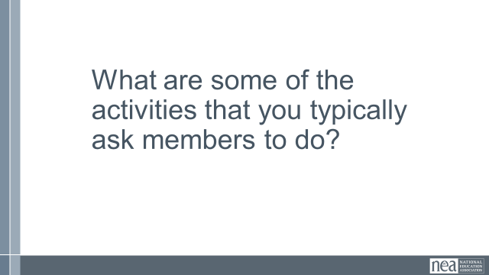  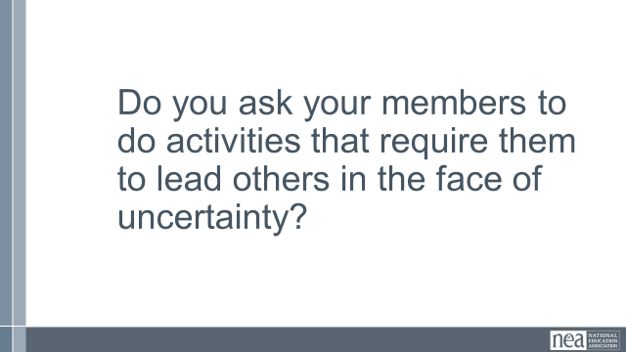  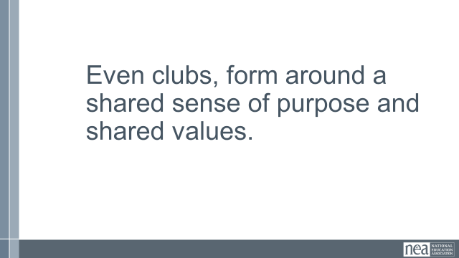  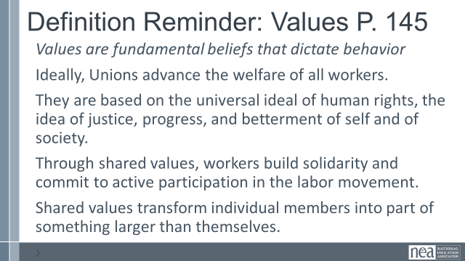  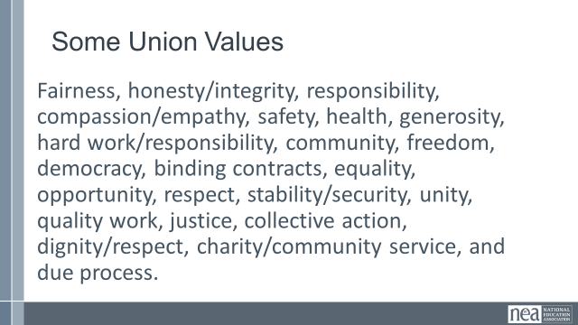  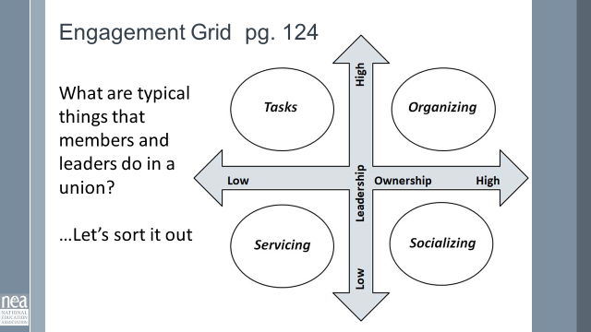  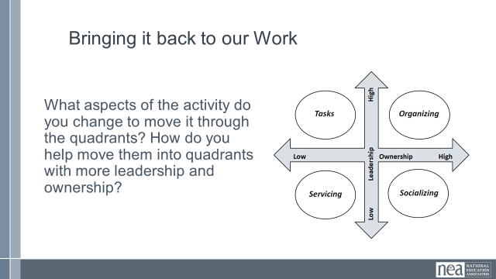  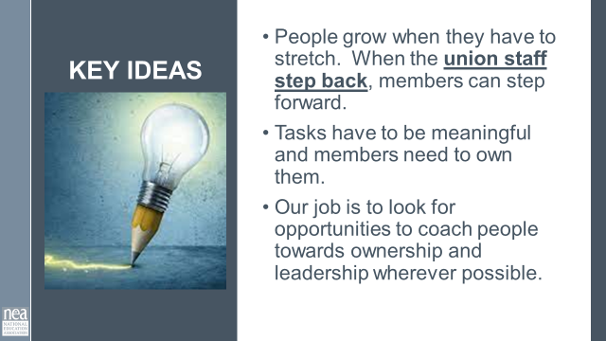  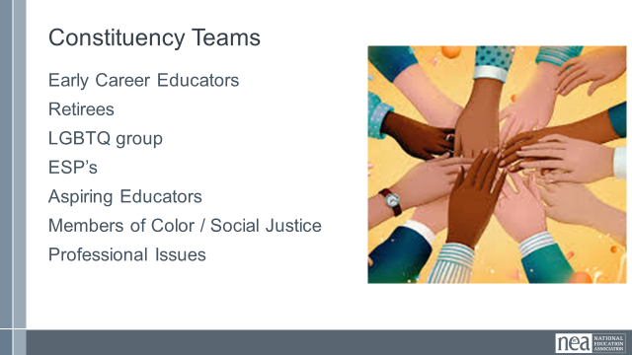  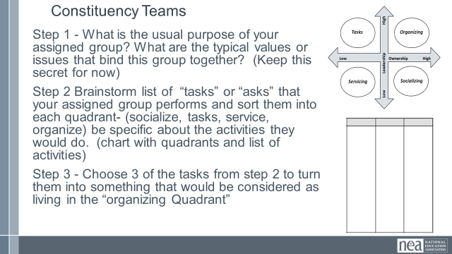  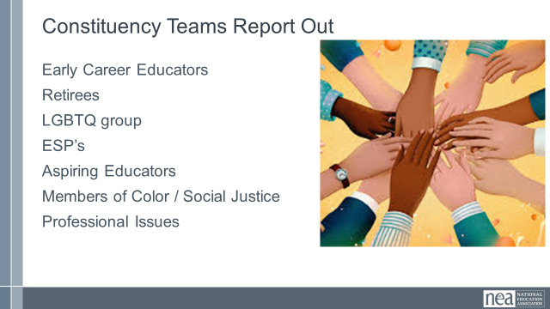  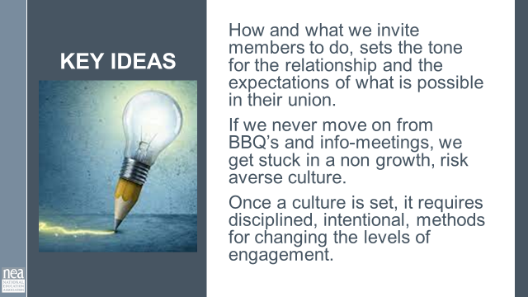 | MAKE SURE TIMING MAKES SENSE | Ladder of Engagement  - 123-124  Advocacy Mobilizing Organizing Grid  p. 129  Core Values  p. 145 |  | 50 Minutes Engaging Leaders and Members  (7 min)  3 minutes Table talk – Turn in at your tables for 5 minutes and share what some of the activities are that your current work assignment asks members to do.  2 Minutes Whole Room – Let’s hear a few – don’t repeat something that you heard  1 Minute Just thinking on your own about the responses you heard, Do we ask or expect our members to lead others in the face of uncertainty?  1 Minutes- Even clubs form around a shared purpose and have shared values.  Let’s review the definition of values quickly, and then review some examples union values  3 Minutes activity introduction. What we ask people to do is directly linked to their decision to stay engaged and how much effort they contribute to the resolution of the problem in front of them. Turn to your Engagement Grid Handout on Page 129. Our colleague at NEA, John Donaghy, broke down what brings us to organizing – it is a function of how much ownership and leadership a person has in the activity. We defined leadership already (enabling others in the face of uncertainty). Ownership is the accountability and responsibility for the outcome of something.  Let's break it down  - Servicing- low ownership, low leadership. You are receiving something while doing very little to achieve it.  - Tasks: Low ownership, but high leadership. You are asking to do something and have responsibility, but are not responsible/accountable for the outcome.  - Socializing: High ownership, and low leadership. You have high accountability, but it takes very little engagement to get this outcome.  - Organizing: High ownership and low leadership. You have high accountability for the outcomes and it takes brining in others to achieve this work.  Here is an example: We have a constituency group that is focused on professional issues ‘organizing’. Staff write the training and provide the training, and invite members to it.  5 Minutes table Activity: Work with your table mates to answer the following:  - Where does this example land on the grid?  - How would you change the actions in the example to move it to other quadrants?  3 Minutes Report Out - They should have identified the scenario as being a service. In order to make it socializing, the members might take ownership of the invitations but not much else. To move it to task, the staff person would pick a cadre, train the cadres, provided support for the cadre to implement the training. For it to move into organizing – the members would identify what the problem is they need to solve, they would then determine if training is how they want to solve it. They design, implement, and do the turnout. Staff advises and supports.  Key Points:  - People grow when they have to stretch. When the union staff step back, members can step forward.  - Tasks have to be meaningful and members need to own them.  - Our job is to look for opportunities to coach people towards taking risks and raising expectations for what they can do with their union.  5 minutes Activity Introduction Now we will do some real-life practice.  Each table gets well known constituency; Retirees, LGBTQ group, ESP’s, Aspiring Educators, Members of Color Group, Student Group,, and Professional Issues Group. You are going to complete three products for each of your group.  First, what is the usual purpose of your assigned group. What are the typical values or issues that bind this group together. Discuss this, take good notes on 8.5 x 11 paper and put it away for safe keeping. This should take about 10 minutes. You are not to share this with any other group yet.  Second, you are going to brainstorm a typical list of “tasks” or “asks” that your assigned group performs. Put these on a chart. What are activities that this group could do that would fall into each quadrant- (socialize, tasks, service, organize) be specific about the activities they would do. (Chart with quadrants and list of activities)  PICK 3 of these from step 2 to turn them into something that would be considered as living in the “organizing Quadrant” it has high ownership and high leadership. (Chart with three sections that describes organizing activities.  8 Minutes of work time  8 Minutes to share out  What was most challenging about this?  What is a big new learning that you think the room needs to hear?  1 Minutes Wrap Up / Key Point:  How and what we invite members to do, sets the tone for the relationship and the expectations of what is possible in their union.  If we never move on from BBQ’s and info-meetings, we get stuck in a non-growth, risk averse culture.  Once a culture is set, it requires disciplined, intentional, methods for changing the levels of engagement. |  | Participants will learn to use the engagement grid to analyze and design tasks.  They will review and identify purpose and core values and their roles in recruiting.
3:40-4:25  Jeny |  | Review pages 136 Hard asks and Types of NO |  | 45 Minutes – Making Connections and Building Your Base  4 Minute Introduction – Continuing in our Constituency groups. You are going to work on getting as many other constituencies to see the value of joining together with you. Think about what build solidarity – shared values and interests. Your task is to try out your organizing skills to get other groups to join you. Now, remember, the more resources and people we have, the bigger actions we can take – aka the more power we can wield. It really is NOT in any constituency’s best interest to remain an island BUT it is also not healthy to dilute solidarity and purpose by joining everything – this causes a lessening of credibility and focus. Also, often we prejudge which groups will be the No’s without asking. It’s important to give groups that have common values and interests a chance to support our interests without pre-judging their answer.  Step 1 – in your constituency groups first, review your three activities – then strategically think about which of the other groups may have shared values or issues that this activity could support. You also need to review what you said were your values and your issues. Take 10 minutes to consider who you will target AND what you might be willing to say yes to.  Step 2- Move out and have one on ones that seek commitment for your ask. The goal is a yes from as many other groups as possible. Work your 1-1 skills, have conversations and see how much you can build your base.  10 Minutes in Constituency Groups  20 Minutes to seek commitments  10 Minutes Debrief:  Who really asked you great questions?  (Offered Resources, included values, etc?)  Who genuinely made you move your thinking? How?  Who really challenged your skills in asking? Why?  What is something that you will take away from this?  1 Minute Key Point:  It is critical that our constituencies continue to grow their base by connecting with other groups in the union.  Base building allows our constituency groups the ability to leverage more resources to achieve the things they cannot alone.  Assuming the answer without the ask will generally hurt your group more than the ask when the ask is done correctly. |  | Participants will work through a scenario to apply the skills of relational 1-1’s, in order to recruit more people to their base.
4:25-4:30  Ellen |  |  |  | Closing  Prepping for Getting Home
4:30 – 5:00 | Adult Choice Networking
5:00 | ADJOURN

