Facilitator Agenda: From Club to Fighting Union Day #3
General Materials Needed: |  |  |  |  | Room Set-up:
1 Set of Handouts per Person  Name Tags or Name Tents  Sign-in Sheet  Pens and Pencils |  |  | Chart Paper  Post its  Highlighters – 3 colors  Chart Markers – non-permanent |  | Round Tables  Projector, Screen and Speakers  Carousel stations and reporting stations around the perimeter  50 people
Key Outcomes for the Day
What is an organizing plan that moves a club to a fighting union
Clubs are focused on a problem but it is not a fight with the boss and/or on the issues their larger constituency would engage on.
Cooperation with the boss will not win the fight for the workers.
FSE – F---ing social events 😊 or WBF – winning boss fights
Leaders and managers can be moved by wins --- then we can “undermine” that charge. Has to be a recognition of a failure in order to move forward

Bring something from home for this day --?
Working within one constituency OR stitching together several constituencies?

Time | Essential Questions | Resources |  | Instructions, Activity and Debrief (Facilitators) |  | Outcomes
 | What question(s) should this learning section answer? | Charts, handouts, articles, materials, slide |  | What are you saying, what are they doing, what questions will you use to guide learning and make clear the important points  Include an estimate for how long each section of the learning will take |  | As a result of this section of learning, what will participants know or be able to do?
8:30-8:45  Ellen  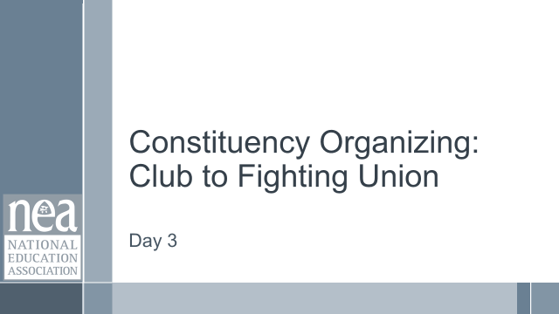  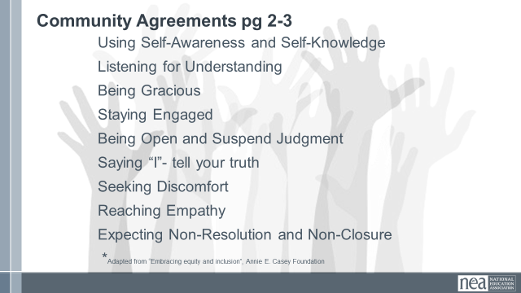  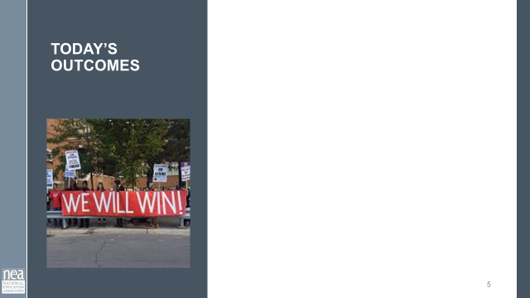  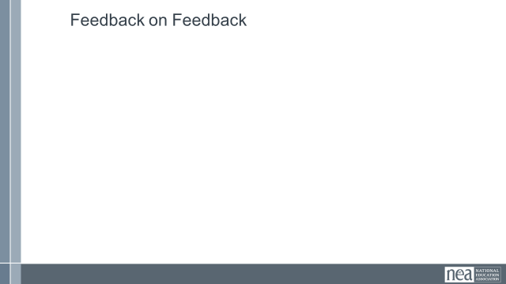 |  |  |  | Re-entry  Review the Norms  Today’s Outcomes  Housekeeping Details  Feedback on Feedback
8:45-10:15  Katie  W/ Zac and Melissa  DO WE INCLUDE ARR (Affirm, RESPOND, REDIRECT) RESPONDING TO OBJECTION SLIDES? |  | One on Ones Pg 135 - 139  Developing Your Script p. 140  IAF P. 141  Listening Resources  P 142  Communication Shut Downs  p. 143  Asking Questions Grid p. 144 |  | 90 Minutes One on One for Leader Recruitment  2 Minutes Introduction: We do 1-1s to build relationships. Mary Beth Rogers once said, “Organizing is a fancy work for relationship-building. We define organizing as leadership that enables people to turn the resources, they have into the power they need to make the change they want. Power comes from commitment to work together to achieve a common purpose and commitment is developed through relationships. These are our public relationships- not our private relationships. They focus on the shared work and through sharing common values and interests- we create understanding that is the bedrock of public relationships. Something about Public Relationships  5 Minutes – Quick review Looking at page 135, where is the majority of your work? Recruitment, Maintenance, or mobilizing.  5 Minutes Introduction: We have gotten into the habit of considering the quick blitzes and membership recruitment conversations as relationship building 1-1's. But they are not. They are data collection, education, and recruitment. WHO Is doing them is as important as HOW they are being done. We as staff have to build the capacity of members to do these types of 1 to 1s so that we can work on the deeper relationship building conversations with leaders. Return to the assessment piece of Leaders – needs to be a skill that is broadly taught to increase capacity.  Every good conversation of every membership recruitment or issue blitz is ended with “who is trusted and respected” and that data is fairly regularly collected. A solid example of this can be found on page 140. The real question to address is how WE are following up with the identified leaders? (Think back to yesterday, when we discussed leaders and creating processes for Iding leaders).  The follow up with identified leaders is key. For identified leaders, as we invite them into our organization, we take the time to do relational meetings. Something about this is not a blitzy type conversation or necessarily is scripted. We are typically also asking them if they are willing to risk relationship capital or credibility  12 Minutes VIDEO - We are going to watch a video about relational 1-1's with Ernesto Cortez. He is an organizer with IAF in the south. You will notice that they are loosely following the guidance on page 141. Something about the IAF  In between his lecture, you will see people practicing 1-1's. – Keep track of what you notice about these one on ones.  Ernesto Cortes on Relational Meetings - YouTube  10 Minutes Report Out – What did you notice? Facilitator will listen for the key Learning Points from Video, then facilitator shares the key learning points and highlights any that were not said out loud.  - Listen and ignore the qualities that you think people have to check.  - Organizing is selective, and must be if we are to build the structures the move people forward. But you must be able to check your own bias in this work, or you will continue to pick people that you like.  - Relational meetings for those you want to dig deeper with, the wide net is 2-3 minutes with other people.  - You also need to share in these conversations, reflect a little on your own story and what you share as part of your public life.  - Tension is not a negative, it is energy. Where does energy come from?  A good self-check for you can be found on page 142 – Bad habits of listening  4 Minutes Intro and Group Move - We are going to move into smaller new groups. Once I get you assigned, I will give you the directions.  We are going to work with page 143. As a team generate at least one effective direct/redirect to the communication shutdown. If you get stuck move on, our goal is for the group to get at least one redirect for each shut down in the next  15 minutes. Group Work - Teams work on their redirects  10 minutes Debrief – Were there any teams that got them all?  Who has one that they could not come up with a good redirect? Who has something for that?  DO WE INCLUDE ARR RESPONDING TO OBJECTSION SLIDES?  5 minutes Prepping for Fishbowl -Let’s move into a circle with two chairs in the middle.  We will practice the relationship recruitment 1-1 with leaders.  3 Minutes -Tag Team Relational Fishbowl Intro  - One trainer will be the leader that is the target of an organizing conversation (See background below) are going to talk to.  - Another trainer will be the facilitator who moves participants into and out of the role of organizer in the middle.  - The “leader” will put up three objections each round. After the” organizer” gives a response to the objection- the facilitator will say stop, thank the current participant, and have another “organizer” jump in where the other person left off. (This will mean the member/trainer will have to respond to the previous person- but it allows the person to pivot and have to practice).  - After three objections and responses- stop and reset. Ask the group what went well and what did not.  - Total of 3 Rounds.  Background:  - Leader in the Middle: You are a leader who has not been very involved in the union but you are very involved in your worksite. You are 9 years into your profession. You have thought about being a union member, but time has passed and you have not seen a reason to join at this point. You do not particularly care about professional issues, and are worried about your pay and being able to afford to stay in the profession. Maybe a few years ago you would have been interested in professional issues.  - Organizers: You have done the 1-1's in the building and this person was ID-ed as the most respected person. You got them to agree to another meeting. You want them to join your professional issues team.  20 Minutes of Activity 3 rounds of 3 people.  2 Minutes Key Learning  - Relational Meetings are not just ‘get to know you’. They are intentional, not with everybody, and the goal is to walk away with the foundation of a public relationship and commitment to keep working together.  - We have to pivot and focus on what members care about. If we keep agitating on our interests and not there's- we lose the chance to learn more and go deeper.
10:15-10:30 | BREAK
10:30- 11:00  Zac    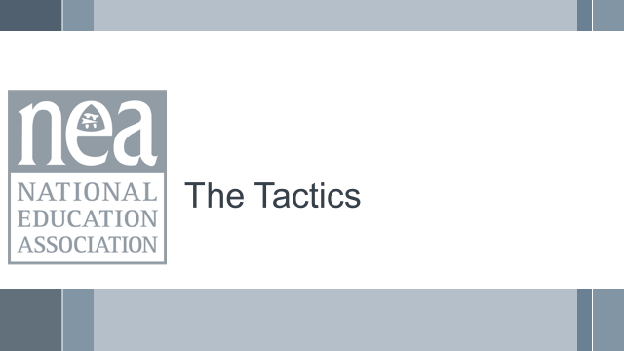  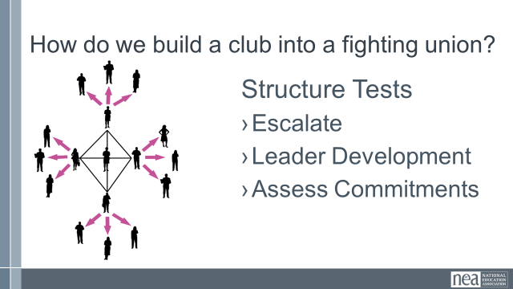  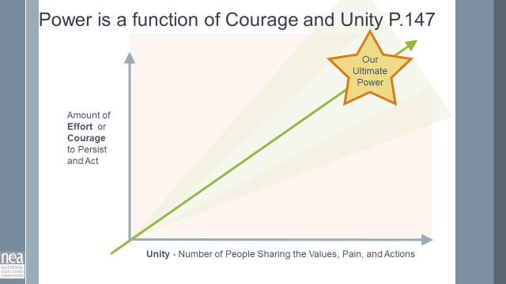  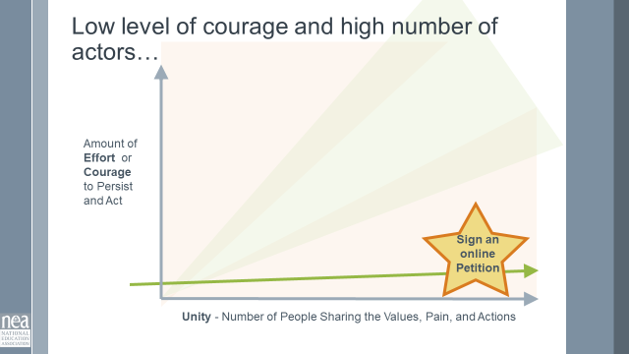  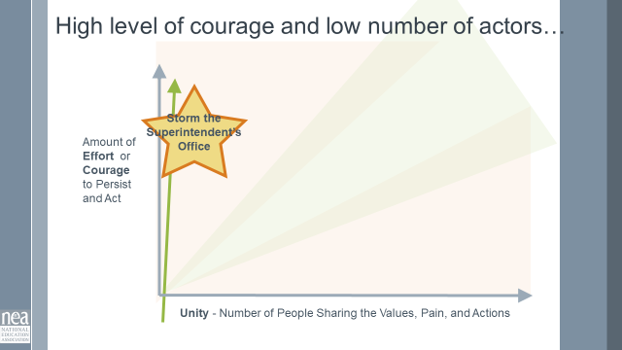  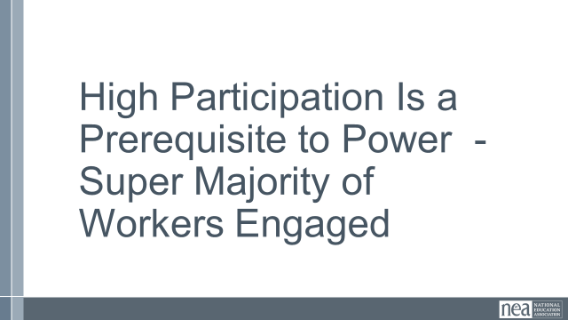  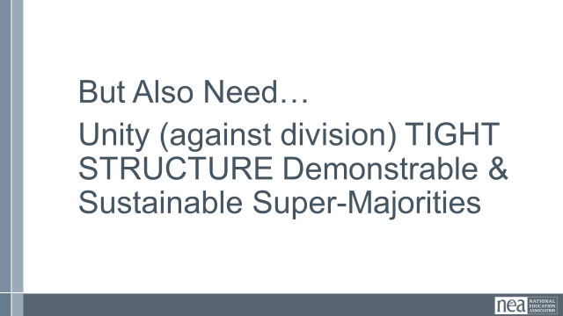  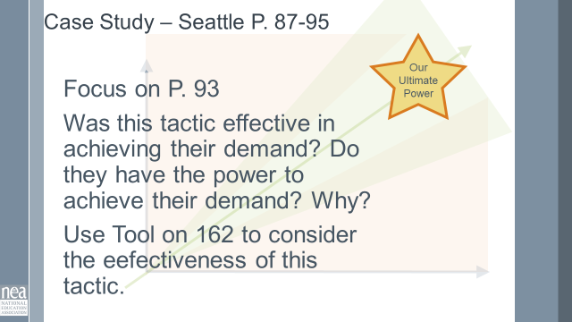  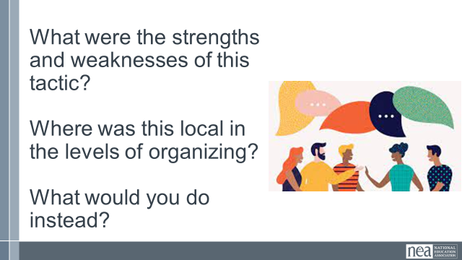  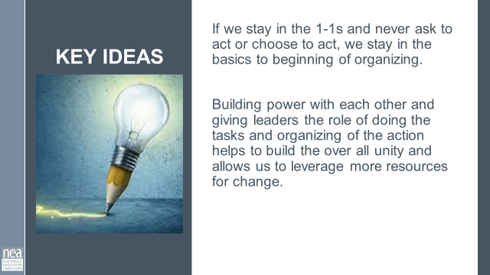 | Structure Tests | Power as a function of unity P. 147  PAR SEATTLE  87-95 specific focus on p. 93  Campaign Assessment Tool P. 162 |  | 30 Minutes – Tactics that Build a Club Into a Fighting Union  3 Minutes Intro - Structure Tests! These are actions we ask people to lead – they function to make our campaigns visible, AND allows us to see if the people who have committed can act together and leverage their resources for change.  What is a structure test? It is essentially a tactic, set within a larger campaign and strategy to engage leaders. We test to see if we truly have commitment to act together. Now, we know not to start with the hardest tactic, but something that engages and shows our effectiveness and brings people on board. (Use the tool on page 147) to highlight the idea of unity and courage/effort.  NEED SOME SCRIPT ABOUT POWER AND UNITY  Power is the function of people acting together and then how difficult the action is. Unity is the basis for people's movements and unions. With high membership, we have a lot of people doing one thing together. But what if we asked them to work together and do something more difficult (like was into the SB Presidents office). That would take immense unity and courage to achieve, thus increasing power.  If we add more people to our allies and share resources, now we have even more people acting together, thus generating more power.  15 minutes work time  Looking at the handout PAR SEATTLE 87-95. Read this story- reflect on the specific story on page 93. Assess the effectiveness of this tactic (of voting down school budgets). Using the tool on page 162. (Can be done by table.)  10 Minutes Share out.  What were the strengths and weaknesses of this tactic?  Where was this local in the levels of organizing?  What would you do instead?  2 Minutes Key Point  - If we stay in the 1-1s and never ask to act or choose to act, we stay in the basics to beginning of organizing.  - Building power with each other and giving leaders the role of doing the tasks and organizing of the action helps to build the over all unity and allows us to leverage more resources for change. |  | Participants will add to their understanding of tactics – not only are they about building pressure on a target, they also grow capacity of a club to take on a boss fight.
11:00-12:30  MELISSA AND Jeny  Slides needed:  - presentation criteria  - group share guidelines  -feedback guidelines |  | 5 min – Introduce Activity (Melissa)  40 min – Group planning (2-4 groups) (Both)  45 min – Share out, questions/  Insights (Zac)  Parking Lot w/ sticky note questions |  | (5 min - Melissa) Back Home Work:  This is not to think about a campaign - but a reflection of the current and to the possible. Where is your work currently? How can you take it to the next level? (Dream big!).  Start with where you are currently on the levels of Organizing, where do you want to be.  Draw your roadmap for getting there. Start with your goal.  - What activities and actions do you want your local or group to be focused on?  - Where are you now in the levels of organizing?  - Who is your constituency?  - What steps can you take to get there given the levels?  Be as specific as possible  Thinking to your back home work: Draw this out.  - What is your current constituency group  - What are they asked to do?  - In a perfect world what would you ask them to do?  - Who are the leaders and how or how will you find them?  - What are your communities/local/groups resources?  - Who are your leaders? How will you create a cycle of interruption and leader identification?  - What the issues and who has the resources to give your constituency what they want?  (30 min work time)  (35 min ) Presentation Time  - Share out in front of the group. 3 min, 2 min clarifying questions  (10 min) Feedback  Participants will write post it notes giving specific suggestions for next steps. Not general or “good job”, but questions about potential missing links.
12:30-1:00  Ellen  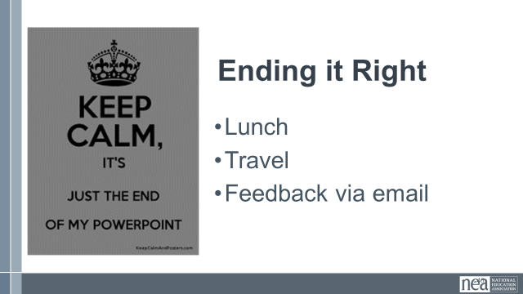 |  |  |  | Closing  - Some kind of recognition and time to do evaluations?
1:00 -2:00 | LUNCH and ADJOURN

