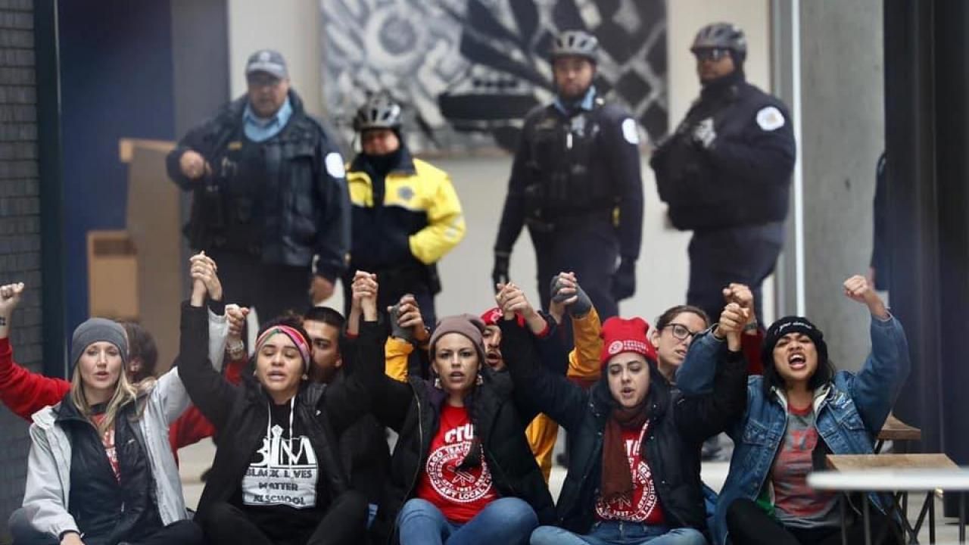

Leaders   | Ganz on Leaders  Trusted and Respected  Leader, Mobilizer, Activist

