Facilitator Agenda: Day # 1
General Materials Needed: |  |  |  |  | Room Set-up:
Data Set  Pre-Email with survey on skill level |  |  |  |  | Zoom
Key Outcomes for the Day
Formatting, Sorting, Filtering, Concatenate, and Text to Columns
Time, Facilitators, and Slides | Essential Questions |  | Resources | Instructions, Activity and Debrief (Facilitators) |  | Key Outcomes
What is the clock time for start and end? Who is doing this Section? What are the PPT slides (pic of slides)? | What question(s) should this learning section answer? |  | Charts, handouts, articles, materials, videos | What are you saying, what are they doing, what questions will you use to guide learning and make clear the important points  Include an estimate for how long each section of the learning will take  Include Key points. |  | As a result of this section of learning, what will participants know or be able to do?
2:30pm – 2:45pm  Introductions  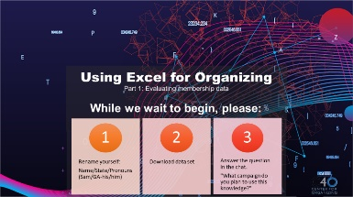      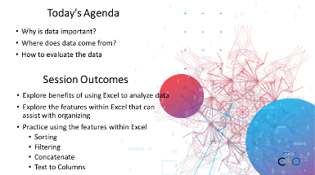 | What will we cover? What will we focus on today?  Who are you? Who are your facilitators?  Ellen |  | Data Set | 10 Minutes Welcome  Land Acknowledgement  Agenda  Participant Expectations  Session Goals  Community Agreements  5 Minutes Introductions  Participants introduce themselves, location, pronouns, and why they signed up for this session. |  | Participants will understand the structure of their time and how we will work together.
2:45pm-2:55pm  Monet    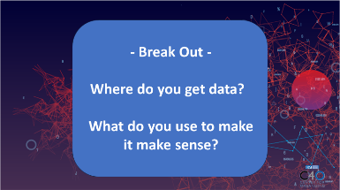  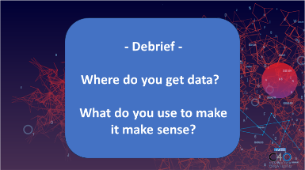  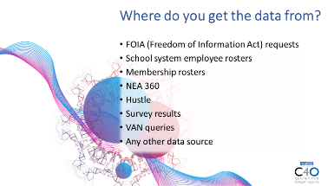 |  |  |  | 5 Minute Breakout  Discuss this question for 5 minutes in breakout rooms.  Where do you get data?  What do you use to make it make sense?  2 Minute Debrief  1 Min Facilitator Share out  Benefits of Excel  1 Minute
Beth  2:55pm-3:05pm      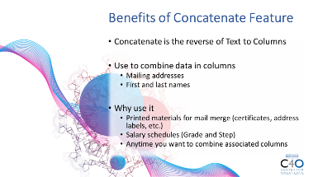  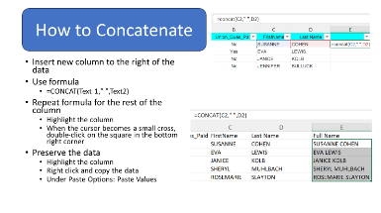   |  |  |  | Concatenate  10 Minutes  Making the Information Accessible when Evaluating Membership Data  Concatenate is the reverse of Text to Columns  Use to combine data in columns  Mailing addresses  First and last names  Why use it  Printed materials for mail merge (certificates, address labels, etc.)  Salary schedules (Grade and Step)  Anytime you want to combine associated columns  How To  Insert new column to the right of the data  Use formula  =CONCAT(Text 1," ",Text2)  Repeat formula for the rest of the column  Highlight the column  When the cursor becomes a small cross, double-click on the square in the bottom right corner  Preserve the data  Highlight the column  Right click and copy the data  Under Paste Options: Paste Values
Monet  3:05pm-3:15pm  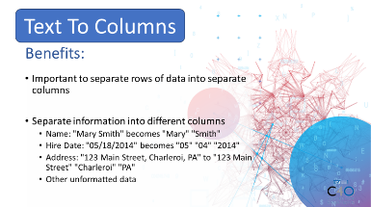  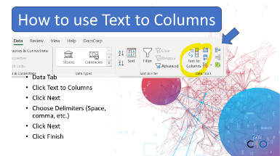 |  |  |  | Text To Columns  Important to separate rows of data into separate columns  Separate information into different columns  Name: "Mary Smith" becomes "Mary" "Smith"  Hire Date: "05/18/2014" becomes "05" "04" "2014"  Address: "123 Main Street, Charleroi, PA" to "123 Main Street" "Charleroi" "PA"  Other unformatted data  How To  Data Tab  Click Text to Columns  Click Next  Choose Delimiters (Space, comma, etc.)  Click Next  Click Finish
Jeny 15 Min  3:15pm-3:25pm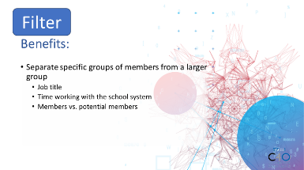  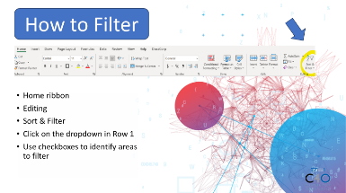 |  |  |  | Filter  Who has used the filter feature in Excel? When do you use it? Ask participants to use the raise hand feature to share when they use the filter feature.  Filtering is a feature that will allow you to identify a list of members who meet a certain set of criteria. For example, given the data in the Excel for Training workbook, why would you find value in identifying the elementary school teachers in the membership list?  Benefits  Separate specific groups of members from a larger group  Job title  Time working with the school system  Members vs. potential members  How to  Home ribbon  Editing  Sort & Filter  Click on the dropdown in Row 1  Use checkboxes to identify areas to filter  Beth  Time allotment  Model: 2 minutes  Independent practice 5 minutes  Debrief and Reflection: 3 minutes  Share screen with participants so that they can see how to filter and identify the number of elementary school classroom teachers  Best Practices REMINDER  Make a copy of the worksheet so that you do not compromise your data.  Save your work regularly.  Note that the membership list that was received from the school system has 302 individuals in the bargaining unit  After filtering the list  there are 42 elementary school teachers  2 Art  20 Elementary classroom  4 Library media  4 Instrumental music  1 Vocal music  2 PE  6 Resource teachers  3 School counselors  Now it is time for you to try to filter. When you hear the magic word, turn off your camera and filter the bargaining unit for the following:  Identify the number of members  How many staff work at Perfect Elementary School?  After completing the task, turn your camera on  Once all cameras are on  Ask participants the to identify the number of members in the unit  Ask the participants the number of staff at Perfect Elementary School  Reflection  How can you use this tool in your current work world?
Jeny 15 Min  3:25pm-3:35pm  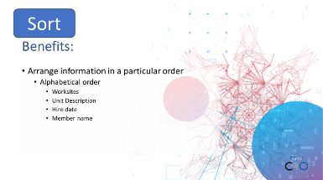  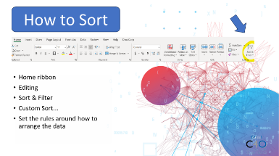 |  |  |  | Sort  Arrange information in a particular order  Alphabetical order  Worksites  Unit Description  Hire date  Member name  How to  Home ribbon  Editing  Sort & Filter  Custom Sort ...  Set the rules around how to arrange the data  Group Work  Try to Sort
Monet 5 min  3:35pm-3:55pm  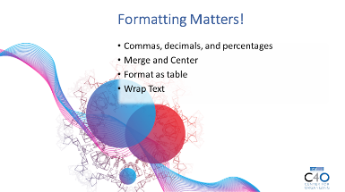  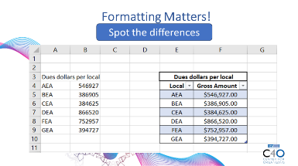 |  |  |  | Formatting  Show two examples of spreadsheets, talk about difference between formatting.  Depending on time have them do it themselves.  How to  Commas, decimals, and percentages  Merge and Center  Format as table  Wrap Text  DO NOT USE IN .CSV  Activity  Challenge: Sort addresses to go knock on doors. How did they choose to sort it?  Format it into a presentable way for your volunteers.  5 Min  Share outs of formatting and how they completed it.
3:55pm – 4:00pm  Beth  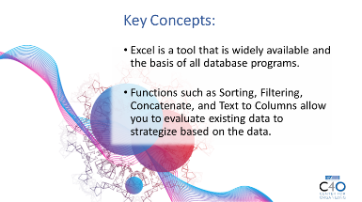  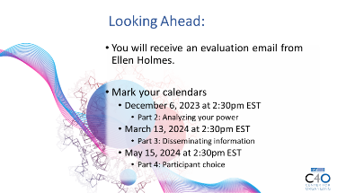   | What questions do I have? What do I need to know? |  |  | 5 Minutes Wrap Up  - Key Concepts  - Excel is a tool that is widely available and the basis of all database programs.  - Functions such as Sorting, Filtering, Concatenate, and Text to Columns allow you to evaluate existing data to strategize based on the data.  - Looking Ahead  - You will receive an evaluation email from Ellen Holmes.  - Mark your calendars  - December 6, 2023 at 2:30pm EST  - Part 2: Analyzing your power  - March 13, 2024 at 2:30pm EST  - Part 3: Disseminating information  - May 15, 2024 at 2:30pm EST  - Part 4: Participant choice |  | Participants will get opportunity for feedback and leave session with what they need to know for tomorrow.
 | ADJOURN

Facilitator Agenda: Part # 2 Analyzing your power

General Materials Needed: |  |  |  |  | Room Set-up:
Data Set  Pre-Email with survey on skill level |  |  |  |  | Zoom
Key Outcomes for the Day
- Participants will explore the features within Excel that can assist with organizing
- Participants will use pivot tables and goal seeking to summarize large sets of data.
- Participants will practice using goal seek to how to determine a numerical goal for member turnout outcomes, recruitment outcomes, or salary goals.
- Participants will practice using Excel and Google Maps to evaluate areas of local power

Time, Facilitators, and Slides | Essential Questions |  | Resources | Instructions, Activity and Debrief (Facilitators) |  | Key Outcomes
What is the clock time for start and end? Who is doing this Section? What are the PPT slides (pic of slides)? | What question(s) should this learning section answer? |  | Charts, handouts, articles, materials, videos | What are you saying, what are they doing, what questions will you use to guide learning and make clear the important points  Include an estimate for how long each section of the learning will take  Include Key points. |  | As a result of this section of learning, what will participants know or be able to do?
2:30pm – 2:40pm  Introductions  Beth  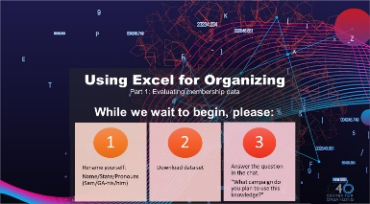      Insert slides 4-5 | What will we cover? What will we focus on today?  Who are you? Who are your facilitators? |  | Data Set | 5 Minutes Welcome  Land Acknowledgement  Agenda  Participant Expectations  Session Goals  Community Agreements  5 Minutes Introductions  Participants introduce themselves, location, pronouns, and why they signed up for this session. |  | Participants will understand the structure of their time and how we will work together.
2:40pm-3:00pm  Seleste  Pivot Tables    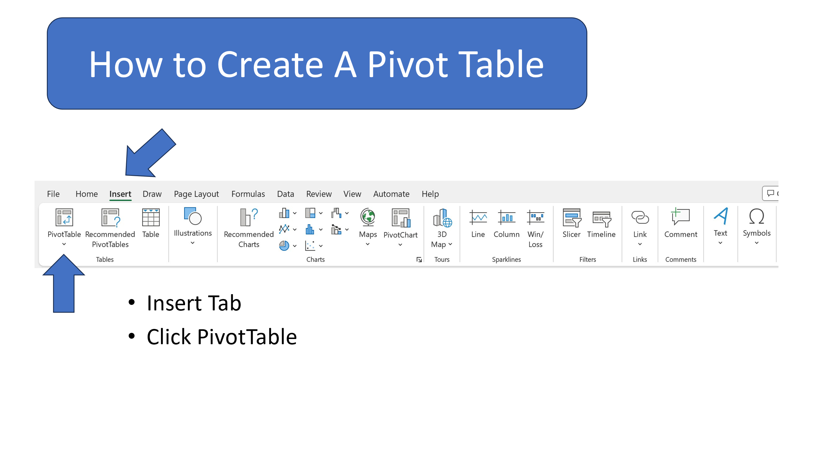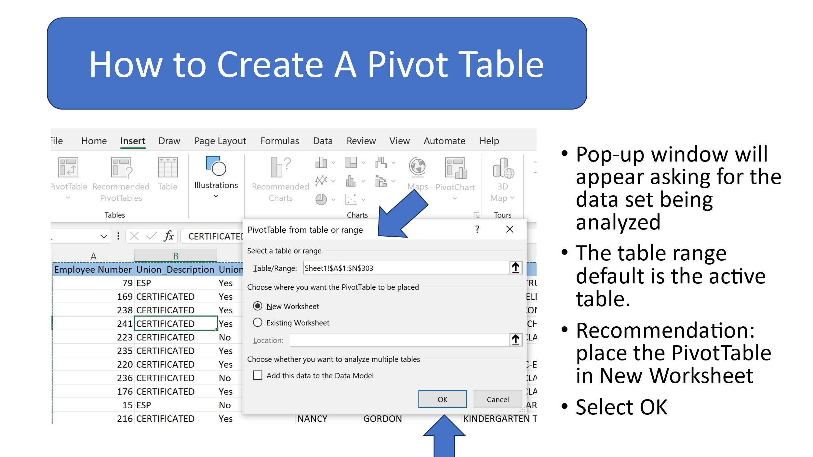 | How can we use pivot tables to summarize large sets of data? |  | Data set  PowerPoint or direction slides | Slide 6: Introduction to section  Slide 7: There are two primary benefits to using the pivot tables feature in Excel. 1) It summarizes large data sets quickly and 2) The information can be updated automatically.  Slide 8: To find how to create a Pivot Table, go to the Insert tab on the Command Ribbon and select Pivot Table.  Slide 9: A pop-up window will appear asking for the dataset that you want to analyze. The table range default is to the active table. It is recommended that you place the Pivot Table into a new worksheet.  Slide 10: It is time to identify the information that will be analyzed.  Slide 11: The data can be analyzed by identifying the potential list of targets for a membership campaign or number of people who may be affected by a decision based on a worksite, job title, or years of service within the system. Let’s take a moment to determine the number of people who hold a specific job title within the bargaining unit. The facilitator will guide the participants as to how to sort that information. Now it is your turn. What are the top 3 represented job titles within the bargaining unit? What are the least 3 represented job titles?  Slide 12: Here is another opportunity to create a pivot table. Let’s determine the number of people within the membership by job title. The facilitator will guide the participants to complete the task. Now it’s your turn. Which job title has the most membership? Which job title has the most potential?  Slide 13: Debrief: In what situations might you want to use the Pivot Table feature? Group discussion
Monet
Goal Seek
3:00pm-3:30pm

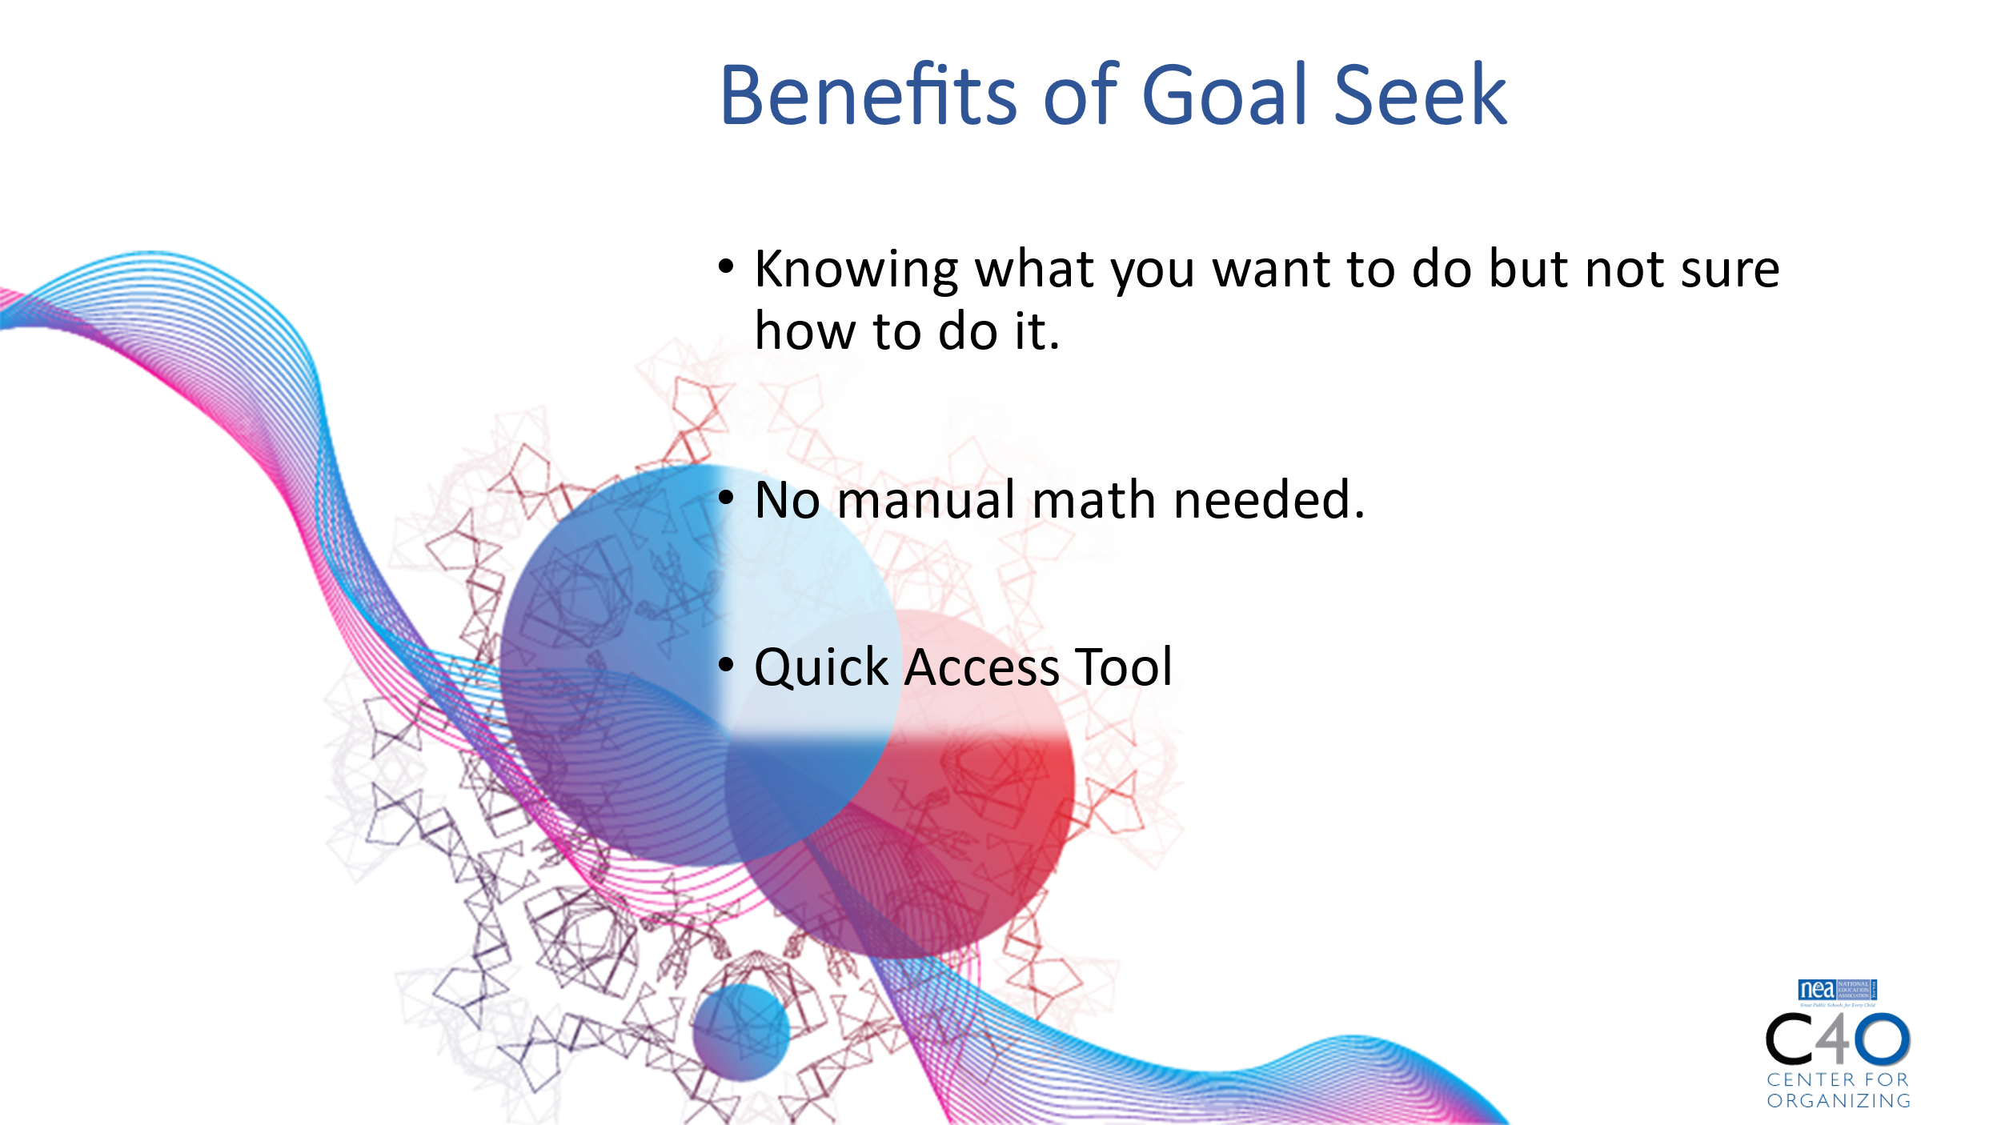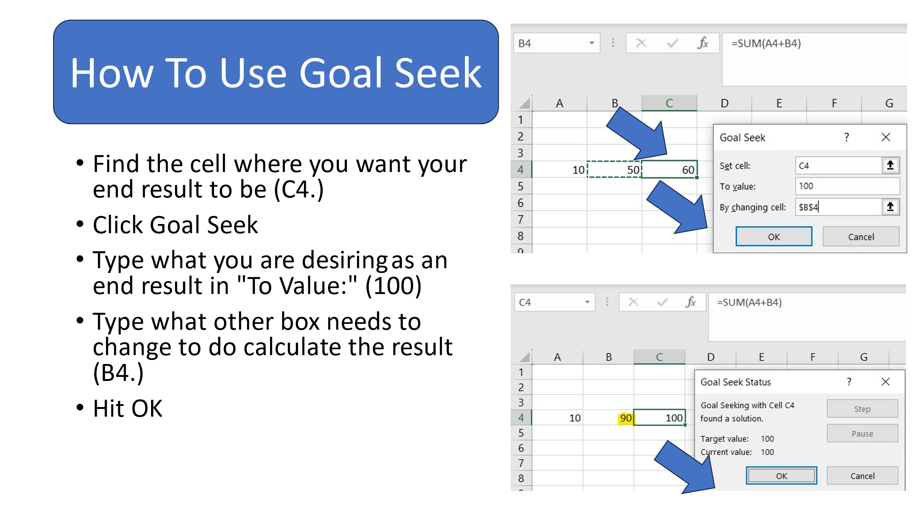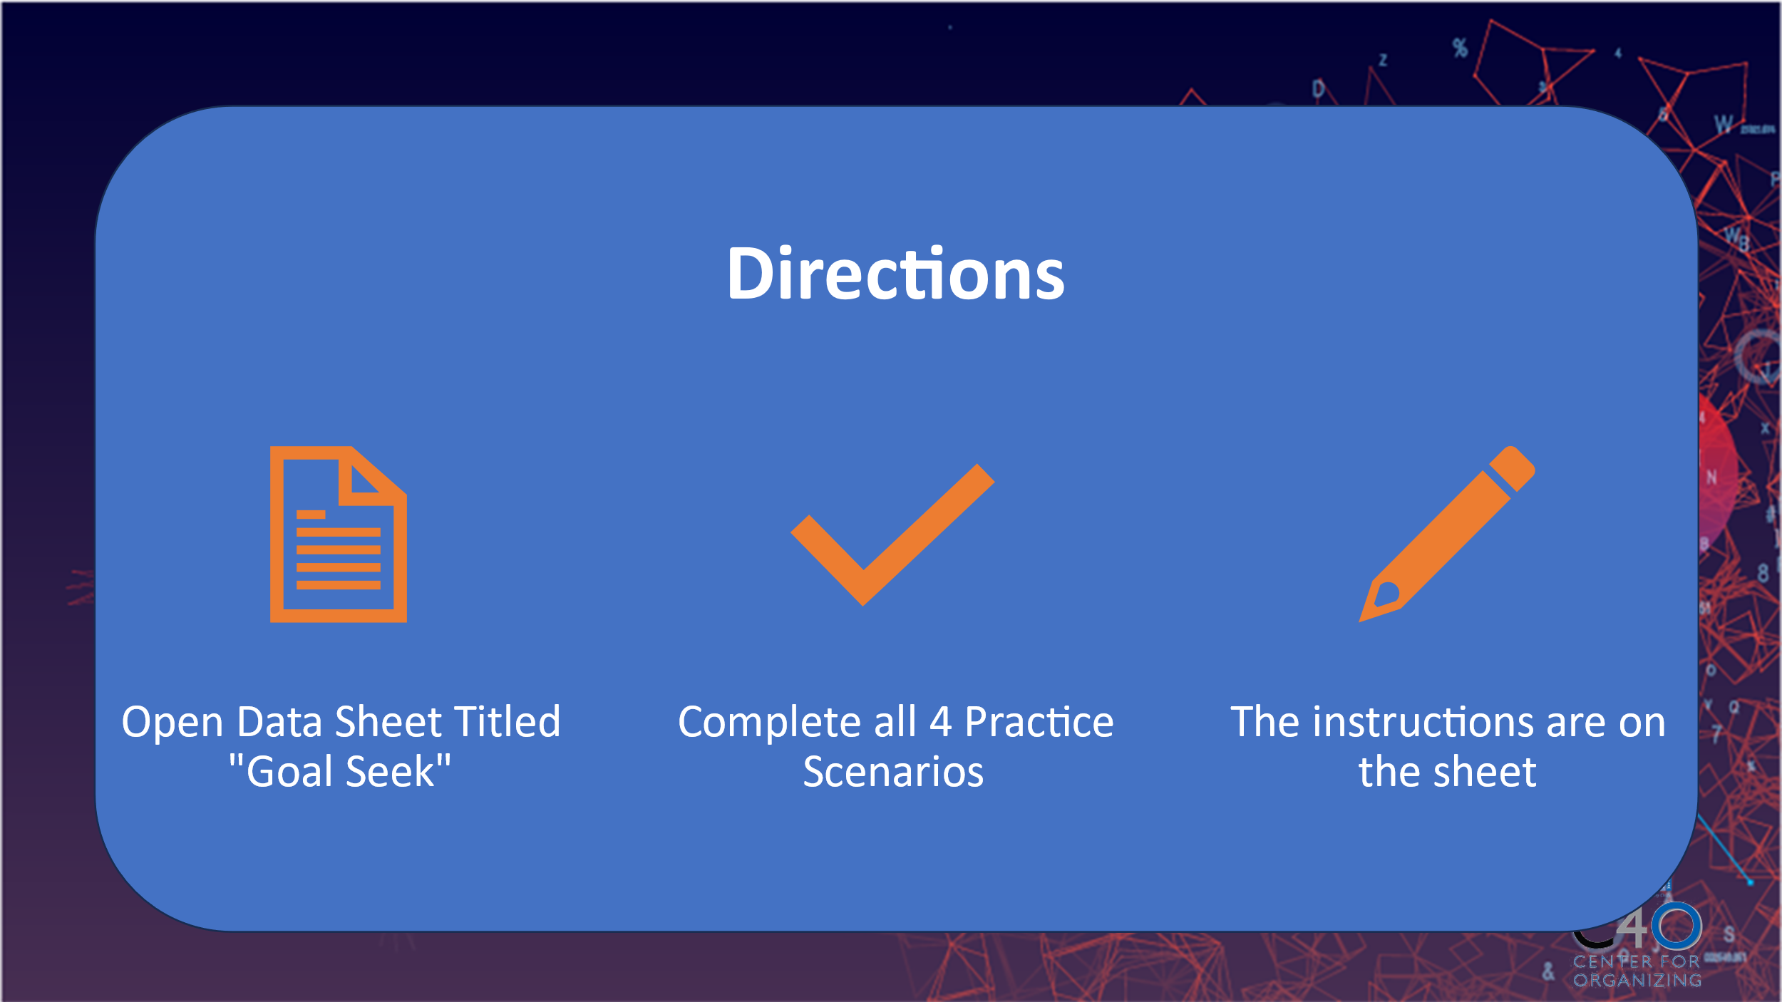
Chad  Power Mapping  3:30pm-3:50pm  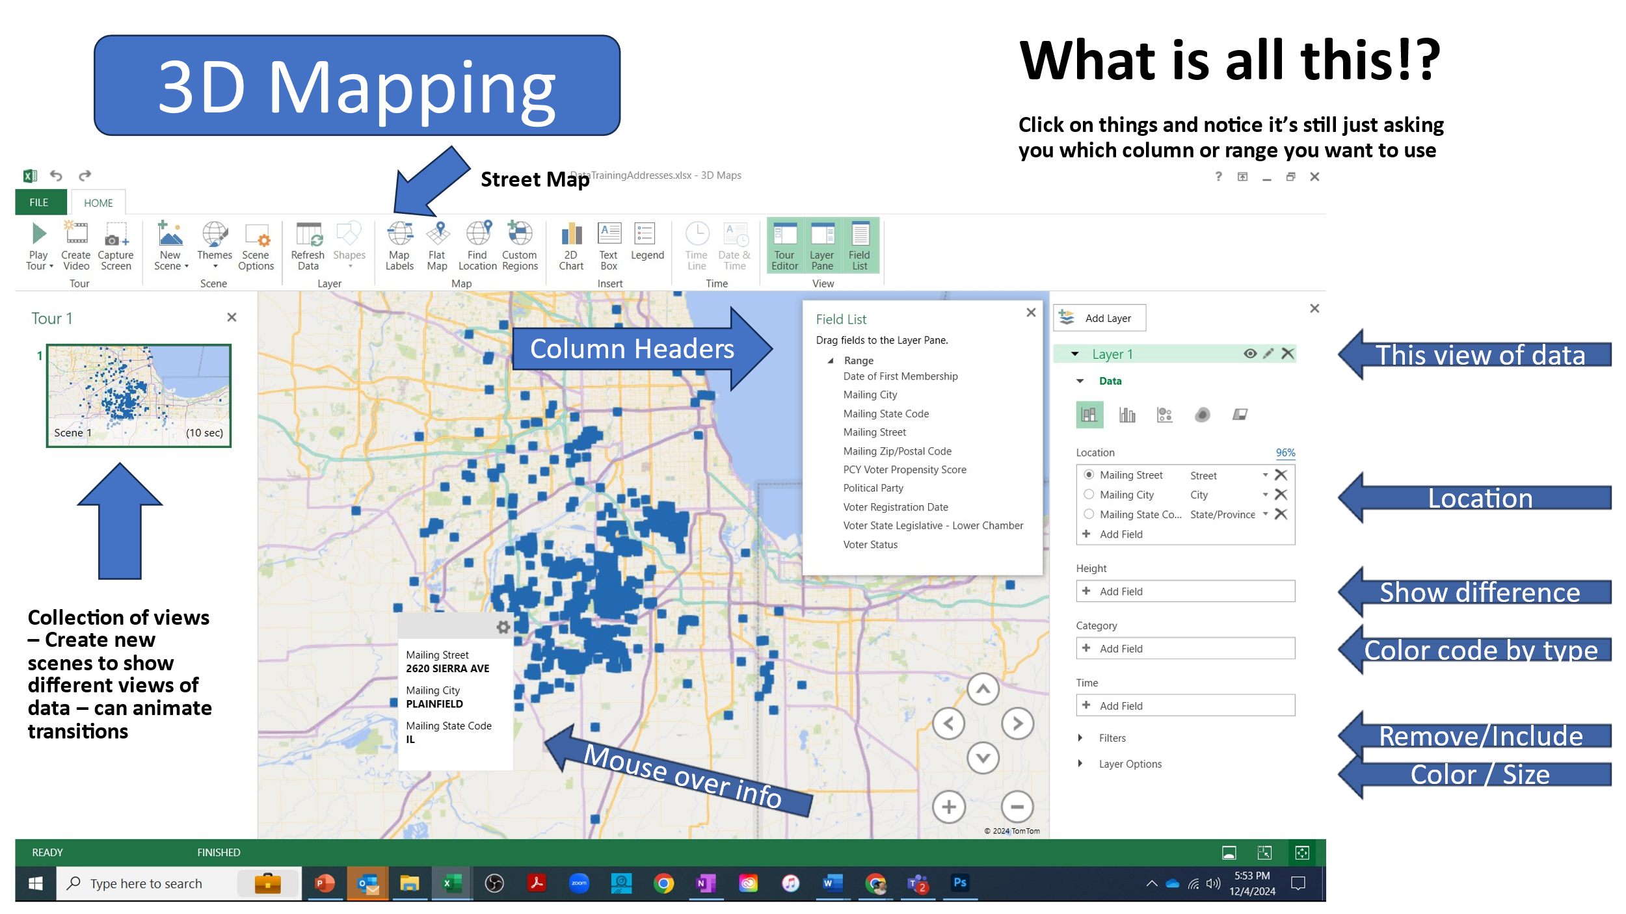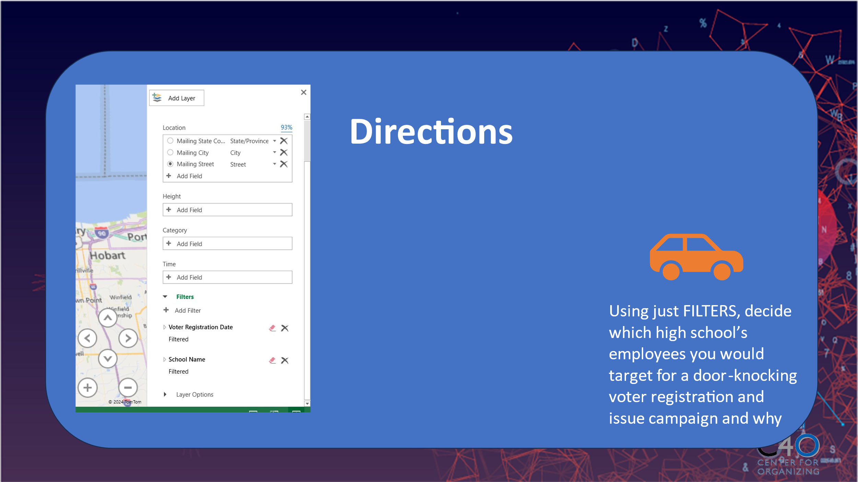 | How can visualizing data help in our decision making and organizing processes? |  | Data Training Addresses Excel sheet | - Have participant open the DataTrainingAddresses.xlsx  - Walk participants through identifying the path to open 3D maps in Excel  - Provide participants with a overview of the 3D mapping window, identifying key fields. Starting from Lay options at the bottom and working up. Make sure to explain how each field is connected to the worksheet as either a column header or range within the worksheet.  - Begin the activity by having them setup or verify the location settings  - With the 3D mapping window example showing, have participants click on the different fields so that they can see how they connect to the worksheet. They will see the column headers or the ranges just as described earlier. Let them know they will be selecting some of the for the final activity  - Explain that for the final activity, there are many ways to visualize the data, however for this exercise we’re keeping it simply but also showing them the field they will use most and is a good starting point to explore other features…the Filter Field.  - Final Activity: Using just filters, ask the participants to determine which school district they would do a door knocking campaign for registration and issues and why.  - Note: The slide has the configuration the participants will want to reproduce.  - The answer may likely be Victor J Andrew High because the unregistered members are closely grouped on the map, which may also indicate that there are local issues to explore with these folk that either explains their disengagement or provides insight into opportunities for engagement  - Ask participants what other ways they could imagine visualizing data. Possible answers would be adding more member information to use like leader identification scores, subject area or grade level information
3:50pm – 4:00pm  Beth  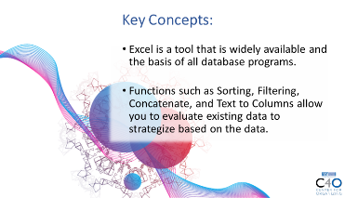  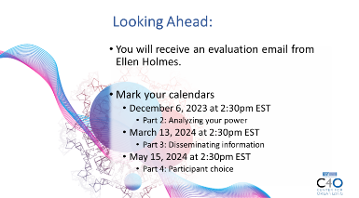   | What questions do I have? What do I need to know? |  |  | 5 Minutes Wrap Up  - Key Concepts  - Excel is a tool that is widely available and the basis of all database programs.  - Functions such as Pivot Tables, Goal Seeking, and Power Mapping allow you to analyze large sets of data to strategize based on the data.  - Looking Ahead  Session feedback- Put the link in the chat.  https://forms.office.com/r/HekdErpq1t  - Mark your calendars  - March 13, 2025 at 2:30pm EST  - Part 3: Disseminating information  - May 22, 2025 at 2:30pm EST  - Part 4: Participant choice |  | Participants will get opportunity for feedback and leave session with what they need to know for tomorrow.
 | ADJOURN

Facilitator Agenda: Part # 3 Disseminating information
General Materials Needed: |  |  |  |  | Room Set-up:
1 Set of Handouts per Person  Name Tags or Name Tents  Room signs, sign in signs  Highlighters – 3 colors  Pens and Pencils |  | Chart Paper  Markers- Mr. Sketch Non Permanent  Post its  Index Cards |  |  | Round Tables  Projector, Screen, Microphones, and Speakers  Carousel stations and reporting stations around the perimeter  50 people
Key Outcomes for the Day
Time and PPT | Essential Questions |  | Resources | Instructions, Activity and Debrief (Facilitators) |  | Key Outcomes
 | What question(s) should this learning section answer? |  | Charts, handouts, articles, materials, videos | What are you saying, what are they doing, what questions will you use to guide learning and make clear the important points  Include an estimate for how long each section of the learning will take  Include Key points. |  | As a result of this section of learning, what will participants know or be able to do?
 | BREAK
12:00 to 1:00 | LUNCH
 | BREAK
 | ADJOURN
Facilitator Agenda: Day # 4 Participant choice
General Materials Needed: |  |  |  |  | Room Set-up:
1 Set of Handouts per Person  Name Tags or Name Tents  Room signs, sign in signs  Highlighters – 3 colors  Pens and Pencils |  | Chart Paper  Markers- Mr. Sketch Non Permanent  Post its  Index Cards |  |  | Round Tables  Projector, Screen, Microphones, and Speakers  Carousel stations and reporting stations around the perimeter  50 people
Key Outcomes for the Day
Time and PPT | Essential Questions |  | Resources | Instructions, Activity and Debrief (Facilitators) |  | Key Outcomes
 | What question(s) should this learning section answer? |  | Charts, handouts, articles, materials, videos | What are you saying, what are they doing, what questions will you use to guide learning and make clear the important points  Include an estimate for how long each section of the learning will take  Include Key points. |  | As a result of this section of learning, what will participants know or be able to do?
 | BREAK
12:00 to 1:00 | LUNCH
 | BREAK
 | ADJOURN
Facilitator Agenda: Day # 5
General Materials Needed: |  |  |  |  | Room Set-up:
1 Set of Handouts per Person  Name Tags or Name Tents  Room signs, sign in signs  Highlighters – 3 colors  Pens and Pencils |  | Chart Paper  Markers- Mr. Sketch Non Permanent  Post its  Index Cards |  |  | Round Tables  Projector, Screen, Microphones, and Speakers  Carousel stations and reporting stations around the perimeter  50 people
Key Outcomes for the Day
Time and PPT | Essential Questions |  | Resources | Instructions, Activity and Debrief (Facilitators) |  | Key Outcomes
 | What question(s) should this learning section answer? |  | Charts, handouts, articles, materials, videos | What are you saying, what are they doing, what questions will you use to guide learning and make clear the important points  Include an estimate for how long each section of the learning will take  Include Key points. |  | As a result of this section of learning, what will participants know or be able to do?
 | BREAK
12:00 to 1:00 | LUNCH
 | BREAK
 | ADJOURN

