Facilitator Agenda Day 1 – Organizing Through Advocacy
General Materials Needed: |  |  |  |  | Room Set-up:
1 Set of Handouts per Person  Name Tents with the Norms  Sign-in Sheet  Room signs, sign in signs  One ream of white photocopy paper  Chart Paper (4 to 5 full w Sticky Strip) |  |  | Materials Box for each table with:  Markers (Mr. Sketch variety)  Post its – 3x3” and 4X5” sizes  Index Cards  Highlighters – 4 colors  Pens and Pencils  Participant “toys” |  | Round Tables  Projector, Screen and Speakers  Carousel stations and reporting stations around the perimeter  50 people
Key Outcomes for the Event:

Time | Essential Questions | Resources |  | Instructions, Activity and Debrief (Facilitators) |  | Outcomes
 | What question(s) should this learning section answer? | Charts, handouts, articles, materials, slide  RED is for Facilitator  BLUE is for Participant |  | What are you saying, what are they doing, what questions will you use to guide learning and make clear the important points  Include an estimate for how long each section of the learning will take |  | As a result of this section of learning, what will participants know or be able to do?
7:00 -8:30 | Breakfast, Facilitator Prep
Entry Activity   | Include the following in the end of the day recap email  - Day 1 PowerPoint  - Day 1 evaluation  - Day 2 PowerPoint  - Sign up for the Collective Bargaining Resource Page  - Homework: Read p.5-8 Three Theories of Change, p.91-94 Why Grievances are Not Enough, and How to Use Grievances to Organize from the Participant’s Handbook  What do you know about really good advocacy?
8:30 -8:50 Ellen  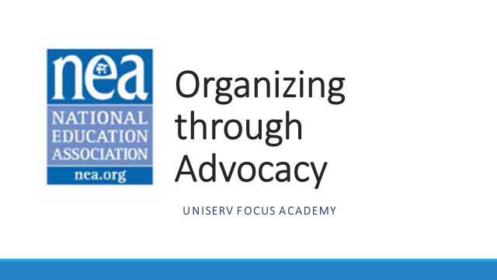      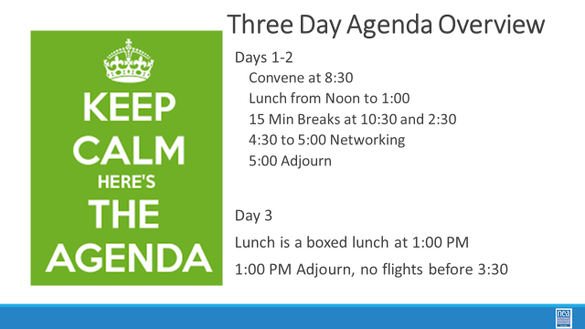  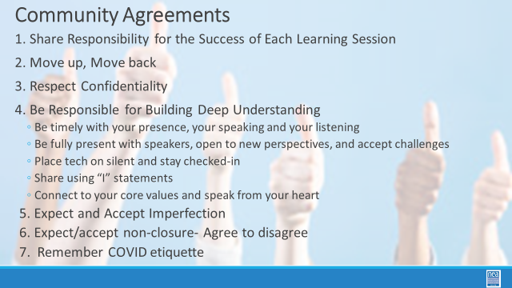  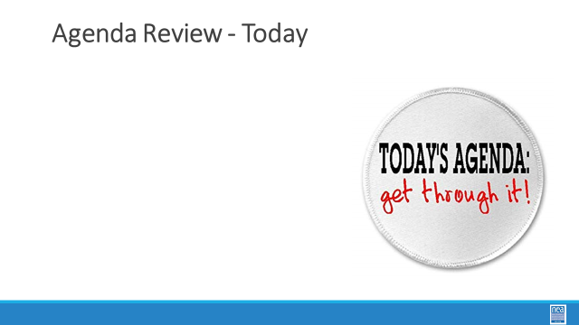 | How will we work together to support learning? | Norms are on Name Tents  Name Tags  Parking Lot  Handout Package |  | 30 Mins TOTAL Getting Started (Ellen)  10 Mins NEA Welcome  Native Land Recognition  The National Education Association is committed to honoring the spaces that we occupy to advance the work.  - We begin by acknowledging that through a history of colonization and brutality, we currently reside on and are connecting from the traditional lands stewarded by generations of indigenous people.  - We honor these indigenous people, all elders, past, present, and emerging. We are called to learn and share these learnings about this tribal history, culture, and contributions that have been suppressed in the telling of the story of what we now call the United States of America.  Why are we here?  - We are here to build stronger ESP leaders.  - NEA is committed to building effective sites where members can lead and growth their associations.  5 Mins Facilitator Introductions  - Team intros include: Name, Work Location, years in the work, and your required pronoun  5 Mins Group Introduction Whip  - Have a quick model from one of the trainers.  Three Day Agenda Review  - See charts on walls for review.  - Note the two breaks, lunch, and adult network 4:30-5pm each day and then 1pm on Thursday.  3 Mins Group Logistics  5 Mins – Group Agreements  5 Mins – Today’s Agenda |  | Participants will know how we are going to work, the basic schedule, and the logistics relevant to the training.
8:50-9:15  August  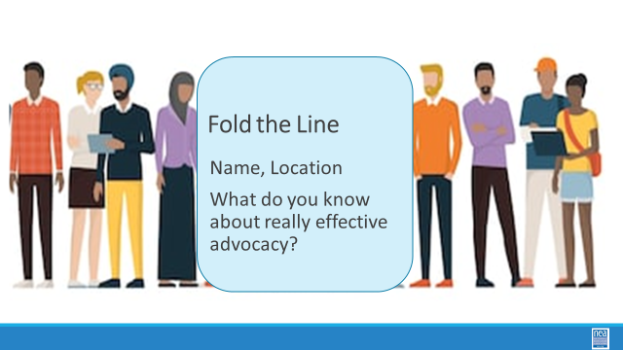 | What do you know about advocacy? |  |  | 15 Minutes Total – What do you know?  5 mins Set up - Ask participants to line up in one long straight line with those who travelled farthest away at one end and those who travelled the least at the other. Once lined up – help them fold the line – the people at the extreme ends become partners – the next, the next, etc. Once partnered up – ask them to share who they are, where they are from, AND What do you know about really good advocacy?  5 mins to talk with partner  5 Mins to share out
9:15 –9:45  Seleste    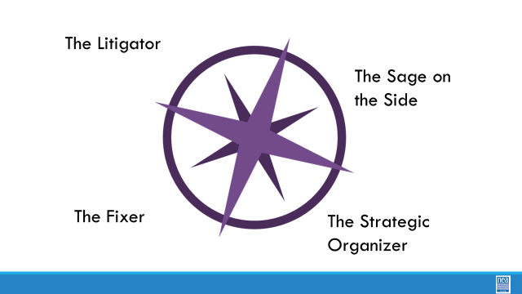  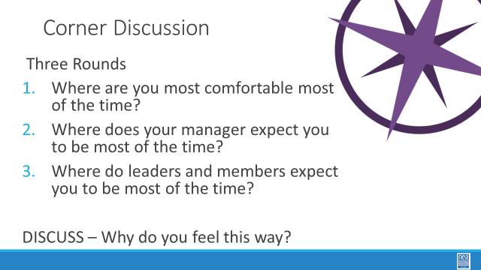  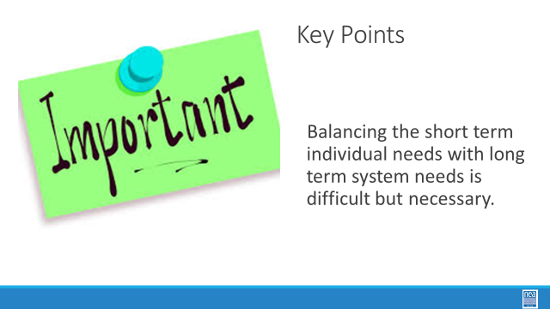 | What are the challenges with advocacy in your work life? | Need Four Charts in the Corners with the Name of the Roles |  | 30 Minutes Total - Where do you stand Seleste  The Litigator- mount cases that will result in legal decisions and policy wins for members  The Guide on the Side –support and train members who handle advocacy at the worksite and affiliate level  The Fixer – work with management to solve problems quickly and effectively  The Strategic Organizer – turn individual issues into collective issues for organizing.  The four points of a compass we will do three rounds of this –  Round 1 – what role do you feel most comfortable in doing – introduce yourself and tell each other why you feel this way.  Round 2 – what role does your manager expect you to be doing most of the time - – introduce yourself and tell each other why you feel this way.  Round 3 – what role does your affiliate leadership and members expect you to be doing most of the time -– introduce yourself and tell each other why you feel this way.  In each round, gather at the corner that best fits for you and discuss WHY you selected this.  Overall debrief  For each of the corners ask –  Where is the power if this is your corner?  How many members are engaged?  Who is the story of the win/loss about?  Key Points - Balancing the short-term individual needs with long term system needs is difficult but necessary.
9:45- 10:00  Steven |  |  |  | 15 minutes to Explore the Unorganized to Fighting Union Continuum: Clubs are groups of people who follow, rely, and build programs. Programs have a prescribed way of working with a pretty predictable set of outcomes. They are not bad, and we need to understand how they operate. Fighting Unions are groups of people with multiple “natural leaders” engaged through structures, moving people to risk use their resources to achieve the change they want. Outcomes are unpredictable. Page 4 describes this continuum of Unorganized to Fighting Union. You will see elements listed in the left-hand column, with descriptors of what each element might look like as it moves across the continuum towards fighting union. At your tables, take time to explore the continuum and discuss with your colleagues what stands out to you.
10:00-10:15 | BREAK
10:15- 10:45  Steven |  | Levels of Organizing  Club or Union Handout Pg 4 |  | 30 Minutes Total – What does advocacy look like in your locals?  5 minutes: Debrief discussion from before break  15 Minutes for activity- Activity Directions: Everyone – close your eyes and think about one unit you work with – got it in your minds? Great.  Step 1 – 5 minutes- Each person will assess where their local lies on the Club to Union continuum – especially as it related to advocacy.  Step 2 – 5 minutes- Share at your table what your findings are  15 Minutes – Debrief  (Note: Participants were eager to discuss as whole group)  What did you notice?  What surprised you about your assessment?  What are you wondering about?  Key points  Don’t grieve in silence  When your union fights members need to know  When you handle advocacy at an individual level, the real winner is the boss
10:45-11:10  Vanessa | What are some foundations you need to have? | Participant Handout pg 9-15 |  | 20 Mins – Problem Solving Analyzing  Problem Solving Process  Remember the 4 corners from earlier this morning, the way each of us approach the work is not always the same. We run into the same issue rooted in problem solving. Recognizing that we approach our work in different ways, we are going to focus on the person who is at the center of the work.  Let’s look at the steps of problem solving. We are going to look at the 5Ws and an H.  We need to figure out who is doing the work. If we have a formal timeline, then we start with the deadline and plan backwards. Finally, we are going to evaluate. After the fact, what happened? Did it work? What information/feedback do we need to improve the process moving forward?  In doing this work, be mindful of the pitfalls in resolving the conflicts. (Consider highlighting a couple key options. If time allows, allow the participants to share the options that they recognize as pitfalls.)  Revisit one step in the problem-solving analysis  - We need to know the whole contract or policy  - We need to be aware of the key definitions  Dig into the problem-solving cycle. Be mindful of where we can involve more individuals in the work.  Why is it a problem?  How could the problem be solved?  What is the best solution and how will it be implemented?  Who implements what?  What happened – feedback?  We are going to start to analysis the problem by looking at  - Past practice  - Contract/ Policy/handbooks  - Laws  - Or is this someone’s need to vent  The next step in the problem-solving model is to brainstorm possible solutions. Please consider if you want to  - Address this in a collaborative or adversarial way  - Grievance vs. Organizing path. In determining if we are going to grieve or organize around the situation, we need to think about who is at the center of the work.  - There is a cost benefit analysis to any solution.  When choosing a solution, we need to consider  - What the member wants  - Needs of the association  - The district needs  We have been focusing on individual concerns. Disciplinary issues definitely relate to individual issues. In addressing disciplinary issues, let’s look at a few disciplinary related terms. Please know that each state may have varied takes on these terms. If you are in a pro-employee state, there may be labor relations laws that extend beyond the laws of the federal floor.  - Garrity rights  - 7 tests of just cause (pg 15 in Participant Handouts)  Key Points  - Navigating through the complexities of problems need a formalized problem-solving process helps to ensure that nothing is overlooked/omitted.
11:10-11:35  Bekah | What are the steps typically found in a grievance process? | Participant Handouts pg 9-21 |  | 25 Minutes Total– Best Practice Carousel  What do we know about advocacy in our work?  12Minutes Working as teams – create a list on chart paper that would teach a person new to this work the key foundations they would need to know to be successful.  8 Minutes Carousel - We are going to visit each of the other teams’ chart. Take a pen and post it notes – You can leave them questions about what is missing, you can leave them check marks for things that are the same as you have, you can leave them light bulbs about ideas you had not thought of.  5 Minute Overview of what makes for good advocacy - Point them to the following two handouts as you debrief with them.  Key Points  - While there are several ways across the states to approach advocacy, being thorough, adhering to a standardized process, and completely documenting advocacy matters are necessary.
11:35-12:00  Toney |  | Participant Handouts pg 22-89  Grievance Forms: 11-12, 43-45 |  | Scenario time (25 min)  10 min: We are going to be working in scenario teams and you will be assigned a scenario team. These teams will be working to write a grievance this afternoon. (Break into scenario groups, making sure to have at least two groups working on each scenario). Count off by 6.  Scenario 1: Discrimination p. (1, 2 Teams)  Scenario 2: Academic Freedom p. (3, 4 Teams)  Scenario 3: Access to Professional Development p. (5, 6 Teams)  Read the scenario and skim the supporting documents. While you are skimming, keep in mind these four questions.  15 mins – Reviewing the Case-4 questions -  - Is there a grievance procedure?  - Are there timelines to consider?  - Who can be a grievant?  - Is there a form for your procedure?  Also, look to pages 11-12 for a grievance form that you can use for this exercise. Know that, depending on the state, there may or may not be a standard form. If there is no standard form, you can use anything that includes the necessary elements.  Worktime: You will not be writing the grievance yet. Use this time to review the scenario and think through the 4 questions.
12:00 - 1:00 | LUNCH
1:00 – 2:00  Charles | How do I prep and write a grievance? | Three Scenarios |  | Grievance Scenarios, cont.  5 Minutes – Introduction - Review the grievance form. When completing the form, the purpose is to be thorough and concise (this is not a dissertation). Much of the information is demographic information about the member. Introduce concepts of writing the grievance. There may be a form that exists, often in a CBA, but non-bargaining states can create their own if a formal form has not been created. Pages 11-13 and 43-45 are two examples. The grievance process often has 3-4 steps. Level 1 is often a formal concern to the member’s immediate supervisor.  When completing the grievance form, the following should be included:  - Who is involved in the grievance?  - When did the grievance occur?  - Where did the grievance occur?  - Why is this a grievance?  - What contract/policy did the action violate? How do you remedy the situation? When identifying the violations, it is key to remember to use all of the relevant Board policies and contract language. The statement needs to clearly articulate how the board policy or CBA have been violated.  - Relief sought: how to make the member whole – you will not get any apology public or private.  Additional words/phrases to remember and include ensure that the grievance will have the largest scope possible.  Utilizing an intake form can ensure that the member(s) affected are part of the process and that you, as the staff member, are not the one processing the grievance in isolation.  Worktime: 25 minutes to draft your grievance and submit your grievance to Principal Ellen by email to eholmes@nea.org.  5 minutes- Tips for processing grievances-  Good tips to consider as you prep your case.  - General concept- it is important to know that when you are prepping your grievance, you should prep as though it will go all the way through the grievance procedure, be that at arbitration or the school board  - If you, as the UD, are the ones driving the grievance, you should be communicating with the local grievance committee, if it exists. Usually, if this exists, the committee will look at the violation and evaluate whether there are grounds for a grievance and will coordinate the advocacy.  - You should anticipate what the employer’s response will be because you can use this to prep your argument, your presentation.  - Even in locals where there is a collaborative relationship, you should not enter the process assuming that you will be able to reach an agreement.  - In some CBAs, the first step may be an informal conversation; this may need to happen prior to the submission of the written grievance.  - Be mindful of timelines. Rarely are timelines written by the local, in the local’s favor. There are real, legal consequences to missing timelines. If a timeline is missed by the local, they may be forfeiting the grievance. Also note that some violations may be ongoing, so the timeline is constantly restarting. (I.e., ongoing pay errors).  Don’t grieve in silence. Grievances can provide an opportunity to engage members in the work of their union.  Now we are going to transition to preparing for hearings. You just finished the grievance form; that should function as an outline for your grievance presentation. You should also arrive early and do what you can to be as prepared as possible. In the crafting of your argument, you should work in a chronological order; this helps the employer understand the concerns and helps the member stay focused. Once you have established what happen, in chronological order, you should then be clear about WHY this is a violation. Finally, you need to be clear about your remedy; what relief are you seeking? We include “make whole” language to ensure that we leave the door open for any remedy that comes up during the process. Remember, thinking creatively can be of immense value here.  25 min work time to prep case for presenting. (1:30-2:00)  Finalize preparing what you will present after break. |  | .
2:00 -2:15   | BREAK
2:15 -3:30  August | What are the differences in issues? |  |  | Group presentation Time - 75 minutes  5 minutes –introduction  10 minutes – to get located  40 Minutes Presentation - Each team gets 20 minutes to present to the other side and hear the outcome. (a total of 40 minutes)  20 minutes Debrief and Key Points:  Popcorn around the room to get feedback on these three questions:  What did you take away from listening to your partner group's presentation?  What was challenging as a presenter?  If you were doing this for real, how many workers would be involved on the union side?  Key points-  Know your grievance procedure.  Use your grievance procedure.  Know how to analyze your CBA/policy.  Connect as many workers as possible to the work of the union, including grievance work.  How many people were involved from the union if the scenario was implemented as we just did?*
3:30-4:15  Charles |  | School Board Hearing Handbook |  | 45 Minutes Total – Prepping for a School Board Hearing; Opening Statements  10 min School Board Hearing Format (Charles)  There are 11 standard format steps to formal hearings.  Reference Common Format that is an additional handout – see Roman numerals 1-11. Ask the participants to read the steps silently. Facilitator will read the steps aloud and elaborate on the steps over the next few slides.  Opening Statements  An opening statement provides the hearing examiner or arbitrator a roadmap of the case. The components of the opening statement include:  - Description of the district and bargaining unit  - Background of the employee’s work history  - The action that lead to the grievance  - Provides intended entitlements  - What the union intends to prove  - Summarizes the case  - The remedy sought  15 min- Participants draft opening statement on own  10 min- pair share; coach on if hit the key points  10 mins- to debrief and key points: The opening statement provides a roadmap to your case.
4:15-4:30 | How are we doing so far? |  |  | 15 Minutes - Ending it Right (Ellen)  Questions, Connections, Reflections  Housekeeping announcements  Plus/Delta at the Door  FOR TOMORROW – |  | Participants will be able to bring a little closure to their learning and provide feedback on the day.
4:30 – 5:00 | What is the expertise among my colleagues? |  |  | Choice Networking Activities |  | Participants will make useful connections with staff from other affiliates.
5:00 | ADJOURN

