Facilitator Agenda Day 2 – Organizing Through Advocacy
General Materials Needed: |  |  |  |  | Room Set-up:
1 Set of Handouts per Person  Name Tents with the Norms  Sign-in Sheet  Agendas on the table (1 per)  Room signs, sign in signs  One ream of white photocopy paper  Chart Paper (4 to 5 full w Sticky Strip) |  |  | Materials Box for each table with:  Markers (Mr. Sketch variety)  Post its – 3x3” and 4X5” sizes  Index Cards  Highlighters – 4 colors  Pens and Pencils  Participant “toys” |  | Round Tables  Projector, Screen and Speakers  Carousel stations and reporting stations around the perimeter  50 people
Key Outcomes for the Event:

Time | Essential Questions | Resources |  | Instructions, Activity and Debrief (Facilitators) |  | Outcomes
 | What question(s) should this learning section answer? | Charts, handouts, articles, materials, slide  RED is for Facilitator  BLUE is for Participant |  | What are you saying, what are they doing, what questions will you use to guide learning and make clear the important points  Include an estimate for how long each section of the learning will take |  | As a result of this section of learning, what will participants know or be able to do?
7:00 -8:30 | Breakfast, Facilitator Prep
Entry Activity  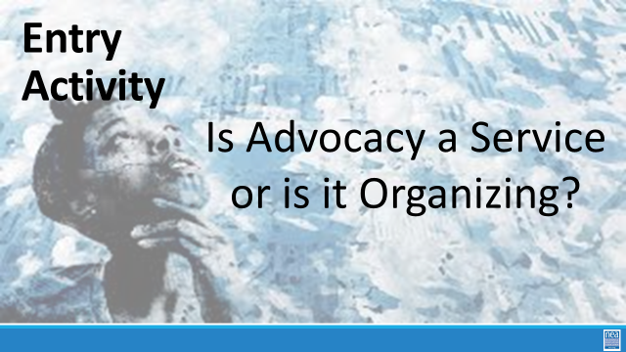 | End of the Day Email:  - Send CBMA database website link to participants for registration in preparation for research activity on Day 3  - Day 3 PowerPoint  Is advocacy a service or is it organizing?
8:30 -9:00  Ellen  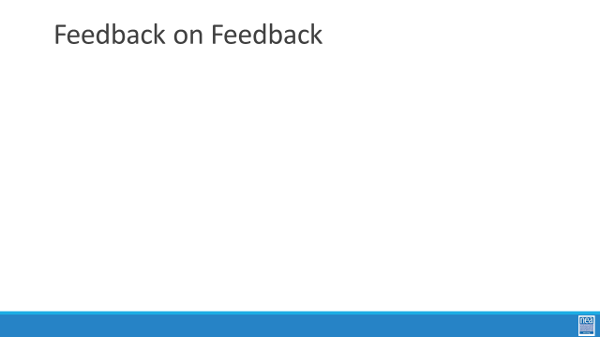  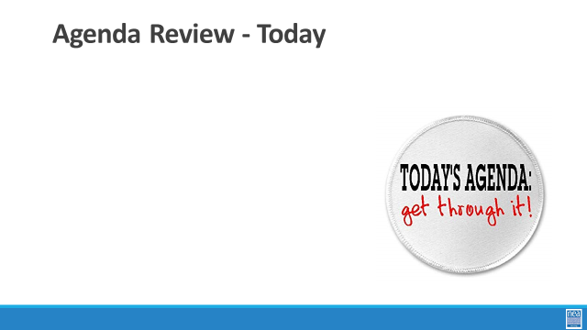  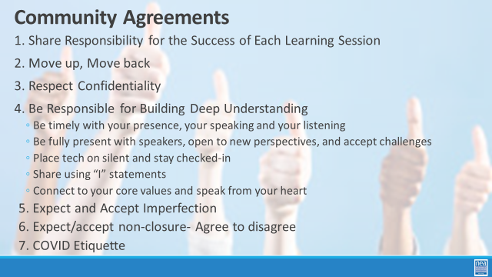 | How will we work together to support learning? | Norms  Parking Lot  Agendas on the Table  Name Tents  Handout Package |  | 15 min- Welcome back -  Reentry  Feedback on Feedback  Agenda Review  Norm Review |  | Participants will know how we are going to work, the basic schedule, and the logistics relevant to the training.
9:00-9:20  Charles  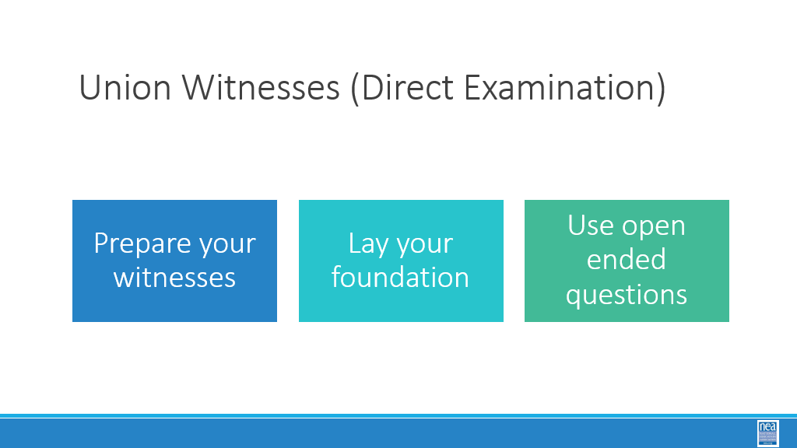  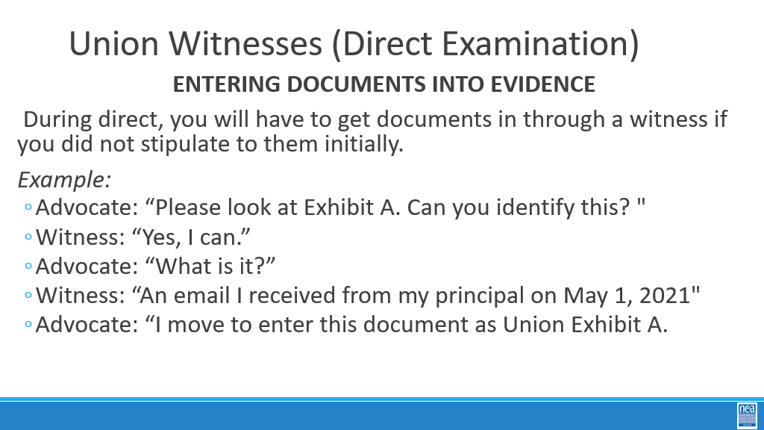  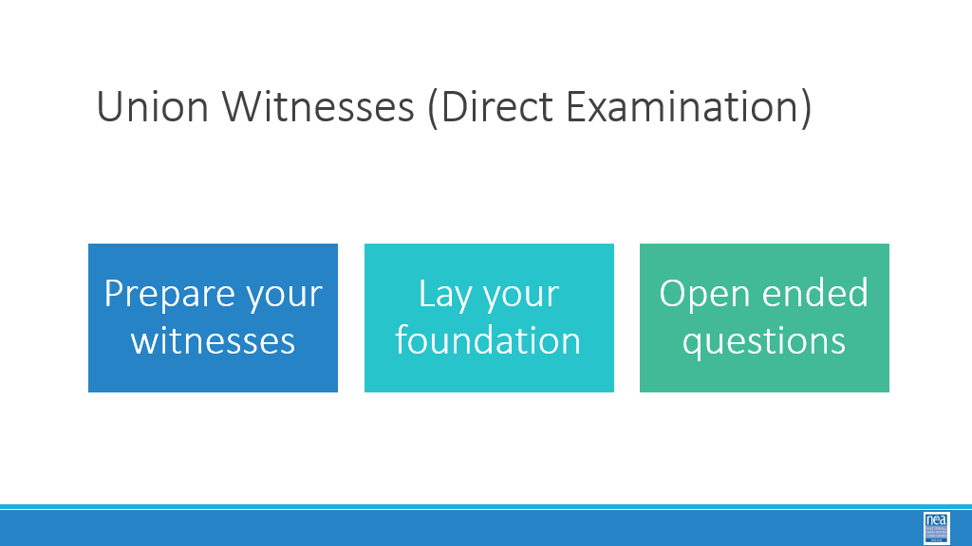  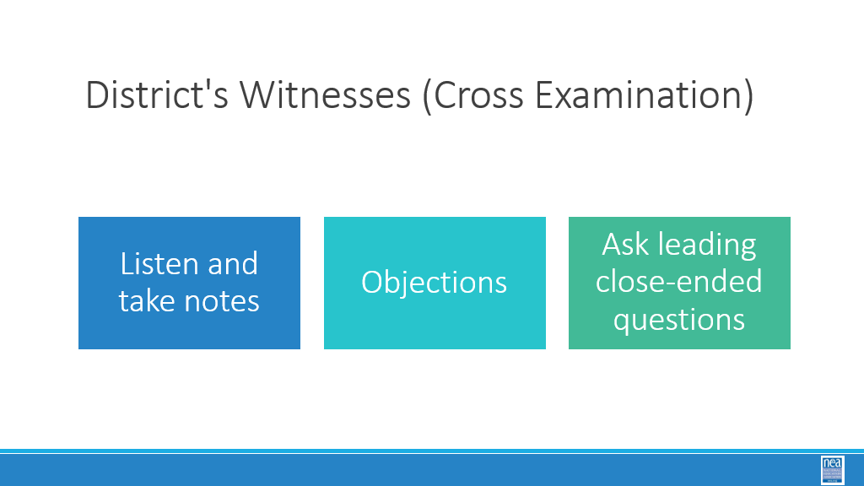 |  |  |  | 20 minutes-Charles  Now we are going to explore the typical next level of a grievance procedure, BOE Hearing. Two core components of a BOE level hearing are direct and cross examinations of witnesses.  Direct Examination  Prepare your witnesses ...including  1. Basic information...Lay foundation (name; occupation; etc.)  2. Show how they are relevant to the case  3. Enter supporting documentation  IMPORTANT:  - Keeping the answers brief/succinct  - OPEN ENDED” questions re their specific connection to the issue …to help prove your case through witness testimony  - only answer questions that are asked  - Do not ask questions that will lead to an answer you do not know  - Encourage witness to be calm and collected  - Prepare, prepare, prepare!  Cross Examination  - Listen and take notes on anything that goes against your case  - Objections (see resource)…object to questions asked of a witness  - Ask leading close-ended questions  - Avoid “Why” Questions as they can derail your case! This gives the opportunity for the District’s witness to enter testimony that will support the District’s case.  - Do not ask questions that will lead to an answer you do not know as they too can harm your case.  ***Bonus*** (While this is important aspect to arbitrations, this training is only a cursory in nature)  How to enter documents into evidence:  Documents The two sides in an arbitration have the ability to agree to which documents can be entered in as exhibits in
9:20 -10:00  Steven  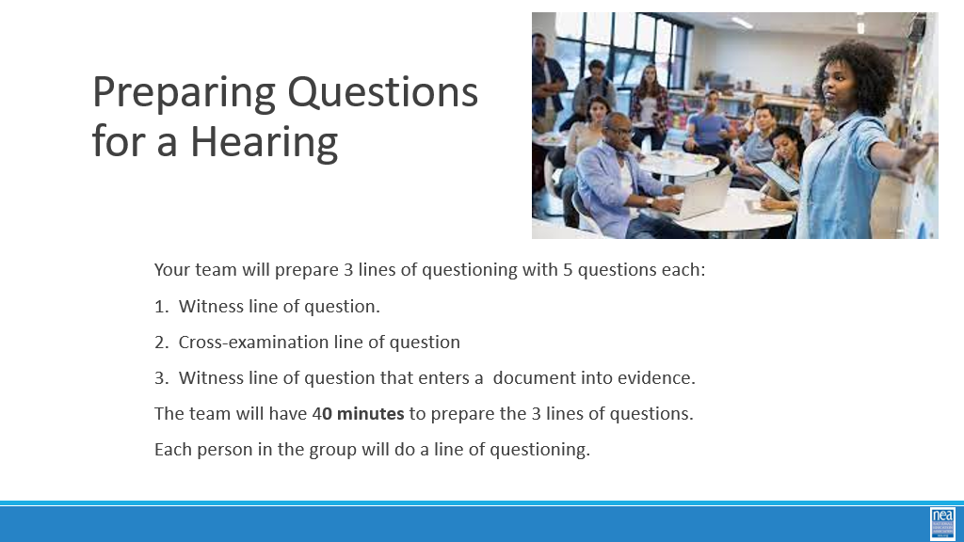 | How do I prepare to present and question at a school board level. | . |  | 40 Minutes TOTAL – Prepping and presenting questions for School Board Hearings  Ask participant to move their groups from yesterday. (3-5 minutes)  Introduction and Directions (3-5 minutes)  The next 30 minutes will be a chance to prepare questions for a BOE hearing. Each team will prep 2 lines of questioning. The questions should focus on the content as opposed to the necessary background questions (Tell us about yourself, where do you work, how long have you worked for your employer, in what capacity do you work for your employer, etc.) that typically are asked of a witness.  Any Questions? (2 minutes)  Activity Time (30 minutes)  Direct Examination:  - Determine an aspect of the case that you will need to elicit from a witness  - Develop a line of question relevant to that aspect.  Cross-Examination:  - Contemplate aspect of the case the district will want to emphasize  - Which witness(es) would they call to support that aspect?  - Develop a line of Cross-examination questions  Directions:  - Each line of questions should consist of 5 questions.  - The team will have 30 minutes to prepare the 2 lines of questions.
10:00- 10:15 | BREAK
10:15-10:45  Toney  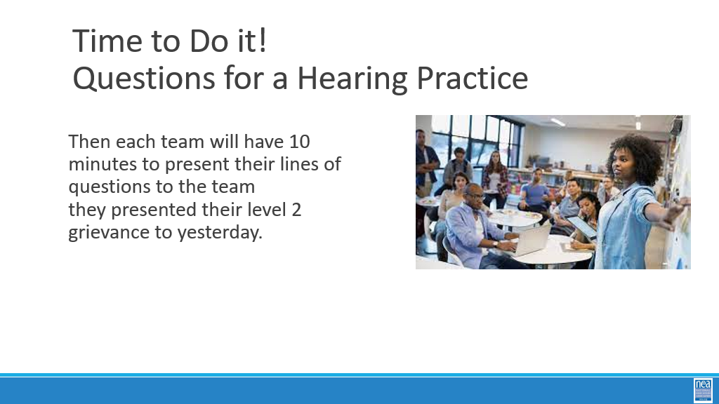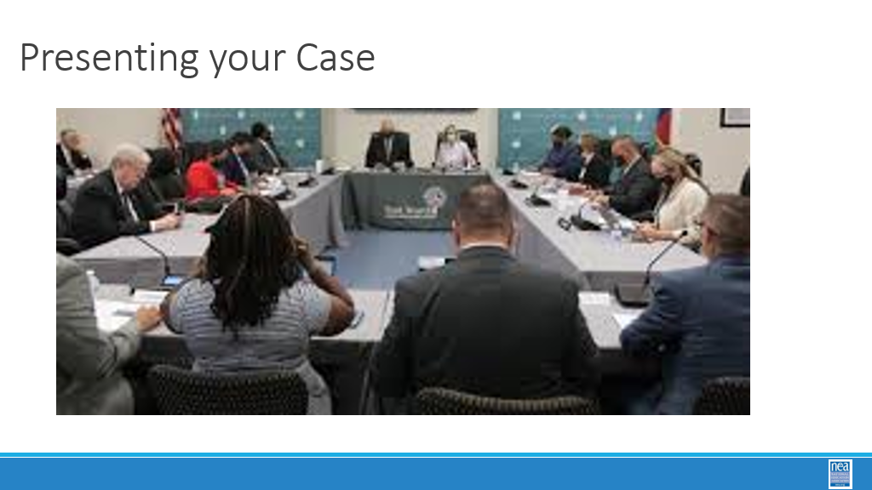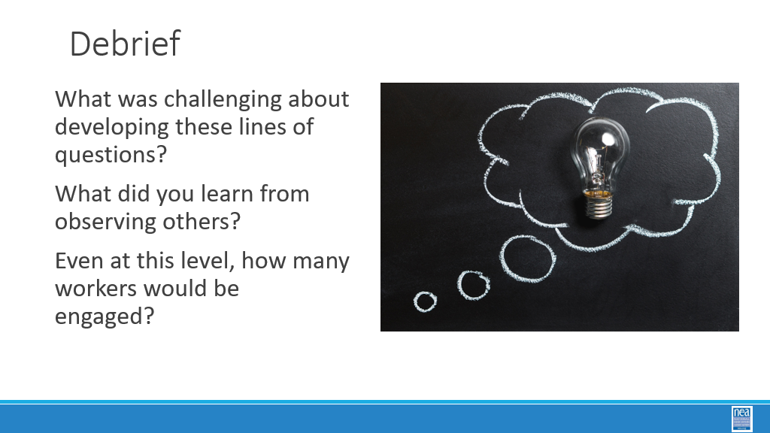 |  |  |  | 30 min-Presenting questions to each side  Pair up with the other team with same scenario  Each team will have 10 minutes to present their lines of questions to the other team. The other team will provide 2 minutes of feedback (12 minutes total). Repeat with the other team (12 minutes)  (Total of 24 minutes)  Toney: Debrief for 6 Minutes  - What was challenging about developing these lines of questions?  - What did you learn from observing others?  - Even at this level, how many workers would be engaged?
10:45- 11:15  Bekah  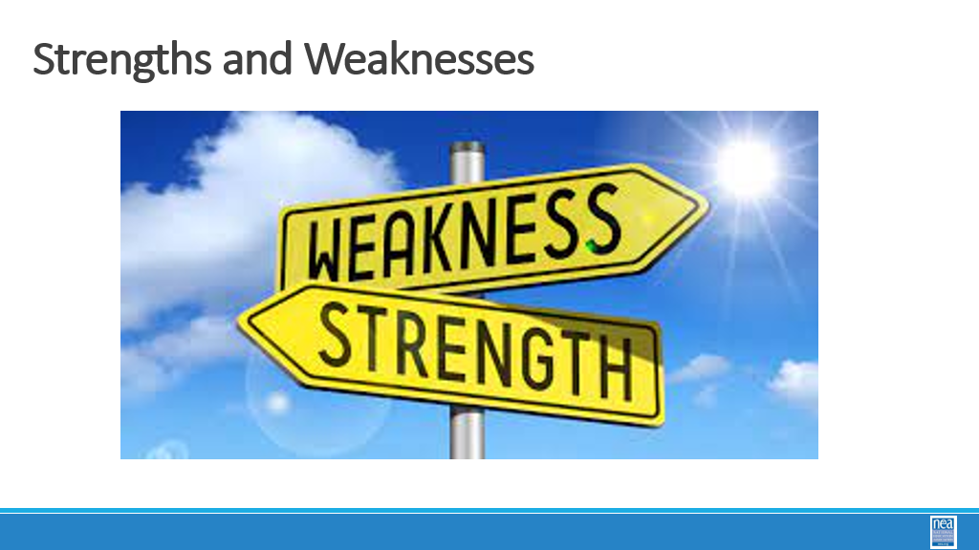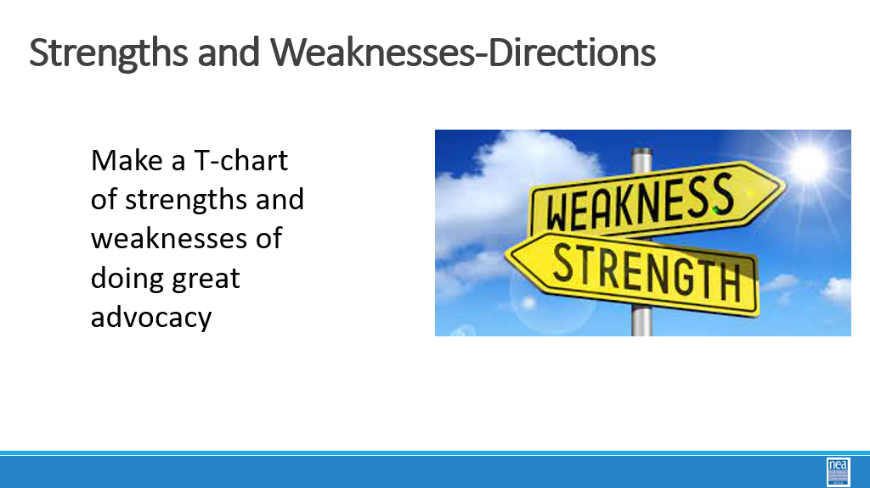  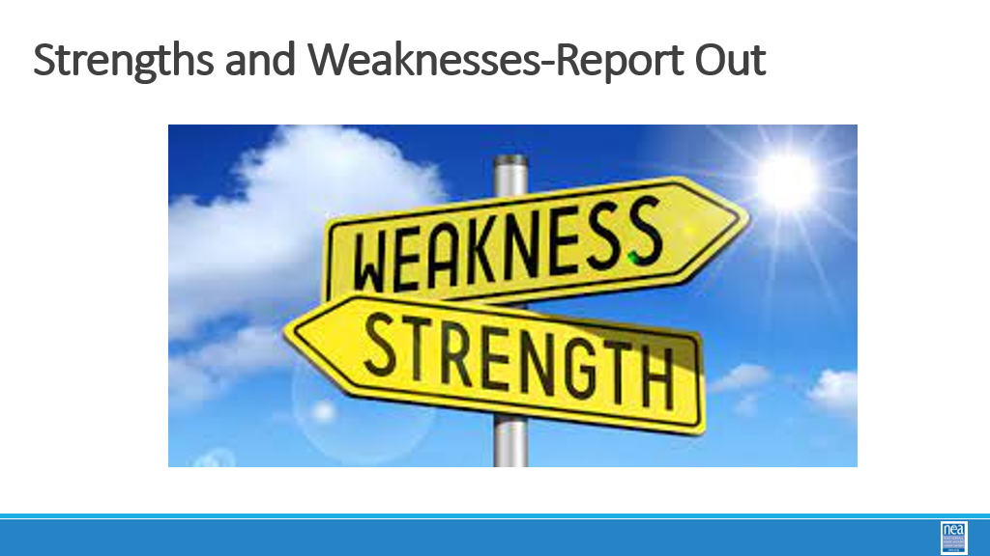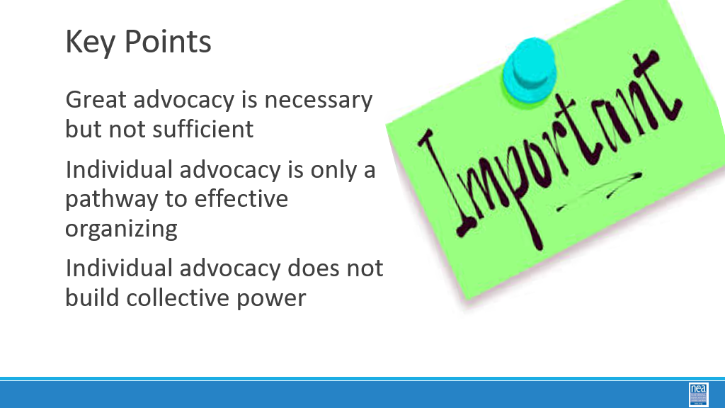 |  |  |  | 30 Mins TOTAL– What are the Strengths and Weaknesses  5 mins - Randomly assign groups of 5 -- count off by 5  15 mins -Using a piece of chart paper, make a T chart and list what are the strengths of doing great advocacy and what are the weaknesses of doing great advocacy  10 Mins – Discussion  Important Points:  -Great advocacy is necessary, but not sufficient.  -Advocacy is only a pathway to effective organizing.  - Individual advocacy does not build collective power
11:15 -12:00  Steve and Ellen  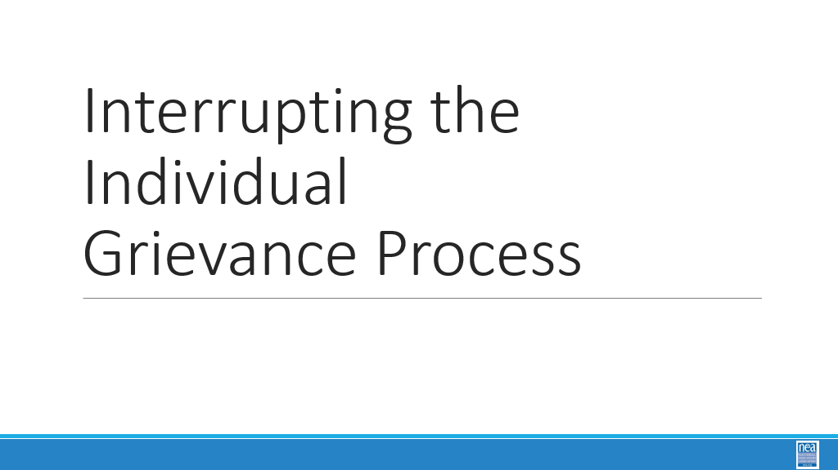  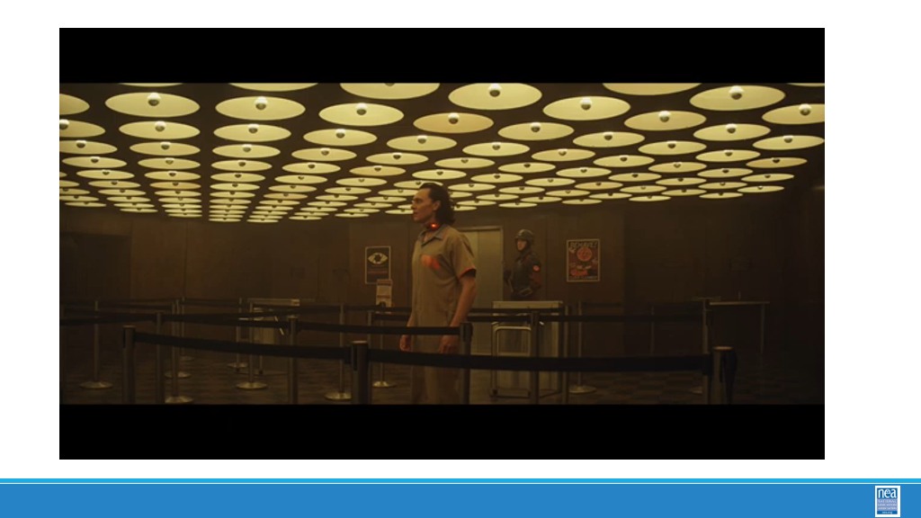  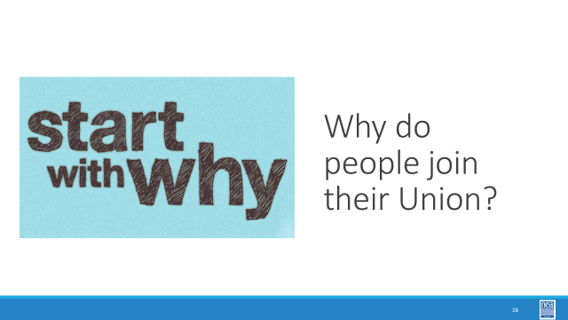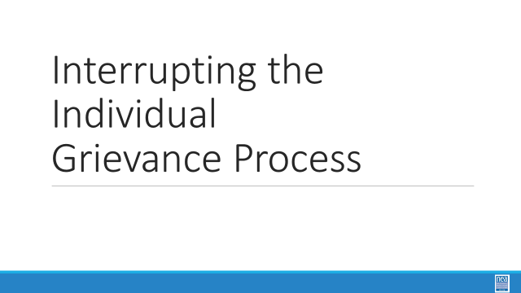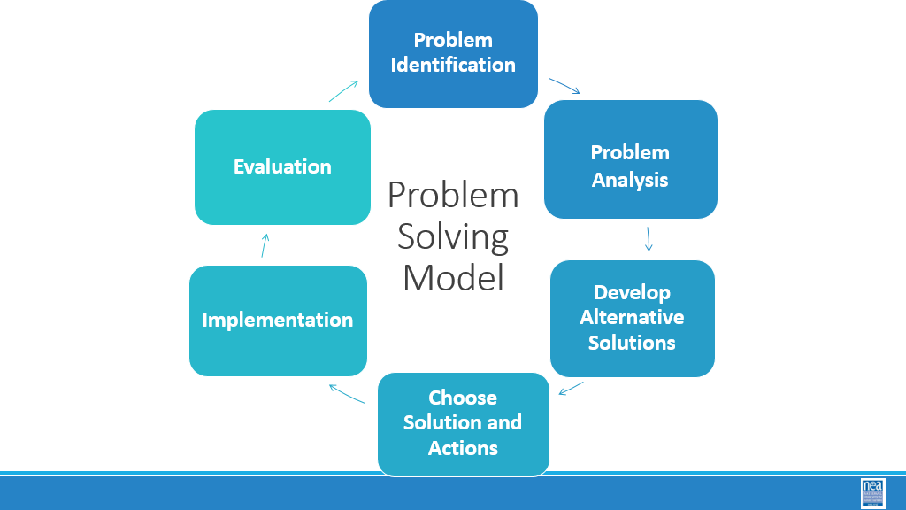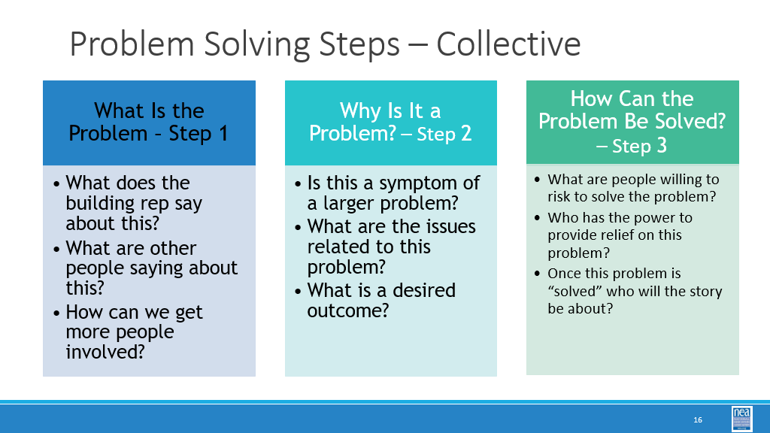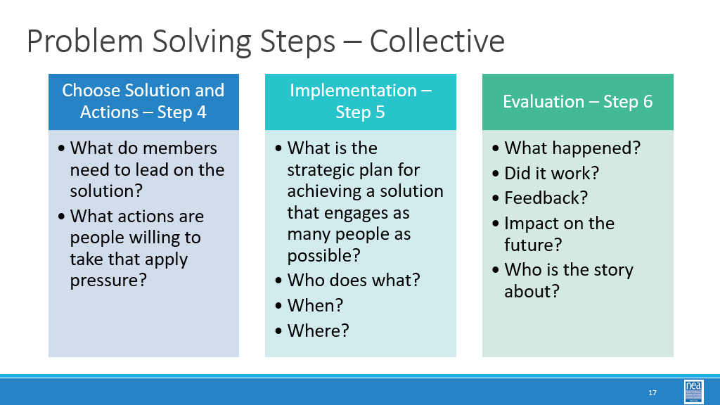  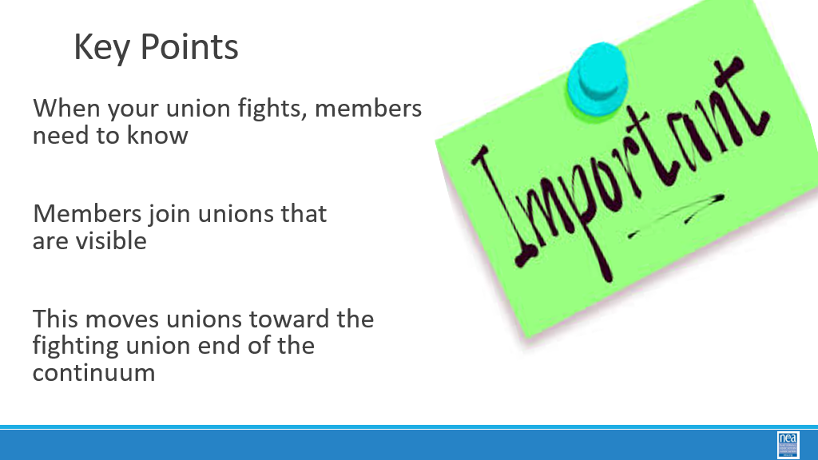  Ellen  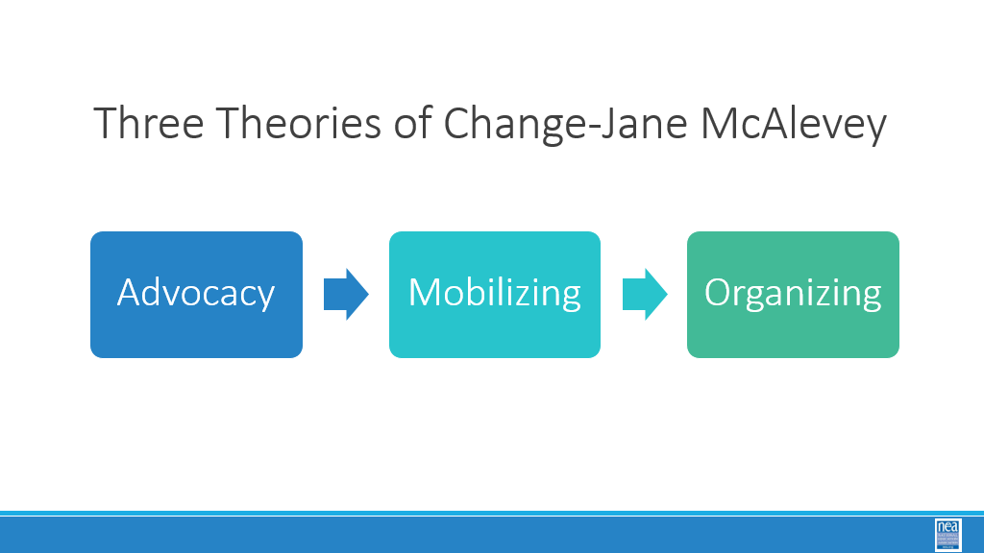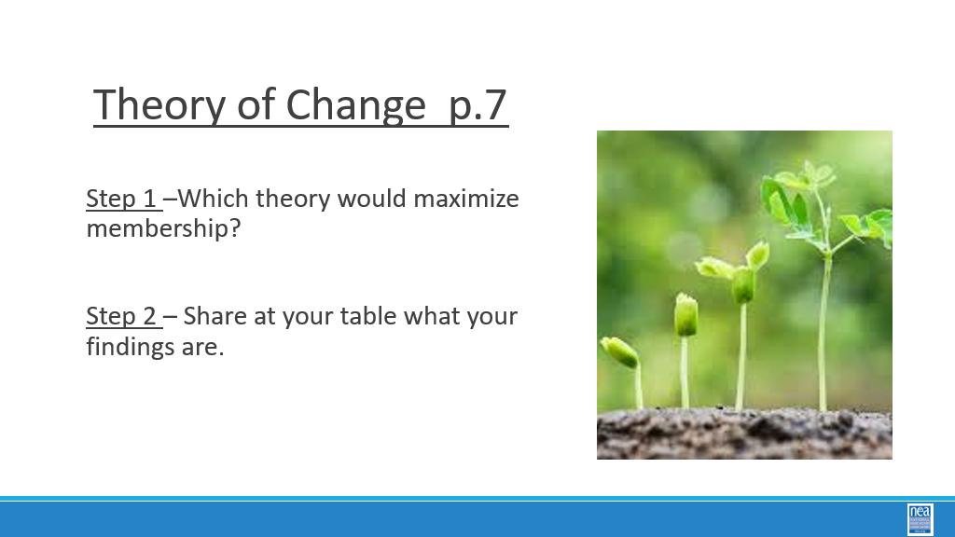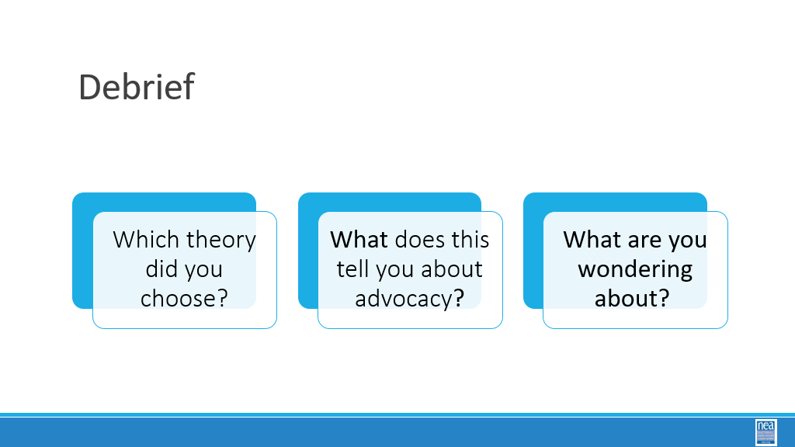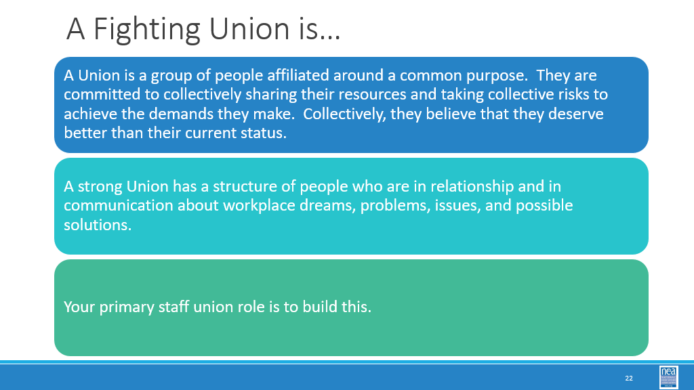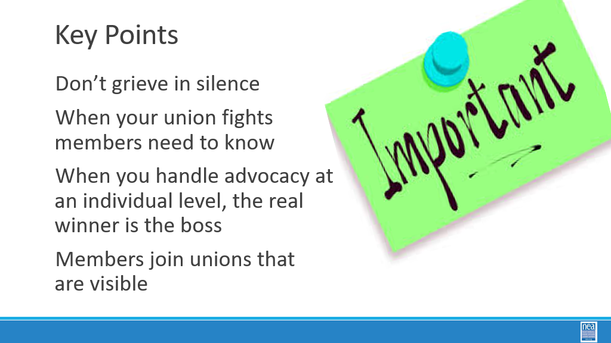 |  | Three Theories of Change Framework Pg 5-8  Participants handbook-Problem Solving Steps page 94 |  | 45 Minutes TOTAL– Interrupting the Individual Grievance Process  3 mins- introduce Loki video of disrupting timeline 2 mins  Sacred Timeline- Like the Sacred Timeline in Loki, our locals are often focused solely on the grievance timeline as opposed to finding ways to further engage and involve members in the grievance process. It is important to follow “the sacred timeline of a grievance procedure, but there is so much more they can do. While the video discourages “variants,” want them. While the TVA fears “nexus” events that create new timelines, we embrace them. Variants (organizers) create nexus events (tactics) that create multiple timelines (campaigns).  6 minutes. Start w/why do people join their unions. Turn in and talk for a quick minute. Allow members to popcorn answers, not allowing participants to repeat someone else’s response. Members join a group that they feel as if they are the center of.  15 Minutes to share how the problem-solving cycle changes from individual advocacy to collective - Let’s revisit our problem-solving model, but this time look at how we interrupt the individual grievance process. Instead of focusing on the individual grievance intake form, consider what would happen if you applied the questions in this cycle as opposed to the questions in the other cycle (Facilitator will use the 2 Problem Solving Steps slides) See pg. 94 of handouts for other questions that allow you to interrupt the individual cycle of advocacy and make it more collective (“Coaching for Organizing through Advocacy”).  Key Point: If you are always doing the work, you are creating changes that are not visible or putting people in the center of the work. When you fight, members need to know. Members join unions that are visible. This moves our unions towards fighting unions.  Notice the shift in the questions as we move around the cycle  As we dig into each step notice that the questions are focused on getting deeper into the issues and getting more and more people engaged.  15 min- The Three Theories of Change framework comes to us from Jane McAlevey. This is found on Pages 5-8. She asserts that the decline in the labor movement comes primarily because of the overreliance on advocacy and mobilizing to build power. Organizing requires mass support among the rank and file – power is built through numbers. Mobilizing activates an already convinced membership and unlike organizing, does not continually seek to expand those who are involved. Advocacy relies on making change through a small set of professionals or technical experts.  10 minutes to discuss and report out – Why do people join their unions?  Let’s have a quick table conversation – why do people join their unions?  What are some of your thoughts?  Key Points: When you handle advocacy at an individual level, the real winner is the boss. Organizing is how workers build power to win.
12:00 - 1:00   | LUNCH
1:00-1:30  Seleste  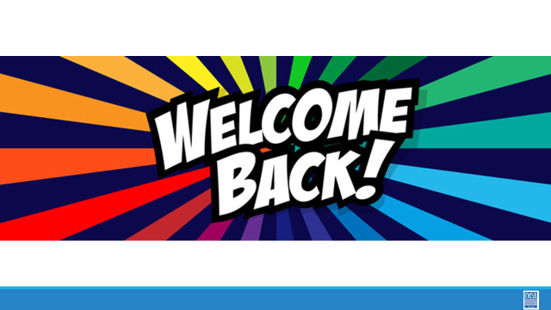  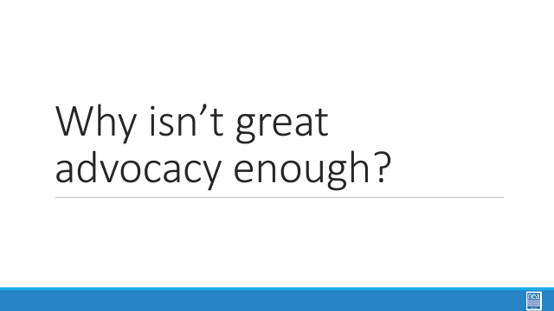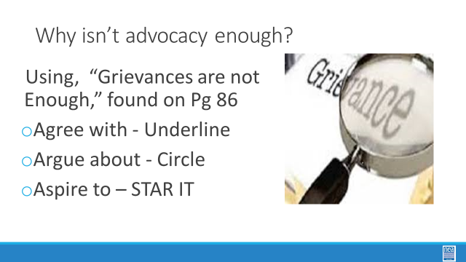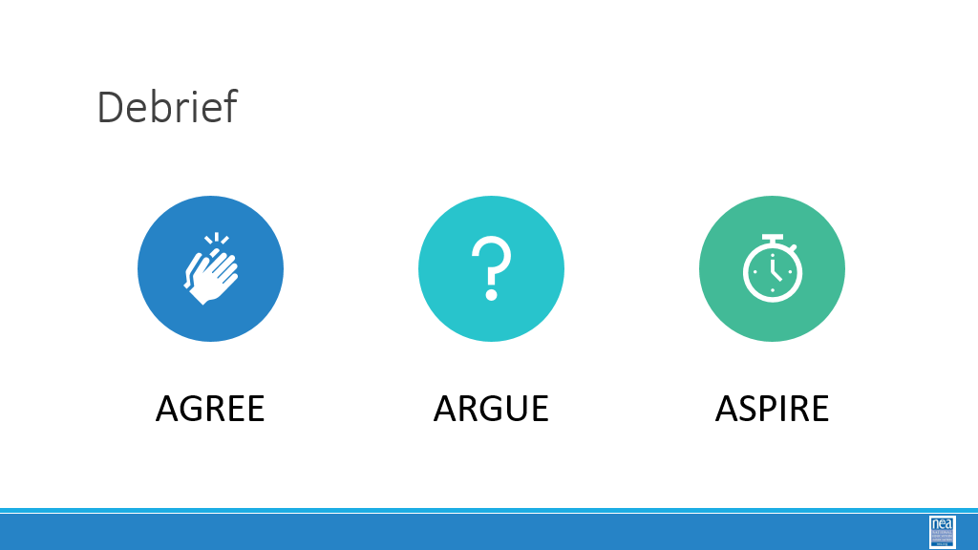  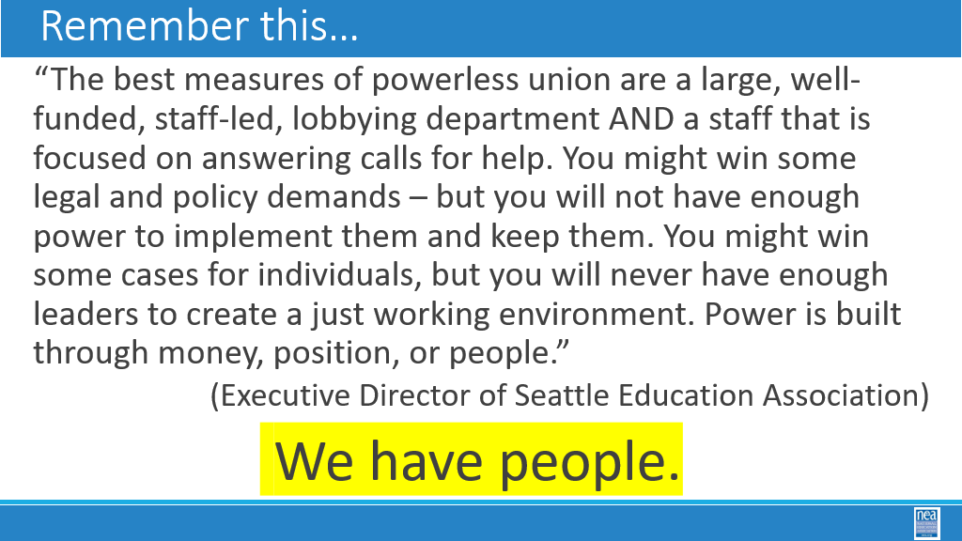 |  |  |  | 30 Minutes Total – Why isn’t great advocacy enough?  5 mins to prep  We have explored about why advocacy is not enough.  20 mins- Using page 91 (“Why Grievances are Not Enough) we will do a 3 A’s activity – Agree, Argue, Aspire  - Agree with - Underline  - Argue about - Circle  - Aspire to – STAR IT  5 mins- Discuss what you see, and the debrief as a whole group
1:30 – 2:15  Vanessa  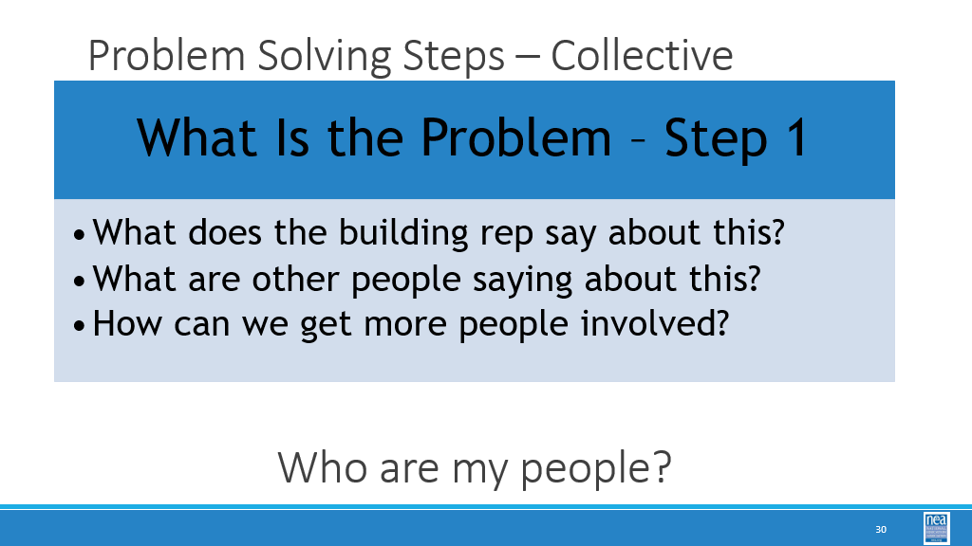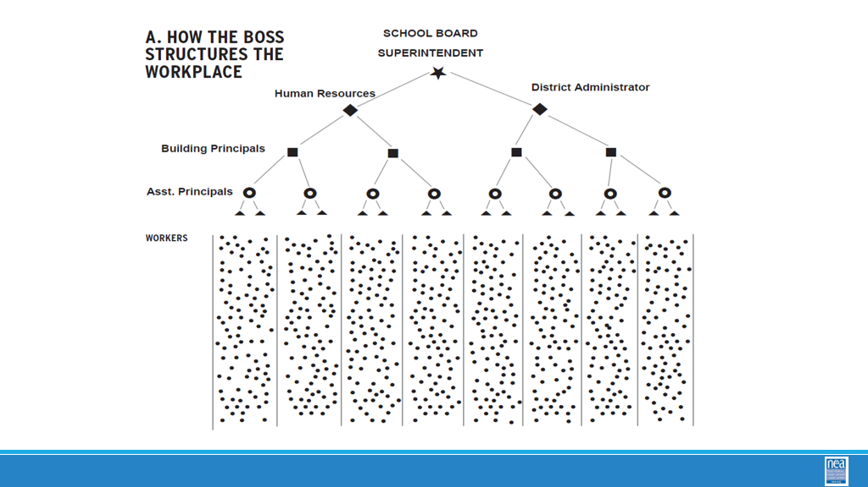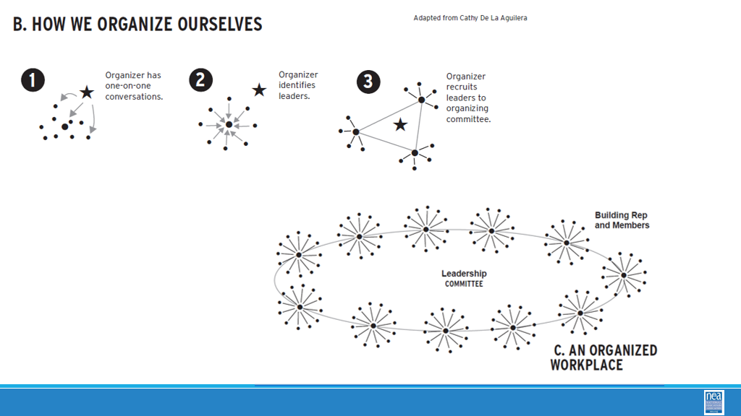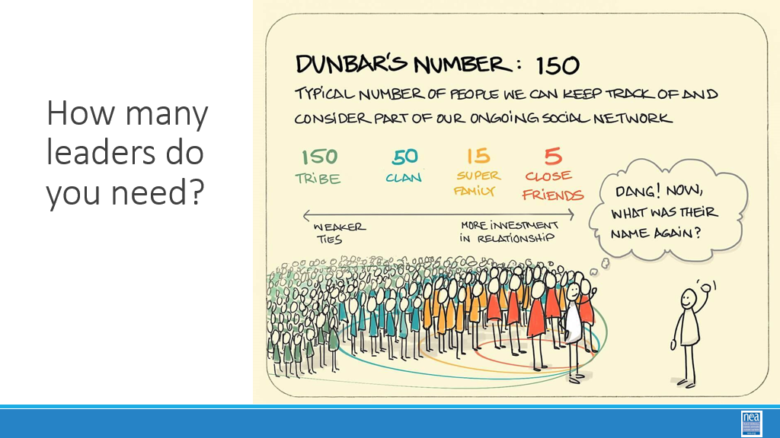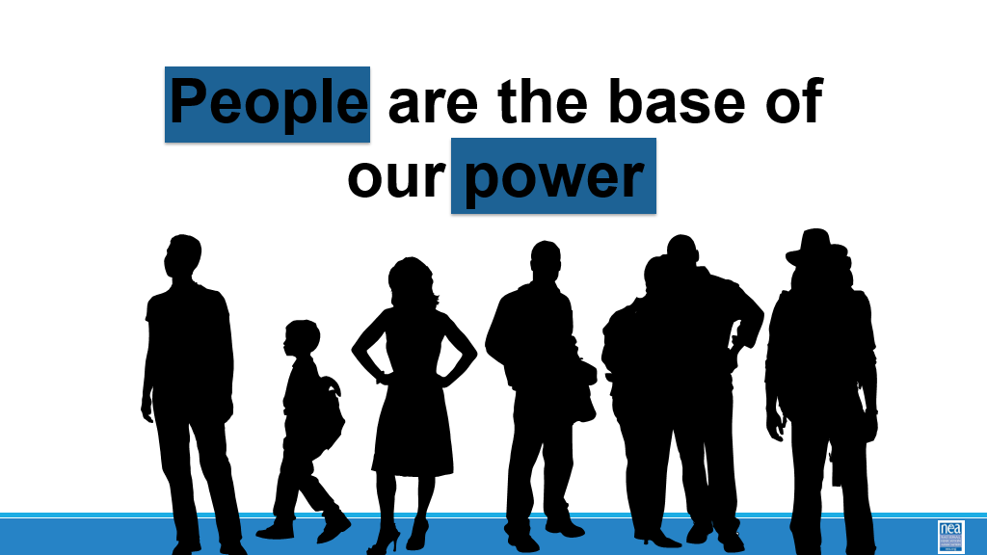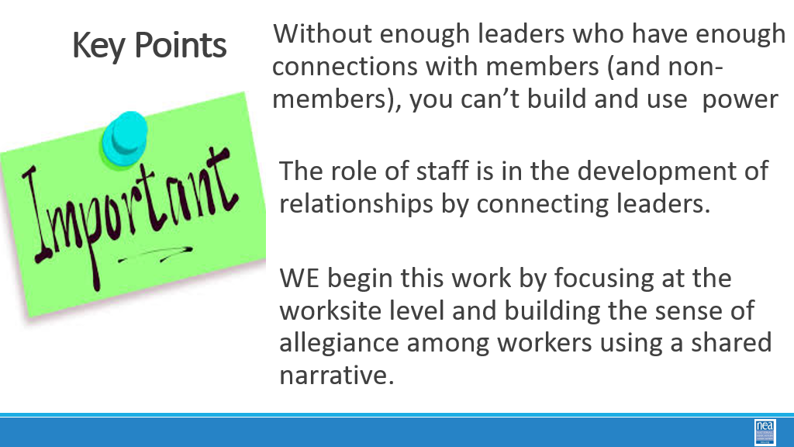  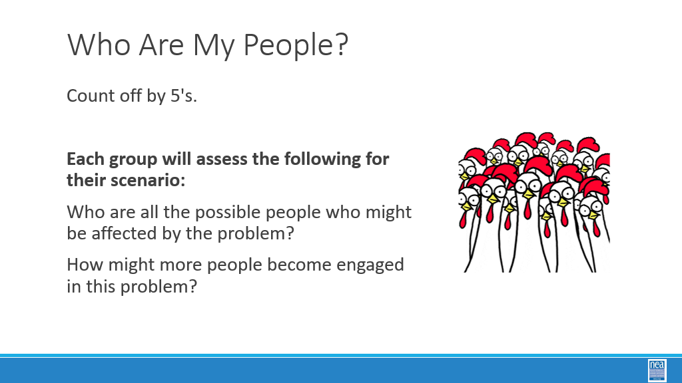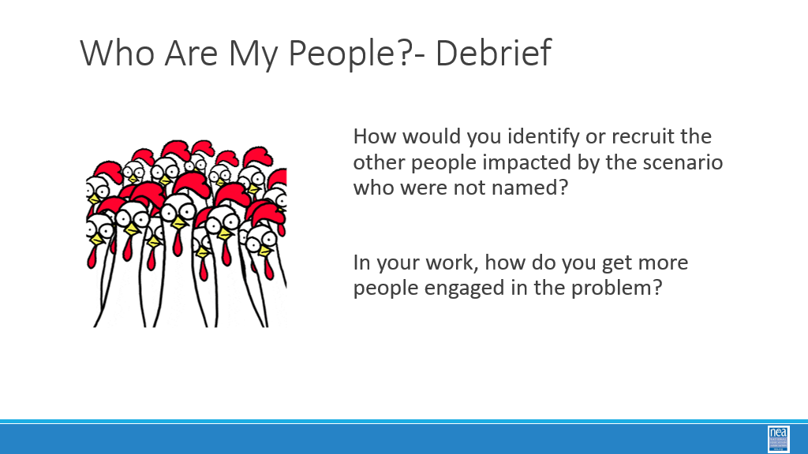 |  |  |  | 45 mins total: People-  15 min  Back to what is the problem, Step 1 when looking through an organizing lens. We have building reps, members, individuals who care about a single issue. Bottom line, we need to figure out who are our people.  Review how a school system is organized by the boss, and how we need to organize it. If we look at a traditional leadership model, we see a single leader at the top (by position and title). An advocacy theory is that the boss holds the power. The majority of the individuals are the workers. He workers are disconnected without a structure.  Instead let’s look a model where we develop a plan and structure to organize ourselves to build power. An organizer has one-on-one conversations to recruit leaders. The organizer then connects the individual leaders to form an organizing committee. This structure does not have a single leader. This model promotes shared decision making and power building.  Review how many leaders we need  Dunbar: The superintendent has the ability to effect change/move people to action because of his/her title. We need relationships. A good organizer can have as many as 50 meaningful relationships.  Key points: People are the base of our power  5 minutes: Return to your scenario groups. Answer the following questions:  - Who are the people who are affected?  15 Minutes of work Time - Who are my people  Return to Scenario  5 min debrief:  - How many more people are now part of the problem-solving process?  - What barriers/challenges, if any, did you anticipate in engaging more people?  - What challenges did you identify |  | .
2:15 -2:30   | BREAK
2:30-3:05  Ellen and August  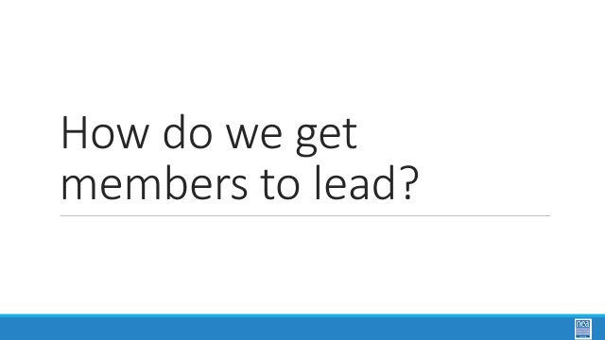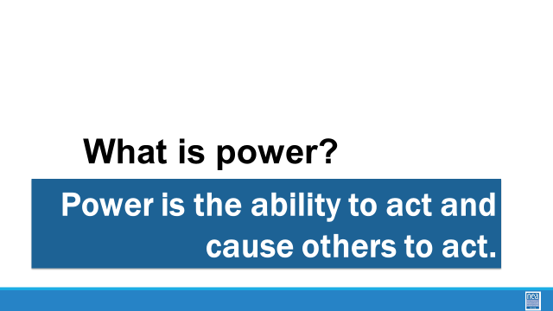  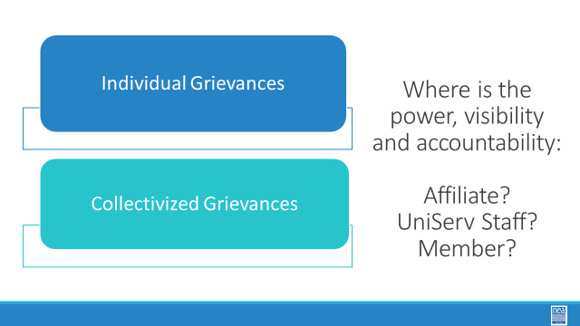  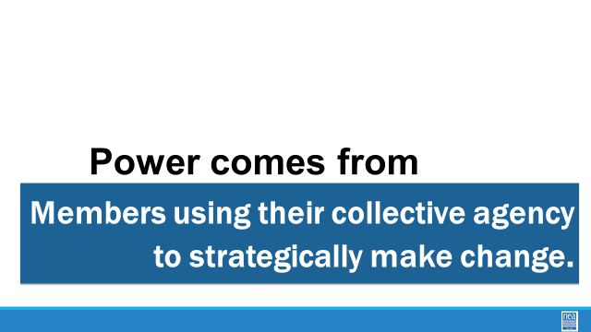  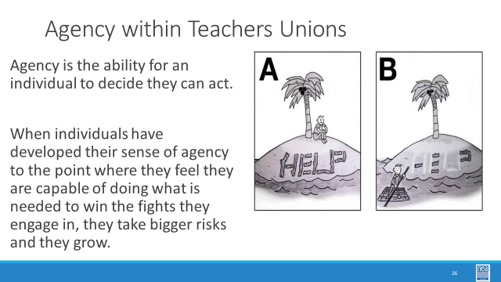  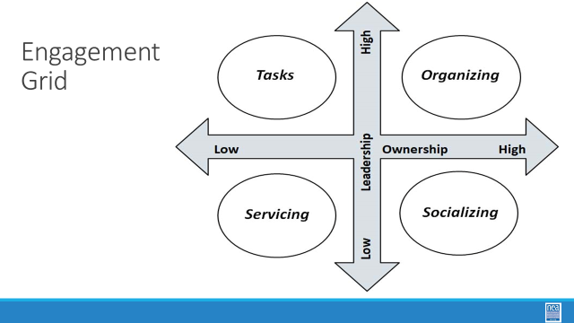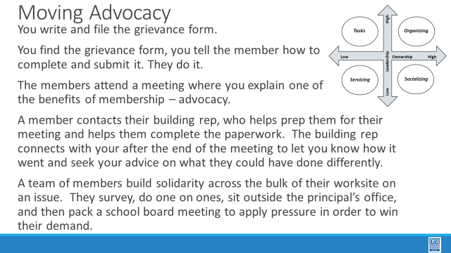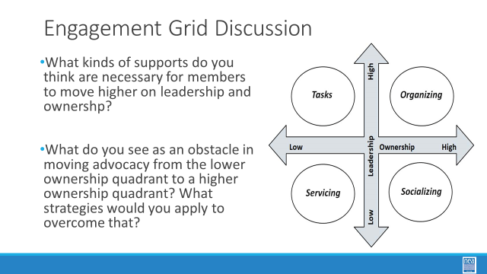  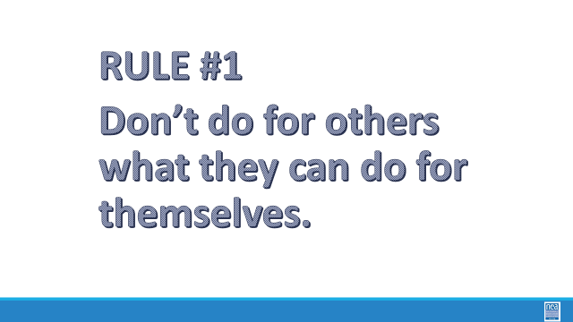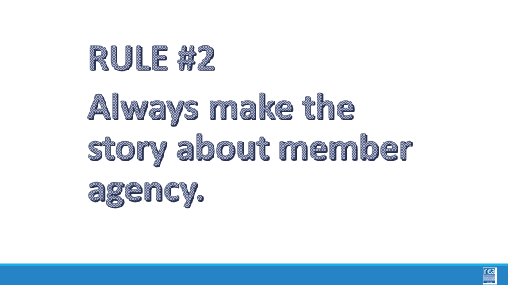  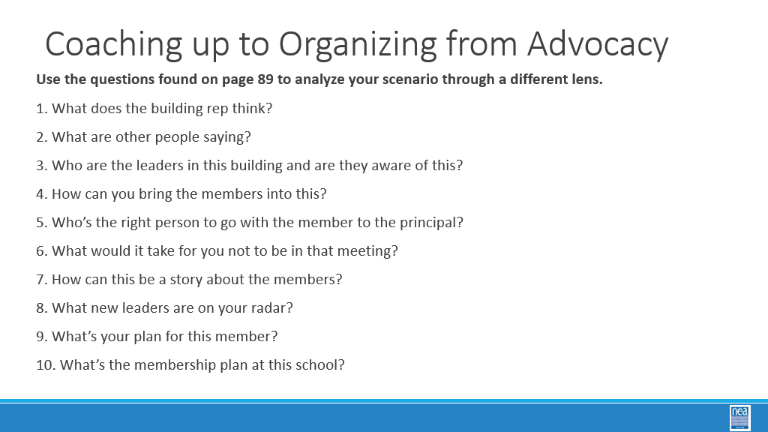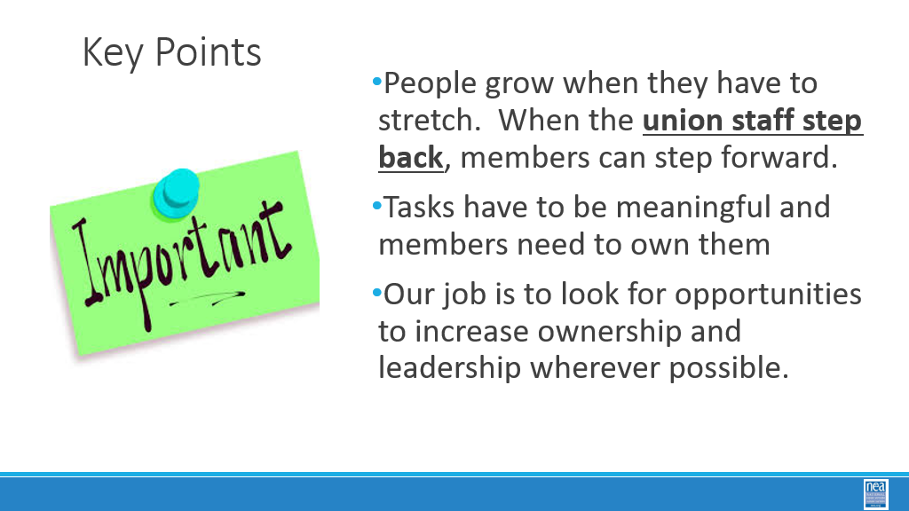 |  |  |  | 35 Minutes Total – How do we get members to lead (Ellen)  Let’s do a quick reminder – Power is the ability to act and cause others to act  10 Minutes from here through the slide about agency  Quick Table talk - When we do individual grievances vs. collectivized grievances -  Where is the power, visibility, accountability for the UniServ Staff? For the Member  Take few responses  Turquoise and Blue  IG: All the power is in the advocate, the professional, the UniServ Staff  CG: This is lead by the people, the people take on the issue. The people are the center.  Power comes from members using their collective agency to strategically make change.  Palm Trees  So, what is agency? - it is the ability for an individual to decide they can act. Acting is a risk. The more capable they feel to do the action, the more risk they are willing to take. It is through this that we grow rank and file to activist members, then to mobilizer members, and into trusted and respected and tested leaders.  The Goal for us, as UDs, is to help allow for this growth, to facilitate a member’s and leader’s ability to act.  10 Minutes from the Engagement Grid through Rule 2 Slide  Low Leadership/Ownership  *Staff led or Local Leader lead, surface  *When members feel like they are leading and they are oragnaizing, this is is the goal!  This engagement grid is a useful framework to help you think about how to move members and their actions into the organizing space. The Horizontal axis represents low to high ownership. The Vertical axis represents low to high leadership. VERY high ownership and leadership are required for organizing. Let’s focus on some examples of actions that involve advocacy.  1-2-3-4-5  At your tables – decide which quadrant each of these 5 actions live in and why you think so.  Debrief  Key points – the way you begin to collectivize grievances is rule 1 and 2  10 minutes - Coaching up to Organizing – Return to Scenario use Page 94 to ask these questions about your scenario  Key points
3:05-4:15  Toney  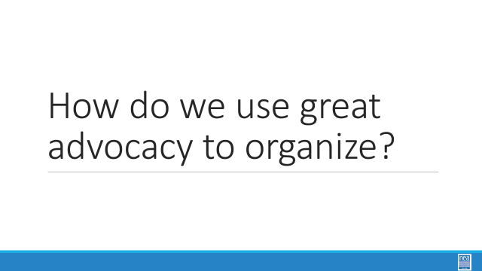  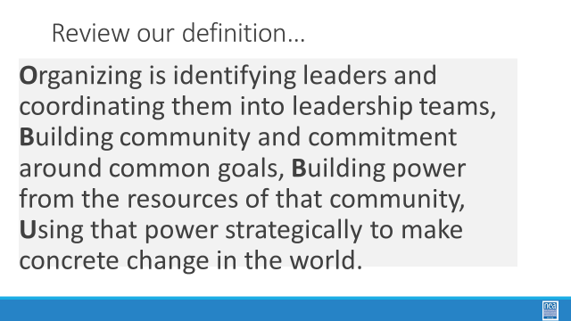  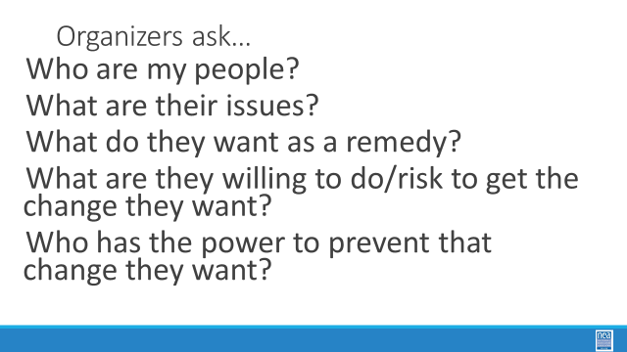  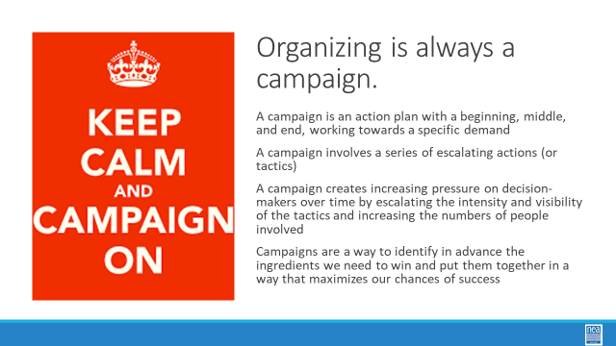  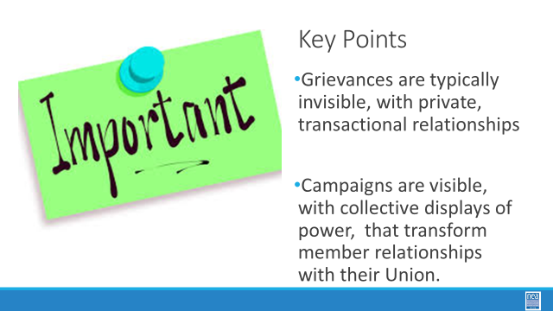  Bekah  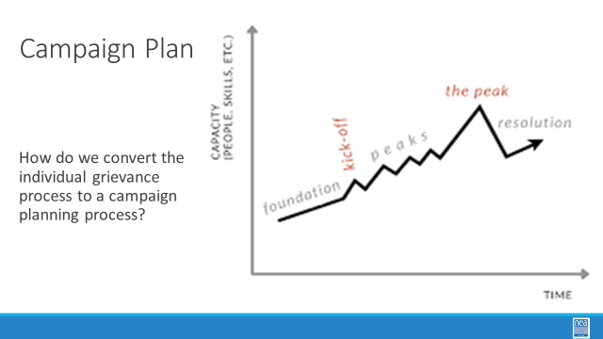  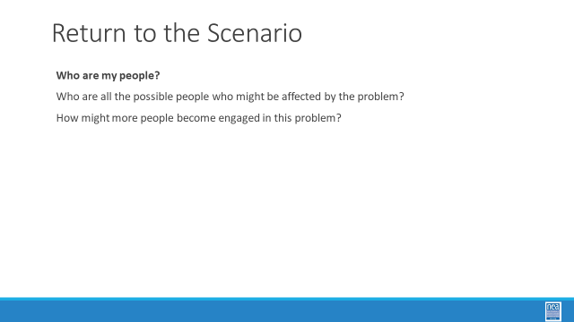  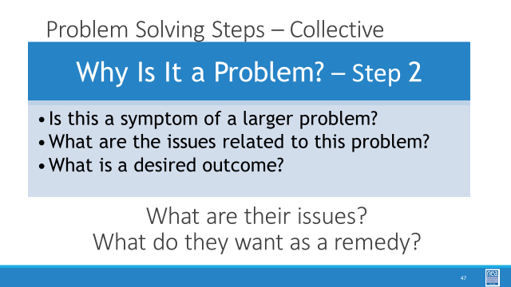  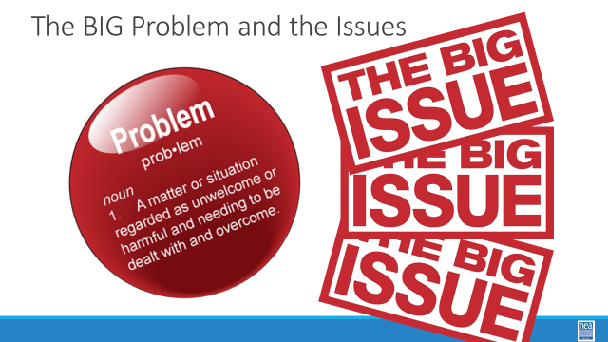  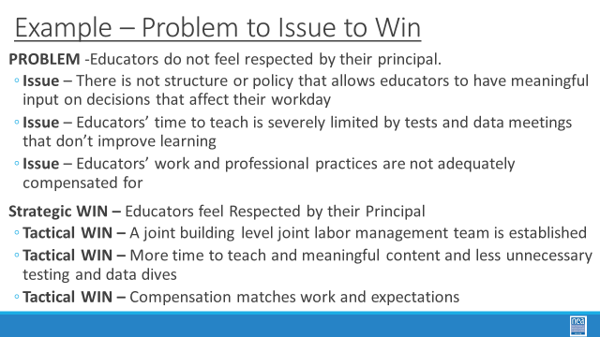  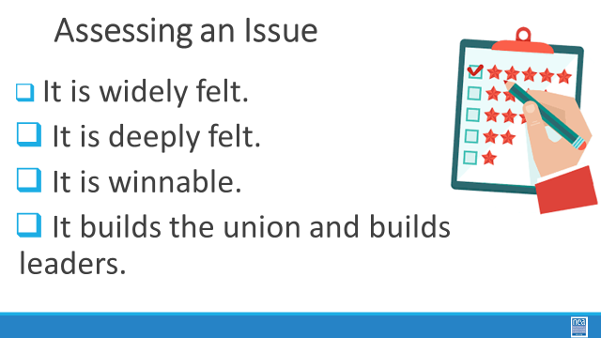  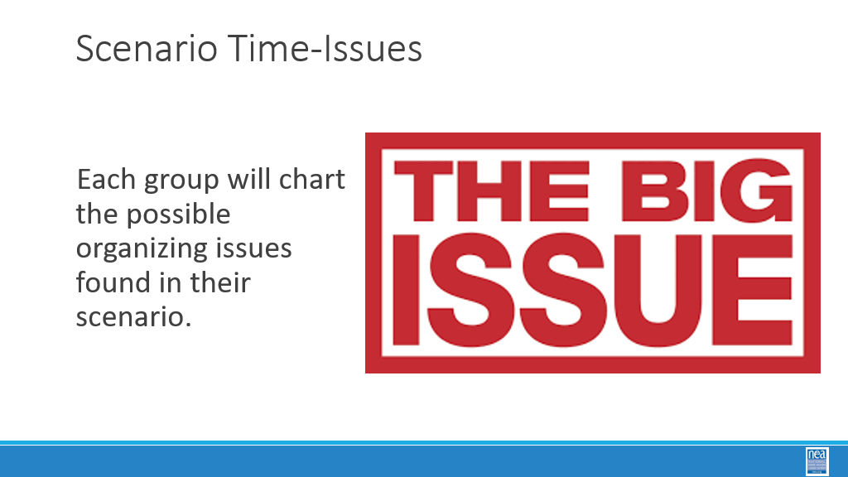  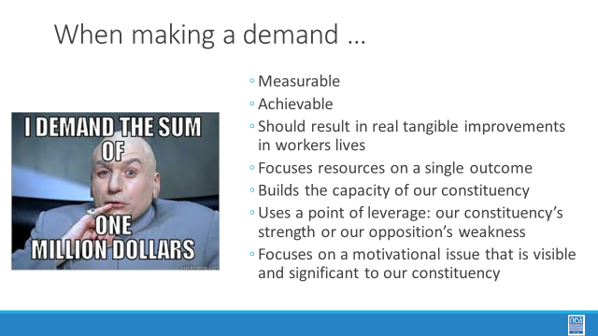  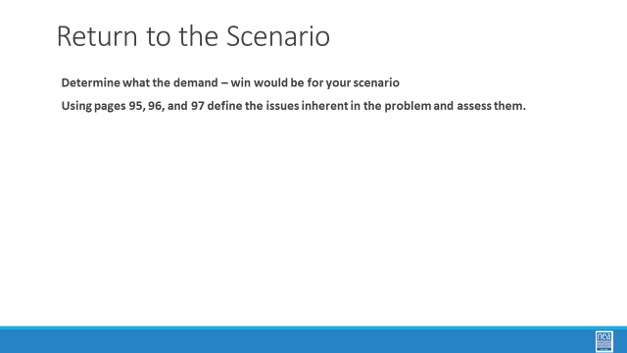 |  |  |  | 70 Minutes – How do you use great advocacy to organize?  10 Minutes - From Review of Organizing Definition to Key Points  Review the definition of organizing: “Organizing is identifying leaders and coordinating them into leadership teams, Building community and commitment around common goals, Building power from the resources of that community, Using that power strategically to make concrete change in the world.”  If they are reading the slide, summarize with the following:  - Organize Leaders  - Create Leadership teams  - Foster environment around common goals  - Build power through resources  - Use the power created to bring the change so desired  Organizer’s ask  -Who are my people? (Who can you rely on, who is willing to join you on the battlefield, who care about the same issues)  -What are their issues? (What do they care about?, What concerns do they have, Why do they feel the way they do?)  -What do they want as a remedy? (What is their solution, Why do they want that remedy, How will that remedy help?)  What are they willing to do/risk to get the change they want? (What tactics could be used in an overall campaign)  Who has the power to prevent that change they want? (Who are the movers and shakers? Who are the targets to get them what they want?)  Campaigns  Are intentional plans. They have a start, middle, and a finish. Actions, or tactics, should escalate throughout the campaign with the goal of increasing pressure and the number of people engaged. Ultimately the campaign will help the local achieve its demands.  Key Points  - Grievances are invisible, often there is little communication with members other than the grievant  - Campaigns create power, engage members and create the change desired.  10 Minutes intro Campaign Plan  Turn and talk at your table. How could you convert the grievances presented earlier today into a campaign? How could you generate momentum beyond just the grievant?  Connect the Problem Solving Cycle to the Questions Organizers ask  Problem Solving Step 2- Why is it a problem?  -Is this a symptom of a larger problem?  -What are the issues related to this problem?  -What is a desired outcome?  The Organizer’s Question  -What are the members’ issues  -What is the demand they want to achieve?  The Problem and the issues  - Problem definition: A matter or situation regarded as unwelcome or harmful and needing to be dealt with and overcome.  - The Problem is the BIG Issue  - The Problem is a complaint; issues flow from the problem  - Why is it a problem – what are their issues and what do they want to win?  Example Slide  - Take inventory through members of the problem and the issues surrounding the problem they care about  - Solve issues lead to tactical wins  - Tactical wins lead to a strategic win  Assessing an Issue: How do we determine what makes a “good” issue?  - It is widely and deeply felt  - It is winnable  - It builds the union and builds leaders  40 Minutes Scenario Time – Identify problems and issues 100-102  Report out – What are some issues your team identifies and how do you know that they would be good issues?
4:15-4:30  Ellen | How are we doing so far? |  |  | 15 Minutes - Ending it Right-  Ellen: **NOTE** Send CBMA database website link to participants for registration in preparation for research activity on Day 3  Questions, Connections, Reflections  Housekeeping announcements  Plus/Delta at the Door  FOR TOMORROW – |  | Participants will be able to bring a little closure to their learning and provide feedback on the day.
4:30 – 5:00 | What is the expertise among my colleagues? |  |  | Choice Networking Activities |  | Participants will make useful connections with staff from other affiliates.
5:00 | ADJOURN

