Online Facilitator Agenda Day 1 – Organizing Through Advocacy
General Materials Needed: |  |  |  | Room Set-up:
Key Outcomes for the Event:

Time | Essential Questions | Resources | Instructions, Activity and Debrief (Facilitators) |  | Outcomes
 | What question(s) should this learning section answer? | Charts, handouts, articles, materials, slide  RED is for Facilitator  BLUE is for Participant | What are you saying, what are they doing, what questions will you use to guide learning and make clear the important points  Include an estimate for how long each section of the learning will take |  | As a result of this section of learning, what will participants know or be able to do?
2:00 – 2:30 | Zoom opens - Facilitator tech check and adjustments
Entry Activity  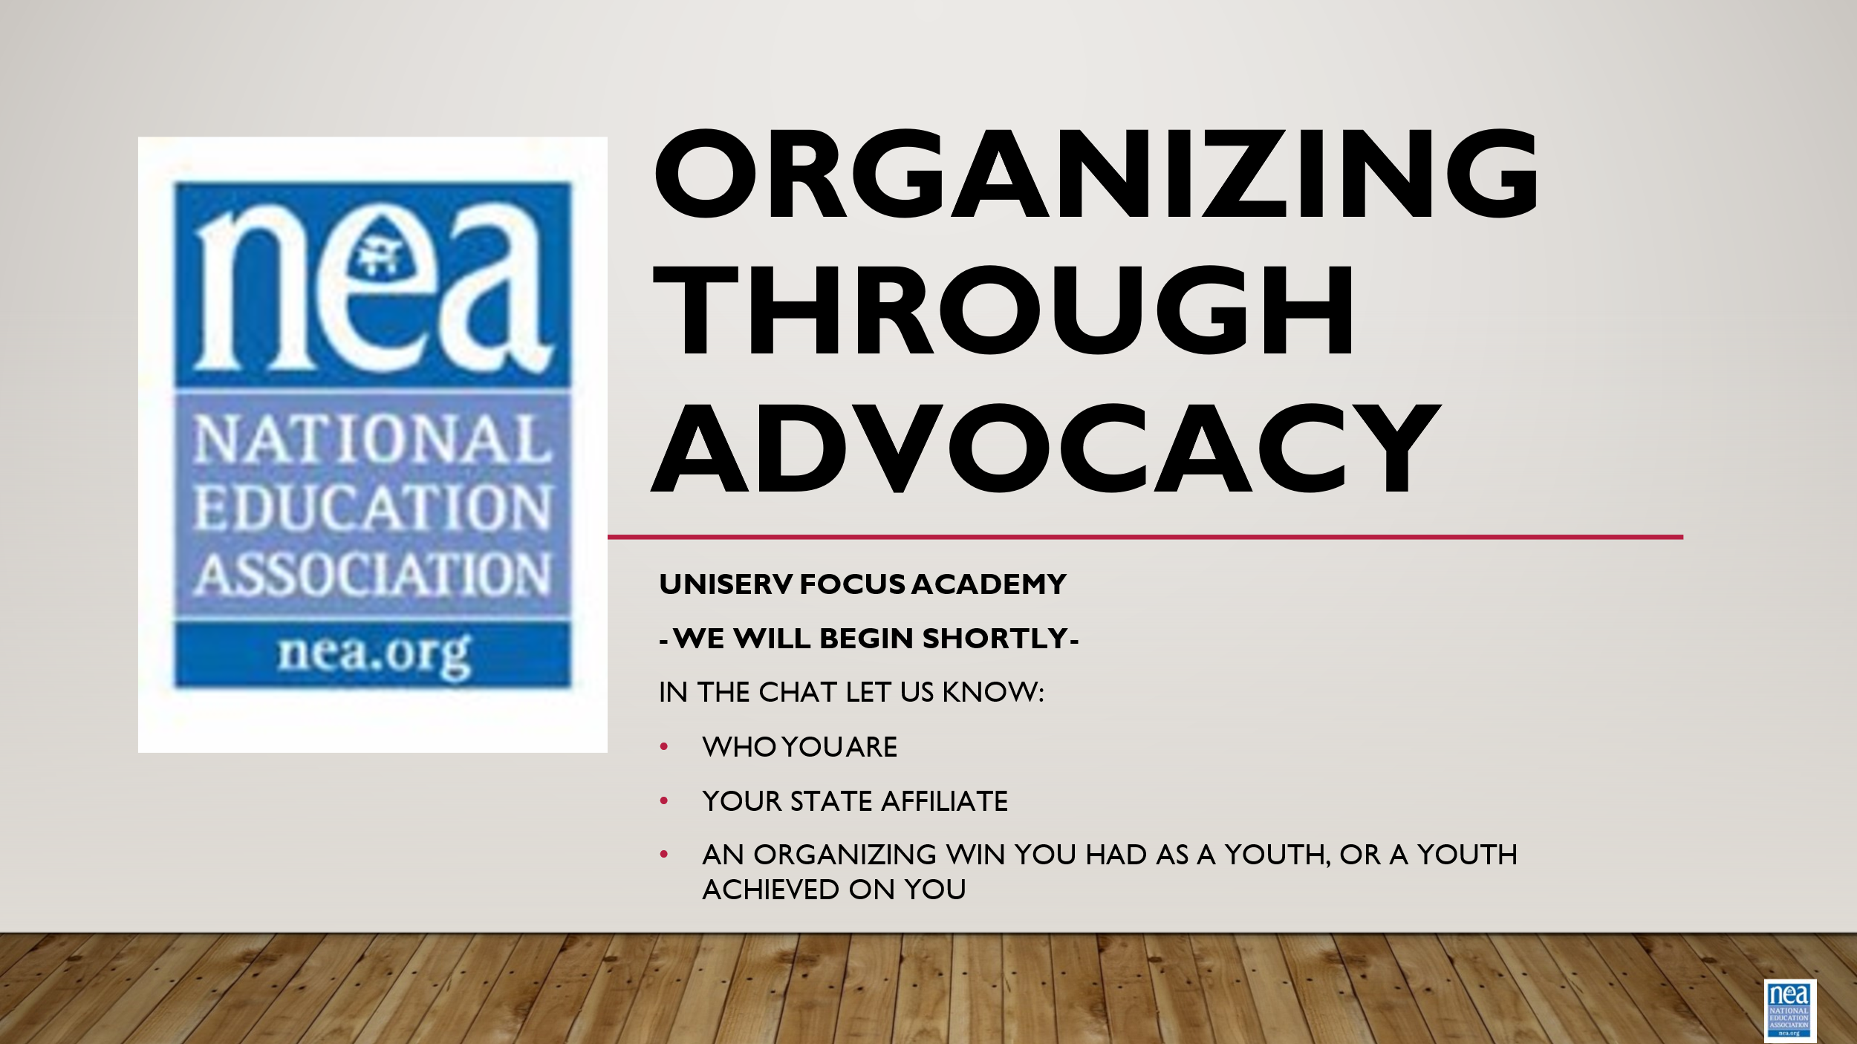 | 2:50 – the zoom is opened to participants. Music is being played and participants are engaged with an entry task: name, state affiliate, and a question for the day.
2:30 Chad  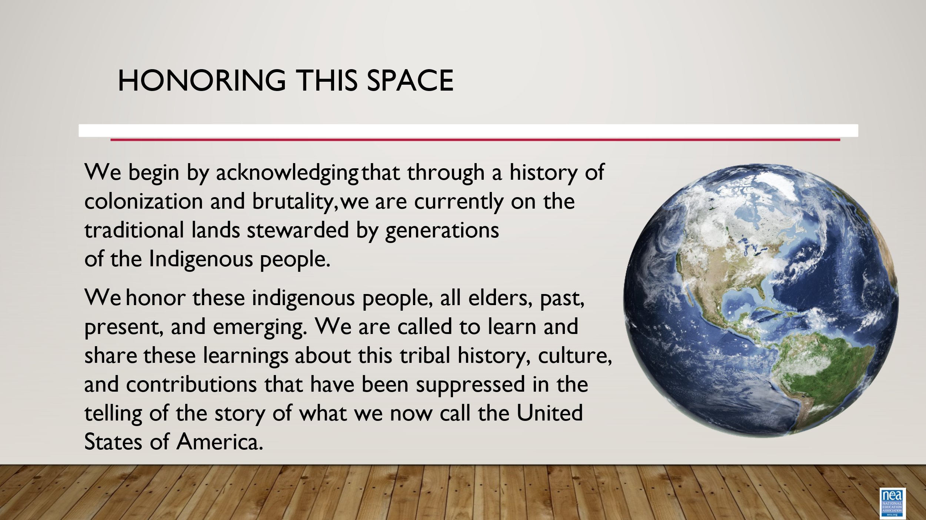    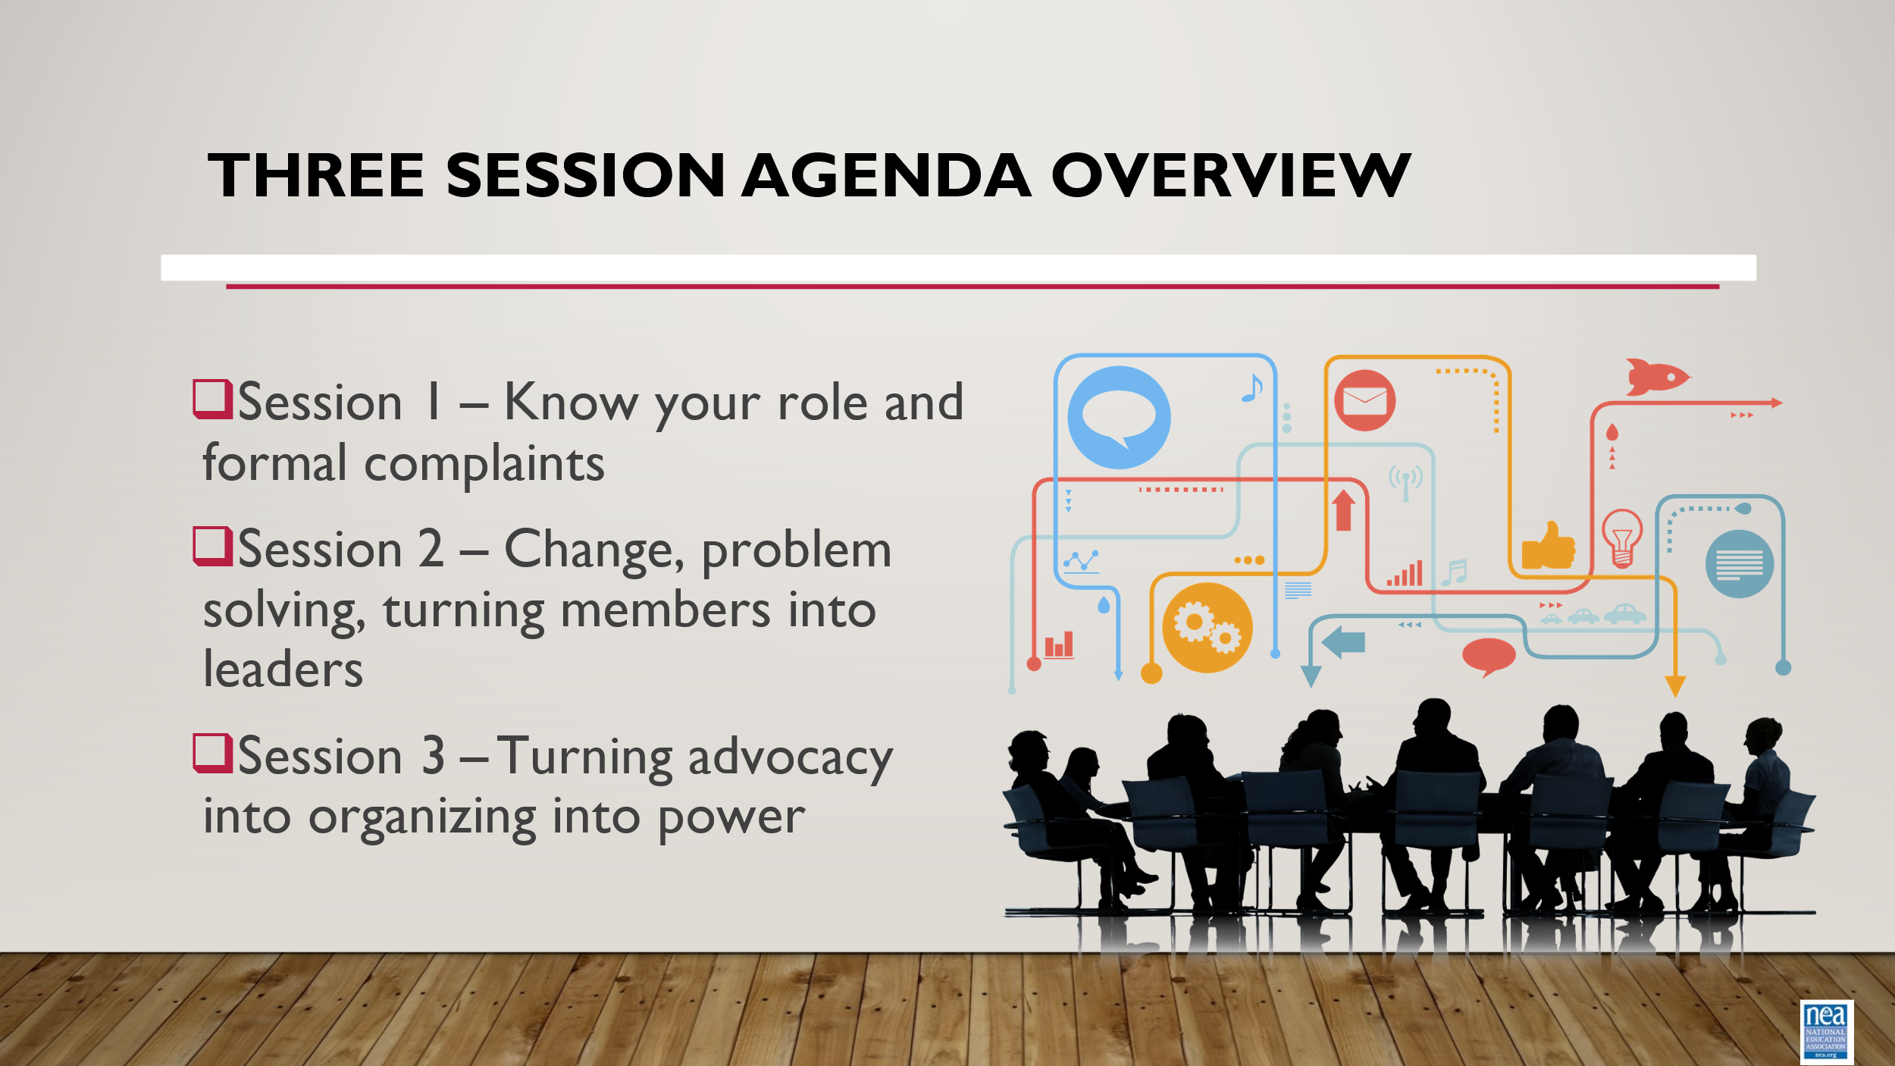  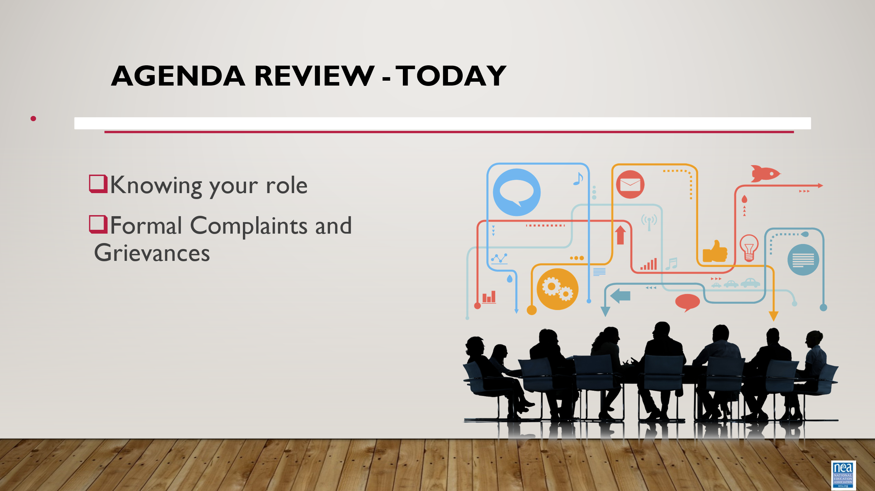 | How will we work together to support learning? |  | The National Education Association is committed to honoring the spaces that we occupy to advance the work.  - We begin by acknowledging that through a history of colonization and brutality, we currently reside on and are connecting from the traditional lands stewarded by generations of indigenous people.  - We honor these indigenous people, all elders, past, present, and emerging. We are called to learn and share these learnings about this tribal history, culture, and contributions that have been suppressed in the telling of the story of what we now call the United States of America.  5 Mins Facilitator Introductions  - Team intros include: Name, Work Location, years in the work, and your required pronoun  5 Mins – Today’s Agenda |  | Participants will know how we are going to work, the basic schedule, and the logistics relevant to the training.
2:35 – 3:00  Chad    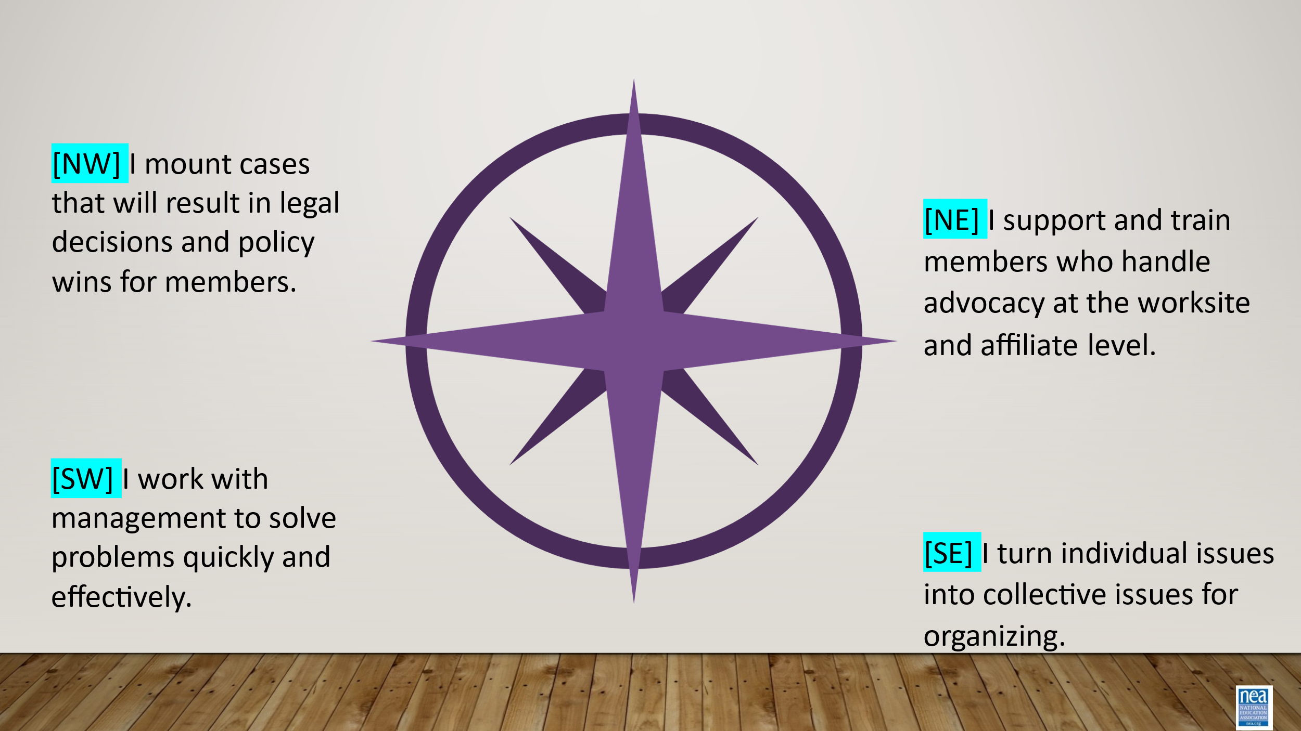  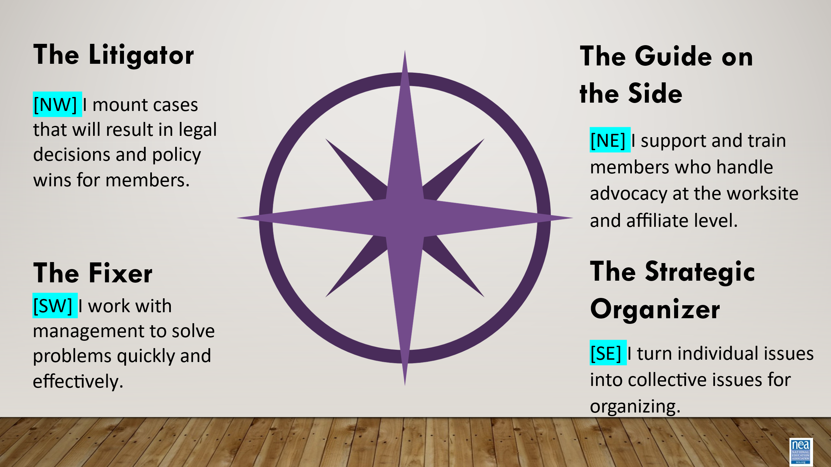  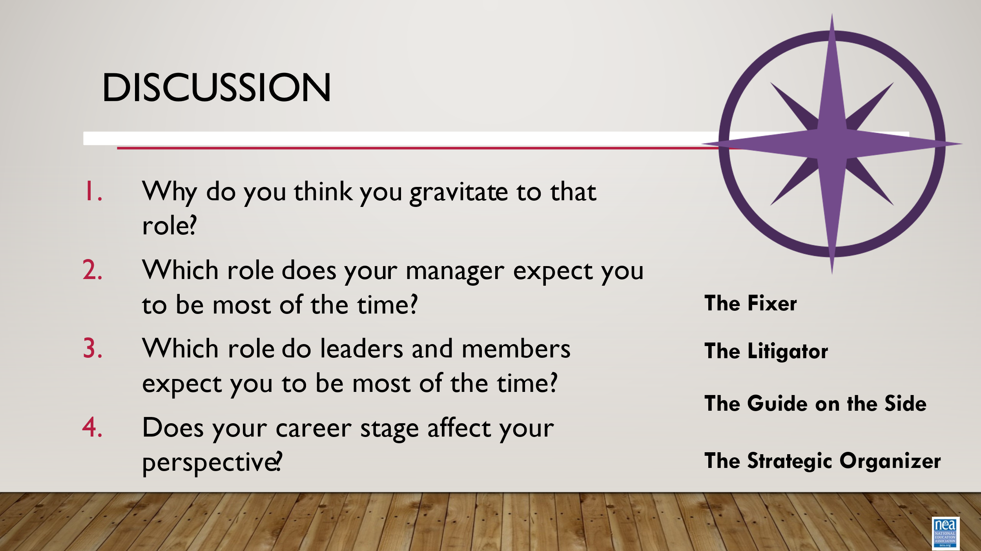  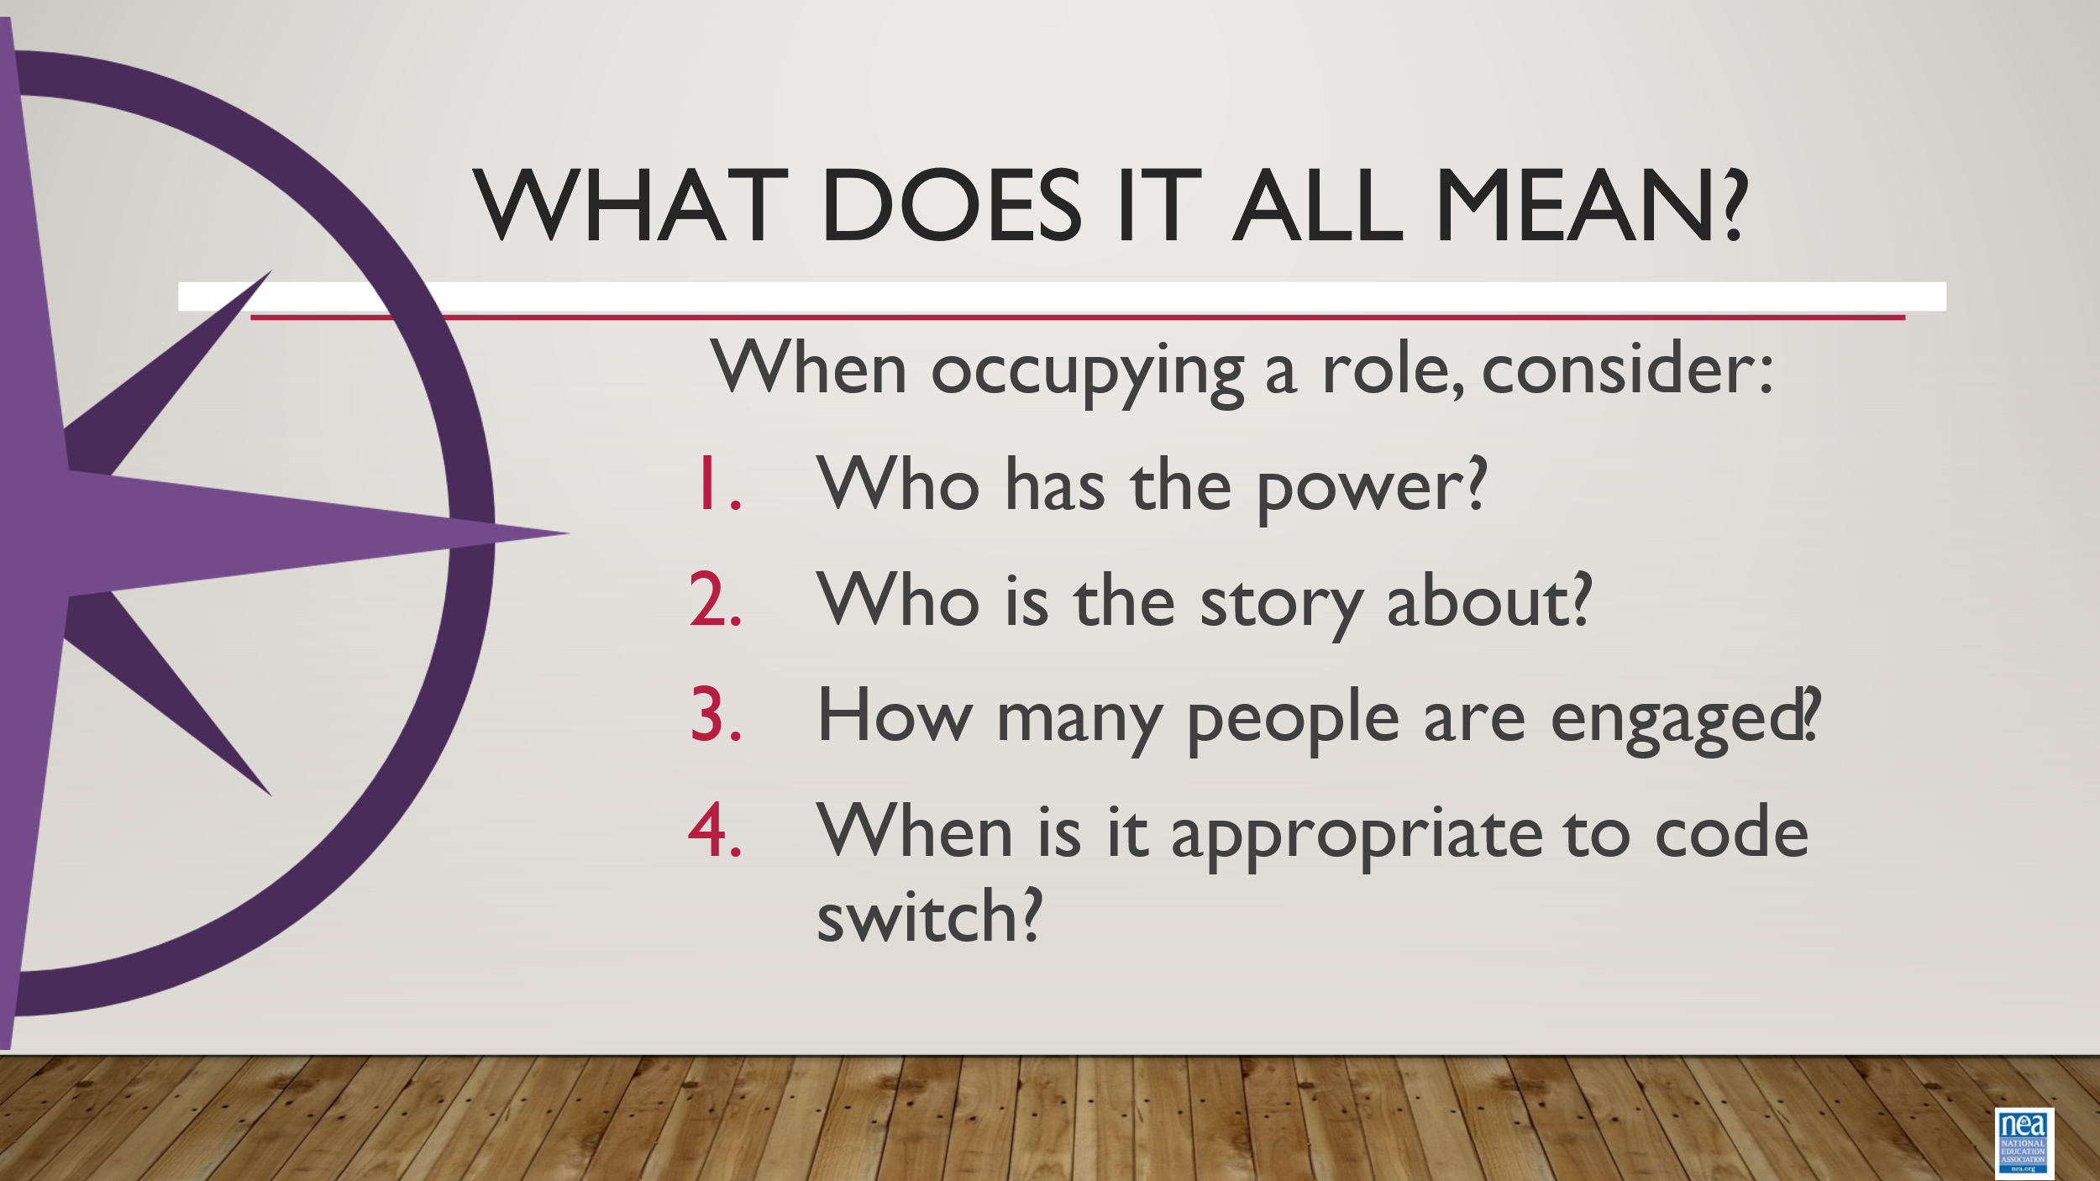  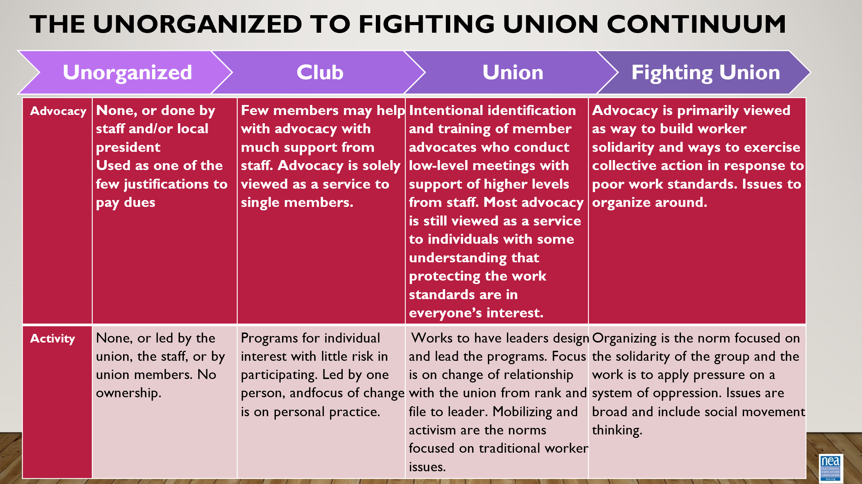  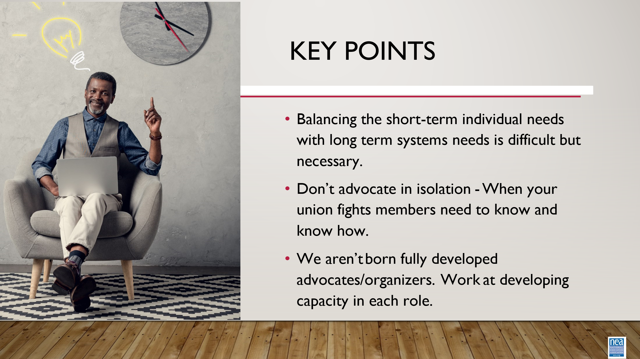 | What is your natural role as an advocate? | Participant waterfall | 25 Minutes Total - Where do you stand  The Litigator- mount cases that will result in legal decisions and policy wins for members  The Guide on the Side –support and train members who handle advocacy at the worksite and affiliate level  The Fixer – work with management to solve problems quickly and effectively  The Strategic Organizer – turn individual issues into collective issues for organizing.  Participants will look at the descriptions of each organizer role. Each role is denoted as a direction on the compass. They should be instructed to think about which role they typically occupy or have a tendency to gravitate towards or see themselves as. When instructed they will put their direction in the chat and hit send all at the same time creating a waterfall response.  After that, the next slide reveals the type of advocate that description matches.  Overall debrief  For each of the corners ask –  Why do you think you gravitate to that role?  Which role does your manager expect you to be most of the time?  Which role do leaders and members expect you to be most of the time?  Does your career stage affect your perspective?  To connect their thinking to their preferred role and other potential roles, ask them:  - Who has the power?  - Who is the story about?  - How many people are engaged?  - When is it appropriate to code switch?  To connect their thinking to why it’s important to understand and be able to occupy all the roles of an advocate, but also to orient their advocacy towards power and capacity building, go over the unorganized to fighting union continiuum.  Key points:  - Balancing the short-term individual needs with long term systems needs is difficult but necessary.  - Don’t advocate in isolation - When your union fights members need to know and know how.  - We aren’t born fully developed advocates/organizers. Work at developing capacity in each role.
Charles:  3:00 – 3:40pm  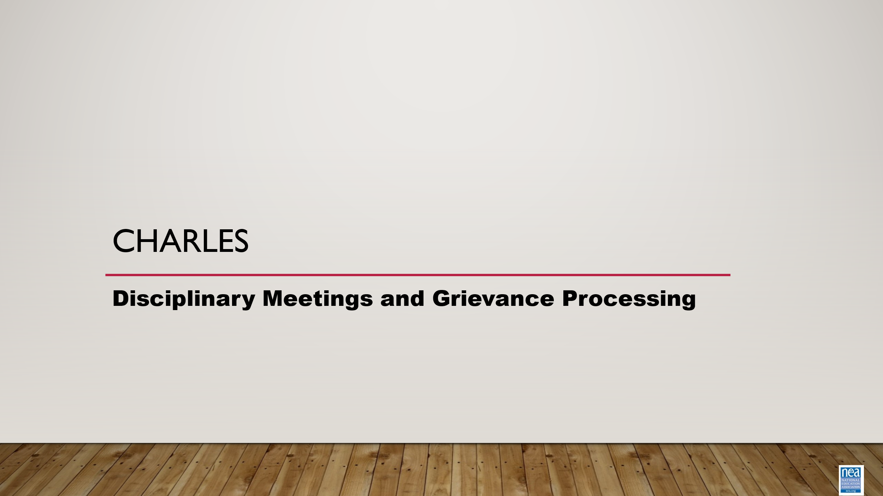  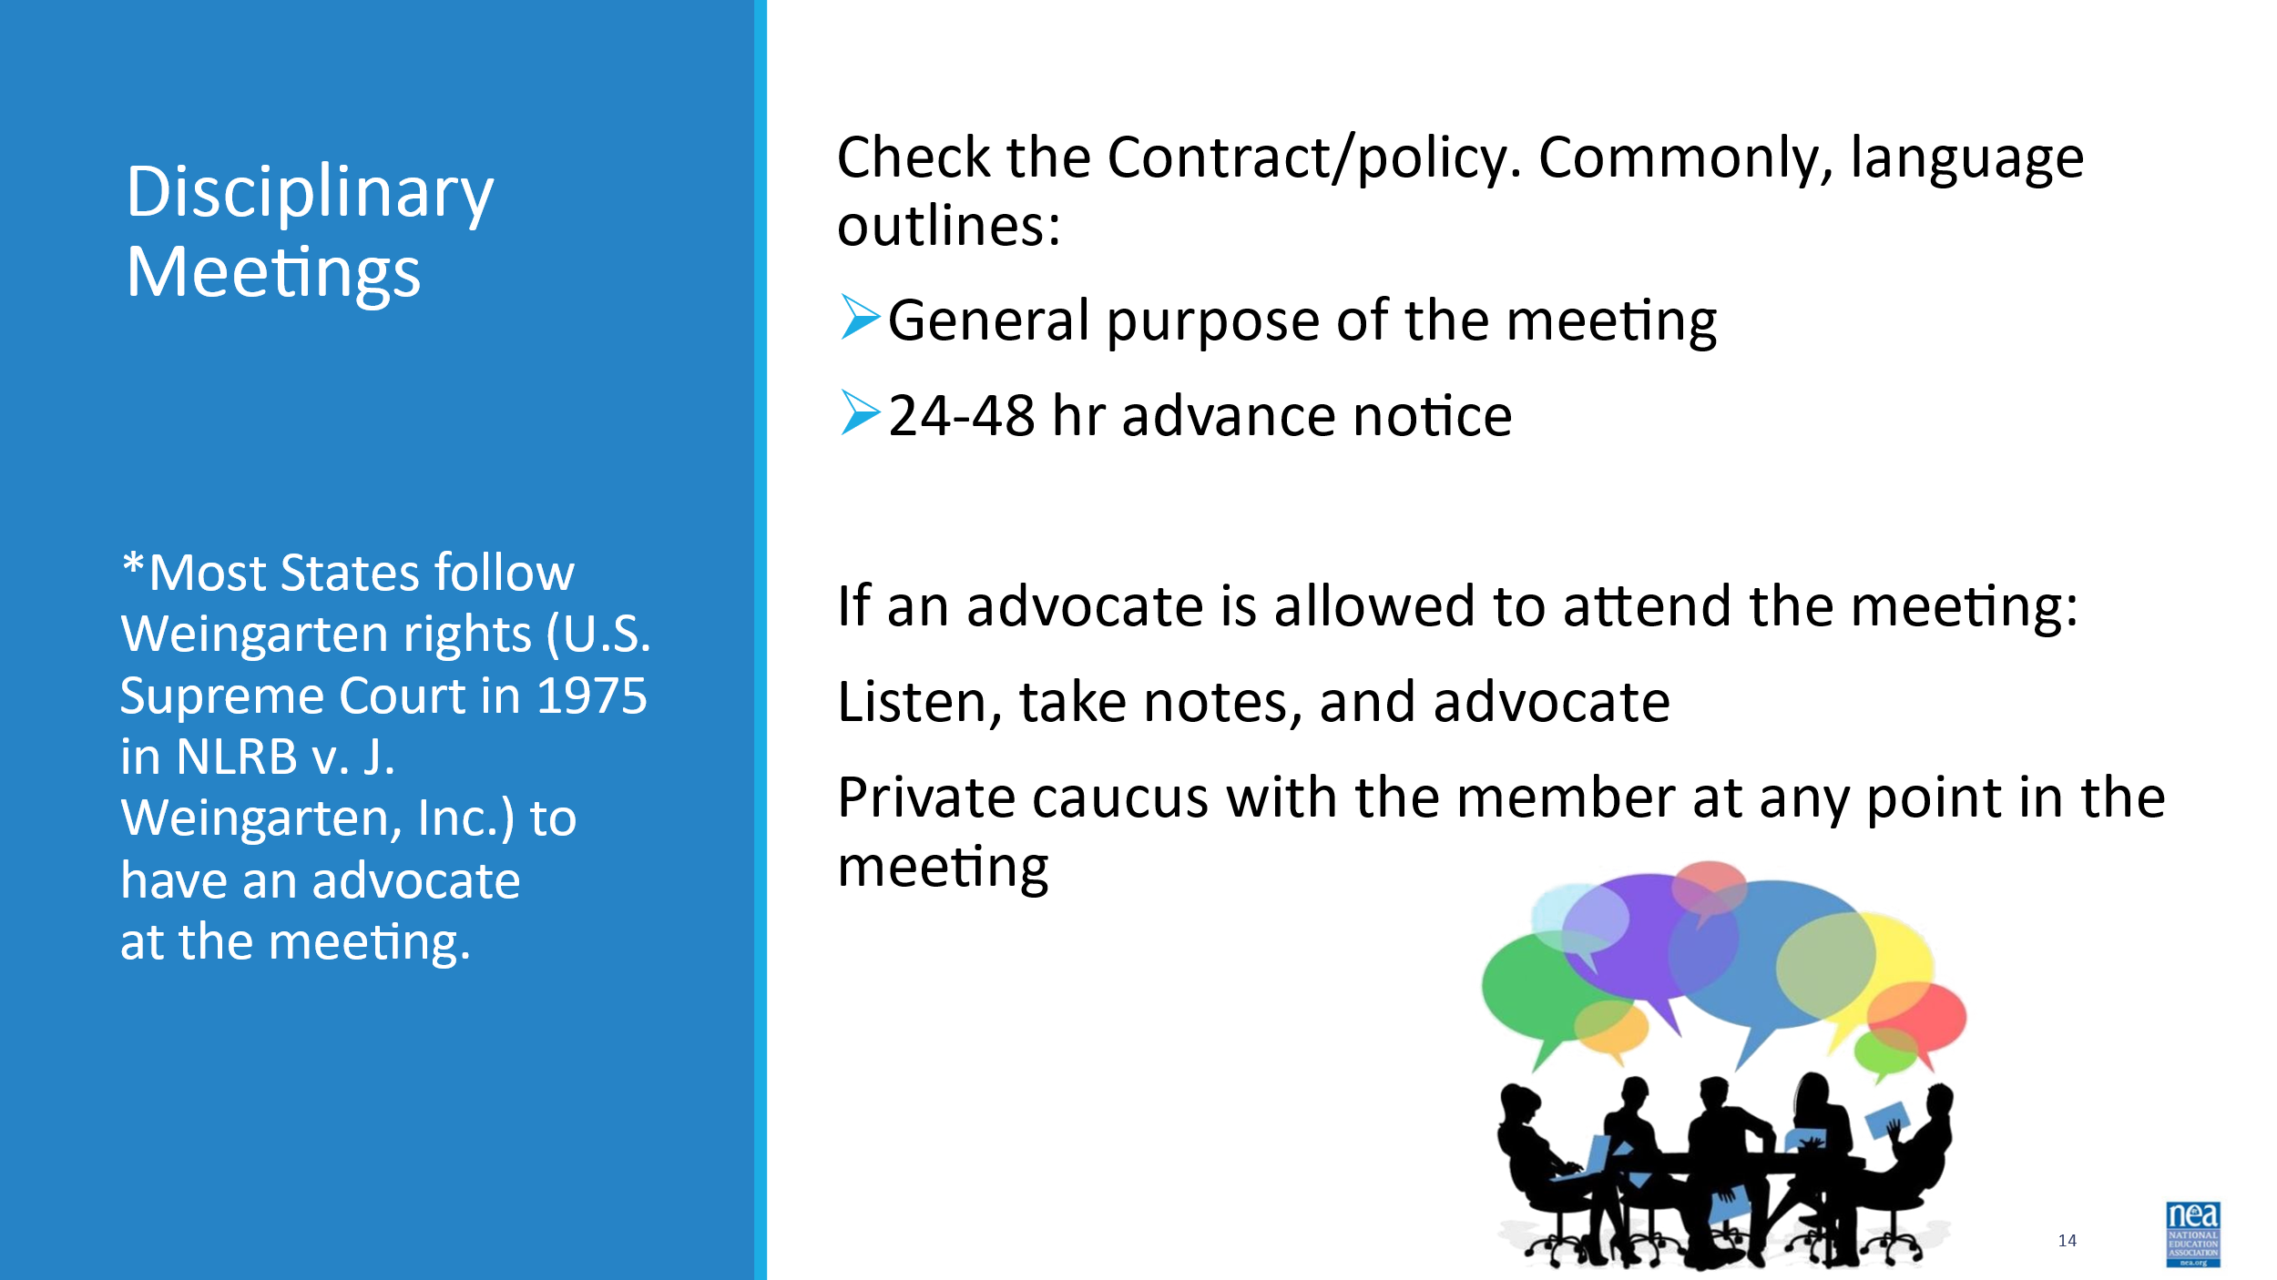  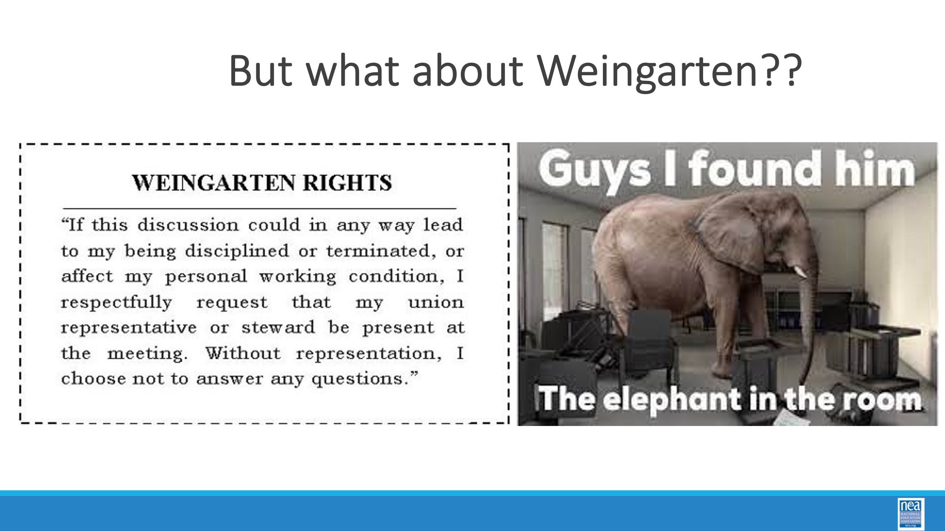  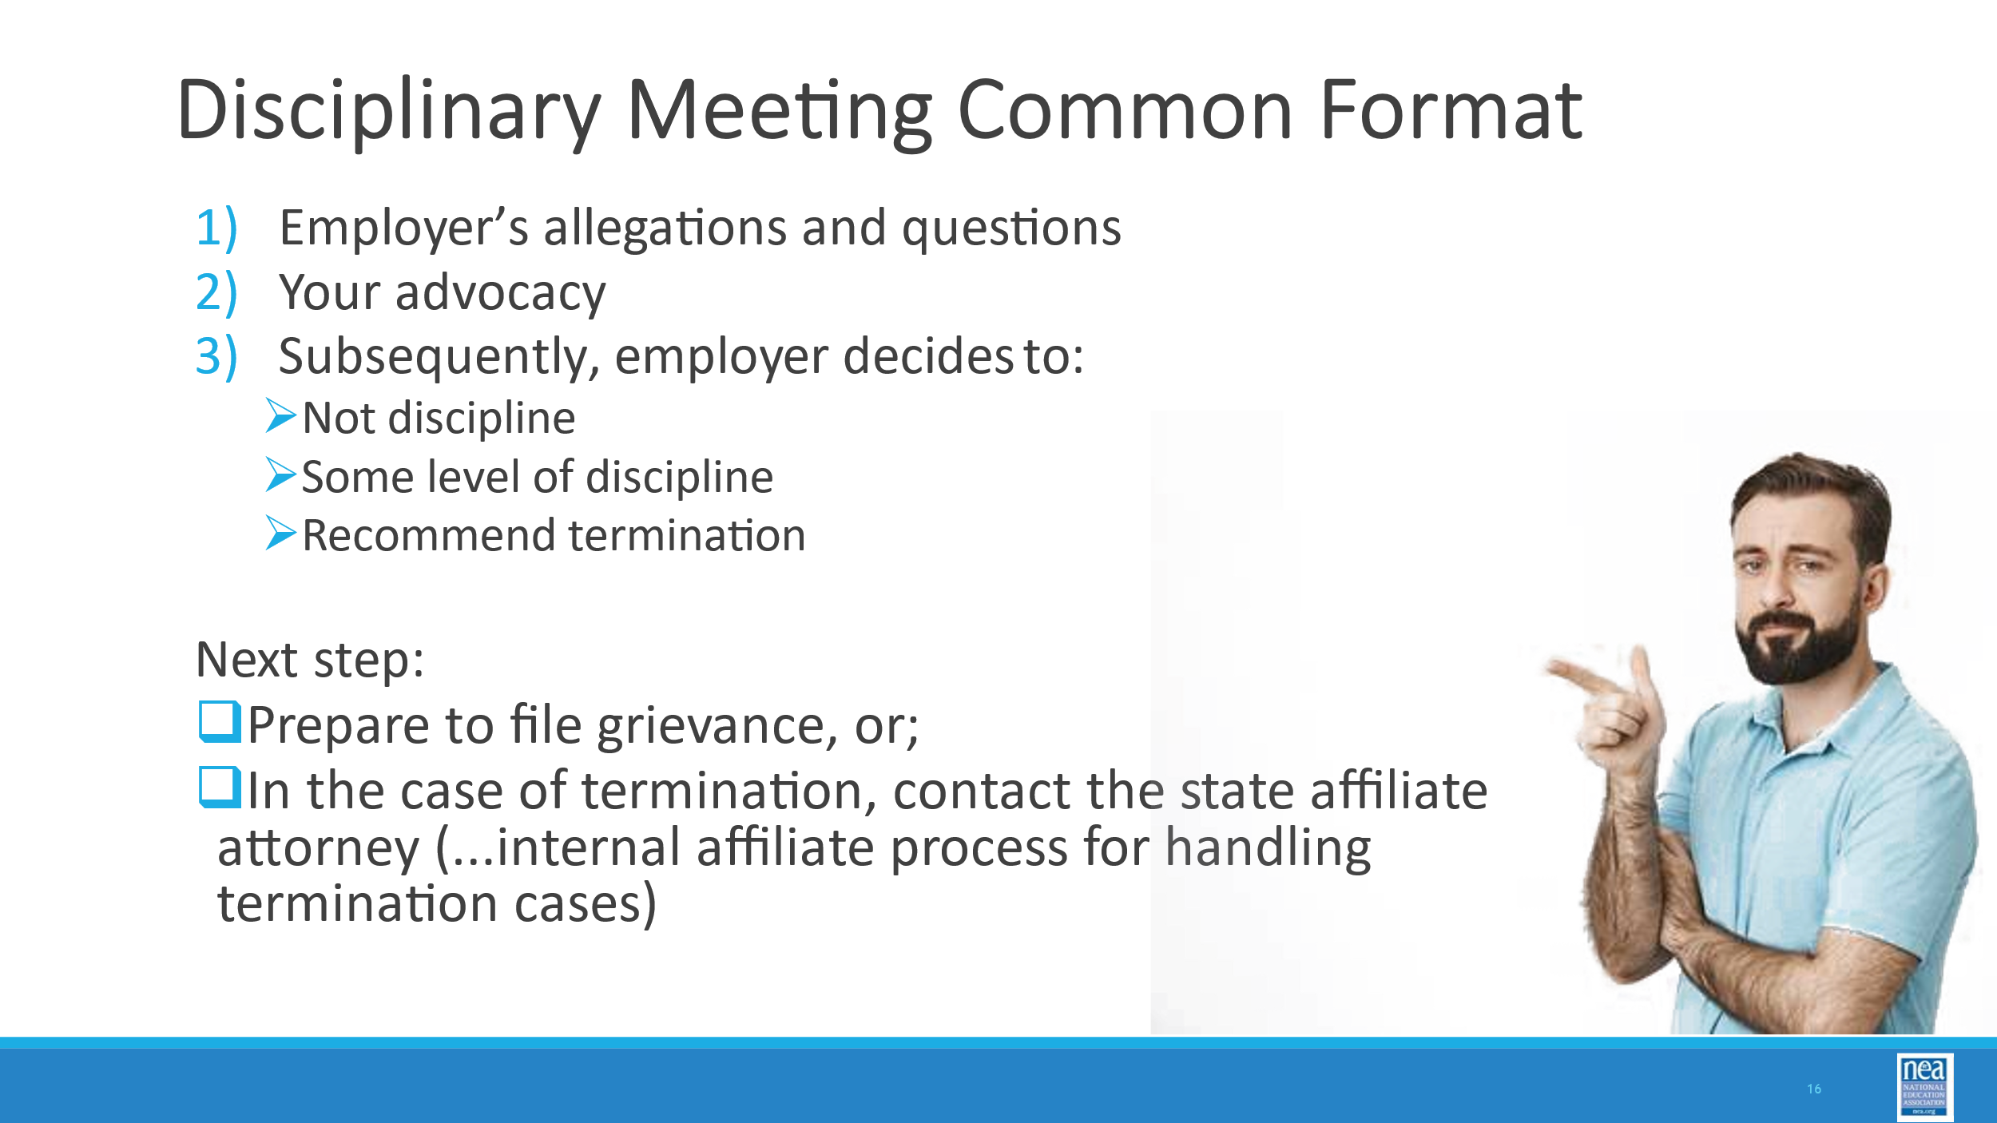  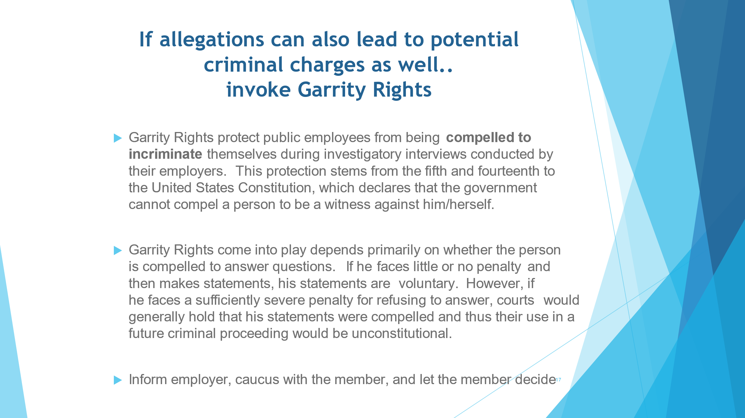  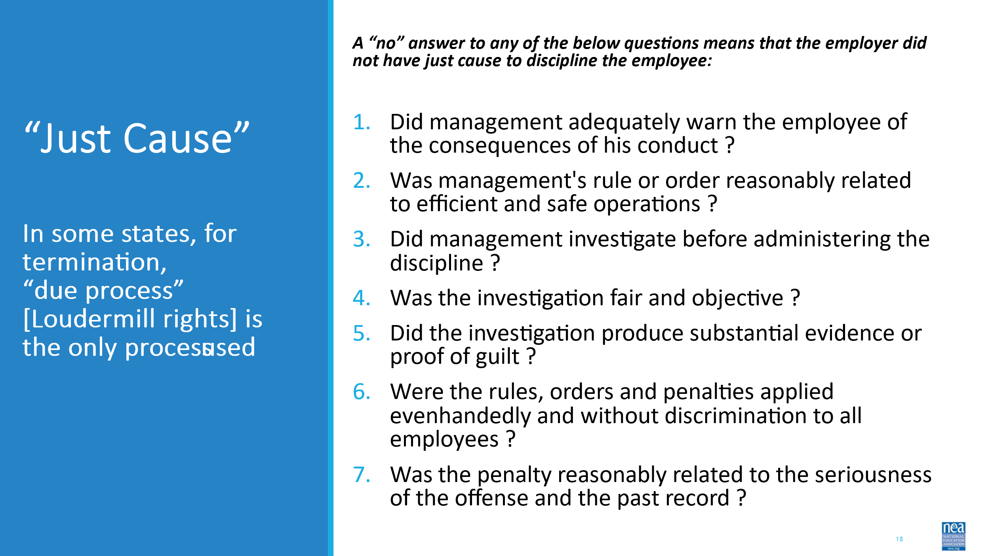  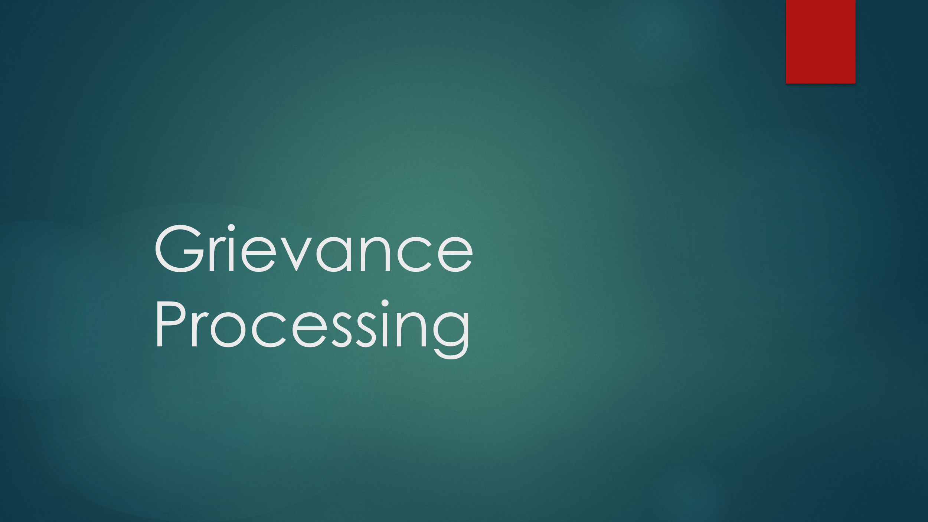  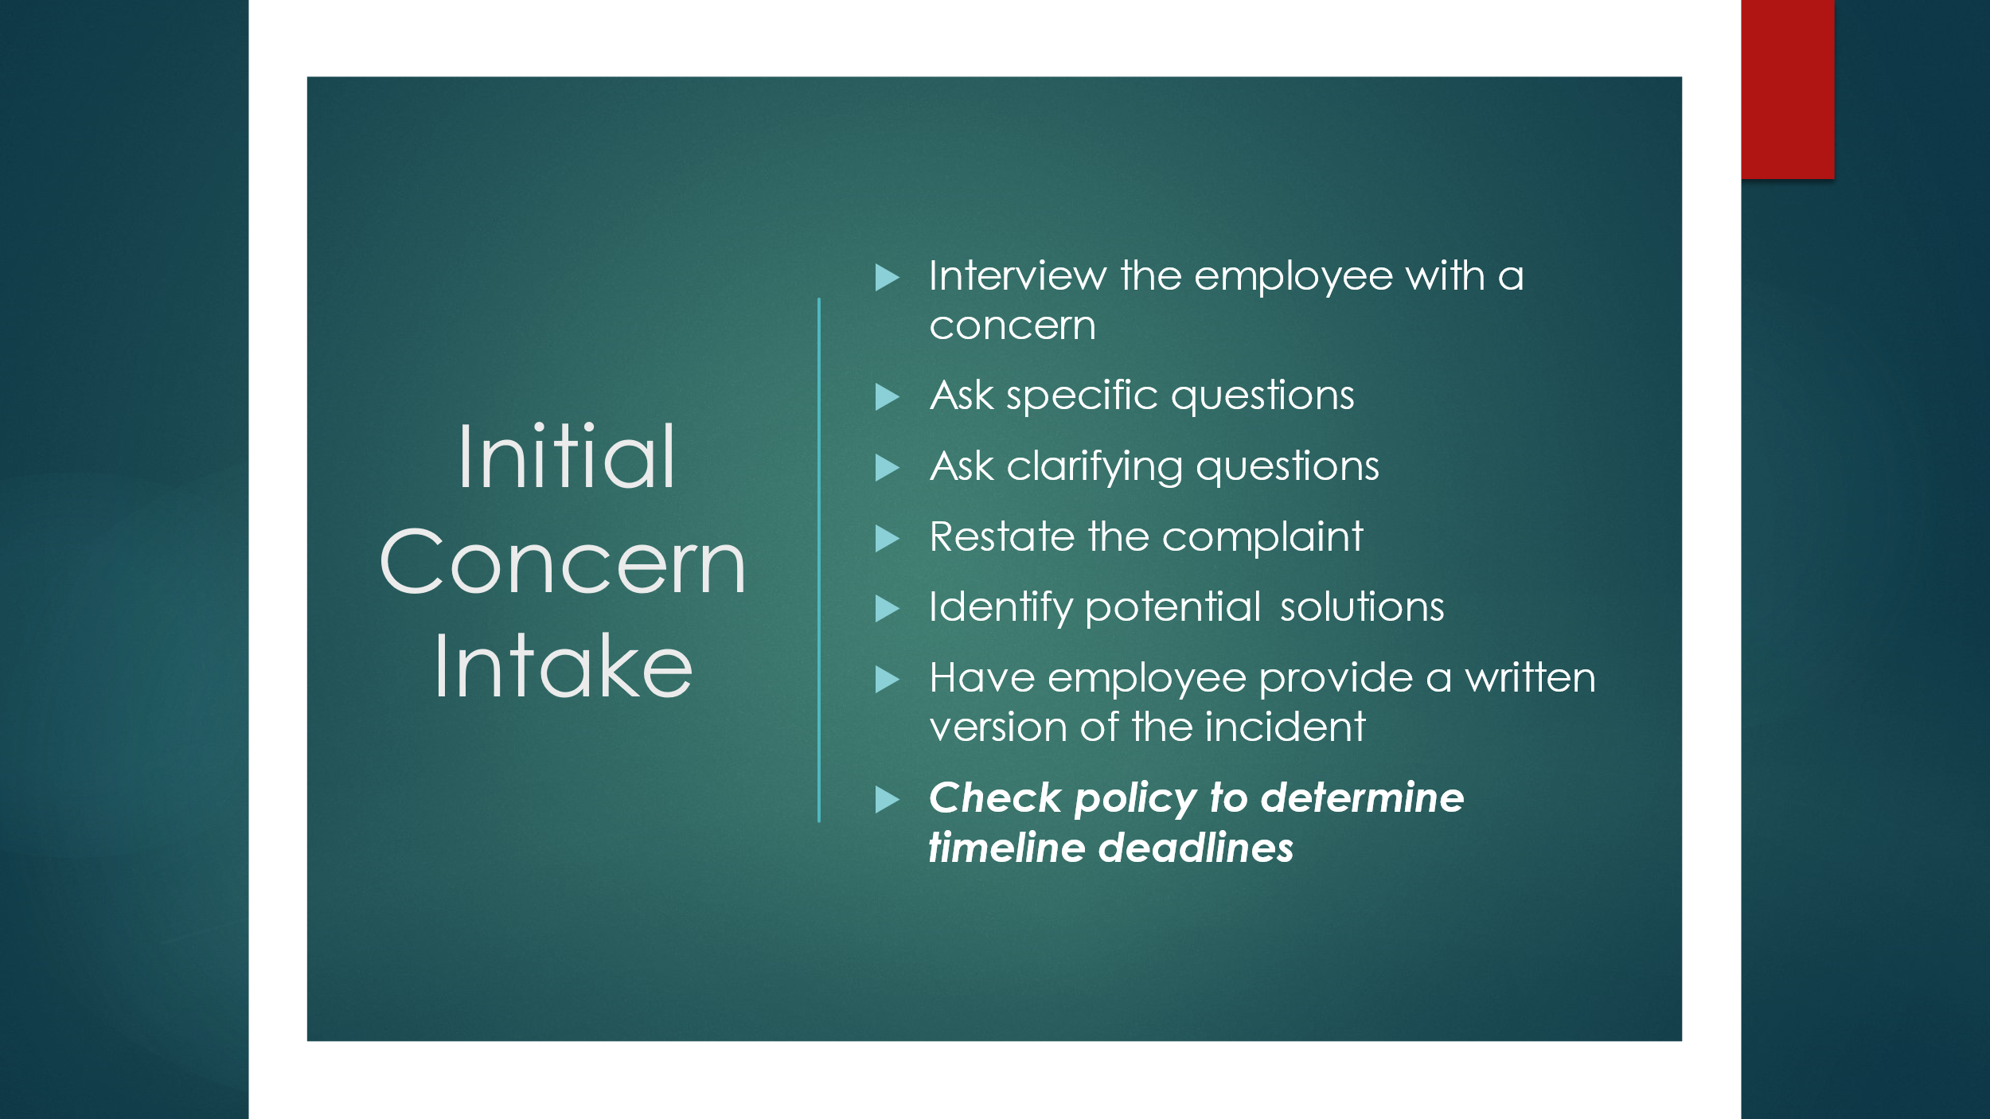  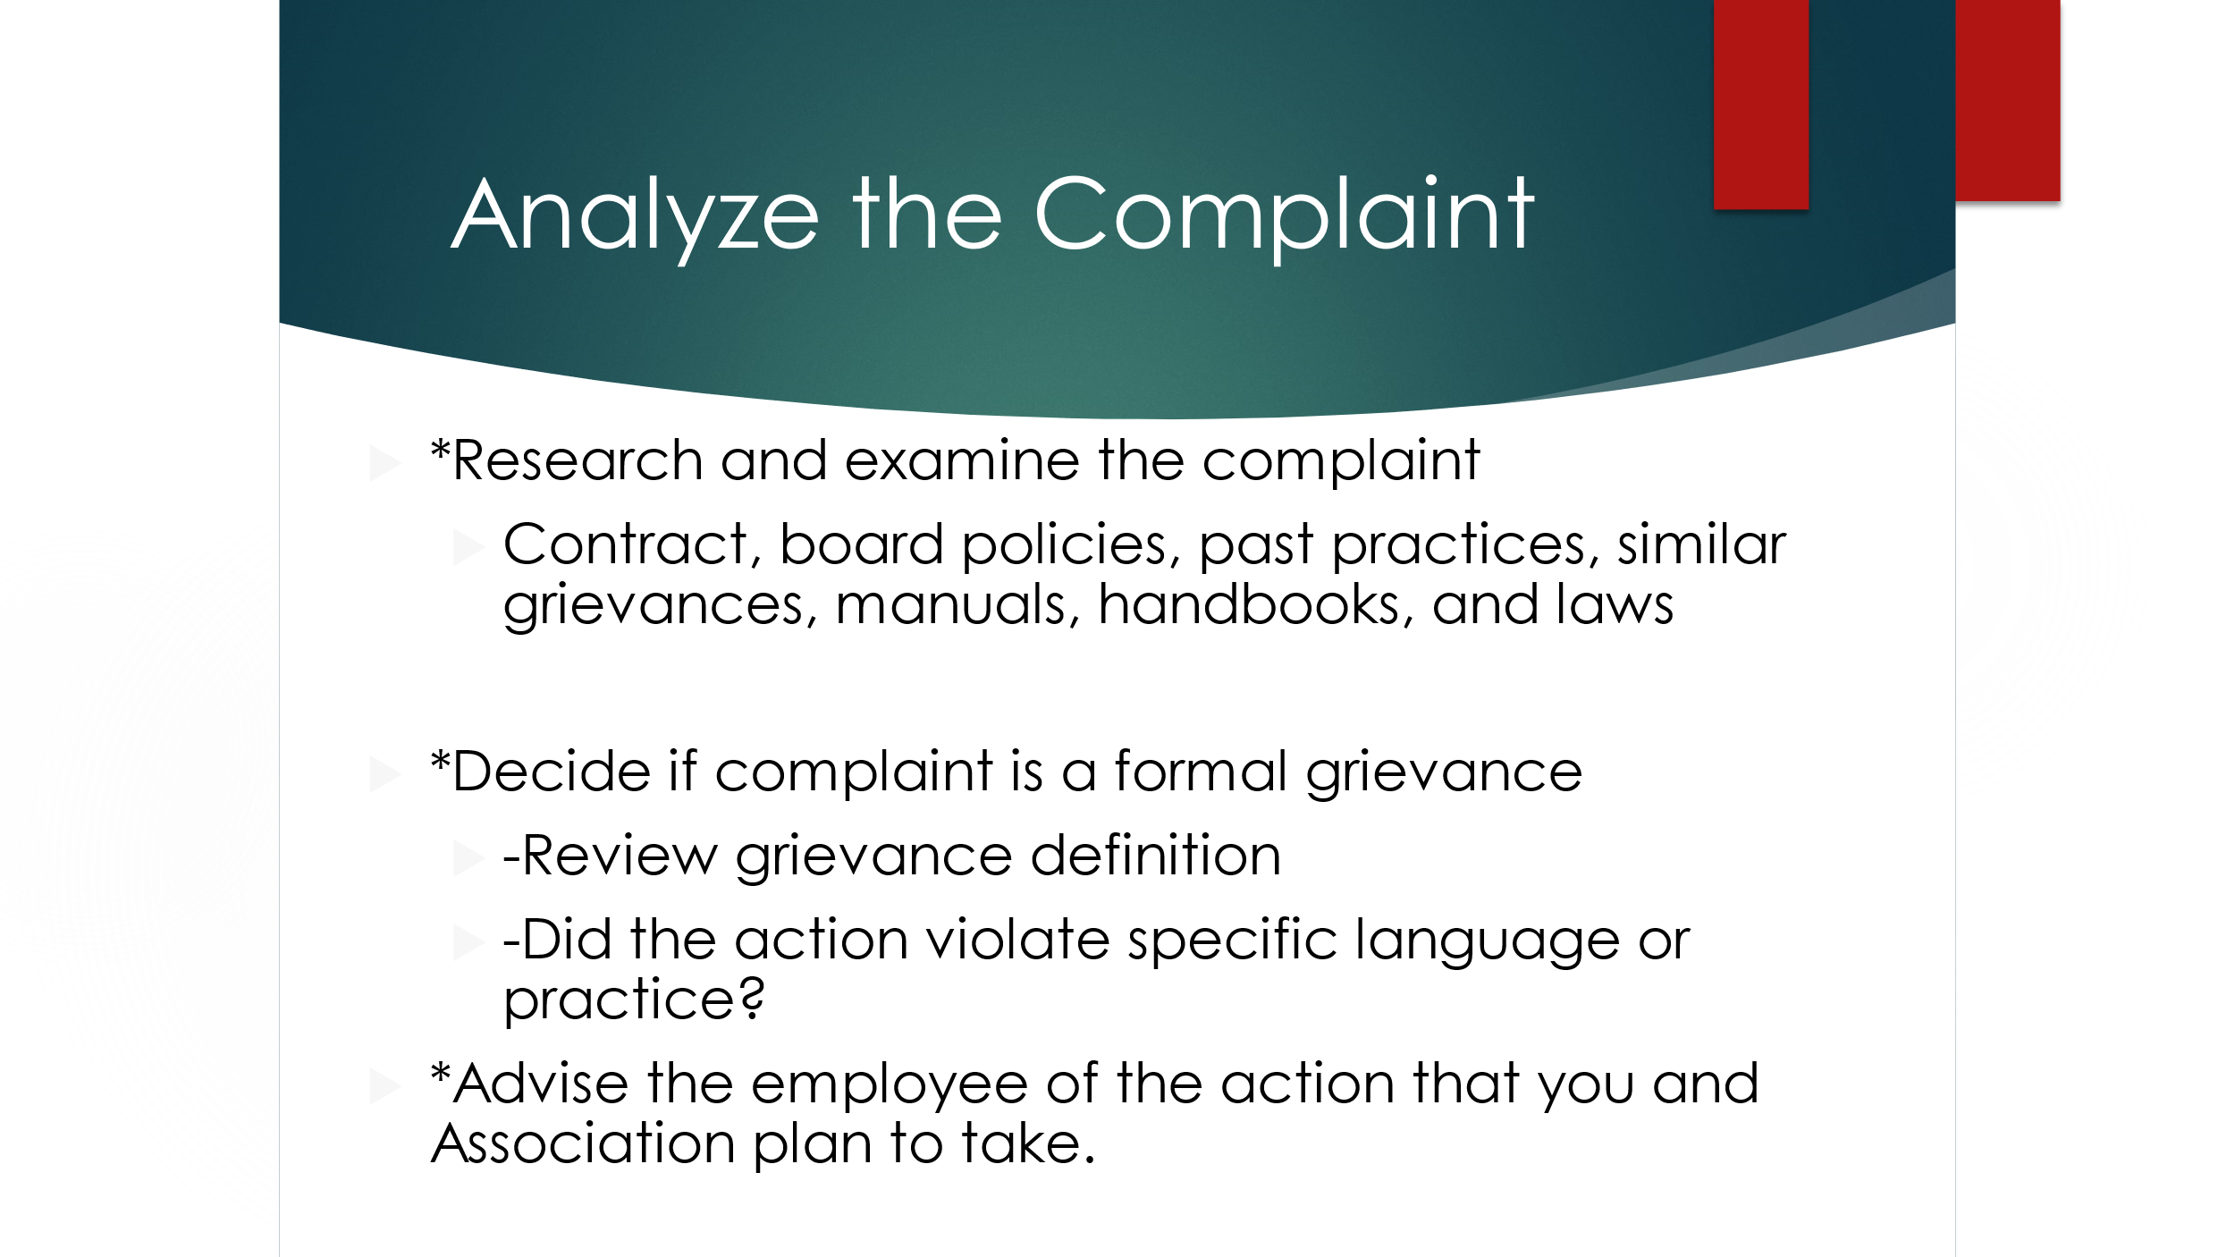  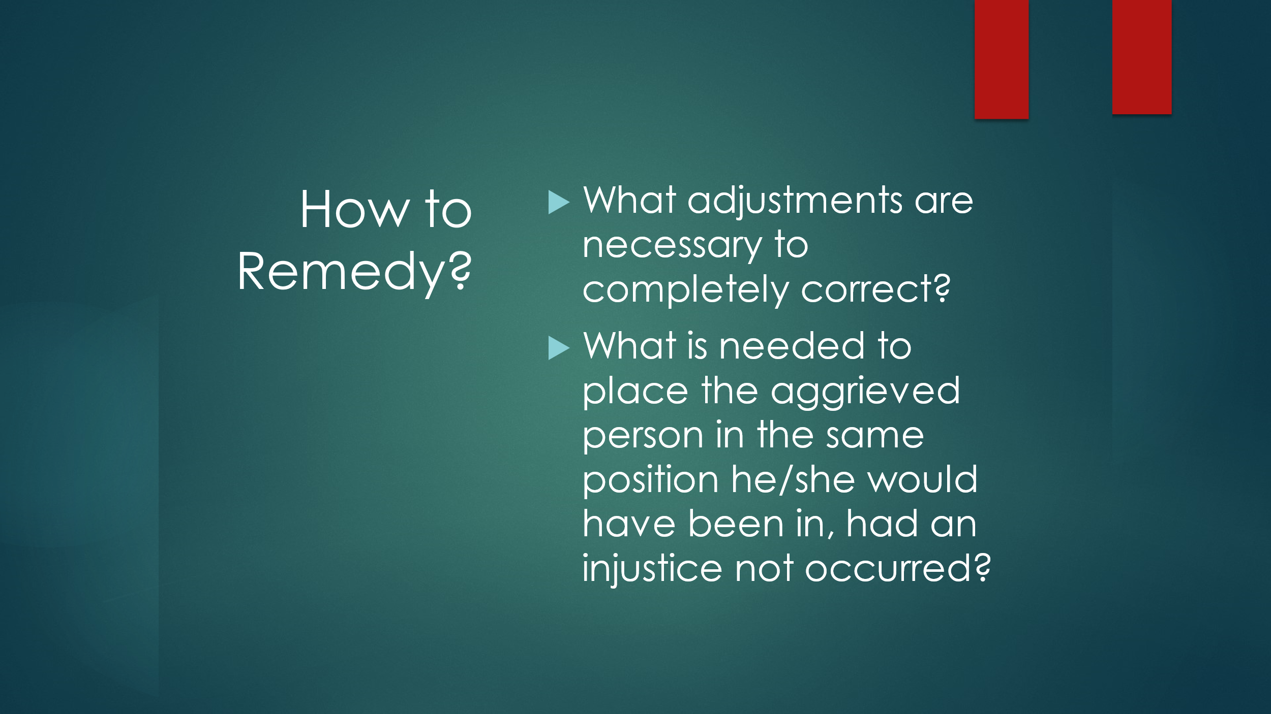  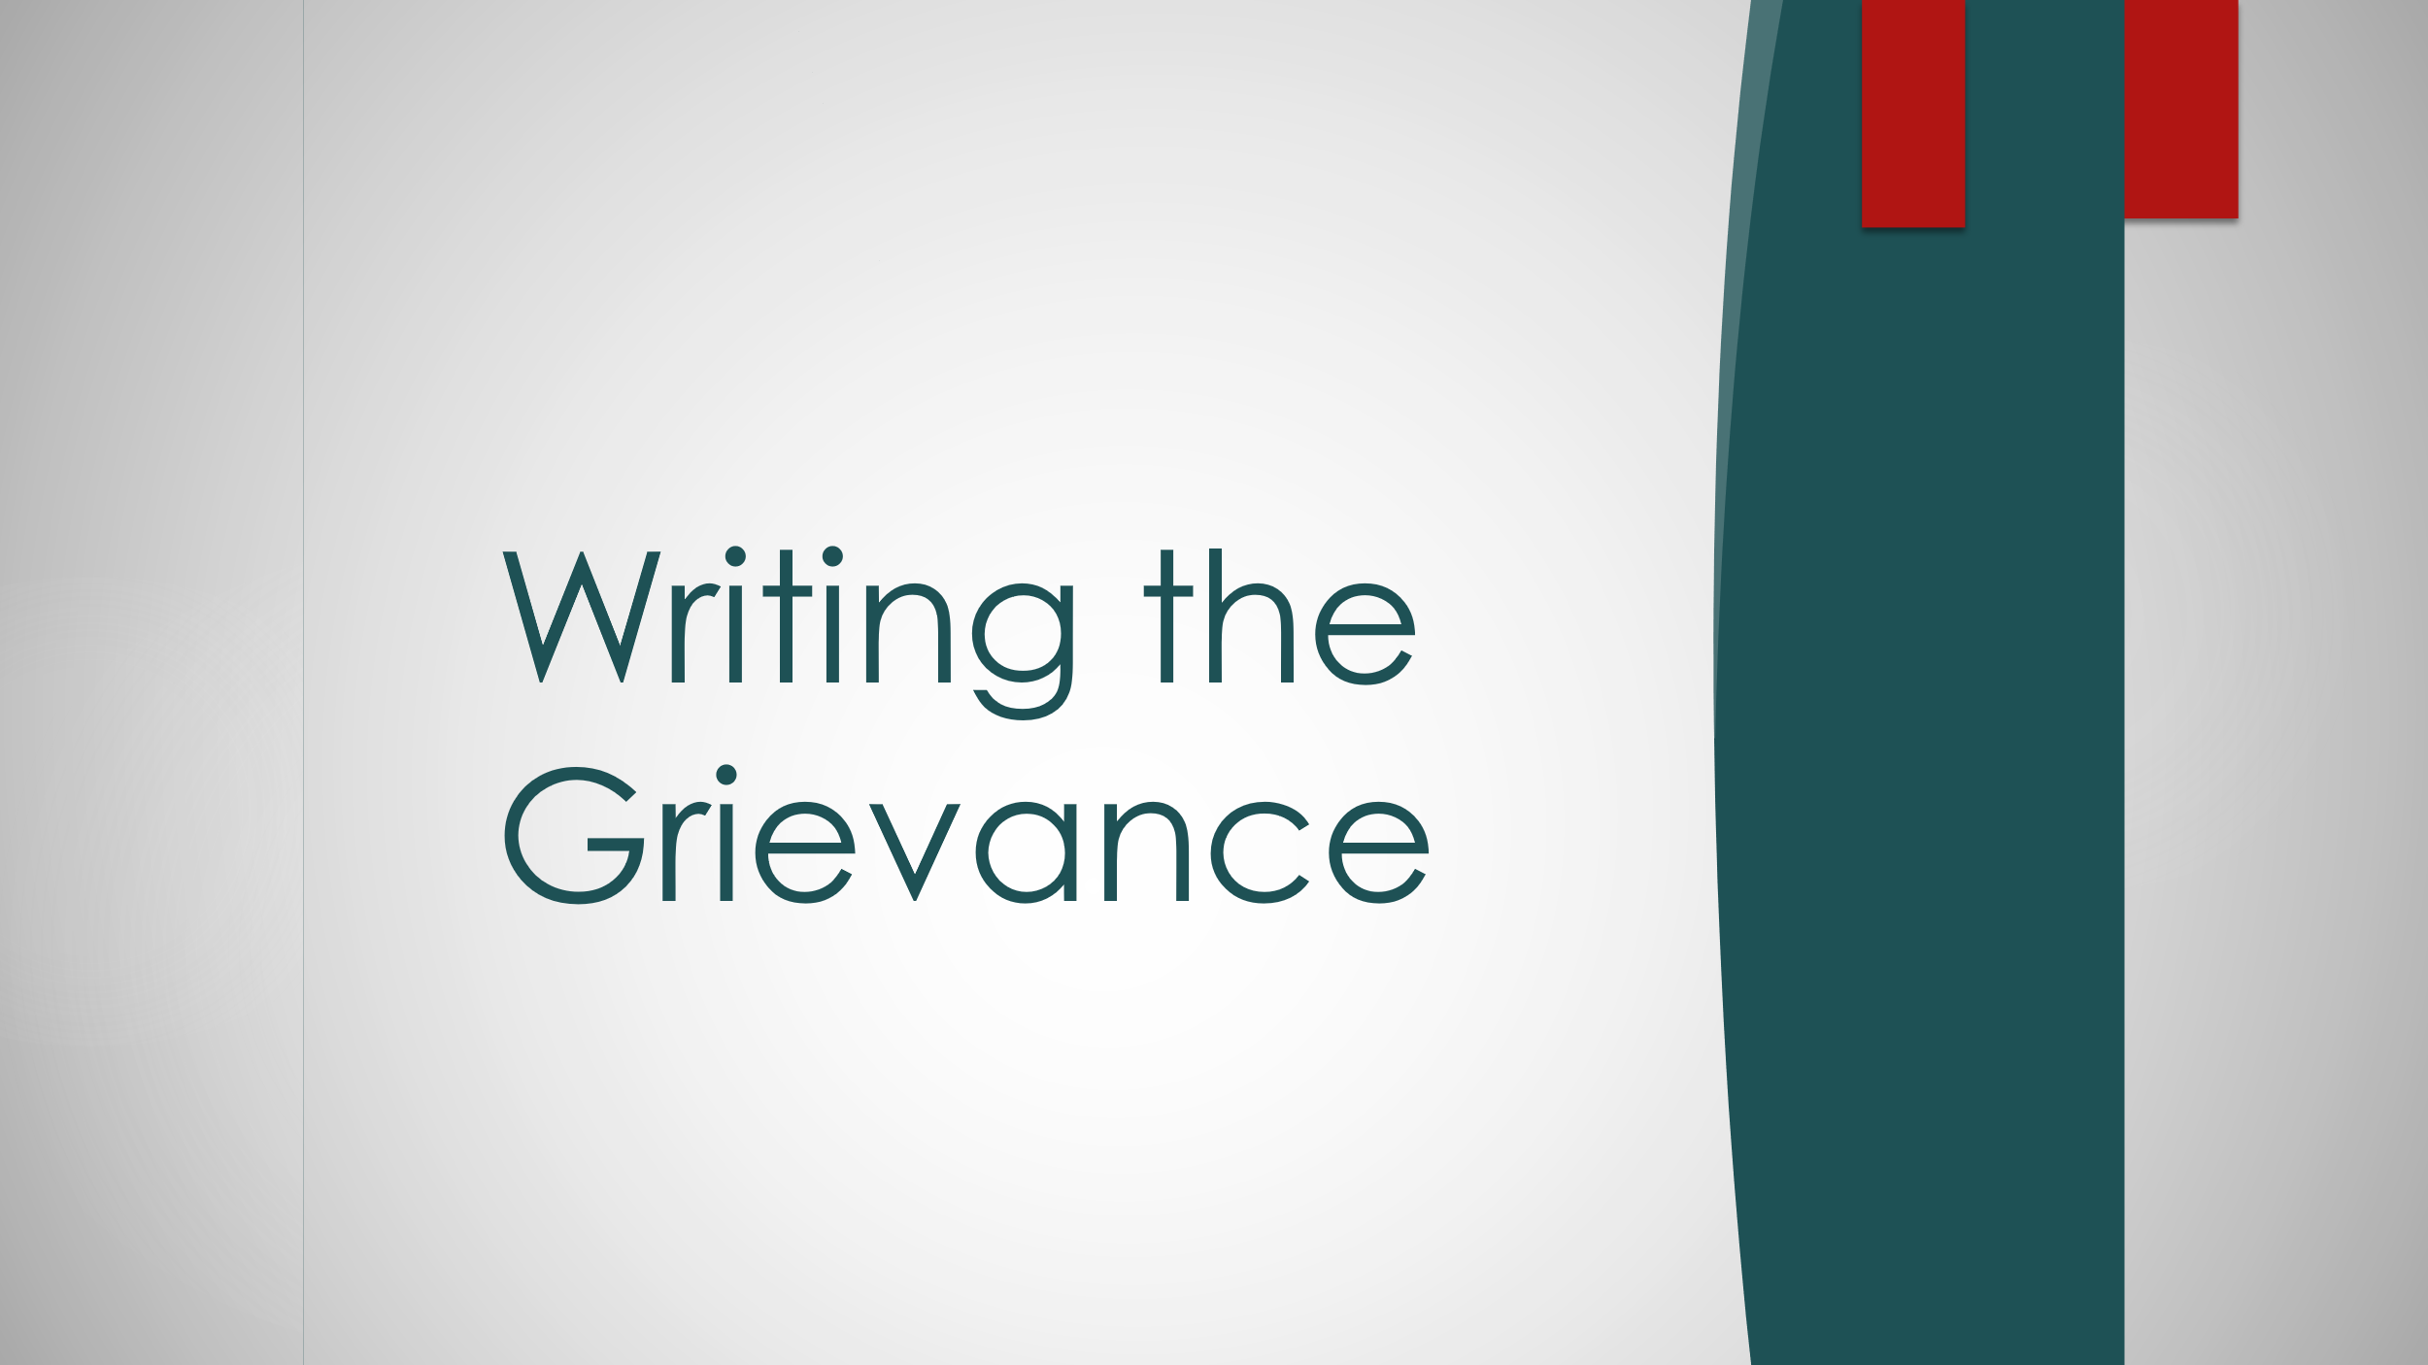  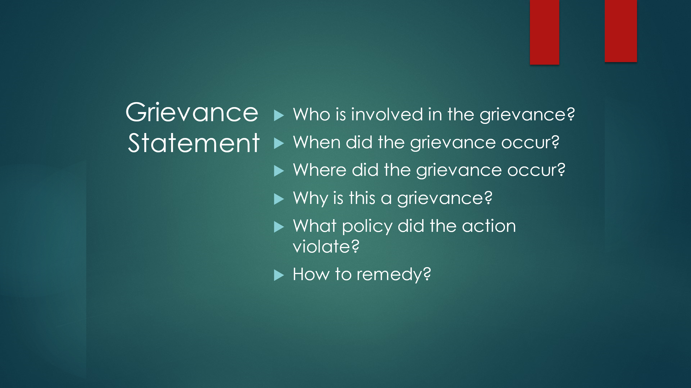  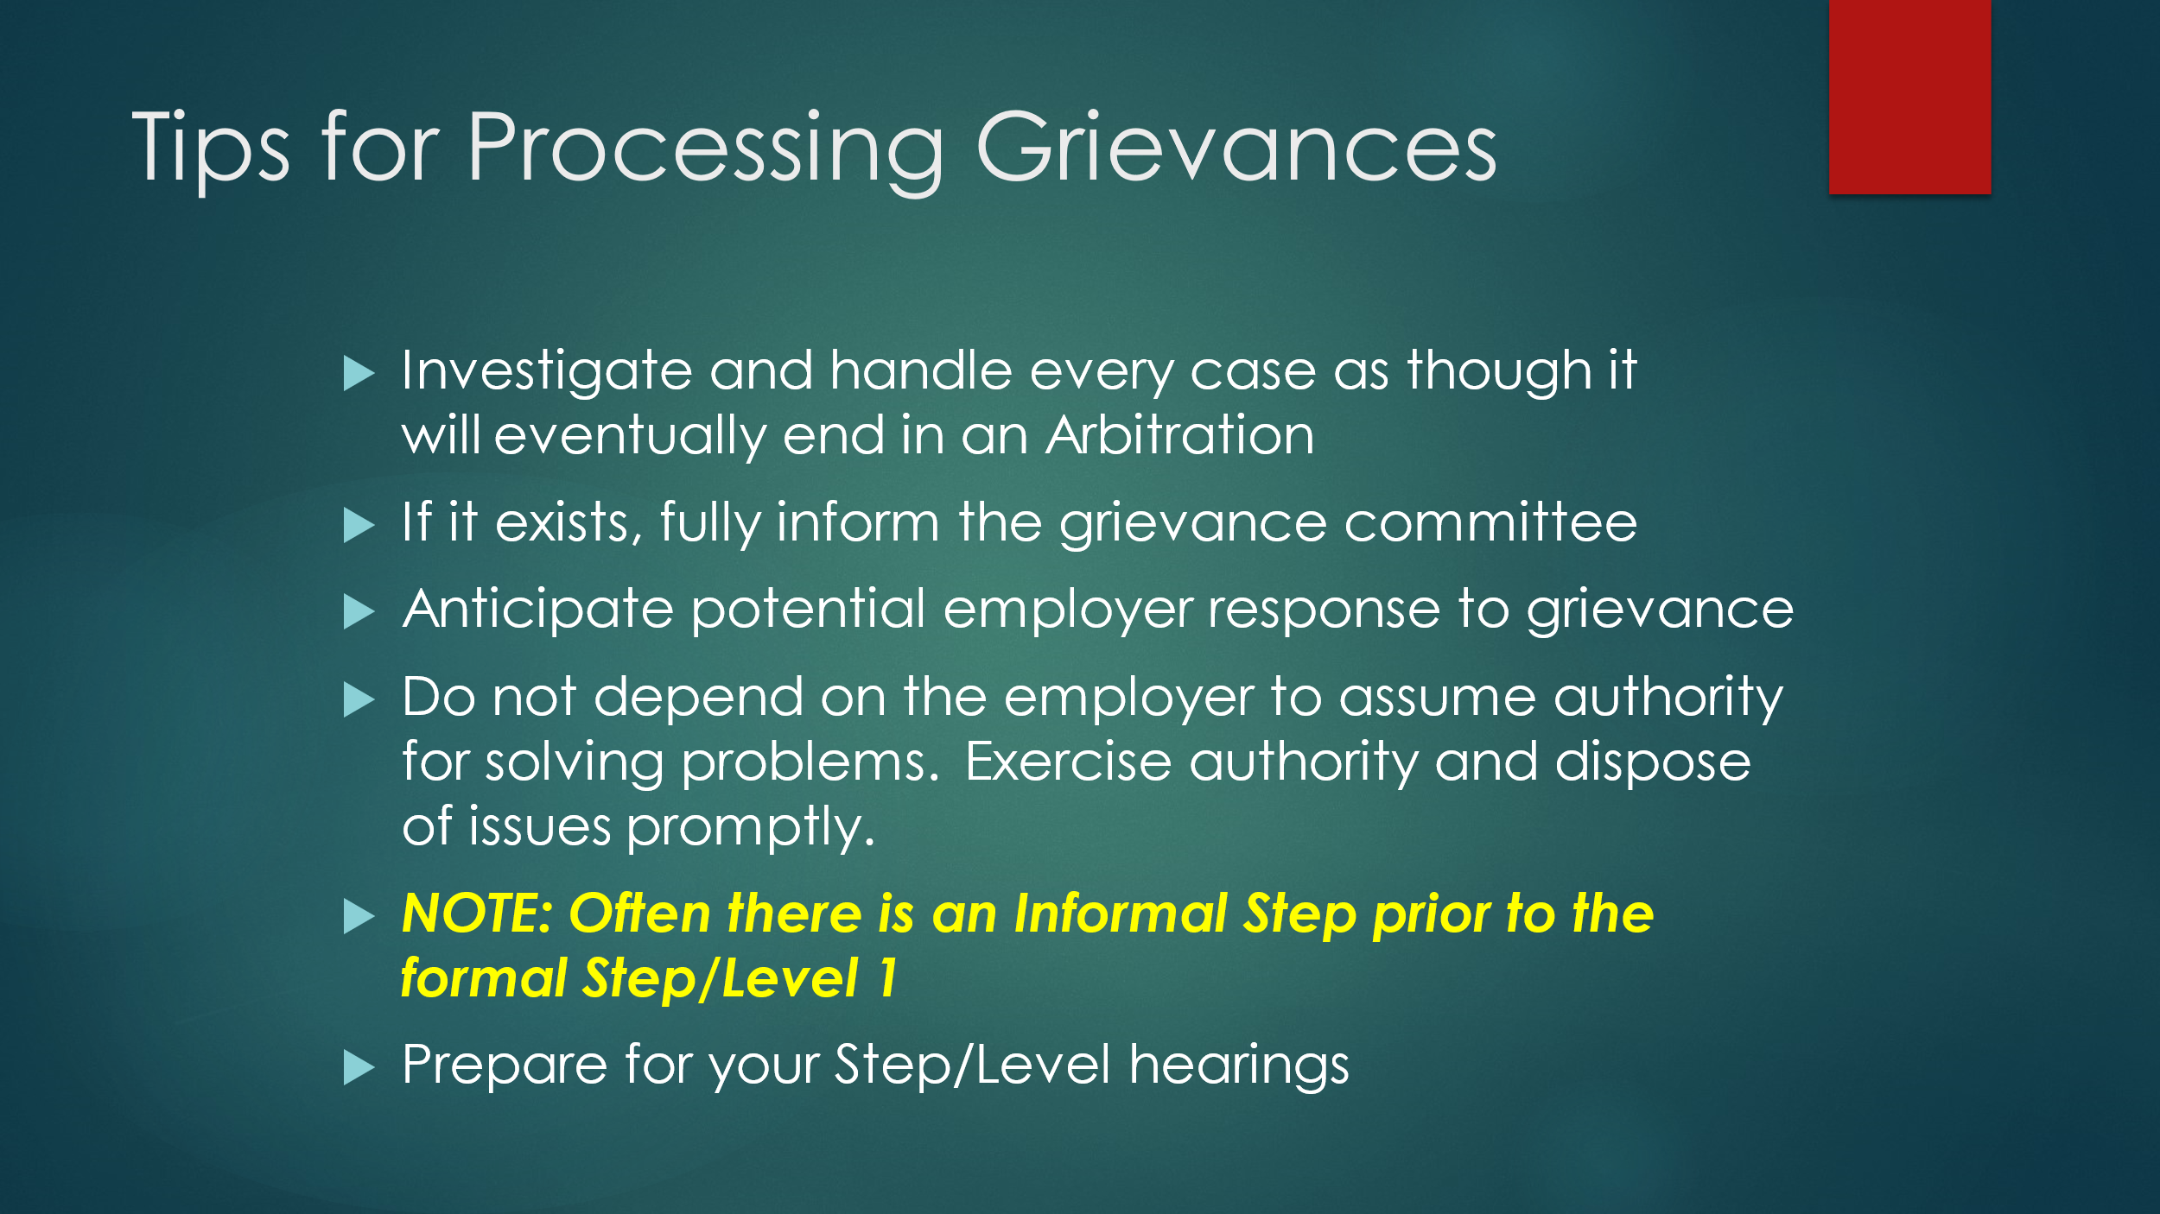  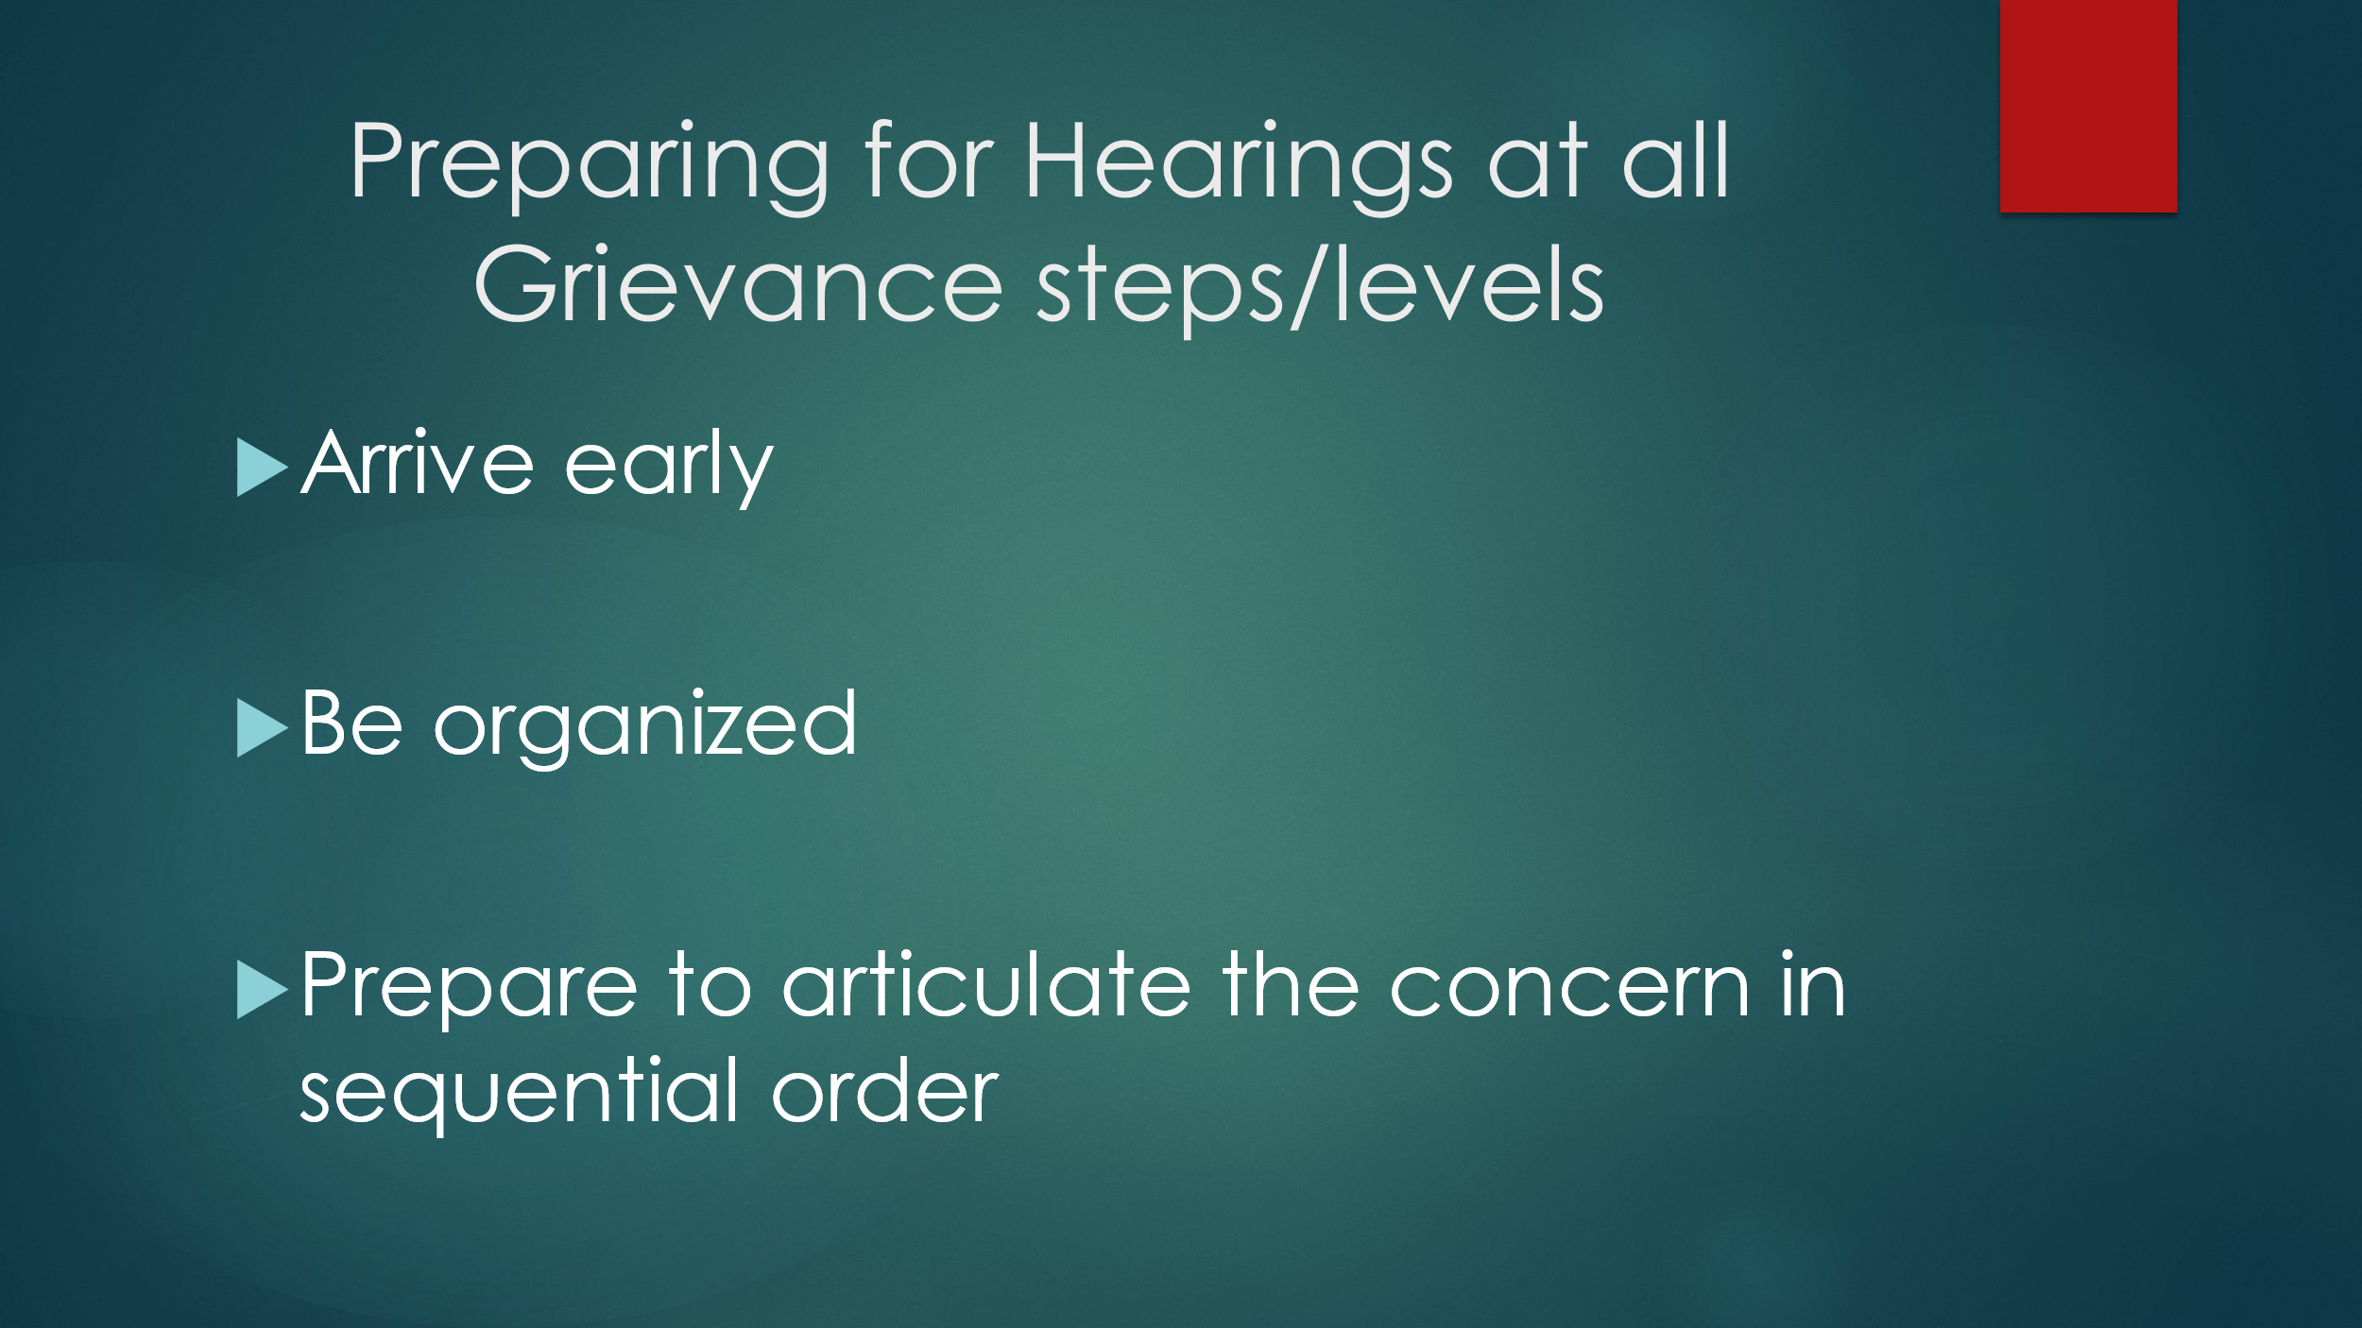  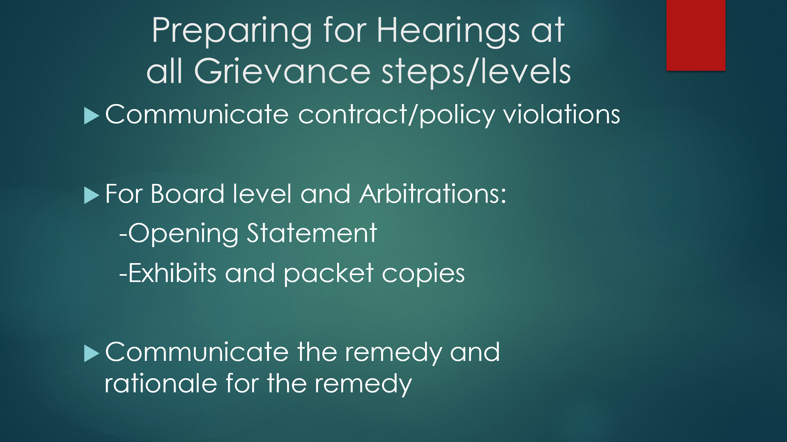  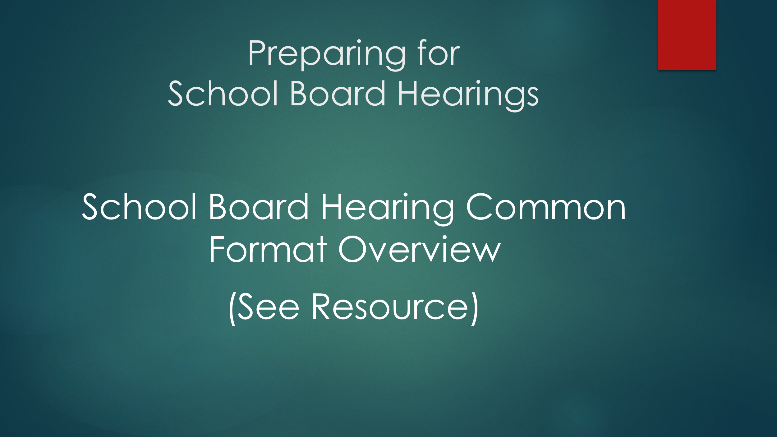  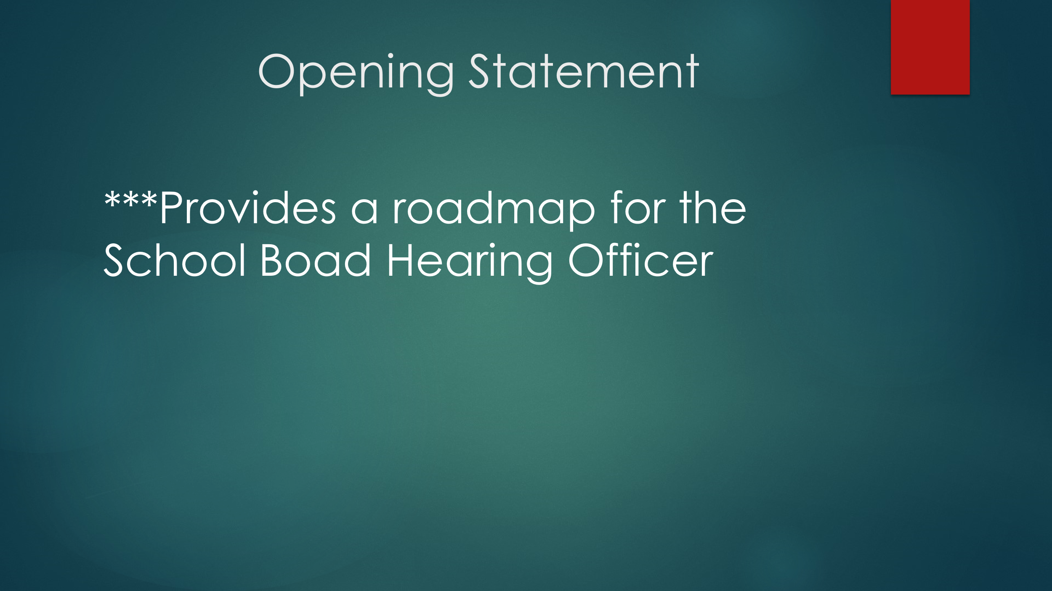  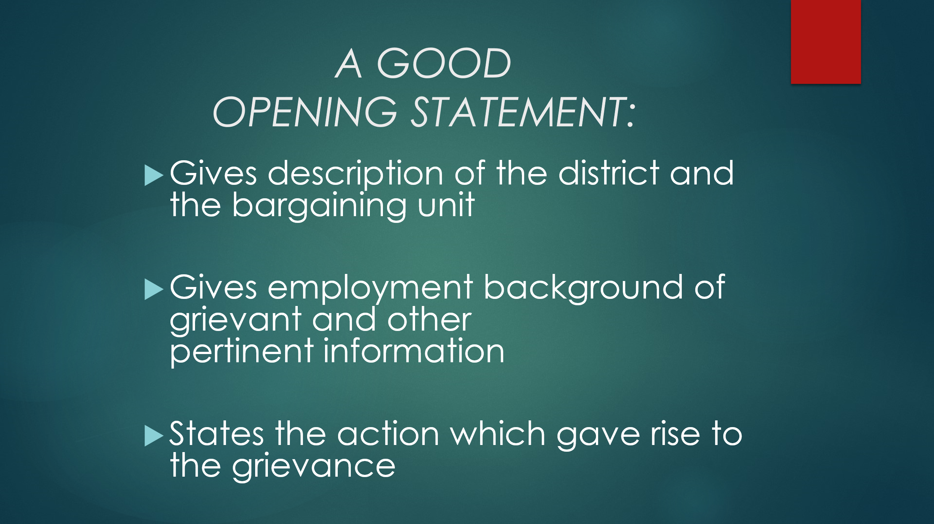  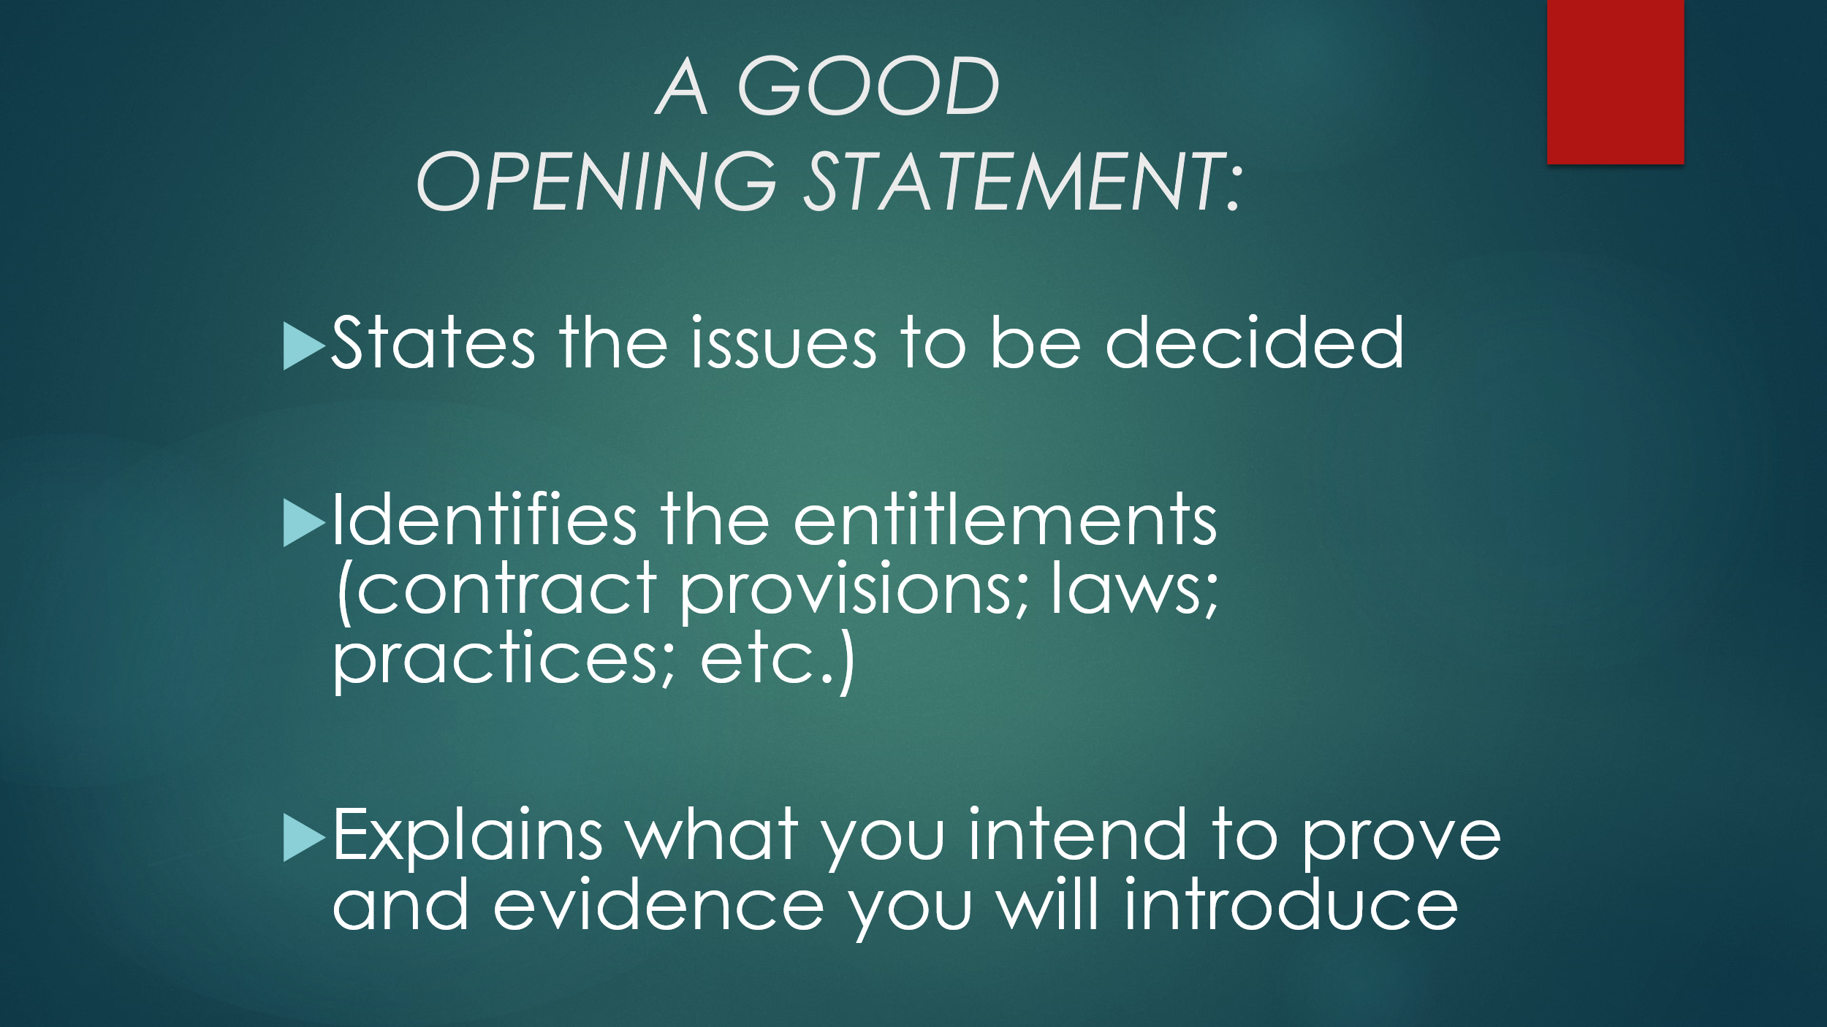  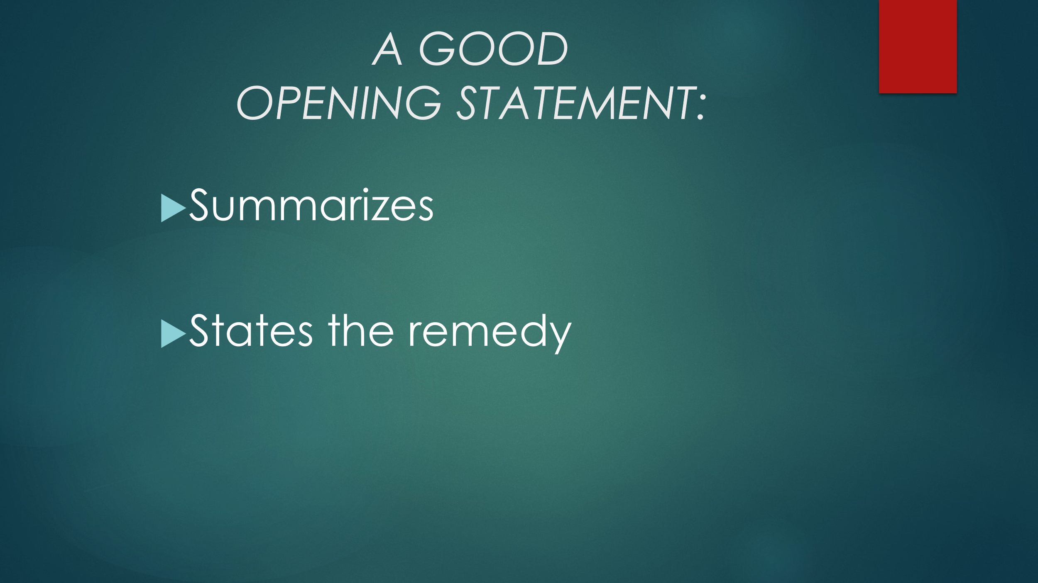  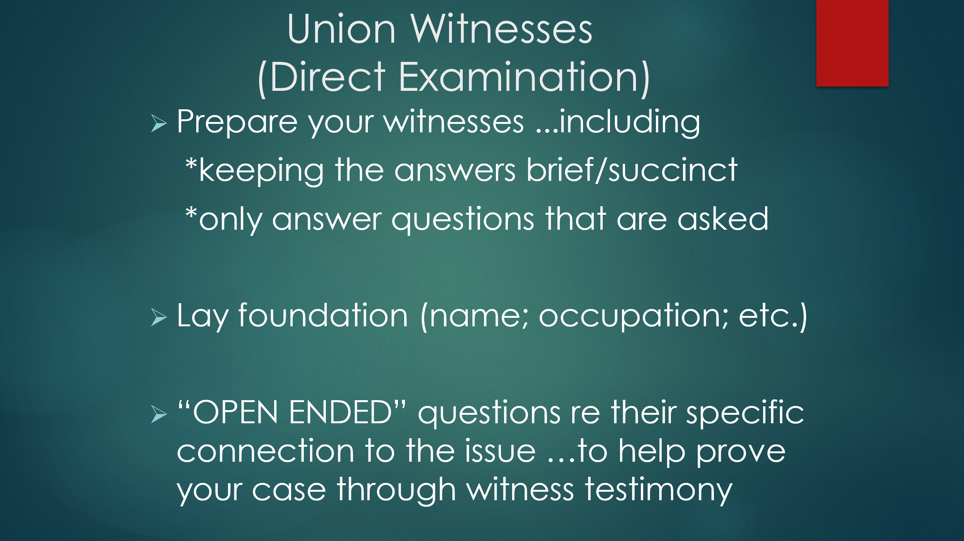  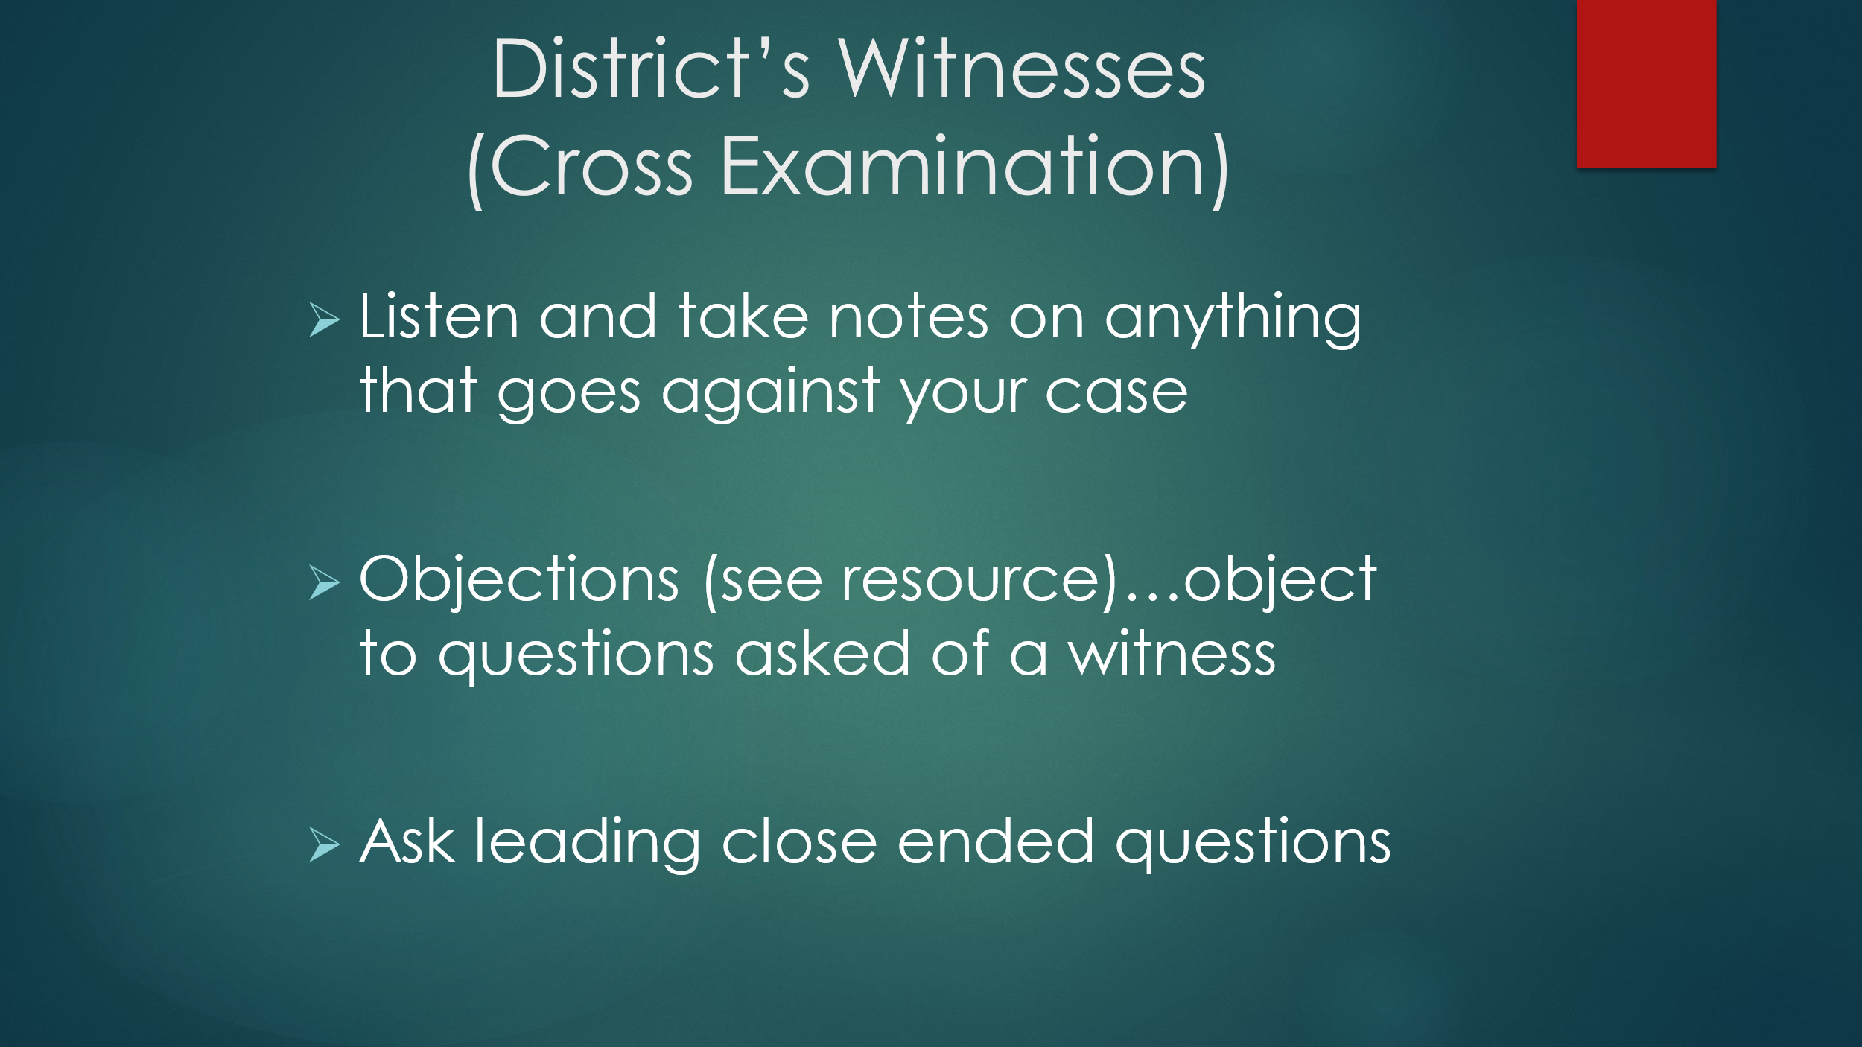  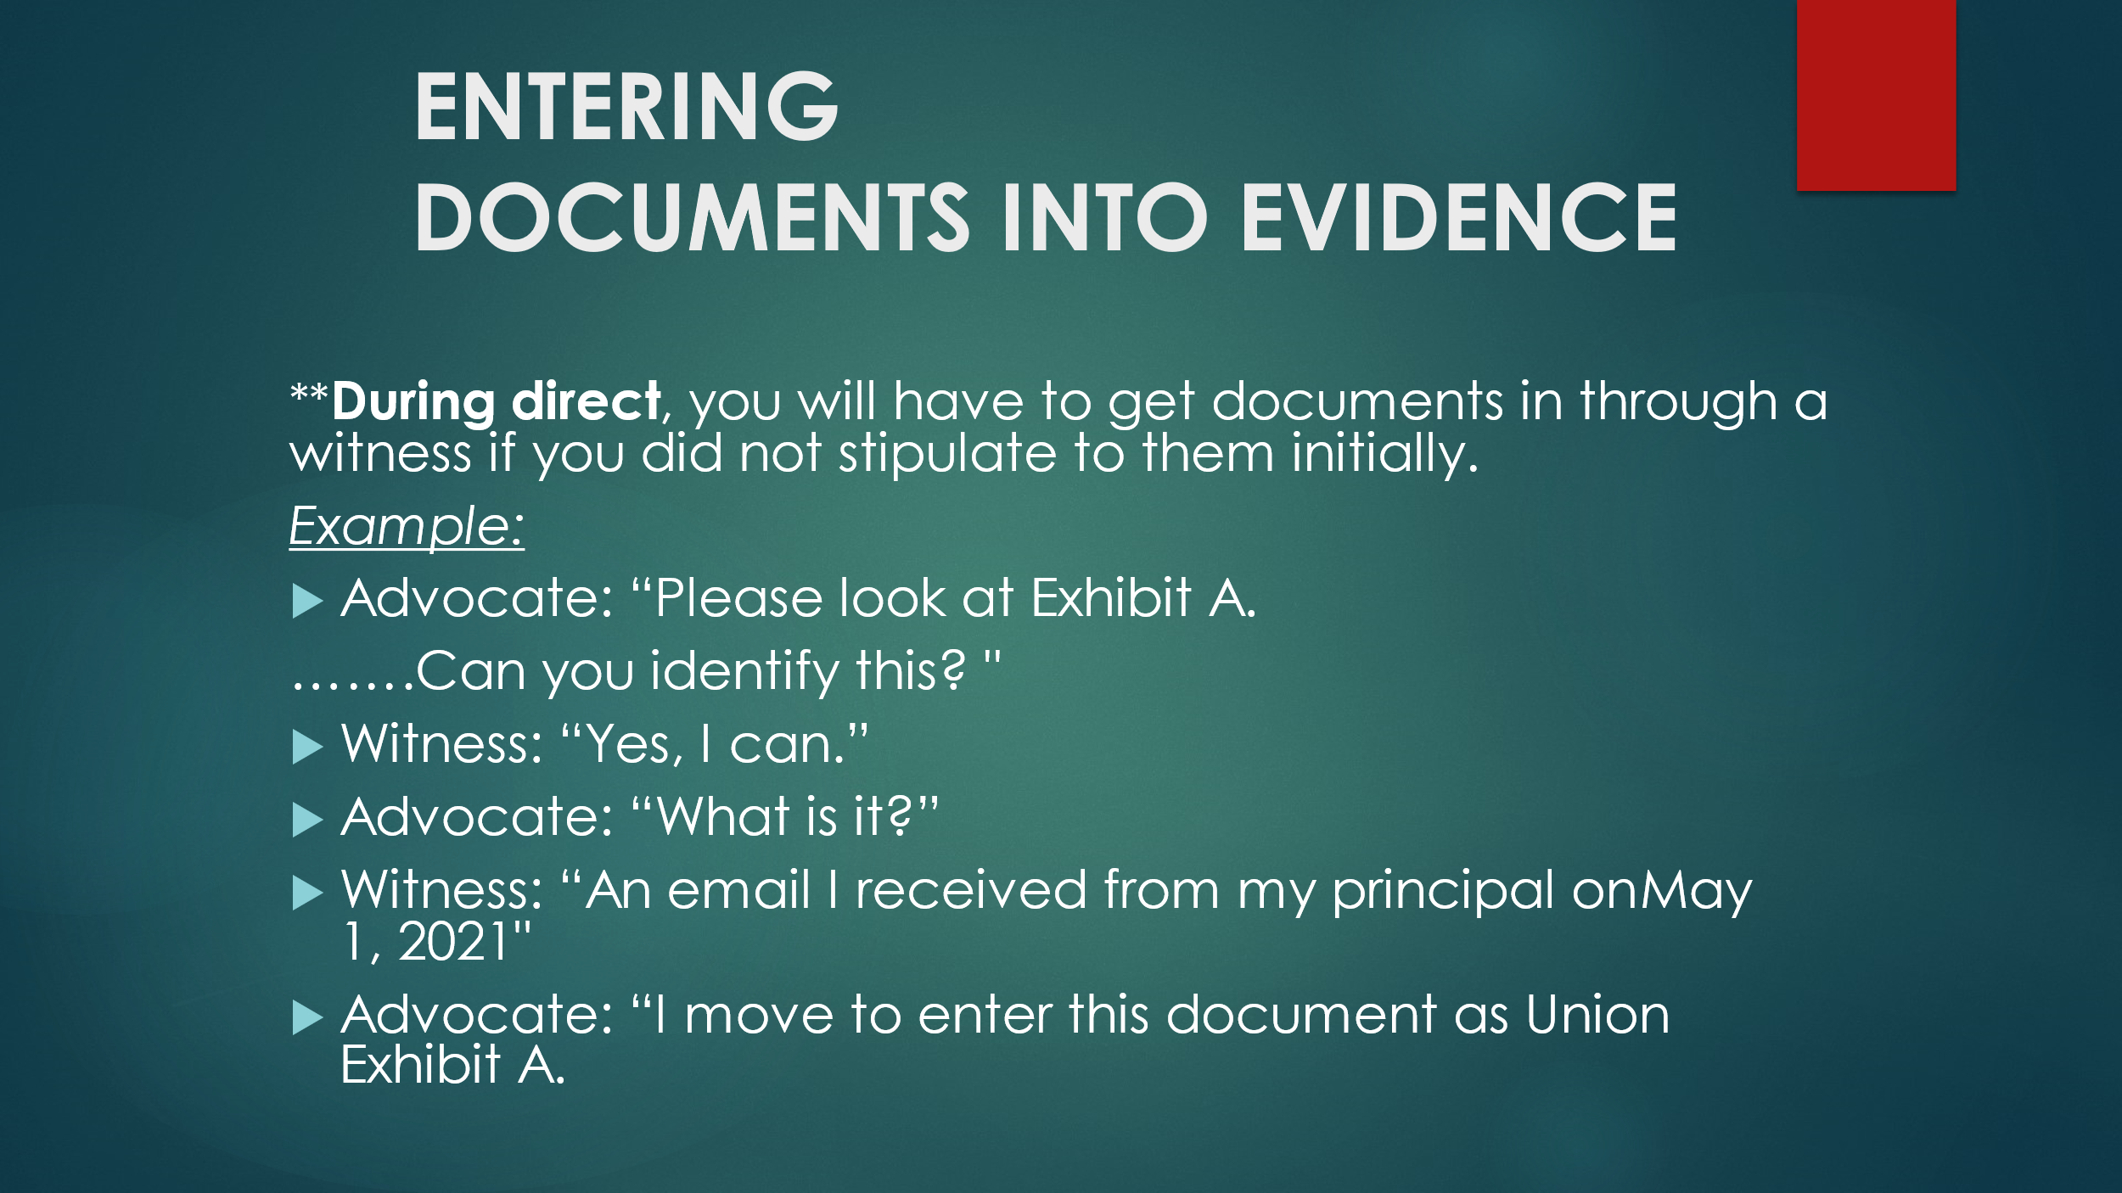  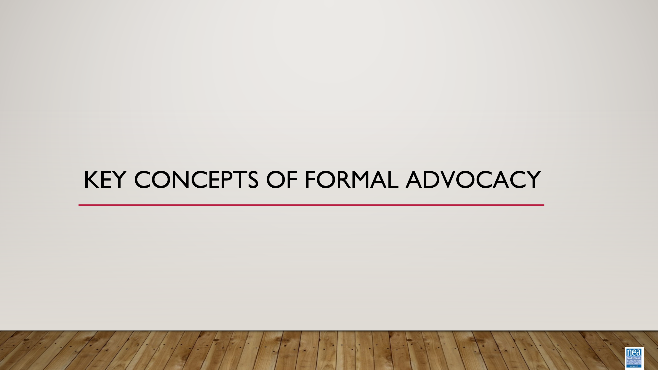 | How do staff understand and effectively utilize formal grievance and complaint procedures as an advocate? |  | 40 Minutes total  Grievance  5 Minutes – Introduction - Review the grievance form. When completing the form, the purpose is to be thorough and concise (this is not a dissertation). Much of the information is demographic information about the member. Introduce concepts of writing the grievance. There may be a form that exists, often in a CBA, but non-bargaining states can create their own if a formal form has not been created.  When completing the grievance form, the following should be included:  • Who is involved in the grievance?  • When did the grievance occur?  • Where did the grievance occur?  • Why is this a grievance?  • What contract/policy did the action violate? How do you remedy the situation? When identifying the violations, it is key to remember to use all of the relevant Board policies and contract language. The statement needs to clearly articulate how the board policy or CBA have been violated.  • Relief sought: how to make the member whole – you will not get any apology public or private.  Additional words/phrases to remember and include ensure that the grievance will have the largest scope possible.  Utilizing an intake form can ensure that the member(s) affected are part of the process and that you, as the staff member, are not the one processing the grievance in isolation.  Worktime: 25 minutes to draft your grievance and submit your grievance to Principal Ellen by email to eholmes@nea.org.  5 minutes- Tips for processing grievances-  Good tips to consider as you prep your case.  • General concept- it is important to know that when you are prepping your grievance, you should prep as though it will go all the way through the grievance procedure, be that at arbitration or the school board  • If you, as the UD, are the ones driving the grievance, you should be communicating with the local grievance committee, if it exists. Usually, if this exists, the committee will look at the violation and evaluate whether there are grounds for a grievance and will coordinate the advocacy.  • You should anticipate what the employer’s response will be because you can use this to prep your argument, your presentation.  • Even in locals where there is a collaborative relationship, you should not enter the process assuming that you will be able to reach an agreement.  • In some CBAs, the first step may be an informal conversation; this may need to happen prior to the submission of the written grievance.  • Be mindful of timelines. Rarely are timelines written by the local, in the local’s favor. There are real, legal consequences to missing timelines. If a timeline is missed by the local, they may be forfeiting the grievance. Also note that some violations may be ongoing, so the timeline is constantly restarting. (I.e., ongoing pay errors).  Don’t grieve in silence. Grievances can provide an opportunity to engage members in the work of their union.  Now we are going to transition to preparing for hearings. You just finished the grievance form; that should function as an outline for your grievance presentation. You should also arrive early and do what you can to be as prepared as possible. In the crafting of your argument, you should work in a chronological order; this helps the employer understand the concerns and helps the member stay focused. Once you have established what happen, in chronological order, you should then be clear about WHY this is a violation. Finally, you need to be clear about your remedy; what relief are you seeking? We include “make whole” language to ensure that we leave the door open for any remedy that comes up during the process. Remember, thinking creatively can be of immense value here.
Chad  3:40 – 4:00  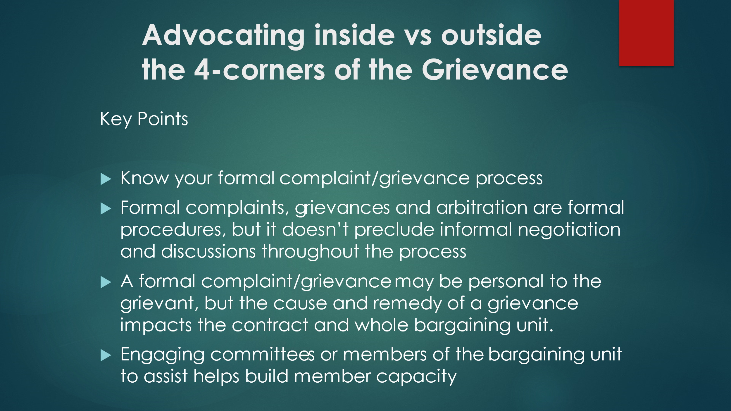  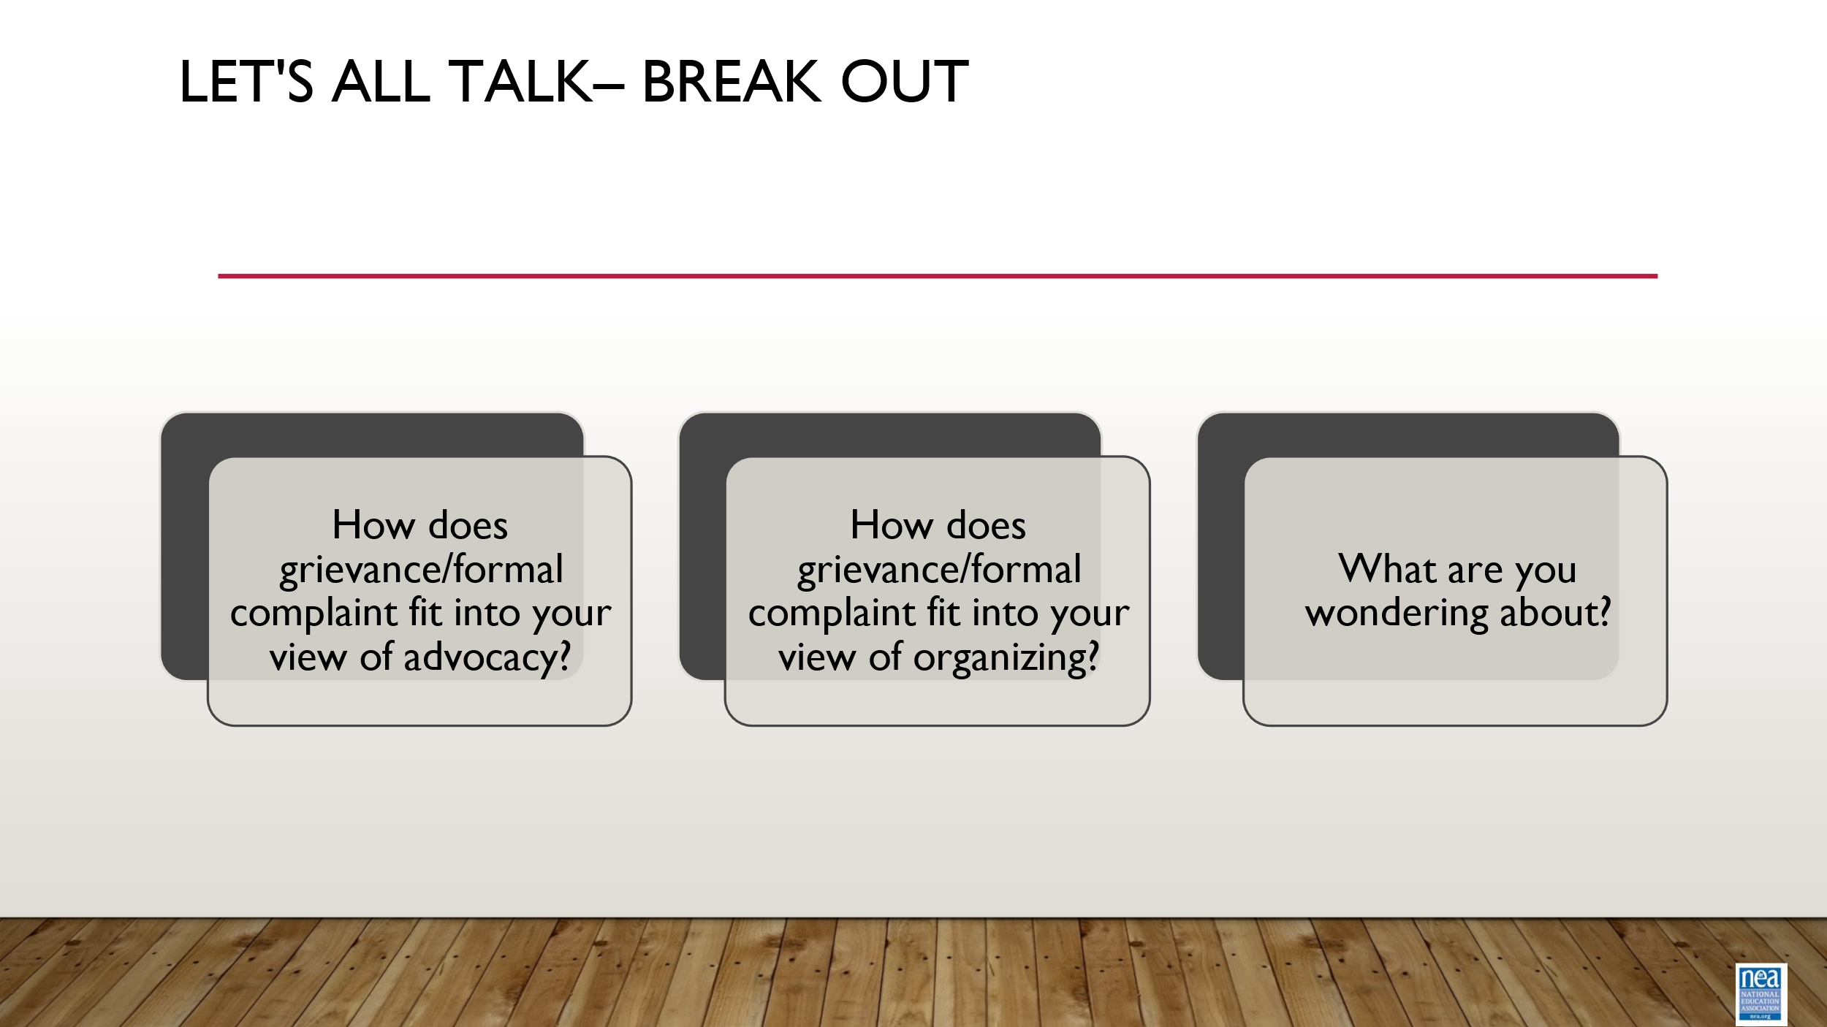  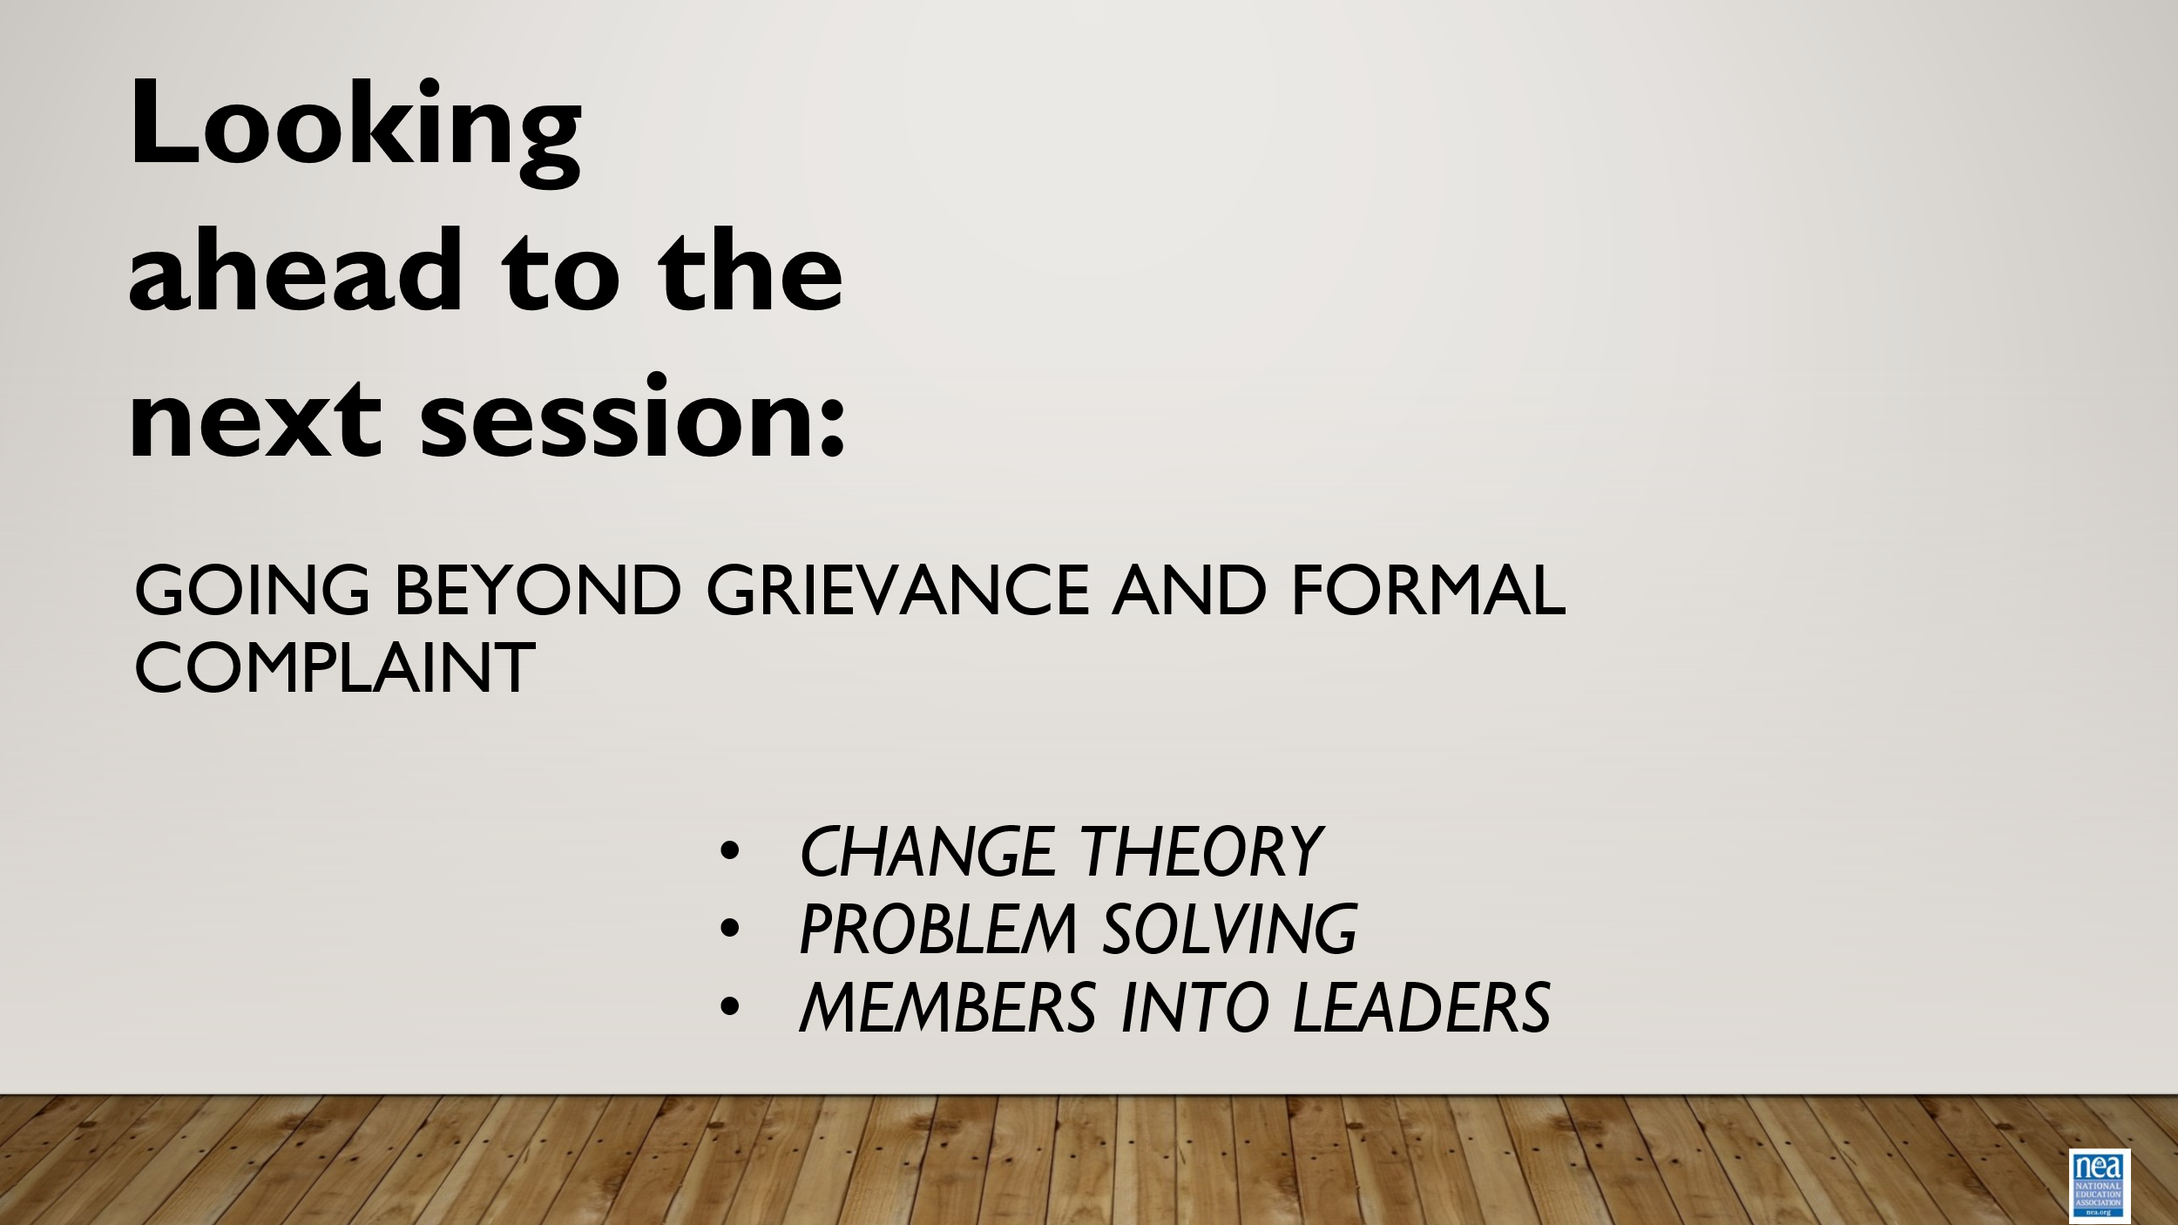 | How do we connect our formal advocacy skills to our view of organizing? |  | 3 minutes: Go over advocating inside vs outside the 4-corners of the grievance  Key points:  Formal grievance/ complaints can help locals organize by showing that they are (valued) and your organization is capable and willing to take action (safety). A well-managed complaint process can transform dissatisfied members into well-informed members who can take action (agency).  7 minute – Breakout  7 minute – report out  2 minutes – Close out look ahead to day 2

