Facilitator Agenda Day 2 – Organizing Through Advocacy
General Materials Needed: |  |  |  |  | Room Set-up:
Key Outcomes for the Event:

Time | Essential Questions | Resources |  | Instructions, Activity and Debrief (Facilitators) |  | Outcomes
 | What question(s) should this learning section answer? | Charts, handouts, articles, materials, slide  RED is for Facilitator  BLUE is for Participant |  | What are you saying, what are they doing, what questions will you use to guide learning and make clear the important points  Include an estimate for how long each section of the learning will take |  | As a result of this section of learning, what will participants know or be able to do?
2:00 -2:30 | Facilitator Prep
Entry Activity
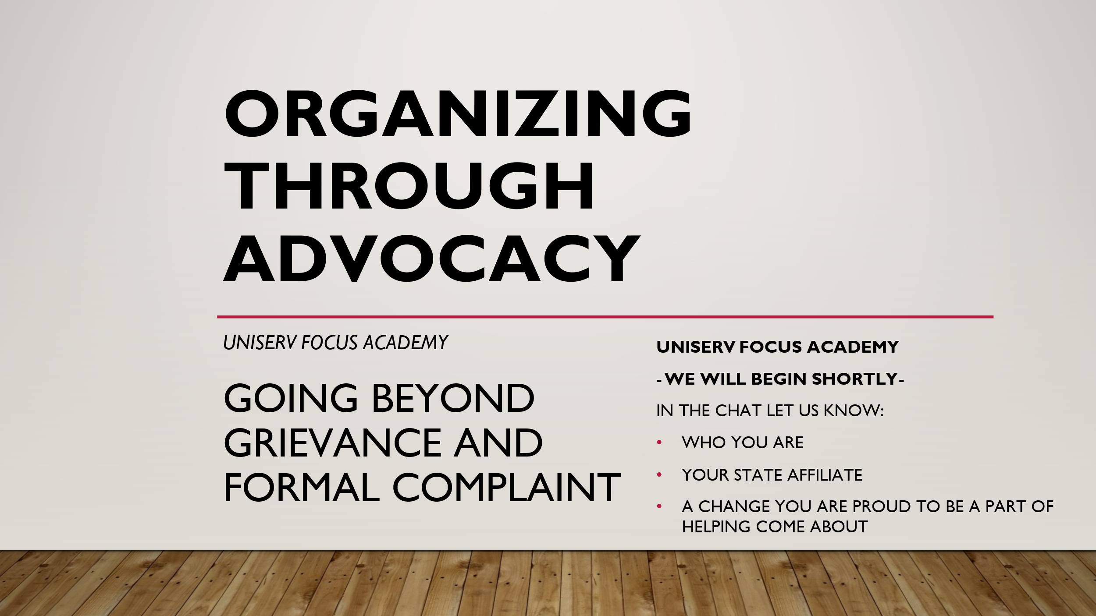

2:30 – 2:32  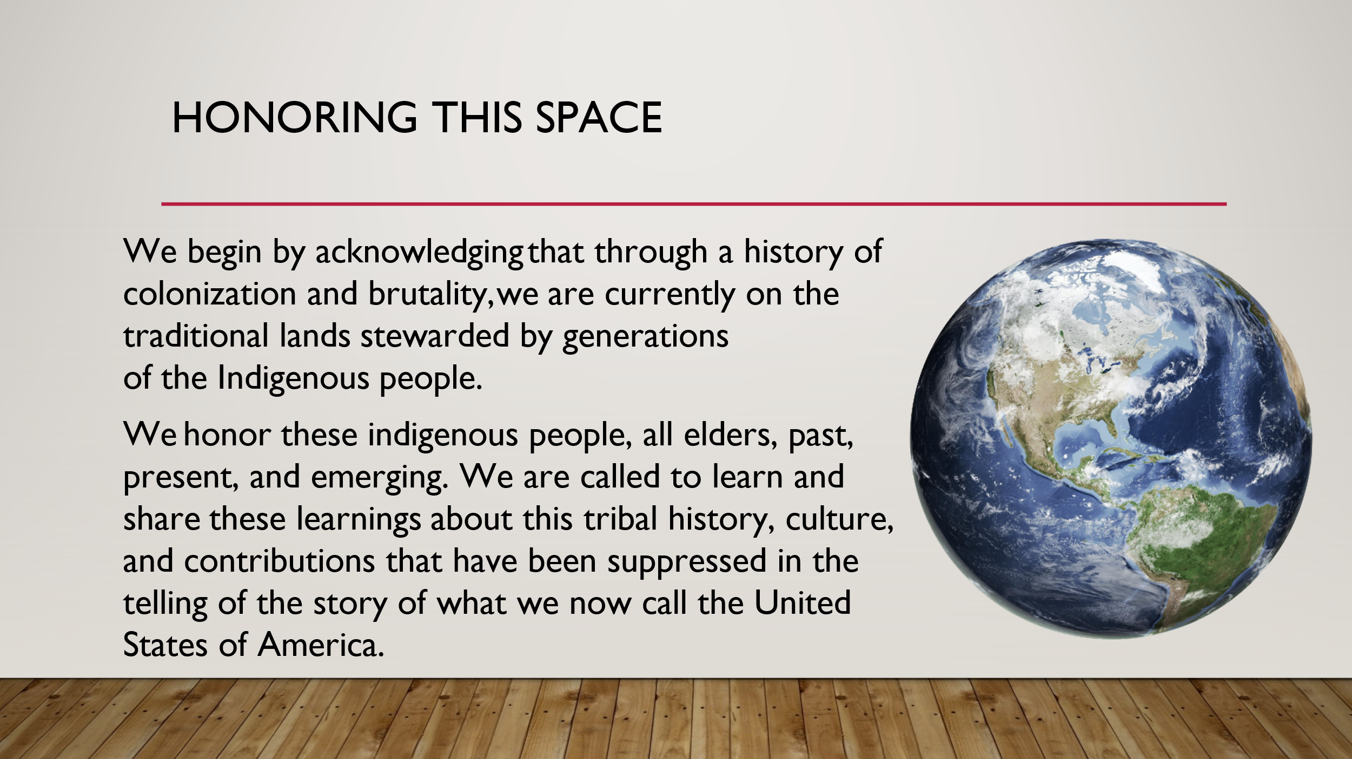  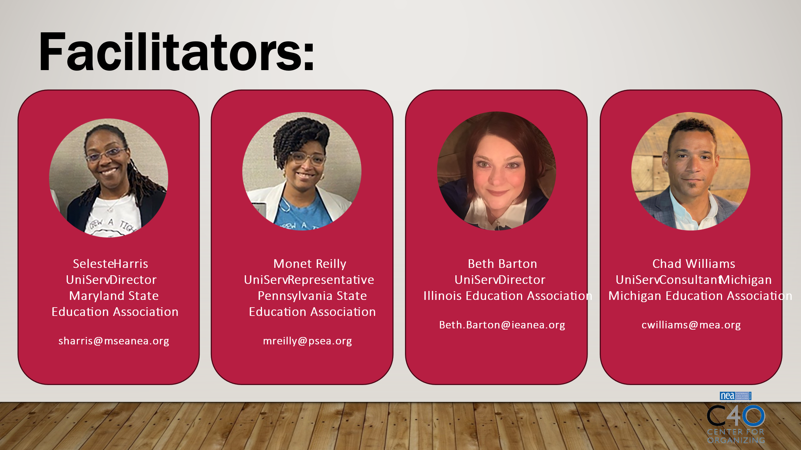  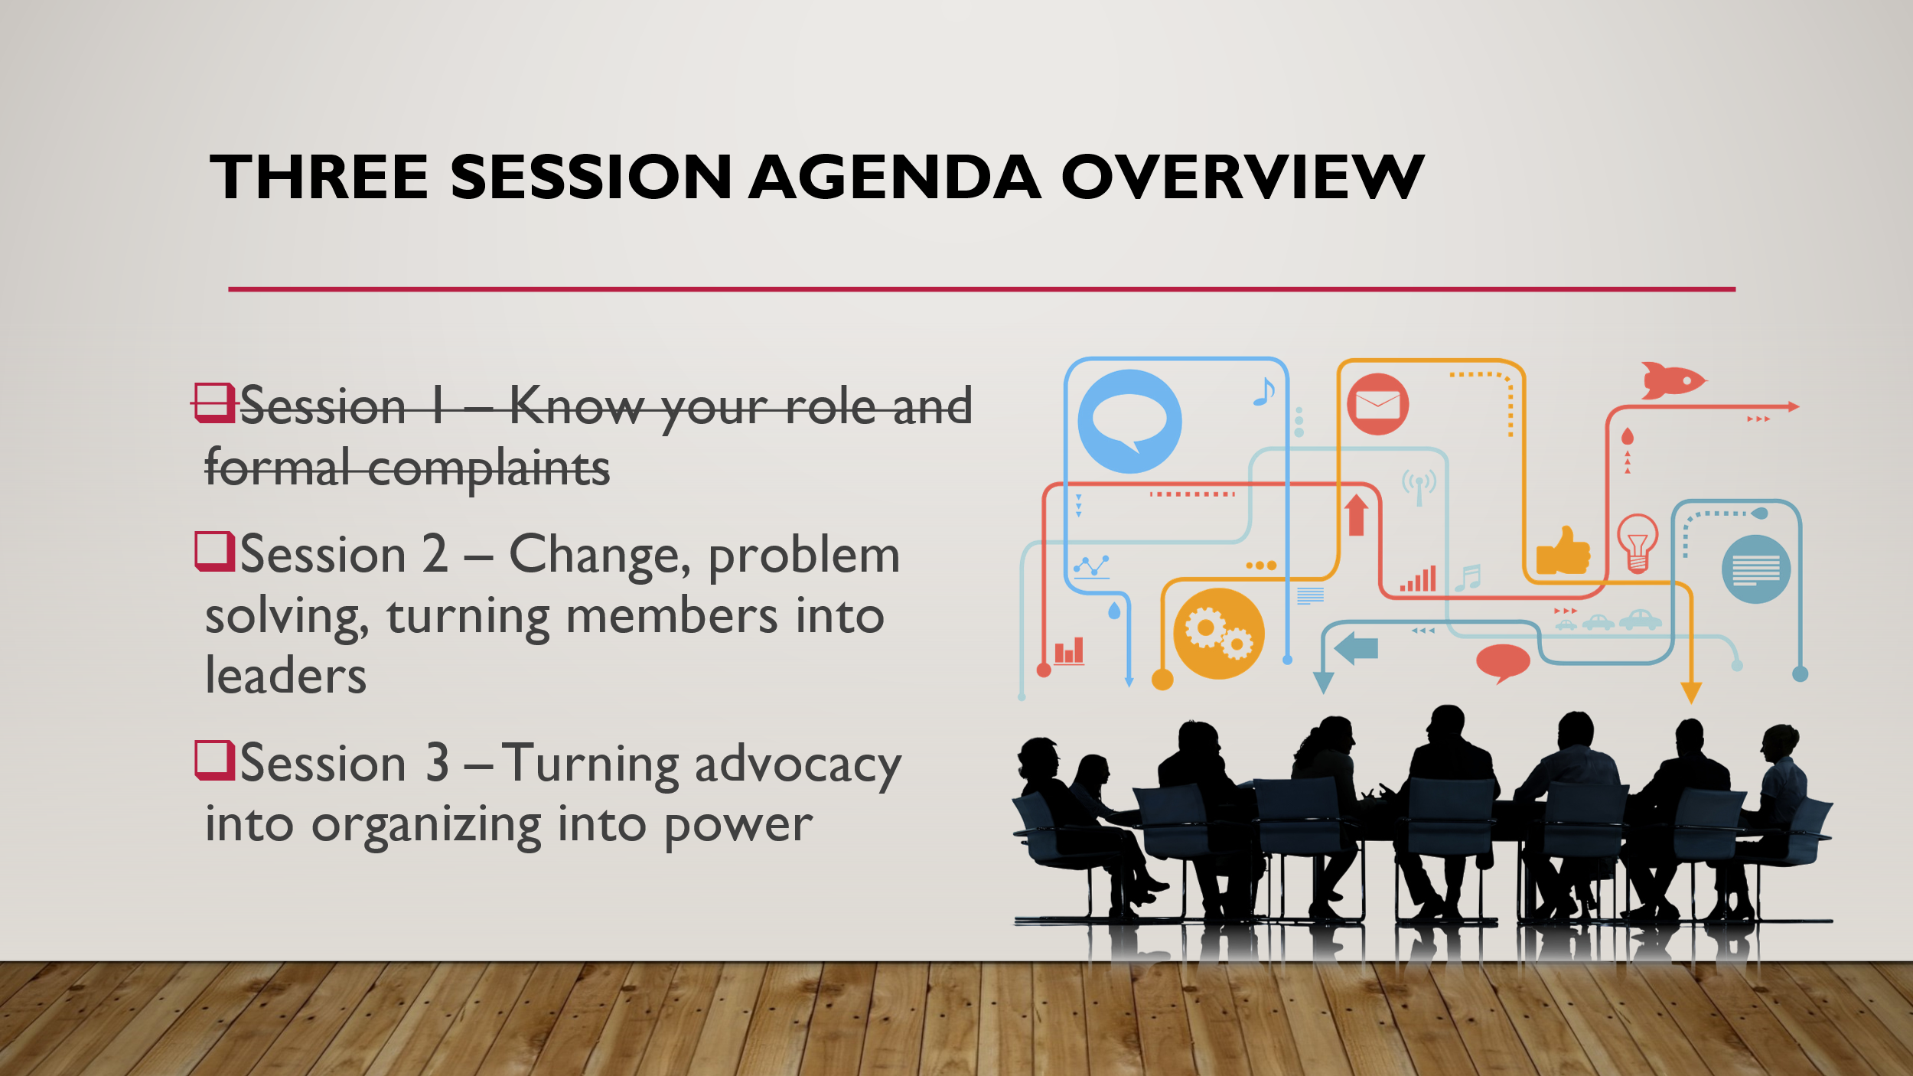  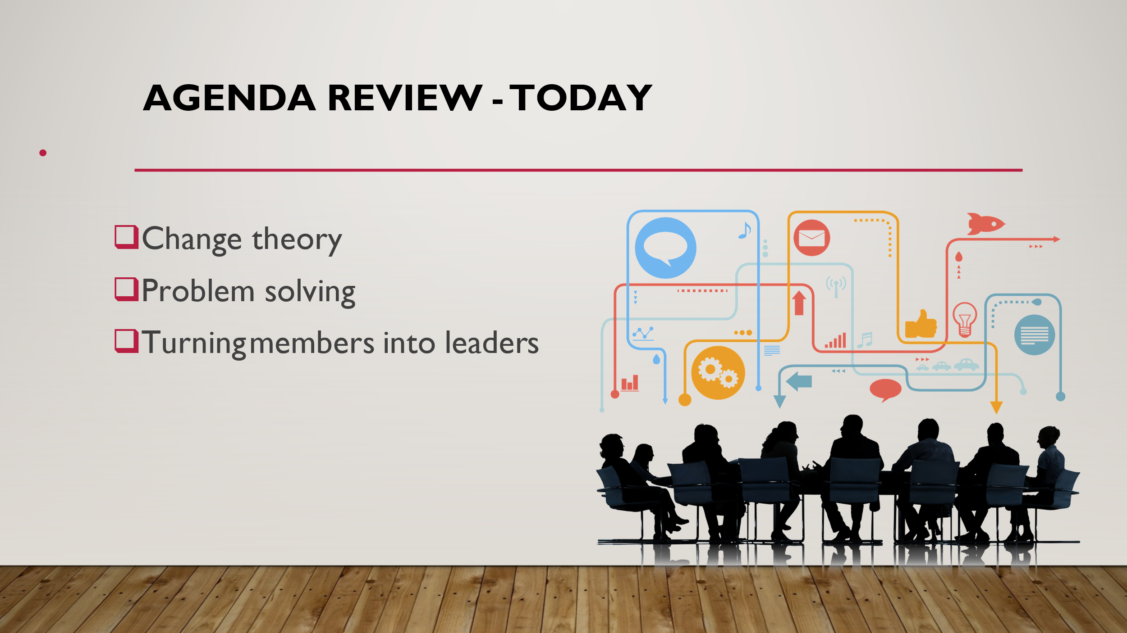 | How will we work together to support learning? |  |  | 2 min- Welcome and review  Reentry  Agenda Review  Norm Review |  | Participants will know how we are going to work, the basic schedule, and the logistics relevant to the training.
2:32 – 2:55  Ilyssa  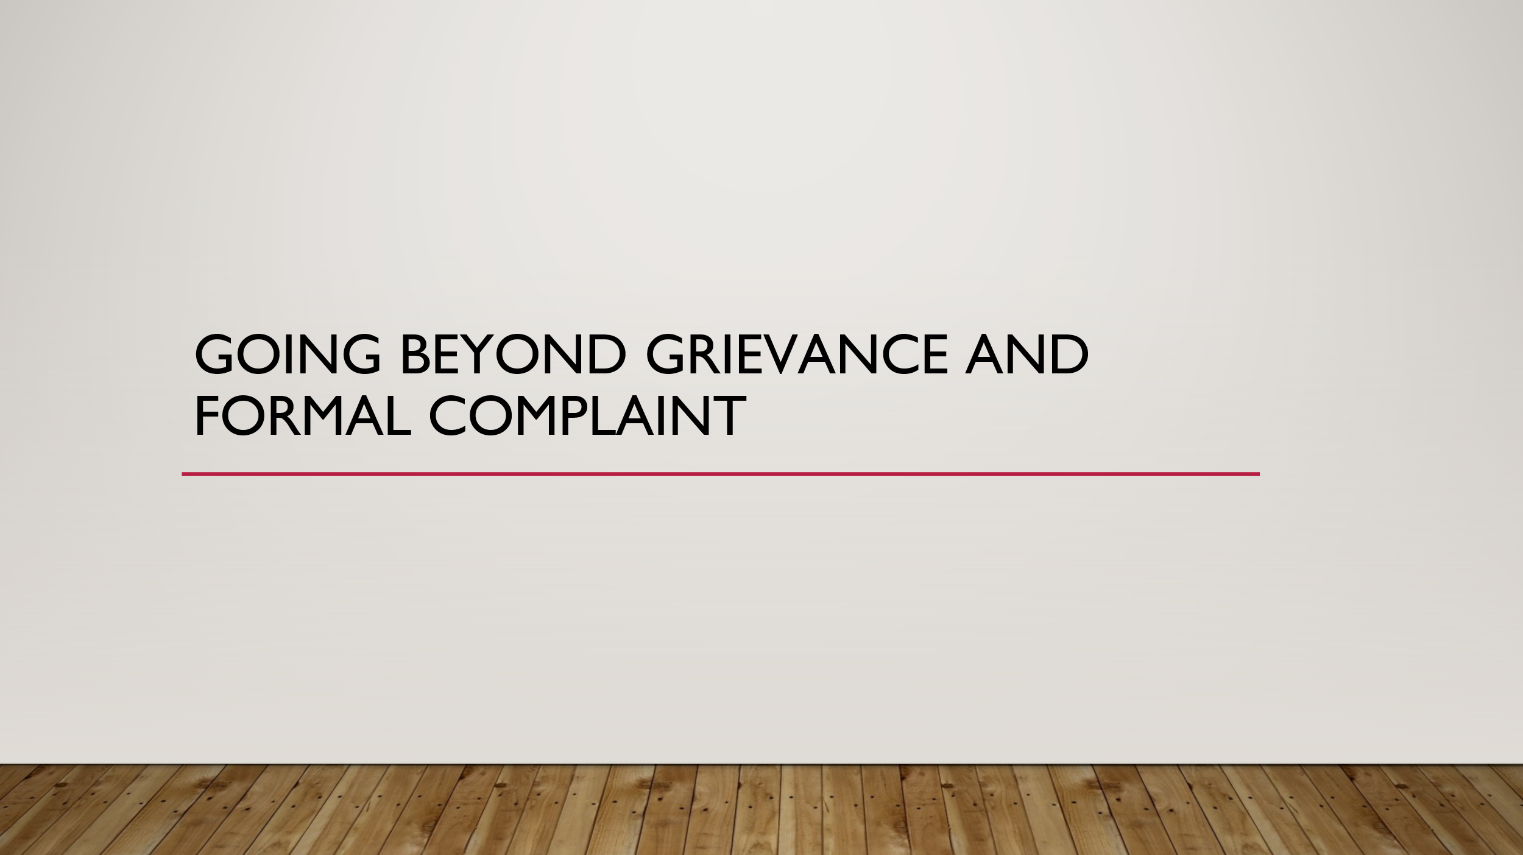  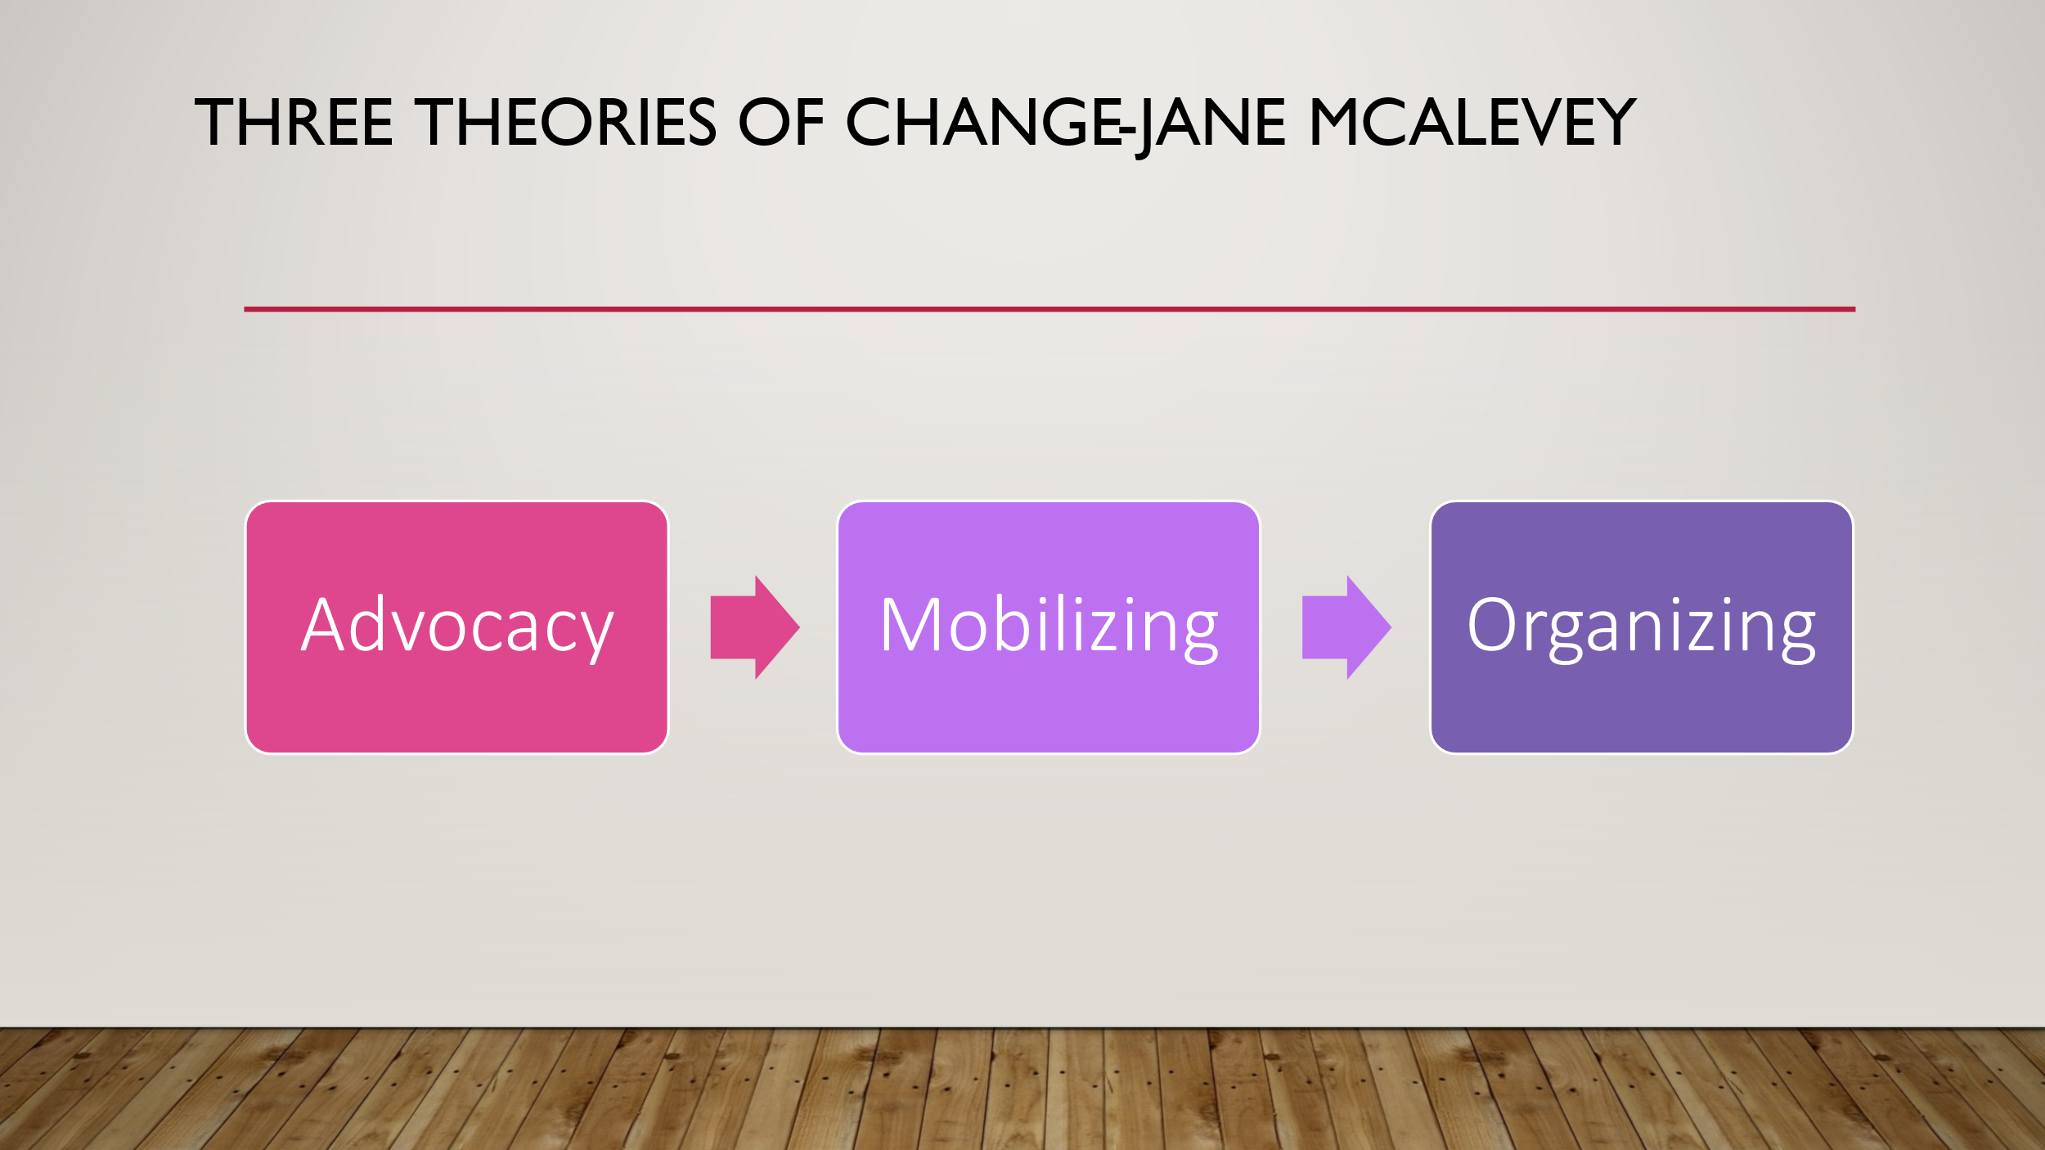  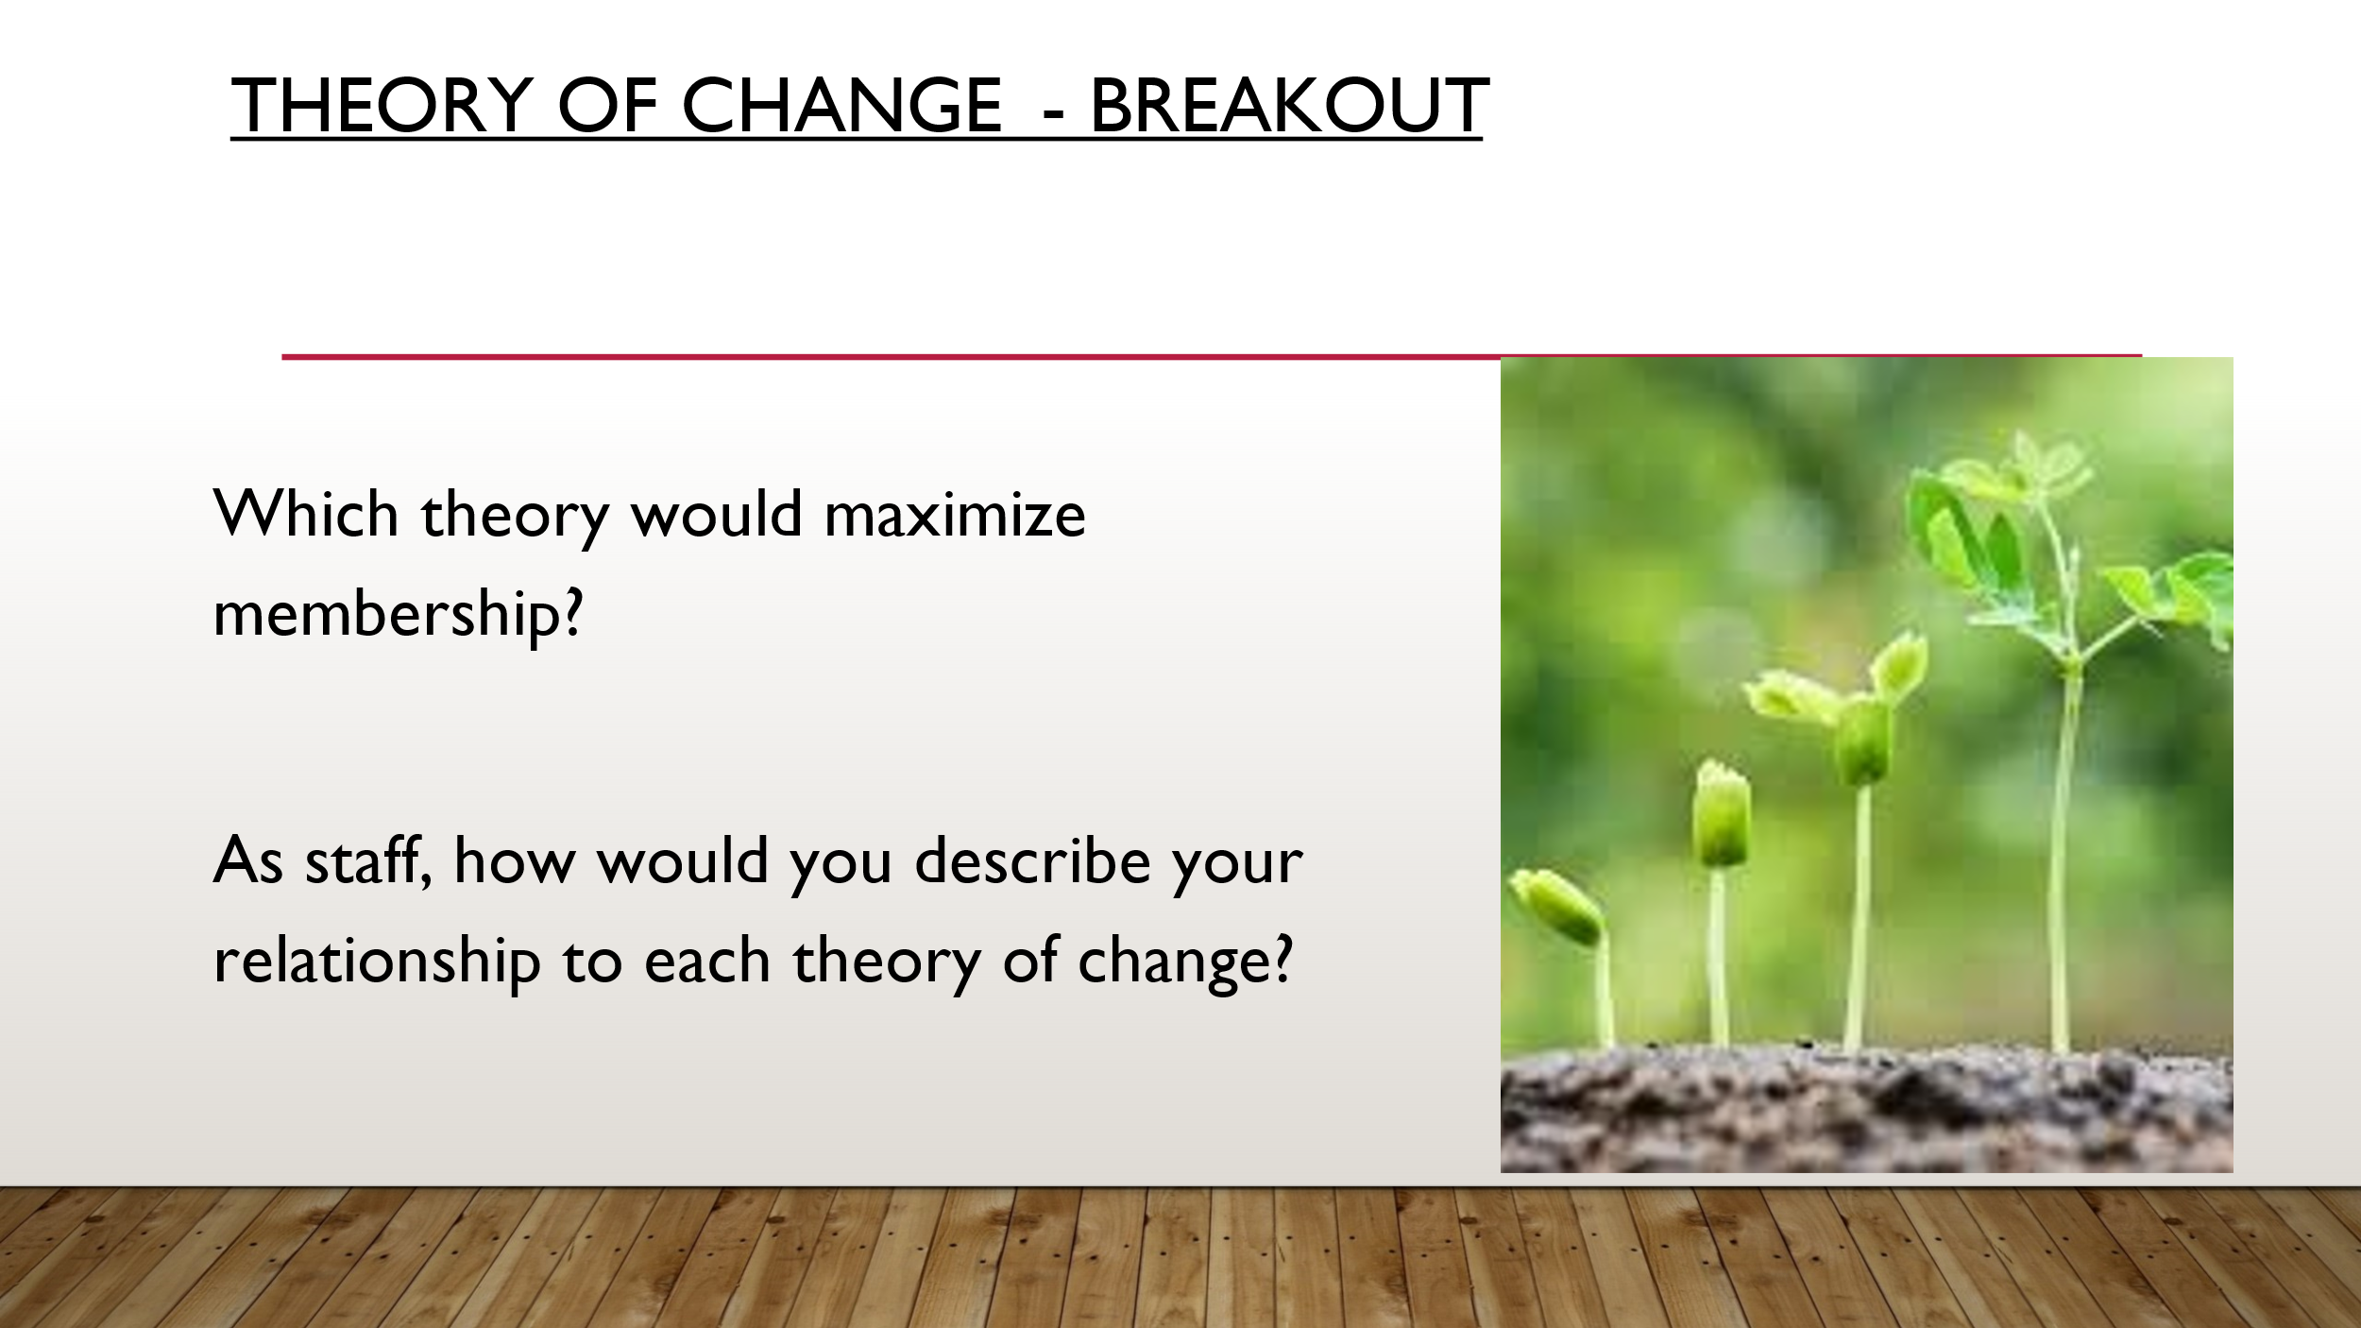  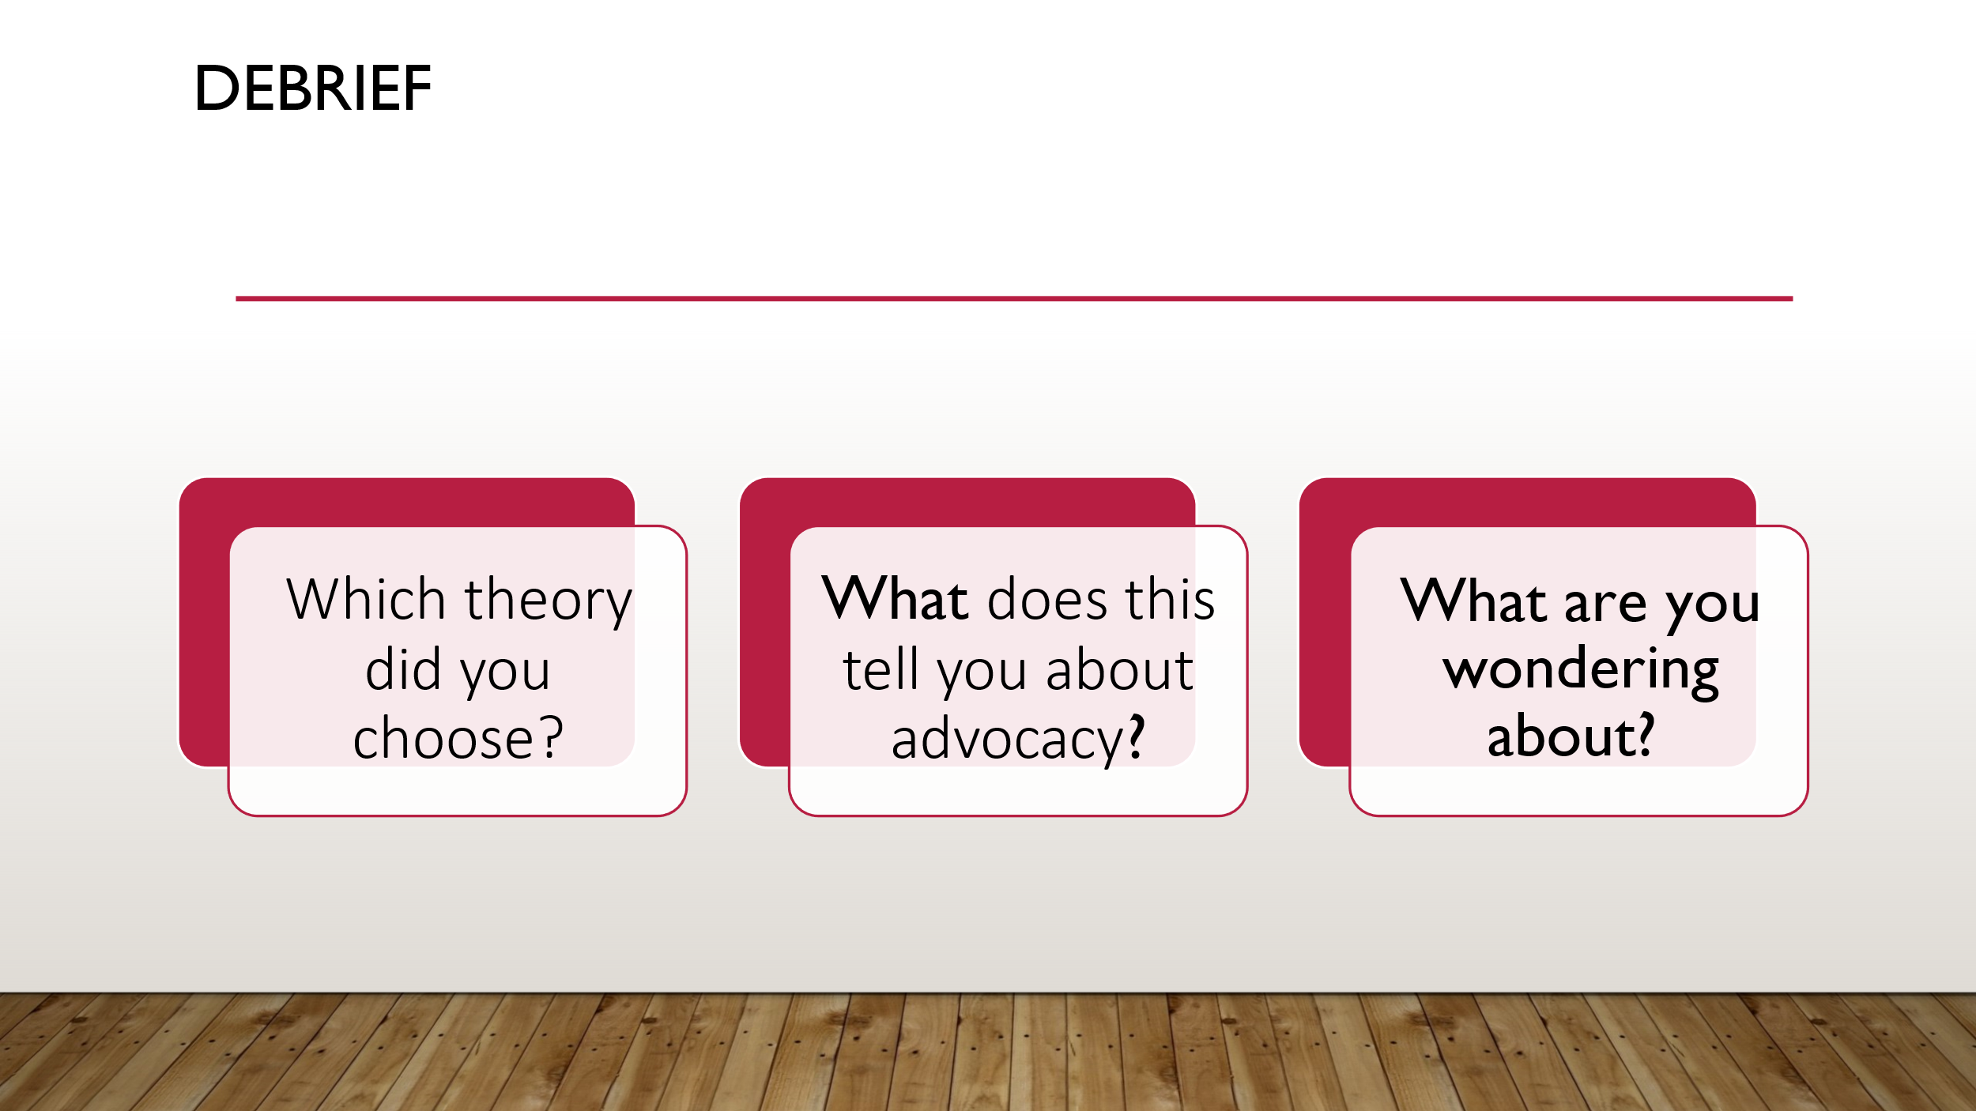  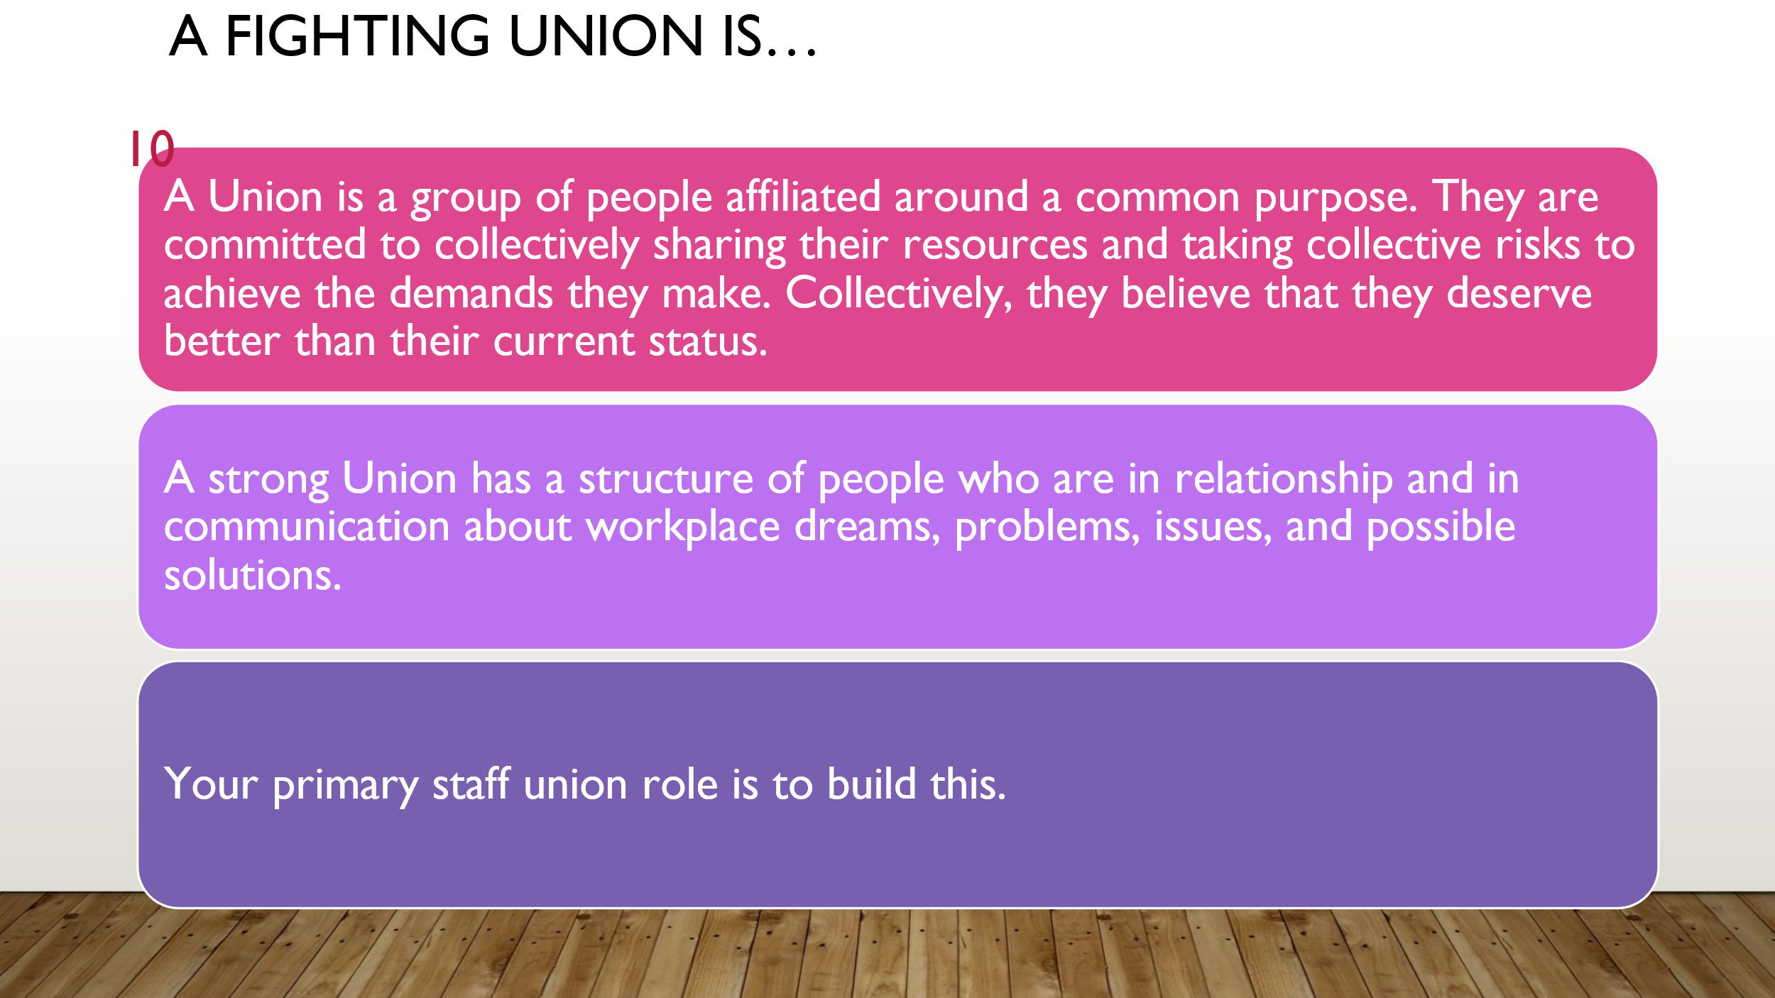  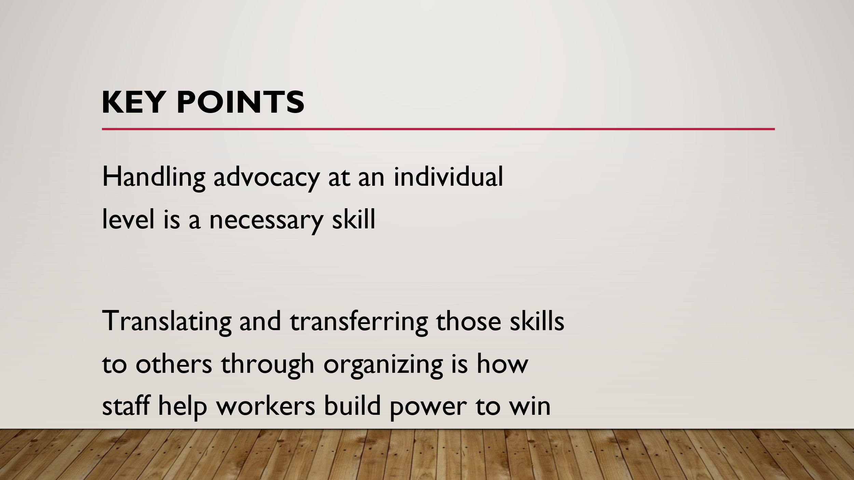 |  | Three Theories of Change Framework Pg 5-8 |  | 23 minutes  (note: this session can be longer to taking time from the last session – up to 10 minutes. )  Discuss/review with participants Jane McAlevey’s 3 theories of change:  Pg. 5 of resource guide.  5 minutes - Facilitator can summarize the 3 theories from the reading:  - Advocacy  - Mobilizing  - Organizing  7 minutes – Breakout  Prompt:  - Which theory would maximize membership?  - As staff, how would you describe your relationship to each theory of change?  7 minutes – report out and discussion  - Which theory did you choose?  - What does this tell you about advocacy?  - What are you wondering about?  3 minutes – A fighting Union is and Key Points  Key points:  - Handling advocacy at an individual level is a necessary skill  - Translating and transferring those skills to others through organizing is how staff help workers build power to win
2:55 – 3:10  August  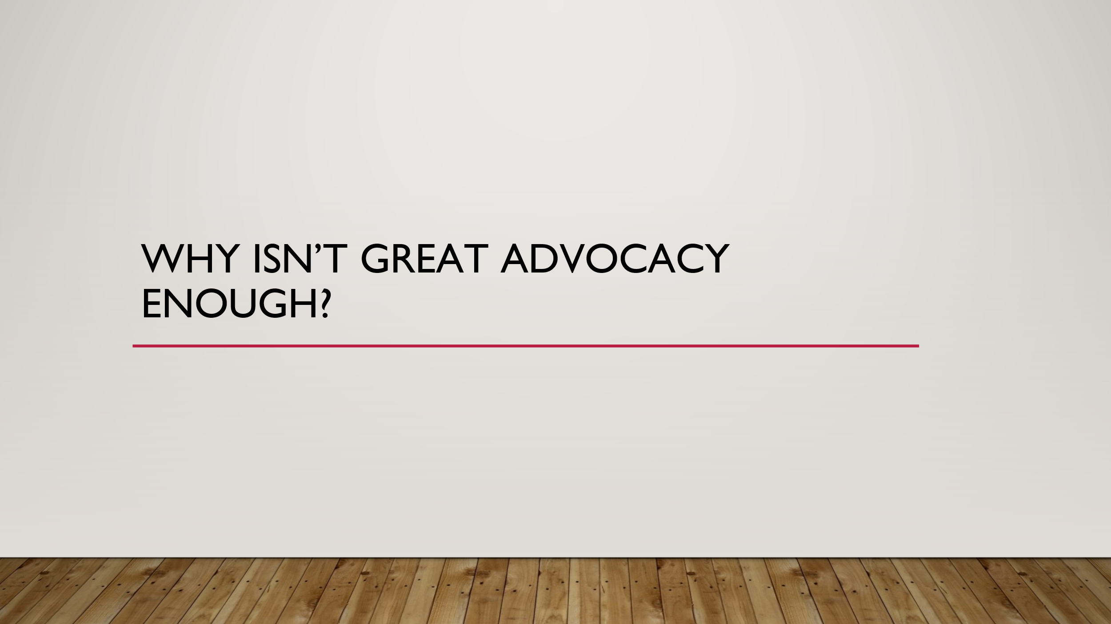  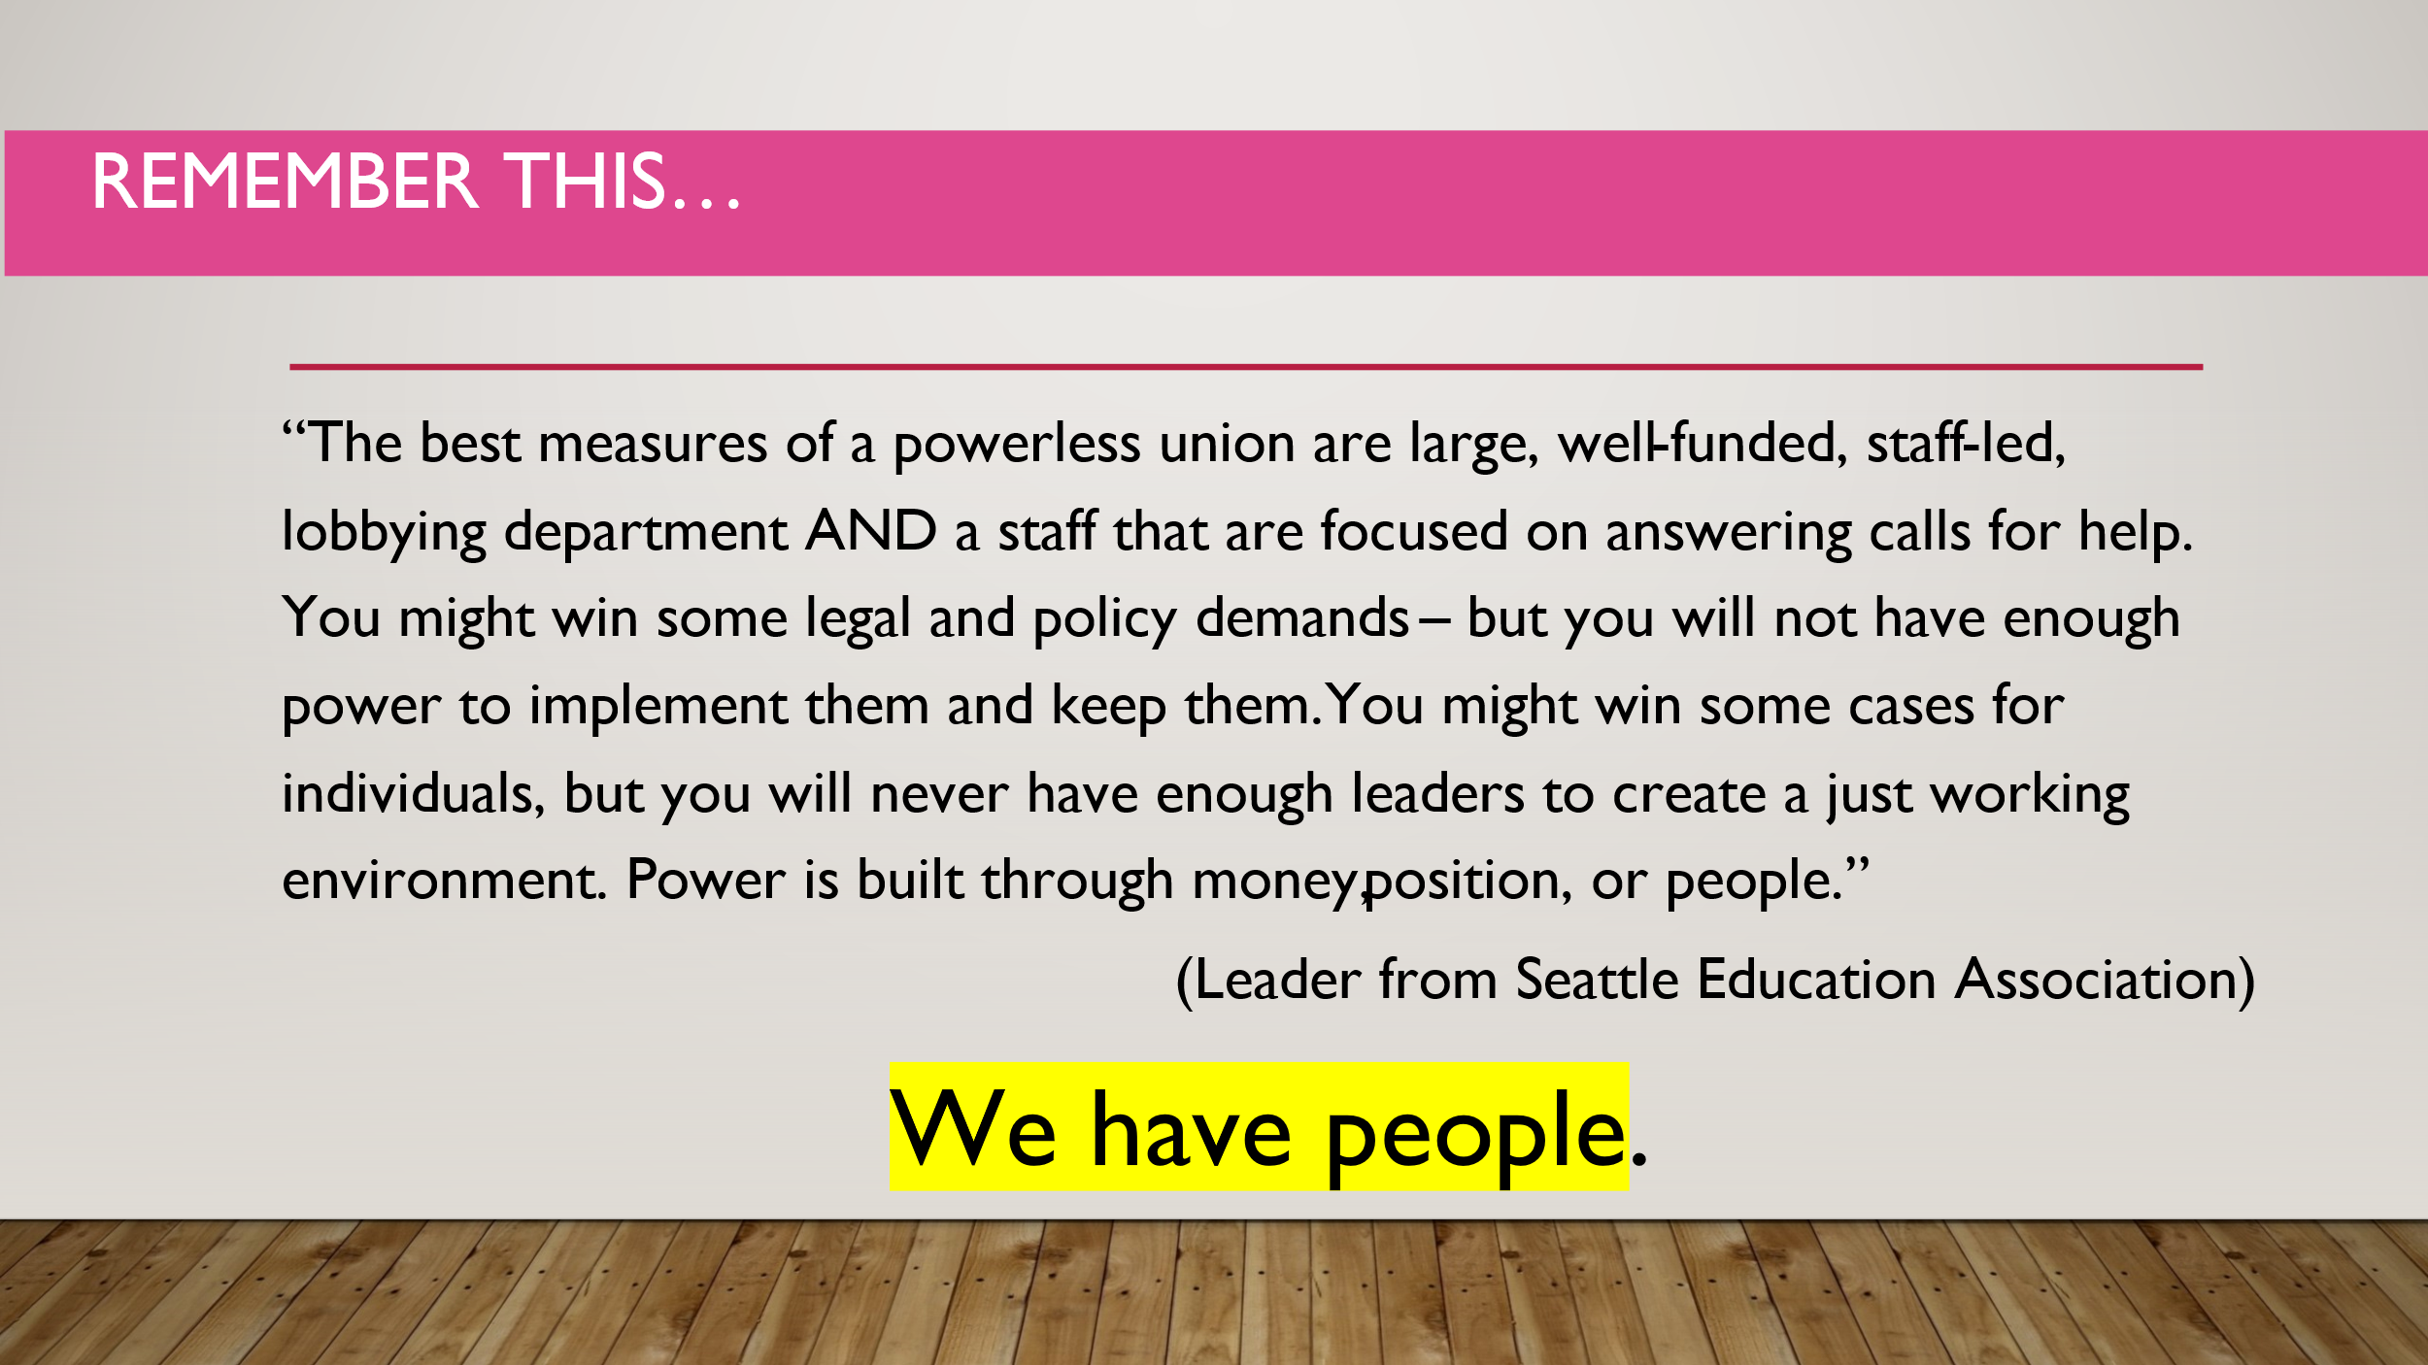  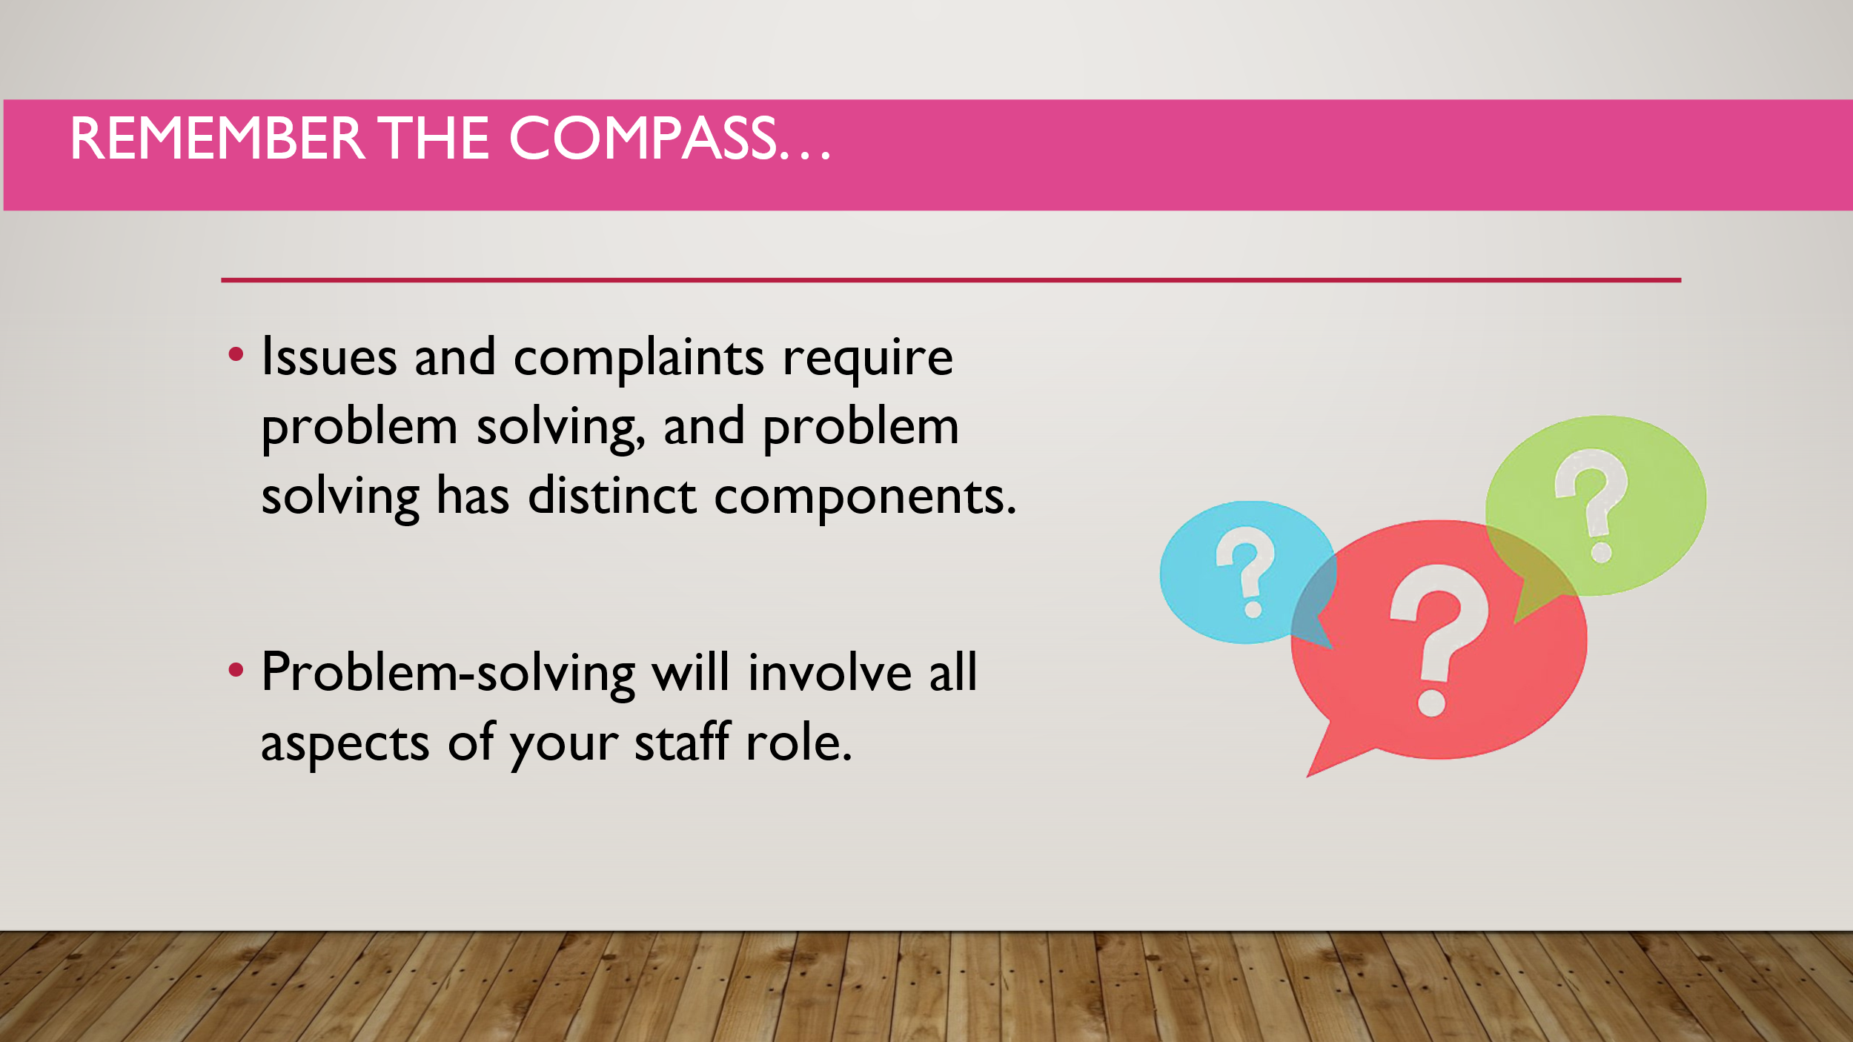  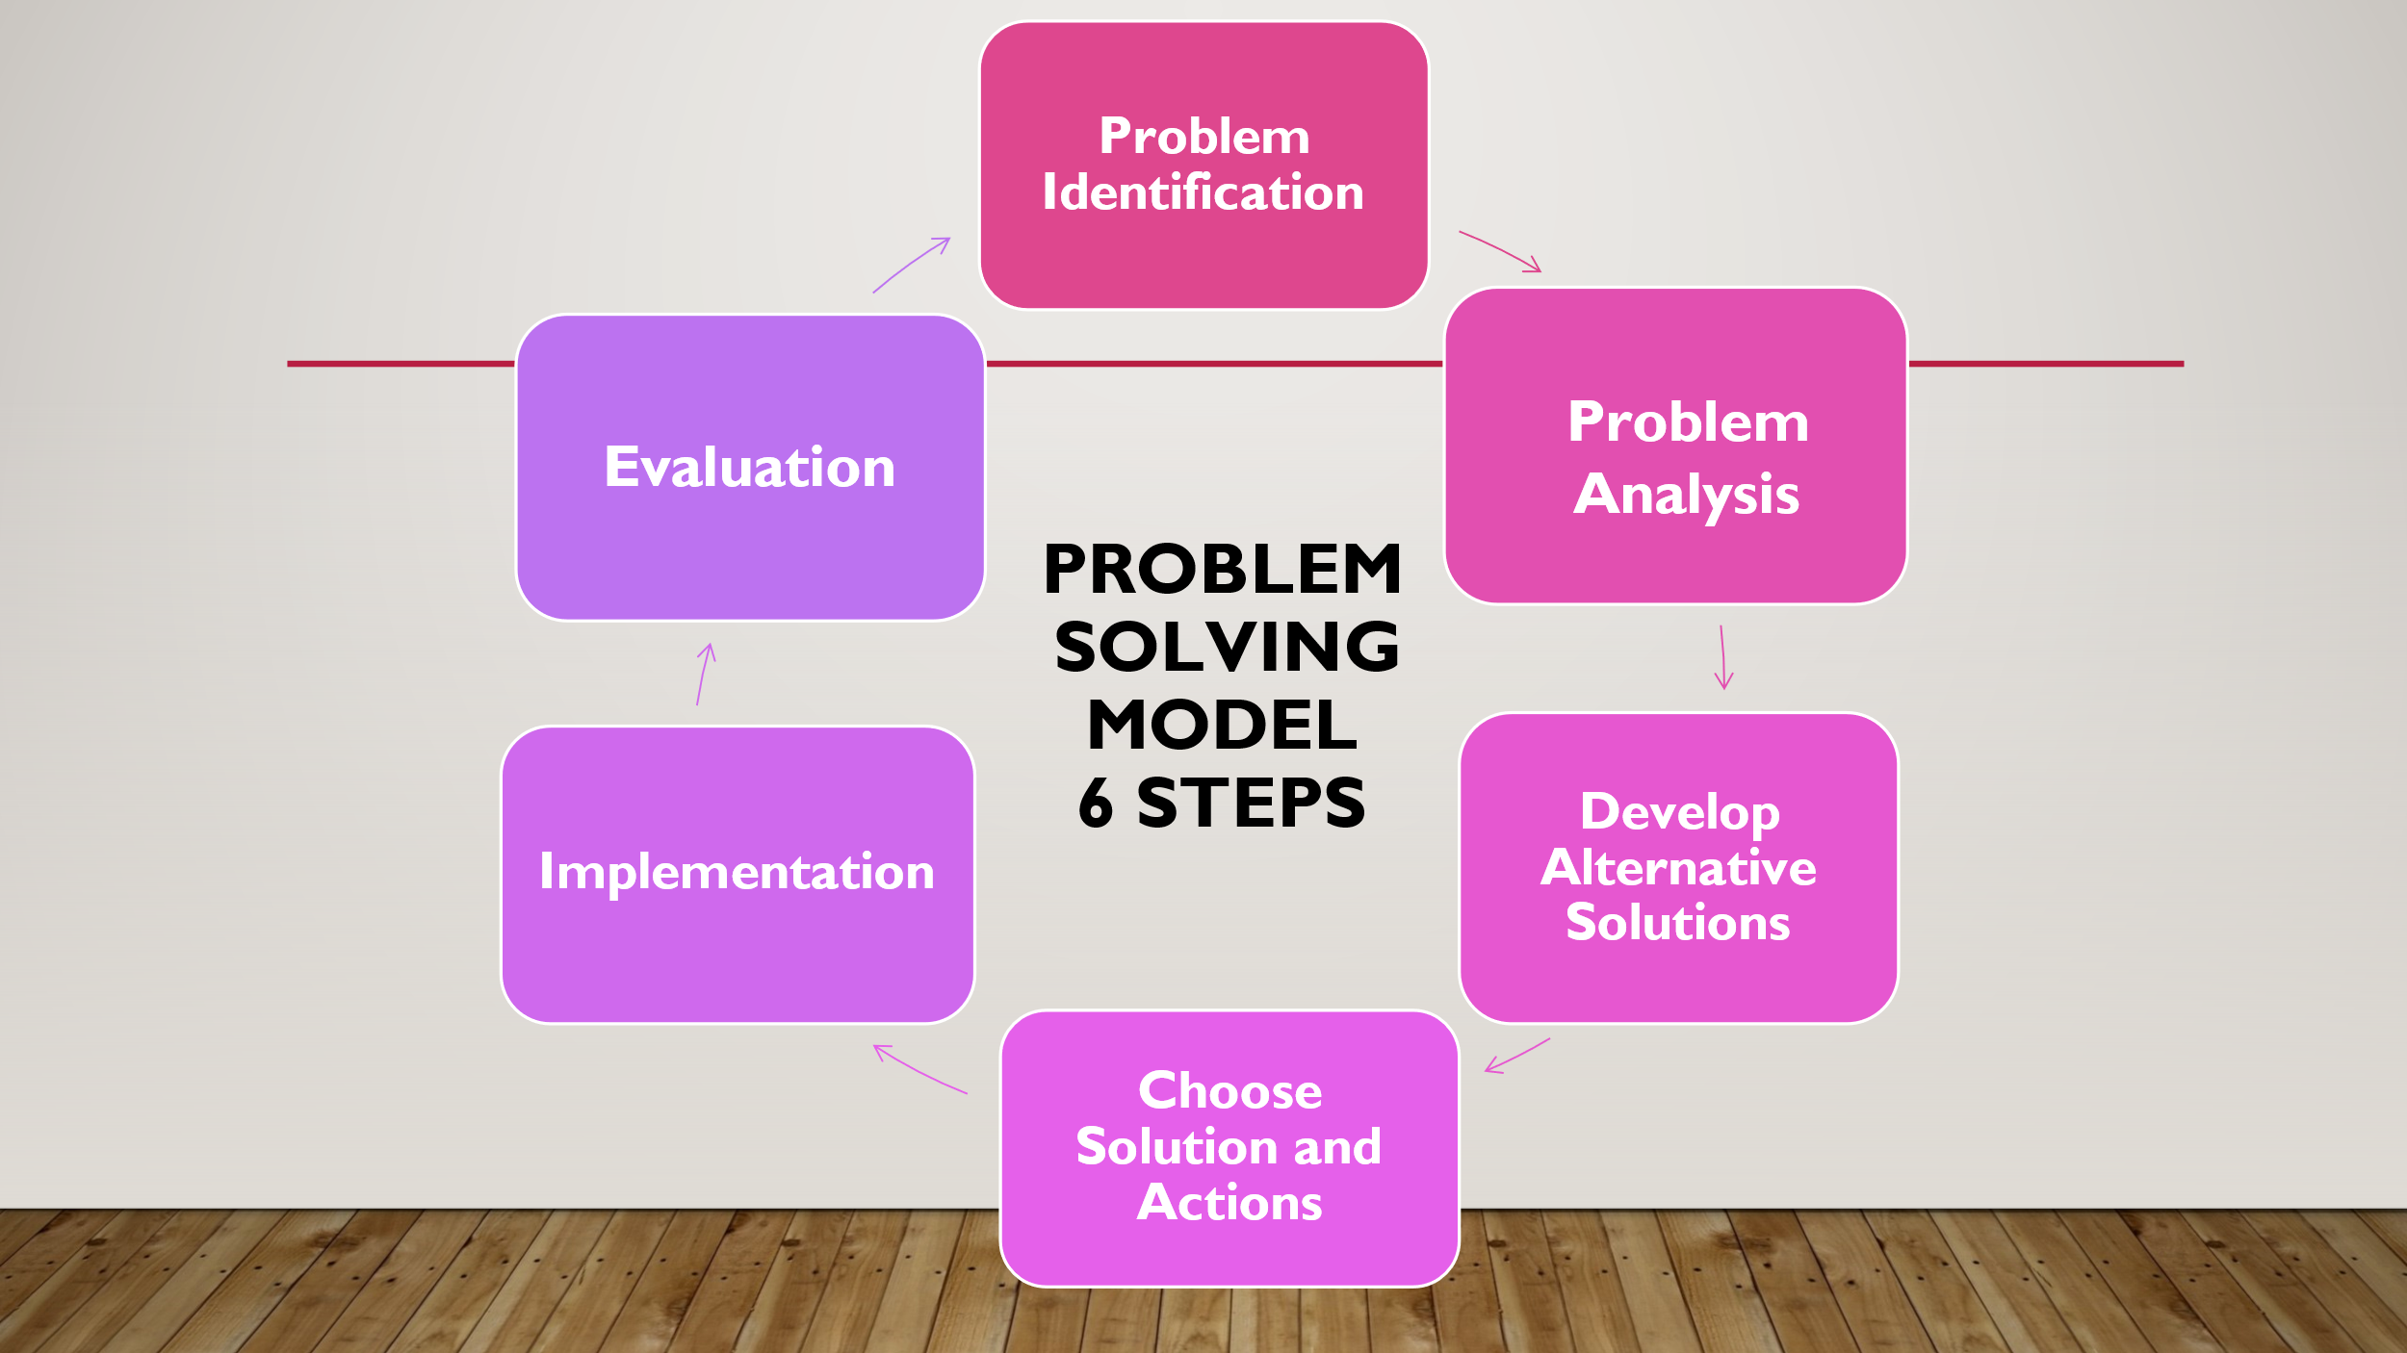  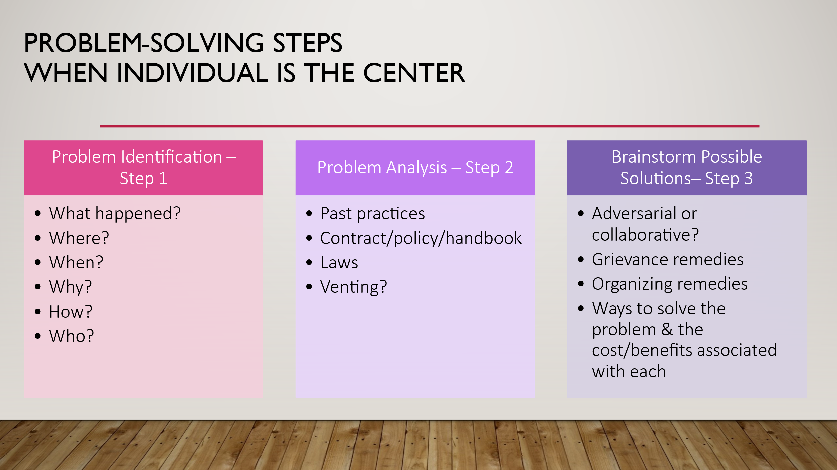  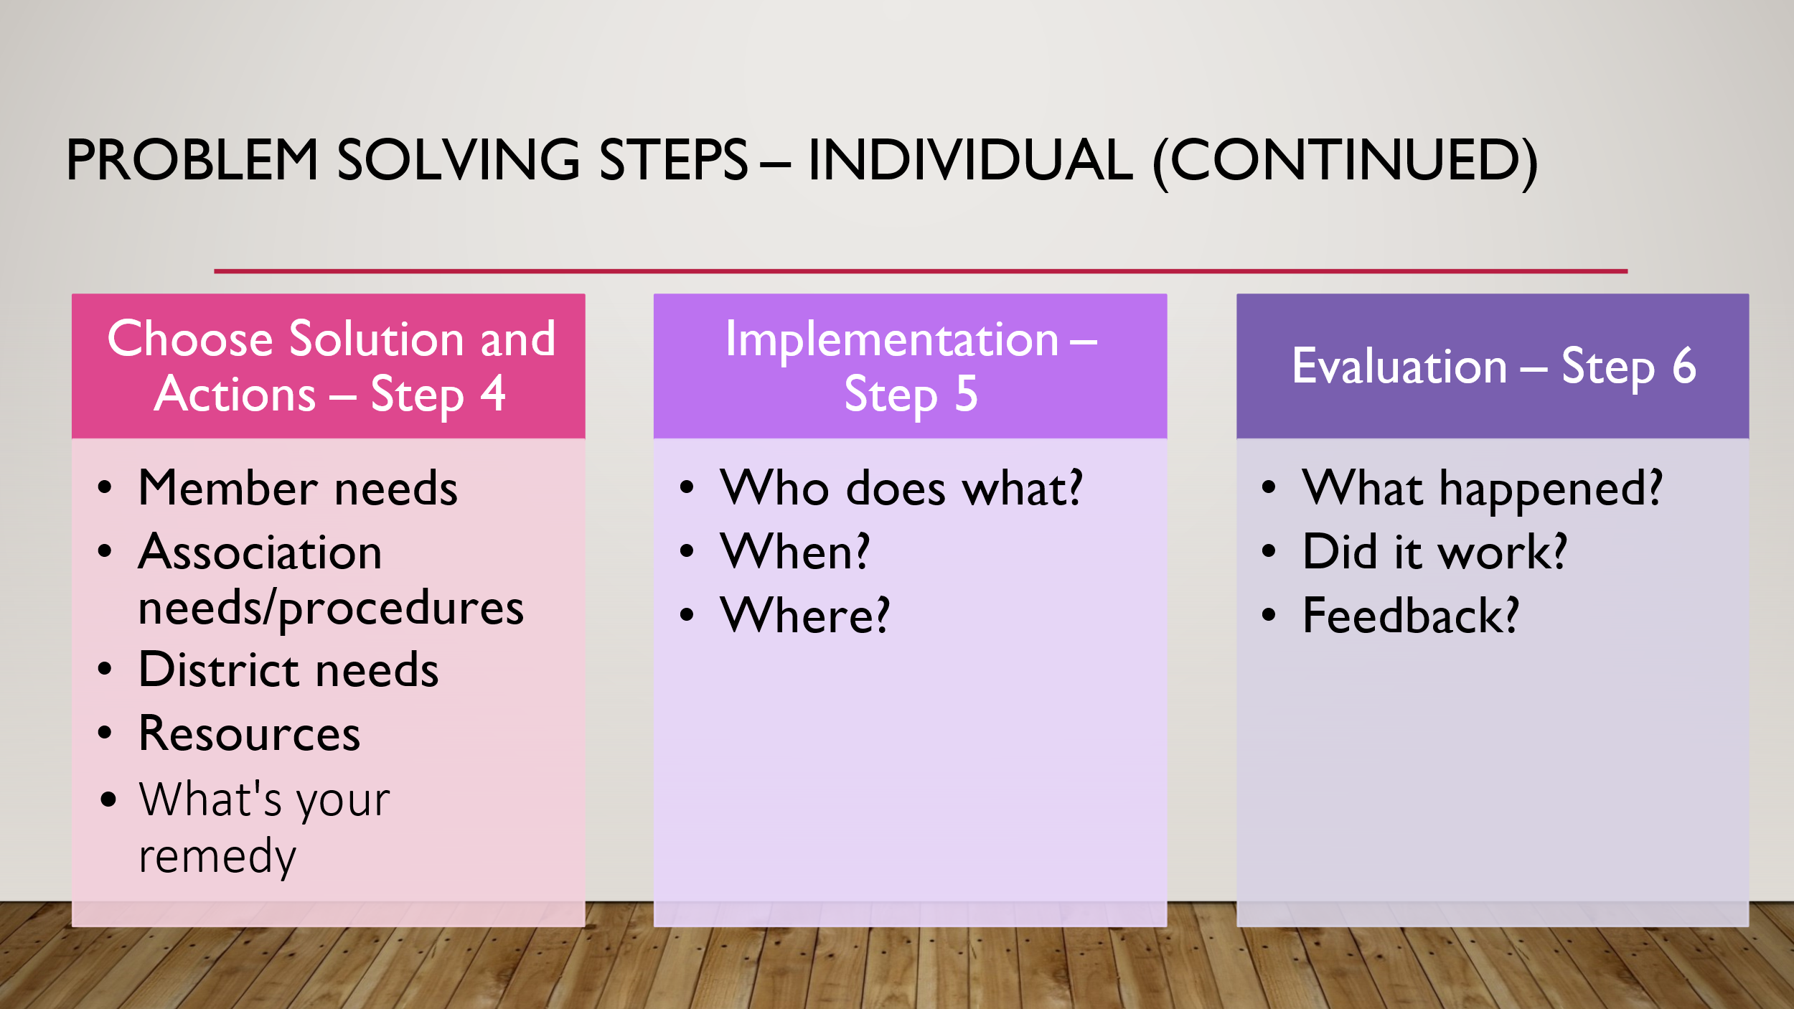  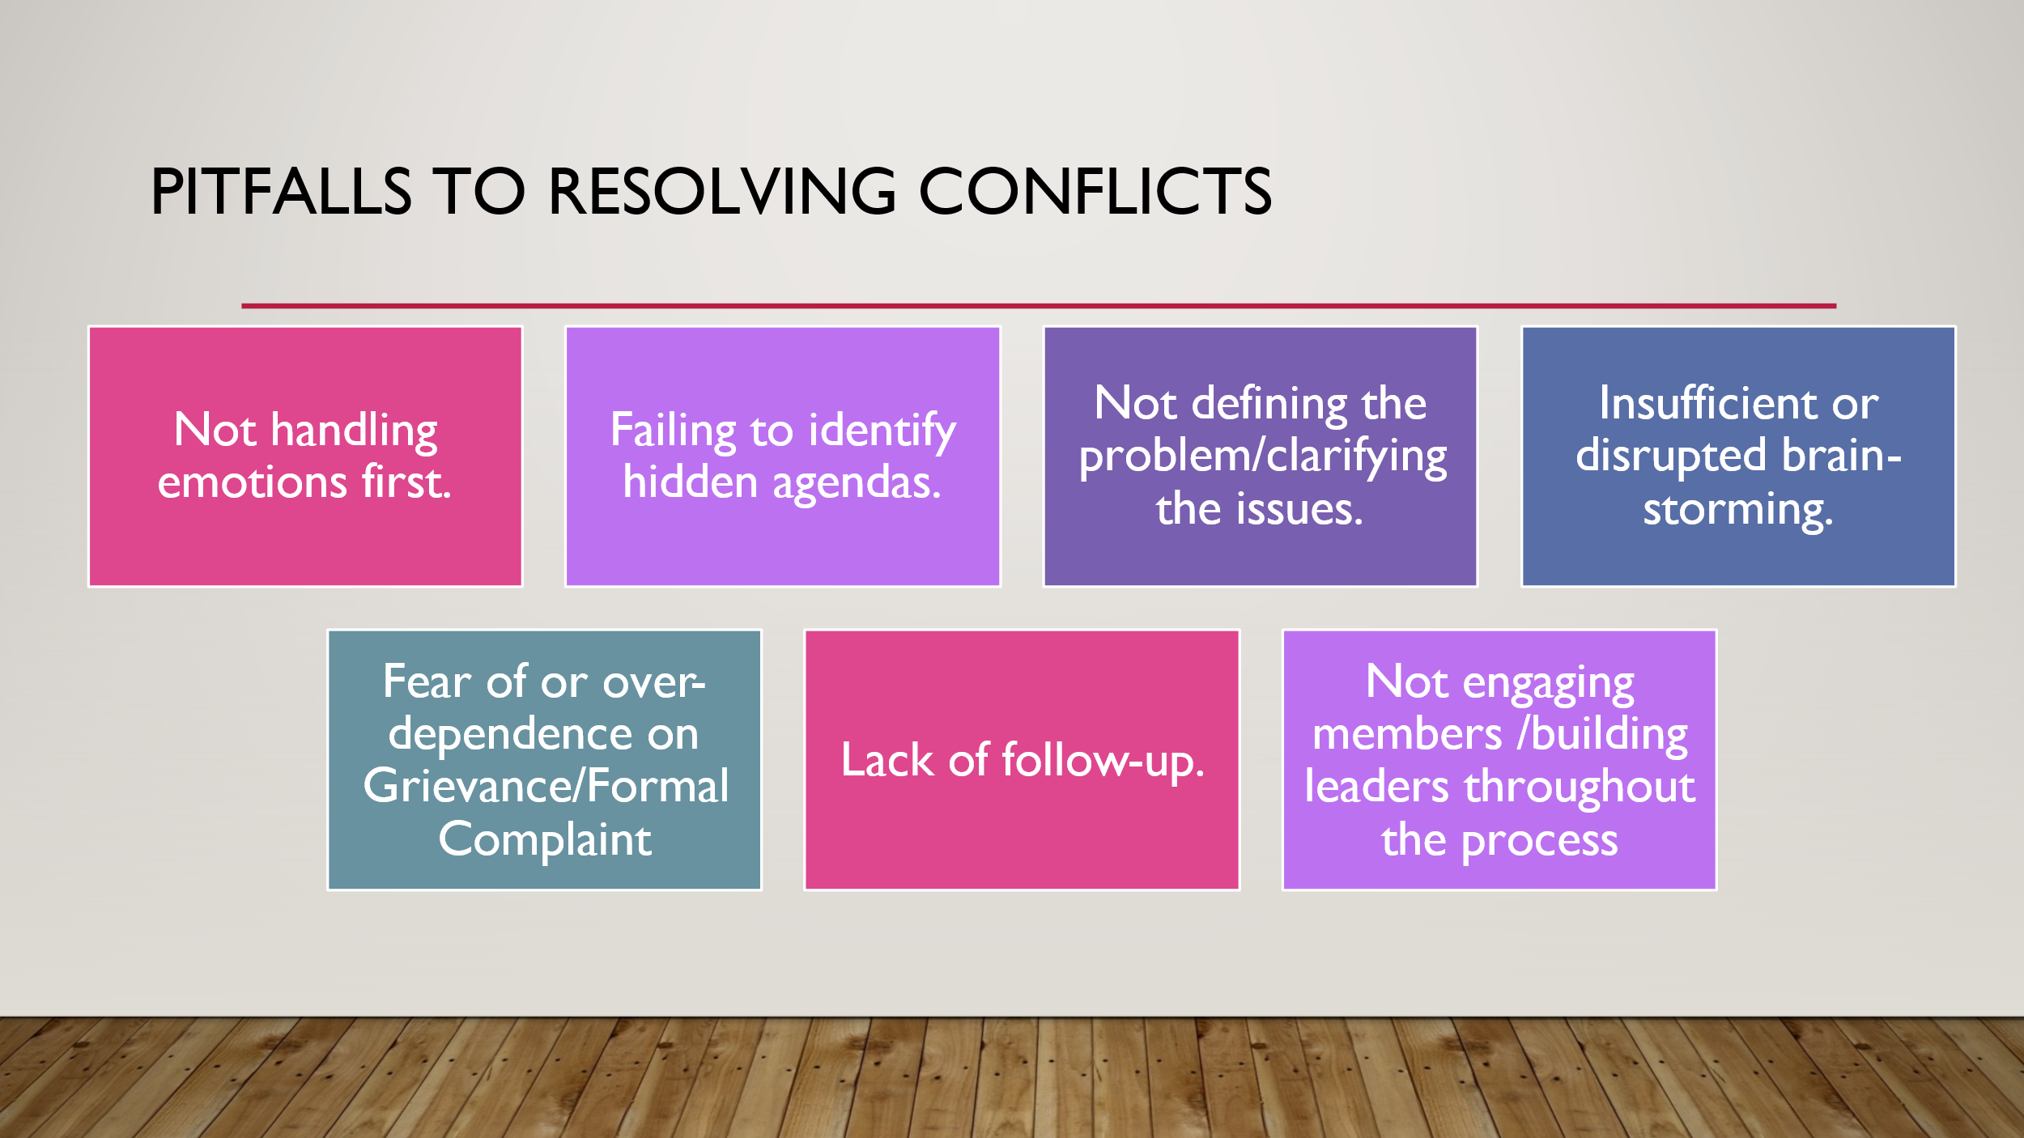  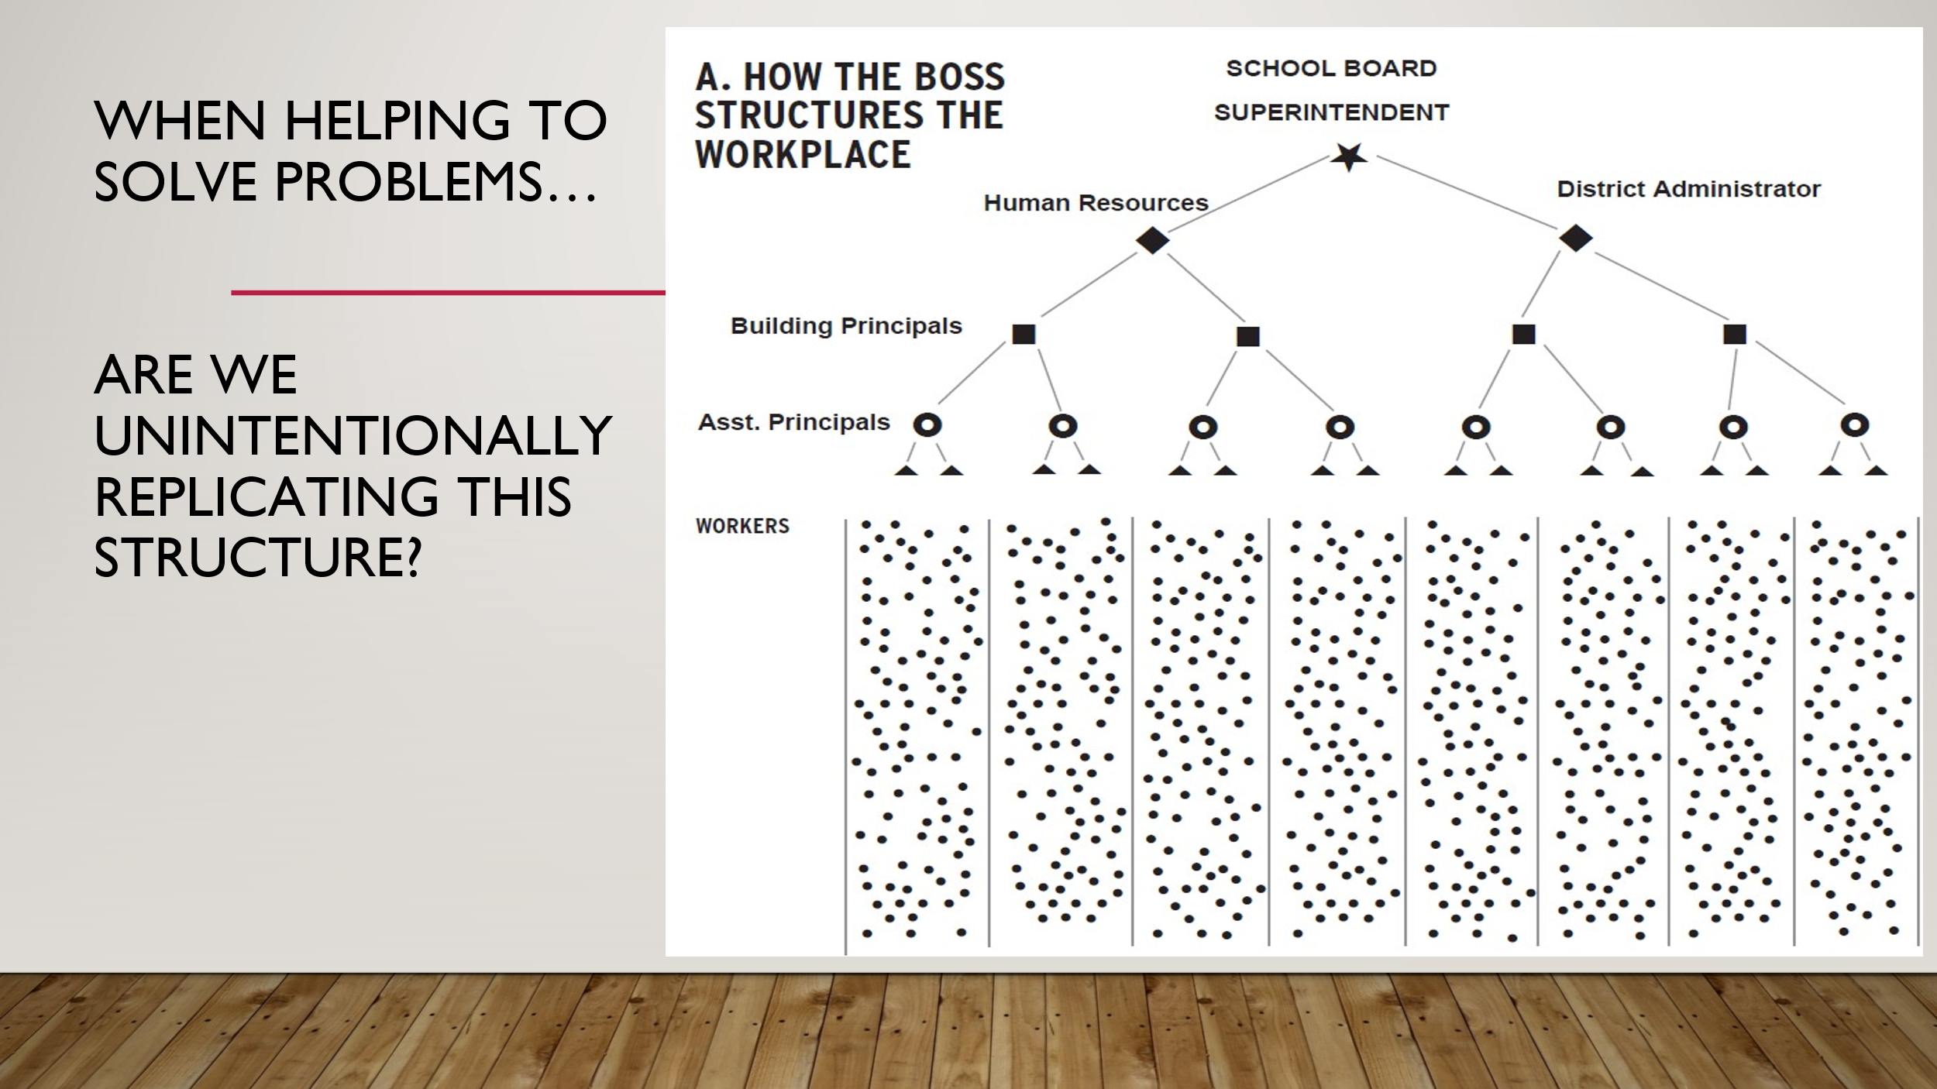  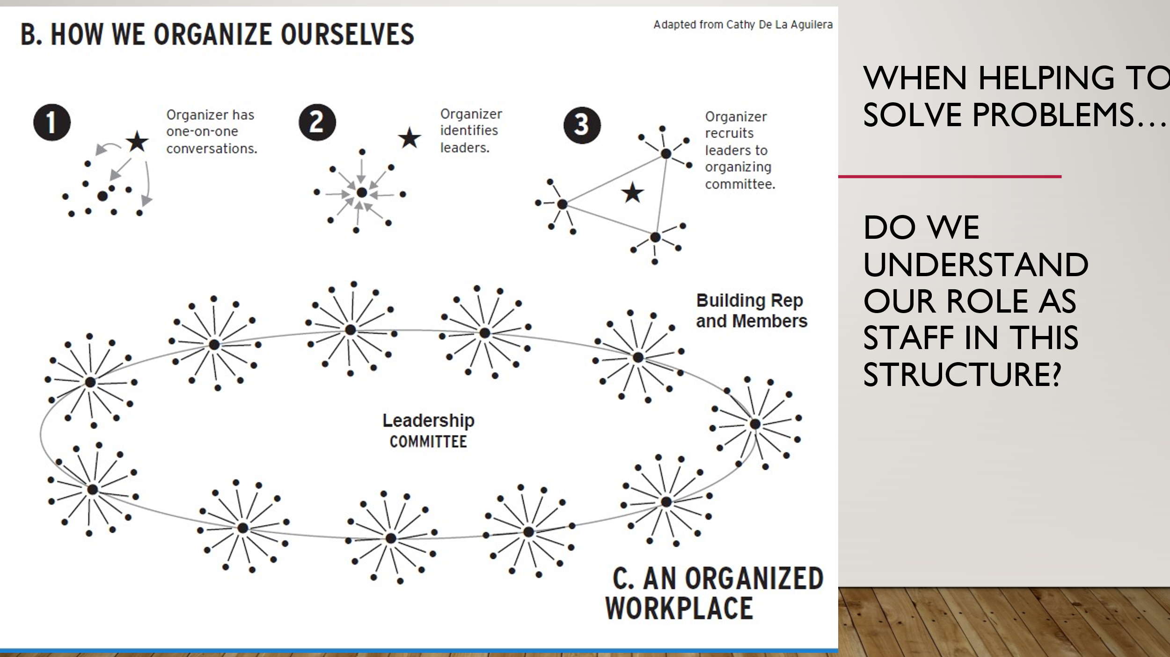  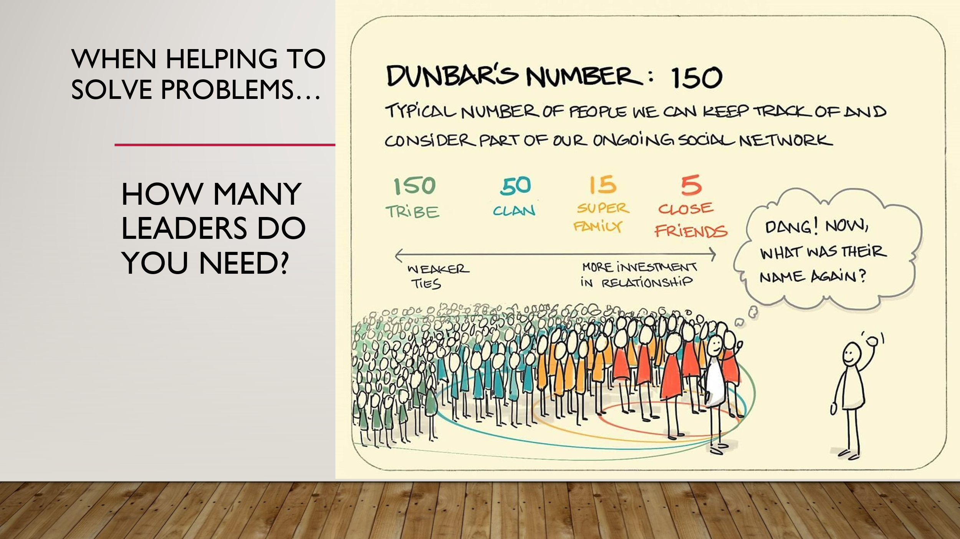  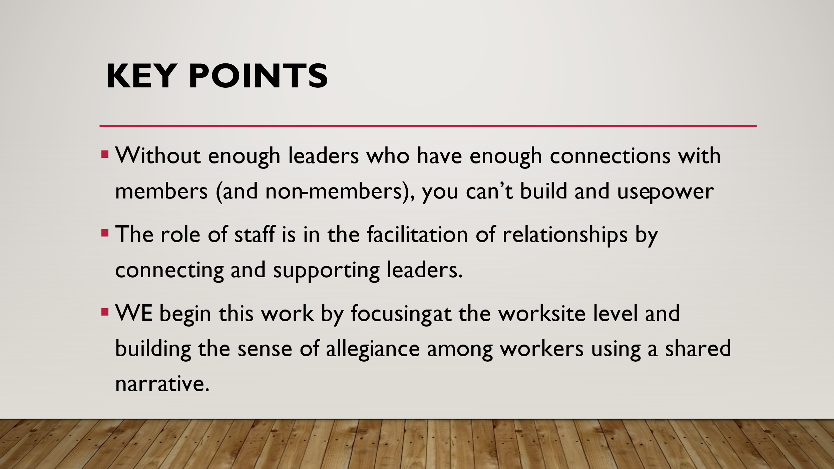 | Why isn’t great advocacy enough? | .  Participants handbook-Problem Solving Steps page 94 |  | 15 minutes - Why isn’t great advocacy enough?  2 minutes – discuss the question with participants  13 minutes – go over the problem solving cycle and connect the need to have distributed leadership to not only solve problems but also not to organize ourselves in the same manner as the employer does. One organizational structure advantages the employer at limiting power, the other allows our organization to grow power.  Discuss how the structures we intentionally or unintentionally replicate impact our ability to help solve problems (as staff) and grow capacity and power?  Go over Dumbar’s number slide – key point: distributed leadership allows for a broad network that have strong ties vs weak ties. Strong ties are the things that grow and sustain capacity and power.  Key Points:  - Without enough leaders who have enough connections with members (and non-members), you can’t build and use power  - The role of staff is in the facilitation of relationships by connecting and supporting leaders.  - WE begin this work by focusing at the worksite level and building the sense of allegiance among workers using a shared narrative.
3:10 – 3:30  August  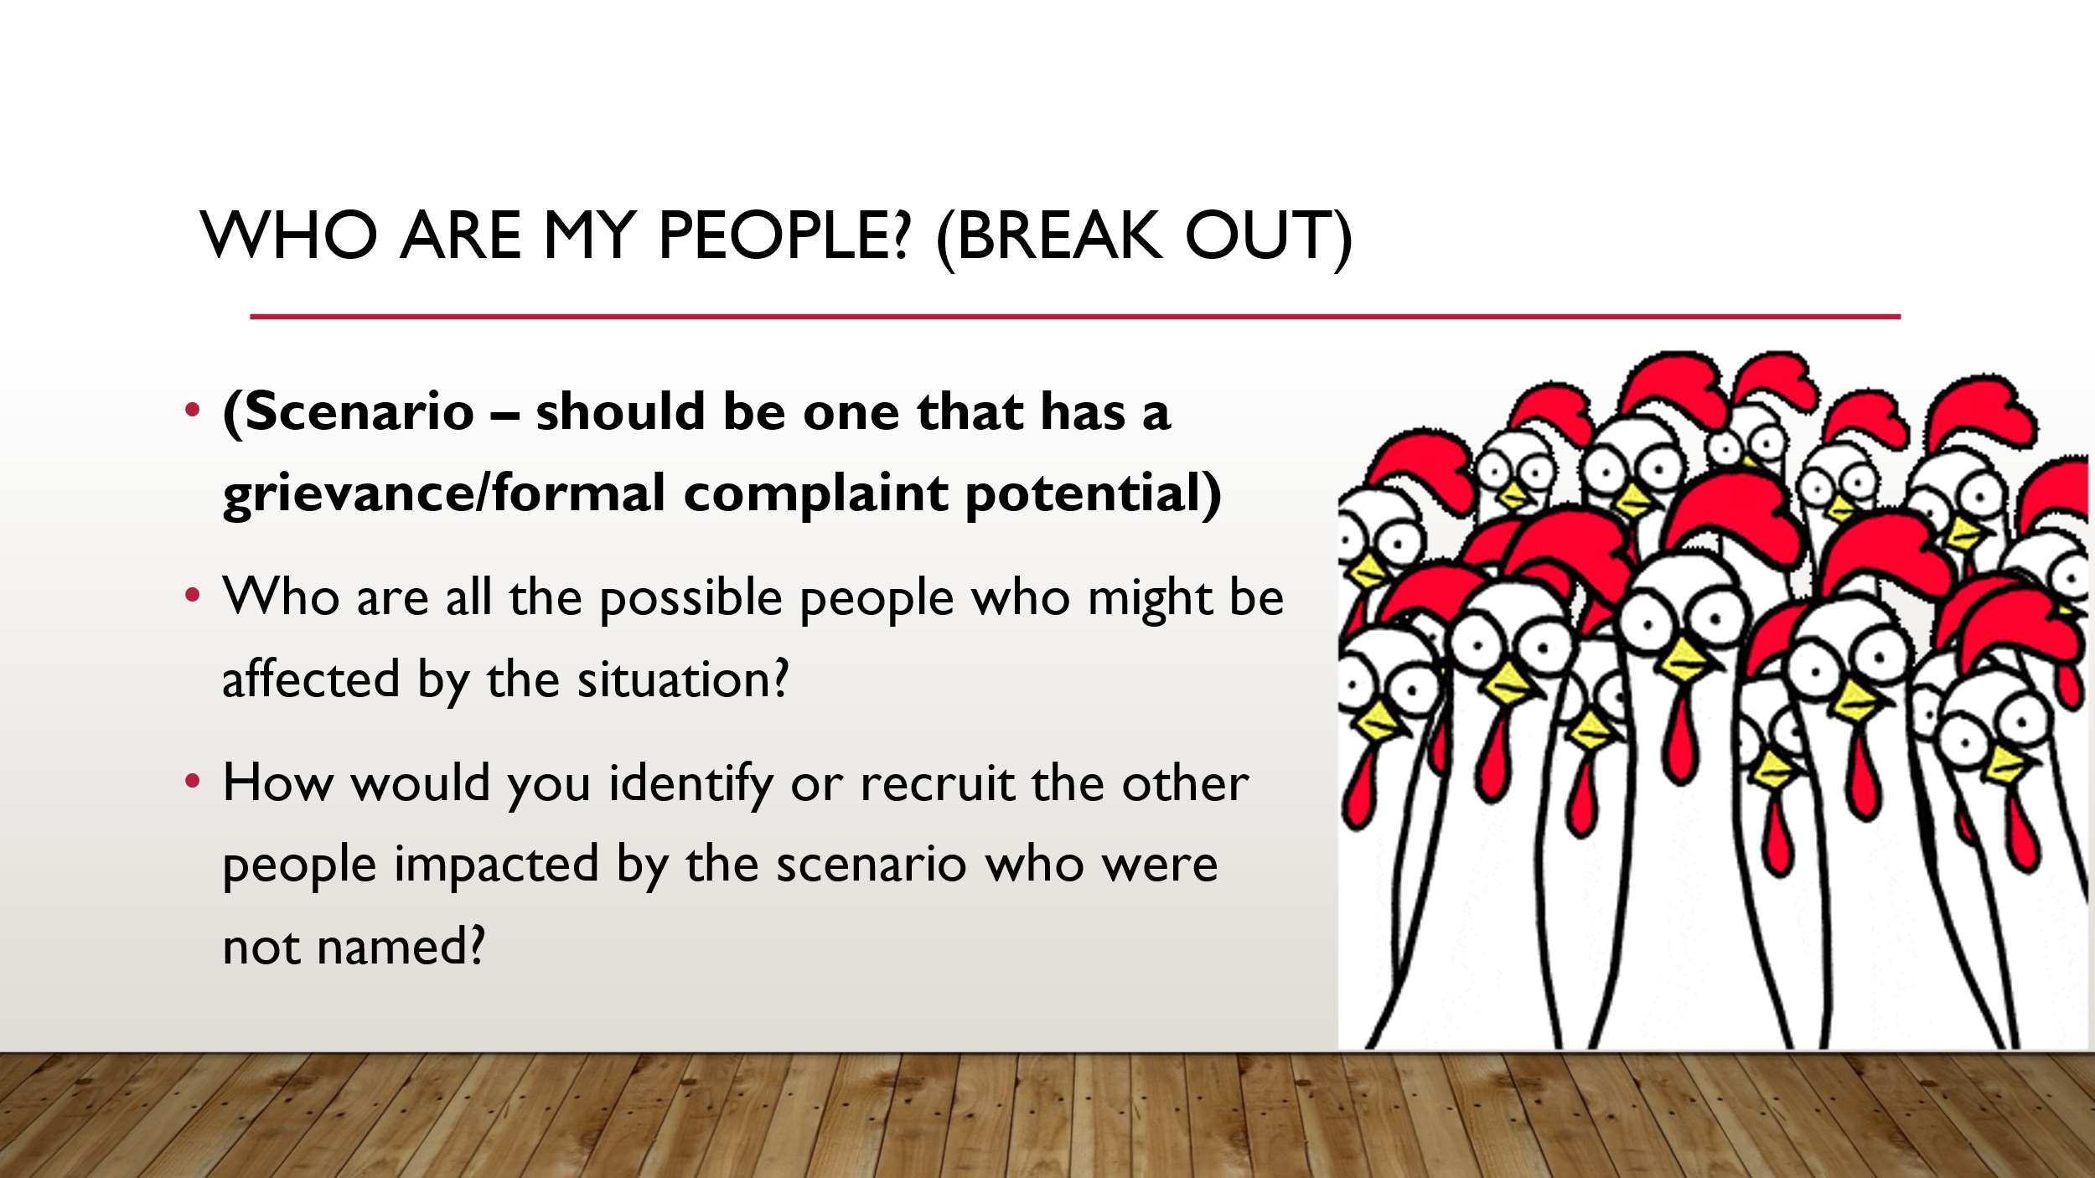 |  |  |  | 20 minutes total  (note: this session can be longer to taking time from the last session – up to 10 minutes. )  1 minute – frame the breakout as an opportunity to apply the concepts of problem solving and structure to potential real world scenario.  ^{Scenario #1}  You, the union staff, get a call from a building rep and a president.  A well-respected teacher and union member, Mrs. J, was given an unfair disciplinary write up.  This is the situation: A parent complained that a 7th grade girl’s “about me” project showed 4 LGBTQ+ pride flags. The parent did not come speak to the teacher—she went straight to the school board. On the write up, the principal wrote that Mrs. J didn’t show “good judgement” and “clear classroom expectations of appropriateness.” In his disciplinary meeting with the member, the principal told Mrs. J that he’s a conservative Christian, “we can’t promote this here” and asked her if she would allow a Confederate flag or swastika on the wall of her classroom. He also announced that he needs to talk to the students about talking about their sexual orientation at school.  He directed her to turn in lesson plans weekly for his review. He ordered Mrs. J to take down ONLY the project with LGBTQ+ flags and leave every other student project up on the classroom walls. Mrs. J didn’t want any student to feel targeted, so she took down every project. Mrs. J and her building rep both tried to talk to the principal and assistant superintendent about this unfair treatment of both students and staff. The administrator never addressed the issue, and just keep telling Mrs. J that she needs to “understand that parents have opinions too.”  The local president and building rep are horrified. There’s a history of homophobia in the district, including several union members who fear retaliation from their supervisors. The local officers know their superintendent and school board members well. They believe that the district leadership will back the principal’s actions. The president, building rep, and Mrs. J are game to try anything and believe that many of their colleagues would also be horrified. The local isn’t familiar with grievances and doesn’t have a grievance chair.  ^{10 Minutes – Breakout}  ^{5 Minutes – Report out}
3:30 – 3:45  Ilyssa  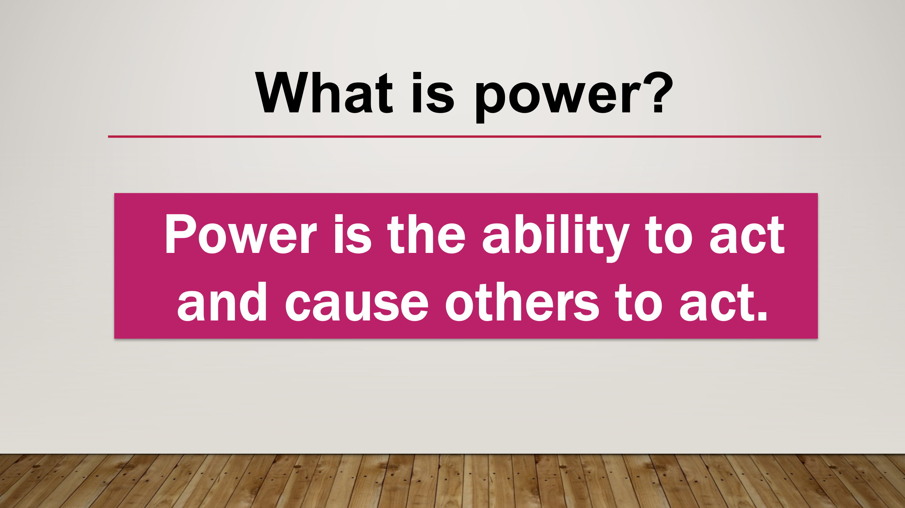  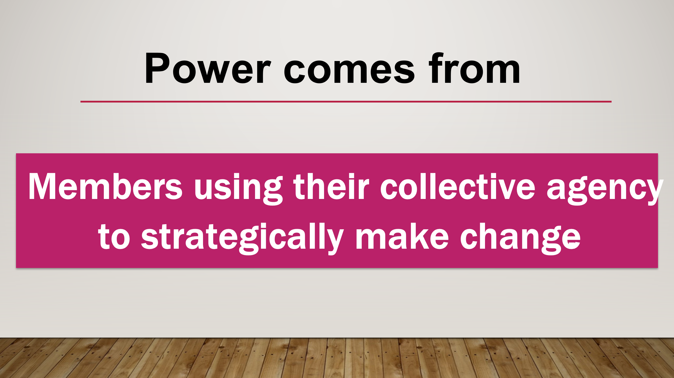  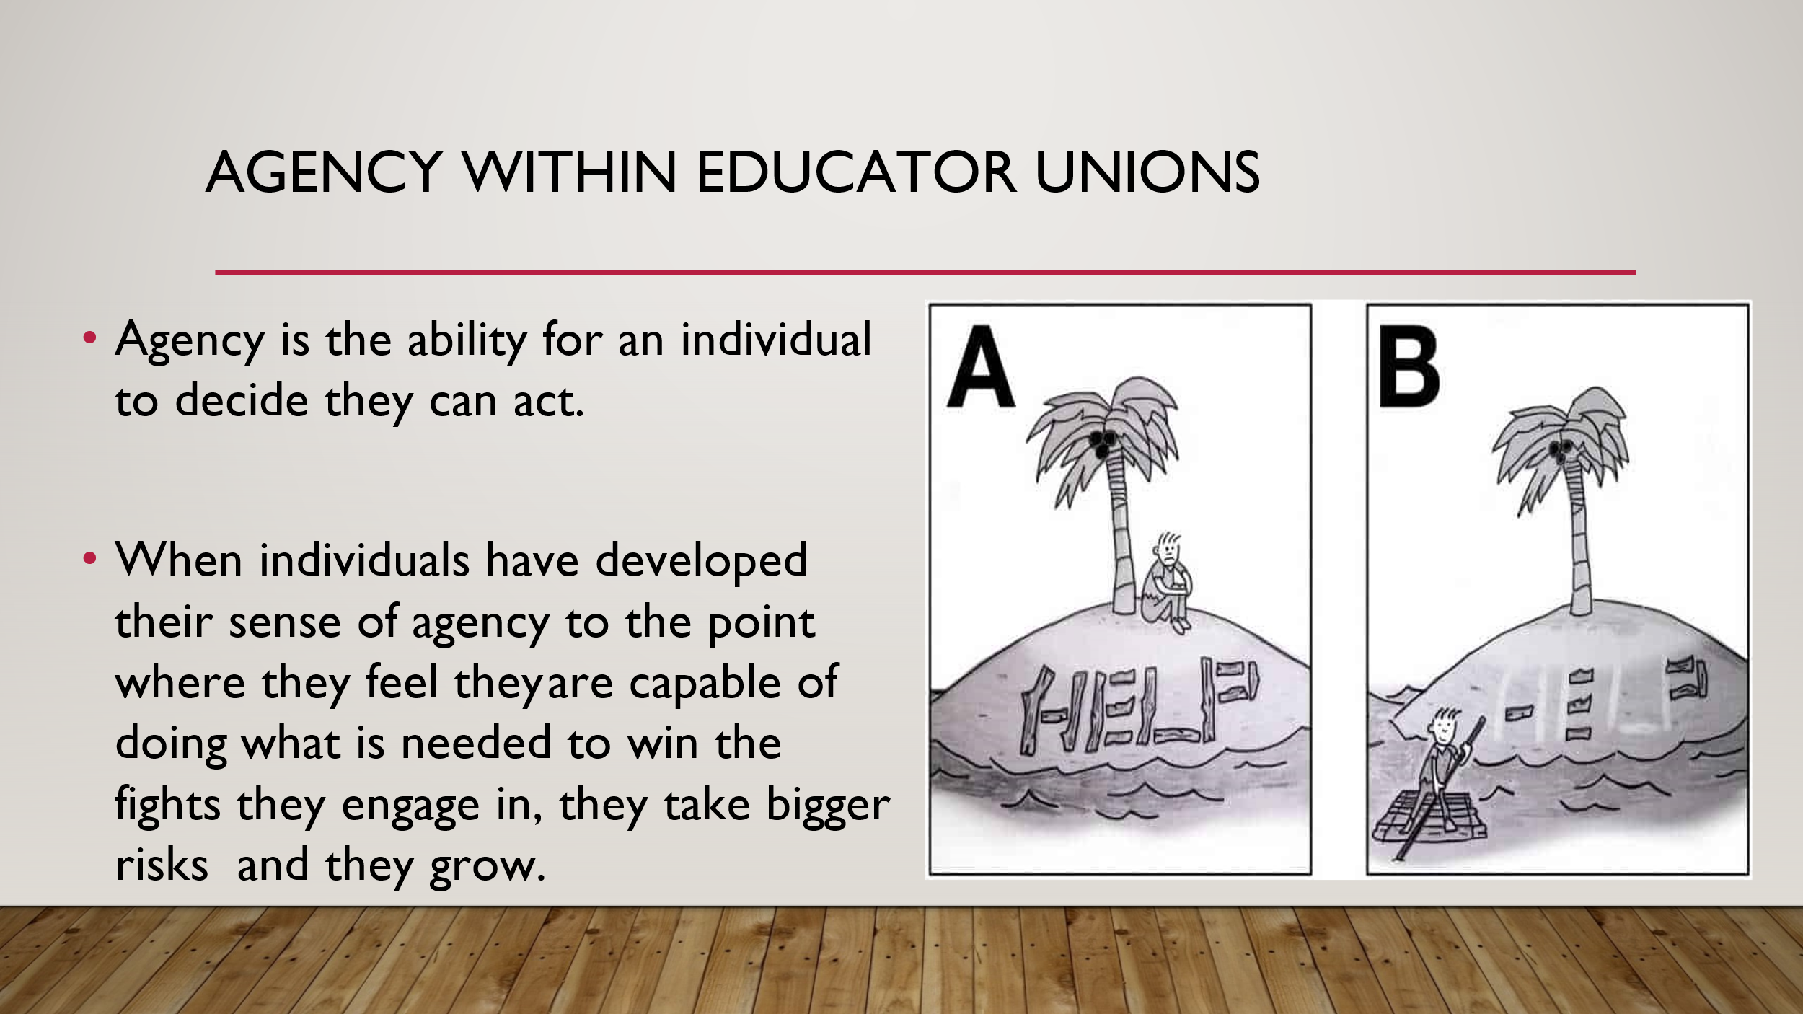  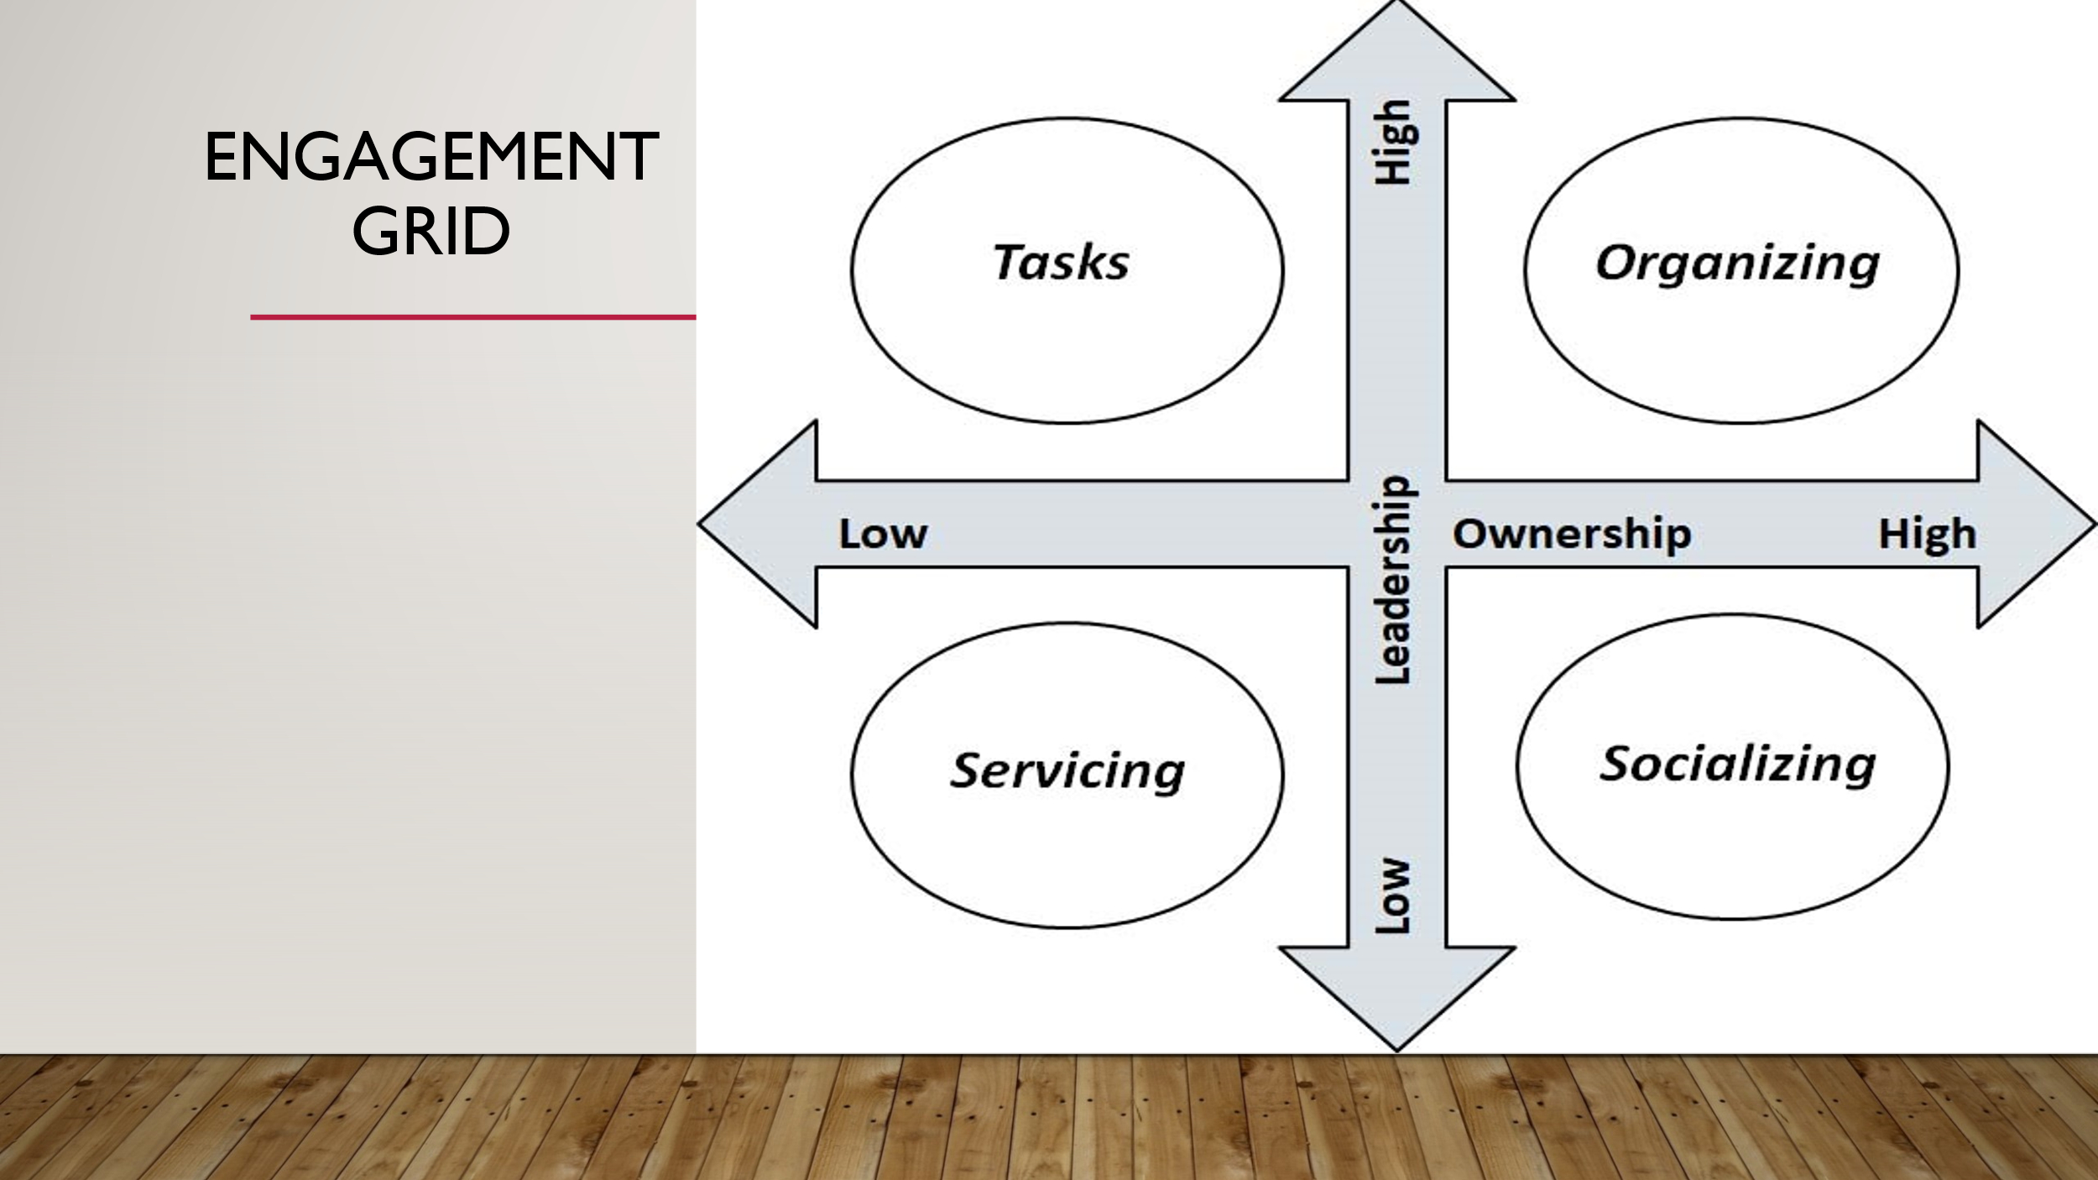  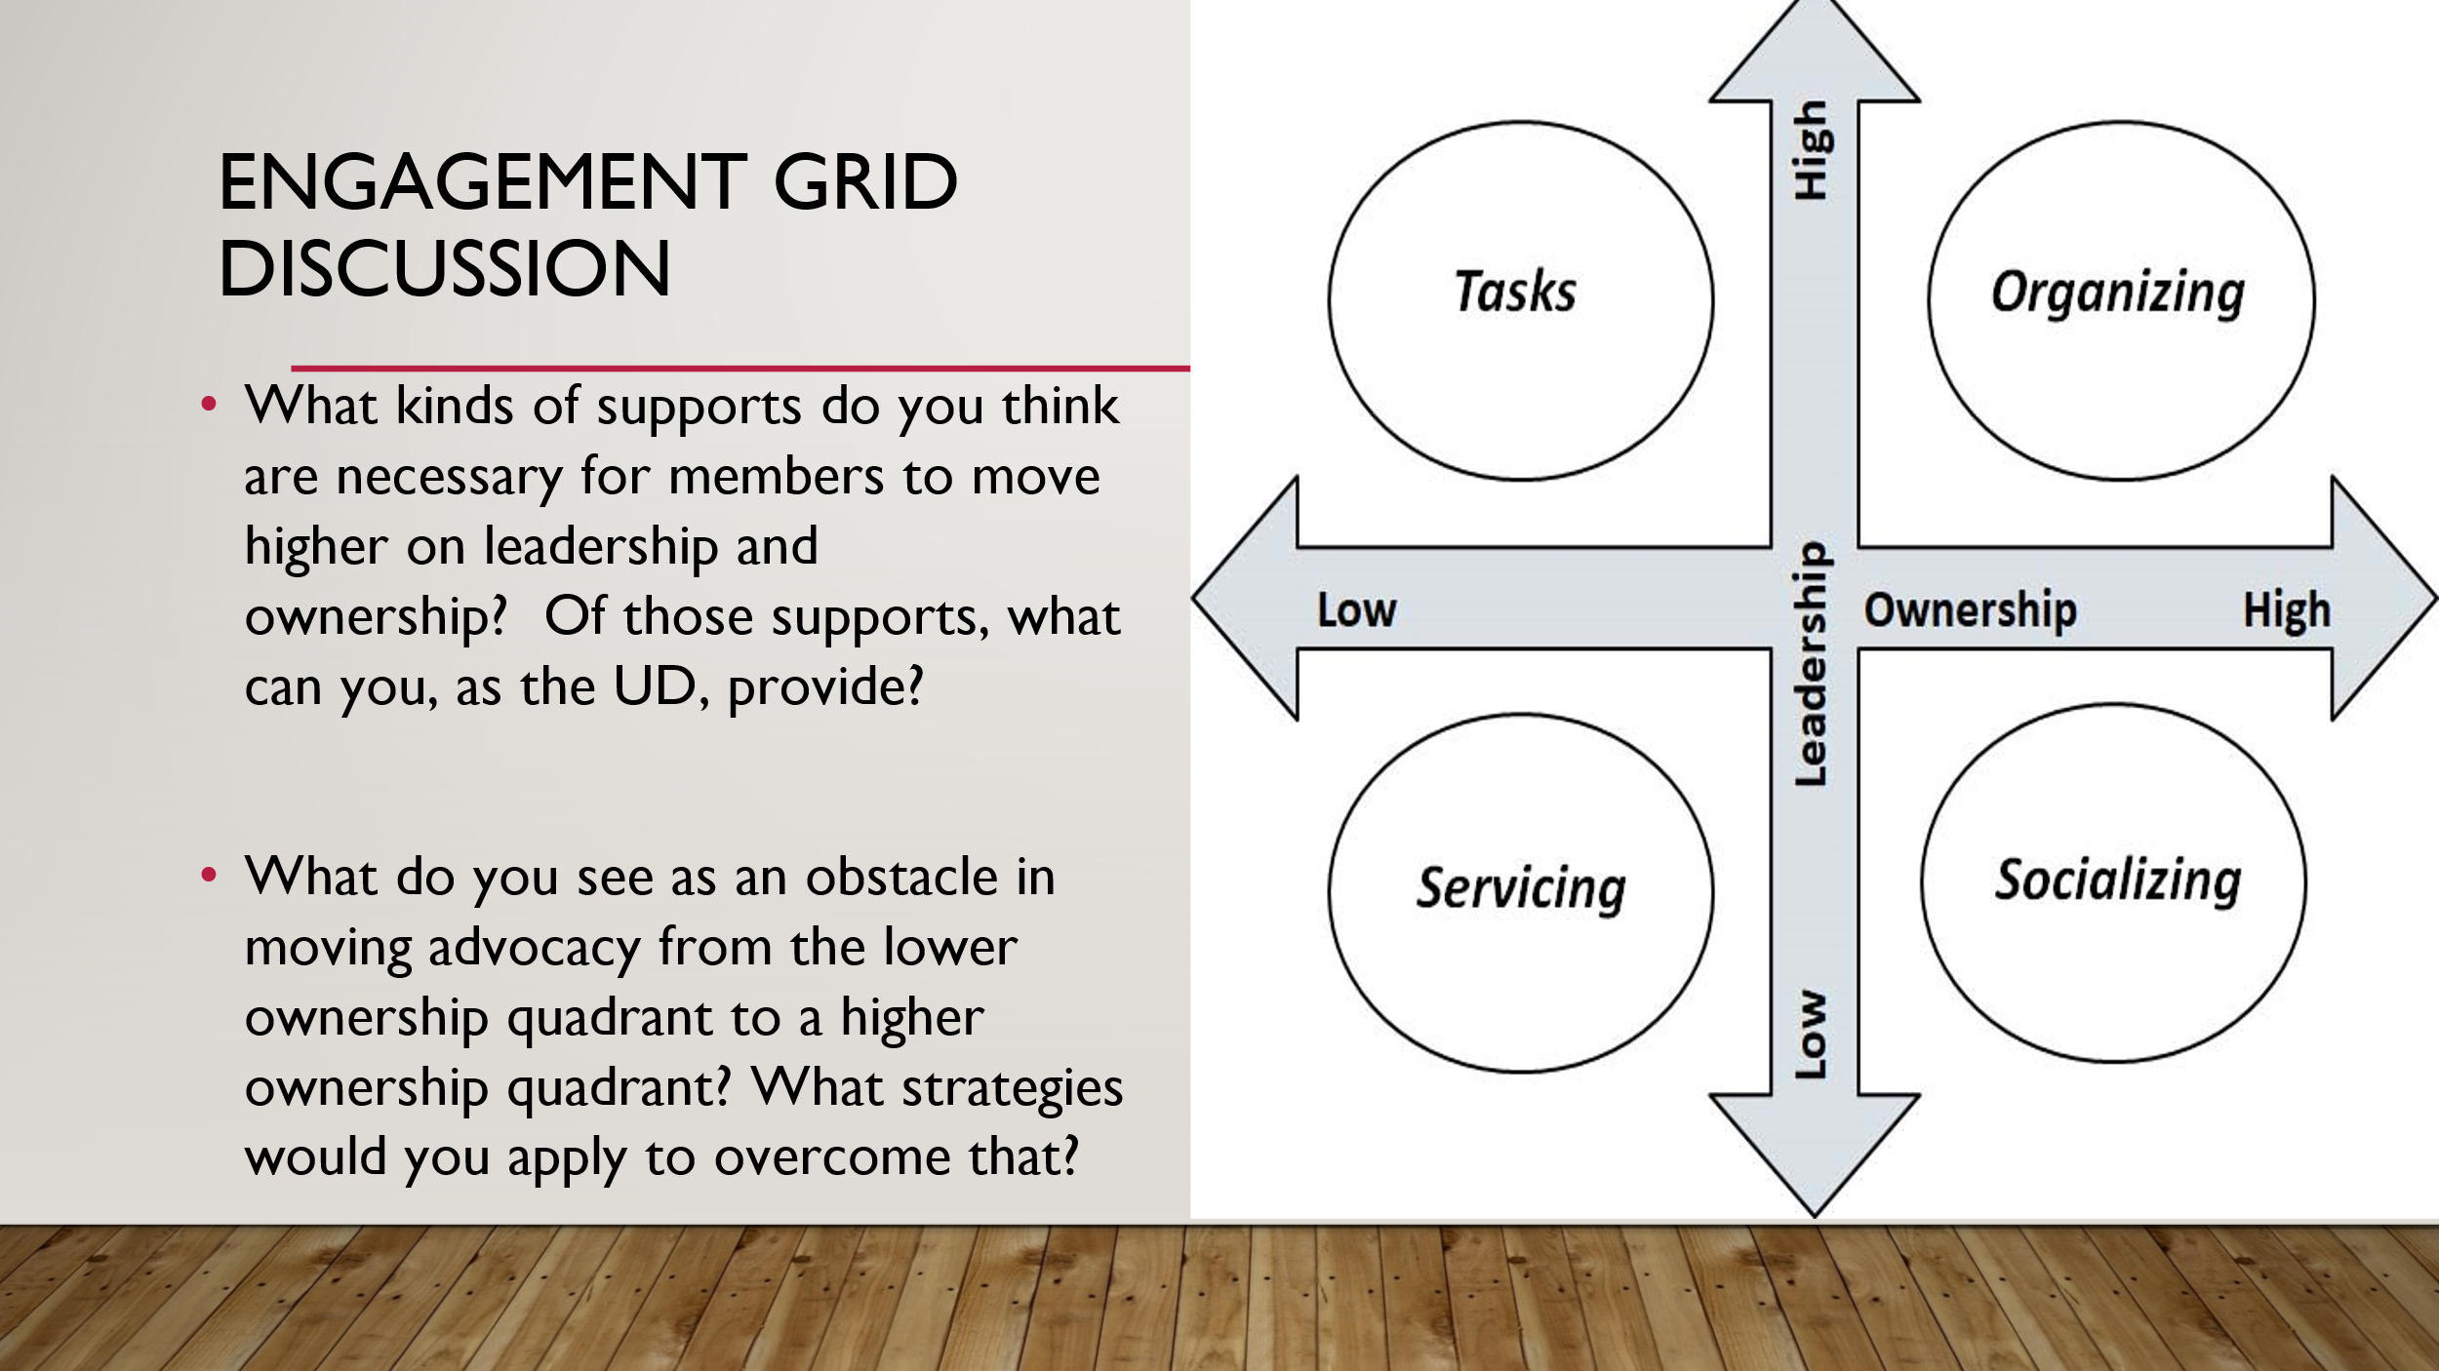  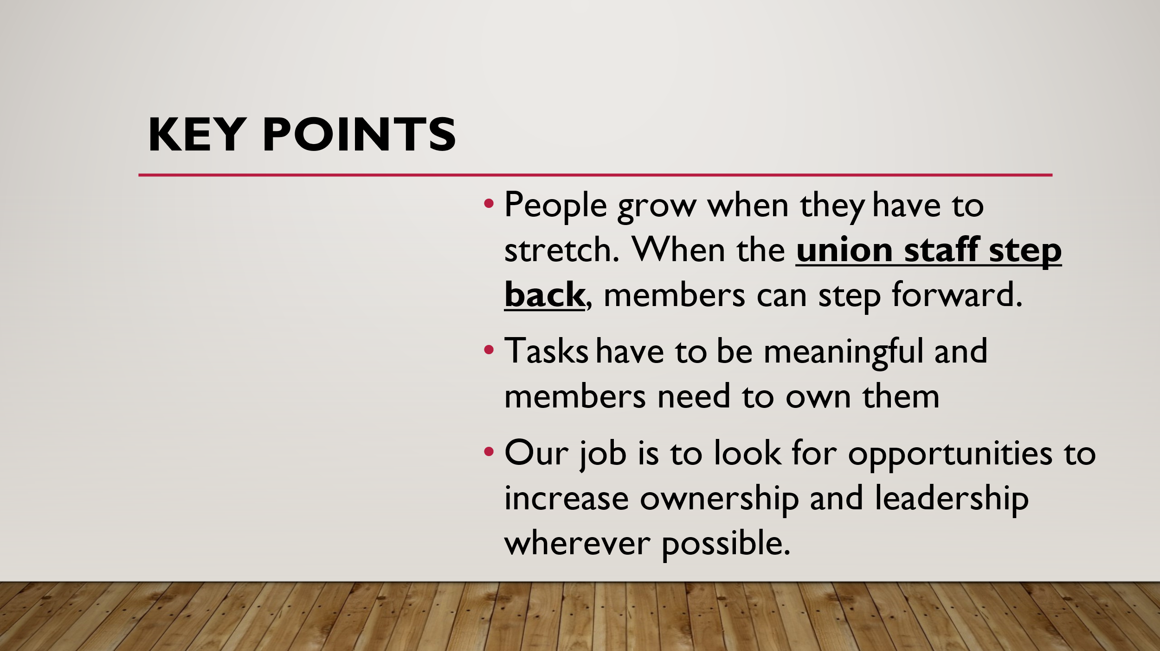 | How do we get members to lead? |  |  | 15 minutes  Discuss where power comes from and how power grows from the development of individual agency that can be channeled through collective action (of said individuals)  Lead a discussion using the engagement grid. Provide an overview of the grid and what it represents. Have participants think about how they foster agency within their members utilizing the prompts.  - What kinds of supports do you think are necessary for members to move higher on leadership and ownership? Of those supports, what can you, as the UD, provide?  - What do you see as an obstacle in moving advocacy from the lower ownership quadrant to a higher ownership quadrant? What strategies would you apply to overcome that?  Key points:  - People grow when they have to stretch. When the union staff step back, members can step forward.  - Tasks have to be meaningful and members need to own them  - Our job is to look for opportunities to increase ownership and leadership wherever possible.
3:45 – 4:00  Melissa  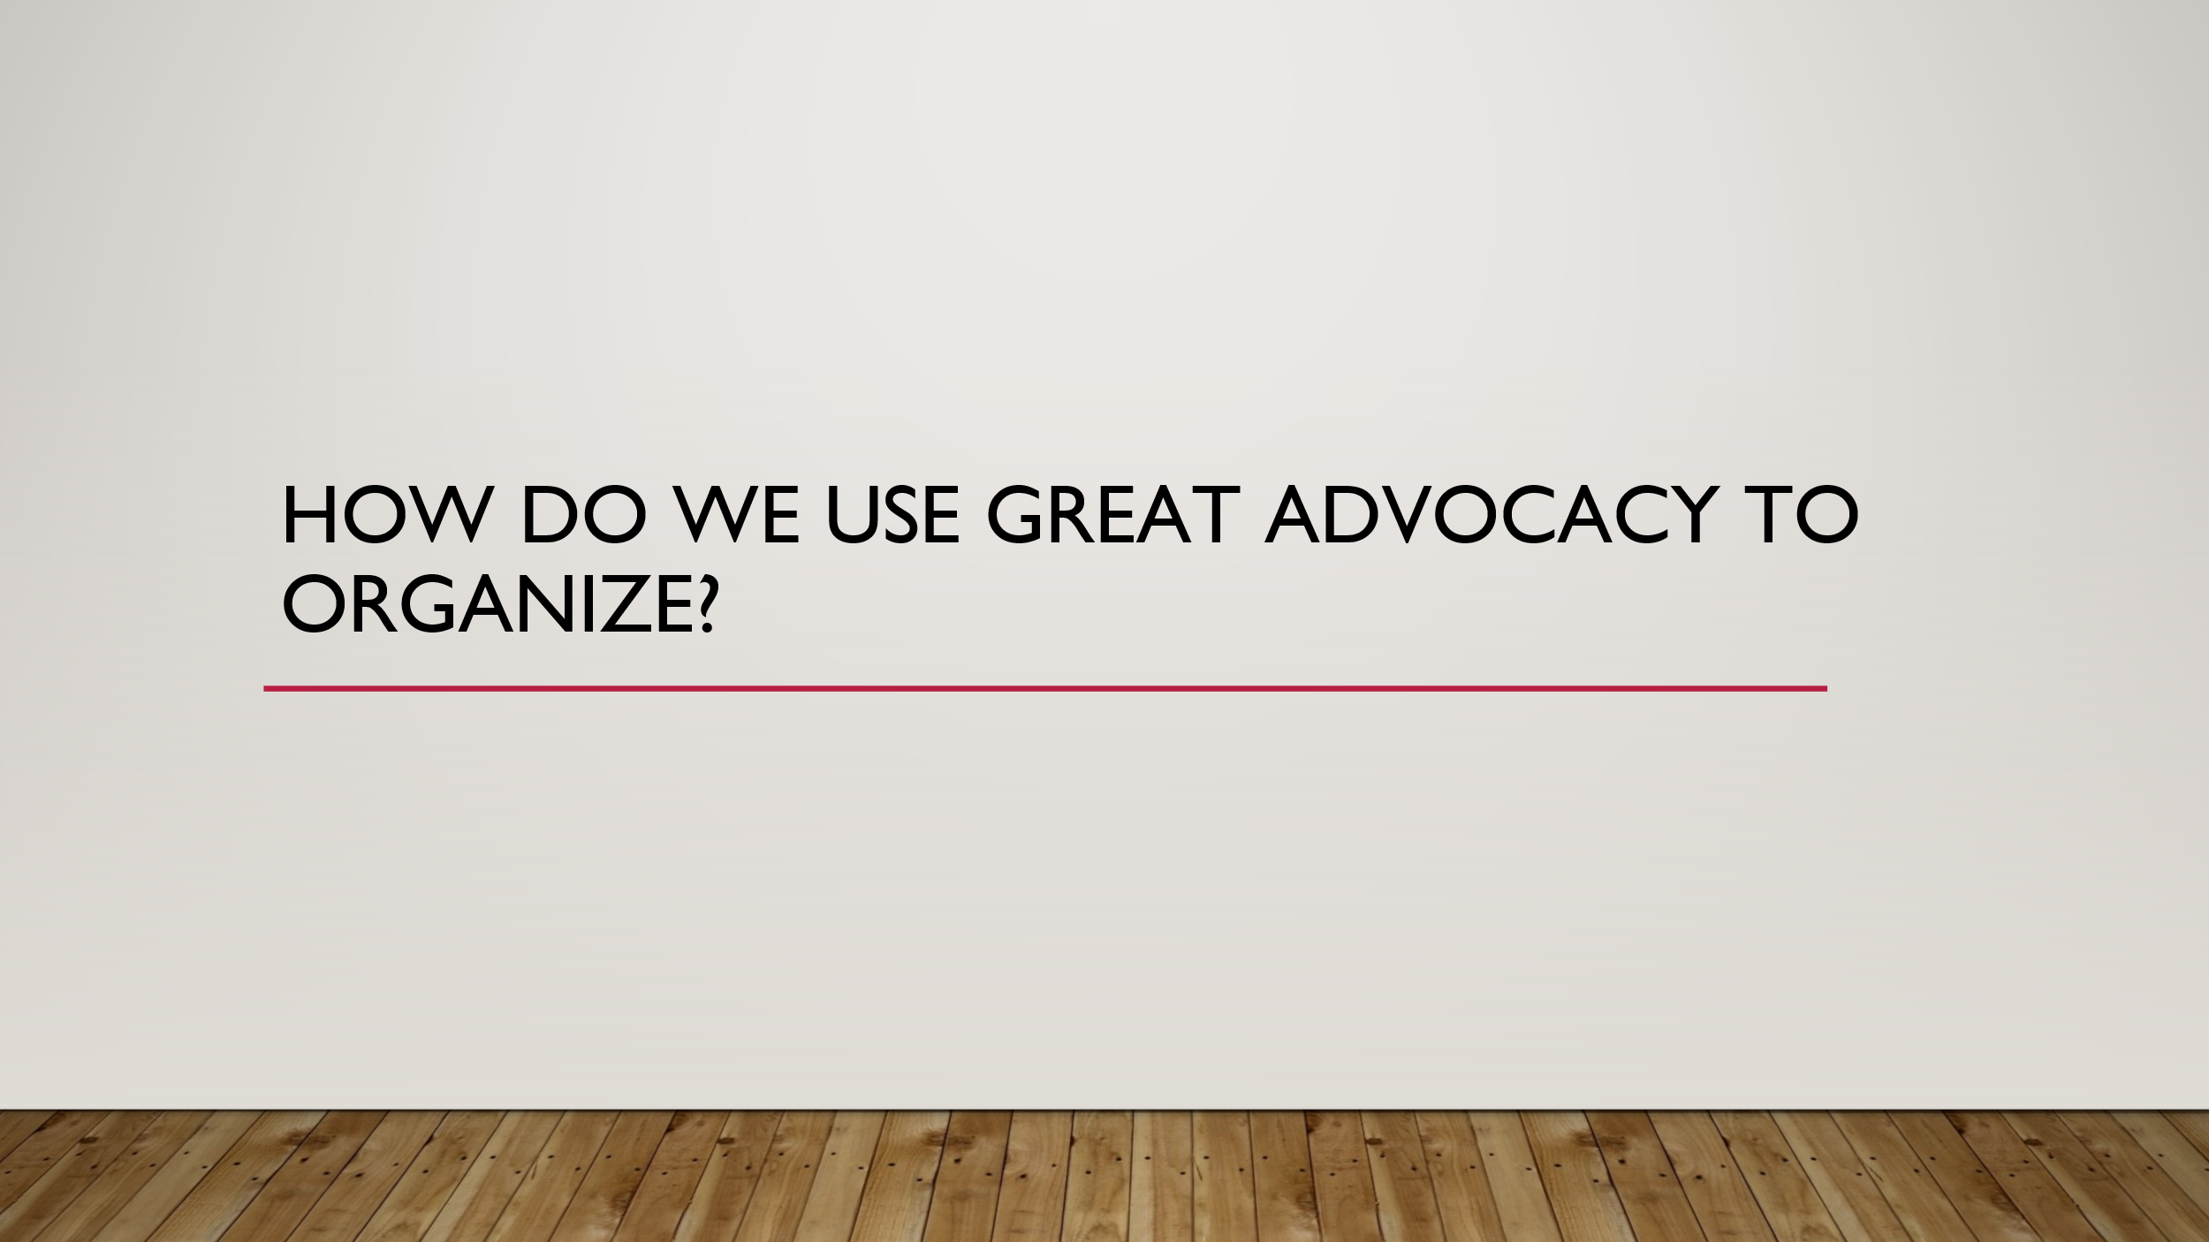  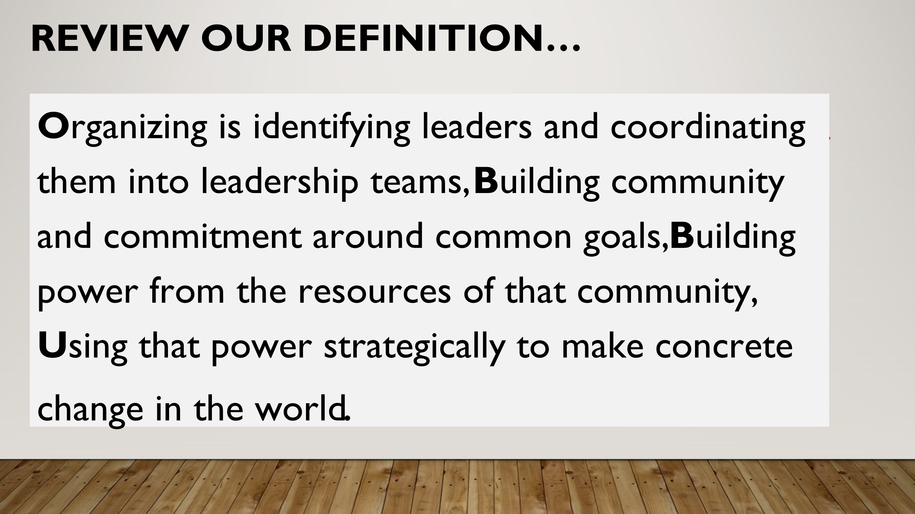  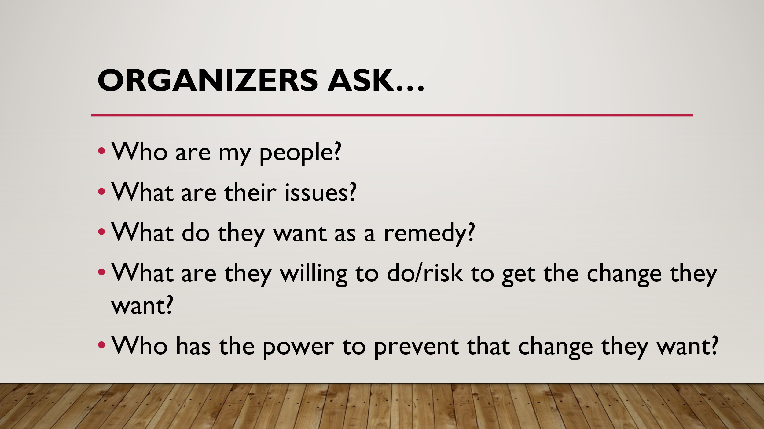  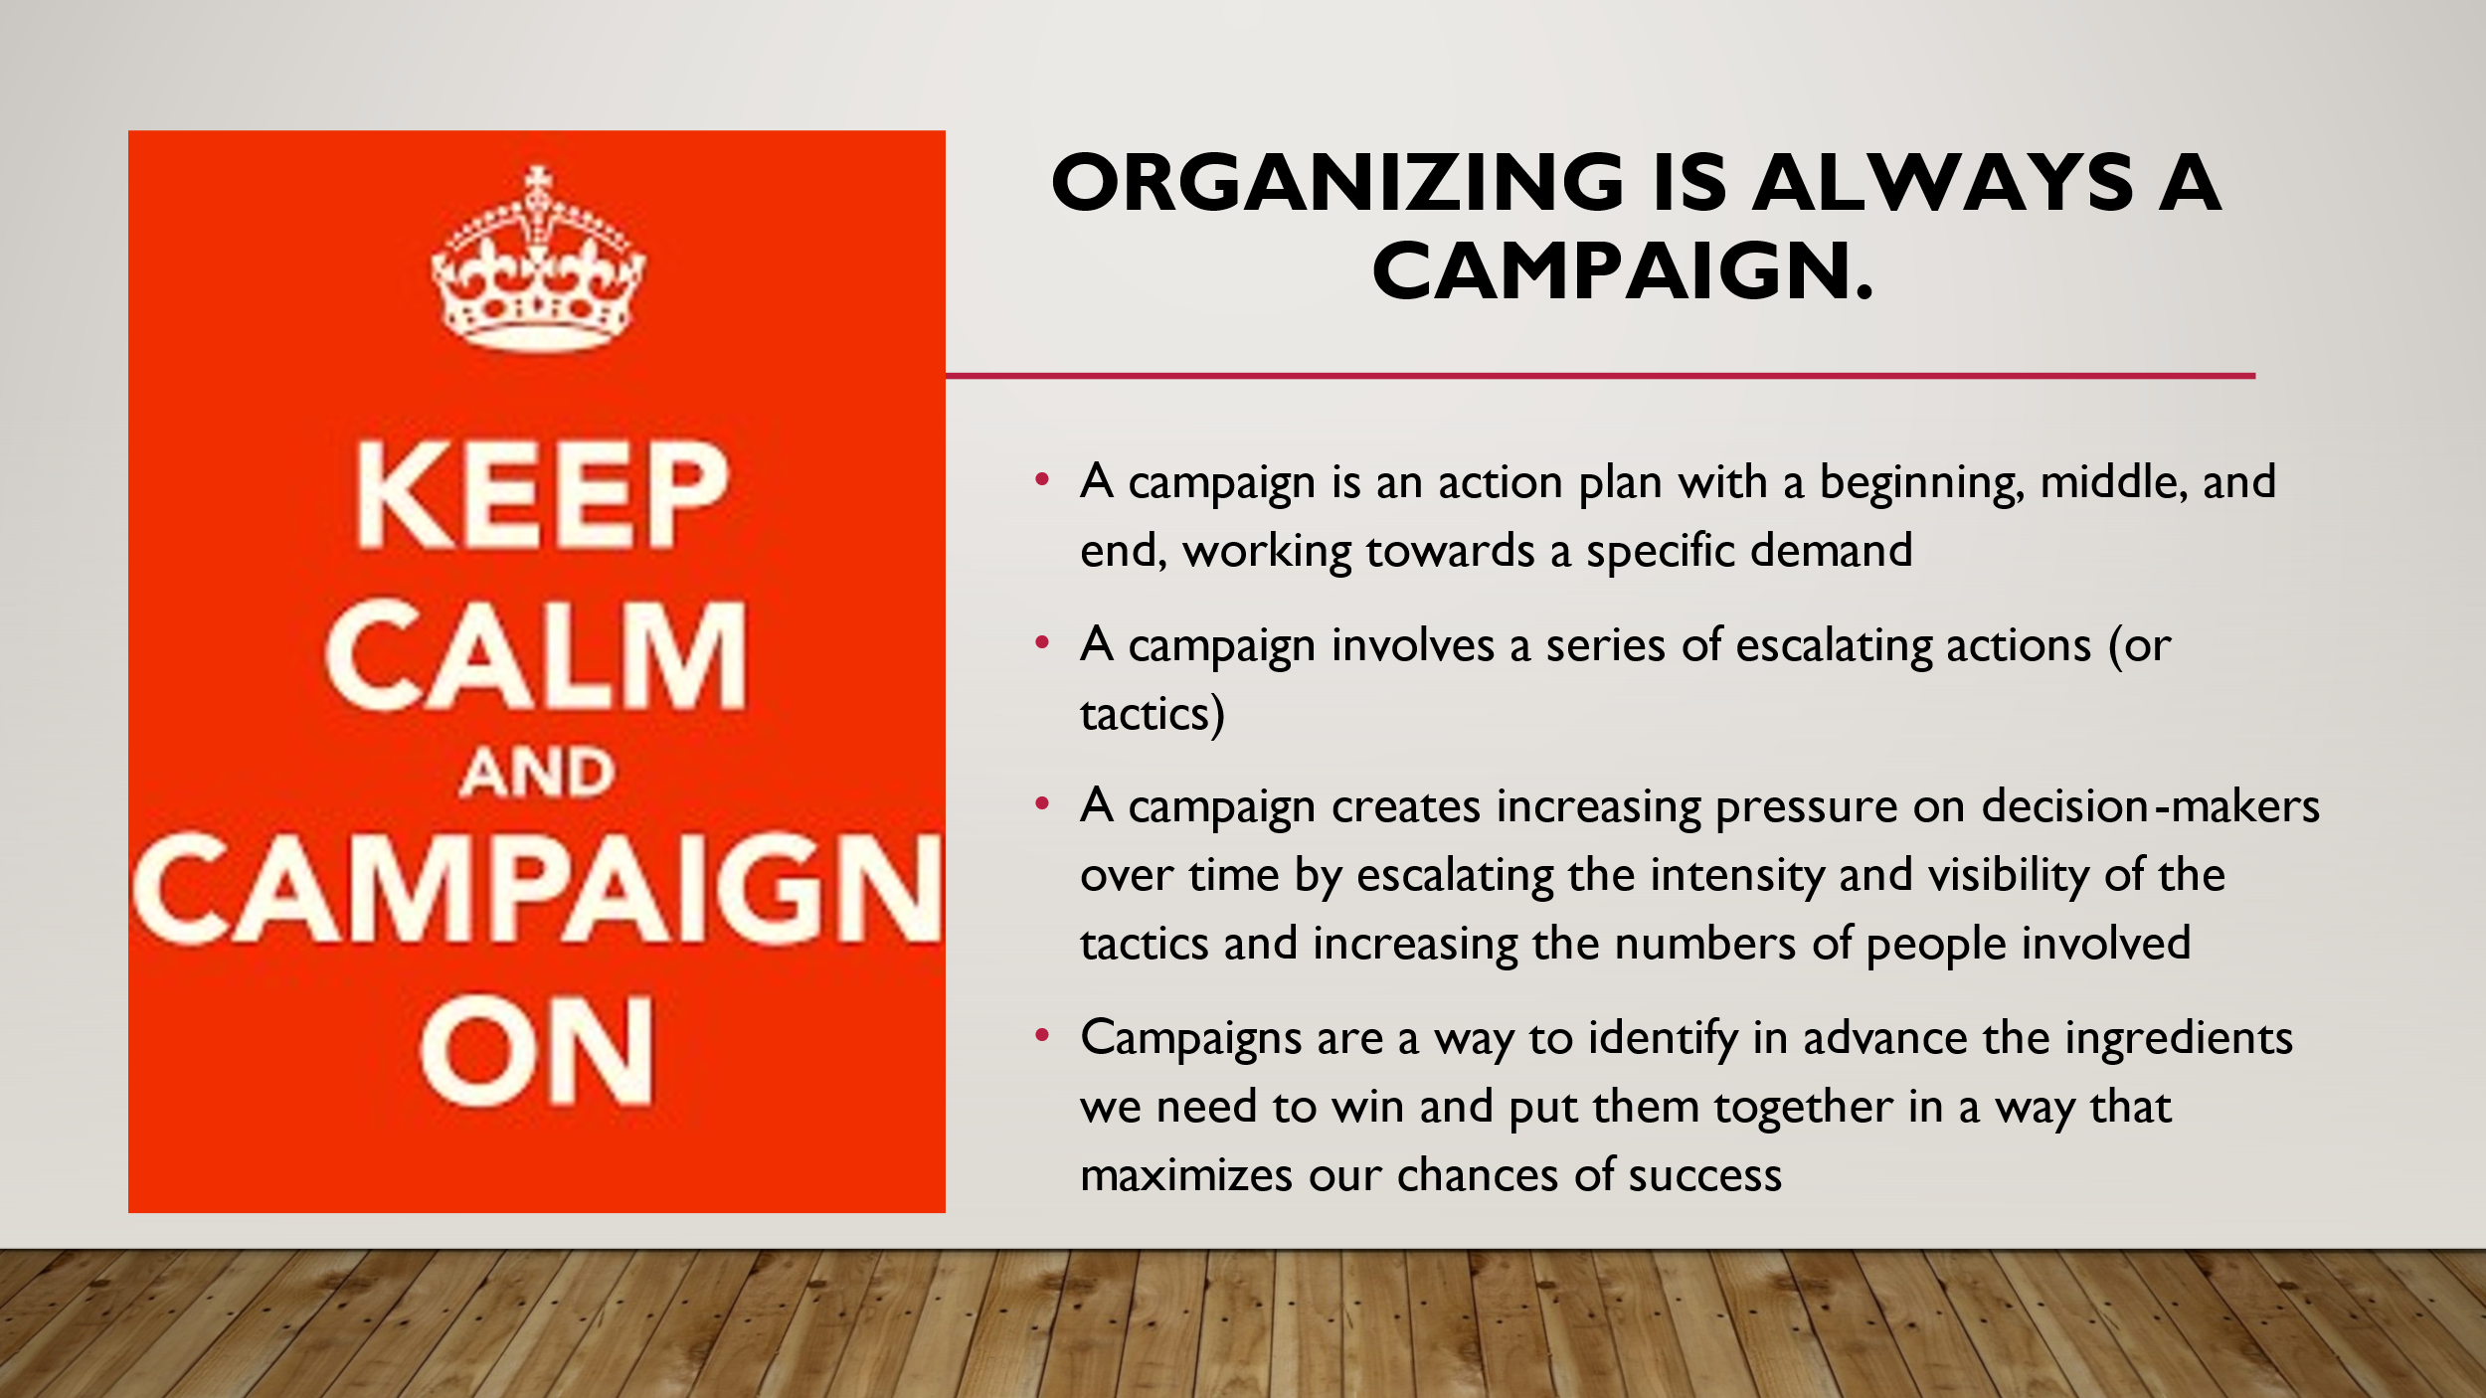  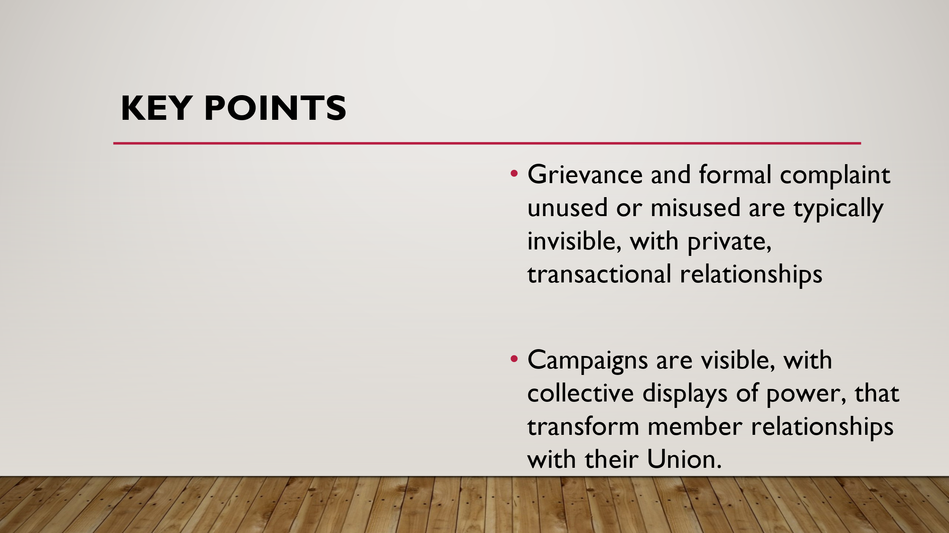  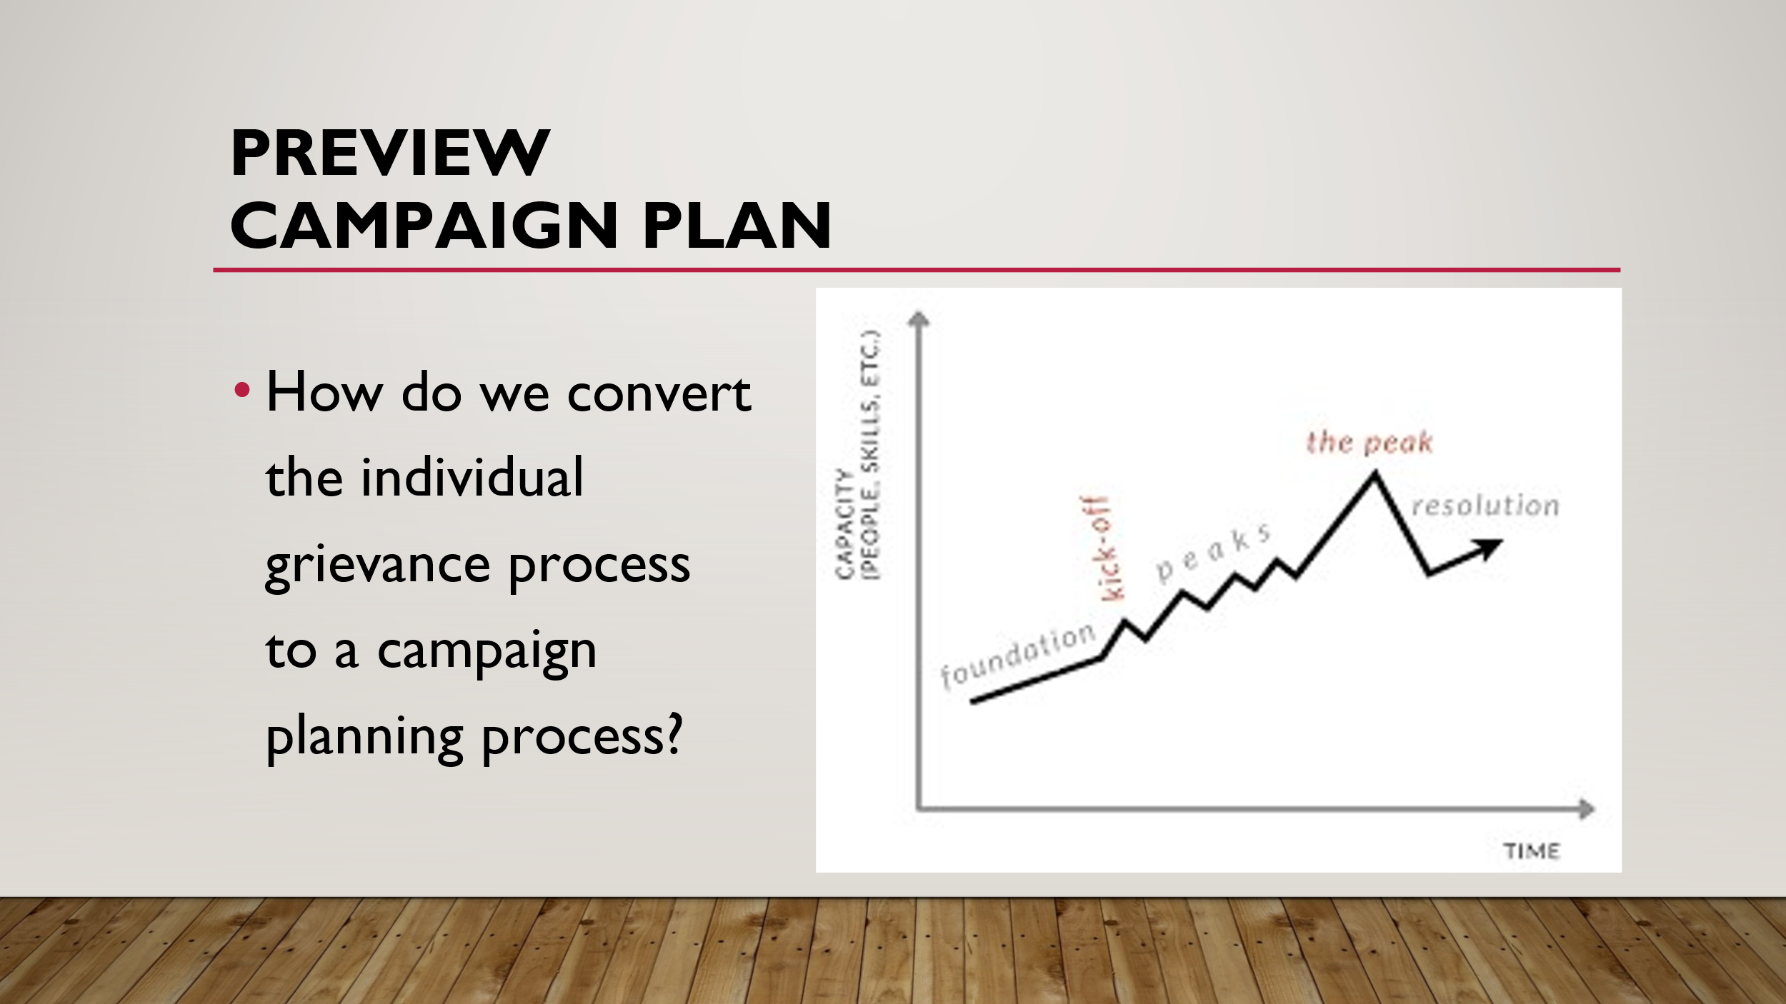 | How do we use great advocacy to organize? |  |  | 15 minutes  (note: this session can be shorter to allow for longer time in the breakouts and scenario. )This is the turn for the final session  Guide participants through the last slides within the context that what had been discuss previously is intended to ultimately be applied in campaigns…not every campaign is huge, but regardless of size, a campaign is how advocacy, problem solving, structure, and agency are applied to grow capacity and power.  Key points:  - Grievance and formal complaint unused or misused are typically invisible, with private, transactional relationships  - Campaigns are visible, with collective displays of power, that transform member relationships with their Union.
4:00 | ADJOURN

