Facilitator Agenda Day 3 – Organizing Through Advocacy
General Materials Needed: |  |  |  |  | Room Set-up:
Key Outcomes for the Event:

Time | Essential Questions | Resources |  | Instructions, Activity and Debrief (Facilitators) |  | Outcomes
 | What question(s) should this learning section answer? | Charts, handouts, articles, materials, slide |  | What are you saying, what are they doing, what questions will you use to guide learning and make clear the important points  Include an estimate for how long each section of the learning will take |  | As a result of this section of learning, what will participants know or be able to do?
2:00-2:30 | Facilitator Prep
Entry Activity | Make sure you know your escape plan – check out, flight and taxis
 | What is the status of our learning? |  |  | 3 Mins Total - Welcome back
2:30 – 3:00  Seleste  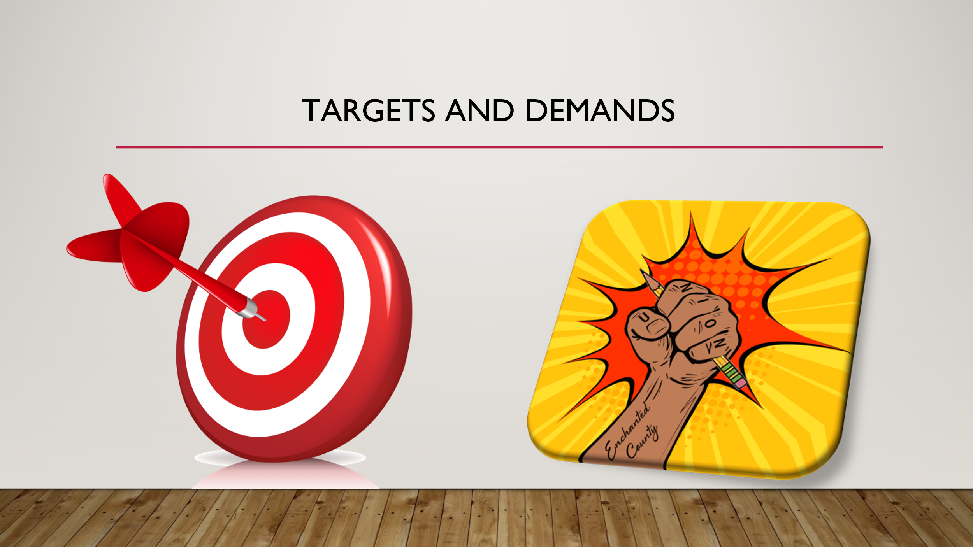  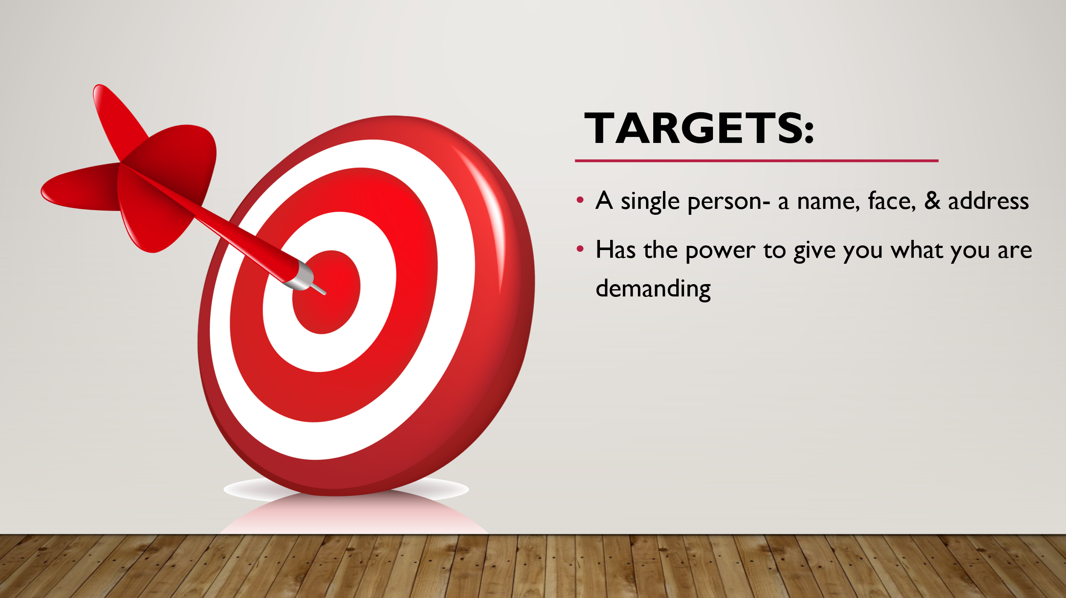  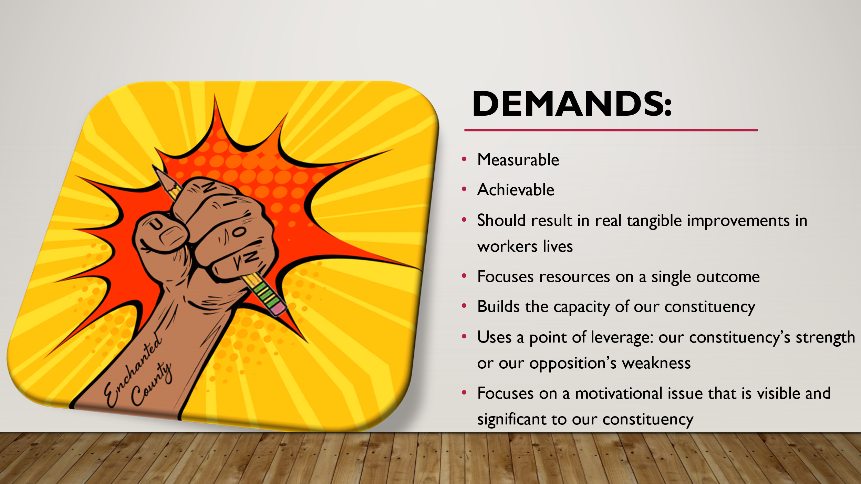  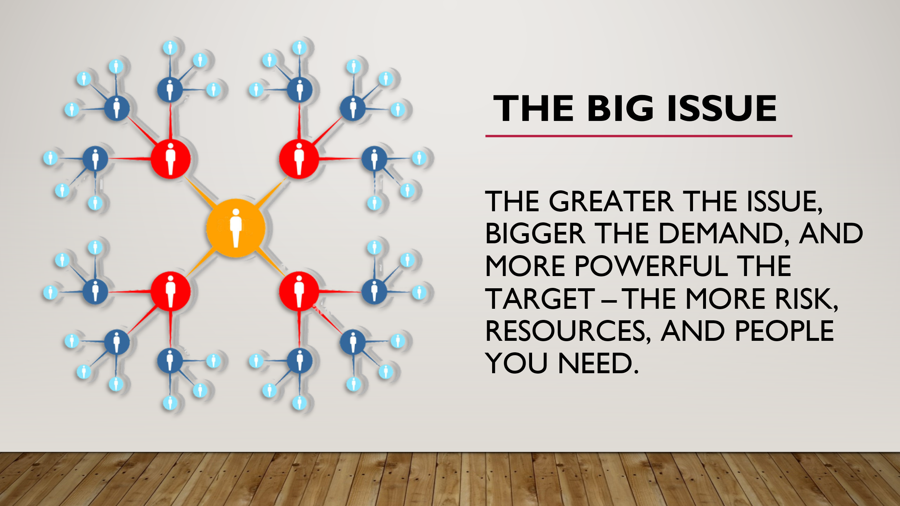  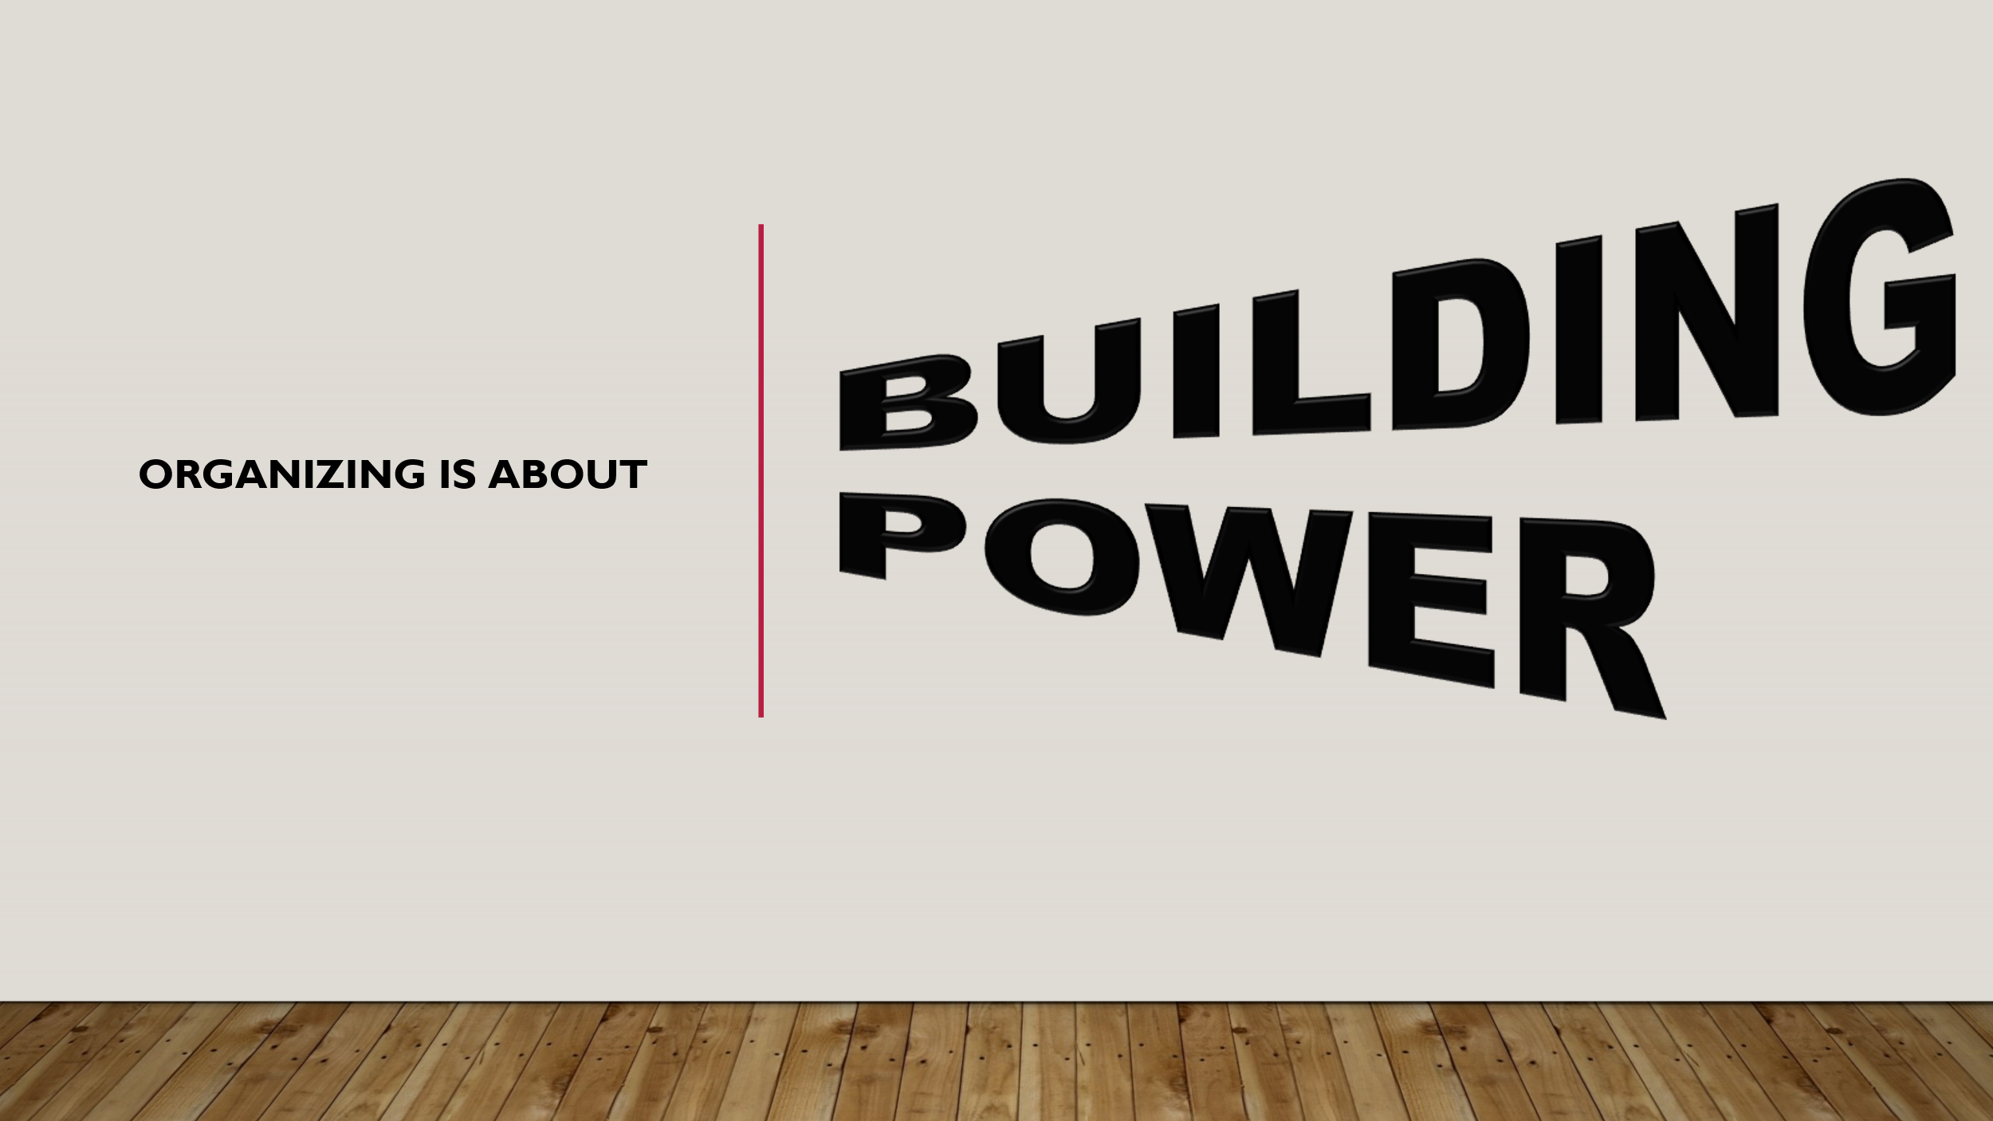  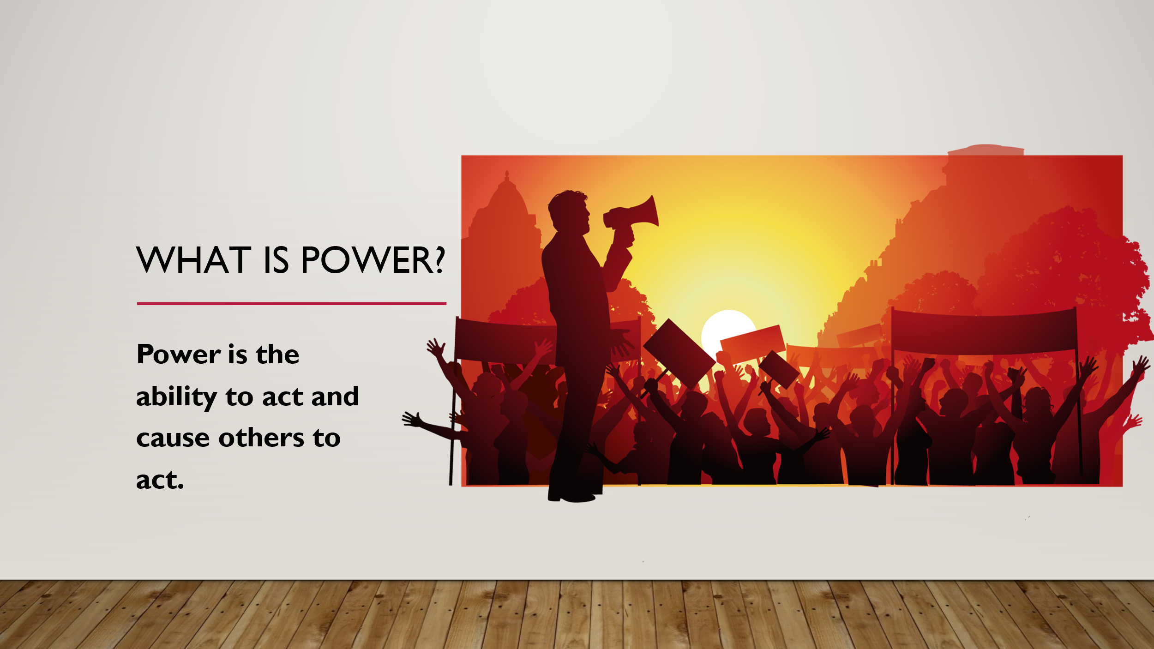  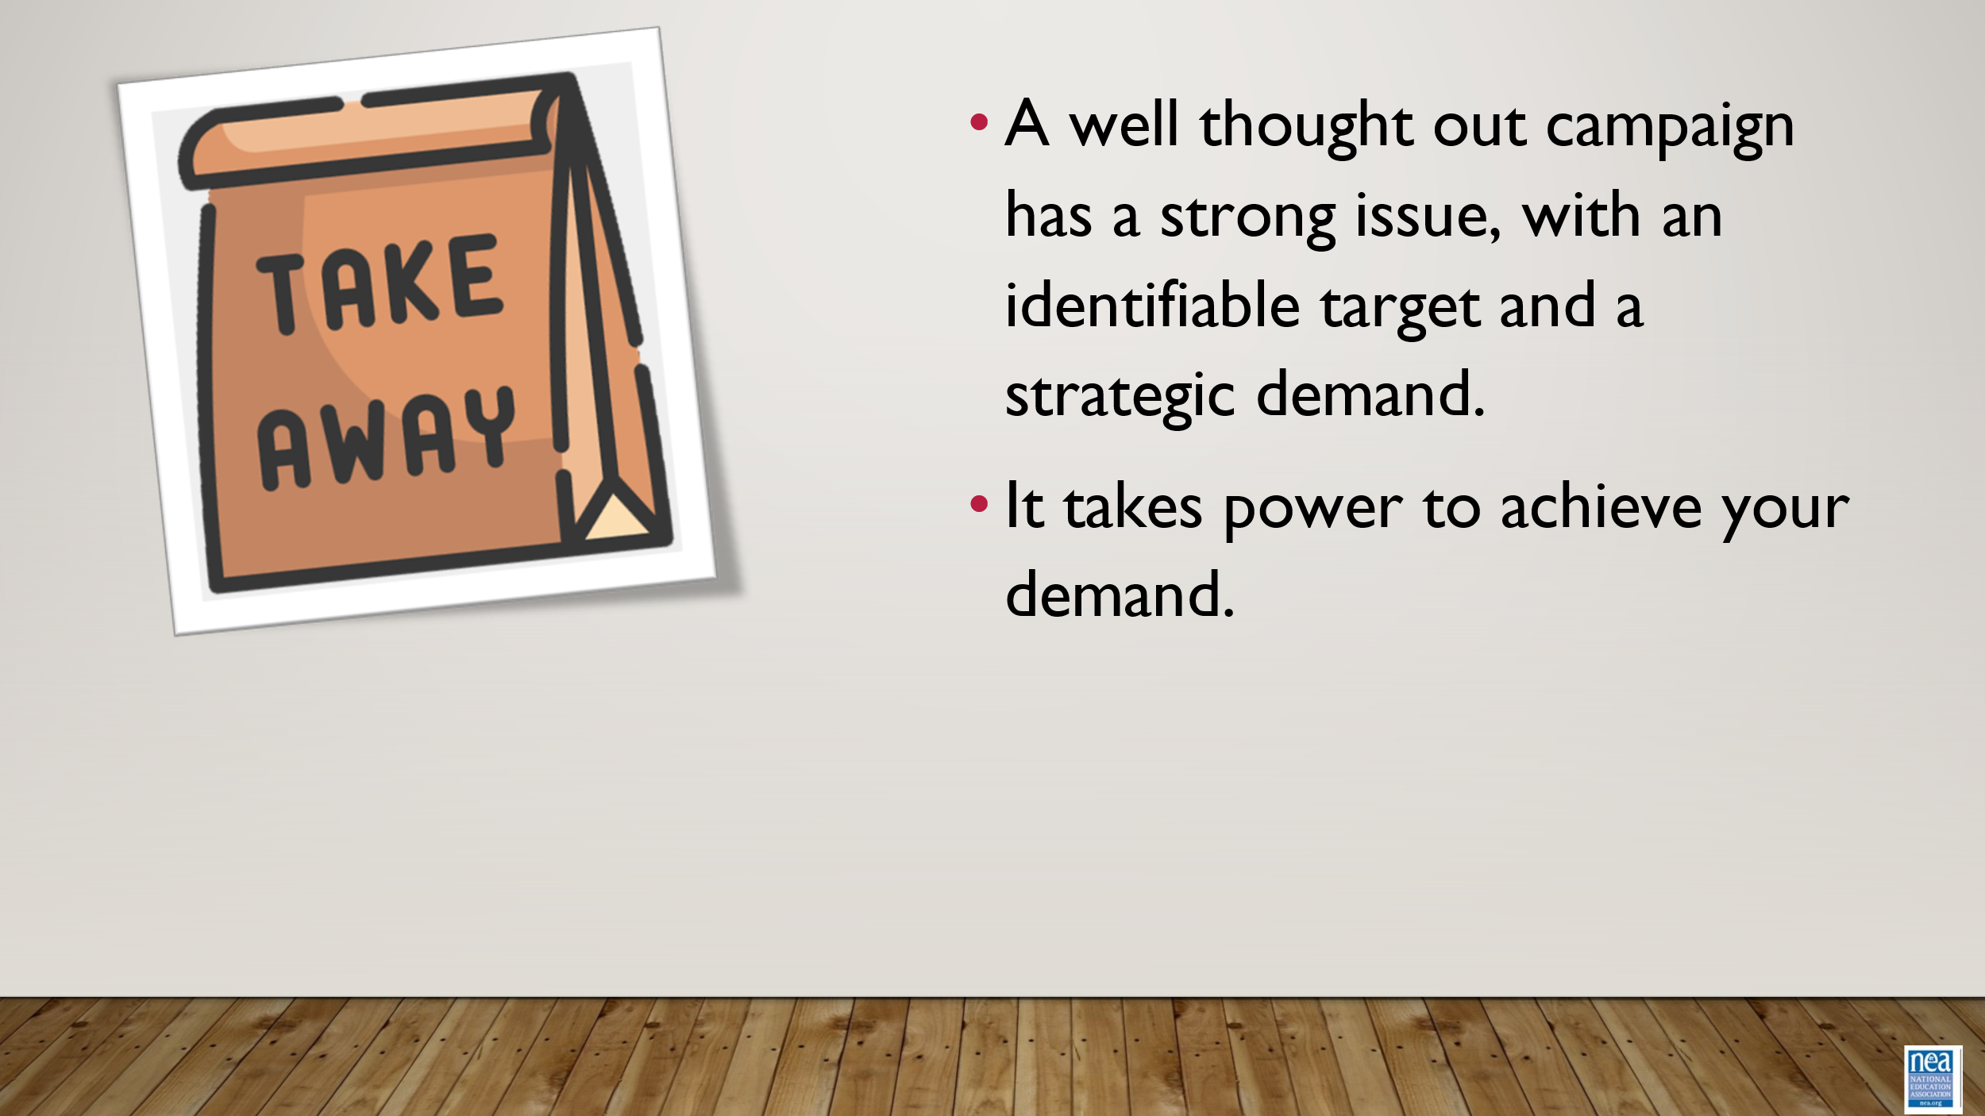  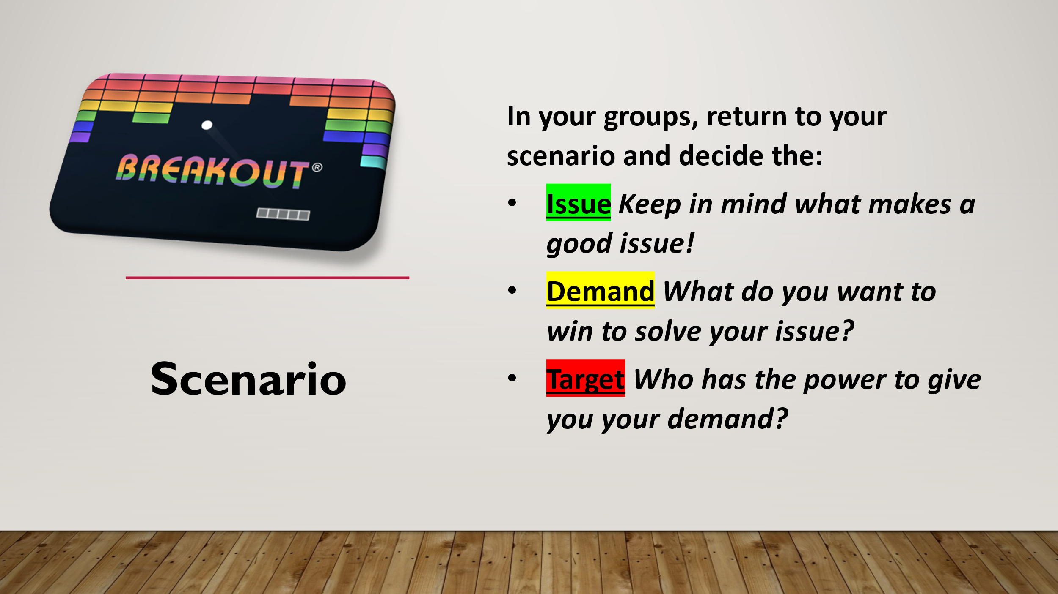  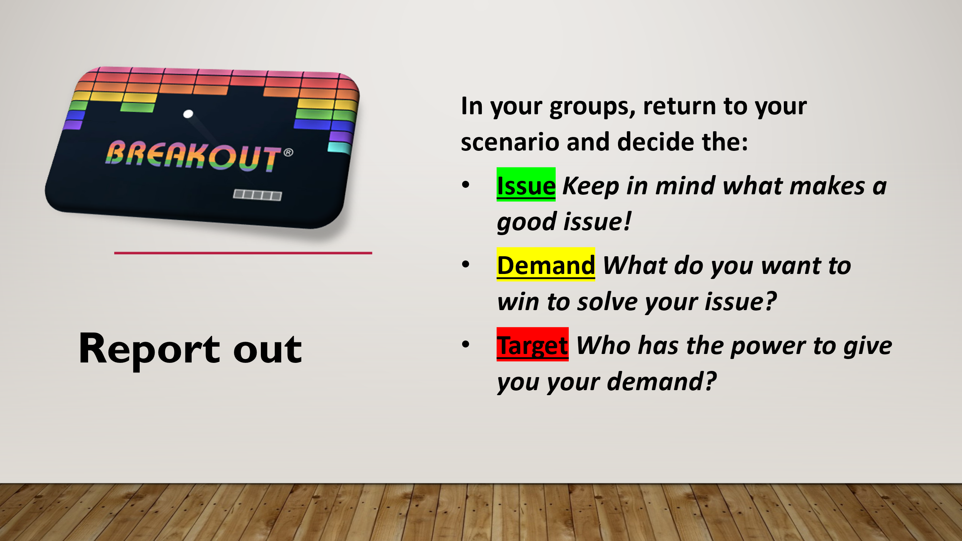 |  |  |  | 30 Mins – Targets and Demands  3 Mins Total- INTRODUCE DEMAND and Set Up p.113  - A demand is what the group wants– the win –  - A demand is the outcome that addresses the issue you are making of the target  - If the issue is what is wrong, the target is what we want that will fix the issue.  3 Min- INTRODUCE TARGET p 103-109  - The last idea that we want to cover is Targets.  - TARGET: A target is a single person with a name and an address. The target is the person with the power to give the workers the change they are asking for. A target has a name, a face and an address.  10 Mins – Break out / 5 Min – Report out  In your groups, return to your scenario and decide the:  Issue Keep in mind what makes a good issue!  Demand What do you want to win to solve your issue?  Target Who has the power to give you your demand?  1 min- Organizing is about building power  - Use our resources to generate power  1 min- What is Power  - Power is getting folks to act  2 Min- WRAP UP/KEY POINTS  - A well thought out campaign has a strong issue, with an identifiable target and a strategic demand.  - A target is a specific person!  - We don’t choose the issues! We identify the issues from talking to members!  4 Min – Scenario Setup
10:00-10:50  Vanessa  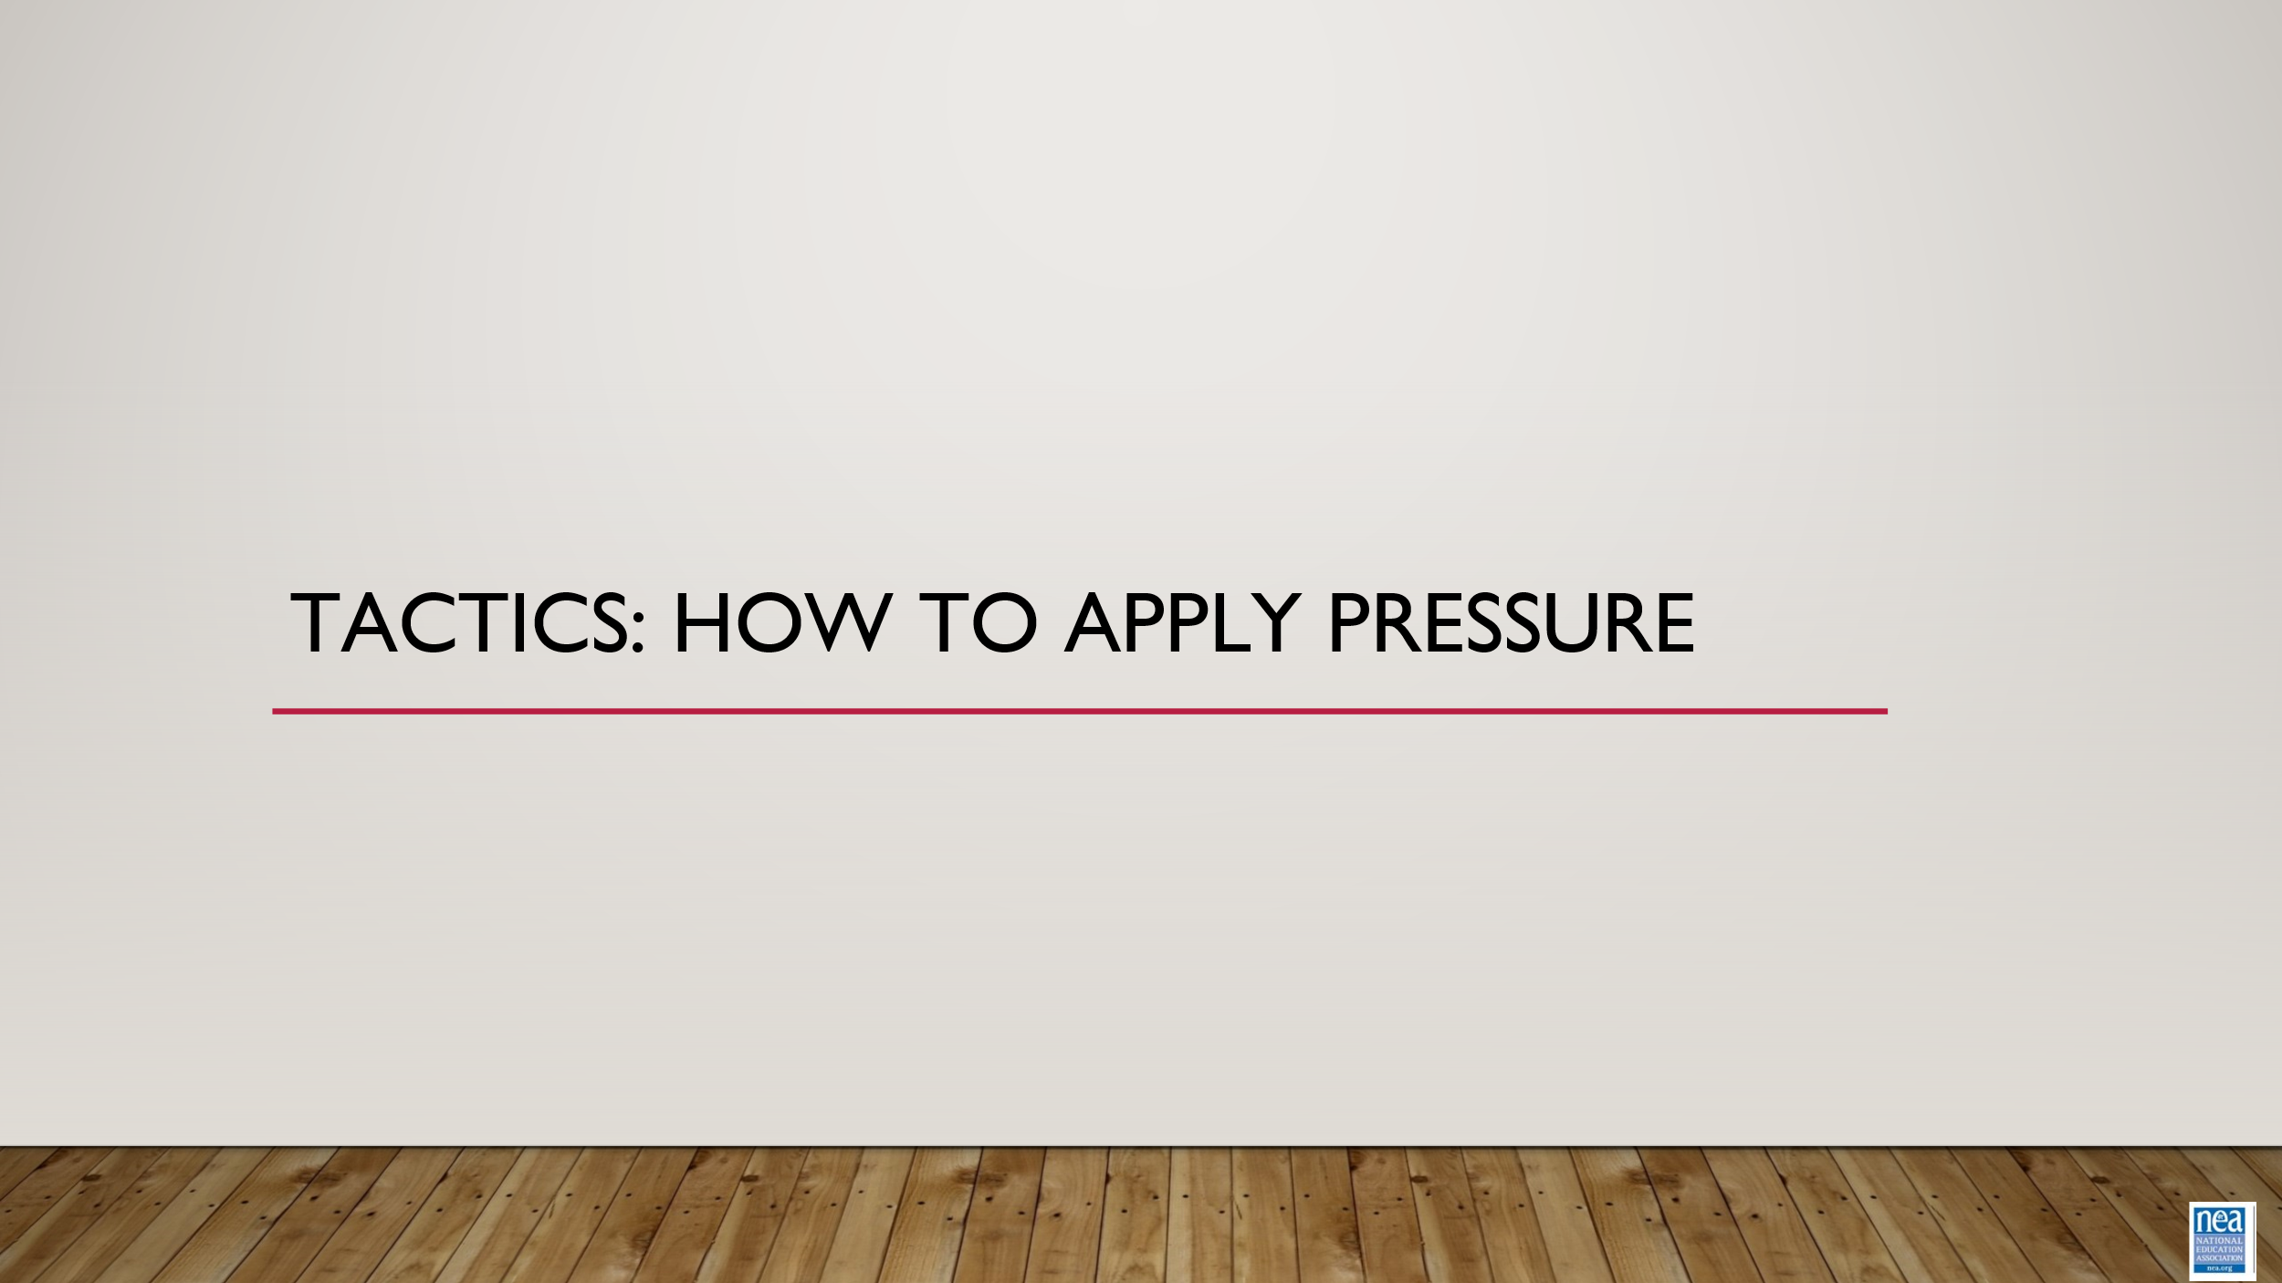  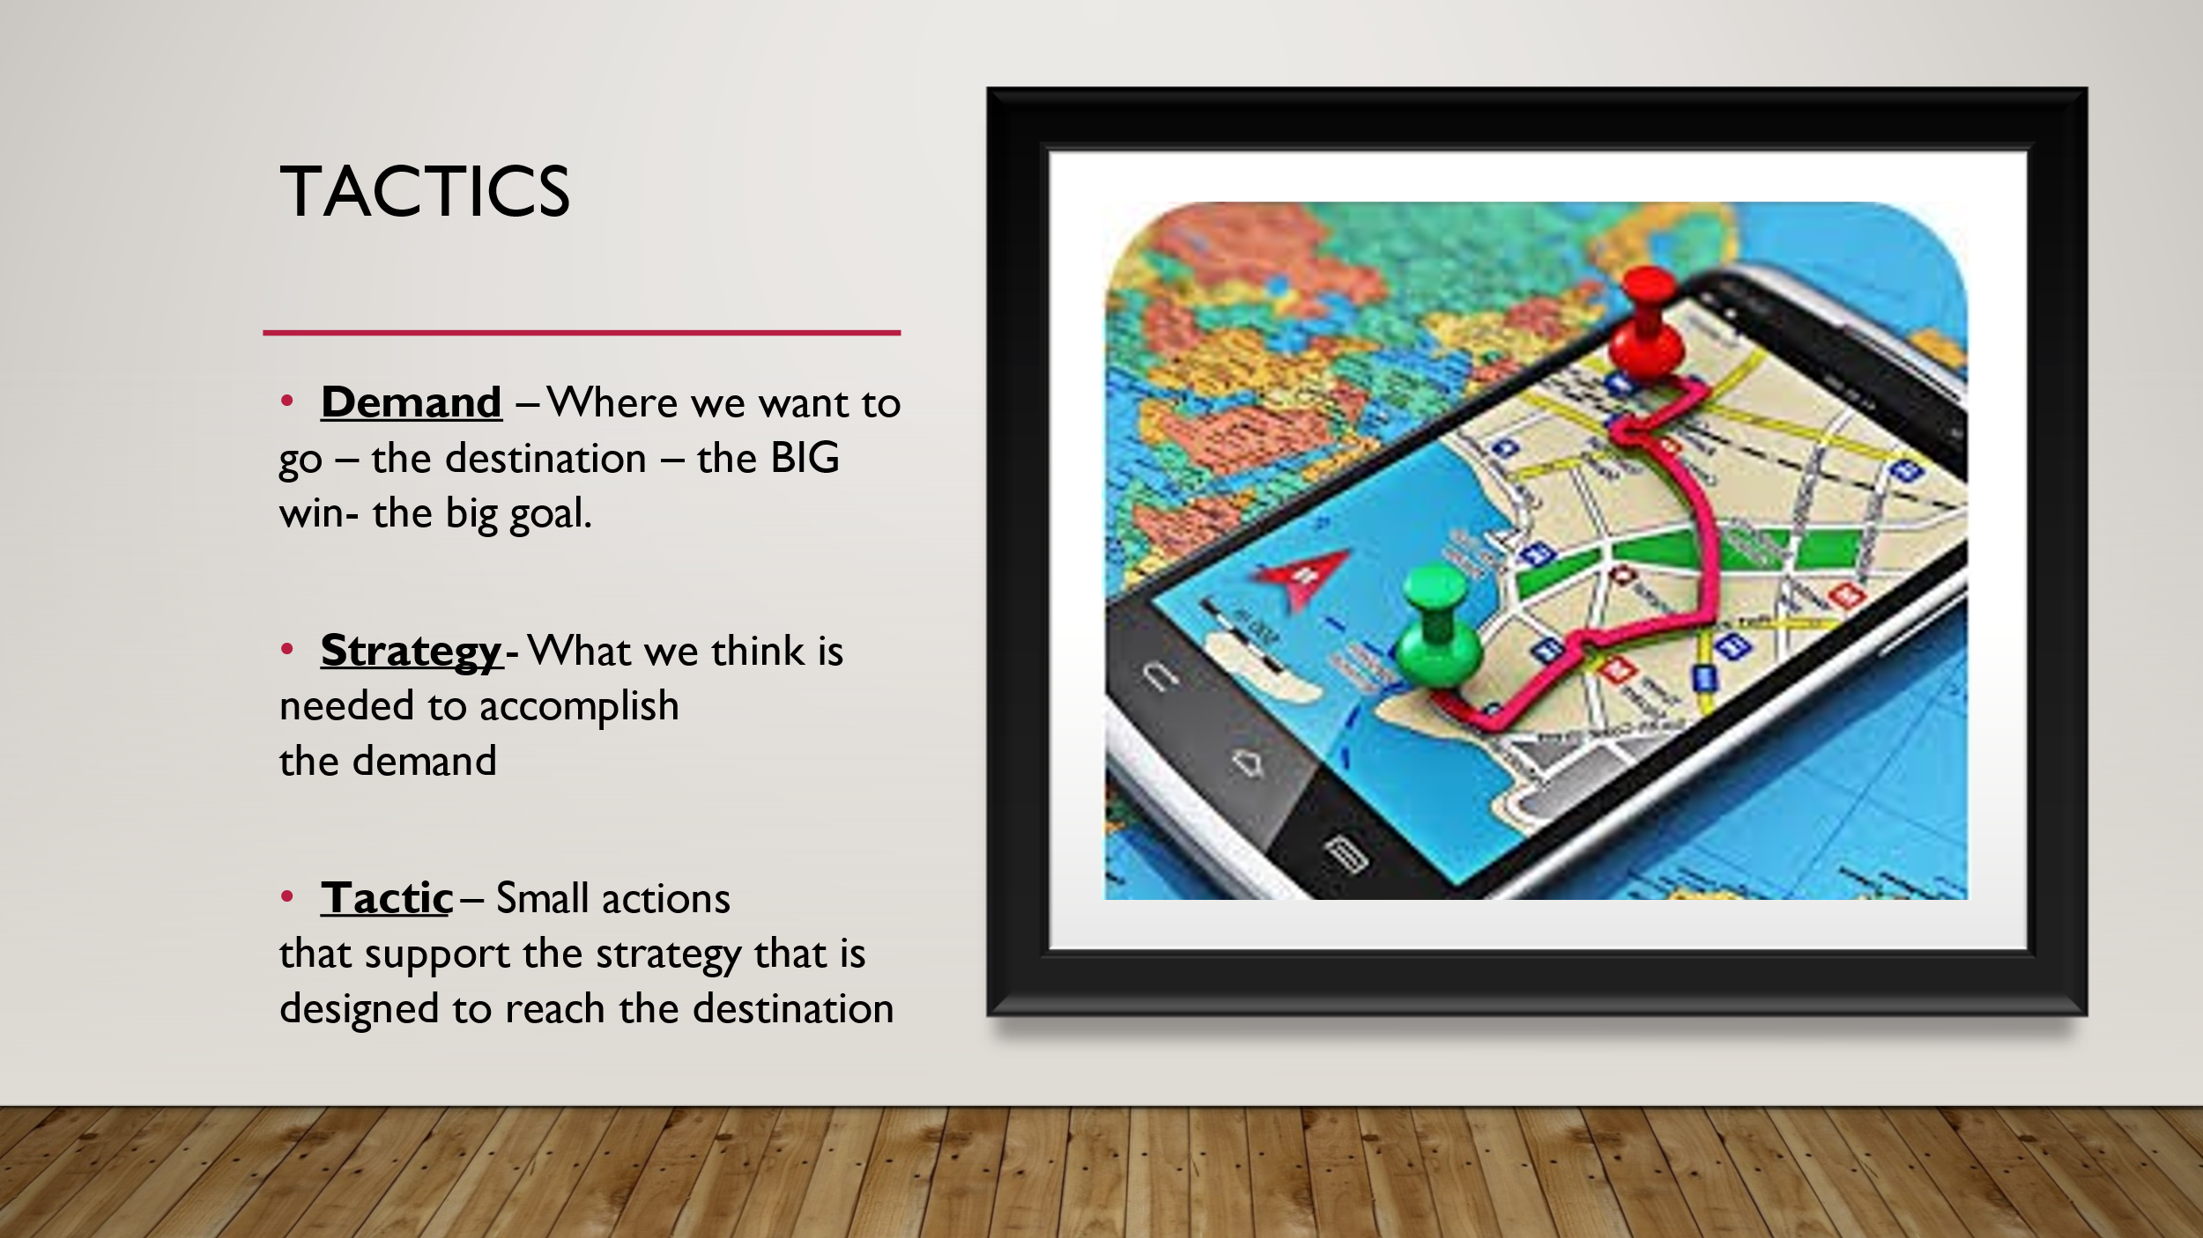  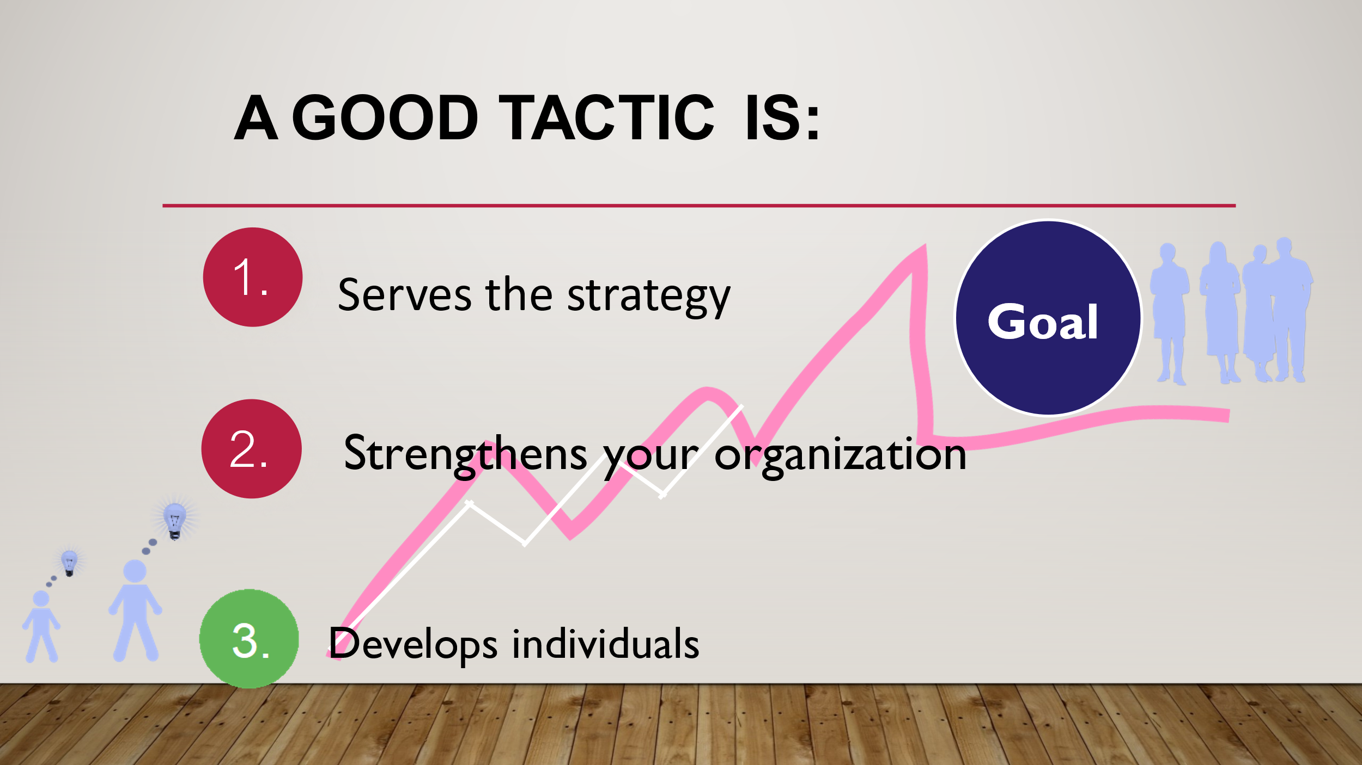  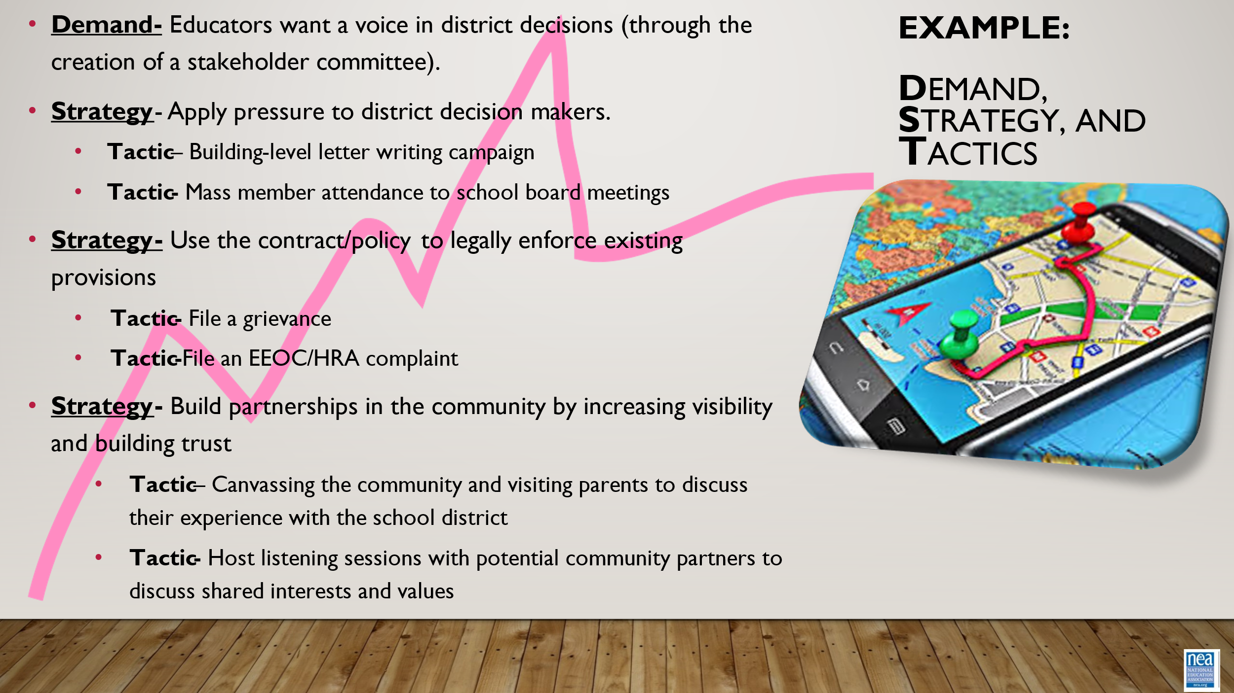  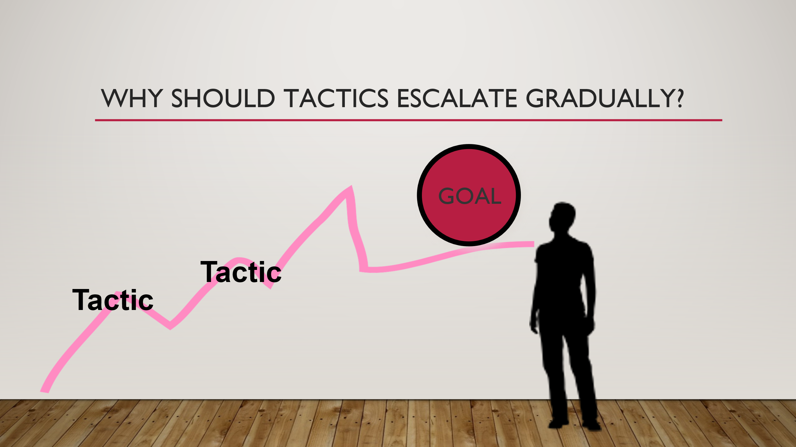  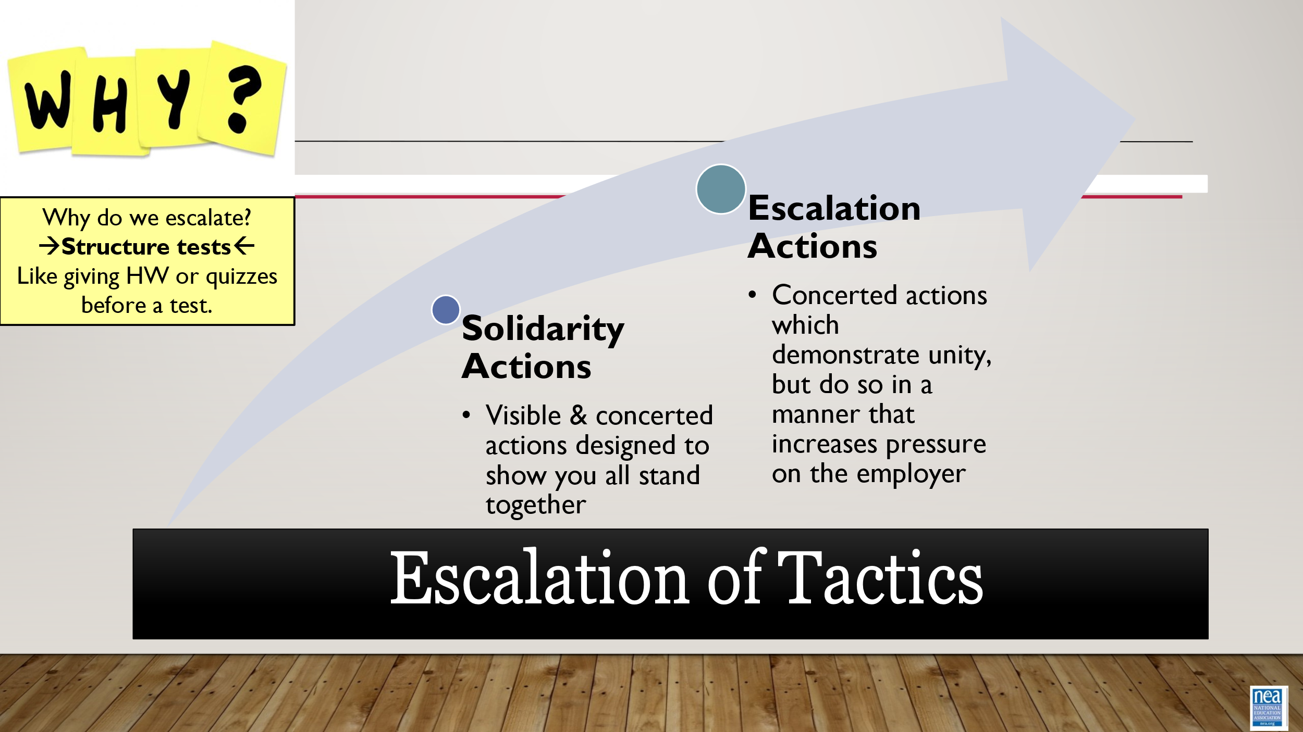  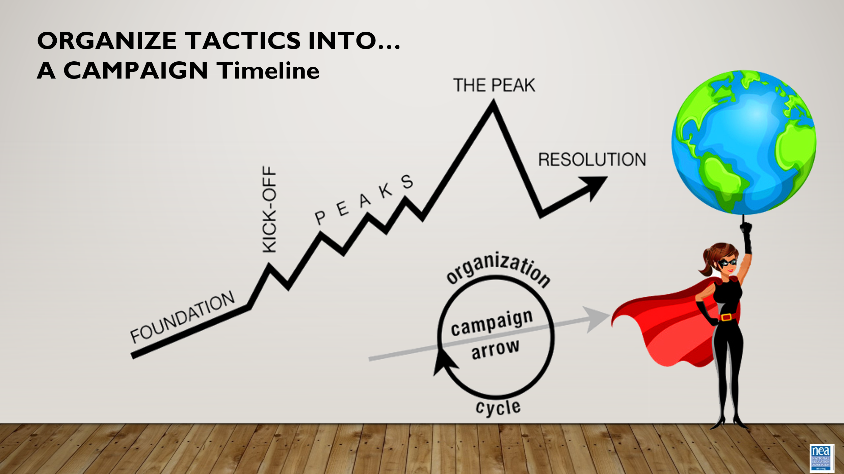  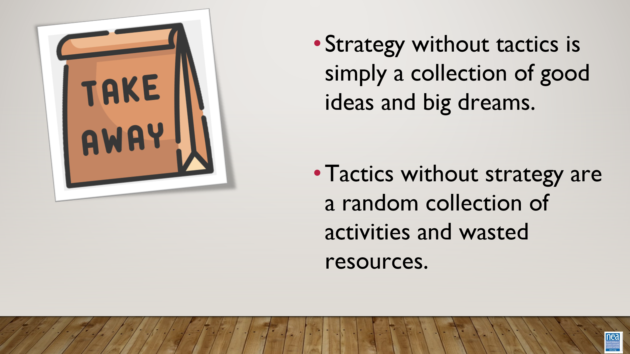  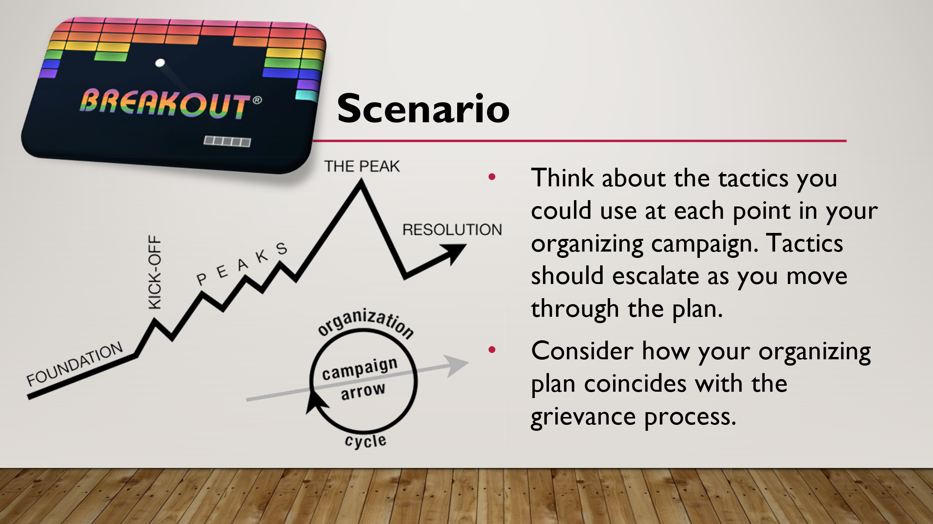  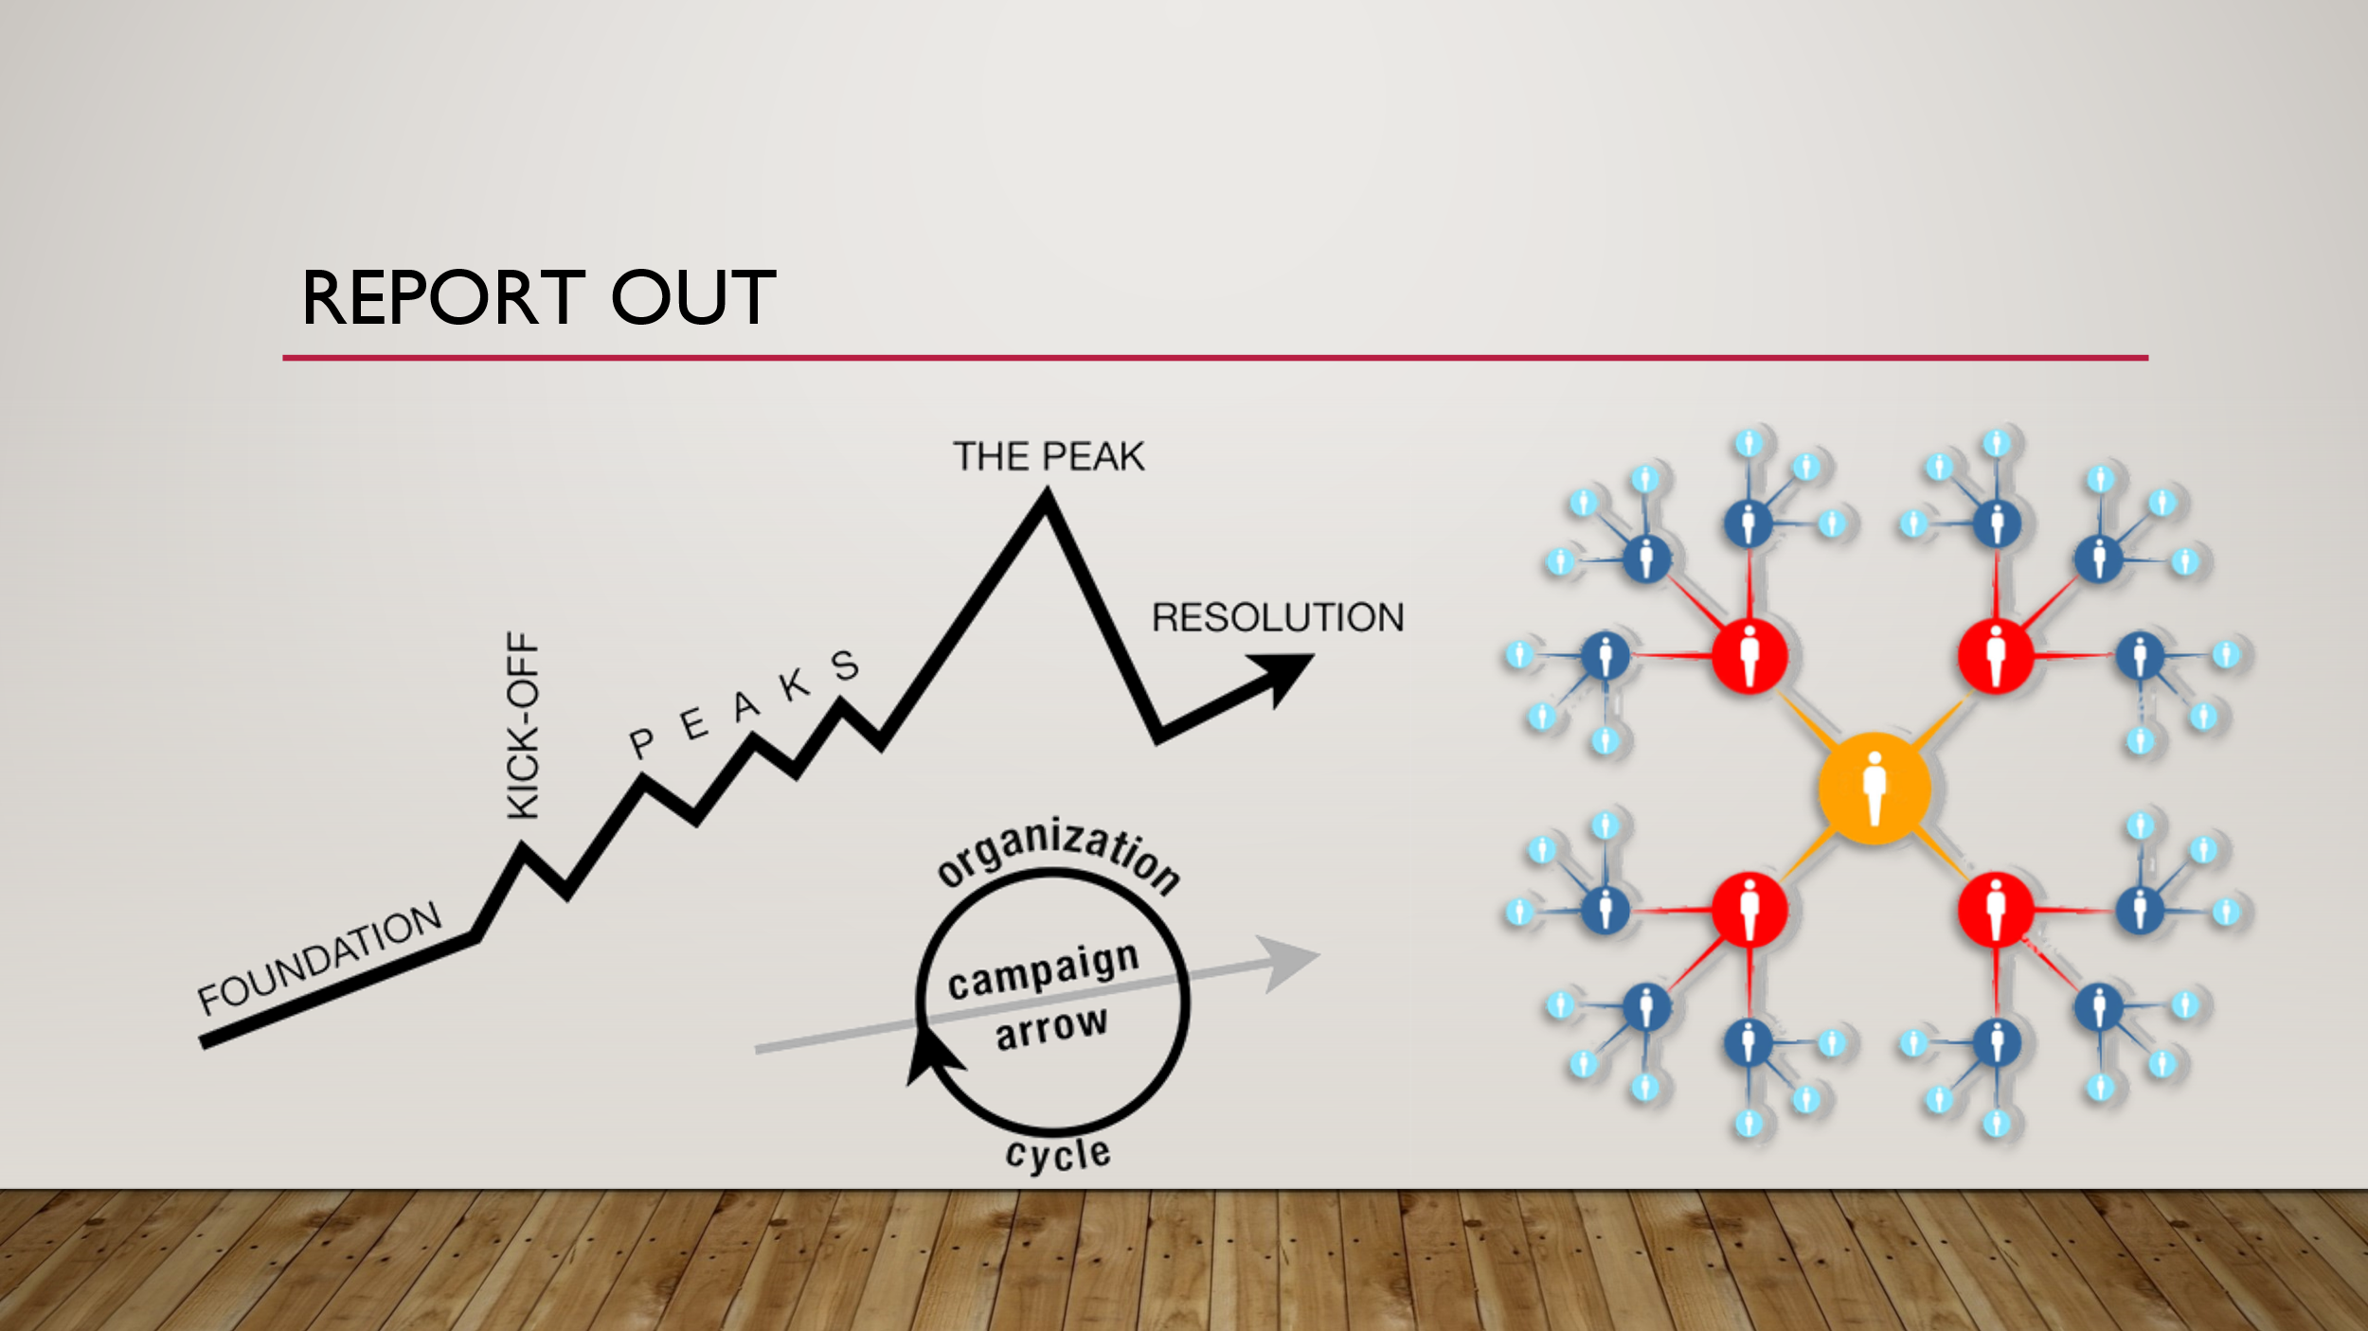  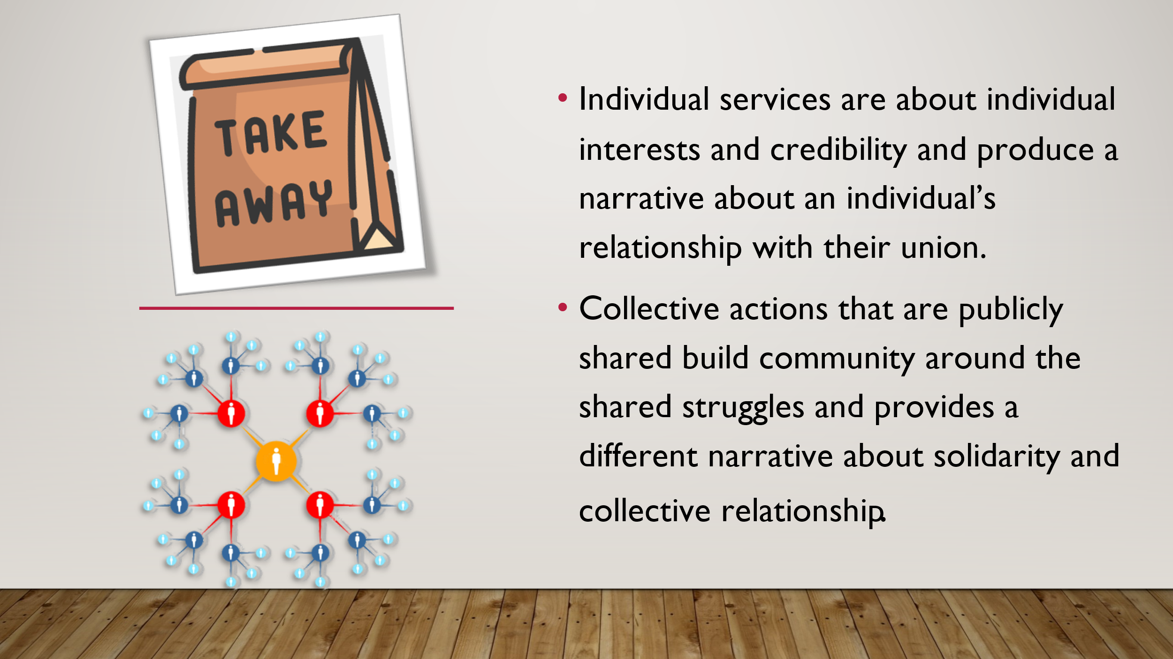  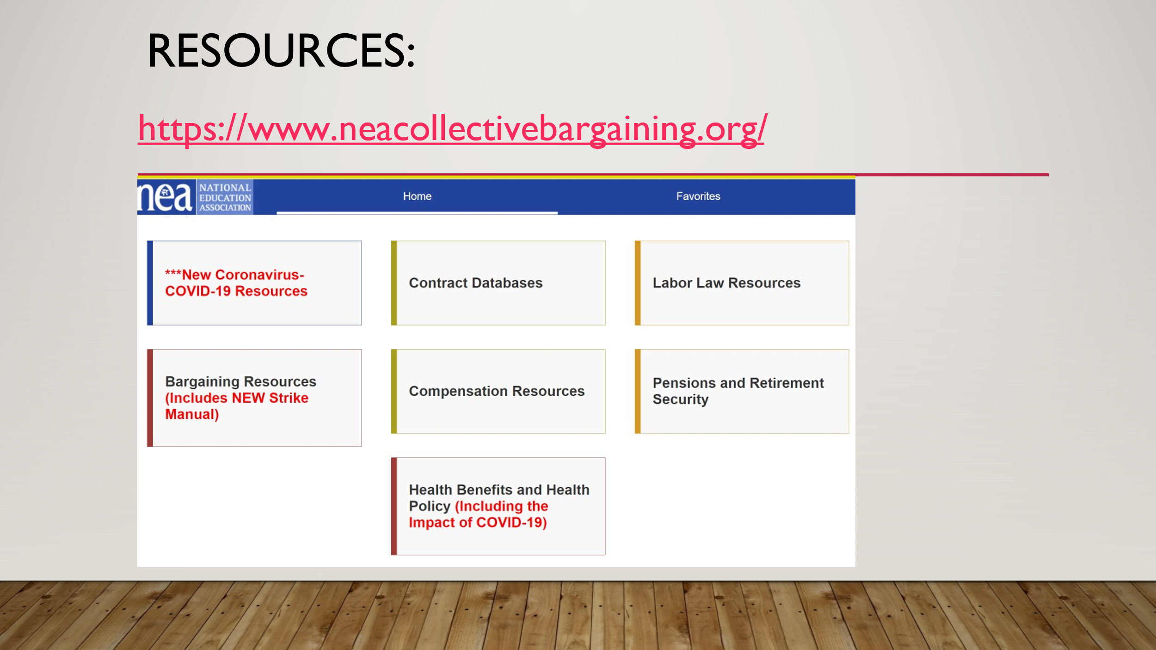  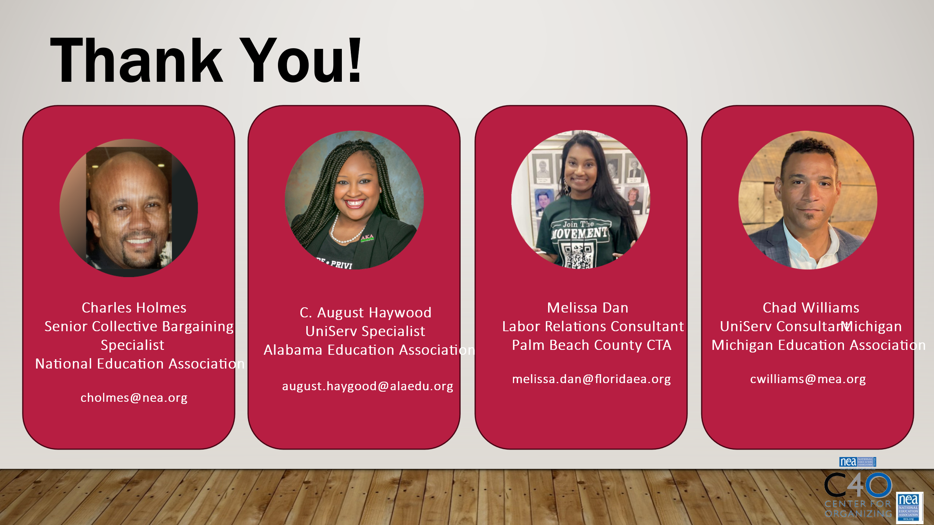 |  |  |  | 50 Minutes total – How to Apply Pressure  10 minutes for slides Demand and Tactics through Campaign Mountain  Demand and Tactics  Demand- the BIG Win  Tactics- Are Actions you to take as a part of an escalation plan that increases pressure on your target to try to win your demand.  Demand and Tactical Win  Walk through how each tactic leads to a tactical win. Tactical wins lead to achieving the demand.  A good tactic:  - Strategic- right time and place  - Strengthens – creates solidarity  - Develops individuals...moves them from mobilizing to organizing  Why should tactics escalate?  Each escalation is more public, more visible, and has more risk. WE transform members to activists, activists to leaders by asking them to take bigger risks  3 Mins- Campaign Mountain  Let’s put it all together...  - Foundation – gather info, id issues, id leadership team  - Kick-off –public event that indicates what the issue, demand, and targets are  - Escalating peaks of activity that should escalate in  - Risk  - Capacity (people, resources, engagement)  - Increase leadership and ownership  - Campaign Compression Points  - THE PEAK – The most public, risky, momentum, engagement, and resources  - The Win- We achieve our demand  - Debrief, regroup, and continue to climb  3 Minutes on Key Points  - Strategy without tactics is simply a collection of good ideas and big dreams.  - Tactics without strategy are a random collection of activities and wasted resources.  - The bigger the win you want, the more resource you need.  - Good tactics actually result in more resources – relationships, skills, hope and trust.  30 Minutes Scenario - Return to your Scenarios – what are the various tactics that you can use to apply pressure at the various stages of the process.  15 Minute – Report out and discussion  Are there different demands at different levels?  How many people are engaged?  How will you know if the tactic was successful?  How did the grievance process connect to the campaign?
4:00 | Adjourn

