  - Participant Handouts

2022-23    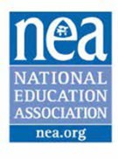 | Organizing Through Advocacy  UniServ Director are the first line of contact between the workers in our public schools and the state and national affiliates. The challenges of workload, shifting priorities, and having an organizing mindset in the face of overwhelming requests for service make the job complex and challenging. Organizing through Advocacy will help you build and calibrate your current skills, knowledge, and dispositions with the goal of building power to win.  The resources compiled here are to support your learning during your time with us and provide you enough content and framing for continued application of the skills and concepts presented.  Director  Tom Israel  tisrael@nea.org  Academy Coordinator  Ellen Holmes  eholmes@nea.org

