Member Rights and Issue Organizing with the Advocacy Model
Slides and activities from Member Rights Training
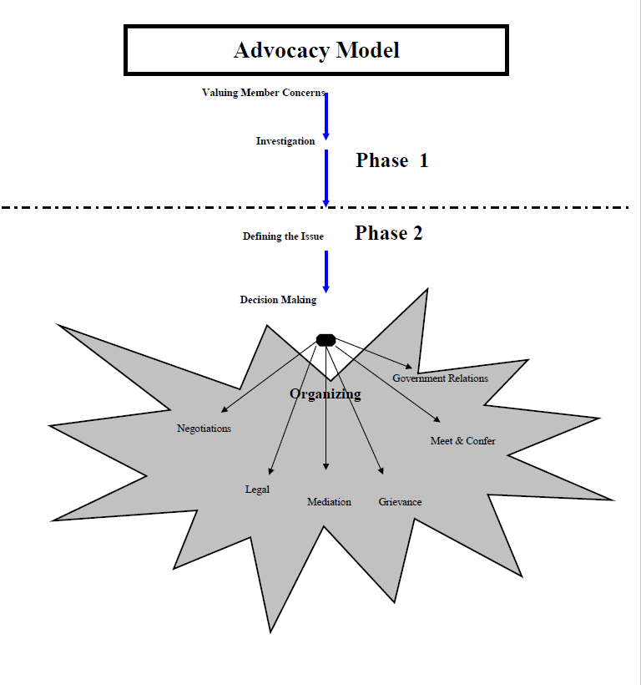
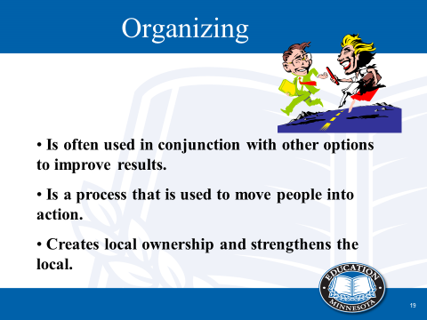
Slide notes:
As you look at options for resolving an issue, look for organizing strategies at the same time. Doing so can strengthen your local and help you achieve a better result.
The main purpose of organizing is to motivate the leadership, the members, and others to act together to resolve an issue.
This first slide on organizing is meant to demonstrate that organizing goes hand in hand with many of the decision-making options.
Organizing provides a means of sharing the issue and bringing strength to the decision-making option you choose. It creates local ownership of the issue, rather than the issue belonging to just the negotiations chair, the grievance chair, etc.
Note: Even though we will talk about ORGANIZING along with several options, toward the end of our descriptions, we will also talk about ORGANIZING as an option on its own.

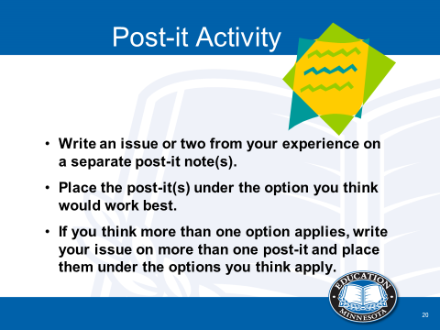
Slide notes:
Note: Post-its of varying colors should be on the tables. Have posters up around the room, each with one of the decision-making options on it. Add one for issues to refer to agencies such as Workers Comp., TRA, etc. (from Phase I)
You will see these Decision-Making Options printed on posters around the room. It is likely that you might have used some of them already, and we’d like to tap into that experience. Select an issue or two that you have come across before. Perhaps it is something your local has dealt with or you yourself have experienced. Write the issue on a post-it note (on the table) and in a moment you will place it under the option you used to resolve it---or the one you think could be used.
If you think more than one option applies, write your issue on more than one post-it and place them under the options you think apply.
As one presenter describes the various options throughout this section of training, a second presenter will be asked to use the participants’ examples to show how organizing might be used along with each option. (See specific notes under each option included.) The decision-making options are described in the next sections. At the end of each decision-making option, use a couple of post-it examples to illustrate the option.
Before posting your issue(s), we now ask you to consider four other issues and post those under the appropriate option at the same time. Let’s look at these options on the next slide.

