https://www.theguardian.com/us-news/2022/mar/16/us-union-victories-wave-labor-strategists

US unions see unusually promising moment amid wave of victories
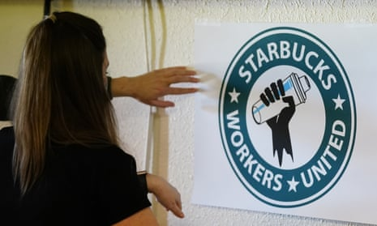
Labor strategists hope wins will turn into a larger trend but acknowledge it won’t be easy as corporations fight fiercely against unionization

A Starbucks barista in Buffalo, New York, helps out the local Starbucks Workers United in Mesa, Arizona, in February. Photograph: Ross D Franklin/AP
Steven Greenhouse Wed 16 Mar 2022 06.00 EDT
The recent, much-publicized wave of union victories in the US at companies as varied as the giant coffee chain Starbucks, trendy outdoor outfitters REI and media group the New York Times is spurring hopes that this will somehow turn into a much larger unionization wave that lifts millions of Americans.
This is an unusually promising moment for unions, labor strategists say, as they strain to figure out how best to build a larger wave, although they acknowledge it won’t be easy because US corporations fight so fiercely against unionization.
Union strategists are debating whether there are ways to transform the wins at Starbucks – workers at six Starbucks have voted to unionize so far – into a wave of unionization at McDonald’s and other fast-food companies, and whether the REI victory could be a springboard to victories elsewhere in retail, perhaps at Walmart or Whole Foods.
“We have a moment right now,” said Stuart Appelbaum, president of the Retail, Wholesale and Department Store Union, the union that the REI workers voted to join. “I think that success breeds more success. When people see what’s happened at some Starbucks in Buffalo, they ask, ‘Why can’t we do that, too?’”
His union is campaigning hard to win a rerun union election at the Amazon warehouse in Bessemer, Alabama, but labor experts say it’s much easier for unions to win at a Starbucks with 30 employees or an REI store with 100 than at an Amazon warehouse with perhaps 5,000 workers and management running an all-out, anti-union campaign.
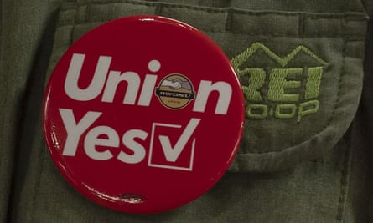
A union button is seen on an REI employee’s vest in New York City. Photograph: Ron Adar/Sopa Images/Rex/Shutterstock
“You have thousands of people who are standing up at Amazon wanting to be part of this movement,” Appelbaum said. “It relates to how people feel they were treated during the pandemic. Their contributions were not being rewarded sufficiently, and the risks they took were not being recognized sufficiently. Workers felt the callous indifference of too many employers. Plus, workers were concerned about the profiteering that was going on and the exponential explosion of income inequality. That we have such a pro-union president is helpful, too.”
Moreover, workers feel unusually empowered because of the low unemployment rate and record number of job openings.
It is a moment when many workers are making inquiries about unionizing (beyond the well-known efforts among grad students, adjunct professors and museum workers). Organizers say workers at McDonald’s, Target and Trader Joe’s are asking about unionizing. That first union victory at a Starbucks in Buffalo, New York, in December has led to workers at 140 Starbucks in 27 states petitioning for unionization votes. What is happening at Starbucks is the wildfire that union organizers dream of – an organic, bottom-up, fast-spreading effort.
Erica Smiley, executive director of Jobs with Justice, a labor rights group, said all this worker energy is great. But acknowledging how fierce anti-union campaigns can be, she said: “The pressure is on us as a movement to help move this forward. It’s really an uphill battle.”
The recent string of lopsided union wins was impressive and inspiring: 88 to 14 at REI in Manhattan, 25 to three at Starbucks in Mesa, Arizona, 404 to 88 among New York Times tech workers, and 142 to 44 at the Art Institute of Chicago. These victories came despite vigorous anti-union campaigns by management
“We’re in a moment when we are questioning how effective traditional union-busting tactics are,” said Rebecca Givan, a labor studies professor at Rutgers. “Traditional union-busting tactics like scaring immigrants and dividing workers by race – how effective they are has been brought into question.” Givan said workers at Starbucks stores that have unionized speak with workers at other Starbucks to inoculate them against anti-union efforts by telling them what anti-union message and tactics to expect.
While the recent union wins fuel optimism, the Bureau of Labor Statistics reported in January that just 10.3% of US workers are in unions and just 6.1% in the private sector. In the 1950s, more than one in three private-sector workers were in unions, in the 1980s, more than one in five. Now it’s just one in 16.
The pressure is on us as a movement to help move this forward. It’s really an uphill battle
Erica Smiley
Tefere Gebre, who recently stepped down as executive vice-president of the AFL-CIO, the nation’s main labor federation, said unions were doing far too little to seize the moment and unionize workers. “Workers want unions, but the question is, do unions want workers?” Gebre said. “If you talk to any labor leader, they’ll tell you, “That’s what we’re really for. We want members.’ How you mechanize that is a different thing.”
Gebre said far too many union leaders don’t want to stick their necks out and spend members’ dues money on unionizing more workers. “Right now we have fiefdoms that people think are big enough,” Gebre said, warning that if union membership continues to decline, unions will inevitably lose clout.
“For far too long our growth strategy has been entirely attached to politics, but that has failed us over and over,” Gebre said. A Republican filibuster has blocked Joe Biden’s push to enact the Pro Act, which would make it easier for workers to unionize.
Gebre said the nation’s unions should send far more organizers and money to back the union drives at Starbucks and Amazon. “The rest of the labor movement should be willing to lend a hand,” even if they don’t get any of the members, said Gebre, who was recently named Greenpeace’s chief program officer. “That’s what solidarity means.”
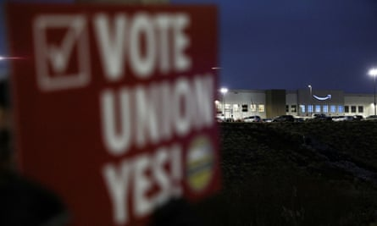
A person holds a sign reading ‘Vote union yes!’ in front of an Amazon facility in Bessemer, Alabama. Photograph: Dustin Chambers/Reuters
Unions have often balked at organizing small workplaces like restaurants with a few dozen workers, preferring to focus on larger workplaces. In addition to seeking a $15 wage, the Fight for $15 – which was largely financed by the Service Employees International Union – sought to pressure McDonald’s to agree to remain neutral and not oppose unionization. That might have allowed efforts to unionize dozens of McDonald’s and hundreds of McDonald’s workers at once, but McDonald’s rejected pressures to agree to neutrality.
Workers United, the union that is organizing Starbucks, is an Service Employees International Union (SEIU) affiliate, but has taken a different approach. “It’s better to organize 10,000 workers at a time than 25,” said Erik Loomis, a labor historian at the University of Rhode Island. “But the more 25s you organize, the more people will see that success and gain confidence to take action themselves. You’re seeing that with Starbucks.”
Givan said the Starbucks victories might inspire workers at McDonald’s, Chipotle and other fast-food companies to seek to unionize, and if just one or two of those restaurants unionize, it could spur many workers at those chains to seek to do likewise, especially in union strongholds like Boston, Chicago, Los Angeles, New York, San Francisco and Seattle.
“We don’t have the luxury as a movement to be picky on strategy,” said Smiley of Jobs with Justice. “At this moment, we have to let every flower bloom – not in a way that will burn the future, but in a way that will crack open the door to allow us to think a little differently.”
Stephen Lerner, architect of the SEIU’s groundbreaking Justice for Janitors campaign, said it was exciting that Starbucks workers are organizing and winning elections. But he said that even when workers win union elections, corporations often drag their feet for years before ever reaching a union contract, that is, if they ever agree – a strategy that hugely frustrates workers.
“That’s why to beat giant corporations, you need comprehensive campaigns,” Lerner said. “We need giant campaigns to pressure giant companies at multiple levels to make sure they negotiate and reach good contracts.”
Seeing how intense anti-union efforts can be, many labor leaders resist calls that they do more organizing if unions are ever to grow larger and stronger. “Organizing at any place is too hard,” Gebre said. “In the entire history of the labor movement, it’s never been easy. But that’s what unions are there for: to do the hard work.”

