Facilitator Agenda: Reframing Membership (Dec 12, 2024)

General Materials Needed: |  |  |  |  | Room Set-up:
Pre-Email with survey on skill level |  |  |  |  | Zoom
Key Outcomes for the Day

Time, Facilitators, and Slides | Essential Questions |  | Resources | Instructions, Activity and Debrief (Facilitators) |  | Key Outcomes
What is the clock time for start and end? Who is doing this Section? What are the PPT slides (pic of slides)? | What question(s) should this learning section answer? |  | Charts, handouts, articles, materials, videos | What are you saying, what are they doing, what questions will you use to guide learning and make clear the important points  Include an estimate for how long each section of the learning will take  Include Key points. |  | As a result of this section of learning, what will participants know or be able to do?
2:30pm – 2:40 pm  Dawn: Slides 1-3  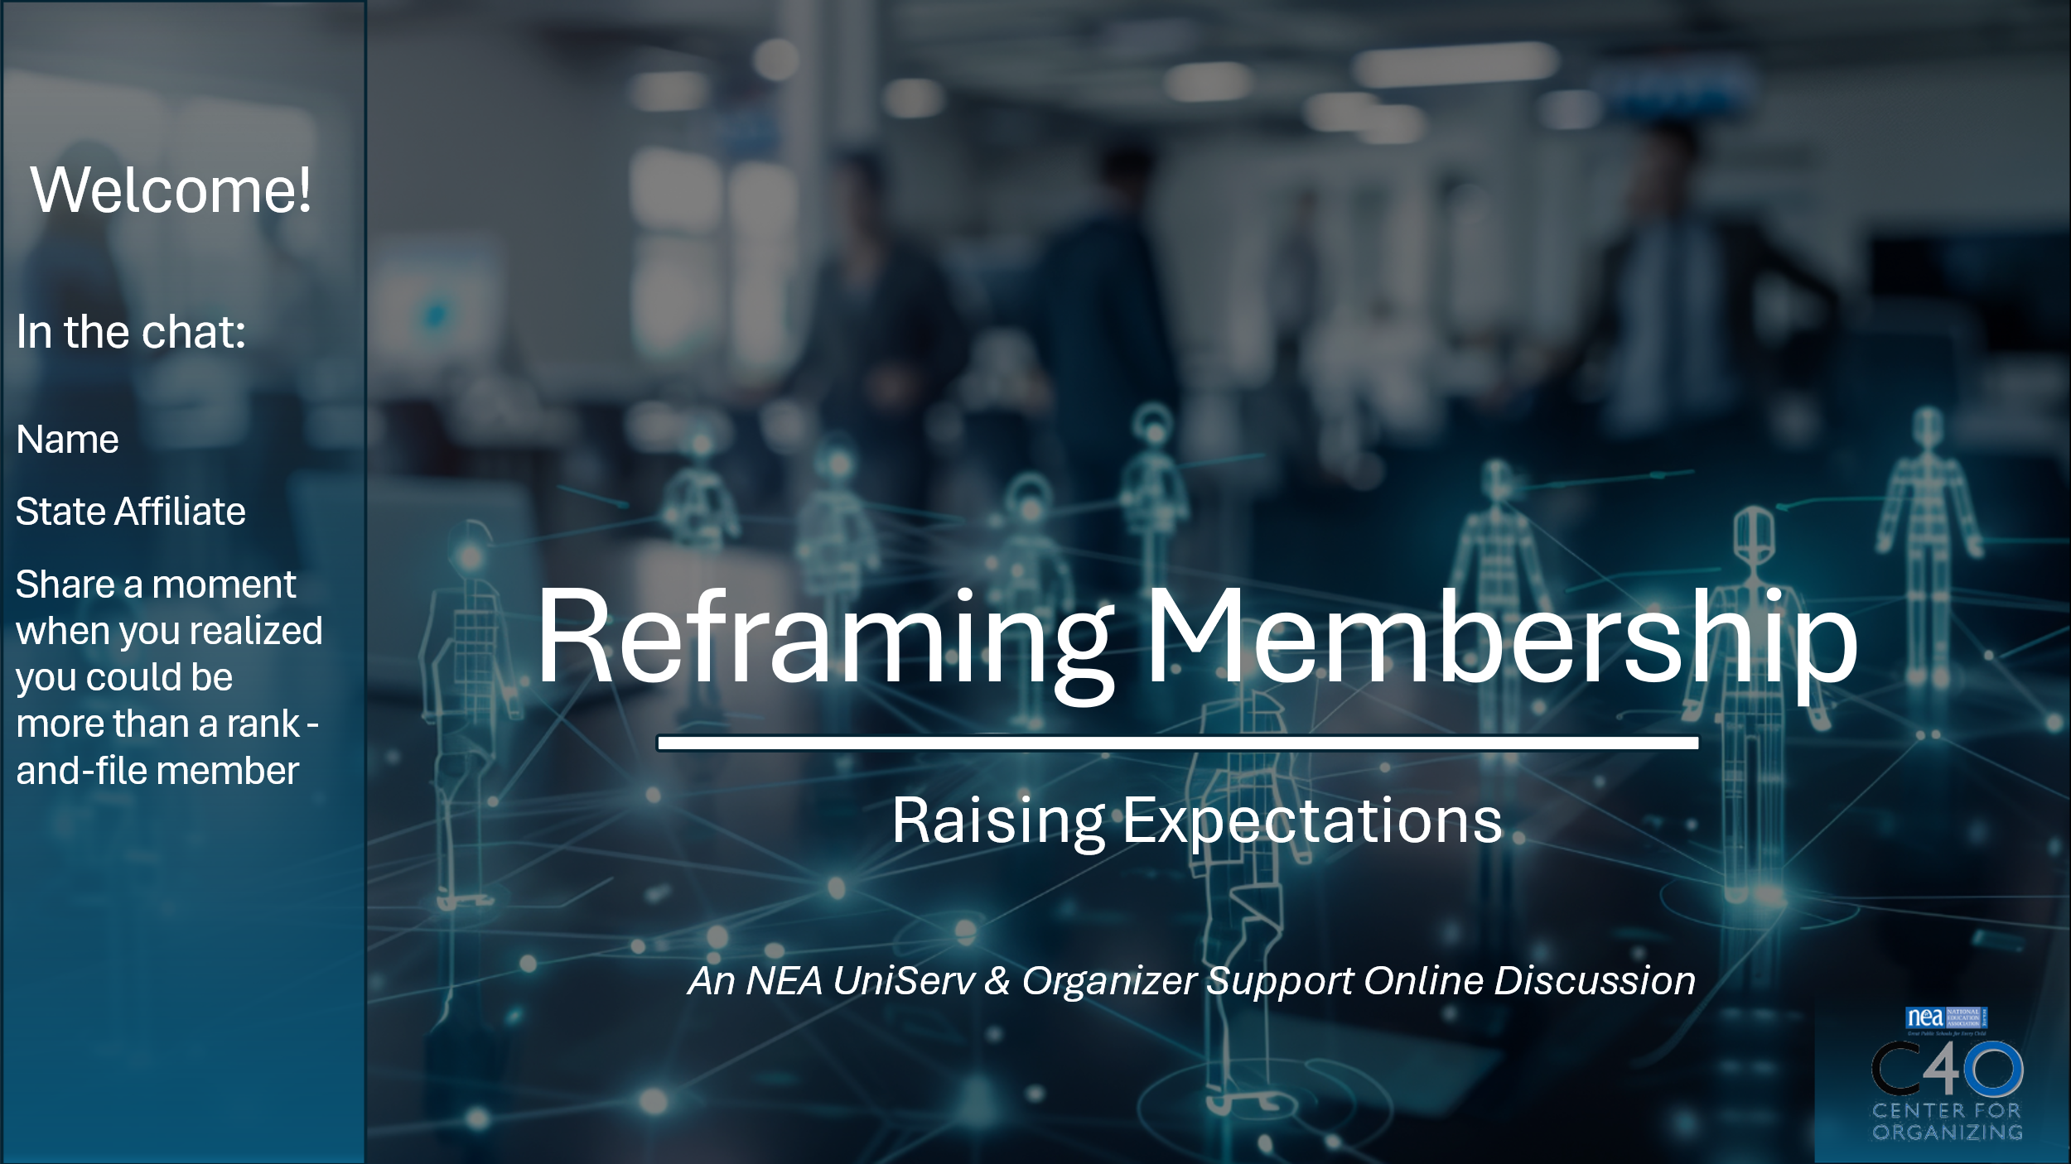  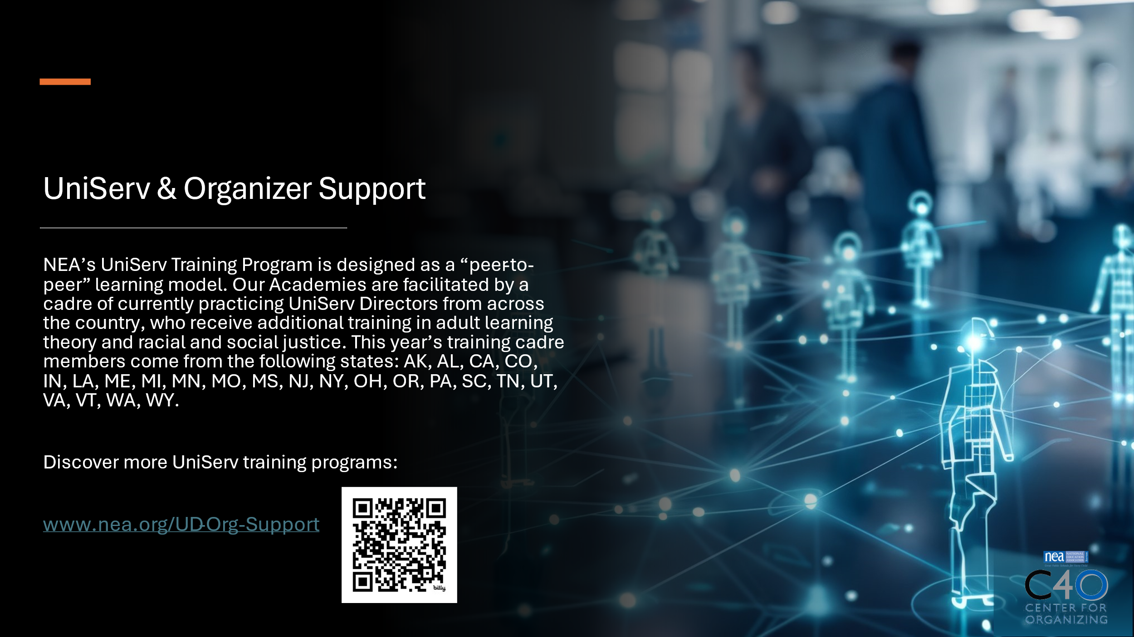    Zac: Slides 4-5  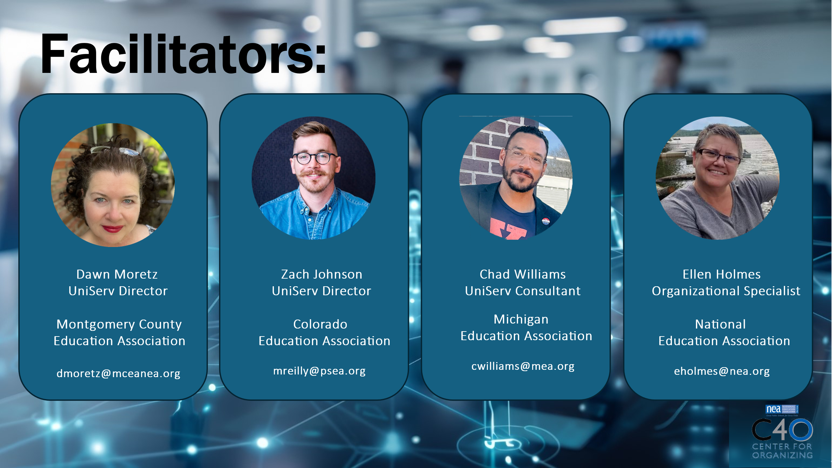  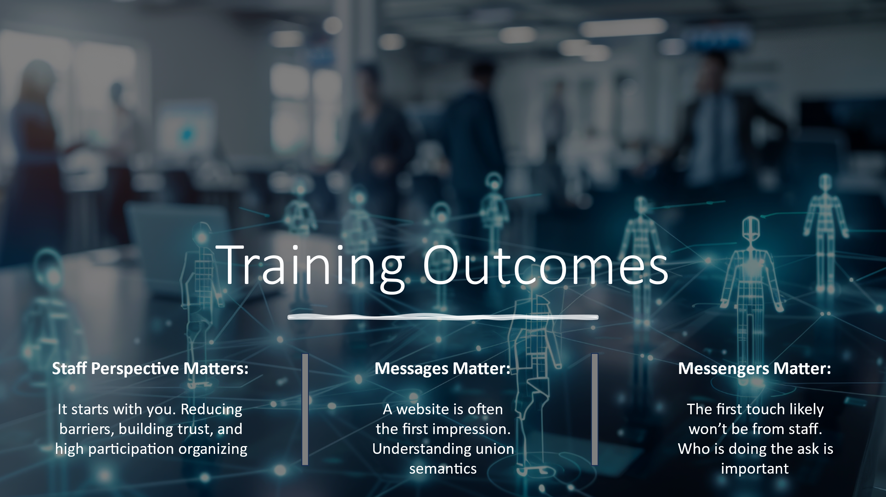 | What will we cover? What will we focus on today?  Who are you? Who are your facilitators? |  | PPT | Dawn & Zac--10 Minutes-Welcome (2:30-2:40 pm)  Dawn: Slides 1-3  - Welcome- Participant Introductions (in Chat)  - Refer to Community Agreements  - Land Acknowledgement  Zac: Slides 4-5:  - Presenter Introductions  - Purpose of Training  - Intended Outcomes  Pass off to Chad |  | Participants will understand the structure of their time and how we will work together.
2:40-3:10 pm  Chad: Slides 6-16    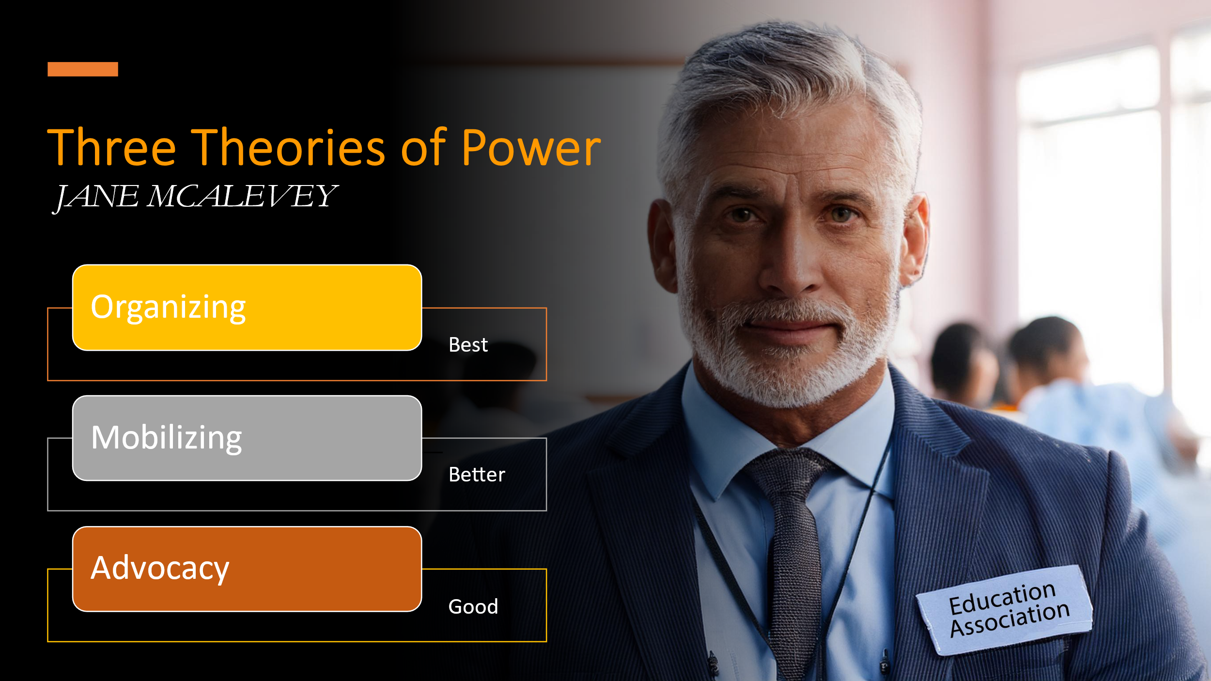  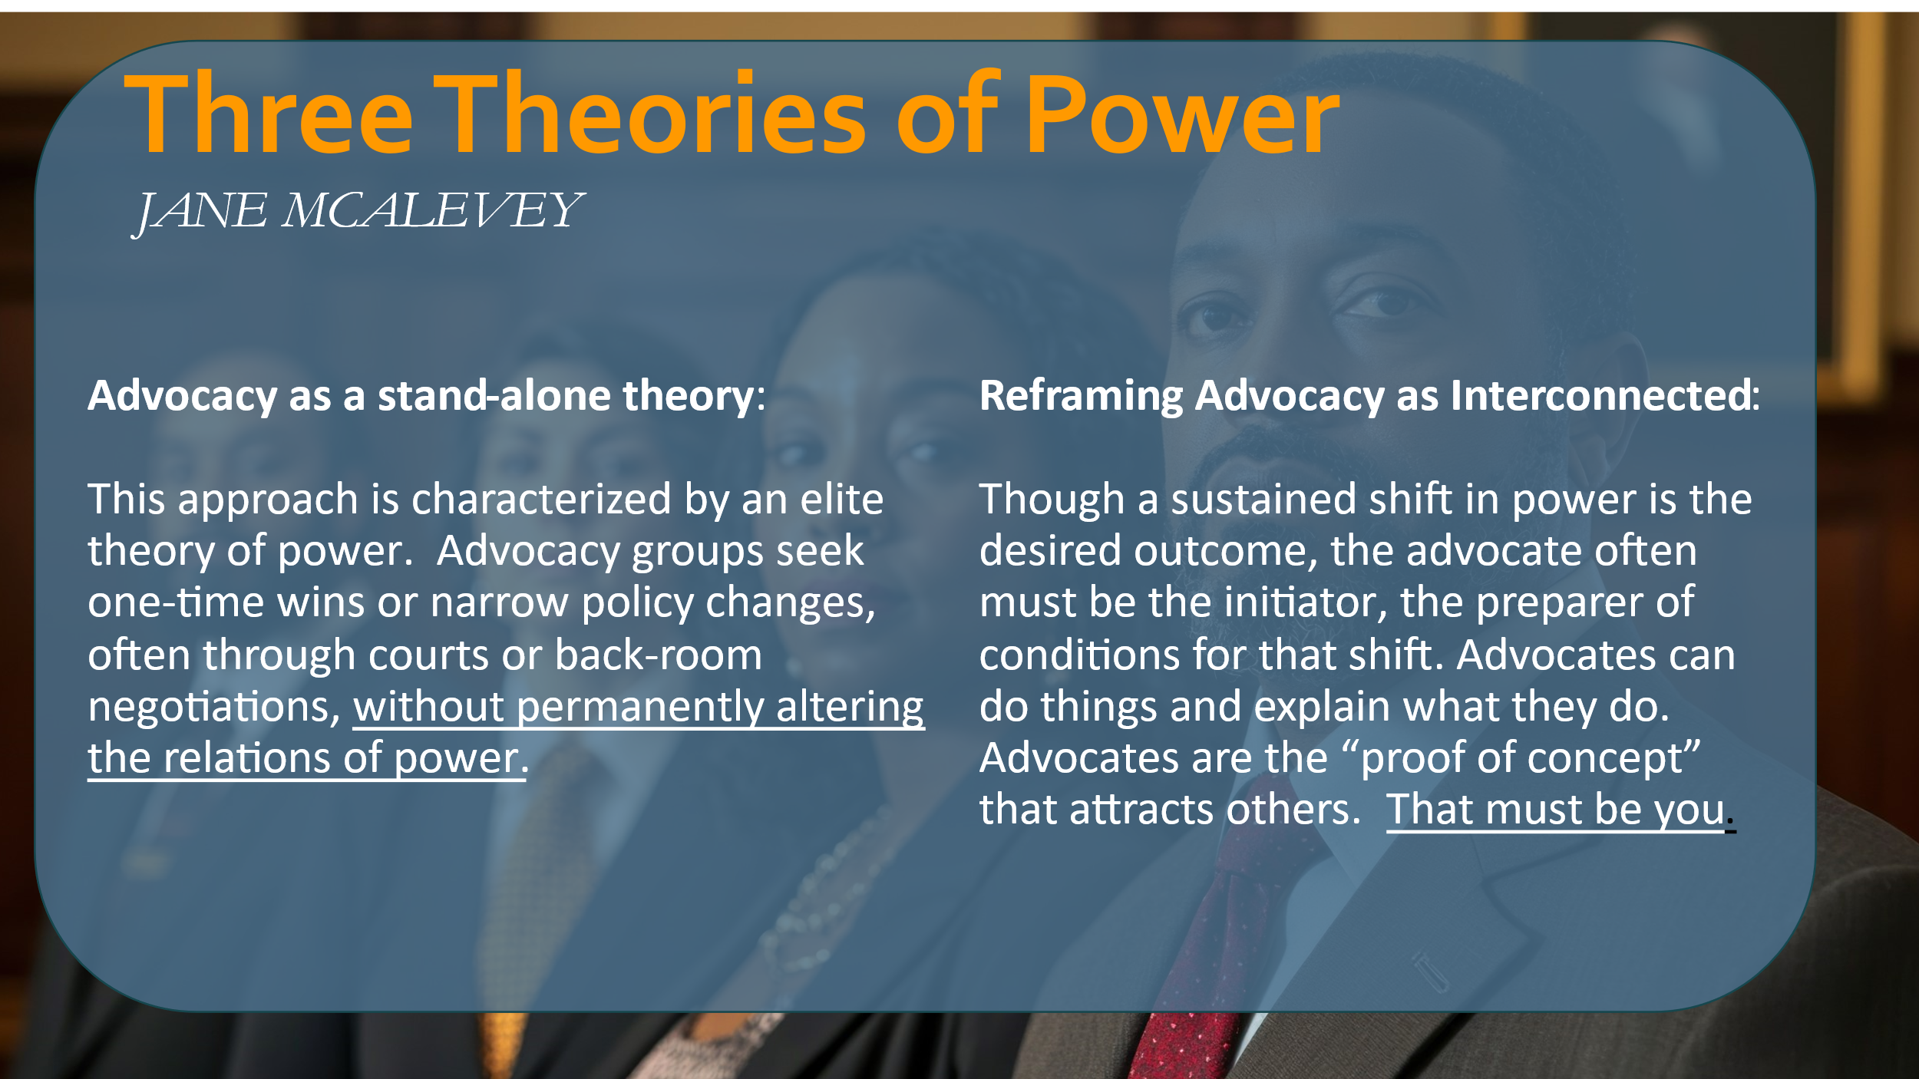  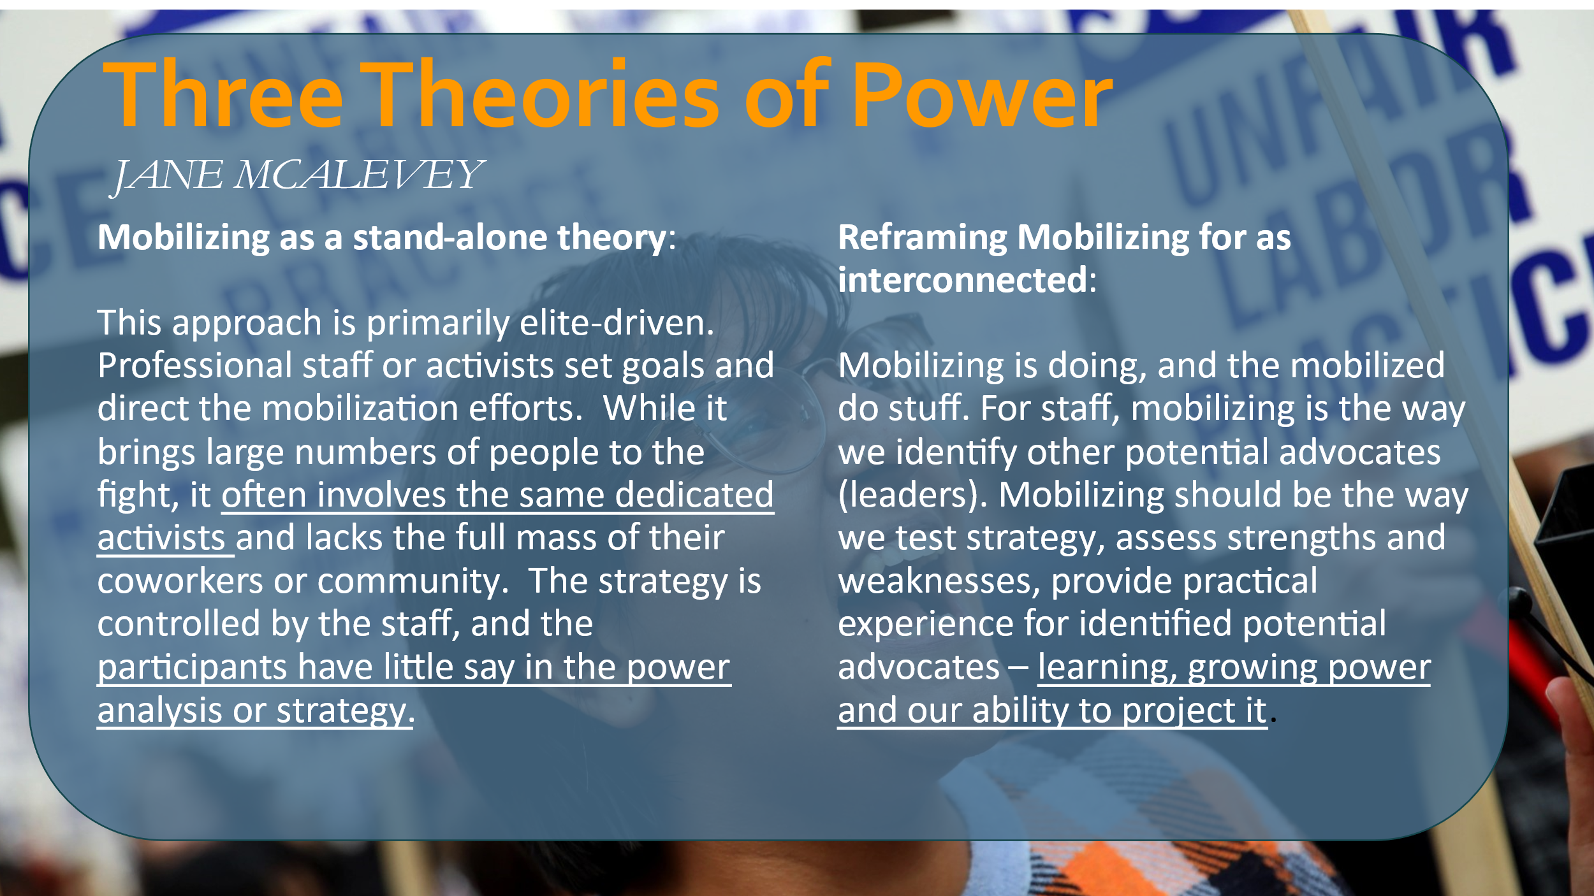  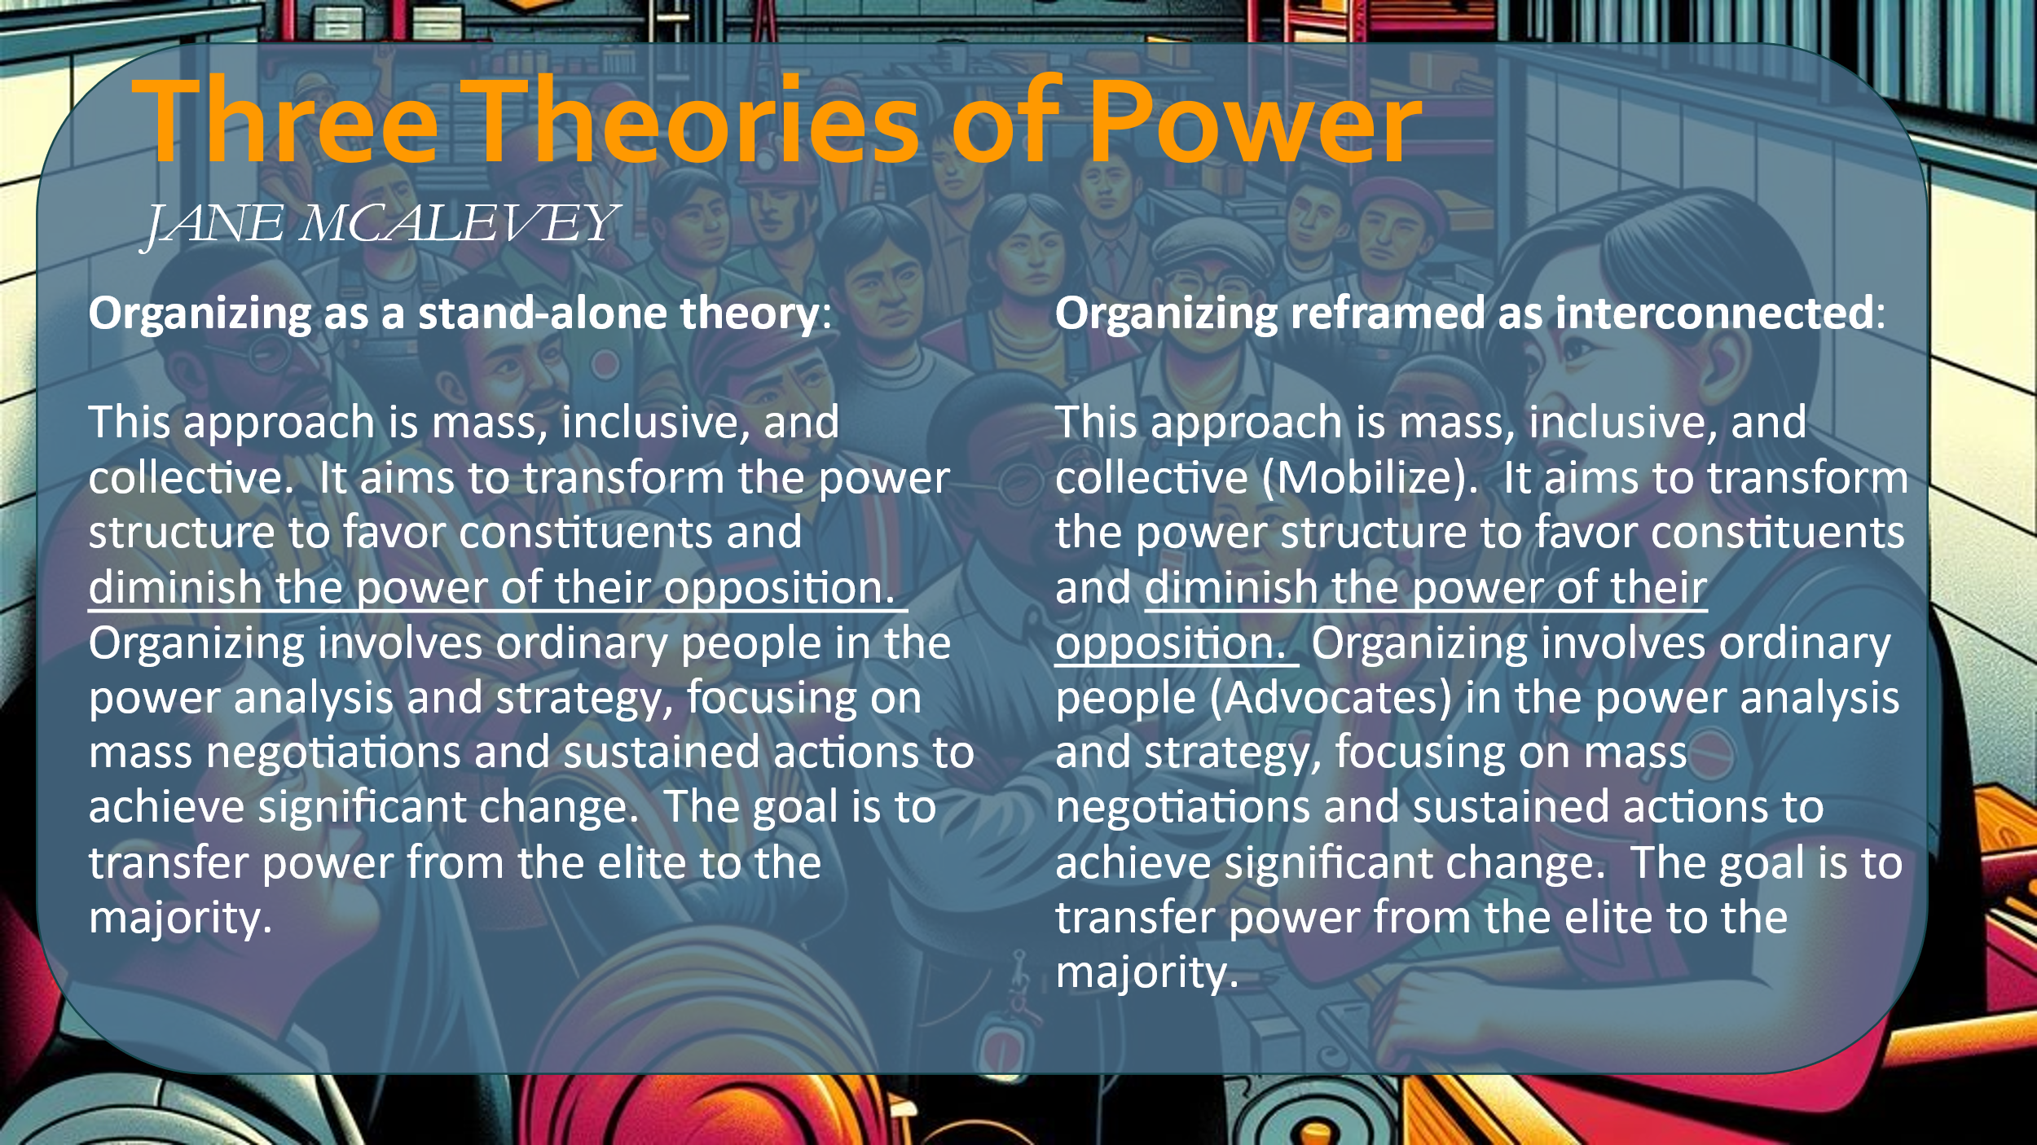  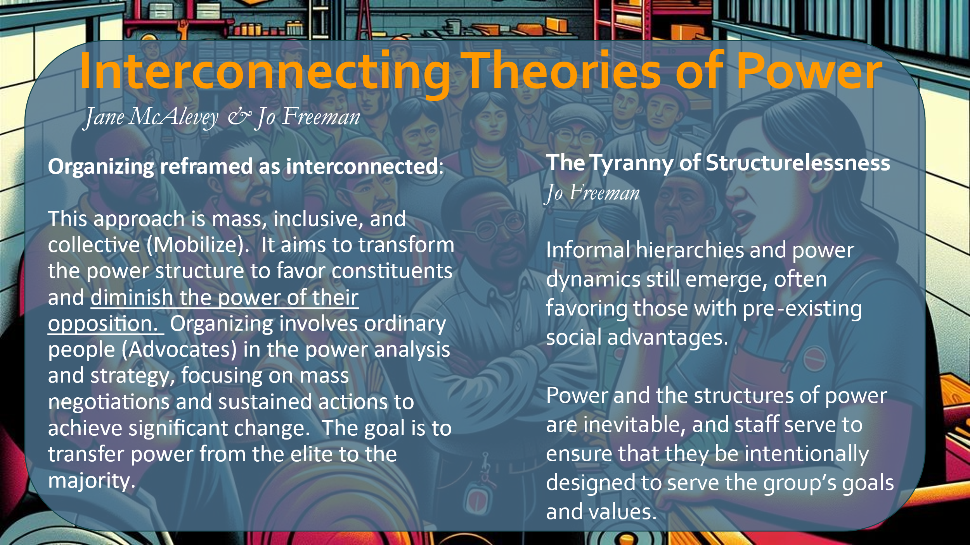  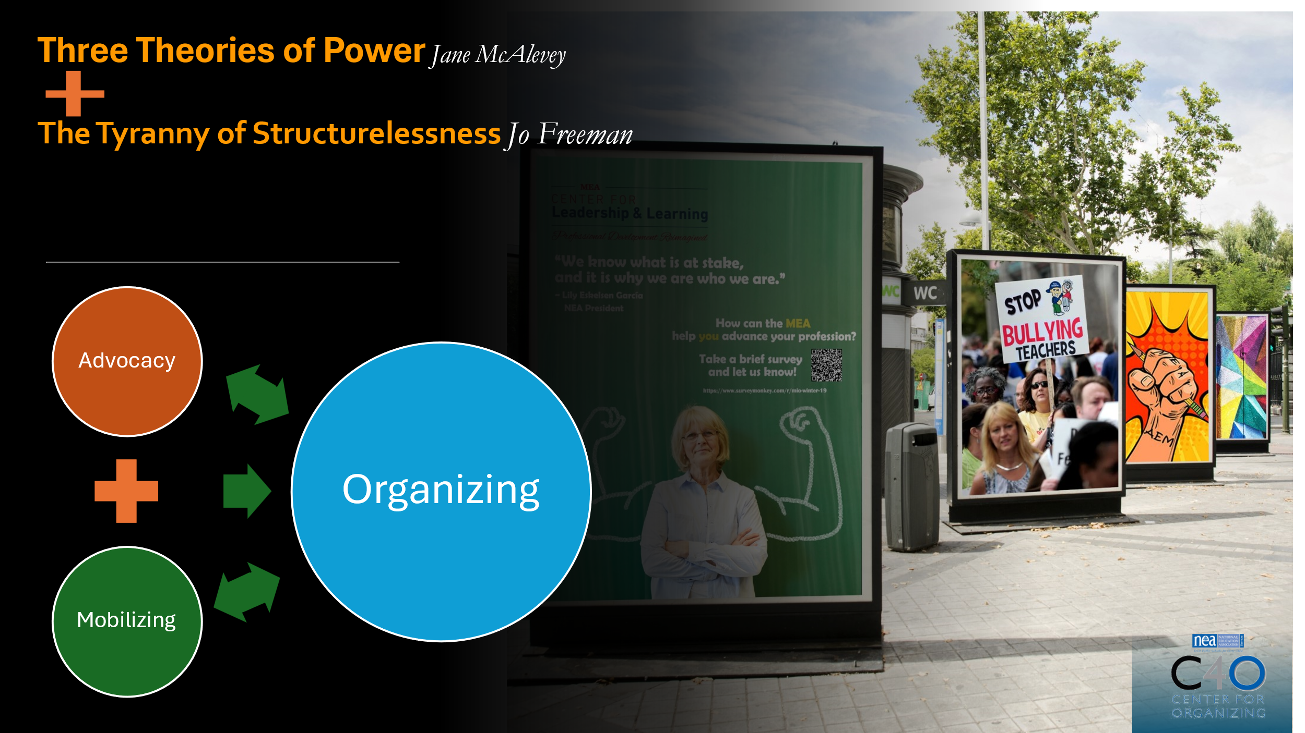  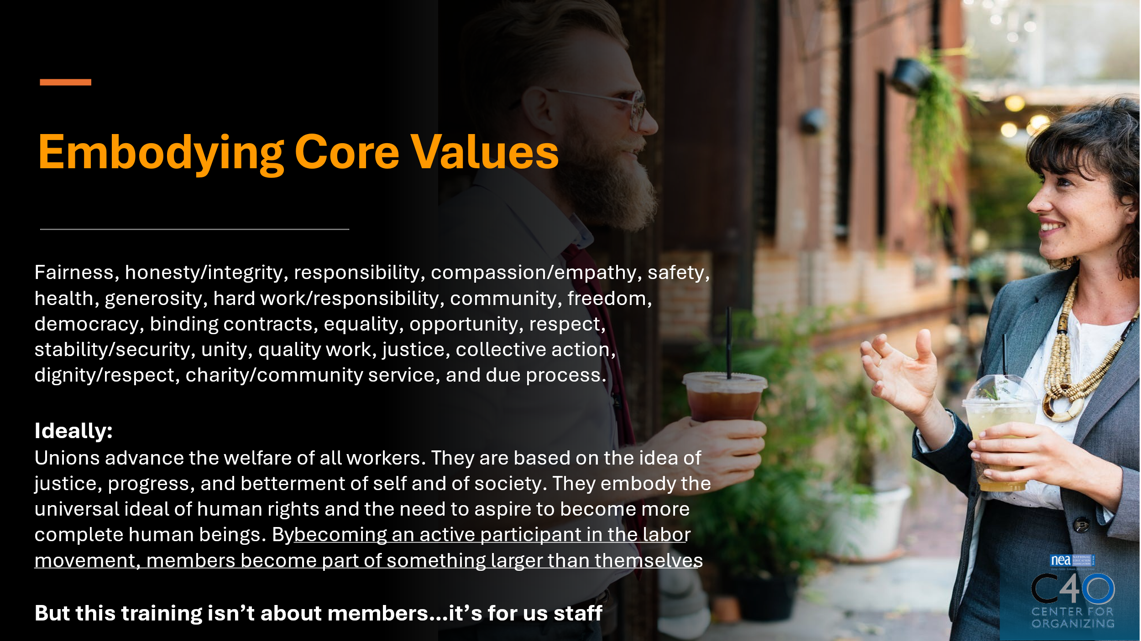  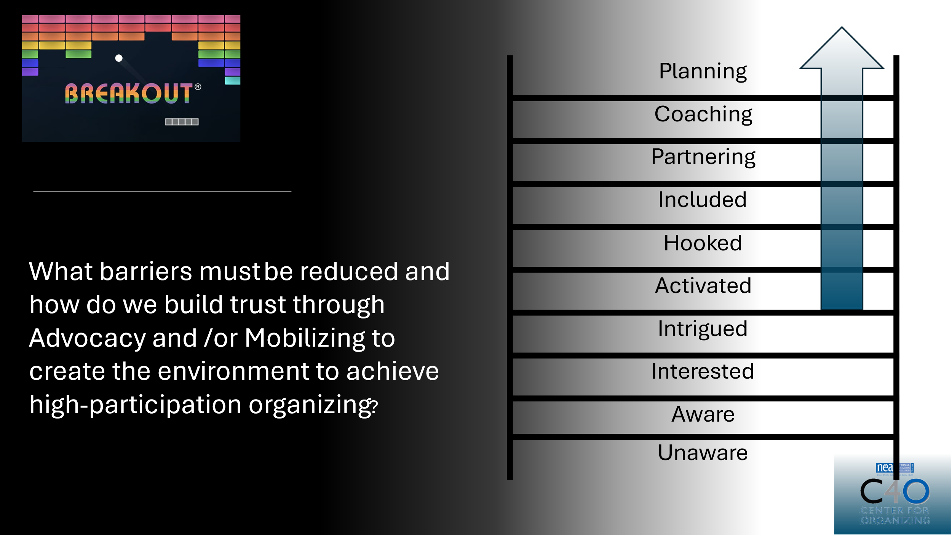 |  |  |  | Chad--3 The Staff Perspective Matters - THEORIES OF POWER-30 min (2:40-3:10 pm)  - 10 min to front-load  - 10 min for breakout  - 10 min to report back  Slides 7-12: 10 min for front loading (2:40-2:50 pm)  Slide 7: Three Theories of Power  Advocates are those who have the privilege to advocate.  Mobilizers- not as connected  Organizers- Leaders who are trusted and respected.  Slide 13: CORE VALUES  Wanted to ground us in this before we move onto semantics and how we use words to communicate our values.  Take a second to soak these in.  Slide 14: What happens...  Slide 15: Ladder  Most of our asks do not get us past the first 4 hooks. Page 35 of the handouts.  Harry Hans- how do organizations build organizers.  We get who we invite.  In a minute go to breakout rooms- page 35. We will give you 4 classic invitations to the union; I have used all these in my work.  You ask in your group- how far does the invite take you up this ladder?  How could you adjust your invitation to move up the ladder?  Example: Chris Smalls, we will not be doing this for you, he asked people to join him in the struggle and to do the work. All the organizers invited people into the work and to partner.  Think about your invitation, if you say pizza party, that may not be worth your time. But the issue they care about, people will find time to address it. Is the issue the right one to invite them in on? A consideration.  Where do you end up with your "ask" "invitation" from your state/local?  Slide 15: 10 min for Breakout Groups (2:50-3:00 pm)  Think about... Picture in your head the educator that would be most attracted to this type of invite?  Only open 4 rooms this time.  1 and 5, 2 and 6, 3 and 7, 4 and 8.  Break them out and have them answer the question that relates to their room number.  Slide 16: 10 min for Scenario/Ladder Report Out (3:00-3:10 pm)  Pass off to Dawn
3:10-3:30 pm  Dawn: Slides 17-20    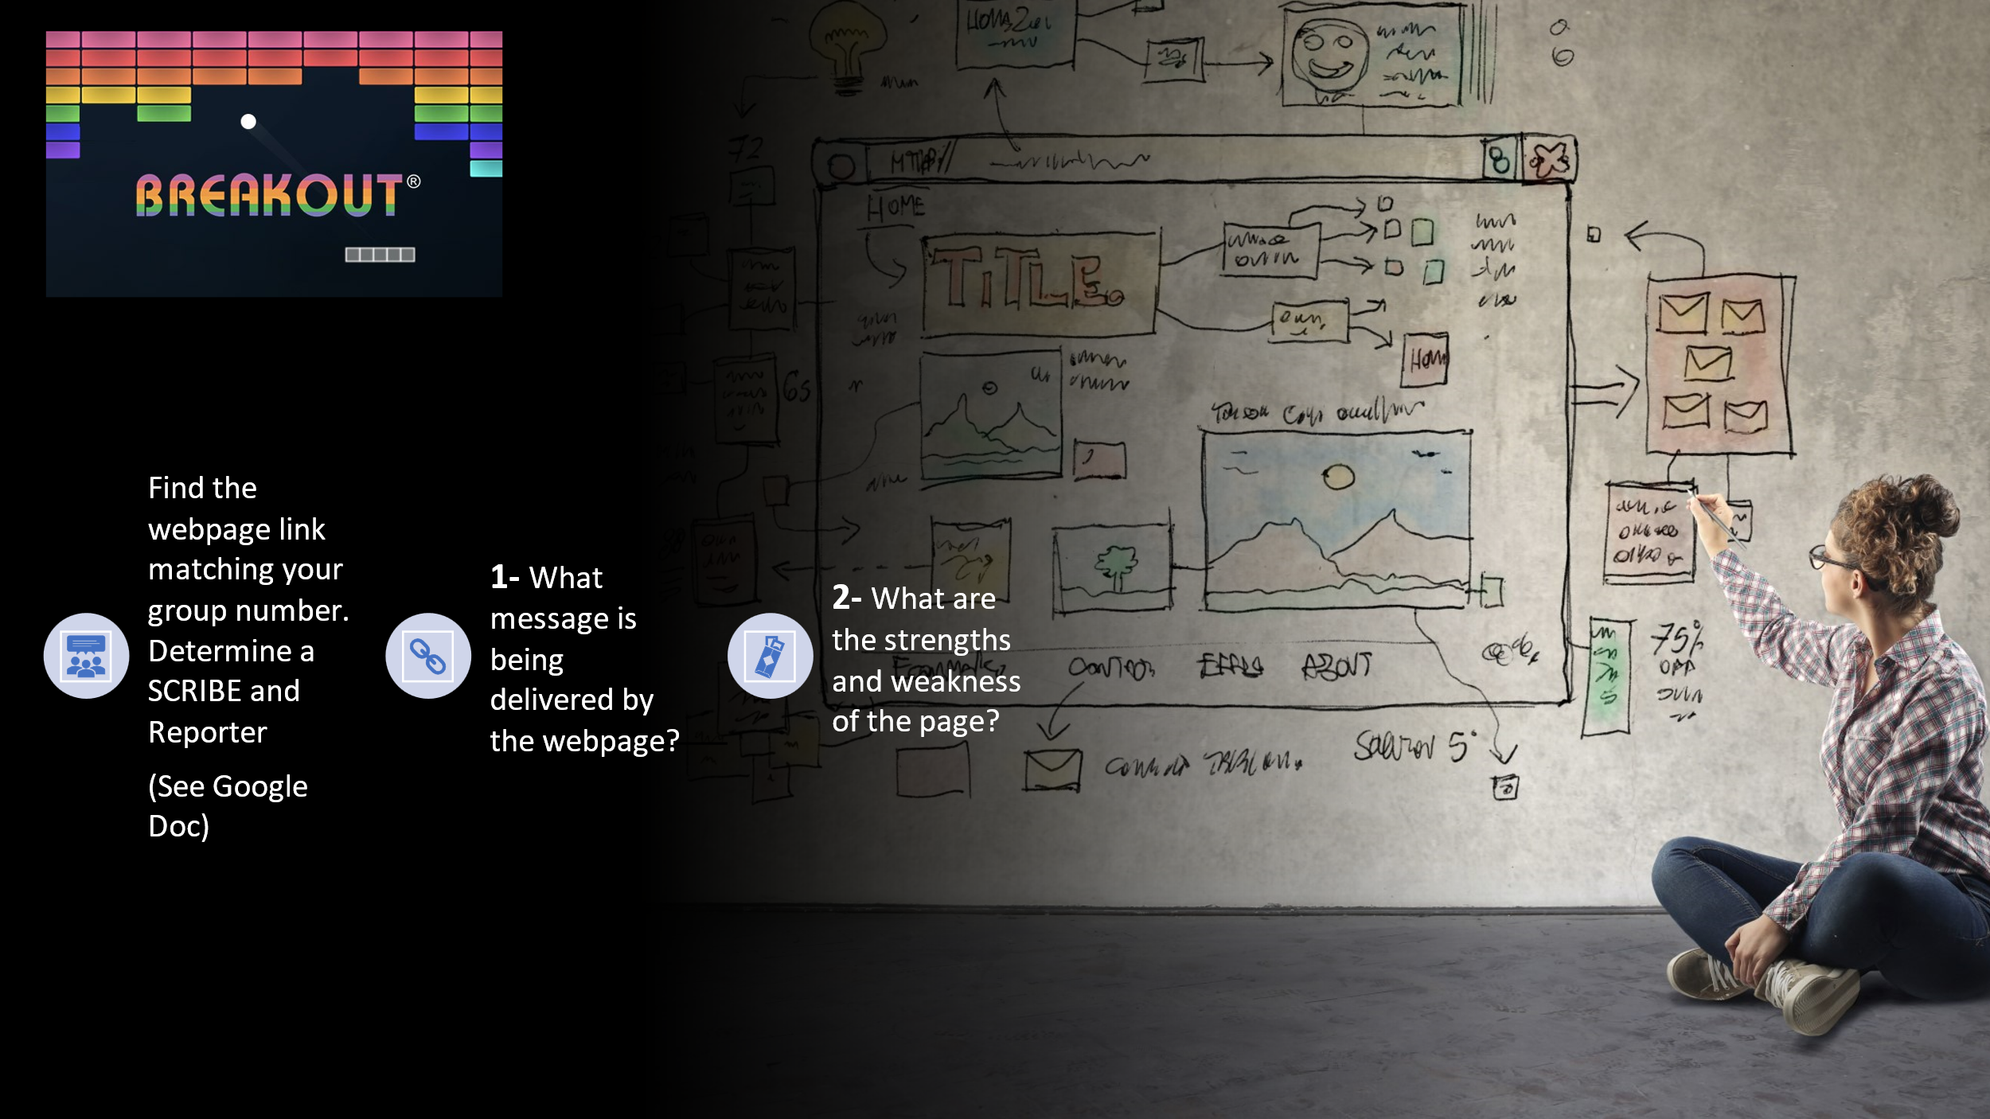  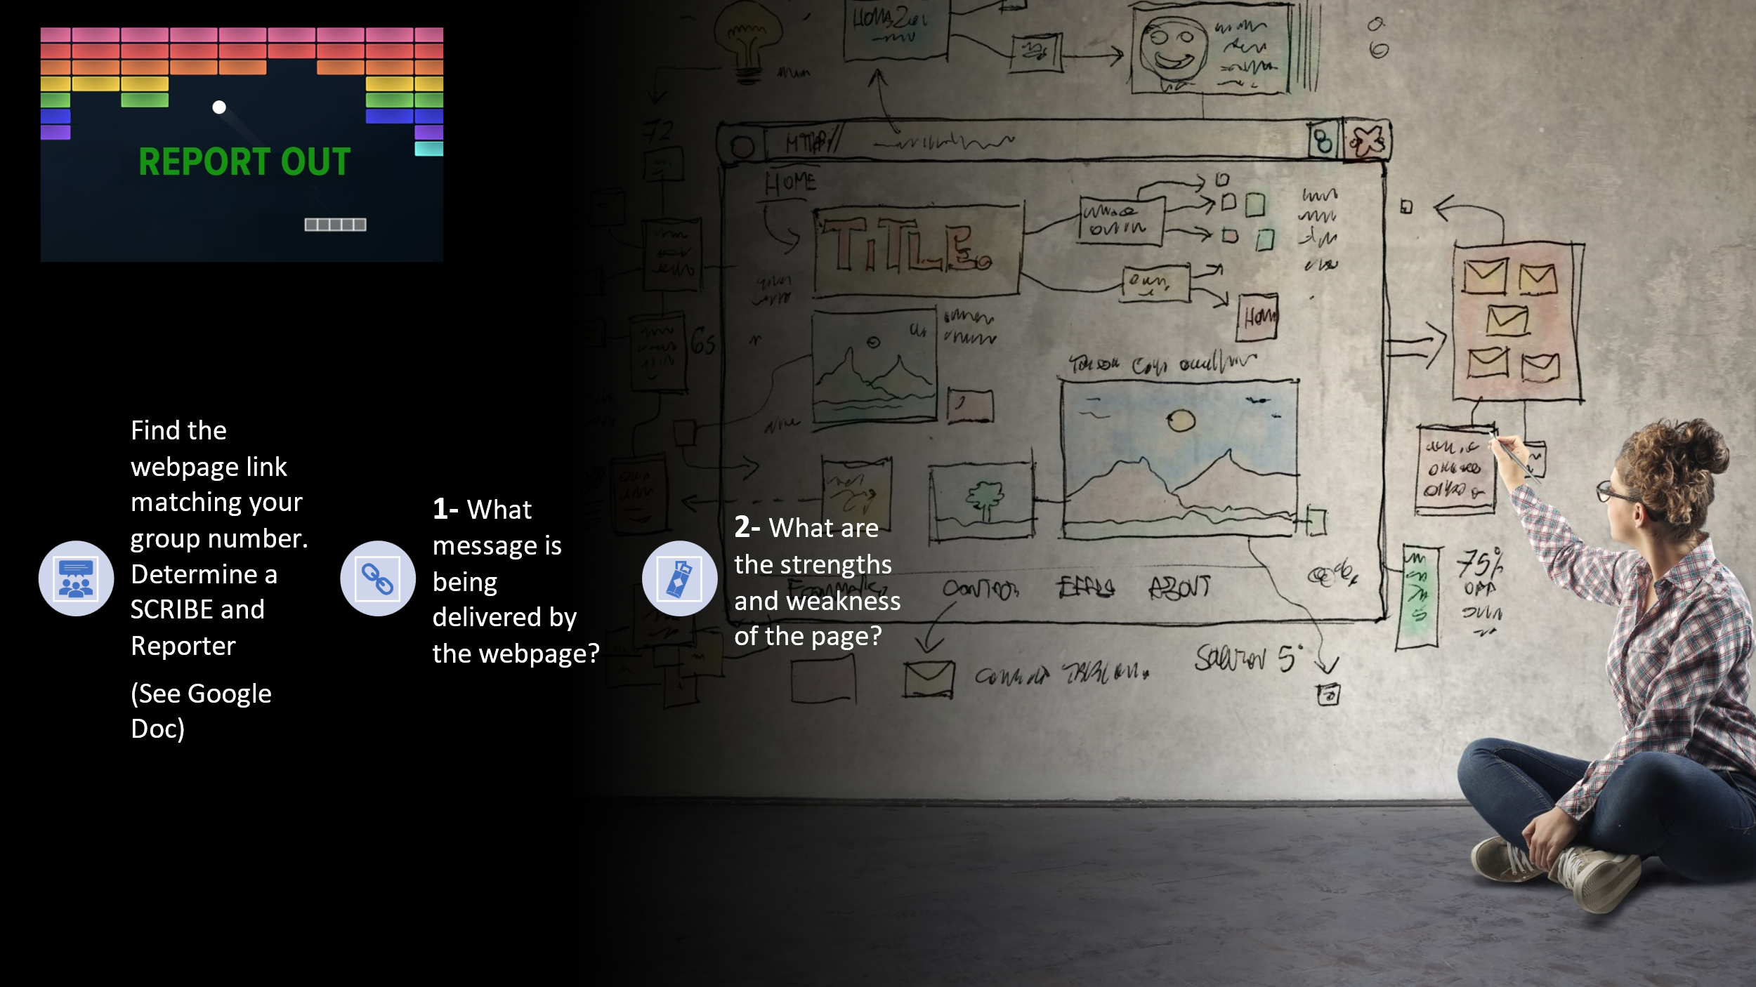  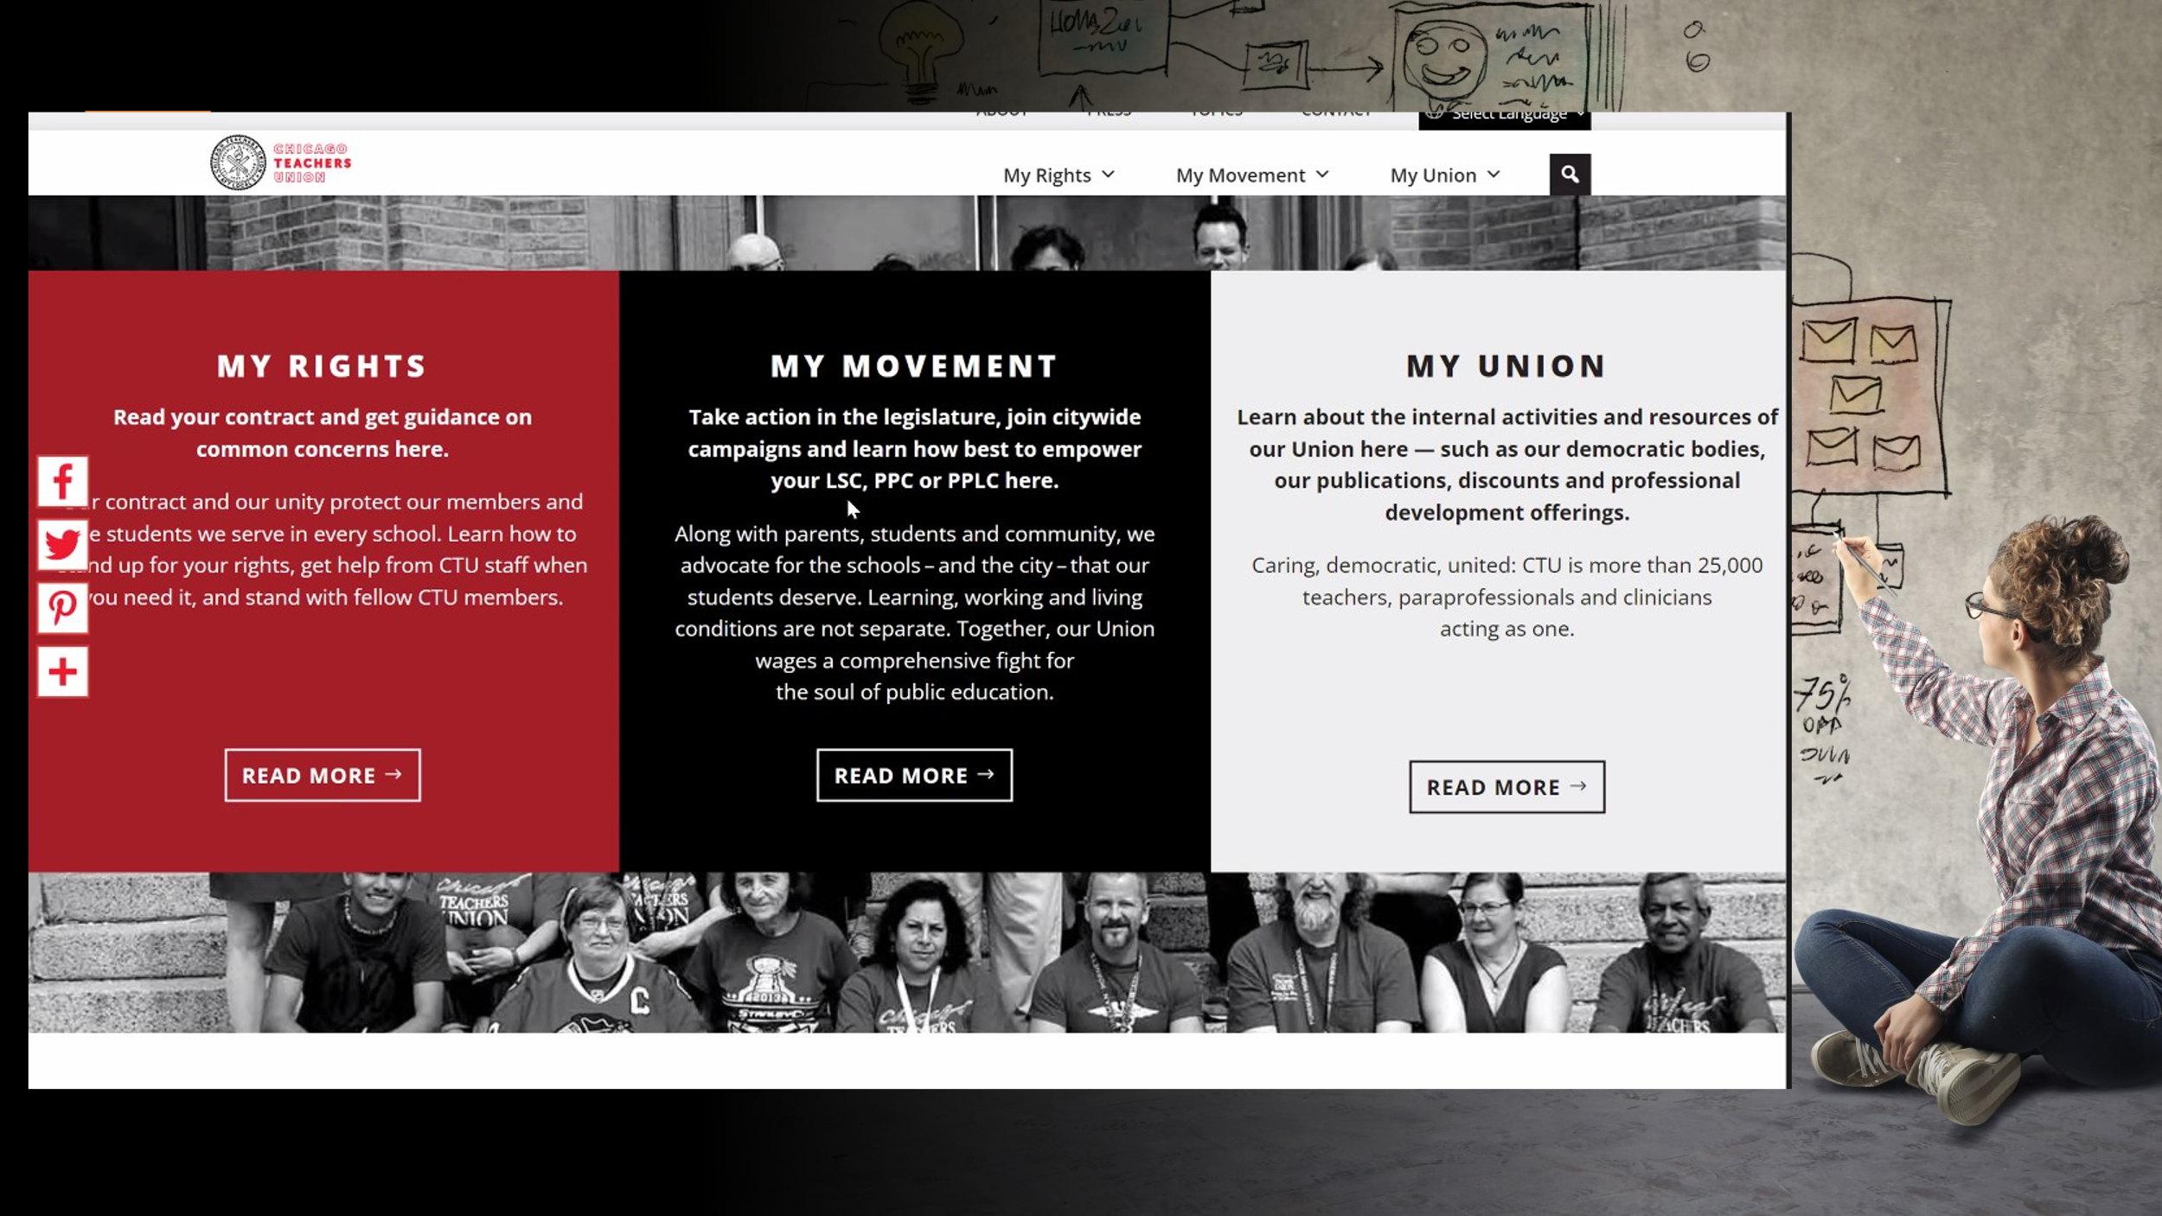  3:30-3:40 pm  Dawn: Slides 21-23  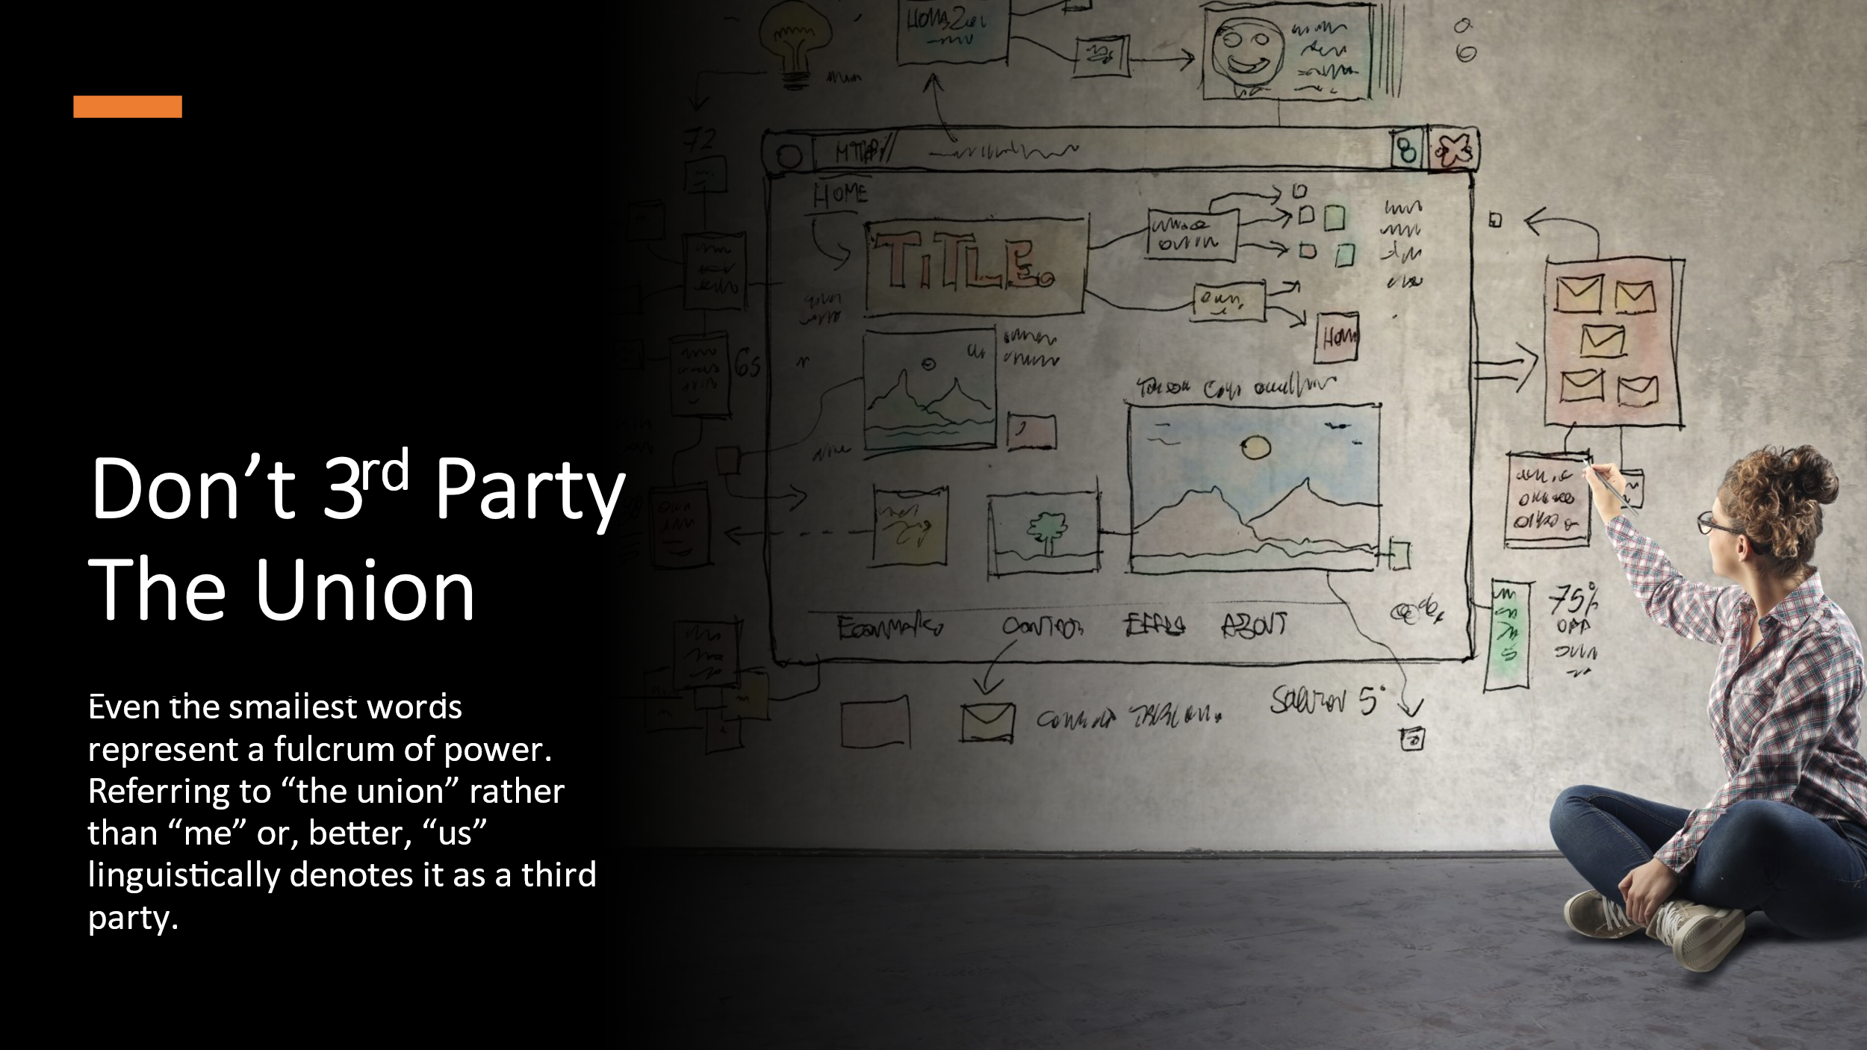  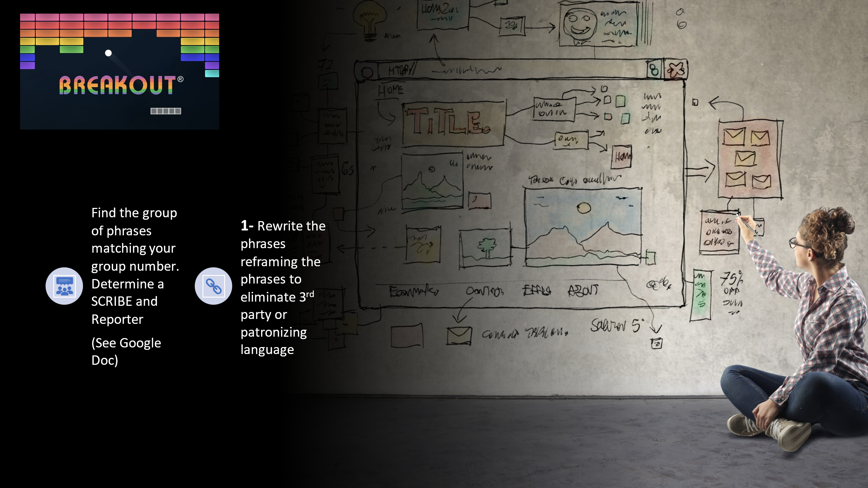  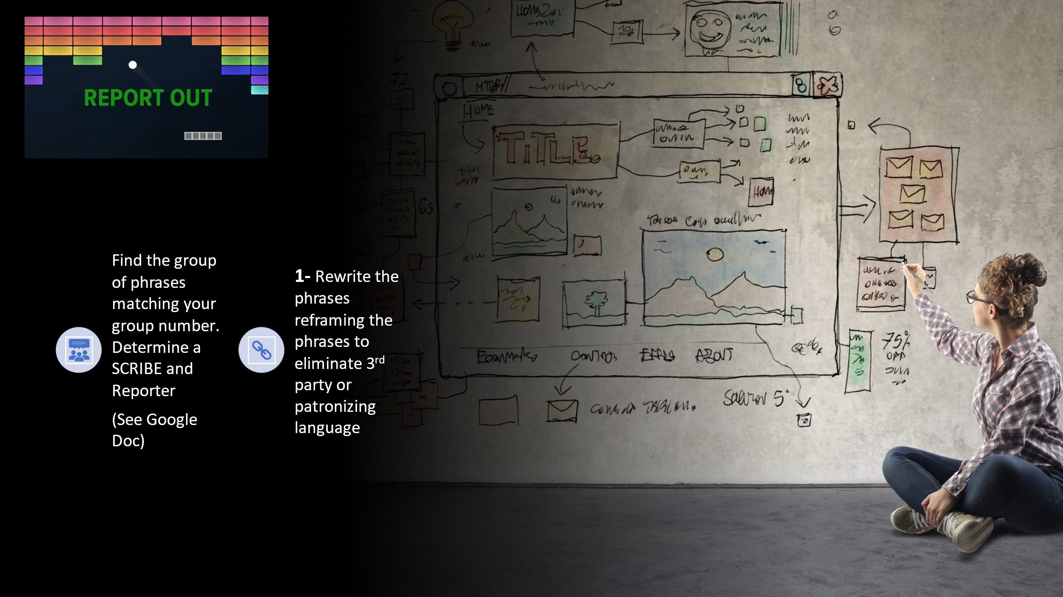 |  |  | https://docs.google.com/document/d/1jaqXw_WfguvZ_Ve4q7yqJREU6lsWiySMr4hXCMnslzE/edit?usp=sharing | Dawn: The Message Matters - 20 minutes for Slides 17-20 (3:10-30 pm)  - 5 min to explain  - 5 for website review  - 10 for sharing out  Slide 17: Breakout Rooms for Website Analysis (5 min)  1. Explain how the breakout rooms are going to work and how to scroll to correct example that matches Breakout room # on the Google Form.  2. Ensure each group has both a scribe and a reporter  Slide 18: Breakout Room Assignments (5 min)  Cut and paste the Union Website Analysis Googe Doc into CHAT:  https://docs.google.com/document/d/1LSgUUHXmGLcH6kf9xwrmpRoJVf7TnxMXASlgUtY6A4E/edit?usp=sharing  Slide 19: Report Out (10 min)  Each breakout room will report out for up to 2 minutes each for total of 10 min.  Slide 20: CHICAGO TEACHERS UNION Webpage  We saw this as a very strong example. Is there anything that stands out to you?  A standout for us: Intentional. READ your contract. My union. Not that we will defend, but that they actively take part in their own agency and desire for their value of respect to be realized through their own action.  This is a bargaining state, but we put in quite a few examples in your pre-reading about Amazon because they do not have a history or culture of bargaining and shows that they clearly communicated values (fairness/respect/safety), risk (this will not be easy, but it will be worth it), and they won (they got recognition).  Dawn: Slides 21-23 UNION SEMANTICS (10 min)  - 1 min to explain  - 5 min to complete in Google Doc  - 4 min report out  Slide 21: Don’t THIRD PARTY the Union  Oftentimes, people-including staff-” third party” the Union by referencing it in the third person. However, that creates distance and makes it easier to think of the Union in the S Model.  For this exercise, you will work in the same breakout groups as before and redo the provided sentences (common phrases) by having a scribe type your answers directly onto the Google form under your Room number.  You can’t use the following words: The union (or union at all), we, us, our, or I.  Cut and paste Semantics Google Doc into CHAT: https://docs.google.com/document/d/1Z5b5nonrtRWL1mCdiSDnFqTCnxt0bHlyfm44MKv-tKc/edit?usp=sharing  Slide 23: Report Back  Pass off to Zac
3:40-3:55 pm  Zac: Slides 24-28    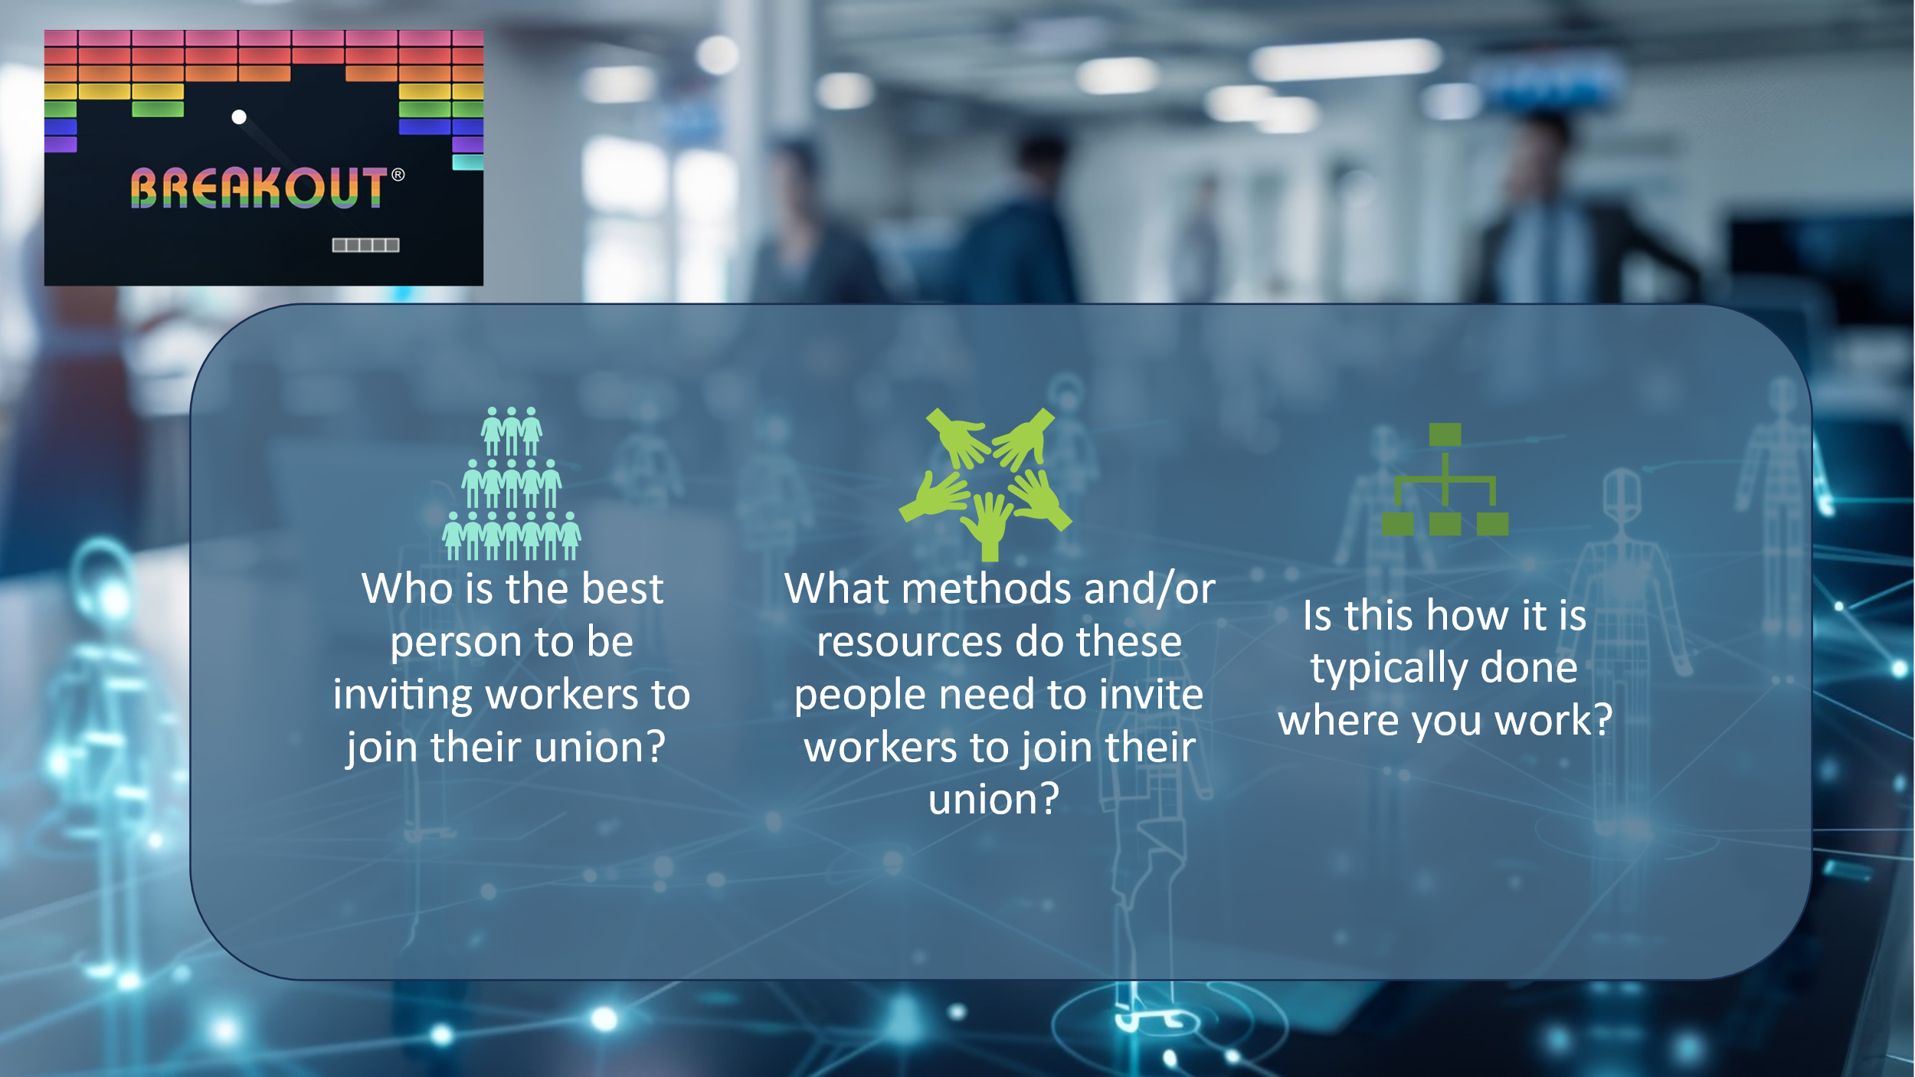  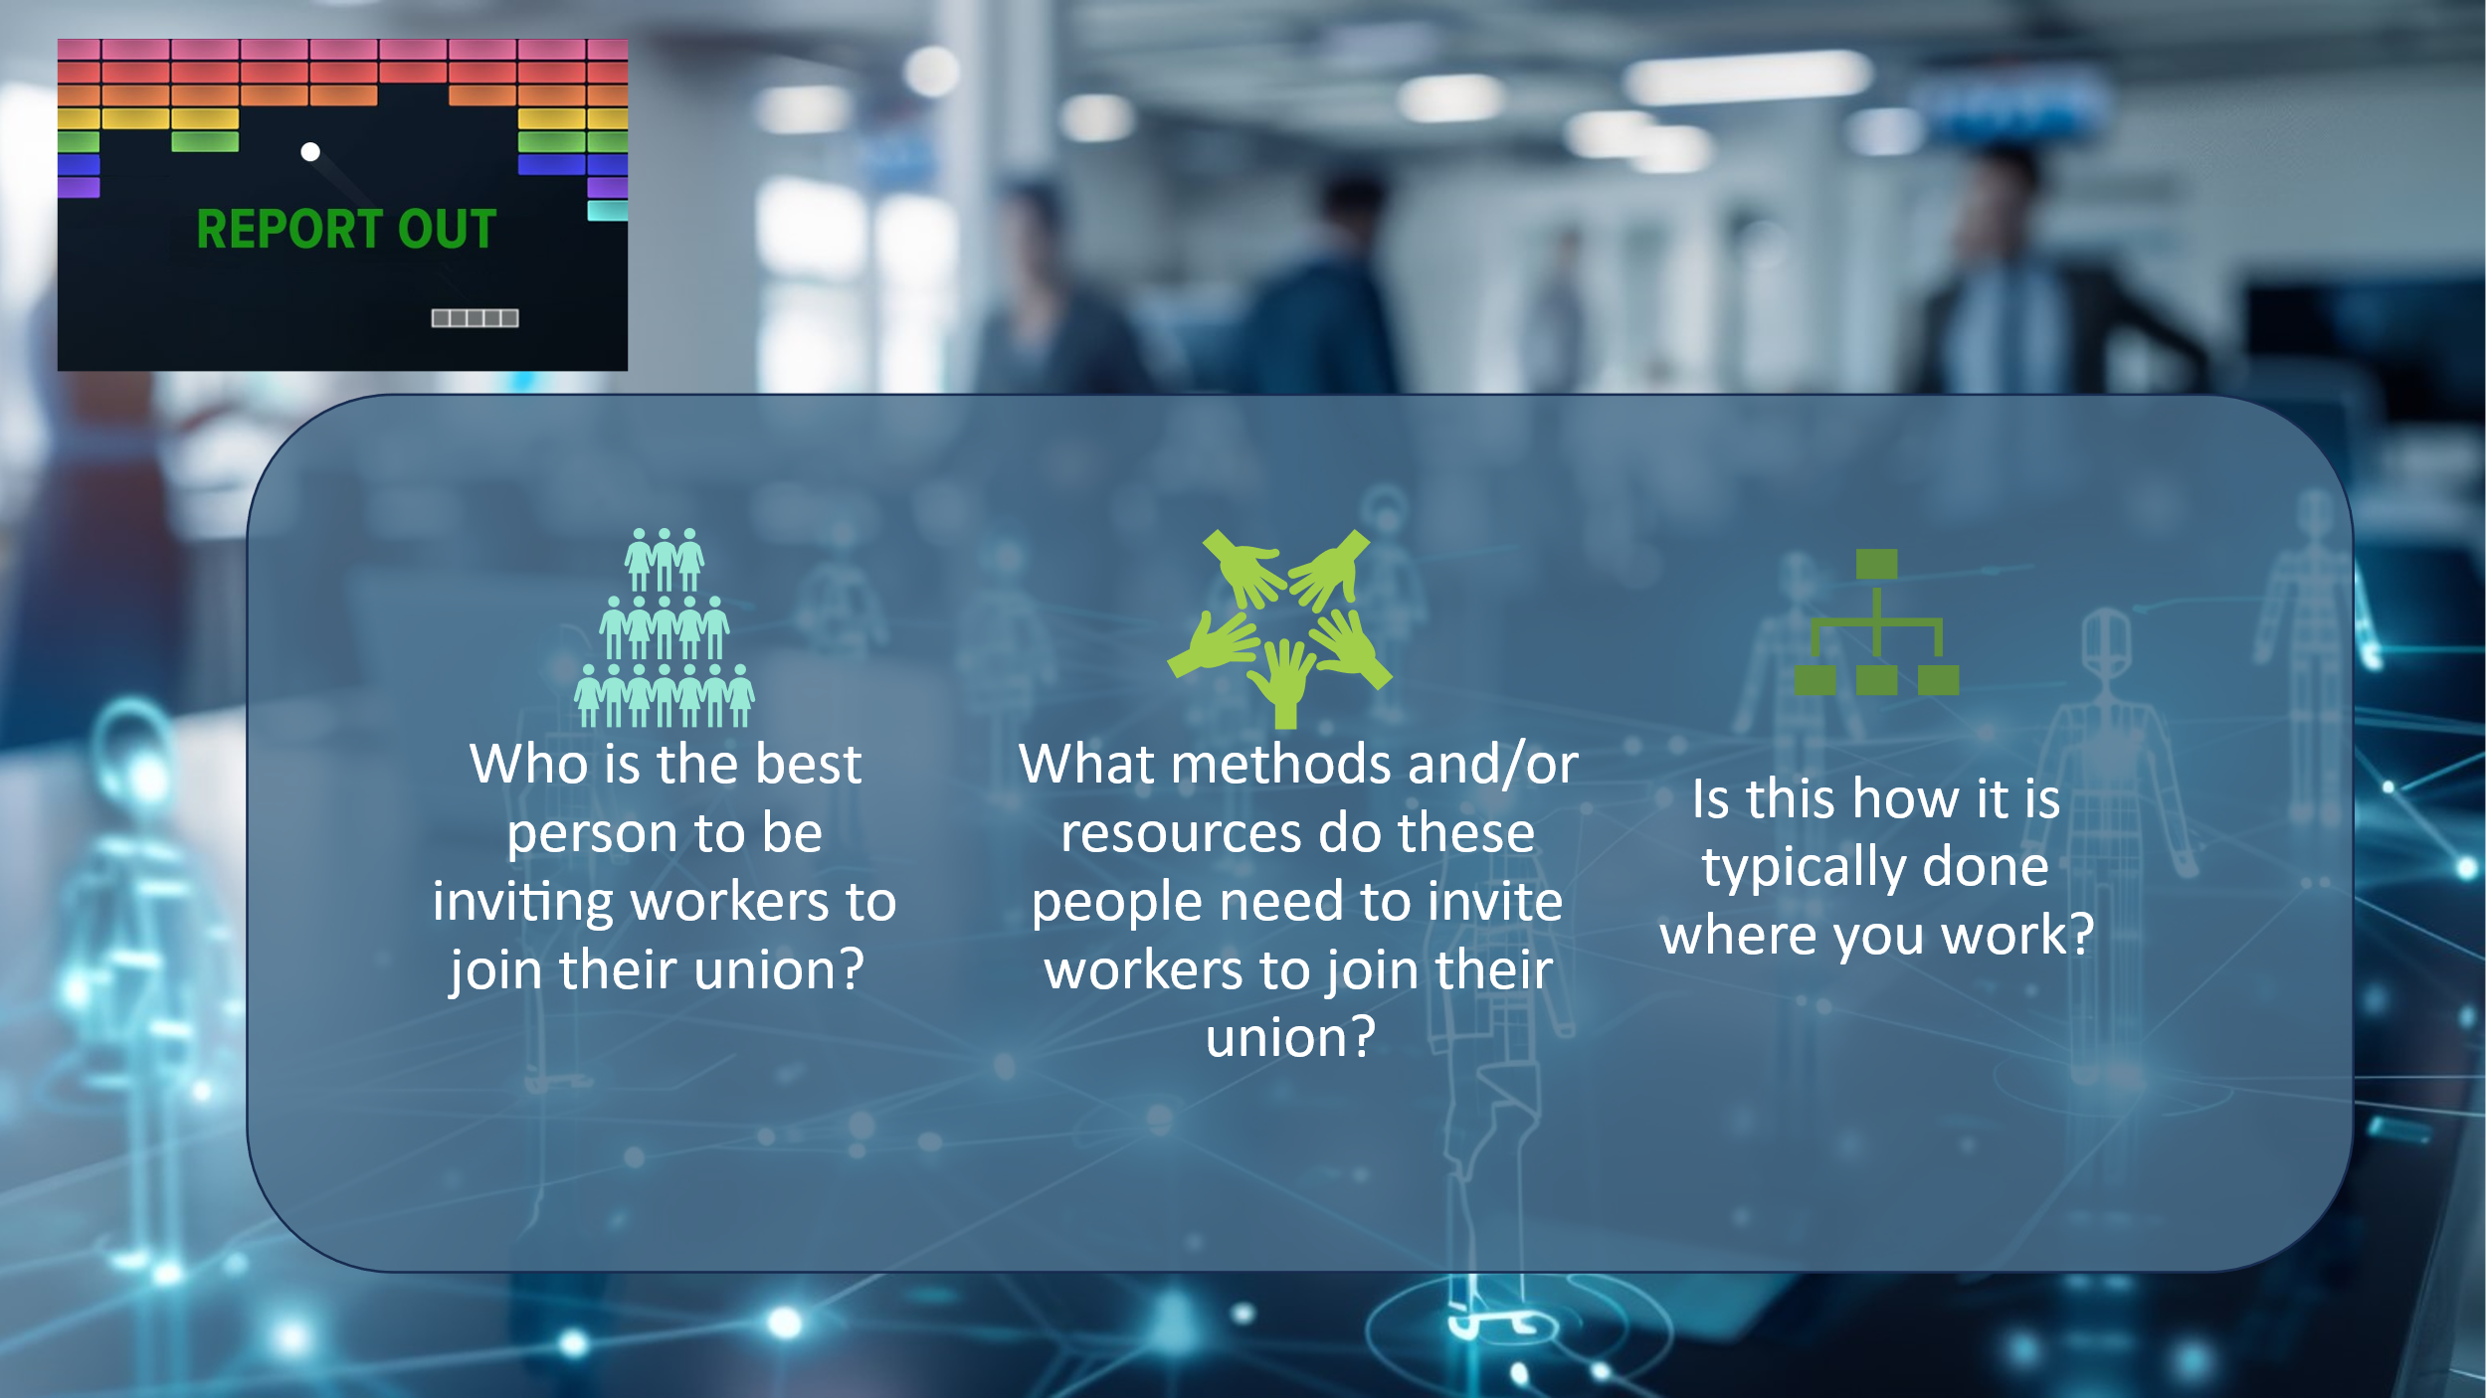    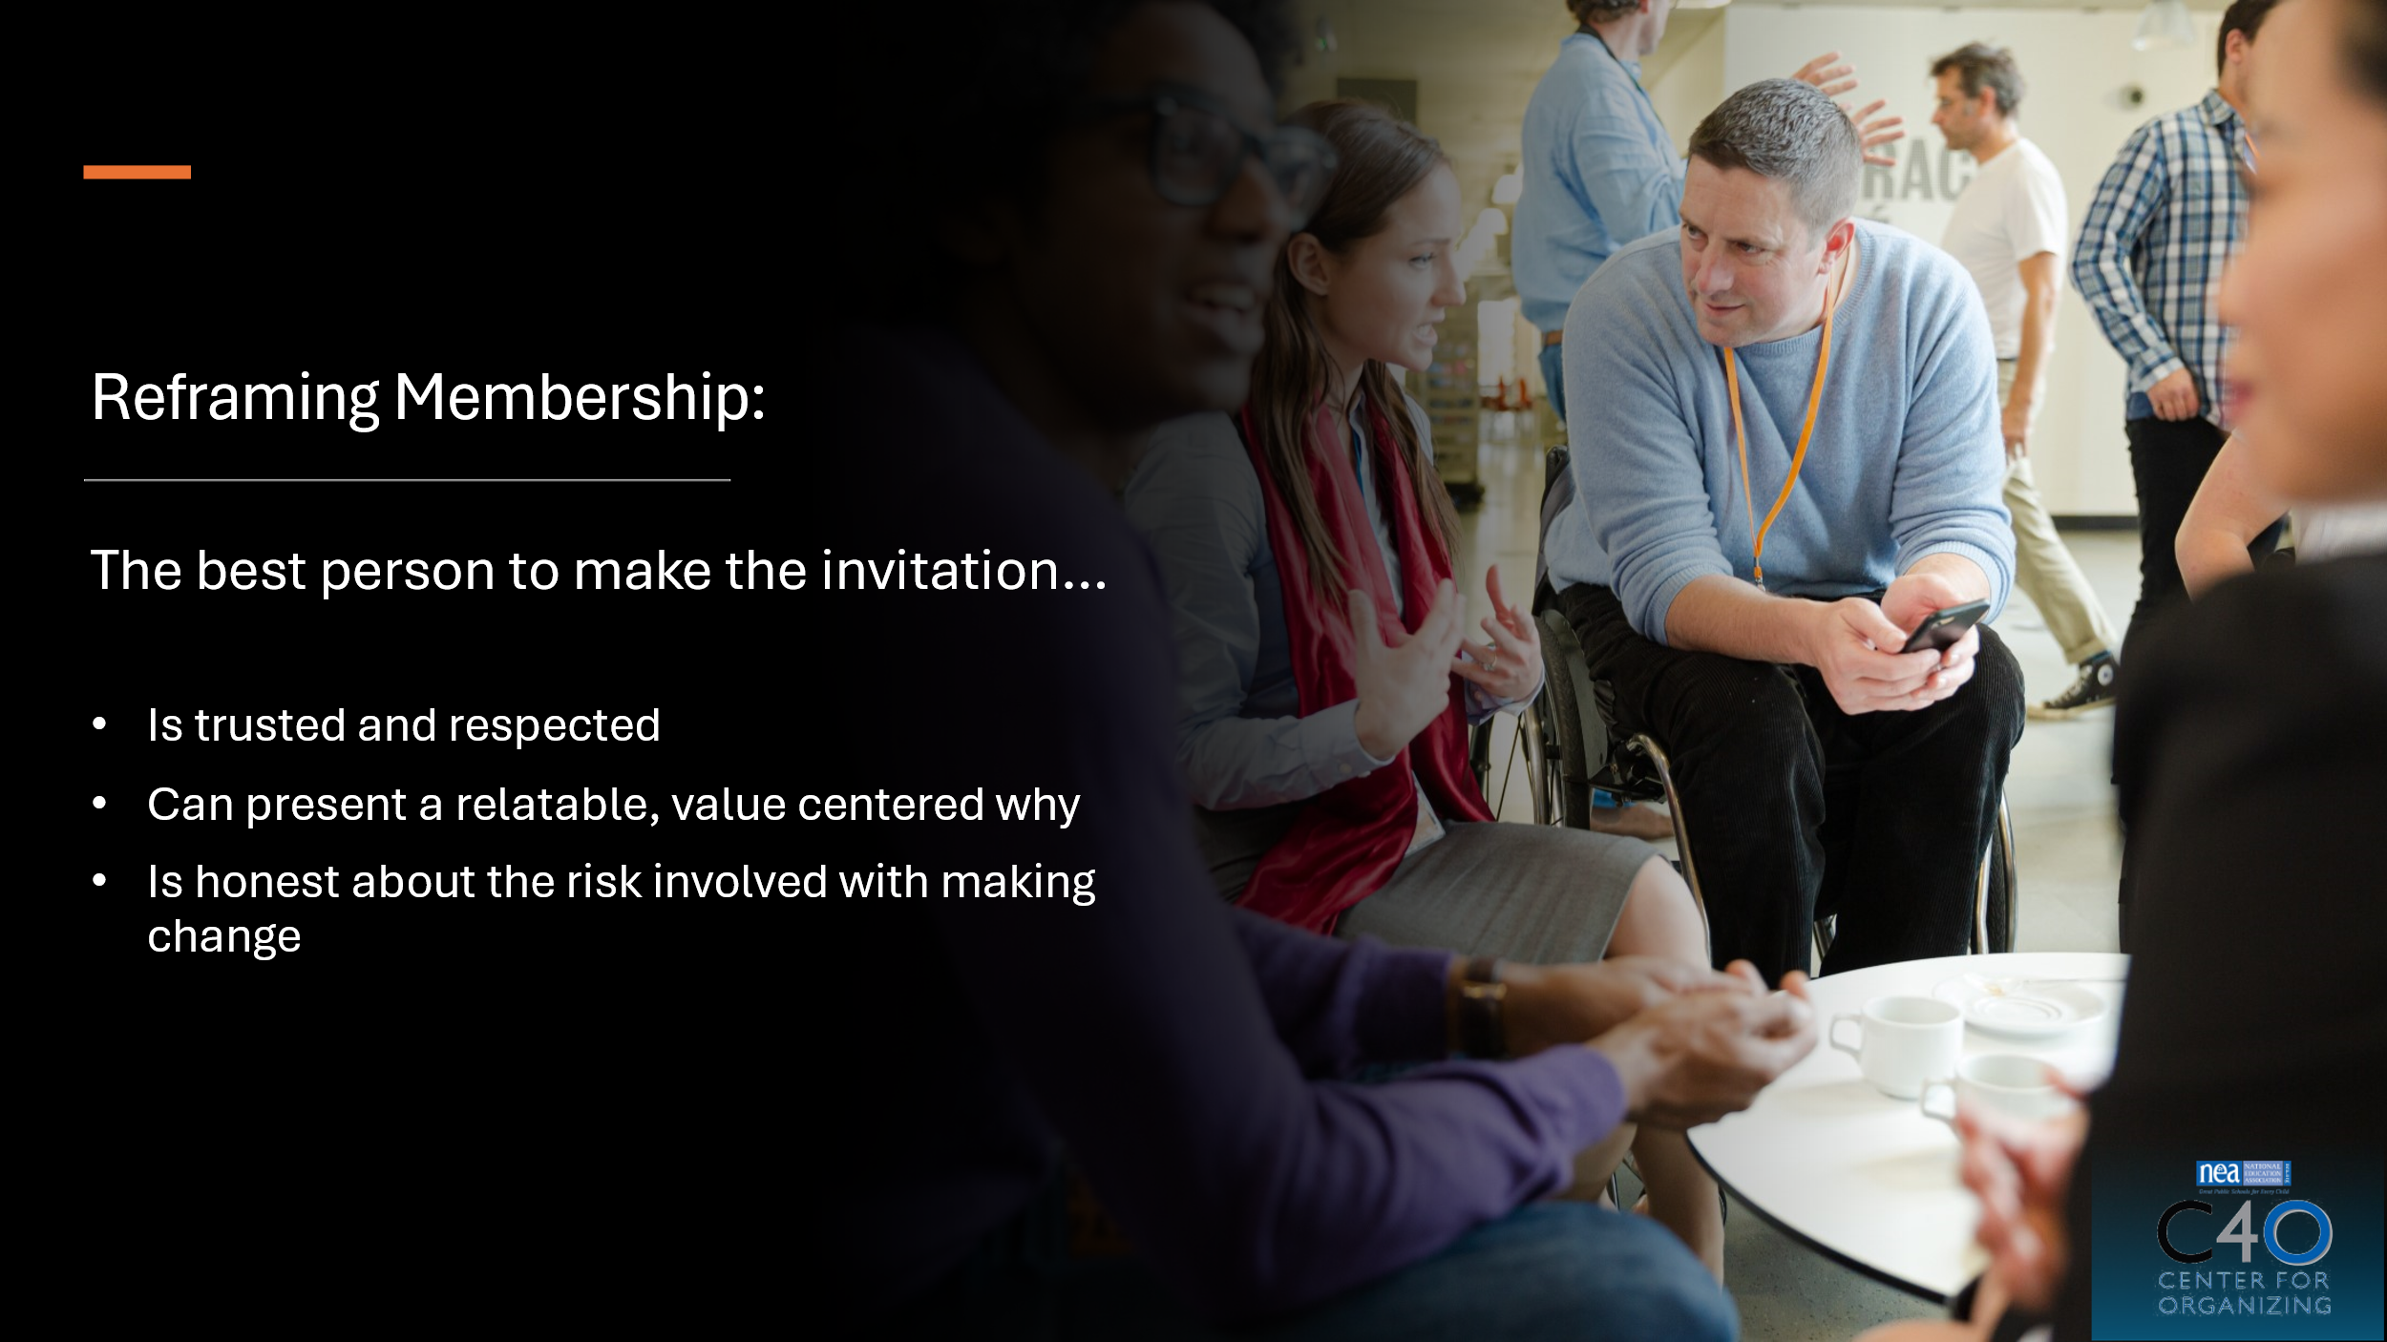 |  |  |  | Zac—The Messenger Matters (3:40-3:55 pm)  Slide 24: The Messenger Matters  Slide 25: Breakout Room Assignments  Slide 26: Report Out  Slide 27: Building Power  Slide 28: Reframing Membership—The best person...  Relationships between members are the strongest currency we have as a union. Tapping into that currency is something we cannot have as staff.  Our role is to support member leaders with this work and support their growth from services to values-based invitation that includes values, risk, and a hopeful vision or wins.
3:55-4:00 pm (5 min)  Zac: Slides 29 & 30  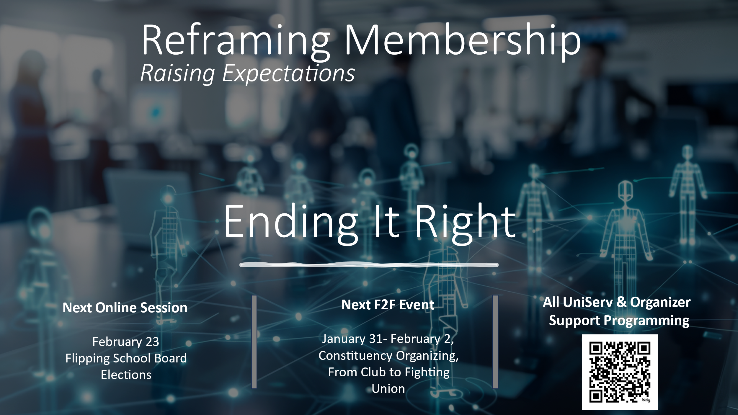  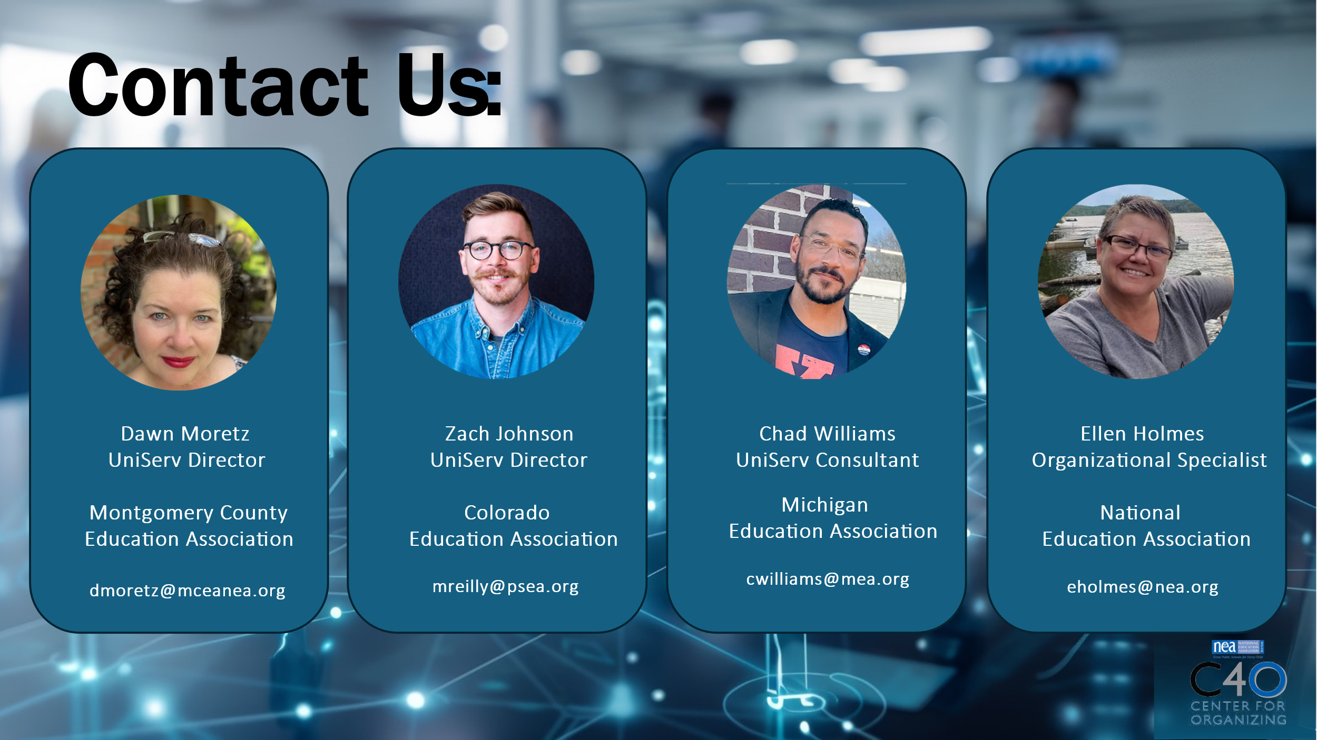 | What questions do I have? What do I need to know? |  |  | Zac—5 Minute Wrap Up (3:55-4:00 pm)  - Key Concepts  - Looking Ahead  - You will receive an evaluation email from Ellen Holmes.  Slide 29: Ending It Right  Slide 30: Contact Us! |  | Participants will get the opportunity for feedback and leave the session with what they need to know for continued engagement.
 | ADJOURN

