https://www.usatoday.com/story/opinion/voices/2022/11/26/union-workers-south-rare-changing/10751564002/

The South's racist past is harming workers today. Unions can help us build a new future.

Only 6% of workers in the South are members of a union. In my home state of North Carolina, that number is just 2.6%. We're changing that.
Cookie Bradley
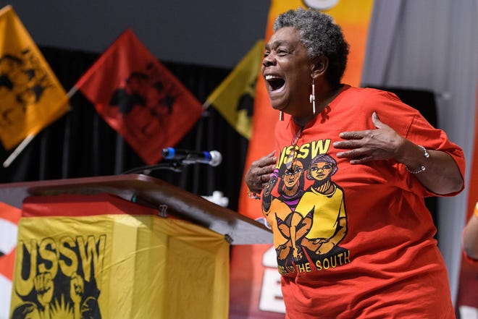
I was just 22 years old when I was faced with an impossible situation: Work two jobs or become homeless.
I was a young mom living in North Carolina, and I knew I had no other choice but to work to provide for my son. Waffle House paid me just $3.75 an hour, so after my full day shift at the restaurant, I worked late nights as a home care worker just to survive. I never qualified for food stamps or other government assistance because I was told “I made too much money.” But after 40 years holding down two jobs, I can say without a doubt that it’s never been enough.
I’ve met too many workers in home care, nursing homes, fast food and warehouses across the South who share my struggle – the wear and tear injuries on the job, the low pay, the lack of benefits, the time lost with family.
As a nursing home worker, I’ve been stretched so thin that at times I’ve had to care for 20 patients by myself, all for a job that never gave me benefits. As a fast-food worker, my manager once told me to finish my shift despite seriously injuring my back after slipping on a sheet of ice in the freezer.
No matter the job, our stories are the same. And for Black workers like me, we feel like no matter how hard we work, the system is always stacked against us.

That’s why today, hundreds of workers of every race across the South are coming together to form the Union of Southern Service Workers. We’re launching our union to fight back against systems of historic oppression and subjugation in the South and advance racial and economic justice within our communities.
Service workers:How you treat a server says more about you than anything else, especially these days

Southern workers face an uphill battle for unions
For too long, Black and brown workers across the South have been systematically excluded from labor protections, minimum wage protections and union rights by racist politicians who built and enforced Jim Crow.
As a result, the South today is the region with the lowest wages, the fewest worker protections and the lowest rate of union density throughout the United States. Only 6% of workers in the South are members of a union. In my home state of North Carolina, that number is just 2.6%.
Get the Opinion newsletter in your inbox.
What do you think? Shape your opinion with a digest of takes on current events.
Delivery: Daily
Your Email
We are stuck in a system dominated by racist preemption laws and attacks on voting rights that protect corporations at all costs. Throughout the South, corporations like McDonald’s, Starbucks and Dollar General exploit workers and our communities with low wages and too often with unsafe working conditions, while raking in record profits and retaliating against workers who dare to speak out.
Reality check on the American workforce:Time to invest in people with disabilities
Nursing shortages:Nurses are stressed out and burned out – putting your health at risk
I’ve been a member of Raise Up, the Southern branch of the Fight for $15 and a union for eight years. We’ve won victories by joining together, speaking out and taking militant action on the job against low pay, dangerous work conditions, sexual harassment and more. Yet despite these significant victories, working people in the South have not enjoyed the same gains as many other workers in other areas of the country.
For most of us, it has been almost impossible or completely impossible to form a union through the existing rules. We are building our union despite the fact that the rules are rigged against us as Southern workers because we know that there is no solution other than collective action by workers.

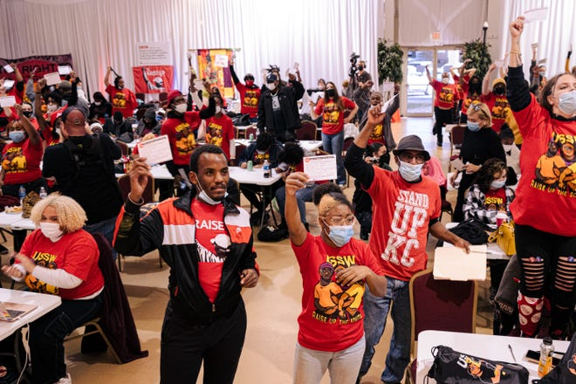
Southern workers 'have to make a little noise'
Growing up in the South during the 1960s, I saw my granddaddy fight for his civil rights, housing, health care, respect and dignity – and today, workers of all races are continuing that fight. Working people across the country have shown us there is strength in numbers, and now the Union of Southern Service Workers is bringing that power to the South.
We have to define what a union is for ourselves, not let those in power do it for us. We must build the kind of union that reflects our everyday reality and our needs, even if big corporations and politicians don’t want to acknowledge it at first. And if the rules that govern union organizing don’t work for millions of workers, we must demand a new set of rules.
The reality for service workers in the South is that we are concentrated in high turnover industries and move from job to job and industry to industry. For nearly 40 years, I’ve gone from fast food to home care to nursing homes. Countless companies across the South employ the same low-wage, high-turnover model.
The problems that we face aren’t isolated to one employer so we can’t just focus on one employer. We need a union that reflects that reality. We are building an organization that includes all low-wage service workers in industries like fast food, care and retail. We are building a union along these lines because this is the most effective way to express our power.
United with the Union of Southern Service Workers, workers will become what anti-democratic politicians and union-busting corporations fear most: a multiracial, cross-sector movement committed to fighting for living wages, fair working conditions and a voice on the job through a union. We won’t let politicians or corporations tell us any longer that we can’t have a voice on the job, because our voices have never been louder.
We’ll take our marching orders from the late Rep. John Lewis, who joined a Fight for $15 strike line in Atlanta in 2013, grabbed the bullhorn and told workers to “use your marching feet.”
“Sometimes you have to make a little noise,” he said. “Sometimes you have to find a way to make a way out of no way. Sometimes you have to find a way to get in the way."
Cookie Bradley, 63, works in fast food and home care in Durham, North Carolina, and is a founding member of the Union of Southern Service Workers.

