Remote Facilitator Agenda: Promoting Environmental and Occupational Health and Safety
 |  |  |  | Objectives:
Segment Position / Segment Minutes | Cues | Resources | Instructions, Activity and Debrief (Facilitators) |  | Outcomes
 |  | Chat links or app URL’s | What are you saying, what are they doing, what questions will you use to guide learning and make clear the important points  Include an estimate for how long each section of the learning will take |  | As a result of this section of learning, what will participants know or be able to do?
-0:10 / 10 min  Chad | 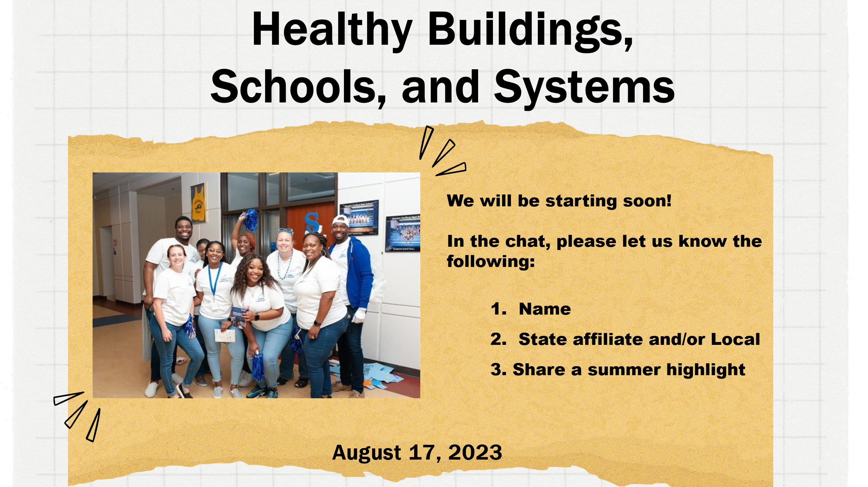 |  | - 10 minutes prior to webinar start time, the zoom is opened for participants to enter.  - Music should be playing. Session host welcomes participants as they enter and encourages them to begin engaging in the chat by responding to the welcome slide prompts.  - The host engages in direct banter with participants based on their responses. |  | Outcome: Participants are engaged and ready to participate  Rationale: Rather than a cold start to a webinar, the time prior to formal start-time mimics in-person session entry by creating opportunity to talk and share among the participants – set the vibe. When the content starts, participants are engaged in the space.
+0:00 / 3 min  Chad | 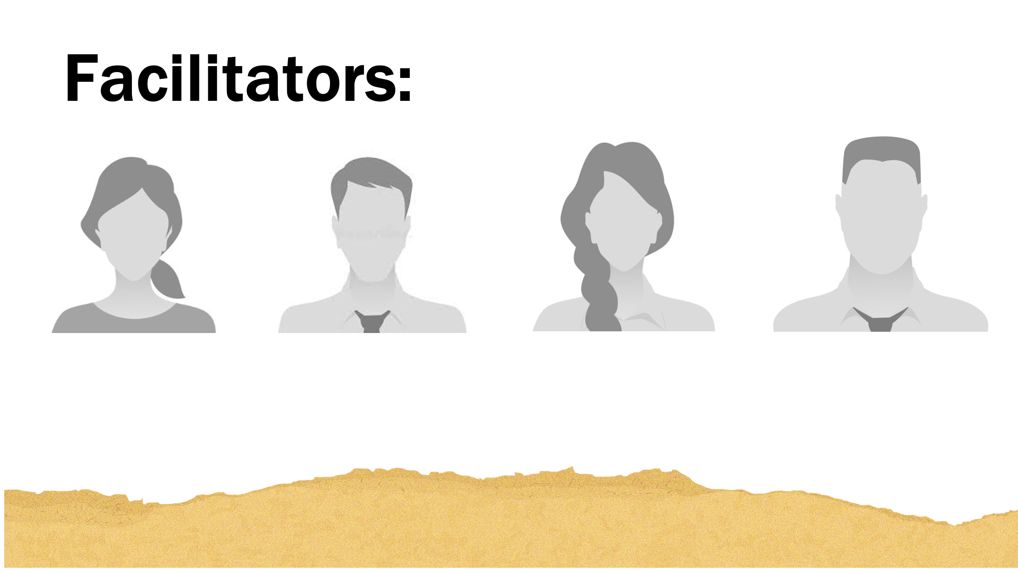  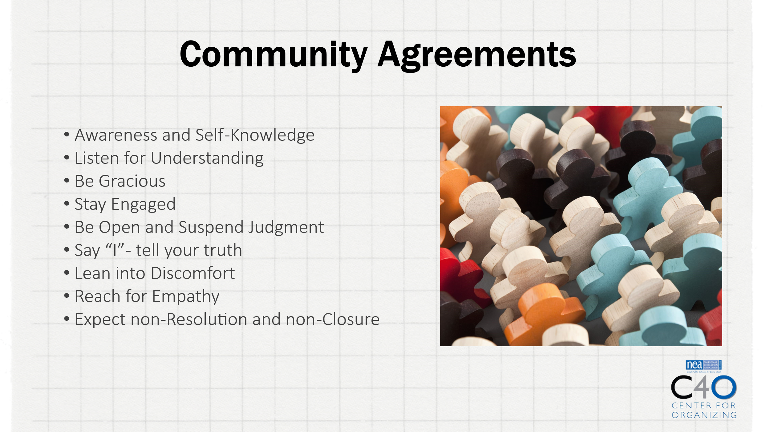  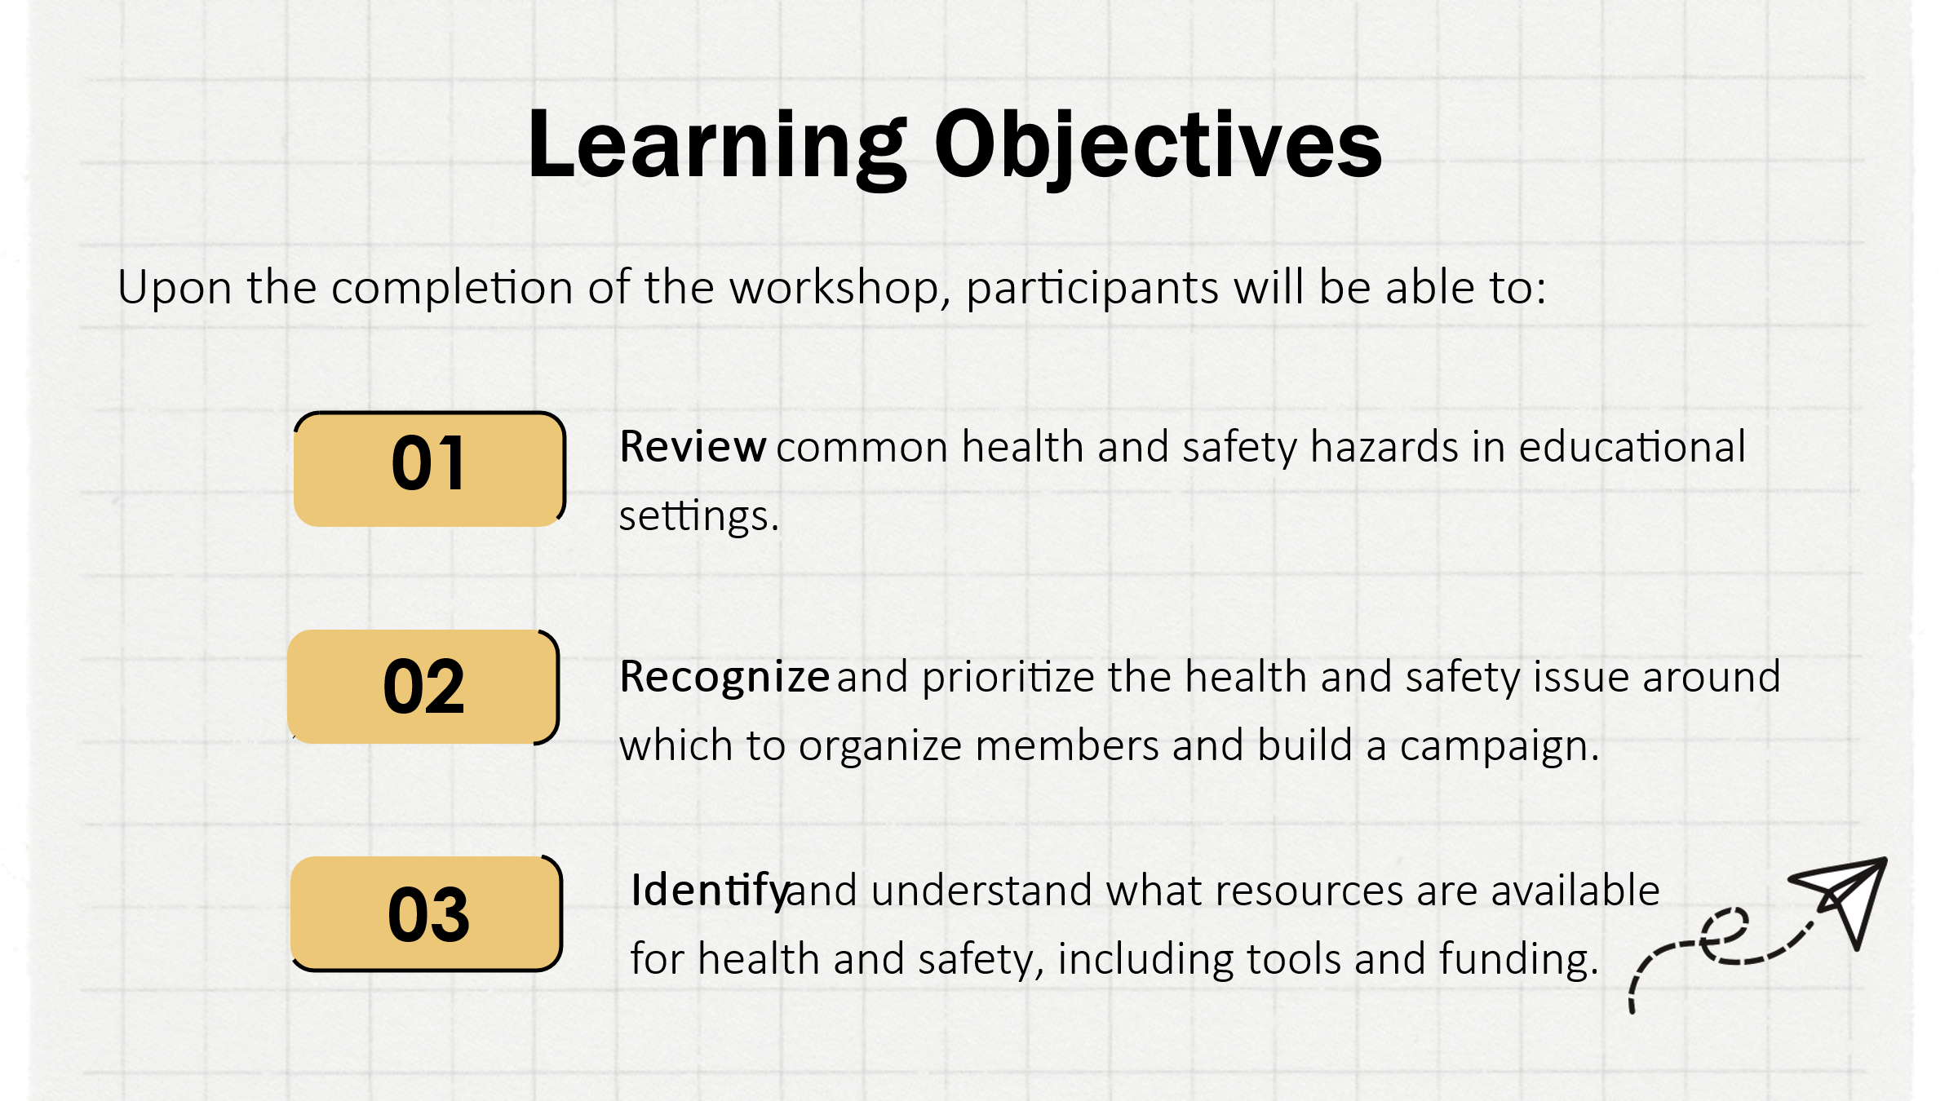 | [insert Slide deck URL] | - Session host formally welcomes participants, introduces the facilitators, and reviews the session objectives.  - A URL for the slide deck should be put into the chat for participants who wish to follow along with the actual presentation. |  | Outcome: participants are prepared to engage the content in their preferred style  Rationale: Some participants appreciate being able to look ahead, and some may have to leave the session early, so having the presentation upfront address those issues.
+0:03 / 8 min  Eunice | 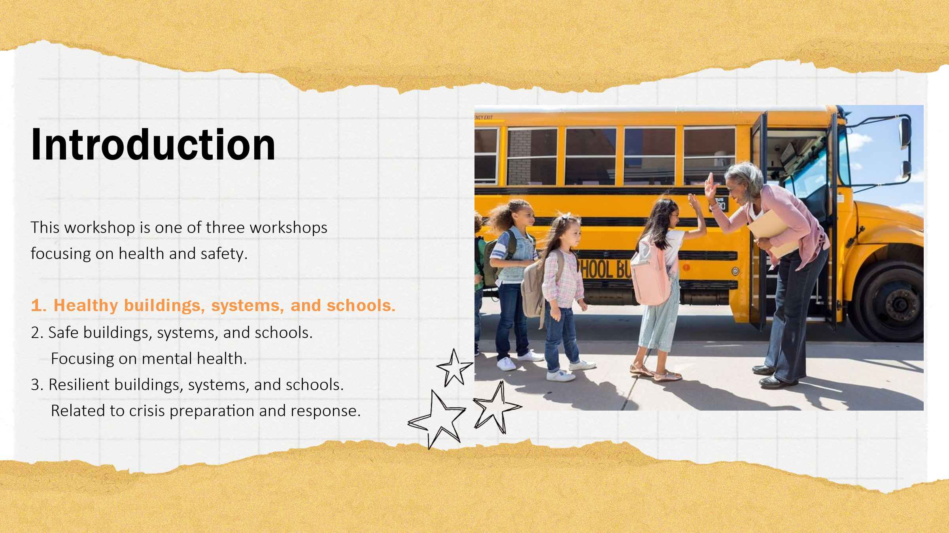  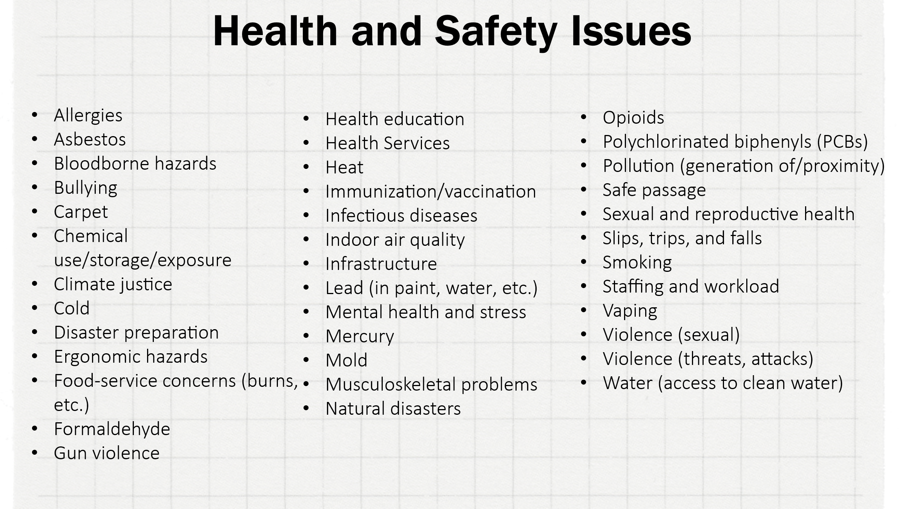  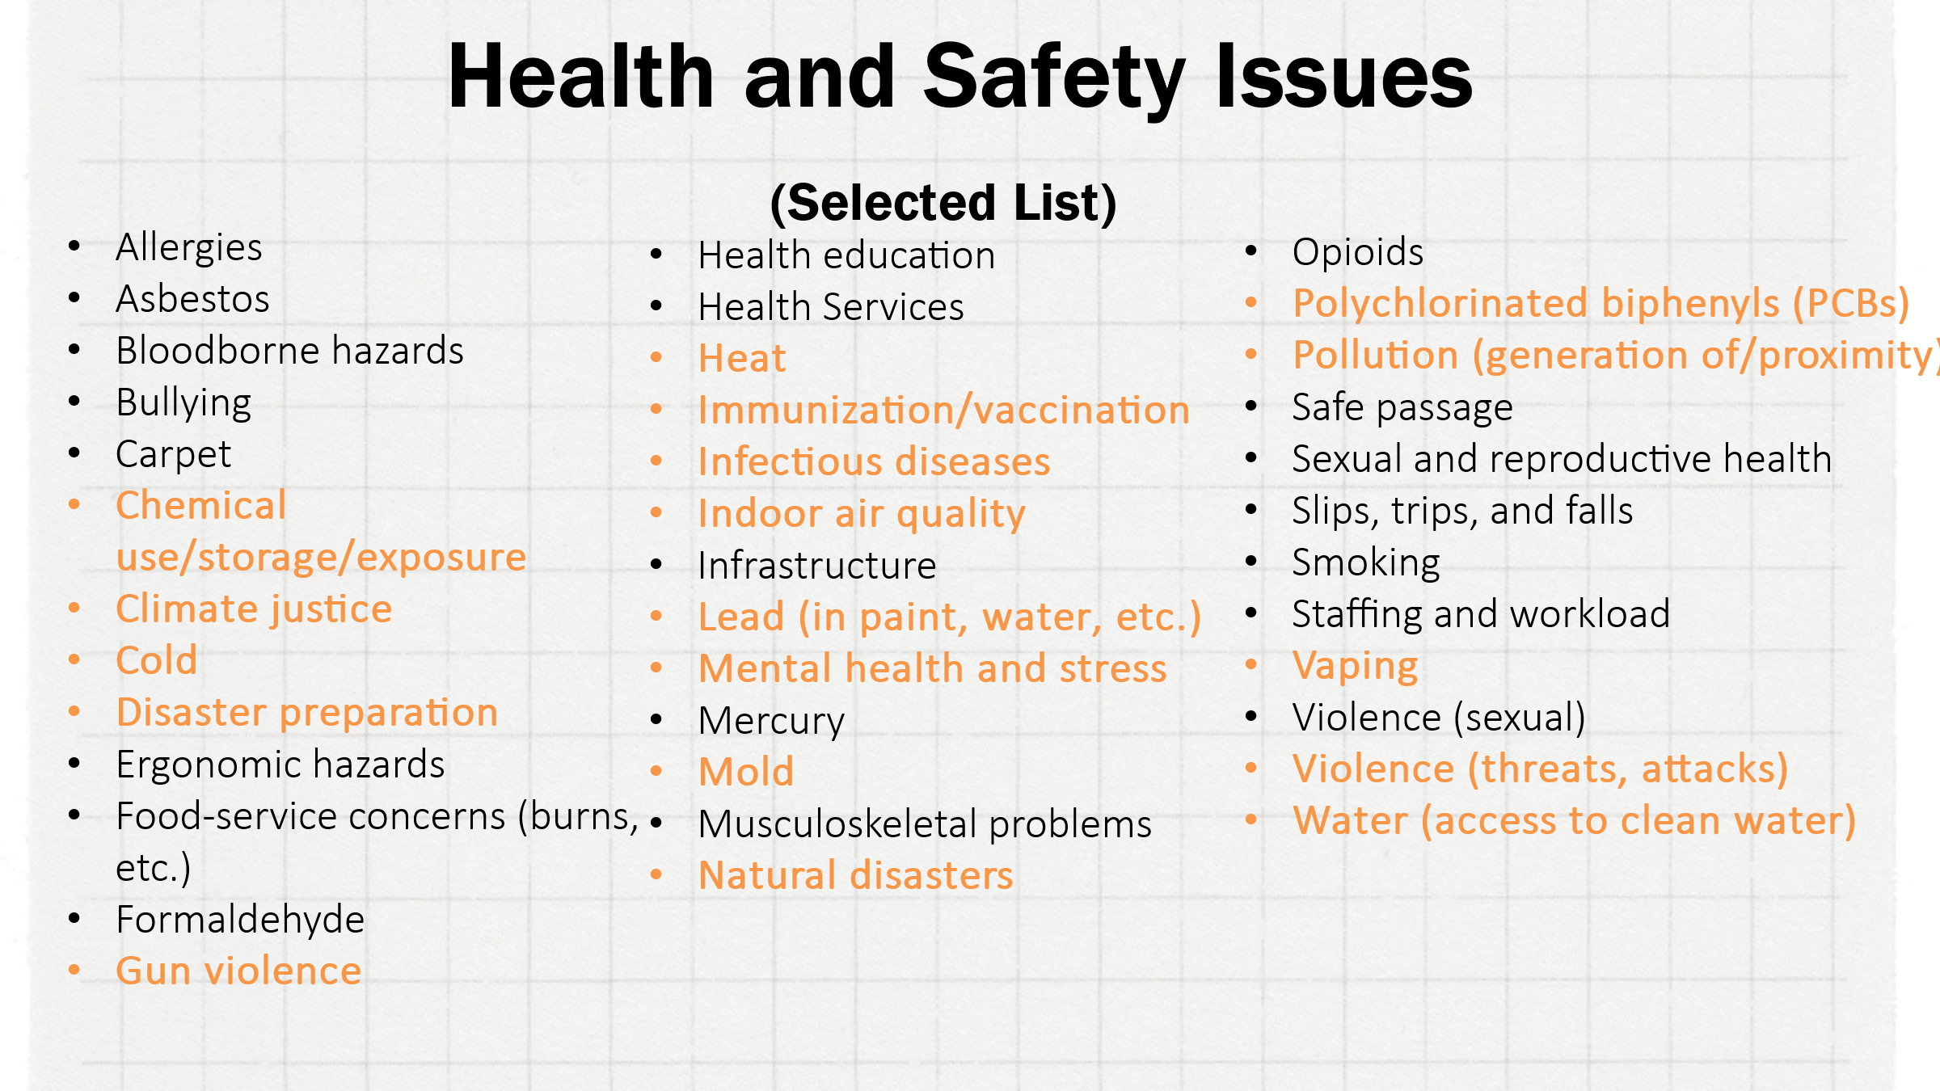  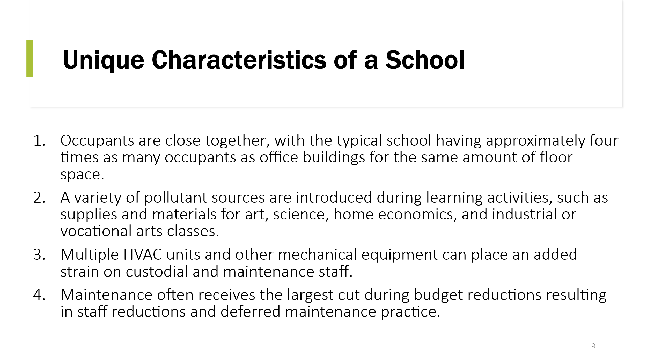  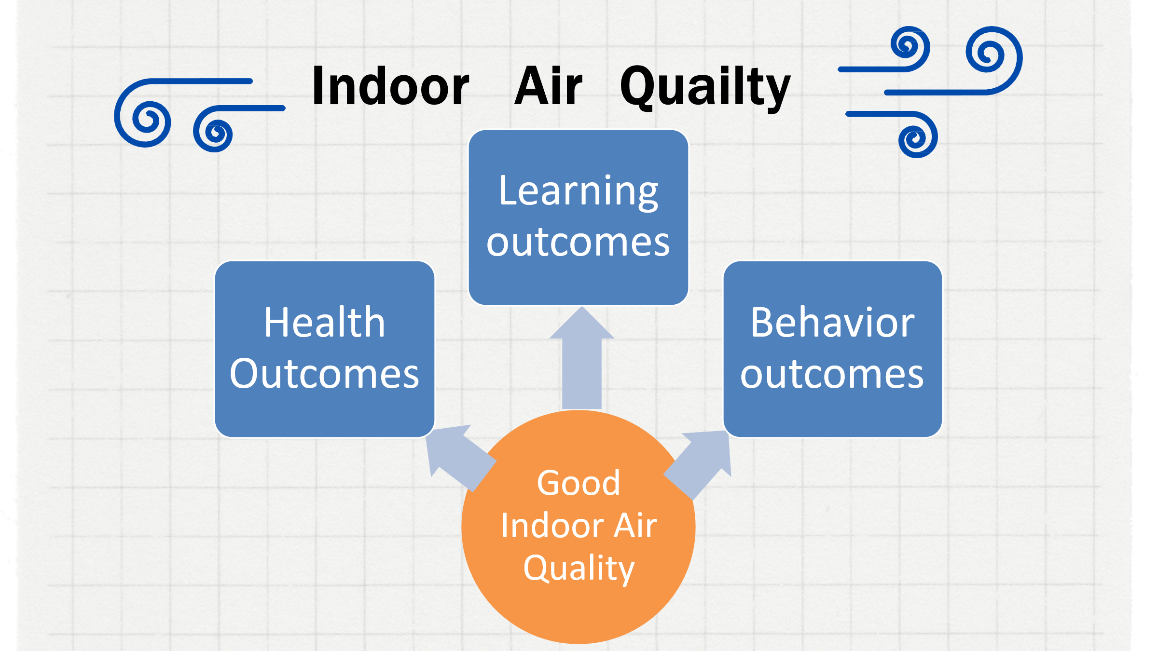  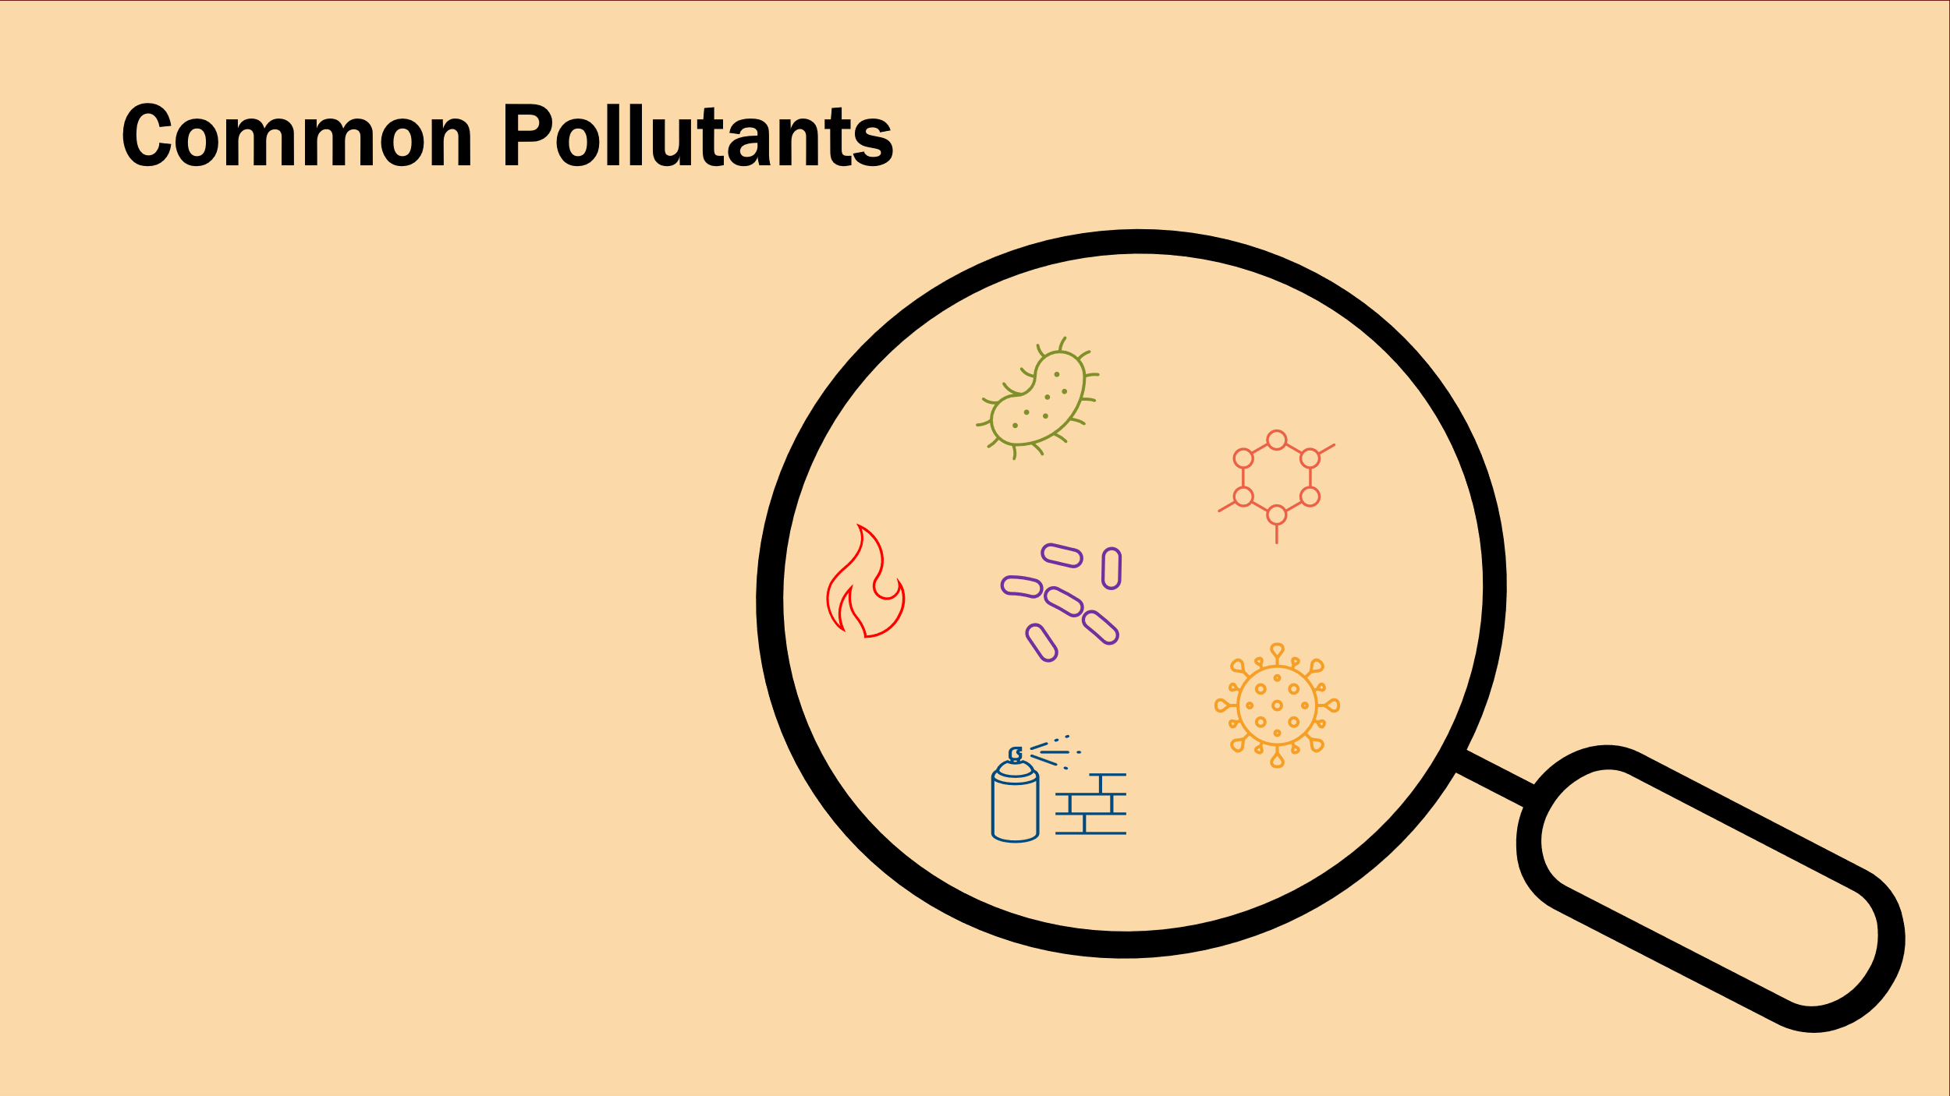  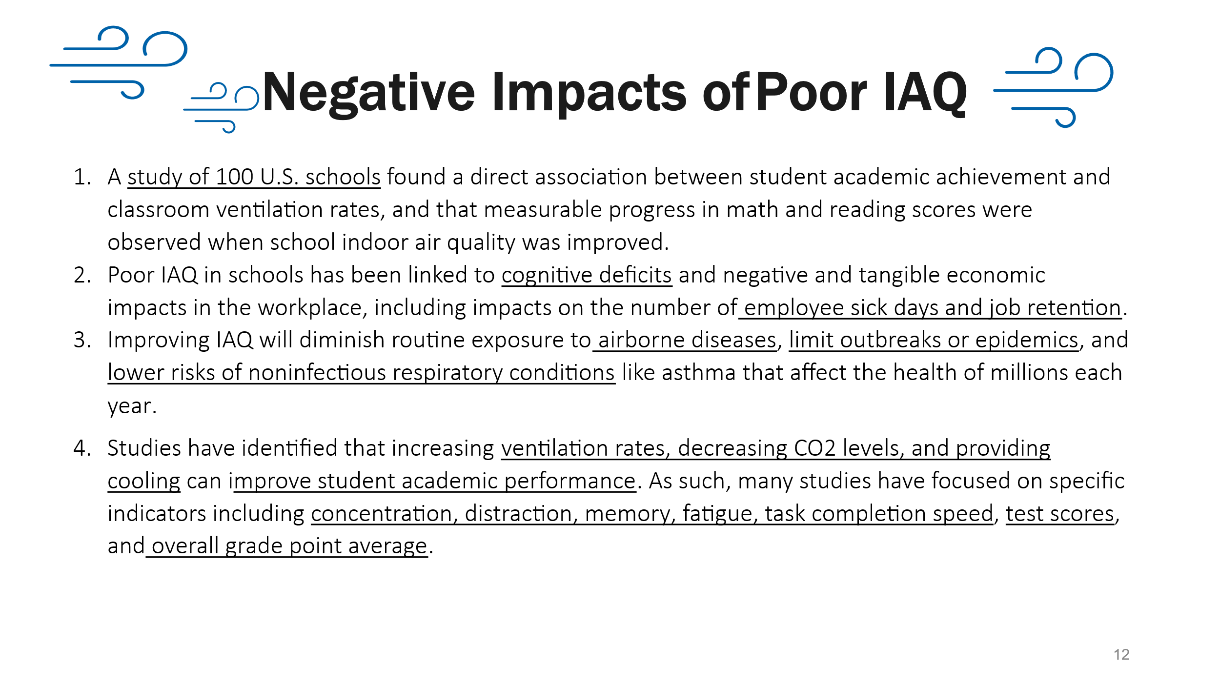 | Why Haven’t We Made it Safer to Breathe in Classrooms?” https://www.nytimes.com/2023/08/09/opinion/air-filter-covid-smoke-schools.html | Slide 5.  - This health and safety workshop is the first of a series. Today’s session will focus on environmental and occupational health.  - The next workshop is on Advocating for Educators’ Mental Health and Psychological Safety  - The last workshop is on Tools and Strategies to Address Gun Violence in Schools.  These will be hosted​ in 2025. Keep an eye out for them.  - February 13, 2025 2:30-4:00 PM ET – Safe Schools – Advocating for Educators’ Mental Health and Psychological Safety  - May 15, 2025 2:30-4:00 PM ET – Safe Schools – Tools and Strategies to Address Gun Violence in Schools  Slide 6-7.  First, we would like to hear from you.  Ask participants Please type in the chat all the health and safety issues members have expressed concerns about.  - Highlight any patterns, similar, or unique issues.  The health and safety issues listed on this slide are a selected list, meaning there are a lot of other issues that are not listed because of space limitations. The health and safety issues in orange are the health and safety issues the NEA program has worked on with state affiliates.  I would like to convey that we respond to affiliate requests, so even if there’s a health and safety topic they don’t hear about, we are happy to assist folks think it through and find the support they need.  Slide 9  - Schools are unique ecosystems. They have characteristics that are different from other workplaces.  Slide 10  - The COVID-19 pandemic demonstrated the importance of good indoor air quality.  - We will begin exploring the variety of ways health and safety issues manifest. The term “indoor air quality” can be defined as a term that often refers to the quality of the overall indoor air in an environment.  Major Causes for Poor IAQ  - Pollution sources, like mold, CO2, wildfire smoke  - Improperly operated and maintained HVAC, there are a variety of pollutant sources some of which are introduced for learning, such as supplies and materials for art, science, home economics, and industrial or vocational arts classes occupants are close together  Slide 11  Ask Participants: What are some common pollutants we see in schools?  The common pollutants we see in schools are  - Viruses,  - bacteria  - fungi  - Carbon monoxide,  - carbon dioxide,  - cleaning products  - Particulate matter 2.5, 10  Slide 12  - We know the negative impacts of poor IAQ and hundreds of studies have demonstrated those impacts.  Poor IAQ affects teaching and learning  - Increased absenteeism due to illness. Asthma is the leading chronic disease-causing school absenteeism a total of 10 million missed school days per year.  - Poor IAQ can lead to headaches, dizziness, sleepiness, and other factors inhibiting performance. Difficult to concentrate. |  | Outcome: Review common health and safety hazards in educational settings.  Rationale: Participants may have only had experience or exposure to a handful of health and safety issues, so we will want to broaden their perspective on what other health and safety issues might be
+0:11 / 3 min  Eunice |  | https://youtu.be/TrbeuJRPM0o | Environmental Racism Explained  - Facilitator should set up the video prior to playing it by asking them when hearing health complaints from members, how often did you connect the complaint to the individual or building, and how often have you connected the complaint to a community?  - Video run time: 2 minutes |  | Outcome:  Rationale:
+0:14 / 6 min  Eunice |   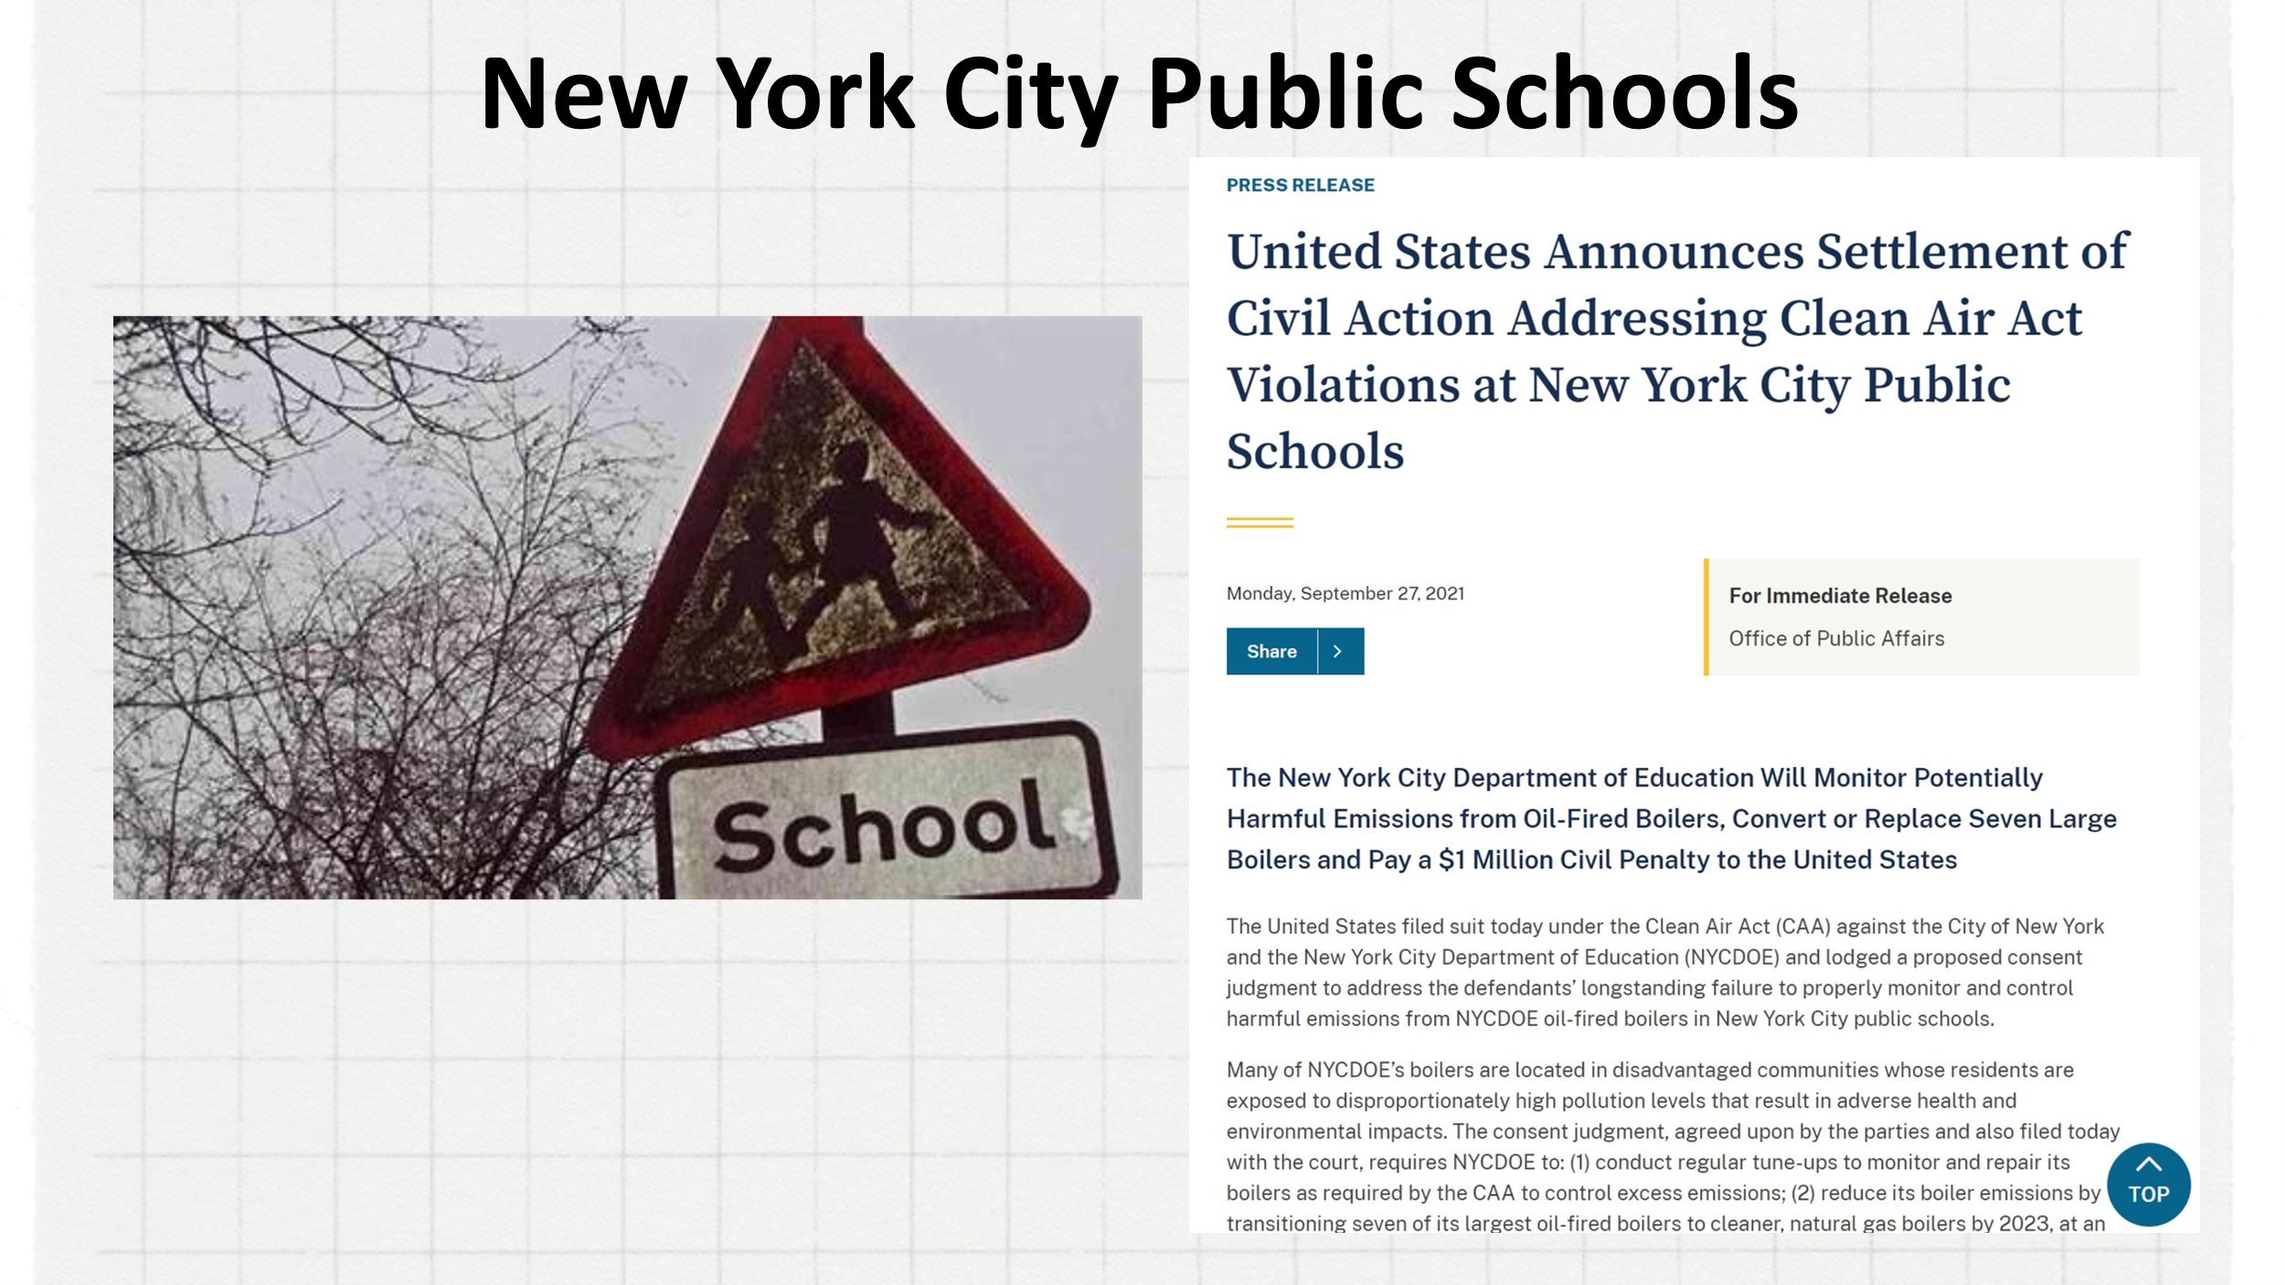 | Environmental Gentrification  https://ecommons.luc.edu/cgi/viewcontent.cgi?article=1036&context=ies_facpubs  https://www.justice.gov/opa/pr/united-states-announces-settlement-civil-action-addressing-clean-air-act-violations-new-york  “United States Announces Settlement of Civil Action Addressing Clean Air Act Violations at New York City Public Schools,” September 27, 2021. https://www.justice.gov/opa/pr/united-states-announces-settlement-civil-action-addressing-clean-air-act-violations-new-york. | Slide 14  My Neighborhood is killing me:  - Different types of environmental injustice, the types that the program has worked on are:  - Air pollution  - Access to Clean water  - Exposure to Toxins  Points the facilitator can make when working with members:  - Black, brown and indigenous people and their communities are more vulnerable to climate change  - Climate change and environmental racism intensify racial inequalities.  - Low-income people are less prepared for extreme weather, less likely to be insured and have fewer financial resources to recover after events.  - Students cannot learn, and educators cannot teach when they’re out sick.  Slide 14  New York City Public Schools  For years, poorly maintained oil-fired burners in hundreds of New York City schools, located disproportionately in minority communities, spewed toxic emissions harmful to humans and the environment.  The failure to conduct the required boiler tune-ups have caused excess pollutants and particulate matter (“PM”) emissions, contributing to environmental harm and to the risk of adverse human health effects to the students attending public schools and to local communities.  PM contributes to or exacerbates respiratory illnesses, including children’s asthma, which disproportionately affect these communities  The Environmental Protection Agency recently brought a successful suit against the city’s school system to deal with this issue.  Environmental Gentrification:  The facilitator should introduce the idea that there are additional considerations when organizing around health and safety like Environmental Gentrification that if not considered, the solution could be as detrimental as the disease. |  | Outcome:  Rationale:
+0:20 / 6 min  Chad | 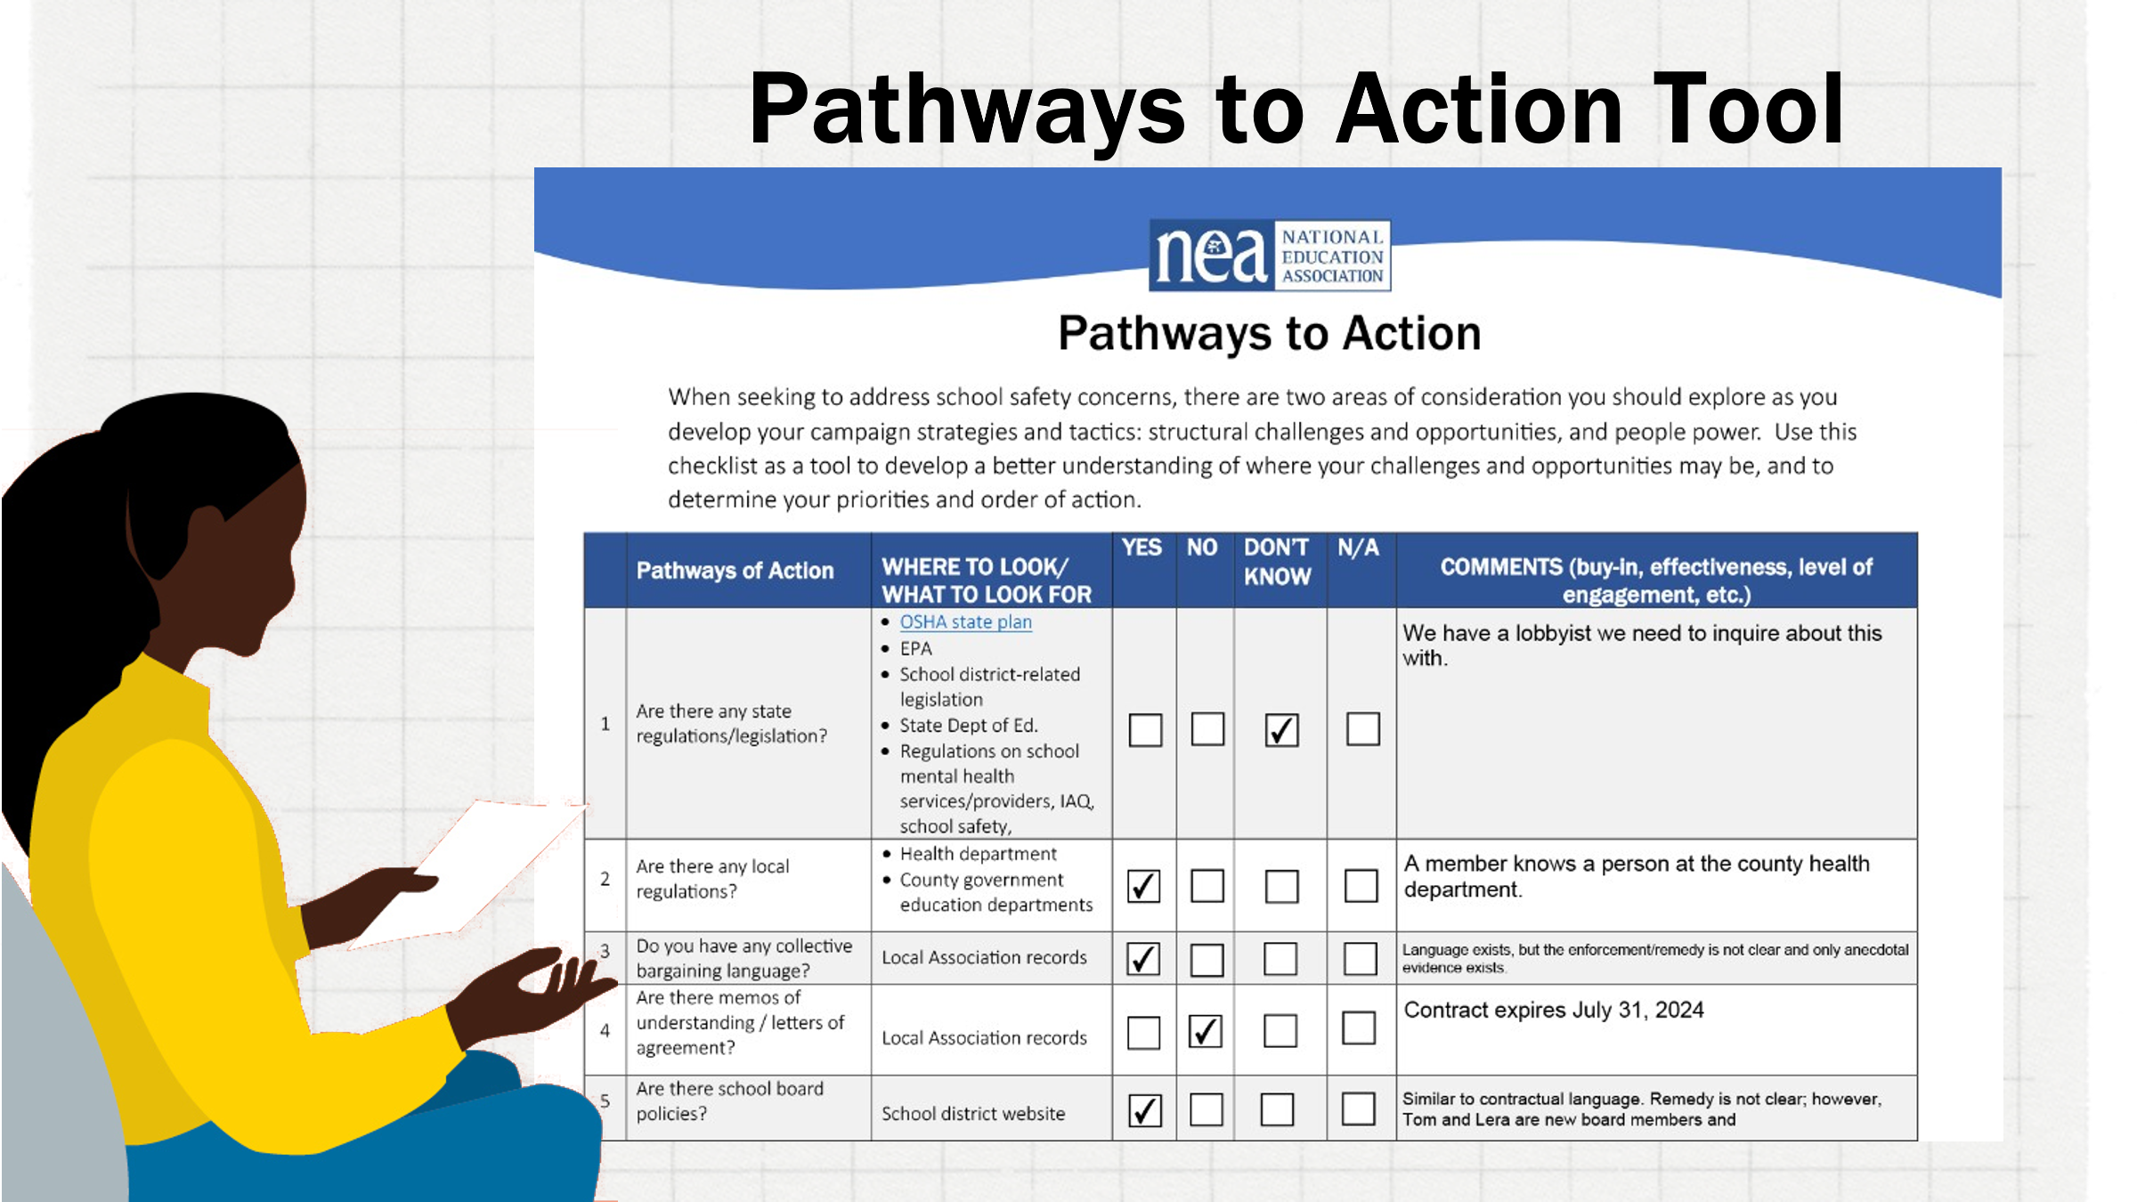  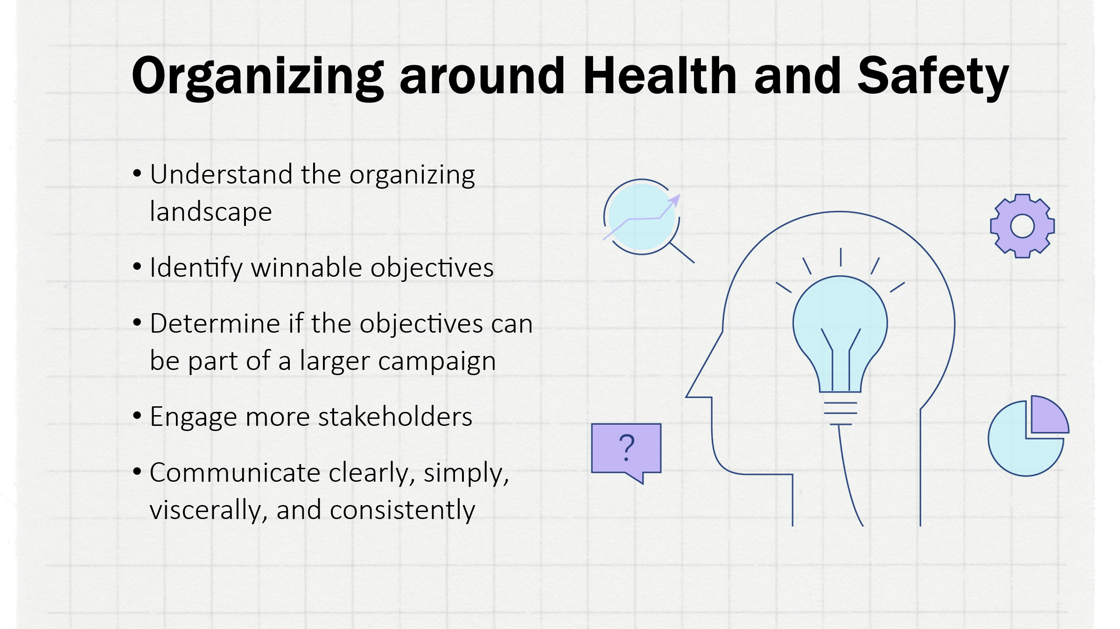 | [Drop tool PDF in chat]  UK health and safety organizing article:  https://www.tuc.org.uk/sites/default/files/ORG_HandS_What.pdf | Introduce the pathways to action tool  - Drop the tool PDF in the chat  - Give background/origin story of the tool (Eunice)  - Explain that the tool is intended to be a consistent through-line as we explore other aspects of organizing around health and safety (Chad)  - Ask the participants to take a moment and open the tool and take note of its features.  - As participants are looking at the tool on their computers, the facilitator should highlight the tool’s features and explain the rationale of its creation.  - Share with the participants the concepts of organizing around health and safety as explained in the “WHAT MAKES HEALTH AND SAFETY A GOOD ORGANISING ISSUE? Building organizing unions” resource document.  - Make a point of explaining that the Pathways to Action tool provides a means of analysis and assessment to provide answers and insights into understanding and structuring your approach to organizing around health and safety issues.  - Drop the resource URL in the chat at the conclusion |  | Outcome: Participants understands what the pathways to action tool is and begins to conceptualize ways that it may impact their work around health and safety  Rationale: Health and safety is a broad issue and paths to action may not be clear. The tool serves to help create a structure around the analysis and assessment of health and safety issues experienced by members, allowing the staff person to identify gaps, priorities, and opportunities.
+0:26 / 18 min  Chad | 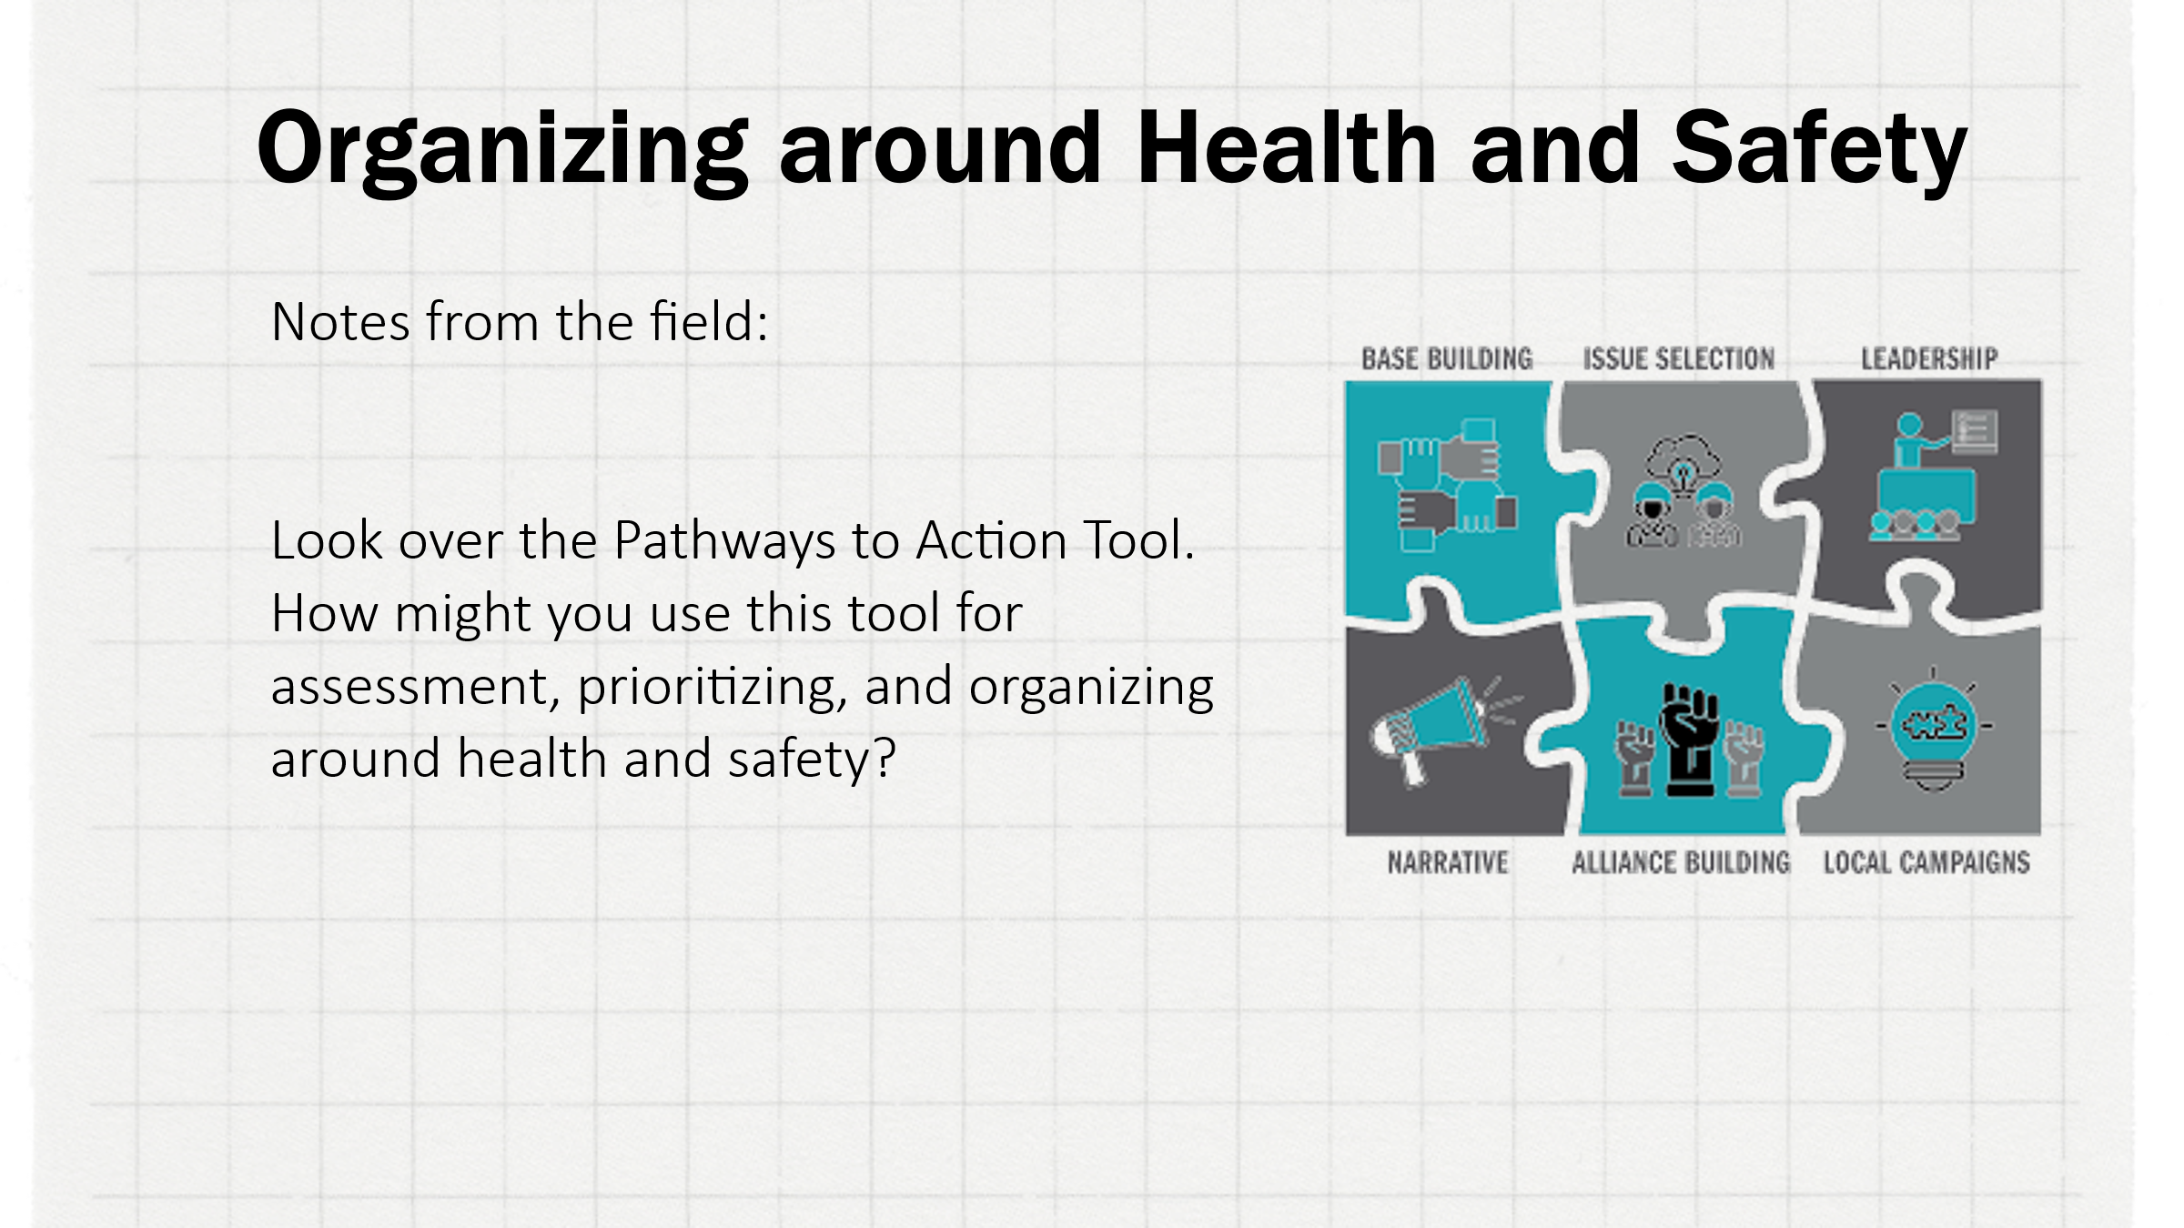 |  | Breakout setup: 3 minutes  Explain the objectives and directions for the breakout.  Establish who the first group respondent will be AND who the group reporter will be prior to triggering the breakout. (ex. Newest UD/Organizer responds first in the group, most veteran UD/Organizer is the reporter)  Breakout: 10 minutes  Broadcast the directions into the breakout rooms after participants enter.  Participant directions  - Scan document  - ID a current health and safety issue in your work  - how could you use this tool?  - What way might this tool direct or inform your work around member concerns differently?  Report out: 5 minutes |  | Outcome: participants will utilize the tool within their own contexts  Rationale: Each staff person may have default tendencies in their approach to action. This exercise will help both reveal that as well as reveal alternate paths to action.
+0:44 / 4 min  Eunice | 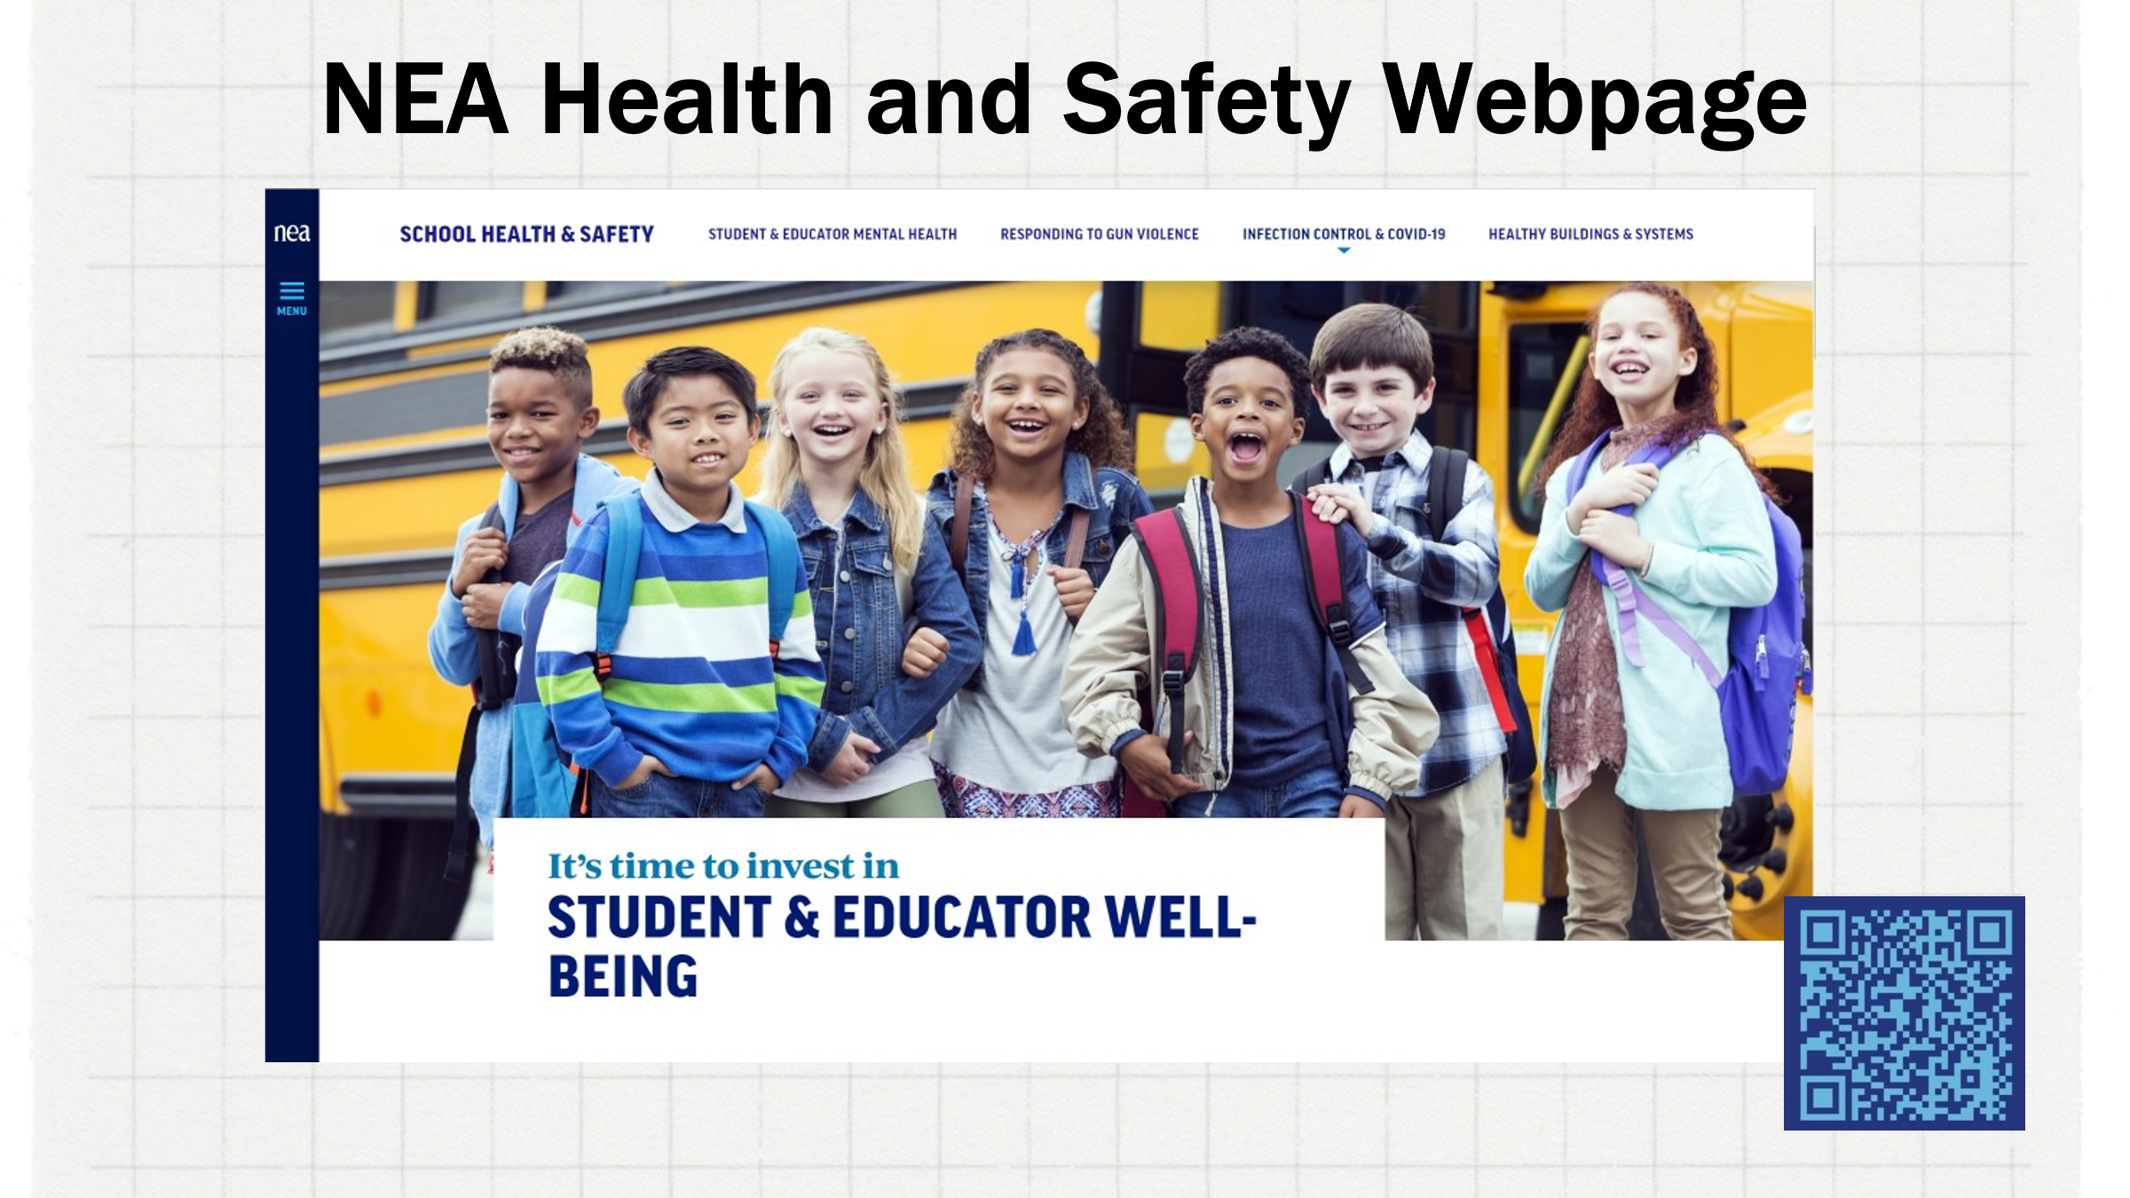  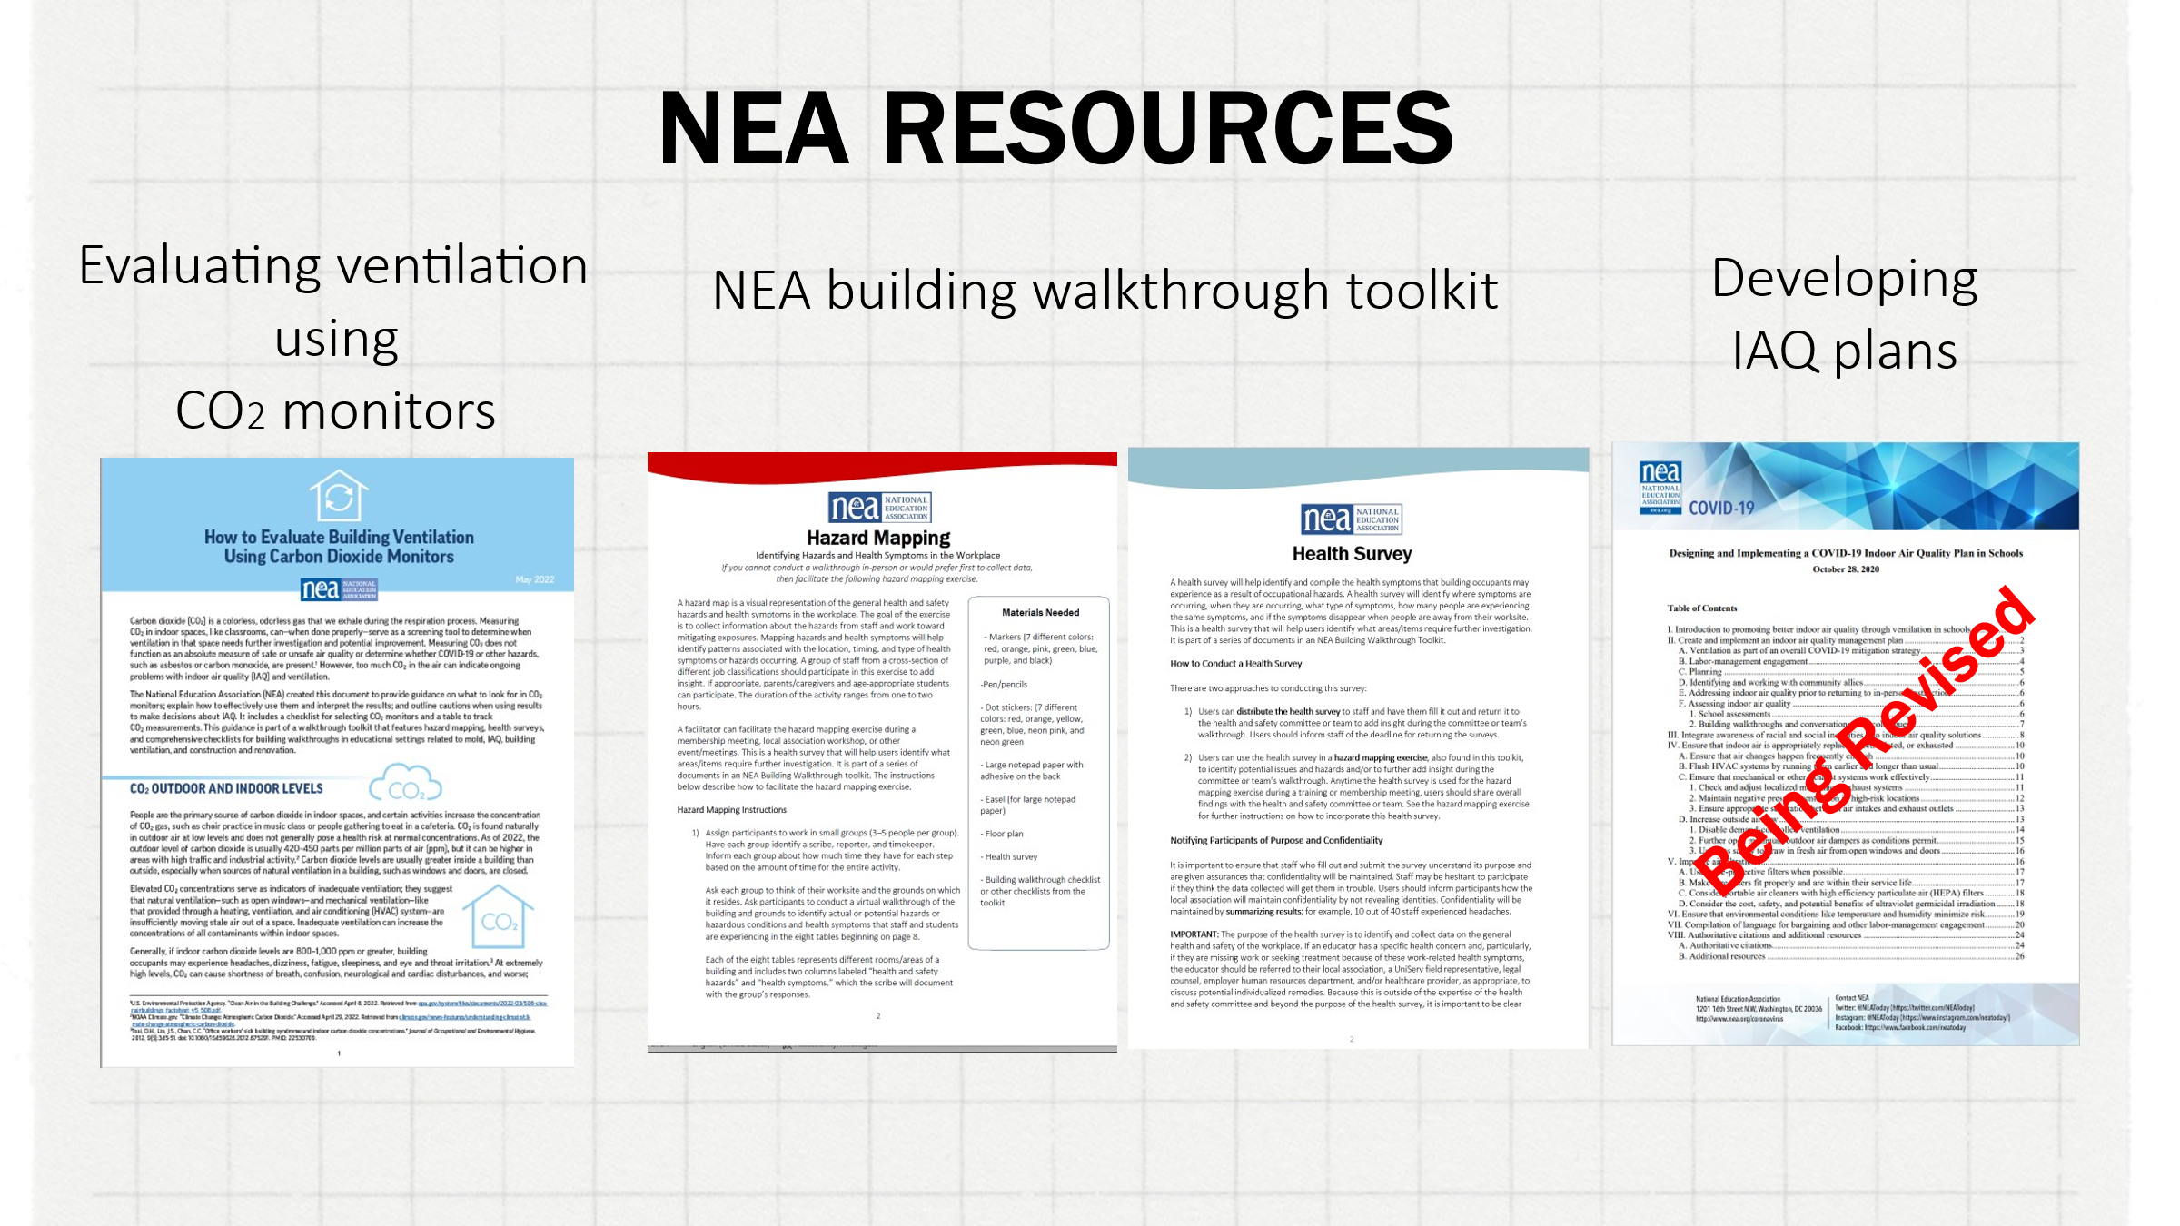  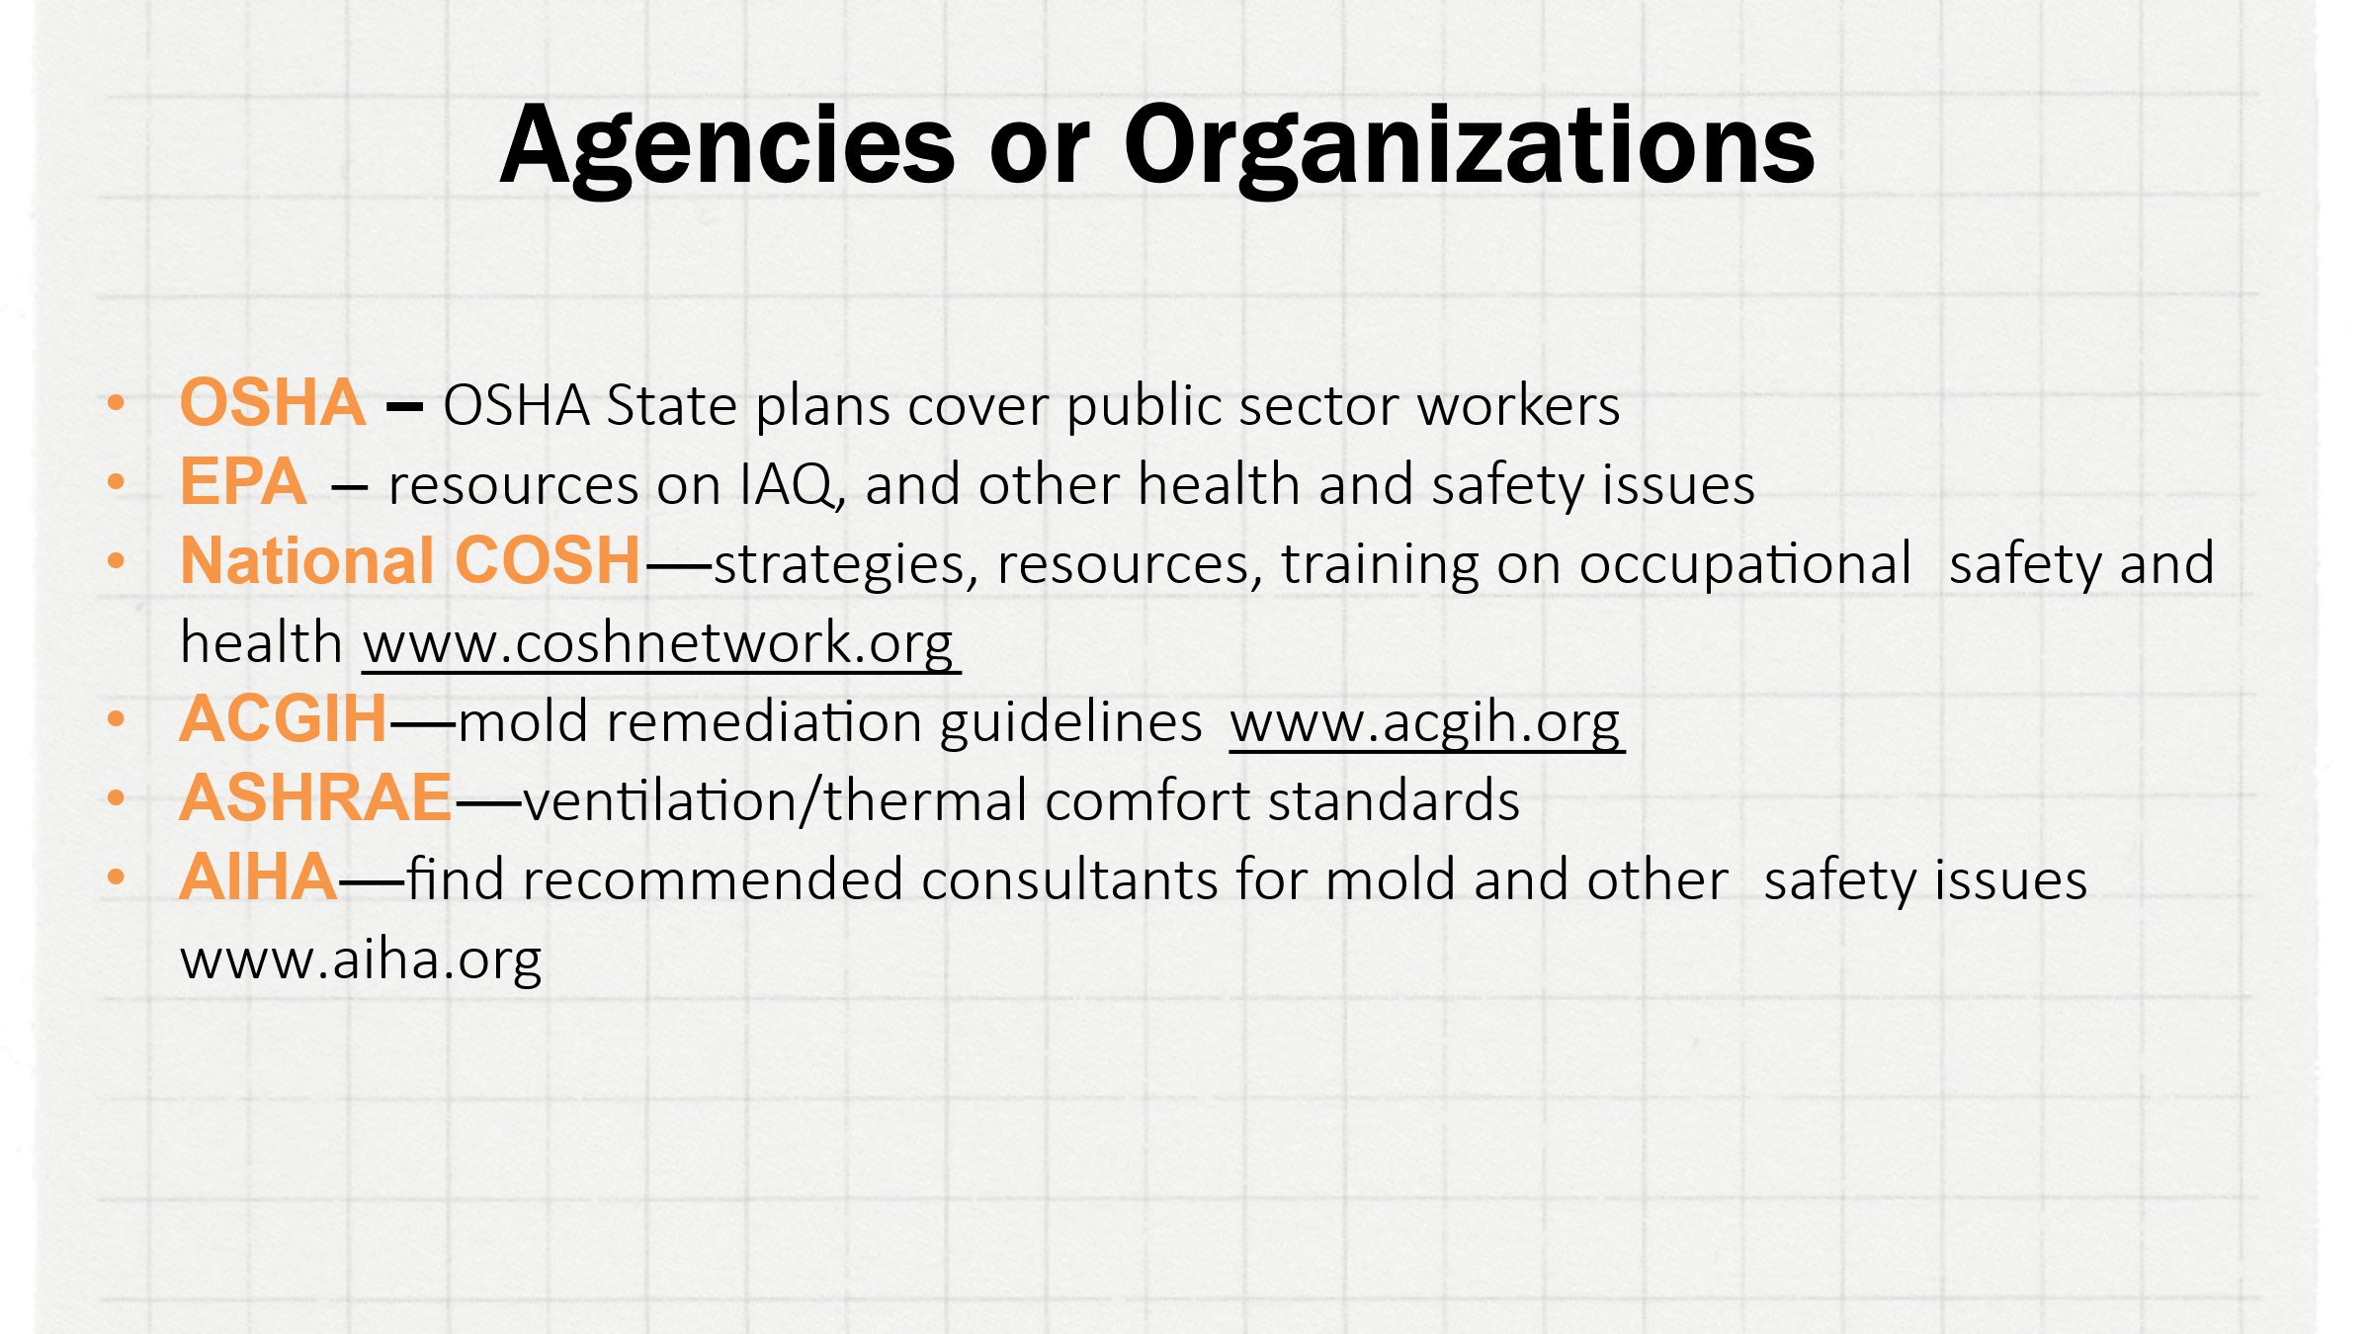 | School Health & Safety | NEA  NEA RESOURCES  (slide 20)  Building Walkthrough Toolkit: Healthy Buildings & Systems | NEA  Evaluating Ventilation using CO2 Monitors: How to Evaluate Building Ventilation Using Carbon Dioxide Monitors | NEA | Resources and health and safety agencies  The facilitator should briefly share and explain the variety of NEA resources available to staff and members, as well as briefly explain the relevant agencies and organizations where staff can obtain health, safety, and policy information. |  | Outcome: Identify and understand what resources are available for health and safety  Rationale: NEA and other agencies have done a lot of work on this – use it!
+0:48 / 20 min  Naomi | 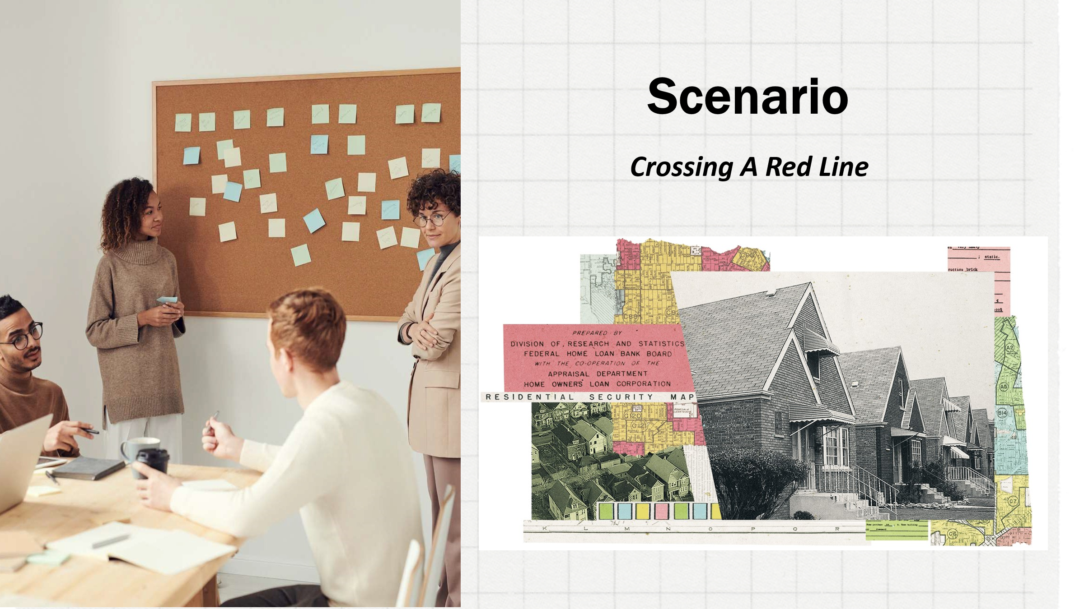  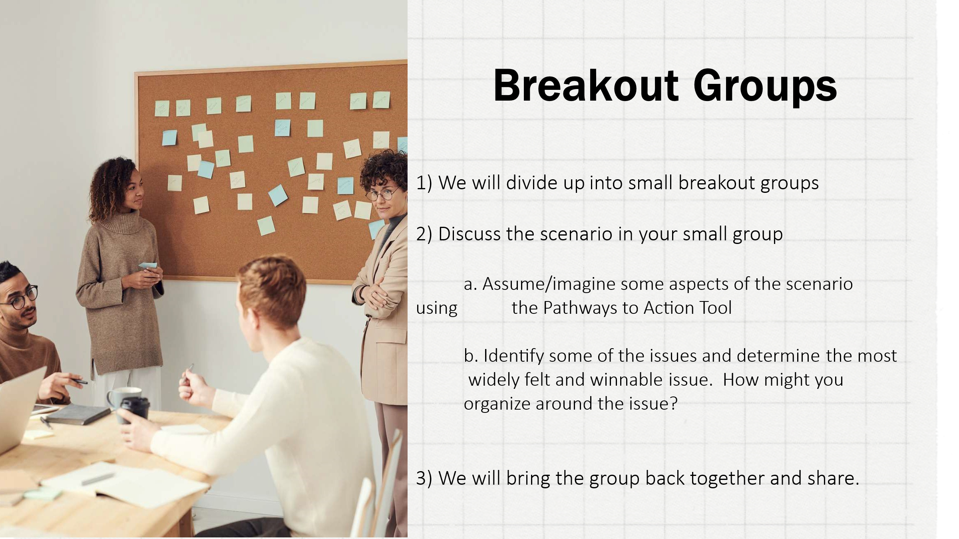  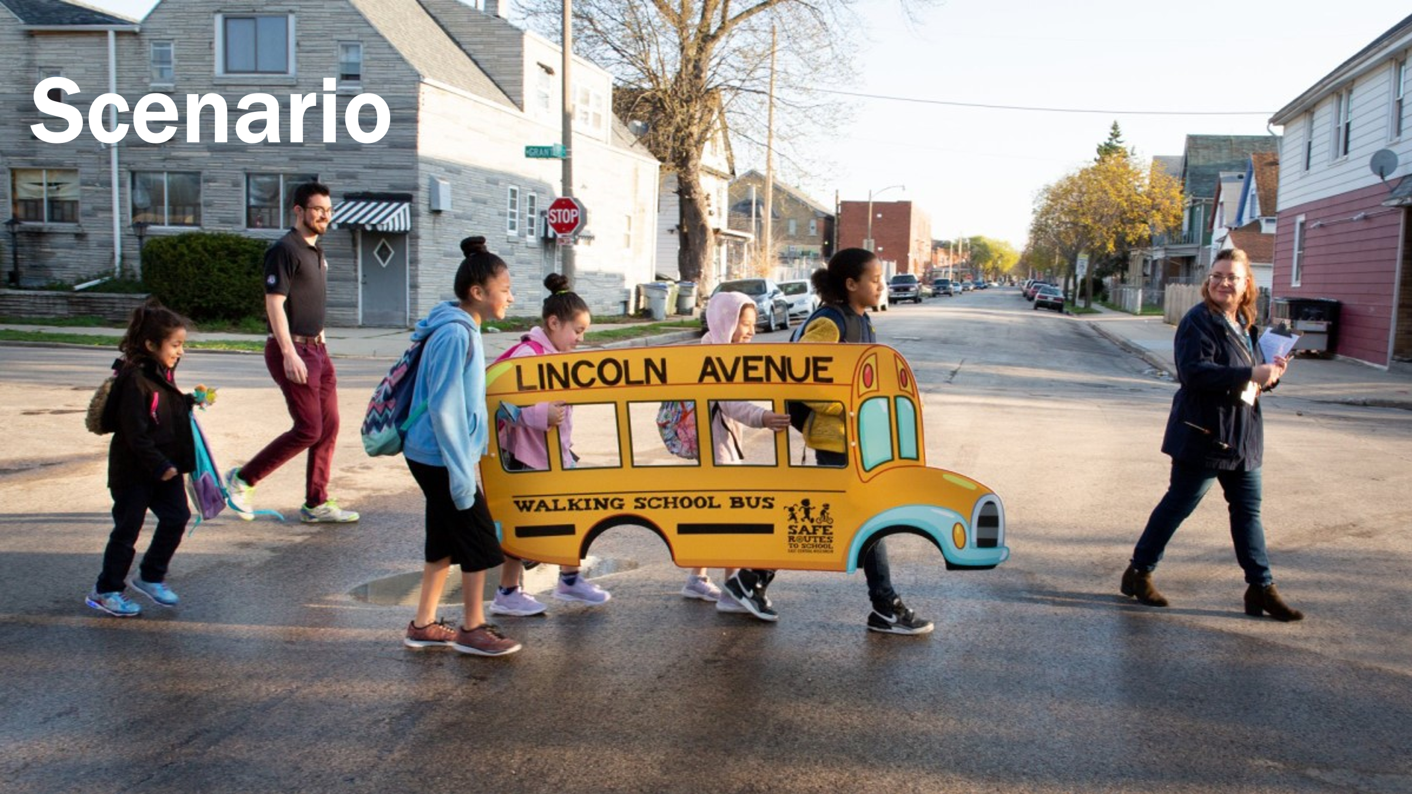   | [Drop scenario PDF in chat]  Google Slide link:  https://docs.google.com/presentation/d/1u79ANfv5py_bYHXpK-LXFJfFLdzqSDVrZGjJ19-Pi9o/edit?usp=sharing | Scenario setup: 5 minutes  Drop the scenario PDF in the chat  Facilitator will read the CliffsNotes scenario for participants…  Breakout: 10 minutes  Breakout directions:  - We will divide up into small breakout groups  - Discuss the scenario in your small group  - Assume/imagine some aspects of the scenario using the Pathways to Action Tool  - Identify some of the issues and determine the most widely felt and winnable issue. How might you organize around the issue?  - Think of a slogan for your campaign  - We will bring the group back together and share.  Report out: 5 minutes |  | Outcome: Participants will utilize the pathways to action tool to approach a scenario  Rationale: Both the tool and differing perspectives of the group participants will help reveal the utility of the tool towards analysis, assessment, and identification of priorities and opportunities
+1:08 / 10 min  Adia | 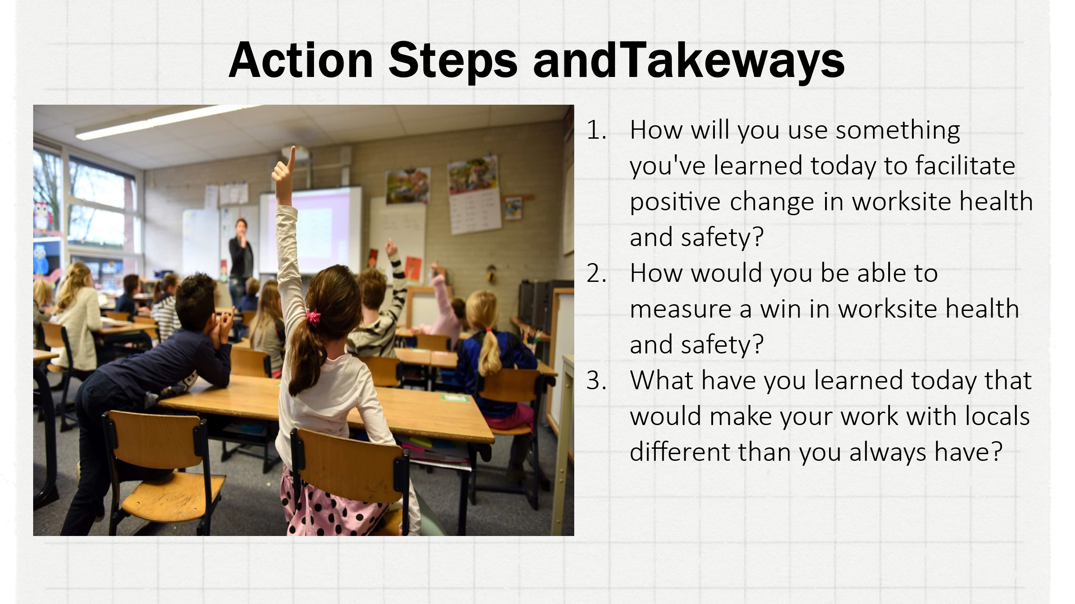 |  | Action Steps and Take aways  Facilitator prompts for group discussion:  - How will you use something you've learned today to facilitate positive change in worksite health and safety?​  - How would you be able to measure a win in worksite health and safety?​  - What have you learned today that would make your work with locals different than you always have? |  | Outcome: Participants will reflect on how the tool and the training experience could impact issues within their own locals  Rationale: Reflection is the final step in synthesizing the new information so that it is useable within their own contexts
+1:18 / 12 min  Chad |    | [insert facilitator contact info here] | Final questions and answers  Copy-paste the facilitator contact information into the chat  Reiterate that participants will receive a follow-up email that will contain the presentation as well as table of all the links and resources presented.
+1:30 | End |  | There is a 10 minute flex time built in at the end that can be taken to extend other segments earlier in the presentation.

