OL Facilitator Agenda: Safe Schools 2/13/25 – Advocating for Educators’ Mental Health and Psychological Safety
General Materials Needed: |  |  |  |  | Zoom Set-up:
PowerPoint Presentation  PDF version of presentation  Mental Health Pathways of Action 2025 - fillable.pdf |  |  | Scenario Video - Aspen School District - Electronic Devices |  | Steering: Screen share  Chat monitor  Time keeper – message in chat / text
Facilitator Pre-planning:
- Prior to this portion of the training, a review of the mentoring program should be done with participants
Segment Position / Segment Minutes | Slides | Segment & Resources |  | Instructions, Activity and Debrief (Facilitators) |  | Outcomes
Start Time:  2:30 PM EST  Time / Length |  | Charts, handouts, articles, materials |  | What are you saying, what are they doing, what questions will you use to guide learning and make clear the important points. |  | As a result of this section of learning, what will participants know or be able to do?
+0:00 / 5 min  Introduction  Slide: 1-3  Chad | 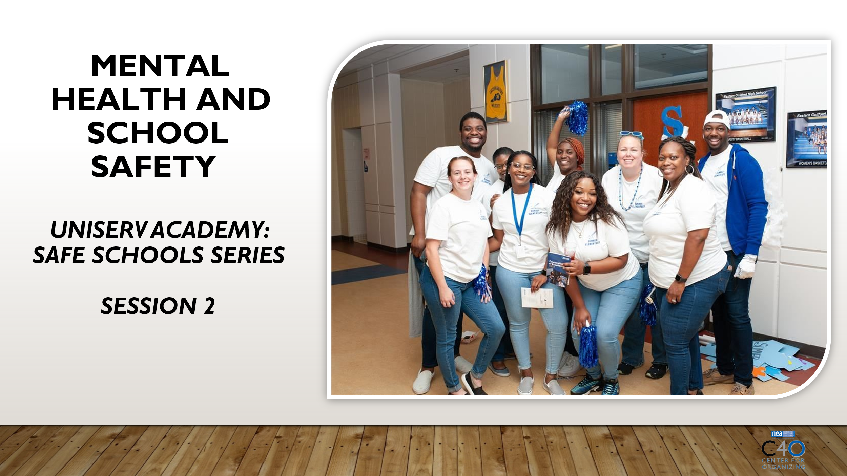  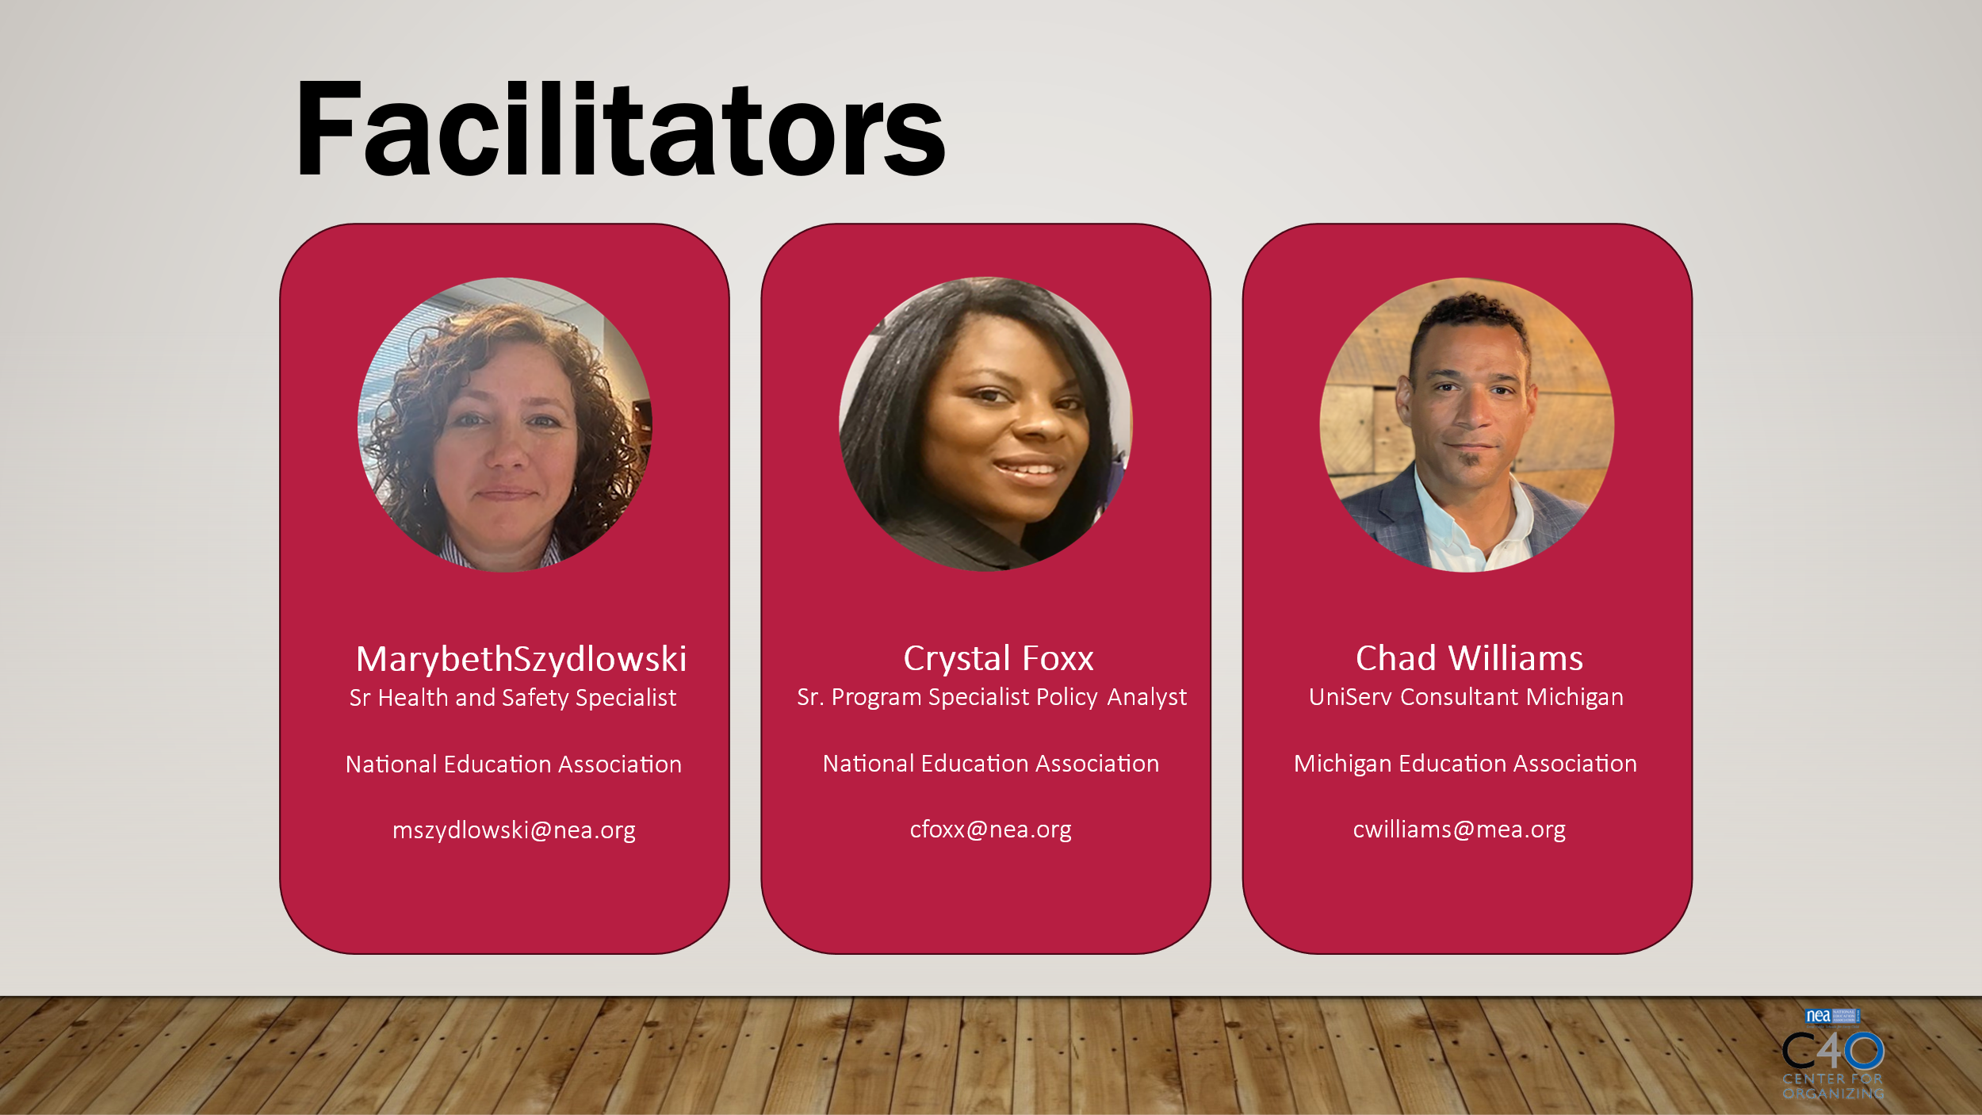   | NA |  | Introduction and land acknowledgment |  | Outcome:  Introduction
+0:05 / 10 min  Exploring school safety issues  Slide 4-6  Marybeth  Crystal | 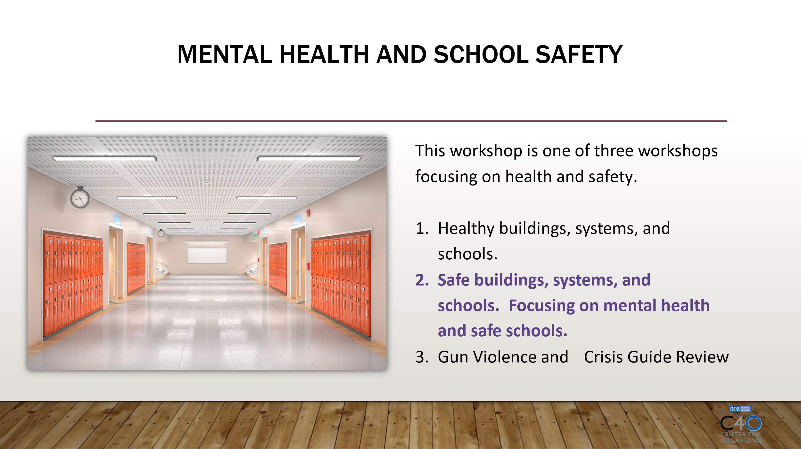  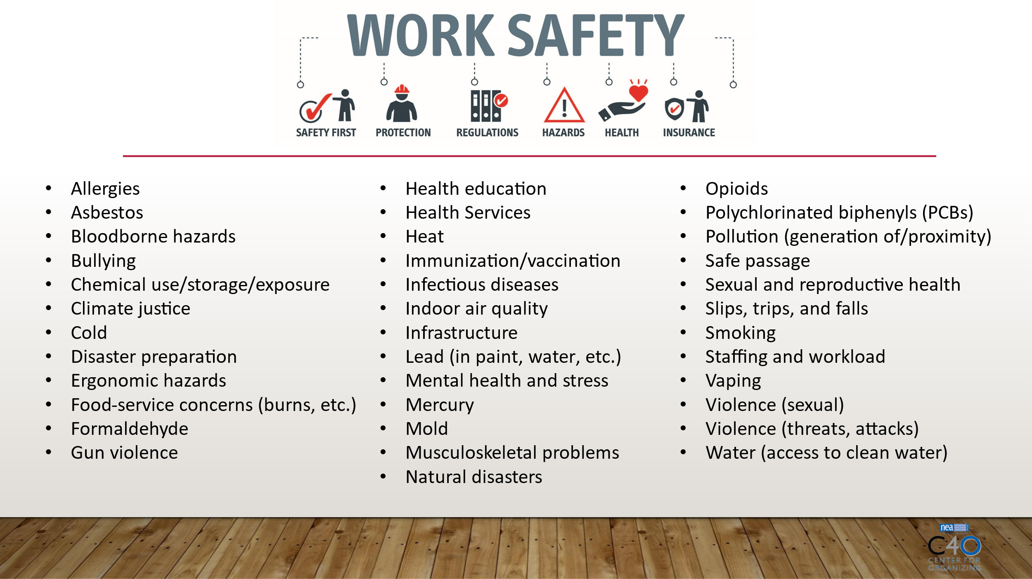  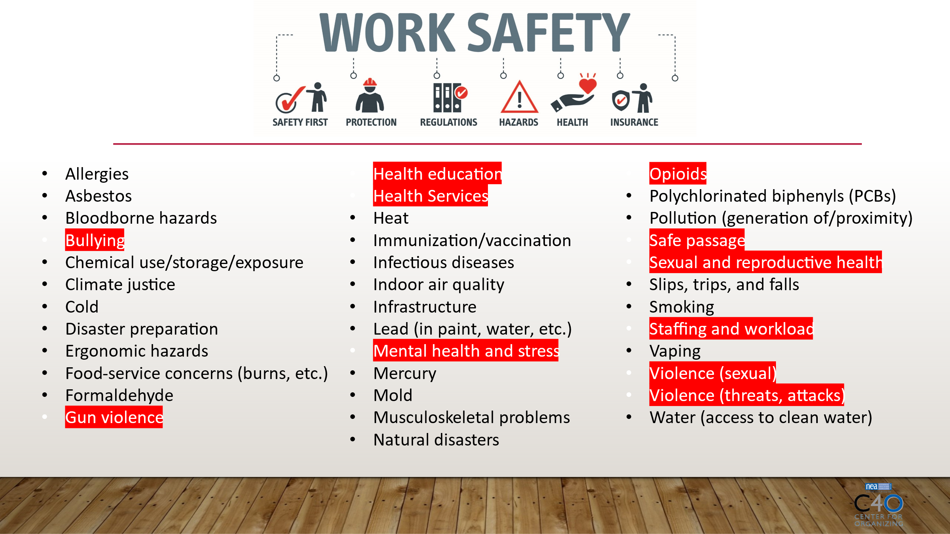 |  |  | - Discus the background of the school safety series, connection to NEA departments, and future opportunities to engage with NEA colleagues/departments/future trainings around school safety.  [Activity] Ask participants what health and safety issues have members expressed concerns with. Please type them in the chat.  - The health and safety issues listed on this slide are a selected list, meaning there are a lot of other issues that are not listed because of space limitations.  - The health and safety issues in orange are the health and safety issues the NEA program has worked on with state affiliates. I would like to convey that we respond to affiliate requests, so even if there’s a health and safety topic they don’t hear about, we are happy help folks think it through and find the support they need. |  | Outcome:  Participants will begin understand that the school safety series is part of a larger NEA initiative.  Rationale: It is very common that state affiliate staff are unaware of the departments and resources that exist and are available to them.
+0:15 / 5 min  School safety in terms of psychological safety  Slide 7-8 | 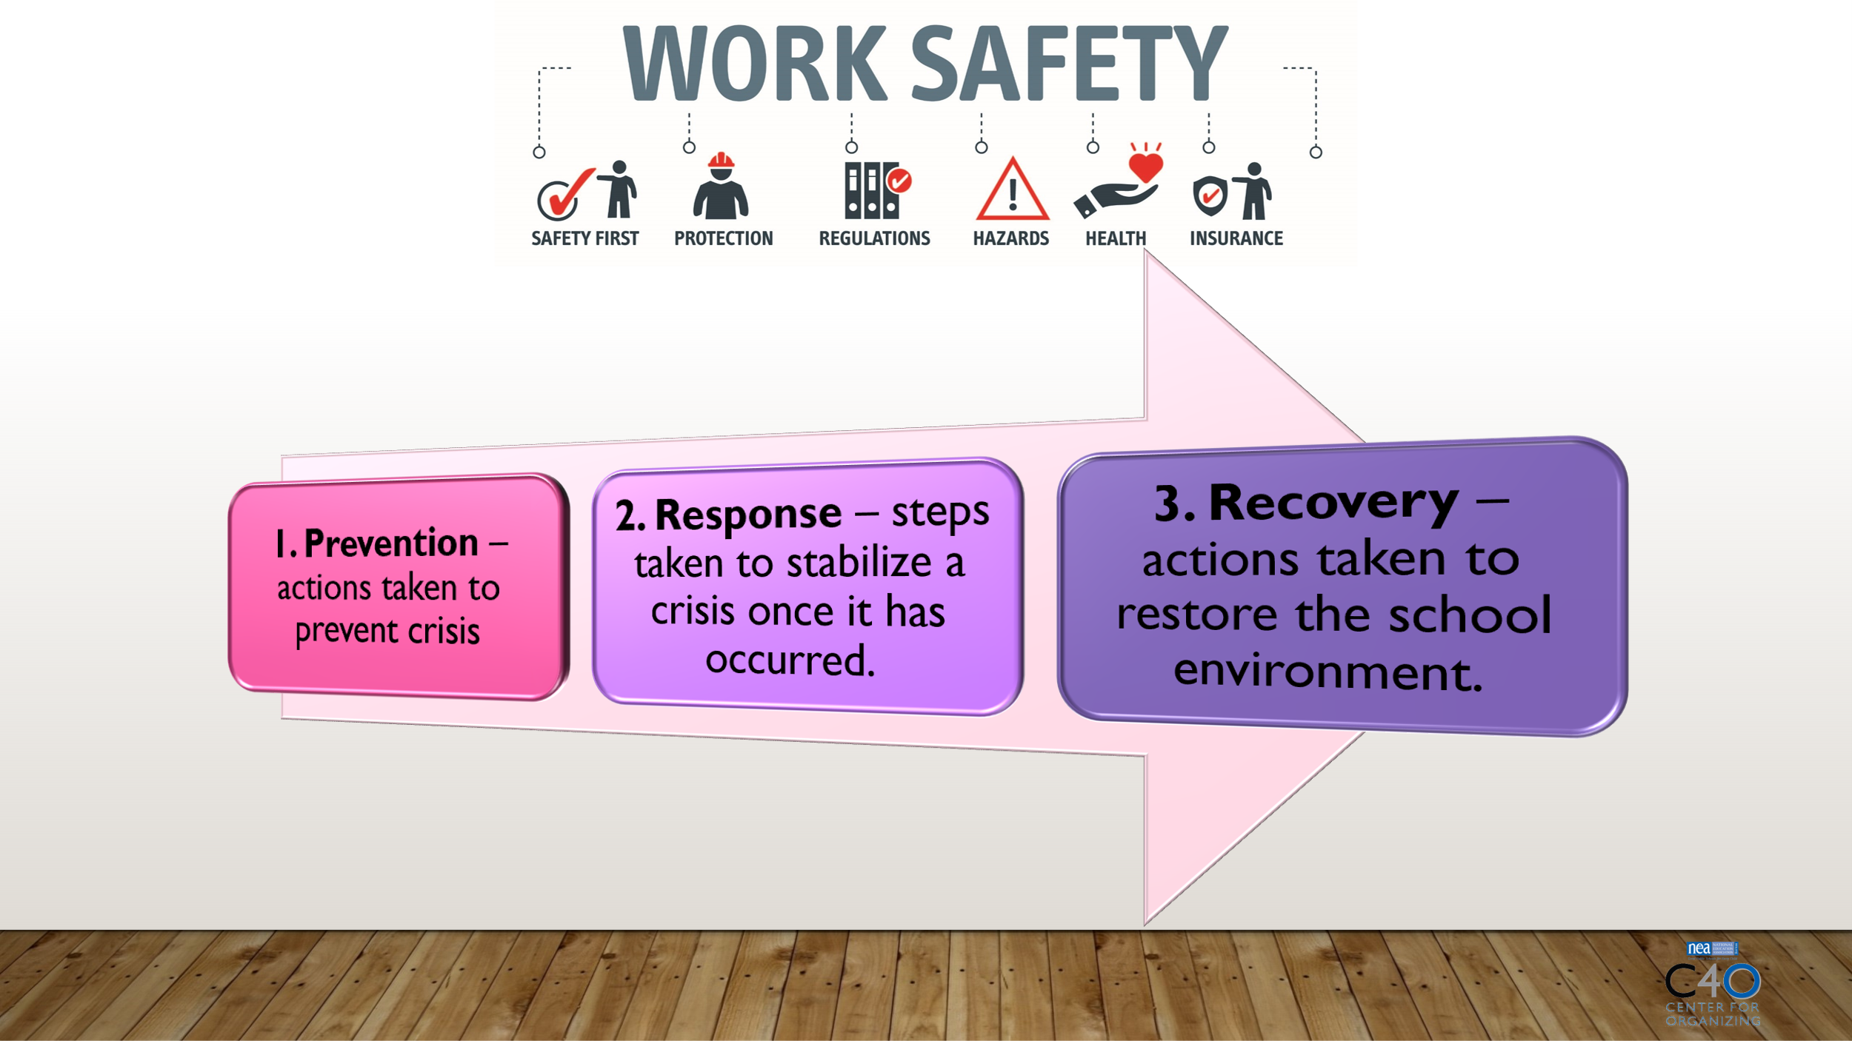  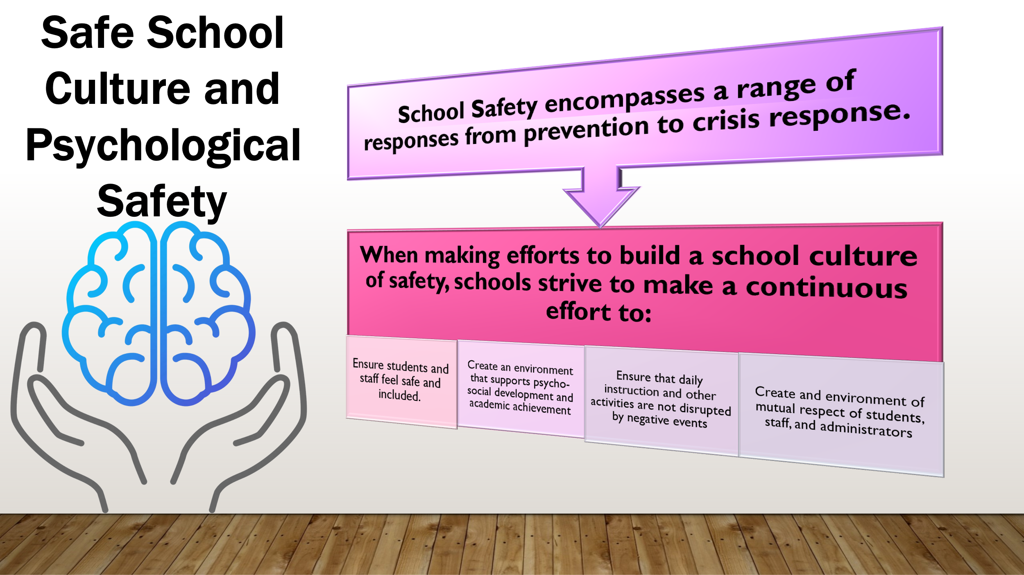 |  |  | How does the impact of social media and personal device usage on mental health relate to school safety  The issue of social media and device usage poses a threat to mental health that can be addressed through school safety prevention, response, and recovery measures.  To maintain safety, we can turn to the phases of school safety related to prevention and response.  School Safety includes behavior regulations for buses and bus stops, student code of conduct, crisis planning for threats and emergencies, emergency drills, school safety audits, security officers, security equipment, student prevention and intervention programs, and procedures for visitors and school events.  Next, we will look at ways we create safe school culture. These programs are not only to create a safe school culture that fosters prevention …. they may also be a part of the supports that are used to respond to threats to school safety. That support psychological safety…. which also connects safety to mental health support in school.  **Psychological Safety  Natural cues– what I want to move on to next--- next we will …  Psychological Safety – How mental health supports building safe school culture. Mental health supports entail direct services and environmental constructs that support positive social-emotional development |  | Outcome:  Participants will begin understand the steps of maintaining a safe school and be introduced to the psychological aspect of school safety and how technologies are playing a role in school.  Rationale: We often think of contributors and responses to school safety in terms of events; however, unseen internal forces and ubiquitous technologies are often driving the events we respond to.
+0:20 / 30 min  Impact of social media on school safety  Research, policy, and action recommendations  Slide 9-14 | 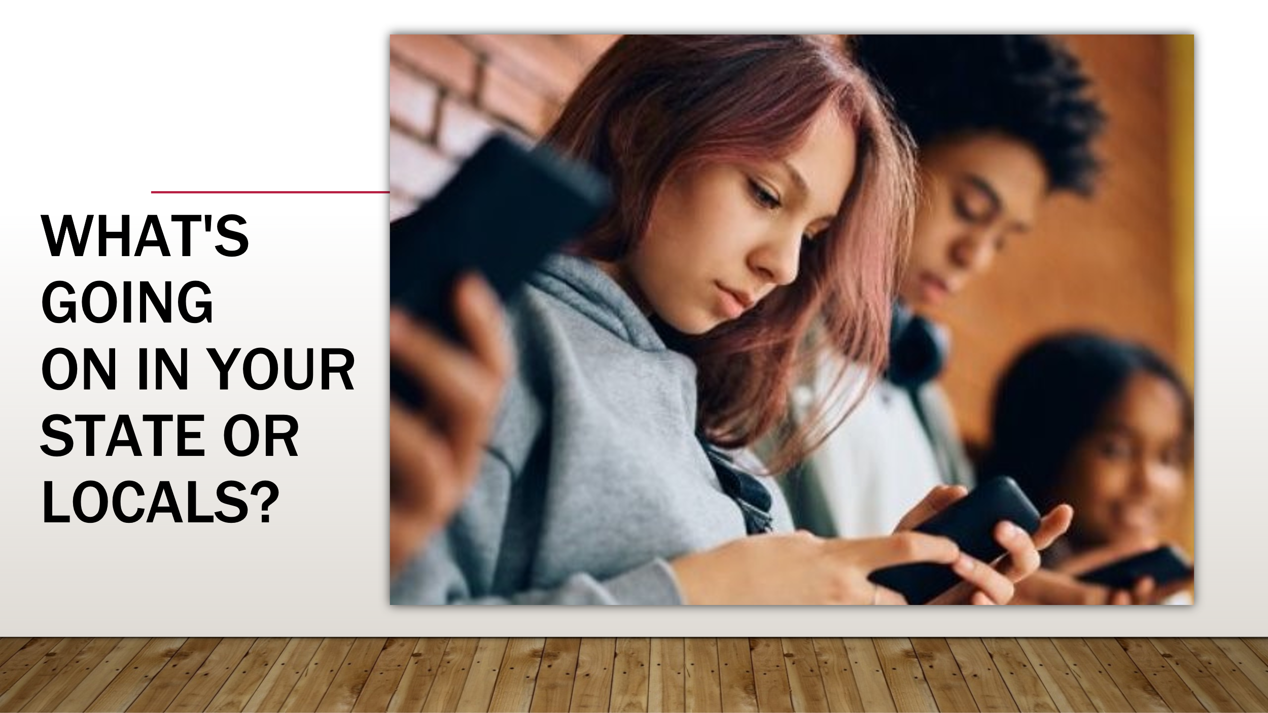  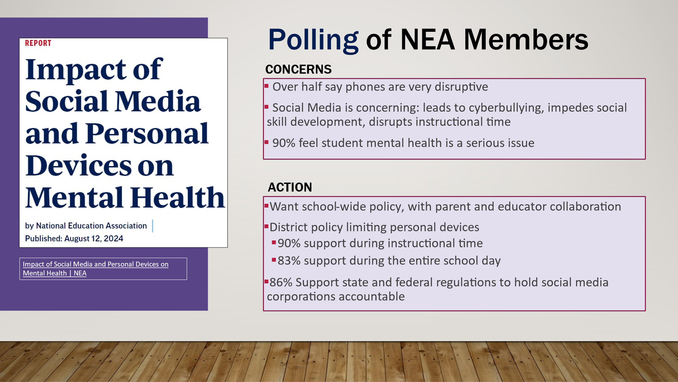  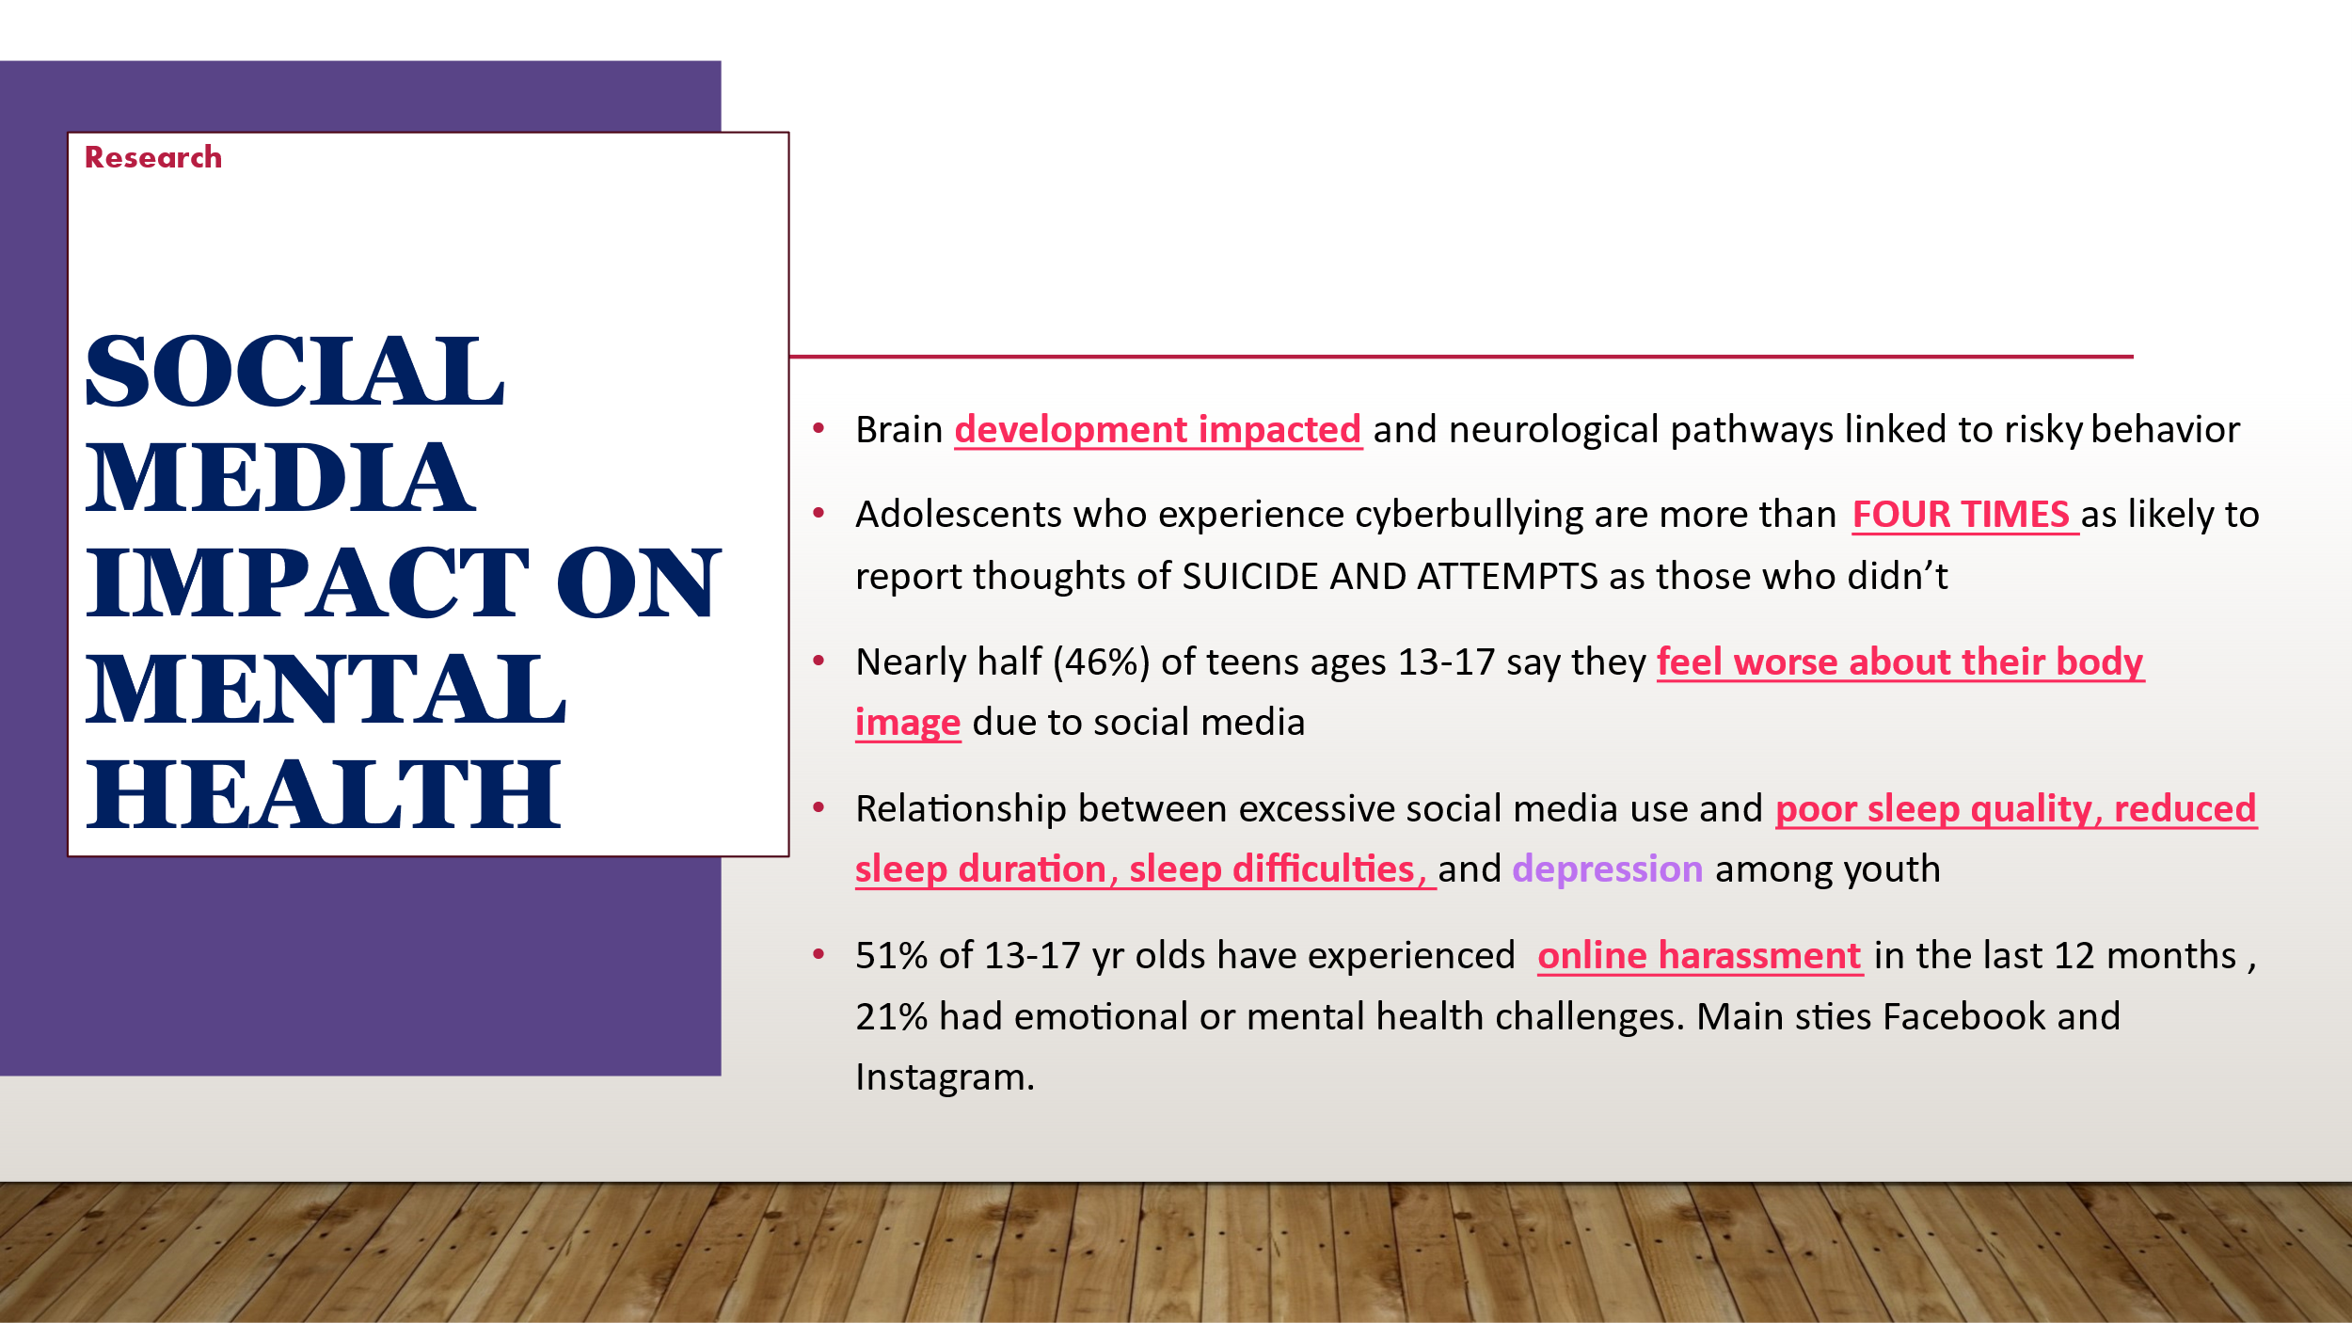  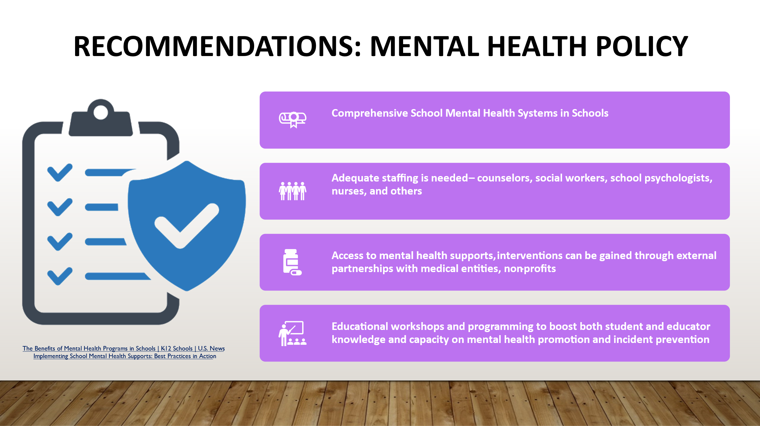  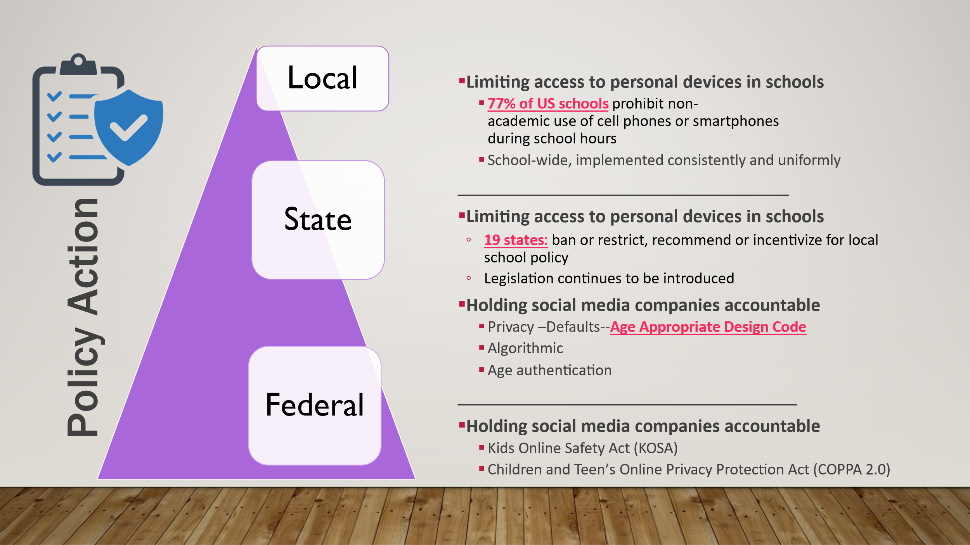  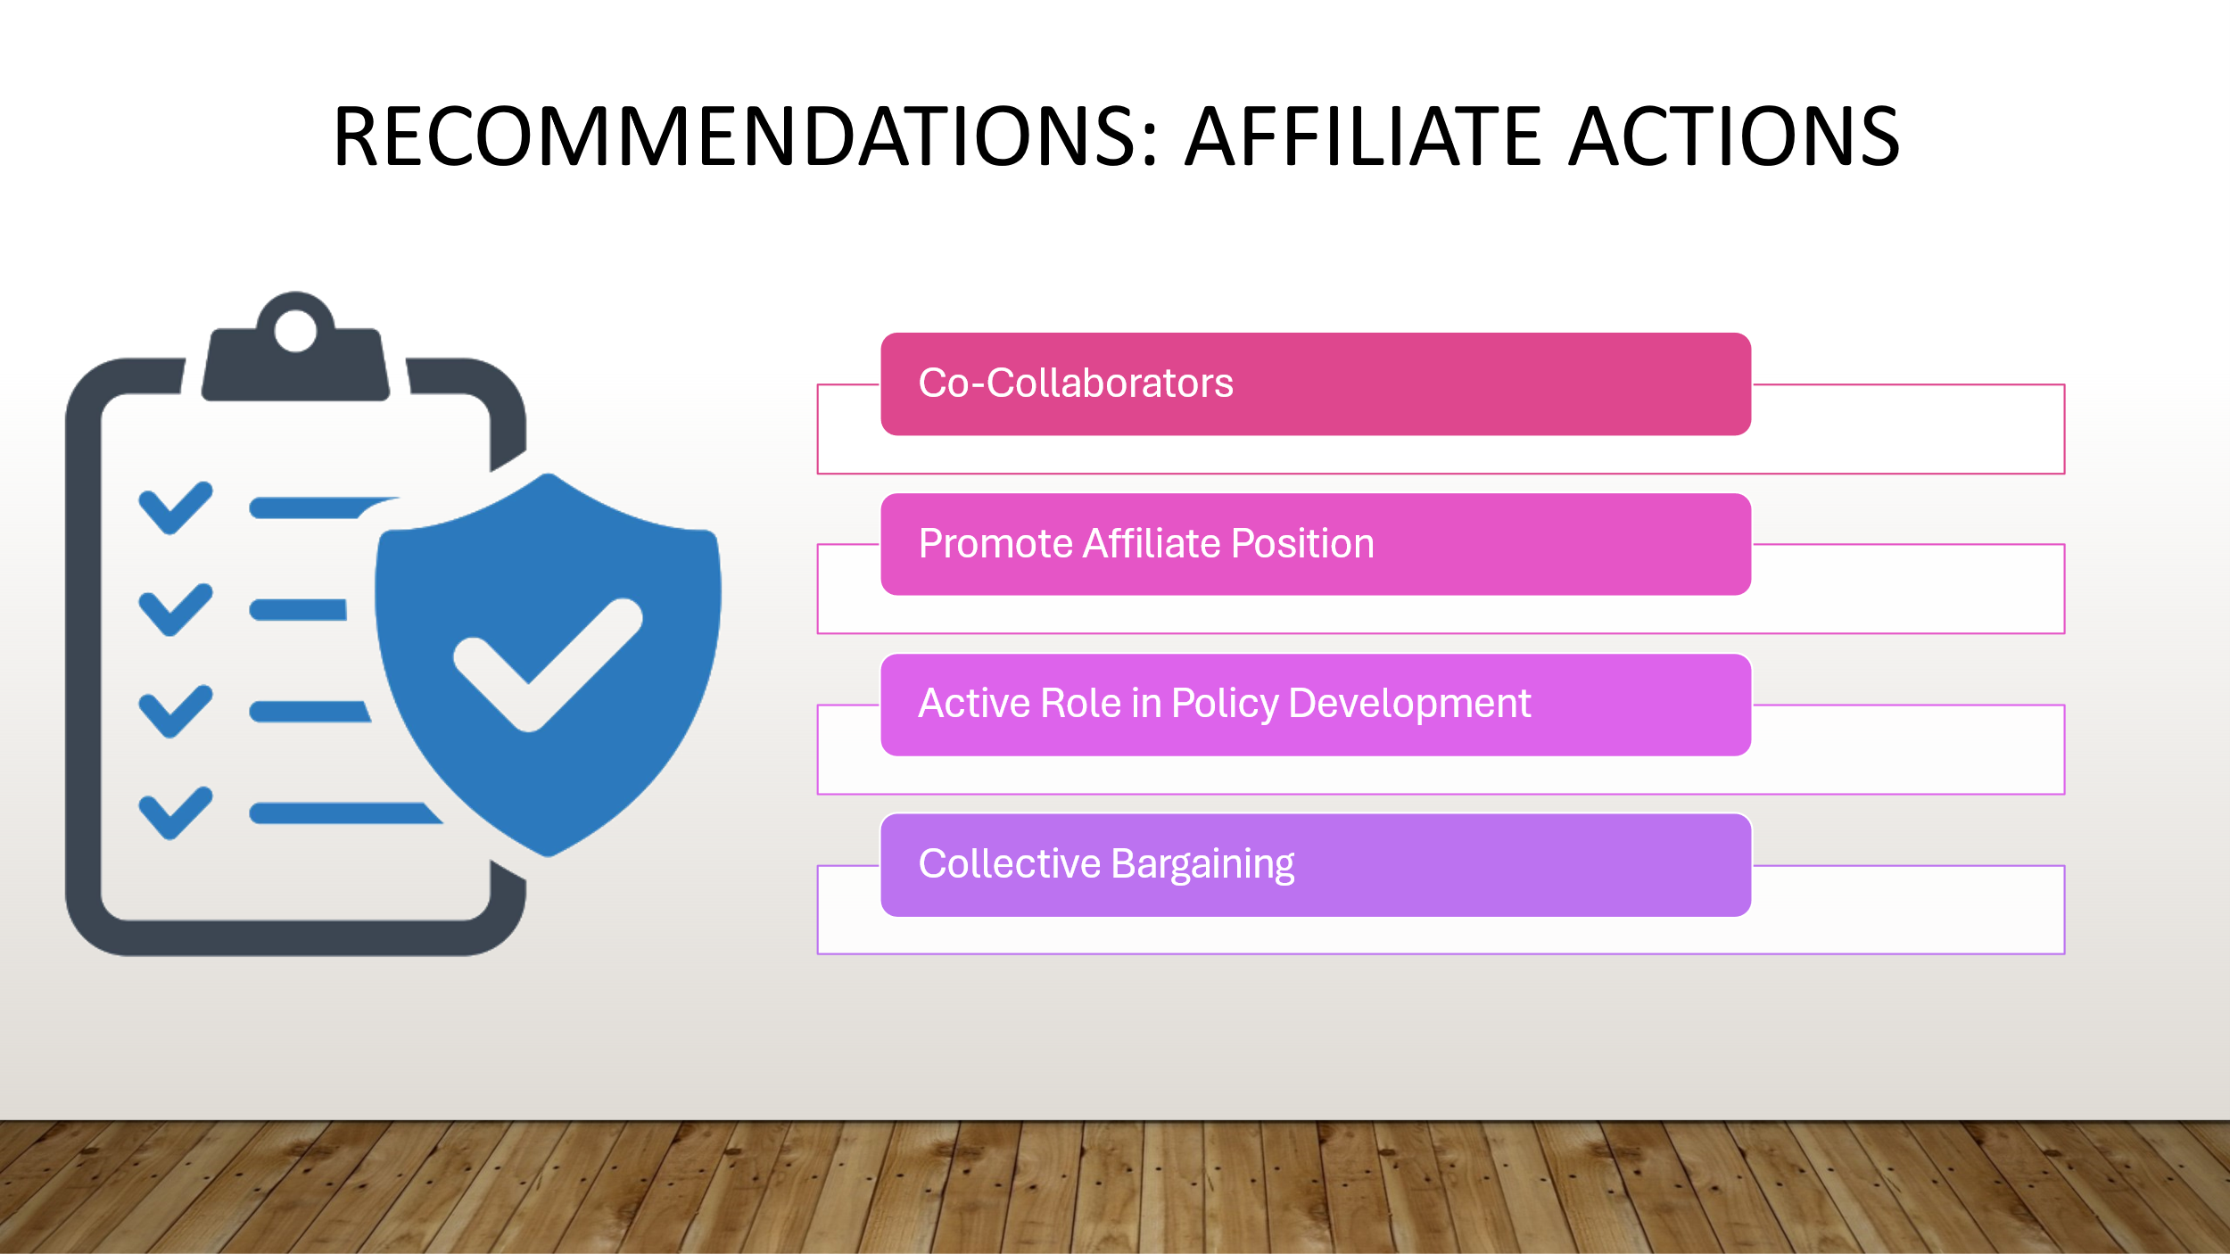 | Resource links:  - APA chief scientist outlines potential harms, benefits of social media for kids  - Cyberbullying linked with suicidal thoughts and attempts in young adolescents | National Institutes of Health (NIH)  - Social Media & Eating Disorders: Statistics, Pros & Cons  - Interplay between social media use, sleep quality, and mental health in youth: A systematic review - ScienceDirect  - Online-Hate-and-Harassmen-2023_0_0.pdf |  | [Activity] Open question for participants in the chat or mic themselves to share what they know or have heard is going on in their state about addressing the mental health concern with student access to cellphones and social media  ** Chad and Crystal can send chat comments to MaryBeth during slides 9-13  Review NEA member polling from the summer of 2024. Will share with participants what NEA members are seeing in schools pertaining to: students personal device use, the health concerns from using social media, the disruption the cause to the learning environment and what educators would support in the form of policy to reduce personal device use that would positively impact the health of students  provide current data on the detrimental impact on student mental health when using social media.  Online harassment can include many types of unwanted or hostile contact on digital platforms–including social media, chat, and email–such as verbal abuse, hate speech, trolling, spamming, impersonation, and defamation. More severe forms include ongoing harassment campaigns, sexual harassment, stalking, doxing4, and swatting5. By hate, we mean abuse and harassment targeting someone for their identity, specifically as part of a marginalized group  Share the policy action that is taking place at the local, state and federal level to address policy on limiting personal devices use in schools and/ or corporate accountability to improve the online safety and privacy of students. while we can limit cell phones addressing what students access and how also needs to be looked at.  Share suggestions that affiliates can take to address policy on personal device use to positively impact the mental health of students.  - Co-Collaborators  - Lobby for policies and laws  - Engage in coalitions  - Focus groups to gain community and affiliate insight  - Promoting the affiliate position  - Op-Ed  - Resolutions  - Concern for student mental health  - Educator safety  - Active Role in Policy Development  - Advise on policy language  - Share policy examples  - Support data collection  - Collective Bargaining |  | Outcome:  Participants will begin learn about the research around social media use and state affiliate positions on policy responses, as well as the broad categories of policy and action  Rationale: Participants should have a broad understanding of the issue as well as have a general understanding of policy and action structures
+0:50 / 15 min  Applying specific staff actions to the broader policy and action structure  Introducing the pathways to action tool  Slide 15-20 | 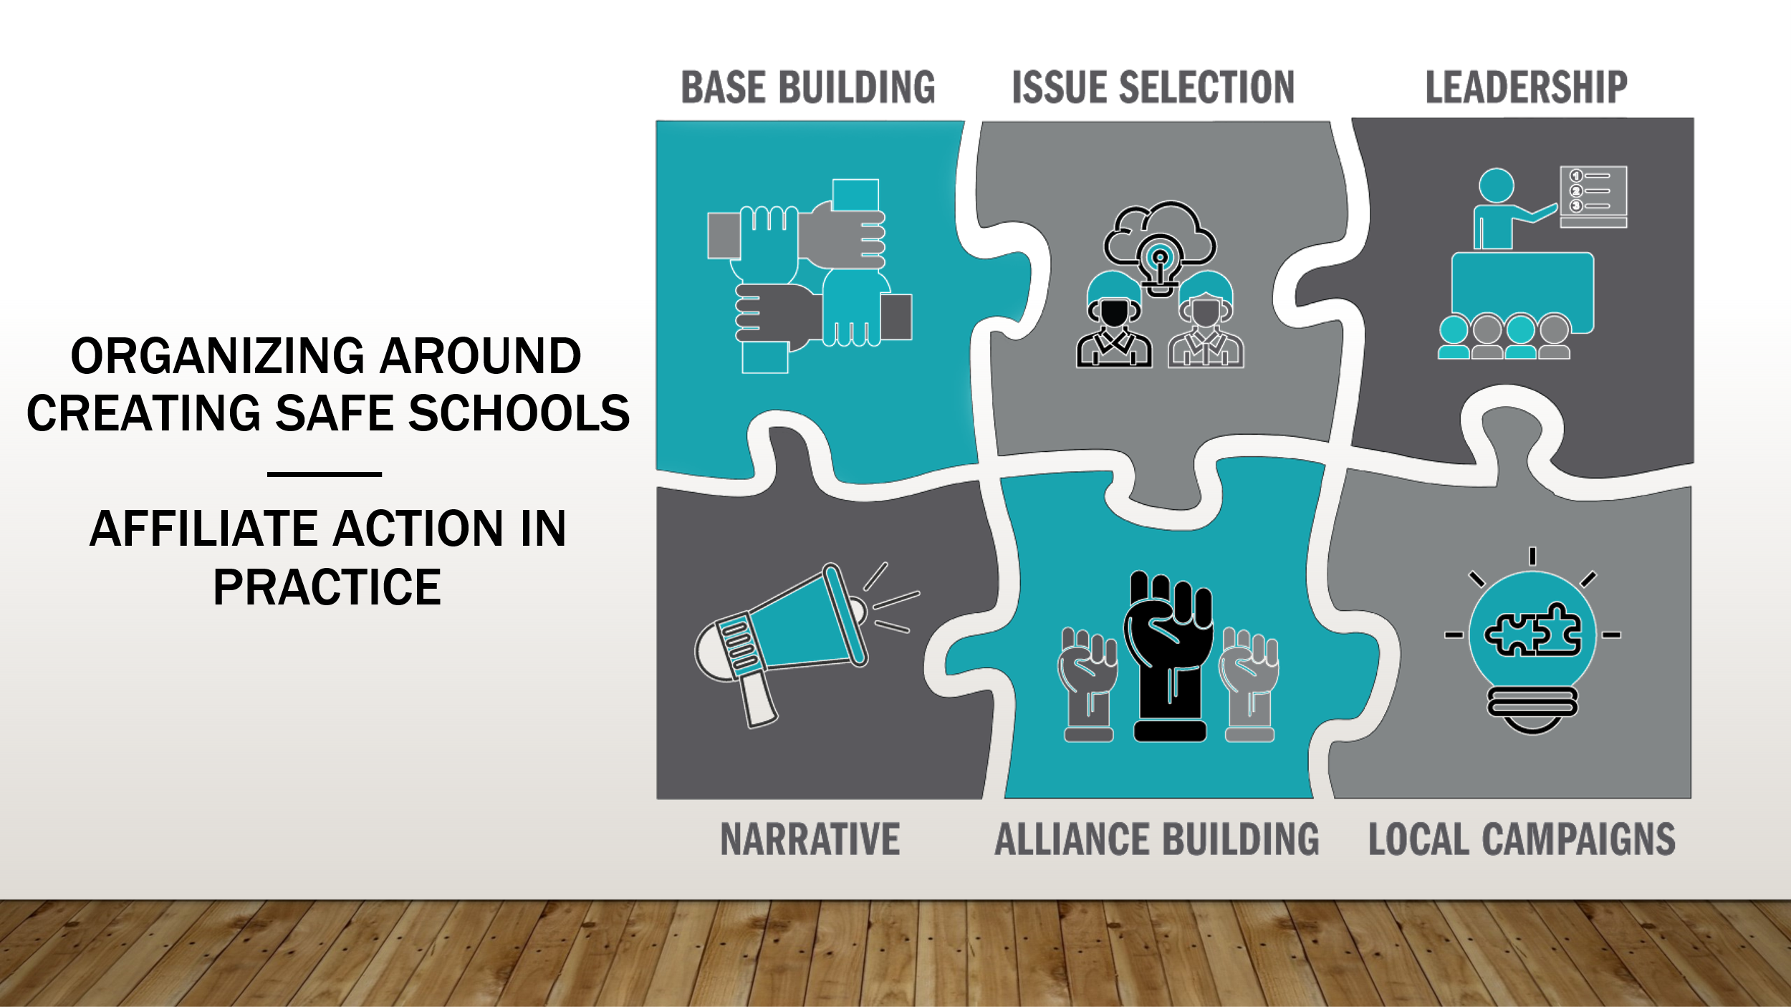  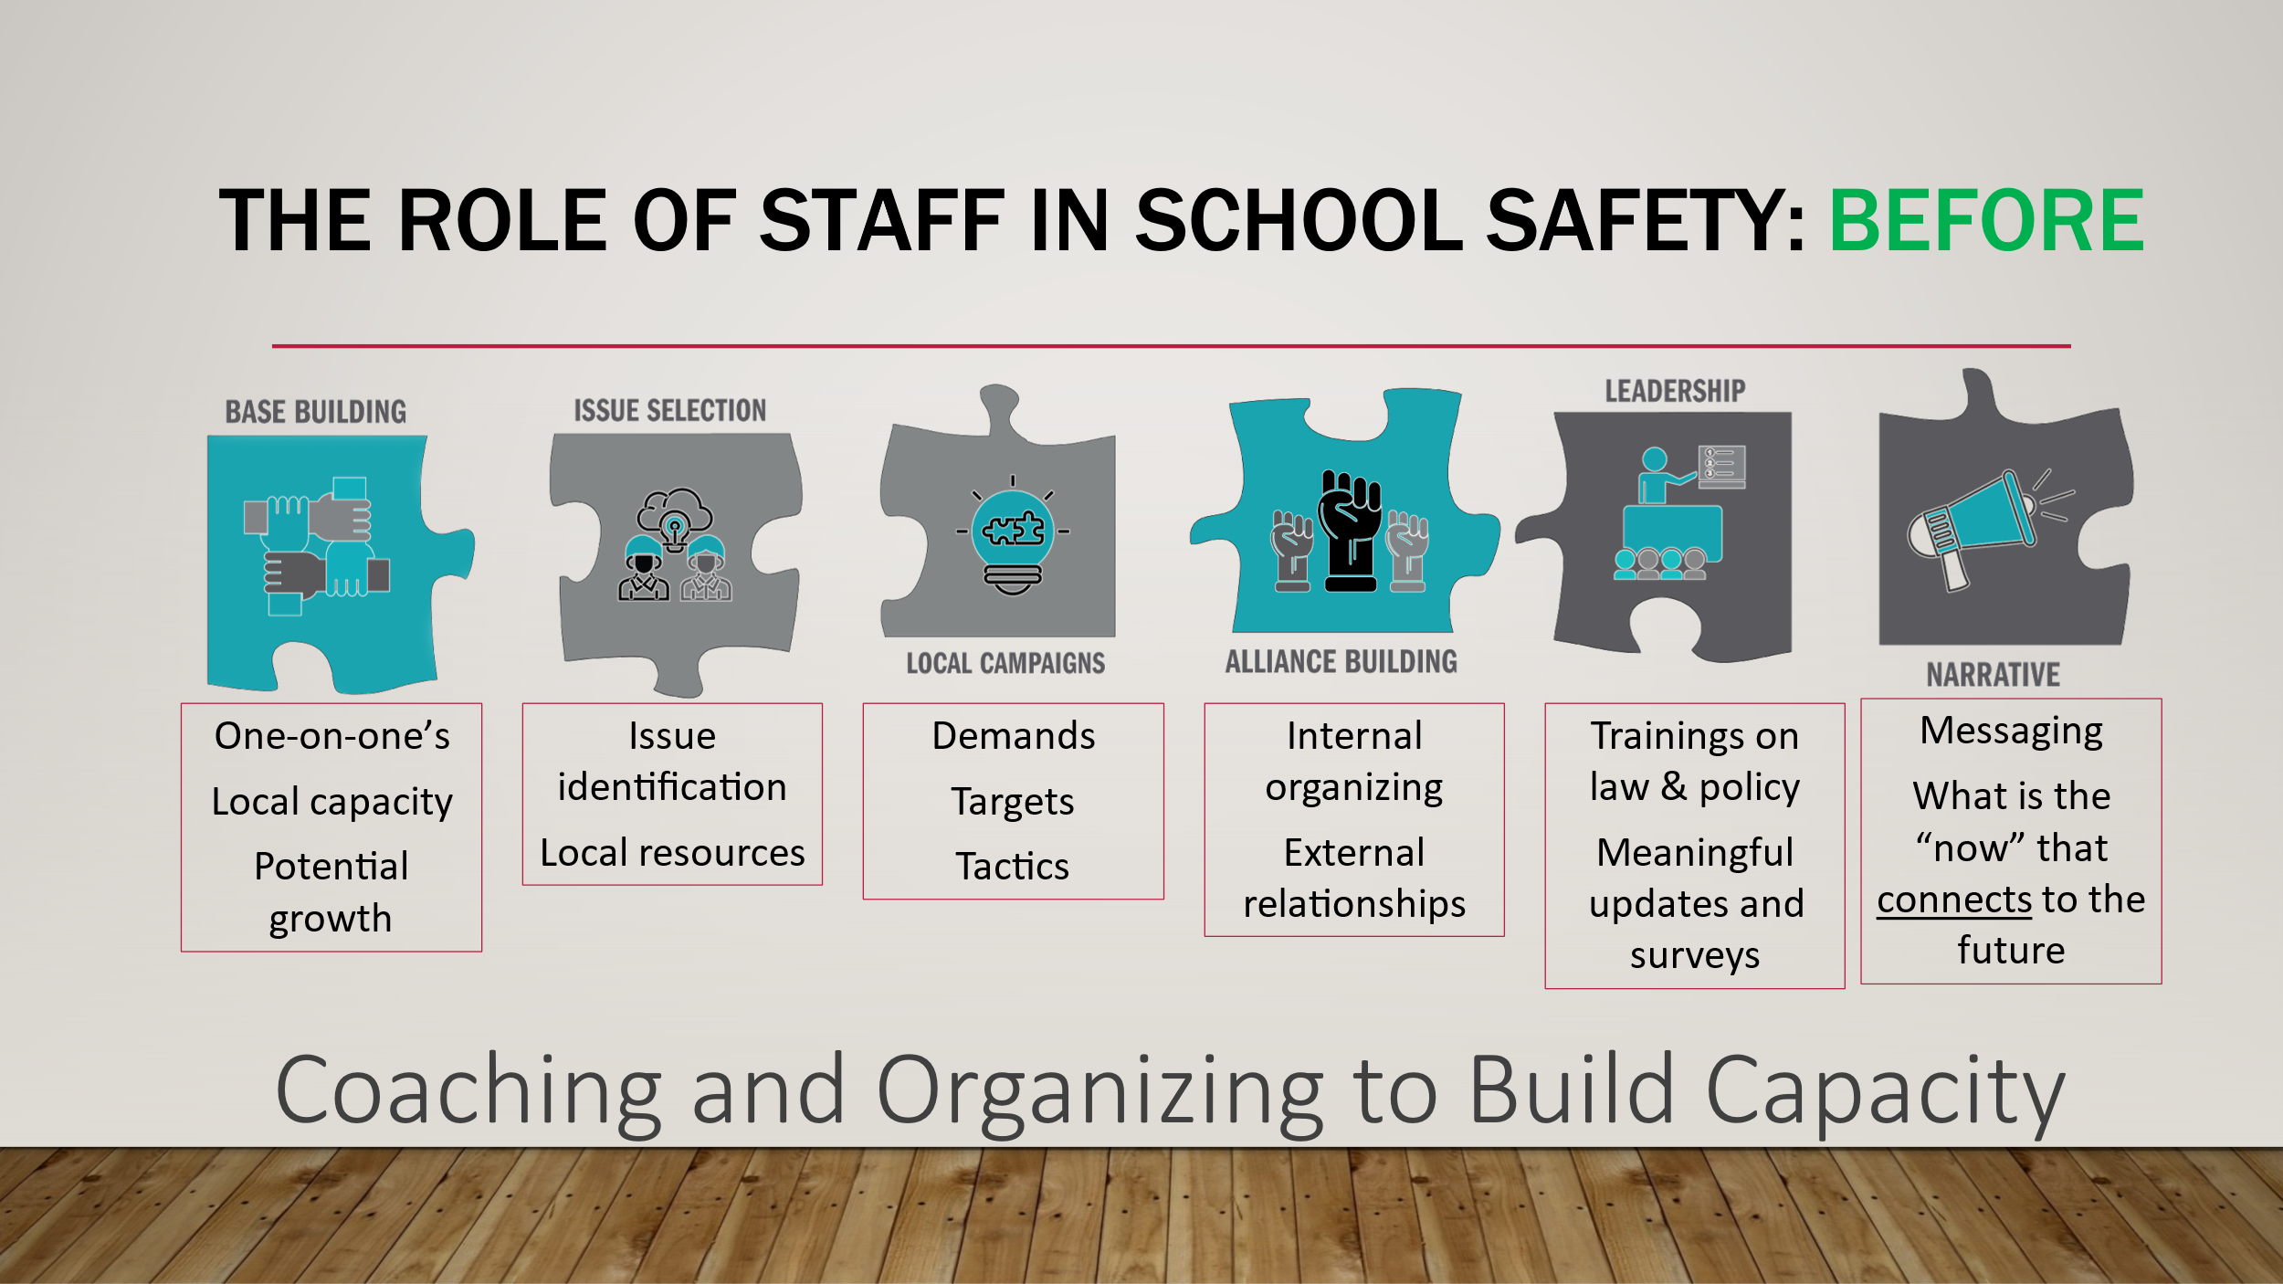  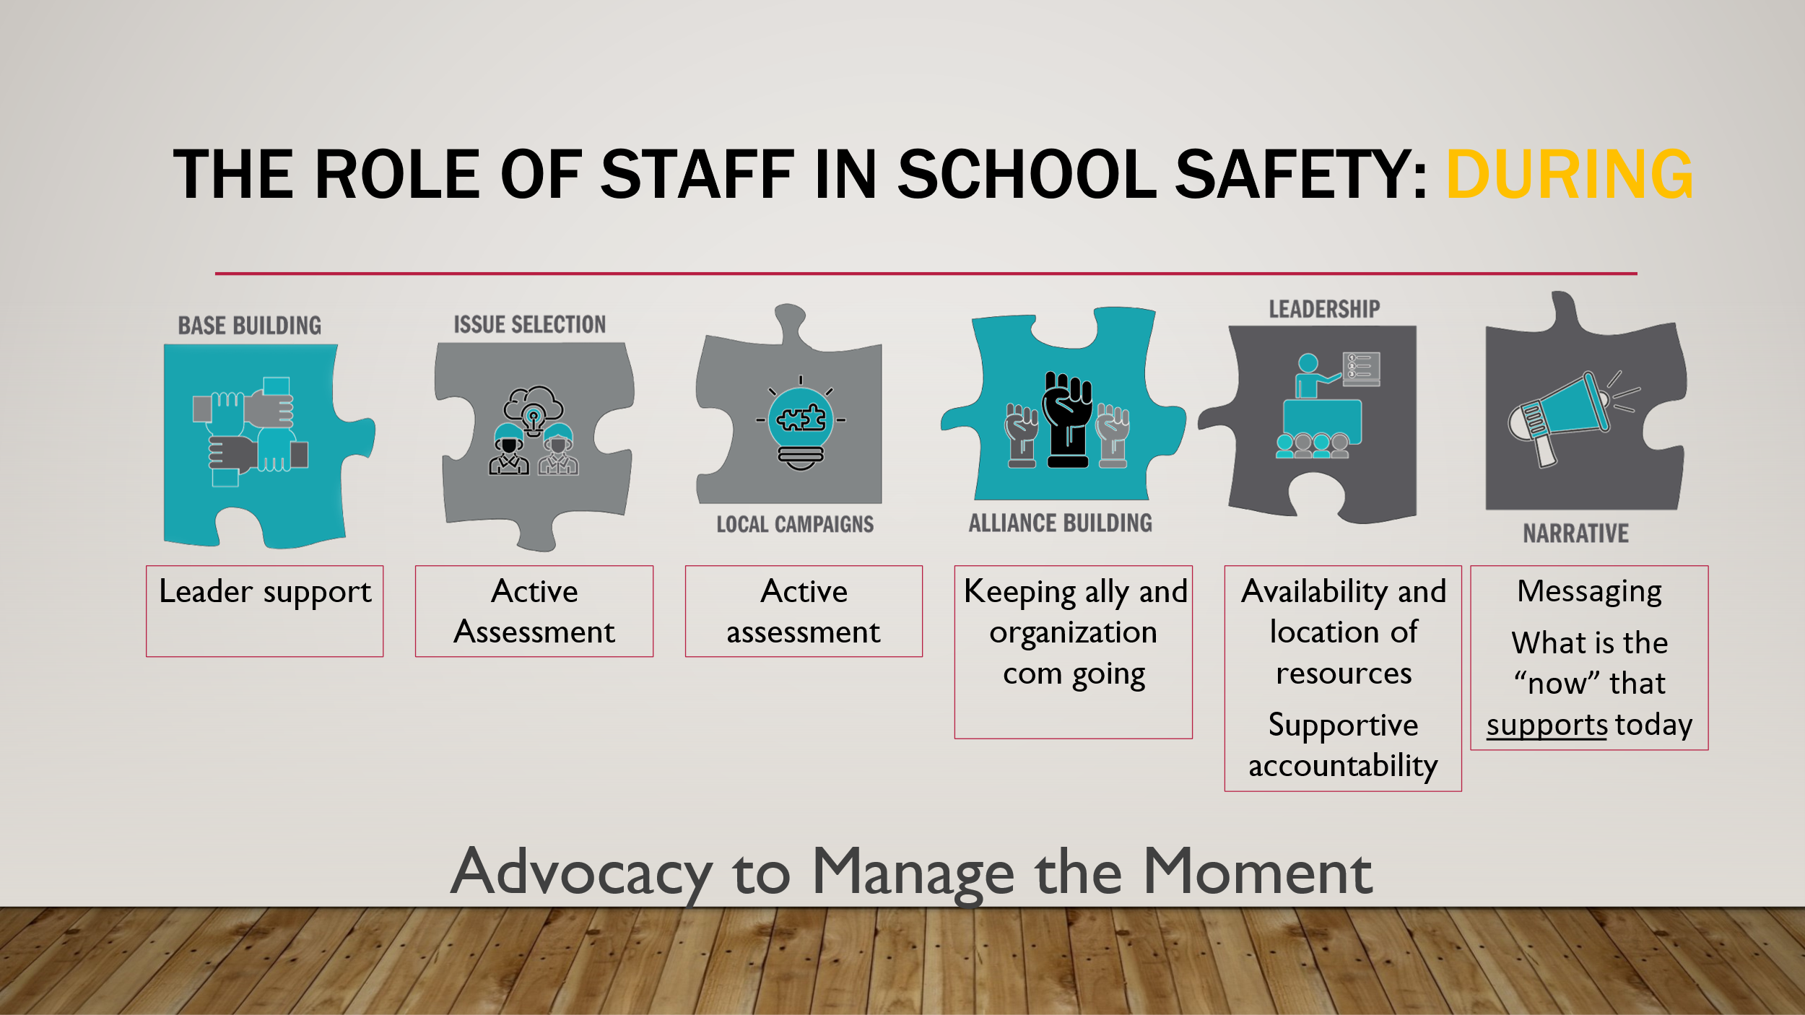  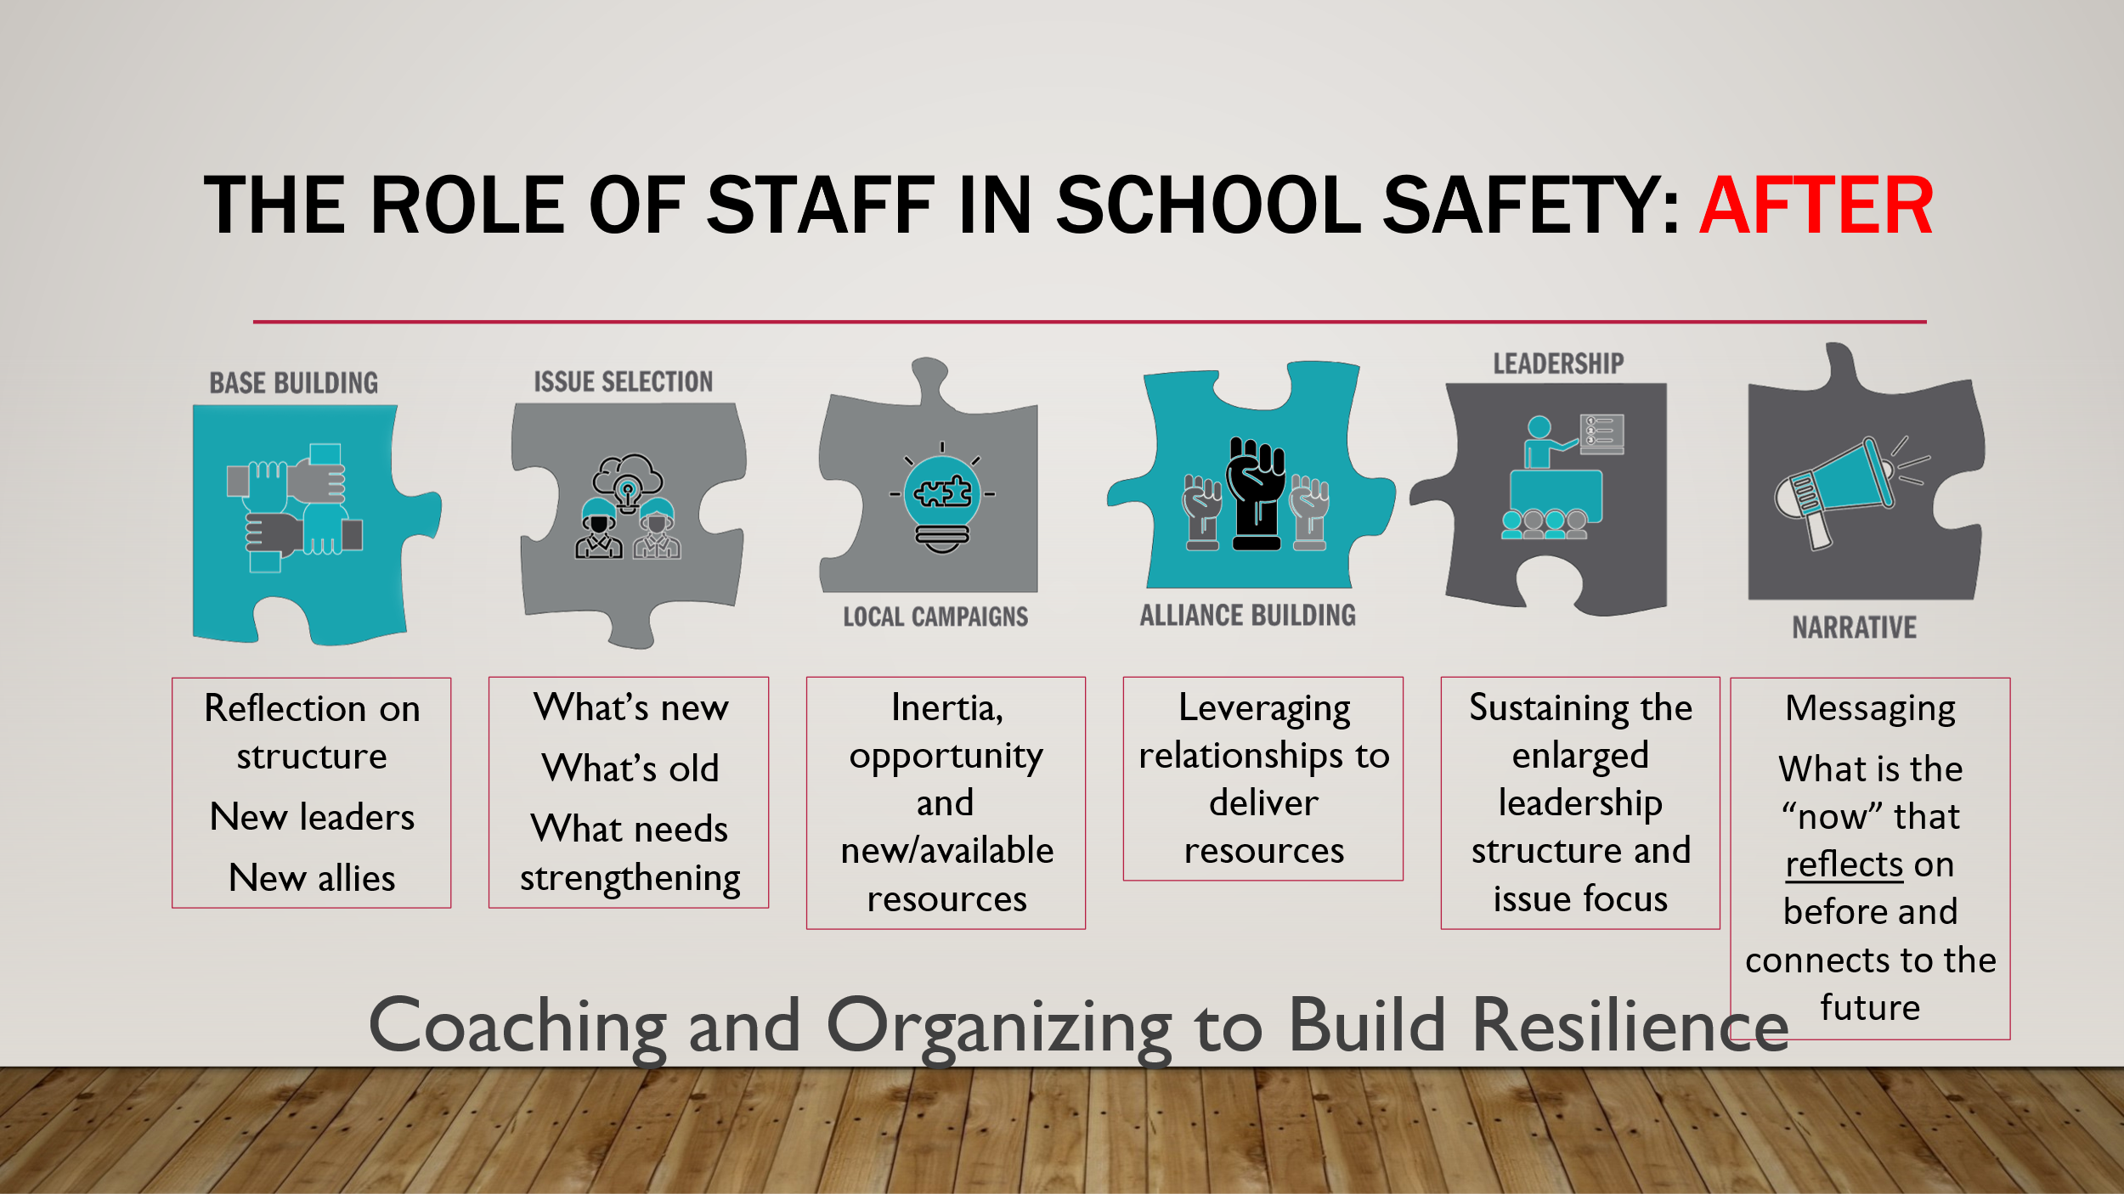  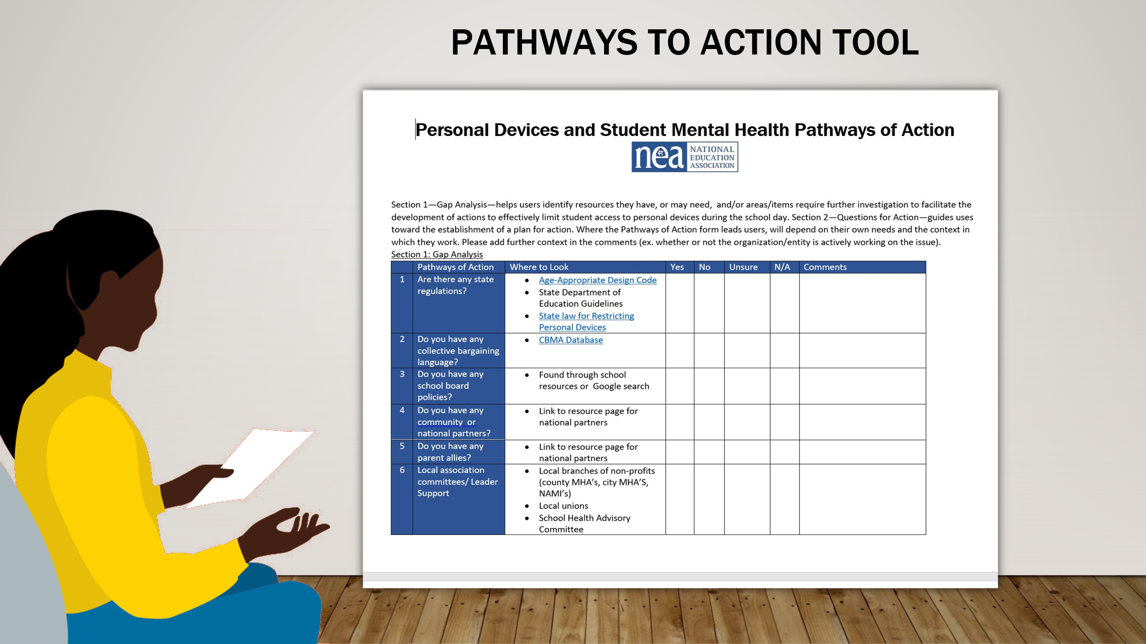  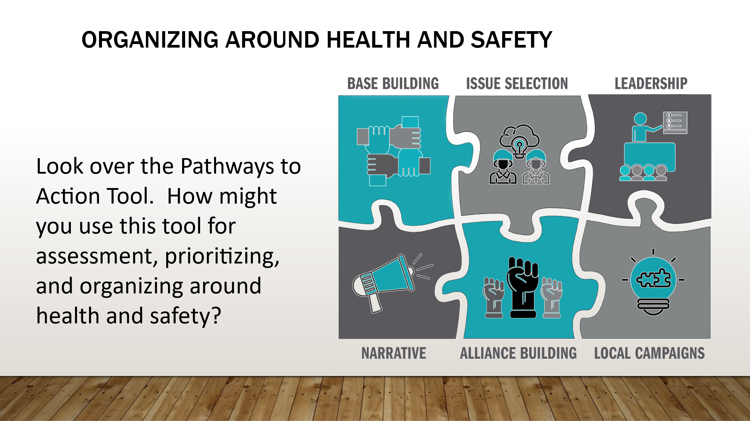 | Pathways to action tool |  | Resource: Chad  WHAT MAKES HEALTH AND SAFETY A GOOD ORGANISING ISSUE? Building organizing unions  Look over the Pathways to Action Tool. How might you use this tool for assessment, prioritizing, and organizing around health and safety?  We have provided an overview of School Safety, the foundations of building safe school culture and some considerations for action before, during, and after a crisis  Now lets use the lens of organizing, advocacy, and coaching to examine what we can do in the same context--  Think about these in the context of before , during, and after  Introduction to scenario  Preview- Role of Staff – Before During and After  Chad- Before Considerations  Coaching and organizing in the prevention and preparation phase  Response  Recovery- is also a sequence of preparation and organizing  ** What would staff do in each phase  CHAD-  We have provided an overview of School Safety, the foundations of building safe school culture and some considerations for action before, during, and after a crisis  Now lets use the lens of organizing, advocacy, and coaching to examine what we can do in the same context--  Think about these in the context of before , during, and after  Introduction to scenario  Preview- Role of Staff – Before During and After  Chad- Before Considerations  Coaching and organizing in the prevention and preparation phase  Response  Recovery- is also a sequence of preparation and organizing  ** What would staff do in each phase  Chad- Gap Analysis-  Frame role of staff in what they should consider or be doing in the three phases ( 5 min)  *** Put a Text box under each icon  **Chad – During  Coaching and organizing Before an incident  - Examples of what staff can do to:  - Understand organizing landscape  - Identify winnable objectives  - Determine Campaign Objectives  - Engage stakeholders  - Communicate  promotes physical and psychological safety  Chad- Frame role of staff in what they should consider or be doing in the three phases  *** Put a Text box under each icon  Coaching and organizing During a Crisis  - Examples of what staff can do to:  - Understand organizing landscape  - Identify winnable objectives  - Determine Campaign Objectives  - Engage stakeholders  - Communicate  Chad-- Frame role of staff in what they should consider or be doing in the three phases  *** Put a Text box under each icon  Coaching and organizing After a Crisis  - Examples of what staff can do to:  - Understand organizing landscape  - Identify winnable objectives  - Determine Campaign Objectives  - Engage stakeholders  - Communicate  Chad -- Pathways to action tool – link here to mental health one -- Social Media/ Device Usage  [Activity] Break out session 10 minutes  In the breakout group questions to consider:  - Scan document  - ID a current health and safety issue in your work  - how could you use this  - What way can this tool direct my work in a different way than I typically use? |  | Outcome:  Participants will learn about and connect the specific staff actions and activities to the policy and affiliate action structures related to mental health and school safety, and learn how to use the pathways to action tool to identify gaps and opportunities within their locals  Rationale: We’ve defined the broad structures of policy and affiliate action, now we take the next step to define concrete actions and activities staff should be taking to affect policy and affiliate action in 3 phases: before, during and after a school event.
+1:05 / 20 min  Scenario  Slide 21-24 | 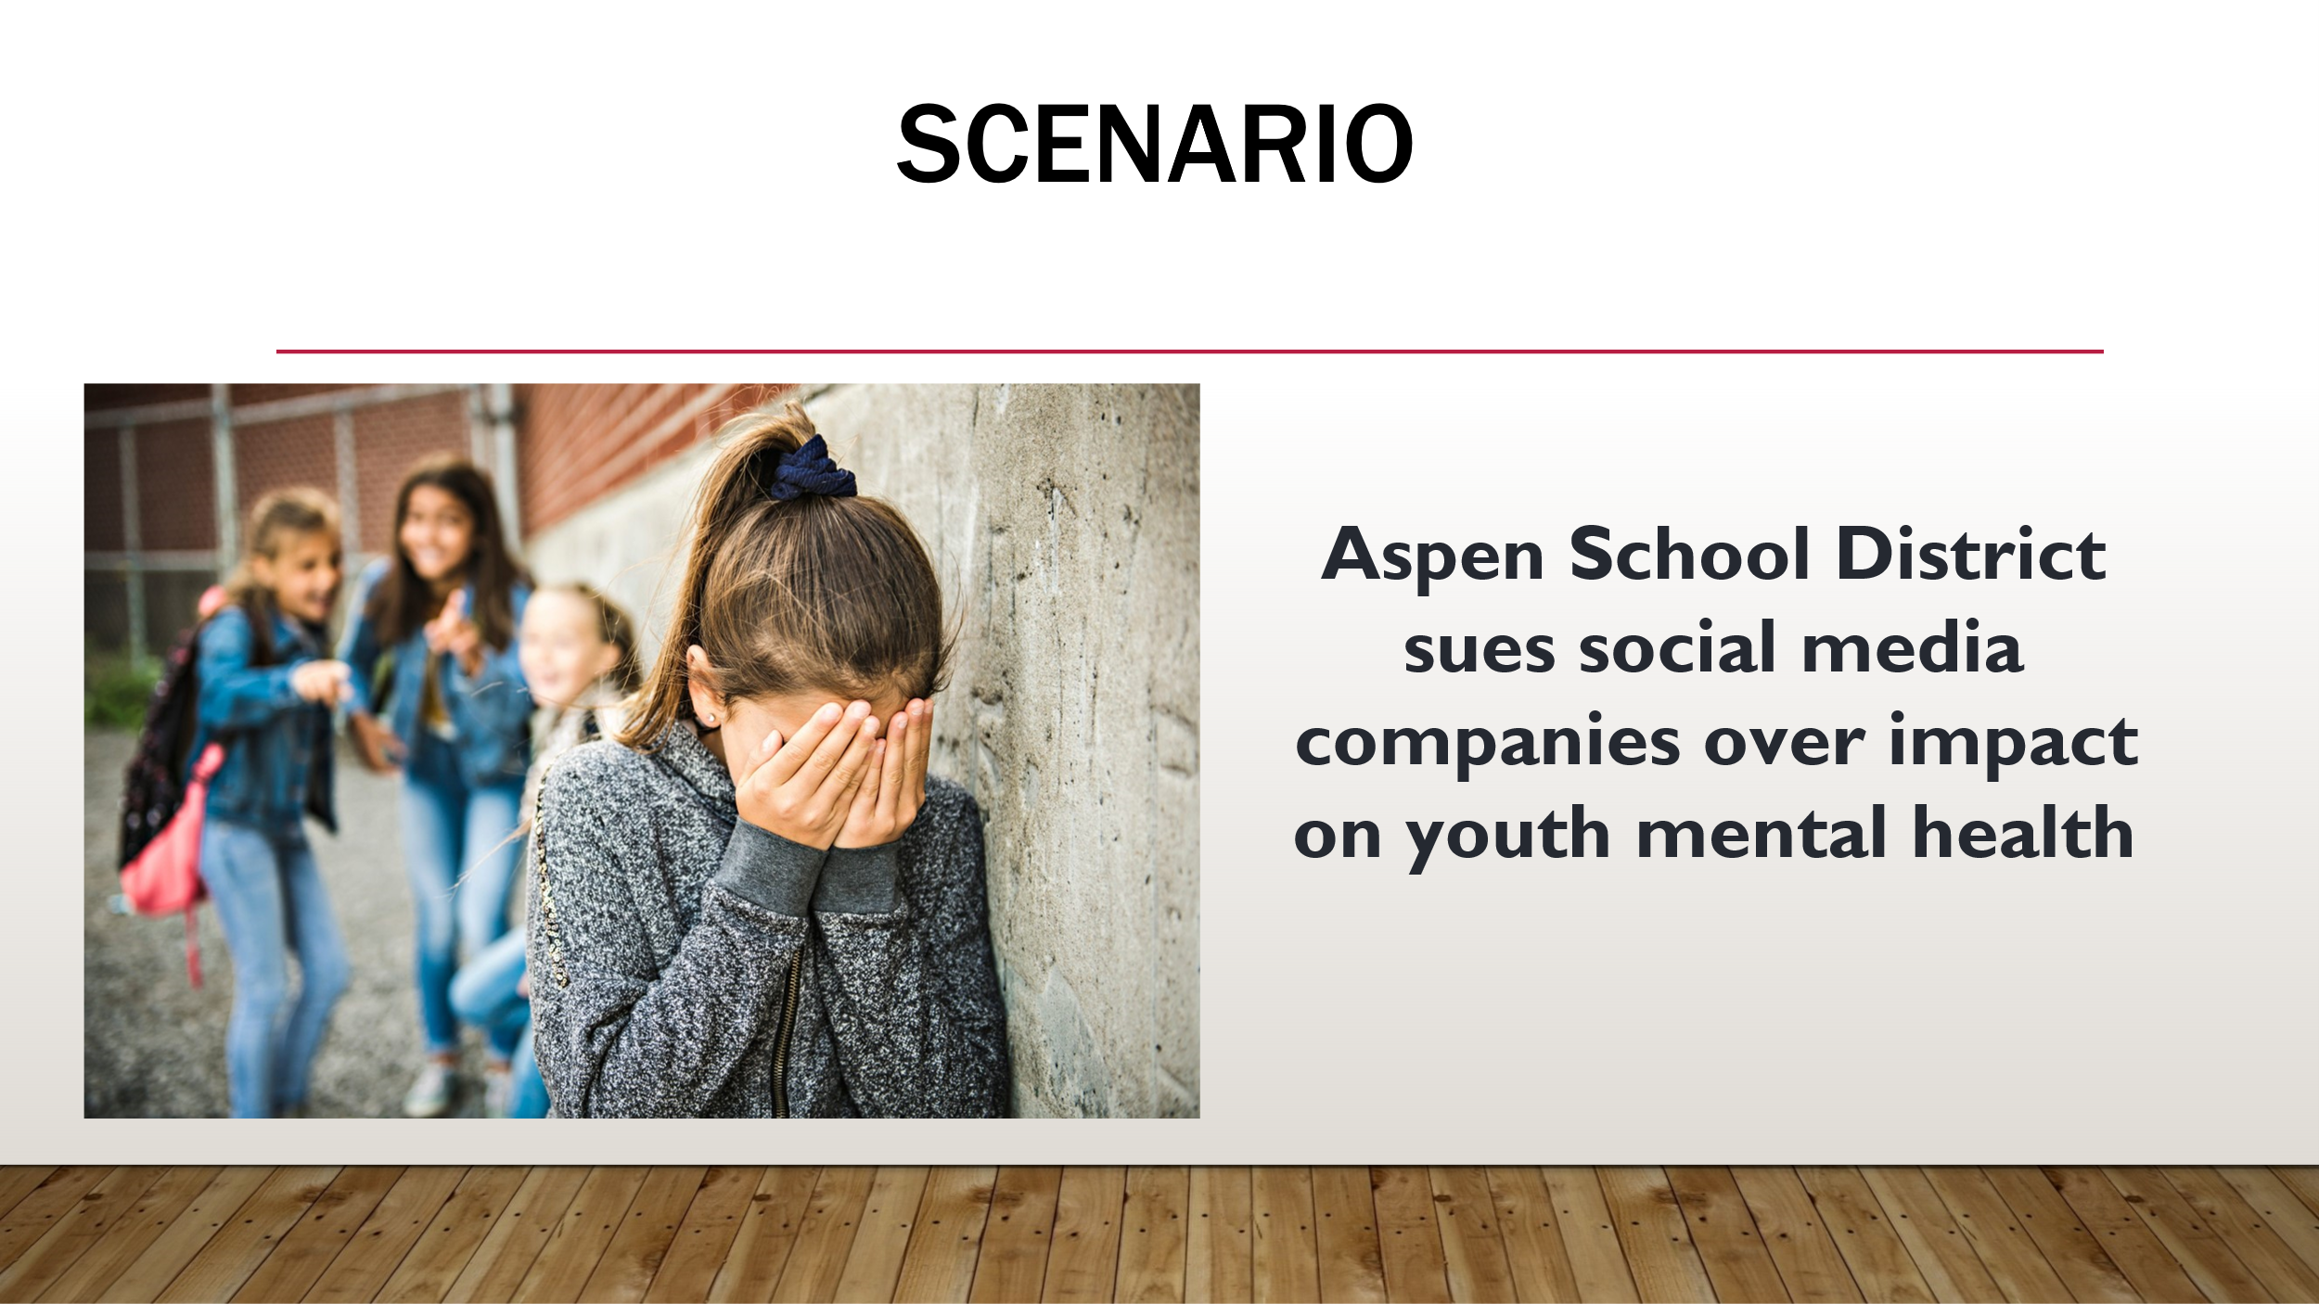  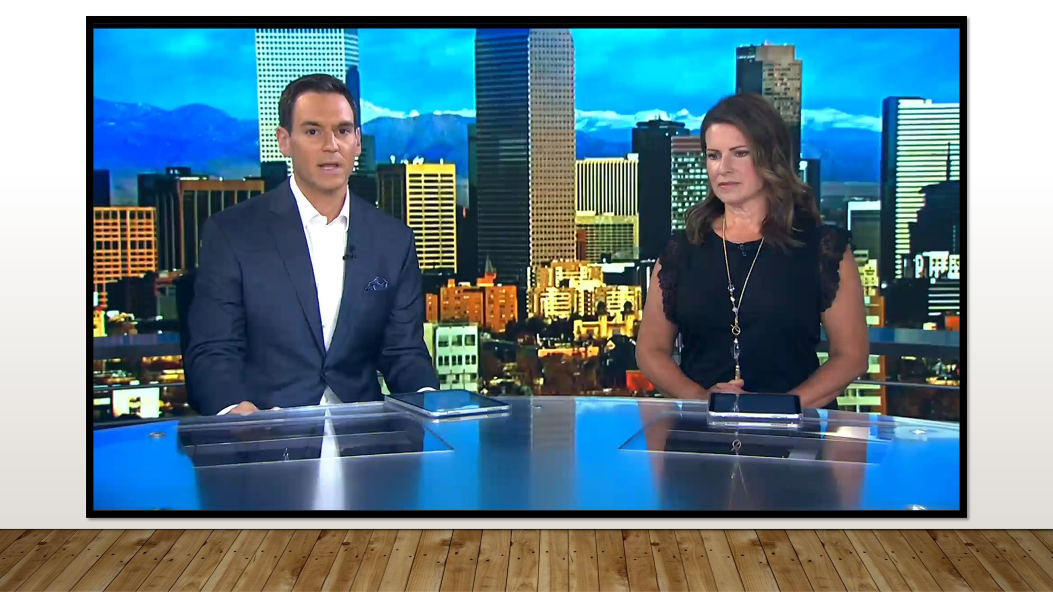  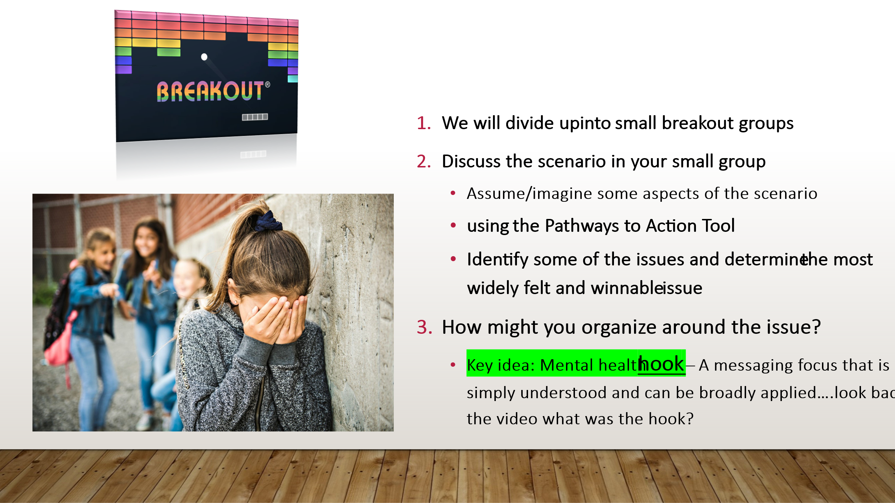  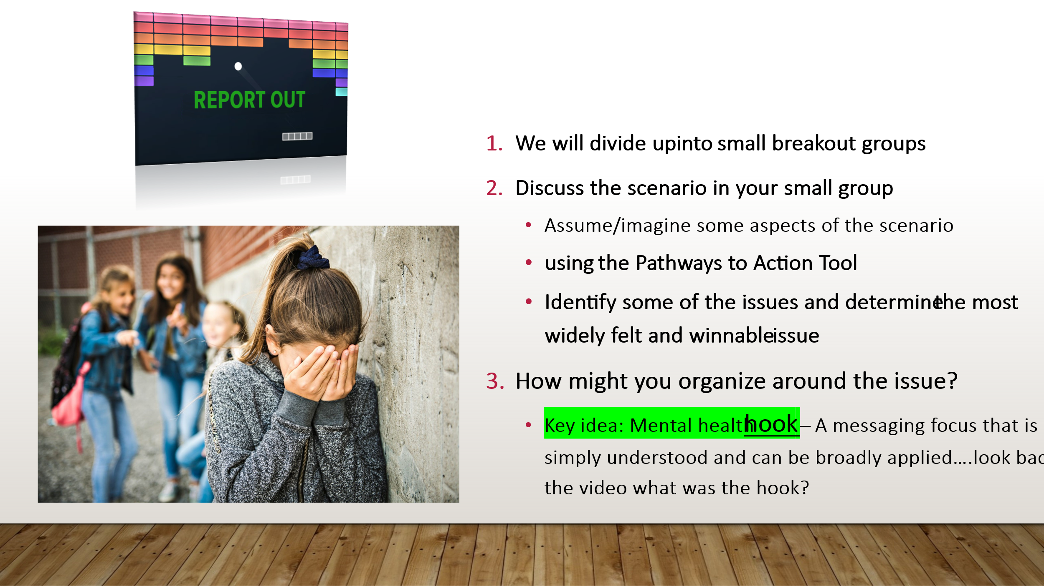 | Scenario Video - Aspen School District - Electronic Devices  Video (2 min run time) |  | Look at adding Educator to Educator Violence – Case Study? Multiple solutions  ** Parent engaging educators to respond to student bullying– and the educator is bullied by the parent  ** Discuss with Chad and UniServ staff  - Social Media Bullying Scenario– Parent and Educator Online Issue  - Ask Participants to Identify the Harm to….Mental Health and Psychological Safety  - Each Breakout group can talk about a different aspect of mental health and safety and a social media issue----  - ***Chad: use the pathway to action tool to center the activity--- Review “where to look” – identify gap areas (possible areas for running a campaign to fill) (Get the document down to 1 page)  Possible questions:  - Impact to Staff- Mental Health and Safety  - Impact to Students – Mental Health and Safety  - Impact to Safe School Culture – Mental Health and Safety  - What Mechanisms are in place to address the issue  What is the objective?  ASK CHAD--? –( If time) Activity – If you were to Build a Campaign  -- Determine Key Components- Show on Slides for a guide- to help them frame the conversations  Who are the targets?  [Activity] Group: 4 groups – go to the month of your birthday – groups done in month quarters Jan-March, etc.)  - We will divide up into small breakout groups ​  - Discuss the scenario in your small group  - Assume/imagine some aspects of the scenario  - using the Pathways to Action Tool  - Identify some of the issues and determine the most widely felt and winnable issue  - How might you organize around the issue?  - Key idea: Mental health hook – A messaging focus that is simply understood and can be broadly applied….look back at the video what was the hook?  - use the pathway to action tool to center the activity--- Review “where to look” – identify gap areas (possible areas for running a campaign to fill) (Get the document down to 1 page) |  | Outcome:  Participants will utilize their knowledge of mental health, social media and school safety as an issue as well as the pathways to action tool and apply that to a real life scenario.  Rationale: Though each staff person will have their own frame and experience with mental health, social media and school safety, there are some consistent concepts and techniques that can be applied to address the issue and identify potential issue campaigns
+1:25 / 5 min  Action steps and take aways  Slide 25-28 | 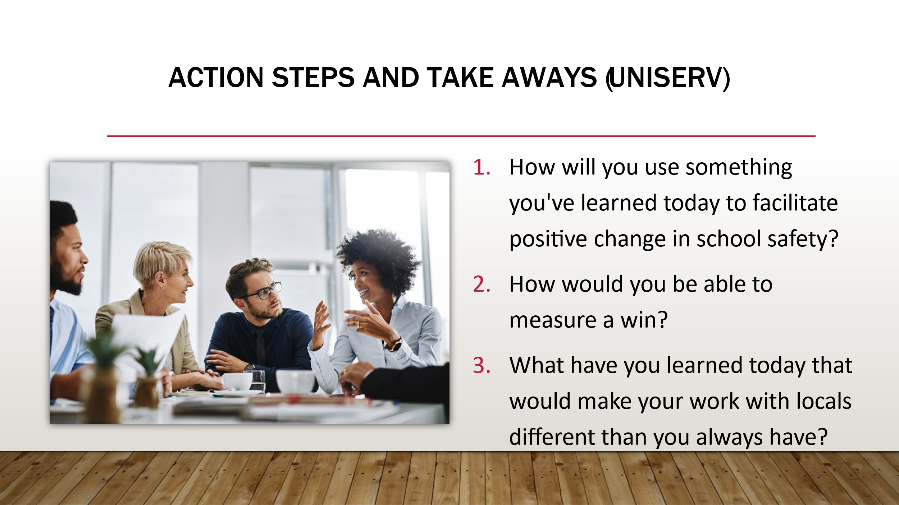  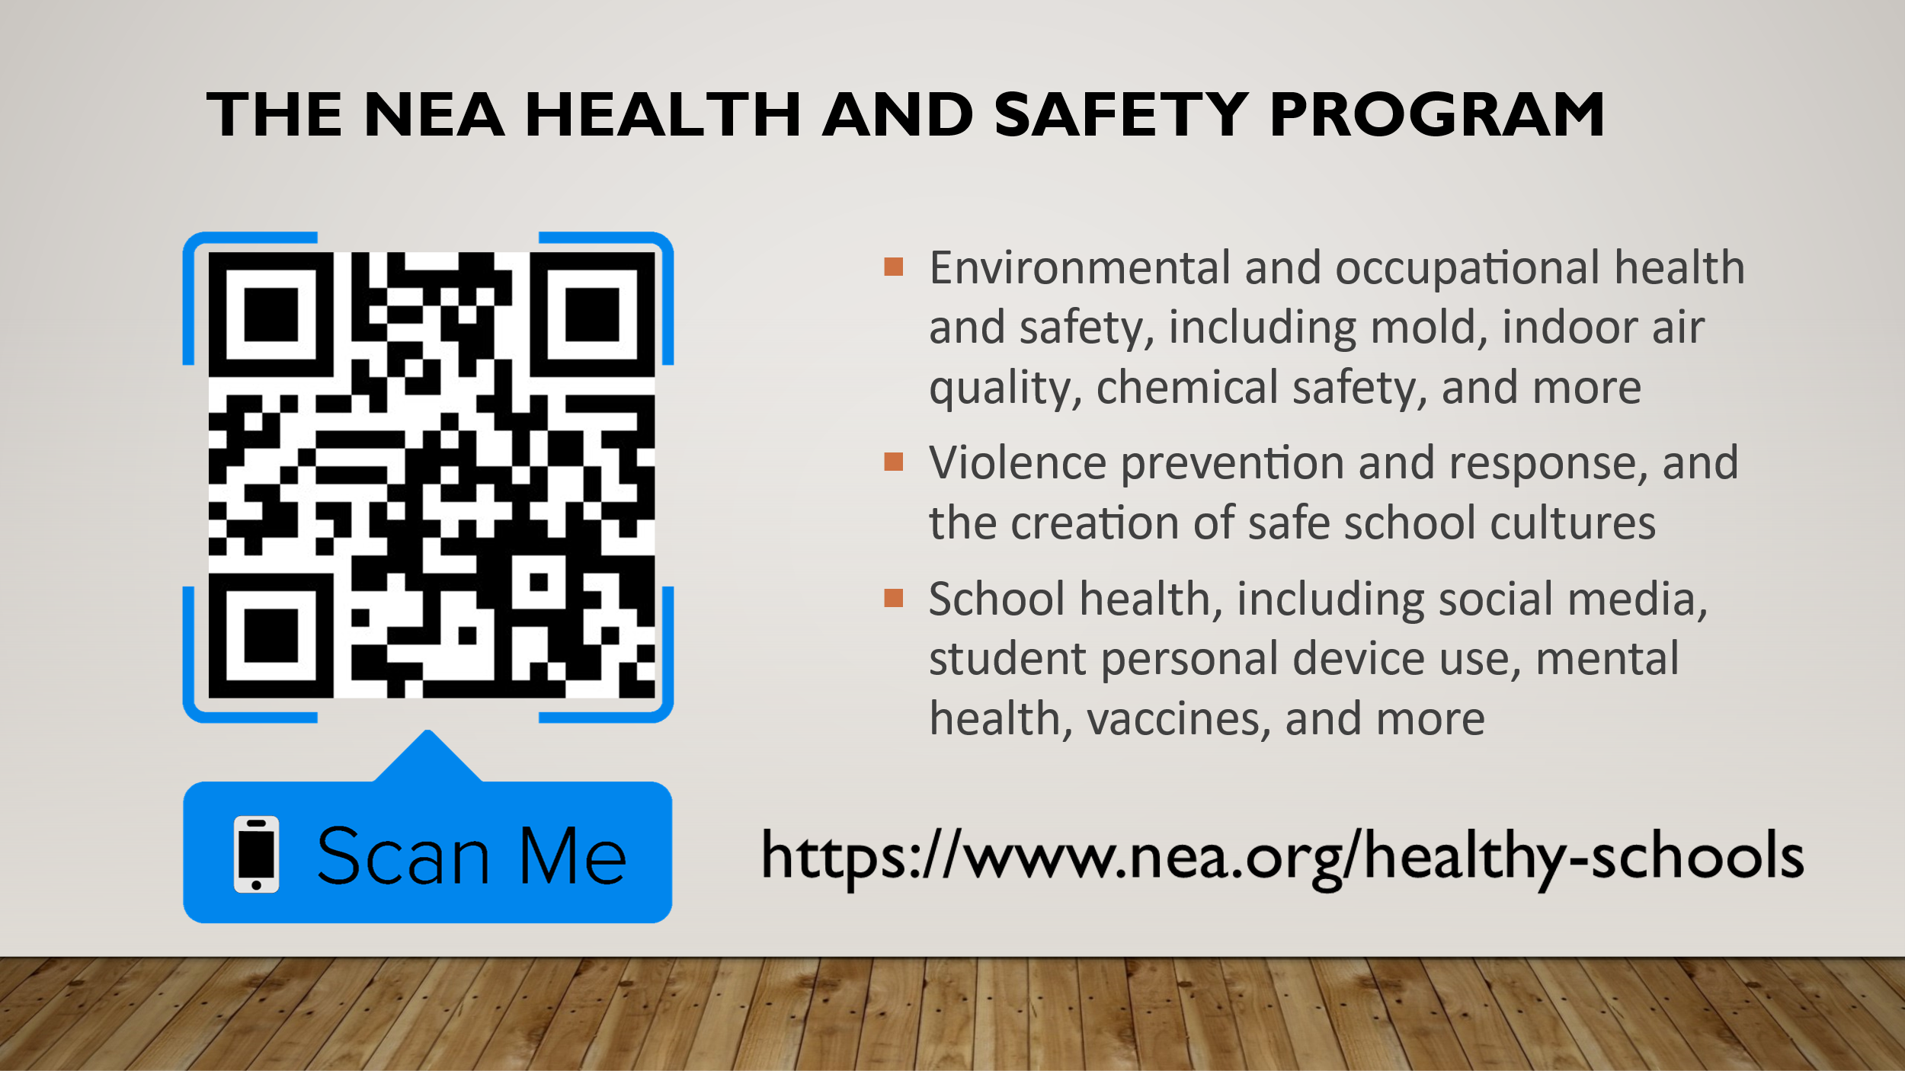    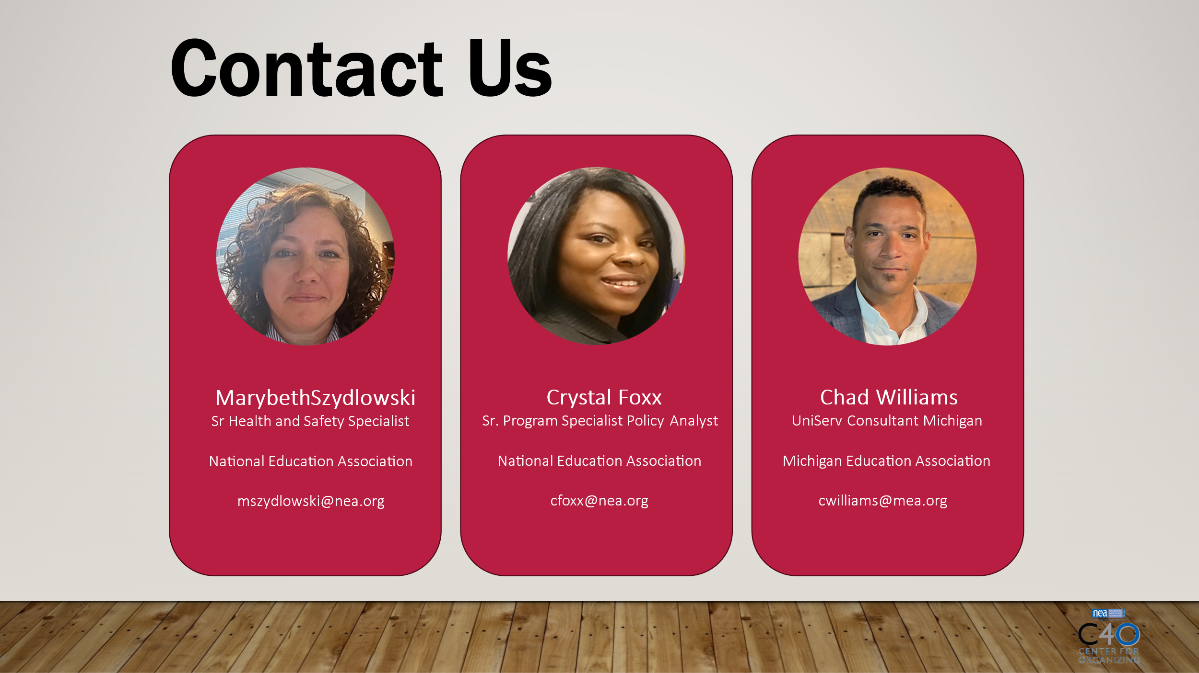 | Add a link in the chat ** Get QR Code for Brochure  School Health & Safety | NEA  Evaluations  https://forms.office.com/r/PBp0r3QXNN |  | How can we use this to support our locals?  What have you learned today that would make your work with locals different than you always have?  how can you use this toolkit to challenge your work to try a new avenue of thinking to solve health and safety issue  In your work  Crystal - Health and Safety Program Information and Resources  Add a link in the chat ** Get QR Code for Brochure  School Health & Safety | NEA  ** Discuss what we offer and how we can individualize request**  In the next few slides, I will be sharing and explaining the variety of NEA resources available to staff and members, as well as briefly review the relevant agencies and organizations that staff can obtain health, safety, and policy information.  - mention resources specific to pathways to action and what resources we have that could be useful in the pathways  ** Add additional resource links– bargaining resources

