Online Facilitator Agenda
Safe Schools: Tools and Strategies to Address Gun Violence in Schools
General Materials Needed: |  |  |  | Room Set-up:
Key Outcomes for the Event:

Increased Knowledge of the Guide
- Participants will be able to identify the four phases of the NEA School Gun Violence Prevention and Response Guide (Prevention, Preparation, Response, Recovery) and understand their purpose.
Application of Advocacy & Organizing Tactics
- Participants will connect the guide’s strategies to core union staff functions—member engagement, issue identification, leadership development, and power building.
Scenario-Based Problem Solving
- Participants will apply the guide to a realistic school gun violence scenario, analyzing how coaching, advocacy, and organizing tactics shift across phases.
Capacity Building for Locals
- Participants will conceptualize ways to integrate the guide into ongoing union work so that locals are better prepared, more resilient, and able to collectively advocate for safer schools.
Commitment to Action
- Participants will leave with one specific next step they can implement in their local or state context to strengthen readiness and response to gun violence issues.

Time | Essential Questions | Resources | Instructions, Activity and Debrief (Facilitators) |  | Outcomes
 | What question(s) should this learning section answer? | Charts, handouts, articles, materials, slide  RED is for Facilitator  BLUE is for Participant | What are you saying, what are they doing, what questions will you use to guide learning and make clear the important points  Include an estimate for how long each section of the learning will take |  | As a result of this section of learning, what will participants know or be able to do?
2:00 – 2:30 | Zoom opens - Facilitator tech check and adjustments
Entry Activity  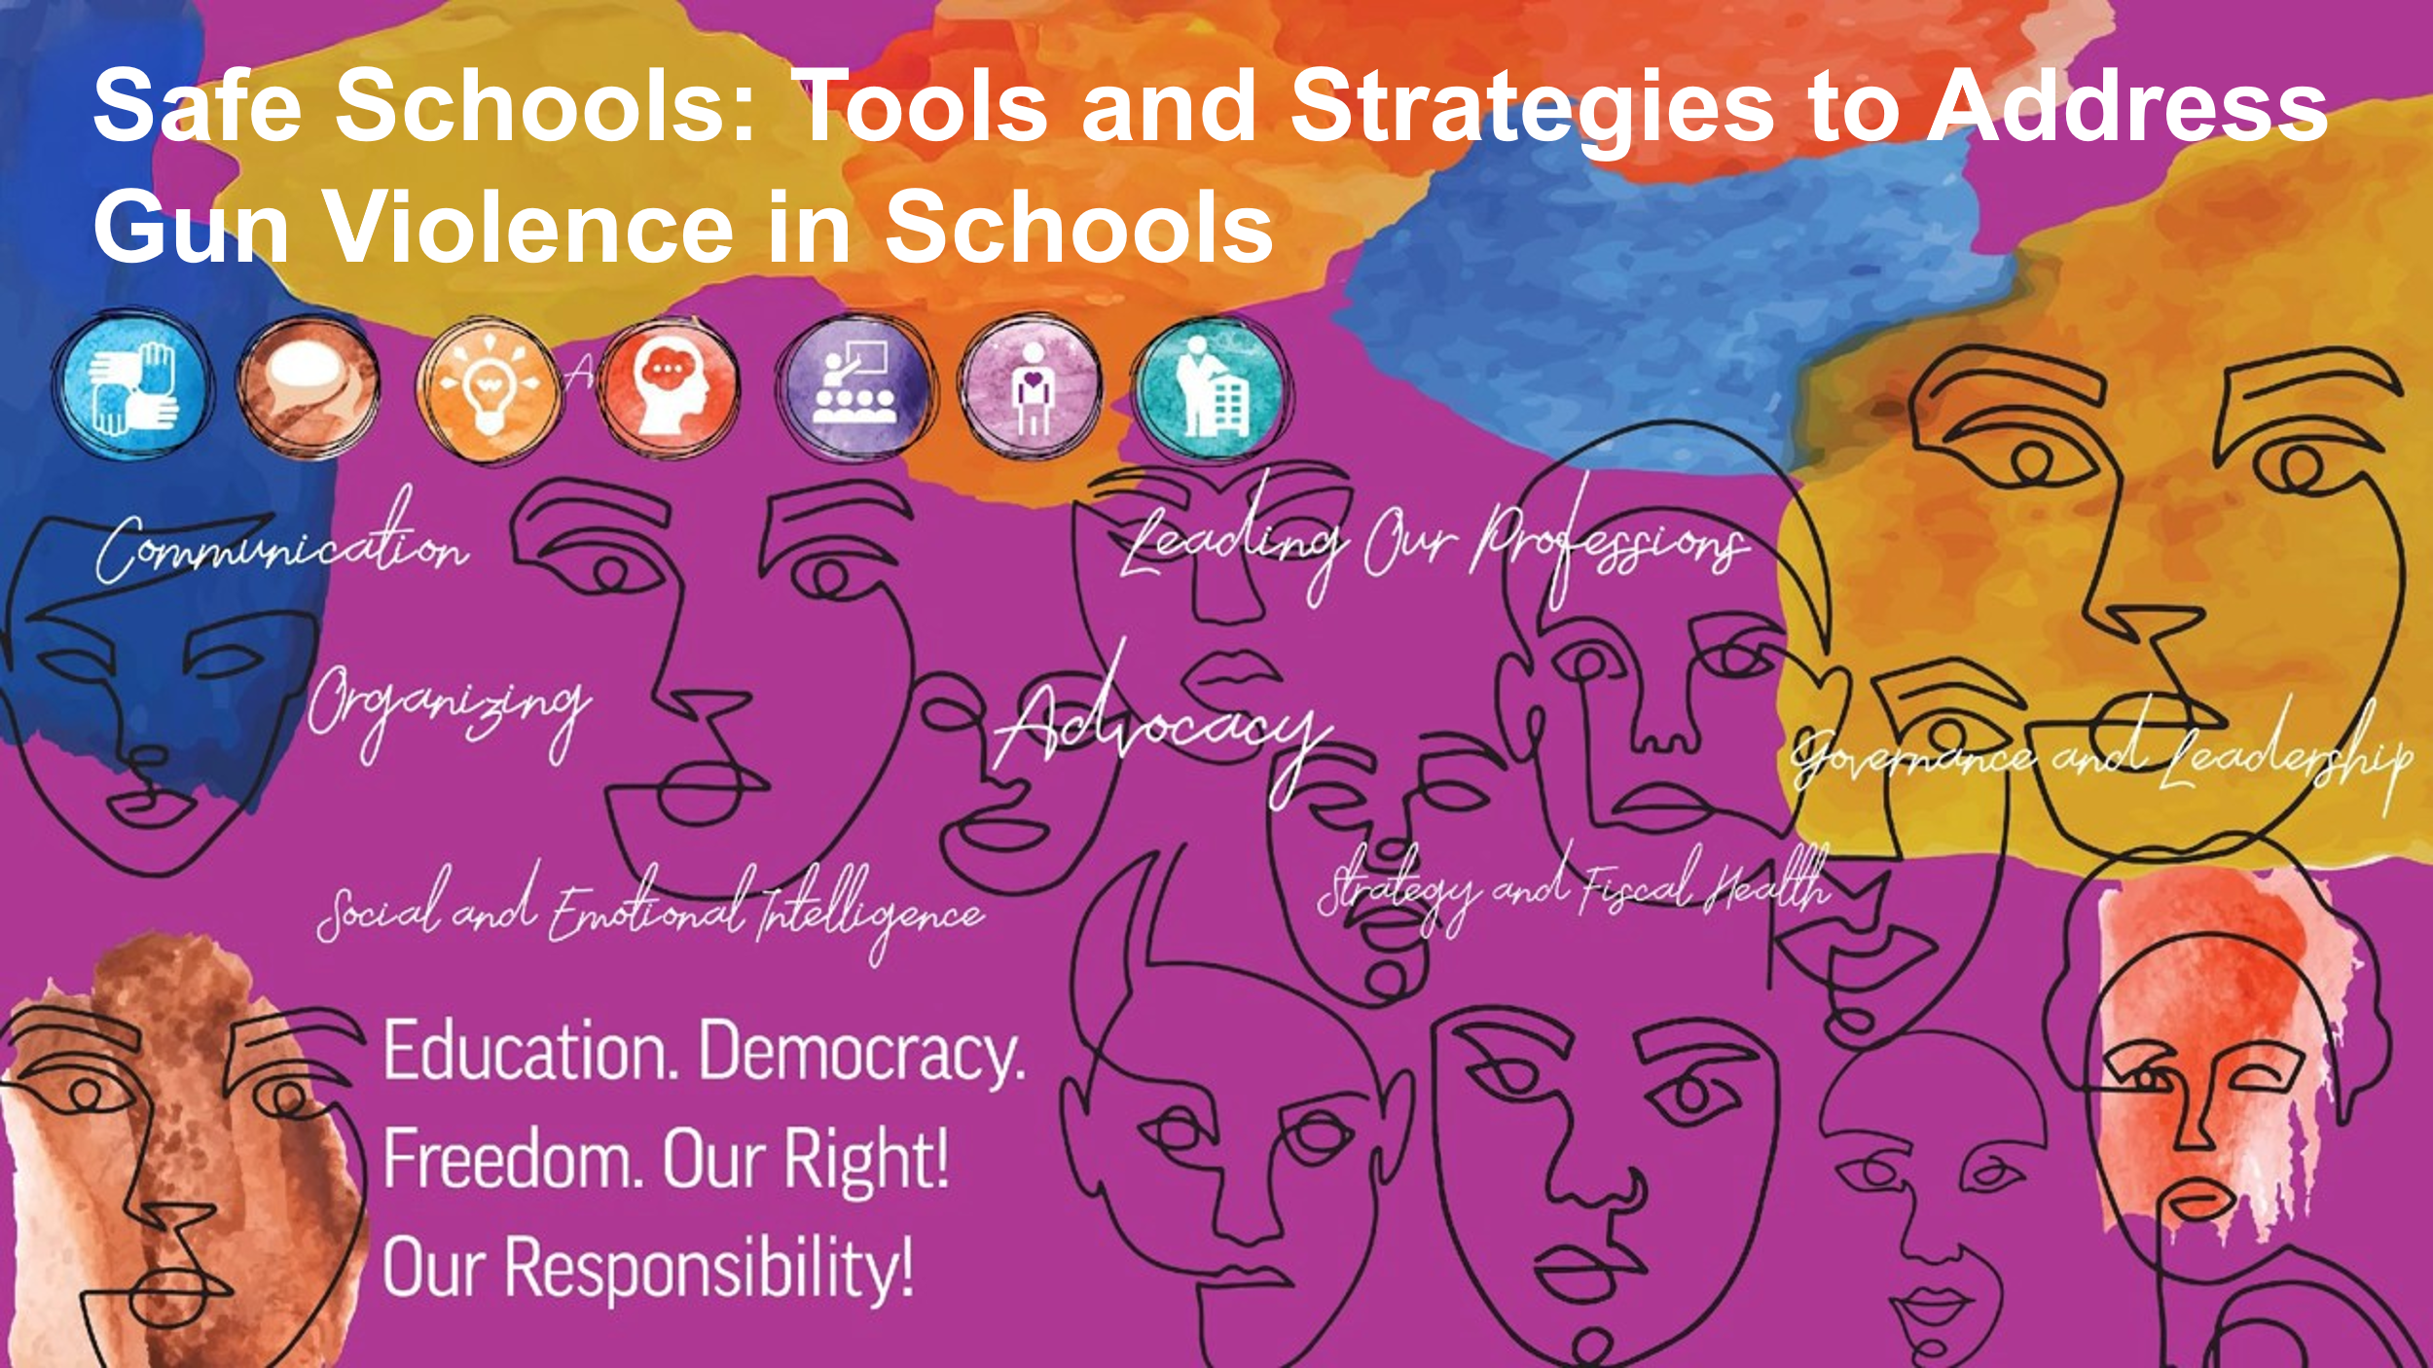 | 2:50 – Zoom opens with music. Entry prompt in chat: name, state affiliate, and one word that comes to mind when you think of safe schools.
2:30 Chad  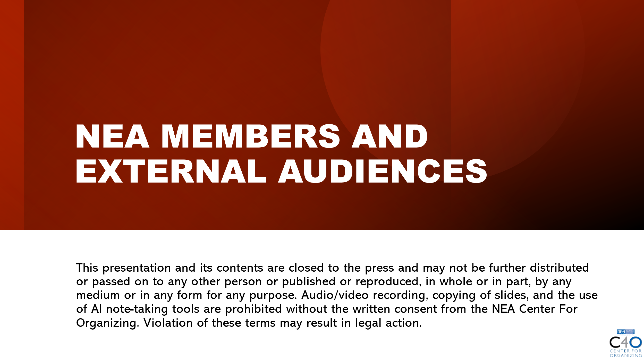  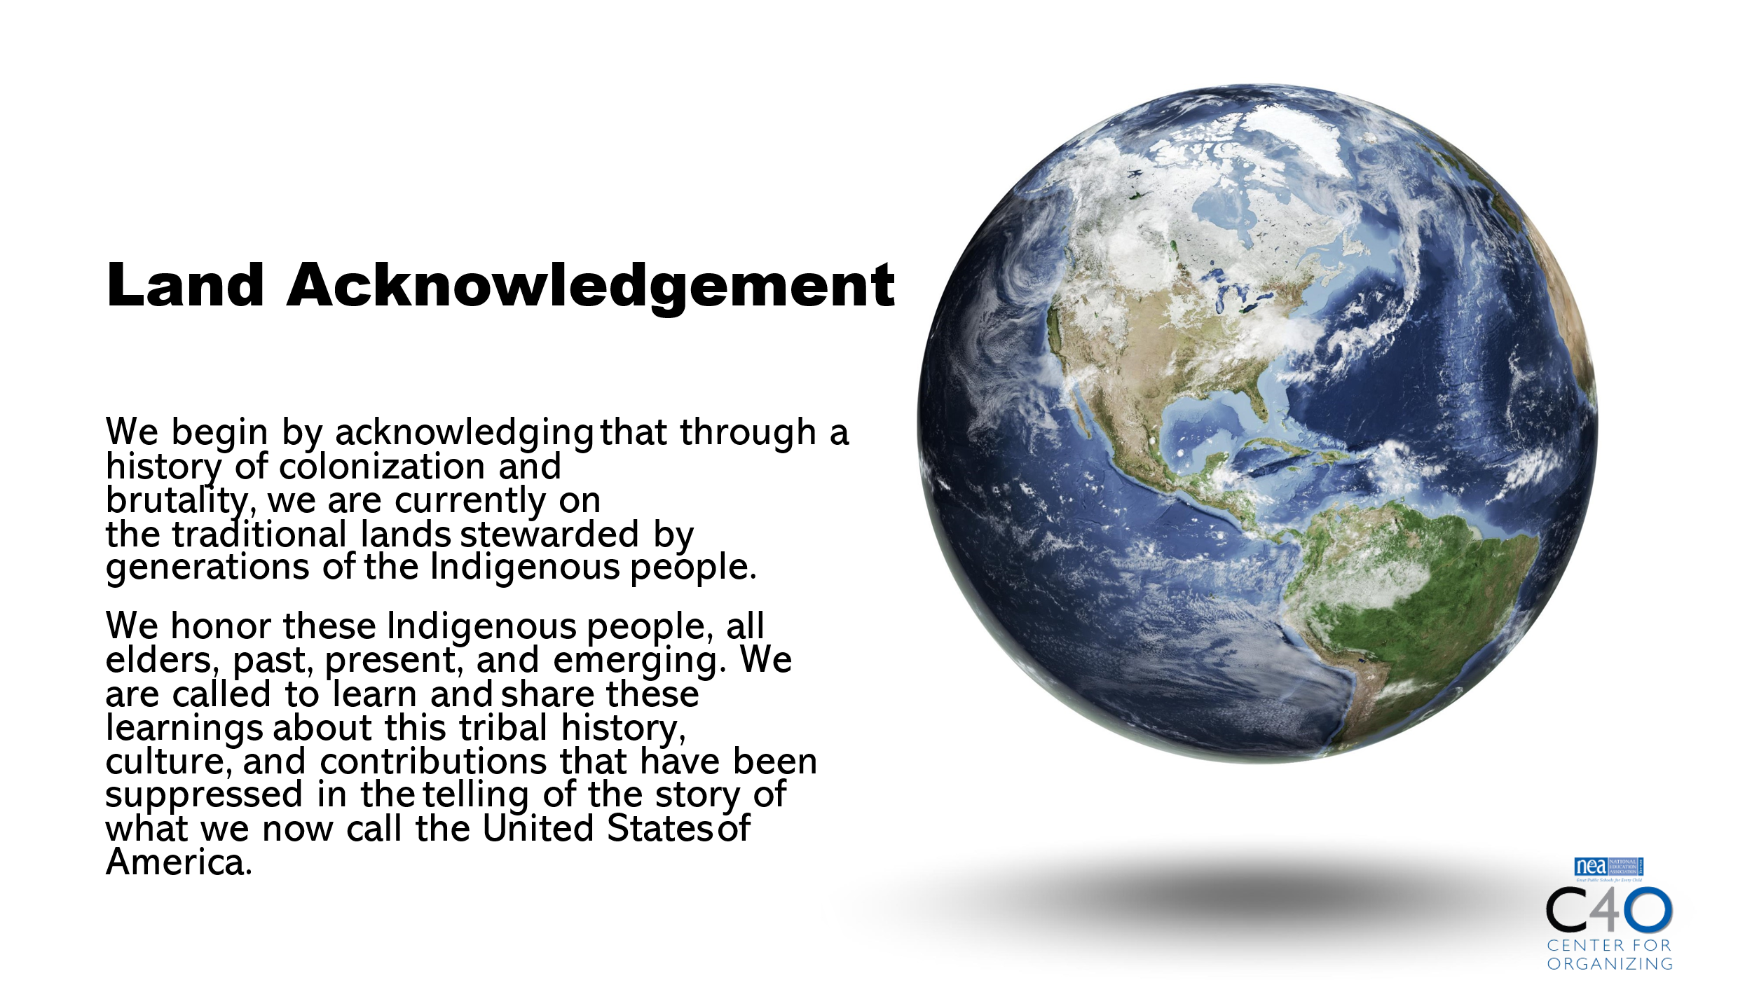  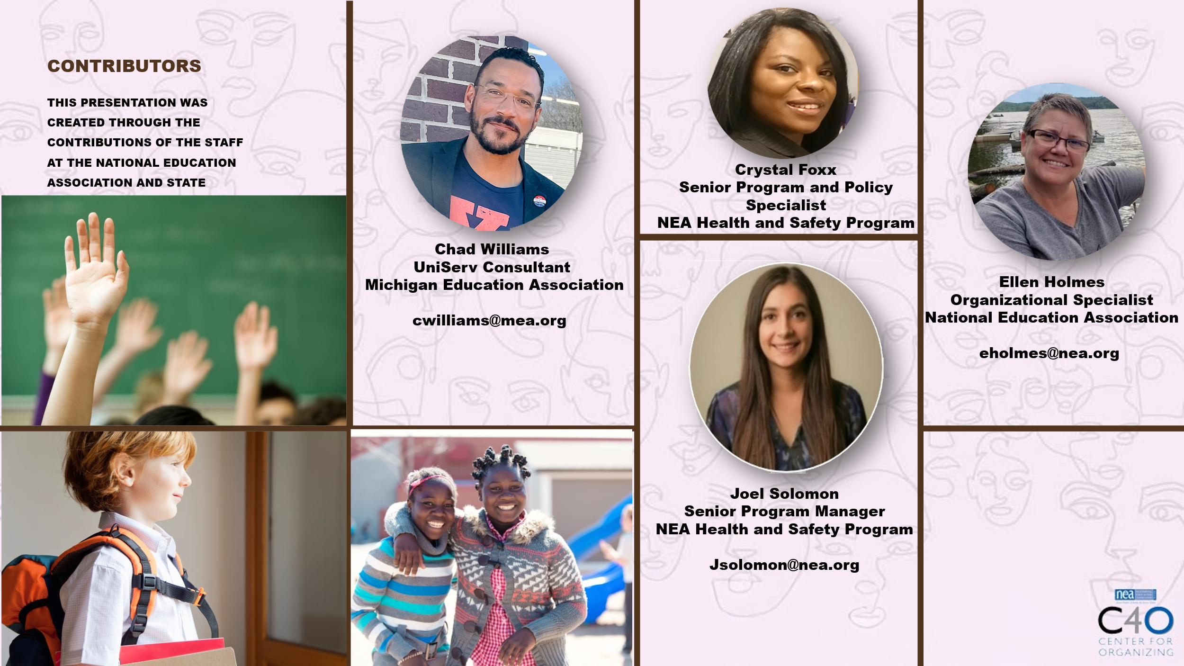  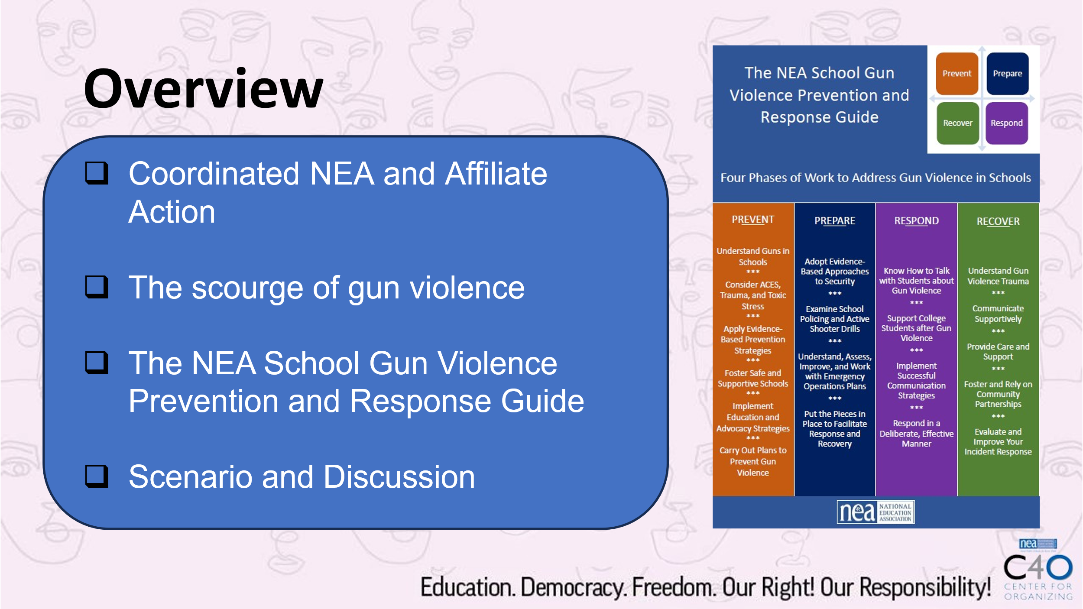 | How will we work together to support learning? |  | The National Education Association is committed to honoring the spaces that we occupy to advance the work.  - We begin by acknowledging that through a history of colonization and brutality, we currently reside on and are connecting from the traditional lands stewarded by generations of indigenous people.  - We honor these indigenous people, all elders, past, present, and emerging. We are called to learn and share these learnings about this tribal history, culture, and contributions that have been suppressed in the telling of the story of what we now call the United States of America.  5 Mins Facilitator Introductions  - Team intros include: Name, Work Location, years in the work, and your required pronoun  5 Mins – Today’s Agenda |  | Participants will know how we are going to work, the basic schedule, and the logistics relevant to the training.
2:35 – 2:50  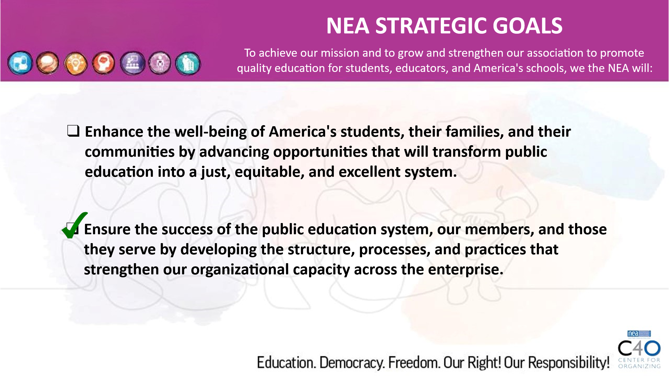  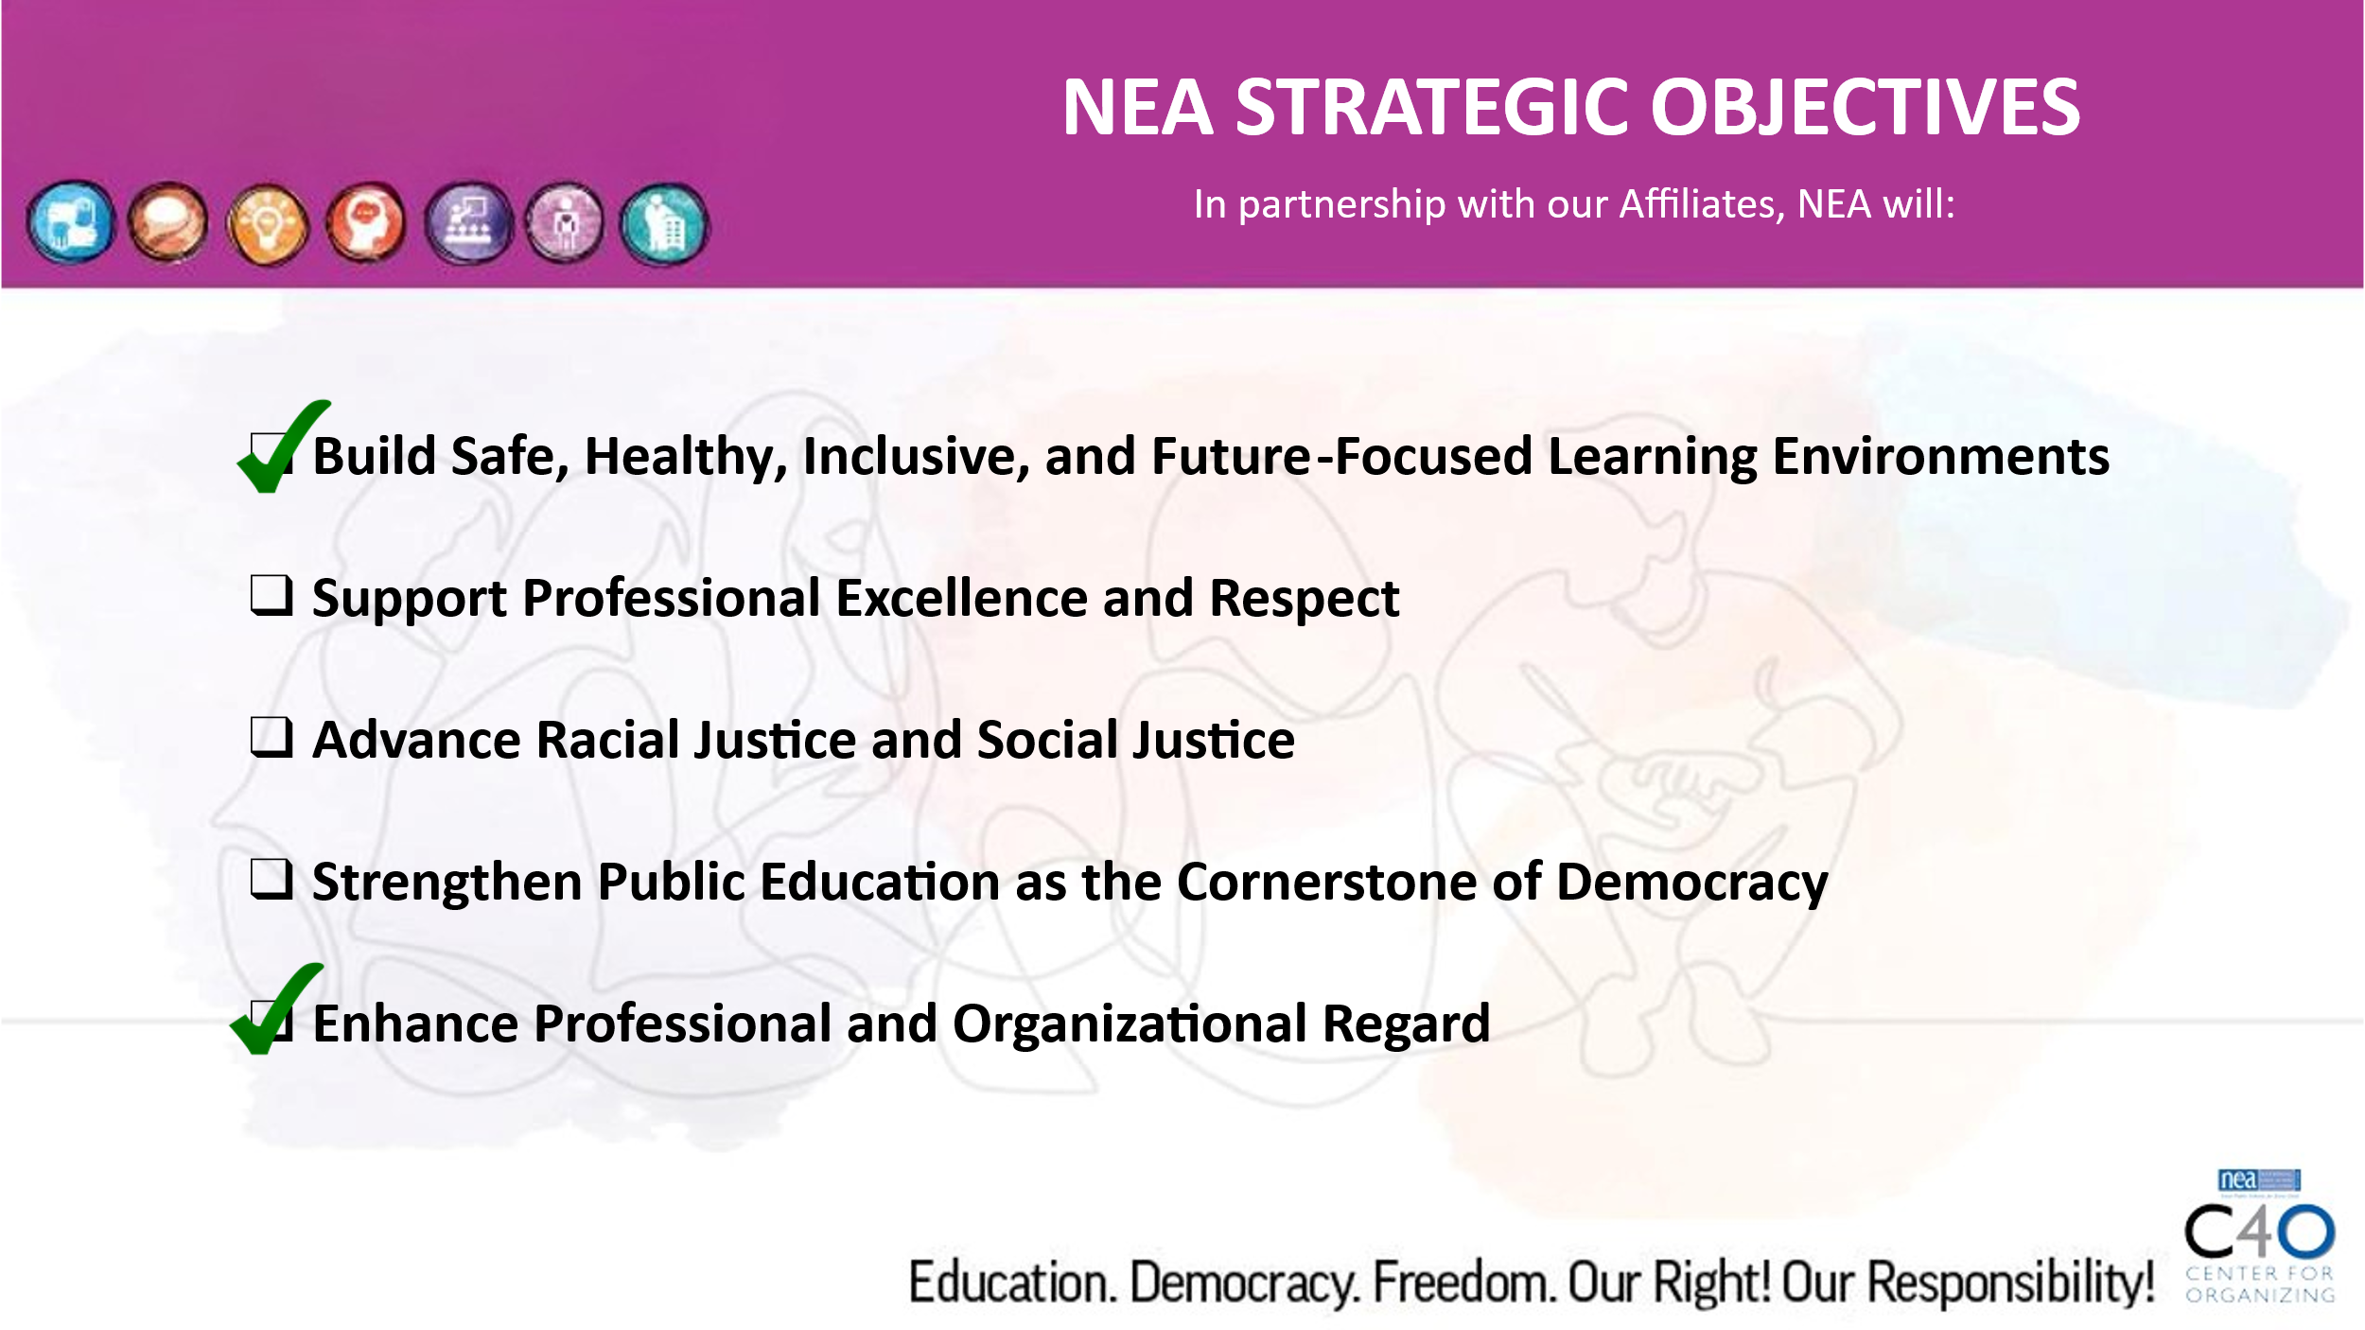  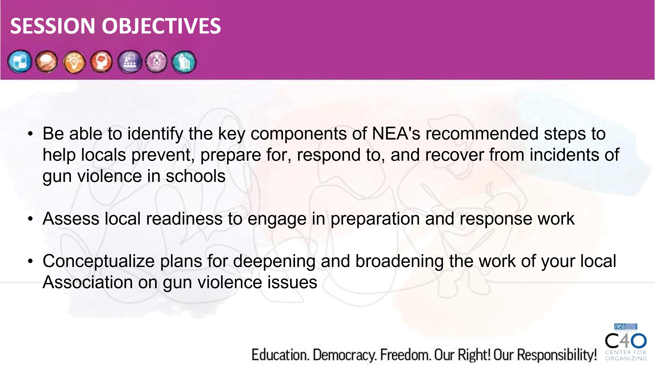  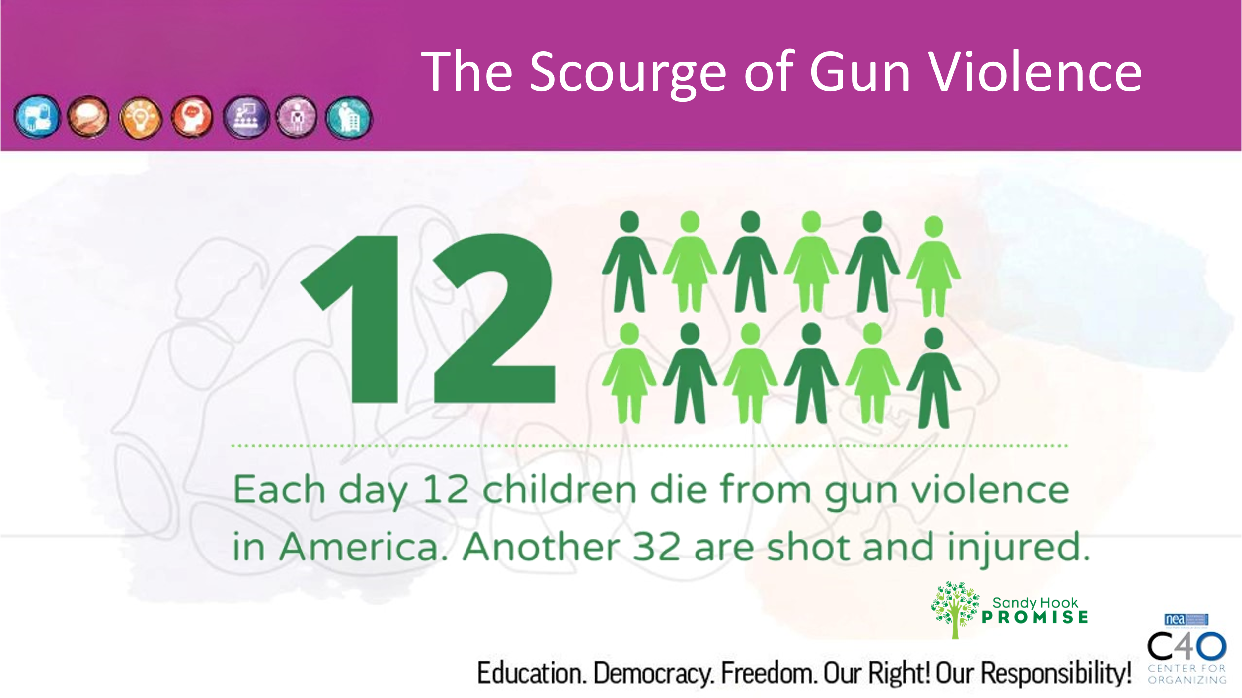  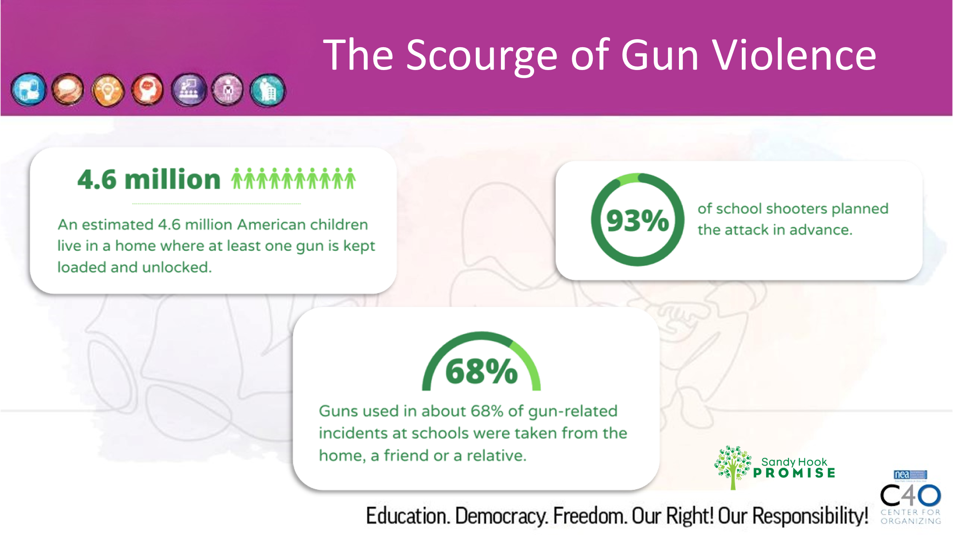 | Why is this work urgent for locals? |  | 15 Minutes Total  Present NEA slides and statistics related to the prevalence of gun violence in our schools and community  Talking points:  - The work to prevent gun violence is both national and local.  - Coordinated effort between the national, state, and local helps keep strategies, tactics, and objectives consistent and allows sharing of knowledge and resources amongst and between affiliates and locals  - Gun violence is personal and inextricably connected to the families, communities, and schools we serve.  - As an organizing issue, it is widely felt and broadly understood by literally everyone in the community |  | Participants understand urgency and context of gun violence issues.
2:50 – 3:35pm  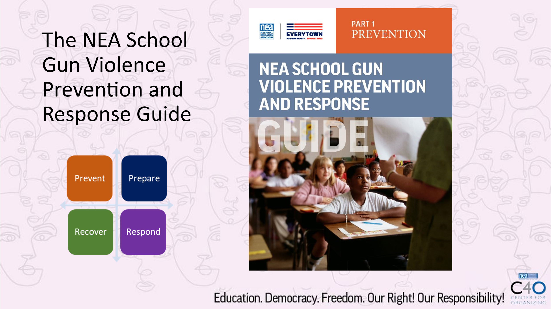  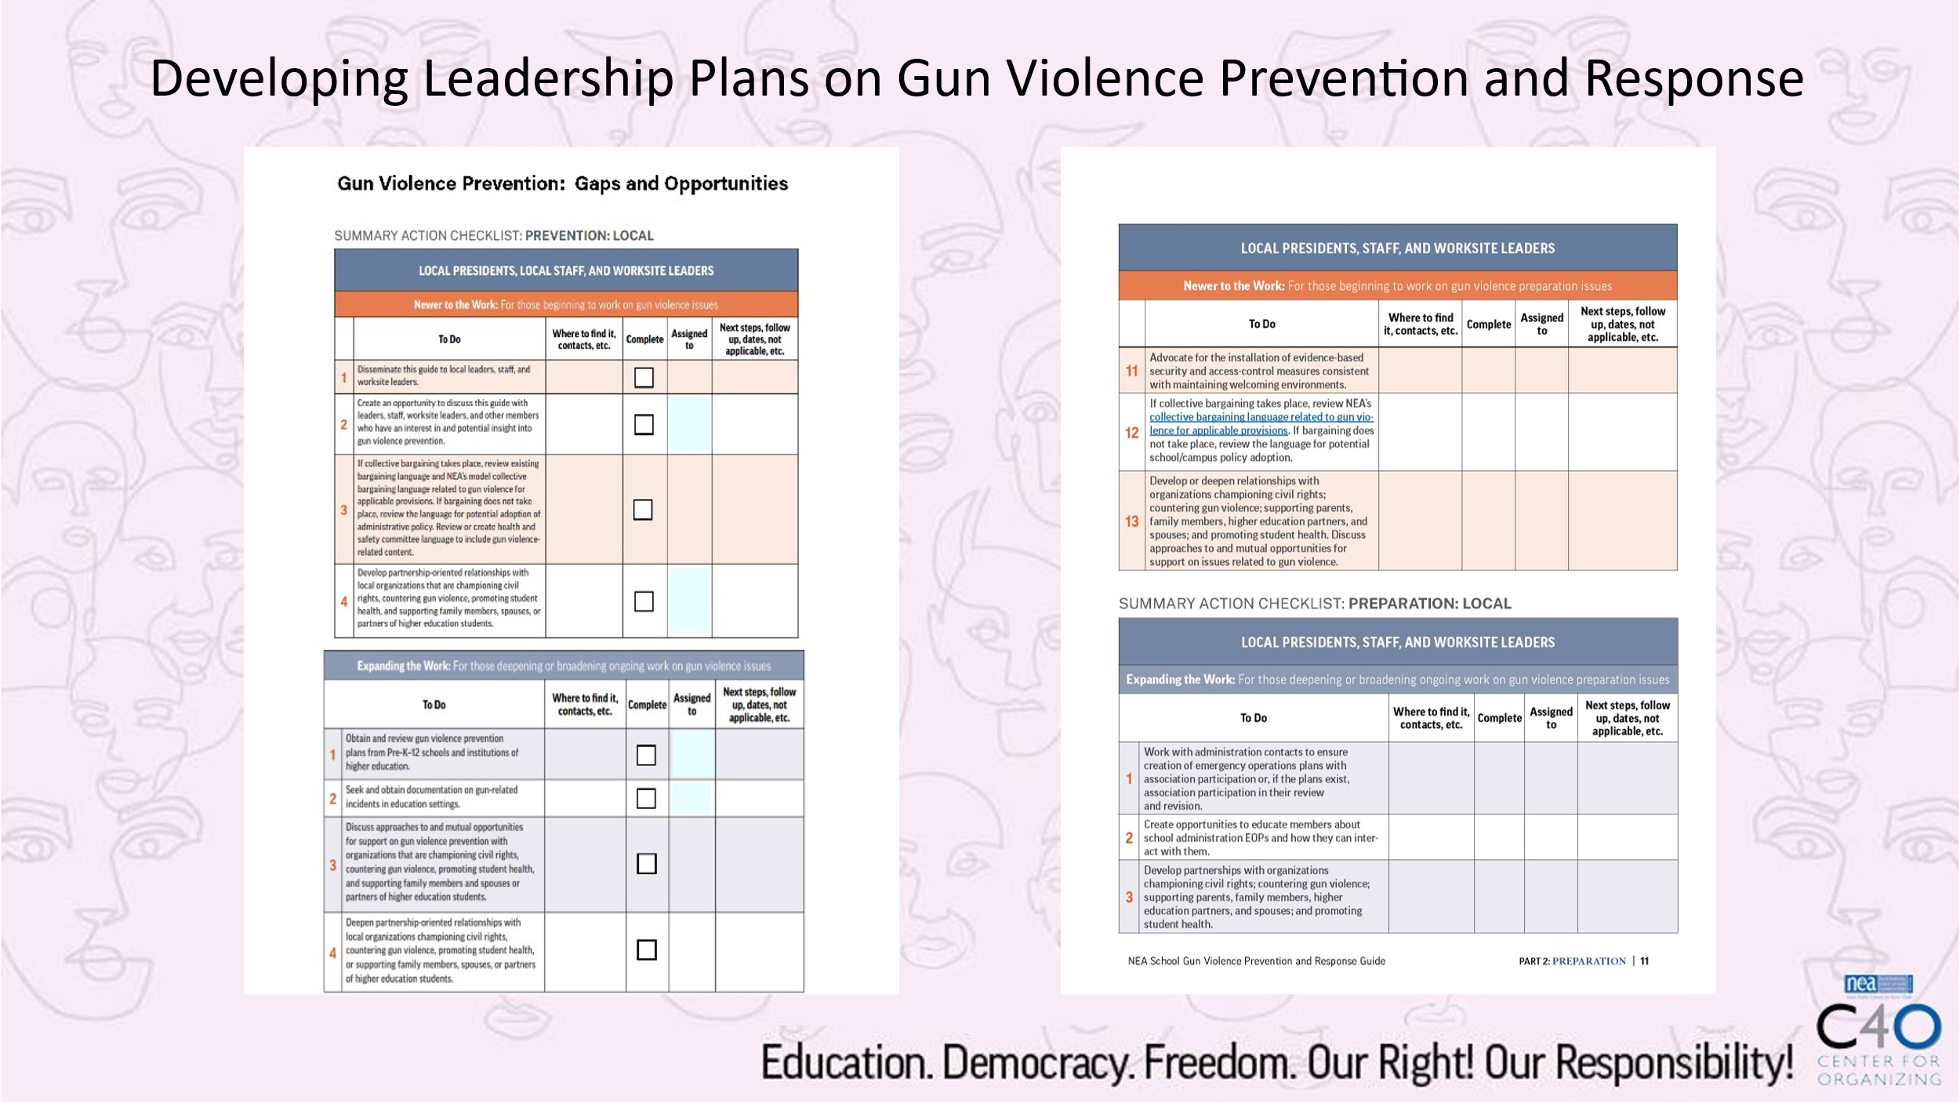  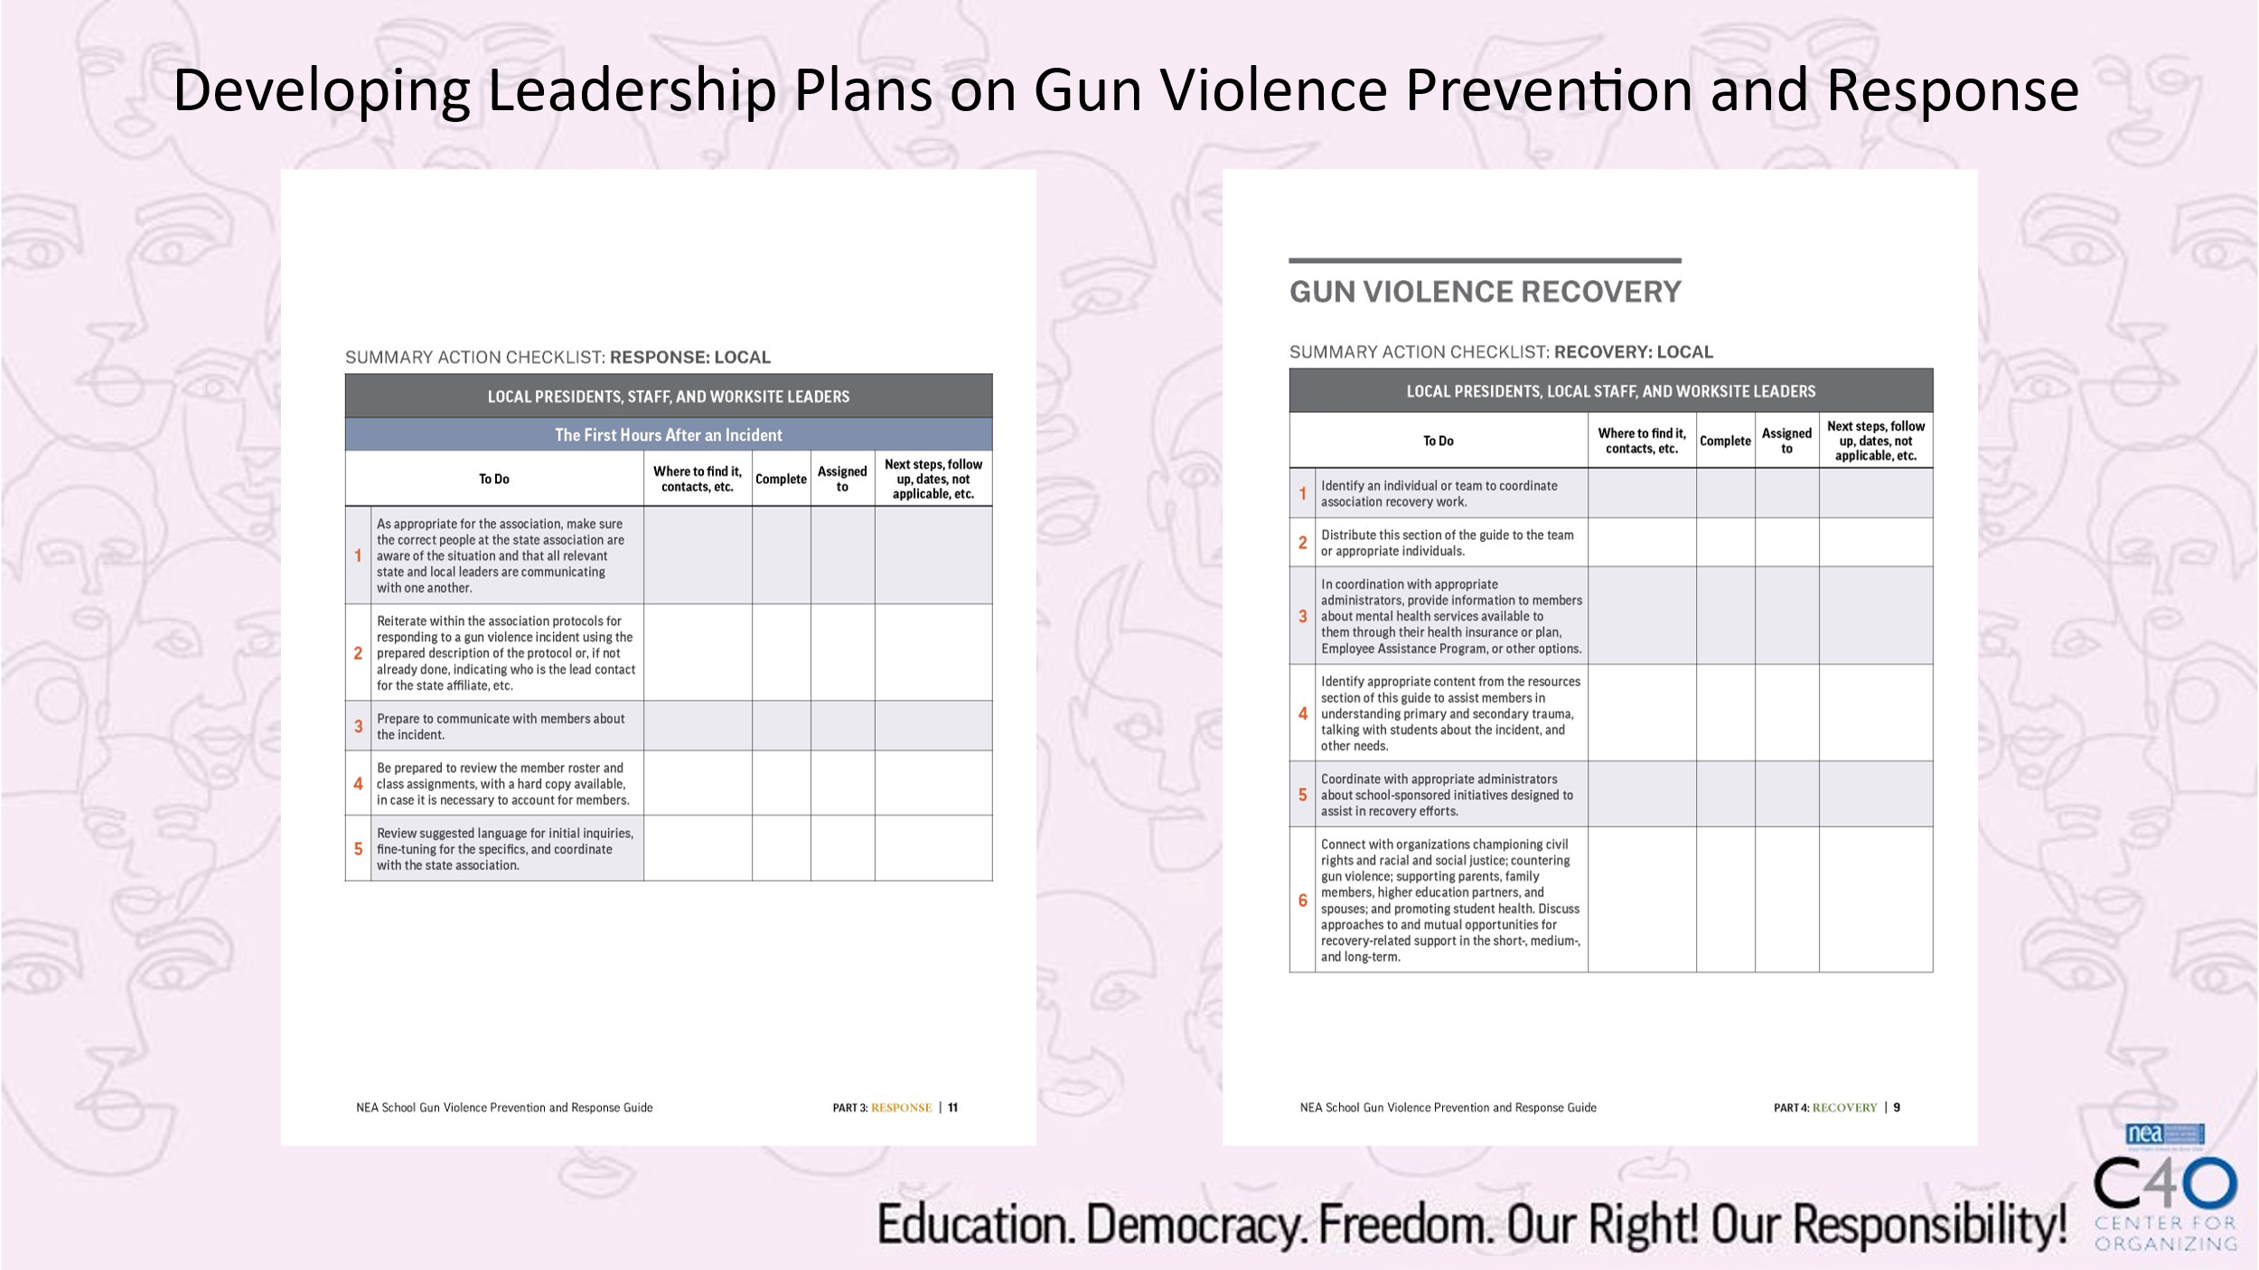  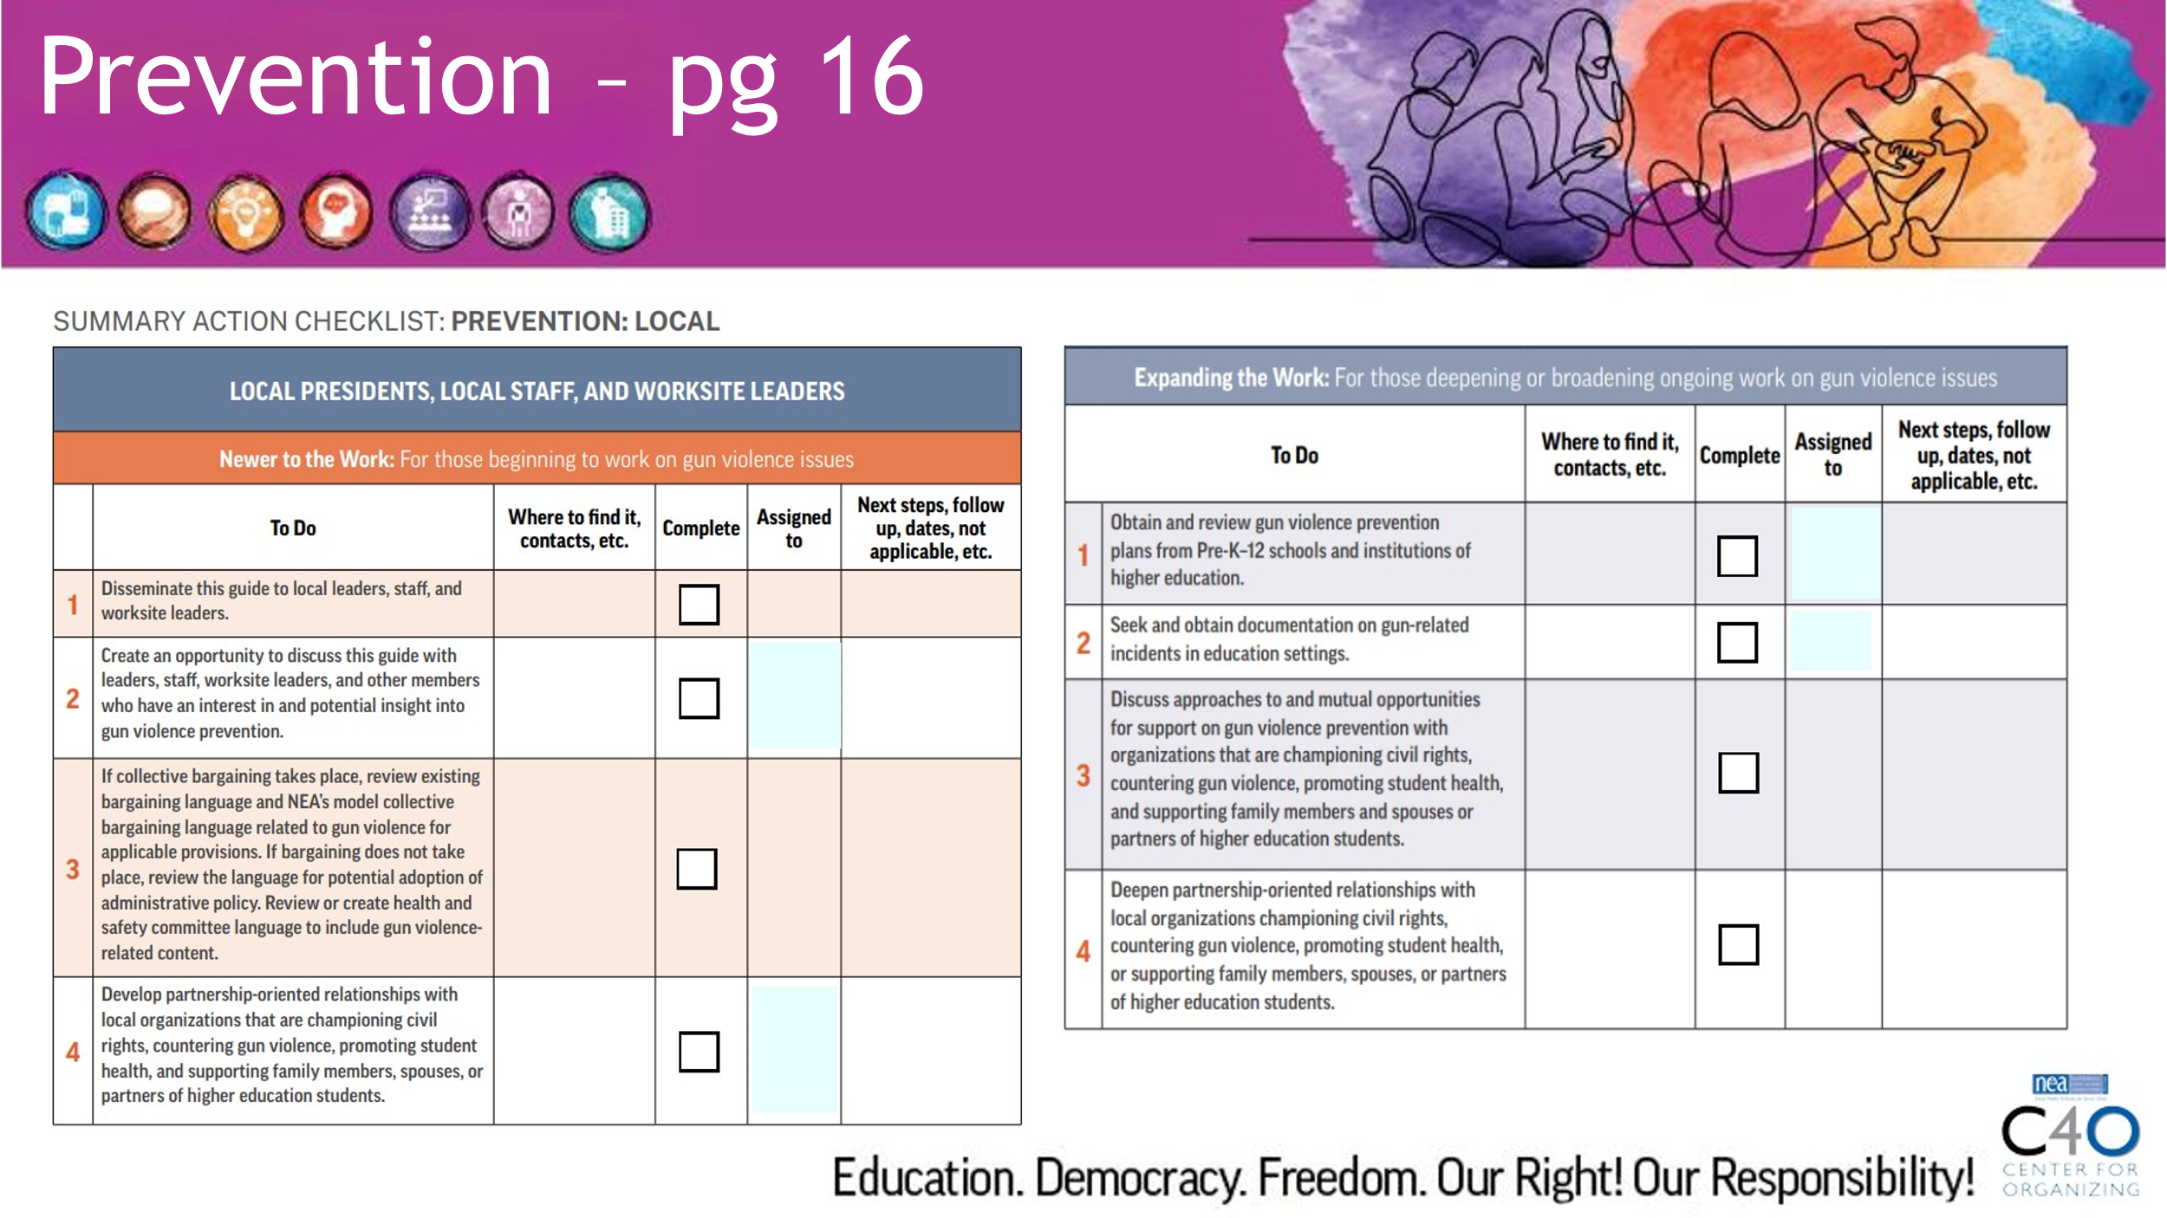  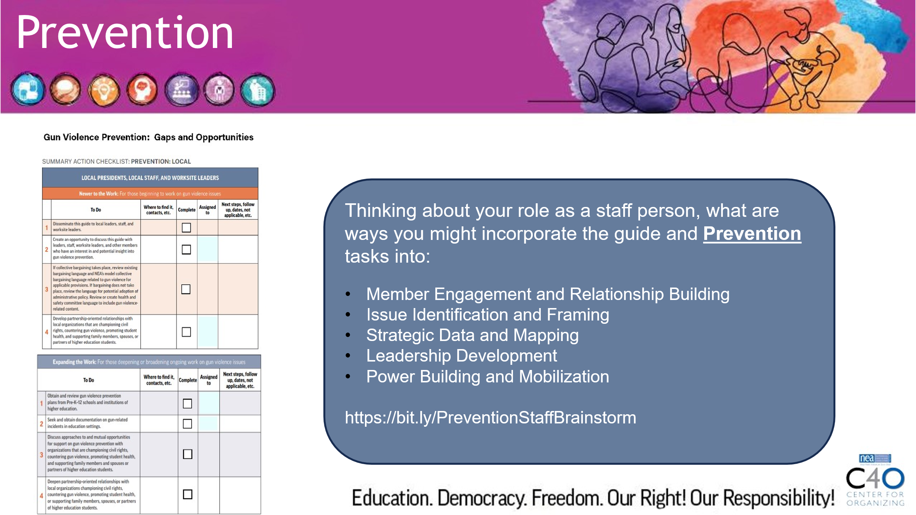  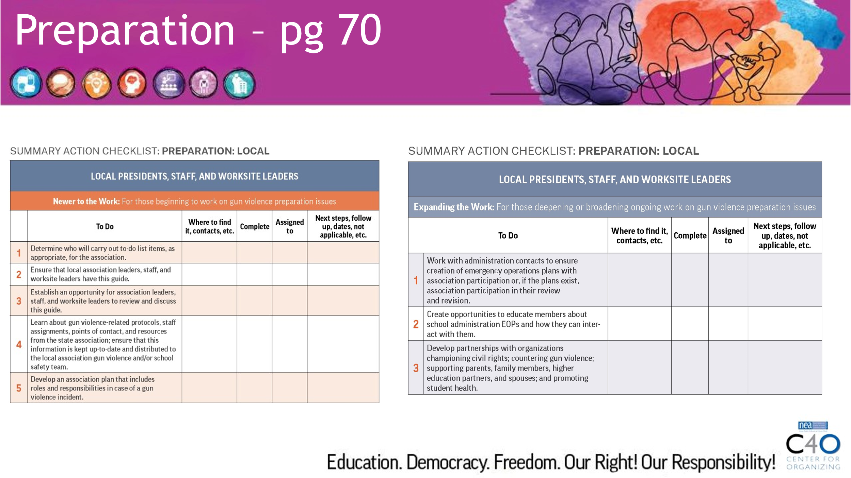  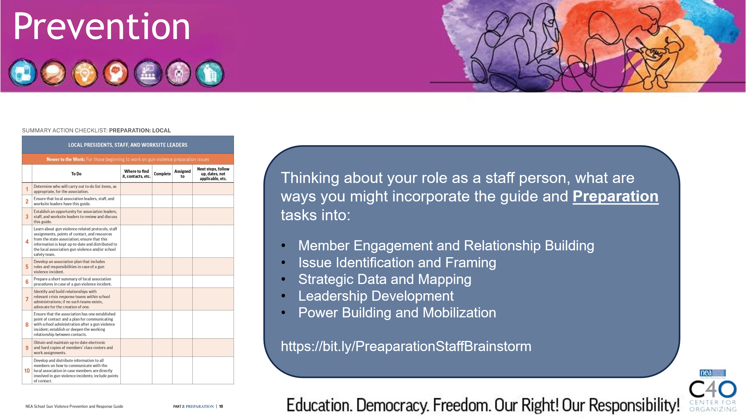  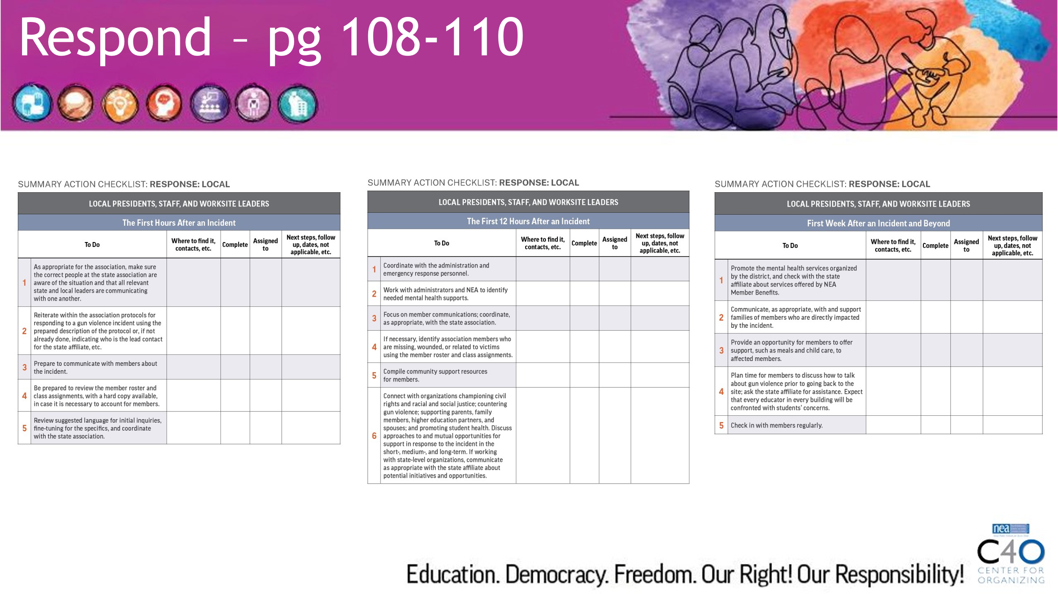  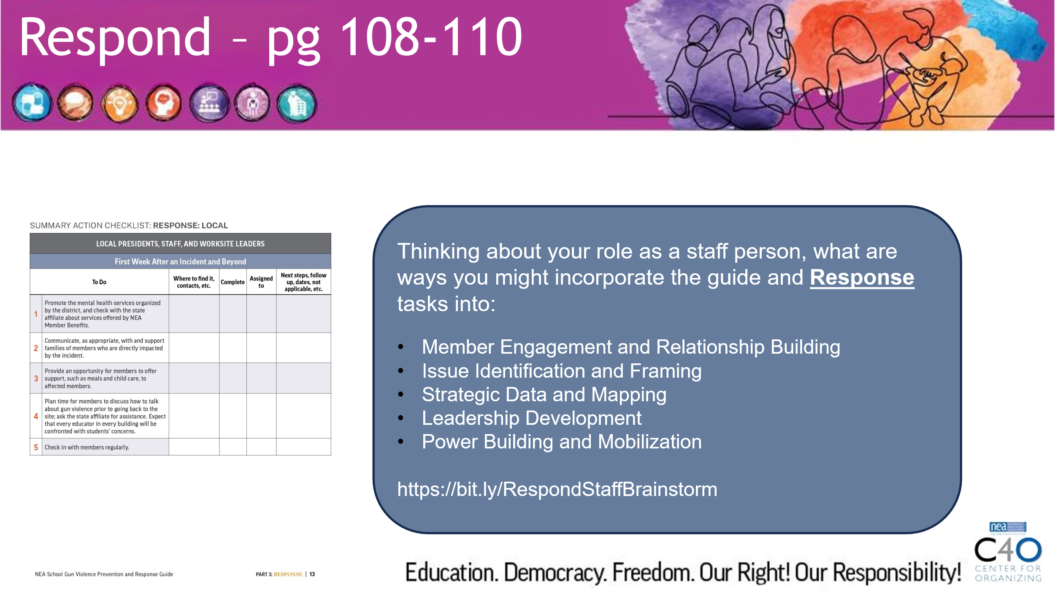  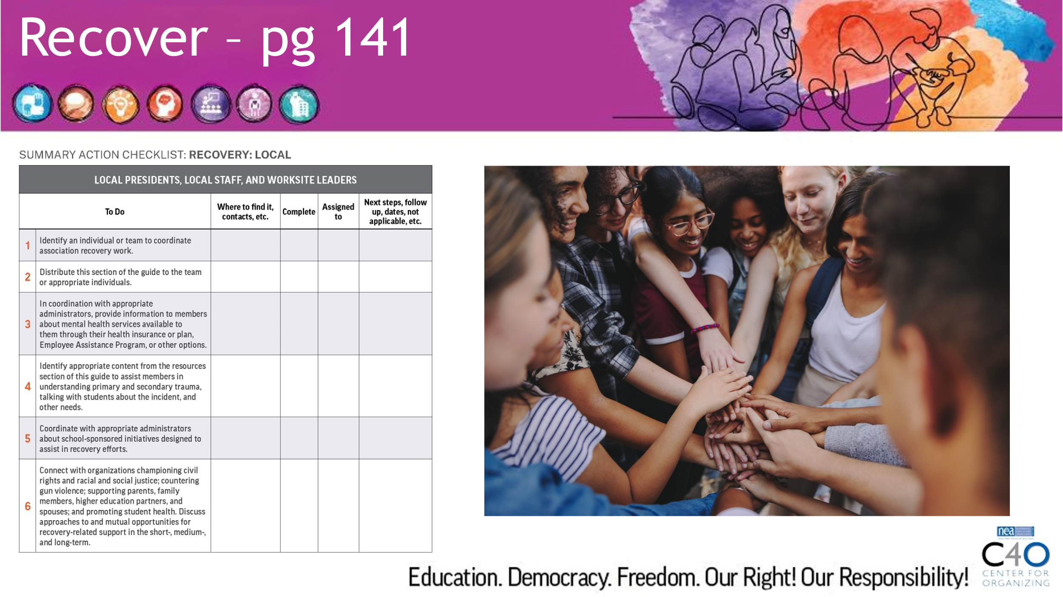  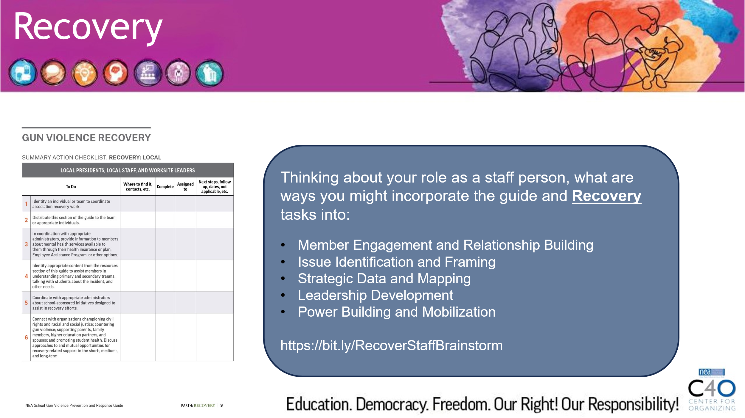 | What are the components of NEA’s Gun Violence Guide? | Brainstorm Share Docs:  Link to Prevention Staff Brainstorm share document: https://bit.ly/PreventionStaffBrainstorm  Link to Preparation Staff Brainstorm share document: https://bit.ly/PreaparationStaffBrainstorm  Link to Response Staff Brainstorm share document: https://bit.ly/RespondStaffBrainstorm  Link to Recovery Staff Brainstorm share document: https://bit.ly/RecoverStaffBrainstorm | 45 Minutes total  Walk through four phases (Prevention, Preparation, Response, Recovery  Discussion topic: Which phase feels most urgent?  In small group, whole group or breakout discussion, go through each phase and debrief highlighting common strategies and unique ideas.  Share Documents  Utilize the share documents to capture feedback for each phase. Screen share the document during each debrief. Let participants know that these documents are living documents and will grow with each cohort that experiences this training – the documents will be available in POPS. |  | Participants can identify the four phases of the Guide and connect them to aspects of their advocacy and organizing  Participants can conceptualize application of Prevention, Preparation, Response, and Recovery tasks.
3:35 – 3:55  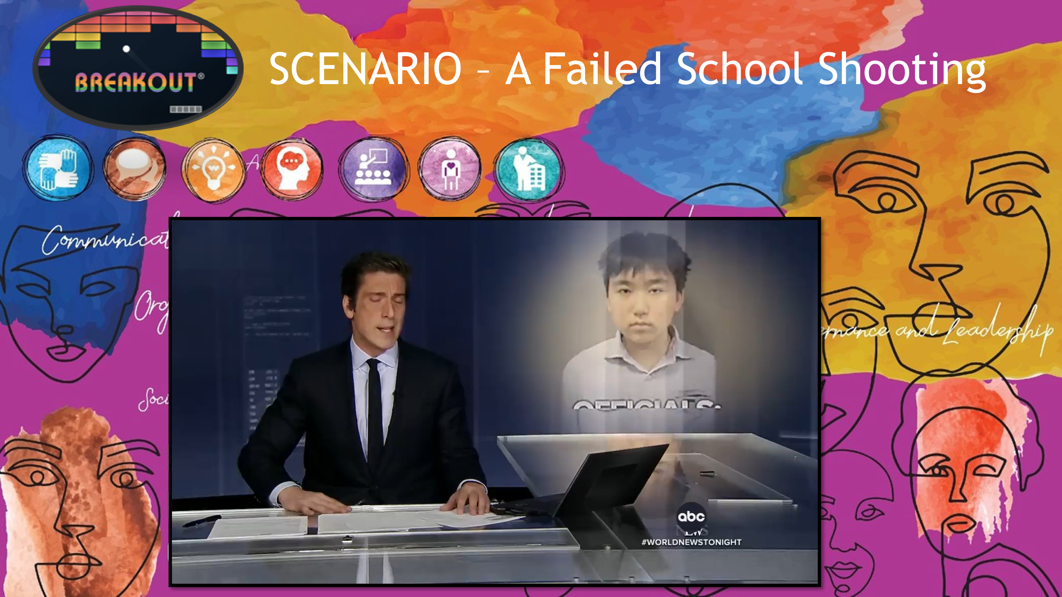  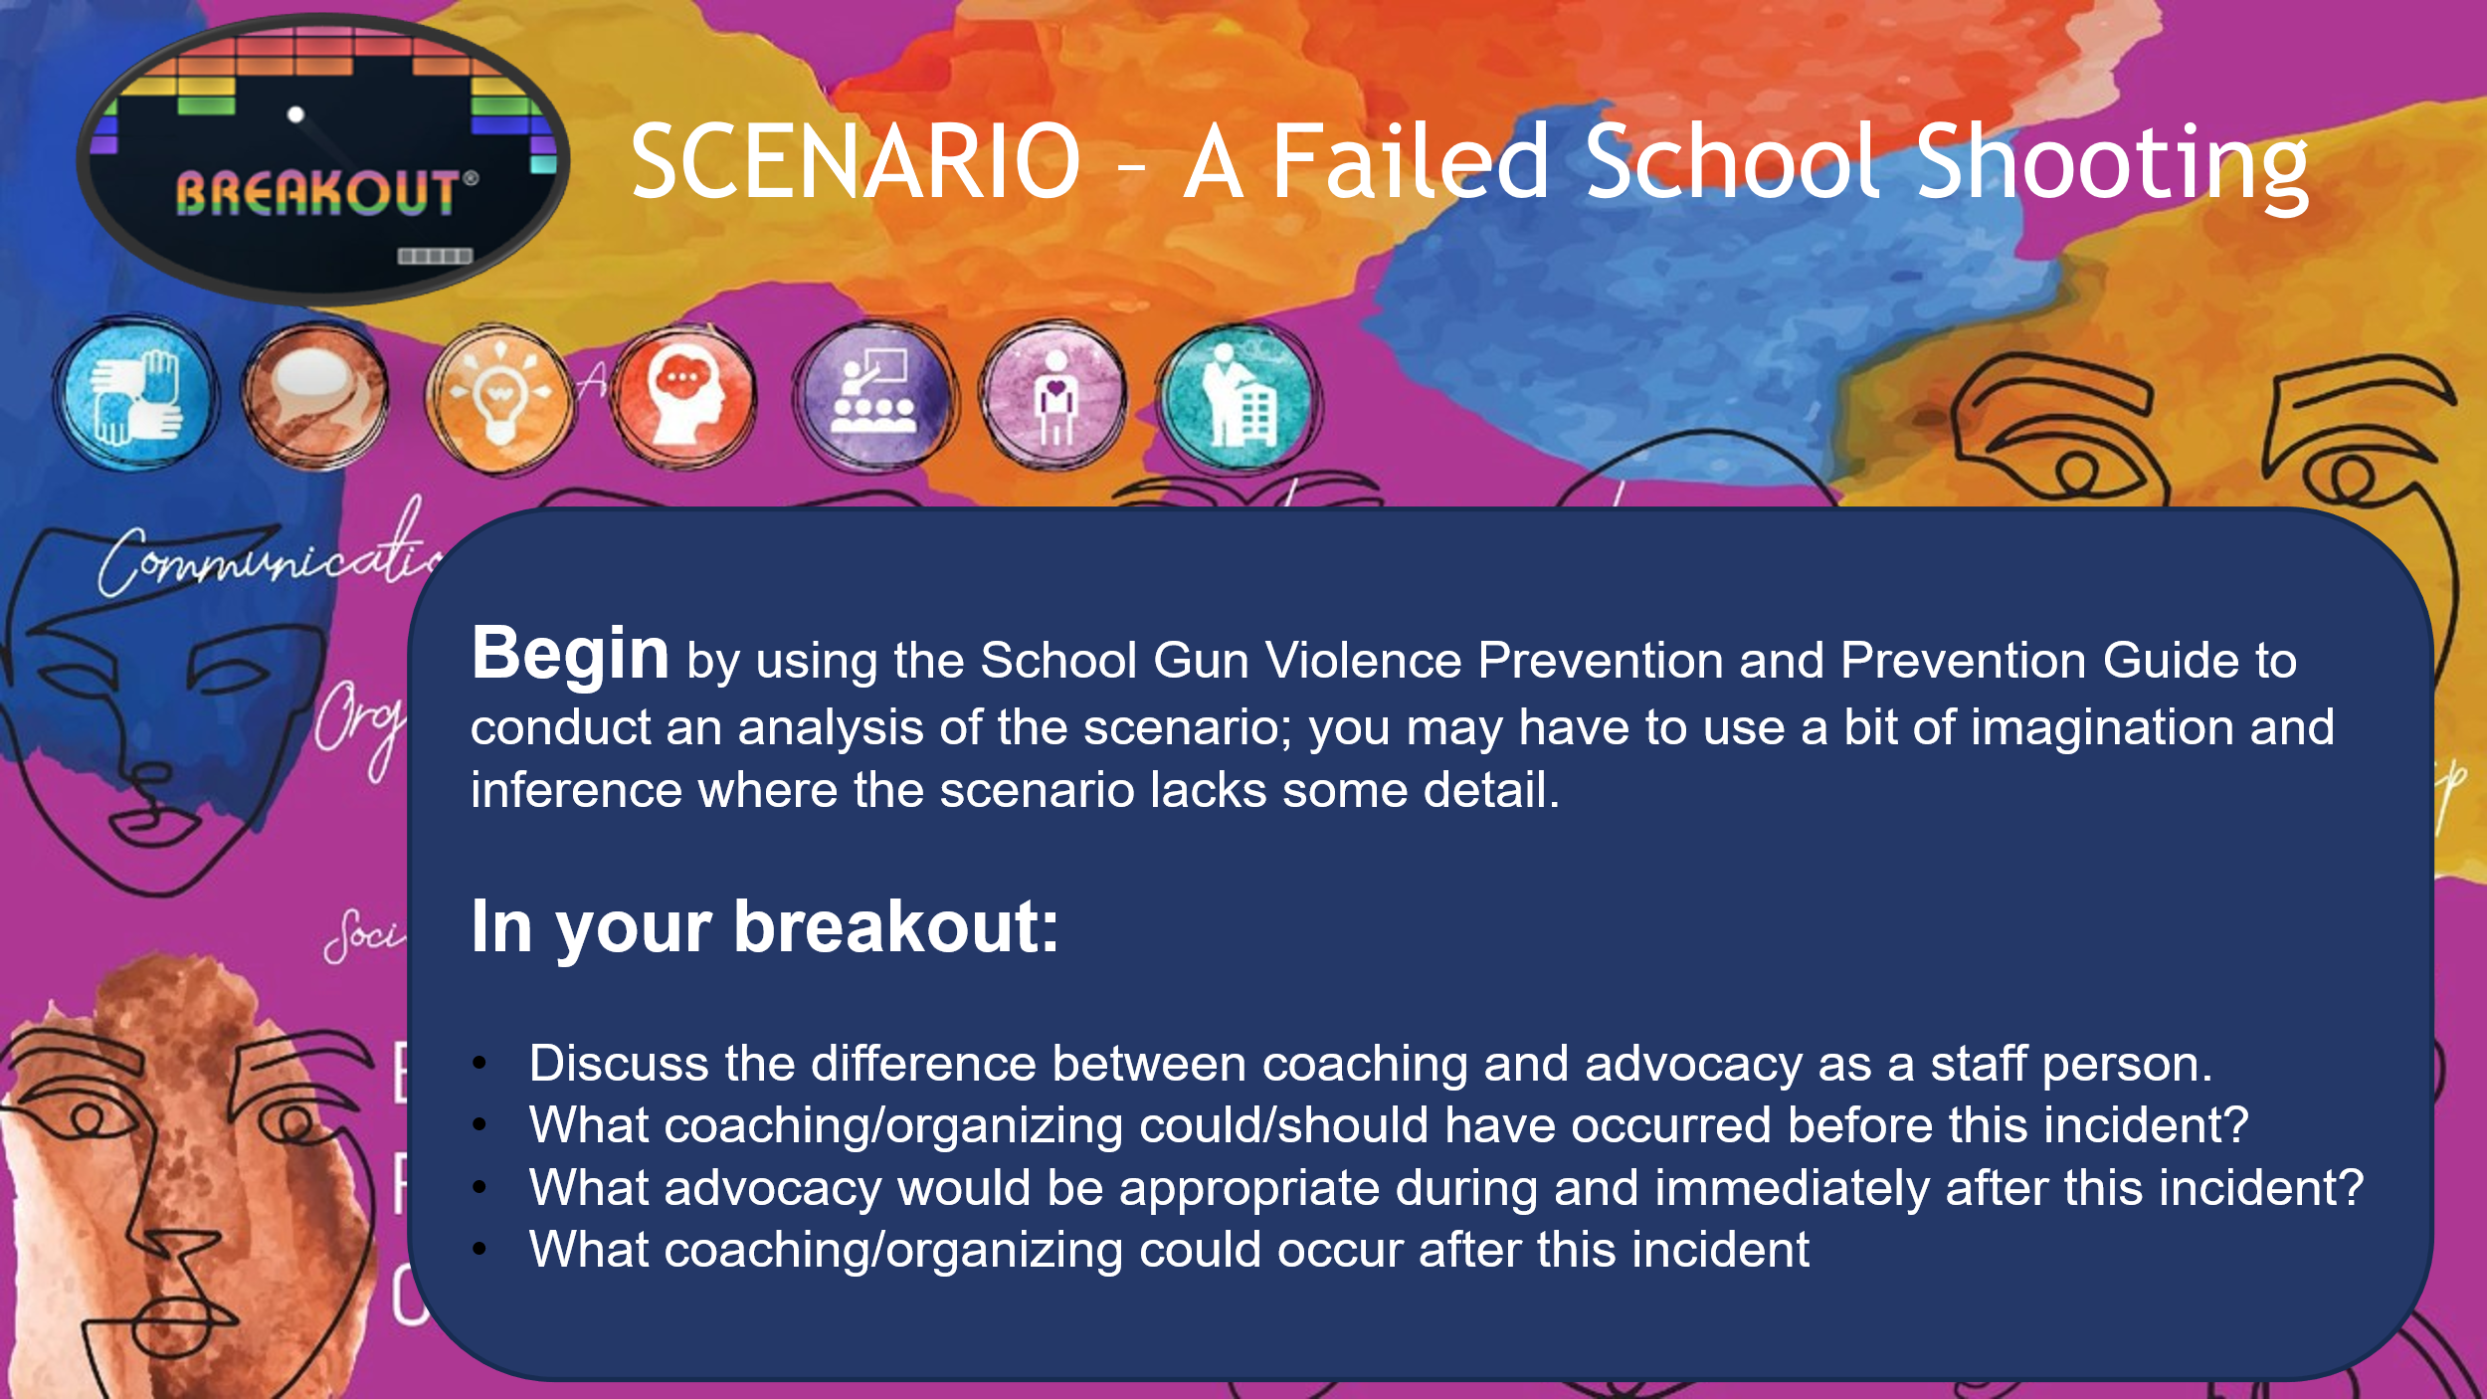  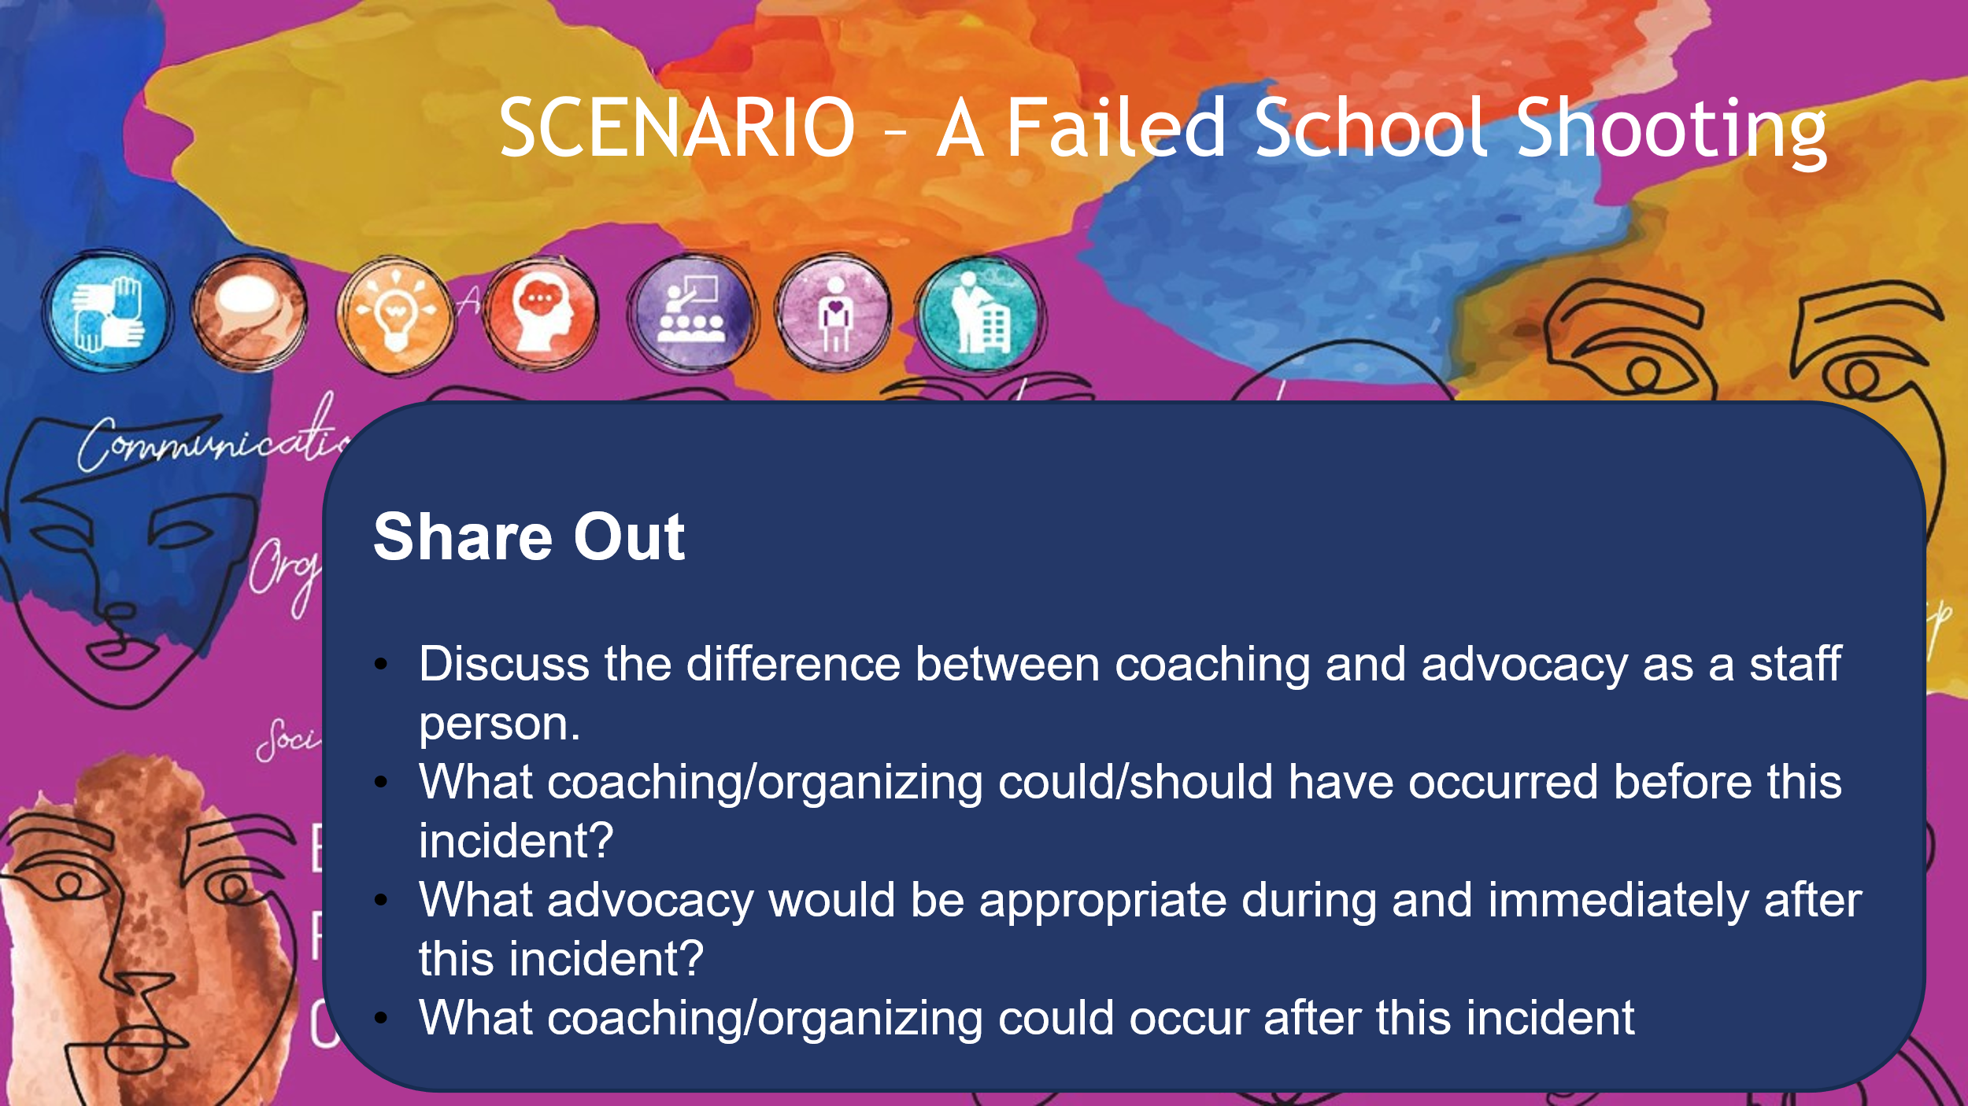 | What does coaching/advocacy/organizing look like in a scenario? |  | 20 Minutes Total  Scenario framing: 2 min  Video run time: 2 min  Begin setting up the scenario by reminding participants to have their prevention guide available for review.  Set up their thinking by reminding them that they had discussed organizing and advocacy ideas for each phase, and they will apply some of those to this scenario, but they will also need to consider how they as staff operate in terms of when should THEY advocate and organize and when THEY should coach advocacy, as well as organizing?  10 minute – Breakout  5 minute – report out |  | Participants apply guide strategies to a realistic scenario.
3:55 – 4:00  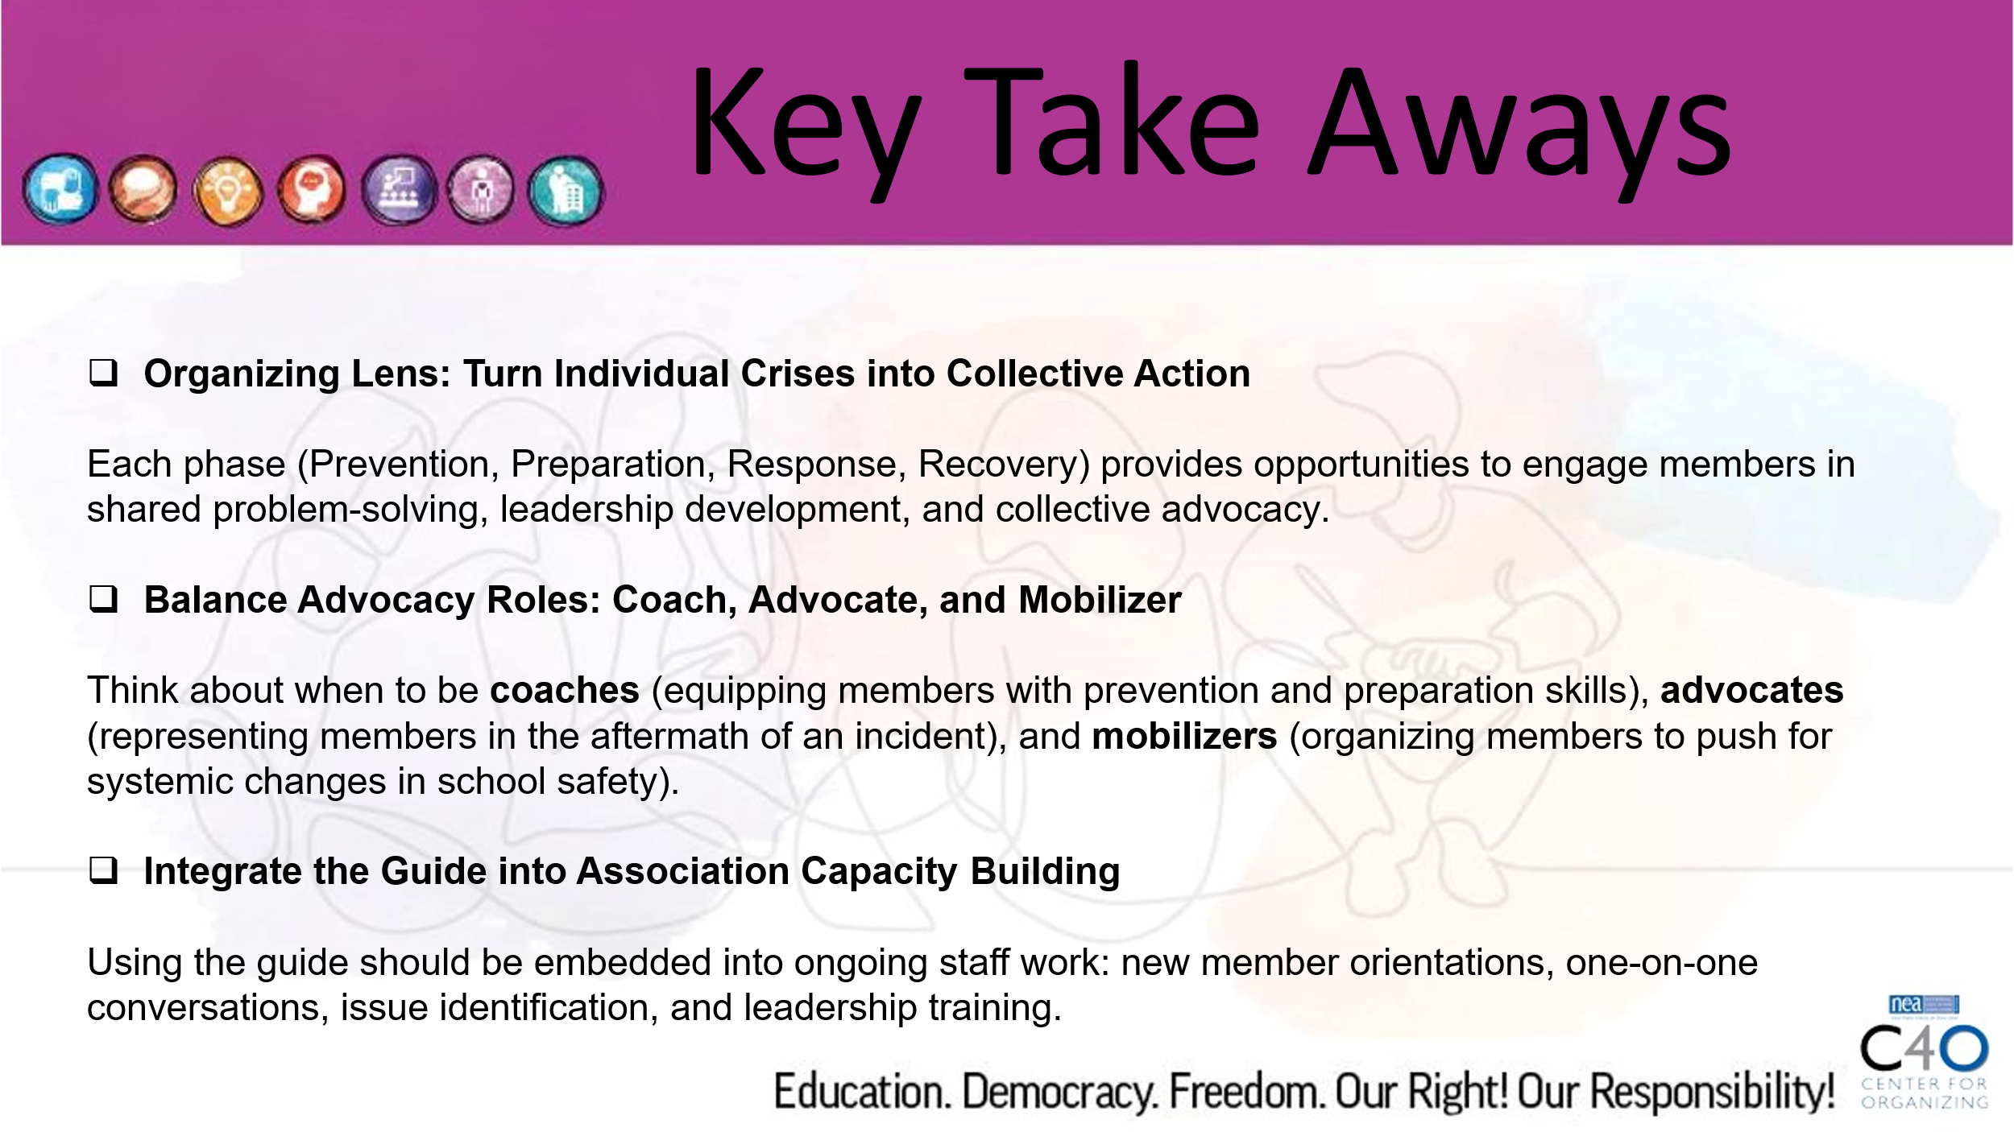  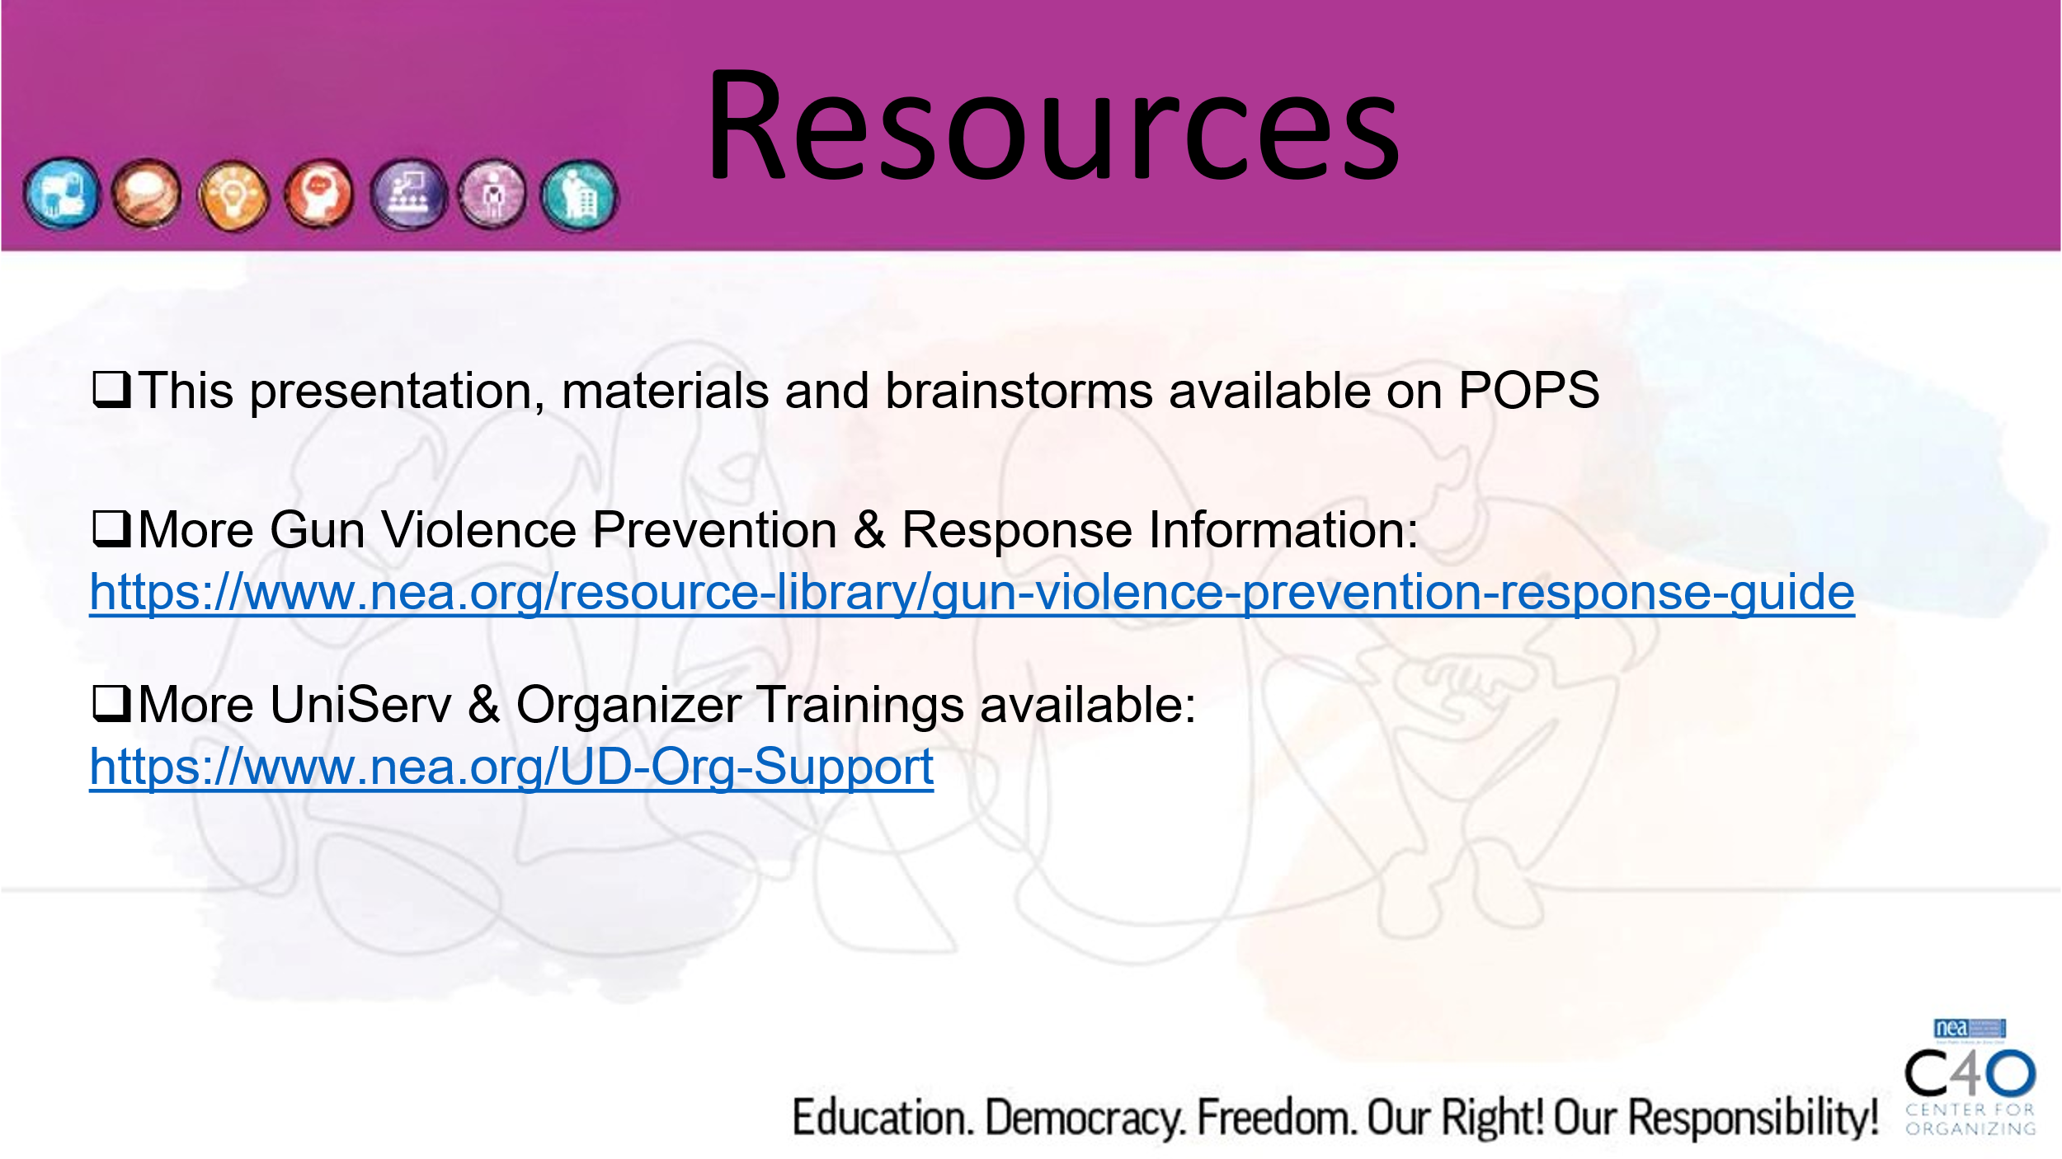  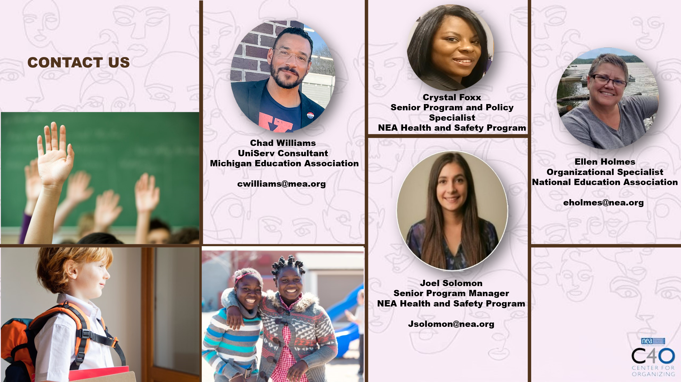 | What are our next steps? |  | 5 Minutes Total  Revisit objectives, show take aways, share resources, participants share one takeaway in chat or off mute.

