Facilitator Agenda Day 1 –Teachers Unions and Social Justice
General Materials Needed: |  |  |  |  | Room Set-up:
1 Set of Handouts per Person  Name Tents with the Norms  Sign-in Sheet  Agendas on the table (1 per)  Room signs, sign in signs  One ream of white photocopy paper  Chart Paper (4 to 5 full w Sticky Strip) |  |  | Materials Box for each table with:  Markers (Mr. Sketch variety)  Post its – 3x3” and 4X5” sizes  Index Cards  Highlighters – 4 colors  Pens and Pencils  Participant “toys” |  | Round Tables  Projector, Screen and Speakers  Carousel stations and reporting stations around the perimeter  50 people
Key Outcomes for the Event:
Participants will understand what social justice unionism is.
Participants will be able to recognize core elements of a union that builds power through a social justice framework.
Participants will be able to build a plan aligned with a social justice strategy towards social justice demands.

Day 1 Themes and Big Ideas –
How did we get here? (History activity, community builder)
Who leads? (Some thought or discussion activity – maybe a push pull with quotes, and the discussion questions focuses on the role of staff
(World as it is) Exploring three assessments – Three Frames of Unionism, Race and Equity, What if my union…
Role of Leaders in Change – McAlevey Leaders, Mobilizers, and Activists
Time | Essential Questions | Resources |  | Instructions, Activity and Debrief (Facilitators) |  | Outcomes
 | What question(s) should this learning section answer? | Charts, handouts, articles, materials, slide  RED is for Facilitator  BLUE is for Participant |  | What are you saying, what are they doing, what questions will you use to guide learning and make clear the important points  Include an estimate for how long each section of the learning will take |  | As a result of this section of learning, what will participants know or be able to do?
7:00 -8:30 | Breakfast, Facilitator Prep
Entry Activity | What do you think of as Social Justice Unionism?
1:00-1:35  Naomi & Jessica  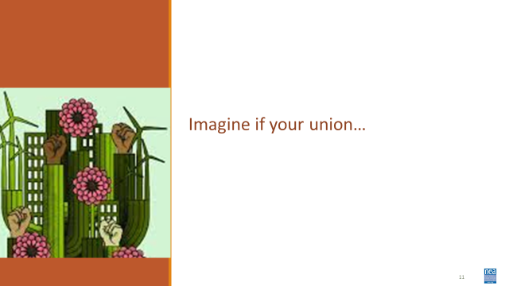  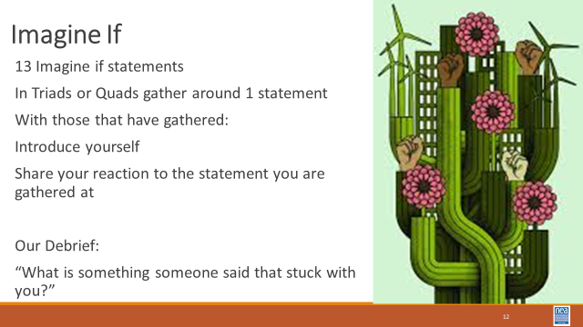  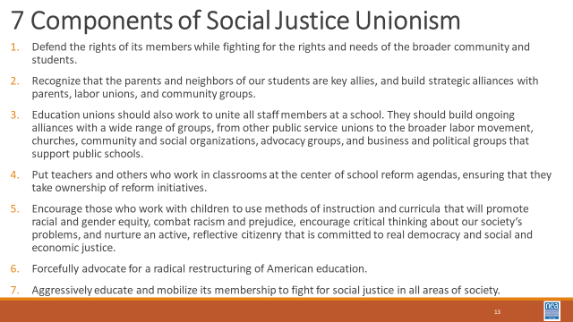  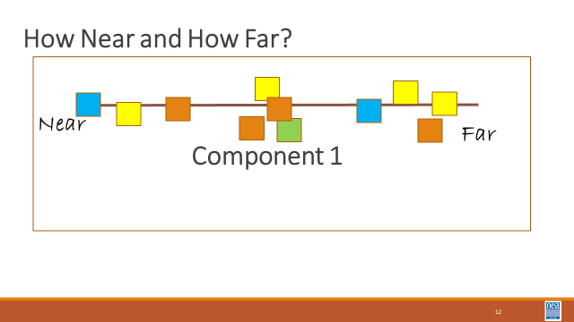  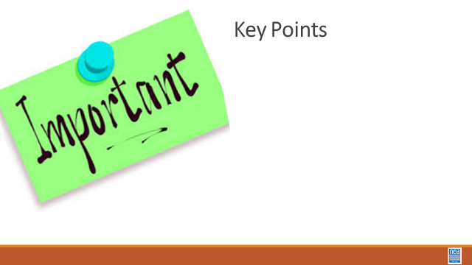 |  | Social Justice Unionism https://neahq-my.sharepoint.com/:w:/g/personal/eholmes_nea_org/ES3hKEhA-N1JrIjEnF6TouABC06A19tvrfMbjXVPRURqeg?e=NDFEzT |  | 45 Minutes - Imagine If Your Union…  30 Minutes – Imagine if Your Union Community Building Activity  Using the info on page 21, build a set of –posters, signs, cards – with the 13 Imagine if statements. Have folks gather in groups of 3 or 4 with one statement. They introduce themselves and discuss their reaction to the What if statement their group is considering. There could be time to do two rounds of this. Include a debrief – “Please read your ‘Imagine if’ statement and tell us, what is something that someone said that stuck with you? “  15 Minutes – Let’s Define Social Justice  Show the Definitions  (facilitators hang chart papers with 7 continuums each with near and far on the end – label each of the seven with one of the 7 components of social justice. Have each participant first determine where they think their local(s) are at their tables, then transfer those decisions to the big wall charts. The results will be a plot of the room and where they feel their locals are on each component) Determine where your union is on each of the 7 Component found on Page 74, and the article in the handouts from Rethinking Schools  Debrief Conversation Starter: “Thinking of your one local and the Seven Components of SJU, which component would you consider the most “ripe” for movement? The most entrenched?”  Key Points  - It matters what your locals think more than you.  - Not every local is ready for social justice work in this moment.  The successful social justice campaigns outlined in this text were not staff driven. |  | Participants recognize member perceptions and priorities are the primary indicator of readiness for organizing, and practice assessing readiness
1:35-2:15  Shelly & Matt  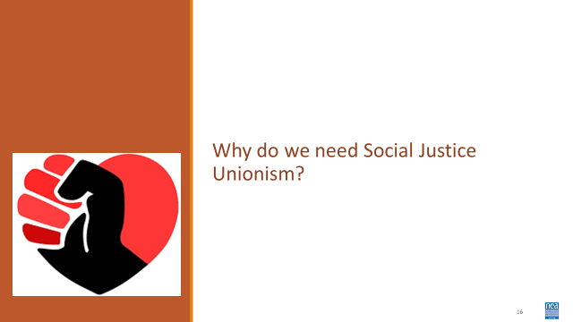  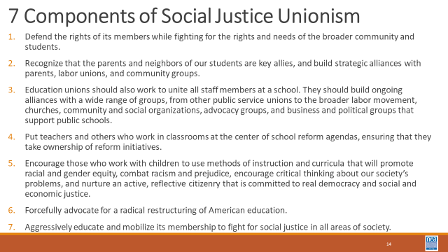  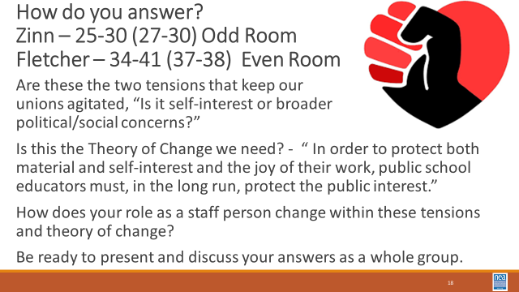 | Why is there a need for Social Justice Unionism? | Handout Two Tensions  https://neahq-my.sharepoint.com/:w:/g/personal/eholmes_nea_org/EYwjH9skKCdNthAMlPB7QAQBKOU0jQOkc-BTTNLoPi8s1w?e=YdKLZJ |  | 45 Mins TOTAL – Why do we need Social Justice?  Let’s begin where all good work begins, with exploring why – Why do we need Social Justice?  Read aloud and post on PPT and provide in handouts, The two paragraphs on Page 42 of “Visions of Justice that begin with, “ Two tensions have been…”  AND the paragraph on page 51 that begins with, “ Teacher Unions have at times challenged the …” as an agitator.  People are assigned either the Howard Zinn and Bill Fletcher Articles and are asked to use what they learn to respond to the two tensions and theory of change posed in the agitation materials. Tensions, “Is it self-interest over broader political/social concerns?” and the theory of change is, “ In order to protect both material and self-interest and the joy of their work, public school educators must, in the long run, protect the public interest. “ How would Howard or Bill answer this based on their interviews? Be ready to present and discuss your answers as a whole group. |  | Participants understand historical basis for current struggle, responsibility to move members to own identity as workers and break down martyrdom mindsets.
2:15-2:30 | BREAK
2:30-3:05  Sara & Albert  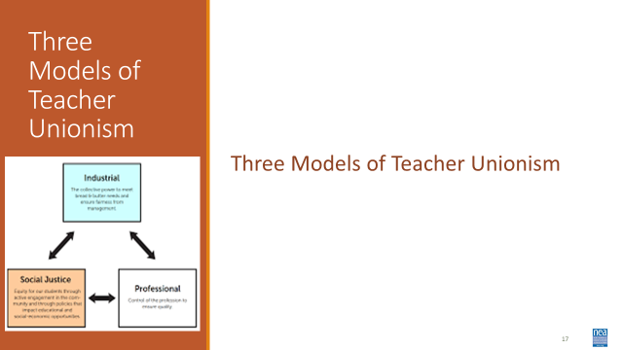  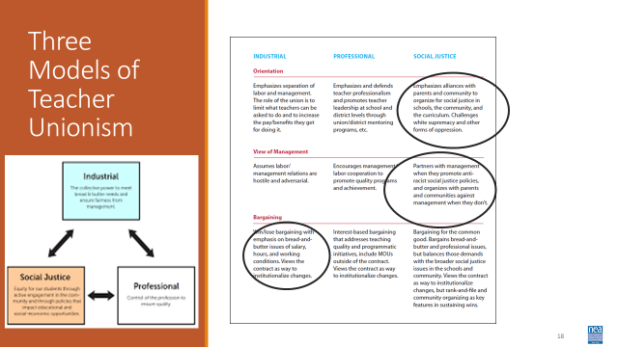  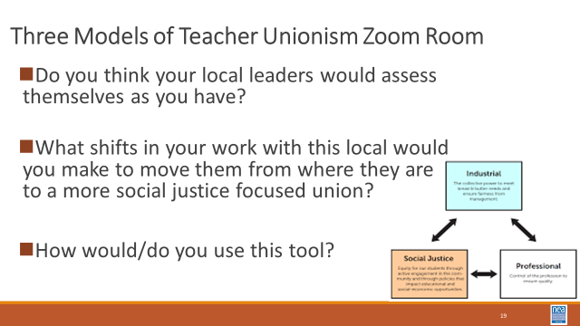 | What kind of Union do you work with? | Video for Facilitators  https://www.turnweb.org/videos/patrick-dolan-organizing-through-the-three-frames-of-unionism-industrial-professional-and-social-justice/  Three Frames Handout  https://neahq-my.sharepoint.com/:b:/g/personal/eholmes_nea_org/EQ6iFL9oLUZIo8DOjTm1lVwBWlFrO003EMAfuOnh3Oz5Ew?e=YuWzm5 |  | 45 Mins TOTAL – Three Frames of Unionism  Using the chart on page 103 – update our handout -  Think of a local you work with. Think about how the leadership of that local would read this chart. You are going to circle the descriptor in each row (component) that best fits what you believe the leadership of that union would circle. With your group discuss the following: In which of the models do most of your circles show up? How does this align with the local’s stated vision and mission? For example – if their vision is “The Union is the Community Leader in advancing Equity” and most of their circled descriptors are in the Industrial model column – there appears to be some misalignment. What does that mean for your work with them? How do/would you use this tool with your leadership teams/colleagues?  Report out  Key Points  - This is not a linear process.  - Context matters.  - This is framework to help organize thinking and work. |  | Participants will understand some of the differences in the three models of unionism and will explore how to apply this tool to their work.

