Facilitator Agenda Day 1 –Teachers Unions and Social Justice
General Materials Needed: |  |  |  |  | Room Set-up:
1 Set of Handouts per Person  Name Tents with the Norms  Sign-in Sheet  Agendas on the table (1 per)  Room signs, sign in signs  One ream of white photocopy paper  Chart Paper (4 to 5 full w Sticky Strip) |  |  | Materials Box for each table with:  Markers (Mr. Sketch variety)  Post its – 3x3” and 4X5” sizes  Index Cards  Highlighters – 4 colors  Pens and Pencils  Participant “toys” |  | Round Tables  Projector, Screen and Speakers  Carousel stations and reporting stations around the perimeter  50 people
Key Outcomes for the Event:
Participants will understand what social justice unionism is.
Participants will be able to recognize core elements of a union that builds power through a social justice framework.
Participants will be able to build a plan aligned with a social justice strategy towards social justice demands.

Day 1 Themes and Big Ideas –
How did we get here? (History activity, community builder)
Who leads? (Some thought or discussion activity – maybe a push pull with quotes, and the discussion questions focuses on the role of staff
(World as it is) Exploring three assessments – Three Frames of Unionism, Race and Equity, What if my union…
Role of Leaders in Change – McAlevey Leaders, Mobilizers, and Activists
Time | Essential Questions | Resources |  | Instructions, Activity and Debrief (Facilitators) |  | Outcomes
 | What question(s) should this learning section answer? | Charts, handouts, articles, materials, slide  RED is for Facilitator  BLUE is for Participant |  | What are you saying, what are they doing, what questions will you use to guide learning and make clear the important points  Include an estimate for how long each section of the learning will take |  | As a result of this section of learning, what will participants know or be able to do?
7:00 -8:30 | Breakfast, Facilitator Prep
Entry Activity   | What do you think of as Social Justice Unionism?
8:30 -9:15  ___  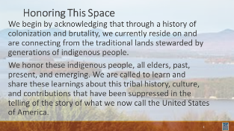    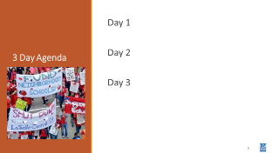  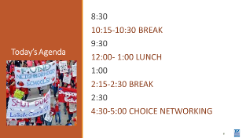    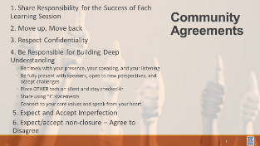  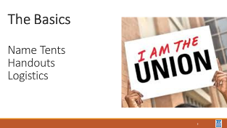  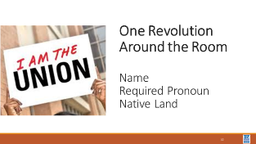 | How will we work together to support learning? | Norms  Parking Lot  Agendas on the Table  Name Tents  Handout Package |  | 45 Mins TOTAL Getting Started  30 Minutes – Welcome, Community Agreements, Agendas, Name Tents, Handouts, Logistics  15 Minutes – Introductions  Team Introductions  One Revolution Around the Room –  Each person states their name, where they are from, required pronouns, Native Land |  | Participants will know how we are going to work, the basic schedule, and the logistics relevant to the training.  Participants will begin to build a community around the content we are discussing.
9:30 – 10:15  ____  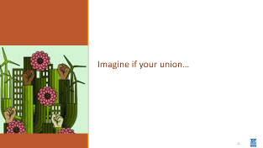  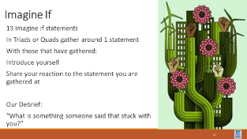  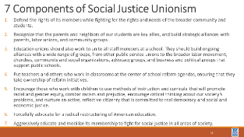  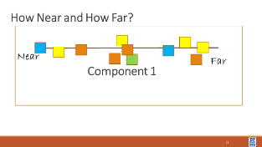   |  | Social Justice Unionism |  | 45 Minutes - Imagine If Your Union…  30 Minutes – Imagine if Your Union Community Building Activity  Using the info on page 21, build a set of –posters, signs, cards – with the 13 Imagine if statements. Have folks gather in groups of 3 or 4 with one statement. They introduce themselves and discuss their reaction to the What if statement their group is considering. There could be time to do two rounds of this. Include a debrief – “Please read your ‘Imagine if’ statement and tell us, what is something that someone said that stuck with you? “  15 Minutes – Let’s Define Social Justice  Show the Definitions  (Facilitators hang chart papers with 7 continuums each with near and far on the end – label each of the seven with one of the 7 components of social justice. Have each participant first determine where they think their local(s) are at their tables, then transfer those decisions to the big wall charts. The results will be a plot of the room and where they feel their locals are on each component) Determine where your union is on each of the 7 Component found on Page 74, and the article in the handouts from Rethinking Schools  Debrief Conversation Starter: “Thinking of your one local and the Seven Components of SJU, which component would you consider the most “ripe” for movement? The most entrenched?”  Key Points  - It matters what your locals think more than you.  - Not every local is ready for social justice work in this moment.  The successful social justice campaigns outlined in this text were not staff driven. |  | Participants recognize member perceptions and priorities are the primary indicator of readiness for organizing, and practice assessing readiness
10:15-10:30   | BREAK
10:30 – 11:15  ___  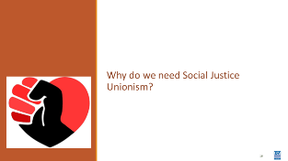  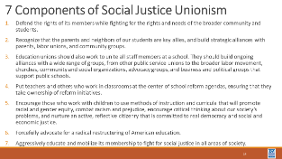  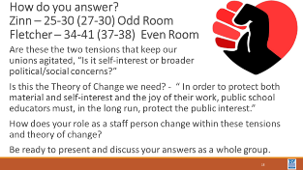 | Why is there a need for Social Justice Unionism? | Handout Two Tensions |  | 45 Mins TOTAL – Why do we need Social Justice?  Let’s begin where all good work begins, with exploring why – Why do we need Social Justice?  Read aloud and post on PPT and provide in handouts, The two paragraphs on Page 42 of “Visions of Justice that begin with, “ Two tensions have been…”  AND the paragraph on page 51 that begins with, “ Teacher Unions have at times challenged the …” as an agitator.  People are assigned either the Howard Zinn and Bill Fletcher Articles and are asked to use what they learn to respond to the two tensions and theory of change posed in the agitation materials. Tensions, “Is it self-interest over broader political/social concerns?” and the theory of change is, “ In order to protect both material and self-interest and the joy of their work, public school educators must, in the long run, protect the public interest. “ How would Howard or Bill answer this based on their interviews? Be ready to present and discuss your answers as a whole group. |  | Participants understand historical basis for current struggle, responsibility to move members to own identity as workers and break down martyrdom mindsets.
11:15 – 12:00  ____  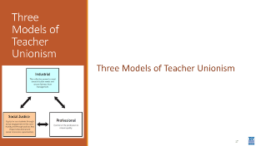  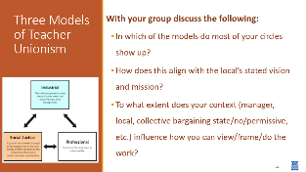  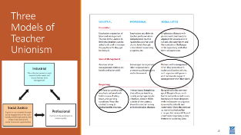  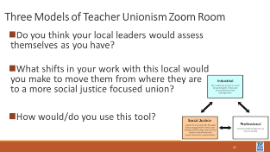 | What kind of Union do you work with? | Video for Facilitators  Three Frames Handout |  | 45 Mins TOTAL – Three Frames of Unionism  Using the chart on page 103 – update our handout -  Think of a local you work with. Think about how the leadership of that local would read this chart. You are going to circle the descriptor in each row (component) that best fits what you believe the leadership of that union would circle. With your group discuss the following: In which of the models do most of your circles show up? How does this align with the local’s stated vision and mission? To what extent does your context (manager, local, collective bargaining state/no/permissive, etc.) influence how you can view/frame/do the work?  For example – if their vision is “The Union is the Community Leader in advancing Equity” and most of their circled descriptors are in the Industrial model column – there appears to be some misalignment.  - What does that mean for your work with them?  - How do/would you use this tool with your leadership teams/colleagues?  Report out  Key Points  - This is not a linear process.  - Context matters.  - This is framework to help organize thinking and work. |  | Participants will understand some of the differences in the three models of unionism and will explore how to apply this tool to their work.
12:00 – 1:00   | LUNCH
1:00-2:15  ___  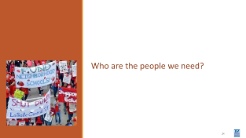  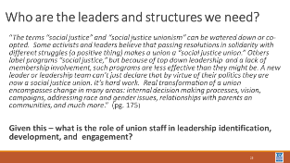  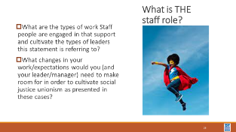  , but  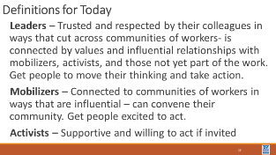  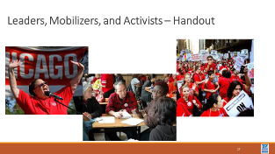  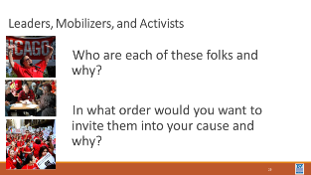  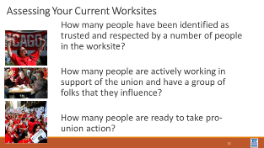  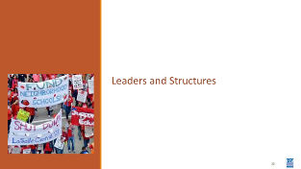  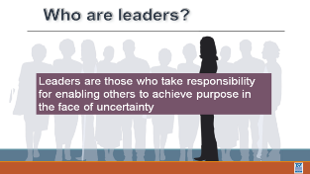  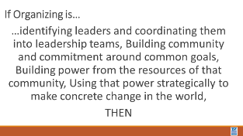  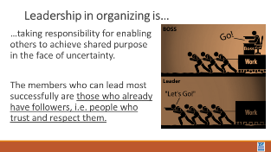  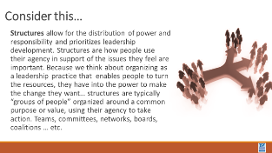  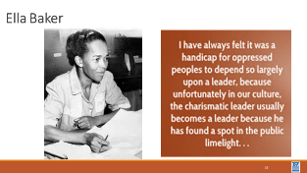  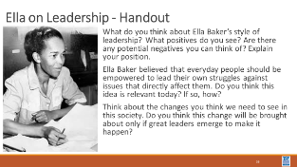  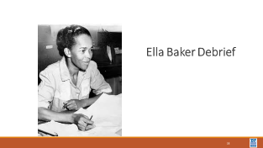  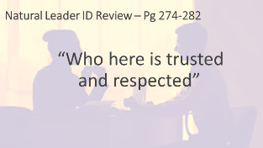  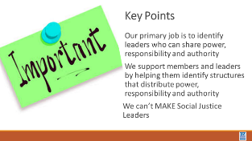 | Who leads the work? | Leader Mobilizer Activist Handout  Ella Baker on Leadership  What is Leadership Ganz Resource |  | 75 Mins TOTAL– Who are the leaders we need?  15 Minutes – Intro to Leadership  10-minute – Count by 5’s  Page 175 – Using the paragraph “The Terms Social justice and social justice unionism can be watered down…”  Discuss - What is the role union staff in leadership identification, development and engagement?  A reminder about “trusted and respected”  40 Minutes - Leader, Mobilizer, Activist activity  30 Minutes Show the definitions for Leaders, Mobilizers, and Activists  Divide into teams of 4 to 5. Give them the scenarios. They are to determine WHO are activists, mobilizers, and leaders based solely on the scenario. AND they are to determine who they would speak with first and why. They will spend about 15 minutes in discussion around the following questions:  Who is a leader, a mobilizer, and an activist? How do you know?  In what order would you want to invite them into your cause and why?  There is a correct answer – the person who moves the most people to act is the leader. The LAST person you invite is that person. It is a high stakes ask.  10 mins – second part of the scenario activity  30 Minutes – Leaders and Structures  30 minutes to read and 10 minutes to report out  Facilitator discusses the first four slides:  Leaders are those who….  Organizing is…  Leadership in organizing is…  Structures are…  We often hear about men who led the labor movement – but Ella Baker’s ideas about leadership formed the foundation of the work by folks like Marshall Ganz. Working with your team, you are going to learn a little bit about Ella Baker’s views on Leadership – the NCAE Case Study mentions her as person whose teachings they worked with.  PAST FAC GROUP TO FUTURE FAC GROUP: IT WAS REALLY POWERFUL TO HAVE A BLACK WOMAN READ ELLA’S STATEMENT FROM THE POWERPOINT—THIS MAY BE ESPECIALLY IMPORTANT IF A WHITE-PRESENTING PERSON IS FACILITATING THIS SECTION.  As you read the article, be thinking about how you answer the following questions?  - What do you think about Ella Baker’s style of leadership? What positives do you see? Are there any potential negatives you can think of? Explain your position.  - Ella Baker believed that everyday people should be empowered to lead their own struggles against issues that directly affect them. Do you think this idea is relevant today? If so, how?  - Think about the changes you think we need to see in this society. Do you think this change will be brought about only if great leaders emerge to make it happen?  5 minutes - Key Points  - Our primary job is to identify leaders who can share power, responsibility and authority  - We support members and leaders by helping them identify structures that distribute power, responsibility and authority  - We can’t MAKE Social Justice Leaders, but we can help potential leaders connect with potential followers. |  | Participants will be able to identify the differences between a leader, mobilizer, and an activist. Participants will review the three most prevalent forms of leadership we see. Participants will understand the design of effective structures for building power.
2:15 -2:30   | BREAK
2:30-3:15  ____  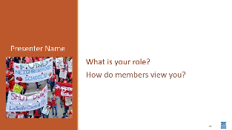  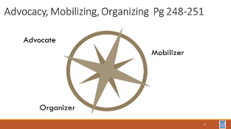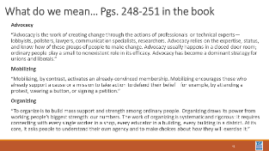    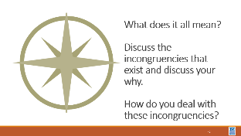 | What are the ways members think about my role? | Advocacy Mobilizing Organizing Frameworks |  | 45 Minutes – How do members view me?  Using the content from pages 248-251 in the book we are going to do a three corners activity.  Let’s define Advocacy, Mobilizing and Organizing - take about 15 minutes in your groups discuss what these words mean, and where you see your practices as a staff person.  NOW that you have read and discussed we are going to do some movement.  - Select the compass point that best answers where you are for each of the following questions -  - 1. What role do your leaders see you in currently? Why?  - (Potential “deeper” question”: Does this view align with the actual expectations of the work they want you to do?)  - 2. What role does your manager expect you to be in most often? Why?  - (Potential “deeper” question:” Is this a question of resources, tokenization, racial/gender dynamics?)  - 3. What would your role look like if you were working with a Social Justice local? Why?  - (Potential “deeper” question:” Dive deeper into obstacles to get there, etc.)  Debrief  What does it all mean?  Discuss the incongruencies that exist and discuss your why.  How do you deal with these incongruencies?  Key Points  We may see our roles differently than our managers and our members.  Your compass helps you define the direction of the work. |  | Participants will reflect on the ways in which their members view their work and discuss ways that they can work to make changes.
3:15- 4:15  ____  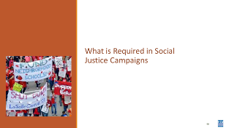  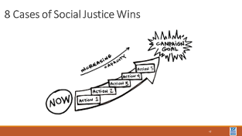  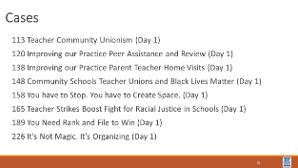  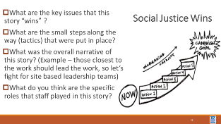  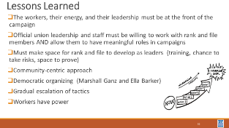  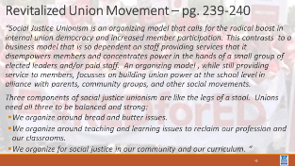  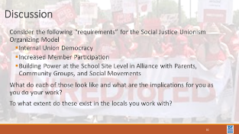  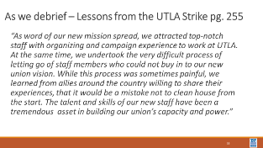  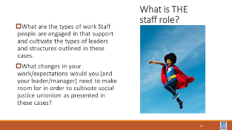 | How do staff work with caucus and insurgent leaders? | Case Studies |  | 60 Minutes Total – What is required in a social justice campaign?  Use excerpts from Bob’s article on page 100 – the five efforts of Social Justice Unionism to frame up the activity - or some other assessment – maybe the “Levels of Organizing” that was used in Advanced Organizing  There are 8 mini cases. There are eight mini-case studies from page 113-169, and page 189, and 226. They all present “wins” that various locals were able to achieve. Form eight teams. In your team look for the evidence of the following:  What are the key issues that that this story “wins”?  What are the small steps along the way (tactics) that were put in place?  What was the overall narrative of this story? (Example – those closest to the work should lead the work, so let’s fight for site based leadership teams)  From whose perspective is this story being told?  What do you think are the specific roles that staff played in this story?  How long did it take for this story to evolve?  What makes this story a social justice win or not?  (Refer to the 7 Components on Page 74 and the Three Frames of Unionism found on pages 103-106  Lessons Learned Across the Cases  Report Out and Discuss  What changes in your work would you and your manager need to make room for in order to cultivate social justice unionism as presented in these cases?  Feedback from last training:  - Consider reducing number of cases (evaluate number of live participants first)  - Organizer on p29 in Participant’s Handbook was not used to take notes of each case. Explicitly spell out how to use the organizer to maximize active listening. Participants' attention began to wane as groups reported out.  - How can we make the case study presentation more interactive?  - Suggestion: Have groups split into categories with a specific focus, then return to share as a whole case.  - Emphasize being member driven and staff coaching  - Role of staff was a recurring question, refer to the roles of leaders, activists, etc.  *As of 6/15-16/2022 |  | Participants will identify issues, tactics, and narratives that have led to social justice wins in union affiliates.  Participants will identify the “invisible” staff roles in the member facing stories presented in this section. They will assess how much of their work would need to shift when leading social justice unionism branded work.
4:15-4:30  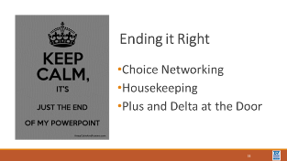 | How are we doing so far? |  |  | 15 Minutes - Ending it Right  Questions, Connections, Reflections  Housekeeping announcements  Plus/Delta at the Door  FOR TOMORROW – |  | Participants will be able to bring a little closure to their learning and provide feedback on the day.
FOR THE FACILITATOR DEBRIEF:
Please consider your group of participants and how you want to split out for affinity groups for the Day 2 Poster Pathway. These are affinity groups built around topics such as redlining, distribution of wealth, school segregation, etc. so you might consider a Black-presenting group and a white-presenting group, but reading your individual room, you may want to include a group of non-Black folk of color (knowing that you may have to push back on non-POC who want to use it as an escape hatch).
5:00 | ADJOURN

