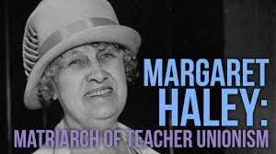
Then and Now
You will need the essay found on pages 67-69 of Teacher Unions and Social Justice

What does Margaret Haley describe in her essay that are still problems today?
How well do you think our unions have achieved wins around these issues?

If we could bring Margaret Haley here, what would you want to tell her about your work for a union that makes you proud?

