Teacher Unions and

Social Justice

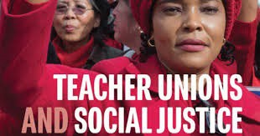

Day 3 Handouts

Outcomes:
- What are strategies that allow us to win?
- What are the key ideas this book outlines?
- What are we going to do when we go home?

