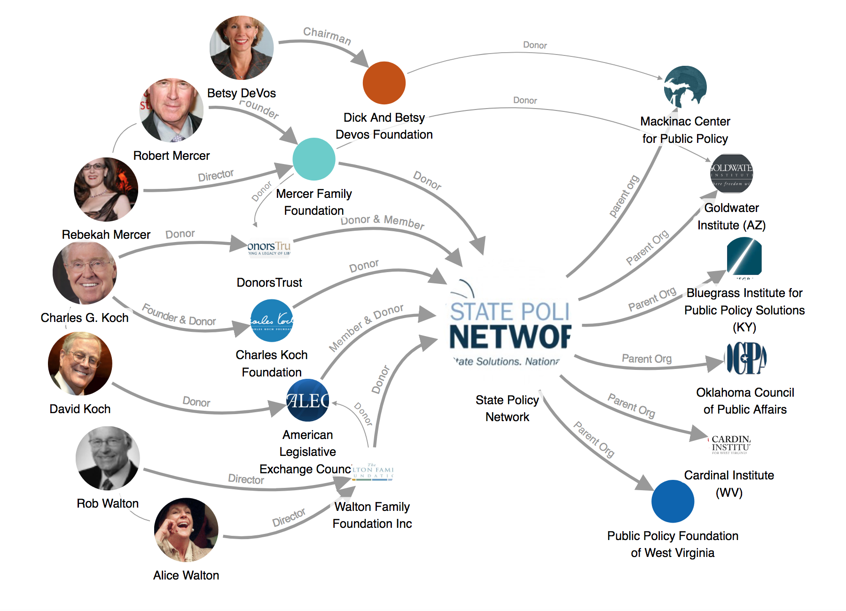
Backers and affiliates of the State Policy Network, which put out a manual to attack striking teachers. See map at LittleSis.org.

