Facilitator Agenda: Online Winning School Board Races
General Materials Needed:
Handout packet (Vote Goal Exercise, Campaign Plan Template, Mapping Charts, Slides)
Zoom & Breakout Rooms

Key Outcomes/Learning Objectives:
- Build sense of community and find thought partners from other states
- Understand what key information to gather to get their local ready for their school board race
- Learn the importance of mapping their school board, their community, and their membership
- Calculate a vote goal and discover where to find important data
- Discuss the fundamentals of organizing a member and voter contact program
- Discover NEA resources for school board races

Agenda Overview:
2:30pm – 2:35pm Welcome – Melissa
2:35pm – 2:55pm Introduction Icebreaker – Natasha
2:55pm – 3:00pm Association Readiness - Melissa
3:00pm – 3:10pm Mapping - Natasha
3:10pm – 3:30pm Vote Goal - Meighan
3:30pm – 3:35pm Organizing Members- Melissa
3:35pm – 3:40pm Voter Contact – Natasha
3:40pm – 3:55pm Breakout Discussions - Melissa
3:55pm – 4:00pm NEA Resources – Meighan

Time, Facilitator and Slides | Resources | Instructions, Activity and Debrief | Essential Questions and Key Outcomes
 | Charts, handouts, articles, materials, videos | What are you saying, what are they doing, what questions will you use to guide learning and make clear the important points  Include an estimate for how long each section of the learning will take  Include Key points. | What question(s) does this section answer?  What will participants know or be able to do?
2:30pm – 2:35pm  Melissa |  | Welcome & Introductions
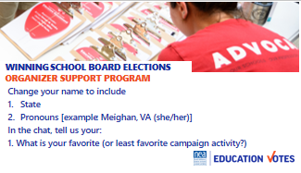  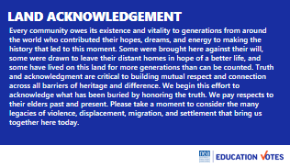  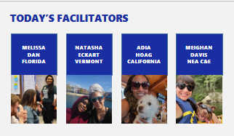  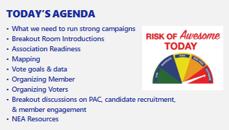  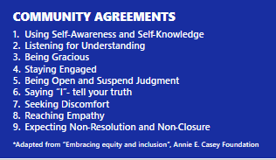 |  | Welcome  - Hey Everyone – Welcome. We will get started in a few minutes and in the meantime if you could change your screen name, add your state &pronouns, make sure you are muted, & type in the chat your favorite or least favorite campaign activity. I despise yard signs so anything with yard signs is a no for me.  Land Acknowledgement  - We will start this meeting with our land acknowledgment. [Read out loud].  Trainer Introductions  - Today we have the pleasure of having these awesome trainers from around the country with various backgrounds in working with all kinds of locals to share their knowledge of school board elections.  Today’s Agenda  - Here is just a preview of some of the topics we will be covering today. We only have 90 minutes so we are really going to cover the fundamentals to get ready for your school board race and give us some time at the end to have some open space for discussion at end.  Community Agreements  - We have a set of community agreements we use in this training program. Do folks have anything they would like to add to this list? | Who are the trainers?  What is our agenda?  How will we interact with each other?
2:35pm – 2:55pm  Natasha |  | Introduction Breakouts
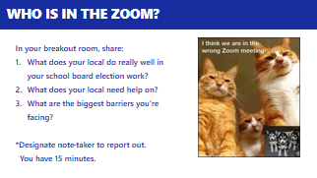 |  | Transition  We really want to use our time together to be as interactive as possible. We always hear what folks love the most about our trainings is the connections they make to staff in other states and hearing what they are doing.  We want to transition into a breakout to have some of those discussions. Here are the questions we want to answer. Make sure to designate someone to take notes and report out.  Report out  Great, let’s hear a report out of those discussions. | What do we know? What do we need to learn?
2:55pm – 3:00pm  Melissa |  | Getting Your Local Ready
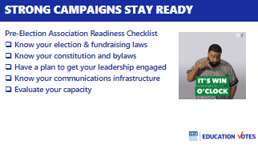  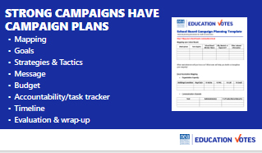 | Campaign Plan Template | So let’s start with what you need to do to set your local up for success.  Association Readiness (3 min)  Strong campaigns think about their races months and even years before. There are some key pieces of information and steps to take to get your local ready for an election.  - First, you need to know the rules. You need to know spending limits, coordination rules, what legal disclaimers you need to use, and how you can raise & spend your dues & PAC money. These rules are all state specific so please coordinate with your affiliate GR or Political Director.  - You also want to know your own local’s process for recommending candidates. Make sure you also clarify with your Governance and Executive Board how decisions are made on program, campaign donations, and spending money. It’s better to get clarity on that on the front end then get into arguments a month before the election.  - Speaking of leaders, make sure you take an opportunity to get buy-in in the beginning from your leaders. Leaders will be invested in the success of a plan if they feel like they were a part of making it.  - Make sure you have access to Facebook pages, you will need that to run digital ads. Start building in collecting/updating personal email addresses and cell phones of your members.  - You also want to know the capacity of your GR committee and building reps. This will help you figure out where you need to spend your time doing leadership ID/development.  Overview of Campaign Plan (2 min)  - Strong campaigns need a plan. There are lot of different formats for campaign plans. The important thing is to find a format that works for your local. Here are the core components for most plans. We’ve also shared this template with you in your packet. We won’t have time to spend on all of these, but we will be digging deeper on a few.  - Let’s quickly run through each component.  - Mapping – this is getting the lay of the land. Some campaign plans might refer to this section as research.  - Goals – these are external goals like how many vote you will need to win the election, and our internal goals about increasing PAC participation, recruiting x number of volunteers etc.  - Our strategy is our overall plan and our tactics are those individual actions to get us there, for example we know having our members vote in big numbers is part of our strategy and doing building meetings is the tactic to help us achieve that strategy.  - Message – We have a message that we will be repeating to external audiences like voters, and what we will be saying to our members to motivate them to vote.  - Budget/Fundraising - Elections are expensive and we have outside money trying to influence our elections so it’s critical that we have our own independent political action committees to support our campaigns and a budget that reflects our spending priorities.  - Accountability/Task tracker –We know stuff doesn’t get done unless there is a name and deadline attached to it.  - Timeline – Our last step is putting it on a calendar that will work for you | How do I set my local/campaign up for success?
3:00pm – 3:10pm  Natasha |  | Mapping
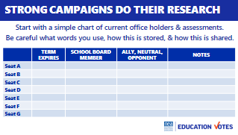  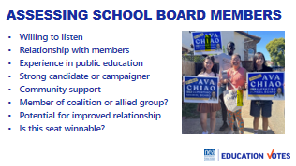  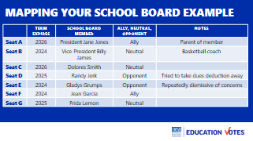  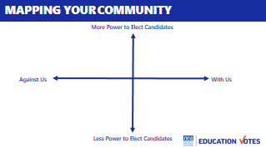  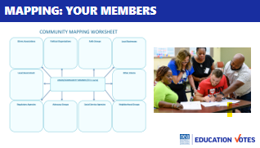 | Mapping charts | Let’s dive a little deeper into research and mapping.  Mapping your School Board  - Mapping is so important because your ultimate goal isn’t just winning an election, but building a majority of support on your school board.  - Real quick in the chat, how many allies do you have on board, how many opponents, how many swing votes?  - If you don’t know those numbers or maybe it lives in your President’s head, here is a simple chart to use to make assessments so you can see how many races/seats you need to target (note specific metrics on what is means to be an ally).  - We can’t always win everything, so it’s important that we know how to tier these races out so you focus your resources on the seat you have the most likelihood to win.  Assessing School Board Members  - Here’s a few factors to help assess your school board members.  - If they are incumbents you should make sure you are also looking at their voting history. Your strongest allies aren’t just folks who come in for interview, but really have a relationship with the union.  - As you are deciding races you want to focus on, make sure you are also looking at who your coalition partners are recommending. These factors can help you determine a candidate’s viability before you go into your recommendation process.  Chart Example  - Here’s an example, we’ve assessed everyone and included important notes to consider.  - So how many seats do we need to flip to have a majority? (2)  - Securing a majority in one cycle, may be a tall order. The districts up might not work in your favor, you may not have great candidates. To that point, it’s important to look out at future races and start doing candidate recruitment early.  - Make sure you protect your friends.  - Incumbents are hard to beat and there may be some districts you will never win and should not play in.  Community Mapping  - Besides mapping our school board, what are some other things we should map or research before the election? (Two big ones are the community and our membership). We need to know important relationships our members hold and we need to know who we should try to recruit as partners.  - Here’s a great chart that will help you classify the different groups in your community based on their support and their power or resources to win elections. What quadrant on this axis should we be focusing our community outreach on? (upper right).  Mapping Members  - We also have this helpful chart to help capture the relationships your member hold.  - Why would knowing what groups our members are involved with be helpful? (they are better messengers to help recruit into your coalition) | What races should we target/prioritize?  Who should we recruit as partners?  What groups do our members have relationships with?
3:10pm – 3:30pm  Meighan |  | Calculating Vote Goal
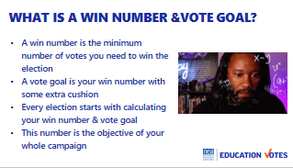  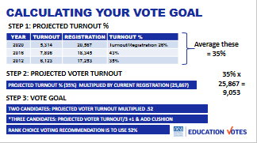  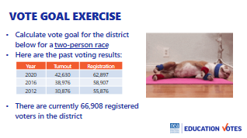  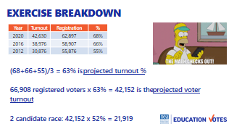  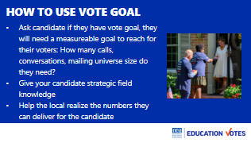  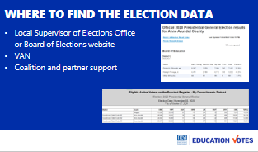  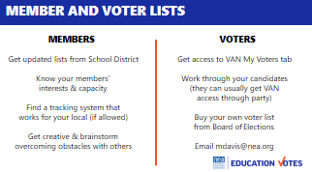 | Vote Goal Exercise Sheet | This might be seen as research like your mapping, but it will also be the biggest goal you are working towards in your campaign plan – your vote goal.  Vote Goal  - You might hear folks say win number instead of vote goal, here is the difference. Your win number is that minimum number of votes you need to win the election. You vote goal is that number with a little extra cushion. This a critical number to know because it will help your candidates know how many doors they need to hit, how much mail you need to send, and if you can win this election just by turning your members out.  Calculating Vote Goal  - Here’s how you calculate your vote goal  - Gather information for the past three elections that look like the one you are working on. If it’s in a presidential year, look at the information for that district for the past three presidential elections. Depending on your state, this may be super easy to find on the State Board of Elections website or your clerk’s website.  - You will average the turnout for these past three elections. This is your projected turnout %.  - You also need to look up how many registered voters there are in this district. Take the percentage from step 1 and multiply that percentage with registered voters. This is your projected voter turnout.  - Now to calculate vote goal if this is a two-person race, you take your projected voter turnout and multiply .52. If you have more than 2 candidates, you’ll divide your projected voter turnout by the number of serious viable candidates and add 1. It’s also smart to add cushion on top of that.  Exercise  - Now it’s your turn.  - There’s vote goal worksheet in your packet and one of the trainers is going to drop in the chat.  - Here’s data you need on your slide.  - When you have the answer drop it into the chat.  Exercise Breakdown  - Here’s the math.  - You can see the turnout %’s by dividing turnout by registration. You add those 3 up and divide by 3 to get your projected turnout %.  - Take your number of registered voters multiply it by your projected turnout % and that’s your projected voter turnout.  - It’s a 2 person race so we will multiply by .52 to get your vote goal.  How to Use Vote Goal  - For folks in urban areas or really large districts, these vote goal numbers can feel outrageous and you may never get close to reaching them. Vote goal is still valuable lesson though.  - You should definitely ask your candidates if they have a vote goal. It’s a good indication of how serious they are about running a viable campaign. If they don’t have one, you can share the data you used.  - It’s also a helpful number to share with your members so they know we can deliver for the candidate or stress how we need to be organizing friends and family if it’s more than your membership.  - If you have budget, it’s good to know so you can make decisions around mail or digital.  Finding the Data  - To find the data you need to calculate your vote goal, you should start with going to clerk or checking out the board of elections website. Just note you may still have to do some math. To get the turnout % for this school board district, I need to add all the ballots cast and then go back to voter registration during that time to get that total. A lot of states won’t calculate turnout for particular school board district and not all voters go all the way down the ballot. The more data you can get for that specific district, the better.  - For folks who are dealing with new districts or redistricting – try to find data that is as close as you can get.  - Make sure to coordinate with your partners on this.  Lists  - To reach your vote goal, you need lists.  - For members, make sure you are getting updated lists from district, the year round organizing toolkit has helpful hints in there  - Know who your members are and what they care about. You can do this during any kind of listening tour or work into back to school blitzes.  - Find system that works for you to keep track of it. It could be spreadsheet or local buying their own database if you can’t use VAN or 360.  - Speaking of VAN, does everyone know what that is? It’s the Voter File Database. NEA has one with member info and one with voter info, but you usually need to add that tab to your profile.  - VAN is offered free to your states. There is a designated administrator. Most states do not let members use VAN. If you go through your chain of command, we can help set-up programs with you on VAN, including tracking, phone, cutting turf packets etc.  - We know some of you can’t access VAN, that sucks & we hate that for you. Here are some workaround ideas:  - Get canvass or phone lists from candidates  - You can usually buy file from the Board of elections for small fee. It usually comes in an excel file. Not the best but it could be a good way to do postcard campaign or make turf packets for your leaders.  - Meighan has had some luck getting it for UDs through GR Directors, so email her with your state if you want to give it a try. | How do I calculate how many votes we need to win?  How do I use vote goal data?  Where do I find that data?  Where do I find the lists?
3:30pm – 3:35pm  Melissa |  | Organizing Members
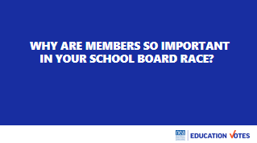  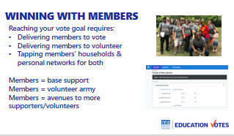  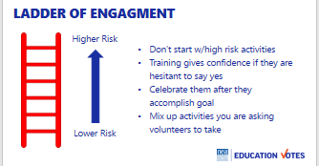  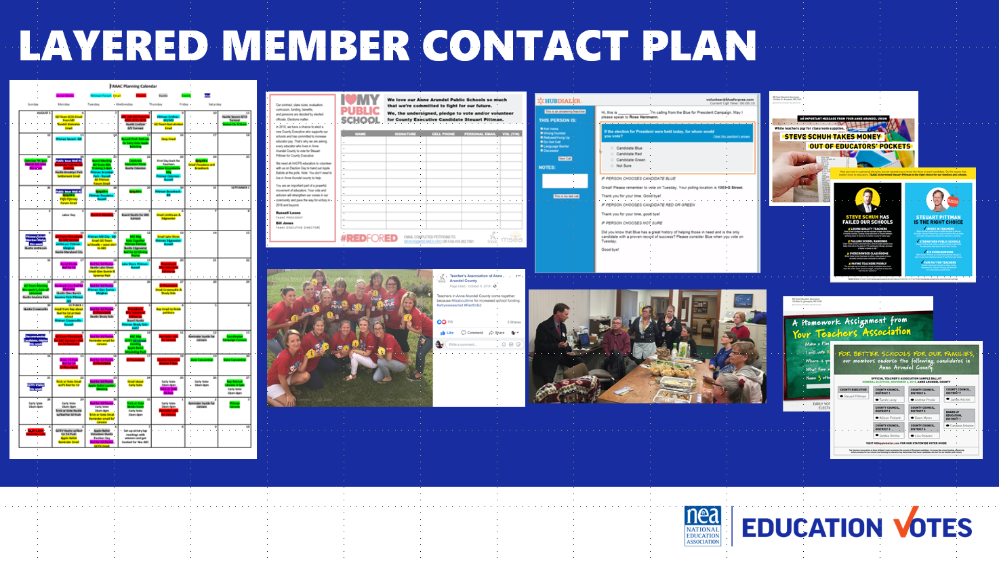 |  | Okay we’re moving on from the research and talking about member engagement and sharing some best practices. Before we get into that, Why are members so important in your school board race? (most self-interest, most motivated to vote & volunteer).  *Voters love talking to educators 71% of voters are more likely to support after hearing from an educator.  Winning with Members  - We can run the tables just by making sure we have a good member program. It’s very important that we not just look at members as volunteers, but we look at them as voters and avenues to do that relational organizing to tap into their friends and families.  - One cool thing about VAN and elections is that we have access to our members’ household members as well in our programs. We don’t have to use PAC money to communicate with them.  Ladder of Engagement  - As we recruit members into volunteer leadership roles, it’s important to remember the ladder of engagement. We want to start with smaller risk roles and move into the higher risk roles.  - What’s a good smaller risk activity to start with volunteers?  - What are examples of higher risk?  - Low: Postcarding, Phone calls  - High: Canvassing, Leadership/Running events  Example of Member Program  - Here’s an example from a local where you can see their calendar and each of these different colors represents different mode of contact that was layered. We had 5k members living in the district so it’ was important to turn out as many as possible.  - They started with ID petition where members got a “I love my public school” t-shirt if they took the voter ID pledge. We used this as a way to clean-up emails & cells and start mining for volunteers.  - On Tuesdays every week, schools would take pictures and have visibility days in their shirts and we posted them on Facebook.  - The GR committee had weekly phone banks to call through the 5k members that lived in the county and what was great about these events is the candidate would come out and thank them while they had the best takeout we could find. They also would touch base with folks who had volunteered on the pledge to get them scheduled for a campaign event.  - We also sent every member 3 pieces of mail – one bio piece in September, one persuasion candidate comparison piece in early October, and one GOTV piece right before early voting started.  - This local had the highest turnout and most volunteers and won a race no one thought they would win b/c of this program. | What role(s) do members have in this election?  How should we engage them as volunteers?  What is a good example of a member program?
3:35pm – 3:40pm  Natasha |  | Voter Contact
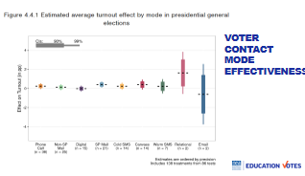  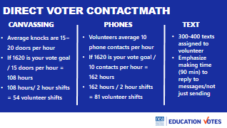  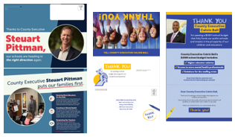 |  | We don’t have a lot of time to dig into voter contact so we wanted to hit a couple of highlights.  - Let’s first talk about the most effective voter contact. On this slide are the most common voter contact methods that were studied by a group of progressive strategists and researchers called the Analyst Institute that help us win elections. These rolling pin graphs show you what increases turnout by percentage point. The longer the rolling pin plot is, the less certainty we have in that tactic.  - These numbers might seem tiny, but remember how close elections are these days. Moving the needle 1-3% could very well mean victory for your candidates.  - Now a lot of these tactics on here cost a lot of money, we are probably not having a huge direct mail program for our school board election and we know relational organizing is incredibly effective, but just telling our folks to go talk to their friends and family isn’t going to get us to your vote goal. We need to make sure our programs include direct voter contact – phones, doors, & texts (to a lesser extent).  - Here’s some helpful field math for your direct voter contact programs.  - For canvassing, these are the average knocks. You may have higher depending on how close doors are together, you may have smaller if it’s really rural turf. You can see if my vote goal is 1620, I’m going to need 54 two hour shifts. So if I’m talking to a candidate, and commit to turnout 9 volunteers each week – I’m going to need to have 6 days of action to reach that 54 shift goal.  - Here are the averages for phone. Again – you should monitor your own numbers that first phone bank to see how your averages break. These are good guidelines so you can start thinking through how many canvasses and phone banks you will need to plan for.  - Text messages are continuing to decline but we know it’s still worthwhile technology with our members, we call them warm SMS b/c we have a relationship. Here are two good rule of thumbs as you make texting plans for members. Don’t assign more than 400. Sending isn’t the issue, you need folks who can commit 90 minutes to monitor their phone and respond to people quickly. We don’t leave them on read.  - We also wanted to share something affiliates usually do for statewide races that is a really smart tactic for school board races too. Here are few examples of what we call thank you mail. It gives us the opportunity to share with the public before election time the good things your candidates been doing for schools. In a lot of states, you can use dues money for this. You can also do the opposite of this, what we call spank you mail. Make sure to coordinate with your GR department on this b/c there may some | What kind of voter contact should we focus on?  How do you calculate how many volunteers you need for canvasses, phone banks, & text banks?
3:40pm – 3:55pm  Melissa |  | Breakout
 |  | We know we just threw a lot at you. So we wanted to take this next 15 minutes to have some breakout discussions on your next steps.  Facilitator Questions:  - Mapping (Target, Community, Members)  - How many races are you going to target/priorities?  - Do you have partner organizations?  - Are you going to map member relationships?  - Vote Goal/Data  - Do you have access to this data?  - If not, how are you going to get it?  - Member Engagement  - How will you communicate with your members as voters?  - How will you recruit volunteers?  - Voter Contact  - What voter contact methods will you focus on? | What are my next steps with what I just learned?
3:55pm – 4:00pm  Meighan |  | NEA Resources
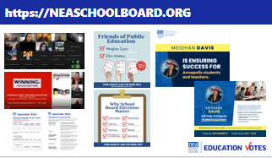  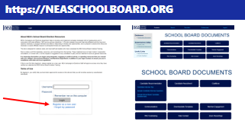  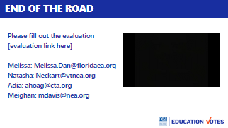 |  | So we have a few resources at NEA beyond this training to assist with your school board races.  Neaschoolboard.org  - This is a website where we house past trainings, decks plus templates to use. There’s a canva social media shareable on here plus info on a direct mail vendor that has created mail templates if you have funding to do direct mail.  - You need to go to this website and register as a user to access these resources.  See Educators Run  - This is a training program for members who want to run for office, primarily school board.  - One great thing is you can have your allies joins as “community ally $25 membership” and they can attend. NEA pays for hotel and food. State Affiliates approve participants and pay for their travel.  Wrap  - We’ve hit our time limit. If anyone has questions we haven’t touched on though, a few of us can stick around.  - Our last ask is to fill out the evaluation. We want to continue to provide UDs the resources you need so if you can take a minute now and we’ll even play some Boyz II Men mood music for you.  - Thank you again and have a great day. | What resources does NEA have to help me win my election?

