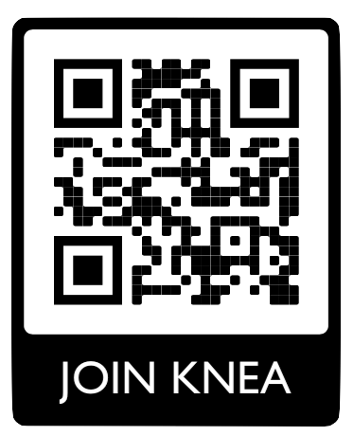

Building Rep Manual
2025-26

Table of Contents
Click a heading to skip to a section
Table of Contents 2
The Powerful Role of Building Association Reps 3
Directory 4
What is the Representative Assembly? 5
Who Do I Talk To? 6
All About Membership: KNEA has strength in numbers! 8
Conflict Between Coworkers 10
What if a member thinks the admin is breaking the rules? 11
How to Represent Your Coworkers in Disciplinary Meetings 12
Due Process: Kirkwood Educator Rights 14
Rep Guide to Different Types of Admin Meetings 16
Grievance Process 17
Attending Board Meetings 21
Professional Boundaries: Technology, Marijuana, and Adult-Student Boundaries 22
The 10-Minute Meeting 24
KNEA Tough Questions 25
CBA Myths 27
Issue Organizing Resources 29

The Powerful Role of Building Association Reps

You are the leadership of Kirkwood NEA in your school.
You are a…
CONNECTOR: Update your co-workers on important NEA items that affect them.
RECRUITER: Ask all certified staff in your school to be NEA members.
CONFIDANTE: Listen to your co-workers’ concerns. They trust you and expect confidentiality.
PROBLEM SOLVER: Help your coworkers have tough conversations and navigate the chain of command.

Responsibilities:
- Keep your nose clean at work: school work during contracted time and union work during lunch/ off contracted hours.
- When you are representing KNEA in a meeting, you are putting on your UNION REP hat. You are speaking to admin as an equal.

Decide on each BAR’s role:

Issues Rep | Contract Action Rep
- Listen to member concerns and help explore solutions (preliminary meeting)  - Take notes in meetings between admin and members | - Send bargaining updates about meetings and ways to support  - Maintain group contact method (personal email list? Group text?) and update member additions/drops and contact changes  - Share feedback about CBA with bargaining team.
Both:
- Meet with admin as needed
- Create a schedule, send invitations, and lead ten-minute meetings
- Serve as the “first contact” for staff with membership questions, admin concerns, or staff disagreements
- Stay updated with GroupMe messages
- Attend monthly Representative Assembly Meetings
- Know who your building’s members are! You have a Google Sheet* with member contact info. Keep this list confidential and communicate any edits. *Reach out to Leah Thomas if you need help finding the sheet
- Attend at least one board meeting per school year.

Directory

KNEA Presidents – Mary Beth Kesler (Robinson) and Maria Tutskey (Robinson)
KNEA Vice President - Ashley Luther (KHS)
KNEA Secretary - Amy Leatherberry (KHS)
KNEA Treasurer – Molly Brockmeyer (Keysor)
Grant Writer - Jeni Ono (Westchester)
Membership Chair - Leah Thomas (Keysor)
Delegate - Representative Assembly - Ashley Luther (KHS)

KHS Representatives - 10
Amy Barker (2025-2027)
Lexie Eskelsen (2025-2027)
Jason Evans (2024-2026)
Jason Hoeing (2025-2027)
Sue Ellen Minich (2024-2026)
Lucas Ravenscraft (2024-2026)
Jordan Sabotic (2025-2027)
Kelly Schnider (2024-2026)
Christina Zibart (2025-2027)
one open spot
Nipher Representatives - 3
Colleen Bevilacqua (2024-2026)
Dan Langford (2025-2027)
One open spot
NKMS Representatives -3
Dan Hohenstein (2024-2026)
Jessica Langford (2024-2026)
One open spot
Keysor Representatives - 3 or 4
Jen Bartin (2024-2026)
Nathan Bauer (2025-2027)
Dani Johnston (2025-2027)
Ryan Kuchem (2025-2027)
North Glendale Representative-1
Gina Muller (2024-2026)
One open spot
Robinson Representatives - 2
Kristin Davis (2024-2026)
Stephanie Fry (2025-2027)
Tillman Representatives - 2
Nicole McManamon (2025-2027)
Clint Presley (2025-2027)
Westchester Representatives - 3
Caroline Brightman (2025-2027)
Erik Hansen (2025-2027)
Kristy Santinanavat (2025-2027)
KECC Representative - 1
Monica Ealy (2025-2027)

What is the Representative Assembly?
YOU are! The Representative Assembly consists of the KNEA Executive Committee and Building Association Reps. We will have a 30 minute Zoom meeting once a month at 7:30pm.

Sample Meeting Agenda:
10 minutes: BAR Training/Binder
20 minutes: Action items, voting, and parking lot

Please review these meeting dates and accept the Google Calendar Invitations: 8/26, 9/30, 10/28, 11/18, 12/16, 1/27, 2/24, 3/31, 4/28, 5/19

The below graphic helps delineate the differences between BARs, the bargaining team, committees, and the executive committee.

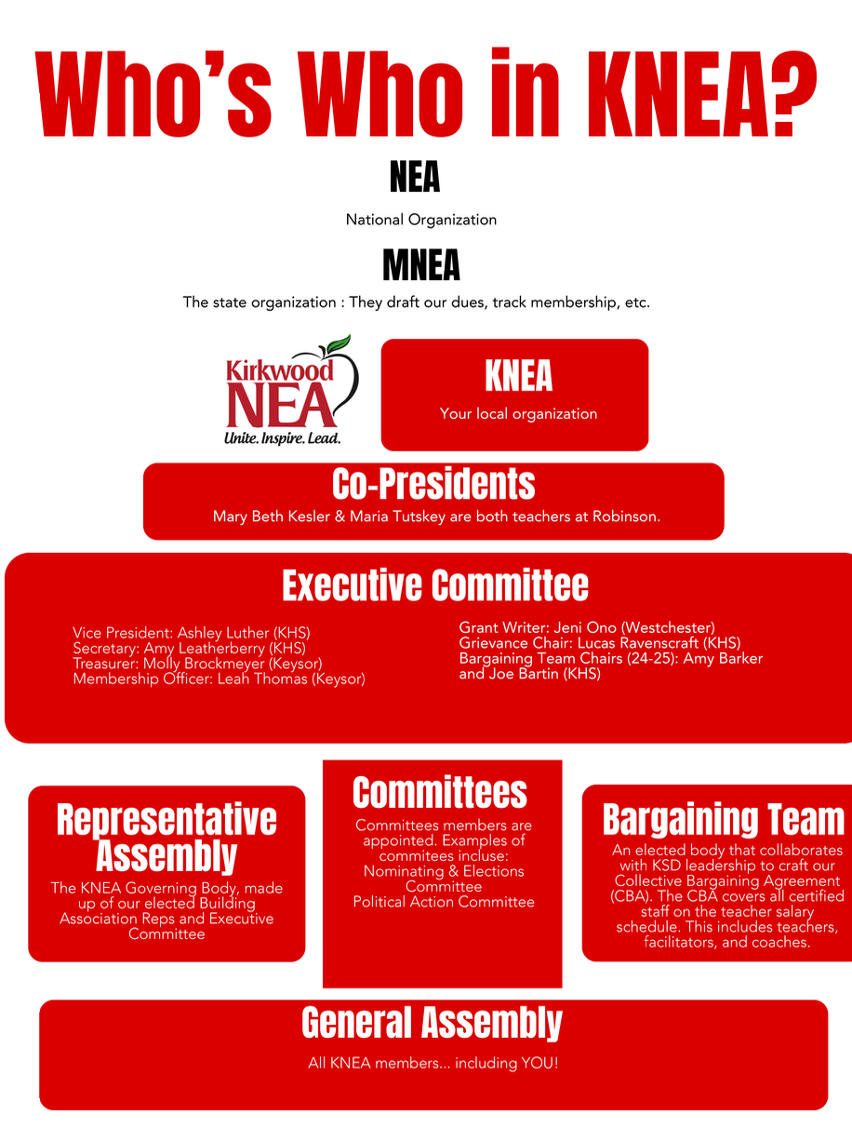



Who Do I Talk To?

Guiding Members to the Correct Union Leader
 | Start with . . . | If it doesn’t get resolved, next go to . . . | Finally, if it’s still not resolved, go to . . .
I have a question or concern about salary and/or benefits. | Your building association rep | Local President | HR Office
I have a question or concern about the evaluation system. | Your building association rep | Local President | MNEA UniServ Director Alice Floros  alice.floros@mnea.org
My evaluation is inaccurate. | Your building association rep | The Local President | MNEA UniServ Director Alice Floros
I need representation/assistance in a meeting with administration/school board. | Your building association rep | The Local President | MNEA UniServ Director Alice Floros
I have a health insurance question | Your building association rep | Local | The Local President
I have been threatened, assaulted, or asked to resign. | Immediately call MNEA UniServ Director Alice Floros
I have been hotlined and Children’s Division has contacted me. | MNEA UniServ Director Alice Floros
I have a great idea for our union. | Your building association rep | The Local Vice-President | The Local President
I need a membership form for someone. | Your building association rep | Membership Officer | Grace Garland  grace.garland@mnea.org
I need to change my dues payment method. | Grace Garland  grace.garland@mnea.org
I want to file a grievance. | Your building association rep and your local president(s)
I would like something negotiated into a future contract. | A bargaining team member in your building | Email to Bargaining Team chair | The Local President
I would like information about MNEA scholarship funds or other union grants. | MNEA website
I would like to know more about what is going on at the state and national level. | Jenny Smith (Meramec Valley NEA, jenjenbowben@gmail.com) and Kathy Pennington (Parkway NEA,pennington_kathy@yahoo.com) | MNEA UniServ Director Alice Floros | MNEA President Rebeka McIntosh
I would like to change an aspect of our state union. | Governance District 11 Reps: Jenny Smith (Meramec Valley NEA, jenjenbowben@gmail.com) and Kathy Pennington (Parkway NEA,pennington_kathy@yahoo.com ) | MNEA President Rebeka McIntosh
I would like to change an aspect of our national union. | The 2 reps from Missouri on the National Education Association board:MNEAboardofdirectors@mnea.org | The NEA President | Bring a motion to the MNEA Representative Assembly

All About Membership: KNEA has strength in numbers!
Contact Membership Chair (Leah Thomas) with questions. If someone wants to join, send them to mnea.org/join
Who qualifies for early enrollment and reduced dues?
- First-time members.
- Returning educators or support staff who were not members during the 2024-2025 membership year AND who have not previously participated in Early Enrollment.

What is the reduced dues structure for “first-time” members?
- $0 dues until September.
- 50% off the total of state and national dues Year 1. Local dues are not reduced.
- 33% off the total of state and national dues Year 2. Local dues are not reduced.
- 16% off the total of state and national dues Year 3. Local dues are not reduced.

What is the reduced dues structure for “returning” members?
- $0 dues until September.
- 50% off the total of state and national dues the returning year. Local dues are not reduced.
Below are the 2025-26 annual dues cost for Active Professional (paid on the certified schedule) members for each level of dues. Years 2-4 are based on the 2025-26 dues schedule; these amounts will change based on the dues structure in place for that membership year. No dues are deducted until September.
Reduced Dues Year | NEA/MNEA Dues | Local Dues | Total Dues
Year 1 | $ 318.00 | $ 20.00 | $ 338.00
Year 2 | $ 423.00 | $ 20.00 | $ 443.00
Year 3 | $ 529.00 | $ 20.00 | $ 549.00
Year 4 | $ 635.00 | $ 20.00 | $ 655.00

Below are the 2025-26 annual dues cost for Active Education Support Professionals (paid on the non-certified schedule) for each level of dues. Years 2-4 are based on the 2025-26 dues schedule; these amounts will change based on the dues structure in place for that membership year. No dues are deducted until September.
Reduced Dues Year | NEA/MNEA Dues | Local Dues | Total Dues
Year 1 | $ 190.50 | $ 15.00 | $ 205.50
Year 2 | $ 254.00 | $ 15.00 | $ 269.00
Year 3 | $ 317.50 | $ 15.00 | $ 332.50
Year 4 | $ 381.00 | $ 15.00 | $ 396.00
MNEA staff are here to help you with your organizing efforts. Please reach out to your regional office contacts listed below.

UniServ Information: Unit 07, Alice Floros, 314-449-7090, alice.floros@mnea.org
Regional Office Administrative Assistant: Grace Garland, 314-584-1308, grace.garland@mnea.org

Support Staff
Support staff are welcome and encouraged to join KNEA. If an ESP (Education Support Professional) has an issue with admin or their work, let them know how being a member of KNEA can help them:
- Legal protection if needed
- Rep in meetings with admin

The sky’s the limit for support staff! While we don’t have many support staff members now, when we have more, they can get their own BAR and maybe their own CBA!

How to drop MSTA

- Contact MSTA
email: KTaube@msta.org.
I want to cancel my membership with MSTA effective immediately. Do not take any of my membership dues for the rest of this school year. If I paid in full, please prorate the dues to this point in the year and refund me.
- For District Payroll Deduction
–contact your district’s payroll dept or finance person and KTaube@msta.org. You do not have to notify local MSTA leadership that you are cancelling.
Email: I want to cancel my membership with MSTA effective immediately. Do not take any more of my membership dues for the 24-25 school year. If I paid in full, please prorate the dues to this point in the year and refund me.

Conflict Between Coworkers

What do I do if a coworker comes to me with a problem with another educator (not admin)?

Questions to ask your coworker
- Do you want help with this or are you just venting?

- What have you done already to resolve this?

- How would you like me to support you?
  - Give you a reality check?
  - Help with a plan for better communication
  - Meet with both people
  - Go to MNEA mediation
  - Go to district HR?

MNEA mediation: Benefits: Not job-threatening and does not involve any school administrators. Everyone gets a chance to talk about the issues and we try to reach an agreement about how to treat each other moving forward.

Complain to your principal or HR: Be cautious: if you go to administration because you cannot get along with someone, this could impact your own evaluation or employment. If you choose to go to admin, ask administrators to take action to stop the issue with your coworker. Put your concern in email and keep it very short and factual.

What if a member thinks the admin is breaking the rules?
What if my coworker thinks that the building principal/ district is breaking the rules? They think they have a grievance.

As KNEA rep, you should:

- Take notes. Write down as many facts as you can. What has the person done to solve the problem?

- Gather documentation. Have the member collect/ print relevant emails, text messages, etc.

- Maintain confidentiality and explain that you will likely need to share the information with the KNEA president and/or Uniserv Director.

Review your options, such as….
- Member talks to the principal with a rep present and asks for a solution and follows up in writing.
- Rep or member asks the principal for a solution and follows up in writing.
- Rep calls KNEA co-presidents to update on the situation.
- Member writes a formal grievance complaint with help from KNEA leadership. This includes issues violations of the collective bargaining agreement, school board policy, and staff handbook.

**Which things go straight to Alice Floros, our MNEA UniServ Director?**
- Suspensions/Administrative Leave
- Hotline calls/ anything involving Children’s Division
- Improvement Plans/Job Targets
- Notice of Deficiency/Notice of Charges
- Concerns around marijuana use
- Assaults/ School Violence
- Workers Compensation concerns

Alice Floros//573-508-8545//alice.floros@mnea.org

How to Represent Your Coworkers in Disciplinary Meetings

From the 2024-2025 KNEA_KSD Collective Bargaining Agreement
Section 9.1 Union Representation at Meeting with Administrators
The Board of Education understands the importance of affording employees the opportunity to have a Union represent during employee discipline matter, when in the judgment of the administration, the presence of the Union representative will not (1) cause undue delay; (2) violate the privacy or other rights of teachers, students, parents, or others; (3) jeopardize the safety, welfare, or interests of students or others, or (4) otherwise interfere with the operation of the district; provided however that when a Union representative is permitted to be present, the representation may ask questions and may request a conference with the employee.

Frequently Asked Questions
Do I get to talk when repping members in meetings with admin?
Yes! Be sure to use the clarifying questions in the boxes on page 10 and guide to different types of meetings on page 14. You can also ask for a minute to talk to your coworker out of the room.
Do I get a sub to rep my coworkers?
You can ask, but there is no guarantee. Typically, we are not getting a sub to watch the class if we need to rep someone. Members should ask to reschedule meetings with the principal for when the rep is available within 48 hours— maybe after school or before school the next day. Virtual meetings are okay too.

What if we can’t postpone the meeting or the person has to go to the meeting alone?
Try to find another rep. Get to the Root: ask for an explanation about why the meeting can’t be postponed. Keep it cute/ keep it mute: Take notes of what admin asks or says. Request 48 hours to think before responding because they are still processing.

Top Tips for Representing a Coworker in a Meeting with Administrators
    - Listen carefully to the question, write it down, breathe, think…then respond
    - Ask the admin if your coworker can write down the questions and then send an email with answers after they have some time to think.
    - If your coworkers gets upset, ask for a quick break. Try to avoid getting loud with an administrator in a disciplinary meeting.
    - Tell the truth: lying in an investigation can lead to discipline
    - Be concise: don’t answer questions that weren’t actually asked
    - Do not speculate: only speak to the facts.
    - If you are given a written disciplinary memo, you must sign it or get in trouble for insubordination. You can write “Signed, but not agreed to. Rebuttal to follow.”
If the principal is surprised or concerned about you there as a rep, you can say
“It’s nothing bad. These meetings can be emotional for employees. I’m just here to help make sure that my coworker understands what might have happened and what you expect. Just trying help keep her calm and keep us all on the same page.”
REASON | QUESTIONS TO ASK
Get more information/ slow down the meeting | Can you clarify…?  Can you explain your interpretation of ?  Can you repeat what you said so I have it right in my notes?  Could we get a copy of the statement/ policy?  What supports have been available to help the teacher?
Stop the meeting/ call out bad behavior | What if we take a 10 minute break? I want to be sure we all hear and understand each other  Can we get back to you after she has a chance to process all this?  Is it necessary to be loud right now?  Can we reschedule this meeting? It’s getting emotional.

Due Process: Kirkwood Educator Rights
DUE PROCESS per page 4 of the KSD Updated 2024-2025 Employee Handbook * We will update if needed when the 25-26 Handbook is released.
Complaints made against an employee must be called to the attention of the employee. The employee may provide a written response to the complaint. Complaints not called to the attention of the employee may not be used as the basis for disciplinary action. The Kirkwood School District practices progressive discipline for employees, which includes verbal warning; written warning; suspension with/without pay and discharge. Disciplinary action shall be appropriate to the behavior, which precipitates the action.

The District reserves the right not to follow the practice of progressive discipline in instances when, in the judgment of the District, consideration for the health and safety of the employee, other employees, and or students, or the effective operation of the District would dictate prompt action requiring removal of the
employee from his/her work situation. An employee may have a representative present, if they so choose, when the District is contemplating
suspension or discharge of the employee.

Due Process FAQ
Can anonymous complaints be used?
It is against due process for anonymous complaints to be used in official employee discipline.
Can old complaints be used a second time to punish?
It is against due process to be disciplined twice for the same incident. This is double jeopardy.

Can I be written up for something I didn't know about?
No. Per the KSD employee handbook, “Complaints made against an employee must be called to the attention of the employee. The employee may provide a written response to the complaint. Complaints not called to the attention of the employee may not be used as the basis for disciplinary action.”

Am I entitled to see the evidence against me?
Due process entitles workers to see evidence. You should have a chance to respond to the specifics.

What is an egregious violation where progressive discipline would not be followed?
Egregious violations include threats or student safety concerns. In these situations, teachers may be suspended from work with pay while the investigation is happening.

Am I entitled to a rep in all meetings like this or only for suspension or discharge?
Feel free to ask for a rep anytime. Many principals allow it. Officially, you are entitled to a rep for investigation meetings, discipline meetings, suspensions and discharge meetings.
Fair Disciplinary Procedures
Checklist to procedural fairness with due process and progressive discipline

Goal: Fair process for educators to respond to concerns and make corrections.

- INVESTIGATIVE INTERVIEW: The employee must be interviewed as part of the investigation before there is any disciplinary punishment. The employee must have the chance to review the accusations, ask her own questions and share her perspective. It is not fair to discipline an employee before they can give their side of the story.

- TIMELY: Was the employee informed of accusations in a timely manner? Typically, “timely” means within 10 work days of the admin finding out about a problem.

- NO ANONYMOUS COMPLAINTS: Was the employee informed of who made accusations? The employee needs to have these details in order to respond to accusations and share their own perspective on the reasons for the complaints. Hearsay is not a legitimate basis to discipline an employee.

- EVIDENCE: The employee should get a chance to review any evidence that could be used to discipline her.

- CONSISTENT APPLICATION OF THE RULES: Is the employee being treated fairly? Are the rules being applied to everyone the same way or is there favoritism?

- TIME TO IMPROVE: Does the employee have time to improve or are they being told that they will be terminated if the issue is not fixed immediately?

- PROGRESSIVE DISCIPLINE: Tries to correct problems with informal verbal counseling. Continued issues of the same policy will have more serious consequences. Egregious issues, for example illegal actions or drinking on the job, do not follow progressive discipline.

Example of Progressive Discipline Process

- Informal Verbal discussion (Hey, Alice, you have been late two times this year.)

- Formal Verbal Discussion (You’ve been late 3 times this year. If this continues, again, I’ll need to write you up and inform HR.)
- Written documentation (This email is a summary of our past 2 conversations on 9/1 and 9/10 about your lateness. I am concerned. )

- Written reprimand (You have violated the staff conduct policy multiple times. Sign this memo and we’ll put it in your personnel file.)

- Improvement Plan (You must clock in and out daily for 6 wks. Last chance.)

Rep Guide to Admin Meetings
This year, we’d like each building’s reps to meet at least quarterly with administration. We’ve made a Google Form to structure your meetings and note-taking. These are short (15 minute) meetings to check in and discuss current issues.

First Meeting
- How do you think it's going in the building with all of the employees?
- What are your goals for the year?
- There’s a couple of concerns. We’d like your help to fix these and make an action plan together.
- Is there anything our local can help with to improve the culture and climate here at the school?

Follow-up meetings
- How do you think things are going?
- Let’s check in on action items from last time. What have we each done?
- New items: What’s going well? What should change?

Meeting goals:
- The goal is to solve problems and be the real voice for your colleagues.
- Consider scheduling regular meetings with admin as a group of building reps. Strength in numbers!
- The rep team should prep before the meeting: Old business, new business
- The union runs the meeting–please do not let your administrator make the whole agenda or do the meeting without you all adding in your concerns and topics.
- Take detailed notes within the Google Form–especially on action steps or commitments from the administrator.

Focus on what matters
- Be fair— thank administrators who fix a problem or respond well, but still follow up on unresolved concerns
- Take a break from the meetings or reschedule if tensions flare.
- Follow up every email with a summary of what happened. If admin sends their own summary, respond to it and correct if necessary.

Getting the Most of Admin Meetings:

REASON | QUESTIONS TO ASK
Get more information/ slow down the meeting | - Can you clarify…?  - Can you explain your interpretation of ?  - Can you repeat what you said so I have it right in my notes?  - Could we get a copy of the statement/ policy?
Stop the meeting/ call out bad behavior | - What if we take a 10 minute break? I want to be sure we all hear and understand each other  - Can we get back to you after she has a chance to process all this?  - Is it necessary to be loud right now?  - Can we reschedule this meeting? It’s getting emotional.
More ideas | - Just so I understand, how specifically would you like me to approach you if I have a question or concern in the future?  - I am confused because in the past, my understanding is that your expectations were____________. I respect your work here. I am hearing you say that you would like for me to ________. I am happy to do that. How would you like things to be handled moving forward?  - I definitely get your concern and appreciate your ideas. Can we brainstorm together how to make it work? I am trying to figure out how to meet your expectation when we also have to deal with _________(this other situation). What are your thoughts on this?
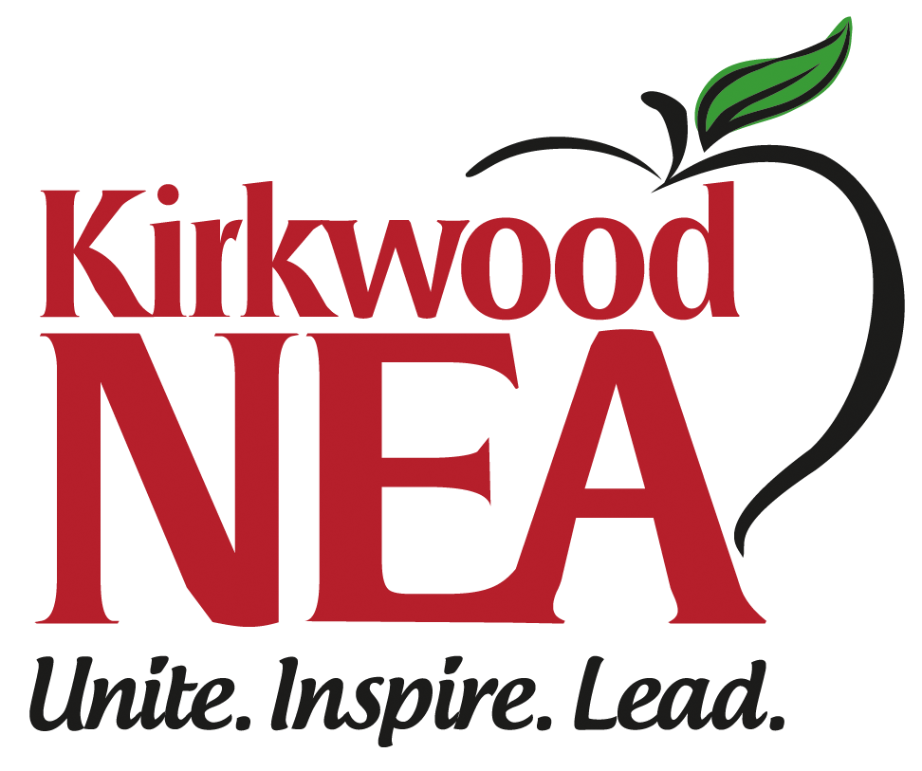  Remind the administrator about consequences for not working with you | - Anonymous building survey about an issue  - Notify the administrator that you will have to inform the building about their action/inaction: “We are the building reps for this building. It is our responsibility to follow up with everyone and let them know that you stated that anyone who is not happy here needs to leave. How do you think that will make our hardworking coworkers feel?”  - Reference your union structure–That’s a concern we’ll have to bring to our local executive board and MNEA rep.  - Reference a possible grievance–We’d like to solve this issue without a grievance. We’re expecting an update by XYZ date and resolution.

Different Meetings BARs May Need with Admin:
Investigative Meetings: Ensure Due Process
Ask admin if the person can write down the questions and send an email response after they have time to think.
Help the member to tell their side of the story:
Allegations can sound bad: withhold judgment and maintain a professional demeanor
You can’t answer questions for the member, but you can pose a question to the member (“so, it sounds like you are saying XYZ?” or “I think he is asking you…”)
Promote accuracy, due process, and respect
Take notes
Make sure the allegations are made clear
If the investigator/principal seems to be badgering the member, interject and remind them that questioning should be done respectfully
Ask about timelines: when they will get a final outcome.

Disciplinary Meetings: check for reasonableness, clarify expectations
Ask the supervisor to go explain the results of their investigation
Ask the supervisor to explain their rationale for discipline, and specifically the proposed level of discipline (oral warning, documented oral warning, written warning, etc.)
Probe whether the allegations are serious enough to warrant the proposed discipline, including how others may have been treated in similar situations.
Principals do occasionally reduce the level of discipline as a result of these meetings, or simply issue a letter of counseling or direction.
Clarify expectations going forward if the situation is one that might recur (example, the discipline is related to how the member handled a student who repeatedly behaves in a challenging manner; what is the expectation the next time the behavior occurs?)
Determine next steps
If the discipline appears unfair, we can file a grievance.

Performance Feedback Meetings: clarifying concerns and confirming support
Take notes
Watch for disparate treatment – are others being held to the same standard?
Ask clarifying questions if there is confusion.
Repeat back positive things you hear from the principal – this encourages the principal to maintain a balanced viewpoint and helps ease defensiveness from the member
Highlight evidence that may have been overlooked: principals don’t see everything the member might be doing
In addition to direct feedback, discuss what supports may be available and useful. Consult our contract and your UniServ rep for additional possible supports.
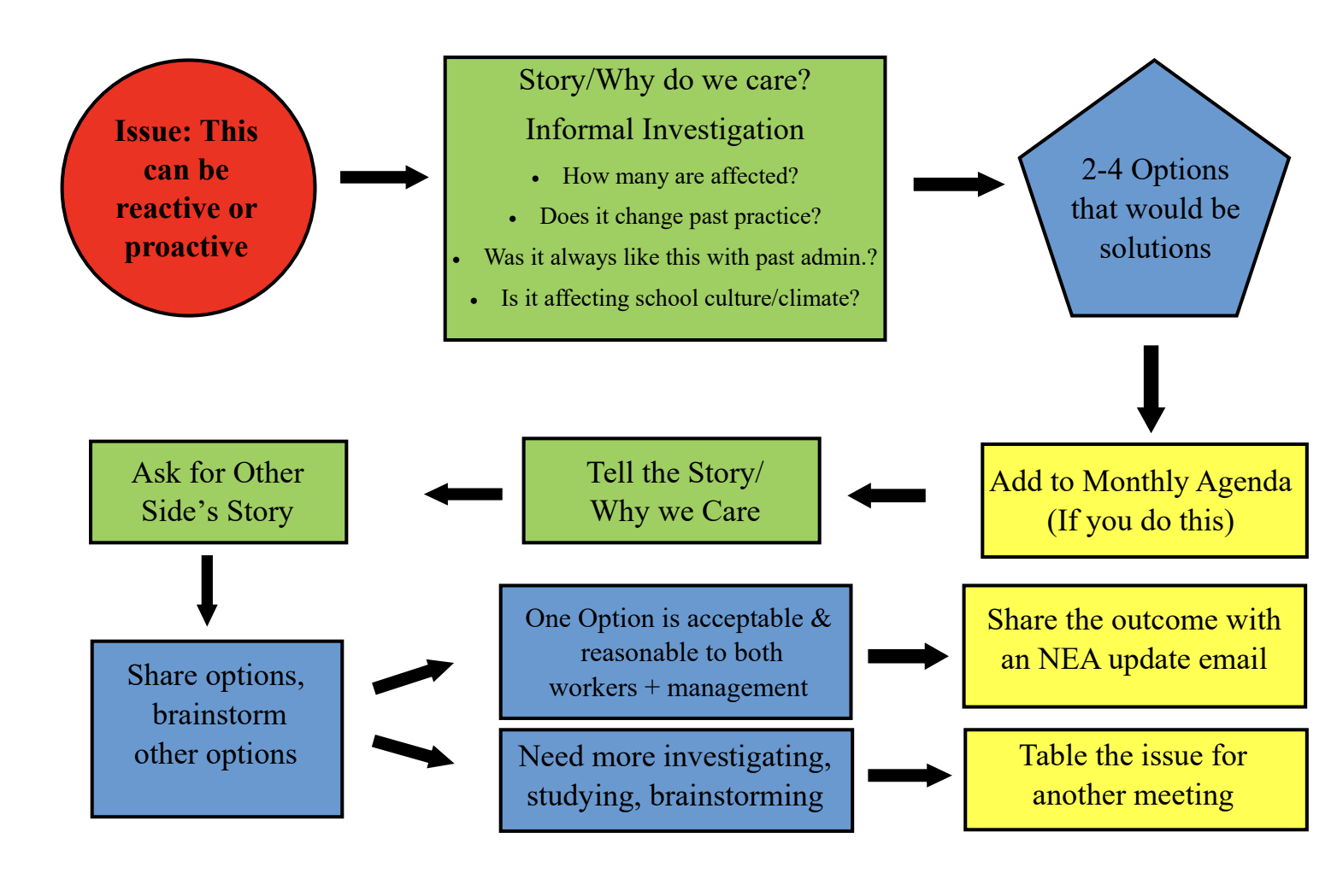
Help clarify or explain what the administrator is asking of your colleague.

Grievance Process
- Deals with violations of the collective bargaining agreement, policies or staff handbook
- Handled by concerned educator, building rep and MNEA UniServ Director Alice Floros
- Formal, cannot be anonymous ·
- Involves meeting with the superintendent and the school board.

Summary steps to filing
1) Write the grievance and compile evidence documents.
2) Meet with principal
3) Meet with Superintendent or Designee
4) Meet with School Board

Administrator Meeting FAQ

- Why does admin have to meet with our local? We already have enough meetings.

The purpose of the meeting is shared leadership and collaboration. We are all on one boat and we’d like to swim in the same direction.

- Why does the union have to be involved? Why can’t people with concerns come straight to admin?

Individuals are always free to come to administration. However, many people would rather have issues resolved as part of a group process.

- Why does the union have to have a group of reps at the meeting? Wouldn’t it be more efficient/ personal if it was a one on one meeting with a lead rep?

The purpose of the meeting is shared leadership and collaboration. The rep team works with all teachers and there are many voices in different grades and departments that need to be heard.

- Why can’t admin have MSTA at the meeting?

There is one union exclusively representing educators for collective bargaining. This meeting with the union reps is not for MSTA.

Attending Board Meetings

Each building will pick a board meeting to attend. You will attend and encourage other members at your school to attend. Wear your KNEA shirts!
- You’re encouraged to make a public comment sharing a win at your school and celebrating teachers. Depending on the time of year, we may also have some bargaining goals you can mention in your comment.
- Talk with your other BARs up for your building’s month here.

Professional Boundaries: Technology, Marijuana, and Adult-Student Boundaries

What should I know about technology?
- Don’t use school email for union business. Central Office can see anything on your computer and your emails. They are not private. Use your personal email (and if possible, your personal device and cellular/wifi).
- Many emails sent from a school computer can be released to the public via Sunshine Act. Be careful what you put in writing.
- Be careful about posting photos of you and alcoholic beverages.
- Please do not follow students on social media (Tiktok, Snapchat, Facebook, Instagram) or comment on their pages.
- Please do not talk about your students on social media.

What should I know about marijuana use for school employees?
Please know that even with the new law on recreational marijuana, school employees still need to be very cautious about marijuana consumption. These rules apply even with a medical marijuana license.

1.Districts typically have 2 relevant policies: GBEBB: Employee Drug and Alcohol Testing and GBEBA: Drug-Free Workplace.

2.. No cannabis products on campus or in your car on school property, per the Drug-Free School and Communities Act. No cannabis products in your car or with you at an off-campus district approved activity, including professional conferences.

3. Cannabis smokers should be careful of smoking in their cars in general or wearing clothes they smoked in recently to school. All the district needs is “reasonable suspicion” aka smelling like weed, to drug test you. The technology is not yet widely available to determine current impairment through saliva testing.

4. Do not talk to admin about a medical marijuana license UNLESS you have had an injury at work which often triggers a drug test. Don’t volunteer information of any kind in this situation. Educators should call Alice Floros as their MNEA rep before telling the admin about their medical marijuana license.

5. Educators should be careful about cannabis jokes or references with kids or at work—full stop. An area employee was disciplined for a joke in the past, so the districts tend to be a bit conservative.

Adult-Student Boundaries
As your union, MNEA wants to be sure that your rights on the job are protected. We also want to remind you of your responsibilities so you can protect yourself.
Appropriate | Inappropriate
Respect for personal space. Giving high fives | Please avoid invading personal space/being too close. It’s best to pull up a chair to avoid standing over/behind a student. This includes limiting physical contact and hugs especially for HS and MS.
Appropriate comments regarding academic and social environment | It’s wise to avoid commenting on the clothes of students or coworkers. Male educators should contact a principal or a female coworker to address girls’ dress code violations. Please avoid compliments that are more personal or physical in nature, e.g., “you have great legs, “you should wear that sweater more often,” laughing at verbal comments with sexual overtones.
Conversations with students that support learning and growth for students. | Conversations, emails, or phone texts with students that become personal in nature. Most districts have policies prohibiting emails to students between 10PM and 6AM.
Referring conversations about serious student problems to the guidance counselor or school psychologist | Please protect yourself by contacting a school counselor immediately via email if you have concerns about a student’s health and safety.
Staff members set standards and show by example that they will not tolerate harassment or discrimination | Please don’t encourage an atmosphere of loose and inappropriate boundaries around gender and discrimination issues
Student-teacher relationship centered on school events and activities | Please maintain the same student-teacher relationship outside of school events. It’s best to avoid taking students to lunch, giving gifts or rides and receiving or writing personal notes.
Being careful about your conduct outside of school, especially when it involves district students. | In your personal life, please avoid situations where district students are engaging in illegal activity, including using tobacco products and drinking alcohol. This includes friends of your family.
Appropriate use of plan time in a manner consistent with educational purpose | It’s best to avoid writing passes for favored students to cover tardiness or absences.
Being careful with your jokes/humor around students. | At school, its best to avoid offensive humor, sarcasm or teasing. It can be hurtful even if you didn’t mean anything by it.
Being careful with student nicknames. Ask them what they’d like to be called. | Please avoid coming up with your own nicknames for students or using nicknames you hear others call them. Students can feel hurt when an educator uses a nickname.

The 10-Minute Meeting
Building Association Reps will host regular building or department meetings in order to have the best shot at strengthening rapport with their colleagues. These meetings are often held at the end of an existing meeting (like an all staff meeting for example) when a large number of the membership is in the same place. Duty-free lunchtime is another opportunity to hold a short meeting. By running a concise meeting, Building Reps can share important information, collect feedback/concerns from members, and report out on success stories. Be sure to stick to the time limit to get more member participation. Click here for example slide templates.

Example 10-Minute Meeting Schedule
Time | Purpose | Category | Why
2 minutes | Current Issues Update | Brief recap of last meeting issues | Keep members informed, alleviate rumors
4 minutes | Hot Issue | Current issue that requires member input before the next meeting | Actively seek member input to inform decisions
3 minutes | What’s on your mind? | What’s going on in the building? Is there an issue that needs follow-up? | Keep a pulse on current issues
1 minute | Success or Problem Story | Thank members for their support | Build a can-do, optimistic culture
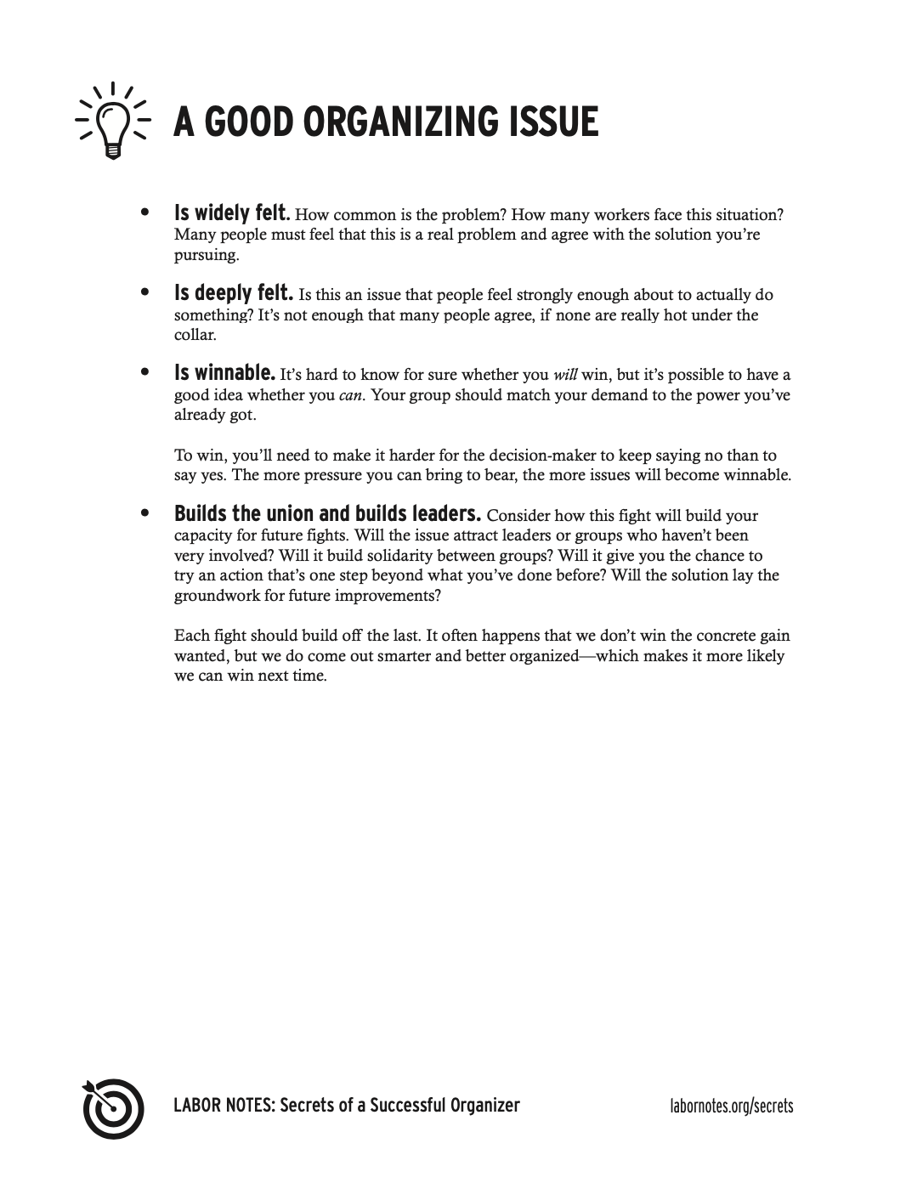
After the meeting:
- If needed, schedule an admin meeting to discuss member concerns.
- Share any action items with the Representative Assembly.

KNEA Tough Questions
Below are some examples of simple answers to tough questions. There may be answers you feel are more appropriate but that still follow the process of affirm, answer and redirect.
Dues: “I don’t think it is worth being involved with the union because dues are so expensive”
Affirm: I can understand why you would be concerned about dues as an educator.
Answer: Our dues give us power and a voice at the national level, state level and here locally. Dues support our efforts as a local education association to provide professional development programs, legal representation, contract negotiations, education policy monitoring and lobbying, and school board election campaigns.
Redirect: For the cost of a large soda each day, your membership allows you to have a voice in the decisions that directly impact your working conditions and provides you with the opportunity to build the schools your students deserve.

Ineffective: “Why should I be involved with the union? The union can’t do anything about classroom size.”
Affirm: I can understand your concern. Classroom size can be a challenging issue to address.
Answer: In fact, union members have been able to get classroom size language into many of their contracts.
Redirect: Right now that is a decision that is solely up to management. As a union, if we stand united as one voice, we can have greater authority in decisions around classroom size. You need to decide if you want management to have the only voice or if you deserve to be a part of the decision-making process when it comes to the quality of your student’s education.

Walkout: “My superintendent told me the only weapon that the union has to get good agreements is to go on strike.”
Affirm: I can understand why you would be concerned after hearing that. Nobody ever wants to go on strike.
Answer: The only time there is a strike is when an overwhelming majority of your co-workers vote to go on strike. Only you and your co-workers can make this decision.
Redirect: The superintendent realizes that you can negotiate good contracts every year, even without a strike. They want to talk about strikes instead of the issues that concern you. (Specify their issue).

Protect Lazy Workers/Bad Teachers: “We have people at my school that are incredibly lazy. Why would I be involved with a union that is just going to protect lazy educators?”
Affirm: I can understand your concern.
Answer: A union can’t protect anyone that is unable or unwilling to do their job. The union helps to ensure all employees are subject to the same fair evaluation. If an employee is subject to termination, there needs to be clear documentation of due process to ensure there is just cause for the termination and it’s not simply because an administrator doesn’t like you personally. It is simply about having a fair set of rules that apply to everyone.
Redirect: There is a process of handling those unable or unwilling to do their job. Lazy employees are the result of lazy management that does not want to put in the work for a fair just process of termination and instead talks about the union protecting lazy workers rather than the issues that concern you and your students. (Specify their issue).

Retirement: “I’m getting ready to retire. I don’t need the union because this is my last couple years.”
Affirm: I understand your concern.
Answer: Your association is your voice on all the issues that affect your retirement from this district and with the state retirement system overall. NEA has terrific member benefits, like long term care and care insurance for retired members.
Redirect: It’s important for you to be an active member now so that your future is not jeopardized. Did you know our local has and is fighting hard for the retirement incentives you have? This is a priority issue for our local every year because we believe every veteran educator like yourself deserves to retire with a little extra money after working so hard to improve the future of our students and nation. We would not have what we do without the power of our united membership. Now more than ever, we must stand together to protect what we have and ensure future educators will receive the same fair compensation for their honest hard work.


CBA Myths
Myth: The district will help me keep track of my certifications.
Truth: You are responsible for ensuring your certification is current and that it reflects the positions you are willing to hold. This is especially true for elementary staff whose schools serve a broader certification range. Doing the following once a year is a good idea:
- Check that your certification is current and reflects positions you are willing to hold.
- Review and print your employee report card
- Review your personal info when MNEA emails their annual membership update. Each year. We have members who find errors in this documentation; thus, annual review can help held off issues before they become problems.

Myth: The CBA process is exclusionary.
Truth: After the May 2023 election, the school board recognized KNEA as the exclusive collective bargaining representative of all KSD staff. KNEA gathers data including listening sessions at each building and a comprehensive survey. Any KNEA member may be nominated for the bargaining team. Once elected, the team creates priorities for bargaining sessions that will benefit all certified KSD employees directly from stakeholder feedback. Through a series of bargaining meetings, KSD admin and the bargaining team negotiate a collective bargaining agreement which is then voted on by membership and approved by the KSD Board Of Education to become our contract.

Myth: I’m not a member, so KNEA doesn’t help me.
Truth: KNEA represents all KSD teachers. While we believe that membership offers additional protections and advantages, we will always work to ensure all teachers are treated fairly and will
bargain for better salary, benefits, and working conditions for all- because it’s best for students!

Myth: Union dues are crazy expensive. It’s not worth it.
Truth: We understand the financial pressures on educators. We believe the benefits outweigh the costs because our dues give us power and a voice at the national, state, & local levels to advocate on issues that directly impact teachers’ money and time.

Myth: The CBA has made the school day longer.
Truth: The CBA makes NO MENTION of instructional minutes. The CBA only governs the length of the teacher work day as a whole (Section 6.2).

Myth: The CBA has forced the District to stop offering the lump sum payment in the summer.
Truth: The CBA requires that the District publish the dates we will be paid (Section 4.7); it does not require the District to stop offering the lump sum payment.

Myth: Teachers can't communicate with the BОЕ.
Truth: Board members are public figures that we depend on. Our collaboration only makes our district and community stronger. Sharing highlights from your classroom or sending a thank you for their service are two ways to initiate a positive exchange.

Myth: The CBA means we have more PLC meetings.
Truth: The CBA capped mandatory meetings outside the standard workday at 12 hours per school year in an effort to create more equity across buildings. Individual schools can choose to fill (or not!) that time as they wish.

Issue Organizing Resources

