Site Representative Training Resource
Binder



2018-2019

Table of Contents

Topic Page
General Information & Framing the Training
- Centering and Purpose and Hope 4
- Unionism & The Facts of Life in the Workplace 5
- Union Code of Conduct 6
- Dimensions of Power 7
- Member-Centered Union 8
- Inoculation Against Wolves 10
- The Role of a Leader 11

The Crucial Roles of the Site Representative
I. Union Organizer 15
  - Union Democracy
      - Fair and Open Elections 15
      - Members Own Their Union 16

  - Worker Agency & Structure-Based Organizing 17
- Turning Grievances into Direct Action 20
- Site Issue Organizing 21
- Direct Action Planning Form 24
- Elements of an Organized Worksite 26
- Site Assessment 27
- Site Mapping 29
- Wall Charts 37
- CTA 360 40
- One-on-Ones & Organizing Conversations 42
- Individual Assessment Rubric 50
- Site Organizing Teams 53

  - Super-Majority Participation 59
      - Overcoming objections 61
      - Handling drop requests (RAP) 63
      - Pivot/Bridge Worksheet 64
      - Benefits of Membership 65

  - Union Communication 69
      - Internal & External Message Frames 70
      - Union Communications 73
      - Facilitation of Meetings 74
        - 10 minute meetings
        - Surfacing issues
        - Connecting people
        - Strategies for turnout at meetings
        - Meetings with the boss

II. Membership Advocate 79
- Contract Enforcer 79
- Parity 80
- Duty of Fair Representation 80
- Purposes of Grievance Procedure 88
- Interviewing the grievant and practice 93
- Grievance Checklist 102
- Role of Grievance Representatives 103
- Possible Alternatives to Grievance 107
- Complaints & Litigation 108
- Insubordination 109

- Representing Members 111
- Right to Representation & Weingarten Rule 113
- Employee Discipline 121
- Meeting with Administrators/Management 123
  - Role play/Discussion/Scenarios 128

Appendix: Parliamentary Procedures & Evaluation Form 144
Introduction to the Training Method

Trainers will conduct this workshop using a method designed for union members. It is based on small group discussions and activities. This participatory method puts educators at the center of the training. Participants work together in small groups during the workshop, solving real-life problems, and building upon their own skills and experiences. It allows us to learn by doing.

Where Do Our Workplace Rights Come From?

Union members’ workplace rights come from 3 fundamental sources:

- The law
- The union contract
- The power of solidarity

Of these, the most important is worker solidarity. Without it, the District and our bosses can easily break the law and the union contract and get away with it. Worker solidarity is so powerful that even without the law or the union contract on our side, we can win.



The Basic Premise of Unionism:
“An Injury to One is an Injury to All”
Means that the mistreatment of any individual worker creates the possibility of mistreatment for every worker,

Requires that workers come to the support and defense of fellow workers who are threatened,

Creates a balance of power between the employer and the employees, and

Is the foundation of solidarity among employees.

The Facts of Life in the Workplace
- Because of the difference between employee and employer values, conflict between employees and employers in the workplace is unavoidable.
- In a non-union workplace, the employer has a predominance of power and employees must operate as individuals.
- When employees deal with an employer as individuals, their working conditions will tend to get worse rather than better.
- In order to create a balance of power with the employer in the workplace, employees must be able to act together.

IF EMPLOYEES IN A UNION WORKPLACE ACT INDIVIDUALLY,
ALL EMPLOYEES LOSE POWER.

Union Code of Conduct

- I will not criticize any union colleague except to the individual directly.

- If any union colleague is being criticized in my presence, I will confront the criticism and ask that it stop.

- I will not participate in any conversations with management that criticize, or negatively speculate about, any union colleague.

- I will settle my differences with colleagues within my union.

- I will engage in debate, offer others every opportunity for debate and respect minority viewpoints, but I will observe and support the majority mandate of my union.


Dimensions of Power

Power Over is likely the most common way of power expression that comes to mind when the word “power” is mentioned. Power over is when someone has the power to enforce or coerce.

Alternate Sources of Power

To counterbalance the destructive power over, we need to help people recognize other forms of power they already have.

Power To is the abilities, skills and talents that individuals and groups have that help them achieve success.

This power to may be traditional crafts, special skills learned in school, specialized education, or merely the unique life experiences of individuals and groups. It is important for advocacy practitioners to help surface this unique potential to help shape a more just world.

Power With is about the collective voice. Power with helps the group to see common issues, and get organized to take action.

“Power With”, VeneKlasen & Miller (2002) multiplies individual talents and knowledge. “Many disadvantaged communities and groups are fragmented and are often challenged by working together.

Power Within is believing in one’s own worth and abilities. It is overcoming the sense of powerlessness, and shifting it into a confident, yet realistic, frame of reference.

This expression of power recognizes that a good part of one’s powerlessness is actually the perception of being powerless. Power within is one of the most difficult changes to achieve especially with groups that have traditionally been disadvantaged and marginalized groups such as indigenous groups, women, illiterate rural communities and very poor communities. Over a long time of oppression and structural marginalization, many of these groups adopt the belief that they are inferior to others.

Tadros, Nader. “Relationship between Advocacy, Power and Politics”. www.peoplesadvocacy.org. May 17, 2011. <http://advocate-for-children.org/advocacy/important_concepts_social_justice/relationships>
Taking Action – 2 Models of a Union

 | SERVICING MODEL  Weakening Members’ Power | ORGANIZING MODEL  Building the Union and Members’ Power
Member’s View of the Problem | Member has a problem and views it as only a personal issue. | Member has a problem, but understands it is not just personal, but part of the conflict between bosses and workers.
Member’s Response | Members says to Site Rep: “Fix my problem. That’s why I pay dues, isn’t it? | Rep says to Member: “What can we do so principals don’t keep getting away with this?”
Site Rep’s Response | Site Rep talks to the boss alone: “Let’s just settle this so…” | Site Rep talks to other members about how the issue affects us all. Site Rep and members go together to talk to the boss to resolve the problem.
Site Rep’s Role | Site Rep acts as an insurance agent and simply files the grievance. | Site Rep acts as an organizer. The Site Rep files the grievance and involves members to take collective action on the issue. A strong and united message is sent to administration.
Resolution | Grievance is won. Individual member feels happy.  or  Grievance is lost and member feels unhappy and may blame “the union,” not management | Grievance is won. It is viewed as a victory for all. Those involved feel they have successfully defended their rights as workers. Those directly affected see the difference the union makes.  Or  Grievance is lost, but members are even more determined to take the organizing campaign to the next level to protect our rights.
THE RESULT | Members have not built power. Union organization at the worksite is weak. Administration takes advantage of this lack of unity and loss of confidence in the union. It becomes easier for administration to get away with violating the contract and eroding members’ rights. | Members are empowered and the union is better organized at the worksite. The more collective understanding and action there is among members, the less able administration is to get away with disrespecting and intimidating members and violating the contract.

Member-Centered Union Characteristics
- Members see themselves as the union
- Leaders and reps hold one-on-ones regularly (at least yearly)
- Members are assisted in solving problems through education, organizing, and mobilizing
- Members are involved in:
  - Setting goals & strategy
  - Taking collective action in identifying and solving problems
  - Group problem solving that “Focuses on issues not people”
- Proactive unionism
- Members assist one-another
- Members understand their contract
- Not limited to bargaining or grievances; it empowers teaching and learning as well!
- Active membership
- Staff/officers work to develop members’ skills and abilities
- Information sharing and open communication channels
- Decentralized organizational structure
- Members set proactive agenda, independent of management
Adapted from Dr. Elaine Bernard, Harvard Law School


The Role of Leaders to Overcome Inaction

Admin relies on… | Leaders… | Co-workers find…
Fear of conflict and retaliation. | Tap into Righteous Indignation. | The courage & determination to act.
Futility that nothing will change and we have no power. | Help to develop a Plan to Win and share examples of victories elsewhere. | Hope that change is possible & worth fighting for.
Division, pitting us against each other. | Identify common ground & builds relationships. | Unity to act together.
Confusion, passing messages that alarm or distract us. | Interpret and share information, fitting it into a bigger picture. | Clarity and understanding to see through admin’s plan.

“Hire the best. Pay them fairly. Communicate frequently. Provide challenges and rewards. Believe in them. Get out of their way and they’ll knock your socks off.”
-Mary Ann Allison

The Crucial Roles of the
Site Representative

- UNION ORGANIZER

- Union Democracy - Members own their UNION
- Worker Agency - Members acting together are the agents of change
- Structure Based Organizing – Members create and work their plan to win!
- Super-majority Participation - Members are engaged
- Strong Internal & External Communication - Members control the narrative & use student-centered message frame with discipline

- MEMBER ADVOCATE

- Contract Enforcer
- Member Rep in Meetings with Management

Our UNION is as strong as our sites.
Our SITES are as strong as our reps.
Strong REPS are union organizers and member advocates!

“Our movement is of the working people, for the working people, by the working people.... There is not a right too long denied to which we do not aspire in order to achieve; there is not a wrong too long endured that we are not determined to abolish.”

SAMUEL GOMPERS

Union Organizer

Union Democracy

(Members OWN their union)

- SUPPORT UNION POSITIONS, POLICIES, LEADERSHIP, AND STAFF

- Be transparent. Don’t make secret, back-room deals.
- Engage in debate. Respect majority decision. (Disagree in private; be united in public)
- Follow through with union executive board plans to support union majority positions

- FAIR & OPEN ELECTIONS

    - Be aware of pending elections (union, CTA state council, NEA representative assembly)
    - Know deadlines and timelines for voting
    - provide for secret ballot voting
    - inform members of rules concerning signatures
    - return ballots to your elections chair by the deadline
    - Know the guidelines for elections, check your bylaws and call the president if you’re not sure


Members Own Their UNION

- Members speak for themselves
- Leaders listen to their members
- Members drive negotiations through their actions
- Site charts are shared with all members
- If you can’t count it, it doesn’t count!
- Power is in the hands of the members (employer alliance does not build power)
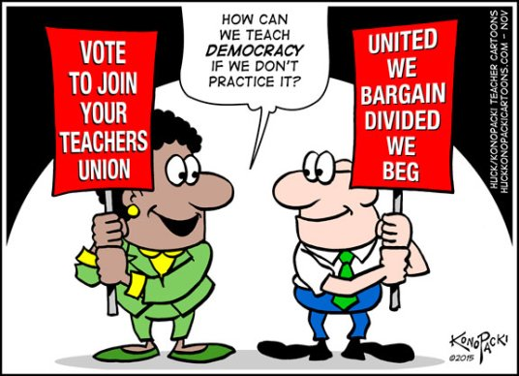
Union Organizer

Worker Agency (Members acting together are the agents of change)

- Assist members in taking direct action to solve issues and/or contract violations at your school site
- Assist members in identifying “organizational cost” – what is it going to take to get what you want at the school site?

Structure Based Organizing (Members create their Plan to Win!)

- Use Site Capacity rubric to determine membership power at school site
- Conduct one-on-one (relational and organizing) conversations to strengthen membership and increase participation
- Help connect-the-dots for members (membership + participation = power)
- Individual assessments (based on what members DO, not what they SAY)
- Assist Building Action Team (as liaison)
- Track participation data on wall chart


A GOOD ORGANIZING ISSUE

- Is widely felt. How common is the problem? How many workers face this situation? Many people must feel that this is a real problem and agree with the solution you’re pursuing.

- Is deeply felt. Is this an issue that people feel strongly enough about to actually do something? It’s not enough that many people agree, if none are really hot under the collar.

- Is winnable. It’s hard to know for sure whether you will win, but it’s possible to have a good idea whether you can. Your group should match your demand to the power you’ve already got.

To win, you’ll need to make it harder for the decision-maker to keep saying no than to say yes. The more pressure you can bring to bear, the more issues will become winnable.

- Builds the union and builds leaders. Consider how this fight will build your capacity for future fights. Will the issue attract leaders or groups who haven’t been very involved? Will it build solidarity between groups? Will it give you the chance to try an action that’s one step beyond what you’ve done before? Will the solution lay the groundwork for future improvements?

Each fight should build off the last. It often happens that we don’t win the concrete gain wanted, but we do come out smarter and better organized – which makes it more likely we can win next time.

- Has a connection to students and the public. If the issue affects students, parents and community, it grows your potential group of activists and the potential support.



LABOR NOTES: Secrets of a Successful Organizer labornotes.org/secrets


What Makes a Good Action?

A good action moves the campaign around the issue. A good action is…

- Simple

- Visible

- Something you know people will do

- Timed for effect

- Builds on past actions (shows escalation)

- Tests people’s willingness to go further (more escalation)

- Unifies people

- Flows from the issue (makes sense in relation to the issue)

- Targets the person(s) with the power to meet your demands
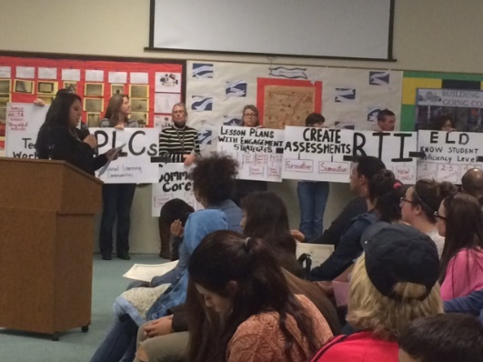
- Creative and fun


Turning Grievances into Direct Action
We file grievances in order to resolve problems on the job.
Problems with the traditional model of handling grievances:

- The worker has a problem and its only seen as a personal gripe
- The Chief Steward, Steward and Union rep is seen as an insurance agent by the members, with the member taking the attitude that this is what they pay dues for
- The Chief Steward, Steward and Union rep acts like an insurance agent, processing complaints and depending on their personal relationship with management
- Chief Steward, Steward and Union rep wins on some issues in which the facts are clear, but lose on those that are open to interpretation
- The Chief Steward, Steward and Union rep gets angry at the worker who fails to recognize the work the union has done on their behalf
- This conflict undermines the unity and strength of the members
- Management takes advantage of the lack of unity, fighting between members and the loss of confidence in the union, by trying to get away with more and more in the workplace
- The Grievance process take time – often grievances take too long. Management may not meet in a timely manner or they may not intend to resolve legitimate grievances and as a result, members view the union as week and unable to address problems on the job
- Grievances take issues away from workers, and give them to management to decide. Or, grievances may end up in front of a non-connected third party where we give up any power over how the grievance will be resolved
- Not every injustice is a contract violation but the issues are still important, and we need a way to resolve them
- The member is not part of the fight so they don’t understand what it takes to win
- When there is a grievance, the Chief Steward, Steward or Union Rep meets with management alone or behind closed doors leaving the impression that the union and management are one, or that the Union is not on their side
- When management stonewalls on legitimate grievances, or when we lose grievances, members blame the union, not management
When Should We File a Grievance?

- Clear violation of the contract
- Need to establish a paper trail
- Need to protect grievance timelines
- Effects only one worker, especially where discipline is involved
- Worker is widely unpopular
- Contract interpretation cases where language is clear

There is a different way to approach problems at work:
Taking Direct Action to Strengthen our Union
(from SEIU Nevada Steward Training)

The Direct Action approach to handling grievances

- When we organize our members and involve them in worksite fights, they understand that worker problems are not personal, but part of the bigger conflict that exists between management and workers
- The Chief Steward, Steward or Union rep is seen as someone who can help build the collective power of the worksite. Workers come to understand that only by sticking together can they enforce the contract.
- The Chief Steward, Steward and Union rep act as organizers and figure out whom else is affected by a worksite problem, and how to act collectively to solve it. Understands the need to be united in the workplace.
- Backed by an educated and organized workplace, the Chief Steward, Steward and Union rep will try to resolve the problem without a formal grievance. The idea is to convince management that they can’t screw with a united, organized workplace if they care about their service.
- If the workers lose the grievance, the blame is on management. It should lead to further efforts to take away power from the bosses, either by changing the contract, doing a better job of organizing the worksite, or figuring out new ways to informally control the work site. When workers win, victories should be viewed as collective victories.
- The Chief Steward, Steward or Union rep gets support from workers who, because they were in the fight and they take away a deeper understanding of the power dynamic between management and workers and a deeper commitment to the struggle.
- The more we are united, and the greater the collective understanding and action, management is less able to get away with dividing us and intimidating and harassing members.
4 Reasons to Take Direct Action to Solve Issues at Work

- Organizing actions with our co-workers helps us win resolution quicker
- Not every issue at work is a grievance, organizing with our co-workers is the only way to resolve some worksite issues
- Organizing around our issues builds workers’ power. It builds solidarity and union visibility. It sends a strong message to the boss that our rights must be respected. When we come together as a union, a group of people acting together, we feel better about ourselves, our Union and our jobs.
- Workers own the issue, take responsibility for solving worksite problems stop 3rd partying of the Union

What issues can be resolved through direct action?

A Checklist:
- It should result in real improvement and be worthwhile. Ask the questions, Will this specific solution help alleviate the problem? Will people see a difference? Will people feel good that they are fighting for something that merits their efforts?
- The issue should be widely felt. Ask the questions, “How common is the problem? How many workers face this situation?” Many people must feel that this is a real problem and must agree with the solution.
- The results should be deeply felt. Ask the questions, “Is this an issue that people feel strongly enough to do something about?” It’s not enough that many people agree about the issue, if none feel strongly about it.
- The issue should be winnable. Ask the questions, “Does this issue seem achievable? Have other groups won similar issues, and how?” Success fosters enthusiasm, once we have one victory, it’s easier to get more help from other co-workers for future fights.
- The issue should build the Union and the Union leadership. Ask the questions, “How will this organizing effort build our member’s capacity for future fights? How will this fight lay the groundwork for future related improvements? Will the effort strengthen the solidarity, empowerment and involvement of our members?” By involving our membership in fights around worksite issues, we will be much more prepared to organize them around major legislative fights and ultimately our contract fight.
What Makes a Good Action?
- It is simple
- It is visible
- Action is within the workers’ experience, outside the boss’ experience
- It is timed for the best effect
- It should build on past actions, to show escalation
- It should test our members’ willingness to go further (more escalation)
- It should unify the members
- It should be related to the issue we’re fighting over
- It should target the right target
- It should be fun!
- Develops our Union
How to Take Direct Action
- Circulate a petition or open letter and get a majority of employees to sign
- Wear a Union Button or Sticker
- Organize a Unity Break
- Filing a complaint or reporting the employer to regulatory agencies
- Participate in a delegation to the boss
- Participate in a delegation to elected officials
- Participate in an informational picket
- Participate in a march around the workplace
- March around the school, district office, Government Centers
Defining a Win
- Workers’ expectations have been raised about what is possible when workers organize
- New leaders are identified and become active
- New members are signed up
- Members more united as a result of the direct action
- Members take ownership of worksite problem
- Members view their union in a new light

Checklist for Choosing an Issue¹
A good Issue for Direct Action is one that matches most of these criteria. The issue should:
- Result in real improvement and be worthwhile. Will this specific solution help fix the problem? Will people see a difference? Will people feel good that they are fighting for something that merits the effort?
- Be widely felt. How common is the problem? How many workers face the situation? Many people must feel that this is a real problem and must agree with the solution.
- Be deeply felt. Is this an issue people feel strongly enough about that they will work on it? It is not enough that many people agree about the issue if none feel strongly.
- Be winnable. Does the goal seem achievable? Do you know other groups that have won similar issues? How did they do it? Success fosters enthusiasm. Once you have solved the easier issues you may get more help from other co-workers to help tackle the more difficult ones in the future.
- Be consistent with long-term goals and direction. How will this solution lay the groundwork for future related improvements? Does it fit with your goals for your next contract campaign, for example?
- Build the Union and build Leadership. How will this organizing effort build workers’ capacity for future fights? How will the effort strengthen the solidarity, empowerment, and involvement among members?

¹ This Choosing an Issue single page is borrowed in part from the Midwest Academy of Organizing manual.
Direct Action Planning Form
- What is your issue? (Explain it simply and clearly both in terms of its effect on workers and our students and/or the community)

- What is your demand? (What will fix the problem? State it clearly and simply.)

- Who can meet your demands? (Who in management has the authority to resolve the problem? Is there more than one person involved?). This is the target of your direct-action campaign.

- What is the plan for uniting workers and demonstrating that unity to move management to meet the demand? (What will you do to influence your target? How will you unify people to take action? How will you prepare your coworkers for the action?)

- How will you escalate if your target says no? A strategy is a collection of actions that escalate from easy, low-pressure tactics to more intense confrontation. What will you do next if one action doesn’t work?
a.
b.
c.

- What are your strengths? (Good leaders, contract language, the law, public cares about this issue, unity)

- What will your challenges be? And what is your plan to overcome those challenges?

- How will you involve and communicate with your co-workers? What communication system will you use: phone trees, meetings, one-on-one conversations, newsletters?

- How will you check in to evaluate your progress toward fixing the problem? Are the actions going well? Did you involve the members you wanted to recruit? Did you achieve your goals? What are the next steps?

- How will you put your plan into action? What are your next steps in the next 2 weeks?
a.
b.
c.

ELEMENTS OF AN ORGANIZED WORKSITE

Our union presence is visible daily to management at all worksites.

- Union site representatives and activists make regular walk-throughs and have relationships with all members, not just active members.

- There is a union rep or site organizer in every school department or work group.

- The list of union reps is written down, regularly updated, and widely available.

- Membership site meetings are regular and well-attended.

- Union representatives attend new-employee orientations; there is a union new employee support program at each school site for new hires.

- There is regular, two-way communication through face-to-face conversations, union newsletters, social media, up-to-date bulletin boards, as part of a member-to-member network.

We defend our standards and enforce our contract.

- Members mobilize and use collective action to solve everyday problems. Contractual grievances are not our primary line of defense.

- Our contract is widely available and promptly distributed, both electronically and in print and is reviewed and discussed on a regular basis.

- Union site reps and activists are trained and empowered to take collective action to resolve concerns at the lowest level, including filing grievances.

- Site administrators do not act unilaterally or abusively, because they know they will get blowback from organized members at the school site.

Members own their Union.

- Union leadership is constantly developing and widely shared and is not dominated by a small clique that resembles an exclusive club.

- Members feel that their union is strong because they act collectively to resolve concerns, and that they have a real voice to improve education for their students.

- Site leaders and activists continuously focus on and track efforts to engage inactive members to get them more involved, particularly influential members.

- Members participate in union-wide programs and campaigns.
- Educators and education support professionals are proud to be union members and recruit potential members to join. Social events are well-attended.

Source: Labor Notes
INFORMAL SITE ASSESSMENT

Chapter: Site:

Name (optional):

Number or unit members at your site: Number of non-members:

- Who are the biggest supporters at your site?

- Who knows the contract best at your site?

- Who are the people most trusted by the members at your site?

- Who are the people most liked by the principal at your site?

- Who are the friendliest people at your site?

- Who are the Association’s biggest critics at your site?

- Who are the instructional leaders at your site?

- If the Association needed to hold an emergency meeting or action, what percentage of the members at your site would attend?
Site Capacity (Power) Rubric
GOAL: Powerful, high-participation school sites to protect quality public education for all students!
HIGH PARTICIPATION is a PREREQUISITE for power!

POWER = RESULTS
Assessment | Site Capacity/Power Indicators: High Participation
1 | - Maximum number of site reps (1 rep per 15 members)  - Site reps attend 90%+ Rep Council meetings  - Building Action Team (BAT) or other organizing team (OT) fully functioning  - 80%+ of members participate in SOLIDARITY COLOR actions  - 50%+ of members participate in other (rally, letter writing, emailing, etc.) actions  - 100% membership density (no FAIR SHARE payers)  - 75%+ of members attend site meetings (meetings at least monthly)  - Conducted 1:1 conversations with all new hires (temp/probes) / data inputted.  - At least 1 site rep uses CTA360 APP (training videos: www.tinyurl.com/cta360videos )  - 75%+ of member VOTE (VEA, local, state, national elections)
2 | - Maximum number of site reps (1 rep per 15 members)  - Site Reps attend 80+ of Rep Council meetings  - Building Action Team (BAT) or another OT formed and ready  - 60%+ of members participate in SOLIDARITY COLOR actions  - 25%+ of members participate in other (rally, letter writing, emailing, etc.) actions  - 95+% membership density  - 50%+ of members attend site meetings (meetings at least monthly)  - Conducted 1:1 conversations with all new hires (temp/probes) and fair share payers.  - At least 1 site rep has downloaded CTA360 APP (training videos: www.tinyurl.com/cta360videos  - 60% of members VOTE
3 | - At least 1 site rep  - Site Rep(s) attend 70+ of Rep Council meetings  - Building Action Team (BAT) or other OT formed but incomplete  - 25%+ of members participate in SOLIDARITY COLOR actions  - 10%+ of members participate in other (rally, letter writing, emailing, etc.) actions  - 85%+ membership density  - 10%+ of members attend site meetings (meetings less than monthly)  - Conducted 1:1 conversations with 75%+ of new hires and fair share payers.  - 60% of members VOTE
4 | - No official site rep  - A member attends some of Rep Council meetings  - No Building Action Team (BAT) or other OT formed  - 10%+ of members participate in SOLIDARITY COLOR actions  - Few members participate in other (rally, letter writing, emailing, etc.) actions  - 80%+ membership density  - Rarely have site meetings  - Still need to conduct 1:1 conversations with new hires and fair share payers.

LEA’s POWER: a) POWER with; b) POWER to; c) POWER within
Ten Questions To Ask When
Mapping Your School

- Grapevines. What paths do people travel? Who can walk freely through the whole workplace? How does news travel?

- Bottlenecks. Are there spots where the flow of work gets bottlenecked? These could be important pressure points. Who works there?

- Work groups. What work groups can we identify on this map? Consider the factors that determine who works together at your school, such as job, work area, and time of day.

- Relationships. Which work groups have contact with each other through their jobs? Which groups are hard to reach? Which groups have contact with other schools in the district?

- Social groups. What social groups can we identify on this map? For instance, who carpools together? Who speaks the same language? Who socializes at lunch or outside work? Who’s related? Who are all the smokers?

- Group concerns. For each work or social group, how does this group relate to the principal and administration? What are the biggest problems affecting this group?

- Water coolers. Where do people congregate? These could be good places for outreach conversations, or group gatherings.

- Broom closets. Where can you talk out of sight of the principal?

- Hangouts. Where do people go after work?

- As time goes by. What on this map changes at different times of day, and week?

LABOR NOTES: Secrets of a Successful Organizer labornotes.org/secrets

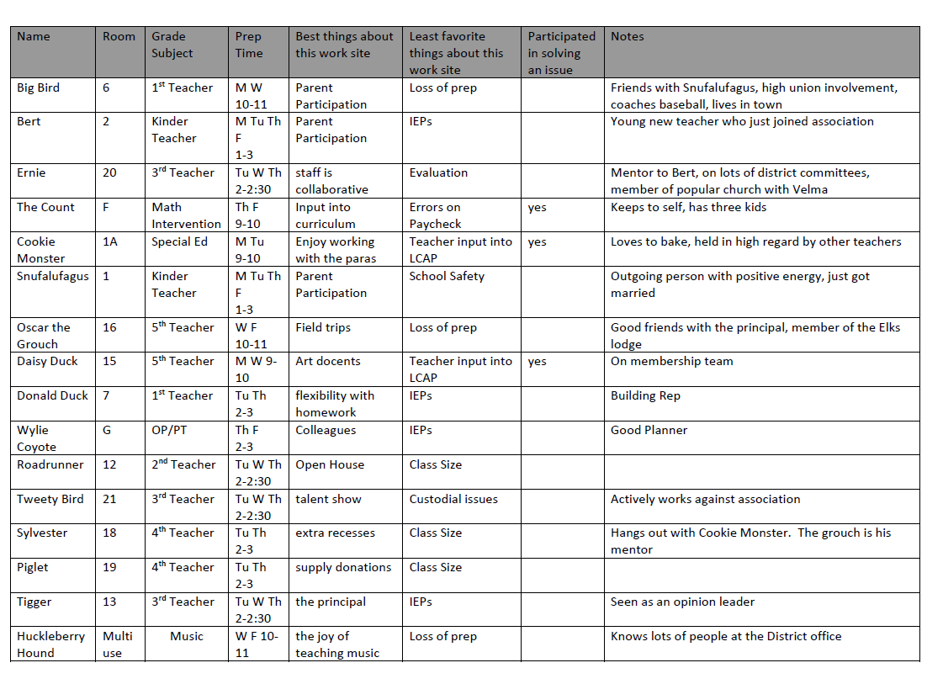
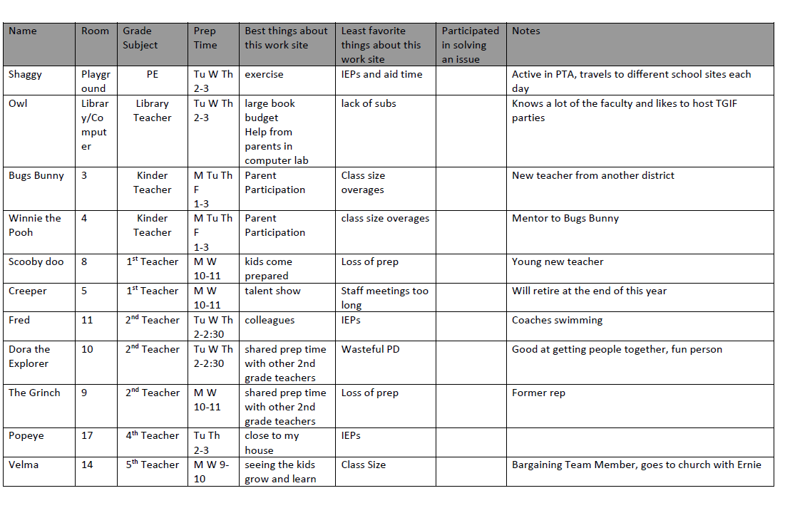

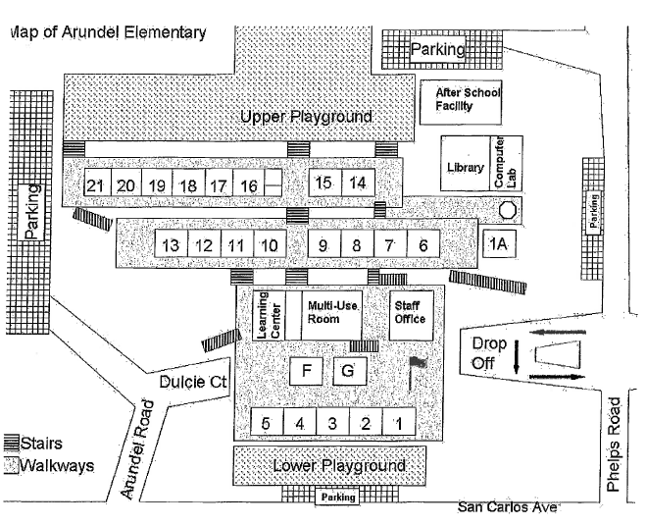

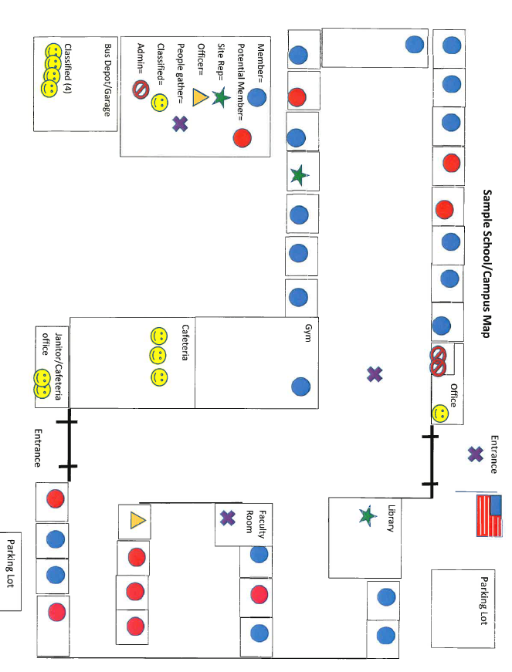

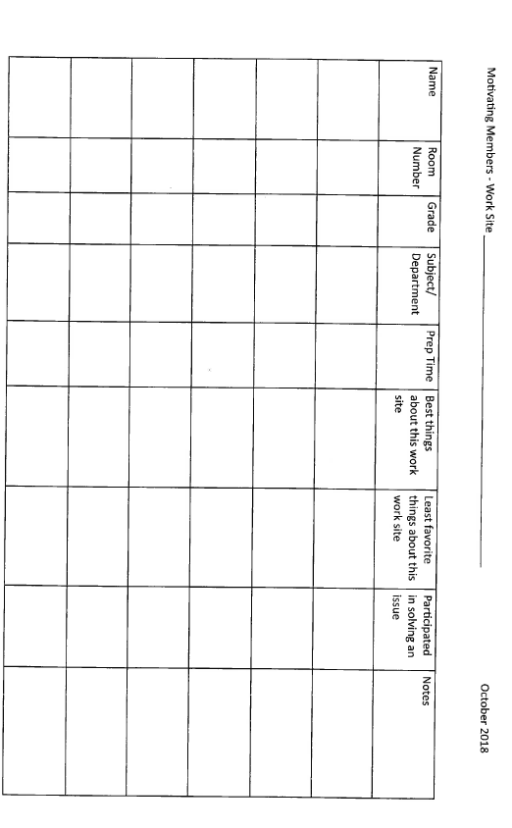

Member Assessment

Name:

School:

Cell Phone: Personal Email:

Organizer(s):

********************************************************************

Member’s Top Issue(s):

So, can we count on you to join us in organizing around issues that will engage and activate the majority of members at your site? Yes *No

*If No, Why Not?

Thinking about your colleagues at your school site, who else cares about the (top issue)?

Do you think we could get several colleagues together to meet to discuss a plan to win? Yes *No

*If No, Why Not?

Date, time, and place of the meeting:

NOTES:


EXERCISE: Draw Your Own Map

Refer to the handout Ten Questions to Ask When Mapping Your School as you draw your own school map in the space below; include the names and rooms of your colleagues.

LABOR NOTES: Secrets of a Successful Organizer labornotes.org/secrets
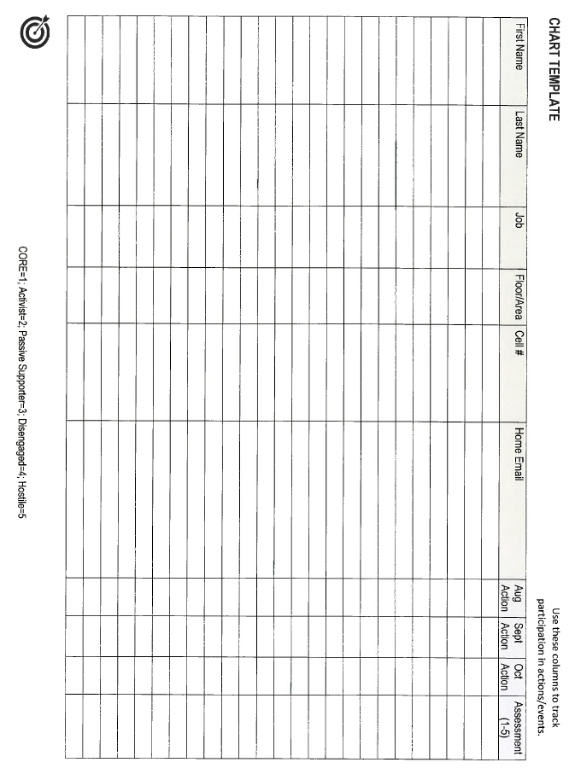

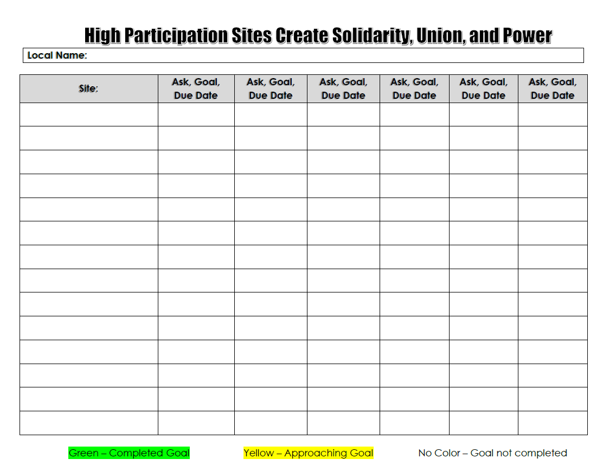

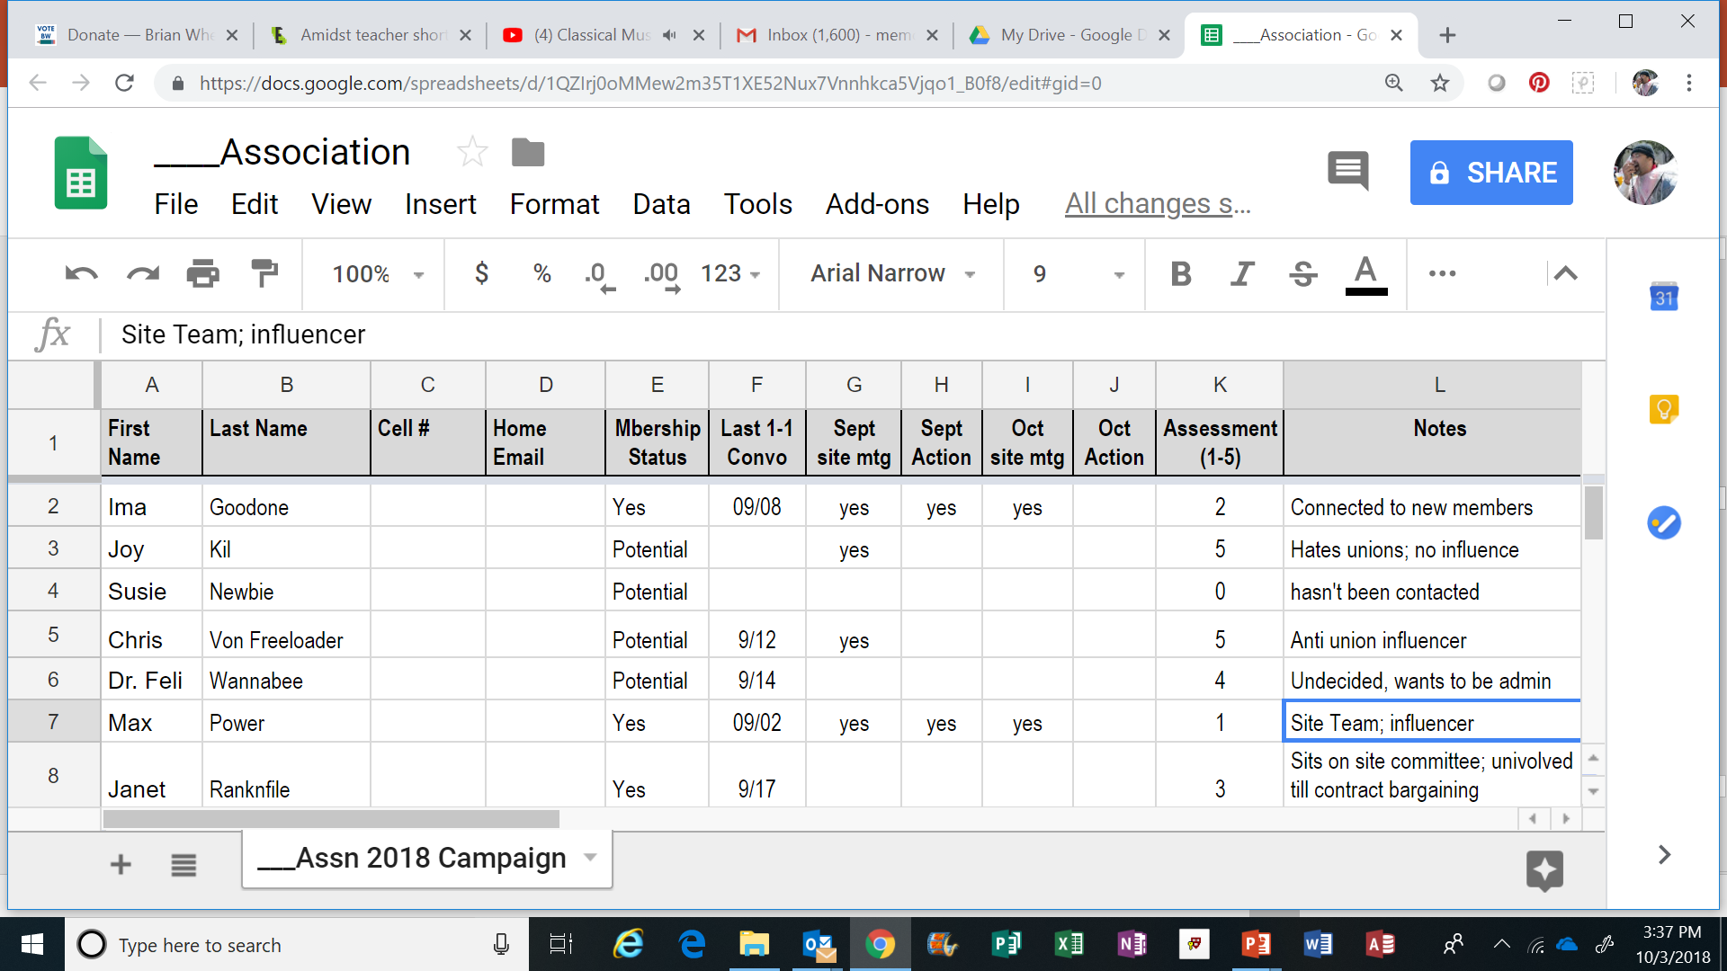

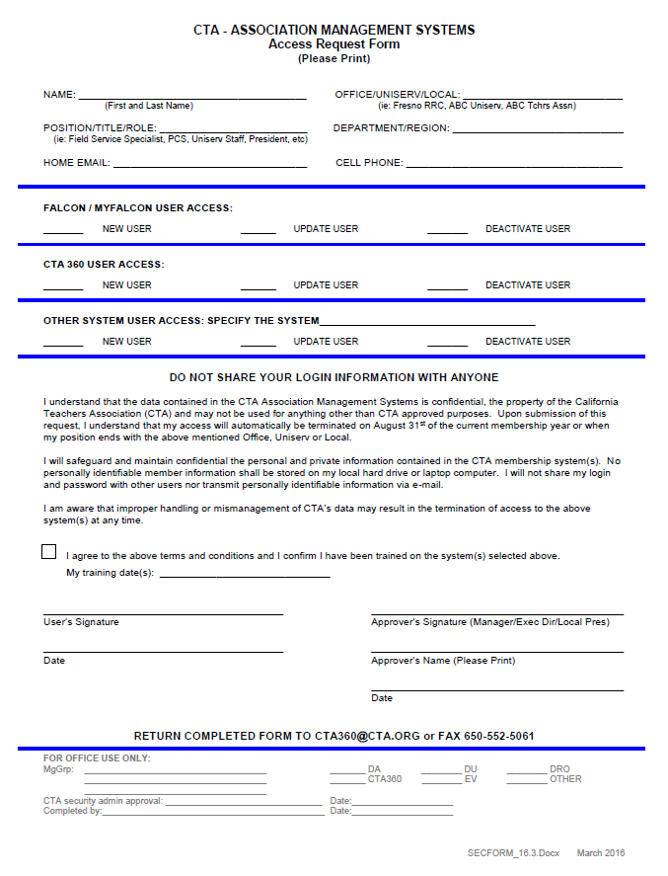
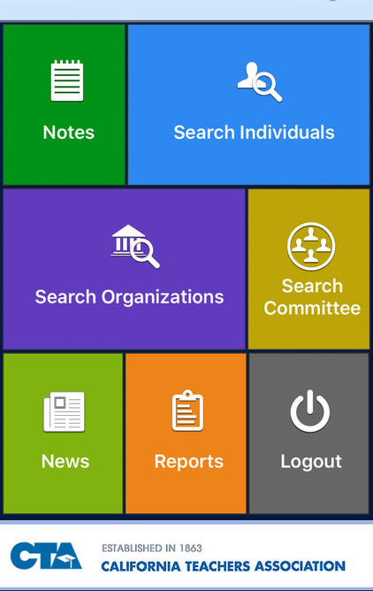

- Using CTA 360 as a tool
- Search individuals or Committees
- Mass email and text
- Member status by Site
- Training videos on ctago.org/cta360

HOW TO BE A GOOD LISTENER

Avoid distractions. Look the other person in the eye, and put your phone away.

Slow down. Our brains process thoughts four times faster than spoken words. It’s easy to skip ahead in a conversation, using your assumptions to fill in the gaps and plan your response. Resist this urge. Focus on what is actually being said.

Don’t interrupt. Take the time to hear the full story.

Keep an open mind. Don’t assume you already know what someone cares about. People will surprise you.

Don’t fish. Avoid leading questions like “Don’t you agree that…”

Practice empathy. Sometimes people need to let off steam. Don’t discourage them. Your immediate task is to hear what they have to say, not to judge.

Show that you hear what they’re saying. React, ask follow-up questions, and repeat back what you understood. If you don’t understand, ask.

Find common ground. You don’t have to agree with every point, but look for areas of agreement, and acknowledge where you differ.

Don’t feel you need to sell something. An organizer is not a salesperson. You’re genuinely looking to learn the other person’s point of view and create something new together.

LABOR NOTES: Secrets of a Successful Organizer labornotes.org/secrets
HOW TO LISTEN

- STOP TALKING… talking and listening cannot occur simultaneously.

- EMPATHIZE WITH THE OTHER PERSON… try to put yourself in the other’s place so you can see what he/she is trying to say.

- CONTROL YOUR ANGER… try not to get angry at what is being said; your anger may prevent you from understanding his/her statement.

- ASK QUESTIONS… when you don’t understand, when you need more explanation, to clarify, not to establish the “facts”. Don’t ask questions to show up or embarrass the other person.

- DON’T GIVE UP TOO SOON… don’t interrupt other people; give them time to say what they have to say.

- CONCENTRATE ON WHAT HE/SHE IS SAYING… focus your attention on their words, ideas and feelings.

- LOOK AT THE OTHER PERSON… their face, mouth, eyes, hands will help communicate with you. Watch their body language.

- LEAVE YOUR EMOTIONS BEHIND… (if you can) try to push your worries, your fears, your problems, outside the meeting room.

- SMILE AND NOD APPROPRIATELY… but don’t overdo it.

- DON’T ARGUE MENTALLY… when you are trying to understand the other person, it is a handicap to argue with them mentally as they are speaking. This sets up a barrier between you and them.

- GET THE MAIN POINTS… concentrate on the main ideas, not the examples. Stories, statistics, etc. are important but are usually not the main points. Examine them only to see if they support or clarify the main idea.

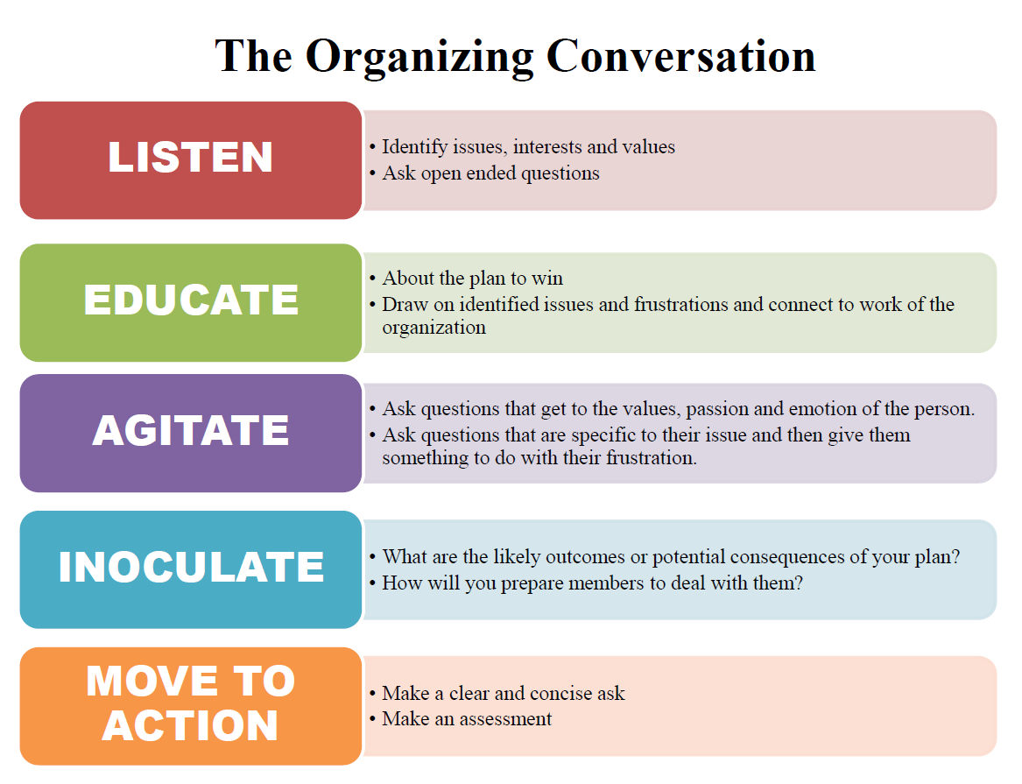

AHUY: Developing an Organizing Conversation “RAP”
The acronym “AHUY” is a helpful shorthand for what it takes to move someone to act: Anger, Hope, Urgency and YOU.
- Opening: Introduce yourself and frame the reason for the conversation. Ask questions to get the other person talking about workplace issues. How will you strike up the conversation?

LABOR NOTES: Secrets of a Successful Organizer labornotes.org/secrets
5. You: “You can make a difference. Your participation matters.” Why is this person’s support critical? What concrete action are you asking them to take? Wait for a response.
4. Urgency: “Now is the time. We can’t wait any longer.” What will happen if you don’t act?
3. Hope: “Change is possible. We can fix this. Here’s our plan.” Inspire hope by conveying a clear, credible, worthwhile plan and sharing why you feel hopeful. What are the steps we need to take together?
2. Anger: “There is an injustice. We have to fix this.” Tap into righteous anger at the injustice and create determination to do something about it. What questions will you ask to learn how the issue affects this person and that the boss won’t fix it unless pressured to do so?
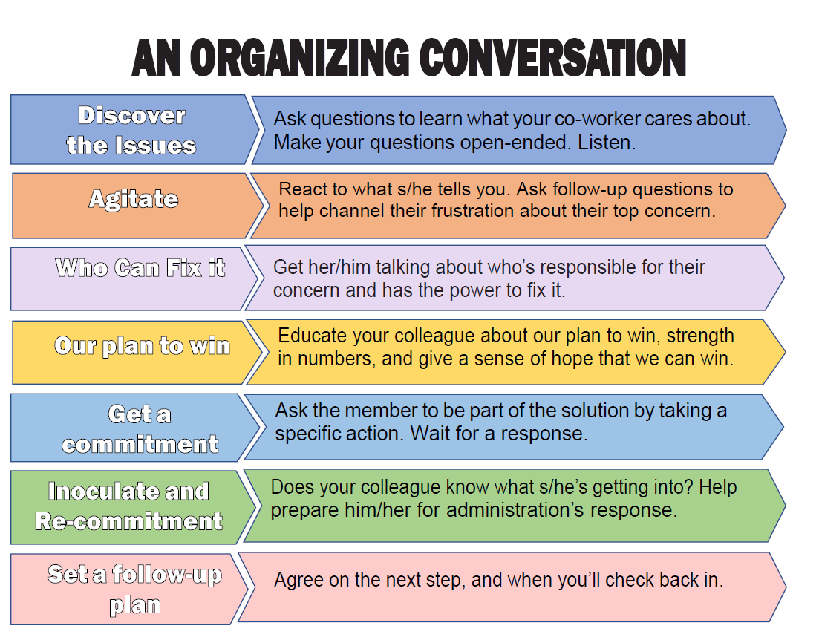



BASIC REASONS

FOR ONE-ON-ONES

To identify leaders

To develop relationships

To identify/validate concerns/issues (self-interests)

To agitate

To discover existing networks of influence

To assess

To get a commitment

To develop POWER

One-on-One Conversations

The major ingredient for a successful one-on-one is planning. Before setting an appointment, determine what you want to accomplish and how you will approach the person.

Be friendly and positive. When you leave, leave a favorable impression. REMEMBER: We are trying to build our union.
The major purposes of a one-on-one are:

- To build a positive relationship with the person as part of our union
- To learn about the self-interests and motivations of the person
- To learn more about the issues and how they are affecting people
- To form assessments about their analysis of the issues and willingness to get involved
- To identify potential leaders and uncover existing networks of influence

The process is relatively simple, but requires practice:

Planning!! What is your purpose? It’s best to have an appointment.

The initial meeting should be in a public place. Meet for coffee.

Introduce yourself and share why you’re here and involved with your local Association

You might start the conversation around F.O.R.M. (family, occupation, recreation, and message).

Listen more than you talk (70/30 Rule). What are their self-interests (motivations)? Clarify the responses.

Ask about issues. Don’t assume or stereotype.

Ask about why they think things are the way they are regarding education and how can things be changed.

Ask about networks. “Besides yourself, whom else should I talk with?”

Educate and Agitate. When you are tempted to make a statement, ask a question.

Agitate, don’t irritate – “So you’re okay with the way things are?”

Talk about personal, not organizational experiences. Be calculating, vulnerable and revealing.

Follow the logic of conversation, but direct it.

Be respectful of time. The initial meeting should last no longer than 20 to 30 minutes.

Always try to end the conversation on a positive note.

Write notes as soon as you leave.

Never argue. It’s a no win situation. You’re less likely to persuade than to alienate.

One-On-One Conversations
Effective organizing is based on building relationships, one at a time and over time, through structured one-on-one conversations. Organizing conversations are the most effective way to gather information, identify members’ and potential members concerns and issues, share factual information, inoculate against other campaigns, move members to action and ultimately affect positive change, grow membership and increase organizational capacity.
Purpose of the Organizing Conversation
- Develop a positive, trusting relationship with the other person.
- Listen
  - To identify concerns and issues
  - Identify leadership and relationships
- Assess bargaining unit employees on a variety of factors and issues
- Move into Action – get commitments
How to Have an Organizing Conversation
Introduction
Tell your personal story - who are you and why this conversation is important. Through your story – motivate and inspire others to take action.
Ask Questions/Listen
What does the individual or group of individuals do at work, what is it like to work there, what is good about the job and what is not good? What would they like to see changed? A good organizer uses the 80/20 or 70/30 rule of listening to talking.
Educate
Give factual information to bargaining unit members on issues, actions and other pertinent information.
Agitate
Why are things the way they are, and who makes these decision? How does it feel to be in that situation? How would things be better if you had a voice in making those decisions? What would it take to make the changes? Connect the Union’s work or organizing plan to the issues identified earlier in the conversation.
Inoculate
Provide clear expectations for likely outcomes and messages that will come from the opposition. Provide factual and evidence-based refutations. Redirect back to the ____ frame making connections between the union’s work and resolution of their issue.
Move into Action/Assessment Question
Move the unit member to action.
Examples of Action:
- Recruit membership
- Recruit a volunteer for political campaign
- Attend a meeting
- Sign a petition
- Sit on a committee
Follow-Up
If you get someone to make a commitment it is important to follow-up and make sure they know how to follow-through.

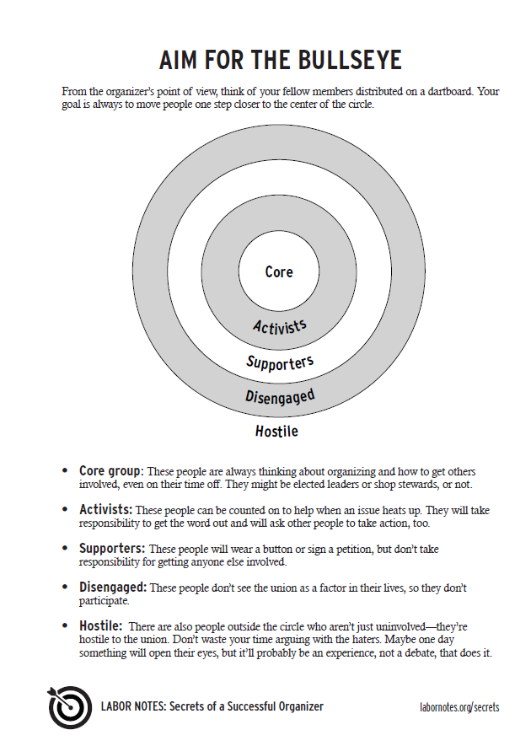

[LOCAL ASSOCIATION NAME]

Individual Assessment Rubric

1 = Member Leader: Member leader who gets other members and potential members to take action.

2 = Member Activist: Member who is continuously and actively engaged in association activities but does not necessarily get others to participate.

3 = Inactive Member: Member who is not engaged in association activities but is in good standing.

4 = Undecided Potential Member: Potential member who has been asked to join and participate but has not yet chosen to do so. Not hostile; there is room for follow-up and potential to join.

5 = Anti-Association Potential Member: Non-member who has been asked to join or participate, has declined to do so, and is anti-association.

6 = Anti-Association Potential Member Leader: Non-member who is anti-association and leads or is well-respected by other members and potential members.

0 = Unassessed Member or Potential Member: Bargaining unit member who has not had a conversation about joining or participating in association activities. There is insufficient information to provide an accurate assessment.

All members are a “0” as we start to systemically collect this information. When you have a conversation with a member, you can then mark them as a 1, 2, or 3.


AGITATION/MOTIVATION

A strategy to move people to take action

Remember your story. Why did you get involved? What inspired you? What made you angry or passionate? Who helped motivate you? How did they do it?

People have so many demands on time they won’t take action unless they are angry and passionate about it. Even if they agree with the issue and sympathize, they won’t get involved until you get them to acknowledge their anger and frustration about the way things are. Ask questions that are specific to their issue and then give them something to do with their frustration.
Draw on identified issues and frustrations and connect to work of the organization:

“You said the workload is impossible and that budget cuts have made things worse…”
“Your principal is disrespecting you and causing you unhealthy stress…”

Agitation questions:
- Make the person think!
- Get the person excited, passionate, emotional, angry…
  - What makes you angry about this?
  - Is it fair that you are treated this way, don’t have enough resources for your
students, have huge class sizes, workload, etc.?
  - Who makes that decision? Who should be making that decision?
  - Why are things the way they are?
  - How did they get this way?
  - How does it impact you personally, professionally, your students?
  - What changes if you don’t take action?
  - How bad would the situation get if people like you who care so much don’t do
anything? Isn’t that what our opponents are counting on?
The ASK
Making change is possible – we have proven it – but it won’t happen if you don’t get involved (or join).
Remind the person that change happens through collective action. Provide specific examples of successful collective action in the organization (ex. school board campaign, bargaining, or something else specific to their issue).
Make your ask very specific, clear and concise.



Building Action Teams
We are in a fight for the future of our students and our profession. In order to build a strong [LOCAL] and win a strong union contract that both (a) moves our schools and our work lives forward, and (b) protects us against the DeVos privatization/charterization agenda, all members at every work site needs to be in this struggle, including union membership.

What happens at the bargaining table is only a small part of winning and enforcing a good contract and building a stronger union. What truly moves the superintendent and school board to settle a strong union contract is our ability to act collectively. When the superintendent and school board see that we are united and taking action, bargaining will move. Likewise, when we are all union members and act collectively with parents and community allies at our worksites, site administrators will respond favorably.

That’s why Building Action Teams (BAT) are being formed at every school. BAT teams are networks of union members at a school (or worksite). BAT leaders — in conjunction with site reps, union staff, and other chapter leaders — will help colleagues in their network stay informed, help build unity and maintain union membership, as part of activating members to collectively address site issues and participate in our [LOCAL] contract campaign.

A good rule of thumb is that a BAT team should be able to spread out and reach every member at your school face-to-face in a day’s time for rapid response. That means:
- Keep networks small. Each BAT leader should have responsibility for 5–10 members.

- Make networks organic. Who does a BAT leader already see on a daily basis? Tap into existing social networks. It builds more effective relationships and networks for our union.

- In order to maintain high union membership and unity, or to communicate urgent messages and/or to counter a false message by [District] administration intended to confuse or scare people, every member needs to hear from their BAT leader right away.
The work of BAT teams will develop as the chapter or site campaign moves forward, but BAT leaders’ role will include:
- Meeting periodically with the site rep(s) to share information and strategize.

- Having regular, short one-on-one conversations with each of the 5-10 members in their network.

- Maintaining union membership for their network and signing up potential members.

- Assessing the support of each member/potential member in their network for union membership, our contract campaign and participating in local and district-wide actions.

- Mobilize members in their network to address site-based issues and/or to participate in union wide actions in support of [LOCAL]’s contract/political action campaigns.

Building Action Team - BAT
Local: __________________________ School: _______________________________________

School Site Rep(s): __________________________________________________________________________
BAT Leader:
BAT Leader:
BAT Leader:

(BAT leaders take responsibility for (5-10) members in their group—the “Day’s Time” rule.)

Building Action Team (BAT)
Our Local is EVERY member!

- Divide up your membership by 1 of the following: a) building location, b) grade level, c) department or d) other manner that facilitates communication. That is the AREA.
- Recruit a BAT MEMBER for each AREA.
- Site Rep communicates with BAT members. BAT members communicate with their AREA members.
- Make sure you have: a) all members’ cell phone numbers, and b) all members’ private emails.
- www.remind.com is a free website for group text messaging. Smart device app, also.

Site Name:

Site Rep(s):

Site Organizer:
Area: |  |  | Area:
BAT Member: |  |  | BAT Member:
Name | Cell # |  | Name | Cell #
1. |  |  | 1.
2. |  |  | 2.
3. |  |  | 3.
4. |  |  | 4.
5. |  |  | 5.
6. |  |  | 6.
7. |  |  | 7.
8. |  |  | 8.
9. |  |  | 9.
10. |  |  | 10.

Area: |  |  | Area:
BAT Member: |  |  | BAT Member:
Name | Cell # |  | Name | Cell #
1. |  |  | 1.
2. |  |  | 2.
3. |  |  | 3.
4. |  |  | 4.
5. |  |  | 5.
6. |  |  | 6.
7. |  |  | 7.
8. |  |  | 8.
9. |  |  | 9.
10. |  |  | 10.

School Organizing Squad

We are in a fight for the future of our students and our profession. In order to build a strong local association and win a strong union contract that both (a) moves our schools and our work lives forward, and (b) protects us against the DeVos privatization/ charterization agenda, all members at every work site needs to be in this struggle, including union membership.

What happens at the bargaining table is only a small part of winning and enforcing a good contract and building a stronger union. What truly moves the superintendent and school board to settle a strong union contract is our ability to act collectively. When the superintendent and school board see that we are united and taking action, bargaining will move. Likewise, when we are all union members and act collectively with parents and community allies at our worksites, site administrators will respond favorably.

That’s why School Organizing Squad teams (SOS) are being formed at every school. SOS teams are networks of union members at a school (or worksite). SOS leaders — in conjunction with site reps, union staff, and other local association leaders — will help colleagues in their network stay informed, help build unity and maintain union membership, as part of activating members to collectively address site issues and participate in the contract campaign.

A good rule of thumb is that an SOS team should be able to spread out and reach every member at the school face-to-face in a day’s time for rapid response. That means:
- Keep networks small. Each SOS leader should have responsibility for 5–10 members.
- Make networks organic. Who does an SOS leader already see on a daily basis? Tap into existing social networks. It builds more effective relationships and networks for our union.
- In order to maintain high union membership and unity, or to communicate urgent messages and/or to counter a false message by district administration intended to confuse or scare people, every member needs to hear from their SOS leader right away.
The work of SOS teams will develop as the chapter or site campaign moves forward, but SOS leaders’ role will include:
- Meeting periodically with the site rep(s) to share information and strategize.
- Having regular, short one-on-one conversations with each of the 5-10 members in their network.
- Maintaining union membership for their network and signing up potential members.
- Assessing the support of each member/potential member in their network for union membership, our contract campaign and participating in local and district-wide actions.

- Mobilize members in their network to address site-based issues and/or to participate in union wide actions in support of local association’s contract/political action campaigns.
School Organizing Squad Commitment
We are in a fight for the future of our students and our profession. In order to win and defend a good union contract and build a stronger union that both (a) moves our schools and our work lives forward, and (b) protects us against the DeVos privatization/ charterization agenda, every member in every corner of our union needs to be in this struggle.

School Organizing Squads (SOS) are being formed at every school. SOS teams are networks of union members at a school (or worksite). SOS leaders will have networks of union members who they see regularly. With the support of site reps, union staff, and other union leaders, SOS leaders will organize colleagues in their network to stay informed, maintain union membership, and get engaged in addressing site issues and winning a strong contract.

As a School Organizing Squad Leader, I commit to:
- Welcome new educators, sign up potential members and maintain union membership for educators in my network.

- Take responsibility for having regular, short organizing conversations with a set group of union members at my school about site-based issues and/or regarding local association’s contract/political action campaigns and assessing their level of support and participation.

- Engage and mobilize co-workers in my network to take collective action to address site issues and to support our local association contract/political action campaigns.

- Meet periodically at my site with our elected Site Representative(s) and fellow SOS Leaders to share information and to coordinate organizing efforts.

School:____________________________________________________________________

Name | Signature | Cell Phone | Personal Email
Return to

“Struggle is a never ending process. Freedom is never really won, you earn it and win it in every generation.”

Coretta Scott King

Union Organizer
Super-majority Participation
(Members are engaged)

- ENGAGE ALL BARGAINING UNIT MEMBERS: PROMOTE UNION MEMBERSHIP AND RECRUIT NEW UNION MEMBERS

- Know the new bargaining unit members and be helpful to them
- Know bargaining unit members’ status: union member or potential member
- Be prepared to overcome objections and answer predictable questions
- Forward membership forms to your membership chair immediately
- Identify organic leaders
- Use CTA 360 as a resource

- HELP MEMBERS UNDERSTAND THEIR VITAL ROLE IN BUILDING UNION POWER

- Connect the dots between Membership + Collective Action/High Participation including elections and electoral campaigns
- Seek out and develop organic leaders
- Assist members in identifying “organizational cost” for negotiations or district-wide issues – what is it going to take to get what you want?

Members Are Engaged – Super-majority Participation

- Identify organic leaders (at least one at every worksite)
- Members are active in their organizing committees, building action teams or contract action teams
- Site Reps are meeting and dialoguing regularly with members at their sites
- Members are asked, “What is it going to take to win what you want?” “Are you and your members willing to do what it will take to win?”
- Membership is high at each site. Reps are having conversations with non-members and overcoming objections
- Membership + collective action/high participation = UNION POWER

Dealing with Objections

Some typical reasons inactive members won’t participate:

- Fear: is on probation, doesn’t like conflict, or has a bad administrator
- Hopelessness:
  - Futility – “nothing is ever going to change”
  - They believe everyone else is apathetic
  - Looking for individual solutions
  - Division: Groups pitted against one another or had a bad previous union experience
  - Confusion: The employer puts out alarming or distracting messages
  - Inaction:
    - Doesn’t have time or know how to do it
    - Believes someone else will do it
    - Needs to think about it

FORMULA FOR OVERCOMING OBJECTIONS
- Acknowledge: “I hear what you’re saying about… (your fear, nothing’s going to change, you don’t have time, etc.)”

- Answer their objection. [Educate]

- Redirect back to their issue and motivation: “You were telling me that (issue) is a concern and that it’s negatively impacting (motivation).”

- Ask: “How will (issue) get better if we don’t act together now?”

Emphasize the following TIPS, as well:

- Use your active listening skills
- Don’t be defensive or argue; be factual
- Don’t 3rd party – explain what this means: use “we” and what we’re trying to accomplish collectively instead of “the union” needs you to do x, y, and z
- If you have a helpful example, use it (a personal story on why you got involved and believed in collective action as the way to win)
- You don’t have to do it all in one conversation
- Leave on a friendly note

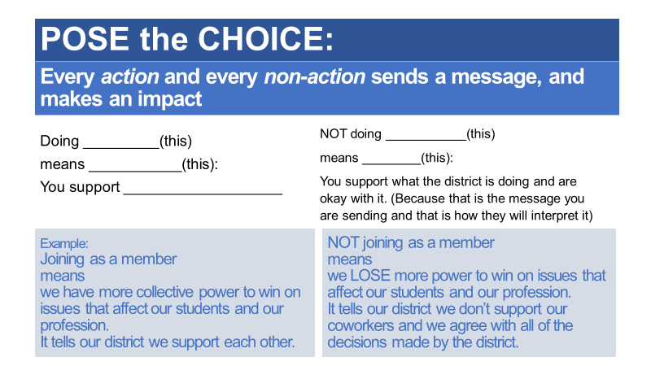
Drop Request SAMPLE RAP

I’m sure you know that our freedom to negotiate a fair return on our hard work and ensure we have the time to care for our loved ones comes from the strength of our union, and our strength comes directly from our membership. By dropping your membership, you diminish our ability to improve or even maintain professional pay, a manageable class size or case load, and a secure retirement. Are you still interested in protecting any of these?

(EDUCATE):
I’m sure you care about: (choose what fits from the list below)
- Professional pay, benefits, and a secure retirement
- Maintaining manageable class sizes, caseloads and workload.
- Our ability to advocate for the public education our students deserve, including securing adequate and sustainable funding, so you get the resources you need to do your job.
See if member will continue membership: i.e."Will you continue your membership to help fight for (state what member is interested in achieving)?” If not…continue to AGITATE

(AGITATE):
If the member still wants to drop…agitate. (Ideas below)
- Our union’s power comes from our numbers, including membership. If you drop your membership, we will have less power to win what you need to support your family / resources for your classroom / secure a safe retirement. [Will you be ok with having less power to achieve X?]
- Freedom isn’t free. We need to invest in our secure future and protect our freedom to stand together.
- By not standing with us, you are telling the district that you don’t support [ what local is working to achieve ]. Are you ok with [describe current site/district issue]?
(INOCULATE):
- Are you aware that there are groups associated with the Koch Brothers and Betsy DeVos working right now to weaken our power so that they can achieve their agenda of privatizing public education and diminishing our secure retirement? Only our collective power can prevent them from doing that.
(MOVE TO ACTION and ASSESS):
Can I count on you to stand with us (your colleagues) and maintain your membership?
If yes, ask them if they want to get more involved/participate on a committee, etc.

If no, walk them through the VOLUNTARY TERMINATION OF MEMBERSHIP FORM before you give them the President’s contact information

- Log your conversation on CTA360 – NOTES.

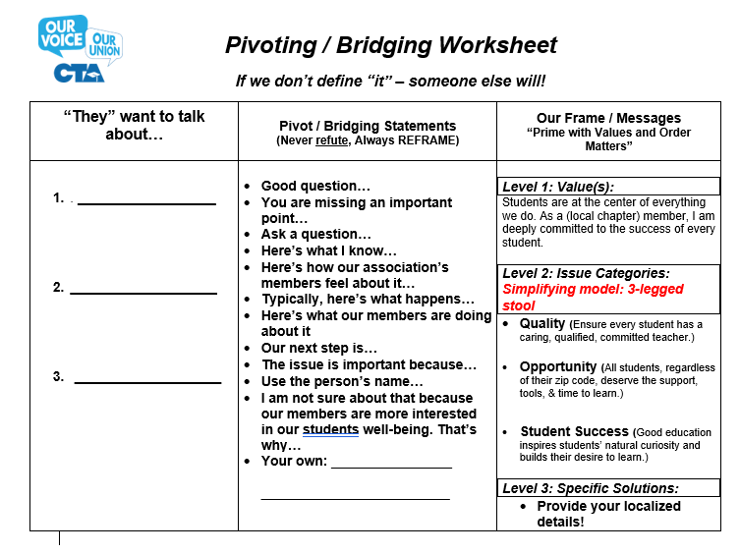

Benefits of Union Membership

Union Members Non-Members
- Receive the benefits of the collectively bargained contract.

- Representation ONLY on matters pertaining to the collective bargaining agreement (contract).

- Give input on proposals for contract negotiations.
For Public Education
- We’re a part of California’s leading education organization fighting for a better future and the public education all our students deserve.
- We unite with colleagues in collective action to address concerns at our worksites, as well as during contract negotiations to win better salaries, benefits and teaching and working conditions for educators and education support professionals, to better support our students.
- We’re informed and play an active role in CTA’s local and statewide legislative and political advocacy to strengthen public education.
- We give input and determine priorities and focus for contract bargaining proposals; we vote at contract ratifications and for all our union officers, as well as can run for and hold elected union office in our local chapter.
For Your Career
- Access to Leadership Development training opportunities sponsored by CTA at the local, regional and statewide levels.
- Access to multiple CTA and NEA conferences, such as Good Teaching Conference, Issues Conference, GLBT Issues Conference, Human Rights Conference, ESP Conference and Summer Institute.
- Professional Editorial subscriptions to the CTA Educator and NEA Today magazines.
For Your Rights
- Representation on all matters related to enforcing the collective bargaining agreement (contract) with the employer.
- Access to legal and professional representation and advice:
- Due process rights, wage & hour issues, California Commission on Teacher Credentialing cases
- Certification and classification issues
- Discrimination cases under federal and state laws
- Discrimination based on union activity
- Retirement issues
- $1 million in work-related liability insurance.
For Your Wallet
- NEA Life Insurance Coverage.
- CTA Disaster Relief Fund grants.
- CTA Death & Dismemberment Insurance.
- Exclusive Discounted CTA & NEA Member Benefits programs:
- Auto & home insurance
- Voluntary life & disability insurance
- Investment & financial tools and resources
- Travel, restaurant & purchasing discounts, and many more

CTA Mission Statement: The California Teachers Association exists to protect and promote the well-being of its members; to improve the conditions of teaching and learning; to advance the cause of free, universal, and quality public education; to ensure that the human dignity and civil rights of all children and youth are protected; and to secure a more just, equitable, and democratic society.

[ ]: YOUR LOCAL UNION  - Individual and group representation by leaders and professional staff  - Promotion of economic and professional benefits  - Exclusive Bargaining Agent in Employer-Employee Relations  - Negotiated salary increases and fringe benefits  - Professional programs: teacher education, standards, curriculum and instruction, professional rights and responsibilities, human relations, legislation, public relations, salaries, insurance and retirement  - Protection of employee rights and privileges under District policy and State law, including legal consultation  - Union publications: Newsletter, special bulletins, & more | ALCOSTA Service Center Council (SCC) / Concord Regional Resource Center (RRC)  - Enhanced professional staff assistance  - Assistance with contract preparation  - Local training and workshops provided in:  - Bargaining  - Membership  - Grievance Processing  - Contract Preparation  - Retirement  - Organizing  - Professional Growth  - Fringe Benefits  …and more! | STATE LEVEL – CTA  - Legal Services (both personal and job-related matters)  - CTA Scholarship Programs  - State consultants and individual representation  - Increases in salaries through greater financial support from state legislation and programs  - Public Relations: News releases, radio programs, television programs, speaker services & publications  - Weight of the State Union (300,000+ represented members) on local or individual programs  - CTA Endorsed Special Services Programs: Group Term Life Insurance, Group Disability Insurance, Credit Unions, and Auto and Homeowner’s Insurance  - CTA special services benefits for members are : discounts on travel and entertainment, new automobile purchasing, automobile extended warranty insurance, automobile quotation service, national automobile club, and hotel discount programs  - State Union publications: California Educator, & more. | NATIONAL LEVEL - NEA  - On-the-job Liability Policy ($1,000,000) for each member for each occurrence  - Dues-Tab Life Insurance  - National recognition for research in education  - Representation in the U.S. Congress for federal aid to education and legislation  - Protection and promotion of federal income tax benefits and allowances for employees  - Promotion of federal financing of teacher scholarship programs  - Exclusive national voice of the teaching profession in the U.S.  - NEA special services benefits for members are: life insurance plans, NEA book program, car rental program, credit card program, unified magazine service, tax-deferred annuity plan  - DuShane Fund for the advancement and protection of employees’ rights nationally  - National publications: NEA NOW, NEA Today, NEA Travel Guide  - http://www.neamb.com/
BENEFITS OF BELONGING TO [LOCAL ASSN] / CTA / NEA

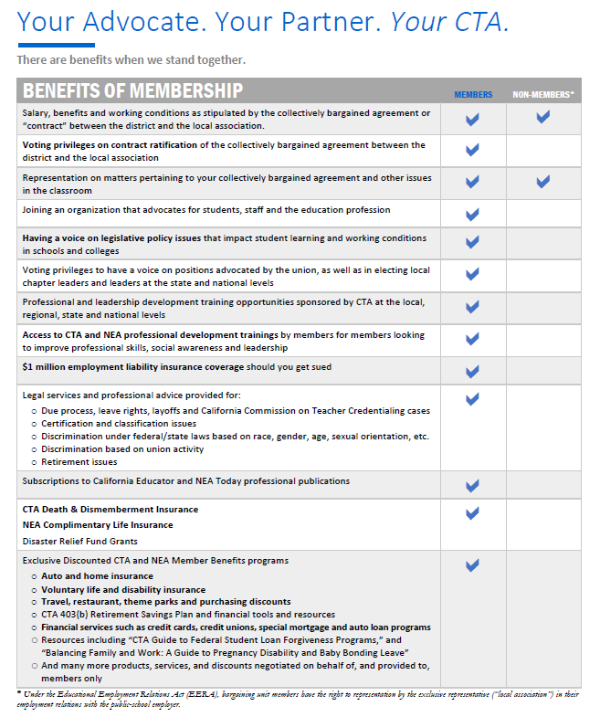
1 | You will make positive changes for your students and your profession.  All members have the right to participate in the decision-making process of our local, state and national unions. Together, we decide the issues we will champion, such as improving the quality of education for our students and working conditions for educators in schools and colleges.  With CTA, you are guaranteed a strong and credible voice with your local school district and in public policy discussions to advance legislation and policies that benefit our students, public education and the middle class.
2 | You will become a better teacher and be awarded for innovation.  Whether it’s attending one of CTA’s annual conferences, participating in some of the many trainings or workshops offered throughout the year, or learning from the true experts in the field – your colleagues, you will have access to a wealth of practical information and resources to improve your professional skills and be the best educator you can be.  And what if you have an innovative idea for your students, but need a little financial help to get it off the ground? CTA can help you bring your idea to life through a grant from CTA’s Institute For Teaching.
3 | You will make your community and the world a better place.  CTA members have a long history of social justice advocacy, such as fighting for universal free public schools for all California students, standing up for civil and human rights, and securing protections against arbitrary or unfair treatment of educators. Your membership in the union supports a more just, equitable community, state and world…and helps build a brighter future for all of us.
4 | You can save time and money with cta and nea member benefits  CTA and NEA Member Benefits offer almost 50 different voluntary programs and services for you to enjoy—many with exclusive benefits designed for members. Take advantage of special life, disability, auto and home insurances available to you. You'll also find discounts for travel, shopping, entertainment, magazines, car and home purchases, and more. CTAInvest.org also provides financial and investment education for members, including preparing for retirement.
5 | You will have the confidence and peace of mind to speak your mind.  You are the expert, and you know what’s best for your students. Work in confidence knowing that CTA Legal Protection and Liability Coverage safeguards you as you make a difference. We’re here to make sure you can advocate for your students without being scared your job is at risk.


Lafayette Education Association

cta.org

nea.org

Union Organizer

Union Communication
(Members control the narrative)

- Use appropriate union message frame(s) in all internal & external communication

- Attend monthly union rep council meetings

- Bring membership concerns to the rep council/officers
- Hold regular union site meetings
- Actively listen to members
- Be aware of “hot” issues
- Deliver union correspondence to members
- Model & encourage message frame discipline
- Manage member surveys
- Collect member personal email addresses

- Keep union bulletin board up-to-date

- Encourage members to use cta.org and nea.org websites


Local EA Message Frame

Students are at the center of everything we do.
As a [LOCAL ASSN]/CTA member, I am deeply committed to the success of every student.

SUCCESS  Good education inspires students’ natural curiosity and builds their desire to learn. | OPPORTUNITY  All students, regardless of their zip code, deserve the support, tools, & time to learn. | QUALITY  Ensure every student has a caring, qualified, committed teacher.
- [LOCAL ASSN] members work tirelessly to ensure all our students have the Public Education they deserve.  - California Teachers Association (CTA) works for the initiatives described in our THE PUBLIC EDUCATION OUR STUDENTS DESERVE document.  - Other talking points… | - Our [LOCAL ASSN] Time to Teach campaign is focused on reducing workload, caseloads and class sizes to ensure that our members have time to give our students individual attention. | - Great teachers are attracted to and stay in districts where they are appreciated and supported. Our [LOCAL ASSN] ensures that.  - Our [LOCAL ASSN]/CTA helps provide our members with the tools necessary to help students and to be successful.

#StandTogetherWinTogether
#WeAreCTA
Union Message Frame

Our Union Guarantees Our Freedom

Freedom to achieve the Public Education All Our Students Deserve | Freedom to negotiate a fair return for our hard work. | Freedom to guarantee that we all can care for our loved ones.
- Highlight items from the CTA Advocacy Agenda (advocacyagenda.cta.org)  - Manageable class size/ caseload/workload  - More time to work individually with our students  - Funding & resources for our students  - Our local union/CTA leaders fight for quality public education for all students regardless of their background or zip code (www.cta.org/forallstudents)  - Other talking points… | - Our local union/CTA members passed Prop 55 and we need the freedom to ensure that those monies go to our classrooms and worksites.  - We must have competitive salaries that attract and retain the best educators for our students.  - Our local union/CTA guarantees we all have the freedom to have a VOICE at our worksites, district, state and nation.  - Other talking points… | - Our local union/CTA guarantees that we all can ensure we have quality health care for our families.  - Our local union/CTA ensures we can take leave to be with our loved ones when needed.  - Other talking points…


Dues Message Frame
Our Dues Dollars are a Collective Investment in Our Students, Our Freedom and Our Future!

Protecting our freedom and our future isn’t free!
Our secure profession | Our secure retirement | Quality neighborhood schools for our students
- Our collective dues provide the resources to secure union member POWER EQUALITY. Power equality means life-altering improvements in members’ contracts.  - Freedom to negotiate a fair return on our work and guarantee that we can care for our loved ones.  - Higher wages and benefits  - Paid leave  - Professional development  - Certification guidance/ National Board Certification. Prevents weakening credentialing standards.  - CTA conferences and trainings  - Professional staff to help us negotiate strong contracts for educators & our students  - Excellent legal representation  - Access to experts on educator rights  - $1 million in work-related NEA liability insurance  - Legislative advocates working fulltime on our behalf | - Secure defined benefit at the end of our careers  - Ability to retire with dignity  - Combats the millions of dollars our opponents spend to destroy our defined benefit retirement.  - Provides legislative advocates, political organizers and campaigns to elect great decision-makers who ultimately control our retirement security. | - Great teachers build great public schools that build great communities.  - Secure funding for our schools.  - Freedom to participate in decision-making at school sites  - Better teaching & learning conditions  - Smaller class sizes / caseload  - Safe, stable, and supportive schools for our kids  - Helps protect valuable educational programs for our students.  - Ensures accountability for all public schools.  - Combats the millions of dollars our opponents are pouring into anti-public education movements.
AS A UNION REPRESENTATIVE YOU CAN

HELP TO MAINTAIN COMMUNICATIONS BY:
- Communicating with members on a person-to-person basis as often as possible.
- Keeping in mind that members are busy people and that a written communication often requires a personal follow-up.
- Remembering that many of the people who most need to have information will not read the written communications.
- Letting the members of your faculty know what times you are available to discuss our union as it relates to them.
- Recognizing small issues before they become problems.
- Giving special attention to new staff members in explaining issues and in giving background information on programs and policies.
- Inviting members to respond to existing policies and proposed changes.
- Being readily available to members who want to express their views.
- Gaining the respect of those you represent through honesty, integrity, and a willingness to accept the confidence of those who seek your friendship or services.
- A constant line of communication between you and the elected leaders on any problem that may be developing.
- Being aware of what is in your contract.

TRY A 10-MINUTE MEETING

Union representatives who hold regular building meetings – especially in difficult times – have the best shot at strengthening membership rapport.

“But they won’t stay for a building meeting,” you complain. “They say they’re too busy.”

Try promising a 10-minute building meeting – timed by the clock. You have to rule with an “iron hand” and few words, but you can do it.

Below is a sample mailbox announcement of the 10-minute meeting and a sample agenda to distribute at the start of each one.

Of course, it’s easier for the union representative to vote in Rep Council by merely “sensing” the opinion of members, but have you really done anything to build member consensus? Ask members their opinions on union matters. Let them have a voice and the feeling that their opinions count in the decision-making process.

Note on the sample agenda members still have the opportunity to “let off steam” through the tear-off on the bottom. The union rep can then talk on an individual basis to those who write down their concerns.

Make union meetings snappy and businesslike. Try the 10-minute meeting!

SAMPLE ANNOUNCEMENT | SAMPLE AGENDA
10-MINUTE [LOCAL] MEETING on  (Day & date)  (10 minutes! You don’t believe it?  Then bring along your stop watch.)    [LOCAL] leaders need your ideas!  We’re trying to keep you informed!  Remember, only 10-Minutes!  We begin at ___time_____ sharp.  We meet at __________place_______________.  We wind up at ___time_____ sharp.  Honest, it really is a 10-minute meeting on ______________! | UNION Meeting Agenda  A. What was discussed at Rep Council meeting last time (2 minutes)?  B. We need your opinion on ______________.  Your views will be presented at the next Rep Council meeting (4 minutes).  C. Latest developments on the problems of  _________________________. (3 minutes)  D. An LEA victory you should be proud of (1 minute).  Time’s Up!  We told you we could do it in 10-minutes!  Don’t forget to leave your questions and suggestions at the door.
I’d like a meeting about

Name/E-mail

PLANNING THE 10-MINUTE MEETING

Time | Agenda  Category | Topic | Rationale
2 Minutes:  (minutes 1-2) | A. Current Issues Update | Brief review of major topics discussed at last month’s Rep Council Meeting. | We’re keeping members informed. We try to reduce the back room attitude so often prevalent during negotiations. Keeping members informed is not a matter of how much they are told. Rather, it’s a matter of feeling that leaders are working to inform them. Personal contact prevents rumors from “hurting” staff morale or Union credibility.
4 Minutes  (minutes 3-6) | B: Our Hot Issue | Here is a current issue. We need your ideas before we go to the next Rep Council meeting. | This reinforces in members’ minds that their opinions are actively sought and presented to the Council meeting.
3 Minutes  (minutes 7-9) | C: What’s on Your Mind? | A review of a current issue that concerns members in this building. | This may be the most important issue to come up at Rep Council. Members need to feel that the Union is conscious of their needs. Often just talking about a problem gives considerable relief.
1 Minute: | D: A Success  or Problem Story | We’re having some success in this area, or, we’re optimistic in this area – thanks to YOUR efforts. Keep up the good work.  or  We are having a problem in this area. We need your help in dealing with this | Praise. Encourage. Nourish the members. Develop a spirit of optimism. Low morale kills support for Union goals, especially during a prolonged impasse or crises. Personal contact builds confidence.  Level with the members. Obtain their creative ideas in approaching the problem. Ask them to think of solutions between now and the next 10-minute meeting.
“Time’s up! We told you we could do it in 10-Minutes!
Don’t forget to leave your questions and suggestions at the door.”

10-MINUTE [LOCAL] MEETING
ON

Day & Date

(10 minutes! You don’t believe it? Then bring along your stop watch.)

[LOCAL] leaders
want to keep
you informed!

Remember, only 10-Minutes!

We begin at ______ sharp!
(Time)

We meet at ____________________________
( Name/Place/Location)

We wind up at ____________!
(insert ending time)

Honestly, it really is a 10-Minute Meeting on ____________!

[LOCAL] Meeting Agenda

- What was discussed at Rep Council meeting last time?
(2 minutes)
B. We need your opinion on ____________________.
Your views will be presented at the next Rep Council meeting. (4 minutes)
C. Latest developments on the problems of _________________. (3 minutes).
D. A [LOCAL] victory you should be proud of (1minute).

Time’s Up! We told you we could do it in 10-minutes!

Don’t forget to leave your questions and
suggestions at the door!

I’d like a meeting about: __________________________________________________________________________________________________________________________________________________________________________________________________________________________________________________________________________________________________

__________________________

(Name and personal e-mail)

“Labor can not stand still. It must not retreat.

It must go on, or go under.”
-Harry Bridges
Member Advocate

CONTRACT ENFORCER

- Have working knowledge of the collective bargaining agreement (contract)
- Keep copy of contract in your rep handbook and make sure there is one in the staff room
- Know the grievance procedure: following timelines is critical
- Inform grievance chair and/or president and help formulate informal or level 1 grievances
- Collect pertinent information and save documentation in a site grievance file
- Stay in contact with the president or grievance chair to keep them informed of progress
- Make sure all bargaining unit members (union members and potential members) are represented fairly
- Remember you are an advocate, not a judge
- Caution bargaining unit members regarding insubordination
- Know when to ask for help
- Be prepared to pursue other ways to settle the issue, if it isn’t a grievance

PARITY

When acting in your role as a union representative, you have parity with admin. Parity or the "Equality Rule" makes you a "legal equal" to the boss. But, it’s in effect only when you are doing your job as a union representative, not when you’re acting as an individual employee. You’re acting officially when you investigate and argue grievances, request information and otherwise defend members.

DUTY OF FAIR REPRESENTATION (DFR)

DFR IN A NUTSHELL:

Covered by DFR | Not Covered by DFR
- Bargaining wages, hours and working conditions | Providing representation in statutory claims e.g. Education Code, Civil Rights laws etc.
- Enforcing the Collective Bargaining Agreement (CBA)

When the union is acting as the Exclusive Representative, it has a duty to treat everyone fairly…
GENERAL PRINCIPLES
- The Educational Employment Relations Act (EERA) states, at Gov't. Code Section 3544.9:
- "The employee organization recognized or certified as the exclusive representative for the purpose of meeting and negotiating shall fairly represent each and every employee in the appropriate unit."
- PERB has held that a union breaches its duty of fair representation if its actions are "arbitrary, discriminatory, or in bad faith."
- Arbitrary action is action "without a rational basis or devoid of honest judgment,"
- Discriminatory action treats a group or individual differently because of some characteristic, e.g., nonmembership in a union, race or national origin, occupational category, etc.
- Bad faith usually refers to treatment based on personal dislike or animosity.
- Union Representatives must act reasonably, fairly and honestly toward all employees in a bargaining unit.
CONTRACT NEGOTIATIONS
Always a Violation:
- The union fails to seek input from the entire bargaining unit
at the beginning of negotiations and prior to ratification.
- Union intentionally misrepresents a fact or a term of the contract in order to secure votes for ratification.
Not a Violation:
- Bargaining provisions with a negative impact on some unit members provided there is a rational basis (usually a benefit to the unit as a whole or a more fair approach.)
- Limiting contract ratification to members of the union.
CONTRACT ENFORCEMENT
Always a Violation:
- Refusal to take a grievance to arbitration because the grievant is not a union member, has opposed the union, or has taken certain positions in internal union politics.
- Refusal to take a grievance to arbitration because the nonmember or fee payer grievant refuses to pay the costs of the arbitration (only religious objectors may be charged the reasonable costs of using the grievance and arbitration procedure.)
- Failure to seek an extension of time where: (1) the union assured the grievant it would do so; (2) the grievant made repeated requests to pursue the grievance; and (3) the union attempted to cover up the blown timelines by informing the grievant that the grievance lacked merit when the facts suggested otherwise.
Probably a Violation:
- Gross negligence or a pattern of negligence.
- Failure to investigate or perfunctory investigation.
- Failure to explain why the union has dropped or settled a grievance.
- Failure to identify a contract section that has obviously been violated where an important right is at stake.
Not a Violation:
- Simple negligence or poor judgment.
- Refusal to take a grievance to arbitration because a favorable decision will harm a larger number of teachers in the unit.
- Refusal to take a grievance to arbitration because it is determined that the grievance lacks merit, even though the analysis is later determined to be erroneous, as long as the decision was made in good faith and had some basis in reason.
- Refusal to take a grievance to arbitration because a reasonable settlement was reached, even though the grievant was opposed to the settlement.

APPEAL PROCESS
- If there is a process for appealing the union's decision not to take a grievance to arbitration, a DFR charge will be dismissed unless the employee can show:
  - The appeal process was exhausted or
  - The appeal process could not provide the employee with adequate relief.
REPRESENTATION OUTSIDE THE COLLECTIVE BARGAINING AGREEMENT
Not a Violation:
- Refusal to advise or represent, e.g., in Education Code or other statutory claims.

Probably a Violation:
- Once representation is undertaken, the union's agents fail to use the same degree of care required by the duty of fair representation.
INTERNAL UNION AFFAIRS
The union may limit the following to members:
- Contract ratification (provided there are opportunities for input prior to ratification.)
- Election of officers and recall of officers.
- Selection of representatives to contractually established committees.
- Purely social events.
SELF-REPRESENTATION
- Employees have the right to present grievances to the employer without the union and to have those grievances adjusted prior to arbitration, provided the union is notified of the grievance and the proposed settlement and is allowed to provide input prior to a final agreement.
- The union may eliminate this right through negotiations.
- Only the union has the right to take a grievance to arbitration.
- Employees have a right to retain their own attorney to advise them about contract disputes, but the union has the right to present the case as it sees fit, and to exclude the employee's attorney from grievance meetings or arbitration hearing. A union demand that the employee terminate the attorney’s services would likely violate the duty of fair representation.
PENALTIES FOR BREACH OF THE DUTY
- Order to cease and desist.
- Order to process grievance if procedures are still available.
- Money damages (loss of earnings from union's breach to the present).
- Attorney's fees.
- Order to post a notice of PERB's findings and imposed penalties.
GOOD PRACTICES
Always:
- Be aware of the duty of fair representation, particularly as it applies to non-members and people you find irritating.
When Bargaining:
- Seek input at the start of negotiations.
- Keep unit members informed of the major issues.

- Seek input before ratification.
- Be honest.
LEA
Good Practices

When Enforcing the Contract:
- Be familiar with the contract.
- Investigate all grievances.
- Keep the grievant informed of grievance status.

- Know the time-lines, chart them and follow them.
- Get all extensions of time in writing.
- Make reasoned decisions.
- Keep written records of information gathered and the reasons for a decision to drop or proceed.
- Give the grievant a written explanation for dropping grievance ("lacks sufficient merit" is enough).
- Institute an appeal process.
DUTY OF FAIR REPRESENTATION (DFR) TIPS
The purpose of the DFR doctrine is to assure that unions represent all unit members fairly, without regard or prejudice because of union or political status, and to assure that decisions about matters related to employer-employee relations are not made arbitrarily or in bad faith.
There are three areas in which claims alleging breach of the duty of fair representation arise:
- Contract Negotiations
- Contract Enforcement
- Internal Union Affairs
CONTRACT NEGOTIATIONS
- Duty to actively seek input from all unit members in formulating bargaining positions.
- Bargain reasonable contract provisions which reflect input - "the greatest good for the greatest number."
- Inform unit members of progress of negotiations.
- Accurately inform unit members of the terms of the tentative agreement, prior to ratification.
- Allow input on ratification from all unit members.
- Inform unit members of likely repercussions from concerted activity.

CONTRACT ENFORCEMENT
- Assure that all building representatives, etc., are familiar with the terms of the CBA, including relevant time lines.
- Establish written criteria for determining which grievances to arbitrate.

- Thoroughly investigate claims of contract violation or disciplinary action.
- Establish a system for keeping track of timeliness.
- Make notes of reasons for every decision regarding the union's pursuit of the grievance.
- Explain to the grievant the reasons why his/her grievance will not be arbitrated.
- Union does not have a duty to allow the grievant to pursue the case on his own, or to hire their own representative not affiliated with the union to take the case.
- If an offered settlement is reasonable, the union may accept it, even over the objection of the grievant.
- There is no duty to represent or advise employees on any extra-contractual legal rights, e.g. teacher dismissals
INTERNAL AFFAIRS
PERB generally does not exercise jurisdiction over disputes that concern internal union matters, such as the appointment of committee members (both to internal committees or bi-lateral CBA-created Committees, Bylaws, Internal Elections.)
However, PERB will exercise its jurisdiction if the charge alleges that the union's action has, a "substantial impact" on the member's relations with the employer.

DUTY OF FAIR REPRESENTATION (DFR) QUIZ

- A Local Union does not have to represent a non-union member in his/her contract grievance concerning involuntary reassignment.
True False
- The Local Union President does not have an obligation to inform a unit member who believes he/she has been discriminated against on the basis of race of his/her right to file a charge with the EEOC or DFEH.
True False
- A Site Representative does not have an obligation to inform unit members of grievance timelines.
True False
- A Local Union may prohibit non-union members from voting in elections for Local Union officers.
True False
- A Local Union is obligated to allow all unit members to vote on contract ratification.
True False
- If the Local Union decides not to arbitrate a member's grievance, the member has the right to hire his/her own attorney to pursue the arbitration case.
True False
- If the Local Union has decided not to arbitrate a grievance, it has an obligation to explain to the grievant the reasons why.
True False
- A Local Union may settle or withdraw a grievance over the objection of the grievant.
True False
- A Local Union may charge an agency fee payer for the cost of arbitrating his/her grievance.
True False
- A Local Union officer may be held personally liable for damages caused by a breach of the duty of fair representation.
True False
PURPOSES OF THE GRIEVANCE PROCEDURE

- Provides a systematic method of resolving employee-employer problems
- Provides a method for appeal of administrative decisions without threats of undercutting
- Provides a method of determining workability of agreement or policy.
- More expedient, less expensive method of resolving contract differences.
- Forces both parties to a “dispute” to think through their positions.
- Provides a method of taking concerns to the Superintendent or School Board.
- Provides an opportunity for decisions to be adjusted at a level closest to the allegation.
- Provides a method of relieving frustrations of the aggrieved.
- Provides a method or organizing employees.
- Provides a means of highlighting problems within the District or a building.
- Strengthens the Union in the eyes of the members of the bargaining unit.
- Helps establish employee rights.
- Provides a method of protecting clearly established rights.

It doesn’t matter how strong your contract is, it is not worth anything if you don’t enforce it.

Grievances & the Grievance Procedure
What is a Grievance?

Introduction
The grievance procedure is one tool for enforcing the contract and protecting the rights of members. The grievance procedure is most effective in a worksite that is well organized and strongly supportive of the union.

In a worksite that is weak, administration can turn the grievance procedure against us by manipulating the process and dragging out resolutions. This causes members to lose faith in the union.

The grievance procedure cannot be viewed simply as a neutral, individual, legalistic process. We must incorporate the grievance procedure into a larger strategy of building union power in the workplace. Each grievance filed should have increasing solidarity and building union power as goals.

As a large group, we’ll review the factsheet on the next page.

Grievances & the Grievance Procedure
What is a Grievance?

A grievance is defined in Section 15.2.1 of the contract:

A “grievance” is a claim by one or more specifically named bargaining unit members or by the Association that there has been a violation, misinterpretation, or misapplication of a specific provision of this Agreement* which personally and adversely affects the grievant(s).

But the definition of a grievance is actually a bit broader than this. A grievance may be any of the following:

- Violation of the Contract
Generally, a grievance is any violation of the contract. However, some issues may be excluded from the grievance process (such as the first steps in the progressive discipline procedure), or may require another process in addition to the grievance process (such as meeting attendance rules). Check the contract for the issue you’re concerned with.

- Violation of Past Practice
“Past practice” is a widespread, longstanding practice which is known and allowed by both management and the union.

*Agreement refers to the union contract in this context.

Grievances & the Grievance Procedure
Small Group Activity

Working in small groups, answer these questions for the scenarios on the following page:

- Is it a grievance?
  - Yes, it probably is a grievance
  - No, it probably is not a grievance
  - Maybe, it might a grievance depending upon unknown facts

- What contract sections apply to this issue?

- Is this a good organizing issue?
  - Yes, this would be a good issue to mobilize members around, whether or not it is a grievance. (Brainstorm ways of organizing support.)
  - No it’s probably not. (Why not?)

Issues | Grievance? (Y/N/M) | Contract Sections | Organizing Issue? (Ideas/Explanation)
- The principal announces to the staff in September that the school will be adding an additional open house to the site calendar, bringing the school’s total to three open houses during the school year.
- Antonio suspended from his class a student who struck him. The vice principal returned the student to Antonio’s class the next day. The VP said this was the student’s first offense and so the suspension was unwarranted. Teachers complain that even when the student is not sent back early, the administration doesn’t follow up with the teachers about the suspension.

Issues | Grievance? (Y/N/M) | Contract Sections | Organizing Issue? (Ideas/Explanation)
- Cindy received an ineffective evaluation from her evaluator, the vice principal. She says that the evaluation is unfair and that the vice principal is biased against her. She is especially upset about the comments that the vice principal wrote on the evaluation, which include statements she says are untrue.
- Malcolm is a Visiting Teacher. Whenever he works at Joe Hill Middle School, the administration asks him to cover other teachers’ classrooms during his prep so that the teachers can attend planning meetings. The AR says that this kind of classroom coverage is required of regular teachers too.
- A new policy was announced requiring all teachers at your school to call a student’s parent in the case of any unexcused absence, and to keep a log of such contacts. Vice‐principals, not teachers, have done this in the past.

Interviewing the Grievant & Investigating the Grievance
Role Play

- Review “Guidelines for Interviewing the Grievant” (page 23) and “The 5 Ws + 1 H!” (page 24).

- Next, get into pairs with one person taking the role of the AR/CR and the other the role of the grievant. Your trainer will distribute a handout to the “grievant” describing the grievant’s role The “AR/CR” will interview the grievant attempting. Use the “5 Ws + 1 H!” as a guide. The “grievant” should answer questions truthfully based on the information on the grievance fact sheet, but should not volunteer information. In other words, be a cooperative grievant, but not an easy grievant!

- The participant roleplaying the AR/CR can take notes on page 25.

At the conclusion of the interviews we will discuss as a large group how the role plays went:

- AR/CRs, what were some of the challenges you encountered during the interview? How did you overcome these? What additional questions could you have asked the grievant?

- Grievants, did you feel like the AR/CR cared about your situation and really listened to what you had to say? Was the AR/CR successful in soliciting all the facts you had to give? What additional questions could have been asked?

- How did the AR/CR explain that she/he might be interviewing co-workers or supervisors about your issue? How did the AR/CR explain the next steps in the grievance process?

Interviewing the Grievant & Investigating the Grievance
Guidelines for Interviewing the Grievant

- Find the right place and time for the interview.
A quiet place and sufficient time are the conditions you need.

- Encourage the member to talk.
Let the member “vent” for a few minutes, if necessary. While you are certainly after facts, the member’s feelings are important, too, and can help shed light on the incident. For example, a member’s “hunch” about why a supervisor took a certain action may lead you to discover additional facts or evidence.

- Repeat the story back to see if you have it right.

- Help the member think through the problem.
You and the member should weigh alternatives and explore solutions together as part of the interview. What are the member’s options?

- Explain the next steps.
In many cases you may have to investigate further before you can be certain that there is a legitimate grievance. You should let the member know if you plan on interviewing others as part of your investigation. At the end of the interview explain the grievance process and that it will be important for the member to be involved. Tell the member you need to complete your investigation before you can commit to filing the grievance. Tell the member you will get back to them by a specific date… and then do it!

- Give “homework”.
Is there any information you’re missing and need for your investigating that the member could help collect? For example, do you need copies of performance evaluations, or a witness’s full name and contact information? Get the member actively involved in the investigation.

- Follow up after your investigation.
If, after you complete your investigation, you believe there is not a legitimate grievance, go back and explain that to the member. Discuss other methods for resolving their problem. If there is a grievance, work with the member to prepare for the grievance meeting.

Interviewing the Grievant & Investigating the Grievance
The 5 Ws + 1 H!

WHO: Who is the grievant or grievants? Who else was involved, even if they’re not grievants? Get the full name, job titles, and phone numbers of the grievant and witnesses.

WHEN: When did the incident or problem occur? Get the dates and times. Did the incident happen more than once? Check the time limits in the grievance procedure.

WHERE: Where did the grievance take place? Get the exact location. For some grievances a diagram or photograph may be desireable.

WHAT: What happened? What does the grievant want as a solution? What is the appropriate remedy?

After you know the answer to those questions, you should be able to answer WHY:

WHY: Why is this a grievance? Why did this problem occur? Is there any underlying problem which is not immediately obvious, like discrimination?

Lastly…

HOW: How should this issue be remedied or resolved?

Interviewing the Grievant & Investigating the Grievance
Interview Notes

Interviewing the Grievant & Investigating the Grievance
Small Group Discussion

Consider the scenario you role-played. In small groups, discuss and answer the questions below:

- What happened?

- Is it a grievance? Why or why not? If you don’t think this is a grievance, what would you do about the problem?

- What additional information do you need in order to investigate this grievance and where are you going to get it? What data or documents would you request from the employer in order to prepare to present this grievance?

- What is the remedy or solution?

Interviewing the Grievant & Investigating the Grievance
Evidence

Letter of Reprimand

To: Terry Berry
From: Pat Pain, Principal
Date: May 14

Re: Letter of Reprimand

On Friday, May 10 you sent an email to me requesting to take 1 day of Personal Business Absence on Monday, May 13. You wrote that you needed to take leave in order to take a leisure trip to San Francisco.

In an email I sent to you on May 10 at 12:15PM – before the end of the school day – I stated that your request for leave was denied. I wrote that I denied the leave for the following reasons:

- You’ve had excessive absences this year
- You did not request the leave sufficiently in advance
- The reason for the leave (a trip to San Francisco) is not an emergency

Even though I denied your use of leave on May 13, you still were absent and reported that you were on a Personal Business Absence.

This school year alone you have been absent 19 days, including your absence
on May 13.

This Letter of Reprimand is issued to you for insubordination and abuse use of leave. Continued acts of insubordination and abuse of leave may result in further disciplinary action.

A copy of this letter will be placed in your personnel file(s). You have a right to respond. Your signature below indicates that you received a copy of this letter.

Interviewing the Grievant & Investigating the Grievance
Evidence

Evidence: Emails

-----Original Message-----

From: Pat Pain [patpain@badboss.net]
Sent: Friday, May 10 12:15 PM
To: Terry Berry [tberry@solidarity.net]
Subject: RE: Personal Business Absence on 5/13

Terry,

Your request for Personal Business Absence on May 13 in order that you can vacation in San Francisco is denied. I want to remind you that our school-wide goal this year is to reach an API of 800. In order to achieve this goal, everyone must do their part.

Also, you’ve already used to much leave this year. I expect my teachers to be at work on school days. If you’re part of this team, you need to be here.

Pat Pain
Principal
Eugene Debs Elementary School

-----Original Message-----

From: Terry Berry [tberry@solidarity.net]
Sent: Friday, May 10 6:45 AM
To: Pat Pain [patpain@badboss.net]
Subject: Personal Business Absence on 5/13

Pat,

I’m going to San Francisco for the weekend to visit my parents. I hope it’s okay with you that I take 1 day of Personal Business Absence on Monday, May 13. I will prepare a lesson plan and arrange a substitute.

Thank you.

Terry Berry
Teacher
Eugene Debs Elementary School
COMMON GRIEVANCE SOURCES
ADMINISTRATION:
Fear of the administrator, lack of knowledge of job requirements, personality conflicts, favoritism, unclear orders without explanation, unjustified criticism, ignoring complaints, breaking promises, inadequate work instructions, use of threats, ignoring or repelling suggestions for work improvement, penalizing worker for conditions beyond his/her control, layoff without notice, ignoring good job performance.
WORKING CONDITIONS:
Haphazard planning of work, unguarded work dangers, poor tools or equipment out of order, uncomfortable or unhealthy conditions, excessive rules and regulations, changed work schedules.
COMPENSATION:
Basic pay out of line, unequal pay for same jobs, failure to promote when eligible, unexplained pay shortages, failure to review or explain lack of employee progress.
CHANGE:
Change is a prolific breeder of grievances. Changes in policies, rules, methods, equipment, processes, practices, wage plans, work assignments, etc. Any change, which has an impact on people, should be a "signal" for the possibility of grievances.
PRESSURE:
Change is another common source of grievance. Pressure for production, for quality, for cost reduction, for efficiency. When the employer puts pressure on people for any reason, this is a potential cause of grievances.
IGNORANCE:
Change is often the cause for grievances. Ignorance of the employer's reasons for decisions or actions which have an impact on people. Ignorance of the real need or necessity for decisions or actions or of the eventual benefits or advantages, or of the real impact on those who will be affected. Whenever people are "in the dark" on a management decision or action which will have an impact of them, there is a source of trouble.
INCOMPATIBILITY:
Which simply means the inability of some people to get along with each other. The absence of cooperation between people, and the presence of friction between them, can and often does breed grievances. So, incompatibility is a definite "signal" for potential problems.


DON'T JUDGE – DEFEND
Along with the right to serve as the "Exclusive Representative" comes the duty and responsibility to represent all members of the bargaining unit in a fair and impartial manner. The "Duty of Fair representation" (DFR) is the most important concept that an Union Representative (AR) must understand. The role of an employee organization is not to put its members on trial and judge them, but to defend and protect them from management that has all the power simply because it's Management.
Every bargaining unit member represented by the Union is very much an employee. The School Board, is free, unless limited by the bargained contract, to hire, fire, assign, transfer, promote, evaluate, discipline and establish other conditions of employment for the employees. A chapter should not put an employee in double jeopardy by imposing yet another threat on his/her security by conducting a "study" before agreeing to assist the employee who has to face Management.
Members deserve and pay dues to be protected, not tried by their organization. They deserve an "Advocate." Self-assured, confident employees, not cautious toadies build a healthy organization. Inquisitions by self-appointed guardians of "professionalism" assure the dominance of sycophants and incompetents.
Management can take care of itself. When the Union takes on Management's role it does so at the peril of its members. Only employees can file a grievance, management cannot. Management has the inherent power to obligate. Employees however, thanks to collective bargaining, have the right to complain, file a grievance and, if no settlement is reached, go to arbitration for relief. Confusing the roles stifles employee rights and causes wounds to fester and if left long enough kill the organization.


CAUTION: MEMBER vs. MEMBER
If a member has a complaint against another member, it is not the Union's business to resolve it unless it can be turned into a complaint against management. Even though a conscientious Rep may try to mediate the dispute informally, remember that there is no grievance if management cannot be made accountable for its resolution. The Union is an employee organization, not a counseling service.

A Grievance Checklist for Union Reps

Preparation: Request assistance from your Chapter President or Grievance Chair; use this checklist to help understand the process.
____ Get all the facts from the employee who has the complaint.

____ Get details – dates, examples, witnesses, correspondence, etc.

____ Ask probing questions so that you can get the full story on the issue.

____ Be sure to take notes so you have a record and can check back to verify facts.

____ Get additional facts to support the complaint.

____ Check school board policies and regulations.

____ Determine whether or not there is a legitimate grievance.

IS THE COMPLAINT GRIEVABLE?

____ Determine which Article(s) of the contract has / have been violated.

____ Gather supportive data.

____ Discuss the problem informally with the principal or immediate supervisor in order to reach a settlement.

LEVEL I REPRESENTATION

____ Determine what arguments management will make in this case.

____ Gather supportive data for your arguments.

____ Research back-up information:
- Union Files
- Past Practice
- Past Grievance(s)
- Union Officers and CTA staff

ROLE OF THE GRIEVANCE REPRESENTATIVE

What to do when somebody says, “I’ve got a grievance.”

First, don’t panic. Much of the process of effective resolution is basic fact-finding, subsequently aided by well-reasoned and well-supported argumentation. To that end, an union representative should proceed in the following manner, keeping in mind throughout the necessity of evaluating a potential grievance in accordance with applicable points raised in the next section.
Step 1: LISTEN … carefully and objectively. Achieve a clear understanding of the potential grievance from the grievant’s point of view. Clarify facts and allegations. Take such notes as will help in summarizing the problem later.
Step 2: ASK QUESTIONS. Construct the complete chronology of events and establish the basic facts of the case:
Who is the grievant… department, rant, tenured or probationary, length of service, record at the institution and so on; who else is involved in or affected by the complaint?
What happened under what circumstances and with what result?
When did the action occur… or if it is of a continuing nature, when was injury last incurred?
Where did the action occur?
Why is the matter a grievance – i.e., what provision(s) of the contract have been violated, misapplied or misinterpreted?
How are the parties affected by the grievance, and how should it be remedied?
Step 3: EXAMINE RELEVANT RECORDS, DOCUMENTS. If necessary items are missing or incomplete, construct a list of what is required with the grievant and enlist his/her help in securing those items. Are witnesses available if necessary? Are there any past events, similar previous grievances, or a history of action or inaction, which might have a bearing on this case?
Step 4: CONSULT THE CONTRACT. Determine and examine those parts of the contract at issue. Check the time lines in the grievance procedure. Has an informal solution been attempted? If so, what was the result? Record the nature and details of the informal resolution attempt on the proper form.
Step 5: CONFIRM AND CODIFY YOUR UNDERSTANDINGS. Restate your understanding of the problem to the potential grievant. Check basic facts with him/her and agree upon what additional data is needed, who shall provide it and by when. Arrange how and when to contact him/her. Secure the necessary authorization to examine the individual’s personnel file, if appropriate. Complete the Sep 1 grievance form, indicating that for purposes of preserving the individual’s rights under the grievance procedure’s timelines, you will be filing the grievance immediately.
Step 6: BE OPEN AND HONEST. Tell the individual that the union is concerned about the problem, will consider is carefully, and will do what it can to help; assuming there are facts and arguments to sustain a case. Indicate that you will be contacting the grievance chairperson about the matter and will be in touch shortly. Remind the grievant to save or locate all written records or documentation pertaining to the problem, and urge him/her to report immediately any further developments.
Avoid making any evaluation or judgmental remarks about the faculty member’s conduct or the case presented to you. Treat the case initially as a problem that may also be a grievance, and as if there will be something you can do to help. But don’t promise to take the matter to arbitration. The stakes in (and costs of) arbitration are high; chances are relatively few grievances will be arbitrated.
Step 7: CONTACT YOUR GRIEVANCE CHAIR
Step 8: AS A GENERAL RULE, file any grievances presented to you, no matter what your doubts or reservations. And, in that filing, AUTOMATICALLY REQUEST A STEP 1 MEETING, and cite as many contract clauses as might even remotely be relevant to the complaint. A grievance can always be withdrawn later, just as the list of clauses at issue can be reduced. This general policy is not intended to result in frivolous or “nuisance” filings; rather, it enables the union to cover all bases at the outset, discharges its duty of fair representation, and ensures that no unit member’s rights inadvertently will be denied on the basis of procedural flaws.
At this point you should start a file folder under the union member’s name and place in it all data, documents, grievance forms, and so on derived from your first meeting. Arrange to discuss with the grievance chairperson the facts of the matter, possible arguments the union might use, probable administration arguments, and other pending or settled grievances or precedents, which might be applicable. Develop with him/her the best approach for handling the problem, based upon applicable evaluative criteria.
Conduct as thorough an investigation and analysis of the complaint as possible. In so doing, you may find a way to settle the problem quickly; if not, you will have prepared yourself fully for representing the grievant’s interest – and, in the event the complaint ultimately proceeds to arbitration, you will have constructed a base for reducing arbitration costs. Collect and place in the file all additional data and documentation. Then advise the union member of the recommended approach to the problem and help implement it by one or more of the following actions, as appropriate.
Step 9: Proceed to represent to grievant at a Step 1 meeting.
Suggest the best approach to use in an informal meeting with the appropriate administrator.
Represent the union member in a meeting with the administrator.
Serve as witness in a meeting with the administrator.
Work to resolve the problem through another means.
Counsel and advise the union member.
Refer the union member to someone else for further assistance.
In handling any problem, keep copies of all letters, notes or forms you initiate, plus notes on telephone calls or attempted telephone contacts. It is also a good idea to keep an anecdotal record of events in the file, complete with dates, times, places and names. This should include any efforts to informally resolve a complaint and, in the event of success, an official record of the settlement at the informal level should be filed with the grievance chairperson.

When a grievance is filed, keep a copy of the form together with copies of or notes about any administrative responses, request, arguments and so on. Plot the grievance calendar immediately and place it in the file. If the grievance is settled prior to arbitration, a summation of the case should be placed in the file, and the entire file turned over to the president and grievance chairperson.
GRIEVANT INTERVIEW FORM

DATE:
Grievant’s Name:
Position:
Site:
Work Phone: Home Phone:
I. WHAT is the complaint?

II. WHO is involved?
Administrator?
Witnesses?
III. WHERE did the incident occur?
IV. WHICH provisions are impacted? (Cite specific contract Articles and sections)

V. HOW has the employee been affected?

VI. WHAT remedy does the employee seek?

VII. DOES the employee want to grieve? Yes No
At what level should the grievance be filed? I II III IV
Are we within the grievance time lines? Yes No
What is the last day that we can file the grievance?
Comments:

NAME OF INTERVIEWER:
Work Phone: Home Phone:

POSSIBLE ALTERNATIVES TO GRIEVANCE

STATE
- Education Code
- Fair Employment & Housing Act
- Equal Pay Act
- Family Rights Act
- Labor Code

FEDERAL
- Family Medical Leave Act
- Americans with Disabilities Act
- Title VII of the 1964 Civil Rights Act
- COBRA Regulations
Discrimination or Harassment can be based on:
- Race
- Age (over 40)
- Ancestry/National Origin
- Gender
- Religion
- Disability
- Marital Status
- Sexual Orientation
- Medical Condition
Contact for the enforcement:
- CA Department of Fair Employment & Housing
- CA Department of Industrial Relations
- Cal/OSHA
- CA Employment Development Department
- CA Labor Commissioner
- U.S. Equal Employment Opportunity Commission
- U.S. Department of Labor
Look for additional protections in the following areas:
- Safe/Healthy Workplace
- Threats, Violence & Vandalism
- Sexual Harassment
- Participation in political activities
- Voluntary participation in drug rehabilitation
- Complaints about safety/health concerns
- Refusal to perform dangerous work

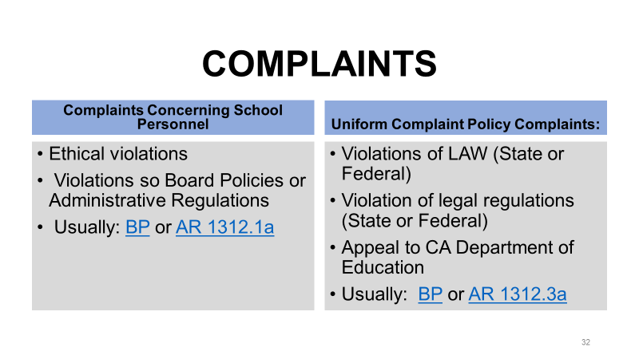
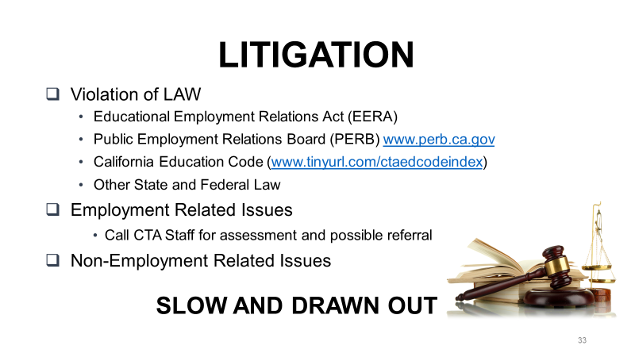

INSUBORDINATION

DEFINITION:
Insubordination is defined in Black's Law Dictionary as "State of being insubordinate; disobedience to constituted authority. Term imports a willful or intentional disregard of the lawful and reasonable instructions of the employer." Webster defines insubordinate as "not submitting to authority, rebellious."

IT CAN GET YOU FIRED!
Insubordination is one of the major contributing factors in many employee dismissals and is one of the easiest charges to prove. However, it is a concept that is misunderstood by many employees and as a result they place themselves in the position of being insubordinate. In order to avoid this hazard, a thorough understanding of the concept is necessary.
REMEMBER WHO'S BOSS!
First, it is important to understand that the principal or immediate supervisor has some management rights simply because he or she is the "boss". Any principal or immediate supervisor has the right to exert leadership, to direct the institutional operations, to enforce rules, policies, reasonable orders and directions so long as they conform to the contract and are clear and unambiguous, not injurious to your health, applied uniformly, and justly administered.
RULE # 1:
The best rule to follow in regards to insubordination is "Don't be."
WORK, THEN GRIEVE RULE:
If a worker at your site comes to you and questions a directive issued by the immediate supervisor or principal, advise him or her to discuss the objections with the principal. If the principal insists that the order be obeyed, advise the member to comply unless it is a threat to the health or safety of the staff member or students. Then file a grievance. This is the "Work, then Grieve" rule.

“Every moment is an organizing opportunity, every person a potential activist, every minute a chance to change the world.”
Dolores Huerta

Member Advocate

MEMBER REP

- Provide information sources and referrals to members.

- Represent members in meetings with the supervisor

- Establish a working relationship with site administrator.
- Keep leadership and staff updated of problems.

- Hold meetings at the site after each rep council meeting

- Distribute union materials in a timely manner

- Assist members with problems or concerns


What Does It Mean to be an Advocate?

- As an Association Representative, your role is to defend the processes outlined in the contract, to ensure processes are implemented fairly, and that every member has the right to a defense.

- Seek out employees who you know are either in trouble, or have concerns about issues on which you may be helpful. Do not wait for them to come to you. They may be too embarrassed or shy or may believe that no one can help them. Maybe you can't, but at least give it a try.

- Respect the employee’s position and point of view. Offer encouragement, support, understanding, and acknowledgment of the problem or issue. Do not treat it as insignificant even though it may seem to be.

- Defend the employee’s rights. Do not judge the employee as a person nor make judgments with respect to his or her performance and competence. Your job is to defend the process - not to be the judge and jury.

- The role of the Association is to listen to the complaint of a member, devise the best strategy for securing his or her interests, and set about securing a solution in the best way possible. The truth of the complaint will come out in the grievance process.

- Strictly observe the employee’s rights. Do not discuss the employee’s situation with other employees. If you need to investigate the problem or issue with other employees make every effort to do so without mentioning the employee’s name

- If the problem is serious, do not try to be heroic and handle it alone. Contact your CTA primary contact staff person immediately.

- Meet with the principal or immediate supervisor if that person is required to reach solution to the matter. Make it clear that you are there to represent the employee, not to side with the principal. Management can take care of itself. The Association is there to represent members.

- Initiate the formal level of the grievance procedure if necessary.

- When you are meeting with the principal as an Association Representative, remember that you have parity in the meeting. You are there as equals.

- If an employee has a complaint against another employee it is not the Association’s business to resolve it unless it can be turned into a complaint against management. However, a conscientious grievance representative may try to mediate informally.


Right to Union Representation
Small Group Discussion

The California Educational Employment Relations Act (EERA) affords public school employees the right to:

- To organize a union
- To bargain collectively
- To engage in union activities for the purpose of collective bargaining or other mutual aid or protection
- To have union representation in certain matters

The EERA, section 3543.2(a), states that public school employees who have a union are entitled to union representation in “[…] matters relating to wages, hours of employment, and other terms and conditions of employment” (emphasis added). “Other terms and conditions of employment” is a broad term which includes things like evaluations, class size, leave, transfer, and discipline.

This means that school employees who have a union are entitled to union representation in any meeting, interview, or discussion with their employer that they reasonably believe could lead to discipline or otherwise impact the terms and conditions of their employment.

It is an unfair labor practice for an employer or supervisor to interfere with these rights, to deny them, or to retaliate or threaten to retaliate against a worker for exercising such rights.

- A principal calls you into his office and hands you a Letter of Reprimand. Are you entitled to have a union representative present? Why or why not?

- Your vice principal schedules a meeting to discuss your evaluation. Your vice principal has been hostile to you in the past. Can you invoke your right to a union representative? Why or why not?

- You are in a meeting with your supervisor discussing a student’s progress when your supervisor suddenly begins asking you in an accusatory manner about some missing supplies. What do you do?

Right to Union Representation
Guidelines

- You must request that an Association Representative or other union representative be present. If you do not, you waive your rights to representation.

- You must have a reasonable belief that the “terms and conditions” of your employment may be impacted as a result of the meeting.

- You have the right to know the subject of the meeting in advance of the meeting.

- You have the right to consult your Association Representative prior to the meeting.

- You do not have the right to refuse to attend the meeting if your request for a representative is denied. But you can and should continue to repeat your request for representation to the supervisor conducting the meeting, take notes, and refuse to answer questions.

- You do not have the right to a union representative of your choice. Representation may be based on availability.

- Representation rights do not apply if the supervisor is issuing discipline which has already been decided.

Right to Union Representation
Developing a Communications Plan

In small groups, develop a plan to inform the members at your site about their rights to union representation and the need to request a union representative.
You’ll be asked to share some ideas with the large group.

Good Ideas:

Right to Union Representation
Small Group Discussion

Supervisors sometimes claim that the only role of an Association/Council Representative at an investigatory meeting is to observe the discussion. However, unions believe the law gives union representatives a much more active role in these meetings.

An AR/CR has the right to: compel management to inform her of the purpose of the meeting/interview; take the employee aside for a pre-interview conference before questioning begins; speak during the interview/meeting and ask for clarification on what the supervisor states; and advise the employee on how to respond or if she should respond to the supervisor’s questions.

- How would you counsel a member before an investigatory meeting?

- What would you, as the union representative, do during the meeting?

- What would you do after the meeting?

- What would you do differently if you thought the member was “guilty” or in the wrong? Would you still represent the member in the meeting?

Right to Union Representation
Guidelines

The Role of the AR/CR

- Be conscious of your duty of fair representation. The law requires that the union and its representatives represent all members of the bargaining unit fairly, no matter how we feel about the employee and regardless of whether she joined the union.

- Ask the supervisor the purpose of the meeting as much in advance of the meeting as possible. If the meeting happens without advance notice, when you arrive, ask the supervisor the subject of the interview/meeting. Ask the supervisor what type of conduct is at issue (lateness, performance, student complaint, etc.) and what type of action the supervisor is considering. The supervisor must provide this information.

- You have the right to meet with the member before questioning begins. Take the member aside for a private pre-interview conference. Let the member know all the questions must be answered truthfully. However, advise the member to keep their answers brief and not to offer any additional information. Tell the member not to answer a question they do not fully understand until it is clarified. Let the member know that anything they say in that meeting will be held against them, and tell the person to keep cool.

- During the interview, if the member doesn’t understand a question, ask the supervisor to clarify.

- After a question is asked, you can give advice on how to answer. Excuse yourself and the member in order to confer privately.

- When the questioning ends, you can provide additional information to the supervisor. Remember, anything you say can be used against the member, too. But you may wish to provide additional information such as the member’s clean disciplinary history, or positive evaluation history, or even add facts that the member did not mention, but which help her case.

- In your role as a union representative you are equal to the supervisor.

Right to Union Representation
Right to Information

EERA (page 9) gives workers the right to organize a union, bargain collectively, engage in union activities, and to have union representation. Your right to information when investigating a potential grievance is inferred from the right to bargain (and the employer’s obligation to bargain in good faith) and the right to representation.

The union is entitled to a wide variety of data and documents during a grievance investigation, including personnel files, attendance records, leave requests, memos, emails, schedules, meeting minutes, disciplinary records, seniority lists, and more. You can’t prove your case without the facts, and if management has those facts, you should have access to them, so request all the documents and data that might be useful to the grievance you are handling. Below is sample text that you can use in an email, letter or memo to an administrator:
To: Principal Mick Jagger
From: Joe Hill, SDEA Association Representative
Date: October 5, 2013
Re: Request for information

In order to investigate the grievance of Aren R. Lucky, the union hereby requests the following information:

- Copies of any and all referral slips generated by Ms. Lucky regarding student Billy Idol
- A written statement explaining the rationale for returning student Billy Idol to Ms. Lucky’s classroom on October 2, 2012 after Ms. Lucky suspended him for two days on October 1, 2012
- Copies of any and all existing written statements from witnesses to the incident between Ms. Lucky that were used in making the decision to return Billy Idol to Ms. Lucky’s classroom
- For those witness statements that were made verbally and then used in making the decision to return the Billy Idol to Ms. Lucky’s classroom, please include a written summary of each witness’s verbal statement
- Copies of any video material from school security cameras that was used in making the decision to return the Billy Idol to Ms. Lucky’s classroom
- Rock High School’s current student discipline policy

Please provide the information by October 10, 2013. If any part of this request is denied or if any material is unavailable, please state so in writing and provide the remaining items by the above date, which the union will accept without prejudice to its position that it is entitled to all documents and information sought in this request. This letter is submitted without prejudice to the union’s right to file subsequent requests.

THE WEINGARTEN RULE:

AN EMPLOYEE HAS THE RIGHT TO HAVE A UNION REPRESENTATIVE AT A MEETING WITH THE EMPLOYER IF HE OR SHE HAS A REASONABLE EXPECTATION THAT DISCIPLINE MAY RESULT.

This is a private sector rule that has been made applicable to Public School employees under the EERA. (See Redwood CCD v. PERB (1984) 159 Cal.App.3d 617)
THE COURT'S GUIDELINES
1. The employee must request the representative. The right arises only in situations where the employee requests representation. The employee may and will forfeit this right if he/she goes ahead and meets with management without an Union Representative.
2. There must be a reasonable belief that discipline will result from the investigatory meeting. Regular "run-of-the-mill" conversations with management such as review of job requirements or training will not be covered. However, the right to representation exists even in cases where no discipline does result from the interview. The right to representation is based on the reasonable belief of the employee, not anyone else in the situation.
3. The employer is not required to interview the employee. The employer may decide not to interview the employee, if the employee requests the presence of a union steward, but may continue the investigation. The employer does not have to justify his/her refusal to allow union representation. The employer is free to carry on the inquiry without interviewing the employee, and thus leave to the employee the choice between having an interview unaccompanied by his representative, or having no interview and forgoing any benefits that may be derived from one. If the employee refuses to be interviewed without his/her Rep, the employer would then be free to act on the basis of information obtained from other sources.
Though this appears to leave the union and employee a choice to make, there is, in fact, nothing to be gained by meeting with management without one's union representative. An employer who is serious about resolving a problem should welcome a union's participation. The choice, then, remains with the employer.
4. The employer has no duty to bargain with the union representative at an investigatory interview. The representative is present to assist the employee, and may attempt to clarify the facts or suggest other employees who may have knowledge of them. The employer, however, is free to insist that he is only interested, at that time, in hearing the employee's own account of the matter under investigation.

EMPLOYEE’S RIGHT TO REPRESENTATION

Under the Education Employment Relations Act (EERA), employees have the right to union representation at a meeting with the employer if he or she has a reasonable expectation that discipline may result. The employee must request the representative.

 There are six (6) areas of individual representation:

- Disciplinary meetings
- Investigations of wrongdoing
- Complaint representation
- Required responses to derogatory material
- Other unusual circumstances
- All other areas of professional-employment relations

 The union is not able to represent an individual employee in
three (3) areas:

- Receipt of a directive
- Formal evaluation procedures
- Notice of disciplinary action


When Employee Discipline is The Issue

Many times the issues are not clear-cut around who is at fault. It is not uncommon for administration to attempt to discipline an employee unfairly. Many contracts have language about how and when discipline will happen. There are some things, however, that are mandated. Over the years, through court cases on this issue, the Seven Tests for “Just Cause” for employee discipline have emerged.

SEVEN TESTS FOR JUST CAUSE

- Did the employer give the employee forewarning or foreknowledge of the possible or probable disciplinary consequences of the employee’s conduct?

- Was the employer’s rule or managerial order reasonably related to the orderly, efficient, and safe operation of the employer’s business?

- Did the employer, before administering discipline to an employee, make an effort to discover whether the employee did in fact violate or disobey a rule or order of management?

- Was the employer’s investigation conducted fairly and objectively?

- At the investigation, did the employer obtain substantial evidence or proof the employee was guilty as charged?

- Has the employer applied its rules, orders, and penalties even-handedly and without discrimination to all employees?

- Was the degree of discipline administered by the employer in a particular case reasonably related to
a) the seriousness of the employee’s proven offense?
b) the record of the employee in his service with the employer?

A ‘No” answer to any one or more of the above questions normally signifies that just and proper cause did not exist. In other words, such a “no” means that the employer’s disciplinary decision contained one or more elements of arbitrary, capricious, unreasonable, and/or discriminatory action to such an extent that the decision constituted an abuse of managerial discretion warranting the arbitrator to substitute his judgment for that of the employer.

If you have an employee who is disciplined, either around a grievance issue or some other issue, be sure to follow all the procedures you would for a grievance—interview, get the information, check the contract for violations, etc. Also, check your evidence against the Seven Tests for Just Cause. If you feel a member’s rights are being violated, grieve if you can.

Emergency First-Aid For
The Union Representative

In the first few minutes or hours following an incident that poses a threatening outcome for a member, the Union Rep should be prepared to do the following:

The first stage of an incident is often filled with trauma, which hinders clear thinking. Therefore, it is vital that members be warned against taking precipitous and potentially unwise actions.

Warn Members –

- Not to make spontaneous responses to charges brought against them.
- Not to appear at any accusatory hearing (including a meeting with an administrator) unless accompanied by union representatives.
- Not to attempt to defend themselves alone.
- Not to accept “an opportunity to resign.”
- Not to agree to any proposals, whether orally or in writing.
- Not to submit any written statement to administrator or school directors.
- Not to refuse to carry out an order of an administrator, even though doing so would violate the Contract.

Advise Affected Members—
- To write down immediately everything that happened—a narrative including time, date, location, names of involved persons, witnesses, and actual words spoken.
- To get advice early from union representatives, not to “wait and see what happens.”
- To keep copies of all correspondence and papers relating to the situation.


Meetings with Administrators

THE SITE REPRESENTATIVE FILLS IN THE GAPS

Gets the Information
Asks questions and starts with “what is the purpose of this meeting?”
Clarifies facts
Listens
Take notes

Advocates for the Employee
Speaks for the employee when possible
Explains
Points out extenuating circumstances
Argues the employee’s case
Asserts rights under the collective bargaining agreement

Protects the Employee
From verbal abuse
From making a bad decision about their job
From making statements that could be used against them

Supports the Employee
Provides moral support
Provides helpful information and advice

REMEMBER: If the employee is accused of serious misconduct that could result in dismissal or criminal prosecution (usually sexual contact with students or excessive force) your job is to assert their Fifth Amendment right to remain silent, get them out of there, and get them to a CTA attorney. Contact the Union office immediately.

MEETING WITH YOUR MANAGEMENT

Suggestions to DTA members when meeting with management

1. Avoid arguments among Union members in the presence of management.

If you have a difference of opinion during a meeting, take a recess and iron the problem out in private; present a united front to management.

2. Keep to the point.

Avoid getting led off on side issues by management.

3. Get the main point of management’s argument.

Try to narrow the area of difference between union and management.

Try to pin management down on why it did what it did, or failed to do what it should have done.

4. Avoid getting excited.

5. Treat the management representatives, as you would like to be treated.

Let any break in good relations come first from the other side.

Remember that the representative to whom you are speaking is not always personally responsible for the complaint of grievance; therefore, you may get less cooperation from him/her by trying to place the blame on his/her shoulders.

6. Avoid unnecessary delays.

If management asks for more time, try to determine whether it is an attempt to stall or is based on a sincere desire for more facts needed to settle the case.

Remember, the more time that passes, the “cooler” the complaint, concern, or grievance becomes and the less support you will get from the teacher or teachers involved.

The longer the concern or grievance is tied up by management, the more difficult it will be for the union.
The more concerns that are pulled up in the procedure, the more likely that management will try to “horse trade” settlement of a few problems for dropping of others.

If the grievances are made a part of contract negotiations, management may attempt to trade off other contract demands for settlement of grievances that should have been taken care of long before.

- On grievances, settle them at the lowest appropriate step of the grievance machinery, but make sure they are properly settled.

This saves time.

It helps build better relationships in the department.

Don’t pass the buck – if you can settle the grievance satisfactorily in the first step, do so.

- Avoid bluffing.

It is only a matter of time until your bluff is called; it is in the long run wiser to develop a reputation for honesty.

- Maintain your position until proven wrong.

- Enforce the contract!

If the Union has not complained about similar violations of the contract or past practices before, why should management give in now?

The best contract in the world has no value if the members do not require management to live up to its terms.

- If you win your point, stop talking.

Don’t continue to hash it over. Be sure to inform the teachers about it after the meeting.

REMEMBER: You are meeting as equals. There is no reason to bow or scrape or to have a chip on your shoulder. Try to establish a friendly but businesslike relationship. The union is after results that will benefit the unit member and the membership as a whole.
Meeting with Administration
Large Group Discussion

In a large group, discuss and answer the following questions:

- What kinds of meetings with administration have you, as an AR/CR, been part of? Have you ever been a grievant in a grievance meeting?

- What sort of preparation do you think is necessary prior to meeting with administration?

- What should be done to keep the meeting on the union’s agenda instead of giving administration control?

- What sort of follow-up should be done after the meeting?

Meeting with Administration
Guidelines

- Any meeting with administration, whether a grievance meeting, negotiations, or another kind of meeting, requires a strategic plan.

- All meeting participants need to know the union strategy and their role in the meeting. Caucus prior to meetings with administration.

- As a union representative, you are the equal of administration when representing the union – don’t forget it!

- Try to meet on your turf or neutral ground when possible. Your classroom may be preferable to a conference room which is preferable to the administrator’s office.

- Sit directly across from the administration spokesperson. If the administration spokesperson sits at the head of the table, take the other head of the table.

- Take the initiative and begin the meeting. Introduce yourself and the grievant (if necessary) and state the purpose of the meeting.

- Take and keep control of the meeting – stay on the union’s agenda. Don’t get side-tracked.
- Be strategic with your actions and tone. Be professional. Stay cool – don’t be manipulated into showing anger (unless it is part of your strategy to show anger).

- If administration treats you or the grievant in an abusive manner, keep your cool, but don’t tolerate it. Suggest meeting again when management is more under control or, if necessary, move the grievance to the next step.

- Don’t let administration “divide and conquer”. Never argue or disagree in front of administration. Instead, call a union caucus.

- Where appropriate, try a problem-solving approach. Explain the problem and encourage administration to see that a reasonable solution is in their best interest.

- Encourage administration to talk and air their views. A clear understanding of administration’s perspective (even if you don’t agree) will help you decide how to proceed.

- Ask questions and listen carefully to the answers. Probe for areas of possible compromise.

- If administration agrees with your position and remedy, thank them and leave. Don’t talk yourself out of a victory.

- Follow up meetings with written confirmation to administration of agreement or next steps.

- Keep in touch with the grievant(s) and other union members about how the meeting went. If there’s a victory, celebrate it as a union victory that makes the workplace better and the contract stronger!

Meeting with Administration
Preparing to Meet with Administration & Meeting Roleplay

Preparation (Large Group Activity)

Use the Terry Berry grievance from the previous activities. Using the worksheet on the following page, prepare to meet with administration. Develop a strategy for the grievance meeting. You may use the Guidelines on pages 38-39 to help you plan your strategy. (The participant who will eventually roleplay the principal should excuse him/herself for this activity.)

Role play (Large Group Activity)

After everyone has had a chance to develop a meeting strategy, we will ask for a group to present the grievance in front of the large group. One team member will play the grievant and the other the role of the AR/CR. Other group members should help out, as needed. The trainer or another participant will play the role of the principal.

Discussion after the role play

After the role play, we’ll discuss what was effective and brainstorm additional ideas.

If time permits, we’ll do a second round of the role play after our discussions.

Meeting with Administration
Large Group Discussion: Preparing to Meet with Administration

- What are your arguments? Which are the strongest? The weakest? (Cite contract sections)

- What remedy will you ask for?

- How will you maintain a united front? How will you communicate with your co-workers?

- How will you take control of the meeting?

Now prepare the grievant!
Meeting with Administration
Roleplay Observations

 | Strategy | What did you notice? What was good? What could be better?
 | Took control of the meeting at the start
 | Strategic tone and demeanor
 | Terry was an active participant in the grievance meeting
 | Kept the meeting focused on the grievance
 | Put all their arguments on the table
 | Used the contract
 | Kept a united front
 | Encouraged the principal to air their views
 | Used problem solving techniques
 | Was persistent
 | Talked about a solution to the grievance

REP SCENARIOS

Scenario #1
One of the students involved in a fight took a swing at Mr. Atlas, who was trying to break up the fight. Mr. Atlas reacted and threw the student against a wall and knocked him out. Mr. Atlas is very ashamed of himself and wants to resign. The principal wants to meet with Mr. Atlas and suggests that he might want to bring a rep. Mr. Atlas asks you to attend the meeting as his rep.

What would you do?
What would you say in the meeting?

Scenario #2
Ima Scared is told that the principal wants to see her alone to respond to a parent complaint that Ms. Scared has been acting “weird.” Ima doesn’t want to meet with the principal alone and asks you to come with her.

What would you do?
What would you say in the meeting?
What do you do if the principal says he wants to meet alone with Ms. Scared?

Scenario #3
Frieda Forgetting, an association member, is advised that her report cards and other forms are always late, and she has been written up for this two times. The principal, Mr. P. Unctual wants to meet with Frieda. He says he has had it! Frieda asks you to come along as her rep.

What would you do?
What would you say in the meeting?
What solutions might you suggest?

Scenario #4
Clarence Klutz is accused of breaking a student’s finger as that child left the classroom. Clarence says he is innocent. The parents are filing a public complaint, and the police are also on their way. Clarence asks you to go in with him as his rep to the meeting with the policeman and any other meetings that transpire.

What would you do?
What would you say in the meeting?

Scenario #5
The principal limits the use of paper to two reams per month per teacher. Just to run enough for your unit tests will use all your paper. They say these two reams are not enough and they are tired of buying their own paper to supplement. The teachers come to you and ask you to meet with the principal and fix this situation.

What would you do?
What would you say in the meeting?

Scenario #6
There is a teacher who is chronically late because of childcare problems. The principal says enough is enough and threatens to put something in your file. He asks to meet with this teacher (Mary) and Mary asks you to go into the meeting as the Rep.

What would you do?
What would you say in the meeting?

Scenario #7
Your principal has decided that the teachers at your school will pilot a new language arts text. No teachers were asked, and as a matter of fact, you have a great program going-teaming-special lesson plans, etc. It would appear that almost all your teachers would rather wait until the District adopts a text next year to change to a new text. The teachers ask you and the two other Reps to meet with the principal and persuade her to wait on the piloting.

What would you do?
What would you say in the meeting?

Scenario #8
The principal has asked all teachers to attend a second faculty meeting this month. Originally, he had said there would not be a second meeting this month and almost everyone had made other plans for that day. Now, 48 hours before the meeting, he says he has changed his mind and all teachers are to be there. Your Contract says you must attend a minimum of 1 meeting per month but that the principal can call more than that as necessary as long as he gives reasonable notice. You and the other reps are asked to meet with the principal and resolve this issue.

What would you do?
What would you say in the meeting?

Scenario #9
The adjunct duty list has already been set for this year. Your principal now (in January) decides to add two more duties that will require most teachers to add one adjunct duty for the year. She says she is sorry for the inconvenience but that the parents are gung-ho about these events, and she will need teachers there supervising students. (The Contract says the district may assign adjunct duties as long as they are reasonable in number, equitable, and staff has given input.)

What would you do?
What would you say in the meeting?

Site Rep Training [Member Scenario]

“Teacher having a bad year?”

After returning from Winter Break, the principal (Del Linquent) at ABC High School asks you (Anita Help, a 10-year teacher) into his office to discuss an incident that happened just before the break. You have no idea what the meeting is about, nor do you ask what the meeting is about.

It has been a rough year for you, including issues all year with arriving to school on time and getting back to parents. You have been having car issues and a lot of other personal things going on in your life with the high cost of living and the low salaries. In fact, back in November, after multiple conversations, the principal issued you a letter of reprimand for continued tardiness. Although you didn’t like having the letter in your file, you did not seek Union representation.

Your year hasn’t been getting any better after the Winter Break. Recently, on January 9, 2015, you had the worst encounter with a parent of your career. A tenth grade student who has been consistently defiant and disruptive, refused to comply with a simple request to stop talking with other students during silent reading. After repeated warnings, you utilized your discretion and sent the student to the office, suspending him for 2 days. The following Monday (January 12) during the student’s second day of suspension, the father of the student entered your classroom (no students were present) to speak with you about the suspension and about your lack of consistent expectations for all students. You felt the conversation was accusatory and threatening, and after asking the father to leave (he would not leave before receiving a response from you), you felt unsafe and decided to contact campus security who escorted the parent to the school office.

At lunch the principal approached you in the teacher’s lounge and asked if he could see you after school. You agreed to come. After school, you met with the principal in his office. When the meeting began, you immediately asked that the parent, whom you believed “had barged into your classroom” be barred from the school. You also shared with the principal the threats you believed the parent had made and how you felt unsafe when that parent was on campus unescorted. The principal replied by stating that he was disappointed in your relationships with parents in general. When you objected that this parent was a clear safety threat, the principal demurred and stated that “other parents are also complaining about your conduct.” But the principal would not name these parents nor provide the exact nature of the complaints. The principal then proceeded to ask you a series of questions regarding the student you had recently suspended. At this point, you interjected stating that you would answer no further questions without your Union site rep. Visibly agitated, the principal stops the questioning and hands the following Notice of Unprofessional Conduct to you. Upon receiving the NUC, you end the meeting to go find an Association site representative. You are very distraught at what has transpired.

Based on the above account, what should you tell the site rep?

Are there any contractual violations?

How much detail should you provide?

______________________________________________________________________
Notice of Unprofessional Conduct

Date: January 12, 2015

To: Anita Help

From: Del Linquent, Principal

Re: Parent relations

I have received several complaints from parents about your treatment of students and your grading practices. These parents indicate that when they’ve attempted to contact you regarding these matters, they receive no response either in writing or by phone. Many have shared their concerns that when they have spoken with you, you are very defensive and unprofessional and do not want to meet with you because of possible retaliation by you against their children. As you know, this is a very serious concern. Maintaining open communications with parents is essential to ensuring student success. You are directed to forward to me a draft of all your parent communications for my approval prior to sending any parent communications. You are also directed to be professional in all your future interactions with parents.

In addition, I have counseled you previously about arriving to work on time and so I am concerned that these latest incidents are demonstrating a pattern of inappropriate behavior on your part.

This Notice of Unprofessional Conduct will be placed in your Personnel File. You have the right to submit a response provided you do so within ten (10) days. Failure to follow the directive outlined in this letter could lead to further discipline up to and including suspension and/or dismissal.

Site Rep Training [Site Rep Scenario]

“Teacher having a bad year?”

You are a long-time site rep and have a pretty good relationship with all the staff. You know that Ms. Help has been having some issues this past year, but have not intervened because Ms. Help is a very private person. Although Ms. Help is a union member, she never attends union meetings or participates in union actions. But recently, Ms. Help came looking for you, very distraught and upset about a meeting with the principal.

What questions will you ask Ms. Help?

Are there any contractual violations?

Are there any larger implications to this incident and the principal’s behavior?

Is this a potential organizing issue? Why? Why not?

Based on the above account, what would you do next as the site rep?

____________________________________________
Notice of Unprofessional Conduct

Date: January 12, 2015

To: Anita Help

From: Del Linquent, Principal

Re: Parent relations

I have received several complaints from parents about your treatment of students and your grading practices. These parents indicate that when they’ve attempted to contact you regarding these matters, they receive no response either in writing or by phone. Many have shared their concerns that when they have spoken with you, you are very defensive and unprofessional and do not want to meet with you because of possible retaliation by you against their children. As you know, this is a very serious concern. Maintaining open communications with parents is essential to ensuring student success. You are directed to forward to me a draft of all your parent communications for my approval prior to sending any parent communications. You are also directed to be professional in all your future interactions with parents.

In addition, I have counseled you previously about arriving to work on time and so I am concerned that these latest incidents are demonstrating a pattern of inappropriate behavior on your part.

This Notice of Unprofessional Conduct will be placed in your Personnel File. You have the right to submit a response provided you do so within ten (10) days. Failure to follow the directive outlined in this letter could lead to further discipline up to and including suspension and/or dismissal.

Site Rep Training [Principal Scenario]

“Teacher having a bad year?”

After returning from Winter Break, (you) the principal (Del Linquent) at ABC High School ask a 10-year teacher (Anita Help) into your office to discuss an incident that happened just before the break. Ms. Help has no idea what the meeting is about, nor does she ask what the meeting is about.

As the principal, you have been very concerned about Ms. Help’s inconsistent communication with parents, as well as her attendance. In fact, back in November, after multiple conversations with Ms. Help about her attendance, you issued her a letter of reprimand for continued tardiness. Although she didn’t like having the letter in her file, Ms. Help did not seek Union representation.

After winter break on January 9, 2015, you learned of an encounter between Ms. Help and a parent of one of her students. According to the dad of this student, his son has felt singled out and picked on all year by Ms. Help. The dad mentioned to you that he was unaware of any behavioral issues of his son in Ms. Help’s class. And so the parent was especially concerned when his son was sent home under a two-day suspension for defiance. As a result of this concern, the parent shared with you that he felt he needed to speak with Ms. Help (with no students present) and talk to her about the situation. The parent acknowledges that he didn’t make an appointment with Ms. Help, but when he tried to talk to her she became very defensive asking him to leave her classroom, which he did immediately. Unfortunately, the calling of campus security by Ms. Help has only escalated the situation.

And so at lunch you approached Ms. Help in the teacher’s lounge and asked if you could see her after school. Anita agreed to come. After school, Anita joined the you in your office. When the meeting began, Ms. Help immediately became defensive and asked that the parent whom she believed “had barged into her classroom” be barred from the school. She also shared with you the threats she believed the parent had made, and told you that she felt unsafe when that parent was on campus unescorted. You replied by stating that you are disappointed in Ms. Help’s relationships with parents in general. When Ms. Help objected that this parent was a clear safety threat, you demurred and stated that “other parents are also complaining about her conduct.” But you are not going to name these parents nor provide the exact nature of the complaints. You then proceed to ask Ms. Help a series of questions regarding the student she had recently suspended. At this point, Ms. Help interjected stating that she would answer no further questions without her Union site rep. Visibly agitated, you stop the questioning and hand the following Notice of Unprofessional Conduct to Ms. Help. Upon receiving the NUC, Ms. Help ends the meeting to go find an Association site representative. She is very distraught at what has transpired.

Based on the above account, what would you do next as the principal?

Are there any contractual violations that you want to avoid?

How can you use this to single out the behavior and not make it personal against Ms. Help?

What calculated risk might you take against the union?

______________________________________________________________________
Notice of Unprofessional Conduct

Date: January 12, 2015

To: Anita Help

From: Del Linquent, Principal

Re: Parent relations

I have received several complaints from parents about your treatment of students and your grading practices. These parents indicate that when they’ve attempted to contact you regarding these matters, they receive no response either in writing or by phone. Many have shared their concerns that when they have spoken with you, you are very defensive and unprofessional and do not want to meet with you because of possible retaliation by you against their children. As you know, this is a very serious concern. Maintaining open communications with parents is essential to ensuring student success. You are directed to forward to me a draft of all your parent communications for my approval prior to sending any parent communications. You are also directed to be professional in all your future interactions with parents.

In addition, I have counseled you previously about arriving to work on time and so I am concerned that these latest incidents are demonstrating a pattern of inappropriate behavior on your part.

This Notice of Unprofessional Conduct will be placed in your Personnel File. You have the right to submit a response provided you do so within ten (10) days. Failure to follow the directive outlined in this letter could lead to further discipline up to and including suspension and/or dismissal.

_________________ Unified School District
Human Resource Department
_______, CA

GRIEVANCE FORM – LEVEL I

___________________ ____EA Grievance 2014-_________________________

Submission of Complaint – All portions of this section must be completed by the grievant.

Employee Name: Anita Help Work Location: ABC High School

- Statement of the Grievance (Attach extra sheets if necessary): On or about January 12, 2015, the grievant (Anita Help) was called into a meeting with the school principal (Del Linquent). At this meeting, the principal issued to the grievant a Notice of Unprofessional Conduct (NUC), which outlines allegations of parent complaints and communications, as part of a recent incident involving a 2-day suspension of a student for willful disobedience. Before the grievant could provide her version of the facts with a ___EA site representative, the principal issued to her a NUC, which had already been written.

For all the above reasons, ___EA contends that the NUC issued to the grievant is arbitrary and capricious and without just cause.

- Section of the Agreement violated: Article XYZ (Discipline), Article ?? (Evaluation Procedure), District Board Policy ?? and all other pertinent articles, District policies and laws.

- Decision rendered at informal level: ???_______________________________________

- Remedy Sought:
- Remove and destroy the January 12, 2015 NUC and all supporting documents from the grievant’s personnel file.
- Direct the site principal to adhere to the District’s Board Policies on Parent Complaints.
- Provide training to the site principal on Just Cause and conducting objective investigations, and on managing parent complaints.
- All other appropriate remedies to make the grievant whole.

______________________________________________________________________________

DISTRIBUTION:
Upon completion of this section, grievant shall present original and copies #2 and 3 to immediate supervisor. Copy #4 should be retained by grievant.

______________________________________________________________________________

Immediate Supervisor’s Response:

(Date) (Signature)

Thank you for being a site rep!
Our union is stronger because of
your dedication and activism!


Get more resources at cta.org & nea.org

and attend a local workshop or CTA conference!



Parliamentary Motions Guide
Based on Robert's Rules of Order Newly Revised (11th Edition)
The motions below are listed in order of precedence. Any motion can be introduced if it is higher on the chart than the pending motion.
YOU WANT TO: |  | YOU SAY: | INTERRUPT? | 2ND? |  | DEBATE? | AMEND? | VOTE?
§21 Close meeting |  | I move to adjourn | No | Yes |  | No | No | Majority
§20 | Take break | I move to recess for | No | Yes |  | No | Yes | Majority
§19 | Register  complaint | I rise to a question of  privilege | Yes | No |  | No | No | None
§18 | Make follow  agenda | I call for the orders  of the day | Yes | No |  | No | No | None
§17 | Lay aside  temporarily | I move to lay the  question on the table | No | Yes |  | No | No | Majority
§16 | Close debate | I move the previous  question | No | Yes |  | No | No | 2/3
§15 | Limit or extend  debate | I move that debate be  limited to ... | No | Yes |  | No | Yes | 2/3
§14 | Postpone to a  certain time | I move to postpone  the motion to ... | No | Yes |  | Yes | Yes | Majority
§ 13 | Refer to  committee | I move to refer the  motion to ... | No | Yes |  | Yes | Yes | Majority
§12 | Modify wording  of motion | I move to amend the  motion by ... | No | Yes |  | Yes | Yes | Majority
§11 | Kill main motion | I move that the  motion be postponed  indefinitely | No | Yes |  | Yes | No | Majority
§ I0 | Bring business  before assembly  (a main motion) | I move that [or "to"]  ... | No | Yes |  | Yes | Yes | Majority

Parliamentary Motions Guide
Based on Robert's Rules of Order Newly Revised (11th Edition)
Incidental Motions - No order of precedence. Arise incidentally and decided immediately.
YOU WANT TO: | YOU SAY | INTERRUPT? | 2ND? | DEBATE? | AMEND? | VOTE?
§23 Enforce rules | Point of order | Yes | No | No | No | None
§24 Submit matter to  assembly | I appeal from the  decision of the chair | Yes | Yes | Varies | No | Majority
§25 Suspend rules | I move to suspend the  rules which ... | No | Yes | No | No | 2/3
§26 Avoid main motion  altogether | I object to the  consideration of the  question | Yes | No | No | No | 2/3
§27 Divide motion | I move to divide the  question | No | Yes | No | Yes | Majority
§29 Demand risin^{g} vote | I call for a division | Yes | No | No | No | None
§33 Parliamentary law  question | Parliamentary  inquiry | Yes (if urgent) | No | No | No | None
§33 Request information | Request for  information | Yes (if urgent) | No | No | No | None

Motions That Bring a Question Again Before the Assembly - no order of precedence. Introduce only when nothing else pending.
§34 Take matter from  table | I move to take from  the table .. | No | Yes | No | No | Majority
§35 Cancel or change  previous action | I move to rescind/  amend something  previously adopted... | No | Yes | Yes | Yes | 2/3 or  maj. w/ notice
§37 Reconsider motion | I move to reconsider  the vote ... | No | Yes | Varies | No | Majority

____EA Training
DATE
Evaluation

- What did you find most valuable?

- What did you find least valuable?

- What could have been done to improve this training?

- What parts of this training will you take to your local and use?

- What do you need help with or what do you need more of?

- Please provide any other comments or suggestions.

