LGBTQ Caucus Facilitator Agenda – Sessions 1-3 4/11
General Materials Needed: |  |  |  | Room Set-up:
1 Set of Handouts per Person (online in POPS)  Name Tents with the Norms  Room signs,  One ream of white photocopy paper  Chart Paper (4 to 5 full w Sticky Strip) | Materials Box for each table with:  Markers (Mr. Sketch variety)  Post its – 3x3” and 4X5” sizes  Index Cards  Highlighters – 4 colors  Pens and Pencils  Participant “toys” |  |  | Long Rectangle table at back for facilitators  Round Tables for participants  Projector, Screen, mics, and Speakers  Carousel stations and reporting stations  No podium, table with projector big enough for laptop  50 people max
Key Outcomes for the Event:
Identifying and developing leaders and activists across the intersectional landscape of race, class, and gender.
Applying strategies and methods for developing and supporting cross-campus coalitions and alignments across unites/job families focused on seeking worker justice and social justice.
Developing coaching skills and devising coaching interventions that sustain and grow escalating campaigns.
Designing strategic alignment of leadership tests and tactics using a variety of scenarios and case studies specific to the challenges found across worksites and communities.

Track Description:
LGBTQ+ Constituency Organizing can become stuck in the development of programming that results in great recruitment and retention but never moves members into action. This can be especially true in our state and local LGBTQ+ Caucus Groups. For Caucus Groups to overcome the challenges of difference in affiliate membership, job classification silos, worksite geography, and vast differences in local and state policies – Caucus Groups must intentionally focus on Strength and Power Building methods. Building sustainable, broad-based, power-focused Reform Caucuses that can achieve the changes most important to their constituents require base-building, interdependent leadership structures, coalition development, and values-based narratives. Additionally, Reform Caucuses and their affiliates are impacted by race, class, and gender power and oppression dynamics that require explicit strategies to overcome division and build unity across difference.

Overview of Content, Time, and Facilitator Assignment
4/12 Session 1 10:15am-11:45am (90 Minutes)  10:15-10:25 Welcome and Community Agreements  10:25-10:40 World as it is - Highest Hopes  10:40-11:05 Organizing, Power, Campaigns  11:05-11:45 Three Theories for Change  4/12 Session 2 1:45-3:15 (90 Minutes)  1:45-2:15 Recognizing Leadership  2:15-3:00 Assessing our Structures (Club to Union) |  | Anthony  Ellen  Albert  Grat  Jeny  Eric J. | 3:00-3:15 Building a Campaign Overview  4/12 Session 3 3:30 –5:00 (90 Minutes)  3:30-4:00 Centering Race, class, and gender  4:00-4:30 Problems to Issues  4:30-5:00 Power Analysis |  | Eric S.  Salina  Grat  Albert/ Eric J.

Time Slides Facilitator | Resources | Instructions, Activity and Debrief (Facilitators) | Essential Questions and Outcomes
 | Charts, handouts, articles, materials, slide | What are you saying, what are they doing, what questions will you use to guide learning and make clear the important points  Include an estimate for how long each section of the learning will take | What question(s) will this learning answer? What will participants know or be able to do?
Team prep, practice, room set up, sound check, etc.
Entry Activity

4/12 Session 1
10:15am-11:45am
10:15-10:25 | Anthony | 20 Minutes TOTAL Welcome and Community Agreements
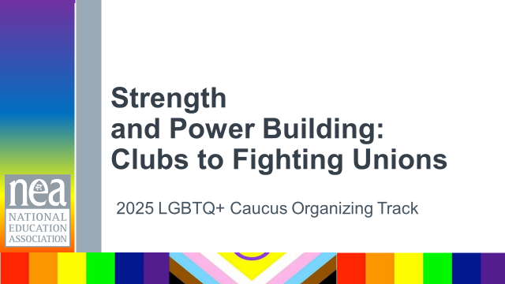  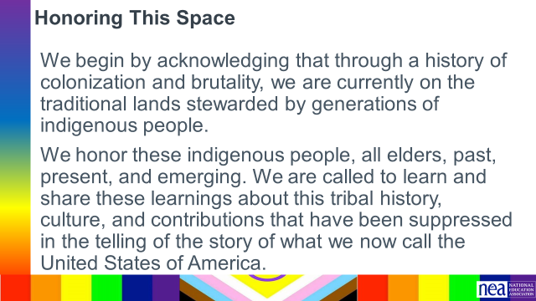  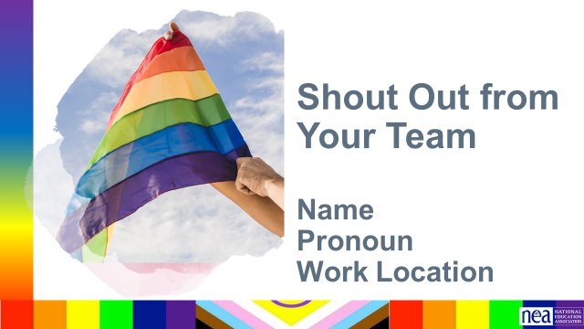  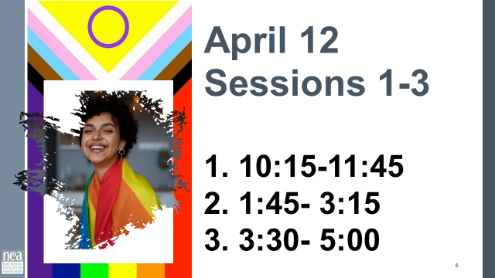  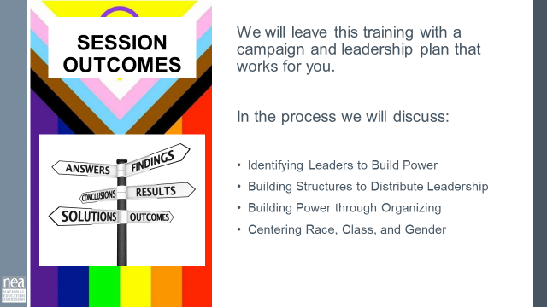  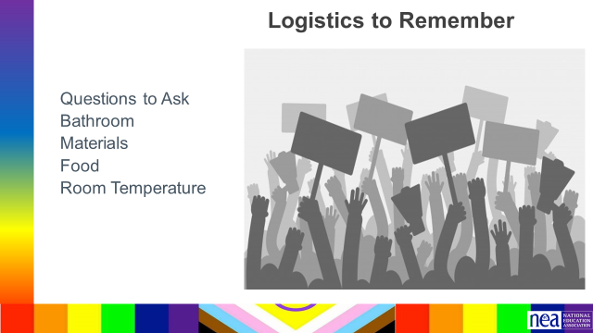 | Community Agreements in Handouts  Agenda on Slides  Parking Lot Chart  Name Tents  Name Tags  Handout Package | Welcome Activity [Chart Paper]  I am ...  I serve as ...  I reside in ...  I am here because ...  My email...  5 Minutes Total  Welcome  Land Acknowledgement  Quick Intro of the facilitator team  First time doing this format at the retired conference  Agenda  Materials  Logistics | Participants will know how we are going to work, the basic schedule, and the logistics relevant to the training.
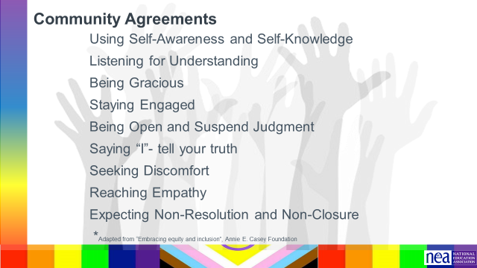 | Community Agreements | 5 Min - Group Review (page 2 in participant handout)  Begin with a proposed list of community agreements, each table needs to describe what they think each agreement means and propose any additional norms not covered by the proposed agreements:  - Using Self-Awareness and Self-Knowledge  - Listening for Understanding  - Being Gracious  - Staying Engaged  - Being Open and Suspend Judgment  - Saying “I”- tell your truth  - Lean into Discomfort  - Reaching Empathy  - Expecting Non-Resolution and Non-Closure  Key Point  - Agreement on how we will work together for five days that allows us the space to manage “airtime” and teaching - AND allows adult learners a safe space to learn. | How will we work together?  Participants will review, clarify and agree to a set of expectations and behaviors that support their learning as a community.
10:25-10:40 Ellen |  | 15 Minutes Highest Hopes
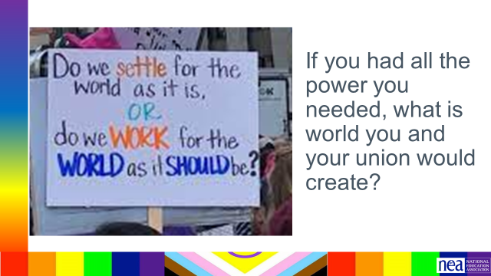 | Chart Paper | 15 Minutes Total  If we get stuck in the what we can’t do and what is being taken away – we are already defeated. Powerful organizers know that they have to be aware of the “World as it is” AND the have to be able to dream about the “World as it should be”  In your groups and using the chart paper you can use pictures, words dance, or whatever to identify the biggest dreams you have for the organizing work you and your team are going to take on. | Participants will create a list of the BIG goals they have for organizing and building power
10:40-11:05 Albert |  | 25 Mins TOTAL - Organizing, Power and Campaigns
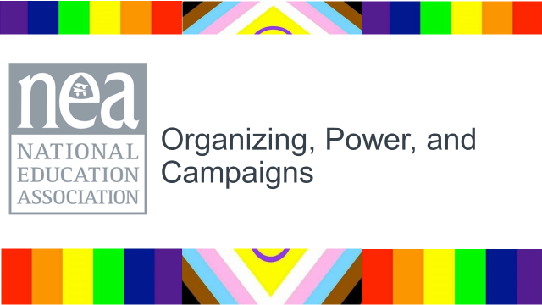  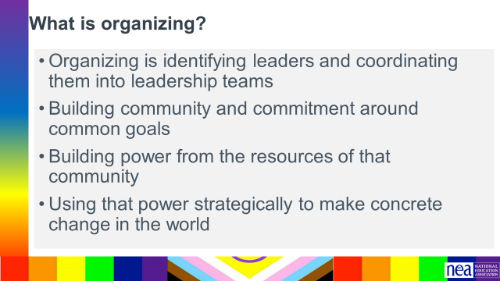  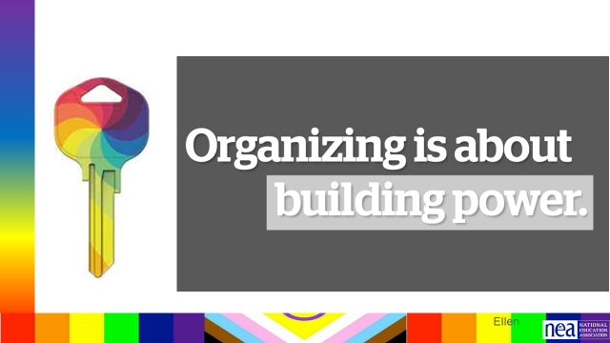 | What is organizing | 5 Minutes – What is Organizing – p. 4 in PH  1 minutes this is the definition of organizing that we are going to work from today.  Organizing is identifying leaders and coordinating them into leadership teams; Building community and commitment around common goals; Building power from the resources of that community; Using that power strategically to make concrete change in the world.  Take 2 minutes with your table and identify words and phrases in this definition that stand out to you.  2 minutes – Whole group report out –  KEY POINT - these are the methods we use to BUILD POWER organizing is about building and using power | Participants will develop a common definition of organizing and power.
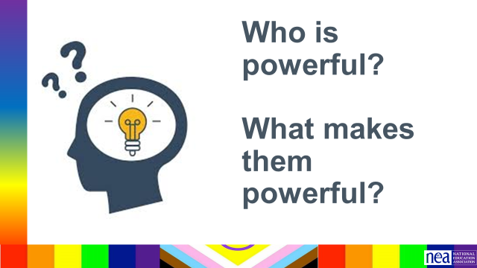  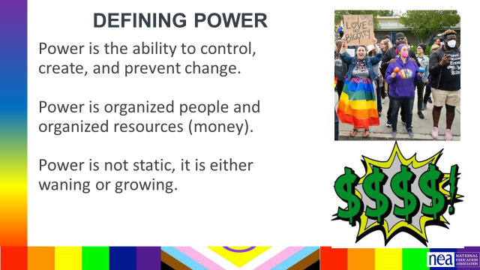  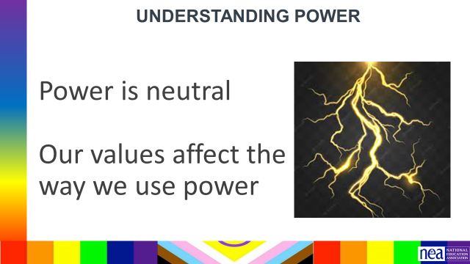  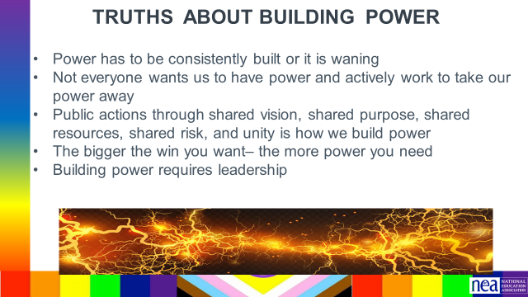  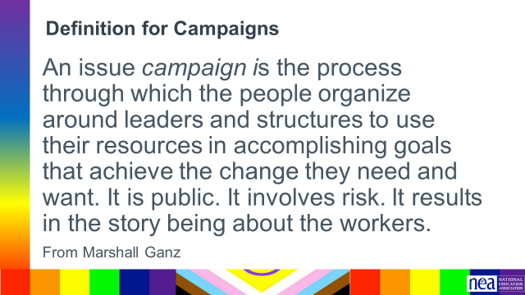  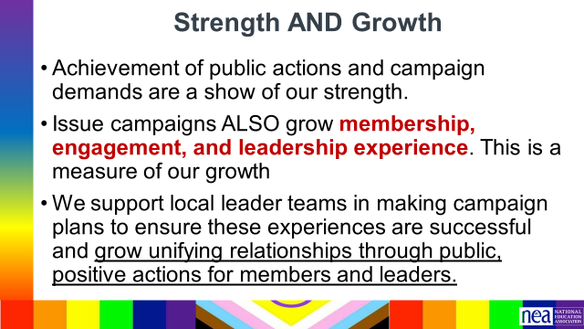  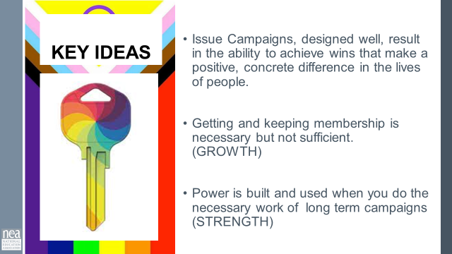 | Eric J will Scribe | 15 Minutes – DEFINING POWER (lecture)  10 minutes – Take 4 minutes at your table to write down WHO is powerful – use full names not institutions. At the end of the four minutes facilitator asks tables to report out and a large group poster is made. Ask the room what do you think these people have in common? Facilitator note - Take all ideas – affirm and lift up any ideas about getting others to act, having control of money, can enact decisions, etc. Then move to defining power and make connections from the content to the people on the list as appropriate. (ex. President Trump might relate to the content about values affecting the way power is used)  Definition of power  - Power is the ability to create, control, and prevent change.  - Power is made up of organized people and organized resources  - Power is not static, it is either growing or waning.  Understanding Power  Power is neutral. Power is simply the ability to make change. Society has biased our beliefs and feelings about who should have and how they should use power – but ultimately power is neutral – we bring all our feels and biases to that.  Our values affect the way we use power. If we are in relationship with people with a certain set of values we would find it easier to risk our resources and personal agency to advance an agenda based on our shared values. Power of the people is always grounded in our values and relationships.  Truths About Building Power  - Power has to be consistently built or it is waning  - Not everyone wants us to have power and will actively work to take our power away  - Public actions through shared vision, shared purpose, shared resources, shared risk, and unity is how we build power  - The bigger the win – the more power you need  - Building power requires leadership  5 Minutes – Defining Campaigns  Campaigns are defined as the following (From Marshall Ganz) A campaign is a process through which your constituency can organize itself to create the power it needs to accomplish goals that will achieve the change they need. And turning their campaign into an organization gives them access to the capacity to build on their successes into the future.  *Collective action.  This is how we define strength and growth.  - Achievement of a campaign demand is a show of our strength.  - Successful campaigns ALSO grow membership, engagement, and leadership experience. This is a measure of our growth  - We make campaign plans to ensure these experiences are successful and grow unifying relationships through public, positive actions for members and leaders.  Key Points  Issue Campaigns, designed well, result in the ability to achieve wins that make a positive, concrete difference in the lives of people.  Getting and keeping membership is necessary but not sufficient. (GROWTH)  Power is built and used when you do the necessary work of long term campaigns (STRENGTH) | What is the importance of campaigns  Participants will understand the purpose of using campaigns and to build both union strength and growth.
11:05-11:45 Grat |  | 40 Minutes Three Theories of Change for Organizing
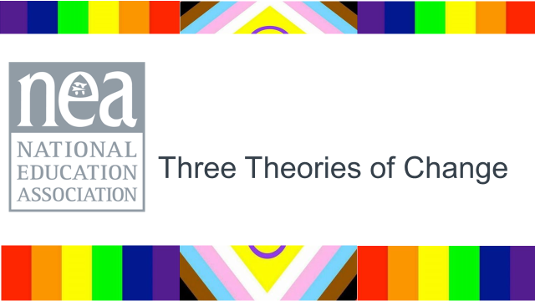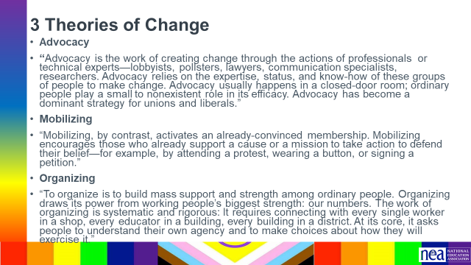  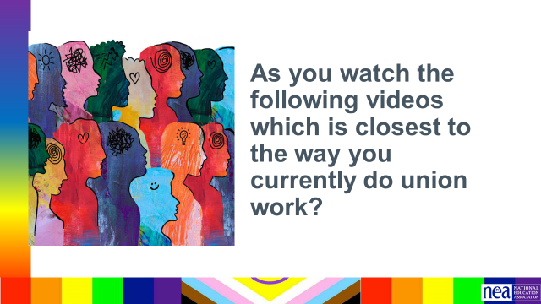  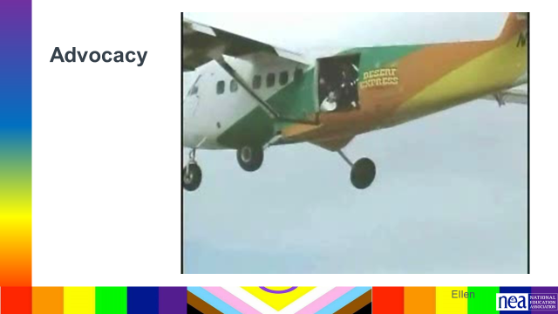    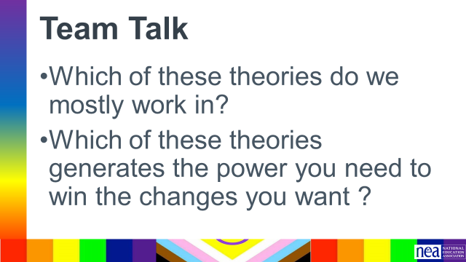  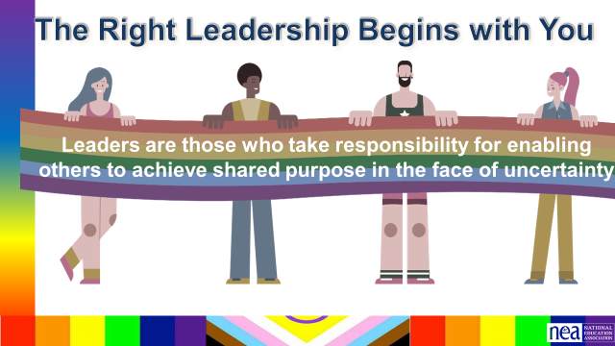  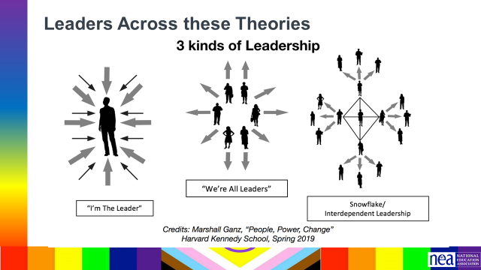  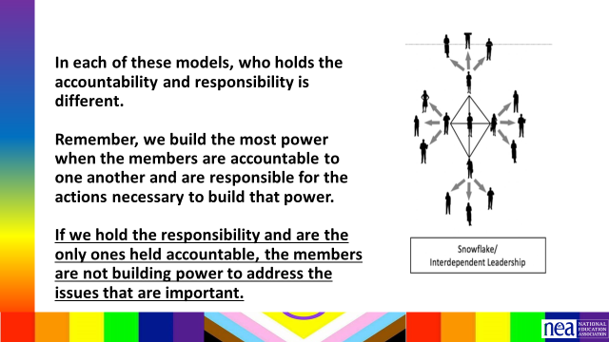  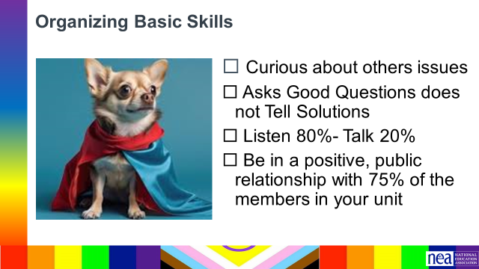  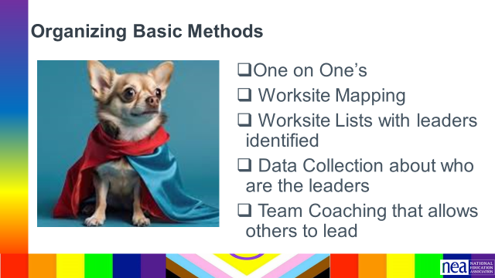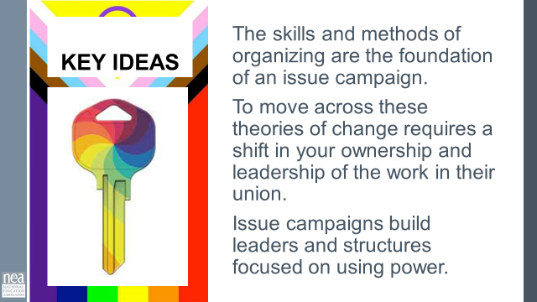 | Page 4 structure of Leaderhsip  Theory of Change Article p. 5-8 in PH | Page 5-8 in participant handout  5 Minutes Introduce - In your Pre Attendance Pack you were asked to read Three Theories of change. These theories out lined in that are - Advocacy Mobilizing Organizing. Give particpants time to Write down words/ideas that stand out in each Ad/Mob/Org - as a table team.  As you watch, which of these theories are closest to the way your union currently does its work?  10 Mins Show the three video examples  **** Facilitator NOTE TURN THE VOLUMN OFF ON THIS VIDEO *** Just say the following as the video plays  Advocacy relies on the experts and the leaders. If this is the only place we ever operate, then we teach our folks that they don’t have the power to make meaningful change in their lives. We actually prevent power from growing. WE have to be ever present to “fix” their problems.  Mobilizing is when we keep engaging with the same people who are already known to us. This does not build new leaders, it typically does not result in base building. The only power it builds is internally. It can feel like doing the same things over and over without really achievieng anything. Herding the cats with no real direction.  Organizing allows our people to publically and collectively make change. They are able to form teams and structures around common values and goals.  10 Minutes Discuss at your tables  - IN Teams  - Which of these theories do we mostly work in?  - Which of these theories generates the power you need to win the changes you want?  10 Minutes Discuss as a Whole Room  What about how your approach the work shapes your locals/  How do we move from one theory to another?  10 Minutes to Wrap up  Moving to another lane starts with you  Leaders who try to do everything for everyone set themselves up to be THE single point of power and when they leave the structure falls apart. Leaders who ONLY work with “the already willing” only continue the status quo – to grow you have to continually reach out and include others – invite them to do something not simply come to something you have developed- Leaders who are organizing are constantly making room for new people and allowing them to lead – taking in new ideas and building new work together.  In each of these models, who holds the accountability and responsibility is different.  Remember, we build the most power when the members are accountable to one another and are responsible for the actions necessary to build that power.  If we hold the responsibility and are the only ones held accountable, the members are not building power to address the issues that are important.  There some basic ideas, skills, and methods you need for this move  Basic Skills -- You need to know how to be  - Curious about others issues  - Asks Good Questions does not Tell Solutions  - Listen 80%- Talk 20%  - Be in a positive, public relationship with 75% of the members in your unit  Basic Methods to Learn to Use Consistently  - One on One’s  - Worksite Mapping  - Worksite Lists with leaders identified  - Data Collection about who are the leaders  - Team Coaching that allows others to lead  2 Minutes Key Ideas  The skills and methods of organizing are the foundation of an issue campaign.  To move across these theories of change requires a shift in your ownership and leadership of the work in their union.  Issue campaigns build leaders and structures focused on using power.  END OF SESSION 1 | What Theory of Change and Organizing framework are we using in our work?  Participants will learn a framework for Theory of Change and assess what approach they are currently taking  Participants will be introduced to the skills and methods required for leading campaigns
4/12 Session 2 1:45-3:15
1:45-2:15 Jeny |  | 30 Minutes Recognizing Leadership – in PH 9-27  NOT 30 MINUTES!!!
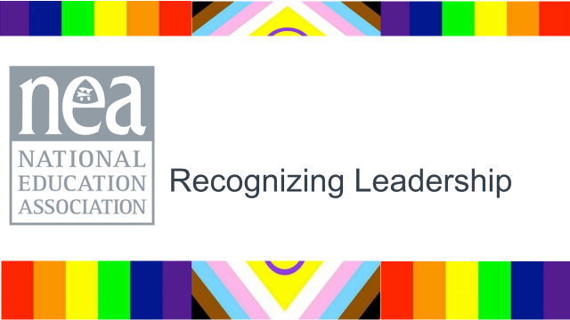  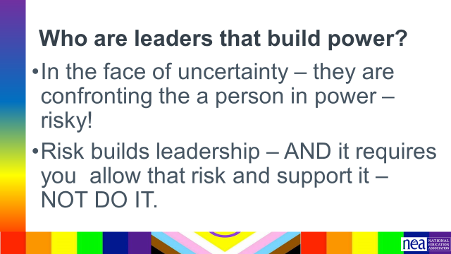  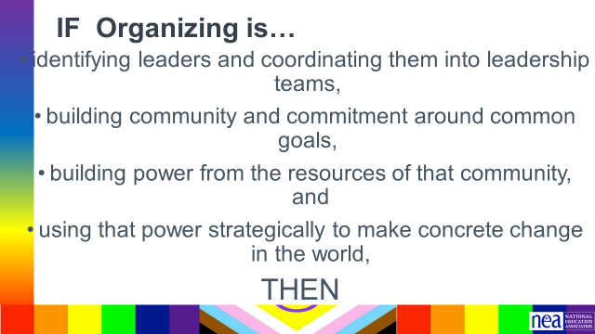  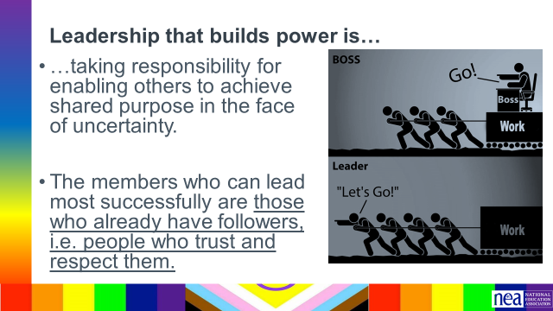  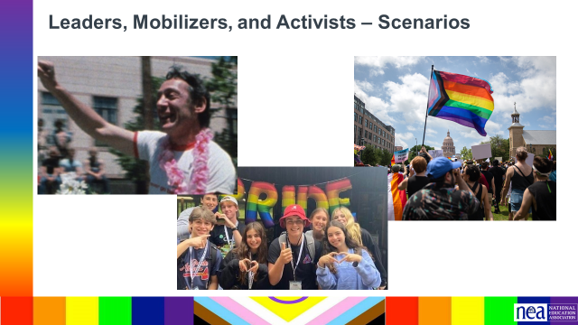  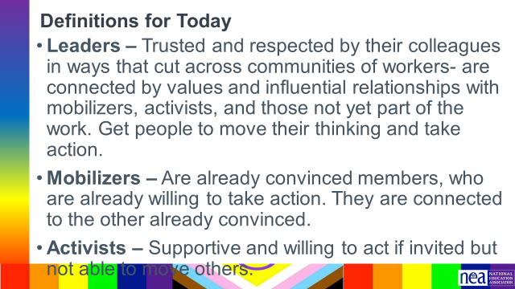  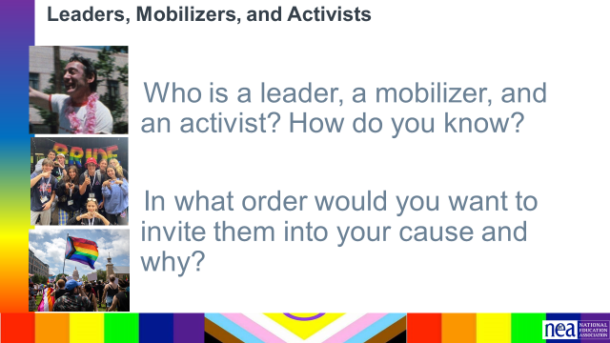  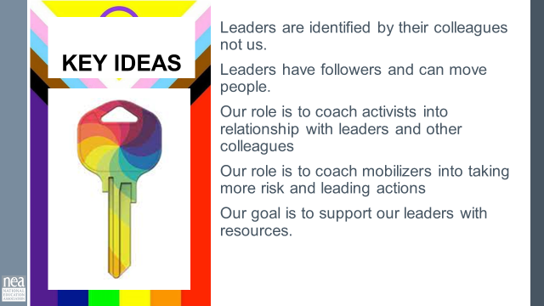 | Leaders Mobilizers Activist Scenarios  Need to be written with LGBTQ EXAMPLES | 5 Minutes Intro  Who are leaders in a campaign?  - In the face of uncertainty – they are confronting the boss – risky!  - Risk builds leadership – but it requires you to allow that risk and support it – NOT DO IT.  If organizing is –  - identifying leaders and coordinating them into leadership teams,  - building community and commitment around common goals,  - building power from the resources of that community, and  - using that power strategically to make concrete change in the world,  THEN  Leadership that builds power is  - …taking responsibility for enabling others to achieve shared purpose in the face of uncertainty.  - The members who can lead most successfully are those who already have followers, i.e. people who trust and respect them.  35 Minutes Leaders, Mobilizers, and Activists – Scenarios  5 Minutes Introduction – We are going to spend some time looking at some scenario descriptions of people that are part of your constituency. You are going to work in teams (3 Teams). Each Team is going to decide who in these stories are Leaders, Mobilizers, or Activists.  When doing this without giving it as a pre-read it might make it go faster if we read through the scenario as a group?  Like one paragraph on each slide and have a participant read it out.  We are going to use the following definitions  - Leaders – Trusted and respected by their colleagues in ways that cut across communities of workers- are connected by values and influential relationships with mobilizers, activists, and those not yet part of the work. Get people to move their thinking and take action.  - Mobilizers – Are already convinced members, who are already willing to take action. They are connected to the other already convinced.  - Activists – Supportive and willing to act if invited but not able to move others.  4 Minutes Let’s get into our groups (3 groups) and make sure you have pages 26-27 in PH with you (don’t use p. 24-25).  15 Minutes – Now that you are in your groups you are going to take the next 15 minutes to decide who is who – AND you need to decide the order in which you would invite them to be part of the work of your constituency. YOU MUST reach consensus.  15 Minutes Report Out– Let’s hear want your teams decided – there is only one right answer. Facilitator note get them to be in discussion with each other. One technique is to ask for a person to share how they ID’d one person. Then ask the room who had the same ID. GO BACK To the first person and ask with the group decided this. Then go to the person who had a different ID and ask why. And so on. The key ideas you are pulling out is who is BOTH trusted and respected, and who ACTUALLY MOVED PEOPLE to do something. What is the evidence of these. It is not about who is liked – or even has the potential – it is who is DOING it.  FACILITATOR KEY  Ted – Activist  Tina- Activist  Destiny – Leader  Paul- Mobilizer  Jorge- Activist  5 Minutes Key Ideas –  - Leaders are identified by their colleagues not us.  - Leaders have followers and can move people.  - Our role is to coach activists into relationship with leaders and other colleagues  - Our role is to coach mobilizers into taking more risk and leading actions  - Our goal is to support our leaders with resources. | Participants will use a scenario to identify leadership.  They will use the terms activist, mobilizer, and leader.  Participants will assess the leadership in their locals.
2:15-3:00 Eric Jones |  | 45 Minutes – Assessing Our Structure
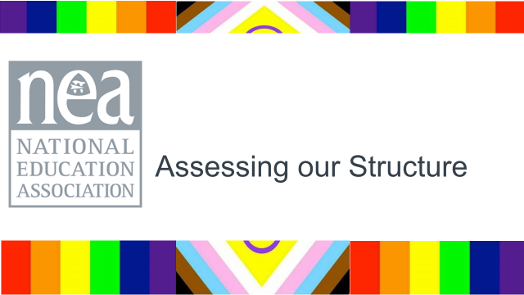  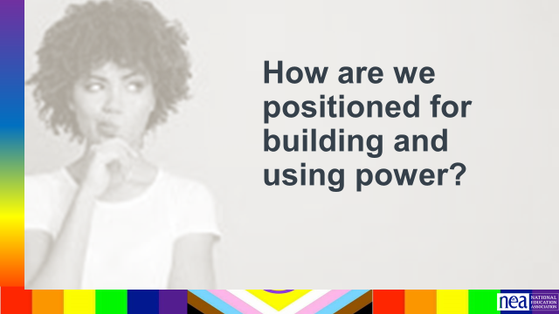  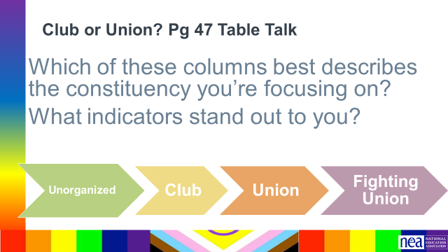  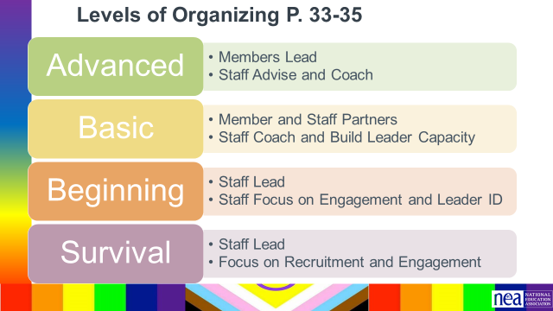  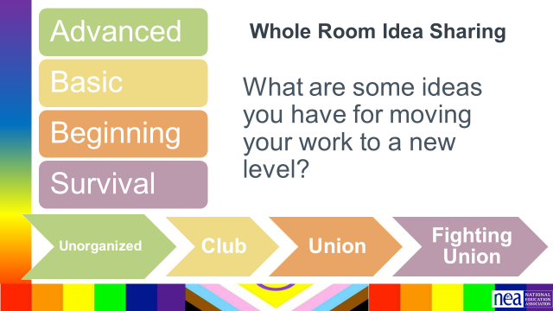 | Club to Fighting Union  Levels of Organizing Complete  Levels of Organizing Planning | 1 Minutes Into - If organizing is about leaders and teams connected around shared values and purpose - that can pool its resources for change, we need to have a good handle on how they are currently operating so that we can adjust our work with them to grow their capacity. We are going to look at two frameworks – Club or Fighting Union P. 28 and Levels of Organizing p. 29-31., you will need these.  15 Minutes Group Work -. Use your local and assess which level it is operating at on the Club to fighting union scale. As your table finishes, discuss what you have assessed and why.  1 Minutes – Intro – now you are going to switch your focus a little bit and used the framework found on pages 29-31.  15 Minutes Group Work –Review the Levels of Organizing found on page 29-31. Think on your current work with your targeted constituency. What level of organizing are you working at with them? As your table finishes, discuss what you have assessed and why.  10 Minutes Whole Room Talk – Share strategies for moving the work from staff led to member led to advance your organizing.  2 Minute - Key Point:  Clubs are fixed, are not growing, and do not have enough resources to achieve the wins they want or to move the community to act.  The best way to transform a community into a constituency is to listen for the shared issues and values in order to invite them to take action for a shared purpose.  When WE do the work, lead the work, make the change happen – we take the opportunity for growth away from a leader. | Participants will be able to assess and plan their work through two frameworks. They will understand that Organizing across affiliates looks differently, but advanced organizing has similar characteristics, regardless of where you are.
3:00-3:15 Eric Simmons |  | 15 Minutes - Building a Campaign Overview
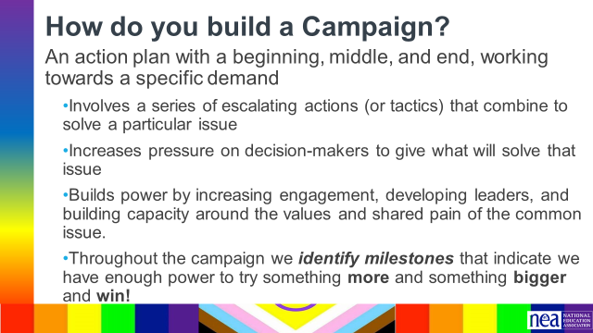  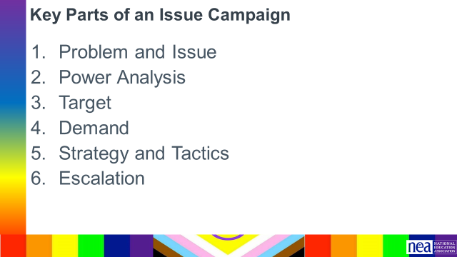  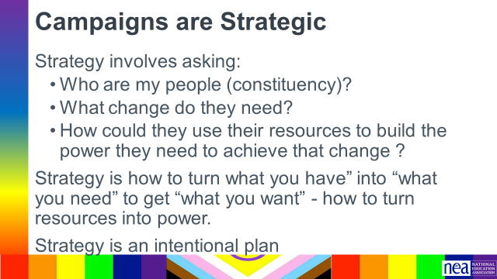  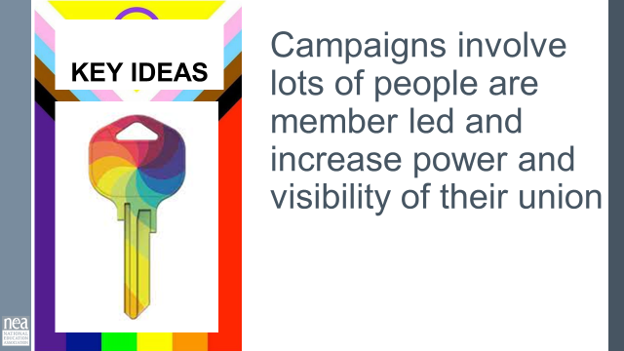 | Campaign plan outline- Pg. 90 | We are going to do a quick little overview of the parts of a well-designed campaign. This is the structure that will set us up for the following sessions with you.  Campaign plans, at their core, are simple. They should all have:  - An action plan with a beginning, middle, and end, working towards a specific demand  - Involves a series of escalating actions (or tactics) that combine to solve a particular issue (each tactic builds upon the last to increase engagement and visibility)  - Increases pressure on decision-makers to give what will solve that issue  - Builds power by increasing engagement, developing leaders, and building capacity around the values and shared pain of the common issue. (this is where we rally our people!)  - Throughout the campaign we identify milestones that indicate we have enough power to try something more and something bigger and win!  Remind folks: Part of our work as leaders is to check in, look back and reflect. Benchmarks are a way to do that. Did we hit our benchmark? Is our strategy working? Are the current tactics we are using getting us to where we want to be? Are they building power? Are they moving the target? Do we need to pivot? Are we increasing our base?  Building a culture into our work and our plans of debrief/reflection and being nimble to adjust as needed helps keep us honest. Remember, the numbers tell us a story and checking them is important.  Key Parts of Issue Campaign, pg. 91 in PH—There are six main parts to building a campaign. We are going to go through step 1 and some of step 2 today.  - Problem and Issue - The problem and issue is the spark! Why we are coming together, why we want a certain win etc.  - Power Analysis – What power do the decision makers have? Who has power over them? What power do we have?  - Target- Who has the power to make a change? Who is the PERSON who can make the change.  - Demand - What needs to be changed? By when? By who?  - Strategy and Tactics -How will we get our demands met? Who needs to be in the fight?  - Escalation-Always plan to escalate. What happens when the target says no? Or doesn’t respond?  Campaigns are Strategic 3.2 Strategy and Tactics pg 103 in PH– Expanded Content on the parts of a winning campaign and a focus on strategy  Strategy involves asking:  - Who are my people (constituency)?  - What change do they need?  - How could they use their resources to build the power they need to achieve that change?  Strategy is how to turn what you have” into “what you need” to get “what you want” - how to turn resources into power.  Strategy is an intentional plan  KEY POINTS- Campaigns involve a large diverse group of people, are member led, and increase power and visibility of the union. Remember our focus here today; moving from the club to fighting union. And that starts with you.  END OF SESSION 2 | How do you build a campaign?  Participants will understand the critical pieces of a campaign plan structure.
4/12 Session 3 3:30 –5:00

3:30-4:00 Salina |  | 30 Mins – Centering Race, Class, Gender in Your Campaign
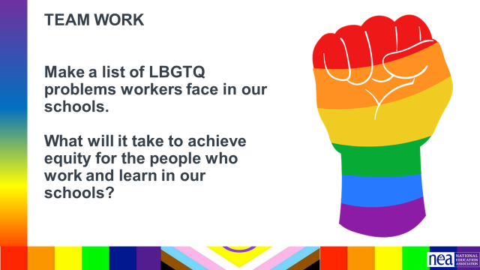  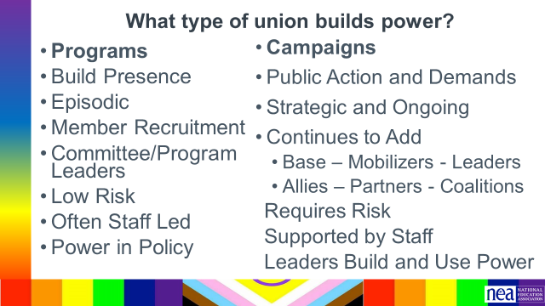  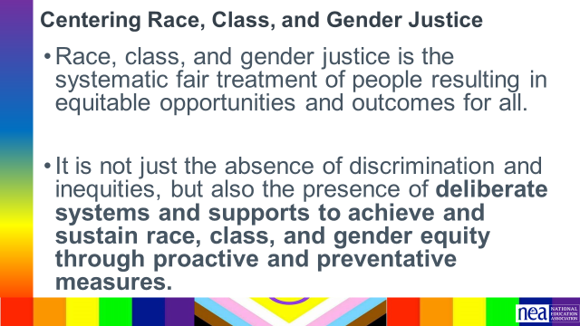  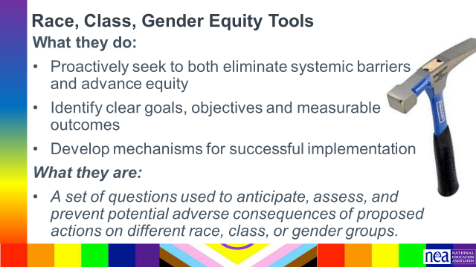  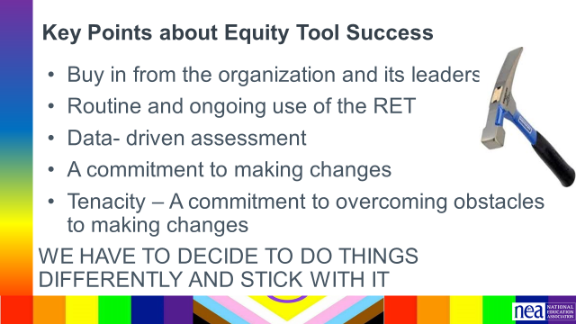  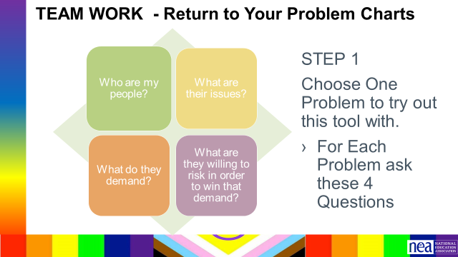  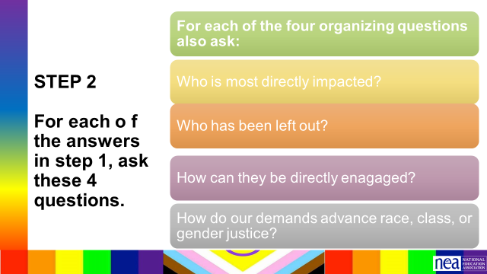  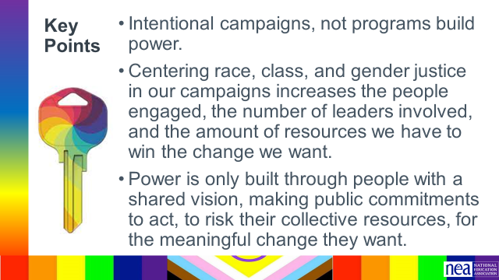 | Charts for problems  Equity Analysis  Equity Assessment  CRSJ BCG Centering Race Guide | Intro – Make a chart  10 Minutes – Chart in teams:  What are the big problems that “your People” want fixed think about your “BIG Ideas” we did earlier today.  Generate a list – 10 minutes  Set aside these charts for now; we will revisit after we go through some content.  2 Minutes Turn and talk - Consider the following question – what will it take to achieve equity for the people who work and learn on locals?  Report out - Take about three ideas from the room.  2 minutes – Union Work that Builds Power  For all of those things, to make meaningful lasting STRUCTURAL change we need power. Power is defined as that ability to create, control, and prevent change. That typically means organized people and organized money or resources – your work is a resource.  How does a union build and transform their power?  Programs tend to be exclusive and exclusionary. They only allow a certain number and/or type of person. Campaigns seek to include as many people as possible.  Programs, such as professional learning, staff led advocacy, social focused events, even policy advocacy do little to build power. Why is that? Well all of these programs are self-selected with little risk to join or leave them. I want to improve my classroom management, so I come to the Union led training on that. I might even lead one – but I have done little to build power with others. Also in a program, I am choosing to solve a “me” Problem and it does not require any other collective commitment.  Campaigns put people at the center of solving the problems they are experiencing. They name the issue, they decide the solution, they decide who they follow, and they determine what they are willing to risk. When we center people in a campaign – staff move to a coaching role. When people are at the center they use their agency and decide how to act, who they will act with, and what they are willing to risk to win. This is when members and leaders feel powerful in their union.  To begin a campaign you have to ask what the people want to solve, ask what they are willing to risk to solve that, and form demands that they think will provided the solution to their problem.  2 mins - What does it mean to center racial, class and gender justice? P. 40 in PH  Race, class and gender dynamics, disparities, and divisions permeate our society, communities, schools, and classrooms. Systemic oppression is so deeply rooted in our history, culture, and institutions that there is no escaping it. Visible or not, the impacts are ever-present. Race, class, and gender justice is the systematic fair treatment of people of all races, resulting in equitable opportunities and outcomes for all. It is not just the absence of discrimination and inequities, but also the presence of deliberate systems and supports to achieve and sustain race, class, and gender equity through proactive and preventative measures.  To continually and systematically keep equity in your work you have to use a Race, Class, and Gender Equity tool (p. 40 & p.41-43), or lens. This is a person and institutional commitment to  - Proactively seek to both eliminate systemic barriers and advance equity  - Identify clear goals, objectives and measurable equity outcomes  - Develop mechanisms for successful implementation of equity focused programs  - A set of questions used to anticipate, assess, and prevent potential adverse consequences of proposed actions on different race, class, or gender groups.  10 Minutes – TEAM WORK – Return to Problem Charts  Step 1  Looking at your PROBLEM CHARTS – consider the c4 Organizing Questions for at least one of your problems - Who are my people? What are their issues?What do they Demand? What are they willing to risk to achieve that demand?  Step 2- Apply the following Equity Tool:  Who is most directly impacted?  Who has been left out?  How can they be directly engaged?  How doess this demand advance race, class, or gender justice?  2 Minutes Key Points-  - Intentional campaigns, not programs build power.  - Centering race, class, and gender justice in our campaigns increases the people engaged, the number of leaders involved, and the amount of resources we have to win the change we want.  - Power is only built through people with a shared vision, making public commitments to act, to risk their collective resources, for the meaningful change they want.  - If your campaign is not designed from the beginning to include those with the least amount of power, the least amount of privilege, the least amount of resources – there is no way to retool a campaign to include them. | Participants will understand how intentionally asking race and equity questions at every point of a campaign helps to center race, class, and gender in campaigns.
4:00-4:30 Grat |  | 30 Minutes TOTAL – Problem and Issue
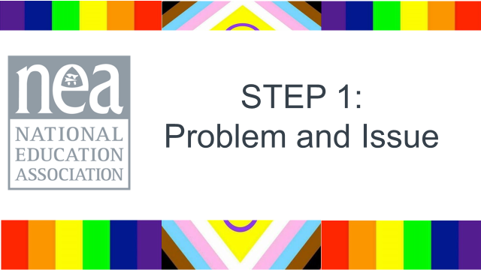  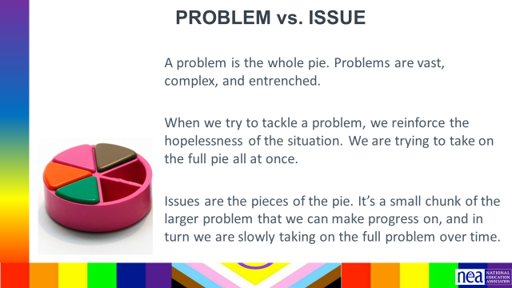  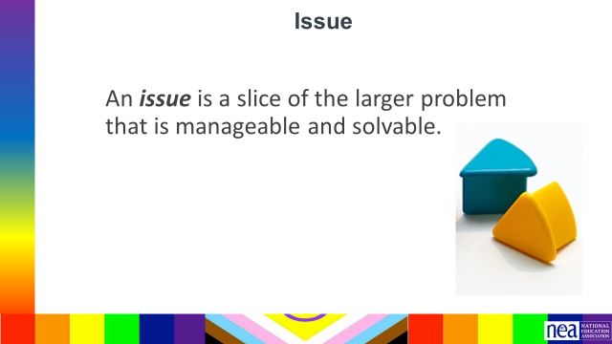  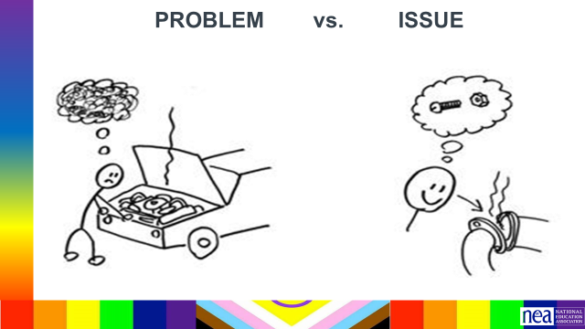  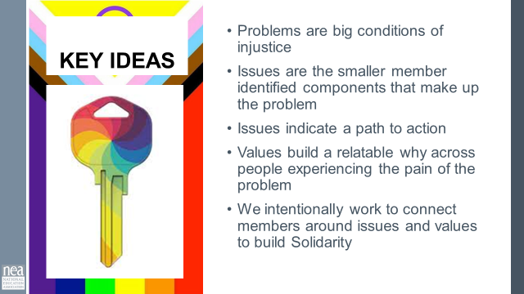  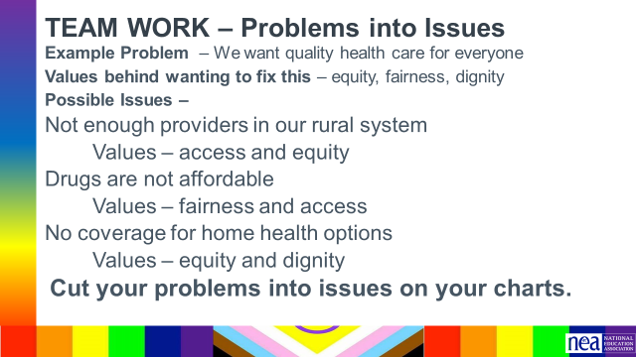  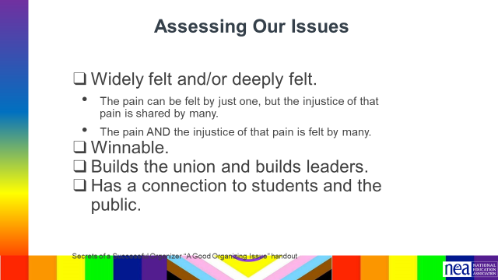  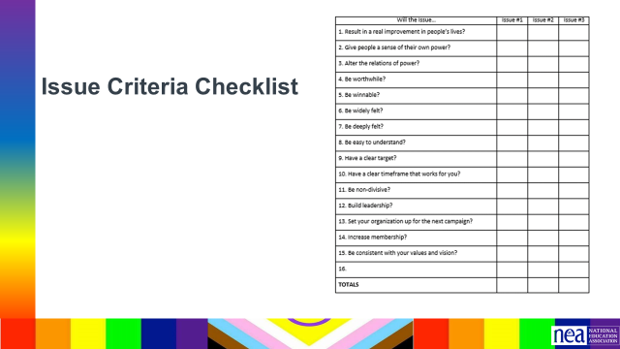 |  | 5 Minutes PROBLEM , ISSUES - p. 93 in PH  - Campaigns start with issues that people have value-based solidarity around.  - An issue is a slice of a workplace problem.  - Often a problem can have different issues depending on the perspective of the people we are working with.  - It is KEY to get enough input on what the issues are that make up the problem so that YOU do not drive the solution.  - Investigating the issue is necessary but not sufficient – we also need to identify workers’ SHARED values – WHY is this an issue? WHY do you want to fix this?  For example, A problem My Car is a piece of JUNK --- Issues – broken radiator hose, bad brakes, smelly interior, hole in the muffler.  Key Ideas  Problems are big conditions that have several smaller solutions  - Issues are the components that make up the problem  - Issues indicate a path to action  - Values build a relatable why across people experiencing the pain of the problem  - We intentionally work to connect people around issues and values to build Solidarity  10 Minutes - Cutting our Problems into Issues  Using the charts you made as we started pick one of your big problems and think about the issues that might be built into that.  Example Problem – We want quality health care for everyone  Values behind wanting to fix this – equity, fairness, dignity  Possible Issues –  Not enough providers in our rural system  Retiree benefits don’t cover specialists  Drugs are not sourced in ways that make them affordable  No coverage for home health options  Cut your problems into issues on your charts.  10 Minutes -Assessing Our Issues - p. 94-95  2-3 minutes on content, 10 minutes on group work - 2-3 minutes on report out.  So how can we determine – assess what issues make the best organizing issues. We can work them through a couple of processes. Using these processes with them keeps us from taking over and allows for leadership development opportunities. They build their confidence and trust and solidarity through a shared process.  At the very least a good issue  - It is widely felt and/or deeply felt.  - The pain can be felt by just one, but the injustice of that pain is shared by many.  - The pain AND the injustice of that pain is felt by many.  - It is winnable.  - It builds their union and builds leaders.  - It has a values-based connection to our workers, students, and the public.  Using the issues you charted at the beginning of this section about issues – Spend just a few minutes using the simplified screener from Labor Notes – and see how it would allow you to screen out issues that might not be good for Organizing.  5 Minutes Report out - what did you find? (if it doesn’t come out, reemphasize the earlier Key Point – Not every issue is an organizing issue) | Why are problem and issue something we need to know? 4  Participants will differentiate between problems and issues, and evaluate issues as being well connected to values and the community, deeply and widely felt, and winnable.
4:30-5:00 Albert/Eric J. |  | 30 Mins TOTAL– Power Analysis and Spectrum of Allies
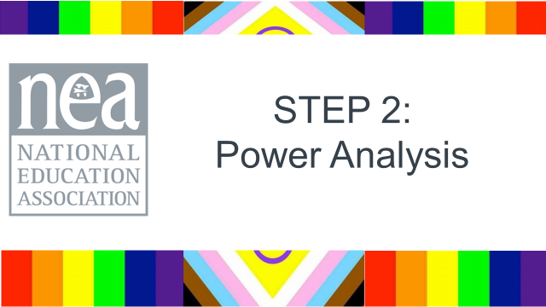  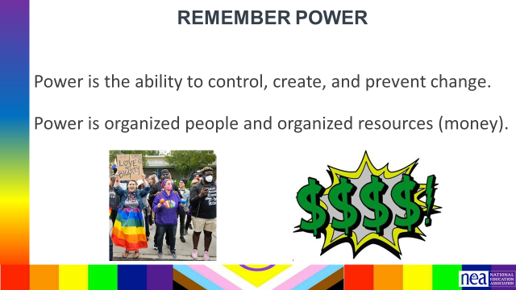  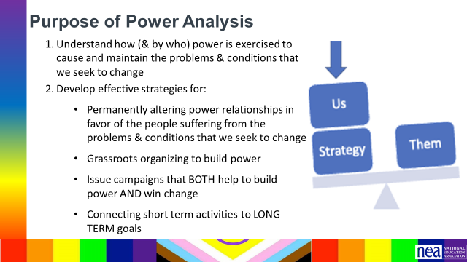  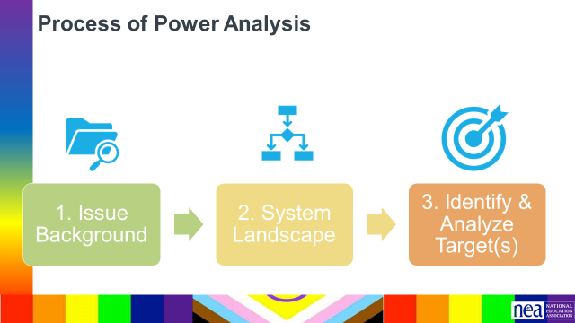  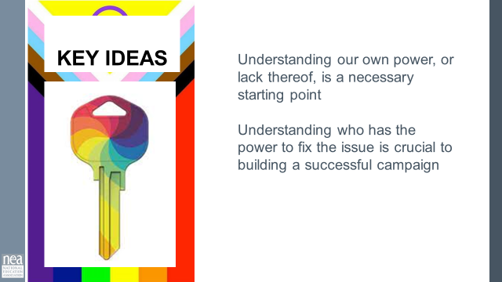  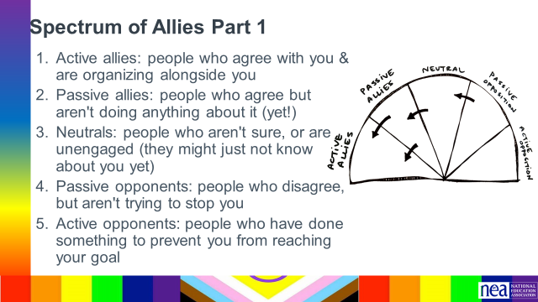  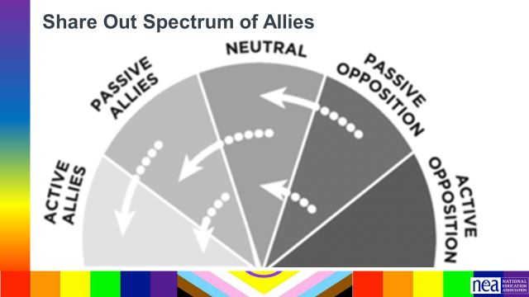  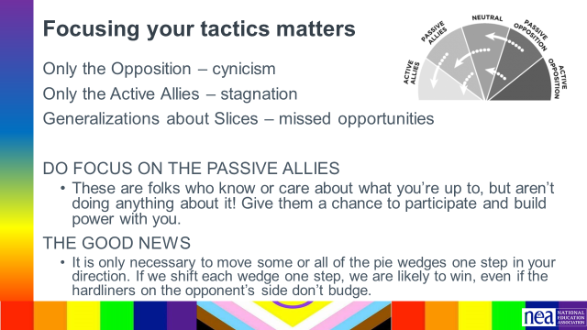  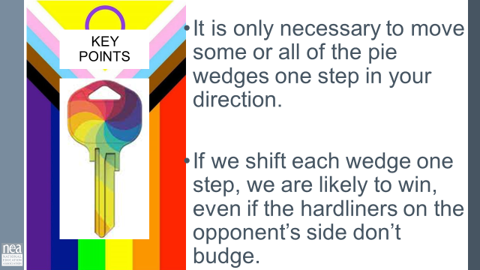 | Chart Paper Teams work to make their own spectrum of allies  ADD POWER ANALYSIS PROCESS TO HANDOUTS  ADD SPECTRUM OF ALLIES TO HANODUTS | Power analysis content – 5 minutes of lecture  Once you’ve identified the Problem and Issue, we need to do a power analysis.  REMEMBER what power is (share slide)  Purpose of Power Analysis  Power analysis is a systematic approach to understanding our own power and the power of our allies and opponents on the issue that we have identified. Doing a power analysis allows us to understand how and by whom power is being exercised to cause and maintain the problems and conditions that we seek to change. This allows us to identify and understand the decision maker who can give us what we want and to develop effective strategies for:  - Permanently altering power relationships in favor of our communities & the conditions that we seek to change  - Grassroots organizing to build power  - Developing Issue campaigns that BOTH help to build power AND win change  - Connecting short term activities to LONG TERM goals  Process of Power Analysis  Now that you’ve identified issues you need to look at three areas as part of your power analysis. We are going to do a deep dive into one part of Step 1 looking at allies and opponents, but know that after this, you have to complete the full analysis to implement a successful campaign the other two steps must be done.  Power Analysis Part 1: Issue Background  Once we’ve identified an issue, what might we need to find out about it in order to build an effective campaign?  - What is the history and current status of the issue?  - What are the competing agendas or positions on the issue?  - What are the narratives surrounding the issue?  - Who are allies on the issue? Who are opponents on the issue? ( We are doing a deep dive on this)  Power Analysis Part 2: System Landscape  Next step is researching the system landscape. The two main questions are:  - What are the decision making processes on this issue?  - Who is involved in each step of the decision making process?  Power Analysis Part 3: Identify and Analyze the Target(s)  l move into Part 3 of the Power Analysis, identifying and analyzing the Target(s). We will do a deeper dive into this analysis today.  Key Ideas  Understanding our own power, or lack thereof, is a necessary starting point.  Understanding who has the power to fix the issue is crucial to building a successful campaign.  Spectrum of Allies (Activity Set up and work 20 minutes)  p.33 in PH  Let’s do that deep dive into step 1 of the power analysis that includes a look at the spectrum of folks that support or oppose the change you want to make.  5 Minutes Set up for teams to create their spectrum (not to fill in- just make the outlines of the 5 pieces of pie.  15 Minutes Work - We are going to begin by learning a method Called Spectrum of Allies. All of our campaigns CAN include a wide range of groups, but particularly in the campaigns we are thinking about that you will be part of, you MUST include others outside of your constituency.  These include a wide range of groups that can be put on a kind of spectrum, from those closest to the point of view of the advocates to those who actively oppose change. Draw a horizontal line to represent that. Those who advocate change are represented by a point at one end of the line (say, on the left), and the opponents by a point at the other end.  Draw a semicircle with wedges. The wedges closest to either end are the active allies and opponents, next in are passive allies. The group in the middle are neutral.  Use the issue that your group identified.  Begin by asking, who might be inclined to be most supportive, least supportive, or neutral. Some examples of groups: ‘unions?’, ‘poor people’s groups?’, ‘business community?’. In your teams, identify these (AND WHY) and put them on your spectrum on the spectrum, and write them into the ‘pie’. Be as specific as possible – names, make them up to match the vignettes you are working with. Identify why people are placed where you placed them.  5 Minutes Whole Group Share – Do a little share out – as the facilitator, focus on the sharing of why the teams placed certain people in certain places.  5 Minutes of Content – Where do you focus your tactics?  Focusing only on the opposition leads to becoming disheartened or cynical, which means you ignore potential allies and support. Focusing only on how to convince the important power-holder who is against you leads to ignoring all of the potential support you could build that could overpower her opposition  Focusing only on active allies leads to being an isolated interest-group, which also means you ignore potential allies and support Always doing events with the same group of individuals or organizations isolates you from creative, powerful community-building that can arise from new alliances and partnerships. Generalizing about whole groups of people risks misunderstanding the nuances of communities If you think about "students" as an entire group, you ignore the huge number of different groups & organizations (potential allies!) that exist in a student community  DO focus on passive allies. These are folks who know or care  about what you’re up to, but aren’t doing anything about it! Give them a chance to participate and build power with you.  Good news, In most social change campaigns, it is not necessary to win the opponent to your point of view, even if the powerholders are the opponent. It is only necessary to move some or all of the pie wedges one step in your direction. If we shift each wedge one step, we are likely to win, even if the hardliners on the opponent’s side don’t budge.  1 Minutes – Key Points  - It is only necessary to move some or all of the pie wedges one step in your direction.  If we shift each wedge one step, we are likely to win, even if the hardliners on the opponent’s side don’t budge. | Participants will apply the Spectrum of Allies method to map focused tactics, narratives, and asks designed to move people toward their overall goal of the campaign.
 |  | CLOSING
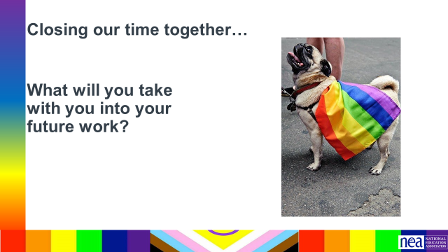

 |  | EXTRA CONTENT THAT WE DON’T HAVE TIME FOR
2:30-3:30 |  | 60 Minutes – 1:1 Conversations
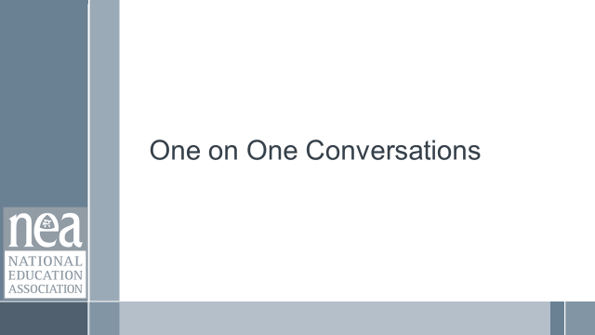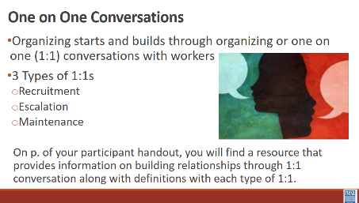  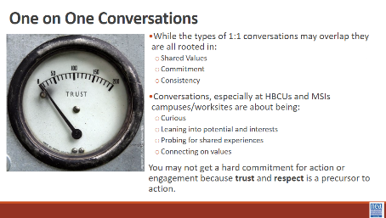  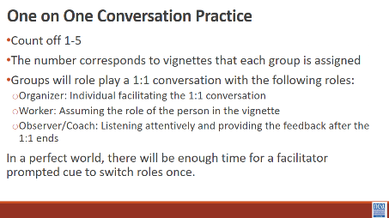  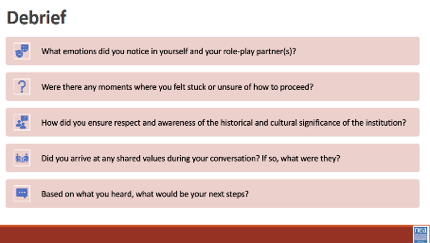  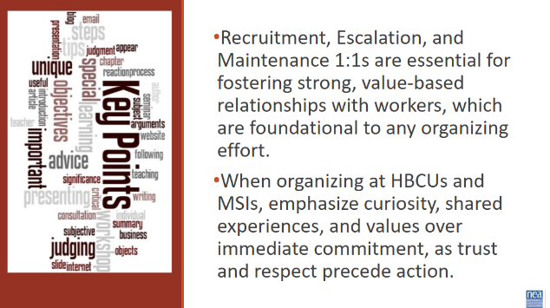 | Handout: Building Relationships  Handout: Vignettes | 10 minutes – Review Types of 1:1s  The beginning of any organizing starts and builds through organizing or 1:1 conversations with workers. On p. of your participant handout, you will find a resource that provides information on building relationships through 1:1 conversation along with definitions with each type of 1:1.  The 3 types of 1:1s we will frame our thinking around are:  - Recruitment  - Escalation  - Maintenance  These 1:1s sometimes overlap but the root of this is a relationship with shared values, commitment, and consistency. Take recruitment 1:1s for instance...when we think of this type of 1:1 you may think of recruiting individuals to join their union or commit to some task, activity, or role.  While this should be our focus widely, it is especially important on higher campuses that you frame a recruitment 1:1 on being curious and leaning into potential and interests, probing for a shared experience (in a respectful way, not an interrogation), and connecting on values. You may not get a hard commitment for action or engagement because trust and respect are a precursor to action.  5 minutes – Activity Set Up  You will count off participants 1-5 (may be modified based on the number of individuals who are present). The number corresponds to vignettes that each group will be assigned. Individuals with the same number will be split into smaller groups of 3 or 4. Groups will role play a 1:1 conversation with the following roles:  - Organizer: Individual facilitating the 1:1 conversation  - Worker: Assuming the role of the person in the vignette  - Observer/Coach: Listening attentively and providing the feedback after the 1:1 ends  Perfect scenario:  15 minutes – Round 1 of 1:1 conversation  2 minutes – Mini-Debrief/Coaching  15 minutes – Round 2 of 1:1 conversation  2 minutes – Mini-Debrief/Coaching  35 minutes – 1:1 Practice  8 minutes – Debrief  Structured debrief using the following questions as a guide:  - What emotions did you notice in yourself and your role-play partner(s)?  - Were there any moments where you felt stuck or unsure of how to proceed?  - How did you ensure respect and awareness of the historical and cultural significance of the institution?  - Did you arrive at any shared values during your conversation? If so, what were they?  - Based on what you heard, what would be your next steps?  2 minutes – Key Points  - Recruitment, Escalation, and Maintenance 1:1s are essential for fostering strong, value-based relationships with workers, which are foundational to any organizing effort.  - When organizing at HBCUs and MSIs, emphasize curiosity, shared experiences, and values over immediate commitment, as trust and respect precede action. | Participants will practice the methods and skills of asking curious questions in 1:1s and apply those in identifying shared interests and values.
9:35-10:35 |  | 60 Minutes – Assessing Our Readiness to Center Social Justice
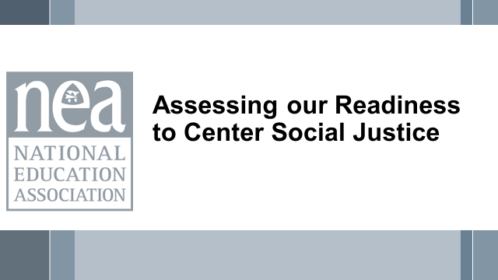  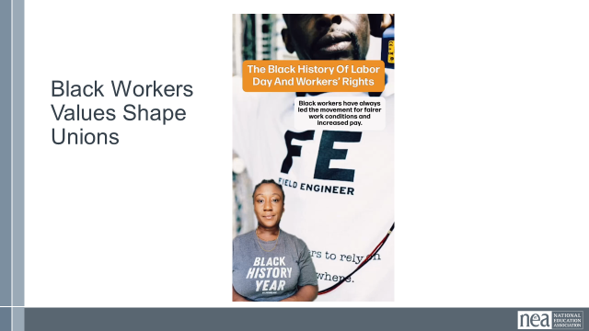  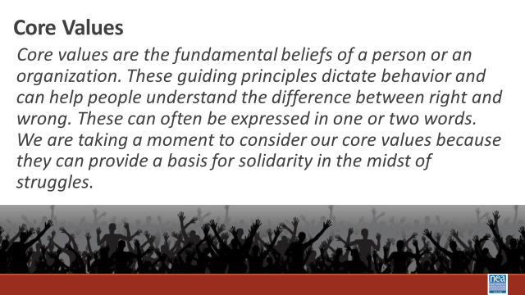  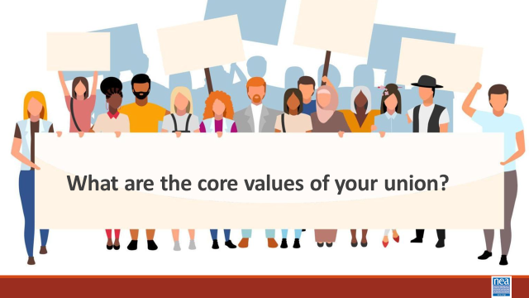  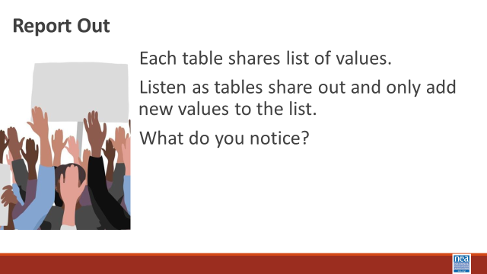  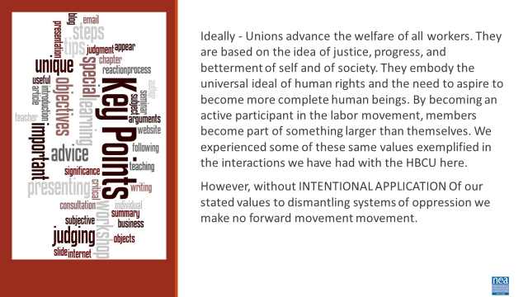  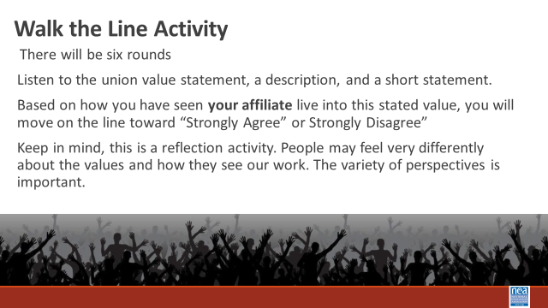  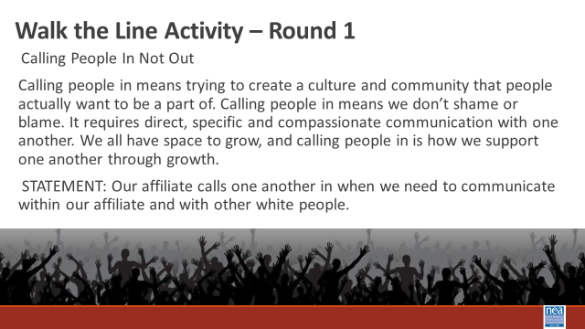  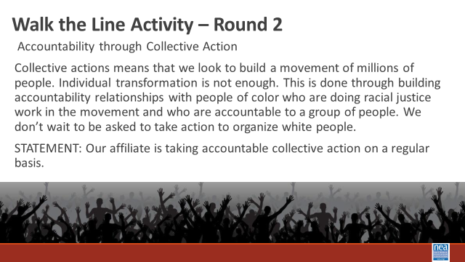  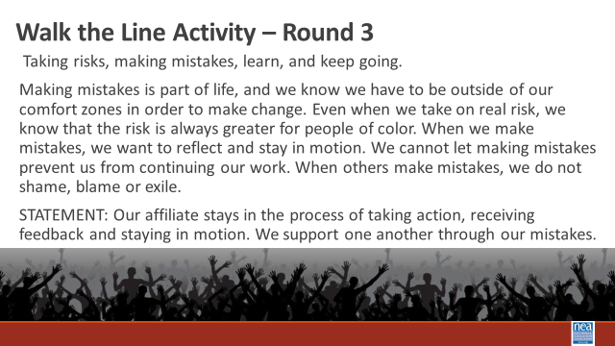  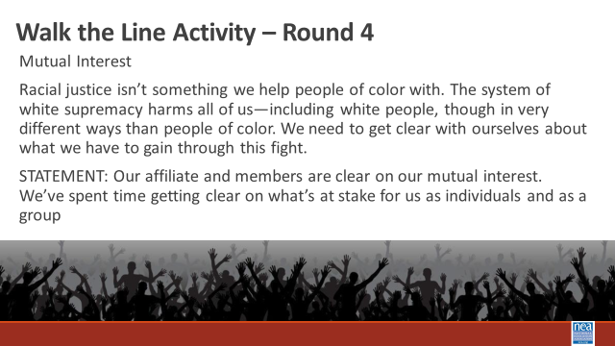  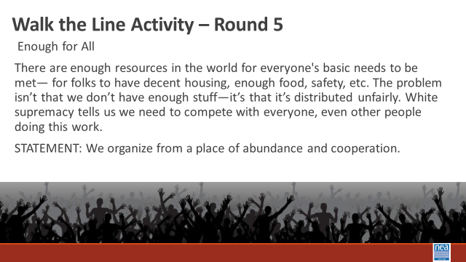  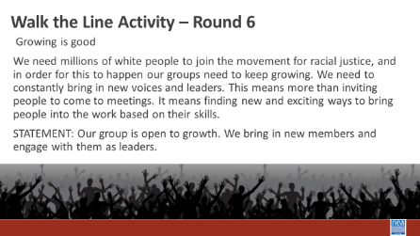  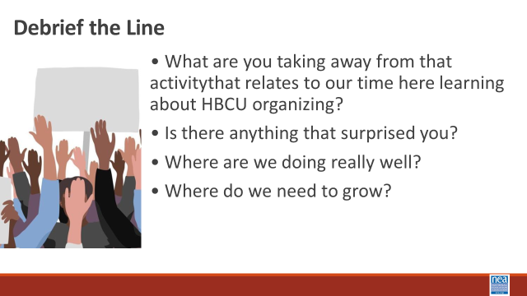  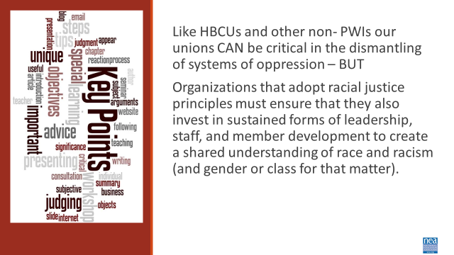 | Article  Unions Must Reckon Anti-Blackness  Organizing Must Change | 15 Minutes Introduction and Core value Brainstorm for Unionism -  Introduction – 4 Minutes There is a module in your course on Unionism w and some resources in your handouts on pages 194-205 we are going to begin thinking about how values shape our unions. Let’s look at how the values held by black workers shaped the history of unionism.  Show Video (2 Minutes)  We like to think that Unions have always been about equity and fairness. Truth is, Women and formerly enslaved black people were excluded from unions. Black teachers founded Colored Teachers Associations CTAs to enhance educational opportunities for Black children, to develop themselves as professionals, political actors, and intellectuals, as well as to organize around broader socio-political concerns in the Black Freedom Movement. Today – it is more important than ever for our work in our unions to be rooted in anti-racism. Unionism is a collection of core values. Core values are the fundamental beliefs of a person or an organization. These guiding principles dictate behavior and can help people understand the difference between right and wrong. These can often be expressed in one or two words. We are taking a moment to consider our core values because they can provide a basis for solidarity in the midst of struggles.  At your tables, brainstorm what you think are CORE union values of your union (turn and talk at your table and list those – be ready to report out). Use the file in Participant Handouts to record your . in your participant handout to record them.  Report out by asking each table to report their list – record those (chart them) – as you go to each table ask them to only add not repeat. Some examples you would expect to see – keep them to one or two words.  Fairness, honesty/integrity, responsibility, compassion/empathy, safety, health, generosity, hard work/responsibility, community, freedom, democracy, binding contracts, equality, opportunity, respect, stability/security, unity, quality work, justice, collective action, dignity/respect, charity/community service, and due process.  5 Minutes -Whole room discussion – How did you see these values exemplified in your time with our HBCU?  Key idea for this introduction and brainstorm activity (2 Minutes)  (don’t read this out loud- ask them to read it for themselves) Ideally - Unions advance the welfare of all workers. They are based on the idea of justice, progress, and betterment of self and of society. They embody the universal ideal of human rights and the need to aspire to become more complete human beings. By becoming an active participant in the labor movement, members become part of something larger than themselves. We experienced some of these same values exemplified in the interactions we have had with the HBCU here. However, without INTENTIONAL APPLICATION of our stated values to dismantling systems of oppression we make no forward movement.  40 Minutes TOTAL- Union Values Walk the Line Activity  (Set Up) Take into consideration that this activity will require standing for an extended period, moving in a small space and some reading. Mark a line on the floor of the room with string or tape. Note that this line needs to be long enough for all of the participants to have space on it. On one side of the line, post a sign that reads “Strongly Agree,” and on the other, post a sign that reads “Strongly Disagree.”  Directions to Give- 2 Minutes  This activity gives us a chance to check and see how our Core Union Values we just discussed, and the Core Values we saw exemplified in our time with the HBCU relates to the values of unionism where we work, in our affiliate. When we intentionally add values that center anti-oppression in our work – Race Class and Gender are systemic forms of oppression that we are socialized to normalize in our work. I am going to read some common Union value statements out loud with a short description. After the description, I will read a simple statement. Once I read the statement, please move and stand on the spectrum of agree/disagree based on your opinion and what you have seen your affiliate do. Keep in mind, this is a reflection activity. People may feel very differently about the values and how they see our work. The variety of perspectives is important.  For each round, (there are 6) Read the description of a value and the statement that follows it. Repeat the statement twice. Then ask people to move. Intentionally call on people, just two or three for each statement, to share why they choose to stand where they did.  Walk the Line Activity 20 Minutes (About 3 minutes per round)  Round 1  Calling People In Not Out  Calling people in means trying to create a culture and community that people actually want to be a part of. Calling people in means we don’t shame or blame. It requires direct, specific and compassionate communication with one another. We all have space to grow, and calling people in is how we support one another through growth.  STATEMENT: Our affiliate calls one another in when we need to communicate within our affiliate and with other white people.  Round 2  Accountability through Collective Action  Collective actions means that we look to build a movement of millions of people. Individual transformation is not enough. This is done through building accountability relationships with people of color who are doing racial justice work in the movement and who are accountable to a group of people. We don’t wait to be asked to take action to organize white people.  STATEMENT: Our affiliate is taking accountable collective action on a regular basis.  Round 3  Taking risks, making mistakes, learn, and keep going.  Making mistakes is part of life, and we know we have to be outside of our comfort zones in order to make change. Even when we take on real risk, we know that the risk is always greater for people of color. When we make mistakes, we want to reflect and stay in motion. We cannot let making mistakes prevent us from continuing our work. When others make mistakes, we do not shame, blame or exile.  STATEMENT: Our affiliate stays in the process of taking action, receiving feedback and staying in motion. We support one another through our mistakes.  Round 4  Mutual Interest  Racial justice isn’t something we help people of color with. The system of white supremacy harms all of us—including white people, though in very different ways than people of color. We need to get clear with ourselves about what we have to gain through this fight.  STATEMENT: Our affiliate and members are clear on our mutual interest. We’ve spent time getting clear on what’s at stake for us as individuals and as a group.  Round 5  Enough for All  There are enough resources in the world for everyone's basic needs to be met— for folks to have decent housing, enough food, safety, etc. The problem isn’t that we don’t have enough stuff—it’s that it’s distributed unfairly. White supremacy tells us we need to compete with everyone, even other people doing this work.  STATEMENT: We organize from a place of abundance and cooperation.  Round 6  Growing is good  We need millions of white people to join the movement for racial justice, and in order for this to happen our groups need to keep growing. We need to constantly bring in new voices and leaders. This means more than inviting people to come to meetings. It means finding new and exciting ways to bring people into the work based on their skills.  STATEMENT: Our group is open to growth. We bring in new members and engage with them as leaders.  Debrief Questions - 15 Minutes  • What are you taking away from that activity ?  • Is there anything that surprised you?  • Where are we doing really well?  • Where do we need to grow?  2 Minutes Key Ideas  Like HBCUs and other non- PWIs our unions CAN be critical in the dismantling of systems of oppression – BUT  Organizations that adopt racial justice principles must ensure that they also invest in sustained forms of leadership, staff, and member development to create a shared understanding of race and racism (and gender or class for that matter). | Participants will use the core values of unionism and the exemplified core values from the HBCU encounter to reflect on the level of intentional anti-racist values found in their own affiliates.
2:55- 3:10 |  | 15 MInutes TOTAL– Leaders
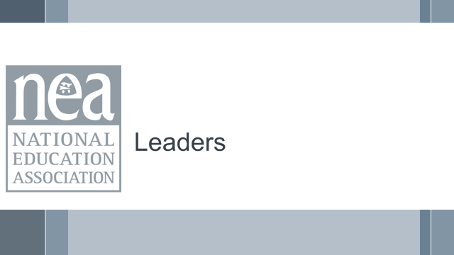  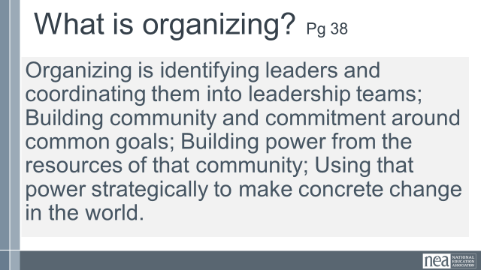  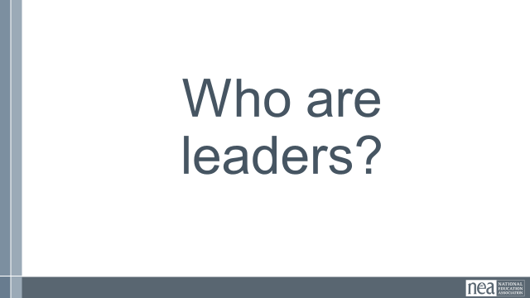  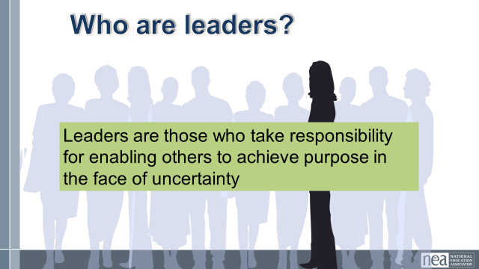  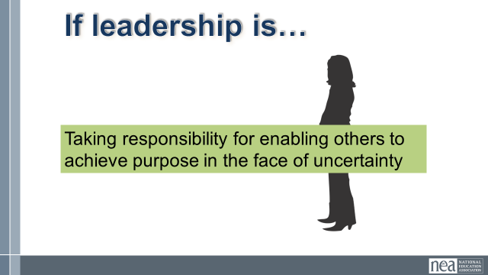  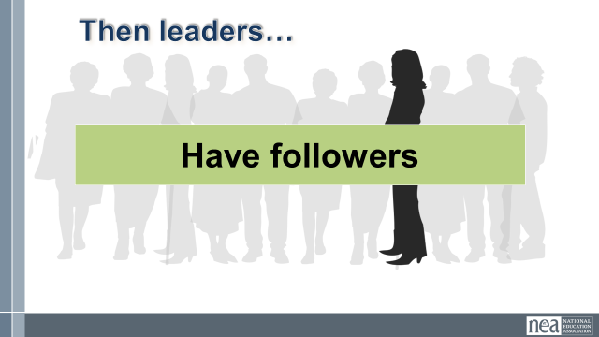  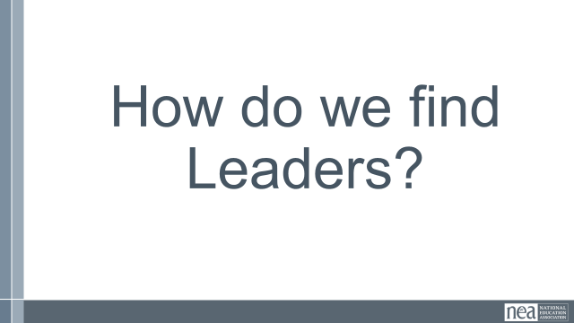  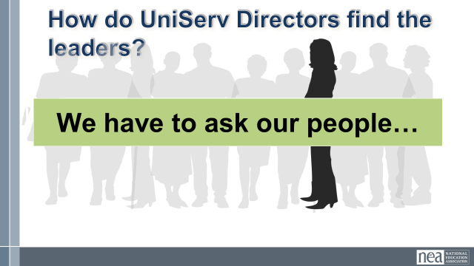  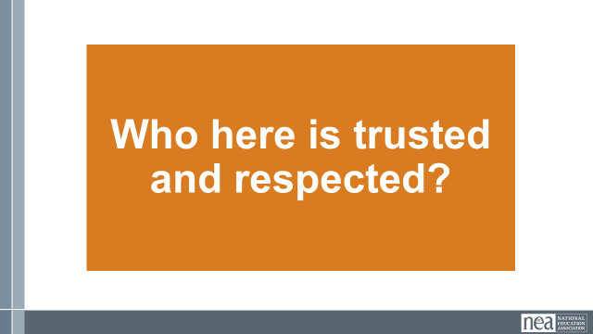  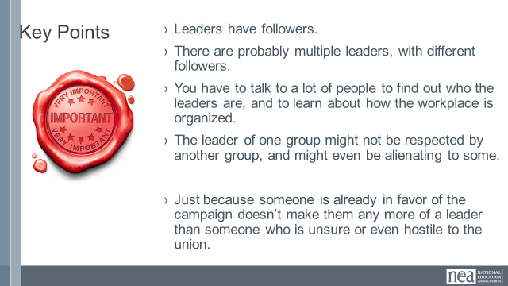 |  | 15 Minutes Overview of Leaders  2 minutes intro -  So before lunch we looked at a definition for organzing and the first part of that definition is about identify leaders and coordinating them into teams. We are going to work on how we actually define leaders and the method for finding them.  5 mins  Turn in at your tables and take just 5 minutes to come up with WHO are leaders.  3 Mins – what are some of the things you said? Hmmm, I heard a lot of qualities, some indicators, lot’s of thinking.  5 minutes – little lecturette  WE are going to use this definition of leadership in this program.  Leaders are those who take responsibility for enabling others to achieve shared purpose in the face of uncertainty  We have seen the enable word previously – but we also see responsibility and getting others to achieve a shared purpose.  If leadership is Taking responsibility for enabling others to achieve shared purpose in the face of uncertainty  Then  Leaders have followers  How do we find leaders?  We have to ask our people  The method we use is the Natural Leader ID. The way that you employ this method is that during almost every opportunity that you are with workers in conversation – you ask them  Who here is trusted and respected? Why this question in this way?  People follow (take risks, take counsel, act in concert with) those people who show up in the workplace in a way that is respectable – they are on time, do their work well, listen etc. AND if we are expecting people to take some sort of public risk – they do that with someone they trust. Trust is built through transparency, positive relationship, being credible and holding confidences.  Why both? I can totally respect how a colleague does their work and gets the kind of outcomes we might all aspire to – but I know that they talk about me behind my back. I am not going to follow them. I may totally trust a person – they would never “sell me out” they are not in concert with the boss – but they are a hot mess about their work. I am not going to risk my public reputation following them.  We then create a data base of ALL THE people who have been named as both trusted and respected – and when a person is mentioned over and over, then I need to be in relationship with that person. It is these folks who can get people to act.  1 Min - WRAP UP/ KEY POINTS  - Leaders have followers.  - There are probably multiple leaders, with different followers.  - You have to talk to a lot of people to find out who the leaders are, and to learn about how the workplace is organized.  - This isn’t to say that people cannot become leaders, but we are starting from the assumption that there are already leaders in the workplace, and we have to find out who they are.  - The leader of one group might not be respected by another group and might even be alienating to some.  Just because someone is already in favor of the campaign doesn’t make them any more of a leader than someone who is unsure or even hostile to the union. Our job as organizers is to identify people’s issues and move them with hope and a plan to win! | How do I identify leaders?  What are qualities that we can look for in identifying leaders?  Participants will work to identify and rank a series of leaders in a short scenario.
3:10-3:40 |  | 30 Minutes total – Leadership Structures
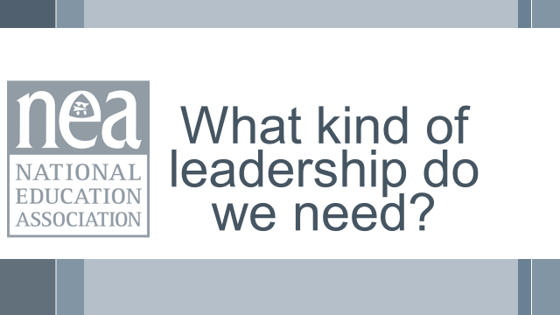  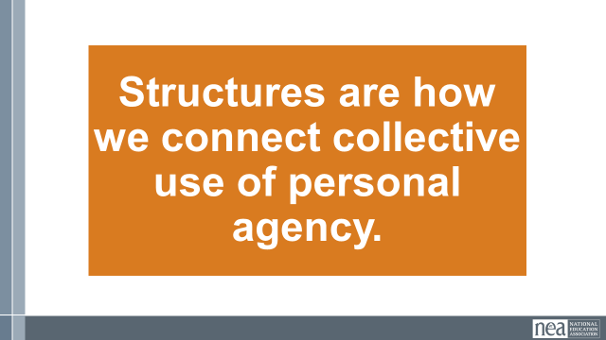  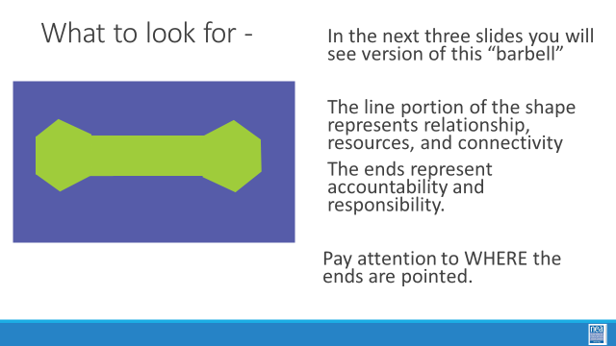  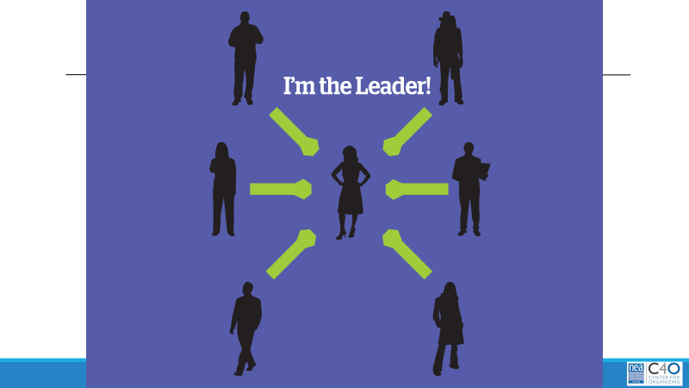  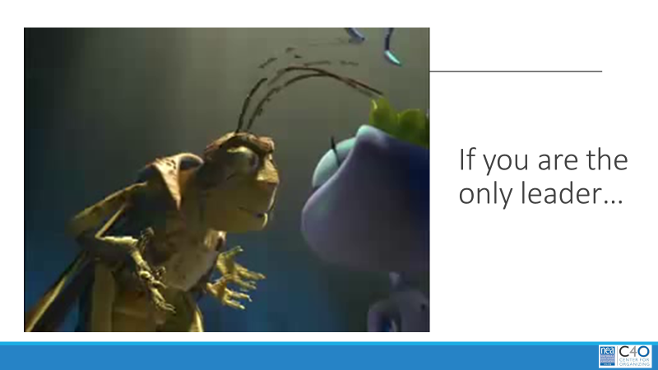  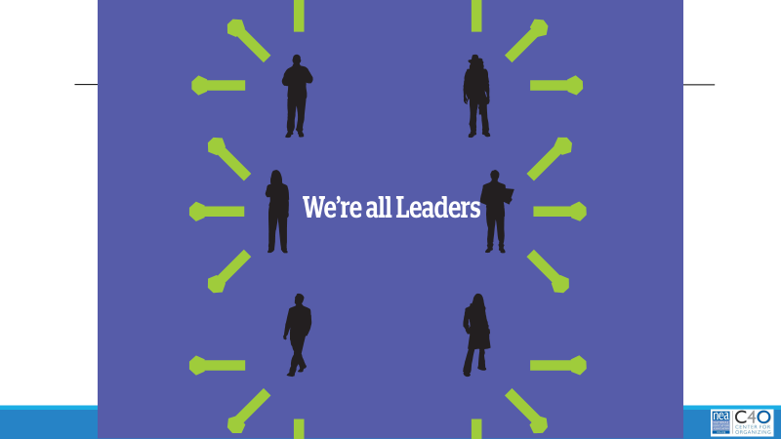    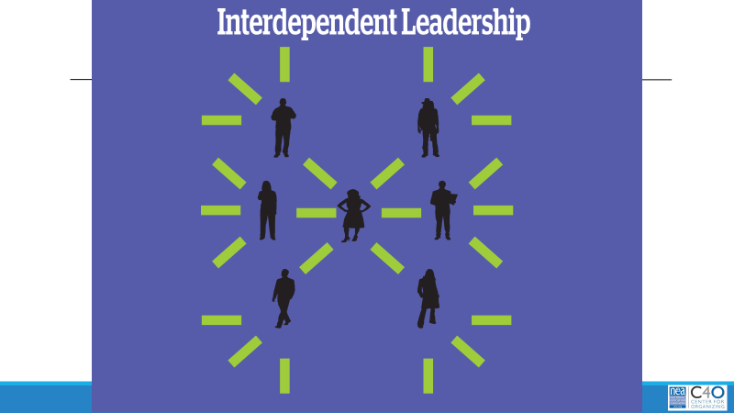    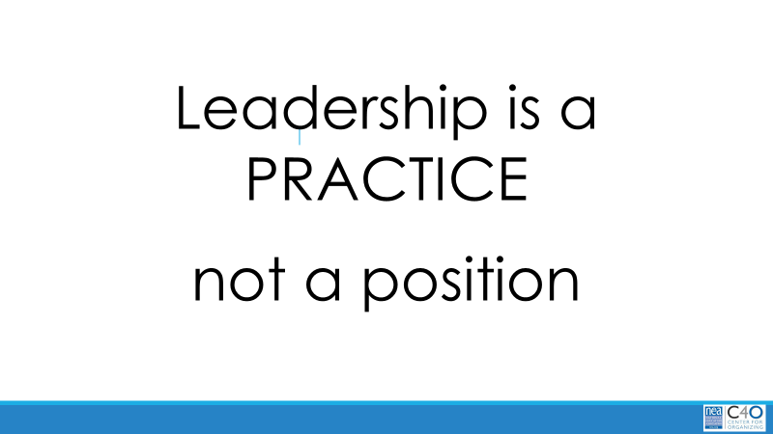  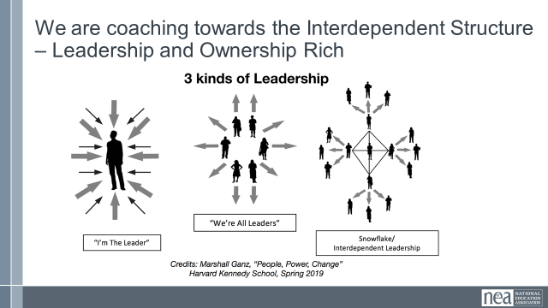  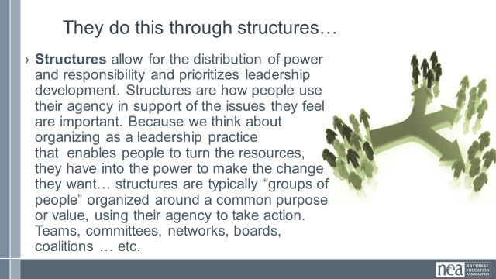  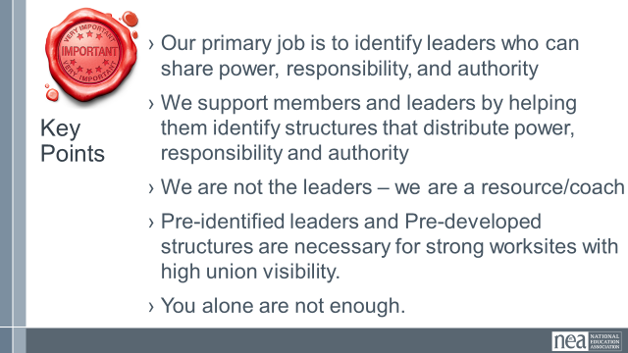 | Structuring Leadership  Ella Baker on Leadership | 5 mins intro  We just talked about leaders – now that we have identified them – what is next?  Well let’s go back to our definition of organizing – we coordinate them into leadership teams. We create structures  Structures are a group of people – they are how we connect collective use of personal agency.  Let’s look at three kinds of leadership structures that are prevalent in our worksites.  1 Min -  As we move through these structures keep track of where the power is and what your job would look like in each of these structures.  In the next three slides you will see version of this “barbell”  The line portion of the shape represents relationship, resources, and connectivity  The ends represent leadership and ownership over the relationships and resources.  Pay attention to WHERE the ends are pointed.  3 Min  - Let’s take a look at the first model – the “I am the leader” model.  - Some things to notice in each slide – these lines represent relationships, and the ends of the lines represent “weight” like dumbbells – the weight of accountability, responsibility, direction of resources.  - In this slide – where is the weight? Where is control over the relationships and resources? Is this a powerful or sustainable model? Who benefits from this structure?  - Let’s look at a short video to help you remember this model – First Rule of Leadership.  3 Min  - Let’s take a look at another model – this is the “we are all leaders” model.  - In this slide – where is the weight? Where is the control over relationships and resources? Is this a powerful or sustainable model – Who benefits from this structure?  - Let’s look at a short video to help you remember this model – Cat Herders  3 Min **** THE FACILITATOR NARRATES THIS VIDEO***  - Let’s take a look at our last model – this is the “Interdependent Leadership” model.  - In this slide – where is the weight? Where is the control over the resources and relationships? Is this a powerful or sustainable model – Who benefits from this structure?  - Let’s look at a short video to help you remember this model – PARACHUTE – Say as the video plays “ In this video you see 81 parachutists who are each connected and focused on a common purpose. If you and 80 of your colleagues jumped out of a plane what would be your common purpose***? Getting to the ground alive! That takes a lot of risk that is done in solidarity to achieve a common goal. There is a tremendous amount of ownership in this shared goal. There is a lot of leadership evident in the support of each other. The organizers and the leadership team are actually NOT part of the diamond shape but are on the outside coaching, providing data and encouragement. So that everyone achieves the same purpose – get to the ground alive.” (MUTE VIDEO)  3 Min  Leadership is a practice and not a position,  If Leadership is Taking responsibility for enabling others to achieve purpose in the face of uncertainty  3 MInutes  Then Leaders have followers.  We are coaching leaders and their followers towards the interdependent structure that is leadership and ownership rich.  They do this through structures that build more and more leaders at different levels with different teams and in different places – but are OUR PEOPLE because they share our values and purpose for change.  1 Min- WRAP UP/KEY POINTs  - Our primary job is to identify leaders who can share power, responsibility, and authority  - We support members and leaders by helping them identify structures that distribute power, responsibility and authority  - We are not the leaders – we are a resource/coach  - Pre-identified leaders and Pre-developed structures are necessary for strong worksites with high union visibility.  You alone are not enough. | What makes for effective leadership structures?  Participants will identify leadership structures in their locals.  Participants will apply the concepts in a small scenarios.
1:50- 2:30 |  | 40 Minutes – Targtes and Demands | 1:50- 2:30
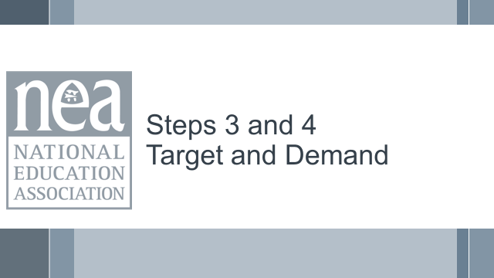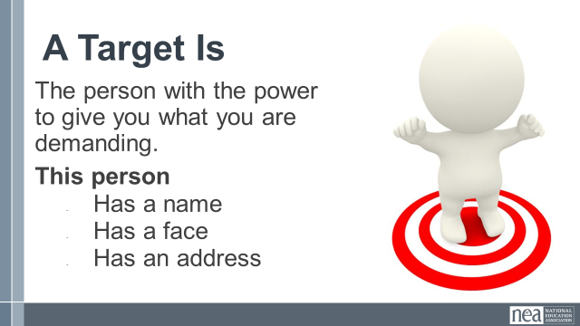  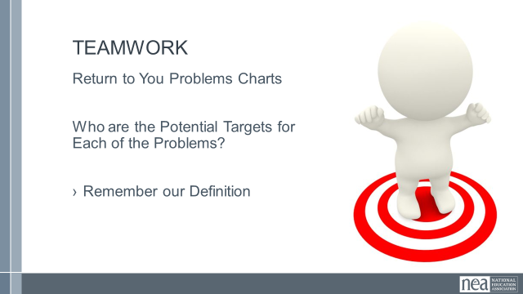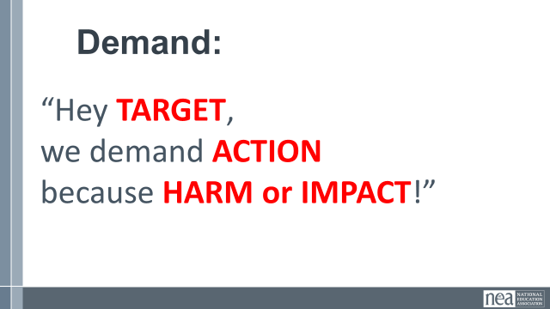  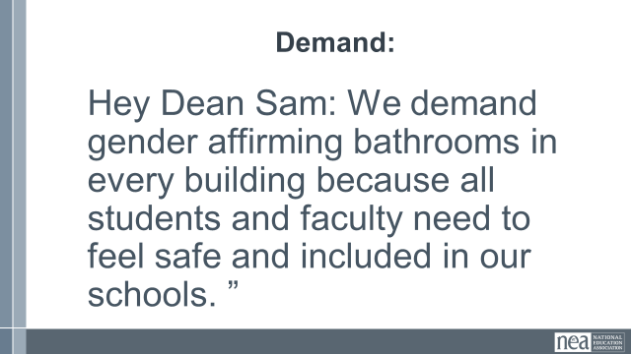  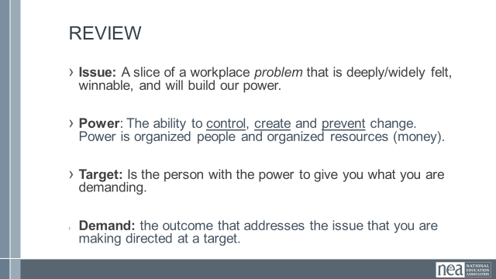  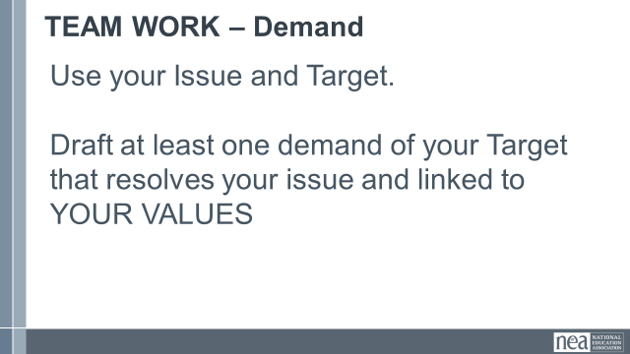  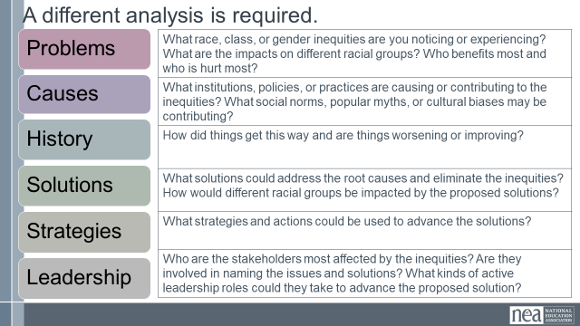  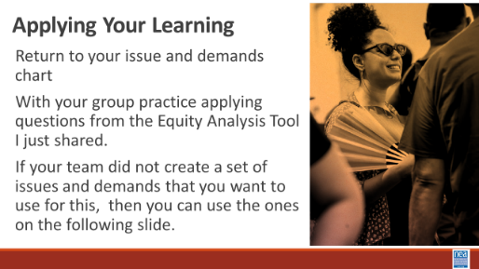  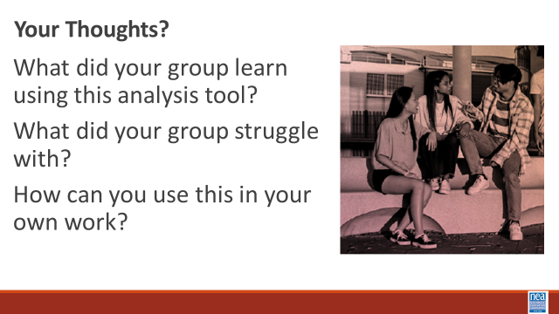  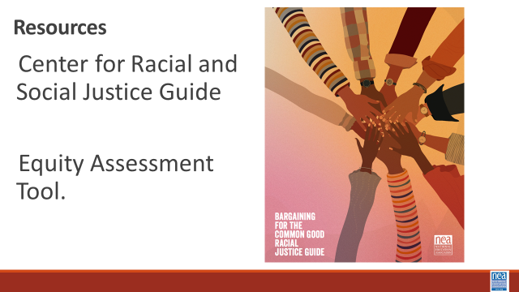  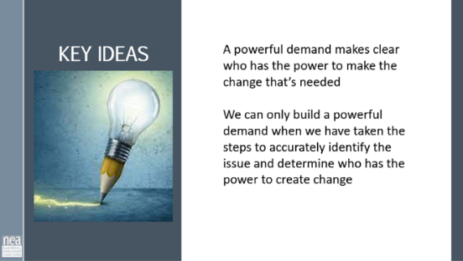 |  | Content 5 MInutes Part 3: Identify and Analyze the Target(s)  Now we’ll move into Part 3 of the Power Analysis, identifying and analyzing the Target(s).  Definition of Target  Ask group: Who has an idea of what we mean by a target in the context of a campaign?  - A target is the person who can make the decision to give you what you want. The target is the person who can meet your demands. We need to be very specific in identifying the target. A target is not an organization or a committee. A target is a person with a face, name, and an address.  5 Minutes – Teamwork Identify Potential Targets for your Issues  10 Minutes of Content  A demand is the outcome that addresses the issue that you are making of a target.  The demand should have the 3 components: the target, the action, and the harm or impact.  “Hey Superintendent Sam: We demand gender affirming bathrooms in every school because all students need to feel safe and included in our schools. ”  This example clearly articulates the Target (Superintendent Sam), the action that we want the target to take (implement gender affirming bathrooms in every school), and the harm or impact (that this will allow students to feel safe and included).  The demand is usually the first thing that your supporters or potential supporters will hear about the campaign. This is why it is important to include the harm or impact, because it creates a moral crisis in the listener and move them to act in support of the campaign.  - Measurable  - Achievable  The demand should be measurable in that we can clearly know whether the target takes the action in the demand or not  Team work – 10 Minutes  Return to your charts and draft a demand of your Target that resolves your issue and linked to YOUR VALUES  10 Minutes – Group Practice – Applying a race, class, and gender lens to your Demands  2 minutes intro  To engage in a systems analysis of a race class and gender issues and develop solutions or to test if the campaign demands center racial justice, good discussion questions to have with partners and union members include:  • Problems: What racial inequities are you noticing or experiencing? What are the impacts on different racial groups? Who benefits most  and who is hurt most?  • Causes: What institutions, policies, or practices are causing or contributing to the inequities? What social norms, popular myths, or cultural biases may be contributing?  • History: How did things get this way and are things worsening or improving?  • Solutions: What solutions could address the root causes and eliminate the inequities? How would different racial groups be impacted by the  proposed solutions?  • Strategies: What strategies and actions could be used to advance the solutions?  • Leadership: Who are the stakeholders most affected by the inequities? Are they involved in naming the issues and solutions? What kinds of active leadership roles could they take to advance the proposed solution?  Group Work – Applying Your Learning – (8 Minutes) Use the 8th file in the Participant handouts and Refer to the 9th File CRJ Bargaining for the Common Good Guide  Return to your problems chart  With your group practice applying questions from the Equity Analysis Tool I just shared.  Without intentionality – we might continue to build power – but it won’t be the type of power we need to demand solutions to the structural inequalities found on our HBCU campuses  Key Ideas  - A powerful demand makes clear who has the power to make the change that’s needed  - We can only build a powerful demand when we have taken the steps to accurately identify the issue and determine who has the power to create change | How do you determine the demand?  Participants will understand how to determine a measurable and winnable demand.
2:30-3:00 |  | 30 Minutes - Strategy, Tactics and Escalation | 2:30-3:00
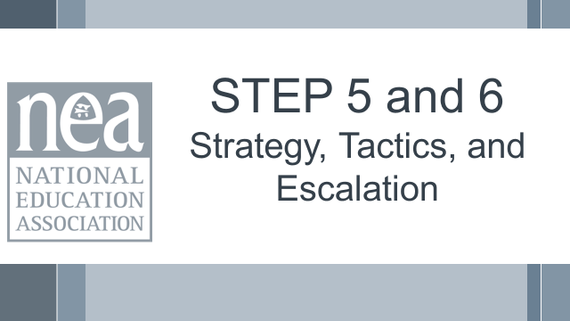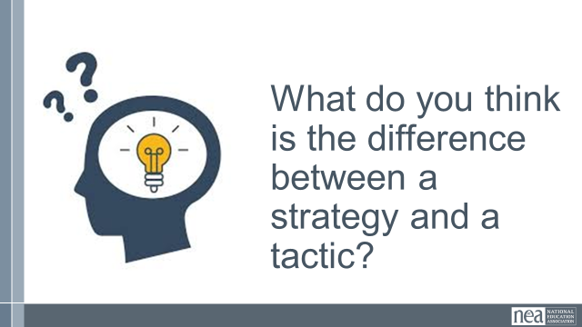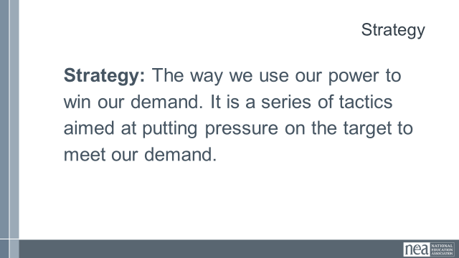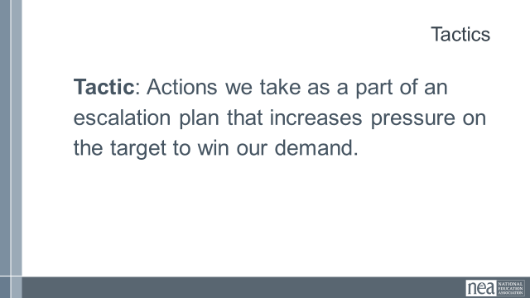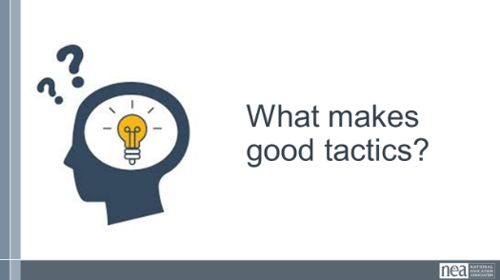  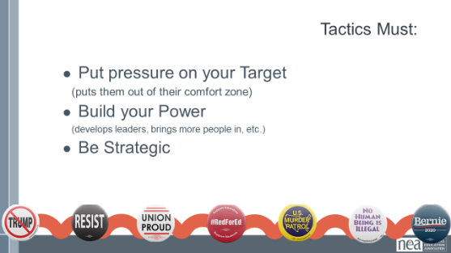  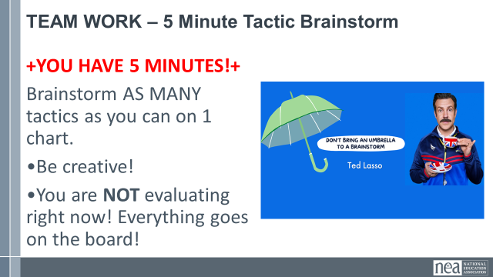  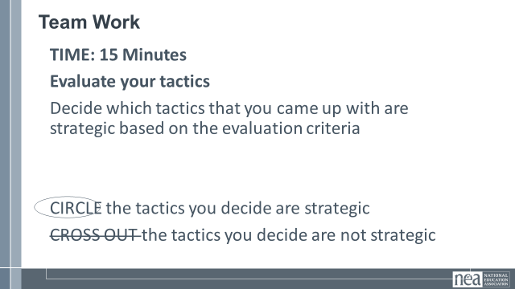  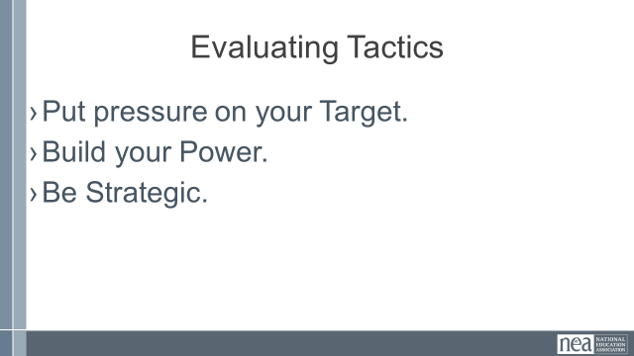  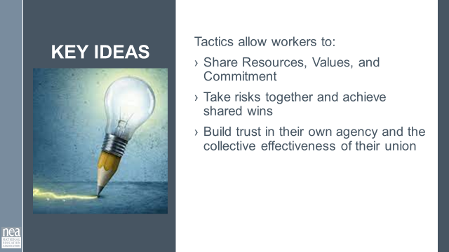  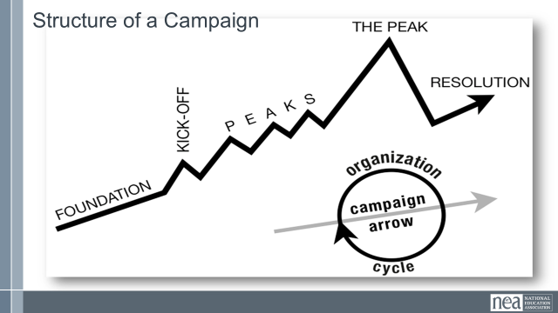  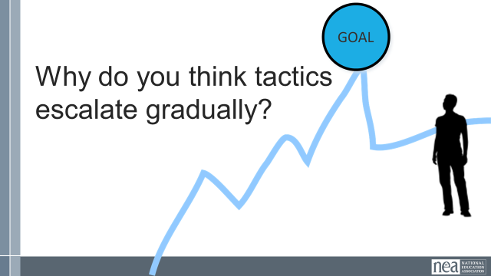  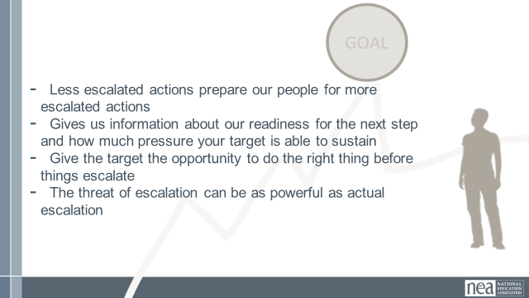  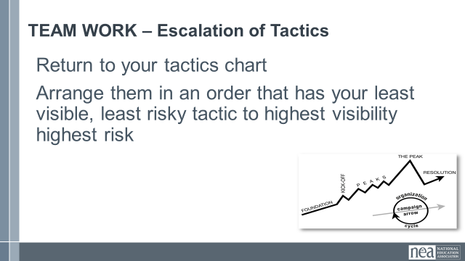  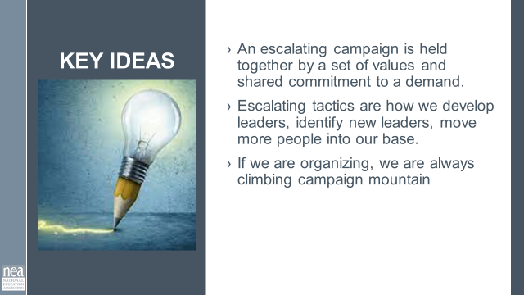 |  | 5 Minutes Strategy vs Tactics  Ask group: What do you think is the difference between a strategy and a tactic?  A strategy is the way we use our power to win our demand. It is a series of tactics aimed at putting pressure on the target to meet our demand. We need a strategy because we cannot just implement tactics in a random way, we need to plan and order our tactics strategically according to an escalation plan.  Tactics are actions we take as part of an escalation plan that increases pressure on the target to win our demand. We design tactics based on our power analysis on the target. Each tactic should put pressure on the target’s self-interest, relationships, or power that we identified in the power analysis.  What makes good Tactics?  Let’s hear from a few people. Who wants to share about their favorite tactic and what made it a good tactic?  Tactics must:  - Put pressure on your Target. Tactics must put pressure on the Target’s Self-Interests, Relationships, or Power. Tactics should put the Target out of their comfort zone - we don’t want to use tactics that the Target is expecting or is used to seeing already, because that won’t put pressure on them.  - Build your Power. We should always be thinking about how each tactic can help us develop our leaders and brings more people into the campaign.  - Be Strategic. We don’t do tactics just for the sake of doing them. We need to make sure that our tactics make good use of our resources in order to put the most amount of pressure on the Target and as part of an escalation plan.  Group Activity (TOTAL For both charting activities 15 mins)  Let’s return to our issue charts.  Review your spectrum of allies AND your target’s power analysis  Based on the power analysis, brainstorm in your groups as many creative tactics as you can! Take 5 mins.  After 5 mins:  Now, take the next 10 mins in your groups to circle the tactics that meet the evaluation critera outlined below -  Tactics must:  - Put pressure on your Target. Tactics must put pressure on the Target’s Self-Interests, Relationships, or Power. Tactics should put the Target out of their comfort zone - we don’t want to use tactics that the Target is expecting or is used to seeing already, because that won’t put pressure on them.  - Build your Power. We should always be thinking about how each tactic can help us develop our leaders and brings more people into the campaign.  - Be Strategic. We don’t do tactics just for the sake of doing them. We need to make sure that our tactics make good use of our resources in order to put the most amount of pressure on the Target and as part of an escalation plan. WE WILL DO THIS IN OUR NEXT SECTION  Key Points  Tactics allow workers to:  - Share Resources, Values, and Commitment  - Take risks together and achieve shared wins  Build trust in their own agency and the collective effectiveness of their union  3 Minutes Now Let’s Escalate  Let’s look at a picture of a campaign – campaign mountain. We try to organize our tactics along this mountain from lowest risk, lowest participation, lowest impact on the target to highest risk, participation and impact  Why do you think tactics escalate gradually?  - Less escalated actions prepare our people for more escalated actions  - Give the target a point to do the right thing before things escalate to the next tactic  - Use the threat of escalation  - Allows more people to join our base  5 Minutes Activity - Escalation of Tactics and report out  Return to your tactics chart – arrange them in an order that has your least visible, least risky tactic to highest visibility highest risk  3 Minutes Key Points – An escalating campaign is held together by a set of values and shared commitment to a demand.  Escalating tactics are how we develop leaders, identify new leaders, move more people into our base.  If we are organizing, we are always climbing campaign mountain | What are strategy and tactics?  What makes effective tactics?  Participants will understand the difference between strategy and tactics and the criteria for effective tactics.

